Ref: 2008/06401

6 November 2009

BIOSECURITY AUSTRALIA ADVICE 2009/27

IMPORTATION OF ZOO BOVIDS FROM New Zealand – DRAFT POLICY REVIEW

This Biosecurity Australia Advice (BAA) provides stakeholders with proposed quarantine measures for the importation of zoo bovids into Australian zoos from approved New Zealand zoos. We would welcome stakeholder comments by 6 December 2009.
For the purpose of this policy review, ‘zoo bovids’ are mammals of the Family Bovidae kept in confinement in approved zoos. Approved zoos are Auckland Zoo, Hamilton Zoo, Orana Wildlife Park and Wellington Zoo.
Quarantine conditions for the importation of zoo antelope from New Zealand were adopted in 1991 and zoo bovidae from the United States in 1994. These were subsequently suspended in 2001 because the risk management measures were inconsistent with more recent policies established by an import risk analysis.
The Australasian Regional Association of Zoological Parks and Aquaria (ARAZPA) has requested access for several species of zoo bovids to boost declining domestic stocks. Some suitable animals are available in New Zealand and, to address the zoos’ request, Biosecurity Australia has conducted a policy review on the importation of zoo bovids from New Zealand. The review has drawn on the following information
- New Zealand’s import risk analysis ‘Diseases of Antelope: Risks of introducing live antelope into zoological gardens’ (available from the Biosecurity New Zealand website),
- current requirements for importation into Australia of sheep and goats, and semen and embryos of cattle, sheep and goats, from New Zealand,
- the suspended import policies for zoo antelope from New Zealand and zoo bovidae from the United States mentioned above, and
- a review of relevant scientific literature.
The policy review concludes that risk management measures are required for Johne’s disease and bovine tuberculosis. It is recommended that the imported animals be certified as coming from zoos where no cases of Johne’s disease or bovine tuberculosis (Mycobacterium bovis) have been diagnosed in the premises of origin during the past five years. It is further recommended that the animals for export, and all other bovids with which they have been in contact in the previous 12 months, have been tested for M. bovis infection with negative results.
A draft review report is attached. It includes proposed quarantine measures for the importation of zoo bovids from New Zealand.
Consultation
Please pass this notice to other interested parties. If those parties wish to be included in future communications on this matter they should get in touch with the contact officer (details below).
Comments on the proposed new measures should be submitted by 6 December 2009 to Biosecurity Australia at the following address:
Animal Biosecurity
Biosecurity Australia
GPO Box 858
CANBERRA ACT 2601

Telephone: (02) 6272 4436
Facsimile: (02) 6272 3399
E-mail: animal@biosecurity.gov.au
An electronic version of submissions would be appreciated. Biosecurity Australia will consider all stakeholder comments as it finalises the policy review.
Information on risk assessments and policy reviews being conducted by Biosecurity Australia is available from our website www.biosecurityaustralia.gov.au.
Confidentiality
Stakeholders are advised that, subject to the Freedom of Information Act 1982 and the Privacy Act 1988, all submissions received in response to BAAs will be publicly available. Comments may be listed or referred to in any papers or reports prepared on the subject matter of the Advice.
The Commonwealth reserves the right to reveal the identity of a respondent unless a request for anonymity accompanies the submission. Where a request for anonymity does not accompany the submission the respondent will be taken to have consented to the disclosure of their identity for the purposes of Information Privacy Principle 11 of the Privacy Act 1988.
The contents of the submission will not be treated as confidential unless they are marked ‘confidential’ and they are capable of being classified as such in accordance with the Freedom of Information Act 1982.
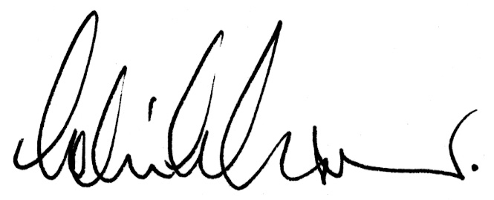
Colin Grant
Chief Executive

Contact: Warren Vant
Telephone no: 02 6272 4436
Facsimile no: 02 6272 3399
E-mail: warren.vant@biosecurity.gov.au

