30 June 2010

BIOSECURITY AUSTRALIA ADVICE 2010/20
FINAL IMPORT RISK ANALYSIS REPORT FOR FRESH APPLE FRUIT FROM THE PEOPLE’S REPUBLIC OF CHINA

This Biosecurity Australia Advice notifies stakeholders that Australia’s Director of Animal and Plant Quarantine has determined a policy for the importation of fresh apple fruit from the People’s Republic of China. The importation of fresh apple fruit may be permitted subject to the Quarantine Act 1908 and application of phytosanitary measures as specified in the Final import risk analysis report for fresh apple fruit from the People’s Republic of China.

In response to a proposal from the People’s Republic of China (China), Biosecurity Australia completed an import risk analysis (IRA) on fresh apple fruit from China. The IRA was completed in accordance with the Import Risk Analysis Handbook 2007 (update 2009) provisions for an expanded regulated process.
The IRA process commenced on 17 March 2008 (Biosecurity Australia Advice (BAA) 2008/05). An issues paper and a draft IRA were released for stakeholder comment on 8 July 2008 (BAA 2008/21) and 21 January 2009 (BAA 2009/01), respectively. The draft IRA report revised after consideration of stakeholders’ comments was reviewed by the independent Eminent Scientists Group (BAA 2009/23) and its conclusions were made available on 4 December 2009 (BAA 2009/29). On 30 March 2010, the provisional final IRA was released for a period of 30 days (BAA 2010/08), during which appeals could be made on the basis of a failure by Biosecurity Australia to follow proper process as set out in the IRA handbook. Stakeholders were notified on 13 May 2010 (BAA 2010/14) that an Import Risk Analysis Appeals Panel (IRAAP) would be convened to consider two of the five appeals submitted. The other appeals were considered to be out of scope of the criteria for appeal.
The IRAAP disallowed the two appeals against the IRA on 9 June 2010. The Panel’s findings are available at www.daff.gov.au/iraap.
However, in response to a recommendation of the IRAAP, Biosecurity Australia has included reference to the spotted wing drosophila (SWD), Drosophila suzukii, in the final IRA report. This inclusion indicates that Biosecurity Australia is currently conducting a separate pest risk analysis for SWD (BAA 2010/09, 31 March 2010). Stakeholders will have an opportunity, through a 60-day period, to comment on the pest risk analysis for SWD, including any measures proposed to manage this pest. Although SWD is present in China, all available scientific information from Asia, Europe and the United States indicates that SWD is a pest of soft fruits, not hard skinned fruits, such as apples and pears.
The Director of Animal and Plant Quarantine has made a policy determination to permit the entry of fresh apple fruit from China to Australia, subject to the Quarantine Act 1908, the Quarantine Proclamation 1998, and the application of phytosanitary measures, as specified in the Final import risk analysis report for fresh apple fruit from the People’s Republic of China. These measures are designed to limit quarantine risk to a level that is acceptably low, in order to achieve Australia’s appropriate level of protection.
The quarantine measures include, sourcing fruit from registered orchards within nominated export areas, area freedom, orchard control and surveillance, fruit bagging, pressurised air blasting of fruit prior to packing, inspection and remedial action if quarantine pests are detected. These measures will be supported by an operational system that maintains and verifies the quarantine status of consignments to Australia, through inspection by the Australian Quarantine and Inspection Service (AQIS). An AQIS officer will be present in China under a pre-clearance arrangement to inspect and verify all consignments prior to export.
The policy will be taken into account by decision makers when considering import permit applications for fresh apple fruit from China in accordance with the Quarantine Act 1908 and Quarantine Proclamation 1998 as amended.
Australia and China will now develop a detailed work plan and work instructions. These will need to be approved by the Australian Quarantine and Inspection Service before any import permit can be issued.
The Final import risk analysis report for fresh apple fruit from the People’s Republic of China is available at www.biosecurityaustralia.gov.au.
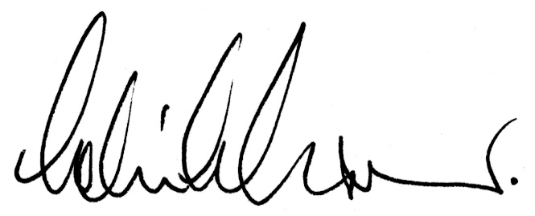

Dr Colin J Grant
Chief Executive

