

Draft Risk Analysis Report for the release of Eueupithecia cisplatensis for the biological control of Parkinsonia (Parkinsonia aculeata)
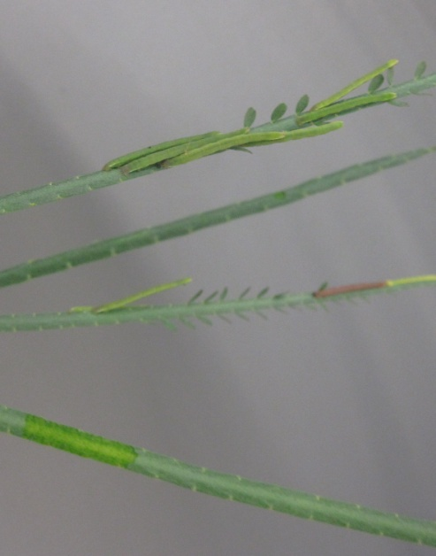

April 2012

© Commonwealth of Australia
Ownership of intellectual property rights
Unless otherwise noted, copyright (and any other intellectual property rights, if any) in this publication is owned by the Commonwealth of Australia (referred to as the Commonwealth).
Creative Commons licence
All material in this publication is licensed under a Creative Commons Attribution 3.0 Australia Licence, except for content supplied by third parties, photographic images, logos, and the Commonwealth Coat of Arms.
Creative Commons Attribution 3.0 Australia Licence is a standard form licence agreement that allows you to copy, distribute, transmit and adapt this publication provided that you attribute the work. A summary of the licence terms is available from creativecommons.org/licenses/by/3.0/au/deed.en. The full licence terms are available from creativecommons.org/licenses/by/3.0/au/legalcode.
This publication (and any material sourced from it) should be attributed as:
Department of Agriculture, Fisheries and Forestry Biosecurity (2012) Draft risk analysis report for the release of Eueupithecia cisplatensis for the biological control of Parkinsonia (Parkinsonia aculeata). Department of Agriculture, Fisheries and Forestry, Canberra. CC BY 3.0.
Cataloguing data
Department of Agriculture, Fisheries and Forestry Biosecurity (2012) Draft risk analysis report for the release of Eueupithecia cisplatensis for the biological control of Parkinsonia (Parkinsonia aculeata). Department of Agriculture, Fisheries and Forestry, Canberra
Internet
The Draft risk analysis report for the release of Eueupithecia cisplatensis for the biological control of Parkinsonia (Parkinsonia aculeata) is available via daff.gov.au/ba.
Inquiries regarding the licence and any use of this document should be sent to: copyright@daff.gov.au.
Disclaimer
The Australian Government acting through the Department of Agriculture, Fisheries and Forestry has exercised due care and skill in the preparation and compilation of the information in this publication. Notwithstanding, the Department of Agriculture, Fisheries and Forestry, its employees and advisers disclaim all liability, including liability for negligence, for any loss, damage, injury, expense or cost incurred by any person as a result of accessing, using or relying upon any of the information in this publication to the maximum extent permitted by law.

Cover image: Eueupithecia cisplatensis feeding on Parkinsonia aculeata (Courtesy: Dr Tim Heard, CSIRO Ecosystem Sciences).

Submissions
This draft risk analysis (RA) report has been issued to give all interested parties an opportunity to comment and draw attention to any scientific, technical, or other gaps in the data, misinterpretations and errors. Any comments should be submitted to DAFF Biosecurity within the comment period stated in the related Biosecurity Advice on the Department of Agriculture, Fisheries and Forestry website. The draft RA report will then be revised as necessary to take account of the comments received and a final RA report will be released at a later date.
Comments on the draft RA report should be submitted to:
Biosecurity Plant
Department of Agriculture, Fisheries and Forestry
GPO Box 858
CANBERRA ACT 2601
AUSTRALIA
Telephone: +61 2 6272 5094
Facsimile: +61 2 6272 3307
Email: plant@daff.gov.au
Internet: http://daff.gov.au/ba

Contents
Acronyms and abbreviations ix
Abbreviations of units ix
Summary xi
1 Introduction 1
1.1 Australia’s biosecurity policy framework 1
1.2 This risk analysis 1
2 Method for analysis 3
3 Assessment of off-target risks 3
3.1 Stage 1: Initiation 3
3.2 Stage 2: Risk assessment 3
4. Draft recommendation on release 5
Appendix A Application to release the defoliating caterpillar Eueupithecia cisplatensis (Lepidoptera: Geometridae) for the biological control of the weed Parkinsonia aculeata (Leguminosae: Caesalpinioideae) 1
1. Summary 3
2. Information on target species, Parkinsonia aculeata 4
2.1. Taxonomy 4
2.2. Description 4
2.3. Distribution 5
2.4. Ecology 7
2.5. Importance 8
2.6. Information on all other relevant Commonwealth, State and Territory legislative controls of the target species 9
2.7. When the target species was approved for biological control 9
3. Information on the potential agent Eueupithecia cisplatensis 10
3.1. Taxonomy 10
3.2. Description 11
3.3. Brief biology of the agent 12
3.4. Native range of the agent 15
3.5. Related species to the agent and a summary of their host range 15
3.6. The proposed source of the agent 15
3.7. Possible interactions with existing biological control programs (of same or related targets and other targets) 15
3.8. The agent’s potential for control of target 16
3.9. Information on non-target organisms at risk from an agent 16
3.10. Information and results of any other assessments undertaken on the species 16
3.11. Report of host specificity testing 16
4. Where, when and how initial release will be made 30
4.1. Release from quarantine 30
4.2. Distributing in the field 30
4.3. Establishment and evaluation 30
5. Copies of any references referred to in the application 30
6. Acknowledgements 30
7. References 31
Appendix B Method for pest risk analysis 34
Stage 1: Initiation 34
Stage 2: Pest risk assessment 35
Stage 3: Pest risk management 42
Appendix C Biosecurity framework 44
Glossary 49
References 51

Tables
Table 1.1 Nomenclature for qualitative likelihoods 38
Table 1.2 Matrix of rules for combining qualitative likelihoods 38
Table 1.3 Decision rules for determining the consequence impact score based on the magnitude of consequences at four geographic scales 40
Table 1.4 Decision rules for determining the overall consequence rating for each pest 41
Table 1.5 Risk estimation matrix 41

Figures
Figure 1 Map of Australia viii
Figure 2 A guide to Australia’s bio-climate zones viii

Figure 1 Map of Australia

Figure 2 A guide to Australia’s bio-climate zones
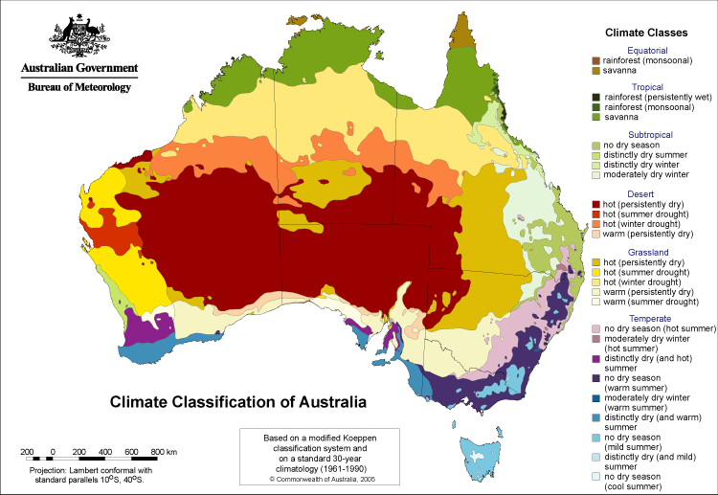

Acronyms and abbreviations
Term or abbreviation | Definition
ALOP | Appropriate level of protection
APPD | Australian Plant Pest Database (Plant Health Australia)
BCA | Biological Control Agent
CABI | CAB International, Wallingford, UK
CMI | Commonwealth Mycological Institute
DAFF | Australian Government Department of Agriculture, Fisheries and Forestry
FAO | Food and Agriculture Organization of the United Nations
IPC | International Phytosanitary Certificate
IPM | Integrated Pest Management
IPPC | International Plant Protection Convention
ISPM | International Standard for Phytosanitary Measures
NPPO | National Plant Protection Organization
NSW | New South Wales
NT | Northern Territory
Qld | Queensland
RA | Risk Analysis
Tas. | Tasmania
Vic. | Victoria
WA | Western Australia
WTO | World Trade Organisation

Abbreviations of units
Term or abbreviation | Definition
ºC | degree Celsius
ºF | degree Fahrenheit
kg | kilogram
km | kilometre
m | metre
μ | micrometre (one millionth of a metre)
ml | millilitre
mm | millimetre
ppm | parts per million
s | second

Summary
This draft risk analysis assesses an application from CSIRO Ecosystem Sciences to release the geometrid moth Eueupithecia cisplatensis for the biological control of Parkinsonia (Parkinsonia aculeata). In accordance with the IRA handbook 2007 (updated 2009), this risk analysis has been undertaken as a non-regulated analysis of existing policy.
The draft report proposes that the biological control agent should be released, subject to standard quarantine conditions associated with the import and release of biological control agents.
The draft report has identified no significant off-target effects or potential consequences that would be associated with the release of Eueupithecia cisplatensis. The risk is estimated to be negligible, which meets Australia’s appropriate level of protection (ALOP).
This draft report contains details of the risk assessment for potential off-target effects associated with the proposed release of Eueupithecia cisplatensis and CSIRO Ecosystem Sciences’ application (Appendix A) in order to allow interested parties to provide comments and submissions to DAFF Biosecurity within the consultation period.

Introduction

Australia’s biosecurity policy framework
Australia's biosecurity policies aim to protect Australia against the risks that may arise from exotic pests entering, establishing and spreading in Australia, thereby threatening Australia's unique flora and fauna, as well as those agricultural industries that are relatively free from serious pests.
Risk analysis is an important part of Australia's biosecurity policies. It enables the Australian Government to formally consider the risks that could be associated with proposals to release a new organism into Australia. If the risks are found to exceed Australia’s appropriate level of protection (ALOP) then release will not be allowed.
Successive Australian Governments have maintained a conservative, but not a zero risk, approach to the management of biosecurity risks. This approach is expressed in terms of Australia’s ALOP, which reflects community expectations through government policy and is currently described as providing a high level of protection aimed at reducing risk to a very low level, but not to zero.
Risk analyses for biological control agents are undertaken within the Department of Agriculture, Fisheries and Forestry Biosecurity, hereafter referred to as DAFF Biosecurity, by technical and scientific experts with consultation with appropriate scientific specialists. Consultation with stakeholders also occurs. DAFF Biosecurity provides recommendations for animal and plant quarantine policy to Australia’s Director of Animal and Plant Quarantine (the Secretary of the Australian Government Department of Agriculture, Fisheries and Forestry). The Director, or delegate, is responsible for determining whether or not release of a biological control agent can be permitted under the Quarantine Act 1908, and if so, under what conditions.

This risk analysis

Background
An application has been submitted by CSIRO Ecosystem Sciences to release a biological control agent (Appendix A). The biological control agent, Eueupithecia cisplatensis is a leaf defoliating caterpillar proposed for the biological control of Parkinsonia (Parkinsonia aculeata) (Leguminosae: Caesalpinioideae). The applicant has followed the steps outlined in the Biosecurity Guidelines for the Introduction of Exotic Biological Control Agents for the Control of Weeds and Plant Pests (http://www.daff.gov.au/ba/reviews/biological_control_agents/protocol_for_biological_control_agents).

Scope
This report assesses the risk associated with the release of a biological control agent into the Australian environment. The primary risk with a release of this nature is the possibility of unwanted off-target effects on other species already present in Australia. DAFF Biosecurity assesses the risk under the Quarantine Act 1908. A parallel process operates for the assessment of biological control release applications, with the Department of Sustainability, Environment, Water, Population and Communities (DSEWPC) also making a ruling under the Environment Protection and Biodiversity Conservation Act 1999.
Plants that are considered weeds are sometimes considered to have value. For example, as ornamental species, traditional medicine, feed for stock etc. Consideration of the benefits and therefore any concerns about eradication of the target weed species are out of scope of this analysis.
DAFF Biosecurity will not commence an assessment to release a biological control agent unless the target has been approved by an appropriate government body. Parkinsonia aculeata was approved as a target for biological control in Australia by The Australian Weeds Committee in 1983.

Contaminating pests
There are organisms that may arrive with imported biological control agents. These organisms may include parasitoids, mites or fungi. DAFF Biosecurity considers these organisms to be contaminating pests that could pose sanitary and phytosanitary risks. Should this application to release be approved, these risks will be addressed by existing operational procedures, that apply to the importation and final release of biological control agents. These procedures include, detailed examination of imported material, confirmation of identity and breeding through one generation before release. For this reason, contaminating pests are outside the scope of this risk analysis.

Next steps
In order to provide a formal opportunity for stakeholder consultation this draft RA report will be open for comment for a 60 day period. This draft RA report gives stakeholders the opportunity to comment and draw attention to any scientific, technical, or other gaps in the data, misinterpretations and errors. The process includes:

- DAFF Biosecurity will consider submissions received on the draft RA report and may consult informally with stakeholders. DAFF Biosecurity will revise the draft RA report as appropriate.
- DAFF Biosecurity will then prepare a final RA report, taking into account stakeholder comments.
- The report will be distributed to the proposer and registered stakeholders and the documents will be placed on the DAFF Biosecurity website.

Method for analysis
Biological control agents (BCA) intended for release are deliberately introduced, distributed, aided to establish and spread. Therefore it would be inappropriate to assess the probability of entry, establishment and spread using the processes described in ISPM 11 (FAO 2004). This BCA RA will focus only on off-target effects, as this is the only concern with regard to the release of biological control agents.

Australia’s appropriate level of protection (ALOP)
The SPS Agreement defines the concept of an ‘appropriate level of sanitary or phytosanitary protection (ALOP)’ as the level of protection deemed appropriate by the WTO Member establishing a sanitary or phytosanitary measure to protect human, animal or plant life or health within its territory.
Like many other countries, Australia expresses its ALOP in qualitative terms. Australia’s ALOP, which reflects community expectations through government policy, is currently expressed as providing a high level of sanitary or phytosanitary protection aimed at reducing risk to a very low level, but not to zero.

Assessment of off-target risks
This section sets out the assessment of off-target risks that could be associated with the release of the biological control agent. As appropriate the methods followed those used for pest risk analysis (PRA) by DAFF Biosecurity in accordance with the International Standards for Phytosanitary Measures (ISPMs), including ISPM 2: Framework for Pest Risk Analysis (FAO 2007) and ISPM 11: Pest Risk Analysis for Quarantine Pests, including analysis of environmental risks and living modified organisms (FAO 2004). The methodology for a commodity-based PRA is provided in Appendix B.
The risk relevant to release of a biological control agent consists of the combination of the probability of off-target consequences on non-target species and the potential magnitude of the consequences of any off-target impacts.

Stage 1: Initiation
Initiation commences when the applicant provides a submission proposing the release of the biological control agent.
The risk analysis area is defined as all of Australia given that once released there will be no control of spread of the agent other than environment constraints related to the biology of the organism.

Stage 2: Risk assessment
This assessment evaluates the probability of off-target effects and the potential economic consequences of these effects.

Assessment of the probability of off-target effects
Given that the proposal is for deliberate release then the probability of entry, establishment and spread is assumed to be certain and therefore the assessment relates to the host specificity of the proposed agent.
A qualitative likelihood is assigned to the estimate of probability of off-target effects. Six descriptors are used: high; moderate; low; very low; extremely low; and negligible. Definitions of each descriptor are given in Appendix B, Table 1.1.
Appendix A gives details provided by the proponent of the host specificity testing that was carried out.

Host specificity testing methodology
Compilation of the host test list, followed an acceptable methodology. Host specificity testing was sufficiently extensive and included three methods:
- surveys of plant use in the native range
- testing of larval development on cut plant material in Argentina, and
- testing of larval development on live plant species in Australia.
The above processes are important in establishing confidence that the outcomes of the host testing indicate all possible off-target effects.

Results of host specificity testing
Of the plant species tested, significant feeding and the ability to complete a life cycle, only occurred on the target species, Parkinsonia aculeata. Adult emergence of 3% was also recorded on Parkinsonia praecox during testing in Argentina, however this species is not present in Australia. Host testing was carried out in Argentina on 27 legume plant species and in Australia on 40 legume plant species. Host testing was in the form of no-choice larval development tests. The applicant states in their report (Appendix A) that “our larvae died rather than feed on all test plant species except P. aculeata”.

On the basis of the work presented in Appendix A it is concluded that the probability of off-target effects is: VERY LOW (the event is very unlikely to occur).

Assessment of potential consequences to off-target species
The potential consequences of the off-target effects of the biological control agent have been assessed using the same methodology (Appendix B) as used in the import risk analyses for pests that may be associated with imported produce.

Criterion | Estimate and rationale
Direct
Plant life or health | Impact score: A – Indiscernible.  Host testing was carried out in Argentina on 27 legume plant species and in Australia on 40 legume plant species. Of all the plant species tested, only the two Parkinsonia species were able to support pupation and adult emergence (P. praecox only recorded 3% adult emergence). During no-choice testing in Argentina and Australia, no feeding (other than on the target plant) was recorded on any plant species tested.  The target organism Parkinsonia aculeata is the only naturalised Parkinsonia species in Australia and there are no indigenous species of this group present in Australia.
Other aspects of the environment | Impact score: A  No evidence of any potential consequences
Indirect
Eradication, control etc. | Impact score: A  No evidence of any potential consequences
Domestic trade | Impact score: A  No evidence of any potential consequences
International trade | Impact score: A  No evidence of any potential consequences
Environmental and non-commercial | Impact score: A  No evidence of any potential consequences

Based on this assessment the potential consequences of off-target effects are: NEGLIGIBLE.

3.2.3 Estimating the off-target risk of release of the biological control agent.
The estimate of probability of off-target effects of very low are combined with the estimate of potential consequences of negligible to provide an estimate of risk of NEGLIGIBLE.
The estimate of risk is the result of combining the probability of off-target effects with the outcome of overall potential consequences. Probabilities and consequences are combined using the risk estimation matrix shown in Appendix B, Table 1.5.
A risk estimate of ‘negligible’ achieves Australia’s appropriate level of protection.

4. Draft recommendation on release
Given that the estimate of risk is negligible it is proposed that this biological control organism should be released subject to standard conditions to ensure that the released material is free of other organisms.

Appendices

A. Application to release the defoliating caterpillar Eueupithecia cisplatensis (Lepidoptera: Geometridae) for the biological control of the weed Parkinsonia aculeata (Leguminosae: Caesalpinioideae)
- Pest risk analysis methodology
- Biosecurity Framework

Appendix A Application to release the defoliating caterpillar Eueupithecia cisplatensis (Lepidoptera: Geometridae) for the biological control of the weed Parkinsonia aculeata (Leguminosae: Caesalpinioideae)
Application to release the defoliating caterpillar
Eueupithecia cisplatensis (Lepidoptera: Geometridae)
for biological control of the weed
Parkinsonia aculeata (Leguminosae: Caesalpinioideae)

CSIRO Ecosystem Sciences
Dr Tim A. Heard
EcoSciences Precinct, 41 Boggo Rd, Dutton Park, GPO Box 2583, Brisbane, 4001
Phone: 07 3833 5730
Mobile: 0434 416 053
Fax: 07 3833 5503
tim.heard@csiro.au

2011-10-26

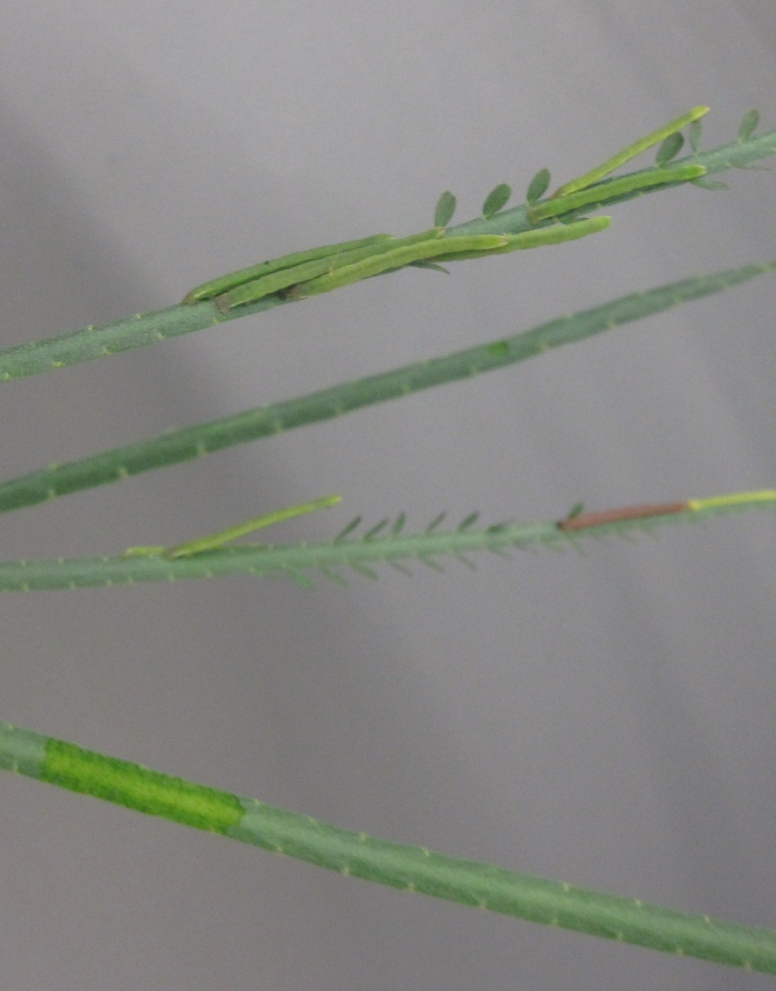
Figure 1 Eight larvae, seven green one brown, of Eueupithecia cisplatensis on a damaged Parkinsonia leaf, most of the pinnules have been removed from the leaves and rasping of the leaf surface is visible on the leaf at the bottom
Table of Contents
1. Summary 3
2. Information on target species, Parkinsonia aculeata 4
2.1. Taxonomy 4
2.1.1. Botanical name 4
2.1.2. Common name 4
2.1.3. Relationships 4
2.2. Description 4
2.3. Distribution 5
2.3.1. Native Range 5
2.3.2. Australian Range 6
2.4. Ecology 7
2.5. Importance 8
2.5.1. Beneficial 8
2.5.2. Detrimental 8
2.6. Information on all other relevant Commonwealth, State and Territory legislative controls of the target species 9
2.7. When the target species was approved for biological control 9
3. Information on the potential agent Eueupithecia cisplatensis 10
3.1. Taxonomy 10
3.2. Description 11
3.3. Brief biology of the agent 12
3.4. Native range of the agent 15
3.5. Related species to the agent and a summary of their host range 15
3.6. The proposed source of the agent 15
3.7. Possible interactions with existing biological control programs (of same or related targets and other targets) 15
3.8. The agent’s potential for control of target 16
3.9. Information on non-target organisms at risk from an agent 16
3.10. Information and results of any other assessments undertaken on the species 16
3.11. Report of host specificity testing 16
3.11.1. Introduction 16
3.11.2. The test plant list 16
3.11.3. Surveys of plant use under natural condition in the native range 20
3.11.4. Tests of larval development in Argentina 23
3.11.5. Tests of larval development on living plants in Australian quarantine 26
3.11.6. Discussion 29
4. Where, when and how initial release will be made 30
4.1. Release from quarantine 30
4.2. Distributing in the field 30
4.3. Establishment and evaluation 30
5. Copies of any references referred to in the application 30
6. Acknowledgements 30
7. References 31

Summary

Parkinsonia aculeata (Leguminosae: Caesalpinioideae) is a shrub or tree from the Americas that can form dense thorn thickets that impact negatively on both environment and the pastoral industry in rangeland Australia. It is recognised as one of twenty worst weeds in Australia (Thorp and Lynch 2000) and has been declared in all states and territories. The Australian Weed Committee approved P. aculeata as a target for biological control in Australia in 1983 (Donnelly 2000).
The defoliating caterpillar, Eueupithecia cisplatensis Prout, has been identified as a potential biocontrol agent of P. aculeata. Preliminary studies on its biology and host specificity made in Argentina, in the field and in laboratory conditions, strongly indicated fidelity to P. aculeata. It was then imported into an Australian quarantine where testing was completed on a broad range of plant species, particularly native Australian caesalpinioids, selected on the basis of phylogeny. Excluding P. aculeata, a total of 67 plant species were tested, 40 in Australia and 27 in Argentina.
This species has proven to be entirely host specific to P. aculeata. In laboratory tests, full development to adult occurs consistently on P. aculeata with a high rate of success (average of 61% in Argentina and 56% in Australia). But no development past the first instar occurred on any test plant species with the exception of was the closely related Parkinsonia praecox on which a very low rate of development (3%) was measured. No feeding occurred on any test plant species other than P. praecox and hence no damage was observed on non-target species. However, even P. praecox was not found to be used by E. cisplatensis in the field in the native range.
We conclude that the level of risk associated with releasing Eueupithecia cisplatensis into the Australian environment is acceptable and that it will potentially be an effective biological control agent for P. aculeata. We seek permission for its release in Australia.

Information on target species, Parkinsonia aculeata

Taxonomy

2.1.1. Botanical name
Parkinsonia aculeata L.

2.1.2. Common name
The plant is usually referred to as parkinsonia in Australia and Mexican palo verde and retama in the American literature. However, overseas it has many local names, including Jerusalem thorn, blue palo verde, horse bean tree, sessaban and Barbados flower fence (Hawkins 2001).

2.1.3. Relationships
Parkinsonia aculeata belongs to the family Leguminosae, subfamily Caesalpinoideae, tribe Caesalpinieae. Relationships of the monophyletic Leguminosae to other Angiosperms is still unclear with several families having been proposed as related, but more recent and well supported studies place Surianaceae and Polygalaceae as sister groups (Woyciechowski 2003). Relationships between caesalpinioid genera of the Leguminosae are also unresolved (Herendeen 2003), but the Peltophorum group, to which Parkinsonia belongs, is strongly supported as monophyletic. The Peltophorum group includes Peltophorum, Parkinsonia, Delonix, Colvillea and Schizolobium (Haston et al. 2005). The only member of the Peltophorum group native to Australia is Peltophorum pterocarpum. The genus Parkinsonia is considered to be congeneric with the paraphyletic Central American genus Cercidium (Hawkins et al. 2007). Parkinsonia aculeata is the only Parkinsonia species known to have naturalized in Australia. Parkinsonia aculeata is easily delimited morphologically from all other Parkinsonia species (Hawkins 2001); however, considerable intra-specific genetic variation occurs across its distribution in the native range. More information on the relationships is given in the section “The test plant list”.

Description
P. aculeata is readily identified in Australia by its smooth, green bark, very distinctive pendulous leaves with minute, easily-shed pinnules, bright yellow, five-petalled flowers, and pods which are straw-coloured when mature and contain 1-11 seeds (Figure 2). Adults typically grow to 5-7 m tall and wide (van Klinken et al. 2009a).

a)
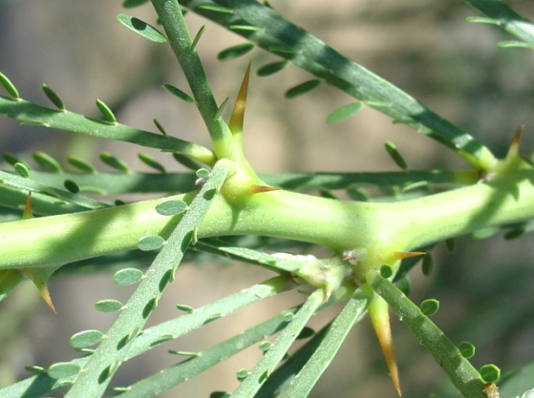

b) c)
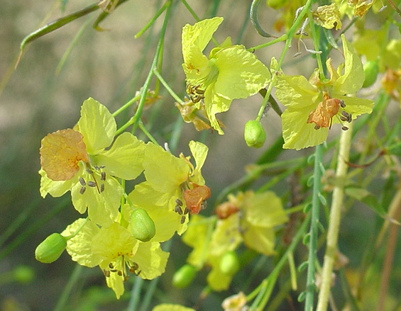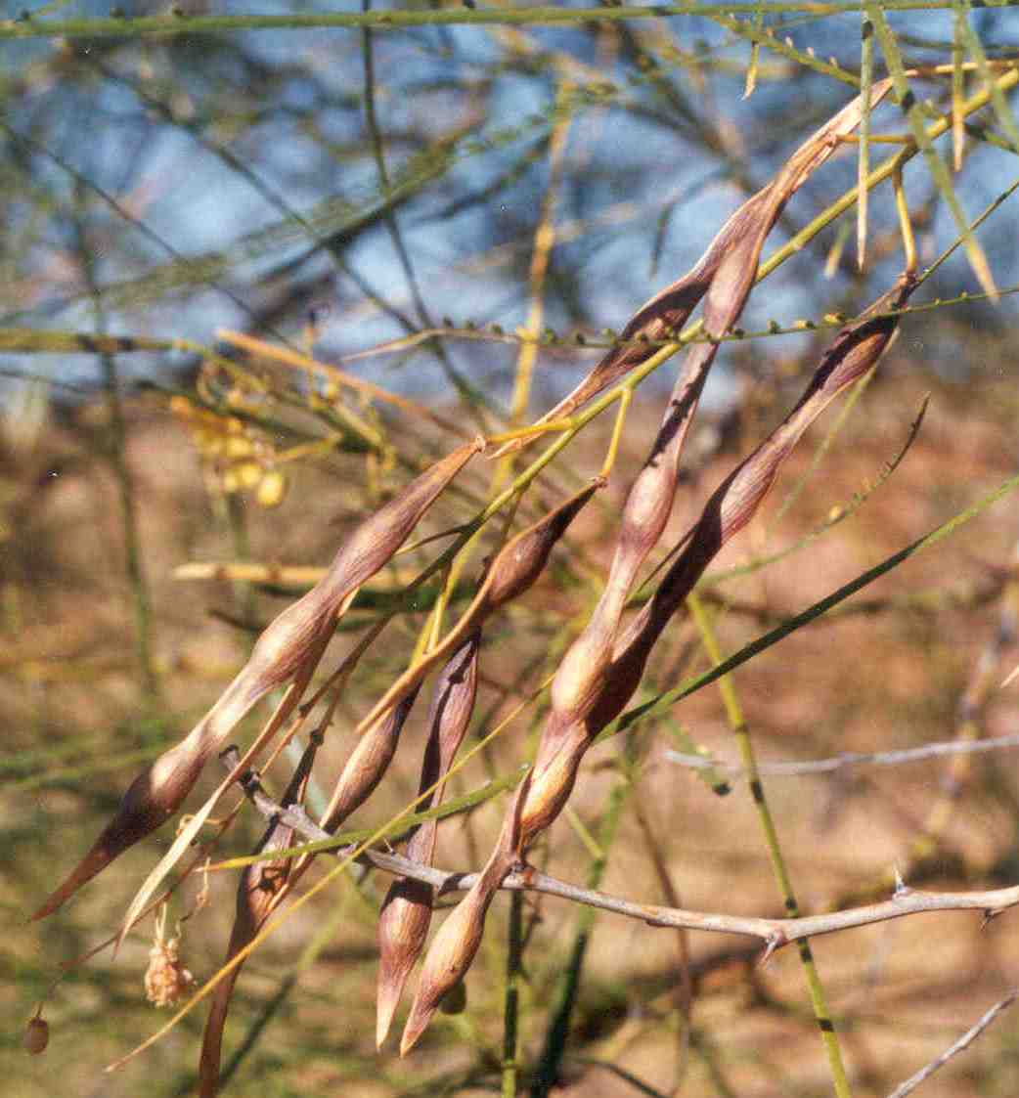

d) e)
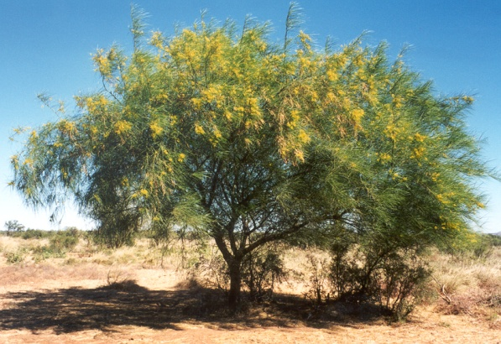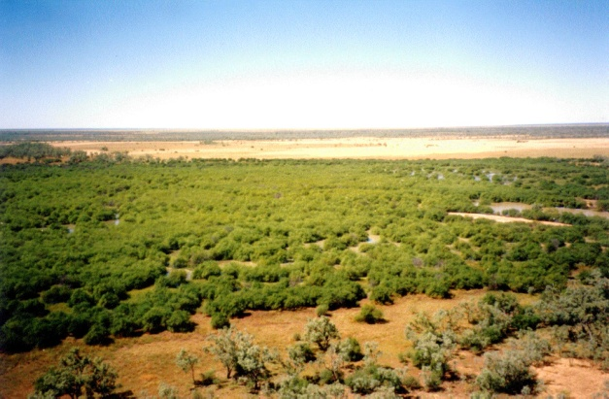
Figure 2. Parkinsonia aculeata in Australia: leaves (pinnae and pinnules) and thorns (a); flowers b); mature pods c) adult plant in flower d); large infestation in wetlands of the Queensland Gulf Region (e). (Source: Nathan March, Biosecurity Queensland).

Distribution

2.3.1. Native Range
Parkinsonia aculeata is native to the Neotropics. Species level and infra-specific phylogenies have been reconstructed using three chloroplast gene regions, and amplified fragment length polymorphism markers (Hawkins et al. 2007). Several genetically distinct populations of P. aculeata have been identified across the Americas: (1) northern and western Mexico, south-western USA and Cuba; (2) eastern and southern Mexico and south-eastern USA; (3) Venezuela; (4) Central America; and (5) Argentina. The Argentine lineage (5) is estimated to have diverged from other lineages (1-4) c. 9.1 million years ago, and the northern Mexico lineage (1) from the Mesoamerican-Venezuelan lineages (2-4) c. 5.2 million years ago (both pre-dating formation of the Isthmus of Panama) (Hawkins et al. 2007). Additional divergent populations may exist in South America, but these have not been analysed genetically.

2.3.2. Australian Range
The distribution of P. aculeata has been mapped nationally on a 50 x 50 km grid, mainly through existing distributional records held by state departments and through expert knowledge (Figure 3). When considered at that grid scale, P. aculeata is now estimated to be present on over 3.3 million ha of Australia, although densities are very low throughout most grid cells (van Klinken et al 2009a).
Most infestations occur across semi-arid and semi-humid Australia, especially in central and north Queensland, the Barkly Region and the Victoria River District of the Northern Territory, and the Kimberley and Pilbara Regions of Western Australia. Although it is widespread in these regions, dense patches are associated primarily with flood-outs, water infrastructure (such as “turkey nests”), water courses and the edges of seasonally-flooded fresh-water wetlands. Elsewhere in Australia records are mostly of isolated plants, or relatively restricted, scattered infestations (van Klinken et al 2009a).
The potential distribution in Australia is much greater than the current. Much of northern and eastern Australia is probably climatically suitable for P. aculeata, provided adequate soil moisture is available, with conditions being optimal in Central Queensland (van Klinken et al 2009a). On the broad scale P. aculeata has probably naturalized in the majority of suitable catchments. Within catchments P. aculeata is generally very sparsely and/or locally distributed, but there is little doubt that P. aculeata will continue to spread through the wetter habitats within its current range. Special efforts are currently underway to prevent its spread into Cape York Peninsula, the Lake Eyre and Murray Darling basins in Queensland and the blue-bush (Maireana spp.) swamps in the Barkly Tablelands (Deveze 2004).
Climate change is expected to result in a southward extension of highly suitable areas in eastern Australia as a result of reduced cold stress (van Klinken et al 2009b). Also, in south-west Australia it is expected that there will be improved growing conditions and reduced cold-wet stress. Reduced rainfall is expected to result in the northern (tropical) interior becoming less suitable, while increased rainfall is expected to increase the suitability of much of Australia.

Figure 3. Current distribution and abundance of P. aculeata in Australia. Source: Queensland Biosecurity.

Ecology
Parkinsonia aculeata has an outstanding ability to survive and grow under a wide range of environmental conditions (Hughes 1989). This includes arid regions to wet-dry tropical regions, with annual rainfall typically ranging between 250 and 1400 mm. Plants probably rarely live more than 20-30 years (van Klinken et al. 2009a). They can produce large numbers of seeds, which are mostly dispersed either by flood waters within floating pods, or become incorporated into the seed bank under or adjacent to parent trees. Seeds are hard-seeded and are released from dormancy by "wet heat" (van Klinken and Flack 2005; van Klinken et al. 2006; 2008). Populations are typically very dynamic as a result of often rare major recruitment events and a wide range of mortality factors, including dieback putatively caused by a suite of soil-borne pathogens (Toh et al. 2008; Diplock et al. 2006, 2008; Toh 2009; van Klinken et al. 2009a), severe frosts, fires, and browsing by macropods or sheep (van Klinken et al. 2009a). In fact most of the 23 initially healthy populations monitored across Australia since 1999-2000 have subsequently declined in adult density, and local extinctions are probably common (van Klinken et al. 2009a). Browsing by sheep, goats and other livestock (generally not cattle) is likely to be an important factor preventing invasions in other countries.

Importance

Parkinsonia aculeata is an example of a plant that is both weedy and beneficial; however, in Australia its negative aspects far outweigh any actual or potential benefits.

2.5.1. Beneficial

Parkinsonia aculeata is widely used as an ornamental in dry areas throughout the Americas because of its spectacular bright yellow flowers; however, it is not generally considered to produce particularly valuable or high quality products (Hawkins 2001). Uses include hedges, windbreaks, shade, fuel (firewood and charcoal), paper-making and low quality fodder (Hawkins 2001). Although wood can be used for carpentry, it is brittle and of dubious durability (Stewart et al. 1992). Parkinsonia aculeata has been used in folk medicine (Barbosa and Prado 1991). Leaves, when made into an infusion, are considered in some areas to have medicinal and antiseptic properties and the infusion has been used to treat fevers, epilepsy and vomiting (Stewart et al. 1992, Hawkins 2001). Raw seeds have been used as a food source by humans in Mexico, children have been reported to eat flowers and seeds in West Africa, and seeds have been investigated as a minor food source in India (Hawkins 2001).
The fodder value of P. aculeata pods and foliage varies, and reports range from it being rarely eaten by livestock or wildlife (Everitt 1983) to being a potentially important fodder tree (MacDicken and Brewbacker 1984, Stewart et al. 1992, Hawkins 2001). It appears to be consumed by cattle only in times of shortage (Stewart et al. 1992), such as late in the dry season (Anon 1972, Deveze 2004, p. 35, 45); however, it is browsed by sheep, goats and camels and, in some parts of the world, branches are lopped during dry periods to feed sheep and goats (Hawkins 2001).
Parkinsonia aculeata has been introduced pantropically, primarily as an ornamental, hedging and fodder tree (Stewart et al. 1992, Woods 1988, Hawkins 2001). In addition, its tolerance to drought, waterlogging and saline conditions has meant that it has often been promoted for rehabilitation and as a multi-purpose tree, particularly in harsh, degraded or marginal land (Hughes 1986, Hawkins 2001). It has been used for reforestation programs in several countries, including India, Sudan and Cape Verde (Hughes 1989) and continues to attract attention as a candidate for the reforestation of degraded environments. However, its usefulness can be limited by its weedy tendencies (Hughes 1989). In Australia P. aculeata appears to have been planted mainly as an ornamental and shade tree.

2.5.2. Detrimental

Most of the detrimental effects of P. aculeata stem from its propensity to form dense, thorny, impenetrable thickets along drainage lines, depressions, ephemeral wetlands and, to a lesser extent, uplands across a large part of Australia. These are of both of environmental and economic significance.
The greatest environmental impact is probably through the exclusion of the herbaceous layer (van Klinken 2006). Parkinsonia aculeata trees are relatively shallow-rooted, but they may shorten the duration that ephemeral water bodies hold water. Dense patches are rarely greater than 1 ha so impacts on biodiversity are likely to be localised and limited to the infestation site (van Klinken 2006). At greatest risk are climatically suitable mesic habitats in arid and semi-arid regions, such as wetlands on the Barkly Tablelands (Northern Territory), wetlands and gorges in the Pilbara Region (Western Australia) (van Klinken 2006) and waterbird habitats of national significance across its potential distribution (Humphries et al. 1991).
In production systems P. aculeata can also replace pasture, but existing infestations probably do not occur at a sufficient scale to cause significant and widespread reductions in carrying capacities (van Klinken 2006). Thicket formation does, however, interfere with stock management, impedes stock access to water, makes the maintenance of water points difficult and provides refuge for feral pigs (Deveze 2004). Both the formation and control of thickets may also exacerbate erosion problems (Wilson and Miller 1987). Thorns may injure hooves of animals and affect leisure and recreational activities, while its flowers are known to cause hay fever (Wilson and Miller 1987; Deveze 2004).
Although P. aculeata is already widespread in Australia, existing infestations are not yet of sufficient scale to cause substantial production losses at the property scale or to cause catchment or regional scale environmental impacts. Most of the direct costs are related to increased property management costs, especially in relation to mustering, accessing water points and maintaining vehicle tyres, and on-ground control work to prevent P. aculeata from becoming a more serious problem. Costs to Australia will increase dramatically if P. aculeata continues to spread and thicket formation continues. However, actual and potential impacts have not been quantified.

Information on all other relevant Commonwealth, State and Territory legislative controls of the target species

Parkinsonia aculeata has been declared in all states and territories other than Victoria, Tasmania and the Australian Capital Territory (Deveze 2004). In Queensland it is classified as a Class 2 declared pest (landholders must take reasonable steps to keep land free of the weed; it is also prohibited to introduce, feed, keep, release, take for commercial use, supply or transport). In the Northern Territory the species is classified as Category B (growth and spread to be controlled). In Western Australia it is declared as P1 (prevention of trade, sale or movement), P2 (eradicate) or P4 (contain) according to districts. In New South Wales it is declared in Category W1 (presence must be notified to the local control authority and the weed must be fully and continuously suppressed and destroyed). In South Australia P. aculeata is notifiable throughout the state, and plants must be destroyed.

When the target species was approved for biological control

The Australian Weed Committee approved P. aculeata as a target for biological control in Australia in 1983 (Donnelly 2000).

Information on the potential agent Eueupithecia cisplatensis

3.1. Taxonomy
Eueupithecia cisplatensis Prout 1910 (family Geometridae) (Figure 4), identified by Geometridae specialist Dr. Axel Hausmann (Bavarian State Collection of Zoology, Munich, Germany).

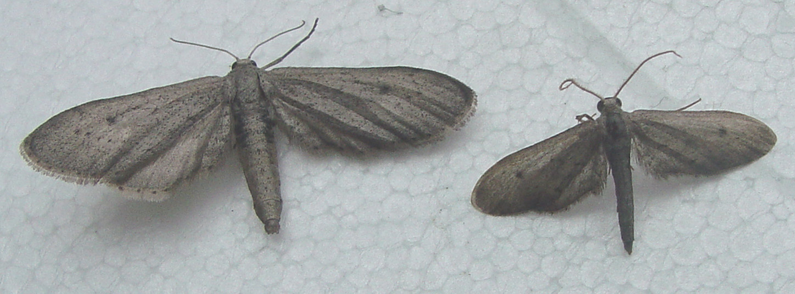
Figure 4. Eueupithecia cisplatensis, female left and male right

Eueupithecia cisplatensis is placed into subfamily Sterrhinae, tribe Sterrhini (see Differential diagnosis below). The Geometridae and all recognized subfamilies are monophyletic (Sihvonen et al. 2011). Also the phylogeny of the Sterrhinae subfamily revealed good support for the subfamily Sterrhinae and the tribe Sterrhini (Sihvonen and Kaila 2004). The tribe Sterrhini consists of approximately 825 species distributed in the following genera: Anthometra, Arcobara, Brachyglossina, Cleta, Emmiltis, Epicleta, Euacidalia, Eueupithecia, Eumacrodes, Eupithecidia, Idaea, Limeria, Lobocleta, Lophophleps, Odontoptila, Protoproutia, Ptychamalia and Tineigidia (Sihvonen and Kaila 2004).
Parsons et al. (1999) included only one species (E. cisplatensis) in the genus Eueupithecia. However, Dr Axel Hausmann recently identified a second cryptic species. This species shows striking differences in female and male genitalia and CO1 gene sequence (Table 1). The CO1 barcode gene differs by 4%, an amount that normally indicates another species. But no significant and constant differential features in colour or pattern of adults or larvae have been found. The second species is less common than E. cisplatensis and is so far only known from the north western Salta Province of Argentina. Further work is needed to confirm that this second species has not previously been described under the closely related Euacidalia genus, the latter including 12 described neotropical and nearctic species.
All testing in Australia was conducted on a pure colony of E. cisplatensis, as confirmed by genitalia dissections. Many provenances were used for Argentinean testing. All insects subsampled for identification were E. cisplatensis, although it is possible that a small number of undetected individuals of the new species could have been present among the test material.
Table 1. Differential features between the two Eueupithecia species collected on Parkinsonia aculeata.
 | E. cisplatensis | Eueupithecia new species
Female genitalia | Length of corpus bursae 1.6 mm, posterior 1/2 sclerotized, slightly folded only | Length of corpus bursae 2 mm, posterior ¾ strongly sclerotized and strongly folded laterally.
Male genitalia | Aedeagus with large basal cornutus (half length of aedeagus) and a smaller, but stout, hook-shaped cornutus at tip. Aedeagus slender, width 0.15 mm. | Aedeagus with one cornutus only. Aedeagus very broad, width 0.4 mm.
Size of adults | On average smaller, wingspan 15-20 mm | On average larger, wingspan 20-25 mm

Description

The following is a description of the genus Eueupithecia obtained by Dr Axel Hausmann (pers. comm. 2011):
Tongue very short. Palpi very small, tapering, last two segments narrow, length 0.6 times diameter of eye in male, 0.8-1.0 times diameter of eye in female. Frons black, flat, smoothly scaled. Antennae filiform, in female with scarce and very short ciliation, in male ciliate-fasciculate, cilia strongly curved, length 2.5 times width of flagellum. Male hindtibia shortened, without spurs, with weak pencil. Female frenulum developed as a long, single stout bristle, appressed without retinaculum in the fold of the anal vein of the forewing (unknown in any other Geometridae, all other female geometrids have a brush of setae, if they have a frenulum). Hindwing Sc+R1 and Rs+M1 with long anastomosis, ca 2/3 length of cell. M2 much closer to M1 than to M3. Forewing with one single areole. Fore- and hindwing elongate and very narrow, discal spots conspicuous, postmedial line dotted. Hindwings of both sexes with setose lobes at the inner termen. Tympanum with ansa narrow at base, dilated at centre, rounded at tip.
Male genitalia: Small. Uncus single, digitiform. Valvae simple, long spatulate. Saccus very small. Aedeagus with cornuti. Sternum A8 simple, without latero-posterior appendages (cerata).
Female genitalia: Ovipositor with additional ventrolateral ovipositor-lobes. Apophyses fine, comparatively short. Ductus bursae very short. Corpus bursae with posterior part strongly sclerotized. Signum absent.
Synapomorphies: Female frenulum; hindwing anastomosis (Sc, Rs+M1).
Differential diagnosis: Genitalic features (male: uncus, valvae, saccus, cornuti, absence of appendages from sternum A8; female: ovipositor-lobes, sclerotisation of corpus bursae, absence of signum) clearly indicating a position in the tribe Sterrhini. The structure of female frenulum is unique in Geometridae and allows separation from Idaea. An isolated lineage of genus Eueupithecia with position between Cyllopodini and Semaeopus resulting from COI NJ analysis of neotropical Sterrhinae, but when excluding the (variable) third codon position, the genus falls within the clusters of the tribe Sterrhini. Tympanum is typical for Sterrhinae. The long hindwing anastomosis an extremely rare character in Sterrhinae (but characteristic for Larentiinae). The asymmetric position of hindwing median veins also unusual for Sterrhinae (characteristic for Geometrinae). The eremic species Idaea volloni in external appearance and in the long anastomosis of hindwing veins Sc and Rs+M1 (very unusual in Sterrhinae) very similar to Eueupithecia, but female frenulum developed as a brush of setae and genitalia of both sexes completely different. The great external similarity, therefore, is probably just a convergence.
Remarks: Both the long vein-anastomosis in the hindwing and the modified female frenulum may be an advantage for wing stability and flight in moths with long and narrow wings.

Brief biology of the agent
Experiments were conducted in Argentina in controlled environment chambers at 25±1°C and 60±5% relative humidity, with a 14:10 L:D photoperiod. Cultures of E. cisplatensis were established in the laboratory from 50 larvae collected in February 2009 on P. aculeata plants growing near La Plata, Buenos Aires Province (60 km south of Buenos Aires city).
Newly hatched larvae were fed bouquets of freshly excised leaves of P. aculeata and reared individually in 0.5-liter plastic jars with perforated lids and moist tissue paper. Head capsule width was measured to establish the number and the duration of larval instars. The duration of the pupal stage was also recorded.
Adult longevity and fecundity were estimated from eight pairs of newly emerged E. cisplatensis. Each pair was kept in 3-litre plastic jars with moist tissue paper containing bouquets of excised fresh leaves of P. aculeata. Every day, bouquets were replaced and eggs removed and counted. A replicate ended when the female died; if the male died first it was replaced. For each replicate, the pre-oviposition period, total number of eggs and longevity of females were recorded.
Brown cylindrical eggs, approximately 0.3 mm in length, are usually laid individually or in strings on the leaflets (Figure 5). The eggs hatch and larvae begin to feed about 5 days after eggs were laid. Body colour of larvae changes progressively from light brown-greenish in the early instars to green-purple in the later instars (Figure 6) mimicking leaf rachises and young shoots. As larvae develop, they eat most of the pinnules and parts of the rachises. The reduced number of prolegs results in the larvae progressing with a looping motion, hence the common name loopers.

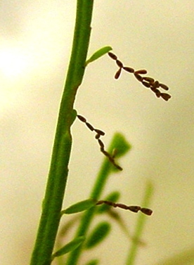
Figure 5. Strings of brown eggs of Eueupithecia cisplatensis on Parkinsonia aculeata leaf.

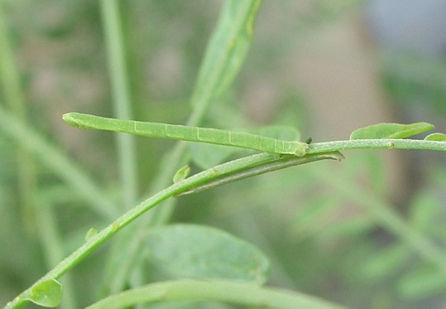
Figure 6. Two larvae of Eueupithecia cisplatensis on Parkinsonia aculeata leaf
Life stage duration. E. cisplatensis undergoes four larval instars. No overlapping was found in head capsule width ranges, therefore they can be used to distinguish the instars (Table 2). Larval mortality was greater during the first and second instars and the survival to the adult stage was 42 %. The duration of the stages was approximately: 5 days for eggs, 17 days for larvae, and 4 days for pupae.
Table 2. Life stage duration and larval head capsules width of Eueupithecia cisplatensis on Parkinsonia aculeata.
Stage | n | Life stage duration (days) |  | Mortality (%) | Cumulative survival (%) | Head capsule width (mm)
 |  | Mean ± SD | Range |  |  | Mean ± SD | Range
Larva 1st instar | 43 | 5 ± 0.24 | 2-8 | 35 | 100 | 0.26 ± 0.01 | 0.23-0.26
Larva 2nd instar | 28 | 3 ± 0.46 | 1-14 | 21 | 65 | 0.42 ± 0.03 | 0.33-0.42
Larva 3rd instar | 22 | 4 ± 0.21 | 2-7 | 5 | 51 | 0.68 ± 0.0 | 0.62-0.72
Larva 4th instar | 21 | 5 ± 0.28 | 3-9 | 0 | 49 | 1.04 ± 0.06 | 0.91-1.11
Larva total | 21 | 17 ± 3.1 | 13-27 | 61 | 49 | - | -
Prepupa | 21 | 2 ± 0.11 | 1-2 | 0 | 49 | - | -
Pupa | 21 | 3 ± 0.11 | 3-15 | 14 | 49 | - | -
Adult | 18 | 4 ± 0.11 | 1-13 | - | 42 | - | -

Female longevity and fecundity. Preoviposion period was 1.8 ± 0.6 days (mean ± SD; n = 6), fecundity was 78.8 ± 62.7 eggs (mean ± SD; n = 8) and the longevity of females was 6.9 ± 3.6 days (mean ± SD; n = 8) (Table 3). The female of pair n° 4, laid a total of 36 green coloured eggs. Previous observations indicate that occasionally, virgin females may lay a few similar green eggs, which never hatch. Based on these observations, we consider these green eggs to be unfertile. The rest of the pairs laid brown fertile eggs.

Table 3. Fecundity and female survival of Eueupithecia cisplatensis on Parkinsonia aculeata
N° of replicates  (pairs) | Female longevity  (days) | Preoviposition period  (days) | N° of eggs
1 | 9 | 3 | 140
2 | 13 | 2 | 79
3 | 8 | 1 | 168
4 | 7 | 2 | 36ª
5 | 2 | - | 0
6 | 7 | 2 | 117
7 | 7 | 1 | 90
8 | 2 | - | 0
Average | 6.9 | 1.8 | 78.8
ª green infertile eggs
Adult females are bigger than male, with a wider abdomen. The morphology of the antennae also shows sexual dimorphism: pectinate in the male and simple in the female (Figure 4).
Natural enemies. Two species of Conura (Hymenoptera: Chalcidoidea) emerged from cocoons, and probably parasitised the larvae.

Native range of the agent
Known from field surveys from Argentina and Paraguay only.

Related species to the agent and a summary of their host range
The genus Eueupithecia has only one member other than E. cisplatensis, which is yet to be described (see above). A study of the biology and host specificity of the latter is planned but as yet little is known except that we suspect it is also a specialist on P. aculeata. It is unknown which of the 18 genera in the tribe Sterrhini are closest to Eueupithecia (A. Hausmann, pers.comm.), so we are not in a position to summarize the host range of the related species. Preliminary analysis shows that the 825 species distributed in 18 genera in the tribe Sterrhini show a broad spectrum of host specificity, from extreme specialists to generalists.

The proposed source of the agent
Fernando Mc Kay, Scientist at the United States Department of Agriculture, Agricultural Research Service, South American Biological Control Laboratory (USDA-ARS-SABCL). Address: Bolivar 1559, Hurlingham, Buenos Aires, Argentina. Phone: (54 11) 4662 0999. Email: fmckay@speedy.com.ar.
Cultures of the genetic material from Argentina that has been tested in Australian quarantine will be maintained and released if permission is granted.

Possible interactions with existing biological control programs (of same or related targets and other targets)
Three insect species have been released in Australia for biocontrol of P. aculeata. Rhinacloa callicrates (a sap-sucking mirid) and Mimosestes ulkei (a seed-feeding bruchid) were released in Queensland in 1993 (Julien and Griffiths 1998) and the Northern Territory in 1989 (Donnelly 2000) and 1994 (Flanagan et al. 1996), respectively. A third insect from Argentina, the seed-feeding bruchid Penthobruchus germaini Pic., was identified from the literature as a potential agent and was released in Australia from 1995 (Briano et al. 2002). Rhinacloa callicrates has established in Central Queensland but has never been observed to reach damaging densities there and did not establish in the Kimberley (Donnelly 2000). Mimosestes ulkei has established at relatively few sites and, where measured, the seed mortality rates have been low (Donnelly 1998, Lockett et al. 1999). It has not been reported in the past several years. In contrast, Penthobruchus germaini established easily, and dispersed readily (van Klinken and Flack 2008). Penthobruchus germaini passes through several generations a year, and oviposits primarily on pods on the tree (Briano et al. 2002, van Klinken 2005, van Klinken and Flack 2008). However, seed consumption rates were relatively low during a national survey conducted between 2000 and 2004 (van Klinken 2005, van Klinken and Flack 2008), and the agent is therefore unlikely to be causing any population-level impacts. Studies showed that beetle populations were unable to track sudden seasonal fluctuations in pod supply, resulting in a lag-phase between seed availability and beetle numbers. Also, high egg parasitism (10-70%) by a trichogrammatid wasp (Uscana sp.), is likely to be a key regulating factor through its effect on egg survival, and indirectly on adult densities. Existing agents therefore do not appear to be having a significant impact.
The proposed agents feed on vegetation tissue and therefore it is unlikely that they will interact with the existing agents.

The agent’s potential for control of target
Leaf feeding by larvae of Geometridae reduces the total photosynthetic area of the plant causing reduction in vigour, growth rate and seed production. In the laboratory the larvae are voracious feeders and completely strip potted plants of all foliage. As the leaves of P. aculeata are undamaged in Australia, the potential for impact on the plant is great.
Geometrids have been used successfully in weed biocontrol programs. Comostolopsis germana damages shoot tips of bitou bush, Chrysanthemoides monolifera, in Australia (Adair and Scott 1989; Adair and Edwards 1996). It is widely established and causes obvious damage to bitou bush. Aplocera plagiata established on St John’s wort (Hypericum perforatum) in Canada and USA but not in Australia (Julien and Griffiths 1998). The Geometridae Chiasmia inconspicua and Chiasmia assimilis from Kenya, were released in 2000 for biocontrol of Acacia nilotica in Queensland. Chiasmia assimilis is showing signs of damage to its host in coastal areas of Queensland - particularly the Bowen/Ayr region and is completely defoliating some plants which may lead to reduced flowering and pod production. Macaria pallidata and Leuciris fimbriaria were released in Australia for control of Mimosa pigra. Both have established and Macaria pallidata is inflicting heavy damage on the target plant.

Information on non-target organisms at risk from an agent
Our thorough host specificity testing (see below), predicts that no non-target plant species are at risk because the host range of E. cisplatensis is confined to P. aculeata.

Information and results of any other assessments undertaken on the species
None known. This is the first time that this insect has been assessed for biocontrol or any other purpose.

Report of host specificity testing

Introduction
The host specificity of E. cisplatensis was tested using three methods: 1 Surveys of plant use under natural condition in the native range; 2 Tests of larval development on cut plant material in Argentina; and 3 Tests of larval development on living plant species in Australian quarantine. All tests delivered the same result: complete specificity to one plant species, P. aculeata. Low rates of pupation were observed on another Parkinsonia species (P. praecox), but that species does not occur in Australia. Each of these tests is considered separately below. But first we discuss the test list which applies to the two latter tests.

The test plant list
The plant list for the Australian plants consists of 40 species from the legume family, in addition to P. aculeata. In addition, another 27 legume plant species were tested in Argentina. The list presented here was compiled according to the modern methods, primarily using degrees of phylogenetic separation, based on published phylogenies (Bruneau et al. 2008, and references therein). This is discussed further below and presented in Table 4.
- The genus Parkinsonia: Parkinsonia aculeata is the only Parkinsonia species known to have naturalized in Australia and so no other species could be tested. Note, however, that Parkinsonia praecox was available in Argentina and was tested there.
- The group Peltophorum is a strongly supported monophyletic group that includes Peltophorum, Parkinsonia, Delonix, Colvillea and Schizolobium (Haston et al. 2005). The only member of the Peltophorum group native to Australia is Peltophorum pterocarpum which is on the list. Peltophorum dubium was also tested in Argentina. Also ornamental member of the group that are exotic to Australia was tested to help define the host range, including Colvillea racemosa in Australia and Schizolobium parahybum and Delonix regia in Argentina.
- The tribe Caesalpinieae is represented in Australia by Erythropleum chlorostachys, which was tested. There are several native Caesalpinia species which could not be obtained and so were replaced by Caesalpinia pulcherrima and Caesalpinia ferrea. The genus Gleditsia is represented in Australia by the exotic Gleditsia triacanthos, which was tested in Argentina, along with Gleditsia amorphoides in Argentina. The genus Haematoxylum is represented in Australia by the exotic Haematoxylum campechianum, which could not be obtained.
- The subfamily Caesalpinioideae. In addition to the tribe Caesalpinieae (above), members of the tribes Cassieae, Cercideae and Detarieae occur in Australia. Representatives of all these groups were included on the test list (Table 4 and 5).
- Fourteen species representing eleven of the tribes of the subfamily Faboideae were included.
- Nineteen species representing the three tribes of the subfamily Mimosoideae were tested. This subfamily contains the large and important tribe and genus Acacia. All of the sections of this important genus were represented (Tables 3 and 4) except Lycopodiifoliae which are very difficult to obtain and grow in cultivation.
- The legume family belongs to the Order Fabales. Traditionally this order contained only the Leguminosae, considered an isolated family. However a novel hypothesis in which the order Fabales contains also the families Quillajaceae, Surianaceae and Polygalaceae is emerging from recent molecular phylogenies (Stevens 2001 onwards). There is scant morphological support for these relationships (Bello et al. 2009). The Quillajaceae are a small family known only from temperate South America. Surianaceae is mostly Australian with two species of Cadellia, one species of Guilfoylia, one species of Suriana and three Stylobasium species. Polygalaceae contains several species of Comesperma, Polygala and Salomonia. Due to the high specificity of the insect being tested, the doubts over the relationships and the lack of morphological similarity, we did not include any non-legume species on the list.

Table 4. Numbers of test plant species in the taxonomic groups of the Leguminosae whether native or exotic to Australia and the number tested in Australian and Argentina

 |  |  |  | Number of species:
Subfamily | Tribe | Group | Section | Native | Exotic | Tested Aust. | Tested Arg.
Caesalpinioideae | Caesalpinieae | Peltophorum (Parkinsonia) |  | 0 | 1 | 1 | 2
Caesalpinioideae | Caesalpinieae | Peltophorum (not Parkinsonia) |  | 1 | 4 | 4 | 3
Caesalpinioideae | Caesalpinieae | Caesalpinia |  | 10 | 2 | 2 | 3
Caesalpinioideae | Caesalpinieae | Dimorphandra |  | 1 | 0 | 1 | 0
Caesalpinioideae | Caesalpinieae | Umtiza |  | 0 | 1 | 0 | 2
Caesalpinioideae | Cassieae |  |  | 81 | 15 | 9 | 2
Caesalpinioideae | Cercideae |  |  | 7 | 1 | 2 | 1
Caesalpinioideae | Detarieae |  |  | 4 | 2 | 4 | 0
Mimosoideae | Acaciae |  | Botrycephalae |  |  | 1 | 1
Mimosoideae | Acaciae |  | Juliflorae |  |  | 2 | 1
Mimosoideae | Acaciae |  | Phyllodineae |  |  | 1 | 0
Mimosoideae | Acaciae |  | Plurinerves |  |  | 1 | 0
Mimosoideae | Acaciae |  | Acacia |  |  | 1 | 3
Mimosoideae | Ingeae |  |  |  |  | 2 | 1
Mimosoideae | Mimoseae |  |  |  |  | 2 | 3
Faboideae | Aeschynomeneae |  |  |  |  | 1 | 0
Faboideae | Bossiaeeae |  |  |  |  | 1 | 0
Faboideae | Desmodieae |  |  |  |  | 1 | 0
Faboideae | Mirbelieae |  |  |  |  | 1 | 0
Faboideae | Phaseoleae |  |  |  |  | 1 | 2
Faboideae | Robinieae |  |  |  |  | 1 | 0
Faboideae | Tephrosieae |  |  |  |  | 1 | 0
Faboideae | Vicieae |  |  |  |  | 1 | 0
Faboideae | Dalbergiae |  |  |  |  | 0 | 2
Faboideae | Galegeae |  |  |  |  | 0 | 1
Faboideae | Milletieae |  |  |  |  | 0 | 1

After considering phylogeny, the test plant species were selected with regards to the biogeographic overlap with the target or the likely final distribution of the agent within the framework of phylogenetic separation. The concept of testing safeguard species of distant phylogenetic relatedness (Wapshere, 1974) has become redundant in most contexts, as such species do not contribute to the determination of host range (Briese and Walker, 2002; Briese, 2003; 2005). While preferential selection of economic or rare and threatened test plant species can be a useful criterion, providing they pass other selection criteria, systematically testing them is not relevant for risk analysis (Sheppard et al., 2005). As there is no plant on which congeners of the agent have been previously found to feed and reproduce, then this aspect did not result in inclusion of any further species. Taking all these factors into account, we arrived at the test list (Table 5). Such a relatively long list was considered necessary due to the size, diversity and importance of the legume plant family.

Table 5. The complete list of plant species subject to non-choice larval development host specificity tests in Australia and Argentina.
Subfamily | Tribe | group | Section | Genus/species | Tested
Caesalpinioideae | Caesalpinieae | Peltophorum |  | Parkinsonia aculeata | Argentina
Caesalpinioideae | Caesalpinieae | Peltophorum |  | Parkinsonia aculeata | Australia
Caesalpinioideae | Caesalpinieae | Peltophorum |  | Parkinsonia praecox | Argentina
Caesalpinioideae | Caesalpinieae | Peltophorum |  | Peltophorum dubium | Argentina
Caesalpinioideae | Caesalpinieae | Peltophorum |  | Peltophorum pterocarpum | Australia
Caesalpinioideae | Caesalpinieae | Caesalpinia |  | Caesalpinia ferrea | Australia
Caesalpinioideae | Caesalpinieae | Caesalpinia |  | Caesalpinia gilliesii | Argentina
Caesalpinioideae | Caesalpinieae | Caesalpinia |  | Caesalpinia paraguariensis | Argentina
Caesalpinioideae | Caesalpinieae | Caesalpinia |  | Caesalpinia pulcherrima | Australia
Caesalpinioideae | Caesalpinieae | Peltophorum |  | Colvillea racemosa | Australia
Caesalpinioideae | Caesalpinieae | Peltophorum |  | Delonix regia | Argentina
Caesalpinioideae | Caesalpinieae | Dimorphandra |  | Erythrophleum chlorostachys | Australia
Caesalpinioideae | Caesalpinieae | Umtiza |  | Gleditsia amorphoides | Argentina
Caesalpinioideae | Caesalpinieae | Umtiza |  | Gleditsia triacanthos | Argentina
Caesalpinioideae | Caesalpinieae | Caesalpinia |  | Pterogine nitens | Argentina
Caesalpinioideae | Caesalpinieae | Peltophorum |  | Schizolobium parahybum | Argentina
Caesalpinioideae | Cassieae |  |  | Cassia brewsteri | Australia
Caesalpinioideae | Cassieae |  |  | Ceratonia siliqua | Australia
Caesalpinioideae | Cassieae |  |  | Chaemacrista mimosoides | Australia
Caesalpinioideae | Cassieae |  |  | Chaemacrista nomane | Australia
Caesalpinioideae | Cassieae |  |  | Labichea lanceolata | Australia
Caesalpinioideae | Cassieae |  |  | Petalostylis labicheoides | Australia
Caesalpinioideae | Cassieae |  |  | Senna artemisioides | Australia
Caesalpinioideae | Cassieae |  |  | Senna corymbosa | Argentina
Caesalpinioideae | Cassieae |  |  | Senna glutinosa | Australia
Caesalpinioideae | Cassieae |  |  | Senna notabilis | Australia
Caesalpinioideae | Cassieae |  |  | Senna spectabilis | Argentina
Caesalpinioideae | Cercideae |  |  | Barklya syringifolia | Australia
Caesalpinioideae | Cercideae |  |  | Bauhinia forficata | Argentina
Caesalpinioideae | Cercideae |  |  | Bauhinia hookeri | Australia
Caesalpinioideae | Detarieae |  |  | Cynometra ramiflora | Australia
Caesalpinioideae | Detarieae |  |  | Intsia bijuga | Australia
Caesalpinioideae | Detarieae |  |  | Maniltoa lenticillata | Australia
Caesalpinioideae | Detarieae |  |  | Schotia brachypetala | Australia
Caesalpinioideae | Detarieae |  |  | Tamarindus indica | Australia
Faboideae | Aeschynomeneae |  |  | Aeschynomene americana | Australia
Faboideae | Bossiaeeae |  |  | Hovea acutifolia | Australia
Faboideae | Dalbergiae |  |  | Geoffroea decorticans | Argentina
Faboideae | Dalbergiae |  |  | Tipuana tipu | Argentina
Faboideae | Desmodieae |  |  | Desmodium tortuosum | Australia
Faboideae | Galegeae |  |  | Sesbania virgata | Argentina
Faboideae | Millettieae |  |  | Lonchocarpus nitidus | Argentina
Faboideae | Mirbelieae |  |  | Pultenaea villosa | Australia
Faboideae | Phaseoleae |  |  | Cajanus cajan | Australia
Faboideae | Phaseoleae |  |  | Erythrina crista-galli | Argentina
Faboideae | Phaseoleae |  |  | Wisteria sinensis | Argentina
Faboideae | Robinieae |  |  | Sesbania cannabina | Australia
Faboideae | Tephrosieae |  |  | Millettia (=Pongamia) sp. McIlwraith | Australia
Faboideae | Vicieae |  |  | Vicia faba | Australia
Mimosoideae | Acaciae |  | Acacia | Acacia aroma | Argentina
Mimosoideae | Acaciae |  | Acacia | Acacia bidwillii | Australia
Mimosoideae | Acaciae |  | Acacia | Acacia caven | Argentina
Mimosoideae | Acaciae |  | Botrycephalae | Acacia dealbata | Argentina
Mimosoideae | Acaciae |  | Botrycephalae | Acacia decurrens | Australia
Mimosoideae | Acaciae |  | Juliflorae | Acacia disparrima | Australia
Mimosoideae | Acaciae |  | Juliflorae | Acacia julifera | Australia
Mimosoideae | Acaciae |  | Juliflorae | Acacia longifolia | Argentina
Mimosoideae | Acaciae |  | Plurinerves | Acacia melanoxylon | Australia
Mimosoideae | Acaciae |  | Botrycephalae | Acacia oshanesii | Australia
Mimosoideae | Acaciae |  | Phyllodineae | Acacia salicina | Australia
Mimosoideae | Acaciae |  | Acacia | Acacia visco | Argentina
Mimosoideae | Ingeae |  |  | Archidendron lucyi | Australia
Mimosoideae | Ingeae |  |  | Enterolobium contortisiliquum | Argentina
Mimosoideae | Ingeae |  |  | Pararchidendron pruinosum | Australia
Mimosoideae | Mimoseae |  |  | Anadenanthera colubrina var. cebil | Argentina
Mimosoideae | Mimoseae |  |  | Dichrostachys cinerea | Australia
Mimosoideae | Mimoseae |  |  | Leucaena leucocephala | Australia
Mimosoideae | Mimoseae |  |  | Prosopis alba | Argentina
Mimosoideae | Mimoseae |  |  | Prosopis chilensis | Argentina

Surveys of plant use under natural condition in the native range
On three field trips to northern Argentina, over the summer of 2009/10 and 2010/11, eight sites in the provinces of Corrientes, Entre Ríos, Formosa, Salta and Chaco with populations of P. aculeata and four co-occurring legume species were sampled for presence of insects by beating foliage over a one square metre sheet (Figure 7). Immature insects were held in plastic containers and provided fresh leaves until the emergence of adults. Voucher specimens of plants and insects collected are maintained at the USDA-ARS-SABCL.
Along the eight sites visited, a total of 391 larvae of E. cisplatensis were collected on P. aculeata and reared to adult. No E. cisplatensis larvae were collected on any of the other surveyed Acacia, Prosopis or Parkinsonia species (Table 6). It is particularly instructive that E. cisplatensis was not found even on the conspecific Parkinsonia praecox. At the same sites, this species was consistently collected on P. aculeata. It is possible that some of the adults reared in this experiment belong to the recently newly identified cryptic species. This only has the effect of reducing the replication obtained for E. cisplatensis but not of changing the conclusion. In addition, larvae of Melipotis acontioides (Guenee) (Lepidoptera: Noctuidae) and Macaria sp. (Lepidoptera: Geometridae) were collected (Table 6).

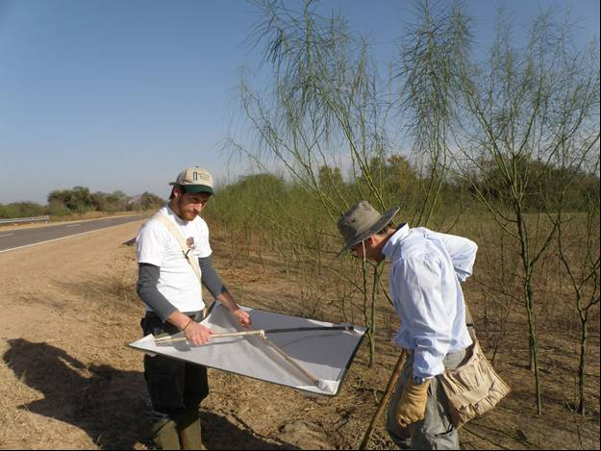

Figure 7. USDA-ARS-SABCL researchers Marcelo Parisi and Fernando Mc Kay beating P. aculeata plants in northern Argentina

Table 6. Number of Eueupithecia cisplatensis and other Lepidoptera on various legume plants species from surveys of plant use under natural condition in the native range in Argentina

Date | Locality | Province | Surveyed plant species | Beats | Eueupithecia cisplatensis | Melipotis acontioides | Macaria sp. | Unidentified Geometridae
2009-12-03 | RN° 14, Pucheta | Corrientes | Parkinsonia aculeata | 50 | 44 | 0 | 0 | 0
2009-12-03 | RN° 14, Cuatro Bocas | Corrientes | Parkinsonia aculeata | 32 | 43 | 0 | 0 | 0
2009-12-03 | RN° 14, Mocoretá | Corrientes | Parkinsonia aculeata | 17 | 13 | 0 | 0 | 0
2009-12-03 | RN° 14, Chajarí | Entre Ríos | Parkinsonia aculeata | 46 | 195 | 0 | 0 | 0
2009-12-04 | RN° Concepción del Uruguay | Entre Ríos | Parkinsonia aculeata | 30 | 35 | 0 | 0 | 0
2010-03-20 | RN° 81, 60 km NW Juarez | Salta | Parkinsonia aculeata | 10 | 24 | - | 5 | 0
2010-09-26 | RN° 81, 60 km NW Juarez | Salta | Parkinsonia aculeata | 15 | 2 | 20 | 0 | 0
2010-03-23 | RN° 95, near Fortín Lavalle | Chaco | Parkinsonia aculeata | 10 | 35 | - | 0 | 0
2010-03-19 | RN° 81, 8 km S Pozo d Mortero | Formosa | Parkinsonia praecox | 10 | 0 | - | 29 | 0
2010-03-20 | RN° 81, 60 km NW Juarez | Salta | Parkinsonia praecox | 3 | 0 | - | 12 | 0
2010-09-26 | RN° 81, 60 km NW Juarez | Salta | Parkinsonia praecox | 10 | 0 | 15 | 0 | 0
2009-12-03 | RN° 14, Pucheta | Corrientes | Prosopis affinis | 2 | 0 | 0 | 0 | 2
2009-12-03 | RN° 14, Cuatro Bocas | Corrientes | Prosopis affinis | 8 | 0 | 2 | 0 | 3
2009-12-04 | RN° Concepción del Uruguay | Entre Ríos | Prosopis affinis | 4 | 0 | 0 | 0 | 0
2010-03-23 | RN° 95, near Fortín Lavalle | Chaco | Prosopis ruscifolia | 10 | 0 | - | 0 | 0
2009-12-03 | RN° 14, Pucheta | Corrientes | Acacia caven | 10 | 0 | 9 | 0 | 0
2009-12-03 | RN° 14, Mocoretá | Corrientes | Acacia caven | 5 | 0 | 1 | 0 | 0
2009-12-03 | RN° 14, Chajarí | Entre Ríos | Acacia caven | 10 | 0 | 1 | 0 | 0
2009-12-04 | RN° Concepción del Uruguay | Entre Ríos | Acacia caven | 5 | 0 | 0 | 0 | 0
2010-03-23 | RN° 95, near Fortín Lavalle | Chaco | Acacia caven | 10 | 0 | - | 0 | 0

Tests of larval development in Argentina

Laboratory no-choice larval survival was evaluated on 28 species of Leguminosae in the subfamilies Caesalpinioideae and Mimosoideae (Table 7). Plants were selected on the basis of taxonomic relatedness to P. aculeata and availability. The plants were a mix of species native to Argentina and introduced from other countries including two species of Australian Acacia. Experiments were carried out in controlled environmental chambers (25±2°C: 60-80% RH; 16:8 L:D).
In each replicate, 10 newly emerged larvae were placed in 0.7-liter plastic containers with perforated lids and moist tissue paper. The larvae were fed bouquets of freshly excised leaves of the test plant species, with their petioles inserted in small recipients filled with water. The bouquets were replaced every 48-72 hours as needed. Feeding damage and larval mortality were recorded daily until adult emergence. The various test plant species and the control plant (P. aculeata) were tested using insects of five different provenances (Table 7). Usually 10 replicates were performed for each plant species, although fewer were done for some plant species (last column in Table 7).
Table 7. The number of replicates of each plant species tested with the various provenances of Eueupithecia cisplatensis in Argentina

 | The number of replicates (in table body) tested with the various provenances (in column header)
Test plants | 1* | 2* | 3* | 4* | 5* | Total
Order Fabales
Family Fabaceae
Sub Family Caesalpinioideae
Tribe Caesalpinieae
Group Peltophorum
Parkinsonia aculeata | 5 | 6 | 2 | 5 | 3 | 21
Parkinsonia praecox | 10 |  |  |  |  | 10
Peltophorum dubium |  | 3 |  | 6 | 1 | 10
Schizolobium parahybum | 3 |  |  |  | 2 | 5
Delonix regia | 4 | 1 |  |  | 5 | 10
Group Caesalpinia
Caesalpinia gilliesii |  | 3 |  | 6 | 1 | 10
Caesalpinia paraguariensis |  | 10 |  |  |  | 10
Pterogine nitens |  | 2 | 8 |  |  | 10
Group Umtiza
Gleditsia amorphoides |  | 2 |  | 7 | 1 | 10
Gleditsia triacanthos |  | 10 |  |  |  | 10
Tribe Cassiae
Senna corymbosa |  | 3 |  | 6 | 1 | 10
Senna spectabilis |  | 3 |  | 6 | 1 | 10
Tribe Cercideae
Bauhinia forficate |  | 3 |  | 6 | 1 | 10
Sub Family Mimosoideae
Tribe Acaciae
Acacia aroma | 7 | 3 |  |  |  | 10
Acacia caven |  | 1 |  | 8 | 1 | 10
Acacia visco |  | 4 |  | 5 | 1 | 10
Acacia dealbata | 10 |  |  |  |  | 10
Acacia longifolia | 10 |  |  |  |  | 10
Tribe Ingeae
Enterolobium contortisiliquum |  | 5 |  |  | 5 | 10
Tribe Mimoseae
Anadenanthera colubrina var. cebil |  |  | 6 |  |  | 6
Prosopis alba |  | 4 |  | 5 | 1 | 10
Prosopis chilensis | 10 |  |  |  |  | 10
Sub Family Papilionoideae
Tribe Dalbergiae
Geoffroea decorticans | 10 |  |  |  |  | 10
Tipuana tipu |  | 10 |  |  |  | 10
Tribe Galegeae
Sesbania virgata |  | 4 |  |  |  | 4
Tribe Phaseoleae
Erythrina crista-galli |  | 10 |  |  |  | 10
Wisteria sinensis |  | 4 |  |  |  | 4
Tribe Millettieae
Lonchocarpus nitidus |  | 10 |  |  |  | 10
*Detail on the various provenances used: 1. Plants tested in Jan 2010 with northern populations (Corrientes and Entre Ríos); 2. Plants tested in Oct 09 with northern populations (Formosa and Salta); 3. Plants tested in Nov 09 northern populations (Formosa and Salta); 4. Plants tested in Feb-Apr 09 with southern populations (La Plata, Buenos Aires); 5. Plants tested in Sep 2009 with northern populations (Formosa and Salta)

Voucher specimens at USDA-ARS-SABCL: 1♀ + 2♂ (Chajarí, Entre Ríos province); 6♂ (RN°14, km 455, Corrientes province); 4♀ + 5♂ (La Plata, Buenos Aires province); 1♂ + 1♀ (Yuchán, Salta Province).

Eueupithecia cisplatensis was able to complete larval development only on P. aculeata and P. praecox, with 61% and 3% of adult emergence recorded, respectively (Table 8). Larvae exposed to the other tested species died between 2-4 days of initiation of testing. No feeding occurred on any test plant species other than P. praecox and hence no damage was observed on non-target species.
Table 8. Results of no-choice larval survival tests on Eueupithecia cisplatensis in Argentina
Test plants | Replicates | Pupation (%) | Adult emergence (%)
Order Fabales
Family Leguminosae
Sub Family Caesalpinioideae
Tribe Caesalpinieae
Group Peltophorum
Parkinsonia aculeata | 21 | 70 (20-100) | 61 (20-100)
Parkinsonia praecox | 10 | 6 (0-30) | 3 (0-10)
Peltophorum dubium | 10 | 0 | 0
Schizolobium parahybum | 5 | 0 | 0
Delonix regia | 6 | 0 | 0
Group Caesalpinia
Caesalpinia gilliesii | 10 | 0 | 0
Caesalpinia paraguariensis | 10 | 0 | 0
Pterogine nitens | 10 | 0 | 0
Group Umtiza
Gleditsia amorphoides | 10 | 0 | 0
Gleditsia triacanthos | 10 | 0 | 0
Tribe Cassiae
Senna corymbosa | 10 | 0 | 0
Senna spectabilis | 10 | 0 | 0
Tribe Cercidae
Bauhinia forficata | 10 | 0 | 0
Sub Family Mimosoideae
Tribe Acaciae
Acacia aroma | 10 | 0 | 0
Acacia caven | 10 | 0 | 0
Acacia visco | 10 | 0 | 0
Acacia dealbata | 10 | 0 | 0
Acacia longifolia | 10 | 0 | 0
Tribe Ingae
Enterolobium contortisiliquum | 10 | 0 | 0
Tribe Mimosae
Anadenanthera colubrina var. cebil | 6 | 0 | 0
Prosopis alba | 10 | 0 | 0
Prosopis chilensis | 10 | 0 | 0
Sub Family Papilionoideae
Tribe Dalbergiae
Geoffroea decorticans | 10 | 0
Tipuana tipu | 10 | 0 | 0
Tribe Galegeae
Sesbania virgata | 4 | 0 | 0
Tribe Phaseoleae
Erythrina crista-galli | 10 | 0 | 0
Wisteria sinensis | 4 | 0 | 0
Tribe Millettieae
Lonchocarpus nitidus | 10 | 0 | 0

Tests of larval development on living plants in Australian quarantine

Details on the quarantine facility and methods of containment

Initial studies were conducted in the Quarantine Insectary at CSIRO Long Pocket Laboratories, Indooroopilly, Brisbane. This was an AQIS approved facility (Approval Number is: Q0174, with classes of goods 95.4 Quarantine Insectary and 6.1 Closed Quarantine Facility for Medium Risk Nursery Stock). Precautions included HEPA air filtering, negative air pressure, filtering and chlorine treatment of waste water, air lock entrances, autoclaving or fumigation of waste materials.
On 2 March 2011, the colony was moved to our new premises, the Queensland EcoSciences Precinct QC3 Quarantine Facility for Containment of Arthropod and Pathogen Agents for Weed Biocontrol, situated at the EcoSciences Precinct, 41 Boggo Rd, Dutton Park, Brisbane, 4102. This is an AQIS approved facility, QAP No: Q2140, QC level: 5.3 and QIC level 7.3. All necessary movement permits were obtained. Precautions include double glazing of glasshouses, HEPA air filtering, negative air pressure, filtering and heat treatment of liquid waste, air lock entrances, autoclaving or fumigation of solid waste.
All staff are experienced quarantine operators who strictly follow AQIS approved guide-lines. A Standard Operating Procedures document for the facility is available upon request. All staff wear overalls, hairnets and booties when entering the laboratories which they remove before leaving the building. Insects are transported to the facility in sealed containers. Containers are unpacked in a specially designed unpacking room. Insects are held in cages in the laboratories, glasshouses or controlled environment rooms. Changes to new containers are done inside a walk-in cage. Method of disposal and treatment of refuse and packaging is by autoclaving or fumigation.

Materials and Methods

A shipment of approximately 200 eggs was received in Australian quarantine from a mix of locations in Argentina in February 2010. A colony was established which prospered for four generations from May until July 1010, providing adults which were used for host specificity testing in which between 1 and 4 replicates of 22 plant species were completed. The fifth generation of the lab colony was heavily affected by a Nosema-like microsporidian pathogen in August 2010. This invalidated the tests undertaken with this generation. The disease was severe and damaging to the colony, which took until December 2010 to recover following a strict hygiene regimen. The majority of remaining tests were done with the recovered colony in 2011. In April 2011, another shipment of 20 pupae from Argentina was imported and integrated into the quarantine colony to boost the genetic diversity generally and especially of genetic material from the north which was more closely climatically similar to the areas of P. aculeata infestation in Australia. The final tests done between June and August of 2011 used this mixed colony.

Laboratory no-choice larval survival was evaluated on 40 species of Leguminosae (Table 9). To obtain larvae for testing, eggs were collected from the colony and held in a petri dish until emergence of the neonate larvae. From these, 50 larvae were counted and placed on the foliage of an individual test plant species growing in a pot (Figure 8). The plants were held for larval development in an aluminium frame cage lined with gauze and measuring 250 x 250 x 800 mm or 250 x 250 x 500 mm depending on the size of the plant. The cages were kept in a quarantine glasshouse to allow plants to maintain good condition. Plants were monitored regularly and extra plants of the same species were added if the larval feeding depleted the original plant. Plants were held for an average of 47 days (range 28 to 69 days), by which time all adults had emerged from the P. aculeata control plant.
One P. aculeata control plant and a variable number of plants for each other test species were used in each trial. For validity, the survival and development of the immature stages to adult on the control plant had to be confirmed. For immature stage viability, the rate of the eggs that resulted in emerged adults on P. aculeata was set at 30%. This figure was somewhat arbitrarily set but allows the exclusion of the one trial where adult survival was low on the control plant. A total of 27 trials were done to complete the tests. For each plant species, different individual plants were used for each replicate throughout all trials. Initial studies showed that leaves of P. aculeata of all ages are suitable for larval development and so no special plant requirements were required concerning leaf age.

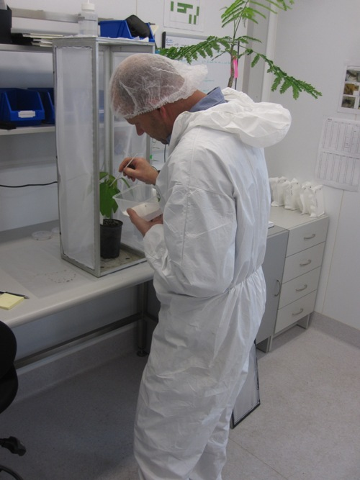
Figure 8. Andrew White transferring newly hatched larvae of Eueupithecia cisplatensis onto a plant during no-choice tests in an Australian quarantine

Results

The Australian no-choice tests showed a consistent failure of larvae of E. cisplatensis to develop on any plant species other than P. aculeata (Table 9). No feeding or damage was observed on any non-target test plant species.
Table 9. Results of laboratory no-choice larval survival tests on Eueupithecia cisplatensis in Australian quarantine. A replicate consisted of 50 larvae on one plant in one cage.
Subfamily |  |  |  |  | Replicates | % adult emergence (range)
 | Tribe
 |  | Group
 |  |  | Section
 |  |  |  | Genus/species
Caesalpinioideae
 | Caesalpinieae
 |  | Peltophorum
 |  |  |  | Parkinsonia aculeata | 29 | 56% (34%-86%)
 |  |  |  | Peltophorum pterocarpum | 4 | 0
 |  |  |  | Colvillea racemosa | 4 | 0
 |  | Caesalpinia
 |  |  |  | Caesalpinia ferrea | 4 | 0
 |  |  |  | Caesalpinia pulcherrima | 4 | 0
 |  | Dimorphandra
 |  |  |  | Erythrophleum chlorostachys | 4 | 0
Caesalpinioideae
 | Cassieae
 |  |  |  | Cassia brewsteri | 4 | 0
 |  |  |  | Ceratonia siliqua | 4 | 0
 |  |  |  | Chaemacrista mimosoides | 2 | 0
 |  |  |  | Chaemacrista nomane | 4 | 0
 |  |  |  | Labichea lanceolata | 4 | 0
 |  |  |  | Petalostylis labicheoides | 4 | 0
 |  |  |  | Senna artemisioides | 4 | 0
 |  |  |  | Senna glutinosa | 4 | 0
 |  |  |  | Senna notabilis | 4 | 0
 | Cercideae
 |  |  |  | Barklya syringifolia | 4 | 0
 |  |  |  | Bauhinia hookeri | 4 | 0
 | Detarieae
 |  |  |  | Cynometra ramiflora | 4 | 0
 |  |  |  | Intsia bijuga | 3 | 0
 |  |  |  | Maniltoa lenticillata | 4 | 0
 |  |  |  | Schotia brachypetala | 4 | 0
 |  |  |  | Tamarindus indica | 4 | 0
Faboideae
 | Aeschynomeneae
 |  |  |  | Aeschynomene americana | 4 | 0
 | Bossiaeeae
 |  |  |  | Hovea acutifolia | 4 | 0
 | Desmodieae
 |  |  |  | Desmodium tortuosum | 4 | 0
 | Mirbelieae
 |  |  |  | Pultenaea villosa | 4 | 0
 | Phaseoleae
 |  |  |  | Cajanus cajan | 4 | 0
 | Robinieae
 |  |  |  | Sesbania cannabina | 4 | 0
 | Tephrosieae
 |  |  |  | Millettia sp. McIlwraith | 4 | 0
 | Vicieae
 |  |  |  | Vicia faba L. | 4 | 0
Mimosoideae
 | Acaciae
 |  |  | Acacia
 |  |  |  | Acacia bidwillii | 4 | 0
 |  |  | Botrycephalae
 |  |  |  | Acacia decurrens | 4 | 0
 |  |  |  | Acacia oshanesii | 4 | 0
 |  |  | Juliflorae
 |  |  |  | Acacia disparrima | 4 | 0
 |  |  |  | Acacia julifera | 4 | 0
 |  |  | Plurinerves
 |  |  |  | Acacia melanoxylon | 4 | 0
 |  |  | Phyllodineae
 |  |  |  | Acacia salicina | 3 | 0
 | Ingeae
 |  |  |  | Archidendron lucyi | 4 | 0
 |  |  |  | Pararchidendron pruinosum | 4 | 0
 | Mimoseae
 |  |  |  | Dichrostachys cinerea | 4 | 0
 |  |  |  | Leucaena leucocephala | 4 | 0

Discussion

Three types of methods were applied to evaluate the specificity of this agent. All delivered the same result: total specificity to one plant species, P. aculeata. The methods used differed, but complemented and supported each other. The field survey in the native range could only be done on a small number of legume species that could be found coexisting with P. aculeata. But this method had the advantage of showing the natural host plant use and is hence very accurate.
The two laboratory tests had the common element that they assessed the larval developmental host range. That is, they evaluated the suitability and acceptability of the test plant species for feeding, growth and progression of larvae to later developmental stages. This is a conservative test in the sense that it is extremely unlikely to under-estimate the host range. If a larva is behaviourally and physiologically able to feed and grow when placed on a food source, then it will do so. For some insect species, these types of tests over-estimate the host range. That is they feed and develop on food sources upon which they would not in nature. The fact that our larvae died rather than feed on all test plant species except P. aculeata, proves, to a very high level of confidence, that this insect species will not feed on or damage any other plants species in the field and hence the risks of damage to non-target plants following its release are extremely low.

Where, when and how initial release will be made

Release from quarantine
Eueupithecia cisplatensis is currently being cultured within the quarantine facility at the EcoSciences Precinct, Dutton Park, Brisbane. Specimens of this culture will be deposited with AQIS and the Australian National Insect collection as voucher specimens. Once approval for release is obtained from DAFF and SEWPaC, adults from this culture will be removed from the quarantine after careful inspection to confirm identity and to ensure that no other associated organism such as parasite or pathogen is taken from the quarantine. All requirements imposed by AQIS on the release permit will be followed. Once removed from quarantine, the insects will be placed on P. aculeata in non-quarantine glasshouses to initiate a mass-rearing phase.
Should the culture be lost before approvals are granted or any detrimental signs appear as a result of genetic bottlenecks, the insect will be recollected in Argentina and reared through at least one generation in quarantine before being released. Voucher specimens will be submitted to AQIS and ANIC and the identity of the collected material will be confirmed by an authority on the group.

Distributing in the field
Eueupithecia cisplatensis will be distributed to selected sites throughout the weed’s range in Australia. Release sites will be recorded with their GPS coordinates. It is expected that state and territory government departments, community groups such as Landcare, Bushcare and schools may contribute to this distribution. Senior representatives of the Queensland government and the Northern Territory government have already expressed interest in participating in release activities. CSIRO will provide “How to” packages and starter colonies to interested parties.

Establishment and evaluation
Release sites will be monitored for some years after releases to ascertain whether the insect has established. Should the insect be found to have established, assessments will be made on its effects on the weed.

Copies of any references referred to in the application
Copies of the many references cited in this application are available from the author upon request.

Acknowledgements

I wish to sincerely thank the following people for their efficient and meticulous lab work in Australian quarantine: Andrew White, Gio Fichera, Areli Mira and Alexandre Marchal. Fernando Mc KayMckay, Alejandro Sosa, Marcelo Parisi and Juan Briano of the USDA-ARS-SABCL, Buenos Aires, executed native range field and laboratory work with their usual enthusiasm and high level of ability. Axel Hausmann identified specimens and performed taxonomic research on the agent. Meat and Livestock Australia and the Australian government department of Agriculture, Fisheries and Forestry through the AWRC program provided funding without which this work, and the preceding studies, would not have been done. Dr Rieks van Klinken provided scientific guidance and discussion. Fernando Mc Kay, Rieks van Klinken, John Scott and Louise Morin commented on drafts of the application.

References

Adair RJ, Edwards PB. 1996. An attack strategy against Chrysanthemoides monilifera, a weed of native vegetation in Australia.Moran VC, Hoffmann JH. Proceedings of the 9th international symposium on biological control of weeds, Stellenbosch, South Africa, 19-26 January 1996.Rondebosch, South Africa: University of Cape Town.
Adair, R.J. and Scott, J.K. 1989. The life-history and host specificity of Comostolopsis germana Prout (Lepidoptera: Geometridae), a biological control agent of Chrysanthemoides monilifera (Compositae). Bulletin of Entomological Research 79: 649-657.
Bello, M.A., Bruneau, A., Forest, F. and Hawkins J.A. 2009 Elusive relationships within order Fabales: Phylogenetic analyses using matK and rbcL sequence data. Systematic Botany. 34: 102-114.
Briano, J.A., Cordo, H.A. and DeLoach, C.J. (2002). Biology and field observations of Penthobruchus germaini (Coleoptera: Bruchidae), a biological control agent for Parkinsonia aculeata (Leguminosae: Caesalpinioideae). Biological Control 24, 292-9.
Briese, D.T. 2003. The centrifugal phylogenetic method used to select plants for host-specificity testing of weed biological control agents: Can and should it be modernised? In: Spafford-Jacob, H., Briese, D.T. (Eds.), Improving the Selection, Testing and Evaluation of Weed Biological Control Agents. CRC Tech. Ser. No. 7, pp. 23-33.
Briese, D.T. 2005. Translating host-specificity test results into the real world: The need to harmonise the yin and yang of current testing procedures. Biol. Control 35: 208-214.
Briese, D.T., Walker, A., 2002. A new perspective on the selection of test plants for evaluating the host-specificity of weed biological control agents: the case of Deuterocampta quadrijuga, a potential insect control agent of Heliotropium amplexicaule. Biol. Control 25, 273-287.
Bruneau A; Mercure M; Lewis, GP, Herendeen, PS 2008. Phylogenetic patterns and diversification in the caesalpinioid legumes. Botany 86: 697-718.
Deveze, M. (ed). (2004). ‘Parkinsonia national case study manual’. (QNRME: Brisbane).
Donnelly, G.P. (1998). Levels of attack and destruction of Parkinsonia aculeata seeds by bruchid biological control agents. Proceedings of the Sixth Australasian Applied Entomological Research Conference Volume 2, eds M.P. Zalucki, R.A.I. Drew and G.G. White, p. 310. (University of Queensland Press, Brisbane)
Donnelly, G.P. (2000). Biology and host specificity of Rhinocloa callicrates Herring (Hemiptera: Miridae) and its introduction and establishment as a biological control agent of Parkinsonia aculeata L. (Caesalpiniaceae) in Australia. Australian Journal of Entomology 39, 89-94.
Doyle, J.J., Chappill, J.A., Bailey, C.D. and Kajita, T. (2000). Towards a comprehensive phylogeny of legumes: analyses of rbcL sequences and a general data set. In ‘Advances in Legume Systematics’, Part 9, eds P.S. Herendeen and A. Bruneau. (Royal Botanic Gardens, Kew).
Flanagan, G.J., van Rangelrooy, D.S. and Kerin, S. (1996). Integrated management of Parkinsonia aculeata on the Roper River, Northern Territory, Australia. Proceedings of the IX International Symposium on Biological Control of Weeds, eds V.C. Moran and J.H. Hoffmann, pp. 441-3. (University of Cape Town, Cape Town).
Haston, E.M., Lewis, G.P. and Hawkins J.A. 2005. A phylogenetic reappraisal of the Peltophorum group (Caesalpinieae: Leguminosae) based on the chloroplast trnL-F, rbcL and rps16 sequence data. American Journal of Botany 2, 1359-71.
Hawkins, J.A. (2001). Parkinsonia aculeata (Mexican palo-verde). In ‘Forestry compendium’, (CABI Publishing, Oxon, UK).
Hawkins, J.A., White, L., Hughes, C.E., Contreras-Jiménez, J.L. and Mercado, P. (1999). Investigation and documentation of hybridisation between Parkinsonia aculeata and Cercidium praecox (Leguminosae: Caesalpinioideae). Plant Systematics and Evolution 216, 49-68.
Heard, T.A. (2006). Parkinsonia aculeata: surveys for natural enemies, native range ecological studies and prospects for biological control. Proceedings of the 15th Australian Weeds Conference, eds C. Preston, J.H. Watts and N.D. Crossman, pp. 581-4. (Weed Management Society of South Australia, Adelaide).
Herendeen, P.S., Bruneau, A. and Lewis, G.P. (2003). Phylogenetic relationships in the caesalpinioid legumes: a preliminary analysis based on morphological and molecular data. In ‘Advances in legume systematics, Part 10’, eds B.B. Klitgaard and A. Bruneau, pp. 37-62. (Royal Botanic Gardens, Kew).
Hughes, C.E. (1989). Intensive study of multipurpose tree genetic resources. Oxford Forestry Institute, UK: Unpublished Report.
Hughes, C.E., and Styles, B.T. (1984). Exploration and seed collection of multiple-purpose dry zone trees in central America. The International Tree Crops Journal 3, 1-31.
Julien, J.H. and Griffiths, M.W. (1998). ‘Biological control of weeds: a world catalogue of agents and their target weeds’, 4th edition. (CABI Publishing, Wallingford).
Lewis, G.P. Simpson, B.B. and Neff, J.L. (2000). progress in understanding the reproductive biology of the Caesalpinioideae (Leguminosae). In ‘Advances in legume systematics, part 9’, eds P. S. Herendeen and A. Bruneau, pp. 65-78. (Royal Botanic Gardens, Kew).
Lockett, C., Gray, E. and Donnelly, G. (1999). The prevalence of seed damage by the introduced bruchid, Penthobruchus germaini (Coleoptera: Bruchidae), a biological control agent for parkinsonia (Parkinsonia aculeata), in far north and central Queensland. Proceedings of the 12th Australian Weeds Conference, eds A.C. Bishop, M. Boersma and C.D. Barnes, pp. 431-5. (Tasmanian Weeds Society, Hobart)
Lukitsch, B. and Wilson, A. (1999). Distribution and impact of the mature seed feeding bruchid, Penthobruchus germaini on Parkinsonia aculeata in northern Australia. Proceedings of the 12th Australian Weeds Conference, eds A.C. Bishop, M. Boersma and C.D. Barnes, pp. 436-40. (Tasmanian Weeds Society, Hobart).
Palmer W A; Tilden J W 1987 Host specificity and biology of Prochoerodes truxaliata (Guenee) (Geometridae), a potential biocontrol agent for the rangeland weed Baccharis halimifolia L. in Australia. Journal of the Lepidopterists' Society 41: 199-208.
Prout L. B. 1910. On the Geometridae of the Argentine Republic. London Transactions of the Entomological Society Volume: 1910 Pages: 204-345
Polhill, R.M. and Vidal, J.E. (1981). Caesalpineae. In ‘Advances in legume systematics’, Volume 1, ed. R.M. Polhill, P.H. Raven, pp. 81-95. (Royal Botanic Gardens, Kew).
Ross, R.H. (1998). Caesalpiniaceae: Parkinsonia. Flora of Australia 12, 69-70.
Scoble, M. J. 1999. Geometrid moths of the world : a catalogue (Lepidoptera, Geometridae) CSIRO Publishing, Collingwood, Vic. / edited by Malcolm J. Scoble. OR Parsons, M.S.; Scoble, M.J.; Honey, M.R.; Pitkin, L.M.; Pitkin, B.R. 1999. Geometrid moths of the world : a catalogue (Lepidoptera, Geometridae) CSIRO Publishing, Collingwood, Vic.
Sheppard, A.W., van Klinken R.D. and Heard, T. A. (2005) Scientific advances in the analysis of direct risks of weed biological control agents to non-target plants. Biological Control 35: 215-226.
Sihvonen, P; Mutanen, M; Kaila, L; Brehm, G; Hausmann, A; Staude, HS 2011. Comprehensive Molecular Sampling Yields a Robust Phylogeny for Geometrid Moths (Lepidoptera: Geometridae). PLOS ONE 6 DOI: 10.1371/journal.pone.0020356.
Sihvonen P; Kaila L (2004) Phylogeny and tribal classification of Sterrhinae with emphasis on delimiting Scopulini (Lepidoptera : Geometridae). Systematic Entomology 29: 324-358.
Stevens, P. F. (2001 onwards). Angiosperm Phylogeny Website. Version 9, June 2008 [and more or less continuously updated since]. http://www.mobot.org/MOBOT/research/APweb/.
Thorpe, J.R. and Lynch, R. (2000). ‘The Determination of Weeds of National Significance’. (National Weeds Strategy Executive Committee, Launceston).
van Klinken, R.D. (2005). Total annual seed loss on a perennial legume through predation by insects: the importance of within-season seed and seed-feeder dynamics. Austral Ecology 30, 414-25.
van Klinken, R.D. (2006). Parkinsonia biocontrol: what are we trying to achieve? Australian Journal of Entomology 45, 268-71.
van Klinken, R.D. and Flack. L. (2005). The relationship between wet heat and hard-seeded dormancy and germination. Weed Science 53, 663-9.
van Klinken, R.D. and Flack, L..(2008). What limits predation rates by a specialist seed feeder? Journal of Applied Ecology. In press.
van Klinken, R.D., Campbell S.D., Heard, T.A. McKenzie J. and March N. (2009a) The Biology of Australian Weeds Parkinsonia aculeata L. Plant Protection Quarterly (in press).
van Klinken RD, Lawson BE and Zalucki MP (2009b) Predicting invasions in Australia by a Neotropical shrub under climate change: the challenge of novel climates and parameter estimation. Global Ecology and Biogeography 18, 688-700.
Woods, W. (1985). Bruchid seed beetles for control of Parkinsonia aculeata in Australia. In ‘Proceedings of the VI International Symposium on Biological Control of Weeds, ed. E. Delfosse, pp. 855-62. (Agriculture Canada, Ottawa).
Woods, W. (1988). The potential for biological control of Parkinsonia aculeata L.: phytophagous insects collected from the U.S.A., Mexico and Costa Rica and the effect of insect damage on the growth and survival of the plant. Master of Science Thesis. (University of Western Australia, Perth).
Woods, W. (1992). Phytophagous insects collected from Parkinsonia aculeata (Leguminoseae: Caesalpiniaceae) in the Sonoran Desert Region of the south western United States and Mexico. Entomophaga 37, 465-74.
Woyciechowski, M.F. (2003) Reconstructing the phylogeny of legumes (Leguminosae): an early 21st centur perspective. In ‘Advances in legume systematics, Part 10’, eds B.B. Klitgaard and A. Bruneau, pp. 5-35. (Royal Botanic Gardens, Kew).

Appendix B Method for pest risk analysis
In accordance with the International Plant Protection Convention, the technical component of a plant import risk analysis (IRA) is termed a pest risk analysis (PRA). DAFF Biosecurity has conducted this PRA in accordance with the International Standards for Phytosanitary Measures (ISPMs), including ISPM 2: Framework for Pest Risk Analysis (FAO 2007) and ISPM 11: Pest Risk Analysis for Quarantine Pests, including analysis of environmental risks and living modified organisms (FAO 2004).
A PRA is ‘the process of evaluating biological or other scientific and economic evidence to determine whether a pest should be regulated and the strength of any phytosanitary measures to be taken against it’(FAO 2009). A pest is ‘any species, strain or biotype of plant, animal, or pathogenic agent injurious to plants or plant products’(FAO 2009).
Quarantine risk consists of two major components: the probability of a pest entering, establishing and spreading in Australia from imports; and the consequences should this happen. These two components are combined to give an overall estimate of the risk.
Unrestricted risk is estimated taking into account the existing commercial production practices of the exporting country and that, on arrival in Australia, DAFF Biosecurity will verify that the consignment received is as described on the commercial documents and that its integrity has been maintained.
Restricted risk is estimated with phytosanitary measure(s) applied. A phytosanitary measure is ‘any legislation, regulation or official procedure having the purpose to prevent the introduction and spread of quarantine pests, or to limit the economic impact of regulated non-quarantine pests’(FAO 2009).
A glossary of the terms used is provided at the back of this IRA report.
PRAs are conducted in three consecutive stages.

Stage 1: Initiation
Initiation identifies the pest(s) and pathway(s) that are of quarantine concern and should be considered for risk analysis in relation to the identified PRA area.
The initiation point for this PRA was the receipt of a technical submission from the National Plant Protection Organisation (NPPO) for access to the Australian market for the commodity. This submission included information on the pests associated with the production of the commodity, including the plant part affected, and the existing commercial production practices for the commodity.
The pests associated with the crop and the exported commodity were tabulated from information provided by the NPPO of the exporting country and literature and database searches.
For this PRA, the ‘PRA area’ is defined as Australia for pests that are absent, or of limited distribution and under official control. For areas with regional freedom from a pest, the ‘PRA area’ may be defined on the basis of a state or territory of Australia or may be defined as a region of Australia consisting of parts of a state or territory or several states or territories.
For pests that had been considered by DAFF Biosecurity in other risk assessments and for which import policies already exist, a judgement was made on the likelihood of entry of pests on the commodity and whether existing policy is adequate to manage the risks associated with its import. Where appropriate, the previous policy has been adopted.

Stage 2: Pest risk assessment
A pest risk assessment (for quarantine pests) is: ‘the evaluation of the probability of the introduction and spread of a pest and of the likelihood of associated potential economic consequences’(FAO 2009).
In this PRA, pest risk assessment was divided into the following interrelated processes:

Pest categorisation
Pest categorisation identifies which of the pests identified in Stage 1 require a pest risk assessment. The categorisation process examines, for each pest, whether the criteria in the definition for a quarantine pest are satisfied. A ‘quarantine pest’ is a pest of potential economic importance to the area endangered thereby and not yet present there, or present but not widely distributed and being officially controlled, as defined in ISPM 5: Glossary of phytosanitary terms (FAO 2009).
The pests identified in Stage 1 were categorised using the following primary elements to identify the quarantine pests for the commodity being assessed:
- identity of the pest
- presence or absence in the PRA area
- regulatory status
- potential for establishment and spread in the PRA area
- potential for economic consequences (including environmental consequences) in the PRA area.
The results of pest categorisation are set out in the Appendices. The quarantine pests identified during pest categorisation were carried forward for pest risk assessment and are listed in the document.

Assessment of the probability of entry, establishment and spread
Details of how to assess the ‘probability of entry’, ‘probability of establishment’ and ‘probability of spread’ of a pest are given in ISPM 11 (FAO 2004). A summary of this process is given below, followed by a description of the qualitative methodology used in this IRA.

Probability of entry
The probability of entry describes the probability that a quarantine pest will enter Australia as a result of trade in a given commodity, be distributed in a viable state in the PRA area and subsequently be transferred to a host. It is based on pathway scenarios depicting necessary steps in the sourcing of the commodity for export, its processing, transport and storage, its use in Australia and the generation and disposal of waste. In particular, the ability of the pest to survive is considered for each of these various stages.
The probability of entry estimates for the quarantine pests for a commodity are based on the use of the existing commercial production, packaging and shipping practices of the exporting country. Details of the existing commercial production practices for the commodity are set out in Section 3. These practices are taken into consideration by DAFF Biosecurity when estimating the probability of entry.
For the purpose of considering the probability of entry, DAFF Biosecurity divides this step of this stage of the PRA into two components:
- Probability of importation: the probability that a pest will arrive in Australia when a given commodity is imported
- Probability of distribution: the probability that the pest will be distributed, as a result of the processing, sale or disposal of the commodity, in the PRA area and subsequently transfer to a susceptible part of a host.
Factors considered in the probability of importation include:
- distribution and incidence of the pest in the source area
- occurrence of the pest in a life-stage that would be associated with the commodity
- volume and frequency of movement of the commodity along each pathway
- seasonal timing of imports
- pest management, cultural and commercial procedures applied at the place of origin
- speed of transport and conditions of storage compared with the duration of the lifecycle of the pest
- vulnerability of the life-stages of the pest during transport or storage
- incidence of the pest likely to be associated with a consignment
- commercial procedures (e.g. refrigeration) applied to consignments during transport and storage in the country of origin, and during transport to Australia.
Factors considered in the probability of distribution include:
- commercial procedures (e.g. refrigeration) applied to consignments during distribution in Australia
- dispersal mechanisms of the pest, including vectors, to allow movement from the pathway to a host
- whether the imported commodity is to be sent to a few or many destination points in the PRA area
- proximity of entry, transit and destination points to hosts
- time of year at which import takes place
- intended use of the commodity (e.g. for planting, processing or consumption)
- Risks from by-products and waste.

Probability of establishment
Establishment is defined as the ‘perpetuation for the foreseeable future, of a pest within an area after entry’ (FAO 2004). In order to estimate the probability of establishment of a pest, reliable biological information (lifecycle, host range, epidemiology, survival, etc.) is obtained from the areas where the pest currently occurs. The situation in the PRA area can then be compared with that in the areas where it currently occurs and expert judgement used to assess the probability of establishment.
Factors considered in the probability of establishment in the PRA area include:
- availability of hosts, alternative hosts and vectors
- suitability of the environment
- reproductive strategy and potential for adaptation
- minimum population needed for establishment
- cultural practices and control measures.

Probability of spread
Spread is defined as ‘the expansion of the geographical distribution of a pest within an area’ (FAO 2004). The probability of spread considers the factors relevant to the movement of the pest, after establishment on a host plant or plants, to other susceptible host plants of the same or different species in other areas. In order to estimate the probability of spread of the pest, reliable biological information is obtained from areas where the pest currently occurs. The situation in the PRA area is then carefully compared with that in the areas where the pest currently occurs and expert judgement used to assess the probability of spread.
Factors considered in the probability of spread include:
- suitability of the natural and/or managed environment for natural spread of the pest
- presence of natural barriers
- potential for movement with commodities, conveyances or by vectors
- intended use of the commodity
- potential vectors of the pest in the PRA area
- potential natural enemies of the pest in the PRA area.

Assigning qualitative likelihoods for the probability of entry, establishment and spread
In its qualitative PRAs, DAFF Biosecurity uses the term ‘likelihood’ for the descriptors it uses for its estimates of probability of entry, establishment and spread. Qualitative likelihoods are assigned to each step of entry, establishment and spread. Six descriptors are used: high; moderate; low; very low; extremely low; and negligible (Table 1.1). Descriptive definitions for these descriptors and their indicative probability ranges are given in Table 1.1. The indicative probability ranges are only provided to illustrate the boundaries of the descriptors. These indicative probability ranges are not used beyond this purpose in qualitative PRAs. The standardised likelihood descriptors and the associated indicative probability ranges provide guidance to the risk analyst and promote consistency between different risk analyses.
Table 1.1 Nomenclature for qualitative likelihoods
Likelihood | Descriptive definition | Indicative probability (P) range
High | The event would be very likely to occur | 0.7 < P ≤ 1
Moderate | The event would occur with an even probability | 0.3 < P ≤ 0.7
Low | The event would be unlikely to occur | 0.05 < P ≤ 0.3
Very low | The event would be very unlikely to occur | 0.001 < P ≤ 0.05
Extremely low | The event would be extremely unlikely to occur | 0.000001 < P ≤ 0.001
Negligible | The event would almost certainly not occur | 0 ≤ P ≤ 0.000001

The likelihood of entry is determined by combining the likelihood that the pest will be imported into the PRA area and the likelihood that the pest will be distributed within the PRA area, using a matrix of rules (Table 1.2). This matrix is then used to combine the likelihood of entry and the likelihood of establishment, and the likelihood of entry and establishment is then combined with the likelihood of spread to determine the overall likelihood of entry, establishment and spread.
For example, if the probability of importation is assigned a likelihood of ‘low’ and the probability of distribution is assigned a likelihood of ‘moderate’, then they are combined to give a likelihood of ‘low’ for the probability of entry. The likelihood for the probability of entry is then combined with the likelihood assigned to the probability of establishment (e.g. ‘high’) to give a likelihood for the probability of entry and establishment of ‘low’. The likelihood for the probability of entry and establishment is then combined with the likelihood assigned to the probability of spread (e.g. ‘very low’) to give the overall likelihood for the probability of entry, establishment and spread of ‘very low’.
Table 1.2 Matrix of rules for combining qualitative likelihoods
 | High | Moderate | Low | Very low | Extremely low | Negligible
High | High | Moderate | Low | Very low | Extremely low | Negligible
Moderate |  | Low | Low | Very low | Extremely low | Negligible
Low |  |  | Very low | Very low | Extremely low | Negligible
Very low |  |  |  | Extremely low | Extremely low | Negligible
Extremely low |  |  |  |  | Negligible | Negligible
Negligible |  |  |  |  |  | Negligible

Time and volume of trade
One factor affecting the likelihood of entry is the volume and duration of trade. If all other conditions remain the same, the overall likelihood of entry will increase as time passes and the overall volume of trade increases.
DAFF Biosecurity normally considers the likelihood of entry on the basis of the estimated volume of one year’s trade. This is a convenient value for the analysis that is relatively easy to estimate and allows for expert consideration of seasonal variations in pest presence, incidence and behaviour to be taken into account. The consideration of the likelihood of entry, establishment and spread and subsequent consequences takes into account events that might happen over a number of years even though only one year’s volume of trade is being considered. This difference reflects biological and ecological facts, for example where a pest or disease may establish in the year of import but spread may take many years.
The use of a one year volume of trade has been taken into account when setting up the matrix that is used to estimate the risk and therefore any policy based on this analysis does not simply apply to one year of trade. Policy decisions that are based on DAFF Biosecurity’s method that uses the estimated volume of one year’s trade are consistent with Australia’s policy on appropriate level of protection and meet the Australian Government’s requirement for ongoing quarantine protection. Of course, if there are substantial changes in the volume and nature of the trade in specific commodities then DAFF Biosecurity has an obligation to review the risk analysis and, if necessary, provide updated policy advice.
In assessing the volume of trade in this PRA, DAFF Biosecurity assumed that a substantial volume of trade will occur.

Assessment of potential consequences
The objective of the consequence assessment is to provide a structured and transparent analysis of the likely consequences if the pests or disease agents were to enter, establish and spread in Australia. The assessment considers direct and indirect pest effects and their economic and environmental consequences. The requirements for assessing potential consequences are given in Article 5.3 of the SPS Agreement (WTO 1995), (FAO 2009)and ISPM 11 (FAO 2004).
Direct pest effects are considered in the context of the effects on:
- plant life or health
- other aspects of the environment.
Indirect pest effects are considered in the context of the effects on:
- eradication, control, etc
- domestic trade
- international trade
- environment.
For each of these six criteria, the consequences were estimated over four geographic levels, defined as:
- Local: an aggregate of households or enterprises (a rural community, a town or a local government area).
- District: a geographically or geopolitically associated collection of aggregates (generally a recognised section of a state or territory, such as ‘Far North Queensland’).
- Regional: a geographically or geopolitically associated collection of districts in a geographic area (generally a state or territory, although there may be exceptions with larger states such as Western Australia).
- National: Australia wide (Australian mainland states and territories and Tasmania).
For each criterion, the magnitude of the potential consequence at each of these levels was described using four categories, defined as:
- Indiscernible: pest impact unlikely to be noticeable.
- Minor significance: expected to lead to a minor increase in mortality/morbidity of hosts or a minor decrease in production but not expected to threaten the economic viability of production. Expected to decrease the value of non-commercial criteria but not threaten the criterion’s intrinsic value. Effects would generally be reversible.
- Significant: expected to threaten the economic viability of production through a moderate increase in mortality/morbidity of hosts, or a moderate decrease in production. Expected to significantly diminish or threaten the intrinsic value of non-commercial criteria. Effects may not be reversible.
- Major significance: expected to threaten the economic viability through a large increase in mortality/morbidity of hosts, or a large decrease in production. Expected to severely or irreversibly damage the intrinsic ‘value’ of non-commercial criteria.
Values were translated into a qualitative impact score (A–G) using Table 1.3.
Table 1.3 Decision rules for determining the consequence impact score based on the magnitude of consequences at four geographic scales
Impact score | G | Major significance | Major significance | Major significance | Major significance
Impact score | F | Major significance | Major significance | Major significance | Significant
Impact score | E | Major significance | Major significance | Significant | Minor significance
Impact score | D | Major significance | Significant | Minor significance | Indiscernible
Impact score | C | Significant | Minor significance | Indiscernible | Indiscernible
Impact score | B | Minor significance | Indiscernible | Indiscernible | Indiscernible
Impact score | A | Indiscernible | Indiscernible | Indiscernible | Indiscernible
 |  | Local | District | Region | Nation
 | Geographic scale

The overall consequence for each pest is achieved by combining the qualitative impact scores (A–G) for each direct and indirect consequence using a series of decision rules (Table 1.4). These rules are mutually exclusive, and are assessed in numerical order until one applies.
Table 1.4 Decision rules for determining the overall consequence rating for each pest
Rule | The impact scores for consequences of direct and indirect criteria | Overall consequence rating
1 | Any criterion has an impact of ‘G’; or  more than one criterion has an impact of ‘F’; or  a single criterion has an impact of ‘F’ and each remaining criterion an ‘E’. | Extreme
2 | A single criterion has an impact of ‘F’; or  all criteria have an impact of ‘E’. | High
3 | One or more criteria have an impact of ‘E’; or  all criteria have an impact of ‘D’. | Moderate
4 | One or more criteria have an impact of ‘D’; or  all criteria have an impact of ‘C’. | Low
5 | One or more criteria have an impact of ‘C’; or  all criteria have an impact of ‘B’. | Very Low
6 | One or more but not all criteria have an impact of ‘B’, and  all remaining criteria have an impact of ‘A’. | Negligible

Estimation of the unrestricted risk
Once the above assessments are completed, the unrestricted risk can be determined for each pest or groups of pests. This is determined by using a risk estimation matrix (Table 1.5) to combine the estimates of the probability of entry, establishment and spread and the overall consequences of pest establishment and spread. Therefore, risk is the product of likelihood and consequence.
When interpreting the risk estimation matrix, note the descriptors for each axis are similar (e.g. low, moderate, high) but the vertical axis refers to likelihood and the horizontal axis refers to consequences. Accordingly, a ‘low’ likelihood combined with ‘high’ consequences, is not the same as a ‘high’ likelihood combined with ‘low’ consequences – the matrix is not symmetrical. For example, the former combination would give an unrestricted risk rating of ‘moderate’, whereas, the latter would be rated as a ‘low’ unrestricted risk.
Table 1.5 Risk estimation matrix
Likelihood of pest entry, establishment and spread | High | Negligible risk | Very low risk | Low risk | Moderate risk | High risk | Extreme risk
Likelihood of pest entry, establishment and spread | Moderate | Negligible risk | Very low risk | Low risk | Moderate risk | High risk | Extreme risk
Likelihood of pest entry, establishment and spread | Low | Negligible risk | Negligible risk | Very low risk | Low risk | Moderate risk | High risk
Likelihood of pest entry, establishment and spread | Very low | Negligible risk | Negligible risk | Negligible risk | Very low risk | Low risk | Moderate risk
Likelihood of pest entry, establishment and spread | Extremely low | Negligible risk | Negligible risk | Negligible risk | Negligible risk | Very low risk | Low risk
Likelihood of pest entry, establishment and spread | Negligible | Negligible risk | Negligible risk | Negligible risk | Negligible risk | Negligible risk | Very low risk
 |  | Negligible | Very low | Low | Moderate | High | Extreme
 |  | Consequences of pest entry, establishment and spread

Australia’s appropriate level of protection (ALOP)
The SPS Agreement defines the concept of an ‘appropriate level of sanitary or phytosanitary protection (ALOP)’ as the level of protection deemed appropriate by the WTO Member establishing a sanitary or phytosanitary measure to protect human, animal or plant life or health within its territory.
Like many other countries, Australia expresses its ALOP in qualitative terms. Australia’s ALOP, which reflects community expectations through government policy, is currently expressed as providing a high level of sanitary or phytosanitary protection aimed at reducing risk to a very low level, but not to zero. The band of cells in Table 1.5 marked ‘very low risk’ represents Australia’s ALOP.

Stage 3: Pest risk management
Pest risk management describes the process of identifying and implementing phytosanitary measures to manage risks to achieve Australia's ALOP, while ensuring that any negative effects on trade are minimised.
The conclusions from pest risk assessment are used to decide whether risk management is required and if so, the appropriate measures to be used. Where the unrestricted risk estimate exceeds Australia’s ALOP, risk management measures are required to reduce this risk to a very low level. The guiding principle for risk management is to manage risk to achieve Australia’s ALOP. The effectiveness of any proposed phytosanitary measure (or combination of measures) is evaluated, using the same approach as used to evaluate the unrestricted risk, to ensure it reduces the restricted risk for the relevant pest or pests to meet Australia’s ALOP.
ISPM 11 (FAO 2004) provides details on the identification and selection of appropriate risk management options and notes that the choice of measures should be based on their effectiveness in reducing the probability of entry of the pest.
Examples given of measures commonly applied to traded commodities include:
- options for consignments – e.g., inspection or testing for freedom from pests, prohibition of parts of the host, a pre-entry or post-entry quarantine system, specified conditions on preparation of the consignment, specified treatment of the consignment, restrictions on end-use, distribution and periods of entry of the commodity
- options preventing or reducing infestation in the crop – e.g., treatment of the crop, restriction on the composition of a consignment so it is composed of plants belonging to resistant or less susceptible species, harvesting of plants at a certain age or specified time of the year, production in a certification scheme
- options ensuring that the area, place or site of production or crop is free from the pest – e.g., pest-free area, pest-free place of production or pest-free production site
- options for other types of pathways – e.g., consider natural spread, measures for human travellers and their baggage, cleaning or disinfestation of contaminated machinery
- options within the importing country – e.g., surveillance and eradication programs
- prohibition of commodities – if no satisfactory measure can be found.
Risk management measures are identified for each quarantine pest where the risk exceeds Australia’s ALOP. These are presented in the ‘Pest Risk Management’ section of the report.

Appendix C Biosecurity framework
Australia’s biosecurity policies
The objective of Australia’s biosecurity policies and risk management measures is the prevention or control of the entry, establishment or spread of pests and diseases that could cause significant harm to people, animals, plants and other aspects of the environment.
Australia has diverse native flora and fauna and a large agricultural sector, and is relatively free from the more significant pests and diseases present in other countries. Therefore, successive Australian Governments have maintained a conservative, but not a zero-risk, approach to the management of biosecurity risks. This approach is consistent with the World Trade Organization’s (WTO’s) Agreement on the Application of Sanitary and Phytosanitary Measures (SPS Agreement).
The SPS Agreement defines the concept of an ‘appropriate level of protection’ (ALOP) as the level of protection deemed appropriate by a WTO Member establishing a sanitary or phytosanitary measure to protect human, animal or plant life or health within its territory. Among a number of obligations, a WTO Member should take into account the objective of minimising negative trade effects in setting its ALOP.
Like many other countries, Australia expresses its ALOP in qualitative terms. Australia’s ALOP, which reflects community expectations through Australian Government policy, is currently expressed as providing a high level of sanitary and phytosanitary protection, aimed at reducing risk to a very low level, but not to zero.
Consistent with the SPS Agreement, in conducting risk analyses Australia takes into account as relevant economic factors:
- the potential damage in terms of loss of production or sales in the event of the entry, establishment or spread of a pest or disease in the territory of Australia
- the costs of control or eradication of a pest or disease and
- the relative cost-effectiveness of alternative approaches to limiting risks.
Roles and responsibilities within Australia’s quarantine system
Australia protects its human, animal and plant life or health through a comprehensive quarantine system that covers the quarantine continuum, from pre-border to border and post-border activities.
Pre-border, Australia participates in international standard-setting bodies, undertakes risk analyses, develops offshore quarantine arrangements where appropriate, and engages with our neighbours to counter the spread of exotic pests and diseases.
At the border, Australia screens vessels (including aircraft), people and goods entering the country to detect potential threats to Australian human, animal and plant health.
The Australian Government also undertakes targeted measures at the immediate post-border level within Australia. This includes national co-ordination of emergency responses to pest and disease incursions. The movement of goods of quarantine concern within Australia’s border is the responsibility of relevant state and territory authorities, which undertake inter- and intra-state quarantine operations that reflect regional differences in pest and disease status, as a part of their wider plant and animal health responsibilities.
Roles and responsibilities within the Department
The Australian Government Department of Agriculture, Fisheries and Forestry (DAFF) is responsible for the Australian Government’s animal and plant biosecurity policy development and the establishment of risk management measures. The Secretary of the department is appointed as the Director of Animal and Plant Quarantine under the Quarantine Act 1908 (the Act).
DAFF Biosecurity takes the lead in biosecurity and quarantine policy development and the establishment and implementation of risk management measures across the biosecurity continuum, and;
- conducts risk analyses, including IRAs, and develops recommendations for biosecurity policy as well as providing quarantine policy advice to the Director of Animal and Plant Quarantine
- develops operational procedures, makes a range of quarantine decisions under the Act (including import permit decisions under delegation from the Director of Animal and Plant Quarantine) and delivers quarantine services
- coordinates pest and disease preparedness, emergency responses and liaison on inter- and intra-state quarantine arrangements for the Australian Government, in conjunction with Australia’s state and territory governments.
Roles and responsibilities of other government agencies
State and territory governments play a vital role in the quarantine continuum. DAFF works in partnership with state and territory governments to address regional differences in pest and disease status and risk within Australia, and develops appropriate sanitary and phytosanitary measures to account for those differences. Australia’s partnership approach to quarantine is supported by a formal Memorandum of Understanding that provides for consultation between the Australian Government and the state and territory governments.
Depending on the nature of the good being imported or proposed for importation, DAFF Biosecurity may consult other Australian Government authorities or agencies in developing its recommendations and providing advice.
As well as a Director of Animal and Plant Quarantine, the Act provides for a Director of Human Quarantine. The Australian Government Department of Health and Ageing is responsible for human health aspects of quarantine and Australia’s Chief Medical Officer within that Department holds the position of Director of Human Quarantine. DAFF Biosecurity may, where appropriate, consult with that Department on relevant matters that may have implications for human health.
The Act also requires the Director of Animal and Plant Quarantine, before making certain decisions, to request advice from the Environment Minister and to take the advice into account when making those decisions. The Australian Government Department of Sustainability, Environment, Water, Population and Communities (DSEWPC) is responsible under the Environment Protection and Biodiversity Conservation Act 1999 for assessing the environmental impact associated with proposals to import live species. Anyone proposing to import such material should contact DSEWPC directly for further information.
When undertaking risk analyses, DAFF Biosecurity consults with DSEWPC about environmental issues and may use or refer to DSEWPC’s assessment.
Australian quarantine legislation
The Australian quarantine system is supported by Commonwealth, state and territory quarantine laws. Under the Australian Constitution, the Commonwealth Government does not have exclusive power to make laws in relation to quarantine, and as a result, Commonwealth and state quarantine laws can co-exist.
Commonwealth quarantine laws are contained in the Quarantine Act 1908 and subordinate legislation including the Quarantine Regulations 2000, the Quarantine Proclamation 1998, the Quarantine (Cocos Islands) Proclamation 2004 and the Quarantine (Christmas Island) Proclamation 2004.
The quarantine proclamations identify goods, which cannot be imported, into Australia, the Cocos Islands and or Christmas Island unless the Director of Animal and Plant Quarantine or delegate grants an import permit or unless they comply with other conditions specified in the proclamations. Section 70 of the Quarantine Proclamation 1998, section 34 of the Quarantine (Cocos Islands) Proclamation 2004 and section 34 of the Quarantine (Christmas Island) Proclamation 2004 specify the things a Director of Animal and Plant Quarantine must take into account when deciding whether to grant a permit.
In particular, a Director of Animal and Plant Quarantine (or delegate):
- must consider the level of quarantine risk if the permit were granted, and
- must consider whether, if the permit were granted, the imposition of conditions would be necessary to limit the level of quarantine risk to one that is acceptably low, and
- for a permit to import a seed of a plant that was produced by genetic manipulation – must take into account any risk assessment prepared, and any decision made, in relation to the seed under the Gene Technology Act, and
- may take into account anything else that he or she knows is relevant.
The level of quarantine risk is defined in section 5D of the Quarantine Act 1908. The definition is as follows:
reference in this Act to a level of quarantine risk is a reference to:
(a) the probability of:
(i) a disease or pest being introduced, established or spread in Australia, the Cocos Islands or Christmas Island; and
(ii) the disease or pest causing harm to human beings, animals, plants, other aspects of the environment, or economic activities; and
(b) the probable extent of the harm.
The Quarantine Regulations 2000 were amended in 2007 to regulate keys steps of the import risk analysis process. The Regulations:
- define both a standard and an expanded IRA,
- identify certain steps, which must be included in each type of IRA,
- specify time limits for certain steps and overall timeframes for the completion of IRAs (up to 24 months for a standard IRA and up to 30 months for an expanded IRA),
- specify publication requirements,
- make provision for termination of an IRA, and
- allow for a partially completed risk analysis to be completed as an IRA under the Regulations.
The Regulations are available at www.comlaw.gov.au.
International agreements and standards
The process set out in the Import Risk Analysis Handbook 2007 (update 2009) is consistent with Australia’s international obligations under the SPS Agreement. It also takes into account relevant international standards on risk assessment developed under the International Plant Protection Convention (IPPC) and by the World Organisation for Animal Health (OIE).
Australia bases its national risk management measures on international standards where they exist and when they achieve Australia’s ALOP. Otherwise, Australia exercises its right under the SPS Agreement to apply science-based sanitary and phytosanitary measures that are not more trade restrictive than required to achieve Australia’s ALOP.
Notification obligations
Under the transparency provisions of the SPS Agreement, WTO Members are required, among other things, to notify other members of proposed sanitary or phytosanitary regulations, or changes to existing regulations, that are not substantially the same as the content of an international standard and that may have a significant effect on trade of other WTO Members.
Risk analysis
Within Australia’s quarantine framework, the Australian Government uses risk analyses to assist it in considering the level of quarantine risk that may be associated with the importation or proposed importation of animals, plants or other goods.
In conducting a risk analysis, DAFF Biosecurity:
- identifies the pests and diseases of quarantine concern that may be carried by the good
- assesses the likelihood that an identified pest or disease would enter, establish or spread
- assesses the probable extent of the harm that would result.
If the assessed level of quarantine risk exceeds Australia’s ALOP, DAFF Biosecurity will consider whether there are any risk management measures that will reduce quarantine risk to achieve the ALOP. If there are no risk management measures that reduce the risk to that level, trade will not be allowed.
Risk analyses may be carried out by DAFF Biosecurity’s specialists, but may also involve relevant experts from state and territory agencies, the Commonwealth Scientific and Industrial Research Organisation (CSIRO), universities and industry to access the technical expertise needed for a particular analysis.
Risk analyses are conducted across a spectrum of scientific complexity and available scientific information. An IRA is a type of risk analysis with key steps regulated under the Quarantine Regulations 2000. DAFF Biosecurity’s assessment of risk may also take the form of a non-regulated analysis of existing policy or technical advice. Further information on the types of risk analysis is provided in the Import Risk Analysis Handbook 2007 (update 2009).

Glossary
Term or abbreviation | Definition
Additional declaration | A statement that is required by an importing country to be entered on a phytosanitary certificate and which provides specific additional information on a consignment in relation to regulated pests (FAO 2009).
Appropriate level of protection (ALOP) | The level of protection deemed appropriate by the Member establishing a sanitary or phytosanitary measure to protect human, animal or plant life or health within its territory (WTO 1995).
Area | An officially defined country, part of a country or all or parts of several countries (FAO 2009).
Area of low pest prevalence | An area, whether all of a country, part of a country, or all parts of several countries, as identified by the competent authorities, in which a specific pest occurs at low levels and which is subject to effective surveillance, control or eradication measures (FAO 2009).
Biological Control Agent (BCA) | A natural enemy, antagonist or competitor, or other organism, used for pest control (FAO 2009).
Certificate | An official document which attests to the phytosanitary status of any consignment affected by phytosanitary regulations (FAO 2009).
Consignment | A quantity of plants, plant products and/or other articles being moved from one country to another and covered, when required, by a single phytosanitary certificate (a consignment may be composed of one or more commodities or lots) (FAO 2009).
Control (of a pest) | Suppression, containment or eradication of a pest population (FAO 2009).
DAFF Biosecurity | The unit, within the Department of Agriculture, Fisheries and Forestry, responsible for Australia’s biosecurity policies. Previously known as Biosecurity Australia and the Australian Quarantine and Inspection Service (AQIS).
Endangered area | An area where ecological factors favour the establishment of a pest whose presence in the area will result in economically important loss (FAO 2009).
Entry (of a pest) | Movement of a pest into an area where it is not yet present, or present but not widely distributed and being officially controlled (FAO 2009).
Establishment | Perpetuation, for the foreseeable future, of a pest within an area after entry (FAO 2009).
Fresh | Living; not dried, deep-frozen or otherwise conserved (FAO 2009).
Host range | Species capable, under natural conditions, of sustaining a specific pest or other organism (FAO 2009).
Import permit | Official document authorising importation of a commodity in accordance with specified phytosanitary import requirements (FAO 2009).
Import risk analysis | An administrative process through which quarantine policy is developed or reviewed, incorporating risk assessment, risk management and risk communication.
Infestation (of a commodity) | Official document authorising importation of a commodity in accordance with specified phytosanitary import requirements (FAO 2009).
Inspection | Official visual examination of plants, plant products or other regulated articles to determine if pests are present and/or to determine compliance with phytosanitary regulations (FAO 2009).
Intended use | Declared purpose for which plants, plant products, or other regulated articles are imported, produced, or used (FAO 2009).
Interception (of a pest) | The detection of a pest during inspection or testing of an imported consignment (FAO 2009).
International Standard for Phytosanitary Measures (ISPM) | An international standard adopted by the Conference of the Food and Agriculture Organization, the Interim Commission on phytosanitary measures or the Commission on phytosanitary measures, established under the IPCC (FAO 2009).
Introduction | The entry of a pest resulting in its establishment (FAO 2009).
Lot | A number of units of a single commodity, identifiable by its homogeneity of composition, origin etc., forming part of a consignment (FAO 2009).
National Plant Protection Organization (NPPO) | Official service established by a government to discharge the functions specified by the IPPC (FAO 2009).
Official control | The active enforcement of mandatory phytosanitary regulations and the application of mandatory phytosanitary procedures with the objective of eradication or containment of quarantine pests or for the management of regulated non-quarantine pests (FAO 2009).
Pathway | Any means that allows the entry or spread of a pest (FAO 2009).
Pest | Any species, strain or biotype of plant, animal, or pathogenic agent injurious to plants or plant products (FAO 2009).
Pest categorisation | The process for determining whether a pest has or has not the characteristics of a quarantine pest or those of a regulated non-quarantine pest (FAO 2009).
Pest free area (PFA) | An area in which a specific pest does not occur as demonstrated by scientific evidence and in which, where appropriate, this condition is being officially maintained (FAO 2009).
Pest free place of production | Place of production in which a specific pest does not occur as demonstrated by scientific evidence and in which, where appropriate, this condition is being officially maintained for a defined period (FAO 2009).
Pest free production site | A defined portion of a place of production in which a specific pest does not occur as demonstrated by scientific evidence and in which, where appropriate, this conditions is being officially maintained for a defined period and that is managed as a separate unit in the same way as a pest free place of production (FAO 2009).
Pest risk analysis (PRA) | The process of evaluating biological or other scientific and economic evidence to determine whether an organism is a pest, whether it should be regulated, and the strength of any phytosanitary measures to be taken against it (FAO 2009).
Pest risk assessment (for quarantine pests) | Evaluation of the probability of the introduction and spread of a pest and of the associated potential economic consequences (FAO 2009).
Pest risk management (for quarantine pests) | Evaluation and selection of options to reduce the risk of introduction and spread of a pest (FAO 2009).
Phytosanitary certificate | Certificate patterned after the model certificates of the IPPC (FAO 2009).
Phytosanitary measure | Any legislation, regulation or official procedure having the purpose to prevent the introduction and/or spread of quarantine pests, or to limit the economic impact of regulated non-quarantine pests (FAO 2009).
Phytosanitary regulation | Official rule to prevent the introduction and/or spread of quarantine pests, or to limit the economic impact of regulated non-quarantine pests, including establishment of procedures for phytosanitary certification (FAO 2009).
Polyphagous | Feeding on a relatively large number of hosts from different genera.
PRA area | Area in relation to which a pest risk analysis is conducted (FAO 2009).
Quarantine pest | A pest of potential economic importance to the area endangered thereby and not yet present there, or present but not widely distributed and being officially controlled (FAO 2009).
Regulated article | Any plant, plant product, storage place, packing, conveyance, container, soil and any other organism, object or material capable of harbouring or spreading pests, deemed to require phytosanitary measures, particularly where international transportation is involved (FAO 2009).
Restricted risk | Risk estimate with phytosanitary measure(s) applied.
Spread | Expansion of the geographical distribution of a pest within an area (FAO 2009).
SPS Agreement | WTO Agreement on the Application of Sanitary and Phytosanitary Measures (WTO 1995).
Stakeholders | Government agencies, individuals, community or industry groups or organizations, whether in Australia or overseas, including the proponent/applicant for a specific proposal, who have an interest in the policy issues.
Systems approach(es) | The integration of different risk management measures, at least two of which act independently, and which cumulatively achieve the appropriate level of protection against regulated pests (FAO 2009).
Unrestricted risk | Unrestricted risk estimates apply in the absence of risk mitigation measures.

References

FAO (2004) International Standards for Phytosanitary Measures (ISPM) no. 11: pest risk analysis for quarantine pests including analysis of environmental risks and living modified organisms. Secretariat of the International Plant Protection Convention, Food and Agricultural Organization of the United Nations, Rome, Italy.
FAO (2007) International Standards for Phytosanitary Measures (ISPM) no. 2: framework for pest risk analysis. Secretariat of the International Plant Protection Convention, Food and Agriculture Organization of the United Nations, Rome, Italy.
FAO (2009) International Standards for Phytosanitary Measures (ISPM) no. 5: glossary of phytosanitary terms. Secretariat of the International Plant Protection Convention, Food and Agriculture Organisation of the United Nations, Rome, Italy.
WTO (1995) Agreement on the application of sanitary and phytosanitary measures. World Trade Organization, Switzerland.

A pest is any species, strain or biotype of plant, animal, or pathogenic agent injurious to plants or plant products (FAO 2007b).
In earlier qualitative IRAs, the scale for the impact scores went from A to F and did not explicitly allow for the rating ‘indiscernible’ at all four levels. This combination might be applicable for some criteria. In this report, the impact scale of A-F has changed to become B-G and a new lowest category A (‘indiscernible’ at all four levels) was added. The rules for combining impacts in Table 1.4 were adjusted accordingly.
The Australian Government Department of Health and Ageing is responsible for human health aspects of quarantine.

