washington fruit survey 2006

posted online december 4, 2006

Acknowledgements
It is a large and challenging task to compile information detailed in this publication. This project would not have been possible without the assistance and support of many people and organizations. We would like to thank all of the fruit organizations in the state that supported the survey work and helped to publicize the importance of the work. We would like to thank Vicky Scharlau and Susan Pheasant for their partnership on the Risk Management Agency grant. Thanks go to Dan Kelly at the Washington Growers Clearinghouse and Lindsey Buckner of Tree Top Inc. for their support, assistance and feedback. Special thanks go to Perry Beale for his assistance and cooperation to use the Washington State Department of Agriculture’s geographic information system (GIS) layer to facilitate the area survey portion of this project.
Within our organization, we received the support and technical assistance of several individuals. We would like to thank Suzette Qualey for her work on the interactive data analysis system she developed for this project and Matt Fetter for sharing and helping to adapt computer programs to adjust for coverage and nonresponse. We would like to thank Dave Aune and Tom Birkett for their advice on the best practices to protect the confidentiality of respondents. Thanks go to Bill Wigton and the Area Frame staff for printing and reproducing map materials to make the area frame portion of the project possible. We would like to thank Eric Stebbins of the Oregon field office for his advice in developing the linkage between the computer summary of the data and publication tables.
Within our office we would like to thank our National Association of State Departments of Agriculture (NASDA) employees who collected these data from orchardists. We would like to thank all of our staff for their efforts on the project and for covering other activities so that work could be done by members of the Fruit Tree Acreage Inventory team. Thanks go to Kelly Huston who designed the computerized data collection and editing instrument that helped ensure that we collected data that was consistent and correct; to Wendy Vance who led our efforts to have the most complete list of fruit growers; to Kim Ritchie who reviewed the data from the area frame and helped evaluate the completeness of our sample of orchardists; to Linda Simpson who provided the expertise and dedication to code the many tables in the publication; to Laurel Garrison who was instrumental in documenting many of the programs and developed graphics and presentations from the data. Former Deputy Director Jerry McCall was of great assistance on many topics and provided expertise in editing and review of the data. Former Director Ray Garibay helped initiate the process that led to our office conducting the survey. Joe Ross was our lead statistician on this project performing a myriad of tasks and worked to keep the project moving forward while covering his other assignments.
Most importantly we would like to thank the more than three thousand participants who took the time from their busy schedules to provide the data compiled in this publication. Their responses provide the information for sound decision making.
About the cover: The highlighted areas in the cover graphic represent the land areas indicated to contain some amount of tree fruit from WSDA’s GIS mapping project and provide a pictorial view of the tree fruit industry. A few areas of the state possibly containing fruit acreage have not been mapped. One hundred land areas, approximately 640 acres in size, from the GIS layer containing tree fruit or grapes were screened to evaluate the incompleteness of the list of orchardists included in the survey.

Washington Fruit Survey 2006
Compiled by USDA/NATIONAL AGRICULTURAL STATISTICS SERVICE
Washington Field Office
Chris Messer – Director
Joe Parsons – Deputy Director
P. O. Box 609
Olympia, Washington 98507
Phone: (360) 902-1940
Fax: (360) 902-2091
e-mail: mnass-wa@nass.usda.govailto:

OFFICE STAFF
Kerry Cloud | Steve Hoel | Joe Ross
Laurel Garrison | Kelly Huston | Linda Simpson
Mark Gutierrez | Dave Losh | Gail Spain
Tara Guy | Matthew Pautler | Wendy Vance
Christina Harlow | Jennifer Reichert | Rita Walker
 | Kim Ritchie
U. S. Department of Agriculture
National Agricultural Statistics Service
R. Ronald Bosecker, Administrator
Marshall Dantzler, Deputy Administrator for Field Operations
The funds for this work came from the United States Department of Agriculture (USDA) National Agricultural Statistics Service and a partnership grant between the Washington Wine Industry Foundation and the USDA, Federal Crop Insurance Corporation (FCIC) though the Risk Management Agency (RMA) titled: Grower Decision-Making Tools for Grapes and Tree Fruit. The grant tree fruit partner is the Washington Growers Clearing House Association. Other northwest grant collaborators include: Oregon Wine Board, Idaho Grape Growers and Wine Producers Commission, Washington Tree Fruit Research Commission, Washington State Grape Society and Washington Association of Wine Grape Growers.

Fruit Reporting Areas of Washington State

Contents
Some Notes About These Data 1
Comparisons to Previous Fruit Survey Information 4
Tree Fruit: Acres by Area, Washington, January 1, 1986, 1993, 2001, 2006 5
Tree Fruit: Trees by Area, Washington, January 1, 1986, 1993, 2001, 2006 5
Tree Fruit: Trees per Acre by Area, Washington, January 1, 1986, 1993, 2001, 2006 6
Acreage, by Fruit, Washington, Historical Comparisons 7
Acreage, by Fruit, Washington, Historical Comparisons 9
Tree Fruit Data by County Acres, Trees and Trees per Acre, by Fruit Washington, January 1, 2006 11
Tree Fruit Data by County, Area Acres, Trees and Trees per Acre, by Fruit Washington, January 1, 2006 12
Apples: Acres by Area, by Variety, Washington, January 1, 2006 13
Apples: Trees by Area, by Variety, Washington, January 1, 2006 14
Apples: Trees per Acre by Area, by Variety, Washington, January 1, 2006 15
Apples: Acres by Age, by Variety, Washington, January 1, 2006 16
Apples: Trees by Age, by Variety Washington, January 1, 2006 16
Apples: Trees per Acre by Age, by Variety Washington, January 1, 2006 17
Apples: Acres by Rootstock, by Variety, Washington, January 1, 2006 18
Apples: Trees by Rootstock, by Variety, Washington, January 1, 2006 19
Apples: Trees/Acre by Rootstock, by Variety, Washington, January 1, 2006 20
Apples: Acres by Area, by Age, Washington, January 1, 2006 20
Apples: Acres, Trees, Trees per Acre by Rootstock, by Area Washington, January 1, 2006 21
Apples: Acres, Trees and Tree per Acre by Rootstock by Age, Washington, January 1, 2006 22
Apples: Bearing, Non-Bearing and Total Trees, by Variety Washington, January 1, 2006 23
Apples: Bearing, Non-Bearing and Total Trees, by Age Washington, January 1, 2006 23
Apples: Bearing, Non-Bearing and Total Trees, by Area Washington, January 1, 2006 24
Apples: Bearing, Non-Bearing and Total Trees, by Rootstock Washington, January 1, 2006 24
Sweet Cherries: Acres by Area, by Variety, Washington, January 1, 2006 24
Sweet Cherries: Trees by Area, by Variety, Washington, January 1, 2006 25
Sweet Cherries: Trees per Acre, by Area, by Variety, Washington, January 1, 2006 26
Sweet Cherries: Acres by Age, by Variety, Washington, January 1, 2006 27
Sweet Cherries: Trees by Age, by Variety, Washington, January 1, 2006 28
Sweet Cherries: Trees per Acre, by Age, by Variety, Washington, January 1, 2006 28
Sweet Cherries: Acres by Rootstock, by Variety Washington, January 1, 2006 29
Sweet Cherries: Trees by Rootstock, by Variety Washington, January 1, 2006 30
Sweet Cherries: Trees per Acre by Rootstock, by Variety Washington, January 1, 2006 31
Sweet Cherries: Acres, Trees, Tree per Acre by Area, by Age Washington, January 1, 2006 32
Sweet Cherries: Acres, Trees, Tree per Acre by Rootstock, by Area Washington, January 1, 2006 33
Sweet Cherries: Bearing, Non-Bearing and Total Trees, by Age Washington, January 1, 2006 33
Sweet Cherries: Bearing, Non-Bearing and Total Trees, by Variety Washington, January 1, 2006 34
Sweet Cherries: Bearing, Non-Bearing and Total Trees, by Area Washington, January 1, 2006 34
Sweet Cherries: Bearing, Non-Bearing and Total Trees, by Rootstock Washington, January 1, 2006 35
Pears: Acres, Trees and Trees per Acre, by Area, by Variety Washington, January 1, 2006 35
Pears: Acres, Trees and Trees per Acre, by Age, by Variety Washington, January 1, 2006 37
Pears: Acres, Trees and Trees per Acre, by Rootstock, by Variety Washington, January 1, 2006 38
Pears: Acres, Trees and Trees per Acre, by Area, by Age Washington, January 1, 2006 40
2006 Washington Fruit Survey Pears: Acres, Trees and Trees per Acre, by Rootstock, by Age Washington, January 1, 2006 42
Pears: Bearing, Non-Bearing and Total Trees, by Age Washington, January 1, 2006 43
Bartlett Pears: Bearing, Non-Bearing and Total Trees by Variety Washington, January 1, 2006 44
Winter Pears: Bearing, Non-Bearing and Total Trees by Variety Washington, January 1, 2006 44
Pears: Bearing, Non-Bearing and Total Trees, by Area Washington, January 1, 2006 45
Pears: Bearing, Non-Bearing and Total Trees, by Rootstock Washington, January 1, 2006 45
Apricots: Acres, Trees, Trees per Acre, and Non-Bearing Trees by Variety, Washington, January 1, 2006 45
Apricots: Acres, Trees, Trees per Acre, and Non-Bearing Trees by Age, Washington, January 1, 2006 46
Nectarines: Acres, Trees, Trees per Acre, and Non-Bearing Trees by Variety, Washington, January 1, 2006 46
Nectarines: Acres, Trees, Trees per Acre, and Non-Bearing Trees by Age, Washington, January 1, 2006 47
Peaches: Acres, Trees, Trees per Acre, and Non-Bearing Trees by Variety, Washington, January 1, 2006 47
Peaches: Acres, Trees, Trees per Acre, and Non-Bearing Trees by Age, Washington, January 1, 2006 48
Prunes and Plums: Acres, Trees, Trees per Acre, and Non-Bearing Trees by Variety, Washington, January 1, 2006 48
Prunes and Plums: Acres, Trees, Trees per Acre, and Non-Bearing Trees by Age, Washington, January 1, 2006 49
Tart Cherries: Acres, Trees, Trees per Acre, and Non-Bearing Trees by Variety, Washington, January 1, 2006 49
Tart Cherries: Acres, Trees, Trees per Acre, and Non-Bearing Trees by Age, Washington, January 1, 2006 49
Intentions for 2006 50
Intentions to Topwork, Remove or Plant Acreage by Selected Fruit, Washington, January 1 to December 31, 2006 50
Links to Other Sources 50
Apple Acreage in Washington, Census of Agriculture and Fruit Acreage Surveys 51
Sweet Cherry Acreage in Washington, Census of Agriculture and Fruit Acreage Surveys 51
Pear Acreage in Washington, Census of Agriculture and Fruit Acreage Surveys 52
Respondent Booklet 2006 Grape and Fruit Tree Acreage Study 57
Acres, Number of Trees and Trees per Acre for Major Tree Fruits, 2001 - 2004, Washington, January 1, 2006 1/ 62
Acreage, by Fruit, Washington, Historical Comparisons 63
Apples: Acres by Age, 2001 and 2006 Survey Results 66
Apples: Trees/Acre by Rootstock, by Variety, Washington, January 1, 2006 67
Sweet Cherries: Trees/Acre by Rootstock, by Variety, Washington, January 1, 2006 68
Apples: Acres by Selected Varieties, 2001 and 2006 Survey Results 69
Sweet Cherries: Acres by Selected Varieties, 2001 and 2006 Survey Results 69
Apples: Trees/Acre by Selected Varieties, Washington, January 1, 2006 70
Apples: Trees/Acre by Rootstock, Washington, January 1, 2006 71
Sweet Cherries: Trees/Acre by Selected Varieties, Washington, January 1, 2006 72
Sweet Cherries: Trees/Acre by Rootstock, Washington, January 1, 2006 73
Pears: Trees/Acre by Type, Washington, January 1, 2006 74
Usual Bloom and Harvest Dates, Washington 75

Some Notes About These Data
The 2006 Grape and Tree Fruit Acreage Inventory by Variety Study was designed to measure the details about the Washington Grape and Tree Fruit industries. This is the fifth time a survey of this type has been conducted in Washington. Previous surveys were conducted in 1948-49, 1986, 1993 and 2001. Comparisions to previous data are shown in the publication. Statistics regarding grapes will be released in a separate publication. The following are some notes regarding the tree fruit data.
The survey was supported by all of the major fruit organizations and publicized in many newsletters and industry publications. Orchardists were sent presurvey letters explaining the intent and need to report. An example of the pre-survey letter is included in the appendix of this report. In addition to the existing list of orchard operations, several lists of fruit producers were obtained and matched to the existing list to maximize the coverage of the list portion of the survey. Lists from commissions, associations, county assessors, marketing orders, and others were reviewed for this effort.
The list portion of the survey included all those operation thought to have one or more acres of tree fruit or grapes. The list sample included over 4,400 operations. Nearly all operations were given an opportunity to respond by mail beginning in April 2006. A copy of the questionnaire and respondent booklet are included in this report. The beginning date of data collection was April 24, 2006. The median date of data collection was June 2. Over 90 percent of responding operations had reported by August 4. Follow-up mailings were conducted and all medium and most smaller operations were contacted by telephone. Large operations, defined as those thought to have greater than 500 acres of fruit or those with significant amounts of less prevalent fruit, were followed up with face-to-face interviews. When possible, efforts were made to use grower electronic records. Nearly 20,000 individual blocks of fruit information from approximately 2,600 growers who reported one or more blocks of tree fruit or grapes were tabulated. Approximately 350 reports were collected from operations reporting no longer having fruit. Most of these were operations that had very modest amounts of fruit in the past. Just over 350 additional operations from the original sample were no longer farming or had turned over management of the orchard to another entity. The remainder of the sample was nonrespondents. Most of the nonrespondents were smaller-sized operations as less efforts were made to follow-up with growers expected to report very small fruit acreages.
To evaluate the completeness of the list portion of the survey an area study was conducted. One hundred square miles, or sections, of land containing tree fruit or grapes were statistically sampled and screened for tree fruit or grape producers. Orchard or vineyards operator in the chosen sections were recorded and compared to the names in the list portion of the sample. Those area records not present on the list represent the incompleteness of the list portion of the survey. The list portion of the survey covered 94 percent of the total acreage. Much of the acreage missed by the list portion of the survey had recently changed ownership or management. Most of the operations not present on the list were very small operations.
There were several measures employed to assure data quality. Telephone data collection was conducted using a computerized survey instrument. The survey instrument included prompts to the interviewer when unusual situations were encountered. An example would be an extremely high or low planting density. All records, including those collected by mail and face-to-face interviews, were reviewed within a computerized interactive editing system. This process ensured that records were internally consistent (e.g. acres in blocks of fruit add up to total fruit acres reported). Some data errors can best be identified by reviewing all records meeting a particular criterion. For example, a review of all Braeburn apples blocks planted in the past five years on dwarfing rootstock, sorted by trees per acre, would highlight blocks with usually high or low planting densities. The data in this survey were reviewed in an interactive analysis system that would facilitate these types of reviews.
A small number of operations were able to provide only partial block level information. In these cases, the averages from the reported data were used to complete the block level data. For example, a partially responding ten acre block of Cameo apples planted between 1995 and 2000 on a semi-dwarfing rootstock would have been given the trees per acre average from responding blocks of the same characteristics to estimate the total number of trees for the block.
Block level data from responding orchards represented approximately 70 percent of the published totals. The amount varied somewhat by type of fruit. Several steps were employed to produce the most accurate adjustments between the reported and published totals. Acreages from responding orchards were compared to their past acreages (control data) by fruit item. The ratio of current responses to control data for respondents was computed and multiplied by control data sums of all non-responding operations. For example, if the sum of responding orchards control data was 10,000 acres and those operations reported a total of 10,500 acres in the survey the ratio of reported to control would be 1.05. If non-respondents control data summed to 900 acres the indicated adjustment would have been 1.05×900 or 945 acres. The indicated non-response adjusted total in this example would be 11,445 acres. Recalling the 94 percent of the acreage covered by the list described earlier in this section, an additional adjustment of approximately six percent would be added to adjust for coverage.
The adjusted survey data totals were analyzed by county for reasonableness. In addition to the adjusted survey totals described above, fruit acreage totals from county assessor offices, data from the 2002 Census of Agriculture, the previous fruit tree acreage survey, orchard data from WSDA’s GIS layer, and apple planting trends from a nursery survey were also considered in setting total fruit acreage “targets” by county and region. Targets were also established for individual fruit crops at the state level.
Once the targets were set, the adjustments were carried through to each individual responding block of data. The same adjustment process utilized in the Census of Agriculture, known as calibration, where the weights of responding blocks of fruit are adjusted within tolerance ranges of the targets was used. Before adjustment, responding fruit blocks had weights of one; after adjustment the average weight was 1.14 with a maximum weight of three. This means, for example, that a reported ten acre block of Bing cherries containing 1,500 trees might have received a weight of, say, 1.2. After weighting, the block of fruit would have contributed 12 acres and 1,800 trees to the published totals.
For published items containing few responses and relatively small totals, the adjustments for coverage and nonresponse may cause some distortions. Also, if a dominant producer of a relatively rare variety did not respond, the published total may under-represent the true total.
The data in this publication are shown to the nearest acre and tree. Publishing to the nearest acre and tree facilitates publishing the cross-tabulations by area, rootstock, variety, and year planted. Although every effort has been made to provide high quality data, published items should be considered to approximate the true values. For some items, there were no reports for a breakout or insufficient reports to publish an item without disclosing individual grower data. In this publication, the same general procedure as the Census of Agriculture was employed to protect respondent’s confidentiality. In some cases, additional items are required to be suppressed to prevent disclosure of an individual’s data. For example, if Ambrosia apples in the Wenatchee area are not able to be published, at least one other area would need to be suppressed or one could infer the Wenatchee total by subtracting the published areas from the variety total. This process occasionally leads to items with a sizeable acreage or number of reports to be suppressed. This type of suppression is called a complementary suppression. Data suppressions and zero reported data are indicated with a “-“ in the publication.
In the 2006 survey, bearing trees and non-bearing trees were collected for each block. This allowed orchardists to report some young non-bearing trees in mature blocks. This fact should be kept in mind when reviewing non-bearing trees by year planted. Recent interplantings in mature blocks are reflected in the data by the year planted of the majority of the block. This is one reason that nursery sales will not perfectly correspond to the year planted information.
Respondents were asked to provide the year the trees were planted or topworked. During review of these data, some reports of plantings were reported as occurring prior to the commercial release of the varieties. Upon further review, these were typically situations where trees had been more recently topworked but the orchardist had reported the year the trees were originally planted. The data were corrected when this situation was identified. There are likely some additional blocks of fruit that were reported by year originally planted but have been more recently topworked. This would be an additional reason these results may differ from nursery sales data.
The 2006 survey also included a question on rootstock (dwarf, semi-dwarf, and standard) for apples, sweet cherries, and pears. Data were collected for tart cherries in 2006. In the 2001 and 1993 surveys, tart cherries were not included in the data collection.
Data included in “other varieties” include varieties with minimal acreage, unknown varieties, or varieties not published to avoid disclosure of individual operations. Almost certainly, some acres of the published varieties are included in this other category when the respondent did not designate the variety. The varieties of apples reported but not published include: Akane, Chehalis, Cortland, Criterion, Earligold, Elstar, Empire, Gravenstein, Idared, Jonathan, Liberty, Lodi, McIntosh, Melrose, Mutsu, Newtown, Northern Spy, Sansa, Spartan, and Winter Banana.
The varieties of sweet cherries reported but not published include: Casmer, Chinook, Sam, Stella, Sumnue, and Zing.
The varieties of pears reported but not published include: Cascade, Kalle, and Packham.
The varieties of apricots reported but not published include: Blenheim, Casselbrite, Chinese, Goldcot, Goldstrike, Patterson, Puget Gold, Riland, and Sun-glo.
The varieties of nectarines reported but not published include: Artic Glo, Artic Queen, Artic Rose, August Red, Byrd, Early Red, Fantasia, Firebrite, First Red, Flavortop, Scarlet Sun, Spring Brite, Summer Fire, Sun Glo, Sweet Scarlet, and Zee Gold.
The varieties of peaches reported but not published include: Allstar, Angelus, Artic Gem, Blazingstar, Blushing Star, Brendasun, Coral Star, Cresthaven, Crimson Lady, Delta, Elegant Lady, Fancy Lady, Flamecrest, Flaming Fury, Flavorcrest, Frost, Gold Medal, Golden Jubilee, John Henry, July Sun, Jupiter, Lady Nancy, PF Lucky 13, Red Freemont, Red Lady, Redglobe, Redskin, Redstar, Regina, Rio Oso Gem, Risingstar, Rosa, Scarlet Lady, Sierra Lady, Sierra Gem, Starfire, Sugar Lady, Veteran, and White Lady.
The varieties of prunes and plums reported but not published include: Autumn Sweet, Black Amber, Catalina, Damson, Duarte, Empress, Friar, Shiro, Simka, Stanley, and Yellow Egg.
A small acreage of Balaton tart cherries were reported in the survey and were collapsed into the Montmorency variety total.

Comparisons to Previous Fruit Survey Information
Published results for tree fruit from the surveys conducted with a reference date of January 1, 1986, 1993, 2001, and 2006 are shown in the following four tables. The results for January 1, 2001 and before were rounded to reflect that these data are estimates. The results for the January 1, 2006 reference date are published to the nearest acre and tree. Publishing to the nearest acre and tree facilitated publication of cross-tabulations by area, rootstock, variety, and year planted. Although every effort has been made to provide high quality data, published items should be considered to approximate the true values. The 2006 survey used more advanced procedures and methodology than previous studies. The main differences, described above, are the use of an area study to measure incompleteness of the sampling list and more sophisticated adjustments for nonresponse and coverage. The proportion of fruit operations responding to the survey request increased significantly in 2006 compared to the 2001 survey, leading to higher quality results. The specific methodologies employed for this survey mirror those used for the census of agriculture.
The January 1, 2006 Grape and Tree Fruit Acreage Inventory Study in Washington shows that the acreage for most tree fruits are smaller than five years earlier. The exceptions are sweet cherries and nectarines which showed increases in acreage from 2001. Apples remain Washington’s largest tree fruit crop with 172,986 acres, 10 percent less than the 192,000 acres on January 1, 2001. Apple acreage decreased from 2001 by 26 percent in the Yakima Valley, 28 percent in the Wenatchee area while increasing 49 percent in the Columbia Basin. Sweet cherries ranked second with 36,000 acres, up 24 percent from the 29,000 acres on January 1, 2001. Sweet cherry acreage increased from 2001 by 16 percent in the Yakima Valley, 25 percent in the Wenatchee area and 83 percent in the Columbia Basin. All pears ranked third with 25,200 acres, down 10 percent from the 28,000 acres on January 1, 2001. Pear acreage decreased from 2001 by 20 percent in the Yakima Valley, 2 percent in the Wenatchee area but increased 9 percent in the Columbia Basin.
The tree inventory indicates an overall increase in density for most tree fruits except apricots, and prunes and plums. Apples went from 391 trees per acre in 2001 to 434 trees per acre in 2006. The total inventory of apple trees remained virtually unchanged from the 2001 level of 75.1 million trees. Sweet cherry tree inventory showed a dramatic increase of almost 57 percent, from 4.8 million trees in 2001 to 7.5 million trees in 2006. Trees per acre for sweet cherries went from 165 on January 1, 2001 to 208 on January 1, 2006. The tree inventory for all pears showed a 4 percent decline from January 1, 2001 to 5.6 million trees in 2006. Trees per acre for all pears went to 220, up 6 percent or 13 trees from the 207 trees per acre reported in 2001

Tree Fruit: Acres by Area, Washington, January 1, 1986, 1993, 2001, 2006
Area | Apples | Bartlett Pears | Winter Pears | All Pears | Sweet Cherries | Tart Cherries | Peaches | Nec-tarines | Apricots | Prunes and Plums
 | Acres | Acres | Acres | Acres | Acres | Acres | Acres | Acres | Acres | Acres
Yakima Valley
1986 | 70,715 | - | - | 12,045 | 8,390 | 295 | 1,895 | 560 | 505 | 1,970
1993 | 78,000 | - | - | 12,000 | 8,700 | - | 1,900 | 850 | 600 | 1,400
2001 | 90,500 | 7,900 | 3,000 | 10,900 | 12,000 | - | 2,000 | 1,000 | 600 | 900
2006 | 66,738 | 6,282 | 2,388 | 8,670 | 13,906 | - | 985 | 609 | 545 | 628
Wenatchee
1986 | 61,080 | - | - | 10,880 | 3,730 | - | 400 | 355 | 355 | 35
1993 | 56,000 | - | - | 12,450 | 4,800 | - | 300 | 250 | 400 | 50
2001 | 54,000 | 3,650 | 11,000 | 14,650 | 9,500 | - | 350 | 250 | 450 | 100
2006 | 38,912 | 4,383 | 9,997 | 14,380 | 11,883 | - | 310 | 182 | 293 | 102
Columbia Basin
1986 | 23,580 | - | - | 905 | 1,370 | 895 | 365 | 255 | 270 | 220
1993 | 31,000 | - | - | 1,300 | 2,300 | - | 400 | 350 | 350 | 200
2001 | 37,500 | 450 | 500 | 950 | 4,500 | - | 550 | 250 | 200 | 50
2006 | 55,777 | 618 | 419 | 1,037 | 8,225 | - | 1,052 | 744 | 231 | -
Other Areas
1986 | 5,605 | - | - | 1,920 | 435 | 80 | 135 | 35 | 100 | 85
1993 | 7,000 | - | - | 1,850 | 700 | - | 400 | 50 | 50 | 50
2001 | 10,000 | 600 | 900 | 1,500 | 3,000 | - | 300 | - | 50 | 50
2006 | 11,559 | 417 | 696 | 1,113 | 1,987 | - | 453 | 15 | 30 | -
Washington
1986 | 160,980 | 13,010 | 12,740 | 25,750 | 13,925 | 1,270 | 2,795 | 1,205 | 1,230 | 2,310
1993 | 172,000 | 12,150 | 15,450 | 27,600 | 16,500 | - | 3,000 | 1,500 | 1,400 | 1,700
2001 | 192,000 | 12,600 | 15,400 | 28,000 | 29,000 | - | 3,200 | 1,500 | 1,300 | 1,100
2006 | 172,986 | 11,700 | 13,500 | 25,200 | 36,000 | 1,550 | 2,800 | 1,550 | 1,100 | 800
(-) Withheld to avoid disclosing data for individual farms or no data reported.

Tree Fruit: Trees by Area, Washington, January 1, 1986, 1993, 2001, 2006
Area | Apples | Bartlett Pears | Winter Pears | All Pears | Sweet Cherries | Tart Cherries | Peaches | Nec-tarines | Apricots | Prunes and Plums
 | 1,000 Trees | 1,000 Trees | 1,000 Trees | 1,000 Trees | 1,000 Trees | 1,000 Trees | 1,000 Trees | 1,000 Trees | 1,000 Trees | 1,000 Trees
Yakima Valley
1986 | 13,002 | - | - | 2,036 | 907 | 34 | 321 | 107 | 89 | 294
1993 | 18,200 | - | - | 2,455 | 1,040 | - | 440 | 205 | 115 | 285
2001 | 33,452 | 1,751 | 624 | 2,375 | 1,740 | - | 484 | 237 | 113 | 203
2006 | 28,095 | 1,470 | 496 | 1,967 | 2,601 | - | 275 | 182 | 95 | 138
Wenatchee
1986 | 10,567 | - | - | 1,653 | 420 | - | 70 | 90 | 56 | 8
1993 | 12,500 | - | - | 2,235 | 675 | - | 60 | 65 | 75 | 20
2001 | 19,811 | 717 | 2,104 | 2,821 | 1,940 | - | 91 | 107 | 101 | 37
2006 | 14,749 | 983 | 2,092 | 3,075 | 2,621 | - | 83 | 61 | 54 | 28
Columbia Basin
1986 | 5,913 | - | - | 161 | 150 | 176 | 64 | 51 | 48 | 20
1993 | 11,300 | - | - | 305 | 305 | - | 115 | 95 | 60 | 80
2001 | 17,307 | 130 | 222 | 352 | 610 | - | 227 | 95 | 39 | 4
2006 | 26,484 | 170 | 105 | 275 | 1,877 | - | 381 | 254 | 46 | -
Other Areas
1986 | 1,121 | - | - | 254 | 53 | 6 | 19 | 6 | 14 | 13
1993 | 3,000 | - | - | 415 | 105 | - | 45 | 10 | 10 | 10
2001 | 4,530 | 103 | 138 | 241 | 495 | - | 48 | - | 7 | 10
2006 | 5,747 | 91 | 144 | 235 | 397 | - | 64 | 2 | 4 | -
Washington
1986 | 30,603 | - | - | 4,104 | 1,530 | 216 | 474 | 254 | 207 | 335
1993 | 45,000 | - | - | 5,410 | 2,125 | - | 660 | 375 | 260 | 395
2001 | 75,100 | 2,701 | 3,088 | 5,789 | 4,785 | - | 850 | 439 | 260 | 254
2006 | 75,076 | 2,714 | 2,837 | 5,551 | 7,496 | 244 | 803 | 500 | 199 | 177
(-) Withheld to avoid disclosing data for individual farms or no data reported.

Tree Fruit: Trees per Acre by Area, Washington, January 1, 1986, 1993, 2001, 2006
Area | Apples | Bartlett Pears | Winter Pears | All Pears | Sweet Cherries | Tart Cherries | Peaches | Nec-tarines | Apricots | Prunes and Plums
 | Trees/Ac | Trees/Ac | Trees/Ac | Trees/Ac | Trees/Ac | Trees/Ac | Trees/Ac | Trees/Ac | Trees/Ac | Trees/Ac
Yakima Valley
1986 | 184 | - | - | 169 | 108 | 115 | 169 | 191 | 176 | 149
1993 | 233 | - | - | 205 | 120 | - | 232 | 241 | 192 | 204
2001 | 370 | 222 | 208 | 218 | 145 | - | 242 | 237 | 188 | 226
2006 | 421 | 234 | 208 | 227 | 187 | - | 279 | 299 | 174 | 220
Wenatchee
1986 | 173 | - | - | 152 | 113 | - | 175 | 254 | 158 | 229
1993 | 223 | - | - | 180 | 141 | - | 200 | 260 | 188 | 400
2001 | 367 | 196 | 191 | 193 | 204 | - | 260 | 428 | 224 | 370
2006 | 379 | 224 | 209 | 214 | 221 | - | 270 | 336 | 186 | 277
Columbia Basin
1986 | 251 | - | - | 178 | 109 | 197 | 175 | 200 | 178 | 91
1993 | 365 | - | - | 235 | 133 | - | 288 | 271 | 171 | 400
2001 | 462 | 289 | 444 | 371 | 136 | - | 413 | 380 | 195 | 80
2006 | 475 | 275 | 250 | 265 | 228 | - | 362 | 341 | 198 | -
Other Areas
1986 | 200 | - | - | 132 | 122 | 75 | 141 | 171 | 140 | 153
1993 | 429 | - | - | 224 | 150 | - | 113 | 200 | 200 | 200
2001 | 453 | 172 | 153 | 161 | 165 | - | 160 | - | 140 | 200
2006 | 497 | 218 | 207 | 211 | 200 | - | 142 | 164 | 124 | -
Washington
1986 | 190 | - | - | 159 | 110 | 170 | 170 | 211 | 168 | 145
1993 | 262 | - | - | 196 | 129 | - | 220 | 250 | 186 | 232
2001 | 391 | 214 | 201 | 207 | 165 | - | 266 | 293 | 200 | 231
2006 | 434 | 232 | 210 | 220 | 208 | 157 | 287 | 322 | 181 | 221
(-) Withheld to avoid disclosing data for individual farms or no data reported.

Acreage, by Fruit, Washington, Historical Comparisons
Fruit  Variety | Total Acres
Fruit  Variety | 1986 | 1993 | 2001 | 2006
 | Acres | Acres | Acres | Acres
Apples:
Ambrosia | - | - | - | 374
Braeburn | - | 3,300 | 6,100 | 6,873
Cameo | - | - | 3,200 | 4,308
Cripps Pink
(Pink Lady) | - | - | 3,300 | 4,006
Fuji/Red Fuji | - | 11,100 | 24,400 | 22,153
Gala | 230 | 5,900 | 25,500 | 27,807
Ginger Gold | - | - | 1,600 | 373
Golden Delicious
(Smoothee/Gibson) | - | - | - | 3,191
Golden Delicious
(Standard) | - | - | - | 15,821
All Golden Delicious | 22,665 | 23,300 | 22,700 | 19,012
Golden Supreme | - | - | - | 157
Granny Smith | 8,220 | 8,500 | 17,600 | 23,593
Honeycrisp | - | - | 300 | 4,307
Jazz | - | - | - | 806
Jonagold | 185 | 1,700 | 2,400 | 2,218
Pacific Rose | - | - | - | 277
Pinata | - | - | - | 200
Red Delicious | 121,175 | 110,000 | 82,000 | 51,530
Rome (Red Rome) | 3,815 | 3,800 | 1,300 | 591
Other ¹ | 4,609 | 9,900 | 9,700 | 4,401
Total Apples | 160,980 | 172,000 | 192,000 | 172,986
Sweet Cherries:
Attika | - | - | - | 34
Benton | - | - | - | 176
Bing (Excl. Sunset Bing) | 9,895 | 12,400 | 18,800 | 19,639
Black Republican | - | - | - | 33
Brooks | - | - | - | 22
Chelan | - | - | 1,000 | 2,009
Cristalina | - | - | - | 50
Early Robin | - | - | - | 44
Emperor Francis | - | - | - | 94
Index | - | - | - | 29
Lambert | 1,455 | 900 | 900 | 540
Lapins | - | - | 1,900 | 1,531
Rainier | 815 | 1,400 | 3,200 | 3,605
Regina | - | - | - | 55
Royal Ann | - | - | - | 41
Sandra Rose | - | - | - | 39
Santina | - | - | - | 35
Selah (Liberty Bell) | - | - | - | 95
Skeena | - | - | - | 1,492
Sonata | - | - | - | 98
Sunset Bing | - | - | - | 36
Sweetheart | - | - | 1,000 | 4,401
Tieton | - | - | - | 553
Van | 1,035 | 950 | 1,000 | 615
Other ¹ | 725 | 850 | 1,200 | 733
Total Sweet Cherries | 13,925 | 16,500 | 29,000 | 36,000
Bartlett Pears:
Bartlett | 11,910 | 11,300 | 12,300 | 11,314
Red Bartlett | 1,100 | 850 | 300 | 386
Total Bartlett Pears | 13,010 | 12,150 | 12,600 | 11,700
Winter Pears:
Asian | - | - | - | 257
Bosc | 1,735 | 3,450 | 3,400 | 2,259
Bosc, Golden | - | - | - | 265
Comice | - | - | - | 26
Concorde | - | - | - | 169
D'Anjou | 10,260 | 11,200 | 10,700 | 9,506
D'Anjou, Red | - | - | - | 756
Red Clapp | - | - | - | 72
Seckel | - | - | - | 22
Taylor Gold | - | - | - | 62
Other ¹ | 745 | 800 | 1,300 | 107
Total Winter Pears | 12,740 | 15,450 | 15,400 | 13,500
Total All Pears | 25,750 | 27,600 | 28,000 | 25,200
¹ Prior to 2006, Golden Delicious Apples and Bing Cherries were reported as totals only. Other varieties include varieties with minimal acreage, unknown varieties, or varieties not published to avoid disclosure of individual operations.
(-) Withheld to avoid disclosing data for individual farms or no data reported.

Acreage, by Fruit, Washington, Historical Comparisons
Fruit  Variety | Total Acres
Fruit  Variety | 1986 |  | 1993 |  | 2001 |  | 2006
 | Acres |  | Acres |  | Acres |  | Acres
Apricots:
Goldbar |  | - |  | - |  | - |  | 63
Goldrich |  | - |  | - |  | - |  | 79
Perfection |  | 710 |  | 600 |  | 550 |  | 302
Rival |  | 155 |  | 400 |  | 400 |  | 317
Tilton |  | - |  | - |  | - |  | 107
Tomcot |  | - |  | - |  | - |  | 28
Other ¹ |  | - |  | - |  | - |  | 203
Total Apricots |  | 1,230 |  | 1,400 |  | 1,300 |  | 1,100
Nectarines:
Firesweet |  | - |  | - |  | - |  | 46
Flame |  | - |  | - |  | - |  | 13
Grand Pearl |  | - |  | - |  | - |  | 20
Honey Kist |  | - |  | - |  | - |  | 24
Honey Royal |  | - |  | - |  | - |  | 88
Independence |  | - |  | - |  | - |  | 20
Red Gold |  | 665 |  | 800 |  | 250 |  | 164
Summer Blush |  | - |  | - |  | - |  | 290
Summer Bright |  | - |  | - |  | - |  | 17
Summer Sweet |  | - |  | - |  | - |  | 126
Supreme Red |  | - |  | - |  | 150 |  | 63
Western Pride |  | - |  | - |  | - |  | 62
Western Sweet |  | - |  | - |  | - |  | 13
Other ¹ |  | - |  | - |  | - |  | 604
Total Nectarines |  | 1,205 |  | 1,500 |  | 1,500 |  | 1,550
Peaches:
August Lady |  | - |  | - |  | - |  | 72
Diamond Princess |  | - |  | - |  | - |  | 62
Elberta |  | - |  | - |  | - |  | 275
Glo Haven |  | - |  | - |  | - |  | 33
Golden Alberta |  | - |  | - |  | - |  | 96
Hale |  | - |  | - |  | - |  | 52
O'Henry |  | - |  | - |  | 300 |  | 116
Red Globe |  | - |  | - |  | - |  | 68
Red Haven |  | 740 |  | 500 |  | 150 |  | 370
Rich Lady |  | - |  | - |  | - |  | 165
Ryan Sun |  | - |  | - |  | 250 |  | 43
Saturn |  | - |  | - |  | - |  | 61
Snow Fire |  | - |  | - |  | - |  | 77
Snow Giant |  | - |  | - |  | - |  | 91
Snow King |  | - |  | - |  | 200 |  | 47
Summer Lady |  | - |  | - |  | - |  | 32
Summer Sweet |  | - |  | - |  | 150 |  | -
Suncrest |  | - |  | - |  | - |  | 61
Zee Lady |  | - |  | - |  | 200 |  | 192
Other ¹ |  | 2,055 |  | 2,500 |  | 1,950 |  | 660
Total Peaches |  | 2,795 |  | 3,000 |  | 3,200 |  | 2,800
Prunes/Plums:
Black Amber |  | - |  | - |  | 100 |  | -
Early Italian |  | 1,065 |  | 700 |  | 300 |  | 275
Late Italian |  | 505 |  | 300 |  | 400 |  | 290
President |  | 505 |  | 250 |  | 100 |  | 41
Santa Rosa |  | - |  | - |  | - |  | 30
Other ¹ |  | 235 |  | 450 |  | 200 |  | 165
Total Prunes/Plums |  | 2,310 |  | 1,700 |  | 1,100 |  | 800
¹ Other varieties include varieties with minimal acreage, unknown varieties, or varieties not published to avoid disclosure of individual operations.
(-) Withheld to avoid disclosing data for individual farms or no data reported.

Tree Fruit Data by County Acres, Trees and Trees per Acre, by Fruit Washington, January 1, 2006
Fruit |  | Adams County |  |  | Benton County
 |  | Acres | Trees | Trees per Acre | Acres | Trees | Trees per Acre
Apples |  | 3,767 | 1,553,092 | 412 | 14,930 | 8,713,575 | 584
Sweet Cherries |  | 160 | 39,466 | 247 | 5,377 | 809,764 | 151
Bartlett Pears |  | 16 | 6,179 | 395 | 335 | 71,597 | 214
Winter Pears |  | - | - | - | 140 | 20,927 | 149
Peaches |  | - | - | - | 240 | 60,751 | 253
Tart Cherries |  | - | - | - | - | - | -
Nectarines |  | - | - | - | 180 | 50,743 | 282
Apricots |  | - | - | - | 298 | 47,775 | 161
Prunes and Plums |  | - | - | - | 77 | 18,352 | 237
Fruit |  | Chelan County |  |  | Douglas County
 |  | Acres | Trees | Trees per Acre | Acres | Trees | Trees per Acre
Apples |  | 9,463 | 3,598,962 | 380 | 11,548 | 4,896,873 | 424
Sweet Cherries |  | 6,229 | 1,235,799 | 198 | 2,700 | 659,305 | 244
Bartlett Pears |  | 2,873 | 651,381 | 227 | 666 | 157,593 | 236
Winter Pears |  | 7,169 | 1,477,522 | 206 | 894 | 198,150 | 222
Peaches |  | 18 | 5,184 | 281 | 201 | 51,786 | 258
Tart Cherries |  | - | - | - | - | - | -
Nectarines |  | 23 | 6,318 | 270 | 72 | 19,291 | 268
Apricots |  | 76 | 10,472 | 138 | 202 | 38,732 | 191
Prunes and Plums |  | 8 | 2,901 | 351 | 31 | 9,078 | 291
Fruit |  | Franklin County |  |  | Grant County
 |  | Acres | Trees | Trees per Acre | Acres | Trees | Trees per Acre
Apples |  | 12,680 | 5,653,842 | 446 | 39,330 | 19,277,308 | 490
Sweet Cherries |  | 2,466 | 514,919 | 209 | 5,599 | 1,322,713 | 236
Bartlett Pears |  | 190 | 49,327 | 260 | 413 | 114,567 | 278
Winter Pears |  | 93 | 23,324 | 252 | 324 | 81,093 | 250
Peaches |  | 890 | 313,656 | 352 | 151 | 63,264 | 419
Tart Cherries |  | - | - | - | - | - | -
Nectarines |  | 553 | 186,735 | 337 | 153 | 54,560 | 357
Apricots |  | - | - | - | - | - | -
Prunes and Plums |  | - | - | - | - | - | -
Fruit |  | Klickitat County |  |  | Okanogan County
 |  | Acres | Trees | Trees per Acre | Acres | Trees | Trees per Acre
Apples |  | 589 | 225,078 | 382 | 17,902 | 6,253,646 | 349
Sweet Cherries |  | 1,355 | 259,315 | 191 | 2,954 | 725,446 | 246
Bartlett Pears |  | - | - | - | 843 | 174,064 | 207
Winter Pears |  | - | - | - | 1,934 | 415,898 | 215
Peaches |  | - | - | - | 90 | 26,522 | 294
Tart Cherries |  | - | - | - | - | - | -
Nectarines |  | - | - | - | 87 | 35,511 | 410
Apricots |  | - | - | - | 15 | 5,264 | 356
Prunes and Plums |  | - | - | - | 62 | 16,252 | 261
(-) Withheld to avoid disclosing data for individual farms or no data reported.

Tree Fruit Data by County, Area Acres, Trees and Trees per Acre, by Fruit Washington, January 1, 2006
Fruit | Walla Walla County |  |  | Yakima County
Fruit | Acres | Trees | Trees per Acre | Acres | Trees | Trees per Acre
Apples | 9,987 | 4,988,469 | 499 | 48,776 | 18,304,134 | 375
Sweet Cherries | 564 | 130,819 | 232 | 8,288 | 1,739,217 | 210
Bartlett Pears | - | - | - | 5,920 | 1,394,507 | 236
Winter Pears | - | - | - | 2,179 | 461,729 | 212
Peaches | - | - | - | 745 | 214,305 | 288
Tart Cherries | - | - | - | - | - | -
Nectarines | - | - | - | 429 | 131,533 | 307
Apricots | - | - | - | 247 | 47,168 | 191
Prunes and Plums | - | - | - | 550 | 119,844 | 218
 | Yakima Valley |  |  | Wenatchee
 | Acres | Trees | Trees per Acre | Acres | Trees | Trees per Acre
Apples | 66,738 | 28,094,536 | 421 | 38,912 | 14,749,481 | 379
Sweet Cherries | 13,906 | 2,601,443 | 187 | 11,883 | 2,620,550 | 221
Bartlett Pears | 6,282 | 1,470,306 | 234 | 4,383 | 983,038 | 224
Winter Pears | 2,388 | 496,400 | 208 | 9,997 | 2,091,570 | 209
Peaches | 985 | 275,056 | 279 | 310 | 83,491 | 270
Tart Cherries | - | - | - | - | - | -
Nectarines | 609 | 182,291 | 299 | 182 | 61,121 | 336
Apricots | 545 | 94,944 | 174 | 293 | 54,469 | 186
Prunes and Plums | 628 | 138,255 | 220 | 102 | 28,232 | 277
 | Columbia Basin |  |  | Other Areas
 | Acres | Trees | Trees per Acre | Acres | Trees | Trees per Acre
Apples | 55,777 | 26,484,242 | 475 | 11,559 | 5,747,496 | 497
Sweet Cherries | 8,225 | 1,877,098 | 228 | 1,987 | 396,588 | 200
Bartlett Pears | 618 | 170,073 | 275 | 417 | 90,978 | 218
Winter Pears | 419 | 104,817 | 250 | 696 | 144,239 | 207
Peaches | 1,052 | 380,593 | 362 | 453 | 64,263 | 142
Tart Cherries | - | - | - | - | - | -
Nectarines | 744 | 253,976 | 341 | 15 | 2,482 | 164
Apricots | 231 | 45,856 | 198 | 30 | 3,763 | 124
Prunes and Plums | - | - | - | - | - | -
 | Washington
 | Acres |  | Trees |  | Trees per Acre
Apples | 172,986 |  | 75,075,755 |  | 434
Sweet Cherries | 36,000 |  | 7,495,679 |  | 208
Bartlett Pears | 11,700 |  | 2,714,395 |  | 232
Winter Pears | 13,500 |  | 2,837,025 |  | 210
Peaches | 2,800 |  | 803,404 |  | 287
Tart Cherries | 1,550 |  | 243,508 |  | 157
Nectarines | 1,550 |  | 499,870 |  | 322
Apricots | 1,100 |  | 199,032 |  | 181
Prunes and Plums | 800 |  | 176,649 |  | 221
(-) Withheld to avoid disclosing data for individual farms or no data reported.

Apples: Acres by Area, by Variety, Washington, January 1, 2006
Variety | Yakima Valley | Wenatchee | Columbia Basin | Other Areas | Washington
 | Acres | Acres | Acres | Acres | Acres
Ambrosia | - | 58 | 310 | - | 374
Braeburn | 2,071 | 1,239 | 3,286 | 277 | 6,873
Cameo | 1,022 | 2,871 | 347 | 68 | 4,308
Cripps Pink
(Pink Lady) | 1,385 | 157 | 2,227 | 237 | 4,006
Fuji/Red Fuji | 9,115 | 3,391 | 8,126 | 1,521 | 22,153
Gala | 11,368 | 6,485 | 8,985 | 969 | 27,807
Ginger Gold | 170 | 25 | 62 | 116 | 373
Golden Delicious
(Smoothee/Gibson) | 995 | 858 | 1,085 | 254 | 3,191
Golden Delicious
(Standard) | 7,283 | 4,460 | 3,621 | 457 | 15,821
Golden Supreme | - | - | - | 28 | 157
Granny Smith | 8,038 | 3,818 | 10,109 | 1,629 | 23,593
Honeycrisp | 1,519 | 1,662 | 953 | 173 | 4,307
Jazz | 424 | - | 198 | - | 806
Jonagold | 1,033 | 447 | 197 | 542 | 2,218
Pacific Rose | 124 | - | 93 | - | 277
Pinata | - | 100 | 62 | - | 200
Red Delicious | 21,190 | 11,251 | 15,555 | 3,533 | 51,530
Rome (Red Rome) | 396 | 61 | - | - | 591
Other ¹ | 468 | 1,770 | 490 | 1,672 | 4,401
Total | 66,738 | 38,912 | 55,777 | 11,559 | 172,986
¹ Other varieties include varieties with minimal acreage, unknown varieties, or varieties not published to avoid disclosure of individual operations.
(-) Withheld to avoid disclosing data for individual farms or no data reported.

Apples: Trees by Area, by Variety, Washington, January 1, 2006
Variety | Yakima Valley | Wenatchee | Columbia Basin | Other Areas | Washington
 | Trees | Trees | Trees | Trees | Trees
Ambrosia | - | 52,968 | 397,700 | - | 461,033
Braeburn | 1,097,291 | 621,547 | 1,436,880 | 176,403 | 3,332,121
Cameo | 486,756 | 1,216,089 | 216,495 | 50,279 | 1,969,618
Cripps Pink
(Pink Lady) | 877,712 | 98,654 | 1,274,040 | 129,738 | 2,380,144
Fuji/Red Fuji | 5,097,753 | 1,670,180 | 5,120,428 | 1,048,501 | 12,936,862
Gala | 6,119,657 | 3,201,650 | 4,686,352 | 581,074 | 14,588,733
Ginger Gold | 64,426 | 11,707 | 22,429 | 60,545 | 159,107
Golden Delicious
(Smoothee/Gibson) | 373,481 | 272,234 | 506,525 | 78,993 | 1,231,232
Golden Delicious
(Standard) | 1,987,937 | 1,185,119 | 1,005,184 | 135,267 | 4,313,506
Golden Supreme | - | - | - | 12,796 | 54,857
Granny Smith | 3,516,577 | 1,555,222 | 5,513,481 | 518,766 | 11,104,045
Honeycrisp | 980,325 | 825,485 | 523,646 | 106,882 | 2,436,337
Jazz | 454,632 | - | 229,240 | - | 805,978
Jonagold | 508,096 | 144,756 | 79,464 | 501,007 | 1,233,323
Pacific Rose | 73,744 | - | 94,910 | - | 202,167
Pinata | - | 48,404 | 41,324 | - | 123,168
Red Delicious | 6,089,030 | 2,943,829 | 5,041,761 | 1,439,242 | 15,513,862
Rome (Red Rome) | 97,170 | 14,042 | - | - | 151,612
Other ¹ | 195,571 | 729,316 | 266,817 | 886,345 | 2,078,049
Total | 28,094,536 | 14,749,481 | 26,484,242 | 5,747,496 | 75,075,755
¹ Other varieties includes varieties with minimal acreage, unknown varieties, or varieties not published to avoid disclosure of individual operations.
(-) Withheld to avoid disclosing data for individual farms or no data reported.

Apples: Trees per Acre by Area, by Variety, Washington, January 1, 2006
Variety | Yakima Valley | Wenatchee | Columbia Basin | Other Areas | Washington
 | Trees/Acre | Trees/Acre | Trees/Acre | Trees/Acre | Trees/Acre
Ambrosia | - | 915 | 1,284 | - | 1,232
Braeburn | 530 | 502 | 437 | 636 | 485
Cameo | 476 | 424 | 624 | 740 | 457
Cripps Pink
(Pink Lady) | 634 | 630 | 572 | 548 | 594
Fuji/Red Fuji | 559 | 493 | 630 | 689 | 584
Gala | 538 | 494 | 522 | 600 | 525
Ginger Gold | 379 | 459 | 364 | 522 | 427
Golden Delicious
(Smoothee/Gibson) | 375 | 317 | 467 | 311 | 386
Golden Delicious
(Standard) | 273 | 266 | 278 | 296 | 273
Golden Supreme | - | - | - | 449 | 350
Granny Smith | 438 | 407 | 545 | 318 | 471
Honeycrisp | 645 | 497 | 549 | 618 | 566
Jazz | 1,073 | - | 1,157 | - | 1,000
Jonagold | 492 | 324 | 404 | 924 | 556
Pacific Rose | 594 | - | 1,025 | - | 729
Pinata | - | 482 | 671 | - | 615
Red Delicious | 287 | 262 | 324 | 407 | 301
Rome (Red Rome) | 246 | 229 | - | - | 256
Other ¹ | 418 | 412 | 544 | 530 | 472
Total | 421 | 379 | 475 | 497 | 434
¹ Other varieties includes varieties with minimal acreage, unknown varieties, or varieties not published to avoid disclosure of individual operations.
(-) Withheld to avoid disclosing data for individual farms or no data reported.

Apples: Acres by Age, by Variety, Washington, January 1, 2006
Variety | Year Planted |  |  |  |  |  |  | Total
Variety | Prior to 1986 | 1986-1990 | 1991-1995 | 1996-2000 | 2001-2002 | 2003-2004 | 2005 | Total
 | Acres | Acres | Acres | Acres | Acres | Acres | Acres | Acres
Ambrosia | - | - | - | - | - | 121 | 236 | 374
Braeburn | 283 | 1,246 | 1,986 | 1,395 | 1,268 | 531 | 164 | 6,873
Cameo | - | - | 973 | 1,936 | 982 | 215 | 202 | 4,308
Cripps Pink
(Pink Lady) | - | - | 167 | 2,800 | 477 | 432 | 129 | 4,006
Fuji/Red Fuji | 512 | 2,969 | 8,174 | 6,581 | 1,118 | 2,221 | 578 | 22,153
Gala | 1,122 | 3,310 | 6,144 | 11,690 | 3,316 | 1,535 | 690 | 27,807
Ginger Gold | - | 15 | 244 | 89 | - | - | - | 373
Golden Delicious
(Smoothee/Gibson) | 785 | 589 | 505 | 551 | 568 | 160 | 32 | 3,191
Golden Delicious
(Standard) | 7,019 | 2,527 | 2,482 | 1,743 | 1,408 | 569 | 74 | 15,821
Golden Supreme | 21 | - | 99 | 36 | - | - | - | 157
Granny Smith | 5,253 | 3,378 | 7,199 | 5,177 | 864 | 776 | 947 | 23,593
Honeycrisp | - | - | 295 | 319 | 935 | 831 | 1,927 | 4,307
Jazz | - | - | - | 94 | 41 | 169 | 501 | 806
Jonagold | 220 | 338 | 710 | 541 | 91 | 149 | 169 | 2,218
Pinata | - | - | 53 | - | 8 | 57 | 65 | 200
Pacific Rose | - | 67 | - | 60 | 84 | 66 | - | 277
Red Delicious | 20,929 | 9,813 | 10,689 | 7,947 | 903 | 895 | 354 | 51,530
Rome (Red Rome) | 259 | 201 | 104 | 24 | - | - | - | 591
Other ¹ | 1,094 | 353 | 1,895 | 631 | 239 | 79 | 110 | 4,401
Washington | 37,504 | 24,804 | 41,718 | 41,635 | 12,321 | 8,823 | 6,181 | 172,986
¹ Other varieties includes varieties with minimal acreage, unknown varieties, or varieties not published to avoid disclosure of individual operations.
(-) Withheld to avoid disclosing data for individual farms or no data reported.

Apples: Trees by Age, by Variety Washington, January 1, 2006
Variety | Year Planted |  |  |  |  |  |  | Total
Variety | Prior to 1986 | 1986-1990 | 1991-  1995 | 1996-  2000 | 2001-  2002 | 2003-  2004 | 2005 | Total
 | Trees | Trees | Trees | Trees | Trees | Trees | Trees | Trees
Ambrosia | - | - | - | - | - | 135,971 | 297,127 | 461,033
Braeburn | 109,840 | 426,182 | 1,006,650 | 683,292 | 678,137 | 276,576 | 151,445 | 3,332,121
Cameo | - | - | 461,929 | 905,714 | 382,004 | 97,324 | 122,648 | 1,969,618
Cripps Pink
(Pink Lady) | - | - | 118,612 | 1,700,732 | 270,230 | 202,089 | 88,482 | 2,380,144
Fuji/Red Fuji | 306,515 | 1,695,723 | 4,795,433 | 4,010,828 | 725,931 | 1,016,204 | 386,228 | 12,936,862
Gala | 446,983 | 1,306,748 | 3,029,340 | 6,380,524 | 1,954,262 | 983,786 | 487,091 | 14,588,733
Ginger Gold | - | 7,696 | 104,911 | 38,465 | - | - | - | 159,107
Golden Delicious
(Smoothee/Gibson) | 219,616 | 183,254 | 250,085 | 210,459 | 270,009 | 68,781 | 29,027 | 1,231,232
Golden Delicious
(Standard) | 1,378,194 | 624,626 | 976,847 | 582,503 | 513,273 | 191,239 | 46,824 | 4,313,506
Golden Supreme | 10,025 | - | 26,016 | 18,816 | - | - | - | 54,857
Granny Smith | 2,680,563 | 1,294,668 | 2,694,034 | 2,771,588 | 525,551 | 353,376 | 784,264 | 11,104,045
Honeycrisp | - | - | 131,949 | 174,403 | 467,817 | 444,732 | 1,217,437 | 2,436,337
Jazz | - | - | - | 48,378 | 28,924 | 164,402 | 564,274 | 805,978
Jonagold | 102,551 | 131,140 | 320,940 | 408,136 | 56,828 | 81,575 | 132,153 | 1,233,323
Pinata | - | - | 26,539 | - | 2,643 | 46,696 | 42,213 | 123,168
Pacific Rose | - | 56,523 | - | 59,538 | 36,830 | 49,119 | - | 202,167
Red Delicious | 4,944,469 | 2,550,851 | 4,085,213 | 3,114,357 | 354,869 | 333,181 | 130,922 | 15,513,862
Rome (Red Rome) | 66,631 | 42,585 | 31,471 | 10,095 | - | - | - | 151,612
Other ¹ | 256,195 | 174,472 | 1,040,917 | 356,072 | 126,660 | 38,712 | 85,020 | 2,078,049
Washington | 10,523,205 | 8,494,468 | 19,100,888 | 21,488,179 | 6,414,234 | 4,489,180 | 4,565,601 | 75,075,755
¹ Other varieties includes varieties with minimal acreage, unknown varieties, or varieties not published to avoid disclosure of individual operations.
(-) Withheld to avoid disclosing data for individual farms or no data reported.

Apples: Trees per Acre by Age, by Variety Washington, January 1, 2006
Variety | Year Planted |  |  |  |  |  |  | Total
Variety | Prior to 1986 | 1986-1990 | 1991-1995 | 1996-2000 | 2001-2002 | 2003-2004 | 2005 | Total
 | Trees/Acre | Trees/Acre | Trees/Acre | Trees/Acre | Trees/Acre | Trees/Acre | Trees/Acre | Trees/Acre
Ambrosia | - | - | - | - | - | 1,125 | 1,261 | 1,232
Braeburn | 388 | 342 | 507 | 490 | 535 | 521 | 924 | 485
Cameo | - | - | 475 | 468 | 389 | 452 | 607 | 457
Cripps Pink
(Pink Lady) | - | - | 712 | 607 | 566 | 467 | 685 | 594
Fuji/Red Fuji | 598 | 571 | 587 | 609 | 649 | 458 | 668 | 584
Gala | 398 | 395 | 493 | 546 | 589 | 641 | 706 | 525
Ginger Gold | - | 498 | 431 | 433 | - | - | - | 427
Golden Delicious
(Smoothee/Gibson) | 280 | 311 | 495 | 382 | 475 | 430 | 895 | 386
Golden Delicious
(Standard) | 196 | 247 | 394 | 334 | 365 | 336 | 632 | 273
Golden Supreme | 467 | - | 262 | 522 | - | - | - | 350
Granny Smith | 510 | 383 | 374 | 535 | 608 | 456 | 828 | 471
Honeycrisp | - | - | 447 | 547 | 500 | 535 | 632 | 566
Jazz | - | - | - | 517 | 699 | 970 | 1,126 | 1,000
Jonagold | 466 | 388 | 452 | 754 | 625 | 547 | 782 | 556
Pinata | - | - | 499 | - | 344 | 814 | 646 | 615
Pacific Rose | - | 847 | - | 998 | 437 | 742 | - | 729
Red Delicious | 236 | 260 | 382 | 392 | 393 | 372 | 369 | 301
Rome (Red Rome) | 257 | 212 | 302 | 423 | - | - | - | 256
Other ¹ | 234 | 495 | 549 | 565 | 530 | 491 | 770 | 472
Washington | 281 | 342 | 458 | 516 | 521 | 509 | 739 | 434
¹ Other varieties includes varieties with minimal acreage, unknown varieties, or varieties not published to avoid disclosure of individual operations.
(-) Withheld to avoid disclosing data for individual farms or no data reported.

Apples: Acres by Rootstock, by Variety, Washington, January 1, 2006
Variety | Dwarf | Semi-Dwarf | Standard | Total
 | Acres | Acres | Acres | Acres
Ambrosia | 331 | - | - | 374
Braeburn | 1,097 | 5,080 | 696 | 6,873
Cameo | 547 | 3,427 | 334 | 4,308
Cripps Pink
(Pink Lady) | 1,144 | 2,635 | 226 | 4,006
Fuji/Red Fuji | 6,636 | 13,680 | 1,836 | 22,153
Gala | 7,977 | 16,362 | 3,468 | 27,807
Ginger Gold | 114 | 226 | 33 | 373
Golden Delicious
(Smoothee/Gibson) | 531 | 1,269 | 1,391 | 3,191
Golden Delicious
(Standard) | 971 | 5,462 | 9,388 | 15,821
Golden Supreme | - | 83 | - | 157
Granny Smith | 4,886 | 14,032 | 4,675 | 23,593
Honeycrisp | 2,029 | 1,800 | 477 | 4,307
Jazz | 551 | - | - | 806
Jonagold | 664 | 1,115 | 439 | 2,218
Pinata | 79 | 31 | 90 | 200
Pacific Rose | 117 | 136 | 24 | 277
Red Delicious | 3,842 | 22,294 | 25,394 | 51,530
Rome (Red Rome) | 19 | 238 | 334 | 591
Other ¹ | 1,385 | 1,445 | 1,570 | 4,401
Washington | 32,938 | 89,601 | 50,447 | 172,986
¹ Other varieties includes varieties with minimal acreage, unknown varieties, or varieties not published to avoid disclosure of individual operations.
(-) Withheld to avoid disclosing data for individual farms or no data reported.

Apples: Trees by Rootstock, by Variety, Washington, January 1, 2006
Variety | Dwarf | Semi-Dwarf | Standard | Total
 | Trees | Trees | Trees | Trees
Ambrosia | 432,617 | - | - | 461,033
Braeburn | 841,377 | 2,275,960 | 214,784 | 3,332,121
Cameo | 377,053 | 1,492,739 | 99,826 | 1,969,618
Cripps Pink
(Pink Lady) | 789,705 | 1,487,968 | 102,471 | 2,380,144
Fuji/Red Fuji | 4,606,145 | 7,478,605 | 852,112 | 12,936,862
Gala | 5,063,524 | 7,816,840 | 1,708,369 | 14,588,733
Ginger Gold | 64,513 | 86,951 | 7,642 | 159,107
Golden Delicious
(Smoothee/Gibson) | 319,641 | 458,493 | 453,098 | 1,231,232
Golden Delicious
(Standard) | 439,871 | 1,819,348 | 2,054,287 | 4,313,506
Golden Supreme | - | 29,523 | - | 54,857
Granny Smith | 3,815,032 | 5,717,472 | 1,571,542 | 11,104,045
Honeycrisp | 1,442,744 | 860,973 | 132,621 | 2,436,337
Jazz | 622,358 | - | - | 805,978
Jonagold | 470,690 | 645,344 | 117,289 | 1,233,323
Pinata | 66,466 | 14,581 | 42,120 | 123,168
Pacific Rose | 107,633 | 92,580 | 1,954 | 202,167
Red Delicious | 1,598,287 | 7,471,645 | 6,443,930 | 15,513,862
Rome (Red Rome) | 4,090 | 67,315 | 80,206 | 151,612
Other ¹ | 812,240 | 505,498 | 760,311 | 2,078,049
Washington | 21,884,623 | 38,529,348 | 14,661,783 | 75,075,755
¹ Other varieties includes varieties with minimal acreage, unknown varieties, or varieties not published to avoid disclosure of individual operations.
(-) Withheld to avoid disclosing data for individual farms or no data reported.

Apples: Trees/Acre by Rootstock, by Variety, Washington, January 1, 2006
Variety | Dwarf | Semi-Dwarf | Standard | Total
 | Trees/Acre | Trees/Acre | Trees/Acre | Trees/Acre
Ambrosia | 1,307 | - | - | 1,232
Braeburn | 767 | 448 | 309 | 485
Cameo | 689 | 436 | 299 | 457
Cripps Pink
(Pink Lady) | 690 | 565 | 453 | 594
Fuji/Red Fuji | 694 | 547 | 464 | 584
Gala | 635 | 478 | 493 | 525
Ginger Gold | 568 | 384 | 232 | 427
Golden Delicious
(Smoothee/Gibson) | 602 | 361 | 326 | 386
Golden Delicious
(Standard) | 453 | 333 | 219 | 273
Golden Supreme | - | 355 | - | 350
Granny Smith | 781 | 407 | 336 | 471
Honeycrisp | 711 | 478 | 278 | 566
Jazz | 1,130 | - | - | 1,000
Jonagold | 708 | 579 | 267 | 556
Pinata | 842 | 470 | 466 | 615
Pacific Rose | 921 | 678 | 81 | 729
Red Delicious | 416 | 335 | 254 | 301
Rome (Red Rome) | 213 | 283 | 240 | 256
Other ¹ | 586 | 350 | 484 | 472
Washington | 664 | 430 | 291 | 434
¹ Other varieties includes varieties with minimal acreage, unknown varieties, or varieties not published to avoid disclosure of individual operations.
(-) Withheld to avoid disclosing data for individual farms or no data reported.

Apples: Acres by Area, by Age, Washington, January 1, 2006
Year Planted | Yakima Valley | Wenatchee | Columbia Basin | Other Areas | Washington
 | Acres | Acres | Acres | Acres | Acres
Prior to 1986 | 14,792 | 9,913 | 10,132 | 2,668 | 37,504
1986-1990 | 11,860 | 4,791 | 7,285 | 867 | 24,804
1991-1995 | 13,654 | 8,445 | 15,708 | 3,911 | 41,718
1996-2000 | 16,569 | 9,153 | 13,237 | 2,675 | 41,635
2001-2002 | 3,598 | 3,124 | 4,988 | 611 | 12,321
2003-2004 | 4,213 | 1,303 | 2,780 | 527 | 8,823
2005 | 2,053 | 2,182 | 1,647 | 300 | 6,181
Total | 66,738 | 38,912 | 55,777 | 11,559 | 172,986
 | Trees | Trees | Trees | Trees | Trees
Prior to 1986 | 3,826,920 | 2,156,099 | 3,706,586 | 833,601 | 10,523,205
1986-1990 | 3,385,581 | 1,637,653 | 3,041,292 | 429,942 | 8,494,468
1991-1995 | 6,130,015 | 3,673,126 | 7,178,295 | 2,119,452 | 19,100,888
1996-2000 | 8,902,607 | 4,235,282 | 6,876,970 | 1,473,320 | 21,488,179
2001-2002 | 1,949,949 | 1,343,176 | 2,735,509 | 385,600 | 6,414,234
2003-2004 | 1,865,726 | 586,993 | 1,760,925 | 275,535 | 4,489,180
2005 | 2,033,739 | 1,117,152 | 1,184,665 | 230,046 | 4,565,601
Total | 28,094,536 | 14,749,481 | 26,484,242 | 5,747,496 | 75,075,755
 | Trees/Acre | Trees/Acre | Trees/Acre | Trees/Acre | Trees/Acre
Prior to 1986 | 259 | 217 | 366 | 312 | 281
1986-1990 | 285 | 342 | 417 | 496 | 342
1991-1995 | 449 | 435 | 457 | 542 | 458
1996-2000 | 537 | 463 | 520 | 551 | 516
2001-2002 | 542 | 430 | 548 | 631 | 521
2003-2004 | 443 | 450 | 633 | 523 | 509
2005 | 991 | 512 | 719 | 767 | 739
Total | 421 | 379 | 475 | 497 | 434
(-) Withheld to avoid disclosing data for individual farms or no data reported.

Apples: Acres, Trees, Trees per Acre by Rootstock, by Area Washington, January 1, 2006
Area | Dwarf | Semi-Dwarf | Standard | Total
 | Acres | Acres | Acres | Acres
Yakima Valley | 10,136 | 34,146 | 22,455 | 66,738
Wenatchee | 5,878 | 18,974 | 14,060 | 38,912
Columbia Basin | 12,146 | 30,912 | 12,720 | 55,777
Other Areas | 4,778 | 5,569 | 1,212 | 11,559
Washington | 32,938 | 89,601 | 50,447 | 172,986
 | Trees | Trees | Trees | Trees
Yakima Valley | 7,016,304 | 14,947,942 | 6,130,290 | 28,094,536
Wenatchee | 3,303,955 | 7,600,346 | 3,845,180 | 14,749,481
Columbia Basin | 8,871,989 | 13,327,474 | 4,284,779 | 26,484,242
Other Areas | 2,692,375 | 2,653,587 | 401,534 | 5,747,496
Washington | 21,884,623 | 38,529,348 | 14,661,783 | 75,075,755
 | Trees/Acre | Trees/Acre | Trees/Acre | Trees/Acre
Yakima Valley | 692 | 438 | 273 | 421
Wenatchee | 562 | 401 | 273 | 379
Columbia Basin | 730 | 431 | 337 | 475
Other Areas | 564 | 477 | 331 | 497
Washington | 664 | 430 | 291 | 434
(-) Withheld to avoid disclosing data for individual farms or no data reported.

Apples: Acres, Trees and Tree per Acre by Rootstock by Age, Washington, January 1, 2006
Year Planted | Dwarf | Semi-Dwarf | Standard | Total
 | Acres | Acres | Acres | Acres
Prior to 1986 | 3,803 | 11,591 | 22,110 | 37,504
1986-1990 | 2,987 | 12,071 | 9,747 | 24,804
1991-1995 | 6,471 | 26,693 | 8,553 | 41,718
1996-2000 | 10,289 | - | - | 41,635
2001-2002 | 3,331 | 7,088 | 1,902 | 12,321
2003-2004 | 2,267 | - | - | 8,823
2005 | 3,790 | 1,892 | 500 | 6,181
Washington | 32,938 | 89,601 | 50,447 | 172,986
 | Trees | Trees | Trees | Trees
Prior to 1986 | 2,384,320 | 3,129,853 | 5,009,032 | 10,523,205
1986-1990 | 1,698,184 | 4,284,260 | 2,512,024 | 8,494,468
1991-1995 | 4,155,966 | 11,984,125 | 2,960,797 | 19,100,888
1996-2000 | 6,486,831 | - | - | 21,488,179
2001-2002 | 2,336,700 | 3,169,089 | 908,445 | 6,414,234
2003-2004 | 1,626,091 | - | - | 4,489,180
2005 | 3,196,532 | 1,182,026 | 187,043 | 4,565,601
Washington | 21,884,623 | 38,529,348 | 14,661,783 | 75,075,755
 | Trees/Acre | Trees/Acre | Trees/Acre | Trees/Acre
Prior to 1986 | 627 | 270 | 227 | 281
1986-1990 | 569 | 355 | 258 | 342
1991-1995 | 642 | 449 | 346 | 458
1996-2000 | 630 | - | - | 516
2001-2002 | 701 | 447 | 478 | 521
2003-2004 | 717 | - | - | 509
2005 | 843 | 625 | 374 | 739
Washington | 664 | 430 | 291 | 434
(-) Withheld to avoid disclosing data for individual farms or no data reported.

Apples: Bearing, Non-Bearing and Total Trees, by Variety Washington, January 1, 2006
Variety | Bearing | Non-Bearing | Total
 | Trees | Trees | Trees
Ambrosia | 27,934 | 433,098 | 461,033
Braeburn | 2,850,611 | 481,511 | 3,332,121
Cameo | 1,744,570 | 225,049 | 1,969,618
Cripps Pink
(Pink Lady) | 2,070,212 | 309,932 | 2,380,144
Fuji/Red Fuji | 11,378,663 | 1,558,199 | 12,936,862
Gala | 12,920,071 | 1,668,662 | 14,588,733
Ginger Gold | 151,031 | 8,076 | 159,107
Golden Delicious
(Smoothee/Gibson) | 1,117,000 | 114,232 | 1,231,232
Golden Delicious
(Standard) | 4,060,403 | 253,103 | 4,313,506
Golden Supreme | - | - | 54,857
Granny Smith | 9,586,096 | 1,517,949 | 11,104,045
Honeycrisp | 752,489 | 1,683,848 | 2,436,337
Jazz | 74,258 | 731,720 | 805,978
Jonagold | 1,003,526 | 229,797 | 1,233,323
Pacific Rose | 152,656 | 49,511 | 202,167
Red Delicious | 14,931,200 | 582,662 | 15,513,862
Rome (Red Rome) | - | - | 151,612
Other ¹ | 1,944,173 | 133,876 | 2,078,049
Washington | 65,005,176 | 10,070,578 | 75,075,755
¹ Other varieties includes varieties with minimal acreage, unknown varieties, or varieties not published to avoid disclosure of individual operations.
(-) Withheld to avoid disclosing data for individual farms or no data reported.

Apples: Bearing, Non-Bearing and Total Trees, by Age Washington, January 1, 2006
Year Planted | Bearing | Non-Bearing | Total
 | Trees | Trees | Trees
Prior to 1986 | 10,394,379 | 128,826 | 10,523,205
1986-1990 | 8,459,677 | 34,791 | 8,494,468
1991-1995 | 18,793,898 | 306,990 | 19,100,888
1996-2000 | 21,147,194 | 340,985 | 21,488,179
2001-2002 | 6,210,029 | 204,206 | 6,414,234
2003-2004 | - | 4,489,180 | 4,489,180
2005 | - | 4,565,601 | 4,565,601
Washington | 65,005,176 | 10,070,578 | 75,075,755
(-) Withheld to avoid disclosing data for individual farms or no data reported.

Apples: Bearing, Non-Bearing and Total Trees, by Area Washington, January 1, 2006
Area | Bearing | Non-Bearing | Total
 | Trees | Trees | Trees
Yakima Valley | 23,862,575 | 4,231,961 | 28,094,536
Wenatchee | 12,832,764 | 1,916,717 | 14,749,481
Columbia Basin | 23,071,457 | 3,412,785 | 26,484,242
Other Areas | 5,238,381 | 509,115 | 5,747,496
Washington | 65,005,176 | 10,070,578 | 75,075,755
(-) Withheld to avoid disclosing data for individual farms or no data reported.

Apples: Bearing, Non-Bearing and Total Trees, by Rootstock Washington, January 1, 2006
Rootstock | Bearing | Non-Bearing | Total
 | Trees | Trees | Trees
Dwarf | 16,791,898 | 5,092,725 | 21,884,623
Semi-Dwarf | 34,359,378 | 4,169,970 | 38,529,348
Standard | 13,853,900 | 807,883 | 14,661,783
Washington | 65,005,176 | 10,070,578 | 75,075,755
(-) Withheld to avoid disclosing data for individual farms or no data reported.

Sweet Cherries: Acres by Area, by Variety, Washington, January 1, 2006
Variety | Yakima Valley | Wenatchee | Columbia Basin | Other Areas | Washington
 | Acres | Acres | Acres | Acres | Acres
Attika | 15 | 13 | - | - | 34
Benton | 36 | - | 114 | - | 176
Bing (Excl. Sunset Bing) | 9,408 | 4,773 | 4,232 | 1,226 | 19,639
Black Republican | 9 | 4 | - | - | 33
Brooks | 15 | - | - | - | 22
Chelan | 500 | 132 | 1,021 | 356 | 2,009
Cristalina | 39 | - | - | - | 50
Early Robin | - | 21 | 19 | - | 44
Emperor Francis | - | - | - | - | 94
Index | 15 | - | - | - | 29
Lambert | 82 | 266 | 162 | 30 | 540
Lapins | 260 | 1,159 | 103 | 9 | 1,531
Rainier | 1,424 | 1,396 | 669 | 116 | 3,605
Regina | 48 | 8 | - | - | 55
Royal Ann | 32 | - | - | 5 | 41
Sandra Rose | - | - | - | - | 39
Santina | 12 | - | 23 | - | 35
Selah (Liberty Bell) | - | 52 | 24 | - | 95
Skeena | - | 751 | 395 | - | 1,492
Sonata | 42 | 46 | - | - | 98
Sunset Bing | 21 | 14 | - | - | 36
Sweetheart | 953 | 2,482 | 942 | 24 | 4,401
Tieton | 101 | 89 | 281 | 82 | 553
Van | 342 | 139 | 77 | 57 | 615
Other ¹ | 71 | 523 | 99 | 41 | 733
Total | 13,906 | 11,883 | 8,225 | 1,987 | 36,000
¹ Other varieties includes varieties with minimal acreage, unknown varieties, or varieties not published to avoid disclosure of individual operations.
(-) Withheld to avoid disclosing data for individual farms or no data reported.

Sweet Cherries: Trees by Area, by Variety, Washington, January 1, 2006
Variety | Yakima Valley | Wenatchee | Columbia Basin | Other Areas | Washington
 | Trees | Trees | Trees | Trees | Trees
Attika | 5,058 | 3,282 | - | - | 9,525
Benton | 7,337 | - | 18,136 | - | 33,389
Bing (Excl. Sunset Bing) | 1,525,232 | 814,268 | 901,040 | 181,373 | 3,421,914
Black Republican | 1,018 | 546 | - | - | 5,329
Brooks | 1,874 | - | - | - | 3,687
Chelan | 117,458 | 32,314 | 297,624 | 125,890 | 573,286
Cristalina | 8,736 | - | - | - | 12,737
Early Robin | - | 4,601 | 10,708 | - | 15,845
Emperor Francis | - | - | - | - | 14,343
Index | 3,422 | - | - | - | 7,066
Lambert | 8,975 | 38,229 | 29,063 | 3,786 | 80,053
Lapins | 71,543 | 267,004 | 26,657 | 1,837 | 367,042
Rainier | 373,637 | 356,270 | 155,401 | 28,505 | 913,813
Regina | 10,301 | 3,003 | - | - | 13,304
Royal Ann | 5,673 | - | - | 522 | 7,193
Sandra Rose | - | - | - | - | 8,752
Santina | 2,179 | - | 5,210 | - | 7,390
Selah (Liberty Bell) | - | 16,062 | 4,836 | - | 25,106
Skeena | - | 195,887 | 87,800 | - | 368,215
Sonata | 9,403 | 8,792 | - | - | 22,832
Sunset Bing | 3,433 | 5,354 | - | - | 8,788
Sweetheart | 242,838 | 713,879 | 218,134 | 6,285 | 1,181,136
Tieton | 28,006 | 21,671 | 62,307 | 16,332 | 128,315
Van | 56,124 | 21,776 | 16,216 | 7,585 | 101,701
Other ¹ | 12,910 | 114,408 | 25,449 | 12,154 | 164,920
Total | 2,601,443 | 2,620,550 | 1,877,098 | 396,588 | 7,495,679
¹ Other varieties includes varieties with minimal acreage, unknown varieties, or varieties not published to avoid disclosure of individual operations.
(-) Withheld to avoid disclosing data for individual farms or no data reported.

Sweet Cherries: Trees per Acre, by Area, by Variety, Washington, January 1, 2006
Variety | Yakima Valley | Wenatchee | Columbia Basin | Other Areas | Washington
 | Trees/Acre | Trees/Acre | Trees/Acre | Trees/Acre | Trees/Acre
Attika | 337 | 248 | - | - | 283
Benton | 205 | - | 158 | - | 190
Bing (Excl. Sunset Bing) | 162 | 171 | 213 | 148 | 174
Black Republican | 110 | 128 | - | - | 162
Brooks | 123 | - | - | - | 164
Chelan | 235 | 245 | 291 | 353 | 285
Cristalina | 226 | - | - | - | 253
Early Robin | - | 218 | 579 | - | 356
Emperor Francis | - | - | - | - | 152
Index | 227 | - | - | - | 242
Lambert | 110 | 144 | 180 | 126 | 148
Lapins | 275 | 230 | 259 | 214 | 240
Rainier | 262 | 255 | 232 | 245 | 253
Regina | 216 | 394 | - | - | 241
Royal Ann | 177 | - | - | 111 | 174
Sandra Rose | - | - | - | - | 227
Santina | 180 | - | 226 | - | 210
Selah (Liberty Bell) | - | 308 | 198 | - | 266
Skeena | - | 261 | 222 | - | 247
Sonata | 224 | 189 | - | - | 232
Sunset Bing | 160 | 377 | - | - | 247
Sweetheart | 255 | 288 | 232 | 262 | 268
Tieton | 278 | 243 | 222 | 199 | 232
Van | 164 | 156 | 211 | 133 | 165
Other ¹ | 182 | 219 | 258 | 299 | 225
Total | 187 | 221 | 228 | 200 | 208
¹ Other varieties includes varieties with minimal acreage, unknown varieties, or varieties not published to avoid disclosure of individual operations.
(-) Withheld to avoid disclosing data for individual farms or no data reported.

Sweet Cherries: Acres by Age, by Variety, Washington, January 1, 2006
Variety | Year Planted |  |  |  |  |  |  | Total
Variety | Prior to 1986 | 1986-1990 | 1991-1995 | 1996-2000 | 2001-2002 | 2003-2004 | 2005 | Total
 | Acres | Acres | Acres | Acres | Acres | Acres | Acres | Acres
Attika | - | - | - | 8 | 13 | 5 | - | 34
Benton | - | 17 | - | - | 61 | 51 | 9 | 176
Bing (Excl. Sunset Bing) | 9,963 | 1,923 | 3,409 | 3,018 | 762 | 488 | 76 | 19,639
Black Republican | 11 | - | 21 | - | - | - | - | 33
Brooks | - | - | - | 15 | - | - | - | 22
Chelan | 55 | 299 | 239 | 590 | 367 | 235 | 225 | 2,009
Cristalina | - | - | - | - | - | 39 | - | 50
Early Robin | - | 13 | - | - | - | - | 12 | 44
Emperor Francis | - | - | - | - | - | - | - | 94
Index | - | - | - | 17 | - | - | - | 29
Lambert | 304 | 166 | 57 | 8 | - | - | - | 540
Lapins | 81 | 150 | 454 | 492 | 41 | 277 | 37 | 1,531
Rainier | 910 | 502 | 356 | 1,052 | 487 | 112 | 186 | 3,605
Regina | - | - | - | 13 | 39 | - | - | 55
Royal Ann | 22 | 14 | - | - | - | - | - | 41
Sandra Rose | - | - | - | - | - | - | - | 39
Santina | - | - | - | - | - | - | - | 35
Selah (Liberty Bell) | - | - | - | - | - | 88 | 7 | 95
Skeena | - | - | 54 | 258 | 677 | 444 | 49 | 1,492
Sonata | - | - | - | 47 | 11 | - | - | 98
Sunset Bing | - | - | - | - | - | - | 23 | 36
Sweetheart | 352 | 159 | 447 | 786 | 1,285 | 830 | 541 | 4,401
Tieton | - | - | 61 | 11 | 309 | 155 | 12 | 553
Van | 381 | 61 | 43 | 104 | 20 | - | - | 615
Other ¹ | 213 | 3 | 38 | 331 | 41 | 93 | 14 | 733
Washington | 12,343 | 3,323 | 5,222 | 6,865 | 4,139 | 2,901 | 1,207 | 36,000
¹ Other varieties includes varieties with minimal acreage, unknown varieties, or varieties not published to avoid disclosure of individual operations.
(-) Withheld to avoid disclosing data for individual farms or no data reported.

Sweet Cherries: Trees by Age, by Variety, Washington, January 1, 2006
Variety | Year Planted |  |  |  |  |  |  | Total
Variety | Prior to 1986 | 1986- 1990 | 1991- 1995 | 1996- 2000 | 2001- 2002 | 2003- 2004 | 2005 | Total
 | Trees | Trees | Trees | Trees | Trees | Trees | Trees | Trees
Attika | - | - | - | 1,647 | 4,950 | 1,747 | - | 9,525
Benton | - | 1,838 | - | - | 13,064 | 13,271 | 1,791 | 33,389
Bing (Excl. Sunset Bing) | 1,359,792 | 316,421 | 762,432 | 630,523 | 230,929 | 86,168 | 35,649 | 3,421,914
Black Republican | 1,245 | - | 3,938 | - | - | - | - | 5,329
Brooks | - | - | - | 1,874 | - | - | - | 3,687
Chelan | 10,816 | 76,896 | 63,660 | 150,001 | 126,515 | 55,991 | 89,407 | 573,286
Cristalina | - | - | - | - | - | 8,736 | - | 12,737
Early Robin | - | 2,439 | - | - | - | - | 9,182 | 15,845
Emperor Francis | - | - | - | - | - | - | - | 14,343
Index | - | - | - | 4,204 | - | - | - | 7,066
Lambert | 42,032 | 29,296 | 6,557 | 1,630 | - | - | - | 80,053
Lapins | 12,522 | 29,637 | 96,135 | 148,281 | 10,873 | 60,699 | 8,895 | 367,042
Rainier | 136,540 | 113,391 | 86,050 | 287,398 | 209,592 | 27,954 | 52,889 | 913,813
Regina | - | - | - | 3,509 | 9,448 | - | - | 13,304
Royal Ann | 3,025 | 3,120 | - | - | - | - | - | 7,193
Sandra Rose | - | - | - | - | - | - | - | 8,752
Santina | - | - | - | - | - | - | - | 7,390
Selah (Liberty Bell) | - | - | - | - | - | 23,684 | 1,422 | 25,106
Skeena | - | - | 12,061 | 62,974 | 150,208 | 126,106 | 12,829 | 368,215
Sonata | - | - | - | 10,492 | 3,131 | - | - | 22,832
Sunset Bing | - | - | - | - | - | - | 7,371 | 8,788
Sweetheart | 73,313 | 38,422 | 85,512 | 229,572 | 410,402 | 202,553 | 141,361 | 1,181,136
Tieton | - | - | 12,924 | 4,605 | 69,070 | 35,540 | 3,399 | 128,315
Van | 59,891 | 10,471 | 5,763 | 20,522 | 4,150 | - | - | 101,701
Other ¹ | 41,252 | 330 | 8,310 | 67,860 | 18,853 | 24,447 | 3,869 | 164,920
Washington | 1,749,957 | 625,668 | 1,151,002 | 1,644,370 | 1,268,082 | 685,696 | 370,905 | 7,495,679
Other varieties includes varieties with minimal acreage, unknown varieties, or varieties not published to avoid disclosure of individual operations.
(-) Withheld to avoid disclosing data for individual farms or no data reported.

Sweet Cherries: Trees per Acre, by Age, by Variety, Washington, January 1, 2006
Variety | Year Planted |  |  |  |  |  |  | Total
Variety | Prior to 1986 | 1986-1990 | 1991-1995 | 1996-2000 | 2001-2002 | 2003-2004 | 2005 | Total
 | Trees/Acre | Trees/Acre | Trees/Acre | Trees/Acre | Trees/Acre | Trees/Acre | Trees/Acre | Trees/Acre
Attika | - | - | - | 213 | 386 | 336 | - | 283
Benton | - | 109 | - | - | 213 | 258 | 199 | 190
Bing (Excl. Sunset Bing) | 136 | 165 | 224 | 209 | 303 | 177 | 470 | 174
Black Republican | 117 | - | 191 | - | - | - | - | 162
Brooks | - | - | - | 123 | - | - | - | 164
Chelan | 197 | 258 | 267 | 254 | 345 | 238 | 397 | 285
Cristalina | - | - | - | - | - | 226 | - | 253
Early Robin | - | 191 | - | - | - | - | 794 | 356
Emperor Francis | - | - | - | - | - | - | - | 152
Index | - | - | - | 244 | - | - | - | 242
Lambert | 138 | 177 | 115 | 193 | - | - | - | 148
Lapins | 154 | 198 | 212 | 302 | 268 | 219 | 241 | 240
Rainier | 150 | 226 | 242 | 273 | 431 | 250 | 284 | 253
Regina | - | - | - | 268 | 243 | - | - | 241
Royal Ann | 140 | 218 | - | - | - | - | - | 174
Sandra Rose | - | - | - | - | - | - | - | 227
Santina | - | - | - | - | - | - | - | 210
Selah (Liberty Bell) | - | - | - | - | - | 269 | 218 | 266
Skeena | - | - | 222 | 244 | 222 | 284 | 260 | 247
Sonata | - | - | - | 222 | 296 | - | - | 232
Sunset Bing | - | - | - | - | - | - | 321 | 247
Sweetheart | 208 | 242 | 191 | 292 | 319 | 244 | 261 | 268
Tieton | - | - | 211 | 436 | 224 | 229 | 284 | 232
Van | 157 | 173 | 134 | 197 | 203 | - | - | 165
Other ¹ | 194 | 129 | 217 | 205 | 458 | 264 | 281 | 225
Washington | 142 | 188 | 220 | 240 | 306 | 236 | 307 | 208
¹ Other varieties includes varieties with minimal acreage, unknown varieties, or varieties not published to avoid disclosure of individual operations.
(-) Withheld to avoid disclosing data for individual farms or no data reported.

Sweet Cherries: Acres by Rootstock, by Variety Washington, January 1, 2006
Variety | Dwarf | Semi-Dwarf | Standard | Total
 | Acres | Acres | Acres | Acres
Attika | - | - | 18 | 34
Benton | - | 71 | - | 176
Bing (Excl. Sunset Bing) | 421 | 3,767 | 15,451 | 19,639
Black Republican | - | - | 32 | 33
Brooks | - | - | 20 | 22
Chelan | 401 | 673 | 935 | 2,009
Cristalina | - | 50 | - | 50
Early Robin | - | 29 | - | 44
Emperor Francis | - | - | - | 94
Index | - | - | 16 | 29
Lambert | 5 | 108 | 427 | 540
Lapins | - | - | 1,244 | 1,531
Rainier | 125 | 799 | 2,681 | 3,605
Regina | - | - | 54 | 55
Royal Ann | - | - | 33 | 41
Sandra Rose | - | 39 | - | 39
Santina | - | 23 | - | 35
Selah (Liberty Bell) | - | 62 | - | 95
Skeena | 47 | 206 | 1,239 | 1,492
Sonata | - | - | 54 | 98
Sunset Bing | - | - | 21 | 36
Sweetheart | 33 | 667 | 3,701 | 4,401
Tieton | 142 | 153 | 258 | 553
Van | 7 | 37 | 571 | 615
Other ¹ | - | - | 666 | 733
Washington | 1,289 | 7,081 | 27,630 | 36,000
¹ Other varieties includes varieties with minimal acreage, unknown varieties, or varieties not published to avoid disclosure of individual operations.
(-) Withheld to avoid disclosing data for individual farms or no data reported.

Sweet Cherries: Trees by Rootstock, by Variety Washington, January 1, 2006
Variety | Dwarf | Semi-Dwarf | Standard | Total
 | Trees | Trees | Trees | Trees
Attika | - | - | 3,047 | 9,525
Benton | - | 16,916 | - | 33,389
Bing (Excl. Sunset Bing) | 80,816 | 868,649 | 2,472,448 | 3,421,914
Black Republican | - | - | 5,236 | 5,329
Brooks | - | - | 3,280 | 3,687
Chelan | 133,874 | 230,099 | 209,313 | 573,286
Cristalina | - | 12,737 | - | 12,737
Early Robin | - | 13,036 | - | 15,845
Emperor Francis | - | - | - | 14,343
Index | - | - | 3,573 | 7,066
Lambert | 356 | 13,322 | 66,376 | 80,053
Lapins | - | - | 275,536 | 367,042
Rainier | 39,975 | 224,746 | 649,092 | 913,813
Regina | - | - | 13,009 | 13,304
Royal Ann | - | - | 5,384 | 7,193
Sandra Rose | - | 8,752 | - | 8,752
Santina | - | 5,210 | - | 7,390
Selah (Liberty Bell) | - | 17,450 | - | 25,106
Skeena | 15,308 | 53,594 | 299,313 | 368,215
Sonata | - | - | 11,904 | 22,832
Sunset Bing | - | - | 3,138 | 8,788
Sweetheart | 12,535 | 195,161 | 973,440 | 1,181,136
Tieton | 36,239 | 39,633 | 52,443 | 128,315
Van | 1,382 | 6,190 | 94,129 | 101,701
Other ¹ | - | - | 145,461 | 164,920
Washington | 343,862 | 1,827,703 | 5,324,114 | 7,495,679
¹ Other varieties includes varieties with minimal acreage, unknown varieties, or varieties not published to avoid disclosure of individual operations.
(-) Withheld to avoid disclosing data for individual farms or no data reported.

Sweet Cherries: Trees per Acre by Rootstock, by Variety Washington, January 1, 2006
Variety | Dwarf | Semi-Dwarf | Standard | Total
 | Trees/Acre | Trees/Acre | Trees/Acre | Trees/Acre
Attika | - | - | 166 | 283
Benton | - | 238 | - | 190
Bing (Excl. Sunset Bing) | 192 | 231 | 160 | 174
Black Republican | - | - | 161 | 162
Brooks | - | - | 161 | 164
Chelan | 334 | 342 | 224 | 285
Cristalina | - | 253 | - | 253
Early Robin | - | 447 | - | 356
Emperor Francis | - | - | - | 152
Index | - | - | 222 | 242
Lambert | 76 | 123 | 156 | 148
Lapins | - | - | 221 | 240
Rainier | 319 | 281 | 242 | 253
Regina | - | - | 240 | 241
Royal Ann | - | - | 165 | 174
Sandra Rose | - | 227 | - | 227
Santina | - | 226 | - | 210
Selah (Liberty Bell) | - | 282 | - | 266
Skeena | 328 | 260 | 242 | 247
Sonata | - | - | 220 | 232
Sunset Bing | - | - | 153 | 247
Sweetheart | 380 | 293 | 263 | 268
Tieton | 255 | 260 | 203 | 232
Van | 197 | 169 | 165 | 165
Other ¹ | - | - | 218 | 225
Washington | 267 | 258 | 193 | 208
¹ Other varieties includes varieties with minimal acreage, unknown varieties, or varieties not published to avoid disclosure of individual operations.
(-) Withheld to avoid disclosing data for individual farms or no data reported.

Sweet Cherries: Acres, Trees, Tree per Acre by Area, by Age Washington, January 1, 2006
Year Planted | Yakima Valley | Wenatchee | Columbia Basin | Other Areas | Washington
 | Acres | Acres | Acres | Acres | Acres
Prior to 1986 | 6,650 | 3,650 | 1,587 | 455 | 12,343
1986-1990 | 1,034 | 1,053 | 846 | 390 | 3,323
1991-1995 | 1,502 | 1,723 | 1,721 | 276 | 5,222
1996-2000 | 2,566 | 2,275 | 1,916 | 108 | 6,865
2001-2002 | 1,303 | 1,170 | 988 | 677 | 4,139
2003-2004 | 694 | 1,596 | 535 | 75 | 2,901
2005 | 157 | 415 | 631 | 5 | 1,207
Total | 13,906 | 11,883 | 8,225 | 1,987 | 36,000
 | Trees | Trees | Trees | Trees | Trees
Prior to 1986 | 922,605 | 537,104 | 237,438 | 52,810 | 1,749,957
1986-1990 | 192,696 | 204,481 | 169,058 | 59,432 | 625,668
1991-1995 | 266,440 | 381,045 | 456,605 | 46,912 | 1,151,002
1996-2000 | 552,075 | 604,316 | 460,664 | 27,315 | 1,644,370
2001-2002 | 481,792 | 374,742 | 222,162 | 189,386 | 1,268,082
2003-2004 | 146,169 | 393,904 | 126,368 | 19,255 | 685,696
2005 | 39,666 | 124,958 | 204,804 | 1,477 | 370,905
Total | 2,601,443 | 2,620,550 | 1,877,098 | 396,588 | 7,495,679
 | Trees/Acre | Trees/Acre | Trees/Acre | Trees/Acre | Trees/Acre
Prior to 1986 | 139 | 147 | 150 | 116 | 142
1986-1990 | 186 | 194 | 200 | 152 | 188
1991-1995 | 177 | 221 | 265 | 170 | 220
1996-2000 | 215 | 266 | 240 | 253 | 240
2001-2002 | 370 | 320 | 225 | 280 | 306
2003-2004 | 211 | 247 | 236 | 255 | 236
2005 | 253 | 301 | 325 | 290 | 307
Total | 187 | 221 | 228 | 200 | 208
(-) Withheld to avoid disclosing data for individual farms or no data reported.

Sweet Cherries: Acres, Trees, Tree per Acre by Rootstock, by Area Washington, January 1, 2006
Area | Dwarf | Semi-Dwarf | Standard | Total
 | Acres | Acres | Acres | Acres
Yakima Valley | 193 | 2,709 | 11,004 | 13,906
Wenatchee | 252 | 1,827 | 9,804 | 11,883
Columbia Basin | 469 | 1,972 | 5,783 | 8,225
Other Areas | 374 | 573 | 1,039 | 1,987
Washington | 1,289 | 7,081 | 27,630 | 36,000
 | Trees | Trees | Trees | Trees
Yakima Valley | 53,561 | 632,651 | 1,915,232 | 2,601,443
Wenatchee | 86,842 | 493,706 | 2,040,002 | 2,620,550
Columbia Basin | 83,799 | 577,977 | 1,215,323 | 1,877,098
Other Areas | 119,661 | 123,370 | 153,557 | 396,588
Washington | 343,862 | 1,827,703 | 5,324,114 | 7,495,679
 | Trees/Acre | Trees/Acre | Trees/Acre | Trees/Acre
Yakima Valley | 277 | 234 | 174 | 187
Wenatchee | 345 | 270 | 208 | 221
Columbia Basin | 178 | 293 | 210 | 228
Other Areas | 320 | 215 | 148 | 200
Washington | 267 | 258 | 193 | 208
(-) Withheld to avoid disclosing data for individual farms or no data reported.

Sweet Cherries: Bearing, Non-Bearing and Total Trees, by Age Washington, January 1, 2006
Year Planted | Bearing | Non-Bearing | Total
 | Trees | Trees | Trees
Prior to 1986 | 1,732,156 | 17,801 | 1,749,957
1986-1990 | 623,977 | 1,691 | 625,668
1991-1995 | 1,122,092 | 28,910 | 1,151,002
1996-2000 | 1,619,194 | 25,176 | 1,644,370
2001-2002 | 791,400 | 476,682 | 1,268,082
2003-2004 | - | 685,696 | 685,696
2005 | - | 370,905 | 370,905
Washington | 5,888,819 | 1,606,860 | 7,495,679
(-) Withheld to avoid disclosing data for individual farms or no data reported.

Sweet Cherries: Bearing, Non-Bearing and Total Trees, by Variety Washington, January 1, 2006
Variety | Bearing | Non-Bearing | Total
 | Trees | Trees | Trees
Attika | 2,386 | 7,139 | 9,525
Benton | 9,790 | 23,599 | 33,389
Bing (Excl. Sunset Bing) | 3,219,633 | 202,280 | 3,421,914
Chelan | 390,932 | 182,354 | 573,286
Cristalina | - | 12,737 | 12,737
Early Robin | 4,390 | 11,455 | 15,845
Emperor Francis | - | - | 14,343
Index | - | - | 7,066
Lambert | 79,255 | 798 | 80,053
Lapins | 287,294 | 79,748 | 367,042
Rainier | 776,587 | 137,226 | 913,813
Regina | 13,064 | 239 | 13,304
Royal Ann | - | - | 7,193
Sandra Rose | 222 | 8,530 | 8,752
Santina | 3,588 | 3,802 | 7,390
Selah (Liberty Bell) | - | 25,106 | 25,106
Skeena | 138,990 | 229,224 | 368,215
Sonata | 13,248 | 9,583 | 22,832
Sunset Bing | 1,308 | 7,480 | 8,788
Sweetheart | 630,055 | 551,081 | 1,181,136
Tieton | 69,991 | 58,325 | 128,315
Van | 95,729 | 5,972 | 101,701
Other ¹ | 115,276 | 49,644 | 164,920
Washington | 5,888,819 | 1,606,860 | 7,495,679
¹ Other varieties includes varieties with minimal acreage, unknown varieties, or varieties not published to avoid disclosure of individual operations.
(-) Withheld to avoid disclosing data for individual farms or no data reported.

Sweet Cherries: Bearing, Non-Bearing and Total Trees, by Area Washington, January 1, 2006
Area | Bearing | Non-Bearing | Total
 | Trees | Trees | Trees
Yakima Valley | 2,264,534 | 336,909 | 2,601,443
Wenatchee | 1,894,515 | 726,034 | 2,620,550
Columbia Basin | 1,387,917 | 489,181 | 1,877,098
Other Areas | 341,852 | 54,736 | 396,588
Washington | 5,888,819 | 1,606,860 | 7,495,679
(-) Withheld to avoid disclosing data for individual farms or no data reported.

Sweet Cherries: Bearing, Non-Bearing and Total Trees, by Rootstock Washington, January 1, 2006
Rootstock | Bearing | Non-Bearing | Total
 | Trees | Trees | Trees
Dwarf | 242,198 | 101,665 | 343,862
Semi-Dwarf | 1,428,396 | 399,307 | 1,827,703
Standard | 4,218,225 | 1,105,889 | 5,324,114
Washington | 5,888,819 | 1,606,860 | 7,495,679
(-) Withheld to avoid disclosing data for individual farms or no data reported.

Pears: Acres, Trees and Trees per Acre, by Area, by Variety Washington, January 1, 2006
Variety | Yakima Valley | Wenatchee | Columbia Basin | Other Areas | Washington
 | Acres | Acres | Acres | Acres | Acres
Bartlett Pears
Bartlett | 6,059 | 4,348 | 593 | 314 | 11,314
Red Bartlett | 223 | 34 | 26 | 102 | 386
All Bartlett Pears | 6,282 | 4,383 | 618 | 417 | 11,700
Winter Pears
Asian | 66 | 112 | 7 | 72 | 257
Bosc | 607 | 1,333 | 92 | 228 | 2,259
Bosc, Golden | 64 | 201 | - | - | 265
Comice | - | 13 | - | 5 | 26
Concorde | 33 | 128 | - | - | 169
D'Anjou | 1,435 | 7,544 | 216 | 311 | 9,506
D'Anjou, Red | 156 | 494 | - | - | 756
Red Clapp | - | 35 | - | - | 72
Seckel | - | - | - | - | 22
Taylor Gold | - | 48 | - | - | 62
Other ¹ | - | 87 | - | 14 | 107
All Winter Pears | 2,388 | 9,997 | 419 | 696 | 13,500
Total Pears | 8,670 | 14,380 | 1,037 | 1,113 | 25,200
 | Trees | Trees | Trees | Trees | Trees
Bartlett Pears
Bartlett | 1,408,587 | 975,597 | 162,427 | 63,137 | 2,609,748
Red Bartlett | 61,719 | 7,441 | 7,646 | 27,840 | 104,647
All Bartlett Pears | 1,470,306 | 983,038 | 170,073 | 90,978 | 2,714,395
Winter Pears
Asian | 18,627 | 36,104 | 2,018 | 15,651 | 72,400
Bosc | 153,908 | 334,715 | 28,018 | 62,930 | 579,571
Bosc, Golden | 14,191 | 49,263 | - | - | 63,454
Comice | - | 5,337 | - | 454 | 6,754
Concorde | 8,309 | 55,660 | - | - | 66,900
D'Anjou | 259,417 | 1,415,132 | 50,586 | 47,554 | 1,772,689
D'Anjou, Red | 36,186 | 143,246 | - | - | 203,288
Red Clapp | - | 15,390 | - | - | 24,583
Seckel | - | - | - | - | 4,181
Taylor Gold | - | 13,817 | - | - | 16,849
Other ¹ | - | 22,492 | - | 2,446 | 26,357
All Winter Pears | 496,400 | 2,091,570 | 104,817 | 144,239 | 2,837,025
Total Pears | 1,966,706 | 3,074,608 | 274,890 | 235,217 | 5,551,420
 | Trees/Acre | Trees/Acre | Trees/Acre | Trees/Acre | Trees/Acre
Bartlett Pears
Bartlett | 232 | 224 | 274 | 201 | 231
Red Bartlett | 277 | 216 | 297 | 272 | 271
All Bartlett Pears | 234 | 224 | 275 | 218 | 232
Winter Pears
Asian | 280 | 323 | 291 | 217 | 282
Bosc | 254 | 251 | 306 | 276 | 257
Bosc, Golden | 222 | 245 | - | - | 239
Comice | - | 410 | - | 89 | 259
Concorde | 252 | 436 | - | - | 396
D'Anjou | 181 | 188 | 235 | 153 | 186
D'Anjou, red | 232 | 290 | - | - | 269
Red Clapp | - | 437 | - | - | 343
Seckel | - | - | - | - | 192
Taylor Gold | - | 288 | - | - | 272
Other ¹ | - | 258 | - | 177 | 247
All Winter Pears | 208 | 209 | 250 | 207 | 210
Total Pears | 227 | 214 | 265 | 211 | 220
¹ Other varieties include varieties with minimal acreage, unknown varieties, or varieties not published to avoid disclosure of individual operations.
(-) Withheld to avoid disclosing data for individual farms or no data reported.

Pears: Acres, Trees and Trees per Acre, by Age, by Variety Washington, January 1, 2006
Variety | Year Planted |  |  |  |  |  |  | Washington
Variety | Prior to 1986 | 1986-1990 | 1991-1995 | 1996-2000 | 2001-2002 | 2003-2004 | 2005 | Washington
 | Acres | Acres | Acres | Acres | Acres | Acres | Acres | Acres
Bartlett Pears
Bartlett | 8,062 | 764 | 849 | 920 | 225 | 416 | 78 | 11,314
Red Bartlett | 214 | 98 | 22 | 47 | - | - | - | 386
All Bartlett Pears | 8,276 | 862 | 871 | 967 | 231 | 416 | 78 | 11,700
Winter Pears
Asian | - | 77 | 53 | 30 | 41 | 39 | - | 257
Bosc | 959 | 538 | 369 | 127 | 71 | 191 | 5 | 2,259
Bosc, Golden | 50 | 70 | 55 | 54 | - | 20 | - | 265
Comice | - | - | 12 | 7 | - | - | - | 26
Concorde | 19 | - | - | 73 | 42 | 9 | - | 169
D'Anjou | 7,193 | 669 | 877 | 708 | 52 | - | - | 9,506
D'Anjou, Red | 483 | 60 | 88 | 91 | 16 | - | - | 756
Red Clapp | 26 | 16 | - | 19 | - | - | - | 72
Seckel | - | - | - | - | - | - | - | 22
Taylor Gold | - | - | - | - | 19 | 22 | - | 62
Other ¹ | 45 | 19 | 10 | 11 | 20 | - | - | 107
All Winter Pears | 8,811 | 1,460 | 1,477 | 1,137 | 282 | 304 | 30 | 13,500
Total Pears | 17,087 | 2,322 | 2,348 | 2,104 | 513 | 720 | 108 | 25,200
 | Trees | Trees | Trees | Trees | Trees | Trees | Trees | Trees
Bartlett Pears
Bartlett | 1,781,795 | 185,018 | 233,956 | 218,161 | 38,859 | 133,480 | 18,478 | 2,609,748
Red Bartlett | 60,186 | 24,335 | 5,691 | 12,201 | - | - | - | 104,647
All Bartlett Pears | 1,841,981 | 209,353 | 239,647 | 230,363 | 41,093 | 133,480 | 18,478 | 2,714,395
Winter Pears
Asian | - | 16,777 | 14,582 | 7,253 | 21,794 | 8,146 | - | 72,400
Bosc | 231,762 | 122,387 | 103,258 | 31,642 | 31,347 | 58,295 | 879 | 579,571
Bosc, Golden | 11,322 | 16,001 | 12,715 | 14,949 | - | 4,103 | - | 63,454
Comice | - | - | 1,141 | 3,704 | - | - | - | 6,754
Concorde | 4,620 | - | - | 30,964 | 17,842 | 4,370 | - | 66,900
D'Anjou | 1,308,391 | 145,019 | 177,021 | 122,242 | 17,177 | - | - | 1,772,689
D'Anjou, Red | 132,293 | 13,556 | 22,794 | 21,964 | 5,220 | - | - | 203,288
Red Clapp | 6,915 | 4,122 | - | 9,000 | - | - | - | 24,583
Seckel | - | - | - | - | - | - | - | 4,181
Taylor Gold | - | - | - | - | 6,691 | 6,107 | - | 16,849
Other ¹ | 8,909 | 4,279 | 1,878 | 3,888 | 6,819 | - | - | 26,357
All Winter Pears | 1,711,791 | 326,652 | 337,712 | 248,756 | 113,076 | 90,450 | 8,589 | 2,837,025
Total Pears | 3,553,772 | 536,005 | 577,359 | 479,119 | 154,169 | 223,930 | 27,067 | 5,551,420
 | Trees/Acre | Trees/Acre | Trees/Acre | Trees/Acre | Trees/Acre | Trees/Acre | Trees/Acre | Trees/Acre
Bartlett Pears
Bartlett | 221 | 242 | 276 | 237 | 172 | 321 | 237 | 231
Red Bartlett | 281 | 249 | 262 | 261 | - | - | - | 249
All Bartlett Pears | 223 | 243 | 275 | 238 | 178 | 321 | 237 | 232
Winter Pears
Asian | - | 217 | 274 | 240 | 529 | 209 | - | 282
Bosc | 242 | 228 | 280 | 250 | 442 | 305 | 169 | 257
Bosc, Golden | 227 | 229 | 230 | 274 | - | 202 | - | 239
Comice | - | - | 98 | 499 | - | - | - | 259
Concorde | 245 | - | - | 426 | 427 | 497 | - | 396
D'Anjou | 182 | 217 | 202 | 173 | 328 | - | - | 186
D'Anjou, red | 274 | 226 | 259 | 241 | 328 | - | - | 269
Red Clapp | 266 | 263 | - | 467 | - | - | - | 343
Seckel | - | - | - | - | - | - | - | 192
Taylor Gold | - | - | - | - | 358 | 274 | - | 272
Other ¹ | 197 | 223 | 193 | 351 | 334 | - | - | 247
All Winter Pears | 194 | 224 | 229 | 219 | 401 | 297 | 287 | 210
Total Pears | 208 | 231 | 246 | 228 | 301 | 311 | 251 | 220
¹ Other varieties include varieties with minimal acreage, unknown varieties, or varieties not published to avoid disclosure of individual operations.
(-) Withheld to avoid disclosing data for individual farms or no data reported.

Pears: Acres, Trees and Trees per Acre, by Rootstock, by Variety Washington, January 1, 2006
Variety | Dwarf | Semi-Dwarf | Standard | Washington
 | Acres | Acres | Acres | Acres
Bartlett Pears
Bartlett | 322 | 1,011 | 9,981 | 11,314
Red Bartlett | 50 | 24 | 312 | 386
All Bartlett Pears | 372 | 1,035 | 10,292 | 11,700
Winter Pears
Asian | - | - | 128 | 257
Bosc | 171 | 246 | 1,843 | 2,259
Bosc, Golden | - | - | 220 | 265
Comice | - | - | 18 | 26
Concorde | - | - | 102 | 169
D'Anjou | 86 | 1,063 | 8,357 | 9,506
D'Anjou, Red | 20 | 34 | 702 | 756
Red Clapp | - | - | 49 | 72
Seckel | - | - | 19 | 22
Taylor Gold | - | - | 47 | 62
Other ¹ | - | - | 88 | 107
All Winter Pears | 304 | 1,625 | 11,572 | 13,500
All Pears | 676 | 2,660 | 21,864 | 25,200
 | Trees | Trees | Trees | Trees
Bartlett Pears
Bartlett | 75,817 | 350,684 | 2,183,247 | 2,609,748
Red Bartlett | 10,025 | 8,964 | 85,658 | 104,647
All Bartlett Pears | 85,841 | 359,648 | 2,268,905 | 2,714,395
Winter Pears
Asian | - | - | 34,676 | 72,400
Bosc | 47,565 | 75,972 | 456,034 | 579,571
Bosc, Golden | - | - | 52,200 | 63,454
Comice | - | - | 2,596 | 6,754
Concorde | - | - | 42,458 | 66,900
D'Anjou | 13,939 | 268,123 | 1,490,627 | 1,772,689
D'Anjou, Red | 6,326 | 11,047 | 185,915 | 203,288
Red Clapp | - | - | 13,778 | 24,583
Seckel | - | - | 3,424 | 4,181
Taylor Gold | - | - | 13,534 | 16,849
Other ¹ | - | - | 21,603 | 26,357
All Winter Pears | 74,759 | 445,421 | 2,316,844 | 2,837,025
All Pears | 160,600 | 805,069 | 4,585,749 | 5,551,420
 | Trees/Acre | Trees/Acre | Trees/Acre | Trees/Acre
Bartlett pears
Bartlett | 235 | 347 | 219 | 231
Red Bartlett | 201 | 374 | 275 | 271
All Bartlett Pears | 231 | 347 | 220 | 232
Winter Pears
Asian | - | - | 272 | 282
Bosc | 279 | 309 | 248 | 257
Bosc, Golden | - | - | 237 | 239
Comice | - | - | 144 | 259
Concorde | - | - | 416 | 396
D'Anjou | 162 | 252 | 178 | 186
D'Anjou, red | 315 | 324 | 265 | 269
Red Clapp | - | - | 281 | 343
Seckel | - | - | 185 | 192
Taylor Gold | - | - | 289 | 272
Other ¹ | - | - | 244 | 247
 | - | 274 | 200 | 210
All Winter Pears | 246 | 274 | 200 | 210
All Pears | 238 | 303 | 210 | 220
¹ Other varieties include varieties with minimal acreage, unknown varieties, or varieties not published to avoid disclosure of individual operations.
(-) Withheld to avoid disclosing data for individual farms or no data reported.

Pears: Acres, Trees and Trees per Acre, by Area, by Age Washington, January 1, 2006
Year Planted | Yakima Valley | Wenatchee | Columbia Basin | Other Areas | Washington
 | Acres | Acres | Acres | Acres | Acres
Bartlett Pears
Prior to 1986 | 4,834 | 2,740 | 365 | 337 | 8,276
1986-1990 | 524 | 228 | 102 | 8 | 862
1991-1995 | 363 | 347 | 109 | 53 | 871
1996-2000 | 438 | 512 | - | - | 967
2001-2002 | 53 | 176 | - | - | 231
2003-2004 | - | 347 | 33 | - | 416
2005 | 45 | 33 | - | - | 78
All Bartlett Pears | 6,282 | 4,383 | 618 | 417 | 11,700
Winter Pears
Prior to 1986 | 1,472 | 6,590 | 277 | 471 | 8,811
1986-1990 | 400 | 946 | 60 | 54 | 1,460
1991-1995 | 258 | 1,066 | 50 | 102 | 1,477
1996-2000 | 163 | 919 | 31 | 24 | 1,137
2001-2002 | 51 | 220 | - | - | 282
2003-2004 | - | 248 | - | 35 | 304
2005 | 21 | 9 | - | - | 30
All Winter Pears | 2,388 | 9,997 | 419 | 696 | 13,500
All Pears | 8,670 | 14,380 | 1,037 | 1,113 | 25,200
 | Trees | Trees | Trees | Trees | Trees
Bartlett Pears
Prior to 1986 | 1,094,734 | 599,309 | 81,649 | 66,290 | 1,841,981
1986-1990 | 122,425 | 55,021 | 30,220 | 1,687 | 209,353
1991-1995 | 96,214 | 89,659 | 37,120 | 16,654 | 239,647
1996-2000 | 122,004 | 103,178 | - | - | 230,363
2001-2002 | 15,232 | 25,713 | - | - | 41,093
2003-2004 | - | 104,447 | 17,768 | - | 133,480
2005 | 12,768 | 5,711 | - | - | 18,478
All Bartlett Pears | 1,470,306 | 983,038 | 170,073 | 90,978 | 2,714,395
Winter Pears
Prior to 1986 | 275,190 | 1,281,965 | 62,471 | 92,165 | 1,711,791
1986-1990 | 90,272 | 211,096 | 15,177 | 10,106 | 326,652
1991-1995 | 63,982 | 232,866 | 18,761 | 22,102 | 337,712
1996-2000 | 39,027 | 196,235 | 8,408 | 5,087 | 248,756
2001-2002 | 15,452 | 93,665 | - | - | 113,076
2003-2004 |  | 73,250 | - | 10,818 | 90,450
2005 | 6,095 | 2,494 | - | - | 8,589
All Winter Pears | 496,400 | 2,091,570 | 104,817 | 144,239 | 2,837,025
All Pears | 1,966,706 | 3,074,608 | 274,890 | 235,217 | 5,551,420
 | Trees/Acre | Trees/Acre | Trees/Acre | Trees/Acre | Trees/Acre
Bartlett Pears
Prior to 1986 | 226 | 219 | 224 | 197 | 223
1986-1990 | 234 | 242 | 297 | 204 | 243
1991-1995 | 265 | 259 | 341 | 317 | 275
1996-2000 | 279 | 201 | - | - | 238
2001-2002 | 287 | 146 | - | - | 178
2003-2004 | - | 301 | 545 | - | 321
2005 | 281 | 176 | - | - | 237
All Bartlett Pears | 234 | 224 | 275 | 218 | 232
Winter Pears
Prior to 1986 | 187 | 195 | 225 | 196 | 194
1986-1990 | 226 | 223 | 252 | 189 | 224
1991-1995 | 248 | 219 | 373 | 216 | 229
1996-2000 | 240 | 214 | 269 | 216 | 219
2001-2002 | 300 | 426 | - | - | 401
2003-2004 | - | 296 | - | 313 | 297
2005 | 285 | 290 | - | - | 287
All Winter Pears | 208 | 209 | 250 | 207 | 210
All Pears | 227 | 214 | 265 | 211 | 220
(-) Withheld to avoid disclosing data for individual farms or no data reported.

2006 Washington Fruit Survey Pears: Acres, Trees and Trees per Acre, by Rootstock, by Age Washington, January 1, 2006
Year Planted | Dwarf | Semi-Dwarf | Standard | Washington
 | Acres | Acres | Acres | Acres
Bartlett Pears
Prior to 1986 | 203 | 374 | 7,699 | 8,276
1986-1990 | 46 | 127 | 688 | 862
1991-1995 | 114 | 116 | 641 | 871
1996-2000 | - | 229 | 736 | 967
2001-2002 | - | 40 | 191 | 231
2003-2004 | - | 149 | 260 | 416
2005 | - | - | 77 | 78
All Bartlett Pears | 372 | 1,035 | 10,292 | 11,700
Winter Pears
Prior to 1986 | 171 | 651 | 7,989 | 8,811
1986-1990 | 29 | 244 | 1,187 | 1,460
1991-1995 | 56 | 402 | 1,018 | 1,477
1996-2000 | 19 | 159 | 959 | 1,137
2001-2002 | - | - | 147 | 282
2003-2004 | - | - | 261 | 304
2005 | - | - | 10 | 30
All Winter Pears | 304 | 1,625 | 11,572 | 13,500
All Pears | 676 | 2,660 | 21,864 | 25,200
 | Trees | Trees | Trees | Trees
Bartlett Pears
Prior to 1986 | 36,194 | 156,927 | 1,648,861 | 1,841,981
1986-1990 | 12,668 | 32,409 | 164,275 | 209,353
1991-1995 | 34,238 | 34,238 | 34,238 | 34,238
1996-2000 | - | 67,719 | 162,182 | 230,363
2001-2002 | - | 17,346 | 23,747 | 41,093
2003-2004 | - | 51,734 | 79,465 | 133,480
2005 | - | - | 18,260 | 18,478
All Bartlett Pears | 85,841 | 359,648 | 2,268,905 | 2,714,395
Winter Pears
Prior to 1986 | 28,331 | 173,585 | 1,509,875 | 1,711,791
1986-1990 | 8,350 | 56,796 | 261,505 | 326,652
1991-1995 | 24,066 | 90,908 | 222,738 | 337,712
1996-2000 | 5,669 | 54,892 | 188,195 | 248,756
2001-2002 | - | - | 51,545 | 113,076
2003-2004 | - | - | 78,227 | 90,450
2005 | - | - | 4,759 | 8,589
All Winter Pears | 74,759 | 445,421 | 2,316,844 | 2,837,025
All Pears | 160,600 | 805,069 | 4,585,749 | 5,551,420
 | Trees/Acre | Trees/Acre | Trees/Acre | Trees/Acre
Bartlett Pears
Prior to 1986 | 179 | 419 | 214 | 223
1986-1990 | 272 | 256 | 239 | 243
1991-1995 | 300 | 288 | 288 | 275
1996-2000 | - | 296 | 220 | 238
2001-2002 | - | 431 | 125 | 178
2003-2004 | - | 347 | 306 | 321
2005 | - | - | 236 | 237
All Bartlett Pears | 231 | 347 | 220 | 232
Winter Pears
Prior to 1986 | 166 | 267 | 189 | 194
1986-1990 | 285 | 233 | 220 | 224
1991-1995 | 427 | 226 | 219 | 229
1996-2000 | 293 | 346 | 196 | 219
2001-2002 | - | - | 350 | 401
2003-2004 | - | - | 300 | 297
2005 | - | - | 465 | 287
All Winter Pears | 246 | 274 | 200 | 210
All Pears | 238 | 303 | 210 | 220
(-) Withheld to avoid disclosing data for individual farms or no data reported.

Pears: Bearing, Non-Bearing and Total Trees, by Age Washington, January 1, 2006
Year Planted | Bearing | Non-Bearing | Total
 | Trees | Trees | Trees
Bartlett Pears
Prior to 1986 | 1,754,873 | 87,108 | 1,841,981
1986-1990 | 207,928 | 1,424 | 209,353
1991-1995 | 238,535 | 1,112 | 239,647
1996-2000 | 225,496 | 4,867 | 230,363
2001-2002 | - | 41,093 | 41,093
2003-2004 | - | 133,480 | 133,480
2005 | - | 18,478 | 18,478
All Bartlett Pears | 2,426,832 | 287,563 | 2,714,395
Winter Pears
Prior to 1986 | 1,661,510 | 50,281 | 1,711,791
1986-1990 | 324,050 | 2,602 | 326,652
1991-1995 | 332,418 | 5,294 | 337,712
1996-2000 | 243,001 | 5,755 | 248,756
2001-2002 | - | 113,076 | 113,076
2003-2004 | - | 90,450 | 90,450
2005 | - | 8,589 | 8,589
All Winter Pears | 2,560,978 | 276,047 | 2,837,025
Washington | 4,987,810 | 563,610 | 5,551,420
(-) Withheld to avoid disclosing data for individual farms or no data reported.

Bartlett Pears: Bearing, Non-Bearing and Total Trees by Variety Washington, January 1, 2006
Variety | Bearing | Non-Bearing | Total
 | Trees | Trees | Trees
Bartlett (other) | 2,324,459 | 285,289 | 2,609,748
Bartlett
(red strains, Red Sensation) | 102,373 | 2,274 | 104,647
Washington | 2,426,832 | 287,563 | 2,714,395
(-) Withheld to avoid disclosing data for individual farms or no data reported.

Winter Pears: Bearing, Non-Bearing and Total Trees by Variety Washington, January 1, 2006
Variety | Bearing | Non-Bearing | Total
 | Trees | Trees | Trees
Asian | 41,063 | 31,337 | 72,400
Bosc | 483,954 | 95,617 | 579,571
Bosc, Golden | 52,630 | 10,825 | 63,454
Concorde | 41,119 | 25,782 | 66,900
D'Anjou | 1,734,247 | 38,442 | 1,772,689
D'Anjou, Red | 154,644 | 48,643 | 203,288
Red Clapp | 20,145 | 4,438 | 24,583
Taylors Gold | 3,768 | 13,080 | 16,849
Washington | 2,560,978 | 276,047 | 2,837,025
(-) Withheld to avoid disclosing data for individual farms or no data reported.

Pears: Bearing, Non-Bearing and Total Trees, by Area Washington, January 1, 2006
Area | Bearing | Non-Bearing | Total
 | Trees | Trees | Trees
Bartlett Pears
Yakima Valley | 1,427,919 | 42,387 |  | 1,470,306
Wenatchee | 760,137 | 222,901 |  | 983,038
Columbia Basin | 152,299 | 17,774 |  | 170,073
Other Areas | 86,477 | 4,501 |  | 90,978
Washington | 2,426,832 | 287,563 |  | 2,714,395
Winter Pears
Yakima Valley | 462,478 | 33,921 |  | 496,400
Wenatchee | 1,865,644 | 225,925 |  | 2,091,570
Columbia Basin | - | - |  | 104,817
Other Areas | - | - |  | 144,239
Washington | 2,560,978 | 276,047 |  | 2,837,025
(-) Withheld to avoid disclosing data for individual farms or no data reported.

Pears: Bearing, Non-Bearing and Total Trees, by Rootstock Washington, January 1, 2006
Rootstock | Bearing | Non-Bearing | Total
 | Trees | Trees | Trees
Bartlett Pears
Dwarf | 83,561 | 2,280 |  | 85,841
Semi-Dwarf | 285,732 | 73,916 |  | 359,648
Standard | 2,057,539 | 211,367 |  | 2,268,905
Washington | 2,426,832 | 287,563 |  | 2,714,395
Winter Pears
Dwarf | 66,416 | 8,344 |  | 74,759
Semi-Dwarf | 371,769 | 73,653 |  | 445,421
Standard | 2,122,794 | 194,050 |  | 2,316,844
Washington | 2,560,978 | 276,047 |  | 2,837,025
(-) Withheld to avoid disclosing data for individual farms or no data reported.

Apricots: Acres, Trees, Trees per Acre, and Non-Bearing Trees by Variety, Washington, January 1, 2006
Variety | Acres | Trees | Trees per Acre | Non-Bearing Trees
Goldbar | 63 | 14,471 | 229 | 3,620
Goldrich | 79 | 16,677 | 210 | 5,643
Perfection | 302 | 52,539 | 174 | 343
Rival | 317 | 56,856 | 179 | 16,416
Tilton | 107 | 11,015 | 103 | 124
Tomcot | 28 | 5,603 | 199 | 480
Other | 203 | 41,870 | 206 | 17,646
Washington | 1,100 | 199,032 | 181 | 44,272
(-) Withheld to avoid disclosing data for individual farms or no data reported.

Apricots: Acres, Trees, Trees per Acre, and Non-Bearing Trees by Age, Washington, January 1, 2006
Year Planted | Acres | Trees | Trees per Acre | Non-Bearing Trees
Prior to 1986 | 397 | 64,928 | 164 | 344
1986-1990 | 208 | 32,267 | 155 | 199
1991-1995 | 125 | 23,544 | 189 | -
1996-2000 | 193 | 33,235 | 172 | -
2001-2002 | 101 | 25,897 | 257 | 24,558
2003-2004 | 45 | 11,516 | 254 | 11,516
2005 | 31 | 7,645 | 244 | 7,645
Washington | 1,100 | 199,032 | 181 | 44,272
(-) Withheld to avoid disclosing data for individual farms or no data reported.

Nectarines: Acres, Trees, Trees per Acre, and Non-Bearing Trees by Variety, Washington, January 1, 2006
Variety | Acres | Trees | Trees per Acre | Non-Bearing Trees
Fire Sweet | 46 | 15,973 | 346 | 287
Flame | 13 | 3,717 | 283 | -
Grand Pearl | 20 | 7,134 | 349 | -
Honey Kist | 24 | 7,865 | 334 | -
Honey Royal | 88 | 26,407 | 302 | 4,734
Independence | 20 | 5,227 | 256 | -
Red Gold | 164 | 43,414 | 264 | 1,001
Summer Blush | 290 | 102,576 | 354 | 2,824
Summer Bright | 17 | 7,798 | 451 | -
Summer Sweet | 126 | 36,322 | 289 | 5,165
Supreme Red | 63 | 22,609 | 357 | 523
Western Pride | 62 | 24,544 | 399 | -
Western Sweet | 13 | 5,102 | 394 | 3,888
Other ¹ | 604 | 191,182 | 317 | 28,841
Washington | 1,550 | 499,870 | 322 | 47,263
¹ Other varieties includes varieties with minimal acreage, unknown varieties, or varieties not published to avoid disclosure of individual operations.
(-) Withheld to avoid disclosing data for individual farms or no data reported.

Nectarines: Acres, Trees, Trees per Acre, and Non-Bearing Trees by Age, Washington, January 1, 2006
Year Planted | Acres | Trees | Trees per Acre | Non-Bearing Trees
Prior to 1986 | 217 | 74,111 | 341 | 66
1986-1990 | 206 | 63,087 | 306 | -
1991-1995 | 357 | 111,208 | 311 | 470
1996-2000 | 357 | 122,713 | 344 | 344
2001-2002 | 286 | 85,029 | 297 | 3,002
2003-2004 | 89 | 29,109 | 328 | 29,109
2005 | 37 | 14,613 | 395 | 14,613
Washington | 1,550 | 499,870 | 322 | 47,263
(-) Withheld to avoid disclosing data for individual farms or no data reported.

Peaches: Acres, Trees, Trees per Acre, and Non-Bearing Trees by Variety, Washington, January 1, 2006
Variety | Acres | Trees | Trees per Acre | Non-Bearing Trees
August Lady | 72 | 22,477 | 312 | 10,417
Diamond Princess | 62 | 21,638 | 347 | 2,410
Elberta | 275 | 42,097 | 153 | 419
Glo Haven | 33 | 16,191 | 493 | 3,503
Golden Alberta | 96 | 38,902 | 407 | 4,153
Hale | 52 | 13,615 | 260 | 1,929
O'Henry | 116 | 32,189 | 278 | 307
Red Globe | 68 | 12,031 | 176 | 558
Red Haven | 370 | 82,322 | 223 | 2,776
Rich Lady | 165 | 53,978 | 328 | 5,905
Ryan Sun | 43 | 13,092 | 305 | -
Saturn | 61 | 23,526 | 384 | 1,027
Snow Fire | 77 | 26,573 | 345 | -
Snow Giant | 91 | 33,583 | 368 | -
Snow King | 47 | 14,559 | 311 | -
Summer Lady | 32 | 9,247 | 287 | -
Summer Sweet | 43 | 15,373 | 361 | -
Suncrest | 61 | 10,237 | 169 | -
Sweet Dream | 99 | 38,563 | 391 | 1,084
Valley Sweet | 86 | 33,832 | 394 | 2,835
Zee Lady | 192 | 71,290 | 372 | 2,687
Other ¹ | 660 | 178,089 | 270 | 14,979
Washington | 2,800 | 803,404 | 287 | 54,999
¹ Other varieties includes varieties with minimal acreage, unknown varieties, or varieties not published to avoid disclosure of individual operations.
(-) Withheld to avoid disclosing data for individual farms or no data reported.

Peaches: Acres, Trees, Trees per Acre, and Non-Bearing Trees by Age, Washington, January 1, 2006
Year Planted | Acres | Trees | Trees per Acre | Non-Bearing Trees
Prior to 1986 | 502 | 131,146 | 262 | 531
1986-1990 | 449 | 94,727 | 211 | 375
1991-1995 | 528 | 135,926 | 257 | 154
1996-2000 | 991 | 340,131 | 343 | 8,644
2001-2002 | 179 | 56,639 | 317 | 460
2003-2004 | 79 | 22,902 | 289 | 22,902
2005 | 73 | 21,933 | 300 | 21,933
Washington | 2,800 | 803,404 | 287 | 54,999
(-) Withheld to avoid disclosing data for individual farms or no data reported.

Prunes and Plums: Acres, Trees, Trees per Acre, and Non-Bearing Trees by Variety, Washington, January 1, 2006
Variety | Acres | Trees | Trees per Acre | Non-Bearing Trees
Early Italian | 275 | 59,648 | 217 | 847
Late Italian | 290 | 54,726 | 189 | 5,675
President | 41 | 6,184 | 151 | 740
Santa Rosa | 30 | 8,363 | 283 | -
Other ¹ | 165 | 47,729 | 290 | 5,588
Washington | 800 | 176,649 | 221 | 12,851
¹ Other varieties includes varieties with minimal acreage, unknown varieties, or varieties not published to avoid disclosure of indivdual operations.
(-) Withheld to avoid disclosing data for individual farms or no data reported.

Prunes and Plums: Acres, Trees, Trees per Acre, and Non-Bearing Trees by Age, Washington, January 1, 2006
Year Planted | Acres | Trees | Trees per Acre | Non-Bearing Trees
Prior to 1986 | 206 | 26,420 | 128 | -
1986-1990 | 192 | 49,460 | 257 | 68
1991-1995 | 178 | 42,965 | 241 | 1,881
1996-2000 | 98 | 32,465 | 333 | 1,447
2001-2002 | 123 | 24,879 | 202 | 8,985
2003-2004 | - | - | - | -
2005 | - | - | - | -
Washington | 800 | 176,649 | 221 | 12,851
(-) Withheld to avoid disclosing data for individual farms or no data reported.

Tart Cherries: Acres, Trees, Trees per Acre, and Non-Bearing Trees by Variety, Washington, January 1, 2006
Variety | Acres | Trees | Trees per Acre | Non-Bearing Trees
Montmorency (Tart Cherry) ¹ | 1,550 | 243,508 | 157 | 359
Grand Total | 1,550 | 243,508 | 157 | 359
¹ Includes a small amount of the Balaton variety.
(-) Withheld to avoid disclosing data for individual farms or no data reported.

Tart Cherries: Acres, Trees, Trees per Acre, and Non-Bearing Trees by Age, Washington, January 1, 2006
Year Planted | Acres | Trees | Trees per Acre | Non-Bearing Trees
Prior to 1986 | 743 | 98,968 | 133 | 340
1986-1990 | - | - | - | -
1991-1995 | - | - | - | -
1996-2000 | - | - | - | -
2001-2002 | - | - | - | -
2003-2004 | - | - | - | -
2005 | - | - | - | -
Washington | 1,550 | 243,508 | 157 | 359
(-) Withheld to avoid disclosing data for individual farms or no data reported.

Intentions for 2006
Orchardists were asked for their intentions to topwork, remove, or plant each of the fruit crops. Most operations indicated no change. For apples there were 89 reports of intentions to topwork apples during 2006, 215 reports to remove apples, and 125 reports to put in new plantings. Several orchardists indicated in comments that they were unsure of their 2006 intentions at the time of the survey. The median date of data collection was June 2. A few larger firms that supplied acreage information did not provide a response to the intentions questions. Similar to the adjustments made to the block level data, adjustments were made to compensate for those not responding to any part of the survey. However, no adjustments were made for those not responding or unsure of their intentions for 2006. Data users should evaluate the intentions information considering the factors mentioned above and consider the data shown minimum amounts.
The data does suggest some trends. Apple acreage appeared to be in a near neutral situation with a continuation of the shift toward newer varieties. The data indicated a continued expansion of sweet cherry acreage. Data for pears suggested a neutral acreage outlook for 2006.
There were few reports for the less prevalent fruit crops and they are not shown in the table. However, data for apricots and nectarines indicated a neutral situation with approximately 10 acres of each crop being planted and removed in 2006. Peaches were reported with approximately 40 acres intended to be planted and 10 acres to be removed. Less than 10 acres of prunes and plums were expected to be planted and about 20 acres to be removed. No indications of acreage changes were reported for tart cherries.

Intentions to Topwork, Remove or Plant Acreage by Selected Fruit, Washington, January 1 to December 31, 2006
Fruit | Topwork |  | Remove |  | Plant
 | Acres |  | Acres |  | Acres
Apples |  | 2,265 |  | 2,707 |  | 2,662
Bartlett Pears |  | 48 |  | 50 |  | 56
Winter Pears |  | 30 |  | 63 |  | 157
Sweet Cherries |  | 139 |  | 177 |  | 1,460
(-) Withheld to avoid disclosing data for individual farms or no data reported.

Links to Other Sources
Washington Growers Clearing House Association
http://www.waclearinghouse.org/
Washington Apple Commission
http://www.bestapples.com/
Washington State Fruit Commission
http://www.nwcherries.com/
Northwest Horticultural Council
http://www.nwhort.org/nhcpublic/
Washington Tree Fruit Research Commission
http://www.treefruitresearch.com/
Pear Bureau Northwest
http://www.pearsusa.com/
Washington State Horticultural Association
http://www.wahort.org/
The Marketing Associations
http://www.themarketingassociations.org/
Washington State University Crop Profiles
http://wsprs.wsu.edu/CropProfiles.html
USDA, Economic Research Service
http://www.ers.usda.gov/Browse/Crops/FruitTreeNuts.htm
Center for Sustaining Agriculture and Natural Resources
http://csanr.wsu.edu/Organic/
Mount Vernon Fruit Horticulture
http://mtvernon.wsu.edu/frt_hort/fruit_horticulture.htm

Apple Acreage in Washington, Census of Agriculture and Fruit Acreage Surveys
Date | Wenatchee | Yakima Valley | Columbia Basin | Other Areas | Washington
Census of Ag, 1982 | 56,865 | 66,726 | 16,717 | 5,322 | 145,630
January 1, 1986 | 61,080 | 70,715 | 23,580 | 5,605 | 160,980
Census of Ag, 1987 | 59,022 | 73,103 | 25,811 | 4,673 | 162,609
Census of Ag, 1992 | 57,346 | 73,751 | 31,748 | 6,262 | 169,107
January 1, 1993 | 56,000 | 78,000 | 31,000 | 7,000 | 172,000
Census of Ag, 1997 | 55,643 | 95,548 | 46,072 | 7,411 | 204,674
January 1, 2001 | 54,000 | 90,500 | 37,500 | 10,000 | 192,000
Census of Ag, 2002 1/ | 44,437 | 67,649 | 49,097 | 11,627 | 172,810
1/ Adjusted for coverage

Sweet Cherry Acreage in Washington, Census of Agriculture and Fruit Acreage Surveys
Date | Wenatchee | Yakima Valley | Columbia Basin | Other Areas | Washington
Census of Ag, 1982 | 3,716 | 8,071 | 1,564 | 926 | 14,277
January 1, 1986 | 3,730 | 8,390 | 1,370 | 435 | 13,925
Census of Ag, 1987 | 3,991 | (D) | (D) | (D) | 15,383
Census of Ag, 1992 | 4,923 | 8,545 | (D) | (D) | 16,677
January 1, 1993 | 4,800 | 8,700 | 2,300 | 700 | 16,500
Census of Ag, 1997 | 6,533 | (D) | (D) | (D) | 21,164
January 1, 2001 | 9,500 | 12,000 | 4,500 | 3,000 | 29,000
Census of Ag, 2002 1/ | 12,138 | (D) | 6,687 | (D) | 34,835
(D) Data cannot be published because there are less than 3 operations or one operation has 60 percent or more of the total at the county level. 1/ Adjusted for coverage.

Pear Acreage in Washington, Census of Agriculture and Fruit Acreage Surveys
Date | Wenatchee | Yakima Valley | Columbia Basin | Other Areas | Washington
Census of Ag, 1982 | 8,733 | 10,426 | 819 | 1,499 | 21,477
January 1, 1986 | 10,880 | 12,045 | 905 | 1,920 | 25,750
Census of Ag, 1987 | 10,694 | 11,893 | (D) | (D) | 25,300
Census of Ag, 1992 | 11,684 | 11,039 | (D) | (D) | 25,859
January 1, 1993 | 12,450 | 12,000 | 1,300 | 1,850 | 27,600
Census of Ag, 1997 | 12,682 | 10,993 | (D) | (D) | 27,931
January 1, 2001 | 14,650 | 10,900 | 950 | 1,500 | 28,000
Census of Ag, 2002 1/ | 16,127 | 10,973 | 1,933 | 1,945 | 30,979
(D) Data cannot be published because there are less than 3 operations or one operation has 60 percent or more of the total at the county level. 1/ Adjusted for coverage.
April 17, 2006
The wine grape and tree fruit industries are rapidly evolving in Washington State. Accurate data by species, variety, age, planting density and growing area are needed so that all segments of the industry will be better Agricultural informed and prepared to face future challenges and opportunities. The Washington Field Office of the National Statistics Agricultural Statistics Service (NASS) is partnering with the Washington grape and tree fruit industries to conduct the 2006 Grape and Tree Fruit Acreage Inventory by Variety Study. Additional information about the funding for this study is included in the enclosed information sheet. Your operation has been selected to participate in this important study and we request your cooperation.
The last acreage survey documenting the State’s tree fruit acreage was conducted by NASS in 2000 and wine grape acreage was detailed by a survey in 2002 and can be found on our website at www.nass.usda.gov/wa. Results of the 2006 study will help identify planting trends to aid growers in making decisions about future plantings and supply. This information will also aid the industry with transportation planning, evaluating labor needs, and processing and storage requirements.
Please use the enclosed postage paid envelope to mail the form to us by May 1. We will contact you by telephone if you have not returned your form to us by mail. Results of the study will be published in early 2007. Also enclosed is a respondent booklet containing listings of common varieties by species and other information needed to complete the form.
When completing the form, it is important to note that a new line should be used for each year that planting or topworking occurred. An additional supplement page is provided if you need more space than is provided in the form.
If you have questions concerning this study, please call us at (800) 435-5883 and reference the Grape and Tree Fruit Inventory by Variety Study. Thanks in advance for your assistance.
Christina S. Messer
Director
PS: Use the attached supplemental acreage tables, if needed, to account for all of the blocks of fruit and/or grapes on your operation by species, variety, county, year planted and AVA (for wine grapes).
The National Agricultural Statistics Service is an agency of USDA’s Research, Education, and Economics mission. An Equal Opportunity Provider and Employer.
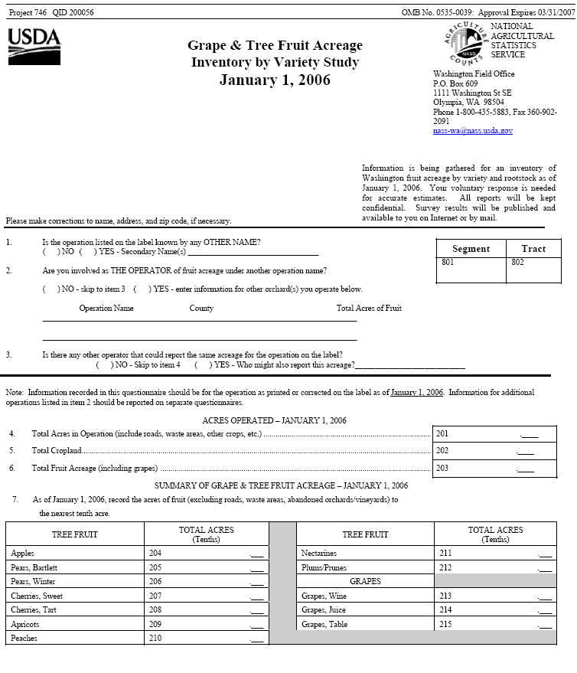
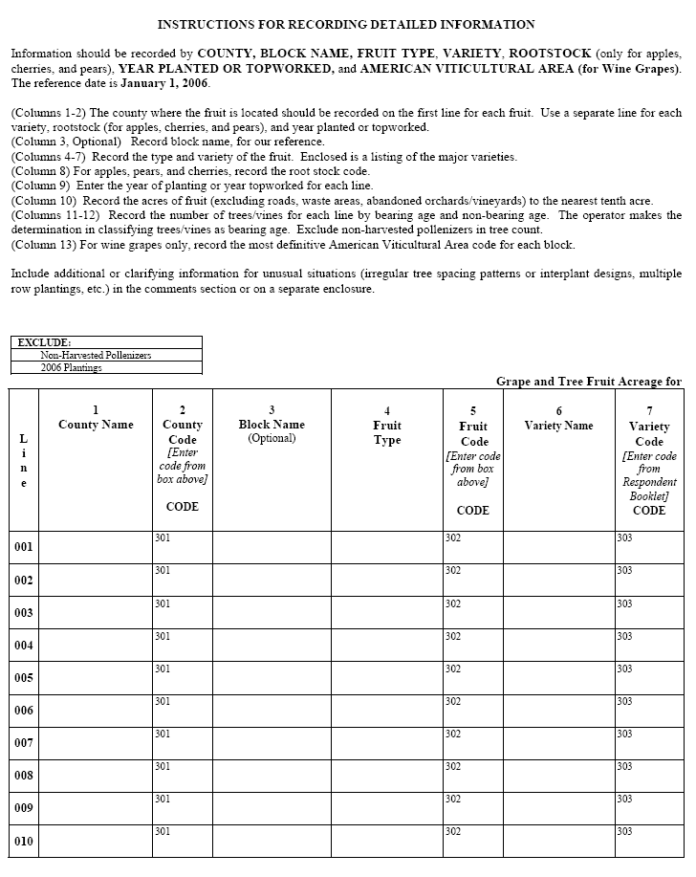
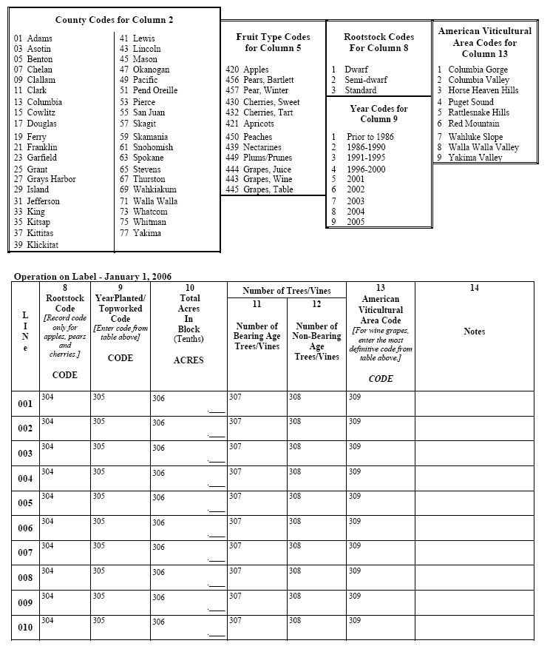
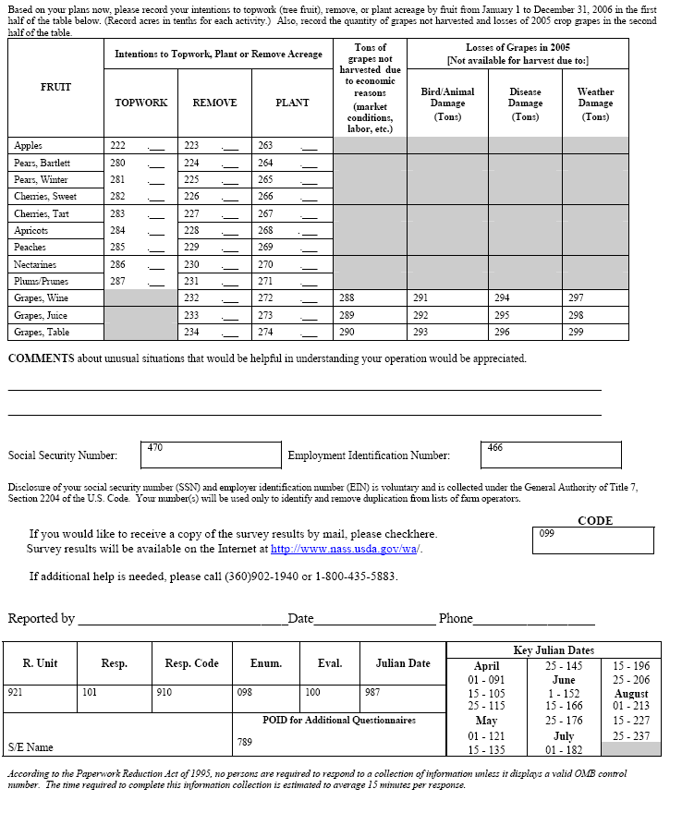

Respondent Booklet 2006 Grape and Fruit Tree Acreage Study
COUNTY CODES - Column 2
1 | Adams |  | 445 | Grapes, Table | 207 | Patterson
3 | Asotin |  | 439 | Nectarines | 209 | Perfection
5 | Benton |  | 450 | Peaches | 210 | Puget Gold
7 | Chelan |  | 456 | Pears, Bartlett | 211 | Riland
9 | Clallam |  | 457 | Pears, Winter | 213 | Rival
11 | Clark |  | 449 | Plums & Prunes | 215 | Sun-glo
13 | Columbia |  |  |  | 217 | Tilton
15 | Cowlitz |  |  |  | 219 | Tomcot
17 | Douglas |  | VARIETY CODES - Column 7 |  | 205 | Wenatchee Moorpark
19 | Ferry |  |  |  | 298 | Other
21 | Franklin |  | APPLE VARIETIES
23 | Garfield |  | 103 | Akane
25 | Grant |  | 104 | Ambrosia | CHERRY (All) VARIETIES
27 | Grays Harbor |  | 105 | Braeburn | 301 | Attika
29 | Island |  | 107 | Cameo | 302 | Balaton (Tart Cherry)
31 | Jefferson |  | 109 | Chehalis | 304 | Benton
33 | King |  | 110 | Crimson Gold | 303 | Bing (excl Sunset Bing)
35 | Kitsap |  | 149 | Cripps Pink (Pink Lady | 305 | Black Republican
37 | Kittitas |  | 113 | Criterion | 310 | Black Tartarian
39 | Klickitat |  | 114 | Earligold | 306 | Brooks
41 | Lewis |  | 116 | Elstar (Valstar) | 308 | Casmer
43 | Lincoln |  | 117 | Fuji / Red Fuji | 307 | Chelan
45 | Mason |  | 102 | Gala | 309 | Chinook
47 | Okanogan |  | 119 | Ginger Gold | 312 | Cristalina
49 | Pacific |  | 121 | Golden Delicious | 332 | Dnoex
51 | Pend Oreille |  |  | (Standard) | 314 | Early Robin
53 | Pierce |  | 120 | Golden Delicious | 316 | Emperor Francis
55 | San Juan |  |  | (Smoothee / Gibson) | 318 | Gold
57 | Skagit |  | 122 | Golden Supreme | 328 | Index
59 | Skamania |  | 123 | Granny Smith | 311 | Lambert
61 | Snohomish |  | 125 | Gravenstein | 313 | Lapins
63 | Spokane |  | 127 | Honeycrisp | 320 | Montmorency (Tart Cherry)
65 | Stevens |  | 131 | Jonagold | 315 | Rainier
67 | Thurston |  | 133 | Jonathan (Ruby Jon) | 317 | Regina
69 | Wahkiakum |  | 139 | McIntosh | 319 | Royal Ann
71 | Walla Walla |  | 158 | Prime Gold | 322 | Sam
73 | Whatcom |  | 101 | Red Delicious | 324 | Sandra Rose
75 | Whitman |  | 156 | Rome (Red Rome) | 326 | Santina
77 | Yakima |  | 155 | Spartan | 330 | Schneider
 |  |  | 157 | Winesap | 333 | Selah (Liberty Bell)
FRUIT TYPE CODES – |  |  | 198 | Other | 321 | Skeena
Column 5 |  |  |  |  | 323 | Sonata
 |  |  | APRICOT VARIETIES |  | 325 | Stella
420 |  | Apples | 202 | Blenheim | 334 | Sumleta
421 |  | Apricots | 221 | Casselbrite | 335 | Sumnue
430 |  | Cherries, Sweet | 220 | Chinese | 338 | Sunset Bing
432 |  | Cherries, Tart | 201 | Goldbar | 327 | Sweetheart
444 |  | Grapes, Juice | 206 | Goldcot | 329 | Tieton
443 |  | Grapes, Wine | 203 | Goldrich | 336 | Ulster
 |  |  | 204 | Goldstrike | 331 | Van
 |  |  | 222 | Moorpark | 337 | Zing
 |  |  |  |  | 398 | Other

GRAPES, JUICE VARIETIES |  | 967 | Souzao | 532 | Brendasun
901 | Concord | 968 | Syrah | 575 | Canadian Harmony
902 | Niagara | 969 | Tempranillo | 576 | Coral Star
908 | Other | 970 | Tinta Madeira | 504 | Cresthaven
 |  | 971 | Tinto Cao | 530 | Crimson Lady
GRAPES, TABLE VARIETIES |  | 972 | Touriga | 508 | David Sun
918 | All Varieties | 973 | Viognier | 503 | Delta
 |  | 974 | White Zinfandel | 505 | Diamond Princess
GRAPES, WINE VARIETIES |  | 975 | Zinfandel | 507 | Elberta
920 | Aligote | 998 | Other | 509 | Elegant Lady
921 | Aurore | NECTARINE VARIETIES |  | 580 | Encore
922 | Barbera | 406 | Arctic Glo | 511 | Fancy Lady
923 | Cabernet Franc | 402 | Arctic Pride | 513 | Flamecrest
924 | Cabernet Sauvignon | 401 | Arctic Queen | 514 | Flaming Fury
925 | Campbell Early (Island Belle) | 408 | Arctic Rose | 515 | Flavorcrest
926 | Carmenere | 427 | August Red | 581 | Glohaven
927 | Cascade | 428 | Autumn Red | 517 | Glory
928 | Chardonnay | 403 | Bright Pearl | 582 | Glowingstar
929 | Chasselas | 429 | Byrd | 516 | Gold Medal
930 | Chenin Blanc | 404 | Crystal Rose | 518 | Golden Alberta
931 | Cinsaut | 416 | Early Red | 583 | Golden Jubilee
932 | Cournoise | 430 | Fairlane | 584 | Goldnine (Arkansas 9)
933 | Dolcetto | 405 | Fantasia | 519 | Hale
934 | Gamay Beaujolais | 418 | Fire Sweet | 521 | John Henry
935 | Gamay Noir | 407 | Firebrite | 534 | June Lady
936 | Gewurztraminer | 431 | Fireburst | 520 | July Sun
937 | Golden Muscat | 432 | First Red | 523 | June Pride
938 | Grenache | 433 | Flame | 524 | Jupiter
939 | Joffre | 409 | Flavortop | 525 | Lady Nancy
940 | Lemberger | 410 | Independence | 585 | Loring
941 | Leon Milot | 434 | Laurie Red | 586 | M A Blake
942 | Madeline Angevine | 411 | Red Gold | 587 | Madison
943 | Madeline Sylvaner | 413 | Scarlet Sun | 588 | Newhaven
944 | Malbec | 435 | September Red | 527 | NJ252
945 | Marechal Foch | 436 | Sparkling Red | 529 | O'Henry
946 | Merlot | 412 | Spring Brite | 531 | PF series (PF Lucky 13)
947 | Mouverdre | 414 | Spring Diamond | 590 | Red Freemont
948 | Mueller-Thurgau | 437 | Summer Beaut | 589 | Red Freemont
949 | Muscat Canelli | 417 | Summer Blush | 533 | Red Glove
950 | Muscat of Alexandria | 415 | Summer Bright | 519 | Red Hale
951 | Muscat Ottonel | 419 | Summer Fire | 535 | Red Haven
952 | Nebbiolo | 438 | Summer Grand | 591 | Red Lady
953 | New York Muscat | 439 | Sunfree | 536 | Red Top
954 | Okanogan Riesling | 423 | Sun Glo | 592 | Redglobe
955 | Orange Muscat | 421 | Supreme Red | 593 | Redskin
956 | Petit Verdot | 424 | Sweet Scarlet | 594 | Redstar
957 | Pinot Blanc | 425 | Western Pride | 537 | Regal
958 | Pinot Gris | 426 | Zee Gold | 539 | Regina
959 | Pinot Noir | 498 | Other | 541 | Rich Lady
960 | Riesling | PEACH VARIETIES |  | 542 | Rio oso Gem
961 | Rousanne | 570 | Allstar | 543 | Risingstar
962 | Royalty | 501 | Angelus | 545 | Rosa
963 | Sangiovese | 571 | Arctic Gem | 547 | Ryan Sun
964 | Sauvignon blanc | 510 | August Lady | 548 | Saturn
965 | Semillon | 572 | Avalon | 538 | Scarlet Lady
966 | Siegerrebe | 573 | Baby Gold 5 | 568 | Siera Lady
 |  | 574 | Blazingstar | 549 | Sierra Gem
 |  | 502 | Blushing Star | 550 | Snow Fire

 |  |  |  | 813 | Friar
563 | Summer Sweet |  |  | 809 | Late Italian (Standard Italian)
564 | Suncrest
526 | Tiffany Rose |  |  | 814 | NY 6
528 | Veteran |  |  | 816 | NY 9
540 | White Hale |  |  | 815 | President
506 | White Donut |  |  | 819 | Santa Rosa
565 | White Lady |  |  | 821 | Shiro
567 | Zee Lady |  |  | 822 | Simka
598 | Other |  |  | 823 | Stanley
 |  |  |  | 810 | Yellow Egg
PEAR (BARTLETT) VARIETIES |  |  |  | 898 | Other
601 | Bartlett (other)
605 | Bartlett (red strains, Red Sensation)
698 | Other |  |  | ROOTSTOCK CODES FOR APPLES, PEARS AND
 |  |  |  | CHERRIES - Column 8
PEAR (WINTER) VARIETIES
701 | Asian |  |  | 1 | Dwarf
703 | Bosc |  |  | 2 | Semi-dwarf
720 | Bosc, Golden |  |  | 3 | Standard
704 | Cascade
705 | Comice |  |  | YEAR CODES - Column 9
707 | Concorde
709 | D'Anjou |  |  | 1 | Prior to 1986
711 | D'Anjou, Red |  |  | 2 | 1986-1990
712 | Kalle |  |  | 3 | 1991-1995
713 | Packham |  |  | 4 | 1996-2000
715 | Red Clapp |  |  | 5 | 2001
717 | Seckel |  |  | 6 | 2002
719 | Taylors Gold |  |  | 7 | 2003
798 | Other |  |  | 8 | 2004
 |  |  |  | 9 | 2005
PLUM & PRUNE VARIETIES |  |  |  | AMERICAN VITICULTURAL AREA CODES - Column 13
801 | Autumn Sweet |  |  | 1 | Columbia Gorge
803 | Black Amber |  |  | 2 | Columbia Valley
802 | Bluefre |  |  | 3 | Horse Heaven Hills
804 | Castleton |  |  | 4 | Puget Sound
812 | Catalina |  |  | 5 | Rattlesnake Hills
806 | Damson |  |  | 6 | Red Mountain
805 | Duarte
807 | Early Italian |  |  | 7 | Wahluke Slope
808 | Elephant Heart |  |  | 8 | Walla Walla Valley
811 | Empress |  |  | 9 | Yakima Valley

Acres, Number of Trees and Trees per Acre for Major Tree Fruits, 2001 - 2004, Washington, January 1, 2006 1/
Fruit | Year Planted | Acres | Total Trees | Trees/Acre
Apples 2/ | 2001 | 6,096 | 3,357,904 | 551
 | 2002 | 6,225 | 3,056,330 | 491
 | 2003 | 5,319 | 2,529,428 | 476
 | 2004 | 3,504 | 1,959,752 | 559
Bartlett Pear 3/ | 2001 | 77 | 18,570 | 241
 | 2002 | 154 | 22,523 | 146
 | 2003 | 132 | 43,080 | 326
 | 2004 | 284 | 90,400 | 318
Winter Pear 3/ | 2001 | 135 | 51,055 | 378
 | 2002 | 147 | 62,021 | 422
 | 2003 | 71 | 23,690 | 334
 | 2004 | 233 | 66,760 | 287
Sweet Cherries 3/ | 2001 | 2,413 | 857,958 | 356
 | 2002 | 1,726 | 410,124 | 238
 | 2003 | 1,263 | 281,608 | 223
 | 2004 | 1,638 | 404,088 | 247
1/ At the request of a researcher, additional data was provided for total apple, Bartlett pear, winter pear and sweet cherry acreage and number of trees by year planted for four individual years that had originally been published as two biennial periods. The original time periods were 2001-2002 and 2003-2004.
2/ Released April 24, 2007
3/ Released November 9, 2007
( - ) Withheld to avoid disclosing data for individual farms or no data reported.

Acreage, by Fruit, Washington, Historical Comparisons
Apples
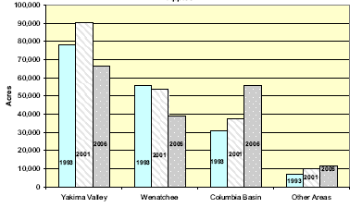
Sweet Cherries
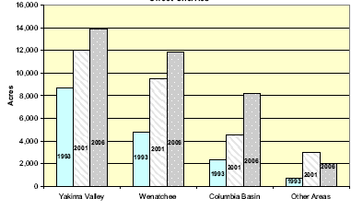
Winter Pears
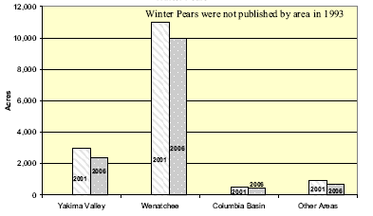
Bartlett Pears
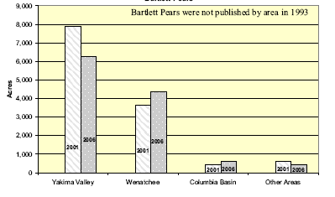
Peaches
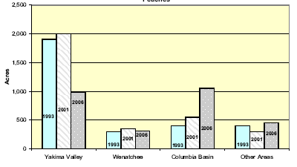
Nectarines
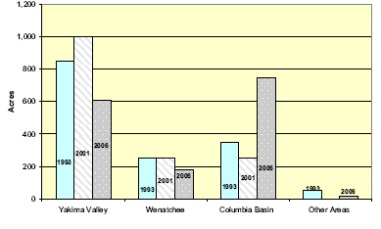
Apricots
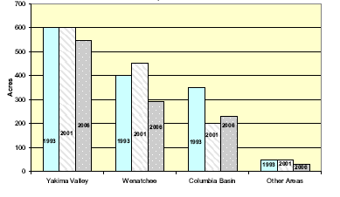
Prunes and Plums
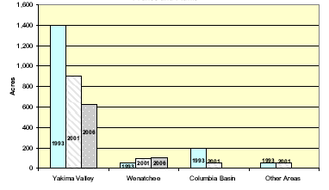

Apples: Acres by Age, 2001 and 2006 Survey Results
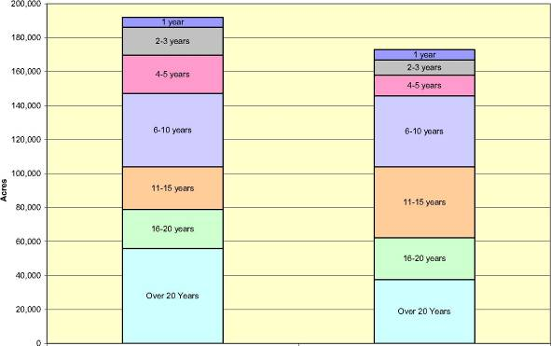

Apples: Trees/Acre by Rootstock, by Variety, Washington, January 1, 2006
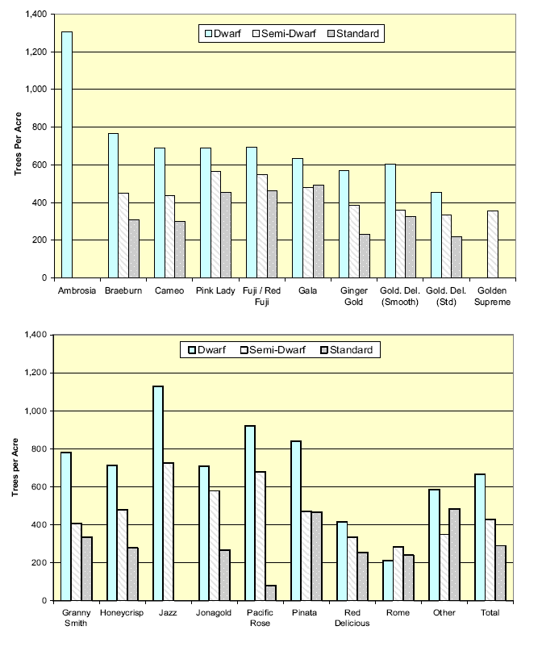

Sweet Cherries: Trees/Acre by Rootstock, by Variety, Washington, January 1, 2006
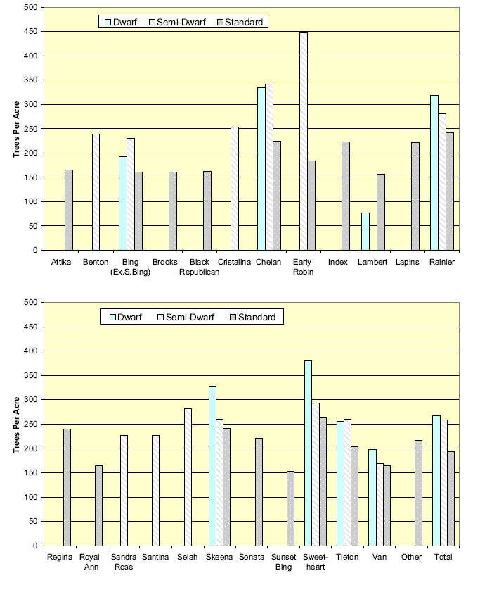

Apples: Acres by Selected Varieties, 2001 and 2006 Survey Results
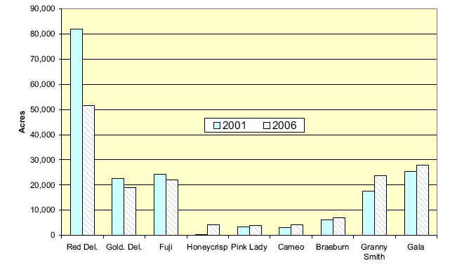

Sweet Cherries: Acres by Selected Varieties, 2001 and 2006 Survey Results
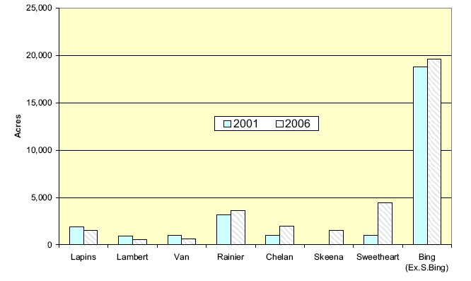

Apples: Trees/Acre by Selected Varieties, Washington, January 1, 2006
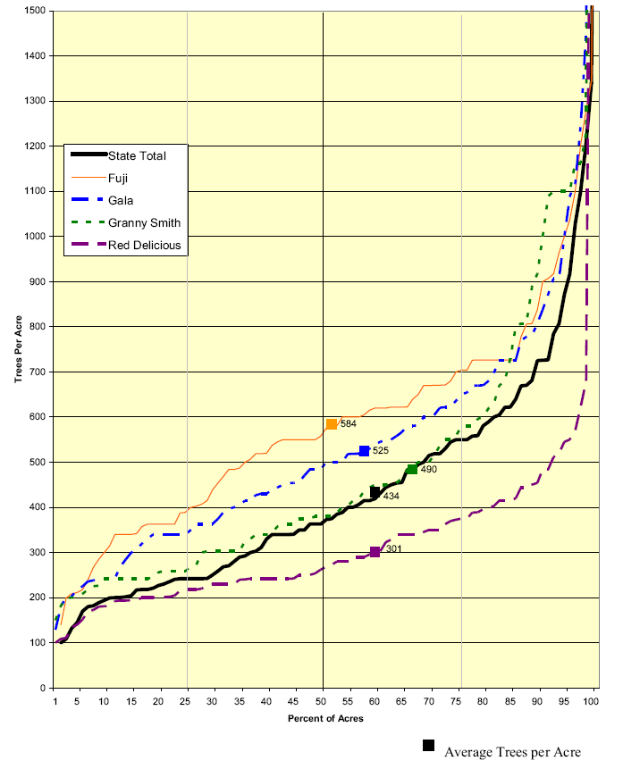

Apples: Trees/Acre by Rootstock, Washington, January 1, 2006
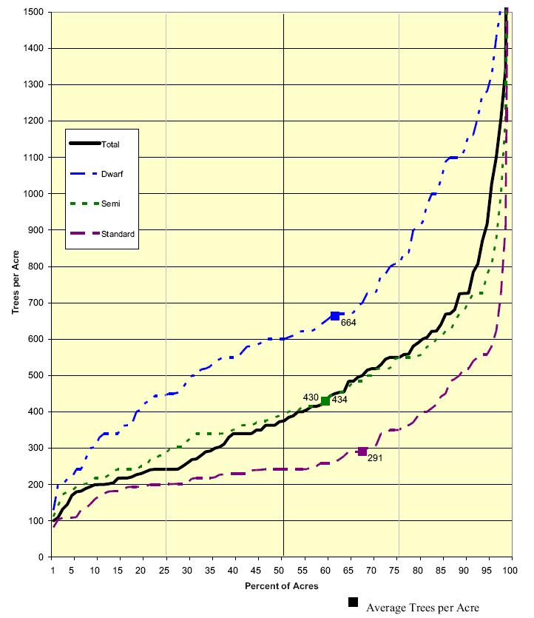

Sweet Cherries: Trees/Acre by Selected Varieties, Washington, January 1, 2006
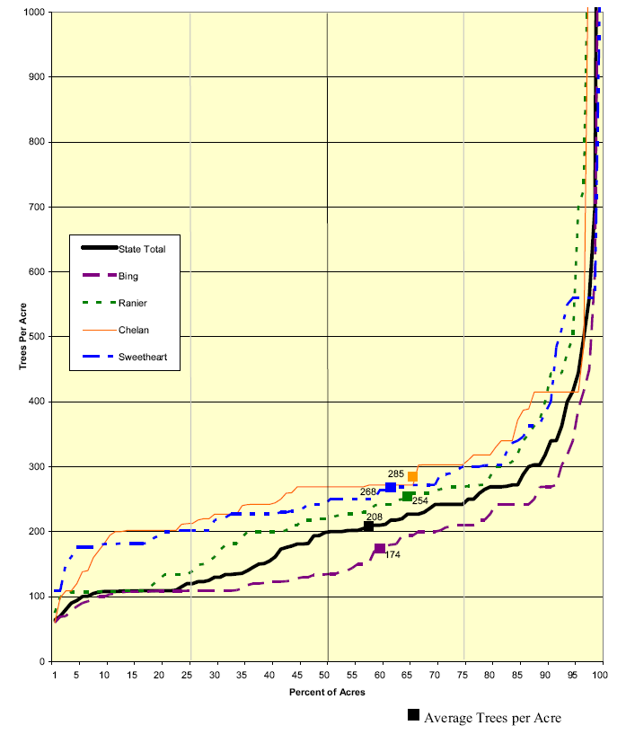

Sweet Cherries: Trees/Acre by Rootstock, Washington, January 1, 2006
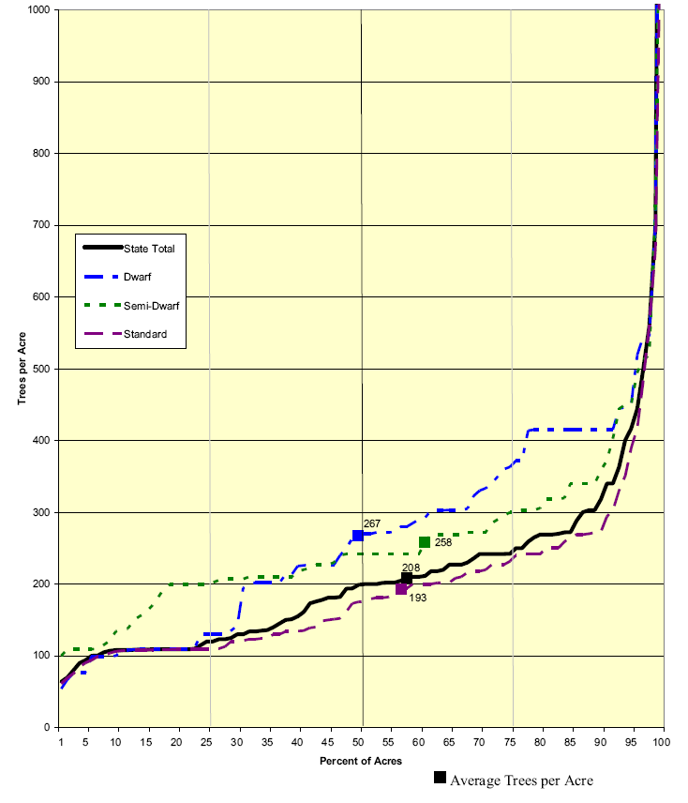

Pears: Trees/Acre by Type, Washington, January 1, 2006
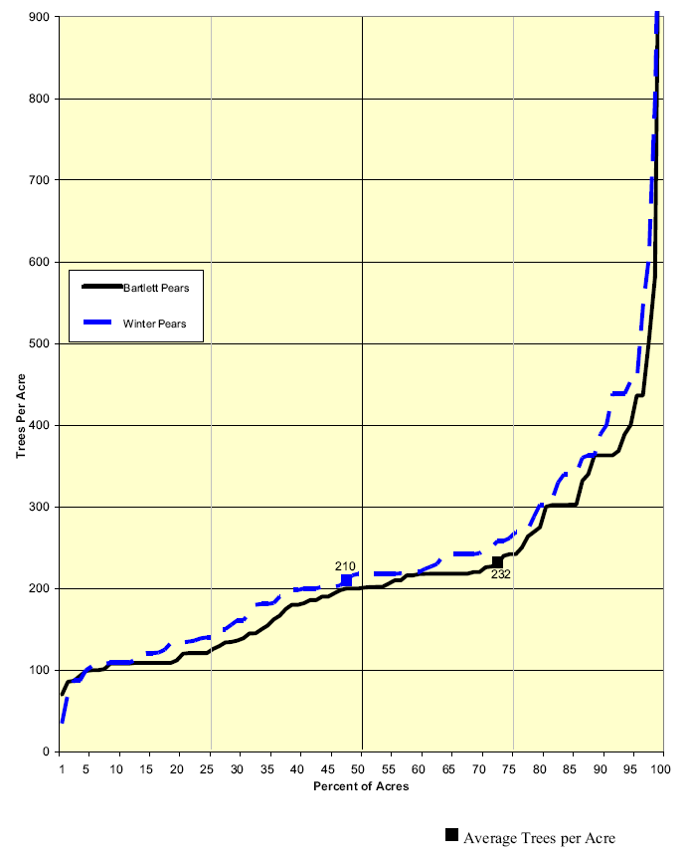

Usual Bloom and Harvest Dates, Washington
Area | Usual Dates of Full Bloom | Usual Harvesting Dates
Area | Usual Dates of Full Bloom | Begin | Most Active | Ends
Lower Yakima Valley 1/
Apples | April 25 | August 15 | September 10-October 25 | November 10
Apricots | March 28 | July 5 | July 5-July 10 | July 20
Sweet Cherries | April 15 | June 15 | June 25-June 30 | July 20
Peaches | April 12 | July 15 | August 20-September 5 | September 25
Pears, Bartlett | April 20 | August 10 | August 15-August 25 | August 30
Pears, Other | April 20 | September 5 | September 20-October 5 | October 20
Plums/Prunes | April 20 | August 20 | August 20-August 25 | October 1
Upper Yakima Valley 2/
Apples | April 30 | September 1 | September 15-October 25 | November 1
Apricots | April 5 | July 20 | July 20-July 25 | August 1
Sweet Cherries | April 20 | June 25 | July 1-July 5 | July 30
Pears, Bartlett | April 25 | August 15 | August 25-September 10 | September 25
Pears, Other | April 25 | September 10 | October 10-October 20 | October 30
Prosser-Kennewick
Apricots | March 20 | June 25 | July 5-July 10 | July 15
Sweet Cherries | April 10 | June 10 | June 15-June 20 | June 20
Peaches | April 10 | July 10 | August 10-August 20 | August 25
Plums/Prunes | April 15 | August 15 | August 25-September 5 | September 15
North Central River Zone 3/
Apples | April 28 | August 10 | August 25-October 20 | November 10
Apricots | April 5 | July 1 | July 4-July 20 | July 20
Sweet Cherries | April 15 | June 2 | June 24-July 4 | July 10
Peaches | April 15 | July 20 | August 10-September 10 | September 15
Pears, Bartlett | April 17 | August 10 | August 15-August 25 | August 30
Pears, Other | April 17 | September 5 | September 10-September 20 | September 25
North Central Intermediate Zone 4/
Apples | May 5 | October 1 | October 1-October 10 | November 1
Sweet Cherries | April 25 | July 1 | July 5-July 20 | August 1
Pears, Bartlett | April 25 | August 15 | August 20-August 30 | September 5
Pears, Other | April 25 | September 10 | September 15-October 1 | October 10
North Central Upper Zone 5/
Apples | May 10 | October 5 | October 5-October 10 | November 5
Pears, Bartlett | May 5 | August 21 | September 1-September 5 | September 10
Pears, Other | May 5 | September 20 | September 25-October 5 | October 10
Columbia Basin
Apples | April 20 | August 10 | August 25-October 15 | October 30
Apricots | April 1 | July 1 | July 10-July 25 | July 30
Sweet Cherries | April 10 | June 5 | June 10-June 15 | July 25
Tart Cherries | April 25 | July 1 | July 5-July 15 | July 20
Peaches | April 10 | July 5 | July 5-July 30 | August 5
Pears, Bartlett | April 15 | August 10 | August 15-August 30 | September 10
Pears, Other | April 20 | August 25 | September 1-September 20 | September 30
1/ Lower Yakima Valley is from Prosser to Union Gap below the City of Yakima.
2/ Upper Yakima Valley is the area around the City of Yakima and extending northwest along the Naches River.
3/ Wenatchee River Zone is the river bottom lands extending from Wenatchee to the Canadian Border.
4/ Wenatchee Intermediate Zone is locations above river bottom lands, such as Cashmere, Entiat, Lake Chelan, Manson, Omak, and Okanogan.
5/ Wenatchee Upper Zone is locations which approach the 2,000 foot elevation mark, such as Peshastin, Leavenworth, Ardenvoir, and Methow Valley.

