

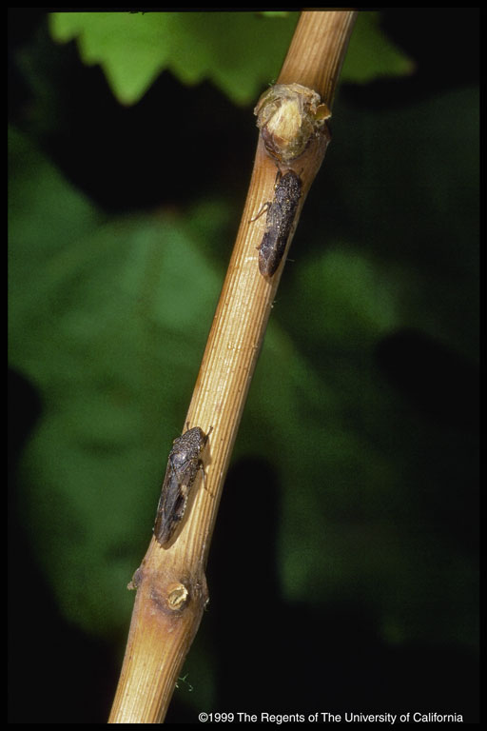
REPORT ON PIERCE’S DISEASE AND
THE GLASSY WINGED SHARPSHOOTER

Report commissioned by
Agriculture Fisheries & Forestry Australia

Dr Nigel Scott Dr Paul De Barro
PLANT INDUSTRY ENTOMOLOGY
E-MAIL: nigel.scott@pi.csiro.au E-MAIL: Paul.DeBarro@brs.ento.csiro.au
Phone: 61 8 8303 8626 Phone: 61 7 3214 2811
Fax: 61 8 8303 8601 Fax: 61 7 3214 2885

PIERCE’S DISEASE (PD) AND THE GLASSY WINGED SHARPSHOOTER (GWSS)

A report on Pierce’s Disease and the Glassy Winged Sharpshooter in California with reference to the Australian grape industry

Nigel Scott and Paul De Barro, CSIRO

Following a request from Mr Michael Taylor, Secretary of AFFA to CSIRO, Nigel Scott and Paul De Barro from the Divisions of Plant Industry and Entomology respectively visited California in October 2000 to view first hand the effects of Pierce’s Disease and glassy winged sharpshooter in the Californian horticultural situation with particular reference to grapes. The visit was hosted by the American Plant Health Inspection Service (APHIS), Mr Mike Guidicipietro and by the Californian Department of Food and Agriculture, Dr Stephen Brown who arranged the itinerary following discussion with the CSIRO staff.

SUMMARY
The history of the recent arrival of glassy winged sharpshooter (GWSS) as a serious threat to horticulture in California, let alone viticulture, and the currently increasing rates of infestations of horticultural areas indicate that the situation is changing rapidly. Without stability in California it is difficult to make a real assessment of the risks involved in importing table grapes into Australia. Higher overall GWSS infestation rates in California may significantly increase the risk of insects finding their way into table grape boxes.

RECOMMENDATIONS

In order to ensure that there is a low risk of GWSS reaching Australia, the following procedures should have priority:

- Experiments to establish the survival time of GWSS insects at low temperatures (0 – 1⁰C) both in the summer and autumn phases of their life cycle. This would provide the highest level of security.

- Evidence as to the efficacy of methyl bromide on mortality of these insects should be provided under the packaging regime proposed.

- Evidence as to the levels of methyl bromide concentrations achieved within bunches of grapes packed within plastic bags within the proposed packages within the containers to be sent to Australia. As indicated in this report available evidence suggests that the international standard of 32g/m³ for 2 h at 21⁰C methyl bromide concentrations will not be reached.

- Methyl bromide fumigation if accepted to be carried out following harvest and prior to chilling in the United States to ensure that methyl bromide fumigation takes place at effective temperatures and to avoid any risk of inadvertent escape of insects that might survive a trip to Australia before fumigation.

Additional Comments

The threat to viticulture posed by GWSS and Pierce’s Disease is not confined to import of table grapes. The occurrence of this insect, its transport on Californian ornamental nursery stock and its polyphagous nature plus the wide range of Xylella pathotypes recorded indicates that this insect and the disease would pose a serious threat to the agricultural and horticultural industries of Australia.

Recommendation

Every effort should be made to ensure that GWSS does not arrive in Australia through sources other than table grapes.

Background

Pierce’s Disease (PD), a bacterial disease of grapes and its associated sharpshooter vectors has been known in California and other parts of the Americas for many years. Until recently the vectors associated with the disease were found almost exclusively in riparian areas and viticulture has co-existed with the disease by avoiding these areas. There is no treatment for vines infected with PD and they die within two to three years of infection. Consequently viticulture in California has been confined to non-riparian areas and the occasional vine, which has been infected by far ranging sharpshooters, is removed. In some cases a cordon infected by riparian sharpshooters can be removed from a vine by pruning.

The situation has changed dramatically in the last two to three years with the advent of the glassy winged sharpshooter Homalodisca coagulata. Anecdotal information provided to us by Dr Phil Phillips suggests that the insect has been recorded from time to time in California for many decades. However in 1990-1993 increased numbers of the insect began to appear and by 1997/98 the numbers and habits of this insect were causing serious concern to the viticultural industry as well as other horticultural industries. The threat this insect poses is due in part to the strength of its mouth parts which enables it to penetrate much tougher tissue such as partly lignified grapevine stems and thus have more available infection sites on the plant and in part to its almost universal adaptation to the Californian habitat be it home gardens, viticulture, plant nurseries (a particular hazard), citrus, almonds and a wide range of other host plants.

The polyphagous nature of this insect means that it is capable of spreading PD widely through the viticultural areas of California with no apparent ecological barrier to its movement. We were shown a small new vineyard in Ventura County which may well have survived the riparian sharpshooters and PD in earlier times but was now 30% infected with PD following the year 2000 season’s feeding by the GWSS. The vineyard looked unlikely to survive in the longer term. Anecdotal information reported to us suggests that areas of Temecula are no longer viable for viticulture because of the disease and the insect.

The situation is still changing rapidly in California and in a recent e-mail Dr Phil Phillips gave it as his opinion that the insect was still on the increase throughout California. The map of California showing the infested and threatened areas (Appendix 1) supports this view. In December 2000 a meeting was convened at the University of California, Davis to consider what information was available and actions to take on the insect and the disease. After this meeting Professor M.A. Walker, UC Davis in a personal communication to us in January 2001 reported that there is “a huge information gap in basic and applied aspects of this problem”.

Pierce’s Disease

Pierce’s Disease is caused by a bacteria Xylella fastidiosa a systemic disease of the plant in the xylem. There is no treatment for the disease in grapevines and infected vines die. In some cases an infected cordon can be removed from a vine by pruning, however with the advent of minimal and mechanical pruning, together with GWSS vectoring disease inoculation into lignified tissue, pruning is not a practical option. The spread of the disease is by xylem feeding insects. There are a large number of strains of Xylella many of which do not cause disease in grapevines. A recent study of Xylella strains isolated from a range of perennial and annual plants showed that those found in grapevines were unique and in a few cases had some commonality with some of the strains found in almonds. They did not appear to be closely related to strains found in other plants such as plums, peach, oak and oleander (Hendson et al., 2001). While not relevant to this report it is probable that GWSS would have similar abilities in spreading other strains of Xylella in plants other than grapevines were the insect to establish in Australia.

Xylem feeding insects which could vector PD, do exist in Australia but their habitat is largely grasses and soft tissue plants. It is unlikely that they would infect grapevines. If they did, the problem of spread of PD if it were to establish in Australia would be similar to that which was occurring in California prior to the advent of GWSS, that is the disease spread would be restricted by the habitat of the insects in question. There are no known insects of the GWSS sub-family recorded in Australia.

The spread of PD in mature grapevines is slow and in part depends on the infection point. In the first year only one arm of a grapevine may be infected and show symptoms. We do not have data on the spread of the bacteria in the vine but it appears likely that in a previously healthy, recently infected vine it would be possible to conceive a situation in which an infected table grape bunch that was recently infected but non symptomatic, could get into a box of berries transmitted to Australia. In such case the titre of bacteria will be low and will reduce further during storage and shipping as Xylella suffers high mortality at temperatures around 4°C (Purcell and Saunders, 1995). Bunches of grapes from vines which are expressing symptoms of PD are unlikely to be picked as they would show varying degrees of shrivelling.

Purcell and Saunders (1995) showed that the riparian types of sharpshooters were unable to feed on lignified tissue such as the rachis of grape bunches and for the same reason it is unlikely that any xylem feeding Australian member of the Cicadellidae could feed on discarded stems and rachis. These stylets are also unlikely to be long enough to reach the xylem in berries.

In intact plants the xylem is under negative pressure and insects need to pump fluid from the xylem in order to feed (Raven 1983). Once cut there will be no xylem tension thus as long as the bunch and the rachis is in good condition, a xylem feeding insect with the capacity to penetrate the rachis xylem could acquire xylem fluid. It is possible that GWSS could pick up infected xylem material from the rachis of such infected bunches but the titre of bacteria acquired by the insect in this way would be extremely low.

In these scenarios Xylella would be acquired by xylem feeding insects at very low concentration and would have to multiply in the foregut of the insect before the insect could obtain an infectious load of Xylella. There is no data to establish whether or not this happens. Xylella is transmitted by all stages of GWSS, but infectivity is lost after moulting as the bacterium is not circulatively transmitted.

On available data bunches are a very low risk for entry of the bacterium and a lower risk as a source of Xylella for a vector.

The discussion of PD above makes it clear that the main issue in the spread or establishment of this disease is the availability of a vector. Without a vector the disease poses no serious threat to Australian viticulture.

Glassy winged sharpshooter

The on-going and as yet unfinished experience with GWSS in California shows that every effort should be made to ensure that this insect does not arrive in Australia not only from the point of view of viticulture, the subject of this report, but for many other horticultural and agricultural industries.

The rapid spread of GWSS in California in the last three to four years has been noted in industry articles (Phillips 1998) and is shown by the size of the infested areas published by CDFA, (Appendix 1) with all but one southern County infested and virtually all Counties at risk.

There are two likely reasons for this rapid spread. The first is the shift from the broad spectrum insecticides to more narrowly active insecticides. This has led to a resurgence in the numbers of sap-sucking insects that had previously been suppressed.

The second is the relatively slow rate of population increase characteristic of a bivoltine (2 generations/year) species such as GWSS. The initial incursion or population was probably a few individuals quite possibly from egg batches. With a two generations per year rate of increase it is likely to take at least six or ten years before such a pest becomes noticeable. It seems likely that GWSS numbers and the area infested will continue to increase until much of California is included. There is no evidence that the rate of spread is slowing and in a response to recent questions, Dr Phil Phillips of CDFA gave us his opinion that the rate of infestation and the area of infestation was still increasing (personal communication 29/11/2000). This anecdotal information is backed up by the unexpected occurrence of an outbreak recorded in Tulare County in late October where significant numbers of GWSS were discovered in a packing house (CFBFA alert 1/11/2000).

In the early part of the table grape season in the United States, May, June and July, the insect is extremely active and all forms can be found in the vineyards and in other orchards. From August to November juvenile life stages are not present and adults become increasingly rare. Eggs occasionally occur but are very uncommon. Reproduced below is the generalized life cycle of GWSS produced by the University of California extension service.

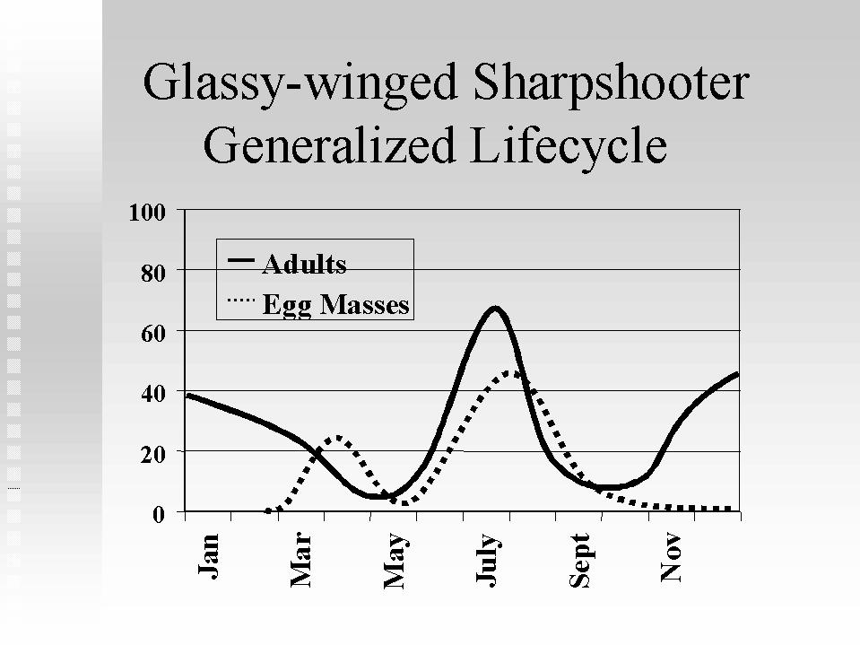From UC Davis Cooperative Extension Service

The risk of the insect arriving in Australia must be in some part related to the number of insects in the source areas from which table grape exports originate. Thus in the early part of the table grape season when the insect is extremely active and all forms of the insect can be found in vineyards and in other orchards the risk must be higher. In August to November juvenile life stages are not present and adults become more rare. Eggs occasionally occur but are very uncommon. The risk may be lower at these times. We were told that there have been no observations of eggs laid on berries or bunches and that the maximum number of insects would appear to be present from June onwards. Their habitats in later parts of the year are not clear, but the report from the Tulare County packing shed referred to above is disturbing as this indicates an infestation in an hitherto unreported area, namely a packing shed. We were told that most, if not all, table grapes were packed in the field but may still pass through a packing shed for palletizing or containerization. This observation highlights the necessity of packing shed hygiene as GWSS could find its way into packaging and products stored in the sheds.

RECOMMENDATION

If field packed table grapes pass through a packing shed or are packed in a packing shed then the packing shed should also be inspected for GWSS infestation.

The activity of the insect is temperature dependent. The following points related to GWSS are a collection of largely undocumented observations and anecdotal information we acquired while talking to all those involved. They were consistent with our own observations and our knowledge of the insect. We have no reason to doubt them.

At temperatures above 60°F (15°C) the insect undergoes short flights and hops while above 65°F the insect flies readily. There is no night picking of table grapes and it is likely that much of the picking period will be above 65°F and GWSS will be able to fly.

In weather below 15°C the insect falls from the trees to the ground and thus could fall from vine to grape picking boxes. In this situation it also tends to return to its previous position as after falling from the tree or vine it reorientates itself in the direction of the trunk, crawls back to the trunk and up the tree.

There is no evidence that eggs are laid on any part of the grape bunch including the stem rachis and berry. Eggs are only found on the underside of leaves. Grapevines are a less preferred host for GWSS but will suffer from serious infestations if they are adjacent to either infested nurseries or to citrus. Unlike the other common sharpshooters the proximity to riparian habitats does not affect the occurrence of GWSS.

There are many other hosts for GWSS including the ubiquitous oleander which lines Californian highways but these hosts are not necessarily hosts to the grape infecting strains of Xylella. Hosts for GWSS can be divided into feeding hosts and egg-laying hosts although eggs laid onto some hosts species do fail to hatch.

Survival of GWSS under adverse conditions

GWSS generates ammonia as a waste product which is toxic to the insect. It thus has a very high requirement for water throughput which accounts for the individual insects passaging as much as 15ml of water per insect per day (Anderson et al 1989). The population chart above suggests that significant numbers of GWSS over winter in California but their water requirements, ammonia production and survival characteristics during this period are not known.

Phil Phillips reported to us experiments which he had done with caged insects showing that above 60°F in the absence of a food source there was 100% mortality in two to three days. At the lower temperatures encountered in September, October, November in California, up to four days’ survival without feeding had been observed. In cold weather the insects appeared to be immobilised. The probability of survival at 0 –1^{O}C is unknown.

APHIS has commissioned experiments to determine the life span of insects at low temperatures. Guidicipietro (e-mail of 1/12/2000) has reported that the two experiments done so far have given equivocal results and no data is yet available. A third experiment is reportedly in progress but no results are yet available and he states that it may be that insects can survive at low temperature.

There is no data on methyl bromide toxicity of this insect but it seems likely that standard methyl bromide fumigation conditions would kill the insect. Given the seriousness of an Australian infestation this should be checked.

RECOMMENDATION

Normally it is not practical to check methyl bromide toxicity on every insect of quarantine concern. However, given the serious consequences of an infestation by this insect, its sensitivity to methyl bromide should be checked.

Studies by Harris et al. (1984) showed that in TKV boxes with grapes packed into transparent perforated polyvinyl bags, MeBr concentrations achieved within the bags were marginal with respect to the required level of 32g/m³ for 2 h at 21⁰C. In the extruded polystyrene boxes the concentrations achieved were well below the specified levels. Whether packed in TKV or extruded polystyrene boxes the table grapes we saw were sub-packed in perforated whole plastic bags before being packed extremely tightly into the boxes. It seems very unlikely that methyl bromide would penetrate these tightly packed boxes and achieve the required concentrations within the polyvinyl bags to kill any insects. The data from Harris et al. (1984) would appear to support this conclusion.

RECOMMENDATION

If methyl bromide fumigation is proposed and accepted as a way of controlling potential GWSS infestations of table grape shipments, we unequivocally recommend that the concentration of MeBr be measured within grape bunches within the plastic bags within the tightly packed polystyrene and TKV boxes. We also recommend that any fumigation be performed before cooling storage and transport of grapes to avoid any risks associated with fumigation at destination.

In California there has been a restriction on the movement of bulk wine grapes from infested areas and all movements have been inspected. In 40,000 shipments so far no insects have been detected in any. There is no restriction on the movement of table grapes in California from infested areas. In Southern Kern County from mid June to August 2000, 10,000 cartons of table grapes from infested vineyards adjacent to infested citrus orchards have been inspected. No GWSS were recovered. At these times as indicated above all life stages would have been present in infested vines. Between 1/7/98 and 3/6/99 there had been 2,791 phytosanitary inspections certifying 10,125,722 cartons of table grapes. These involved 156,063 cartons being inspected. During this period there were lower levels of GWSS than had been observed in 1999/2000 but in no case was a GWSS of any life stage recovered. So far approximately 9 million cartons of table grapes have been exported with 2% being inspected and no GWSS have been found.

Similar concerns to those expressed in Australia have also been expressed in New Zealand. A press release from the Minister of Agriculture and Forestry, New Zealand (2000) relates that there has never been an interception in New Zealand of the sharpshooter or any related species in Californian table grapes, nor has there been any interceptions of the insect during pre-export inspections in California.

In the field picking and packing operations we saw there was a low opportunity for insects to get in to the packages. At the same time the protagonists of table grape export insist that the insect was so big that if it did get into a packet it would be seen on inspection and this may be true. They also insist that the insect is frightened by picking activities and flies away. Our observations, referred to above, suggest that the insect may well return if it is hot weather. If the weather is cooler the insect may be sufficiently inactive to fly or even crawl away, so the risk of an insect falling into a package at low temperatures would be higher.

Turner & Pollard (1959) reported that GWSS undergoes a “partial hibernation”. Presumably this means that at low temperatures the insect is able to slow its metabolism. While the insect appears to be unable to survive low field temperatures experienced in autumn and winter without feeding, none of these temperatures are as low as the 0-1⁰C used for storing and shipping table grapes.

It seems likely that insects could survive in a box that had been chilled and moved to Australia by air transport over a time period of two to three days. It is much less clear how long the insect would survive by sea transport which may take anything from 12-18 days

RECOMMENDATION

In the absence of firm data on insect survival at low temperatures packed table grapes should be kept in secure storage for at least twelve days at low temperature before access to market.

We see the issue of insect survival as being a critical one to manage. Bearing in mind the different climatic conditions in which the insect survives through a complete Californian year, if it were possible to establish that at all phases of its life cycle, the insect was unable to survive a prolonged period of cold treatment this would be an ideal way of ensuring that no insects arrived in Australia.

RECOMMENDATION

The experiments initiated by APHIS to determine the survival of the insect at reduced temperature should have the highest priority. If it were possible to establish that the insect could not survive a prolonged period at 0-1°C then this would remove the need for methyl bromide fumigation with the consequent difficulties of ensuring that the fumigation is adequate and would remove the threat of the entry of the insect to Australia. Such experiments will need to be done in two distinct conditions:

- with the insect in its active phase as encountered in spring, summer and early autumn; and

- with the insect in late autumn where its metabolism is currently unknown but may well be different in terms of survival to that encountered in summer.

Itinerary – September for Dr Nigel Scott, Assistant Chief/Horticulture Sector Coordinator, CSIRO Plant Industry and Dr Paul De Barro, Project Leader, CSIRO Entomology accompanied by:

Dr Michael “G” Guidicipietro U.S. Department of Agriculture, Animal & Plant Health Inspection Service, Plant Protection & Quarantine (APHIS)

Dr Stephen Brown Californian Department of Food and Agriculture

Monday 25 September Dr Phil Phillips,
Area IPM Advisor, University of California
Cooperative Extension
- riparian area Ventura
- GWSS vineyard Ventura
- Non GWSS vineyard Ventura
- GWSS infested Citrus orchard

Tuesday 26 September Mr Jack Marks, Kern County, Dept of Agriculture
Mr James Rudig, CDFA, Fresno
Bakersfield
- Field Packing Operation
- Large Packing Shed, Bakersfield
- Vineyard adjacent GWSS infested Citrus orchard

Wednesday 27 September Dr Terry Lee, Vice President – Research & Technical Services, E & J Gallo Winery
Dr Sandy Purcell, UC Berkely
Prof M. Andy Walker, UC Davis

Thursday 28 September Prof Bruce Fitzpatrick, UC Davis
Mr Vernon Harrington, APHIS, Sacramento
Dr Robert Dowell, CDFA, Sacramento
Dr Conrad Krass, CDFA, Sacramento
Mr Bob Wynn, CDFA, Sacramento
Dr Ray Gill, CDFA, Sacramento

Friday 29 September Dr Matthew Blua, UC Riverside
(Dr Paul De Barro) Assoc Prof Richard Redak, UC Riverside
Dr David Morgan, UC Riverside
Website references:

http://plant.cdfa.ca.gov/gwss/ California Dept of Food and Agriculture

http://danr.ucop.edu/news/MediaKit/GWSS.shtml University of California, Davis Agriculture and Natural Resources

http://www.efarm.org/Presentations/pp-Glassy_Winged_SS/glassy.htm Uni of California Cooperative Extension (Phil Phillips slide presentation)

http://www.ucr.edu/news/gwss/ Univ of California, Riverside

http://www.cfbf.com/gwss.htm California Farm Bureau Federation

http://www.entomology.ucr.edu/information/gwss/ Uni of Calif Riverside, Dept of Entomology

References

Andersen PC, Brodbeck BV, Mizell RF 1989. Metabolism of amino acids, organic acids and sugars extracted from the xylem fluid of four host plants by adult Homalodisca coagulata. Entomologia Experimentalis et Applicata 50:149-159.

Andersen PC, Brodbeck BV, Mizell RF 1992. Feeding by the leafhopper, Homalodisca coagulata, in relation to xylem fluid chemistry and tension. Journal of Insect Physiology 38:611-622.

Harris CM, Harvey JM, Fouse DC 1984. Penetration and retention of methyl bromide in packaged table grapes. American Journal of Enology and Viticulture 35:5-8.

Pollard WF, Turner HN 1959. Life histories and behaviour of five insect vectors of phony peach disease. USDA Technical Bulletin No. 1188.

Raven JA 1983. Phytophages of xylem and phloem: a comparison of animal and plant sap feeders. Advances in Ecological Research 13:135-234.
Weller GL, Graver JE van 1998. Cut flower disinfestation: assessment of replacement fumigants for methyl bromide. Postharvest Biology and Technology 14:325-333.

SCO\affareport.doc
APPENDIX 1

