Northern Australia Biosecurity
Northern Australia’s vast, sparsely populated 10,000 kilometre coastline is the frontline for many high risk animal and plant pests and diseases.
Biosecurity risks can reach Australia through the movement of people and goods by sea and air, through traditional trade, and by natural pathways such as wind, tide and animal migration.
We must protect northern Australia, its unique environment and growing source of agricultural wealth.
Biosecurity in northern Australia underpins northern development and protects the whole country from the threat of pests and diseases that could devastate our $60 billion agricultural industries.
Good biosecurity keeps communities alive; delivers better produce yields; keeps production costs low; increases market access; and preserves Australia for future generations.

Investing in stronger and smarter biosecurity
The Australian Government announced $200 million under the Agricultural Competitiveness White Paper to improve Australia’s biosecurity surveillance and analysis and better target biosecurity risks. Funding has been allocated across northern Australia to a number of projects that are practical and cooperative—actively involving local communities, agricultural producers and all tiers of government. While the White Paper provides funding over four years, the work is creating a legacy that will last beyond the four year funding timeframe.

Initiatives

Expanding our Indigenous ranger network
We have partnerships with Indigenous ranger groups across northern Australia to help deliver pest and disease biosecurity work. Rangers have intimate knowledge of lands and waterways—they are best placed to detect biosecurity threats early.
Aboriginal and Torres Strait Islander rangers help monitor changes in our environment and collect valuable information to help prove that Australia is free of pests and diseases which are present in many other countries. This allows Australia to sell its agricultural exports around the world.
The number of ranger groups undertaking biosecurity activities has increased by more than 50 per cent in the past two years. Around 70 ranger groups now protect Australian biosecurity across the 10,000 kilometre northern coastline.

Indigenous ranger reporting app
We have developed a mobile app to assist Indigenous rangers doing biosecurity work to collect and submit plant, animal and aquatic data.
The days of lots of paperwork and manual transcribing are gone. Human error is reduced and what used to take hours, now takes minutes. Rangers can upload photos, record accurate GPS coordinates and track files, and see current and previous entries so everyone can see what activities have been completed and what’s left to do. No network coverage? No problem. If a ranger is out of network coverage, the app will save the data so it can be submitted when network access has been restored.

Engaging our people and increasing biosecurity awareness
We are working closely with farmers, state and territory governments, industry organisations, rangers and communities across northern Australia to strengthen biosecurity systems and protect our agricultural industries, environment and way of life.

Promotion through music
The partnership between governments, producers and Aboriginal and Torres Strait Islander communities is longstanding and critical for our viability across northern Australia. In celebration, Aboriginal and Torres Strait Islander performers have helped produce a song that captures our connection to our land.
The ‘Frontline’ song powerfully shows why it’s important for us all to be biosecurity aware. The song will be used across a range of community engagement and promotion events for years to come.

Learning about biosecurity with virtual reality
A new 3D virtual reality educational product produced by a northern Indigenous company (enVizion) explains the importance of biosecurity by focussing on the work of Aboriginal and Torres Strait Islander rangers and biosecurity officers.
The headset transports us to areas of northern Australia to meet rangers and biosecurity officers one-on-one, to hear the stories of their chosen career, and experience the importance of our northern coastline. It’s an innovative, virtual reality experience.

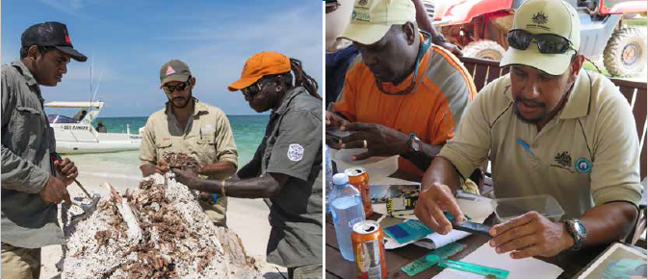

Increasing and improving diagnostic services, skills and facilities
Local, expert knowledge about biosecurity is essential to keep Australia free from pests and diseases.
The Australian Government is investing $3.5 million in expert biosecurity diagnosis of tropical pests and diseases through the Northern Territory Government’s Berrimah Farm facilities.
Improvements will include modernised molecular diagnostic techniques for biosecurity threat species, and will ensure local, timely diagnosis of biosecurity threats as they emerge. It will enhance intelligence and surveillance sharing between the Australian, state and territory governments.

Increasing aquatic, plant and animal biosecurity surveillance
Surveillance underpins our ability to detect biosecurity threats early and to provide evidence of pest and disease status which supports trade and market access negotiations.
Through increased collaboration with our surveillance partners—government, industry and community—we are working together to establish agreed priorities for biosecurity surveillance in northern Australia and to jointly develop strategies to address these threats. This will help support businesses and markets important for developing northern Australia by developing surveillance capability and encouraging participation at all levels.
To achieve this we have:
- identified priority pests and conducted risk assessments to guide collective surveillance effort in northern Australia
- partnered with Plant Health Australia, Animal Health Australia and the Livestock Biosecurity Network to appoint industry liaison officers to better connect farmers, industry and government
- increased surveillance focus in the north through trialling industry-led surveillance models, establishing new sentinel herds and training more people in how to detect and report biosecurity threats
- applied innovative approaches to surveillance including projects to trial remote-operated vehicles for marine pest surveillance and developed new diagnostic techniques for animal and plant diseases
- established a marine pest display at the new Cairns Aquarium to educate the community about priority marine pests and their impact.

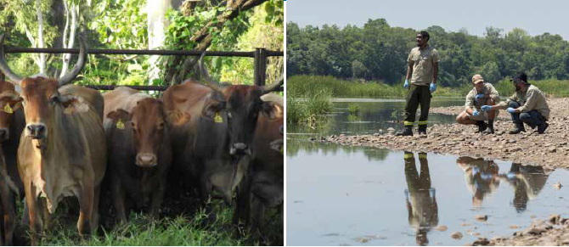

Improving data collection and use
Accurate and reliable data is essential to manage biosecurity threats and report pest and disease changes which could affect Australia’s ability to export agricultural produce. Through the Agricultural Competitiveness White Paper funding, the Australian Government is investing in better electronic systems, digitised reference specimen collections and increased availability of survey data.

Find out more about our work
Agricultural Competitiveness White Paper
agriculture.gov.au/whitepaperbiosecurity
Northern Australia Biosecurity
agriculture.gov.au/biosecurity/australia/naqs/naqs-target-lists
agriculture.gov.au/biosecurity/australia/naqs/naqs-25-years
agriculture.gov.au/biosecurity/australia/northern-biosecurity

