# Ballast water management phase-out schedule

From 8 September 2019, all vessels that reach renewal survey will be required to meet the Regulation D-2 discharge standard of the International Convention for the Control and Management of Ships’ Ballast Water and Sediments (the Convention).

Vessels using ballast water exchange (Regulation D-1) as their primary ballast water management will be required to phase out this management method and meet the Regulation D-2 discharge standard. Vessels may meet this standard by installing an International Maritime Organization (IMO) Type Approved ballast water management system, or as specified within the Convention.

[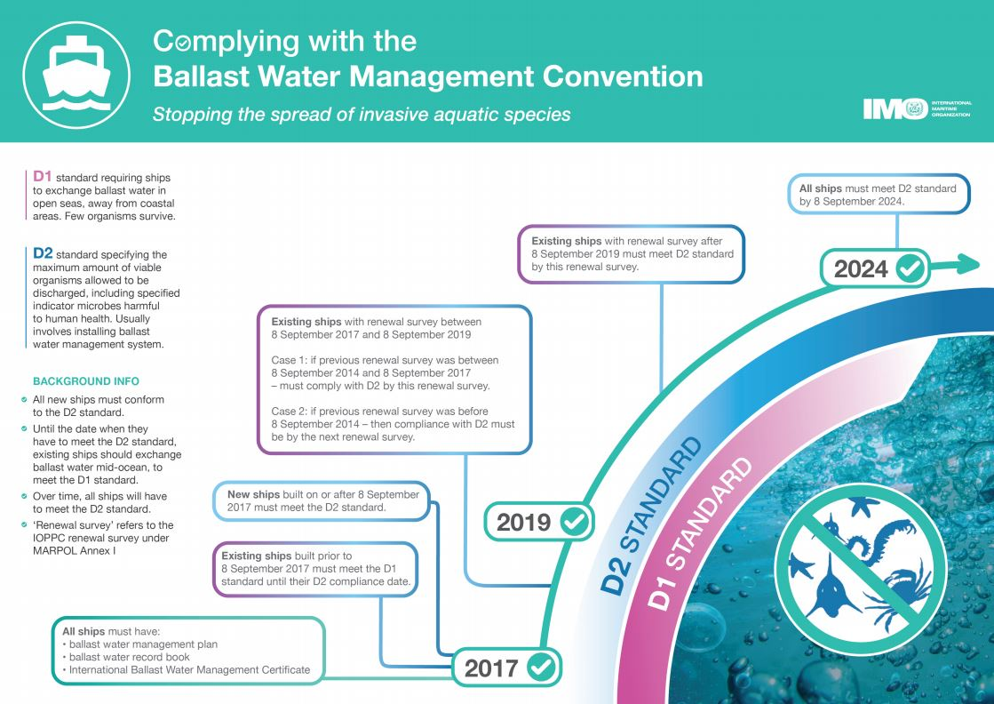](http://www.google.com/url?sa=i&rct=j&q=&esrc=s&source=images&cd=&ved=2ahUKEwjz2t20gLbkAhWPXisKHaRKDxMQjRx6BAgBEAQ&url=http://www.imo.org/en/MediaCentre/HotTopics/Pages/Implementing-the-BWM-Convention.aspx&psig=AOvVaw1m28pIwEJA46OIv7Fp9RKq&ust=1567646491609181)

International Maritime Organization (IMO) -[http://www.imo.org/](http://www.imo.org/en/MediaCentre/HotTopics/Pages/Implementing-the-BWM-Convention.aspx)

## Exemptions

### Exemptions available

Exemptions are available upon application for vessels operating predominantly in Australian waters or the high seas. These include:

* Exemption from the requirement to have a ballast water management plan and certificate
* Exemption from meeting the D-2 discharge standard. This is an exemption that allows vessels to continue to use ballast water exchange as their primary ballast water management method (D-1 discharge standard).

### The D-2 discharge standard

#### Case by case exemptions from meeting the D-2 discharge standard:

Applications will be accepted for vessels operating solely within Australian waters. For these vessels applications will be considered under the following scenarios:

* Floating platforms, Floating Storage Units and Floating Production, Storage and Offloading Units operating exclusively in Australian waters
* Vessels unable to retrofit a ballast water management system based on certified design restrictions
* Vessels which are only required to manage ballast water for the purposes of scheduled maintenance or emergency response.

The following vessels do not need to apply for an exemption:

* vessels that do not use ballast water to control trim, stability or list
* vessels considered to have sealed tanks.

#### Applying for an exemption from meeting the D-2 discharge Standard:

An exemption will only be required from the time the vessel would have otherwise needed to meet the D-2 discharge standard under the Convention. For most vessels, this will be the first renewal survey after 8 September 2019.

Applications must include justification. Supporting documentation, for example a detailed explanation of the vessel’s operating profile, should be included.

### How to apply

To apply for an exemption listed above, download the application form from [www.agriculture.gov.au/ballast](http://www.agriculture.gov.au/ballast) and email to [pestsmarine@agriculture.gov.au](mailto:pestsmarine@agriculture.gov.au)