ya

June
2016
Department of Agriculture and Water Resources

Australia’s Biosecurity Checklist for Commercial Vessels
Ensuring your vessel is prepared to meet Australia’s biosecurity requirements is the best way to minimise the introduction and spread of pests and diseases.

Get ready for arrival

In the office
Submit an accurate Pre Arrival Report (PAR), Ballast Water Report and request to enter a non‑first point of entry



Submit requests for service such as sanitation certification, waste removal, crew change or coastal strip

Understand and follow the department’s directions

Ensure relevant vessel documentation is available for review

Communicate biosecurity requirements to crew and passengers

Any changes to circumstances must be reported to the department as soon as practicable.

This checklist is just one tool to help vessel operators comply with Australia’s biosecurity requirements.
More information can be found at:
agriculture.gov.au/biosecurity/avm/vessels

Get ready for arrival

On the deck
Inspect superstructure, deck and cargo areas for any insects, pests or pools of water

Ensure deck and cargo areas are free from grain, seed or other organic material

Ensure all waste is appropriately contained in bins or waste room that is inaccessible to animals and birds, and free of insects and vermin

Ensure galley and stores are clean and free of insects and vermin

Ensure pets are kept confined on board, and plants stored indoors are away from open windows

Any changes to circumstances must be reported to the department as soon as practicable.

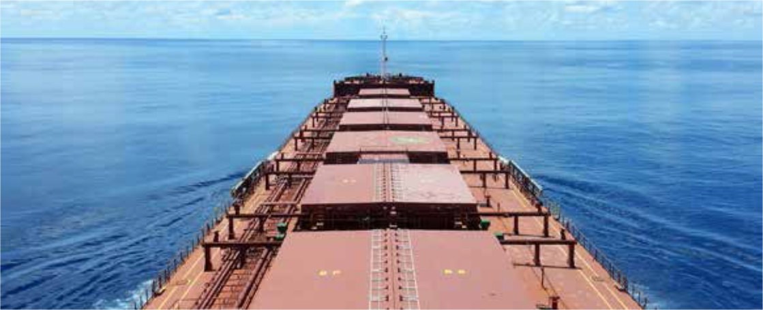Department of Agriculture and Water Resources Within Australia 1300 004 605
BIO2333_0216
Outside Australia +61 8 8201 6185
maritimencc@agriculture.gov.au agriculture.gov.au/biosecurity/avm/vessels

