Biosecurity Emergency Management
Exercise Management Guide
V1.0 17 August 2013
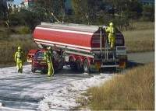

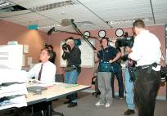
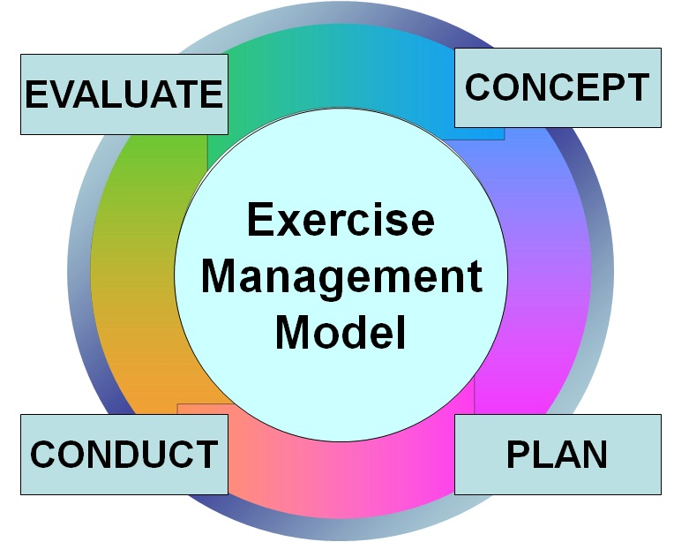

Version Control
Version | Date of issue | Author | Comments
V1.0 | 17/08/2013 | BEPWG | National Emergency Preparedness and Response Working Group endorsed version

Biosecurity Emergency Preparedness Working Group
BEPWG@daff.gov.au
C/- Australian Government Department of Agriculture, Fisheries and Forestry
PO Box 858
Canberra ACT 2600

CONTENTS
INTRODUCTION 1
1.1 Authority 1
1.2 Purpose 1
1.3 Scope and Application 1
1.4 Review and Maintenance 2
1.5 What is an Exercise? 2
INTRODUCTION TO EXERCISE MANAGEMENT 5
2.1 The Exercise Management Model 5
CONCEPT DEVELOPMENT 7
3.1 Identify the Need 7
3.2 Exercise Aim 8
3.3 Exercise Objectives 9
3.4 Standards and Performance Measures 10
3.5 Exercise Scope 12
3.6 Exercise Concept Document 13
EXERCISE TYPES 15
4.1 Discussion Exercises 16
4.2 Functional Exercises 18
4.3 Field Exercises 19
EXERCISE SCENARIO 21
5.1 Background Information 21
5.2 Exercise Inputs 22
PLANNING THE EXERCISE 23
6.1 Exercise Planning Team 24
6.2 Meetings 29
6.3 Exercise Documentation 31
EXERCISE CONTROL STAFF 37
CONDUCT THE EXERCISE 43
8.1 Pre-exercise Activities 43
8.2 Exercise Briefings 44
8.3 Starting the Exercise 46
8.4 Managing the Exercise 47
8.5 Finishing the Exercise 48
8.6 Debriefing the Exercise 48
EXERCISE EVALUATION 51
GLOSSARY 53
TEMPLATES 57

INTRODUCTION

1.1 Authority
This document has been prepared by the Biosecurity Emergency Preparedness Working Group and endorsed by the National Emergency Preparedness and Response Working Group 17 August 2013.

1.2 Purpose
The purpose of this document is to provide a point of reference for Australia’s biosecurity agencies when designing, planning, conducting and evaluating exercises.
This document is designed to provide guidance on contemporary exercise management practices and provides a range of examples and templates that may be used by exercise managers when designing, planning, conducting and evaluating exercises.

1.3 Scope and Application
It is intended that this document will have application to all biosecurity sectors. The concepts and principles throughout this guide are consistent with those applied by other emergency management agencies, as outlined in the Australian Emergency Manual – Managing Exercises, produced by the Australian Emergency Management Institute, Mt Macedon, Victoria. However the text and examples in this guide have been contextualised to exercises being conducted by biosecurity agencies and related industry groups.

1.4 Review and Maintenance
This document has been developed and is maintained by the Biosecurity Emergency Preparedness Working Group.
Comments and/or suggested amendments to this document can be provided to:
Biosecurity Emergency Preparedness Working Group
BEPWG@daff.gov.au
C/- Australian Government Department of Agriculture, Fisheries and Forestry
PO Box 858
Canberra ACT 2600

1.5 What is an Exercise?
An exercise is a controlled, objective driven activity used to practice, test or evaluate processes or capabilities and may be used to educate, train, practice or assess personnel.
An exercise can be as simple as a planning committee discussing a plan, or as complex as a major multi-agency event involving many organisations and participants.
Regardless of the size, exercises are useful to:
- evaluate plans and procedures
- explore issues
- promote awareness
- develop or assess competence
- demonstrate capability
- practice interoperability between agencies
- validate training
- identify gaps
- evaluate equipment, techniques and processes.
Exercises are an essential component of emergency preparedness and should be used by agencies to contribute towards continuous improvement in their ability to respond to and recover from biosecurity incidents.
The following diagram represents a cycle of continuous improvement. We begin at the top of the cycle by identifying the need to prepare, e.g. a pest, disease or other threat has been identified. We then plan for managing or responding to the potential threat, identify or establish appropriate resources (including systems and processes), conduct training for staff and awareness activities for communities. On the outer circle we are impacted by the threat and respond to the incident. We then evaluate our response and take corrective action, which may include reviewing our plans, policies and procedures. When we conduct an exercise, what we are doing is substituting a real event with a simulated event.
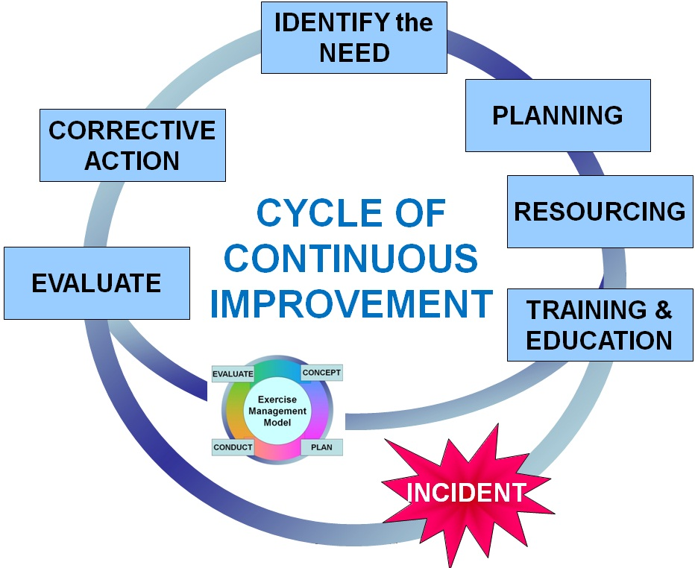
Figure 01. Cycle of continuous improvement
INTRODUCTION TO EXERCISE MANAGEMENT

2.1 The Exercise Management Model
The success of an exercise depends upon the adoption of a structured approach. The exercise management model highlights the phases required to design (concept development), plan, conduct and evaluate an effective exercise.
Figure 2: The exercise management model
Design (or concept development) phase
All exercises begin with a specific need to test, evaluate, assess, practice, train or demonstrate aspects of policy, plans, procedures, systems, training, individuals and/or group performance.
This identified need is then analysed, to determine the aim and objectives for the proposed exercise.
Given the aim and objectives, the scope, type and participants are determined.
With this information in hand, the exercise concept can be developed.
Planning phase
Exercises need to be carefully planned and managed. Even the smallest of exercises requires a coordinated approach to their planning, conduct and evaluation.
During the planning phase an exercise planning team is established and the functions that need to be undertaken to plan, conduct and evaluate the exercise are identified and managed in a coordinated way.
Conduct phase
The conduct phase involves the detailed coordination, by the exercise control staff, as they initiate and manage the various stages of the exercise as it unfolds, ensuring that the exercise meets the identified exercise aim and objectives.
Evaluation phase
Exercise evaluation involves an analysis of the management of the exercise, as well as the participants’ responses to the developing scenario. Evaluation needs to be considered from as early as the concept development phase.
The outcomes of the evaluation should contribute towards the continuous improvement of the organisation.
CONCEPT DEVELOPMENT
The concept development phase is crucial in the exercise management process. It will identify and analyse the need for the exercise as well as ensuring that the appropriate level of authority to conduct the exercise is secured. Obtaining the appropriate level of authority assists in gaining the commitment of all organisations in providing resources during the planning and conduct of the exercise itself.

3.1 Identify the Need
Identifying the need for an exercise is simply a matter of providing an answer to the question ‘why conduct an exercise?’
By combining an understanding of the organisation’s needs and the potential gaps between the required level and actual level of capability, the exercise need can be derived.
This need may be influenced by:
- legislative or regulatory requirements
- review or change of arrangements, policy and/or, plans
- new equipment, procedures, practices
- personnel requirements ( i.e. training, practices and/or assessment)
- the outcomes from previous exercises
- recommendations from independent reviews
- observations and/or lessons from operational activities.
Once the need is understood, it may be determined that an exercise is not the most effective and efficient means to achieve it. It may be more appropriate to conduct training and education activities to address capability gaps. These may be combined with or conducted prior to an exercise.
At this point the aim, objectives and scope should be developed, which provide direction for the subsequent planning, conduct and evaluation of the exercise.

3.2 Exercise Aim
The exercise aim is a statement of intent that gives direction to what will or is desired to be achieved by the exercise. The aim statement can be as generic or as specific as is required to meet the needs of the exercise.
There should only be one aim for an exercise. A clear aim leads to a series of objectives which will suggest the most appropriate type, size and complexity of the exercise.
The essential components of an exercise aim are ‘purpose’ and ‘context’.
Example:
Purpose | Practice the arrangements in the state biosecurity response plan,
Context | during the response to a widespread biosecurity incident.
The aim should begin with a verb and be positive, clear, concise and achievable. The following table provides a list of commonly used verbs and their application.
Verb | Definition/application
Test | To evaluate the abilities, aptitudes, skills or performance of a capability or aspect of that capability in addressing a task or a challenge or combination of both.
Assess | To determine the value, significance, or extent of, or to appraise a capability, plan, process or procedure.
Practise | To undertake an activity or series of activities with the view of improving performance.
Develop | To grow into a more mature or advanced state of capability, plan, process or procedure.
Review | To exercise in the context of going over a plan, process or procedure with the view to improve it or ensuring that it is contemporary practice.
Explore | To examine the potential of a capability, plan, process or procedure.
Validate | To establish the soundness of or to corroborate a plan, process or procedure.
Demonstrate | To display or exhibit the operation or use of a capability, resource, procedure or process.

Examples of exercise aim statements include:

For a single agency exercise:
Exercise aim: | Assess the local office’s ability to respond to a suspected biosecurity incident, in their area.

For a multi-agency exercise:
Exercise aim: | Test the coordination arrangements in the state biosecurity plan, during the response to a wide spread biosecurity incident.

3.3 Exercise Objectives
Exercise objectives are specific statements describing what is to be achieved by individuals, groups or agencies participating in the exercise.
While there should only be one exercise aim there can be many objectives.
Exercise objectives:
- must be set and agreed early in the concept development phase
- must be clear and unambiguous
- should be simple (contain a limited number of aspects) and written in commonly understood language
- should not include words such a ‘timely’, ‘effective’ and ‘efficient’ unless those terms can be quantified and measured.
A common approach to writing objectives is to use the SMART model. This is an acronym for Specific, Measurable, Achievable, Relevant and Task related. The application of SMART objectives in the exercise management context is:
- Specific stresses the need to be specific, rather than general. This means the objective is clear and unambiguous, without vagaries or platitudes. To make objectives specific they must state exactly what is expected.
- Measurable stresses the need for including criteria for measuring progress towards attainment of the objective.
- Achievable stresses the importance of objectives that are realistic and attainable within the parameters imposed by the exercise.
- Relevant stresses the importance of making objectives relevant to the exercise aim and the needs of the participants / participating agencies.
- Task related stresses the need for objectives to be based around activities that can be performed by the exercise participants and observed by the exercise control staff, in order for progress towards achieving the objective being measured.
Examples of exercise objectives, using the SMART model are:

For a single agency exercise:
Exercise aim: | Assess the local office’s ability to respond to a suspected biosecurity incident, in their area
Exercise objectives | - Assess the initial response of the local office staff, when receiving notification of a biosecurity incident.  - Assess the ability of the local office to deploy staff and maintain communication with them, while in the field.  - Assess the ability of local staff to obtain samples and dispatch them in accordance with established procedures.

For a multi-agency exercise:
Exercise aim: | Test the coordination arrangements in the state biosecurity plan, during the response to a wide spread biosecurity incident.
Exercise objectives | - Demonstrate an understanding, by staff, of the coordination arrangements articulated in the state biosecurity plan.  - Establish a coordination framework in accordance with the state biosecurity plan.  - Communicate the coordination framework to stakeholders and the role that they have within this framework.

3.4 Standards and Performance Measures
In addition to developing exercise aim and objectives it is important to identify how it will be determined that the exercise has achieved its aim and objectives.
In some circumstances standards, procedures and other materials will exist, against which performance can be measured. In some cases it may be necessary to develop standards and performance measures to determine how successful the exercise was.
When developed, the standards and performance measures should be used by the:
- exercise planning team to design the exercise inputs
- exercise facilitators to guide participants
- exercise evaluators to measure performance during the exercise.
Standards provide evaluators with a benchmark against which to assess performance. Performance measures may be developed from these standards as well as existing procedures, protocols, etc. In the absence of standards, the exercise planning team may need to work with relevant agencies to define the measures that are to be used to assess performance during the exercise.
Standards are used to quantify the objectives and reflect aspects of the task/capability that are critical to successful performance, and can be used to inform and support the exercise evaluation.
Examples for standards and performance measures are:
For a single agency exercise:
Exercise aim: | Assess the local office’s ability to respond to a suspected biosecurity incident, in their area
Exercise objectives and performance measures | - Assess the initial response of the local office staff, when receiving notification of a biosecurity incident.  - Initial advice is received and documented in accordance with established procedures.  - Relevant staff are notified about the suspected biosecurity incident.  - Relevant staff prepare to be deployed to investigate the suspected biosecurity incident.
Exercise objectives and performance measures | - Assess the ability of the local office to deploy staff and maintain communication with them, while in the field.  - Staff are deployed in a timely manner.  - Staff are deployed with the equipment that is required to undertake the initial investigation of the suspected biosecurity incident.  - Staff maintain contact with their local office and communicate information in a timely manner.
Exercise objectives and performance measures | - Assess the ability of local staff to obtain samples and dispatch them in accordance with established procedures.  - Appropriate samples are taken.  - Samples are packaged in accordance with established standards (IATA).  - Samples are returned to the local office for dispatch to the relevant testing facility.

For a multi-agency exercise:
Exercise aim: | Test the coordination arrangements in the state biosecurity plan, during the response to a wide spread biosecurity incident.
Exercise objectives and performance measures | - Demonstrate an understanding, by staff, of the coordination arrangements articulated in the state biosecurity plan.  - Staff are able to describe the key elements of the coordination framework.  - Staff are able to identify key roles, responsibilities and relationships within the state biosecurity plan.
Exercise objectives and performance measures | - Establish a coordination framework in accordance with the state biosecurity plan.  - An organisational structure is established in accordance with the state biosecurity plan.  - Appropriate staff are identified to fill key roles.
Exercise objectives and performance measures | - Communicate the coordination framework to stakeholders and the role that they have within this framework.  - Stakeholder agencies are identified.  - Contact points within stakeholder agencies are identified.  - Messages are prepared that are appropriate to stakeholder needs.

3.5 Exercise Scope
The exercise scope describes the boundaries in which the exercise will be conducted.
Defining the scope of the exercise should identify what is to be included as well as what is not included in the exercise.
There is often pressure from outside influence to add to the exercise aim, objectives and/or scope as the exercise evolves. This is known as ‘scope creep’ and should be avoided.
The exercise scope should:
- be broad enough so that the objectives can be achieved
- consider the level of commitment of participating agencies
- not be beyond the capability of participants
- consider the level of capability and involvement of participants
- not be changed, once it is agreed.

Examples of scope statements are:

For a single agency exercise:
Exercise scope: | The scope of this exercise is limited to the actions taken by staff working from the local office and procedures established to manage the response to a biosecurity incident.  The exercise will not involve external agencies.

For a single agency exercise:
Exercise scope: | The scope of this exercise is limited to the arrangements articulated in the state biosecurity plan and biosecurity staff working within operations centres established under this plan.  This exercise will not involve the physical deployment of staff or communication with other agencies or the public.

3.6 Exercise Concept Document
Using the proposed exercise need, aim, objective and scope, the exercise concept can now be further developed and documented. The exercise concept document should be used to obtain the direction and authority to conduct the exercise. The exercise concept document should include details of the following:
- exercise need
- exercise aim
- exercise objectives
- exercise scope
- participating organisations
- proposed governance and management structure (for planning the exercise)
- public information requirements
- proposed evaluation methodology
- proposed budget
- proposed timelines.
An exercise concept document template is included at the end of this guide.
EXERCISE TYPES
Exercises can be simple or complex. They might involve a small team practicing a relatively simple drill, or scores of people from a range of organisations simulating a major response. Essentially though there are three main types of exercise. These are:
- discussion exercises, which include:
      - seminar
      - agency presentation
      - hypothetical
      - syndicate progressive
      - workshop
- functional exercises
- field exercises.
An exercise does not have to be restricted to only one type of exercise. Building progressive exercise programs or using several different types of exercise can be useful.
The aim, objectives and scope of the exercise will help to determine the most appropriate type or types needed. Other factors that may influence the type of exercise include:
- needs of the organisation
- skills and experience of the exercise planning team
- lead time
- time available to conduct the exercise
- conflicting commitments
- available resources
- budget
- venues and availability.
This section provides guidance on the types of exercise that can be used in order to achieve the aim and objectives of the exercise.

4.1 Discussion Exercises
As the name suggests these exercises are built around discussion of the scenario. They provide an opportunity to explore issues in some depth and provide verbal responses to situations.
Discussion exercises are useful for developing agreed approaches to particular events, assessing the effectiveness of plans, building relationships or exploring novel ideas or approaches to managing the response to biosecurity incidents. Discussion exercises often involve personnel who work at a strategic level, developing solutions to problems.

Discussion exercises are a cost effective and efficient method. They tend to be more free flowing, informal and exploratory than other types of exercise. They can be conducted away from operational environments, often needing only a room, data projector and a whiteboard. They may be conducted as a stand-alone exercise, as a prelude to a functional or field exercise or as part of a graduated series of exercises.
Seminars are informal discussions, unconstrained by real-time portrayal of events and led by a presenter. They are generally employed to orient participants to, or provide an overview of legislation, strategies, plans, policies, procedures, protocols, response resources, and/or concepts and ideas. Seminars provide a good starting point for agencies that are developing or making major changes to their plans and procedures.
Seminars can be used to:
- induct new personnel
- highlight or examine key elements of a plan.
Agency presentation is a discussion exercise where participants present an action plan relevant to their agency’s operational function. The agency is provided with the scenario and problems or issues in advance so that they may prepare their presentation. Although agency presentations can lack realism and immediacy, they are useful in reviewing existing plans and procedures and can be used to encourage the development of new approaches. Agency presentations can be written and conducted with short lead times, being time and cost efficient.
Agency presentations can be used to:
- consider strategic or operational issues
- focus attention on resources available at a given time and date
- share information about resources and procedures
- build networks and develop shared understanding of different agency capabilities and approaches
- make a presentation to shareholders.

Hypothetical exercise is a discussion exercise where problems are posed by a facilitator and considered by a panel of individuals or groups ‘on their feet’. The facilitator keeps the activity moving by asking probing questions and introducing events, often unexpected, as the scenario unfolds.
Hypothetical exercises are often conducted in front of an audience of emergency managers or stakeholders, who as far as possible should be kept involved in the exercise.
Hypothetical exercises require careful preparation and may need a relatively long lead time compared to other discussion exercises and require highly skilled facilitators with subject matter expertise.
Hypothetical exercises are an effective way of building a shared understanding of different approaches to a problem. They are also useful in simulating operational stress, requiring participants to analyse complex problems and develop appropriate responses in real-time.
Hypothetical exercises can be used to:
- share resource and procedural information
- present and explore ideas with an audience
- assess decision maker’s ability to ‘think on their feet’
- create a degree of operational stress.
Syndicate progressive exercise introduce problems of developing complexity to be considered by groups, in syndicate. The word progressive refers to the graduated development of complexity that will usually occur in an emergency situation and which may be replicated in the exercise via a series of problems to be considered.
Each problem contains a statement and a number of questions (three or four) designed to focus the syndicate group’s attention along a desired path. Each step of questions or problems are discussed ‘in syndicate’ with a response being provided back to the larger group. During the discussion, exercise facilitators assist the syndicate groups by answering questions and guiding them to ensure that they stay on track and achieve the exercise aim and objectives.
Syndicate progressive exercises require careful preparation, they are relatively inexpensive to prepare and conduct and are useful for exercising groups of decision makers, managers or team leaders.
Syndicate progressive exercises can be used to:
- share experiences
- build common approaches to complex issues
- progress through phases of a problem or event or course of action
- encourage understanding of the roles and responsibilities of other agencies
- obtain different possible solutions to a common problem
- examine strategic, political or complex issues.
Workshops differ from other discussion exercises, in that the focus is on achieving or building a product (such as a draft plan or policy). Workshops are led by a facilitator and can be employed as part of a graduated series of activities to determine solutions to exercise and/or operational problems.

A workshop may also be used to produce standard operating procedures (SOPs). To be effective, workshops must be highly focused on a specific issue, and the desired exercise aim and objectives must be clearly defined.

4.2 Functional Exercises
Functional exercises normally take place in a simulated operational environment (such as a control centre or command post) and require participants to actually undertake the particular functions or tasks they would perform as part of the role/s they are playing in the exercise. Functional exercises are usually conducted in real time and scenario information is fed to the participants in a manner similar to the way they would receive it ‘in the real world’.
The input of scenario information is managed by the exercise control team, under the direction of the Exercise Controller, in accordance with the order and timeframe detailed in the master schedule. Participants’ performance is monitored by exercise facilitators and the tempo of the exercise can be increased or decreased by regulating the flow of exercise inputs. The aim and objectives of the exercise determine the amount of interaction facilitators have with the exercise participants.
Exercise managers should be aware that large functional exercises can be complex to plan and conduct. The complexities may occur in the writing of the scenario and developing realistic problems and occurrences. Likely responses need to be planned for and contingencies made for unexpected actions. Functional exercises can be expensive to plan and resource intensive to conduct, however they can be played out many times with different participants, allowing standardisation and promoting consistency.
Functional exercises can be used to:
- practice, develop or assess procedures within operations centres
- practice, develop or assess decision making skills within operations centres
- assess the interaction of operations centres with other centres and/or field teams.
Functional exercises are generally constructed to place emphasis on control and coordination and it is at this level for which they are best suited. They can be specifically designed to test higher level decision making without deploying resources.

4.3 Field Exercises
Field exercises involve deployment of personnel to a simulated incident. They can be as simple as deploying a small team to a simulated infected premises, or as complex as responding to a number of related incidents across the country. They can take the form of a demonstration, a drill or a full scale deployment exercise.
Complex field exercises can be very expensive due to the numbers of people involved. A major field exercise will require a large planning team and many exercise control staff.
As field exercises simulate an actual event this can be useful for exposing response staff to situations they may not normally encounter.
Field exercises can be used to:
- practice, develop or assess the competencies of on-ground personnel
- evaluate the effectiveness of agencies and interagency coordination and cooperation
- evaluate the activation of an emergency plan
- consolidate a progressive exercise program.
Drills are a sub-set of field exercises and are a coordinated, supervised activity designed to test a single or specific operation or function, generally in a single agency environment. Drills are commonly used to provide training on new equipment, develop or validate new policies or procedures or practice and maintain current skills.
Drills have a narrow focus, measured against established standards. They provide immediate feedback and the opportunity to reset and re-run the exercise multiple times.
EXERCISE SCENARIO
Having established the aim, objectives, scope and type of the exercise, the scenario can be developed and documented. This usually includes developing and documenting a range of background information and one or more exercise inputs.
Care should be taken when developing a scenario as it needs to be realistic and believable by participants. Unrealistic or complicated scenarios can be distracting and may affect the conduct of the exercise.
This section provides guidance on what should be considered when developing the exercise scenario.

5.1 Background Information
Background information (sometimes referred to as the general idea) includes a range of information which would normally be available as general knowledge in a real incident.
This background information is usually provided to participating agencies or personnel well in advance of the event as part of the exercise instructions. This will allow participants to undertake appropriate research, actions and/or activities so they can effectively participate in the exercise.
Background information may be provided in the form of:
- written dialogue
- maps, charts or other diagrams
- web site
- video, etc.

5.2 Exercise Inputs
Exercise inputs (sometimes known as ‘special ideas’, ‘exercise serials’, ‘narratives’ or ‘steps’) are used by the exercise control staff to drive the exercise. They provide the additional information or direction that participants require to react, as they would in real life. In some exercises, just a few exercise inputs will be sufficient, however in most cases a range of individual inputs are required to drive the exercise.
Exercise inputs simulate real information and can be provided in the form of a narrative, telephone call, newspaper clipping or other simulated medium. They should be arranged in a chronological order, consistent with the scenario, and details recorded so that they can be introduced into the exercise in a coordinated way and at the appropriate time.

In a discussion exercise, exercise inputs are usually provided by a facilitator. This can be in the form of a narrative, supported by visual displays or other supporting information (newspaper articles, situation reports etc). In a discussion exercise, these inputs will be recorded in the facilitator notes and will include guidance on questions to be asked and expected responses. An example of facilitator notes is included at the end of this guide.
In a functional exercise, exercise inputs are usually provided by the exercise control team in the manner in which they would be received in ‘real life’. This may include telephone, facsimile, email, web site, newspaper article, situation report, Incident Action Plan etc. In a functional exercise, these inputs will be recorded in a master schedule. An example of a master schedule for a functional exercise is included at the end of this guide.
In a field exercise, exercise inputs are usually provided in the form of simulated activities (such as flock of sheep or shed of birds simulating symptoms of a particular disease). Role players may be introduced to add realism (e.g. distressed farmer, etc.). In a field exercise these inputs must be well choreographed and managed by the exercise control staff. These inputs can be recorded in a master schedule. An example of a master schedule for field exercise is included at the end of this guide.
PLANNING THE EXERCISE
The time and effort required to properly plan all aspects of an exercise is often underestimated. The following diagram of an exercise timeline provides an indication of the various activities and documentation that are required for a successful exercise.
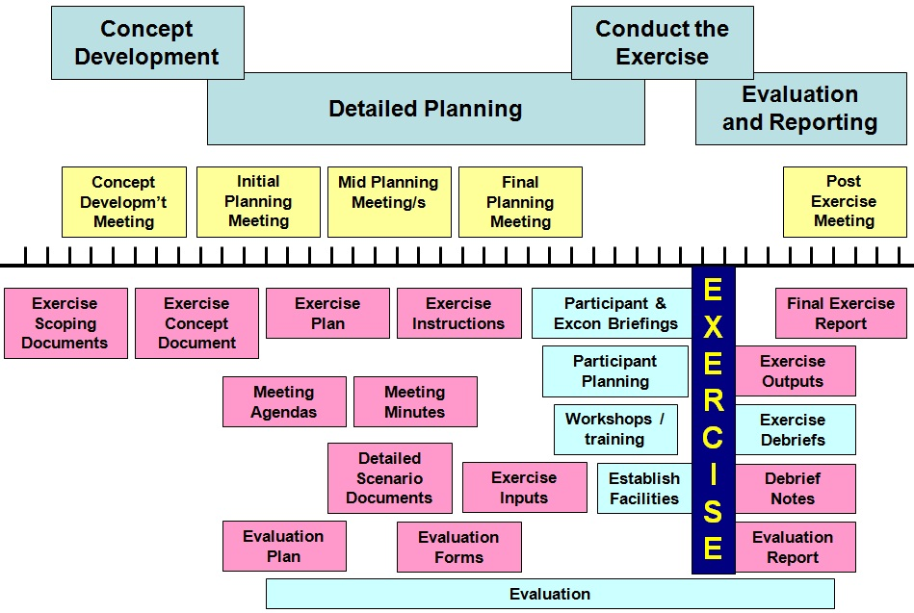
Figure 03: Exercise planning timeline
These activities and the production and coordination of exercise documentation are undertaken by the exercise planning team.
This section provides guidance on the functions performed by the exercise planning team, the meetings that may be required and the documentation that should be produced for an effective exercise.
The roles of staff involved in the design, planning, conduct and evaluation of an exercise may change as the exercise moves through these phases. This sections deals specifically with the roles of the staff involved in the detailed planning phase of an exercise.

6.1 Exercise Planning Team
Exercises need to be carefully planned and managed. Even the smallest of exercises requires a coordinated approach to their design, planning, conduct and evaluation. Establishing an exercise planning team and identifying the functions that need to be managed is essential to ensure the success of any exercise.
The exercise planning team is the group that has primary responsibility for all aspects of the planning phase of the exercise. Although the exercise planning team may undertake all functions required, in larger exercises, it is preferable that responsibility for a number of functions be devolved to specialist groups or teams that report to the exercise planning team.
The exercise planning team will consist of those directly involved in the planning of the exercise and should include representatives from participating agencies. The exercise planning team is chaired by the Exercise Controller.
The exercise planning team will assign roles and responsibilities in accordance with the exercise plan and determine which functions are required for the exercise. These functions may include:
- approval and reporting
- administrative support
- public relations and media
- exercise writing
- exercise control
- exercise logistics
- exercise evaluation.
- These functions are illustrated in the following diagram and further explained below.
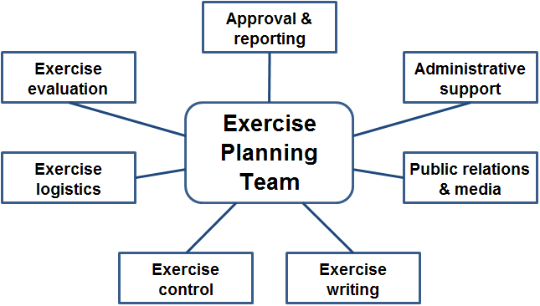
Figure 04: Functions of the exercise planning team
Exercise approval and reporting
The exercise planning team will have responsibility for ensuring that appropriate approvals are obtained to conduct an exercise. This approval may already have been granted prior to the establishment of the exercise planning team or may need to be obtained from a higher authority within an agency or from the bodies that have oversight of particular responsibilities. In addition to having approval from the appropriate authority a regime of reporting may need to be established to ensure that the approving authority receives appropriate advice throughout the design, planning, conduct and evaluation stages of an exercise.
The individual or group of individuals that provides this approval and strategic oversight is known as the Exercise Director/s. The Exercise Director is responsible for approving the aim and objectives of the exercise, as well as the supporting details, including the concept document, exercise plan and instructions provided to participants and participating agencies.
In a small or single agency exercise there may be only one Exercise Director. This may be the agency head or other senior official within that agency.
In larger, multi-agency or multi jurisdictional, exercises there will often be more than one Exercise Director, whereby agencies with major involvement in the exercise each provide an Exercise Director to an oversight committee that provides the required strategic advice and authority.
The Exercise Director/s would not normally have a hands on role during the exercise phases, however will be provided with the exercise report at the conclusion of the exercise, so that appropriate action can be taken.
Administrative support
The exercise planning team will identify staff that can assist with administrative support for exercise related issues. These staff will ensure that a range of support activities are dealt with. These activities could include, but are not limited to:
- arrange and coordinate meetings of the exercise planning team
- provide papers for and records of exercise planning team meetings
- assist with completion of exercise planning documentation
- transport arrangements, for visiting exercise staff and participants
- accommodation for visiting exercise staff and participants
- reception of visiting personnel
- social and after hours activities, including exercise dinners
- exercise memorabilia, etc.
Staff appointed to provide administrative support may be appointed to undertake the role of or assist with facilities management during the conduct of the exercise.
Public relations and media
The exercise planning team will identify staff that can assist with the public relations and media aspects of the exercise. These staff will report to the exercise planning team and will be responsible for ensuring that public relations and media issues related to the design, planning, conduct and evaluation of the exercise are managed.
Staff appointed to provide public relations and media support may take on the role of Media Manager and/or Visitor Manager during the conduct of the exercise and, wherever possible, should not be included as participants in the exercise.
Staff appointed to provide public relations and media support will have responsibility for a range of activities, which commence during the design phase and run through until after all exercise activities have concluded. These activities may include:
- briefing government (including Ministers) and industry partners and stakeholder representatives
- development and implementation of a media campaign (usually documented in a communications strategy).
It is anticipated that staff appointed to provide public relations and media support will contribute to the public relations and media exercise inputs, through participation in the relevant exercise writing team.

Exercise writing
Depending on the complexity of the exercise the exercise planning team may establish one or more exercise writing team/s. The exercise writing team/s will report to the exercise planning team and will have responsibility for the detailed development of the scenario and documentation that is required as inputs or reference material during the conduct of the exercise.
An exercise writing team may be appointed to write all exercise inputs and reference material or in a complex exercise a number of exercise writing teams may be established, each with a specialist responsibility. Examples of these include:
- technical/scientific writing team
- communication writing team
- resource writing team
- etc.
An exercise writing team may consist of as few as two or three people. In any case each team should include:
- subject matter expert/s
- staff with knowledge of the documentation (output) requirements of each exercise writing team.
To ensure continuity throughout the exercise it is appropriate for members of the exercise writing team/s to be appointed to respective exercise control roles during the conduct of the exercise.
Exercise control
The exercise planning team may establish an exercise control team. The exercise control team will operate during part or all of the conduct phase of the exercise. The exercise control team is led by the Exercise Controller (i.e. the chair of the exercise planning team).
The role of the exercise control team is to ensure that the exercise aim and objectives are achieved in a realistic manner. Activities that may be undertaken by the exercise control team include:
- facilitate the flow of exercise information in accordance with the facilitators notes and/or master schedule
- simulate activities that are not performed by exercise participants
- contribute towards the exercise debriefs.
Further guidance on the exercise control team is detailed in Section 7.

Exercise logistics
The exercise planning team will identify staff that can assist with the management of logistics for the exercise. Staff appointed to provide logistics support will report to the exercise planning team and will have responsibility for identifying, sourcing, establishing (or set up), maintaining and repatriating the physical resources and supporting services required for the conduct of the exercise and related activities.
Other functions may include exercise security, safety and risk management.
Staff appointed to provide logistics support may be appointed to undertake the role of Logistics Manager in the exercise control team during the conduct of the exercise.
Exercise evaluation
The exercise planning team will identify staff that can undertake the evaluation of the exercise. Staff appointed to undertake the evaluation will report to the exercise planning team and will have responsibility for evaluating all aspects of the exercise and documenting its findings in an exercise evaluation report.
Where possible staff involved in the exercise evaluation should not have any other exercise appointment.
Further guidance on exercise evaluation is provided in Section 9.

6.2 Meetings
The exercise planning team will manage its responsibilities through a range of planning meetings. These meetings are illustrated in the following diagram and further explained below.
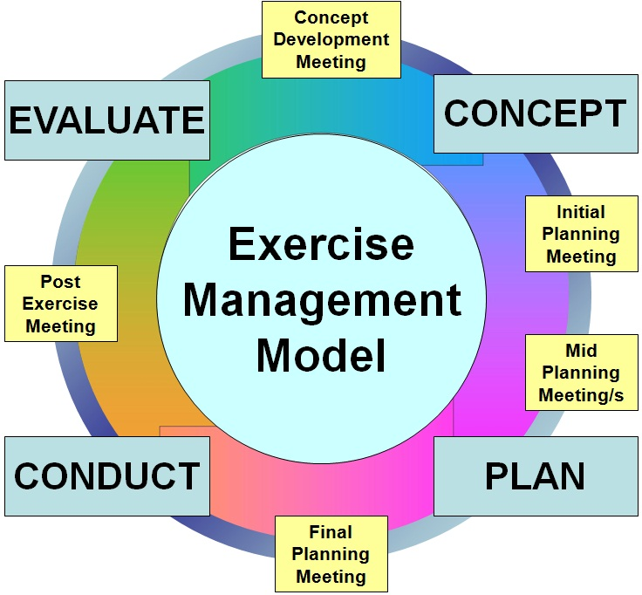
Figure 05: Planning team meetings
Concept development meeting
The purpose of the concept development meeting is to discuss, agree and consider the broad exercise concept. It should confirm the need and answer the question, ‘why do we need to conduct an exercise?’. Consideration may be given to the exercise aim, objectives, scope, evaluation methodology, core dates, participants, budget, venues etc.
The outcome of the concept development meeting should be general agreement on the exercise concept and sufficient guidance to draft an exercise concept document.
Initial planning meeting
The initial planning meeting is perhaps the most important of the planning meetings, for without broad agreement of the exercise framework further planning cannot proceed. The purpose of the initial planning meeting is to agree on how the approved exercise concept will be implemented to achieve the exercise aim and objectives. The approved exercise concept document must be used as the basis for discussion and as many stakeholders as practical should be included in this meeting.
The outcome of the initial planning meeting should be broad agreement of the exercise parameters and sufficient guidance to develop the exercise plan before final endorsement.
Mid planning meeting
The purpose of the mid planning meeting/s is to discuss and refine exercise management arrangements and review the status of exercise planning including addressing any major issues that have arisen. Depending upon the complexity of the exercise it may be necessary to conduct several mid planning meetings.
As required by the scale and complexity of the exercise program, specialist working groups (such as the exercise writing teams) may be required and will meet as required between exercise planning meetings.
Meetings should be scheduled in advance, have identified attendees, be minuted and use action items to ensure identified activities are scheduled and completed on time. Planning meetings are most effective when stakeholders ensure that the same representatives attend through the planning process.
Final planning meeting
The purpose of the final planning meeting is to review all exercise planning and confirm that planning is complete, that all arrangements are in place for participants, exercise control staff and exercise logistics. Where appropriate the scenario and all documents should be validated, if necessary by conducting a trial run of part or all of the exercise.
Introduction of any new planning detail should be avoided at this stage. The meeting should identify any outstanding issues and allocate responsibility for their resolution.
The final planning meeting should be held a number of weeks before the commencement of the exercise and preferably before the commencement of related activities, such as workshops and training.

Post exercise meeting
The purpose of the post exercise meeting is to finalise the exercise and related activities. This will include reviewing the evaluation report and agreeing on any subsequent actions and reporting that need to be undertaken. The post exercise meeting may also make recommendations on the conduct of subsequent exercise programs.
A draft evaluation report, prepared by the exercise evaluator/s, is one of the inputs for this meeting. The draft evaluation report should be endorsed by the exercise planning team and finalised at the post exercise meeting. The evaluation report and other information gathered during the exercise is then used by the exercise planning team to assist with the development of a final exercise report.

6.3 Exercise Documentation
All exercises need to be sufficiently documented in order to inform their design, planning, conduct and evaluation. Good documentation can also allow an exercise, or elements of it, to be used more than once, providing a valuable return on the significant time invested.
Exercise documentation is essential, for a number reasons, including:
- verbal instructions are not reliable
- documents form a permanent record of what has been planned and undertaken
- documents assist with the actual running of the exercise
- documents help to gain commitment to the exercise.
The documents required will vary from one exercise to the next, however as a guide you should consider obtaining or generating the following:
- exercise scoping documents
- exercise concept document
- exercise plan
- planning meeting agenda and minutes
- detailed scenario documents
- exercise instructions
- evaluation report
- final exercise report.
Each of these documents plays an important role in the management of exercises and will contribute significantly to the success of your exercise.
The range of documentation that may be required for an exercise is illustrated in the following diagram and further explained below.
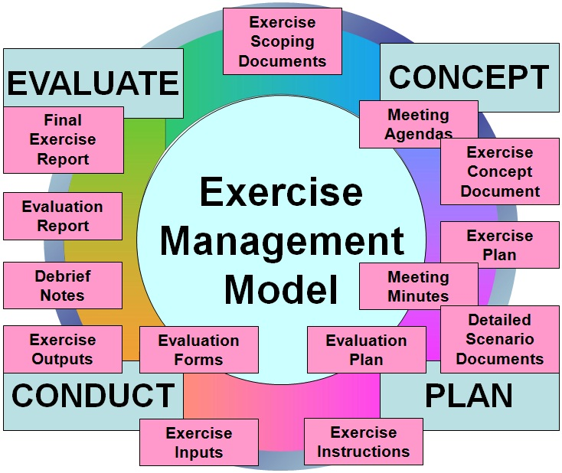
Figure 06: Exercise documentation
Exercise scoping documents
Exercise scoping documents will assist you to answer the question of ‘why do we need to conduct an exercise?’ Exercise scoping documents contribute towards the authority to conduct the exercise and can take many forms. These could include:
- reports from previous exercises
- reports from audits or review of response operations
- directions provided by a higher authority, such as the Minister or head of department
- documents that have a requirement to be exercised at a certain interval, etc.

Exercise concept document
The purpose the exercise concept document is to provide an outline of the proposed exercise and is used to obtain the direction and authority required to plan, conduct and evaluate the exercise. The exercise concept document should include details of the following:
- exercise need
- exercise aim
- exercise objectives
- exercise scope
- participating organisations
- governance and management structure (for planning the exercise)
- public information requirements
- proposed evaluation methodology
- proposed budget
- proposed timelines.
An exercise concept document template is included at the end of this guide.
Exercise plan
The purpose of the exercise plan is to provide further detail of the method (agreed to by the exercise planning team and endorsed by the Exercise Director/s) by which the exercise will be planned, conducted and evaluated.
The exercise plan describes the aim, objectives and performance measures for the exercise. It should provide guidance on all issues relating to the planning, conduct and evaluation of the exercise. The exercise plan should outline the program of related activities with proposed dates and sequence of events. Proposed participants and exercise management arrangements should be identified in addition to planning milestones and resource considerations.
Normally the exercise plan would not be distributed to exercise participants, however some of the information will need to be reproduced in the relevant exercise instructions.
An exercise plan template is included at the end of this guide.
Meeting agenda and minutes
While this may appear to be obvious, there are many exercises being conducted without any written record of the actions that took place to plan, conduct and evaluate them. Meeting minutes in particular form a valuable record for evaluation, reflection and guidance on the conduct of future exercises.
Agenda templates, for each of the meetings described above are provided at the end of this guide.

Detailed scenario documentation
The aim, objectives, scope, type and size of the exercise will influence the level of scenario documentation that is required. As a guide the following should be considered:
- description of the scenario and how it develops
- master schedule (including exercise timings and sequence of inputs)
- background information
- exercise Inputs
- profiles or information on people, businesses, places etc mentioned in the scenario and exercise inputs.
Exercise instructions
The exercise instructions are provided to exercise participants and exercise control staff in advance of the exercise. While all exercise instructions will contain similar information, they may need to be tailored for their particular audience. The exercise instructions should provide sufficient information and be accompanied by any pre-reading that participants or exercise staff require to participate in the exercise.
Evaluation documentation
The evaluation documentation includes an evaluation plan and any other documentation (forms and checklists) used by the exercise evaluators to collect and collate the information required to properly evaluate the planning and conduct of the exercise. The evaluation documentation will be prepared during the planning phase of the exercise and may include a range of documents, checklists and/or templates provided to the exercise participants, facilitators, observers or evaluators to collect appropriate information.
An evaluation plan template and evaluator collection template are included at the end of this guide.
Evaluation report
The evaluation report will be prepared by the exercise evaluation team and endorsed by the exercise planning team. The evaluation report should include:
- a description of the exercise
- a narrative of key events
- an evaluation summary addressing the attainment of the exercise aim, objectives, and performance measures, and
- key observations and recommendations.
An evaluation report template is included at the end of this guide.

Final exercise report
The final exercise report is prepared by the exercise planning team and endorsed by the Exercise Director/s.
The final exercise report will be developed from the evaluation report, notes and outcomes from the various debriefings and any other feedback mechanism that the exercise planning team chooses to use e.g. participant questionnaires, interviews etc.
The final exercise report should include an analysis of any recommendations made during the debriefing and evaluation of the exercise, as well as guidance on appropriate actions required.
EXERCISE CONTROL STAFF
The people who run and support the exercise conduct are known as the exercise control staff and form the exercise control team. The role of the exercise control team is to ensure that the exercise achieves its aim and objectives, at the same time ensuring that it is conducted in a safe and effective manner.
The exercise control team is lead by the Exercise Controller and exercise control staff can be drawn from a range of sources, including:
- the exercise planning team
- participating agencies
- other agencies with exercise management expertise
- contractors or consultants with exercise management expertise.
It is essential that exercise control staff are identified early in the planning phase to enable them to engage in the exercise, be trained in required skills and knowledge and briefed on their role during the exercise. In addition to this, exercise control staff will need to be aware of:
- chain of command, within the exercise control team
- communication arrangements with other members of the exercise control team
- level of interaction with participants, during the exercise.
The number of exercise control staff and the roles they perform will vary from one exercise to another. For example, a small discussion exercise may only require a few exercise control staff (each performing a number of functions), while a large scale exercise will require a large number of exercise control staff, with teams of people appointed to individual functions.
During the exercise, exercise control staff should wear appropriate identification to avoid being confused with exercise participants.
The functions that are regularly required during an exercise are depicted in the following diagram and responsibilities of the staff that perform these functions are described below.

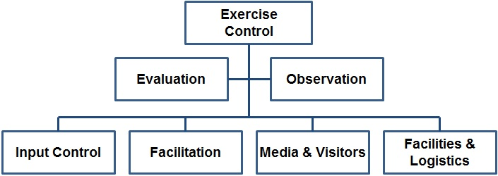
Figure 07: Exercise control staff functions
Exercise control
The chair of the exercise planning team usually performs the role of Exercise Controller during the conduct of the exercise. The Exercise Controller is responsible for selecting and appointing people to the functions required to conduct the exercise.
The Exercise Controller leads the exercise control team, which is responsible for managing all exercise conduct activities to ensure adequate opportunities to achieve the exercise aim and objectives. More specifically, the Exercise Controller will:
- commence the exercise in accordance with the master schedule
- ensure that exercise inputs are managed in accordance with the master schedule
- approve any amendments to the master schedule, should they be required
- conclude the exercise in accordance with the master schedule
- terminate the exercise early, should it be unsafe to continue or other activities affect the exercise.
In large or complex exercises, the Exercise Controller may appoint an Assistant Exercise Controller to assist with all or some of the responsibilities identified above.
Evaluation
Evaluation is an essential element of every exercise and therefore needs to be carefully managed. Section 9 covers evaluation in detail, however it is essential that dedicated staff be appointed to manage the exercise evaluation.
An Evaluation Manager will be responsible for the development and implementation of an evaluation plan, recruiting and briefing evaluation staff, monitoring evaluation activities and producing the required reports.
Observation
Some exercises will attract a lot of attention and requests from other organisations to attend in order to ‘observe’ the exercise. From the outset, the Exercise Director will need to establish an observer policy. In the case that observers are allowed, it is appropriate to appoint staff to manage the observers during the exercise.
An Observer Manager and their staff will have responsibility for developing and communicating an observer program that suits the needs of those wishing to observe. This may include arrangements:
- to attend all exercise venues and related activities
- transport between venues
- catering, accommodation
- other activities, outside of the exercise hours.
Input Control
The control of exercise inputs is largely dependent upon the type of exercise that is being conducted.
- In a discussion exercise, the control of inputs is usually undertaken by the facilitator/s, in accordance with the facilitator’s script or notes.
- In a functional exercise, the control of exercise inputs is usually undertaken by a team of people, working from a dedicated facility and providing those inputs to the exercise participants in the form that they would normally receive them, e.g. telephone, email, facsimile etc.
- In a field exercise, inputs are usually provided in the form of role players and/or participants being placed in a situation, to which they need to respond.
An Input Control Manager therefore has responsibility for:
- managing the tempo of exercise inputs and ensuring that they are provided in accordance with the facilitator’s notes or master schedule
- monitoring participants’ response to the inputs to ensure that the desired result is being achieved
- liaising with the Exercise Controller, in order to maintain or adjust exercise inputs as required.
Staff that may be appointed by the Input Control Manager include role players and a Staging Area Manager.
Role Players are integral to the conduct of most field exercises, can be used in functional exercises and in limited circumstances in discussion exercises. Role players provide realism and can create an emotional perspective to an exercise. In a biosecurity exercise, role players can be used to simulate affected producers, community members, animal owners, businesses or others affected or involved in the exercise scenario. Role players can also be used to simulate the role of the media and officials.
When used, role players need to be carefully managed to ensure that they are aware of the role they are simulating and stay within the ‘script’ that is provided to them.
When there are large numbers of role players it is appropriate to appoint one or more role player managers. When appointed the Role Play Manager reports to the Input Control Manager.
Staging Area Manager will manage the staging area. A staging area is often established for field exercises and is a predetermined location/s where exercise control staff, participants and/or equipment is marshalled for deployment into the exercise site. When appointed the Staging Area Manager reports to the Input Control Manager.
Facilitation
Facilitators usually perform a guiding role during an exercise and are primarily concerned with guiding participants to ensure that the exercise aim and objectives are achieved. This role will vary slightly, depending on the exercise that type, for example:
- In a discussion exercise, the facilitator will lead the discussion, pose problems to the participants and work with them to solve those problems.
- In a functional exercise the facilitator will work alongside participants and provide guidance on what actions and outputs are required from them. The level of facilitator involvement with participants will vary according to the objectives and the participant’s level of skills and knowledge. e.g. where the aim is to train, and there is a low knowledge base, the facilitator will work very closely with and mentor participants as they work through the scenario.
- In a field exercise the facilitator will monitor the actions of participants and suggest corrective action if required. The facilitator may also assist the evaluation team by recording observations and collecting data for the exercise evaluation report.
Media and Visitors
During an exercise, the management of media and visitors will require careful consideration.
It is therefore normal to appoint a Media Manager, who is usually drawn from the agency primarily responsible for the exercise. The Media Manager will be responsible for managing the public information component of the exercise as well as coordinating the organisation’s media responses about the exercise.
The Media Manager may also take responsibility for escorting, or arrange the escort of media and short term visitors that attend the exercise. In large exercises it may be appropriate to appoint a dedicated Visitor Manager for this purpose.
Facilities and Logistics
The Facilities and Logistics Manager is responsible for the smooth operation of the exercise facilities during the conduct phase of the exercise. This may include:
- physical resources and venues, store and consumables
- information and communication technology (ICT) and support services
- communication resources
- transport to and from venues
- catering
- accommodation for visiting staff
- safety and first aid.
The facilities and logistics manager may also be called upon to:
- access additional exercise resources, if required, during the exercise
- manage the establishment and pack up of exercise facilities and equipment
- ensure that all equipment is returned to the appropriate supplier at the conclusion of the exercise
- ensure that exercise venues are returned to their original or agreed state.
Exercise control team
As each exercise is different, it will be necessary to establish an exercise control team that suits the requirements of the exercise. The following diagrams reflect organisational structures for the exercise control teams that may be established for a discussion, functional and field exercise.
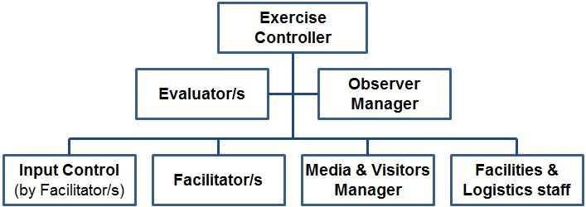
Figure 08. – Exercise Control Team – Discussion Exercise

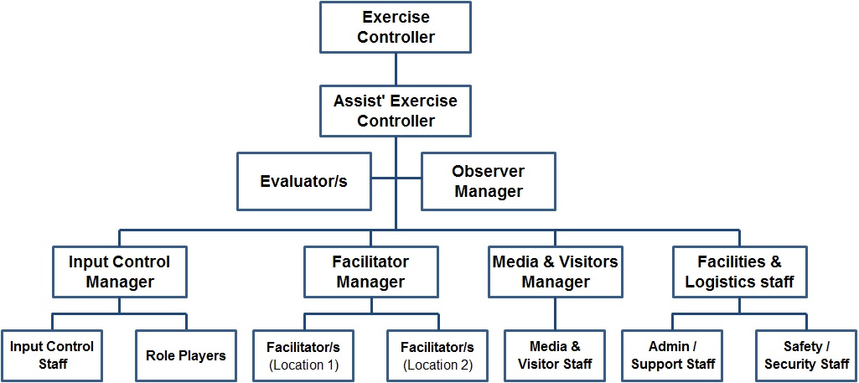
Figure 09. Exercise Control Team - Functional Exercise

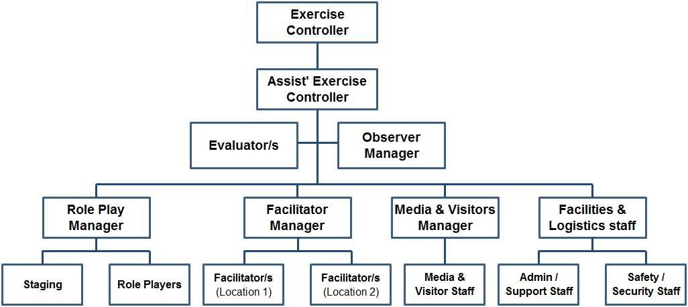
Figure 10. Exercise Control Team - Field Exercise
CONDUCT THE EXERCISE
The conduct phase of an exercise involves:
- pre-exercise activities
- exercise briefings for:
- exercise control staff
- exercise participants
- starting the exercise
- managing the exercise
- finishing the exercise, and
- debriefing the exercise.
This section describes these activities and their application.

8.1 Pre-exercise Activities
Prior to conducting an exercise there may be a requirement to undertake a range of pre exercise activities. These activities are often required to prepare agencies and personnel for participation in the exercise. These activities could include:
- development or review of plans and procedures
- training for participants and exercise directing staff
- providing advice to the public and engaging media outlets
- establishing facilities
- testing of ICT systems and equipment
- rehearsals.
It is also essential to inform those that may be affected by the exercise that the exercise is to be conducted. In a small scale exercise this may be minimal, however in a large scale exercise it may be necessary to:
- brief senior officials
- prepare and issue media releases
- advise appropriate agencies and the public
- advise international agencies and overseas posts.

8.2 Exercise Briefings
To enable the greatest opportunity to achieve the exercise aim and objectives and ensure a successful exercise, it is essential that pre-exercise briefings be conducted for all exercise control staff and exercise participants.
All exercise briefings should follow a consistent format for ease of understanding and support any exercise instructions people have received, prior to the exercise.
To ensure that briefings are effective they must have an identified purpose. Participants must understand this to ensure the briefing is effective and stays on track. This information can be communicated at the beginning of the briefing or during the communication requesting attendance.
Example:
Purpose of briefing | The purpose of this briefing is to provide exercise participants with the information they require to effectively participate in the exercise.

Briefings must be facilitated by an experienced facilitator and should be conducted at the beginning of an exercise. During complex or lengthy exercises it may be necessary to conduct additional briefings at predetermined intervals during the exercise.
Preparing for briefings
In preparation for briefings and debriefings the following should be considered:
- purpose of the briefing
- safety of all involved
- format of the briefing
- participants
- timing
- location, and
- venue.
Types of exercise briefings
A range of briefings may be required to engage staff involved in the exercise and prepare them for the role they will play. The type of briefing that is provided is very dependent upon the information to be conveyed and the ability of staff to convey that information in an effective manner.

As a guide the following briefings may need to be delivered, in which case they need to be considered and planned for during the planning phase:
- senior officers and/or officials briefings
- exercise participants briefing
- exercise control staff briefing
- site specific briefing
- function specific briefings
- task specific briefings
- safety briefings.
In large scale exercises it may be necessary, due to time, venue or number of people involved, to brief managers and/or commanders and then allow them the opportunity to brief their staff.
Format for exercise briefings
Adopting a standard format for briefings will ensure that those planning, conducting and participating in them will be able to anticipate the information that is appropriate to them and contribute at the appropriate time. A suggested format for briefings follows the SMEACS format, an acronym for Situation, Mission, Execution, Administration, Command and Communication and Safety.
The following provides guidance on information that could be covered in exercise briefings, using the SMEACS format.
- Situation | Describes what has happened and perhaps what has been done. In the context of an exercise, this would include some background on the exercise and why it is being conducted.
- Mission | Describes what is to be achieved. In the case of a high level exercise briefing, this may include the exercise aims and objectives, where at a lower level it may include job specific objectives, which contribute to the higher level objectives.
- Execution | Describes how the exercise objectives are to be achieved. It will include instructing groups or individuals to undertake specific functions or tasks. A briefing will generally explain what needs to be done, not how to do it.
- Administration and Logistics | Describes the administrative and logistical arrangements required to undertake the allocated functions or tasks. At a higher level this may include transport, accommodation and catering arrangements for all involved, where at a lower level it may include specific details, e.g. how to obtain stationery for a specific task.
- Command and Communication | Describes clearly the chain of command and communication arrangements for the exercise. Organisational charts and diagrams can be useful to convey this information.
- Safety | Describe any workplace health and safety hazards or risks relevant to the staff being briefed.
- Questions | Conclude all briefings by seeking and answering questions from those being briefed.

8.3 Starting the Exercise
For the exercise to start effectively there will be a number of activities which should be completed just prior to the start time. These may include:
- final test of ICT systems and equipment
- last minute briefing for all exercise control staff and confirming readiness to proceed
- positioning role players, props and special effects
- positioning of exercise control staff and support personnel
- positioning of exercise participants
- advice to the Exercise Controller that all is ready.
Starting the exercise is the responsibility of the Exercise Controller.
The type of exercise will influence the way an exercise is started, for example:
- Discussion exercise usually commence with the subject or scenario being introduced to the participants by the facilitator.
- Functional exercises may be started by an ‘incoming message’ or by a written script detailing the first part of the scenario.
- Field exercises often start by a radio or telephone message (containing the first exercise input) to the appropriate response agency, or personnel.
Once started, the expectation is that participants will ‘run’ the exercise by way of response and reaction to the initial input and any subsequent input, information or activity that is introduced.

8.4 Managing the Exercise
The Exercise Controller manages the conduct of the exercise in accordance with the master schedule. The Exercise Controller can call a temporary halt to the exercise to change its direction, speed it up or slow it down to ensure that the exercise aim and objectives can be met.
Exercise control staff assist the Exercise Controller by ensuring that all is proceeding as planned at each location, and that appropriate inputs occur in accordance with the master schedule. Exercise control staff need to be prepared to react to participant responses and take appropriate actions.
Some issues that need to be considered and managed during the exercise are detailed in the following paragraphs.
Exercise communication
During most exercises:
- participants will need to communicate with other participants
- participants will need to communicate with exercise control staff
- exercise control staff will need to communicate with other exercise control staff.
Therefore it is essential that communication equipment, method of communication and procedures to be followed are identified and communicated to all exercise participants and exercise control staff. This can be done at the appropriate briefing/s.
Site security
Security arrangements appropriate to the site needs to be identified and communicated to all exercise participants and exercise control staff. In some exercises it may be appropriate to appoint or engage staff to manage the security aspects of the site. Consideration should be given to:
- who can and cannot access the site
- under what conditions access is provided
- action to be taken in the event that there is a breach or potential breach of site security.
Identification
A method of identifying all personnel involved in the exercise should be considered. Common methods are to simply produce exercise specific name tags or if warranted, identification passes, complete with photos and bar codes.
In addition to this it is essential to identify the role of personnel within the exercise. i.e. exercise control staff, visitors, observers and participants should be readily identifiable. Using different coloured name tags or wearing of tabards for certain positions is a common approach.
Managing real events
Should a real event occur during the conduct of an exercise it is essential that this is bought to the attention of the exercise control staff. A commonly accepted method is the use of the term NO DUFF to indicate that a real event, that is not part of the exercise, has occurred. At this point the Exercise Controller will need to make a decision as to whether the exercise needs to be paused or stopped all together.

8.5 Finishing the Exercise
Finishing the exercise is a controlled activity. The Exercise Controller is responsible for finishing the exercise in a pre-arranged manner. This could occur:
- at a designated time, according to the master schedule
- upon completion of designated tasks
- if it is not safe to continue with the exercise
- if other activities (including safety breach or actual responses) hinder the progress of the exercise.
In any case, during the planning phase, the exercise planning team must consider strategies that can be implemented by the Exercise Controller, should it be necessary, to terminate the exercise prior to the pre arranged time.
It is important not to overlook the activities required to repatriate the exercise site and/or return equipment to its pre-exercise state. While this will largely be the responsibility of the facilities and logistics staff, the time and effort required should not be underestimated and staff involved must be given every opportunity to participate in designated post-exercise activities including debriefing.

8.6 Debriefing the Exercise
A range of debriefings may be required to provide organisers and participants with the opportunity to communicate their experiences during the design, planning and conduct of the exercise as well as their response to the developing scenario, during the exercise.
The type of debriefing/s conducted will also be dependent upon the type and size of the exercise, the number of participants and the complexity of issues that need to be addressed.
As a guide the following debriefings may be conducted, in which case they need to be considered and planned for during the exercise planning phase:
- hot debriefing (immediately after or at intervals during the exercise)
- exercise control staff debriefing
- exercise participant debriefing
- agency and/or multi-agency debriefing
- exercise planning team debriefing.
While briefings will usually start with general information and become more detailed in subsequent briefings, the reverse is appropriate for debriefings. That is, detailed information is collected at initial debriefings, with that information contributing towards subsequent debriefings, which deal with higher level issues.
Format for exercise debriefings
As with briefings, adopting a standard format for debriefings will ensure that those planning, conducting and participating in them will be able to anticipate the actions that are appropriate to them and contribute in an appropriate way.
At the commencement of any debriefing the facilitator should clearly state the purpose of the debriefing. The following may be used as a guide to the issues that could be covered in exercise debriefings:
- describe how the situation has changed since the original/last briefing. In an exercise debriefing, this may include discussion on the progress that was made in response to the developing scenario (In most cases it is important for participants to have come to a logical conclusion or an ‘end’ to allow them to disengage from the exercise)
- explore whether the exercise objectives were achieved
- identify what went well and what could be improved
- explore the appropriateness and effectiveness of the command structure and communications implemented for the exercise.
Contributions by participants to debriefings can be verbal and/or written. Information collected at debriefings must be recorded so that it can contribute towards the exercise evaluation and any subsequent analysis of recommendations.
EXERCISE EVALUATION
Evaluation of exercises and exercise programs should commence with the initial planning meeting and continue through until after the final debriefing has been conducted, reports are issued and recommendations proposed.
Even the smallest of exercises should incorporate an evaluation process. Although this will be less detailed then a large scale exercise, conducting a thorough evaluation of an exercise is not a minor undertaking.
Exercise evaluation will require dedicated staff and should be given careful consideration during the design phase and implemented as early as practical.
Exercise evaluation will include input from all aspects of the exercise and should be informed by:
          - outputs from the exercise planning process and planning meetings
          - facilitator and/or observer checklists used during the exercise
          - observations from the exercise control staff
          - outputs from the exercise debriefing/s
          - observations from the exercise evaluator/s, and
          - participants’ response to the developing scenario.
In evaluating the planning and conduct of the exercise, the exercise management model and its supporting description (as provided in this guide) could be used by evaluation staff when designing and conducting exercise evaluations.
The evaluation of participants’ performance during the exercise should be measured against the exercise aim and objectives, with the appropriate policy, manuals, procedures and or work instructions used as the standard by which they are evaluated.

Evaluation should look at:
- what was planned
- what was achieved
- why did this happen
- what can be done in the future.
Lessons identified
From every exercise there will be a number of, if not many, recommendations for future action and or improvement. Some may call these lessons learned, however if those same recommendations continue to appear in subsequent exercises they have simply been identified and not learnt. For lessons to be learned and organisational change to be implemented, a genuine lessons management process is required.
Implementing lessons identified
Some agencies have teams of people and technology dedicated to evaluating and implementing the lessons identified from operational responses and exercises, however this luxury is not available to everyone conducting exercises.
During the planning phase, the exercise planning team should identify how the lessons identified from the exercise will be further analysed and implemented. Often the exercise planning team is stood down after the conduct phase and may not have the resources and or authority to analyse, implement or follow up on the lessons identified.
Continuous improvement
The outcomes from an exercise should be considered for future planning, training and exercising. The written outputs from exercises may be used as scoping documents for future exercises. This will assist in ensuring that the lessons identified in one exercise are considered during the design phase of another exercise.
GLOSSARY
Term | Acronym | Definition
Aim (of the exercise) |  | A broad statement of intent of the exercise outcomes.
Control documents |  | Documents developed by the exercise planning team, which are used by the exercise control team during the conduct of the exercise. These may include:  - master schedule  - profiles  - exercise inputs.
Exercise control staff |  | Personnel appointed to assist the Exercise Controller to manage the conduct phase of an exercise.
Discussion exercise | Discex | An indoor exercise employing a carefully prepared scenario to assess and practice various aspects of emergency management planning, procedures or training. Participants usually provide verbal or short written responses during the exercise.
Exercise |  | A controlled, objective driven activity used to practice, test or evaluate processes or capabilities and may be used to educate, train, practice or assess personnel.
Exercise control team | Excon | The group with the responsibility for monitoring the progress of an exercise to ensure objectives are achieved in line with the exercise plan.
Exercise Controller |  | The person appointed by the Exercise Director/s to manage the planning and conduct phases of an exercise
Exercise Director |  | The person who has oversight responsibility and provides the authority to conduct the exercise
Exercise facilitator |  | Exercise control staff who have responsibility for a particular aspect or location of the exercise. The exercise facilitator/s report to the Exercise Controller, they brief and debrief exercise participants on daily activities, monitor the progress of the exercise, provide guidance to exercise participants to ensure that exercise outcomes are achieved.
Exercise instructions |  | Written information provided to all exercise participants and exercise control staff prior to an exercise. It provides the details that are required by individuals to prepare for and participate in the exercise. This is usually provided well in advance of the exercise to allow travel, accommodation and other arrangements to be made and could include reading material that is required to engage in the exercise.
Exercise observers |  | International or domestic stakeholders who observe the exercise. This may be for their own education or to provide recommendations on the potential improvement and validate the exercise as a realistic and thorough test of preparedness.
Exercise plan |  | A document prepared by the exercise planning team and approved by the Exercise Director, which details all aspects of the exercise planning, conduct and evaluation.
Exercise writing team |  | The group of people, appointed by the exercise planning team, who have responsibility for drafting the exercise scenario and inputs.
Field exercise |  | An exercise where resources are deployed in response to a simulated incident. It is conducted in the field, in real time but under controlled conditions, as though it were a real incident.
Functional exercise |  | An exercise designed to test or practice a particular function. It is usually conducted in an actual or simulated operational environment (such as a control centre) and participants undertake the functions or tasks they would normally perform in response to a developing scenario.
Hypothetical exercise |  | A style of exercise where problems are posed by a facilitator and considered by a panel of individuals or groups ‘on their feet’.
Exercise inputs |  | Messages provided to exercise participants by members of the exercise control team (either pre-scripted or manufactured) that are used to direct the exercise in a particular direction, or prompt a particular response, action or outcome.
Master schedule |  | The detailed sequence of events (script or running sheet) used by the exercise control staff to ensure that the exercise stays on track. It provides guidance on sequence and timing of exercise inputs.
NO DUFF |  | The preferred term for indicating that a real event or injury has occurred during an exercise. Sometimes the word ‘authentic’, repeated three times or ‘safeguard’ are used for the same purpose.
Objective |  | A statement of what is to be achieved by individuals, groups or agencies participating in the exercise.
Profiles |  | Documents prepared by the exercise writing team, which provide background information about particular aspects of the scenario, such as individuals, properties, enterprises etc named in other exercise control documents. The exercise profiles may also be used to identify limitations such as resources that are available to the exercise participants. These profiles are used by the exercise control team to assist with responses to exercise participants.
Role players |  | Those who adopt the roles of casualties, affected persons or bystanders.
Scenario |  | A description of the setting, event or developing situation. The scenario will include background information and one or more exercise inputs.
Syndicate progressive exercise |  | An activity in which exercise inputs are discussed by small groups or syndicates to develop responses, usually for further discussion and development

TEMPLATES
Template – Exercise Concept Document
Template – Exercise Plan
Template – Exercise Instructions
Template – Agenda – Concept Development Meeting
Template – Agenda – Initial Planning Meeting
Template – Agenda – Mid Planning Meeting
Template – Agenda – Final Planning Meeting
Template – Agenda – Post Exercise Meeting
Template – Facilitator Notes – Discussion Exercise
Template – Facilitator Checklist – Functional Exercise
Template – Master Schedule – Functional Exercise
Template – Master Schedule – Field Exercise
Template – Exercise Inputs
Template – Evaluation Plan
Template – Evaluator Collection
Template – Evaluation Report
Template – Final Exercise Report

Template | Exercise Concept Document
V 1. | Created September 2012

The purpose of the Exercise Concept Document is to provide an outline of the proposed exercise, including its aim, objectives, scope, participating organisations and other details that allow the exercise concept to be approved by the Exercise Director/s. Suggested headings for the Exercise Concept Document include:
1 Background
Explain why we are conducting the exercise.
2 Aim
The aim of the exercise is to <<insert exercise aim>>.
3 Objectives
The objectives to be achieved by conducting this exercise include:
- <<insert exercise objectives>>.
4 Scope
<<Insert a scope statement, including aspects that are out of scope>>
5 Participating organisations
Identify organisation that are likely to be involved in the exercise and if known, their level of involvement.
6 Exercise Format
Suggest an exercise name and identify the type of exercise that is being proposed. Identify a proposed scenario or context in which the exercise will be conducted.
6 Governance
Describe the governance arrangements for the planning, conduct and evaluation of the exercise. Including Exercise Director/s and planning team, as well as the reporting relationships and authority.
7 Planning
Describe how the exercise will be planned.
8 Public Information
Identify any public information issues that may arise as a result of this exercise.
9 Conduct
Describe key aspects of conducting the exercise, including:
8.1 Exercise dates
8.2 Exercise venue
8.3 Financial considerations
10 Evaluation
Describe how the exercise will be evaluated.
11. Budget
12. Timelines
13 References
Provide a list of key reference documents that may assist in supporting the exercise concept.

Template | EXERCISE PLAN
V 1.3 | Amended September 2012

The purpose of the Exercise Plan is to provide details of the method (agreed by the exercise planning team and endorsed by the Exercise Director/s) by which the exercise will be planned, conducted and evaluated. Suggested headings for the Exercise Plan include:
1 INTRODUCTION
1.1 Background
1.2 Aim of the exercise (or exercise program)
1.3 Objectives
  - Sub Objectives / performance measures
1.4 Scope
1.5 References
1.6 Participants
1.7 Roles and responsibilities
2 EXERCISE FORMAT
  - Exercise Name
  - Exercise Type
  - Scenario (outline only)
3 GOVERNANCE
3.1 Exercise Sponsor, Approval and Reporting
  - Exercise Planning Team
4 PROGRAM OF ACTIVITIES
  - Scheduled Activities (including Meetings, briefings, workshops, training etc)
  - Timings
  - Locations
5 EXERCISE CONTROL
5.1 Exercise Control Staff (appointments and responsibilities)
5.2 Briefings
5.3 Documentation
5.4 Communication
5.5 Safety and Security
5.6 Media and Visitors
  - Exercise Termination (and exit strategy)
  - Exercise Debriefings
6 EXERCISE EVALUATION
  - Purpose of Evaluation
  - Process of Evaluation
  - Exercise Reports
- ADMINISTRATION
  - Costs / Budget
  - Logistical Requirements
  - Travel and Accommodation
  - Catering
- ATTACHMENTS
Exercise Outputs
Exercise Program or Timetable
Exercise Directing Staff (responsibilities)
Exercise Briefings (program / rationale / content)
Exercise Facilities (diagrams and equipment details)

Template | Exercise Instructions
V 1.3 | Amended September 2012

The Exercise Instructions are provided to individuals and/or agencies expected to participate in the activity or exercise, as an observer, participant or member of the exercise control team.
The Information detailed in the Exercise Instructions should be sufficient to allow the individual or agency to engage in the activity or exercise.
The Exercise Instructions should also be supported by any relevant pre-exercise activity or exercise reading and/or documentation.
<<Insert exercise name>>
Exercise Instructions
1 INTRODUCTION
1.1 Background
1.2 Aim of the exercise (or exercise program)
1.3 Objectives
1.4 Scope
1.5 Your Role
2 GENERAL
2.1 Participants
2.2 Exercise Format
2.3 Timings
2.4 Locations
2.5 References or Pre-reading Requirements
3 ADMINISTRATION & LOGISTICS
3.1 Travel
3.1 Accommodation
3.2 Meals and Allowances
3.3 Dress
3.4 Climate
  - Contact Details
4 ATTACHMENTS
Activity Program or Timetable
References or Reading Material
Checklist of things to do (prior to the activity)

Template | Agenda – Concept Development Meeting
V 1.2 | Amended September 2012

CONCEPT DEVELOPMENT MEETING
AGENDA
AIM: To discuss agree and further develop the broad exercise concept and key parameters including aim, objectives, scope, evaluation concept, core dates, exercise localities and participants.

INPUTS: Exercise Scoping Documents

OUTCOME: General agreement and sufficient guidance to develop the Exercise Concept Document.

AGENDA: 1. Aim of the exercise
2. Objectives for the exercise
3. Scope of the exercise
- Planning milestones, key events, related activities, limitations and risk assessment
- Participating agencies and level of participation
- Governance
a. Authority and reporting
b. Planning team (members and appointments)
7 Resource requirements

Template | Agenda – Initial Planning Meeting
V 1.1 | Amended September 2012

INITIAL PLANNING MEETING
AGENDA
AIM: To agree and refine the exercise parameters outlined in the Exercise Concept Document and commence the detailed planning required to draft an Exercise Plan.
INPUTS: Exercise Concept Document
OUTCOMES: Broad agreement of the exercise parameters (as outlined in the Exercise Concept Document) and sufficient guidance to develop the Exercise Plan.
AGENDA: 1. Business arising from the Concept Development Meeting
- Review exercise aim, objectives, scope and identify key performance indicators
- Determine dates, duration and location/s of exercise related activities
- Determine aims and objectives for each related activity
- Determine management arrangements for each activity
- For each exercise related activity, determine participation in order to prepare relevant invitations to attend
- Determine exercise control arrangements and determine staffing requirements for:
  - Exercise Control Team
- Determine logistical requirements and identify staff for:
  - Facilities Management Team
  - Administration and Support Team
- Determine Public Relations and Media requirements and identify staff for:
  - Public Relations and Media Team
- Determine Exercise Evaluation requirements and identify staff for:
  - Exercise Evaluation Team
- Determine Exercise Writing requirements and identify staff for:
  - Exercise Writing Team/s
- Determine actions and allocate responsibilities
(Agenda may need to be tailored to suit multiple activity and single exercise programs)

Template | AGENDA – MID PLANNING MEETING
V 1.1 | Amended September 2012

MID PLANNING MEETING
AGENDA
AIM: Refine exercise management arrangements and review the status of exercise planning including major issues. At the conclusion of the Mid Planning Meeting those appointed to the various exercise management roles should have sufficient detail to undertake their respective responsibilities.
INPUTS: Exercise Concept Document
Exercise Plan
Activities List and Summary of Activities
Draft Exercise Instructions
Draft Scenario Documents
OUTCOMES: Broad agreement on all aspects of the Exercise Plan and sufficient guidance to refine the Exercise Instruction/s before distribution.
Confirmation of exercise scenario and agreed Master Schedule.
AGENDA: 1. Business arising from the Initial Planning Meeting
- Review any finalisation of the Exercise Plan
- Confirmation of scenario detail and documentation requirements
- Review exercise control arrangements, including
  - Exercise Control Team structure and appointments
  - Facilitators
  - Public Relations and Media
  - Visitor and observer arrangements
- Further develop logistical and administration requirements
- Determine actions to be achieved prior to the Final Planning Meeting and allocate responsibilities
(Agenda may need to be tailored to suit multiple activity and single exercise programs)

Template | AGENDA – FINAL PLANNING MEETING
V 1. | Created September 2006

FINAL PLANNING MEETING
AGENDA
AIM: Review all exercise planning and confirm that planning is complete.
INPUTS: Exercise Concept Document
Exercise Plan
Exercise Instructions
Scenario Documents
OUTCOMES: Identify and resolve any outstanding issues.
AGENDA: 1. Confirm key exercise management arrangements, including revised or additional matters
2. Confirm timing of remaining key milestones and/or activities
3. Validation of the exercise scenario and associated documentation
4. Identify and resolve outstanding issues
(Agenda may need to be tailored to suit multiple activity and single exercise programs)

Template | AGENDA – POST EXERCISE MEETING
V 1.1 | Amended September 2012

POST EXERCISE MEETING
AGENDA
AIM: Finalise the exercise program and related reports.
INPUTS: Facilitator/s checklists and exercise notes
Exercise debrief notes
Draft Evaluation Report
OUTCOMES: Finalised Evaluation Report
Recommendations for future exercise programs
Identified arrangements for implementing recommendations
Agreement on the final exercise report and reporting requirements

AGENDA: 1. Review exercise planning
- Concept development
- Detailed planning
- Conduct
- Post Exercise
- Review and finalise the evaluation report
- Identify recommendations for future activities
- Identify arrangements for implementation of recommendations
- Final exercise report (process for completion and distribution)

Template | Facilitator Notes – Discussion Exercise
V 1. | Created September 2012

EXERCISE ONLY
<<Insert exercise name>>
FACILITATOR NOTES – DISCUSSION EXERCISE
INTRODUCTION
<<Include information about the exercise that participants may need to be aware of, e.g. the type of exercise, how it will be conducted and expectations of participants during the exercise>>
AIM
The aim of this exercise is to <<insert exercise aim>>.
OBJECTIVES
The objectives to be achieved by conducting this exercise include:
- <<insert exercise objectives>>.
BACKGROUND INFORMATION
<<this section introduces the scenario and should include the background information that participants will need for this exercise. This information may be read out by the facilitator and may be supported by PowerPoint presentation, maps, photographs, handouts, etc>>
EXERCISE INPUTS
Input # 1.
<<insert the information that forms the first input. This can be supported by PowerPoint presentation, maps, photographs, handouts etc>>
Where discussion is to follow:
Suggested questions | Responses
<<insert question that is to be asked to participants>> | <<insert expected or required response from participants>>
<<insert question that is to be asked to participants>> | <<insert expected or required response from participants>>
Repeat as required…

or where an action or activity is to follow:
Group activity
In syndicate groups:
- <<insert actions to be taken by groups or individuals>>
Input # 2.
Repeat as required for each exercise input.
EXERCISE ONLY

Template | Facilitator Checklist – Functional Exercise
V 1. | Created September 2012

EXERCISE ONLY
<<Insert exercise name>>
FACILITATOR CHECKLIST – FUNCTIONAL EXERCISE
The role of the facilitator, in a functional exercise, is to ensure that participant’s actions are consistent with those anticipated by the exercise planning team, as well as assisting the Exercise Director, by ensuring that the exercise stays on track.
This checklist is designed to identify the key outputs that are being sought from exercise participants and should be used to record when actions are taken and if any additional guidance was required.
Section/role/function | <<insert the section/role/function/s being facilitated>>
Location | <<insert location where this is occurring>>
Role / function description | Outputs | Notes
<<insert a description of the role/function that the facilitator is observing>> | <<list the outputs that the facilitator is specifically looking for>> | <<use this space to record observations that will assist with guiding participants as well as contributing to the exercise debriefings>>
<<repeat as necessary>>

EXAMPLE
Section/role/function | Planning Section
Location | Local Control Centre (LCC)
Role / function description | Outputs | Notes
The LCC Planning Section is responsible for the collection, collation, analysis (or interpretation) and dissemination of information within the LCC. The LCC Planning Section acts as an information centre, by providing information that contributes to the situational awareness of all staff involved in the response. | - Staff briefed at the beginning of shift
 | - Situation reports are prepared and provided within agreed timelines
 | - Incident action plans are developed and disseminated
 | - Information is managed according to agreed standards
 | - Staff are debriefed briefed at the end of shift
<<repeat as necessary>>

Template | Master Schedule – Functional Exercise
V 1.1. | Amended September 2012

The purpose of the Master Schedule is to provide a detailed list of all activities and actions that need to occur, in order for the exercise aim and objectives to be achieved. This table is an example of detail that could be included in the Master Schedule for a functional exercise.
EXERCISE ONLY
Exercise inputs Day #
Serial | From | To | Time | Input, Action or Activity | Comment
101 | IP site supervisor | IP Operations Manager | 8.25 | Request for additional staff to complete disease control activities
102 | ABC News | PR Manager | 8.30 | Request for radio interview
103 | Joe Public | Call centre operator | 8.35 | Advice regarding suspect activity on a nearby property
104 | Minister | Incident Manager | 8.40 | Request for briefing on current situation
EXERCISE ONLY

Template | Master Schedule – Field Exercise
V 1.1. | Amended September 2012

The purpose of the Master Schedule is to provide a detailed list of all activities and actions that need to occur, in order for the exercise aim and objectives to be achieved. This table is an example of detail that could be included in the Master Schedule for a field exercise.
EXERCISE ONLY
Exercise inputs Day #
Serial | Who | How | Time | Input, Action or Activity | Comment
101 | Property owner | Meets with IP Site Supervisor | 8.30 | Property owner explains layout of property and location of affected stock
102 | ABC News | Role player arrive on site | 8.35 | News crew arrive on site requesting footage for evening news
103 | Property owner | Talks to IP Site Supervisor | 8.40 | Request information on how long the testing process will take
104 | Operations Manager (LCC) | Phone call to IP Site Supervisor | 8.45 | Advice that minister requires information on current situation
EXERCISE ONLY

Template | Exercise Input
Version 1. | Created September 2006

EXERCISE ONLY
<<Insert Exercise Name>>
INCIDENT/INFORMATION INPUT

Message Number:
Date/time of inject: |  | Time Injected:
Injection Means: | Phone / Fax / email / other
From:
To:

Message:
(Insert enough detail to allow the person inputting the message to field any immediate enquiries that may come from the input)

Attachments:
- (Insert details of attachments that accompany this input)

Instructions:
(Insert enough detail that will assist an inputer, facilitator or other control staff to follow up on this input, if required)
EXERCISE ONLY

Template | Evaluation Plan
V 1. | Created September 2012

1 INTRODUCTION
1.1 Background to the Exercise (why was it being conducted)
1.2 Exercise Aim
1.3 Exercise Objectives
1.4 Exercise Scope
1.5 Participating Organisations
- EVALUATION
  - Evaluation Aim
  - Evaluation Objectives
  - Evaluation Method
  - Timings
  - Location/s
  - Communication
- APPENDIXES
Appendix 1 – Evaluating the design and conduct of the exercise
This appendix will include the exercise management objectives and criteria against which these are being evaluated.
Appendix 2 – Evaluating performance against the exercise objectives
This appendix will include the exercise objectives and criteria against which these are being evaluated.
Appendix 3 – Exercise Control Staff Questionnaire
Appendix 4 – Exercise Participant Questionnaire
Appendix 5 – Evaluator Collection Template
Appendix 6 – Exercise Evaluation Report Template

Template | Evaluator Collection
V 1. | Created September 2012

Objective #: | <<insert details>>
Performance Measure #: | <<insert details>>
Date: | Location:
Time: | Observed Activity:
Observations:
<<insert observations made for this performance measure>>

This form is reproduced for each performance measure
Evaluation Issues – Initial Analysis
<<insert any analysis of the observation, e.g. why this may have occurred, alternate approaches etc. NOTE this should not be a recommendation, however mad inform recommendations that are made in the final report.>>

Template | Evaluation Report
V 1. | Created September 2012

The Evaluation Report is prepared by the exercise evaluators and provides evidence to the Exercise Planning Team, which allows them to develop the Final Exercise Report. The information provided in the Evaluation Report needs to be factual and supported by evidence (such as the Evaluator Collection Templates).
1 EXECUTIVE SUMMARY
Introduce the exercise in the form of an executive summary. This may also include an overview of the recommendations.
2 INTRODUCTION
2.1 Background to the Exercise (why was it being conducted)
2.2 Exercise Aim
2.3 Exercise Objectives
2.4 Exercise Scope
2.5 Participating Organisations
3. EVALUATION REPORT
  - Evaluation Aim
  - Evaluation Objectives
  - Evaluation Method
- EVALUATION OUTCOMES
  - Exercise Objective 1
    - Rational for Objective 1
    - Observations
    - Analysis
  - Exercise Objective 2
    - Rational for Objective 2
    - Observations
    - Analysis
  - Exercise Objective 3
    - Rational for Objective 3
    - Observations
    - Analysis
- CONCLUSION
Include a summary of the key findings and evaluators comments

Template | Final Exercise Report
V 1. | Created September 2012

The Final Exercise Report is prepared by the Exercise Planning Team. The information provided in the Final Exercise Report is informed by the Evaluation Report, exercise debrief notes and feedback from exercise facilitators, other exercise staff and observers.
The Final Exercise Report is approved by the Exercise Director. It’s distribution will be determined by the Exercise Director, which could be quite limited or it could be made publically available.
1 EXECUTIVE SUMMARY
Introduce the exercise in the form of an executive summary. This may also include an overview of the recommendations and actions proposed to address these recommendations.
2 INTRODUCTION
2.1 Background to the Exercise (why was it being conducted)
2.2 Aim
2.3 Objectives
2.4 Scope
2.5 Participants
2.6 Exercise Type
2.7 Scenario (outline only)
3. GOVERNANCE
3.1 Exercise Sponsor, Approval and Reporting
3.2 Exercise Planning Team
4 PROGRAM OF ACTIVITIES
4.1 Schedule of Activities
4.2 Timings
4.3 Location
5 EXERCISE OUTCOMES
5.1 Exercise Objective 1
    - Rational for Objective 1
    - Observations
    - Analysis and Recommendations
  - Exercise Objective 2
    - Rational for Objective 2
    - Observations
    - Analysis and Recommendations
  - Exercise Objective 3
    - Rational for Objective 3
    - Observations
    - Analysis and Recommendations
- PROPOSED ACTION
Include a proposed method for further analyse (if appropriate) of the recommendations and implementation of appropriate action.

Examples may include; staff within an organisation that are not participating in the exercise but may have their work impacted by the exercise, or residents living in close proximity to where an exercise is being conducted.

