The 2017 National Biosecurity Forum (forum) was hosted by the National Biosecurity Committee (NBC) and the Department of Agriculture and Water Resources on 2 November 2017 in Canberra.
There were 95 participants representing a wide range of sectors across government and industry as well as environmental and research organisations in attendance.

The forum opened with an official welcome and outline of the program by Josephine Laduzko from the Department of Agriculture and Water Resources, who was the day’s facilitator.
A copy of the agenda is provided at Attachment A
With a very full agenda, the morning sessions were focused on updates on the work of the NBC and progress on response to the independent Review of Future Biosecurity Priorities, the draft national biosecurity statement and the NBC’s recommendation around the establishment of an Industry and Community Advisory Group. The sessions between morning tea and lunch focused on industry presentations and the work of Natural Resources Management (NRM) South from Tasmania. The afternoon sessions looked at the feedback from the sessions run at lead-up roundtables around the country and the actions that government, industry and community can undertake to provide solutions to issues raised.

Agenda Item 2: Commonwealth Update
Secretary Daryl Quinlivan (Department of Agriculture and Water Resources) delivered the Commonwealth Update highlighting the growing risk profile Australia faces as trade volumes increase, particularly with our most significant trading partners, China and India. Departmental budgets are likely to decrease and private providers and companies will need to lift their processes and performance as part of their biosecurity responsibility.

Agenda Item 3: National Biosecurity Committee update
Deputy Secretary Lyn O’Connell (Department of Agriculture and Water Resources) provided an update on the year’s work of the NBC as Acting Chair of the Committee. The NBC has agreed research and development priorities are critical to keep pace with the growing volume of trade and associated biosecurity risks. Other priorities of the NBC highlighted by Ms O’Connell are:
- Finalisation and delivery of the Aquatic Emergency Animal Disease Response Deed (Aquatic Deed)
- Gene drive technology’s potential such as its use in the eradication of carp
- Continuing to progress the 2017 independent review ‘Priorities for Australia’s Biosecurity System’ addressing the capacity of the national biosecurity system and its underpinning intergovernmental agreement on biosecurity (IGAB)
- Ongoing development of national property identification code (PIC) framework for commercial horticulture and cropping with the PHA
- Focusing on community engagement to raise awareness of biosecurity
- Development and establishment of the Industry and Community Advisory Group to assist the National Biosecurity Committee

Agenda Item 4: Intergovernmental Agreement on Biosecurity (IGAB) update
William Zacharin (Department of Primary Industries and Regions South Australia) presented an update on the many achievements since it was concluded in 2016 and the development of a current review report
Work is already underway on many of the recommendations, including the development of an exotic pests and diseases list which has proved challenging. The NBC has been taking the lead to ensure increased focus on priority areas, engaging different groups and greater community work is maintained.
Deputy Secretary O’Connell reinforced that there is ministerial support for the independent review of the capacity of the national biosecurity system and its underpinning intergovernmental agreement. However, without the delivery of funding, there can only be partial response to the recommendations.

Agenda Item 5: Workshop One
Tom Krijnen, Department of Agriculture and Water Resources led Workshop One: The national biosecurity statement. The purpose of this session was to discuss consultation options and content of the draft national biosecurity statement, including the table of roles and responsibilities. This was a recommendation of the review and an early commitment of Agricultural Ministers.
Mr Krijnen noted the draft statement included in the review report would form the basis of this consultation.
The first question presented two consultations options – Option 1 which was a multi meeting consultation using the biosecurity roundtables throughout 2018 or Option 2 which would see a single consultative workshop in early 2018.

Qu. 1 Which consultation option on the national biosecurity statement do you prefer?
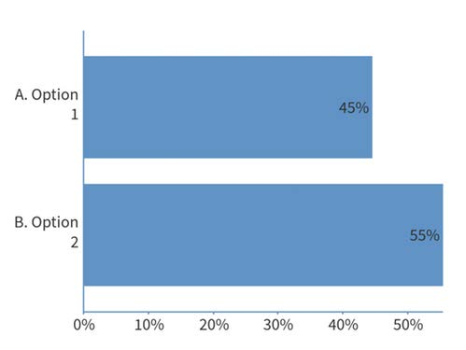
Count Percentage
A. Option 1 33 45%
B. Option 2 41 55%

[74 responses via Poll Everywhere]

Qu. 2. “In 2-3 words, please describe the benefits of a national biosecurity statement for you or your organisation”
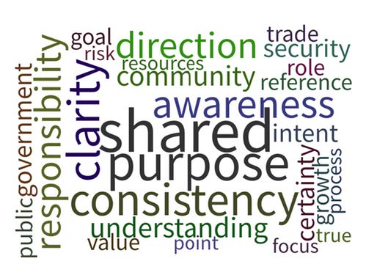
The key terms were: shared purpose, consistency, awareness, clarity, direction and responsibility.

Qu. 3. Would you like to see the roles and responsibilities as part of the statement?
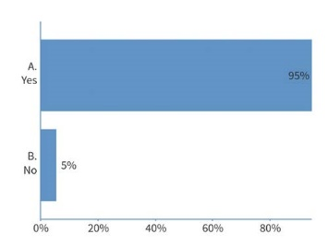
Count Percentage
A.Yes 69 95%
B. No 4 5%

[73 responses via Poll Everywhere]

The workshop then moved onto a series of table discussions and written responses.
Qu. 4. Referring to the draft statement, is there any other information you would like to see in it?
Common Themes
Shared responsibility - within the capacity of each player, recognising public good stakeholders as well as private benefit stakeholders
Science as a stakeholder, its role underpinning understanding and capacity
Diagrams and images - possibly too wordy?
More focus on international trade generating risks
Simplicity is best - very government focused language and tone
What is the outcome of having a statement? How will this be measured?
[72 responses via Poll Everywhere]
Qu. 5 Referring to the draft statement, is there any information in there that you do not think belongs there?
Common Themes
Needs to be plain English - a lot of government speak
Too long - producers won’t read it. Ideally should be a page
What is the appropriate audience for the statement?
Lack of clarity around linkage of outcomes to investment
Statements such as "Shared responsibility does not mean equal" were seen as working against the desired outcome
[28 responses via Poll Everywhere]
How you would your organisation use a statement?
Common Themes
To drive innovation - biosecurity tech development & use to leverage resourcing tool and assist market areas and endorse R&D into technical gaps
Understanding own role in national system
Background document for industry and general communication & community awareness and education
Bringing communities into surveillance efforts - helping spell out shared responsibilities - not articulated pathways or models in the current draft
Justify spending & align internal business plans
Hold governments to account
[38 responses via Poll Everywhere]
This feedback will be used as part of the ongoing development of the draft national biosecurity statement. Option 2 will be adopted as the consultative model. Your further feedback can be provided to biosecurityconsultation@agriculture.gov.au

Agenda Item 6: Centre for Invasive Species Solutions presentation - eDNA
Associate Professor Dianne Gleeson from University of Canberra and Dr Andreas Glanznig from the Centre of Invasive Species Solutions gave a short presentation on the use and potential of eDNA in the detection and eradication of invasive species.
Following the development of a database, work has moved out into the field, using mobile phones as real-time PCR devices. The miniaturisation of the DNA technology offers the promise of un-manned work using drones to collect water or air samples. With the validation of quantitative frameworks, the eDNA process can also indicate biomass in conjunction with detection.
Further work will expand into the testing of ballast water and wider aquatic applications, assisted by funding from the Department of Fisheries Western Australia. South Australian Research and Development Institute (SARDI) has been tasked by the NBC to develop molecular tools using the technology to speed the identification of key marine pests. International accreditation with the development of an ISO framework is also underway.
Further information on the research is available from the Associate Professor’s ResearchGate profile.

Agenda Item 7: Workshop Two
Josephine Laduzko from the Department of Agriculture and Water Resources presented Workshop Two on a proposed Industry and Community Advisory Group, which will engage with the National Biosecurity Committee. This included a brief overview of the existing committee structure and the proposed relationship of the Group to the National Biosecurity Committee.

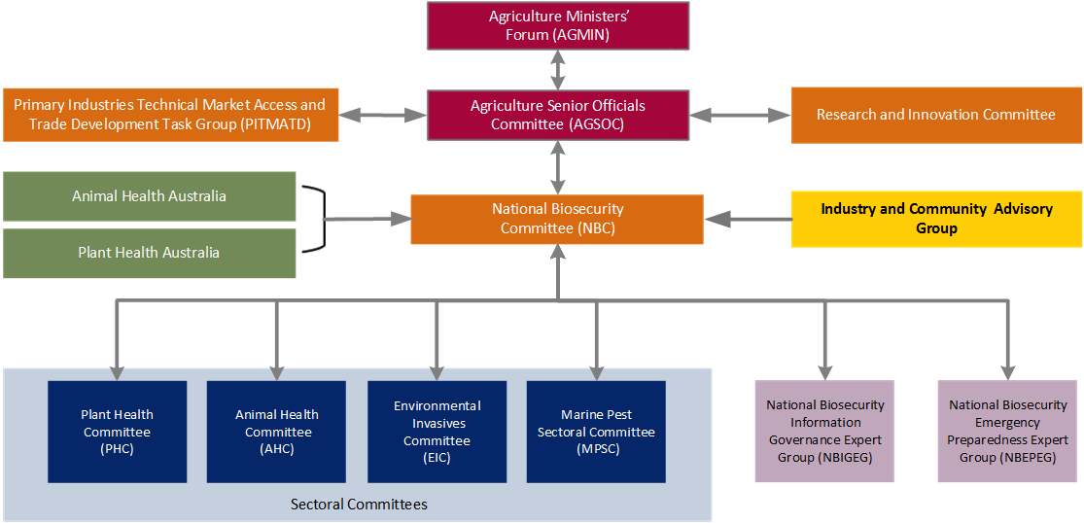

Participants were then asked to discuss the proposal and provide responses on the format and purpose of an Advisory Group which are listed below.
Common Themes
Ability to have industry/community leaders / experts to feed strategically into NBC - without being constrained by jurisdictional context
Has to be measurable & transparency & accountability of response to advice
Specifically, will Local govt representation & Landcare representation be included?
Any new structure needs to be clearly defined and differentiated from other groups
Concerns re bias to those who pay levies rather than other participants - proportions of community involved e.g. recreational fishing/Indigenous fishing - how do we loop them in?
Capacity to address trade discussions
Contributions to and commonality of industry strategy with ability to audit maturity of relevant industry sector
Importance of having the right representation:
- Role in science tertiary / linkages across sectors
- Testing assumptions of industry / community stances
- Test of realistic implementation of policy
[107 responses via Poll Everywhere]
This discussion was followed by five questions answered using Poll Everywhere. The opportunity to engage the wide range of industry at the forum was invaluable to ensuring the Advisory Group structure and process matches industry expectations where possible. Community and environmental organisation were also consulted at the Environment Roundtable held in Sydney on 16 November 2017.
What sort of structure would you like to see the advisory group have?
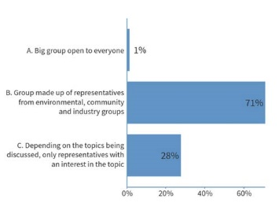
Count Percentage
A. Big group open to everyone 1 1%
B. Group made up of representatives 51 71%
from environmental, community
and industry groups
C. Depending on the topics being 20 28%
discussed, only representatives
with an interest in the topic
[72 responses via Poll Everywhere]

How would you prefer the Group to meet?
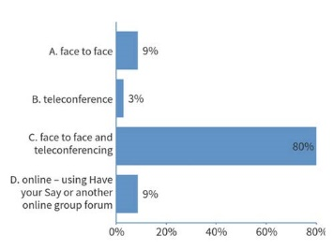
Count Percentage
A. Face to Face 6 9%
B. Teleconference 2 3%
C. Face to Face &
Teleconferencing 56 80%
D. Online – using Have
Your Say or online forum 6 9%
[70 responses via Poll Everywhere]
Do you want to be consulted on specific topics? Please text no more than three suggestions
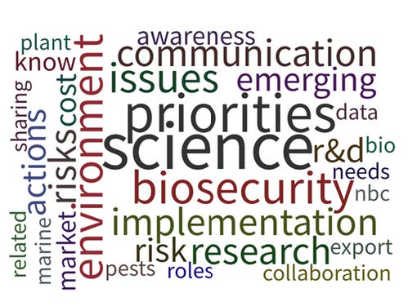
Key words were science, biosecurity, priorities, implementation, communication, and environment.

[66 responses via Poll Everywhere]

If you are representing an industry body or community group, you may not be able to consult with your members prior to the Advisory Group meeting – would this affect your involvement in any of the following ways?
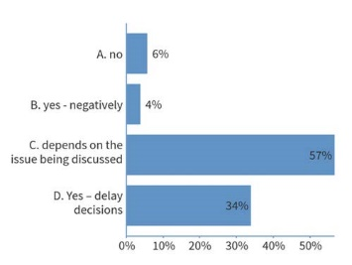
Count Percentage
A. No 3 6%
B. Yes – negatively 2 4%
C. Depends on the issue
being discussed 30 57%
D. Yes – delay decisions 18 34%

[53 responses via Poll Everywhere]
The final question in this workshop looked at the impact of remuneration upon participation in the Advisory Group.
If there were no payment, travel allowance or fees paid to members of the Advisory Group, would this affect your involvement?
Count Percentage

A. No 16 42%
B. Yes 22 58%

[38 responses via Poll Everywhere]

Agenda Item 9: Industry representation – Year in review
Jim Pekin President of the Australian Banana Growers Council (ABGC) covered the impact of the 2015 Panama disease TR4 incursion in Queensland on the banana industry. As Australia’s single largest horticultural sector, it contributes more than $1 billion annually to the national economy. This soil borne bacteria is considered a significant banana plant disease with high levels of residual activity and is very easily transmitted by plant material, soil and water. Eradication is not technically feasible and containment is critical. As eradication is not possible, the Emergency Plant Pest Response Deed has not been triggered.
The ABGC has been very active in education and containment campaigns – it has helped deliver slower spread rates than in other countries. A second property near Tully had a TR4 affected land notice issued in July 2017 – Australia’s largest banana farm. The outbreak is impacting on the local economy, including real estate prices, and potentially banana prices and availability throughout Australia as the Tully area produces 40% of Australia’s bananas.
Inter-industry lessons:
- Good biosecurity is the foundation of sustainable production
- On-farm biosecurity needs to be adopted, not just promoted
- Develop potential responses to your industry’s biosecurity risks
- Conduct training on a regular basis prior to outbreaks
John McDonald from Nursery & Garden Industry Australia (NGIA) represents a peak industry body for a broadly dispersed industry. A national agreement to recognise a BioSecure Hazard Analysis & Critical Control Points (HACCP) is in place with a 3 year trial commencing in 2016. This is part of a larger program by the NGIA and its members to build resilience across the industry by introducing on-farm biosecurity capacities including the EPPRD, biosecurity awareness, R&D and a minor use pesticide program.
The NGIA deals with 30-40 biosecurity incursions a year, and noted that the medium and long term impact for businesses can be the loss of clients. Mr McDonald indicated that the lack of harmonisation of movement control between jurisdictions complicates access to replacement genetic materials, adds additional fees and costs and undermines system creditability due to inconsistency across jurisdictions.
The NGIA believes that dealing with these issues is key to helping growers to participate in the development and adoption of best practice biosecurity measures.
Inter-industry lessons
Business would be assisted by a harmonised domestic biosecurity system via:
- National domestic pest risk analysis framework
- Guidelines for drafting domestic entry conditions
- Uniform administrative requirements
- Agreed definitions of all movement control terminology
- Standardised Plant Quarantine Manual format and storage site
- Standardised documents e.g. plant health certificate/biosecurity certificate
- Remove import inspections for consignments meeting a specific entry condition
- Adoption of electronic certification system/data management

Rod Kerin from the South Australian Oyster Growers Association (SAOGA) provided an update on the impact of the outbreak of Pacific Oyster Mortality Syndrome (POMS) in Tasmania in 2016 on the industry in South Australia. As all of South Australia’s spat stock was imported from the hatcheries in the POMS infected areas, deliveries were immediately halted.
Working closely with SARDI, two spat hatcheries on the Yorke Peninsula were established with a further three hatcheries based in the state beginning deliveries in late 2017. This is a significant reduction in spat numbers and has led to sales being approximately 30% of previous levels. The SAOGA is working with local, state and Commonwealth governments for assistance to hold workforces in localities until production has returned to pre-2016 levels, which is not expected until mid-2019.
Inter-industry lessons:
- Ensure biosecurity planning supports resilience and sustainable production practices
- Build good communications between industry and government to ensure response and support to a biosecurity incursion can be effectively and quickly put in place
- Ensure marketing strategies are in place to maintain and build consumer confidence in the affected product

Agenda Item 10: Bringing community, industry and environment together
Magali Wright (Biodiversity Manager) from Natural Resources Management South presented on their work building a culture of good biosecurity practice across the agricultural, tourism and recreational industries in Tasmania.
The work builds on 13 years of engagement which started with wash down guidelines. Recognising that multiple guidelines would dilute the message, “Check, Clean, Disinfect, Dry” has become the universal practice in Tasmania used across a shared communication action plan tailored for use by different user groups.
With a strong focus on prevention, the consistent use of their simple slogan is applied to all sectors across both natural and productive landscapes by every visitor on each visit. NRM South works closely with existing networks, and supports on-ground community projects, provides tailored support, provision of biosecurity kits and products as well as direct engagement at key events.
The NRM South website also carries a wide range of videos, and the Keep It Clean manual. These materials in conjunction with other products such hygiene kits are able to be used by other jurisdictions and potentially rebranded for wider use. The organisation also conducts an annual survey which provides valuable feedback on the effectiveness of the guidelines and provides broader biosecurity awareness in Tasmania among locals and visitors.
A number of participants responded positively to the presentation, reminding the audience that industry has a key role in funding grass-root activities such as this and the Livestock Biosecurity Network. Another participant raised that as we move into a new phase of the Landcare program, we should be addressing how agriculture and environmental biosecurity issues can be fused, avoiding siloing which can increase conflict between sectors.
Inter-industry lessons:
- Coordination and facilitation is key to projects highlighting agricultural and environmental biosecurity
- Identify buy-in for each partner is key to adoption
- Maintain contact and work on practical solution over time
- Highlight the shared cost and impact of poor biosecurity practices
- Survey outcomes which also acts as an engagement tool

Agenda Item 12: Workshop Three
Karina Keast from the Department of Agriculture and Water Resources the workshop on ‘Surveillance and reporting’. This covered both the feedback the department had received during the state and territory roundtables and asked the attendees to address the issues raised at the state roundtables with possible solutions.
Ms Keast outlined the breadth of the roundtable programs which engaged over 300 representatives around Australia, including an environmental forum in June 2017. These were individual producers and representatives of state and territory based organisations as well as community and government officers.
As our ability to deal with incursions is greatly affected by quick reporting which allows for quicker responses, the key focus of the surveillance and reporting sessions at the roundtables was to ask why are people reluctant to report biosecurity issues?

We then asked participants at the state roundtables what might eliminate the barriers to reporting and how can we encourage reporting?

As part of our effort to action the concerns and needs of producers, individuals and groups with responsibility in the biosecurity space, the attendees were asked to vote on possible government led actions responding to the state roundtable findings.
Please choose your number one preference for possible government led action.

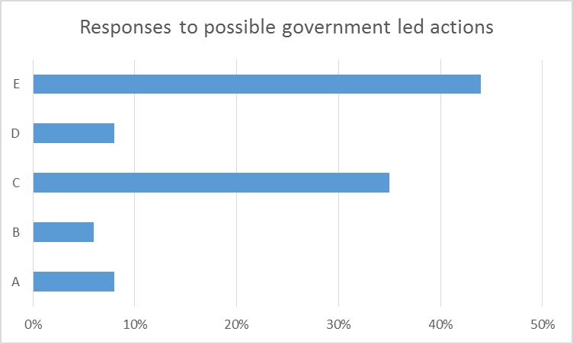

[52 responses via Poll Everywhere]
Count Percentage
A. Review existing & proposed materials (websites, fact sheets etc) to ensure language is easy to understand and messages consistent 4 8%
B. Scope the development of a national 1800 biosecurity hotline 3 6%
C. Broaden biosecurity engagements to include schools, retailers, zoos, museums
18 35%
D. Promote and/or develop biosecurity reporting apps 4 8%
E. Use and promote different forms of communication in languages other English (social media, YouTube, ‘ Have Your Say’, public forums, mail outs, community leaders, trusted advisors
23 44%

This was followed by a vote on possible industry led actions to address to the state roundtable findings.
Please choose your number one preference for industry led action.

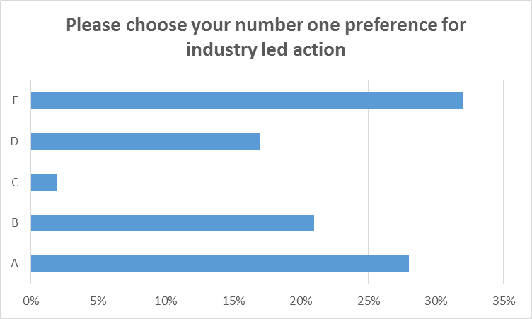

[53 responses via Poll Everywhere]
Count Percentage

A. Appoint industry biosecurity champions to deliver biosecurity messages 15 28%
B. Develop and actively promote real life stories/case studies from affected producers, especially good news stories 11 21%
C. Promote and/or develop reporting apps 1 2%
D. Education campaigns focused on “it’s ok to report” to reduce stigma and fear associated with reporting 9 17%
E. Industry led, targeted biosecurity training 17 32%

This led to a series of questions from the floor including:

Q: One of things pointed out – government isn’t trusted – so why would government lead it?
A: Perhaps the best option is something industry led
Q: Don’t we already have an 1800 number?
A: We have multiple, and they go to different departments. Consistent feedback has been there should be only one number. We are currently scoping this.
Q: At risk of duplicating things that are already happening – actual programs out on farms could contribute. Why set up something new?
A: It is important to get people to join the dots and utilise a range of resources.
Q: The solutions being discussed are city focused communication – elderly people and those with limited connectivity will be excluded. Has to be remembered that technological channels won’t work in the bush
Answer from the floor: Agree with comments about connectivity but connectivity is changing. It can’t be one or the other – we need a mix of messages via a range of channels.
A: The department can scope free download provisions from the new NBC biosecurity website to assist people with limited internet access.
The department will be working to progress the government led actions and encourages industry to progress the industry-led proposals in their own sectors.
We welcome continued feedback on successes and failures around campaigns and engagements with industry, producers, community and environmental groups in the biosecurity space.
Please provide your feedback to biosecurityroundtable@agriculture.gov.au

Agenda Item 13: Workshop Four
Josephine Laduzko of the Department of Agriculture and Water Resources presented the final session of the forum as the fourth workshop ‘Industry’s role in biosecurity’. This presented the social survey findings commissioned by the Department in the 2016 report, ‘Social attitudes and understanding of biosecurity to support market access and plant health surveillance’. This information was also presented to the state and territory roundtables throughout the year. The survey explored how biosecurity is understood within the broader community and the farming sector and producers who are exporters.

The following graphs and information map producer awareness and understanding of biosecurity.
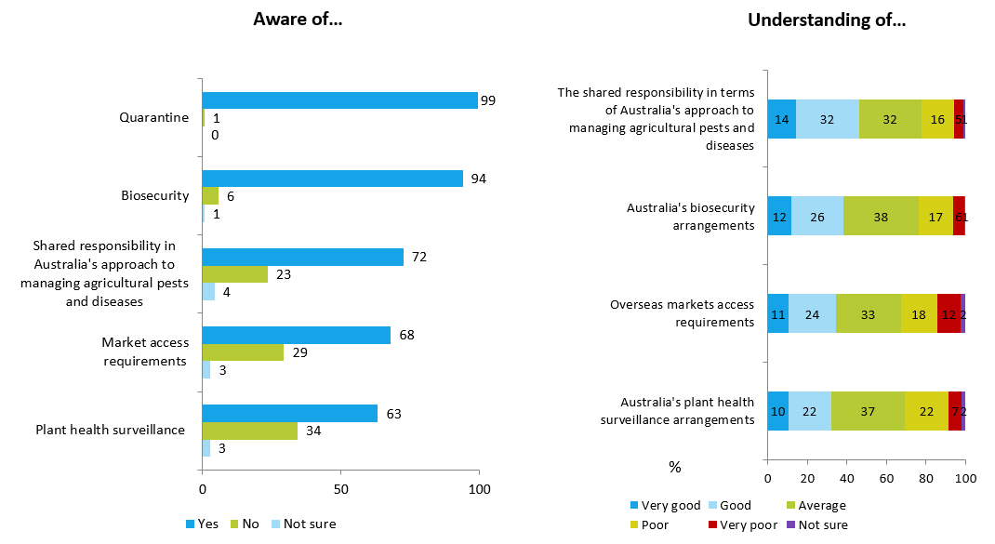
Ms Laduzko then presented the responses from attendees of the state and territory roundtables to the question what stops you or your members from having a biosecurity plan?
Responses included:
- Not seen as relevant – never had an issue
- Didn’t know we needed one
- Costs too high
- Visitors don’t respect rule anyway
- No point as other don’t have plans
- Too many other priorities
- No information or support
The workshop then moved onto table discussions with written responses focusing on the question What can we do to improve biosecurity planning outcomes?
Common Themes
Government - Commonwealth & State | Industry/land manager | Community
Biosecurity officers for each sector | Reward & publicise adoption | Peri-urban should be a significant focus
Discover and coordinate what is already being done at other government and industry levels | Work with trusted industry leaders to deliver messages (i.e Industry Development Officers, local chemical suppliers, agronomists, Integrated Pest Management consultants, quality assurance consultants) | Unmetered internet access for biosecurity website
Consolidation of industry / sector / govt web, phone numbers etc i.e. central web portal? | Many templates already exist across industries e.g. Cattle Council of Australia mailed template plans to 7200 members and linked to Livestock Production Assurance accreditation - Link biosecurity plans to QA programs, especially if linked to market access | Community using local identities
Regulations around conditions for property access, especially with rise in resource exploration | Role of supply chain in encouraging certification schemes
[122 responses via Poll Everywhere]

The discussion then moved onto What can industry/community do?
Common themes
Industry/land manager | Community
Encourage 'brands' to discuss issues while marketing their products | Engage with Landcare groups
Network of experts after implementation (after linked to QA program) To be able to answer industry questions etc | Utility companies to be trained to identify pests and diseases
Use of saleyards to distribute information | Retailers:  - important part of supply chains to also be a participants as well as set standards for producers
[46 responses via Poll Everywhere]

Participants were then asked two questions via Poll Everywhere
What are the 1-3 things that would help your biosecurity planning?
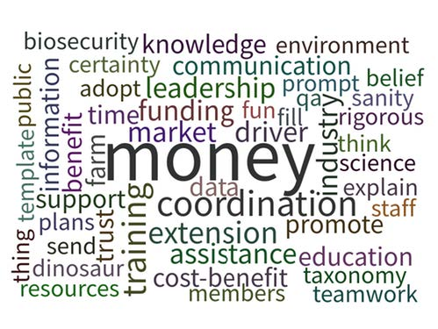

The key terms were: money, coordination, funding, training, extension and assistance.

[50 responses via Poll Everywhere]
Government will consider feedback from this session in future biosecurity planning and encourages industry to consider feedback in their planning.
The final question will assist the department with planning for next year’s roundtable program.
In 2018, do you think you will:
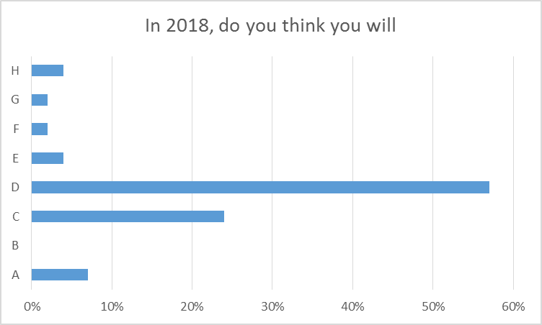
Count Percentage
A. Attend relevant state roundtables 4 7%
B. Nominate a sister organisation 0 0%
C. Attend only national forums 13 24%
D. Attend both your state and national roundtables and forums 31 57%
E. Encourage your state branches to attend state roundtables 2 4%
F. Forward invites to other participants 1 2%
G. Not attend any further meeting 1 2%
H. Receive any updates or available newsletters 2 4%

[54 responses via Poll Everywhere]

Future engagement
The NBC has agreed to deliver the state and territory biosecurity roundtables in 2018 in each state and territory (except the ACT which will be part of the NSW roundtable). The national biosecurity forum and environmental roundtables will also be held.
The National Biosecurity Statement workshop will be held in early 2018.
Once again, we encourage your feedback and thank you for your engagement and interest in biosecurity issues – please don’t hesitate to email us at biosecurityroundtable@agriculture.gov.au

Attachment A – Agenda National Biosecurity Forum, 2 November 2017

Schedule | Topic | Presenter
9:00-9:10 | Item 1: Welcome | Forum facilitator:  Josephine Laduzko, Assistant Secretary, Biosecurity Policy and Response Branch, Department of Agriculture and Water Resources
9:10-9:20 | Item 2: Commonwealth update | Daryl Quinlivan, Secretary, Department of Agriculture and Water Resources
9:20-9:35 | Item 3: National Biosecurity Committee update | Lyn O'Connell, Deputy Secretary, Department of Agriculture and Water Resources
9:35- 9:50 | Item 4: Intergovernmental Agreement on Biosecurity (IGAB) update | William Zacharin, Executive Director, Biosecurity South Australia, Department of Primary Industries and Regions SA
9:50 – 10:25 | Item 5: Workshop one  The national biosecurity statement - roles and responsibilities | Tom Krijnen, Director, Biosecurity Strategy and System Reform, Biosecurity Policy and Response Branch, Department of Agriculture and Water Resources
10:25-10:35 | Item 6: Centre for Invasive Species Solutions presentation - eDNA | Andreas Glanznig, Chief Executive Officer, CISS  Dr Dianne Gleeson, University of Canberra
10:35-11:10 | Item 7: Workshop two  Developing an industry and community advisory group | Amber Parr, Director, Industry Engagement, Biosecurity Policy and Response Branch, Department of Agriculture and Water Resources
11:10-11:30 | Item 8: Morning tea
11:30-12:45 | Item 9: Industry representation - Year in review  • Australian Banana Growers’ Council  • Nursery and Garden Industry Australia  • South Australian Oyster Growers’ Association | Doug Phillips, Past President, ABGC  John McDonald, National Biosecurity Manager, NGIA  Rob Kerin, Chair, SAOGA
12:45-1:20 | Item 10: Bringing community, industry and environment together - Natural Resources Management South | Magali Wright, Biodiversity coordinator, Natural Resources Management South
1:20-2:00 | Item 11: Lunch
2:00-2:45 | Item 12: Workshop three  Surveillance and responses – what have the state biosecurity roundtables told us? How will we respond? | Karina Keast, Director, Response, Biosecurity Policy and Response Branch, Department of Agriculture and Water Resources
2:45-3:30 | Item 13: Workshop four  Industry’s role in biosecurity – what have the state biosecurity roundtables told us? How will we respond? | Amber Parr, Director, Industry Engagement, Biosecurity Policy and Response Branch, Department of Agriculture and Water Resources
3:30-3:45 | Item 14: Closing remarks | Josephine Laduzko, Assistant Secretary, Biosecurity Policy and Response Branch, Department of Agriculture and Water Resources
3:45-4:15 | Item 15: Afternoon tea

