Exporter Supply Chain
Assurance System
Report
January 2015

© Commonwealth of Australia 2015
Ownership of intellectual property rights
Unless otherwise noted, copyright (and any other intellectual property rights, if any) in this publication is owned by the Commonwealth of Australia (referred to as the Commonwealth).
Creative Commons licence
All material in this publication is licensed under a Creative Commons Attribution 3.0 Australia Licence, save for content supplied by third parties, logos and the Commonwealth Coat of Arms.

Creative Commons Attribution 3.0 Australia Licence is a standard form licence agreement that allows you to copy, distribute, transmit and adapt this publication provided you attribute the work. A summary of the licence terms is available from creativecommons.org/licenses/by/3.0/au/deed.en. The full licence terms are available from creativecommons.org/licenses/by/3.0/au/legalcode.
Cataloguing data
This publication (and any material sourced from it) should be attributed as Commonwealth of Australia 2015, Exporter Supply Chain Assurance System Report. CC BY 3.0.
ISBN No: 9781760030858 (online)
Internet
Exporter Supply Chain Assurance System Report is
available at agriculture.gov.au.
Contact
Department of Agriculture
Postal address GPO Box 858 Canberra ACT 2601
Switchboard +61 2 6272 3933
Facsimile +61 2 6272 2001
Email pr@agriculture.gov.au
Web agriculture.gov.au
Inquiries regarding the licence and any use of this document should be sent to copyright@agriculture.gov.au.
The Commonwealth has exercised due care and skill in preparing and compiling the information and data in this publication. Notwithstanding, the Commonwealth, its employees and advisers disclaim all liability, including liability for negligence, for any loss, damage, injury, expense or cost incurred by any person as a result of accessing, using or relying upon any of the information or data in this publication to the maximum extent permitted by law.
Cover photographs supplied by the Department of Agriculture and the Northern Territory Cattlemen's Association (Photographer Luke Bowen).

Foreword

The Australian Government is committed to a strong, viable, sustainable and well regulated livestock sector. We are also fundamentally committed to achieving a greater return through the farm gate for producers.
The live animal export trade is essential to the livelihoods of thousands of Australian families and underpins the economies of many communities across the nation. In particular, the trade is essential to the economy of the north, it is essential to providing competition in the domestic meat processing sector and is an essential source of purpose and income to indigenous communities. In short it is essential for our nation.
Australia has been exporting livestock for over 100 years. We are the second largest exporter of live sheep and the fifth largest exporter of live cattle in the world. Similarly we produce some of the highest quality, sustainably produced livestock for export. Put this together and the reality is that we are providing some of the highest quality, cleanest, greenest and affordable protein, feeding millions of families all over the world.
Since the introduction of the Exporter Supply Chain Assurance System (ESCAS) Australia has exported 8 million head of livestock to 18 countries in 1139 consignments with only 22 incidents of animal welfare concern. In light of this, government and industry are working together to open new export markets and to improve market access for Australian livestock to existing markets. Since this government came to office in September 2013 the value of live animal exports has amounted to $1.4 billion and is continuing to break new ground. Australia's share of the international market is fundamentally built on our superior and safe product and our price competitiveness.
We also understand that our customers value the continuity of supply, and as such this government has worked exceedingly hard to repair the damage done to our international reputation as a reliable supplier by the previous Labor Government.
We can also be proud that we are exporting more than our livestock, we're also exporting animal welfare improvements. In fact government and industry are continuing to work with our trading partners to enhance animal handling and husbandry skills and improve animal welfare outcomes—training more than 7,000 people to date. Industry is continually helping to upgrade facilities in-country to meet international animal welfare standards and our shared commitment to this work is ongoing.
This review offers a timely assessment of the effectiveness of ESCAS in fulfilling its twin objectives of facilitating trade and delivering animal welfare outcomes. It highlights ESCAS's achievements and where it has been effective and identifies opportunities to cut unnecessary red tape and make it a more cost effective, efficient and flexible system into the future.
Significant opportunities exist to reform and simplify administrative processes, increase flexibility and reduce cost burdens while still meeting the core objectives of the ESCAS framework. These include strengthening and clarifying compliance standards, allowing for the sharing and alignment of audits for the same facilities and supply chains and not the least of which, providing the opportunity for industry to take greater responsibility for proactively managing risks within supply chains.

This government's agenda is clear, we are striving to boost Australia's agricultural competitiveness through facilitating trade and market access and putting in place the policy settings that return a greater share of the retail dollar back through the farm gate. This review provides an assessment of a trade that is vital in achieving that goal and one that highlights it as a fundamental component of Australian agriculture—one of the pillars of our great nation.
[signed]
The Hon Barnaby Joyce MP
Minister for Agriculture

Contents
Summary 2
1. Introduction 5
2. ESCAS and animal welfare 14
3. ESCAS and facilitating trade 30
4. ESCAS administration 37
5. Conclusions 42
Appendix A Regulation of animal welfare and livestock exports 44
Appendix B List of submissions 46
Appendix C Summary of investigation report outcomes 47
Appendix D Approved Supply Chain Improvements Program 52
Appendix E Country profiles 53
Appendix F Definitions and acronyms 84
Appendix G References 87

This report contains information until 30 November 2014 unless otherwise stated.
All livestock statistics are for feeder and slaughter livestock only unless indicated otherwise.

Summary
Australia’s livestock exports are an important economic contributor to regional Australia, adding significantly to the total value of Australian farm exports. In 2013–14 export revenue received from live exports was $1 243 million and represented seven per cent (live cattle) and six per cent (live sheep) of total turn-off in their respective industries.
The industry provides communities well beyond farmers with economic benefits and employment opportunities, with an estimate of up to 10 000 people involved directly and indirectly in the industry.
In June 2011, following the public response to footage of mistreatment of Australian animals in some Indonesian abattoirs, the former Australian Government temporarily suspended trade to Indonesia of cattle for slaughter until new safeguards for animal welfare were established.
The Exporter Supply Chain Assurance System (ESCAS) was designed in a matter of weeks and was implemented in Indonesia. It was then progressively rolled out to all Australian export markets during 2012. ESCAS was designed to ensure that Australian livestock exported for feeder and slaughter purposes are handled in accordance with international animal welfare standards and to provide a mechanism to deal with animal welfare issues when they occur—preventing the need for trade suspensions.
In addition, the former Minister, Senator the Hon. Joseph Ludwig, commissioned the Independent Review of Australia’s Livestock Export Trade. The review made 14 recommendations, including the recommendation that the government conduct a review of ESCAS, outlining the initial experiences and making judgements about the effectiveness of the approach in delivering animal welfare outcomes and facilitating trade.
This report reflects on the implementation of ESCAS and considers its effectiveness in ensuring animal welfare and facilitating trade. The report also looks to how the system can be improved, potentially reducing costs to both industry and the Department of Agriculture while continuing to achieve its objectives.
Prior to ESCAS, Australia already had a comprehensive system for managing animal welfare issues from the farm gate to the point at which animals arrive in the importing country. ESCAS extended that system, requiring exporters to account for how exported livestock are treated from their arrival in the importing country until they are slaughtered.
Under ESCAS the exporter must demonstrate, through a system of reporting and independent auditing:
- animal handling and slaughter meets World Organisation for Animal Health (OIE) animal welfare standards (Animal welfare)
- the exporter has control of all supply chain arrangements for livestock transport, management and slaughter, and all livestock remain in the supply chain (Control)
- the exporter can trace or account for all livestock through the supply chain (Traceability).
The development and implementation of ESCAS represented a significant innovation in government policy. There are relatively few areas of policy where the government places regulatory requirements on exporters that extend into other countries.
In developing this report, over 60 stakeholders from across the supply chain were invited to make submissions. Thirty-six submissions were received from industry organisations, producers, exporters, animal welfare organisations, importers, Australian state and territory governments and importing country governments. Views were varied, but the majority of stakeholders said they believe that ESCAS has been a step in the right direction to improve animal welfare. However, opinions differ about whether ESCAS is merely a good first step or has substantially resolved the problems with animal welfare, with the focus now being on continuous improvement and refinement.
While stakeholders recognise that ESCAS allowed trade with Indonesia to resume rapidly, some felt that speed had been traded off against consultation which could have provided better understanding of market complexities and sensitivities.
Before ESCAS was introduced the Australian Government and community had little knowledge about the fate of animals once they arrived in the importing country. Now there is a clear understanding of where animals are going, how they are handled and how they are slaughtered. There is also an improved understanding of the variety and complexity of the supply chains in operation across export markets—from simple integrated importer, feedlot and abattoir relationships, to complex systems with livestock moving between interrelated supply chains.
ESCAS has increased awareness of the importance of animal welfare for livestock handling in Australia’s export markets. This has benefited not only Australian animals but also those sourced from other countries. These improvements have been driven by investments in training and infrastructure from the Australian Government, industry and industry-funded research and development corporations. ESCAS has reportedly provided a significant ‘pull factor’ that has seen increased participation in these programs further down the supply chain.
To 30 November 2014, 8 million head of feeder and slaughter livestock in 1139 consignments have been exported under ESCAS from Australia to 18 countries by 21 exporters. A total of 866 establishments in 19 countries (including facilities in one country yet to receive ESCAS livestock) had been independently audited as being OIE compliant. The rate of pre-slaughter stunning has increased. For example, over 80 per cent of facilities in Indonesia that receive Australian cattle practice pre-slaughter stunning.
From implementation of ESCAS in 2011 to 30 November 2014, there have been 59 incidents of non-compliance with ESCAS requirements confirmed by the Department of Agriculture—47 per cent detected by the Department of Agriculture, 31 per cent self-reported by exporters, and 22 per cent reported by others. Thirty-seven incidents related to issues where there was no direct animal welfare impact but instead were problems with control, traceability or auditing arrangements. Of these, 23 were for movement of livestock outside the supply chain nominated on the ESCAS paperwork to facilities that have been audited and are OIE compliant, with no compromise of animal welfare.
While ESCAS has done much to improve animal welfare outcomes, it has not meant that every animal has been slaughtered in line with OIE standards. Of the millions of animals exported under ESCAS there have been 22 identified incidents of non-compliance where the animal welfare outcome was either adverse or unknown. Most of the identified incidents involved multiple animals, up to several thousand in one instance. In these cases corrective action has been taken to mitigate against further incidents.
Extending the government’s regulatory reach internationally through ESCAS poses challenges for compliance and enforcement. Possible breaches of animal handling standards, reports of improper slaughter techniques and loss of animals from supply chains have been difficult for the Department of Agriculture to investigate. Where breaches can be traced, conditions have been imposed on exporters to mitigate and prevent recurrence within a supply chain.
The ESCAS framework applies a single consistent system to all importing countries, regardless of the significant differences in terms of species exported, transportation method, seasonality, and demand drivers that apply. The ‘one-size-fits-all’ approach of ESCAS does not allow importing countries’ regulations or positive improvements made by exporters or markets to be taken into account.
One of the concerns raised when ESCAS was introduced was the impact it might have on trade and opportunities for Australian producers. International trade is affected by numerous factors such as price, exchange rate, competition, market-specific issues, domestic policies and commercial factors. Among these factors it is difficult to distinguish the impact ESCAS specifically had on trade.
Cattle exports declined prior to the introduction of ESCAS but rebounded to record levels in 2013–14. Total trade volume of sheep has been declining since 2005–06 and has continued to decline following the introduction of ESCAS.
Some difficulties in maintaining individual markets under ESCAS have been experienced. The last consignment to Saudi Arabia occurred in 2012 and it has not been possible to reopen that market under ESCAS. Conversely, ESCAS has enabled the trade in live sheep to Egypt, which ceased in 2006, to recommence. New markets have been opened under ESCAS including Vietnam, Iran, Cambodia, Thailand and Lebanon.
Despite its successes, the regulatory model for ESCAS is complex and imposes costs of over $17.6 million a year on government and the industry. The question remains whether the same gains in animal welfare could have been made through a simpler, clearer and ultimately cheaper system.
The government is committed to increasing farm gate profitability and the prosperity of Australia’s regional communities through reducing red tape burdens on businesses. There have been a number of improvements to the ESCAS framework since September 2013—including the implementation of new auditing requirements for overseas supply chain facilities and administrative changes which streamline document requirements and remove duplication.
In September 2014 the government announced further reforms to remove duplication in the approval process by separating the ESCAS approval from individual consignment approval, adding the option of risk based compliance auditing, and consolidating and improving the auditor checklists. The first of these reforms has been implemented and the other two are nearing completion.
However there are opportunities for further reform which would simplify administrative processes, increase flexibility and reduce cost burdens while still meeting the objectives of the ESCAS framework in maintaining animal welfare and facilitating trade. These include:
- clearer guidelines for describing and managing non-compliance, and clarifying third party complaint processes
- allowing the sharing of audits for the same facilities or supply chains, which will remove duplication, reduce costs and improve opportunities for co-operation between individual exporters
- recognising opportunities for industry to take greater responsibility for proactively managing the risks within supply chains.
Implementation of these reforms, along with ongoing evaluation of export processes and identification of further opportunities for improvement may assist the Department of Agriculture to develop a more efficient and cost effective system for ensuring welfare of exported livestock.

1. Introduction
In June 2011, the former government commissioned the Independent Review of Australia’s Livestock Export Trade (the Farmer Review). The review was led by Mr Bill Farmer AO and finalised on 31 August 2011. It made 14 recommendations, including the recommendation that the government conduct a review of the Exporter Supply Chain Assurance System (ESCAS), outlining the initial experiences and making judgements about the effectiveness of the approach in delivering animal welfare outcomes and facilitating trade. This report is the government’s response to that recommendation.
It has now been more than two years since ESCAS was fully implemented as part of the regulatory arrangements for feeder and slaughter livestock exports. Importers, exporters, the Department of Agriculture and other stakeholders have significant experience with the operation of the system. This report draws on these experiences.
While Australia regulates livestock exports across the supply chain, this report focuses on the component of the supply chain which is only regulated by ESCAS—animal welfare outcomes from the point of disembarkation in the importing country through to the point of slaughter.
Specifically, this report focuses on ESCAS’s effectiveness in improving animal welfare outcomes in export markets and in facilitating the Australian livestock export trade. The report provides data and practical examples of how ESCAS has been implemented and operated as a regulatory system. It reflects on the effectiveness of ESCAS since its implementation, and identifies areas for improvement.
The suspension of live export trade with Indonesia in 2011 had a significant impact on exporters, importers and also on producers—particularly those in northern Australia. However, while these impacts are acknowledged as important they are not the subject of this report.
In addition the report does not cover other regulatory requirements for the export of Australian livestock, such as the Australian Standards for the Export of Livestock (version 2.3) (ASEL).
The data in this report was sourced from the Live Export Trade Assessment (Deards et al. 2014), Australian Bureau of Statistics data (ABS 2015), and Live Animal Export Program data from the Department of Agriculture (Department of Agriculture 2015), current to 30 November 2014 unless indicated otherwise.

1.1 Why did we need ESCAS?
On 30 May 2011, the ABC’s Four Corners aired a story entitled ‘A Bloody Business’ that provided evidence of the systemic mistreatment of Australian-origin cattle in some Indonesian abattoirs. The story created widespread interest in the livestock export trade and many stakeholders, including producers, exporters, peak industry bodies and animal welfare organisations were quick to condemn the poor practices evident.
The former government suspended the export to Indonesia of feeder and slaughter livestock on 8 June 2011. During the suspension, the government and industry developed a new regulatory framework known as ESCAS that would meet the objectives of:
- providing assurances to the Australian community that the welfare of animals exported from Australia is maintained through to the point of slaughter in the importing country
- facilitating the livestock export trade so that exporters can increase market share overseas.
The first consignment was exported under ESCAS on 10 August 2011 and ESCAS was implemented in all markets by 1 January 2013.

1.2 What is ESCAS?
ESCAS is an assurance system that requires exporters’ to have commercial arrangements with supply chain partners to provide humane treatment and handling of livestock from arrival in the importing country up to the point of slaughter. The regulations that underpin ESCAS are outlined in Appendix A.
The system operates by requiring the submission and approval of an ESCAS in order to conduct an export of livestock for feeder or slaughter purposes. The term ‘ESCAS’ may refer to either the assurance system as a whole, or the approval required for an export. An ESCAS must outline the details of the supply chain for the proposed export, including the following:
- the port of arrival
- transport, handling and slaughter of the livestock
- feedlots
- identification, tracking or accounting and reconciliation of livestock
- independent auditing and reporting
- access to premises
- any related operations and facilities.
An ESCAS can only be approved if the Department of Agriculture is satisfied that it will ensure that relevant World Organisation for Animal Health (OIE) standards will be met. An ESCAS approval may be subject to conditions, including conditions related to the matters listed above.
ESCAS does not apply to animals exported for breeding purposes—for example to form part of the importing country’s national herd.
The ESCAS regulatory framework requires four key principles be addressed by an ESCAS including:
- Animal welfare—Animal handling, transport and slaughter in ESCAS supply chains must comply with OIE animal welfare standards. Australia is an OIE member, as are all of its feeder and slaughter livestock markets.
- Control—Under ESCAS exporters must be able to demonstrate control of all supply chain arrangements for livestock transport, handling and slaughter. These arrangements must ensure that livestock remain within the approved supply chain.
Exporters can demonstrate control through either vertical integration, where a parent company has control because it owns all components of the supply chain, or contractual arrangements with parties that are not vertically integrated.
- Traceability—All exporters must be able to trace or account for livestock through the supply chain, to demonstrate that all livestock went only to facilities that had been independently audited, found to be compliant and included in the approved supply chain. Supply chains differ in complexity, which has flow-on effects for traceability requirements. Simple linear supply chains are easier for demonstrating traceability. However, complex supply chains use multiple facilities which may also be included in other exporter supply chains, increasing the complexity of reporting necessary to demonstrate traceability (see Figure 1).
Traceability requirements for cattle and buffalo are different from those for sheep and goats. Exporters must be able to identify cattle and buffalo individually and locate them at any point in the supply chain. Exporters use a mob-based system to account for sheep and goats and can account for them by counting and reconciling numbers at different points in the supply chain.
To confirm traceability of cattle and buffalo, until 21 July 2014 exporters were required to provide end-of-processing reports that detail the progress of all animals through the supply chain. This has since been replaced by traceability declarations. These reports are not required for sheep and goats.
- Independent auditing—Under ESCAS, supply chains in the importing country must be independently audited. Auditing companies must meet the criteria of independence, no conflict of interest, and possession of appropriate competence and expertise (through qualifications and experience). As part of this process, the Australian Government requires auditors to come from companies accredited by an appropriate authority, such as a member of the international body for accreditation of Conformity Assessment Bodies—the International Accreditation Forum.
There are two types of independent audit reports:
- independent initial audit reports, which must be submitted with the exporter’s initial application for an ESCAS
- independent performance audit reports, which an exporter must submit to the Department of Agriculture at intervals to demonstrate ongoing compliance with ESCAS requirements.
Figure 1 Examples of ESCAS supply chain types
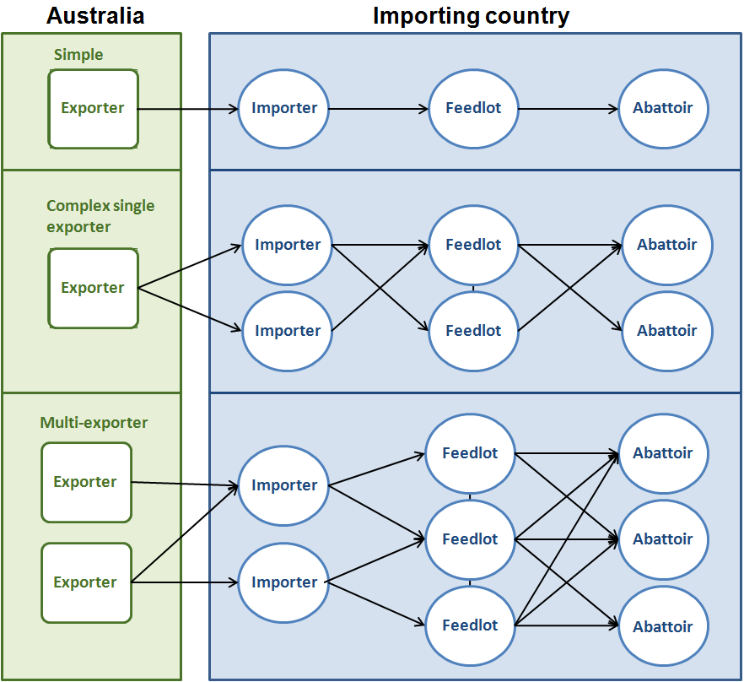

The livestock export process
ESCAS is only one part of the regulation of livestock export in Australia (Figure 2).
The Department of Agriculture regulates the export of livestock under the Export Control Act 1982, the Australian Meat and Live-stock Industry Act 1997 and associated orders, regulations and standards (see Appendix A). This includes the Australian Standards for the Export of Livestock (version 2.3)(ASEL) and the Exporter Supply Chain Assurance System (ESCAS).
To export livestock from Australia, an exporter must complete three steps: become licensed; demonstrate that the livestock will meet importing country requirements; and be able to comply with export legislation and standards, which include both ESCAS and the ASEL.
Licences are an important component of the export process. When applying for a licence, exporters must provide an operations and governance manual that sets out how the export livestock business will operate and be governed. This includes details on how the company will manage risk and records and comply with Australian regulations.
Exporters must ensure the animals are fit and healthy for travel, and prepare them for export in accordance with importing country requirements. This involves demonstrating to the Department of Agriculture that animals are free from infectious and contagious disease and have been prepared according to the importing country’s protocols, which may include performing testing and treatments.
Exporters must also meet the requirements of the ASEL, to maintain animal welfare during preparation in Australia and the voyage to the importing country. ESCAS completes the export process by ensuring maintenance of animal welfare from the point of arrival in the importing country until the time of slaughter.
Figure 2 Supply chain steps
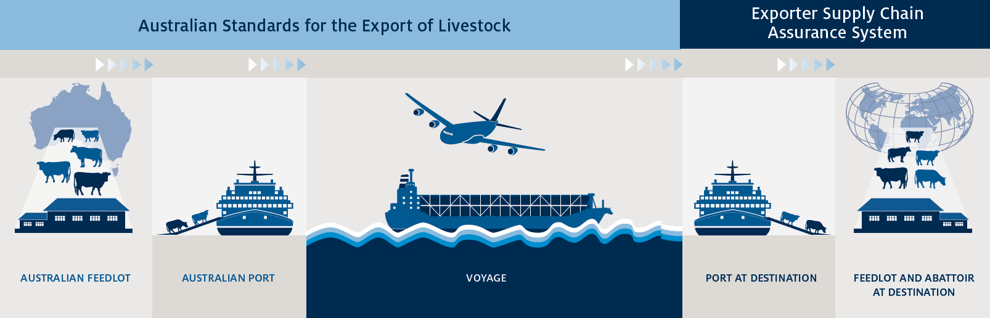

1.3 How was ESCAS developed and implemented?
During the Indonesian trade suspension government and industry worked together to develop a regulatory system under which the livestock export trade to Indonesia could recommence. On 6 July 2011, the former government announced the commencement of the new regulatory requirements—ESCAS—under which trade with Indonesia could recommence. The first livestock consignment was exported to Indonesia under ESCAS on 10 August 2011.
In June 2011 the Australian Government commissioned an Independent Review of Australia’s Livestock Export Trade (the Farmer Review). The Farmer Review recommended that ESCAS be progressively rolled out to all countries receiving Australian feeder and slaughter livestock.
The former government accepted the recommendation, and established an industry–government implementation group (IGIG) for cattle, buffalo, sheep and goats, to consider the review recommendations and oversee implementation. The IGIG consisted of representatives from livestock industry bodies, major livestock exporters, the Commonwealth government and state and territory governments. ESCAS requirements were progressively applied for other countries from 1 March 2012 to 31 December 2012 (Table 1).
Table 1 Date of application of ESCAS requirements, by country
Tranche | Countries | Date ESCAS requirements became applicable
Initial implementation | Indonesia | 6 July 2011
Tranche 1 | Kuwait, Bahrain, Qatar, Turkey | 1 March 2012
Tranche 2 | Israel, Japan, Jordan, Malaysia, Oman, Philippines, Saudi Arabia, Singapore, United Arab Emirates | 1 September 2012
Tranche 3 | Brunei, Mauritius, Russia, Vietnam, all other markets | 31 December 2012
Subsequent implementation | Egypt | 20 March 2014
Note: Other markets include all markets not yet subject to ESCAS at that time

1.4 Stakeholder views on ESCAS
To inform the drafting of this report, submissions were invited from a cross-section of stakeholders, including industry bodies, producers, exporters, importers, animal welfare organisations, state and territory governments, and importing country governments. In the call for submissions, stakeholders were invited to provide comments on their experiences with ESCAS. Specifically, they were asked to consider:
- the effectiveness of ESCAS in improving animal welfare
- the effectiveness of ESCAS in facilitating trade
- the costs of establishing and managing ESCAS
- opportunities to streamline, remove red tape and improve ESCAS.
In total 36 submissions were received, including a joint submission representing the views of several industry organisations and their members.
All submissions that commented on the issue agreed that ESCAS had increased animal welfare outcomes for Australian animals in the livestock trade. Generally animal welfare groups remain opposed to the export of live animals, although they indicated that, if the trade is to continue, ESCAS is a step in the right direction. However, they argued that it requires further strengthening, including by introducing traceability for individual sheep, implementing a requirement for pre-slaughter stunning, and banning full-inversion cattle slaughter restraint boxes. They also advocated for ESCAS to be extended to cover breeder animals, including dairy cattle.
Animal welfare groups also suggested several improvements to ESCAS, such as strengthening the regime of penalties and the skill set of independent auditors.
Exporters and industry organisations expressed the view that ESCAS has increased awareness of animal welfare in overseas countries, particularly in abattoirs where many handling and slaughter practices have improved. They saw this as being driven by the significant investment made by industry to improve animal welfare and upgrade facilities. However, many also expressed concern about ESCAS making exporters responsible for the actions of a third party in another country where they have little control.
Many industry organisations, exporters and importers share the view that the introduction of ESCAS has caused some loss of commercial reputation for Australian livestock exports. Some exporters felt that the complexity of ESCAS and the costs it imposes is putting Australia at a competitive disadvantage, leading some importers to obtain animals from other countries. However, many acknowledge that ESCAS has contributed to an improvement in the trade’s animal welfare reputation and the continuation of the trade with key trading partners like Indonesia.
Several submissions highlighted problems with ESCAS in certain markets or particular circumstances—for example, the limitation for the buffalo industry and the difficulty created for small or mid-value customers who cannot afford the compliance costs.
Submissions from importing country governments expressed the view that the design and implementation of ESCAS did not acknowledge domestic regulations or laws or account for cultural differences and the impact that this can have on their markets—for example, the emergence of a black market and limitations being placed on the use of supply chain facilities under some commercial contracts. At the same time, several importing countries reported that practices advanced under ESCAS have improved efficiency in abattoirs, increased worker safety and assisted them to gain access to new markets.
There was consensus from those involved in the live animal trade that costs of complying with ESCAS are difficult to calculate but their perception is that it is complex and expensive. Some submissions pointed out that the ESCAS process affects associated industries—for example longer assessment times leading to delays in loading vessels in Australia affects the transport industry. These submissions identified opportunities for the Department of Agriculture to improve efficiency, reduce red tape and cut costs.
Some stakeholders raised issues that were outside of the scope of this report—applying to other parts of the export process.

1.5 Overview of ESCAS
Australia exports cattle, buffalo, sheep and goats to countries across the world under ESCAS. Over 8 million feeder and slaughter livestock (ABS 2015) have been exported under ESCAS in 1139 consignments to 18 countries between 10 August 2011 and 30 November 2014 (Figure 3 and Figure 4) (Department of Agriculture 2015). Primary export markets are in South-East Asia and the Middle East.
Figure 3 Feeder and slaughter livestock exports under ESCAS
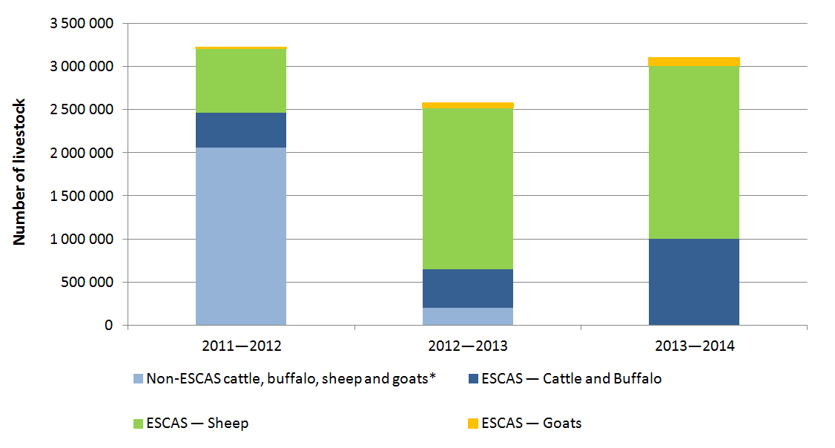
Note: *Non-ESCAS animals were exported during the transition period to countries where ESCAS had not yet been implemented. Sheep and goat figures may include a small number of breeder livestock.
Source: ABS 2015.
Australia typically exports around 500 000 to one million cattle for feeder or slaughter purposes each year, which generally accounts for between 6 and 10 per cent of annual cattle turn-off. Buffalo exports have only been recorded separately from cattle exports for the past three years, with 1600 buffalo exported in
2013–14. Two to three million slaughter sheep are exported each year, predominantly to the Middle East, which accounts for about 6 per cent of annual turn-off. Slaughter goat exports typically number 60 000 to 80 000 per year, representing around 3 to 4 per cent of goat turn-off, and are mostly destined for Malaysia (Deards et al. 2014).
Figure 4 Proportion of livestock to importing countries under ESCAS
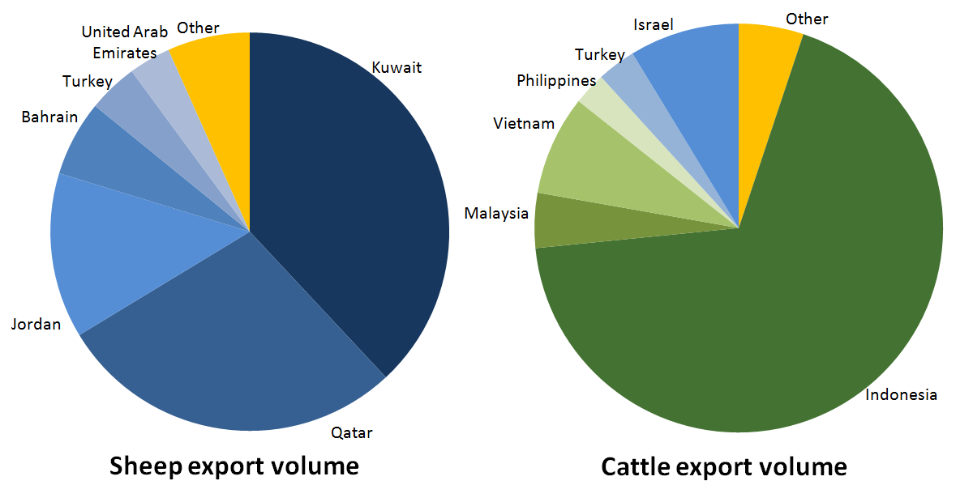
Note: includes data up to 30 June 2014
Source: ABS 2015.
Indonesia and Malaysia receive the highest number of consignments (Figure 5). Consignments to Indonesia are mostly cattle transported by sea averaging 3200 animals each. Consignments to Malaysia consist predominantly of goats transported by air in small volumes (averaging 1000 goats per consignment). In contrast, long-distance markets for sheep receive fewer but larger consignments. These consignments average between 30 000 and 40 000 livestock each, and these markets import larger numbers of livestock overall.
Figure 5 Number of ESCAS consignments, by importing country
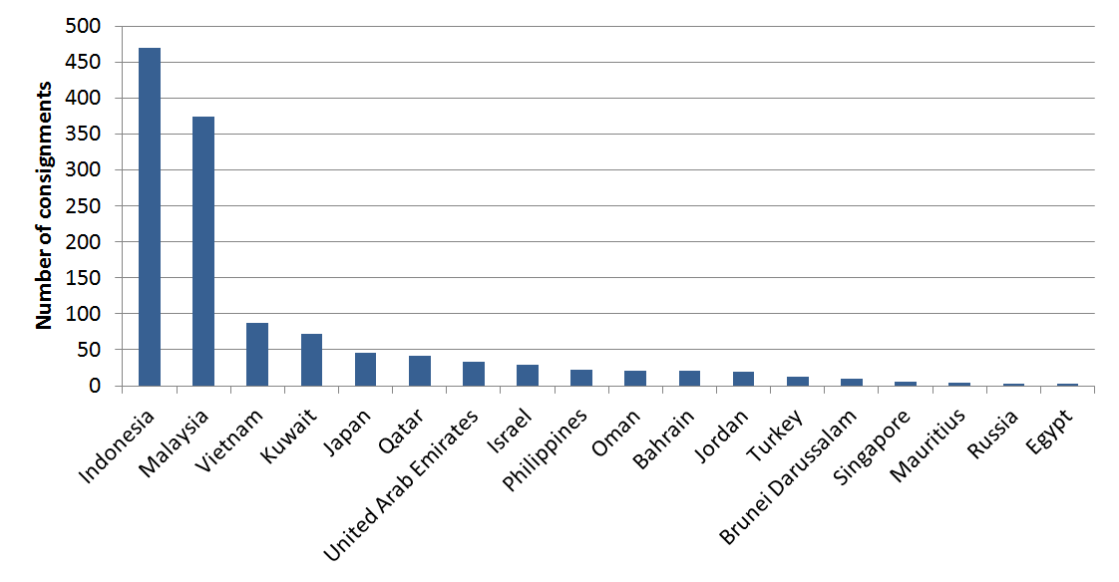
Note: Some consignments appear multiple times in the above graph, where they included livestock destined for multiple countries.
Source: Department of Agriculture 2015.
Twenty-one exporters have exported livestock under ESCAS arrangements, with 18 of these active during 2013–14. Of these, 16 exporters were active the previous year. The number of active exporters fluctuates annually as a result of factors including changing trade demand, the value of the Australian dollar and Australian climatic conditions. The number of exporters had been declining since 2008–09 and the decrease continued following the introduction of ESCAS (Figure 6). However, numbers increased marginally in
2013–14. Further analysis of the impact on trade is provided in Chapter 3.
Figure 6 Effect of ESCAS on number of exporters of feeder and slaughter livestock
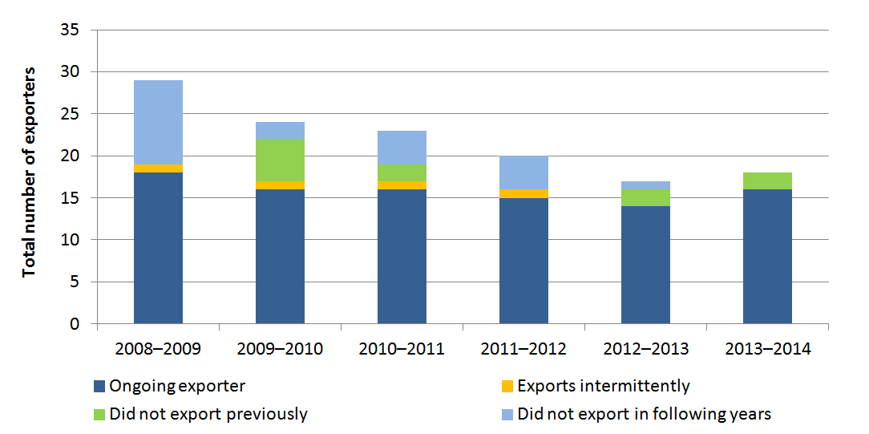
Source: Department of Agriculture 2015.
Exporter numbers are relatively small compared with those of other industries, and the majority of exports are conducted by an even smaller group (Figure 7). Despite the small number of exporters the live export trade is important for Australian farmers generally. The trade provides communities with economic benefits and employment opportunities. It provides employment for on-farm contractors, road transporters, suppliers of hay/fodder to export yards and cattle ships, freight companies, veterinary and feedlot service providers, fuel suppliers and transport businesses. The revenue potential is particularly important for communities in northern Australia and sheep producers in areas of western and southern Australia (Deards et al. 2014). The trade also has significant flow on effects for other livestock markets in Australia. Increased prices for livestock for export has resulted in higher domestic prices—for example, domestic sheep prices increased in mid–2014 as new export markets opened and meat demand remained strong (Meat & Livestock Australia 2014).
Figure 7 Proportion of cattle/buffalo and sheep/goat exports conducted by the five largest exporters, by number of livestock and number of consignments
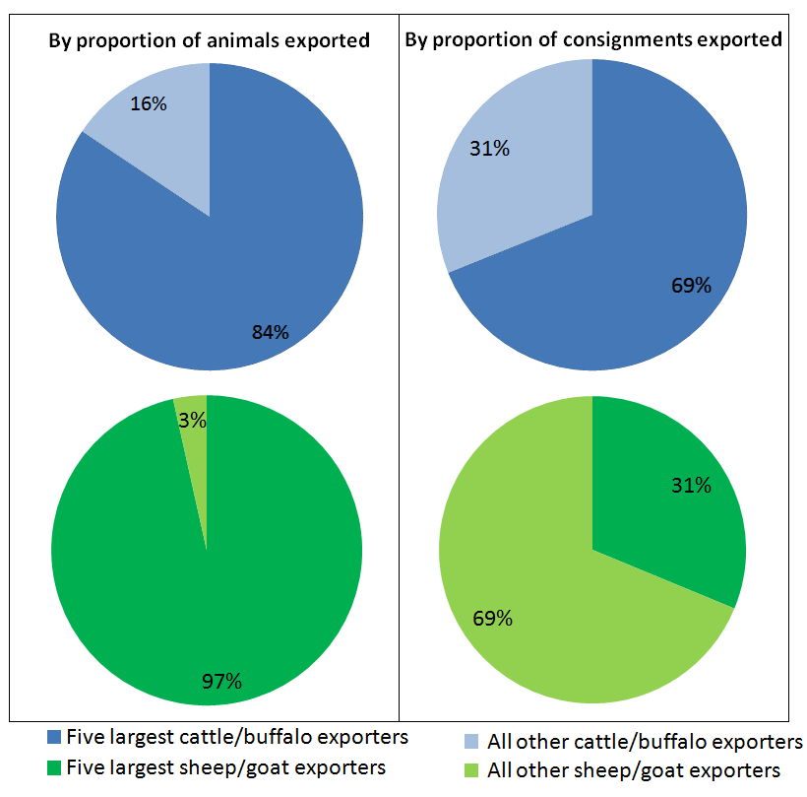
Note: includes data up to 30 June 2014
Source: Department of Agriculture 2015.
It is estimated that the livestock trade employs up to 10 000 people. Between 2011 and 2013, around 4200 people (2427 in the cattle industry and 1775 in the sheep industry) were directly employed on-farm in producing sheep or cattle for live export and a further 3800 people were indirectly employed by the trade. In addition, the industry provides significant employment opportunities for Indigenous Australians in northern Australia (Deards et al. 2014).

2. ESCAS and animal welfare

Key messages
- Industry has invested significant time, effort and funding in animal welfare projects and improvements in livestock export markets, both before and after implementation of ESCAS. The introduction of ESCAS accelerated these efforts. At 30 November 2014, there were 866 facilities that had been audited and shown to be compliant with OIE animal welfare standards.
- Through increasing awareness of animal welfare, training and other projects conducted in countries to which Australia exports livestock under ESCAS, animal welfare has improved for non-Australian livestock.
- The Department of Agriculture has applied a range of measures in response to problems with ESCAS animal welfare, control or traceability compliance.
- In most cases, the measures have been effective, but a limited number of supply chains have experienced recurring problems, particularly in preventing the removal of animals from approved facilities. For these supply chains, additional measures have reduced but not eliminated the problem.
- To date, there have been no criminal prosecutions because of an exporter’s failure to meet ESCAS requirements. In part, this reflects the difficulties in pursuing criminal action against an exporter for a breach of animal welfare standards occurring in another country and involving third parties outside of Australia’s regulatory control.
- The feasibility of introducing another layer of compliance options, such as fines or enforceable undertakings, could be investigated to assist the Department of Agriculture manage repeated non-compliance with ESCAS requirements.
ESCAS was introduced to allow trade to continue without the need for trade suspensions to whole markets, should animal welfare incidents occur to exported Australian livestock. The primary goal of the ESCAS regulatory system is to ensure that Australian livestock exported overseas for feeder or slaughter purposes are managed, transported and slaughtered humanely. Australia is the only country that takes measures beyond its borders to ensure animal welfare is maintained for its livestock.
Prior to the implementation of ESCAS, the primary method of ensuring animal welfare of exported animals was through industry and government projects and investment. This included providing animal welfare training and infrastructure improvements in importing countries.
Industry and animal welfare organisation positions on the live export trade differ, but they generally agree that ESCAS has improved animal welfare standards for Australian livestock exported overseas. They also acknowledge that opportunities exist to improve the system further.
Maintaining high animal welfare standards for animals exported from Australia is vital to ensuring the trade’s ongoing sustainability. ESCAS has brought the additional benefit of improving animal welfare for non-Australian livestock, by raising the profile of international animal welfare standards and improving infrastructure and training in facilities in export markets.

World Organisation for Animal Health animal welfare standards  The export of Australian livestock needs to be done in a manner which is consistent with Australia’s international trade obligations. Export restrictions are uncommon under World Trade Organization (WTO) rules, but may be permitted in response to animal welfare concerns under the ‘public morals’ defence in some circumstances. The OIE is recognised as a reference organisation by the WTO and sets international animal health and welfare standards.  To meet trade obligations, any measures Australia imposes to meet the required standard of animal welfare must be the least trade restrictive option; Australia may not require standards to be met in other countries which exceed those which apply in Australia.  The Terrestrial Animal Health Code (the Code) has been formally adopted by the World Assembly of the OIE, which is the highest authority of the OIE and comprises delegates of all member countries. The Code contains recommendations and standards based on scientific assessments of animal welfare.  In order to obtain an ESCAS, an exporter must demonstrate that the livestock will be transported, handled, slaughtered and subjected to any other related operations in accordance with the relevant recommendations and standards from the Code.  Independent initial and performance audits of supply chains ensure that the facilities they include meet relevant OIE animal welfare recommendations and standards. In addition, all countries that receive feeder and slaughter livestock from Australia are OIE members.  The checklists used by auditors to assess ESCAS performance draw upon the OIE recommendations and standards for humane treatment of animals for transport of animals by sea, by air and by land, and for the slaughter of animals. These are addressed in the performance measures and targets in the checklists, to cover the common stages in the progress of livestock through supply chains to the point of slaughter. | 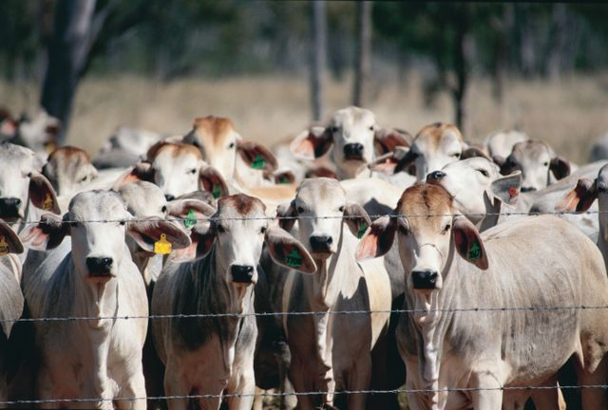  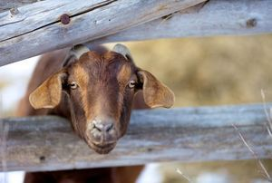

2.1 Assurance of animal welfare within the export process
ESCAS requires proposed exports to meet the animal welfare recommendations and standards of the OIE, as set out in Section 7 of its Terrestrial Animal Health Code 2010. Further detail is included in the ‘World Organisation for Animal Health animal welfare standards box.
ESCAS seeks to ensure livestock are treated in accordance with OIE animal welfare standards. Exporters must demonstrate that their supply chain can meet OIE animal welfare standards before they export livestock. This includes the submission of independent audit reports.
Once the supply chain has been established exporters must continue to demonstrate that animals are treated appropriately, through performance auditing. For cattle or buffalo, the exporter is required to provide further reporting, through accounting and traceability declarations (previously through end-of-processing reports).
ESCAS control and traceability requirements indirectly provide for humane management and slaughter of exported livestock by ensuring they remain within facilities that are audited and compliant.
Since the implementation of ESCAS, Australian livestock have been exported to 866 facilities assessed as meeting OIE animal welfare standards under ESCAS (Figure 8 and Figure 9). Numbers have increased each year, both due to ESCAS being rolled out to each new tranche (see Table 1), and as new facilities have been included in markets already subject to ESCAS requirements.
Figure 8 Number of new feedlots and abattoirs that meet OIE standards and are included in an approved ESCAS, and cumulative number of facilities (feedlots and abattoirs), by year
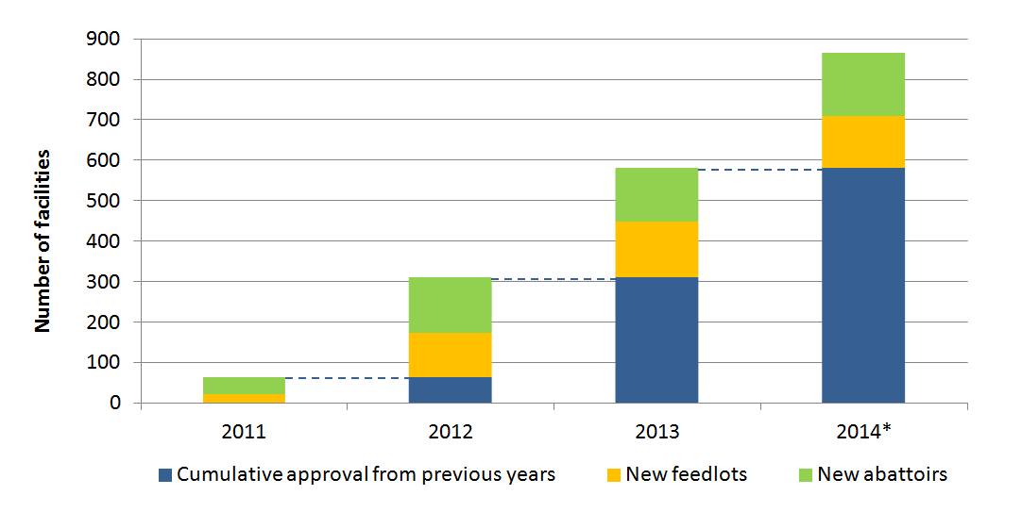
Note: 2014 data includes up to 30 November 2014 only.
Source: Department of Agriculture 2015.
Figure 9 Number of facilities in approved supply chains, by market
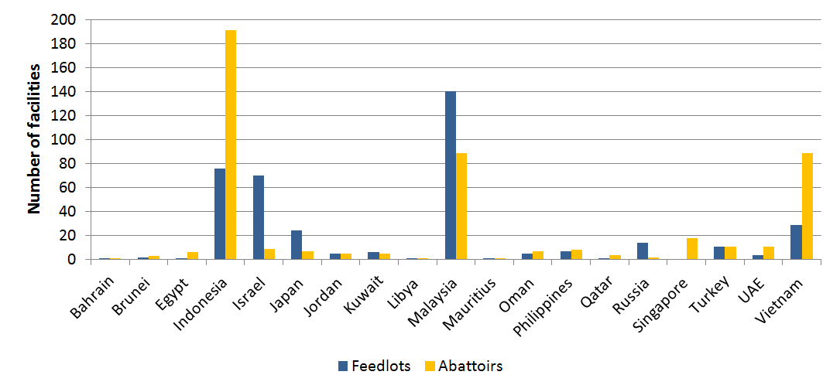
Source: Department of Agriculture 2015
The 866 feedlot and abattoir facilities are in the supply chains of 119 importers. Facilities may be included in one or multiple supply chains. This occurs more in some markets (particularly Indonesia) than others. A large proportion of the facilities are in Indonesia and Malaysia (Figure 9).
ESCAS typically classifies facilities by function, as either feedlots or abattoirs; however, variations exist within these groups. Feedlots include quarantine stations and depots (small feedlots used for animals going to an abattoir that is typically far away from the main feedlot). Any facility equipped and OIE compliant for slaughter of animals is classified as an abattoir (including some mosques). Feedlots and abattoirs approved under an ESCAS can vary significantly in size, from small facilities with throughputs of only one or two livestock per day, to large commercial operations holding or processing thousands of livestock at any given time.
Some countries have single facilities with a feedlot and an abattoir co-located. Other facilities have multiple slaughter areas that are operated independent of each other or a single slaughter area that is operated by different companies at different times. The Department of Agriculture only grants approval for the specific area or operator that is audited as compliant and considers each approval separately from any other approval granted at the same site.

2.2 Animal welfare indicators
It is difficult to precisely quantify improvements in animal welfare outcomes resulting from the implementation of ESCAS. Independent performance audits and reports of non-compliance are used to assess a supply chain’s ongoing compliance with animal welfare requirements. The indicators that the Department of Agriculture records indicate either compliance or non-compliance, and are not designed to provide information about the performance level of a facility.
Since ESCAS was implemented, there have been 22 instances of non-compliance recorded that may have had a negative animal welfare impact. However, using the overall number of instances of non-compliance recorded to determine a non-compliance rate for a supply chain or exporter has some difficulties. Non-compliance may affect varying proportions of livestock within a consignment and it has not always been possible to identify whether animals involved came from one or several consignments. Additionally, it is not known how well the recorded non-compliance rate reflects the true non-compliance rate—it is not known what proportion of non-compliance is detected and reported.
One animal welfare indicator that can be measured and provide some indication of the impact of ESCAS, is the prevalence of pre-slaughter stunning. Although pre-slaughter stunning is not required, several government policies have encouraged the uptake of stunning as a way of improving animal welfare outcomes. Currently only data for Indonesia is available. A study in 2010 noted that pre-slaughter stunning was rarely practised (Caple et al. 2010), whereas ESCAS data recorded from July 2011 to September 2013 showed that 89.7 per cent of cattle exported to Indonesia had been processed in facilities that used pre-slaughter stunning—a significant increase.
Other animal welfare performance indicators may be more useful to exporters to measure the performance of a facility or supply chain, such as by differentiating between average and high performers, or detecting declines in performance before actual non-compliance occurs. Currently there are few, however a project to develop animal welfare performance indicators has been started by Meat & Livestock Australia (MLA) and LiveCorp. The project aims to identify internationally accepted and currently used indicators of animal welfare, develop relevant indicators for each point in the supply chain, and develop a benchmarking method for animal welfare along the supply chain.
The project is also looking at methods to collect data for feedback into further improvements for livestock export systems. The outcomes of this project may provide useful input for the Department of Agriculture’s current work, building exporter performance indicators for live animal exports.

Religious and cultural slaughter practices
OIE standards and ESCAS requirements include provisions for slaughter consistent with halal and kosher specifications for members of the Islamic and Jewish faiths respectively.
Pre-slaughter stunning is not mandatory under the OIE standards. While most livestock in Australia are stunned, pre-slaughter stunning is also not mandatory in Australia.
Slaughter without stunning and use of inversion restraint boxes, as required for some religious slaughter, can meet OIE animal welfare standards. Specific conditions apply in these cases to ensure that animal welfare is maintained; these are included in the ESCAS Guidance checklist developed by the Department of Agriculture.
There have been several government initiatives to encourage stunning. Australia promotes the use of stunning in OIE forums, provides assistance to countries for infrastructure development and training, and works bilaterally with trading partners to encourage stunning in their facilities.
The OIE has produced a discussion paper on animal welfare related provisions of Islamic law that contains further information about this topic. This paper, as well as further information about other animal welfare matters under development, is available from the OIE website at http://www.oie.int/animal-welfare/future-developments.

2.3 Investments in animal welfare improvements in importing countries
Importing and exporting industry participants as well as the Australian Government have invested significantly in improving training and facilities in importing countries to meet ESCAS requirements.
Meat & Livestock Australia and the Australian Livestock Export Corporation (LiveCorp) have been integral in supporting industry activities, including providing advice and training to participants in importing countries, performing gap analyses and risk assessments, and facilitating workshops. Exporters, working with their importers and other supply chain partners, have also invested the funds required to implement the changes needed.
Actions undertaken by industry include:
- providing animal welfare training to over 7000 people working in supply chains, including:
- training in animal welfare and handling, use of stunning equipment and other husbandry procedures
- training of supply chain managers and animal welfare officers
- infrastructure improvements, including installation of new equipment and upgrades to existing equipment
- development of training and calibration courses for ESCAS auditors
- translation of ESCAS training material, such as Standard Operating Procedures, training DVDs and training presentations into multiple languages
- engagement of consultants based permanently in export markets to implement animal welfare improvements, oversee control of supply chains, address general livestock health issues and identify areas for further investment
- research and development projects addressing animal welfare requirements, such as development of animal welfare performance indicators.
The Australian Government has supported ESCAS through programs including the Approved Supply Chain Improvements Program (ASCIP). The government provided $5 million over two years (2011–12 to 2012–13) to encourage industry investment in approved supply chains in export markets.
The ASCIP program reimbursed 25 per cent of Australian livestock exporter investment in supply chains that imported and processed livestock to improve animal welfare outcomes. The program funded eligible activities in approved supply chains in:
- stunning-related activities such as purchasing equipment, technical expertise and training in use
- infrastructure upgrades, including improvements to traceability systems and general facility upgrades to assist compliance with ESCAS along the supply chain
- animal welfare training and translation of material, with a focus on stunning and ensuring compliance with OIE animal welfare standards throughout the supply chain.
Further detail of grants issued is included in Appendix D.
In addition, the government provided funding for the Improved Animal Welfare Program. The program funded activities to support improved animal welfare outcomes in Official Development Assistance eligible countries that import live animals for feeder/slaughter purposes from Australia. Countries eligible for assistance included Indonesia, Vietnam, the Philippines, Malaysia, Jordan, Turkey, Egypt and Mauritius. Activities funded under this program include:
- development and delivery of in-country training courses on OIE animal welfare standards, including the train-the-trainer program delivered by the OIE on animal handling, transport and slaughter
- funding of government officials to undertake training in Australia covering animal welfare and hygienic processing of carcasses
- installation of pneumatic stunners in abattoirs in the Philippines and Vietnam
- a collaborative project between the University of Queensland School of Veterinary Science and Indonesia’s Bogor Agricultural University on aligning the Bogor Agricultural University Faculty of Veterinary Medicine’s animal welfare and public health curriculum with international standards.
See Appendix E for country profiles and market-specific detail on government and industry projects.
ESCAS in Indonesia
Indonesia was the first market in which ESCAS was introduced, in August 2011. Indonesia also receives the largest proportion of feeder and slaughter cattle exports from Australia (62 per cent in 2013). Introduction of ESCAS required a considerable investment by exporters, importers and industry bodies, which has continued to this day.
Investment in improving animal welfare capacity in Indonesia existed prior to ESCAS, through the Livestock Export Program. However to bring facilities up to the standards required for inclusion in a supply chain which can be approved under an ESCAS, many exporters, importers and facility owners have invested
significantly in infrastructure improvements, purchasing new equipment, and training staff. The success of ESCAS is due to the support from the wide range of stakeholders involved in the supply chain that are committed to improving animal welfare.
Importers, facility owners and Indonesian industry bodies have also contributed to maintaining compliance with ESCAS requirements, by continuing ongoing training, performing their own surveillance activities and reporting back to the exporters when and where problems are found.

‘Train the trainer’ program for supply chain managers and animal welfare officers  Meat & Livestock Australia and LiveCorp have successfully delivered several projects to improve industry’s capacity to comply with the ESCAS framework. One project addressed the limited trainer base available to perform animal handling and slaughter training.  Under funding provided through the Australian Animal Welfare Strategy, the project provided | 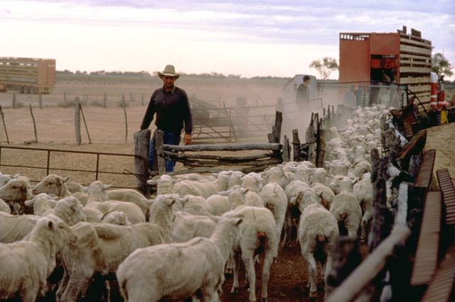
training to 63 key people in supply chains in three key export markets—Indonesia, the Philippines, and in Dubai for various participants from the Middle East. The training was aimed at supply chain managers and animal welfare officers who oversee the activities of other staff. Increasing the skills of the staff allowed them to then transfer their knowledge to people working for them within their supply chain.
This has increased the capacity for teaching OIE-compliant animal welfare principles and practices to more people than would have been possible with one-on-one training of operational staff. In turn this has improved animal welfare outcomes for the Australian livestock handled in these supply chains.

Importing countries have advised that ESCAS has also led to animal welfare improvements for non-Australian livestock. Facilities that receive Australian livestock under ESCAS may also process local livestock, which also benefit from improvements and investment. Industry had been making improvements in markets before ESCAS through the Livestock Export Program (LEP) funded jointly by Meat & Livestock Australia and LiveCorp. The implementation of ESCAS accelerated the LEP process and extended its reach along the supply chain. Funding for the LEP increased yearly from $5.9 million in 2009–2010 to $8 million in 2012–2013, to allocate additional funds to support ESCAS related initiatives (Table 2).
Table 2 Annual Livestock Export Program funding
Year | LEP Budget
2009/10 | $5,905,000
2010/11 | $6,975,000
2011/12 | $7,423,000
2012/13 | $8,025,000
2013/14 | $7,317,000
2014/15 | $7,367,000
Source: pers comm 3 September 2014, P Dundon [MLA]
Industry activities have led to a much greater understanding of the importance of animal welfare and the value it adds to business—such as faster processing times and safer working environments. Many activities improved animal welfare generally. Examples are:
- Training of staff in animal handling and slaughter techniques—staff apply their improved understanding of animal welfare and livestock handling practices to all livestock that pass through a facility and can use these skills even if they move on to facilities which are not subject to an ESCAS approval
- Improvements to facilities also used for non-Australian animals—upgrades including better lighting, OIE-compliant restraint boxes and yard and facility designs that encourage low-stress animal handling will benefit any animals received by the facility
- Transitioning of facilities to pre-slaughter stunning—training and equipment have allowed local animals to be processed using pre-slaughter stunning. These facilities can demonstrate other benefits of pre-slaughter stunning, such as increased efficiency and worker safety, and increased acceptance of pre-slaughter stunning for non-Australian livestock.

2.4 Non-compliance with ESCAS requirements
To 30 November 2014 there were 59 instances of ESCAS non-compliance recorded out of 1139 consignments of livestock exported (Figure 10). The Department of Agriculture manages non-compliance with ESCAS according to legislation and the Guideline - Management of Non-Compliance.
Non-compliance has also been recorded relating to administrative requirements, such as overdue documentation, however this is considered separately in Chapter 4.
Figure 10 Number of instances of ESCAS non-compliance recorded and number of ESCAS consignments, by year
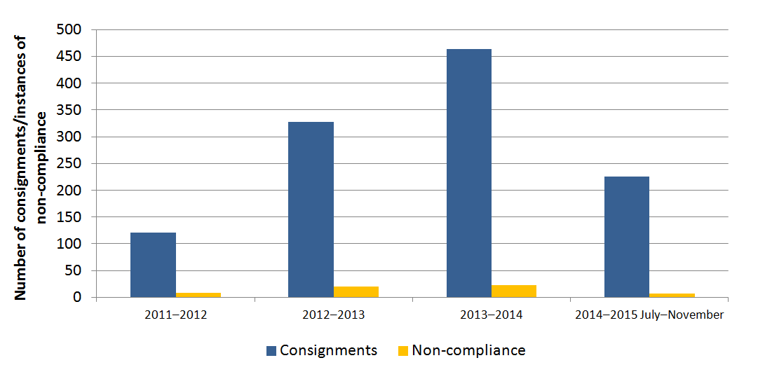
Source: Department of Agriculture 2015.
Non-compliance is categorised according to the nature of the non-compliance and whether there is a direct animal welfare impact on the livestock involved. Non-compliance is categorised as:
- adverse animal welfare outcomes
- movement of livestock out of approved supply chains due to a loss of control and/or traceability
- other.
Non-compliance is also classed as minor, major or critical in accordance with the Guideline – Management of Non-compliance.
Adverse animal welfare outcomes are non-compliance occur where there is poor animal handling or slaughter, or other practices negatively impacting animal welfare.
Movement of animals outside of an approved supply chain accounted for the majority of non-compliance; however, most are due to a loss of control without establishing any adverse animal welfare outcomes. Livestock are only permitted to go to facilities that are listed in the ESCAS approval granted for the consignment. Movement to locations that are not included in that ESCAS is considered non-compliance. Movement of livestock to a facility that is not in the supply chain set out in the approved ESCAS for that particular export, but is approved under an ESCAS for a different export, is considered to be unauthorised movement. Movement to a facility which is not approved under another ESCAS, but where an exporter can provide evidence that animal handling is compliant with OIE animal welfare standards (such as by providing an audit showing compliance at the facility) may also occur. These are not considered to have a direct animal welfare impact.
Movement of livestock to other locations—either an unknown location, or to a known location that is not approved under any existing ESCAS and cannot be shown to meet OIE animal welfare standard—is the third type of movement outside of supply chains. However this type of non-compliance is considered to have a potential direct animal welfare impact, as no evidence can be provided to show that the livestock were handled or slaughtered humanely.
Other examples of non-compliance may include failure to audit a particular facility within the required reporting period, not providing the department with additional information requested, and other issues which have no direct animal welfare impact.
A breakdown of non-compliance numbers by types is further described in Table 3.
Table 3 Types of ESCAS non-compliance
Non-compliance grouping | Non-compliance category | Potential direct animal welfare impact | Total number | Percentage of total non-compliance
Animal welfare | Non-compliance with OIE animal welfare standards | Yes | 8 | 13.6
Movement outside of supply chain—loss of control and traceability | Movement of animals to a facility that is not approved under an ESCAS or compliant with OIE standards, or the location is not known  Movement of animals to a facility that is not approved under an ESCAS, but which meets OIE animal welfare standards  Movement of animals to a facility that is approved under an ESCAS for other exports, but is not listed in the approved ESCAS for that export | Yes  No  No | 14  7  16 | 23.7  11.9  27.1
Other | Any other issue—for example failure to audit a facility within a supply chain in the required time frame, not providing the department with additional information required in an audit, or other issues without an animal welfare impact | No | 14 | 23.7
Total |  |  | 59 | 100

Source: Department of Agriculture 2015.
Different species and markets show different patterns of non-compliance (Figure 11). For sheep there were eight instance of movement outside of an approved supply chain where the final destination was not known. These all occurred in Middle Eastern markets, which is not unexpected, as approximately 98 per cent of sheep exported from Australia under ESCAS enter those markets (Deards et al. 2014). For cattle, the majority of non-compliance related to movement to facilities that had been approved in an ESCAS for a different export, but not approved in the ESCAS for the export in question. Anecdotally, exporters commonly expressed the view that delays between independent auditing and approving a facility for a supply chain, and confusion where supply chains shared some facilities but not others, has contributed to this problem.
Analysis of the data shows the source of reporting of non-compliance varied (Figure 12). Exporter self-reports accounted for 31 per cent of recorded non-compliance. Exporters have become increasingly proactive in reporting non-compliance and taking action immediately to fix the causes and prevent future recurrence. The Department of Agriculture detected 47 per cent of non-compliance, particularly relating to auditing and other requirements. Third-party reports (by animal welfare groups, other industry participants, or members of the public) and independent audits were responsible for the remaining 22 per cent of reports. This information is based on the number of instances of non-compliance recorded rather than the actual number of reports, as in some instances multiple records of non-compliance have resulted from a single report or incident.
Figure 11 ESCAS non-compliance, by type and species affected
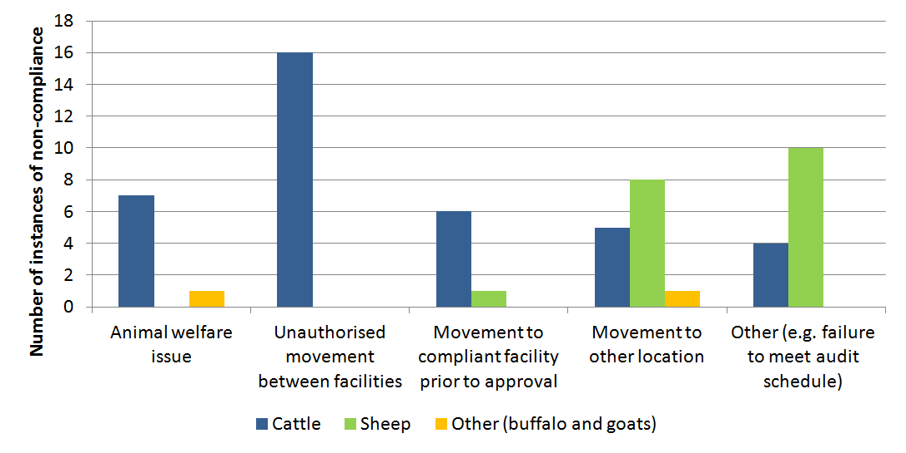
Source: Department of Agriculture 2015.
All eleven recorded instances of non-compliance that were reported to the Department of Agriculture by third parties, were for animal welfare problems within supply chains approved under the ESCAS for export or movement to locations which were neither approved under any ESCAS nor compliant with relevant OIE standards. Non-compliance detected by the department and self reported was spread between several categories, while auditor reports were for non-compliance related to animal welfare problems within supply chains approved under the ESCAS for export.
Animal welfare groups have raised concerns about reporting of non-compliance to the Department of Agriculture, including about a perceived lack of auditor reporting of non-compliance. Experience is that the standard of audits is high, and there has been an increase over time in the number of exporters receiving audits and addressing and resolving non-compliance before the audit is submitted to the Department of Agriculture. The practice of exporters identifying and addressing animal welfare issues immediately is positive and in line with the principles of ESCAS—to detect, manages and prevent non-compliance. For this reason, there are few audit reports with non-compliance that have not had corrective action taken. Audits also provide an assessment at a single point in time, and it is possible that non-compliance may occur outside of an auditor’s visit. To address this, more frequent auditing has been applied to high risk supply chains, but the possibility still remains for non-compliance to go undetected by audits. Industry and auditors have advised they would welcome further training for auditors in ESCAS principles and requirements, and industry is working to develop a training program for auditors that would directly address this need.
Figure 12 Sources of detection of ESCAS non-compliance
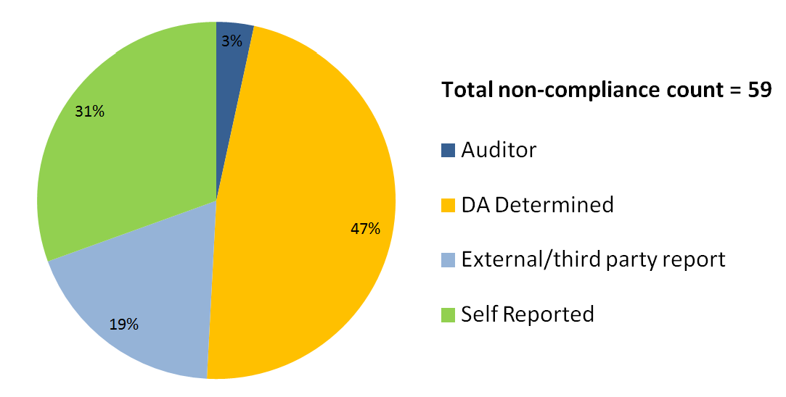
Source: Department of Agriculture 2015.

Managing non-compliance
Before ESCAS, any significant animal welfare incident in the livestock export trade had the potential to affect the entire market, as occurred with the suspension of livestock export to Egypt in 2006 and Indonesia in 2011. ESCAS allows for identification of facilities, supply chains or individuals for targeted compliance action (as needed), enabling trade with the market to continue.
Allegations of non-compliance reported to the Department of Agriculture by third parties trigger an immediate assessment process. The report is assessed to determine where the non-compliance occurred, the department’s records are analysed to determine which exporters may be involved, and those exporters are notified of the complaint and if necessary, further information is requested about the performance of their supply chains. If the assessment determines there is credible evidence of non-compliance then two further actions occur simultaneously:
- the department determines whether immediate action needs to be taken while an investigation occurs. Actions can include applying additional conditions to existing or upcoming exports, requiring further information before permitting any further exports to a particular facility or supply chain, or in the most serious cases suspension of a facility or supply chain from any use
- a full investigation is performed into the allegations. Due to the amount of information needed, the time required for exporters to retrieve information from other countries, the need to communicate with multiple parties, ongoing reporting requirements, and to allow procedural fairness for the parties involved, investigations frequently take several months or longer.
Allegations from third parties and self-reports from exporters are also added to the list on the department’s website and compliance reports are released publicly upon completion. The time taken for ESCAS investigations (excluding self-reported non-compliance), from reporting of the allegation to the Department of Agriculture to publication of the outcomes, ranged between 2 and 12 months with an average of 6.9 months (Department of Agriculture 2015). As outlined above, actions are frequently taken early in the process before a public report is released.
Under ESCAS, the Department of Agriculture has several tools, of increasing severity, to manage suspected or confirmed non-compliance by Australian exporters. These include:
- applying additional conditions to an ESCAS approval to one or more consignments of livestock, such as increased auditing, reporting, security or supervision in a supply chain; or restriction or suspension of facilities within a supply chain
- suspending use of a facility or entire supply chain by refusing to approve ESCAS submissions which include the facility or the supply chain, and varying existing approved ESCASs to remove the facility or supply chain
- taking actions against an exporter’s licence (such as issuing directions to be complied with, or suspending or revoking a licence)
- referring the matter to the Commonwealth Director of Public Prosecutions.
To date, the department has predominantly applied one or more of the first three options either individually or in combination. Where immediate action is warranted, the department has required additional auditing and reporting and the presence of supply chain officers and/or animal welfare officers. There have been several cases of facilities being removed from supply chains until there is evidence that corrective action has been effective. Appendix C contains further detail of ESCAS investigations and resulting regulatory action.
Additional actions that are applied while a departmental investigation occurs can be removed either during the progress of the investigation or at completion, if sufficient information is obtained indicating that there is no non-compliance. If at the conclusion of an investigation there is evidence of non-compliance, additional actions already in place may be implemented permanently or further additional actions may be taken if required.
These regulatory options have been useful. However, the types of conditions that can be applied to address problems within a supply chain are limited, and there is difficulty suspending use of a facility or supply chain that already contains Australian livestock. The potential for the licence of a non-compliant exporter to be suspended or cancelled is an important feature of ESCAS, but there may be benefit in investigating the feasibility of supporting ESCAS with a system of financial or other sanctions (such as enforceable undertakings). Amongst other things, a system of financial or other sanctions may be a more effective regulatory tool than existing administrative or criminal sanctions, or could provide a useful adjunct to the current criminal remedies available under the Export Control Act 1982. For example, there are instances where exporters have not provided information in a timely manner to assist in the completion of an investigation. Being able to fine exporters for this type of behaviour would provide an incentive for exporters to comply with regulatory requirements. To date, there have been no criminal prosecutions taken under ESCAS. In part, this reflects the significant complexities in pursuing criminal actions against an Australian party for a breach of animal welfare standards occurring on foreign soil and typically involving foreign parties.
In addition to regulatory actions by the Department of Agriculture, exporters and industry have also implemented measures to minimise risk of poor animal handling and slaughter. Measures have included not supplying livestock to non-compliant supply chains and voluntarily suspending trade until issues are resolved. Exporters have also provided additional training, arranged for additional oversight of supply chains or upgraded facilities to ensure stunning prior to slaughter.
Many importing country authorities have supported ESCAS, and have also initiated their own responses to allegations of poor animal handling and slaughter. In at least three cases, an importing country’s authorities took action. For example, in December 2012 reports of animal welfare problems at an abattoir in Israel received widespread media coverage in Australia and Israel. The Israeli government was quick to act and started its own investigations into the allegations.
Importing countries have also provided information to the Department of Agriculture and, for example, provided additional oversight at slaughter facilities to prevent animal welfare problems.
Importers have also been actively involved in managing compliance. In Indonesia, an importer association is working to identify and address potential non-compliance issues and maintain compliance with ESCAS requirements. In Vietnam, exporters and importers are working together and holding industry meetings to address the risk of non-compliance.
Non-compliance with ESCAS is inherently difficult to manage, as it requires exporters to manage off-shore entities that are not subject to Australia’s regulatory requirements. The main tool exporters have to gain supply chain compliance, is the risk of the participants losing access to Australian livestock. Livestock exported from Australia to other countries may be subject to additional or conflicting regulations in an importing country, which may make it difficult to balance and meet both sets of requirements. This is particularly so when supply chains extend across multiple jurisdictions within a country or across borders.
Problems with the evidence provided to support allegations of non-compliance with ESCAS can make investigating non-compliance difficult. Reports of possible non-compliance may or may not contain supporting evidence. Even when provided, videos and photographs may not contain identifying details such as location, time or date or may not be of sufficient quality to allow the Department of Agriculture to identify the source of the animals. In 13 of the 22 third-party reports received, evidence to establish non-compliance was insufficient. Whilst in some cases the department has been unable to record non-compliance, there are instances where the department identified poor animal welfare or handling of Australian livestock or livestock outside of approved supply chains, but could not determine the exporter. The department has in some cases been able to take regulatory action, such as applying additional conditions for all exporters to that market.
There have also been allegations that animal welfare incidents may have been fabricated, although this has not been possible to prove. For example, it has been alleged that threats of non-compliance have been used by a buyer to leverage more favourable terms from an exporter.
The longer the time between an incident and its report to the Department of Agriculture, the more difficult it can be to collect evidence to investigate an allegation.
Natural disasters, rioting, intervention by importing country authorities, armed robberies or other extenuating circumstances can affect an exporter’s ability to comply with ESCAS. In some cases, exporters have not complied with the approved ESCAS in order to maintain animal welfare. For example, when the only feedlot in an approved supply chain could not be accessed an exporter temporarily unloaded livestock at a feedlot that was not part of the approved supply chain, rather than leave them on trucks for extended periods. Had the exporter adhered strictly to ESCAS, the animal welfare outcomes ESCAS was set up to achieve would not have been met. Administration of ESCAS must be flexible and focus on outcomes as well as procedure.
Exporters and other parties have also raised concerns about the Department of Agriculture’s consistency in applying non-compliance ratings of minor, major or critical and in how it applies regulatory actions. Some exporters have reported that this has made them reluctant to self-report potential problems.
The Guideline – Management of Non-Compliance provides examples of non-compliance, including what constitutes critical, major and minor non-compliance. The classification is taken into consideration when deciding what regulatory response is required to bring an ESCAS back into compliance, if that is possible. The Department of Agriculture is now more aware of types of non-compliance that are common in different supply chains and the effectiveness of different measures in addressing non-compliance, for example movement of sheep outside of supply chains (further detail is available on page 29).
The Farmer Review recommended that industry develop a through-chain quality assurance system to complement the government’s regulatory compliance programs. This could help reduce the regulatory burden imposed by the government upon industry. An industry-managed assurance system may also facilitate more efficient and effective management of off-shore supply chain participants that are outside of Australia’s regulatory reach. If developed, such a system could provide an alternative way for exporters to meet ESCAS principles, provided it was underpinned by an appropriate statutory framework. Such a framework would allow the regulator to audit and verify the operation of the assurance system and step in should the industry managed system fail.

2.5 Animal welfare impacts resulting from ESCAS non-compliance
Under ESCAS, the Department of Agriculture receives information that can identify animal welfare issues after livestock arrive in their destination country, which is used to identify and target high risk supply chains.
There have been 22 instances of non-compliance with a confirmed or possible animal welfare effect. These accounted for 37 per cent of all ESCAS non-compliance and included all 13 major or critical non-compliance ratings recorded (seven related to cattle, six related to sheep). Twelve cases were investigated and led to regulatory action, as set out in Appendix C. In the remaining case the department accepted that the actions taken by the exporter appropriately addressed concerns, and no regulatory action was taken.
From over 5.5 million sheep exported under ESCAS, there have been eight instances of non-compliance recorded for sheep with a possible animal welfare impact, all for movement of sheep to unknown locations outside of the approved supply chain. Numbers involved in the incidents vary, ranging from a few hundred to up to several thousand sheep. Once animals are moved outside of approved supply chains, the primary issue is that the handling and slaughter processes cannot be confirmed to meet OIE animal welfare standards.
Multiple factors may contribute to this type of non compliance. It is not uncommon for sheep to be managed in feedlots ranging in size from 20 000–60 000 animals, making it difficult to identify unauthorised removal of small numbers of animals. Their relatively small size and the common practice of selling sheep for home slaughter in many Middle East markets may also be relevant. Sheep are not individually identified, unlike cattle, making it harder to trace animals back to an exporter’s supply chain, although many reports involve sheep that have had their ear tags removed.
While conditions have been applied for some supply chains requiring sheep to have identification traceable to the responsible exporter, non-compliance has continued. Introduction of individual traceability for sheep and goats, at least for exported livestock, has been advocated by animal welfare groups. To enhance traceability in sheep and goats, in October 2014 agriculture ministers agreed that state and territory governments will make necessary improvements to the National Livestock identification Scheme for sheep and goats by building on the systems already in place. Each jurisdiction will aim for improved traceability, either by enhancing the current mob-based system or by introducing electronic identification ear tags.
Measures introduced to address ESCAS non-compliance for sheep have also been targeted at preventing movement outside of supply chains. As a result of several separate investigations, conditions have been applied to ESCAS approvals for supply chains and in some cases directions have been applied to exporters’ licences. These have focused on increasing the oversight of sheep movement through supply chains, by increasing reporting and auditing, having supply chain officers to oversee movement and conduct daily reconciliation and accounting, and restricting supply chains to fewer facilities (reducing the opportunities for sheep to be moved). Further information on these measures is included later in this report, and in the publicly available investigation reports on the department’s website.
For cattle and buffalo exported from Australia there have been 14 instances of non-compliance with a possible or confirmed animal welfare impact—six for movement outside of approved supply chains to unknown locations, and eight for confirmed animal welfare issues, usually within approved supply chains.
Cattle and buffalo can be more difficult to handle due to their size and require more specialised equipment for transport, handling, stunning and slaughter. These factors mean that cattle supply chains have more points at which animal welfare can be affected but animals are more difficult to move out of supply chains in significant numbers. Markets that receive Australian cattle can vary culturally but the practice of home slaughter of cattle is less common than for sheep.
Management of the 14 cases of cattle and buffalo non-compliance with a possible or confirmed animal welfare impact has been more varied, reflecting the wider range of causes and circumstances. In several cases, facilities have been suspended from use by either the exporter or the Department of Agriculture until action could be taken to address animal welfare problems. Animal welfare officers have also been established to oversee slaughter in some affected facilities. Where cattle have moved outside of supply chains, similar measures have been taken to those for sheep—imposing additional reporting requirements and having supply chain officers in place to conduct regular reconciliation and accounting of livestock movements. In some cases, exporters and importers have taken extra actions that have improved animal welfare outcomes—for example, two abattoirs introduced pre-slaughter stunning after non-compliance was detected.
Despite the small amount of non-compliance, overall ESCAS has improved animal welfare outcomes in Australian livestock export markets for Australian animals. Prior to ESCAS, there was no obligation on exporters to directly address poor animal welfare practices if they became aware of them, however, industry was involved, through the Livestock Export Program (LEP), in transferring better animal handling skills and knowledge to export markets, particularly in South East Asia and the Middle East. With the implementation of ESCAS, as a result of significant investment and effort from Meat & Livestock Australia, LiveCorp, and individual exporters and their supply chain partners, many more facilities now comply with OIE animal welfare standards. The LEP and other industry programs helped industry meet ESCAS requirements. Flow-on effects of ESCAS have also improved welfare for animals of non-Australian origin.

Movement of sheep outside of approved supply chains
Movement of sheep outside of approved supply chains has occurred in several markets on a recurring basis, including three events each in Jordan and Kuwait. This has resulted in multiple instances of non-compliance being recorded against exporters. Reports on these events released by the Department of Agriculture identified over 4000 sheep as being affected from over 5.5 million sheep exported. Further allegations are currently under assessment. This is particularly an issue for sheep where mob based accounting means individual sheep cannot be traced back to specific supply chains.
The movement of sheep (or other livestock) outside of supply chains to unknown locations leads to a loss of control over how animals are handled and slaughtered, and likely results in poor animal welfare for some of the affected animals.
Sheep that have been removed from approved supply chains have typically been sold individually through local markets or roadside stalls. In one instance allegations included that sheep were moved to other countries, further complicating traceability back to the original supply chain. In another instance it was unclear whether photos of sheep being found in local markets were showing sheep already identified in a previous allegation that that were still outside the supply chain (as those sheep had not been recovered from the local markets).
Management of these cases of repeated non-compliance has required identification of underlying issues and the reasons why previous measures put in place have not adequately addressed non-compliance.
In Kuwait and Jordan, the conditions applied to ESCAS approvals for exports have been escalated by the Department of Agriculture with each subsequent non-compliance, and measures have been expanded across a greater proportion of the supply chain. Initial measures were applied to all exporters within the markets and focused on increasing reporting and observation of supply chains at locations, mostly targeted at where loss of sheep occurred. More recent conditions have been aimed at addressing the underlying issues. For example, difficulty exists in accurately counting large numbers of sheep within feedlots (where there may be 20 000-50 000 sheep), so additional measures have expanded beyond the feedlots to include surveillance of local markets and stalls, to allow information gathering and early detection, and intervention to prevent future incidents.
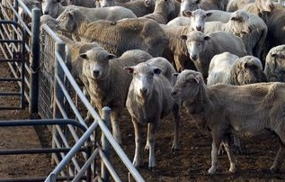

3. ESCAS and facilitating trade

Key messages
- Trade has continued since the introduction of ESCAS, and the demand for Australian livestock remains strong. While trade fluctuations have occurred, they are the result of many factors.
- ESCAS is a costly and complex system for importers and foreign governments and this has had some effects on Australia’s image as a reliable supplier of high-quality livestock. Costs and complexity have also discouraged some commercial parties from participating in the trade. However, ESCAS has also led to unexpected benefits in some importing countries, such as increasing processing efficiencies.
- Export markets vary significantly in how they operate, including species exported, seasonality, transportation method and importing country regulations. These differences require flexible risk-based regulation to ensure animal welfare outcomes are delivered efficiently and effectively.
The livestock export industry is vital to the Australian agricultural sector. Australia is a high-volume exporter of live animals and important to the food security of many importing countries. The industry exports livestock by both air and sea, and consists of feeder and slaughter sheep, cattle, goats and buffaloes to markets in Asia and the Middle East (Figure 13).
Australia is the fifth largest cattle exporter globally; major markets are Indonesia, Israel, Malaysia and Vietnam. Australia is the second largest sheep exporter globally; major markets are Bahrain, Jordan, Kuwait and Qatar (Deards et al. 2014). Goat and buffalo exports to Malaysia and Vietnam respectively are also important and expanding parts of the industry.
The livestock trade is an important contributor to the rural economy and primary producers. The business models of many producers, particularly northern Australian cattle producers, are based on exporting low-weight animals to reach slaughter condition in feedlots overseas, particularly Indonesia. This allows animals to be exported at an age when seasonal conditions in northern Australia are not conducive to weight gain. Livestock of certain ages are more suited to processing overseas, in some markets, and can command higher prices than meat exports (Deards et al. 2014).  Demand for exports of Australian live animals remains strong and the trade cannot be replaced by the boxed meat trade in many markets (Deards et al. 2014). Livestock exports and boxed meat are often viewed as complementary products that supply different sectors of the export market. | Figure 13 Species exported and importing markets  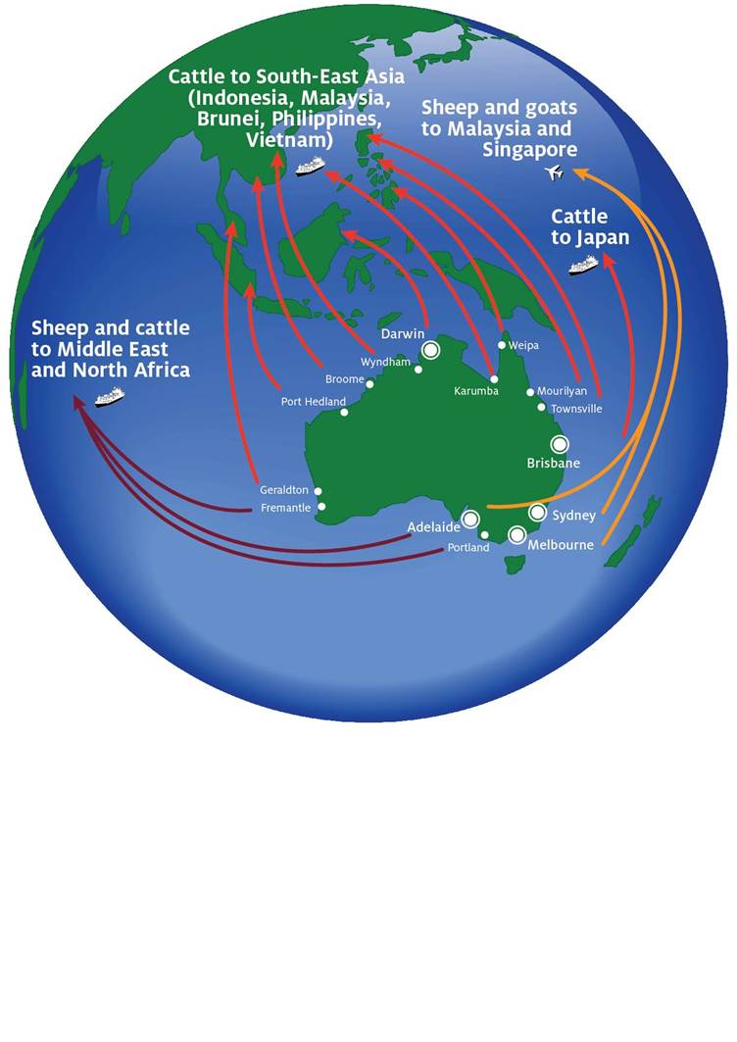  Source: Deards et al, 2014.
3.1 Profiles of export markets
Market summaries are provided in Appendix E for most export markets where ESCAS has been implemented for feeder and slaughter livestock and where trade has been significant. These short, factual summaries provide a snapshot of trade and animal welfare outcomes since the implementation of ESCAS in each market and highlight the differences between markets, even within the same geographical region.
Markets in South-East Asia generally demonstrate the most regional diversity. Differences between neighbouring markets exist in species exported, transportation, seasonality, supply chain arrangements and domestic policy settings. While many markets in the Middle East and Northern Africa primarily import sheep, important distinctions between markets exist.
Differences in how markets operate can challenge ESCAS implementation and operation. ESCAS was originally designed in response to an animal welfare incident in the Indonesian market and subsequently expanded to all other markets. The Indonesian market is Australia’s largest export cattle market. It imported 62 per cent of Australia’s total cattle exports in 2013, mostly from northern Australia (Deards et al. 2014). Middle Eastern markets accounted for up to 98 per cent of Australia’s sheep exports in 2013 (Deards et al. 2014). However, Israel, Egypt and Jordan are also important cattle export markets.
In South-East Asia, markets vary significantly. For example, Malaysia imports sheep, goats and cattle, Vietnam is a growth market for cattle and buffalo, and Japan is a specialty market which only imports cattle.
Religious festivals overseas are an important driver of demand. In Singapore, the lead-up to the festival of Korban is particularly important, as it is the only time of year when Singapore imports live animals from Australia (see boxed text below).
Animals in many Middle Eastern markets are held in feedlots for extended periods to meet increased demand during Eid-ul-Adha. The length of time between animal arrival and slaughter varies considerably. In Indonesia, the time between arrival and slaughter is long, as most imported animals are fed to slaughter weight after arrival. In other markets, the time between arrival and slaughter is much shorter.
Livestock for feeder and slaughter purposes are exported largely by sea. This is due to length of journey, large consignment numbers and higher costs of other types of transport. Sheep and goats exported to Malaysia and sheep to Singapore are the exception. Smaller consignments allow export by air. Cattle exported to Malaysia are generally transported by sea.
Differences in the length of time animals spend in a supply chain may or may not affect the overall complexity of the supply chain. Geographical region does not appear to affect the overall complexity of supply chains. Small countries like Bahrain, Brunei Darussalam and Mauritius typically have simpler or more linear supply chains, however more complex supply chains are found in Indonesia, Israel, Japan and Vietnam, among others.
Finally, domestic policy settings differ significantly between markets and can affect the operation and effectiveness of ESCAS regulations. For example, Mauritius has introduced a permit requirement to prevent the home slaughter of animals imported from Australia. These domestic regulations reinforce requirements for animals to remain within the supply chain. Similarly, in markets where the price of meat is subsidised (for example in Bahrain and Qatar), animals are less likely to exit the supply chain as this would make it difficult for commercial parties to claim the subsidy.

ESCAS and religious festivals
Australian industry has been working in importing countries to further animal welfare through compliance with ESCAS while also maintaining Australian exporters’ access for religious festivals.
Animals being moved outside of the supply chain are an ongoing challenge to be managed under ESCAS. Religious festivals can represent high-risk periods for this occurring, due to the traditional import and sales models where animals (particularly sheep) are widely distributed for home or marketplace slaughter. Since the introduction of ESCAS, Australian animals can only be sent to supply chains that demonstrate they can meet OIE animal welfare standards. This creates particular issues for religious festivals and has, in some cases, significantly limited the ability of Australian exporters to supply animals for Eid-ul-Adha or Korban.
Australian export of livestock (sheep) to Singapore is characterised by a single export event immediately prior to the festival of Korban (Figure 14). Unlike other markets, where trade occurs year round, facilities in Singapore are established temporarily to meet the demand of Korban. Facilities are set up before the beginning of the festival and audited as part of the approval process prior to receiving Australian animals.
As slaughter facilities are only established for a short time, independent performance audits are conducted at the time of Korban each year. Facility approval is based on the compliant outcome of the performance audit from the previous year. This is an example of flexibility in ESCAS regulations where a number of temporary slaughter facilities are approved for use each year.
Figure 14 Export volume of sheep to Singapore, 2011–14
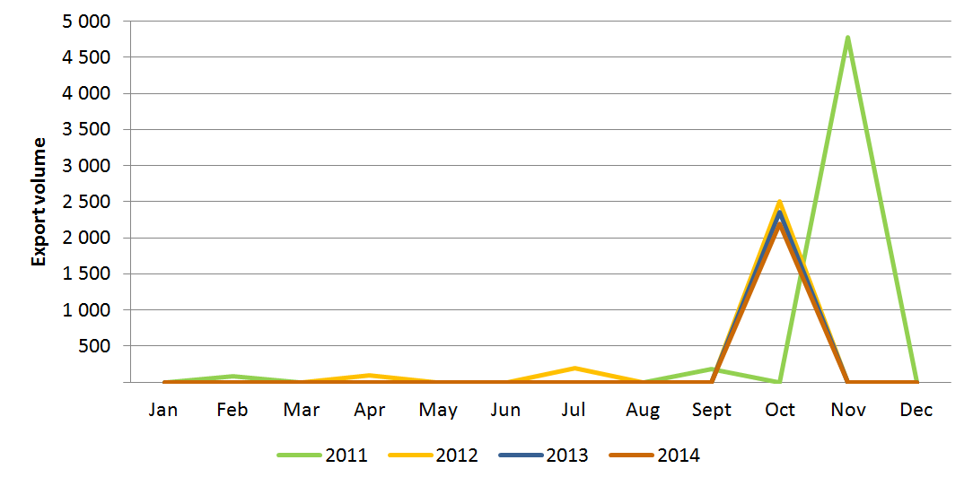
Source: Department of Agriculture 2015.
In the Middle East, an MLA–LiveCorp program has partnered with a Qatari importer to move towards a carcass-only sales policy during Eid-ul-Adha. Customers can visit the abattoirs, purchase an animal, wait for it to be processed and pick up the carcass after slaughter. This allows Australian exporters to supply animals for Eid-ul-Adha while also guaranteeing they are processed in accordance with OIE animal welfare standards.
Implementing these arrangements in Qatar was made easier by commercial arrangements whereby the importer operates an integrated supply chain that includes a feedlot and abattoirs.
Australian industry is working with importers in other markets such as Oman to implement similar arrangements for the supply of animals in religious festivals.

3.2 Effect on markets
Long-term trends in livestock export trade volumes show significant fluctuations over time (Figure 15, Figure 16). Price, the value of the Australian dollar, competition, market-specific issues, domestic policies and commercial factors affect trade volumes, so it is often difficult to distinguish whether ESCAS has affected trade.
Drivers of demand in importing countries vary. For example, some Middle Eastern consumers prefer meat from animals slaughtered under the guidance of local religious officials.
Other drivers include lack of refrigeration and cold chain facilities, domestic government support for the local feedlot and meat processing industry, and lower tariffs or higher subsidies on imported live animals than on imported meat (Deards et al. 2014).
Australian exports of cattle were already declining in the lead-up to the implementation of ESCAS as Indonesia imposed import quotas to encourage self-sufficiency in beef production. Exports rebounded in 2013–14 (Figure 15) when Indonesia’s policy changed to a price-based (rather than quota-based) mechanism. This policy change was designed to increase supply and reduce the price of meat for consumers (Deards et al. 2014).
Figure 15 Sheep and cattle export volume, by financial year
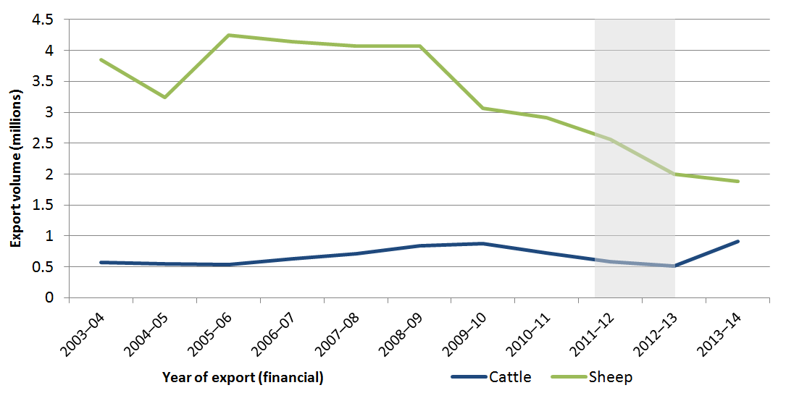
Note: Grey shading represents the time period when ESCAS was implemented in stages.
Source: ABS 2015.
Figure 16 Goat and buffalo export volume, by financial year
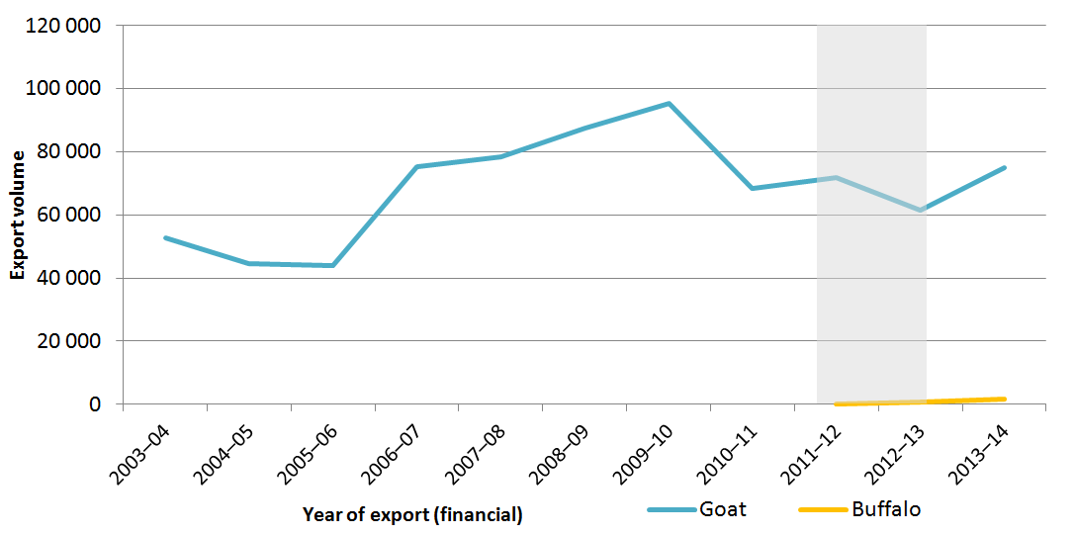
Note: Grey shading represents the time period when ESCAS was implemented in stages. Prior to 2011–12, buffalo was recorded as bovine animals and included in the cattle data.
Source: ABS 2015.
Since implementation of ESCAS, Australia has gained access to several markets. Export protocols have been agreed with Iran, Cambodia, Thailand and Lebanon, although no trade has yet occurred. Trade with Egypt also transitioned to ESCAS regulatory arrangements in 2014, with sheep being exported for the first time since 2006. For Egypt the transition to ESCAS increased auditing requirements, which the Australian Government considered would provide greater confidence that acceptable animal welfare outcomes would be delivered every time (Department of Agriculture 2013a) and provided confidence that trade in sheep could recommence.
Vietnam has emerged as a significant growth market since the introduction of ESCAS while previously it had only imported small consignments. Exports to Vietnam have increased from 945 cattle in 2011–12, to over 130 000 cattle in 2013–14 (ABS 2015). The opening of the Vietnamese market also saw increasing buffalo exports, although numbers remain relatively low (Figure 16).
Goat exports fluctuate greatly (Figure 16). Following the introduction of ESCAS in the important export market of Malaysia, export volumes decreased. However, this trend has not continued and export volumes rebounded in 2013–14.
Trade volumes of sheep to all markets had been in decline for many years and continued to decline following the introduction of ESCAS. This was most significant in the Middle Eastern markets dominated by sheep imports (Figure 17). This is likely to be due to a multitude of factors, which may include the effect of the introduction of ESCAS. The value of the Australian dollar is also expected to influence trade volumes, with competition from north African exporters becoming more significant as the value of the Australian dollar rose, increasing the price of Australian sheep and hence reducing their attractiveness. In addition, industry imposed voluntary suspensions of trade to Bahrain and Pakistan in 2012 and Egypt in 2013. Based on previous trade volumes this equated to a loss of market for potentially 300 000 to 400 000 sheep and 50 000 cattle annually (ABS 2015).
Figure 17 Feeder and slaughter sheep export volumes to the Middle East and the value of the Australian dollar
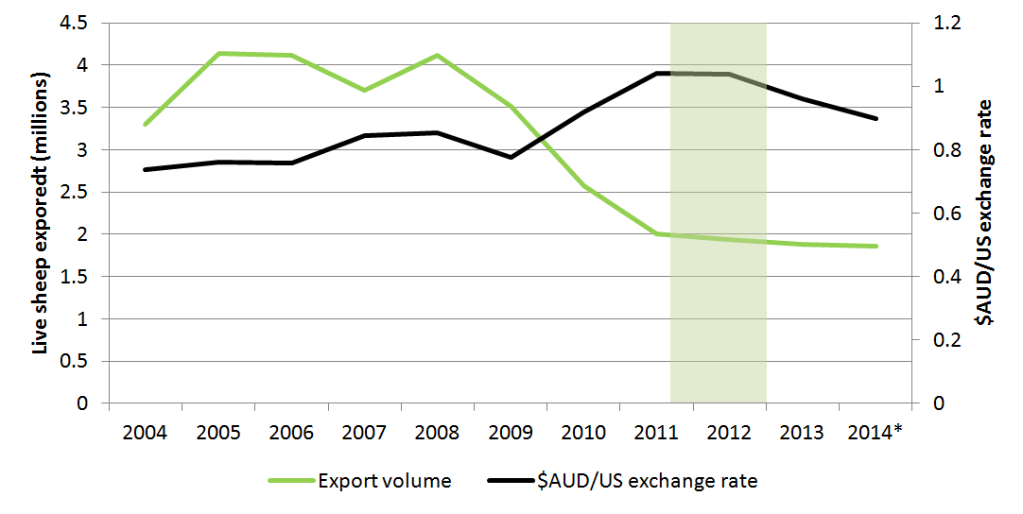
Note: Grey shading represents the time period when ESCAS was implemented in stages. Sheep figures may include a small number of breeder livestock. 2014 data includes up to 30 November 2014 only.
Source: ABS 2015 and Reserve Bank of Australia 2015.
ESCAS has affected sheep export volumes at market level. For example, Australia has not exported live animals to Saudi Arabia since August 2012 due to Saudi Arabia’s concern that the implementation of ESCAS would impinge upon its sovereignty.
At its height in 2006, the Saudi Arabian market received nearly 1.2 million Australian sheep per year and smaller numbers of cattle (mostly breeder rather than slaughter animals). When Australia introduced ESCAS, its sheep exports to Saudi Arabia were already significantly declining—with the increasing value of the Australian dollar reducing the competitiveness of Australian livestock compared to those from northern Africa (Deards et al. 2014) (Figure 18).
Figure 18 Live export sheep volumes to Saudi Arabia and the value of the Australian dollar
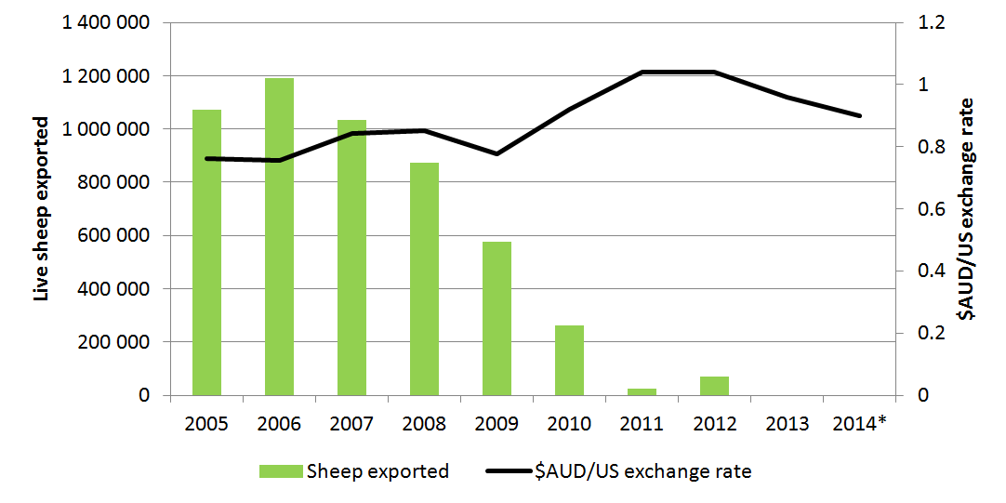
Note: 2014 data includes up to 30 November 2014 only. Sheep and goat figures may include a small number of breeder livestock.
Source:ABS 2015 and Reserve Bank of Australia 2015.

At a whole of trade level, Australia has not traded slaughter camels, camelids or deer since the implementation of ESCAS. Camel meat has particular cultural significance in many Middle Eastern countries, however demand is low. From 2005, only five consignments totalling 485 slaughter camels had been exported. If the trade had been able to continue under ESCAS, export numbers would have probably remained small. No animal welfare audit checklist for the handling and slaughter of camels has been developed. Checklists are used for other species and provide clear guidance to stock handlers and abattoir workers on the steps, actions and processes necessary to deliver animal welfare outcomes consistent with international standards.
Importing countries and exporters have reported that ESCAS has led to greater efficiency in processing animals at the point of slaughter. The one government reported that the system has improved animal handling before and after slaughter and assures the supply of good quality livestock. A Philippines importer noted that ESCAS had improved staff knowledge and contributed to the establishment of procedures for feedlot and meat processing operations. Another Philippines importer used an ESCAS-approved abattoir as a showcase facility and has recently commenced exporting beef to neighbouring South-East Asian markets.
Submissions have raised concerns about ESCAS affecting Australia’s reputation as a reliable supplier of high-quality livestock. In particular, trading partners raised concerns about ESCAS impinging on sovereign rights to regulate their domestic industries and impeding commercial activities.
ESCAS regulations can impose high costs on importers. As discussed in Chapter 2, many facilities overseas have required capacity building or investment to enable them to consistently deliver the animal welfare outcomes required. The costs of improvements may not be commercially viable for small abattoirs that process a low number of animals per week, and the facilities may be priced out of receiving Australian animals. This would have flow-on effects to local economies. However as there are no records of how many facilities received Australian animals before ESCAS, no data is available to assess this impact.
Some countries have implemented domestic regulations that apply to the importation of Australian animals to support the aims of ESCAS. While domestic regulations may strengthen the ability to deliver animal welfare outcomes across the supply chain, it may also lead to substitution with non-Australian origin animals.
Stakeholders have also raised concerns that the complex requirements of ESCAS may prevent entry of new exporters into the market and potential exporters developing the necessary relationships with prospective importers. The combined costs of ESCAS and extra regulation has been anecdotally reported as resulting in a price premium being paid for ‘non-ESCAS’ animals in some markets.
Many Islamic countries celebrate Eid-ul-Adha (known as Korban in South-East Asia). The supply of animals for this and other religious festivals has raised issues with ESCAS. During Eid-ul-Adha Muslims share the meat of freshly slaughtered animals among friends, family and the poor (Deards et al. 2014). Submissions state that some traditional slaughter practices are not possible under ESCAS, and stakeholder submissions from Australian exporters identified their inability to supply animals for religious festivals as a significant impost on the trading relationship. To address this issue flexible arrangements, such as temporary slaughter facilities or use of a ticket system to pick up carcasses from approved abattoirs, have been set up in some markets. Further detail is provided in the ‘ESCAS and religious festivals’ box.

4. ESCAS administration

Key messages
- ESCAS places significant requirements on industry. It is costly to administer for both industry and the Department of Agriculture.
- ESCAS is complex for the Department of Agriculture to administer and for exporters to demonstrate compliance. The significant documentation requirements are unlikely to cost-effectively contribute to the management of supply chain risks.
- Recent red tape reduction initiatives have reduced the administrative burden of ESCAS but there remain further opportunities for improvement.

4.1 ESCAS reporting and assessment
To comply with ESCAS, exporters must show that their supply chains meet ESCAS requirements—that is, that they can ensure animal welfare, control and traceability. Exporters must provide substantial amounts of paperwork to the Department of Agriculture, including application documents, contracts or control arrangement documents, traceability procedures and audit reports on the proposed supply chain. Where an exporter wishes to use multiple supply chains in one consignment, they must repeat the paperwork for each supply chain that they wish to use.
This imposes a significant administrative burden on both exporters and the department in ensuring that documentation submitted is correct. In a review of documentation assessed by the Department of Agriculture over a 10-month period, it was found that 18 exporters submitted around 2800 documents relating to ESCAS, representing approximately 39 per cent of all livestock-related documents received by the department (Predicate Partners 2014).
In the 10-month documentation review period, 55 overdue documents were recorded for over 2600 documents received—approximately 2 per cent. From implementation of ESCAS to 30 November 2014 the department received documents after the due date 197 times (averaging 5 per month). Following up late documents places a burden on the department’s resources.
Multiple factors contribute to documents being overdue. These include exporter competence, complicated requirements for end-of-processing and independent audit reports, issues with timely receipt of information by the exporter from other parties, and the department recording documentation as overdue after only one day. The large volume of paperwork, exacerbated by the need to resubmit similar documents multiple times, can also lead to confusion.
In complex supply chains, issues such as price fluctuations or availability of facilities may mean that commercial parties wish to change facilities included in the approved supply chain. For this to occur, exporters are required to lodge a variation to their supply chain with the department and await approval. Movement of animals to a facility not approved for that specific supply chain, for example prior to being granted approval of a variation, is a breach of ESCAS (as described further in Chapter 2). This is the case even when the facility is already approved in another supply chain. Numerous variations may be requested for the same consignment and may be made any time after the initial approval, from immediately prior to export until the last animal in a consignment is slaughtered. Of the ESCAS documents assessed by the department, 5 per cent are estimated to be for the approval of variations (Predicate Partners 2014).
The administrative requirement to obtain an ESCAS for each individual export has created a rigid system that is not adequately related to risk, regardless of market complexity. Several changes have already been implemented by the Department of Agriculture within the current framework to reduce administrative burdens, without compromising animal welfare outcomes. These have focused on decreasing the volume of documentation required for consignments, and decreasing repetition among documents needed. They include:
- allowing exporters to submit declarations (from 11 December 2013) attesting that contracts with importers and facilities are in place rather than submitting copies of each contract
- removing (from 21 July 2014) the need to submit end-of-processing reports for each cattle and buffalo consignment
- removing the need (from 11 December 2013) to submit the auditor’s assessment checklist when submitting independent audits
- replacing the requirement to publish individual audit reports with publication of information on audit reports received by the Department of Agriculture every four months
- simplifying the approval arrangements for ESCAS variations (from 31 July 2014), reducing paperwork and assessment times.
- Separating ESCAS approvals from individual consignment approvals (from 15 November 2014), reducing the amount of paperwork involved
These changes have reduced the time spent assessing ESCAS documentation, speeding up approvals and reducing charges in many instances.

Implementation of ESCAS in Japan
Implementation of ESCAS has faced some unique challenges relating to the length of time spent by livestock in supply chains in Japan and the number of facilities involved. Cattle exported to Japan may remain in supply chains for years prior to slaughter.
The commercial arrangements have a unique combination of importers, agents and customers involved in the ownership and management of livestock. The style of commercial management has been difficult to fit into a linear ESCAS control arrangement.
In addition, the pre-existing tight regulation of livestock welfare and food safety in Japan means importers and feedlot and abattoir operators have had to simultaneously deal with multiple regulatory arrangements. Commercial parties have to accommodate ESCAS auditing and reporting alongside meeting pre-existing Japanese domestic regulatory requirements.
Implementation of ESCAS in Japan has demonstrated that the current uniform approach to ESCAS in all markets can make the process difficult even for well-prepared exporters and importers. This is more pronounced in markets that already have strict requirements for high standards of animal welfare where ESCAS imposes an additional level of regulation. For Japan, it is unclear whether the additional ESCAS regulations have resulted in any discernible improvements in animal welfare.

4.2 Costs and regulatory burden of ESCAS
The full costs associated with the ESCAS regulatory system are difficult to determine. Since its introduction it has become part of the costs of exporting and built into business structures. As a result it is difficult to isolate ESCAS operation and compliance costs.
The post-implementation regulation impact statement (RIS) from late 2011 identified two sets of costs for exporters under ESCAS: implementation costs and ongoing costs. At that time LiveCorp estimated that establishment of a new ESCAS-compliant supply chain could cost $0.5 million per exporter. Ongoing costs were estimated to be in the order of $2 per animal for cattle exported to Indonesia (Department of the Prime Minister and Cabinet 2011).
The initial cost of establishing ESCAS in a country is significant for exporters. Exporters are required to develop supply chains that can meet OIE standards and supply evidence of compliance at each facility to the Department of Agriculture initially and on an ongoing basis.
Establishment of a compliant supply chain may require infrastructure improvements overseas as well as training for staff working in facilities. While exporters have primary responsibility for demonstrating compliance with ESCAS, costs may be passed on to commercial partners in importing countries, including importers and feedlot or abattoir owners.
To defray some of these costs of establishing supply chains and demonstrating ongoing compliance, the government funded a joint MLA and industry assistance program to help exporters improve facilities they supply in importing countries. Financial assistance was available to assist industry in ensuring supply chains met OIE standards, including reimbursement for:
- purchasing and installing stunning equipment
- infrastructure upgrades
- conducting training, with a focus on raising awareness of animal welfare.
Further information on these assistance programs is provided in Chapter 2 and Appendix D.

Building best practice
One of the recommendations from the Farmer review was for the industry to develop its own assurance system for animal welfare. In response to this recommendation, industry—through LiveCorp and MLA—has invested in research that would underpin a global assurance program (GAP) for animal welfare.
The first part of this research has been completed and published in a report titled Exporter Supply Chain Assurance System – Development of a risk management and quality assurance program (Schuster 2014). The report examines:
- existing systems and resources being utilised to achieve ESCAS compliance and their strengths and weaknesses
- risk management and quality assurance models in place in other industries and sectors
- the cost of compliance with the current ESCAS framework
- the relevance of an industry-initiated risk management and assurance program or management solution, conformance with which would facilitate ESCAS compliance.
LiveCorp and MLA are now partnering to undertake the second stage of this research, which includes detailed design and pilot phases for GAP. The project is due for completion towards the end of 2015 and will provide a sound basis for stakeholders to consider whether GAP has a further role in ensuring positive animal welfare outcomes in the industry (Schuster 2014). | 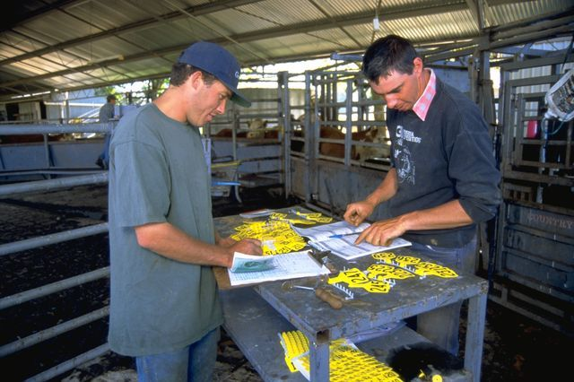
Since the post-implementation RIS, industry has conducted further work to investigate costs to exporters. Recent (2013) estimates range from $0.77 to $14.00 per animal for sheep and from $8 to $45 per animal for cattle (Table 4). These estimates vary depending on species, destination market and transportation method (Meat & Livestock Australia 2014). This is a significant increase on costs reported in 2011. It may also not be reflective of costs for all exporters, as business models and market requirements differ greatly.
Table 4 Cost per animal of compliance with ESCAS
Species | Transport method | High | Low | Mode*
Cattle | Sea | $45.00 | $8.00 | $9.00
Sheep | Sea | $0.77 | $0.77 | $0.77
Sheep | Air | $14.00 | $10.00 | $13.00
Goats | Air | $14.00 | $10.00 | $13.00
Note: The mode represents the number that was represented most often in the sample.
Source: Meat & Livestock Australia 2014.
Additionally, the government has developed a business cost calculator (Department of the Prime Minister and Cabinet 2013). Using this approach it has been estimated that the cost to exporters of complying with ESCAS is in the order of $11.9 million each year (above the direct costs imposed by the Department of Agriculture), although this calculation has a number of caveats.
As a regulator, the Department of Agriculture incurs costs in administering the regulation. This includes assessing applications to export, liaising with exporters to ensure information is compliant, issuing ESCAS approval documentation, non-compliance investigation and assessment of independent audit reports. To manage the additional requirements of ESCAS, the department engaged additional staff for documentation and compliance functions.
ESCAS related services are not all accounted for or billed separately from other live animal export services. The cost of administering ESCAS in 2013–14 was estimated to be $5.7 million. This estimate excludes incidental work undertaken by the department outside of direct administration of ESCAS.
Live animal export certification is funded on a fully cost recovered basis by the department as part of regulating live animal exports. The current cost recovery model was implemented in 2006–07. Since that time, the business environment and trade patterns have changed, and ESCAS was introduced. These factors have placed significant pressure on the cost recovery model, which is no longer aligned with business and service delivery models.
The cost of live animal export certification has not been fully recovered since 2010. While a recent fee review has addressed this, the current cost recovery model is not sustainable and is sensitive to small changes in trade volumes. Under the current model, quarter hourly fees-for-service have been set to recover the full cost of all activities that go into delivering the service. When viewed in isolation some of the hourly charges seem high, but it is important to note that the rate recovers more than just the direct cost of having a departmental officer attend a site to certify a consignment (for example employee wages and superannuation, vehicle leases and travel). The fee also recovers a range of essential, less visible costs such as providing assistance and advice to clients, making bookings, providing veterinary expertise, as well as corporate support (including property costs, financial management, human resource management and information services).
This approach contributes to significant variations in the price for similar services across live animal exporters. Costs associated with the essential support activities are relatively fixed, in that they do not significantly vary against changes in export activity. For example, the costs associated with the department’s human resource management activities do not increase or decrease as a result of a change in the number of export inspections. For sectors with relatively low volume these human resource management costs have to be recovered over lower number of inspection events, meaning that the price is higher than a similar service provided to a sector with higher export volume. Table 5 provides a simple illustration of how the current model contributes to different prices for similar services.

Table 5 Effect of trade volume on cost recovery
 | Low volume sector | High volume sector
Annual number of inspection events | 50.00 | 100.00
Annual Fixed Cost | 100.00 | 100.00
Annual Variable Cost | 50.00 | 100.00
Price per inspection event | 3.00 | 2.00
As a consequence the model no longer distributes costs recovery charges to the various participants in an optimal fashion, which in turn does not promote the efficient delivery and consumption of live animal export certification services. While the review of fees and charges is outside the scope of this report, the Department of Agriculture acknowledges that exporters have concerns about the cost recovery model and costs recovered from industry. The department is undertaking a review of the live animal export certification cost recovery arrangement in 2014–15, as part of a broad departmental review of import and export charges. This review will consider alternative cost recovery models, in accordance with the Australian Government Cost Recovery Guidelines, to drive efficiencies in the delivery and consumption of services in the live animal export sector.
Alternate cost recovery models could explore whether models that operate in other export sectors are applicable to the live animal export sector. For example, within some of these arrangements, annual upfront charges are collected to recover the general cost of the regulatory system and fees are applied to recover the cost of specific services. These models serve to ensure that exporters pay for the services they require, and that all participants make an appropriate contribution to the cost of maintaining the export certification system and infrastructure.
The department has also been exploring opportunities to reduce assessment and processing costs charged to exporters, including reducing the amount of documentation required for assessment and simplifying departmental recordkeeping. When ESCAS was introduced, document processing and assessment took a relatively long time. The department invested significant resources in liaising with industry to ensure documentation for each consignment was submitted correctly and demonstrated compliance. Over time the assessment times decreased (Table 6). This downward trend followed the initial ‘settling in’ as exporters and the department became more familiar with the new arrangements.
Table 6 Assessment times for ESCAS documentation (Indonesia)
Average assessment time | 10 August 2011 – 31 December 2011 | 1 January 2012 – 31 December 2012
Cattle | 611 minutes | 372 minutes
Source: Department of Agriculture 2013b.
The Department of Agriculture has introduced a number of reforms since September 2013 to continue to reduce processing times and cost burdens. For example, the change to publication of summary audits is estimated to have resulted in a cost saving conservatively estimated at $50 000 per annum. Decreasing requirements associated with end-of-processing reports for cattle and buffalo is estimated to have saved 500 hours per annum of document processing work. Other changes have not been formally quantified but have reduced the time spent assessing ESCAS documentation and reduced charges in many instances.
Further reforms were announced by the government in September 2014. These changes are part of a process of continuous improvement to reduce red tape and unnecessary regulation, and streamline the regulatory arrangements while retaining animal welfare safeguards.

5. Conclusions
ESCAS was designed over a short time period as a regulatory arrangement for the export of feeder and slaughter cattle to Indonesia. It was subsequently rolled out to all other markets which received feeder and slaughter livestock. This was done in a very short space of time and was a significant achievement, thanks to the combined efforts of industry, importers, other stakeholders and trading partners.
The introduction of ESCAS ensured the continuation of the livestock export industry. Successive governments have worked to ensure the livestock export trade remains a strong part of Australia’s agricultural industries—recognising the importance of the trade to regional and rural Australia as a source of income and employment.
The short development time and immediate implementation has resulted in a system which is, at times, clunky, rigid and complex. It is an administratively burdensome regulatory arrangement for both government and industry. Despite these shortcomings, the system has been effective in delivering improved animal welfare outcomes.
Many administrative requirements, such as requiring supply chains to be repeatedly approved, are not required to achieve the key principle of ESCAS, which is to ensure OIE animal welfare standards are met through the supply chain. Differences between species, exporters and markets all affect ESCAS’s regulatory effectiveness and the delivery of animal welfare but are not accounted for in its design.
The Department of Agriculture has been working with industry to improve ESCAS and reduce the costs of the system. This is an ongoing process. To date the following improvements have been implemented:
- allowing exporters to submit declarations attesting that contracts with importers and facilities are in place rather than submitting copies of each contract
- removing the need to submit end-of-processing reports for each cattle and buffalo consignment
- removing the need to submit the auditor’s assessment checklist when submitting independent audits
- replacing the requirement to publish individual audit reports with publication of audit summaries every four months
- simplifying the approval arrangements for ESCAS variations, reducing paperwork and improving assessment times.
- separating ESCAS approvals from individual consignment approvals, reducing the amount of paperwork involved
In September 2014 the government announced further reforms to streamline ESCAS, which are in the process of being implemented, including:
- implementing risk-based auditing of supply chains, which reduces the duplication and frequency of audits and reduces the costs to exporters
- consolidating and improving the auditor checklists used to assess compliance with OIE animal welfare standards.
These improvements are the first steps in reducing unnecessary red tape while retaining animal welfare safeguards. There are further opportunities for reform to simplify administrative processes and reduce cost burdens while still meeting the essential objectives of the ESCAS system. These could include:
- clearer guidelines for describing and managing non-compliance, and clarifying third party complaint processes
- allowing the sharing of audits for the same facilities or supply chains, which will remove duplication, reduce costs and improve opportunities for co-operation between individual exporters
- encouraging opportunities for industry to take greater responsibility for proactively managing the risks within supply chains, and supporting industry development of an assurance system as recommended by the Farmer Review. ESCAS could potentially be broadened to allow for comprehensive company or industry assurance systems operating within an appropriate statutory framework.
Despite the challenges ESCAS has posed and the need for improvements, it has delivered significant outcomes. Trade has continued, when it may have otherwise been limited or even phased out entirely. Awareness of animal welfare issues, and of their importance, in livestock handling and slaughter facilities overseas has been improved and ESCAS has provided a valuable source of previously unreported data about the movement and the treatment of animals. However, these benefits may also be able to be provided under a more efficient system than the one currently in place.
This report has provided the first opportunity to consider what has and what has not worked with ESCAS. The government remains committed to the outcomes that ESCAS delivers for animal welfare, but these outcomes need to be delivered in the most effective and efficient way possible to ensure the ongoing viability of the industry. The report may help inform the consideration of further improvements to deliver a more cost effective system that supports trade while continuing to ensure animal welfare.

- — Regulation of animal welfare and livestock exports
All Australian livestock for export must meet the applicable state and territory legislation, Commonwealth export legislation and importing country requirements.

State and territory legislation
Within Australia, state and territory governments have primary responsibility and jurisdiction for enforcing their animal welfare legislation.

Commonwealth export legislation
The Australian Government is responsible for export policy, regulation of livestock exporters, registered premises operators and Australian Government accredited veterinarians, and undertakes activities including licensing livestock exporters, inspections of livestock prior to export, and issuing health certificates and export permits.
The Act and Regulations that relate to licences to export livestock, and Orders that relate to specific export destinations are:
- Australian Meat and Live-stock Industry Act 1997
- Australian Meat and Live-stock Industry (Export Licensing) Regulations 1998
- Australian Meat and Live-stock Industry (Conditions on live-stock export licences) Order 2012
- Australian Meat and Live-stock Industry Regulations 1998
- Australian Meat and Live-stock Industry (Export of Live-stock to Saudi Arabia) Order 2005
- Australian Meat and Live-stock Industry (Live Cattle Exports to the Republic of Korea) Order 2002
The Act and Orders that relate to the preparation of livestock for export by sea and air are:
- Export Control Act 1982
- Export Control (Prescribed Goods – General) Order 2005
- Export Control (Animals) Order 2004 (Animals Order)
The Orders that relate to standards for the export of livestock are:
- Australian Meat and Live-stock Industry (Standards) Order 2005
- Export Control (Animals) Order 2004
The Animals Order regulates the export of individual consignments of livestock by a person. It provides for the Department of Agriculture to grant permission to source, transport and prepare livestock for export, through approval of:
- a notice of intention to export (NOI)
- a consignment risk management plan (CRMP)
- an exporter supply chain assurance system (ESCAS).
The Department of Agriculture may then:
- certify that importing country requirements have been met
- permit the animals to be loaded for export
- grant an export permit.
The standards are the Australian Standards for the Export of Livestock (version 2.3) 2011 (ASEL). ASEL sets out standards for the sourcing of export livestock, their management in registered premises, loading onto a vessel, management on board a vessel and air transport. It also defines reportable mortality limits and references animal health and welfare requirements of the state and territory legislation.

Importing country requirements
Countries may impose conditions that need to be met prior to animals being accepted into their country. For livestock most conditions relate to animal health, such as disease-free status. Some countries have animal health testing requirements, quarantine and transport requirements, and animal weight limits.
- — List of submissions
Table B1 List of submissions
Name
Al Jabri Australia Pty Ltd
Australian Livestock Exporters’ Council (ALEC), Australian Livestock Export Corporation (LiveCorp), Cattle Council of Australia , Goat Industry Council of Australia, Meat & Livestock Australia, Sheepmeat Council of Australia, (Joint submission)
Animals Australia
Australian Buffalo Industry Council
Australian Livestock and Rural Transporters Association
Australian Veterinary Association
Brunei Darussalam - Pehin Dato Haji Yahya, Minister of Industry and Primary Resources
Cattle Council of Australia
Damara Farms Australia
Emanuel Exports
Republic of Indonesia - Minister Suswono, Minister of Agriculture of the Republic of Indonesia
Hashemite Kingdom of Jordan - Dr Akef Al Zubi, Minister of Agriculture
Livestock South Australia
Livestock Shipping Services
Republic of Mauritius - Chief Veterinary Officer, Department of Veterinary Services, Ministry of Agro-Industry and Food Security
Meat & Livestock Australia/Australian Livestock Export Corporation (LiveCorp)
National Farmers’ Federation
North Australian Cattle Company
Northern Territory Government - Chief Executive, Department of Primary Industry and Fisheries
New South Wales - The Hon Katrina Hodgkinson MP, Minister for Primary Industries
Pastoralists & Graziers Association of Western Australia
Republic of the Philippines - Department of Agriculture - Bureau of Animal Industry
Republic of the Philippines - Anonymous importers
RSPCA Australia
Sheepmeat Council of Australia
Republic of Singapore - Senior Veterinarian, Agri-Food and Veterinary Authority of Singapore
Sojitz Food Corporation
South Australia - The Hon Leon Bignell MP, Minister for Agriculture, Food and Fisheries
Republic of Turkey - Ministry of Food, Agriculture and Livestock
Victoria - The Hon Peter Walsh MLA, Minister for Agriculture and Food Security
World Animal Protection Australia
Western Australia Farmers Federation
Western Australian livestock producers
Western Australia - The Hon Ken Baston MLC, Minister for Agriculture and Food
WoolProducers of Australia
Plus one submission provided in confidence
- — Summary of investigation report outcomes
Further information on the below investigations as well as other live animal export investigations is available on the Department of Agriculture website.
Table C1 Summary of publicly released ESCAS investigation report outcomes with findings of possible or confirmed non-compliance.
Location | Report # | Allegation | Species | Department of Agriculture’s findings | Compliance management measures
Gaza | 24 | Animals outside the supply chain – Animal welfare concerns | Cattle | The department found that there was a loss of control and traceability in the supply chain with poor animal welfare outcomes with cattle slaughtered in a manner not consistent with OIE recommendations.  A major non-compliance was recorded against LSS for animals outside the approved supply chain which resulted in poor animal welfare outcomes.  A minor non-compliance was recorded against LSS for the movement of animals into Gaza facilities prior to those facilities receiving ESCAS approval. | No further consignments have been approved for export to the supply chain in Gaza.  The department will consider the findings of this investigation when considering future applications to export livestock that include this supply chain.
Indonesia | 1 | Facilities not up to standard  Animal welfare concerns | Cattle | The department found non-compliance relating to restraint & handling in two abattoirs that handled Australian cattle.  A major non-compliance was recorded against International Livestock Export and North Australian Cattle Company (animal welfare). | Conditions applied to the ESCAS  Two abattoirs removed from the supply chain.
Israel x 3 | 15 & 16 | Facilities not up to standard | Cattle sheep | The department found animals were handled in a manner not consistent with OIE animal welfare standards. | Conditions applied to NOI - unloading in Israel.
 | 30 | Animal welfare concerns | Cattle | The department found that there were elements of poor animal handling during the unloading of a consignment of cattle from the vessel. | The department referred the matter to local authorities in Israel.
Jordan x 2 | 14 | Animals outside the supply chain – 1100 | Sheep | The department confirmed 51 animals were outside the supply chain. Eight tags linked to Livestock Shipping Services and two linked to both Livestock Shipping Services and Wellard.  A major non-compliance was recorded against Livestock Shipping Services for movement of sheep outside the supply chain to other locations. | Conditions on ESCAS.
 | 20 | Animals outside the supply chain – 10000 | Sheep | The department confirmed 2718 animals were outside the supply chain.  A critical non-compliance was recorded against Livestock Shipping Services for sheep outside the supply chain (movement to other location). | Conditions on exporter’s licence. Two facilities voluntarily removed from the supply chain by the exporter.
Kuwait x 3 | 5 | Animals outside the supply chain – 200 | Sheep | The department could not confirm but found that the sheep in the photographs were most likely Australian. | Conditions on ESCAS for all sheep exports to Kuwait.
 | 8 | Animals outside the supply chain – 91 | Sheep | The department confirmed one sheep was exported by Emanuel, and it was likely many more were also Australian.  A major non-compliance was recorded against Emanuel for sheep outside the supply chain (movement to other location). | Conditions on ESCAS for all sheep exports to Kuwait
 | 21 | Animals outside the supply chain – 100 | Sheep | The department confirmed two sheep were exported by Emanuel, and it was likely many more were also Australian.  A major non-compliance was recorded against Emanuel and EMS for sheep outside the supply chain. | Additional conditions on ESCAS for sheep exports to Kuwait.
Malaysia x 3 | 11a | Animal welfare concerns | Cattle | The department found that a few aspects of the handling and slaughter at the abattoir were not in accordance with the OIE animal welfare standards however, the exporter could not be determined. | Conditions placed on ESCAS.
 | 11b | Animals outside the supply chain–9 | Sheep  Goats | The investigation found non-compliance with handling of goats at two approved supply chain facilities.  The exporter removed them from the supply chain. | Conditions placed on ESCAS for several months  Exporter voluntarily removed two facilities.
 | 19 | Facilities not up to standard  Animals outside the supply chain–53 | Cattle | The department confirmed 53 cattle were missing from the supply chain. | Exporter committed to not using supply chain again.
Mauritius | 22 | Animals outside the supply chain–20  Animal welfare concerns | Cattle | The department found four animals exported by ILE were outside the supply chain and not treated in a manner that met OIE animal welfare standards  A major non-compliance was recorded against ILE (animal welfare). | Conditions on ESCAS.
UAE | 23 | Animals outside the supply chain–‘hundreds’ | Sheep | The department found there was a loss of control with 114 sheep moving outside the supply chain.  A major non-compliance was recorded against the Livestock Shipping Services supply chain (movement to other location). | Conditions on ESCAS for all sheep exports to the UAE.
Vietnam | 12 | Animals outside the supply chain–190  Animal welfare concerns | Cattle | The department found that there were 96 cattle outside the supply chain and 94 cattle were sent to an abattoir not yet approved.  A critical non-compliance was recorded against the supply chain for failure to comply with control arrangements (movement to other location).  A Minor non-compliance was issued against Wellard for movement to a compliant facility prior to approval. | Exporter will not use importer in future.

Table C2 ESCAS Non-compliance – publicly released self-reports
Location | Species | Date | Exporter | Issue | Compliance management measures
Pakistan | Sheep | September 2012 | Wellard | Government of Pakistan intervention. | Voluntary suspension of trade  No non-compliance recorded.
Jordan | Sheep | July 2013 | Wellard | Animals outside the supply chain – 6950  (Movement to an OIE compliant abattoir – prior to approval). | Exporter implemented corrective actions  Minor non-compliance against exporter.
Vietnam | Cattle | February 2014 | NACC | Animals outside the supply chain–514  (26 animals moved to other locations, 262 unauthorised movement to compliant facility, 226 moved to OIE compliant facilities prior to approval). | Exporter corrective actions  Critical non-compliance against exporter, follow up audit of corrective actions.
Vietnam | Cattle | February 2014 | SEALS | Animals outside the supply chain –27  (27 cattle–unauthorised movement to approved facilities). | Exporter corrective actions  No action on exporter.

Table C3 Instances of non-compliance with possible direct animal welfare impact, by market
Market | Instances of non-compliance with a possible direct animal welfare impact |  | Species affected | Estimated number of livestock affected by non-compliance | Number of livestock exported to market | Percentage of livestock affected by confirmed non-compliance
Bahrain | 0 |  | – | 0 | 409 606 | 0%
Brunei Darussalam |  | 0 | – | 0 | 14 491 | 0%
Egypt | 0 |  | – | 0 | 58 900 | 0%
Indonesia | 8 |  | Cattle | 384 | 1 554 108 | 0.02%
Israel | 2 |  | Sheep/cattle | 179 | 338 166 | 0.05%
Japan | 0 |  | – | 0 | 25 170 | 0%
Jordan | 2 |  | Sheep | 11 100 | 701 847 | 1.58%
Kuwait | 4 |  | Sheep | 555 | 2 153 872 | 0.03%
Malaysia | 1 |  | Cattle | 8 | 327 015 | 0.002%
Mauritius | 1 |  | Cattle | 7 | 7900 | 0.09%
Oman | 0 |  | – | 0 | 128 242 | 0%
Philippines | 0 |  | – | 0 | 61 050 | 0%
Qatar | 1 |  | Cattle | 1 | 1 505 770 | 0%
Russia | 0 |  | – | 0 | 31 992 | 0%
Singapore | 0 |  | – | 0 | 7058 | 0%
Turkey | 0 |  | – | 0 | 243 586 | 0%
UAE | 1 |  | – | 114 | 230 695 | 0.05%
Vietnam | 1 |  | Cattle | 610 | 236 165 | 0.26%
TOTAL | 22 |  | – | 12958 | 8 035 633 | 0.16%
Source: Department of Agriculture 2015 and ABS 2015

- — Approved Supply Chain Improvements Program
Table D1 Grants issued under the Australian Supply Chain Improvements Program
Year | DAFF ID No. | Recipient | Value | Commencement Date | Grant Term
2012–2013 | GMS-1949 | Australian Rural Exporters Pty Ltd | $23,635 | 14/01/2013 | 2 months
 | GMS-1952 | Livestock Shipping Services Pty Ltd | $168,106 | 14/01/2013 | 2 months
 | GMS-1955 | South East Asian Livestock Services | $14,993 | 13/02/2013 | 2 months
 | GMS-1966 | Australian Rural Exporters Pty Ltd | $5,676 | 25/02/2013 | 2 months
 | GMS-1969 | Meat & Livestock Australia | $70,750 | 14/03/2013 | 2 months
 | ASCIP 001 | Wellard Rural Exports Pty Ltd | $26,254 | 14/03/2013 | 2 months
 | ASCIP 002 | Wellard Rural Exports Pty Ltd | $53,577 | 14/03/2013 | 2 months
 | ASCIP 003 | Wellard Rural Exports Pty Ltd | $26,252 | 14/03/2013 | 2 months
 | GMS-2182 | South East Asian Livestock Services Pty Ltd | $31,685 | 30/04/13 | 2 months
 | GMS-2208 | Australian Rural Exports Pty Ltd | $44,285 | 30/04/13 | 2 months
 | GMS-2211 | Livestock Shipping Services Pty Ltd | $50,618 | 30/04/13 | 2 months
 | GMS-2035 | Meat & Livestock Australia | $60,139 | 16/05/2013 | 1 months
2013–2014 | GMS 2133 | Wellard Rural Exports Pty Ltd | $37,970 | 7/08/13 | 2 months
 | GMS-2150 | Wellard Rural Exports Pty Ltd | $64,325 | 3/09/13 | 2 months
 | GMS-2148 | International Livestock Exports Pty Ltd | $71,080 | 3/09/13 | 2 months
 | GMS 2177 | Elders International Australia Ltd | $9,973 | 21/10/13 | 2 months
 | GMS-2226 | Meat & Livestock Australia | $114,531 | 24/02/14 | 2 months
 | GMS-2271 | North Australian Cattle Company Pty Ltd | $39,123 | 28/02/14 | 2 months
Source: Department of Agriculture 2015.
- — Country profiles
Market summaries are provided for Bahrain, Brunei Darussalam, Indonesia, Israel, Japan, Jordan, Kuwait, Malaysia, Mauritius, Oman, Philippines, Qatar, Singapore, United Arab Emirates and Vietnam. Where there was insufficient information to assess the performance of ESCAS (due to no trade or a small volume of trade) market summaries are not provided.
Data provided is sourced from the Department of Agriculture Live Animal Export program (Department of Agriculture 2015) and the Australian Bureau of Statistics (ABS 2015) available to 30 November 2014 and correct as at 5 January 2015. Livestock numbers are for feeder/slaughter livestock unless indicated otherwise. Additional information on capacity building activities has been provided by MLA. Information on direct investments by exporters in supply chain improvements and capacity building is not included.

Kingdom of Bahrain
ESCAS details  - ESCAS was introduced to the market in March 2012 (indicated by vertical line in Figure E1). In August 2012 the industry imposed a suspension, which was lifted in February 2014.  - The supply chain is simple with a single importer, feedlot and abattoir with facilities partially owned by the Bahraini Government.  - Imported live sheep and carcasses are subsidised by the Bahraini Government and retailed at a fixed price, so there is little incentive to sell outside the approved supply chain.  - There have been 21 consignments exported to Bahrain under ESCAS. | ESCAS Statistics  Consignments  Exporters under ESCAS  Importers under ESCAS  Feedlots  Abattoirs | 21  3  1  1  1
Trade details
- Bahrain has historically been an important market for Australian live sheep exports and was in the top three markets in 2009–2011. In 2012, Bahrain accounted for 11 per cent of live sheep export volume.
- Post introduction of ESCAS, Australia exported 409 606 sheep to Bahrain.
- Following an incident where a consignment failed to unload in August 2012, Australian industry suspended trade. The consignment was redirected to Pakistan where the government assumed control of the consignment, with a very poor animal welfare outcome. Thirteen consignments have been exported to Bahrain since trade recommenced in April 2014.
- Australia is the largest exporter of sheep to Bahrain, followed by Saudi Arabia and Somalia. Following Australia’s suspension of live exports, Bahrain also increased sheep meat imports from other suppliers such as Pakistan, Ethiopia, Sudan and Kenya.
- Sheep that are exported to Bahrain most often depart from Fremantle, and some have also departed from Port Adelaide.
Figure E1 Trade data – live cattle and sheep
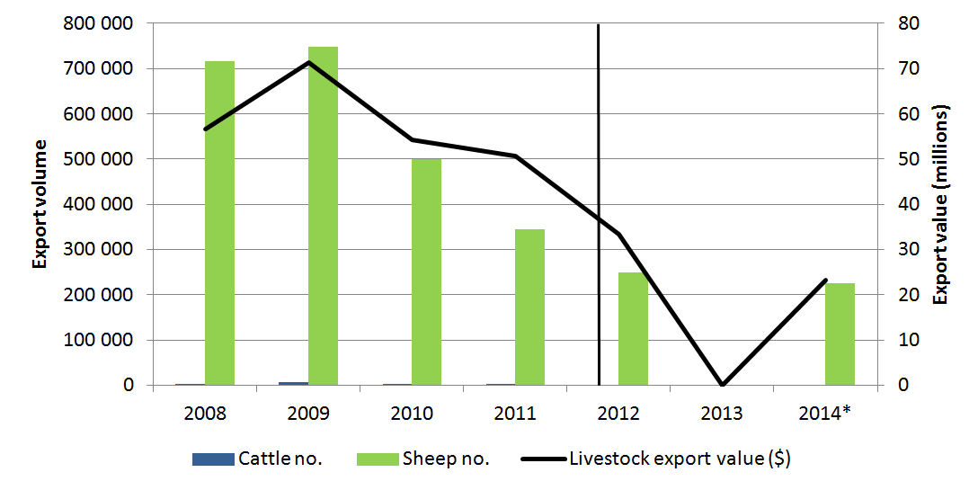
Note: Goats were not exported to Bahrain between 2008–2014. Vertical line indicates date of implementation of ESCAS in this market. Sheep figures may include a small number of breeder livestock. 2014 data includes exports up to 30 November 2014.
Source: ABS 2015.

Investigations/incidents
- There have been no ESCAS investigations for Bahrain.

Supply chain improvements and capacity building
- Australian industry has provided (since April 2014):
- standard operating procedure training at the main feedlot and abattoir in Bahrain for 11 participants
- three separate ESCAS technical advice sessions (totalling 12 days of training).

Brunei Darussalam
ESCAS details  - ESCAS was introduced to the market in December 2012.  - The supply chains are simple with limited consignments and a small number of facilities in use.  - Consignments are often timed for the religious festival Qurban.  - Two feedlots and three abattoirs have been approved under ESCAS. | ESCAS Statistics  Consignments  Exporters under ESCAS  Importers under ESCAS  Feedlots  Abattoirs | 10  1  4  2  3
Trade details
- Brunei Darussalam was Australia’s fourth largest goat export market in 2014, and a market for live cattle and buffalo exports. It returns relatively high prices due to demand.
- Post introduction of ESCAS, Australia exported 11 799 cattle, 1897 goats and 915 buffalo.
- Ten consignments have been exported since ESCAS was introduced.
- Cattle, goat and buffalo exported to Brunei Darussalam depart from Darwin and Karumba ports.
Figure E2 Trade data – live cattle and other
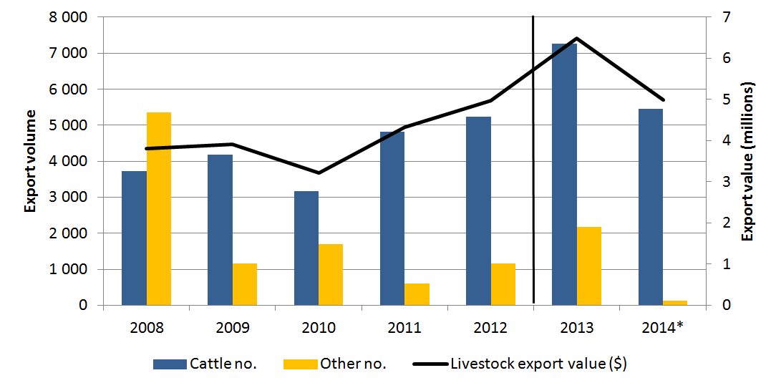
Note: Other livestock export volume includes buffalo and goats. Vertical line indicates date of implementation of ESCAS in this market. Goat figures may include a small number of breeder livestock. 2014 data includes exports up to 30 November 2014.
Source: ABS 2015.

Investigations/incidents
- There have been no investigations or incidents reported for this market.

Supply chain improvements and capacity building
- Australian industry has provided:
- twenty-two days of training for approximately 92 participants
- training focused on animal handling, feedlot performance and abattoir practices.

Republic of Indonesia
ESCAS details  - Indonesia was the first market where ESCAS was implemented. This occurred in July 2011.  - The supply chains are complex with multiple facilities used by multiple importers and exporters; some facilities are government owned and leased.  - Since ESCAS was introduced, 267 facilities have been approved under ESCAS.  - A total of 469 consignments have been exported under ESCAS. | ESCAS Statistics  Consignments  Exporters under ESCAS  Importers under ESCAS  Feedlots  Abattoirs | 469  7  41  76  191
Trade details
- Indonesia is the largest market for live cattle exports from Australia, accounting for 62 per cent of feeder/slaughter live cattle exports in 2013.
- Australia exported approximately 1 553 455 cattle and 653 buffalo to Indonesia under ESCAS.
- The majority of cattle depart from Broome, Darwin, Fremantle, Geraldton, Karumba, Townsville and Wyndham.
- Australia is currently the only supplier of feeder and slaughter cattle to Indonesia.
- One consignment of buffalo was exported under ESCAS.
Figure E3 Trade data – live cattle
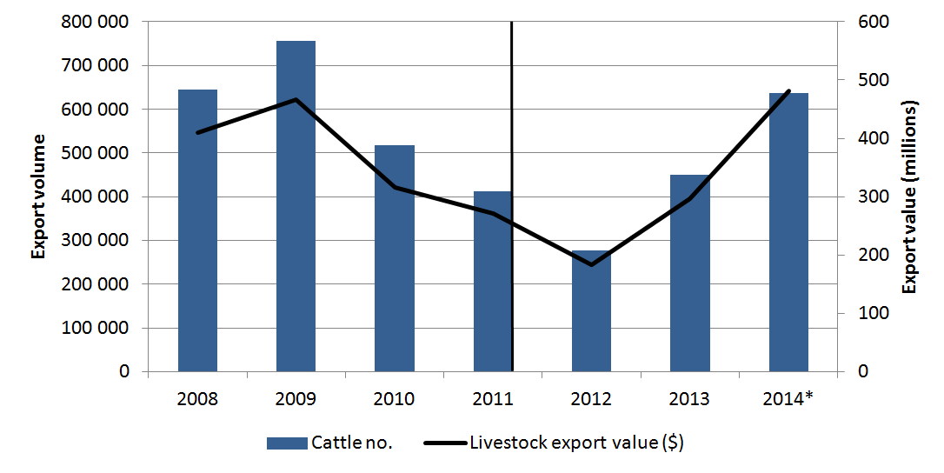
Note: No sheep were exported to Indonesia during this period and goat and buffalo export volumes are too low to include. Vertical line indicates date of implementation of ESCAS in this market. 2014 data includes exports up to 30 November 2014.
Source: ABS 2015.

Investigations/incidents
- There have been several self-reports and third party allegations of ESCAS breaches for cattle exported from Australia in Indonesia.
- The first investigation, in May 2012, found that footage indicated animal welfare breaches in two abattoirs. As a result, the Department of Agriculture removed the two abattoirs from exporters’ ESCAS supply chains.
- The second investigation, in October 2012, found there was no evidence to support that a non-compliance with ESCAS occurred in the abattoir in question.
- Four self-reported incidents of non-compliance with ESCAS are being assessed by the Department of Agriculture.

Supply chain improvements and capacity building
- The Australian Government has:
- supported OIE training for government officials on animal welfare guidelines
- delivered TAFE SA Certificate III in meat processing, which includes training on animal welfare and meat safety
- supported the university twinning project between Australian and Indonesian institutions to align the Indonesian curriculum with international standards.
- Australian industry has provided:
- assistance in the form of gap and risk analyses (126 assessments for 90 abattoirs)
- training totalling 331 days in feedlots, 751 days in abattoirs and 28 days in ports to approximately 2850 participants
- animal welfare and ESCAS seminars in four key cities for over 420 industry and government representatives
- other activities including research and development, nutrition, training manuals and auditor awareness.

State of Israel
ESCAS details  - ESCAS was introduced to the market in September 2012.  - The supply chains in Israel are complex, utilised by a number of different commercial parties and contain a large number of facilities. All feedlot and abattoir facilities are owned by two companies.  - Livestock exports from Australia have been exported to Gaza as part of Israeli supply chains.  - Israel has in place its own animal welfare laws that are stringent and equivalent to OIE standards.  - Seventy feedlots and nine abattoirs have been approved under ESCAS.  - Twenty-nine consignments of sheep and cattle have been exported since ESCAS was introduced. | ESCAS Statistics  Consignments  Exporters under ESCAS  Importers under ESCAS  Feedlots  Abattoirs | 29  4  5  70  9
Trade details
- Israel was Australia’s second largest market for cattle exports in 2013 and an important market for live sheep. Israel imported 98 096 cattle in 2013, which represented 13 per cent of cattle export volume.
- Post introduction of ESCAS, Australia exported 164 289 sheep and 173 877 cattle to Israel.
- Sheep and cattle exported to Israel have mostly departed from Fremantle, Geraldton and Port Adelaide.
- Both the value and number of livestock exports to Israel have been growing in recent years with cattle experiencing a large spike.
Figure E4 Trade data – live sheep and cattle
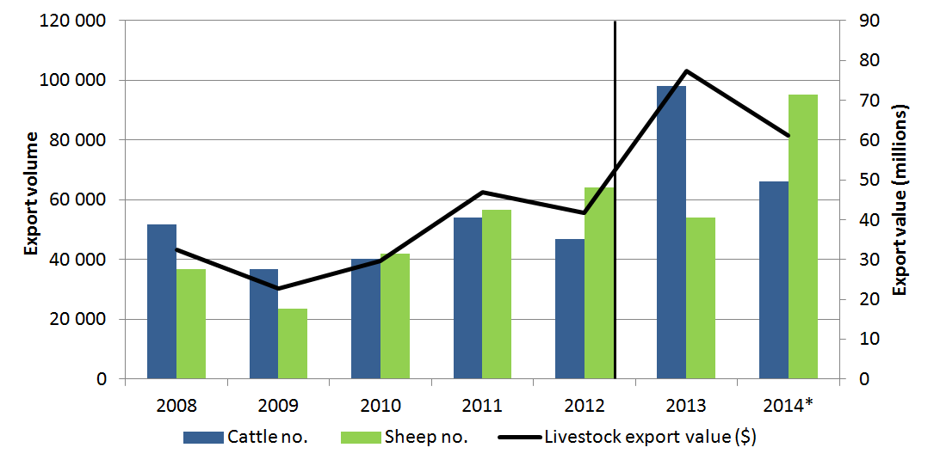
Note: No goats were exported to Israel during this period. Vertical line indicates date of implementation of ESCAS in this market. Sheep figures may include a small number of breeder livestock. 2014 data includes exports up to 30 November 2014.
Source: ABS 2015.

Investigations/incidents
- There have been eight allegations of non-compliance with ESCAS requirements in cattle and sheep exported to Israel.
- Six investigations have been completed and no non-compliance was recorded in five of these cases.
- Four of these reports concerned the handling of livestock during unloading from ships by port workers and have since been addressed by animal welfare handling sessions for port workers arranged by exporters, additional oversight by Israel’s port authorities, and additional reporting to the department from shipboard veterinarians about the standard of animal handling during unloading.
- One investigation found that cattle exported to Israel and moved to Gaza had moved outside of their approved supply chain, and there was also poor handling and slaughter in an abattoir within the supply chain. A major and a minor non-compliance were recorded and regulatory action was taken.
- In addition, Israel has conducted its own investigations under its domestic legislation where allegations of animal mistreatment have been reported.
- Two further reports of non-compliance with ESCAS requirements for cattle have been received by the Department of Agriculture (one from a third party, and one self-report by an exporter). Investigations into these reports are ongoing.

Supply chain improvements and capacity building
- Australian industry has provided (since July 2012):
- consultant training programs
- thirty-seven days training for approximately 190 participants
- a variety of animal welfare and meat quality seminars and workshops.

Japan
ESCAS details  - ESCAS was introduced to the market in September 2012.  - The supply chains are complex, with regular consignments and a number of facilities and agents involved.  - Japan is a highly regulated market with a number of importing country requirements including compulsory quarantine periods. Under Japanese law all animals must be stunned prior to slaughter.  - Two quarantine facilities, 24 feedlots and seven abattoirs have been approved under ESCAS. | ESCAS Statistics  Consignments  Exporters under ESCAS  Importers under ESCAS  Feedlots  Abattoirs | 46  2  11  24  7
Trade details
- Japan accounted for a small percentage of Australia's cattle exports in terms of volume and value in 2013. Japan does not import feeder/slaughter sheep or goats but does import a small volume of breeder buffalo, cattle and sheep. Livestock exported to Japan include high value wagyu cattle.
- Post introduction of ESCAS, Australia has exported 25 170 cattle to Japan.
- Since the mid 2000s Japan has only imported feeder and slaughter cattle from Australia, having ceased trade with the USA.
- Feeder cattle are exported to Japan by sea and depart from Brisbane.
Figure E5 Trade data – live cattle
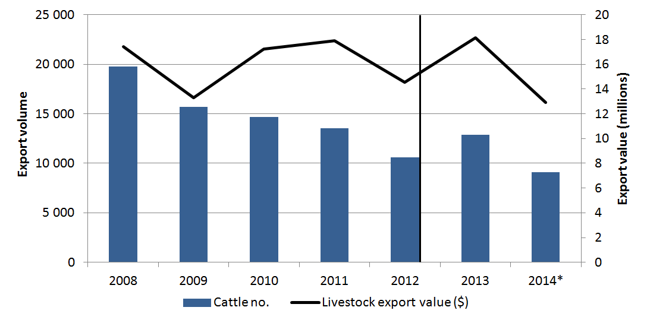
Note: No other livestock species were exported to Japan during this period. Vertical line indicates date of implementation of ESCAS in this market. 2014 data includes exports up to 30 November 2014.
Source: ABS 2015.

Investigations/incidents
- There have been no ESCAS investigations for Japan.

Supply chain improvements and capacity building
- The Australian Government has provided grants to the Australian industry to support animal welfare improvements within the ESCAS supply chain.

Hashemite Kingdom of Jordan
ESCAS details  - ESCAS was introduced to the market in September 2012.  - Jordan has simple supply chains each with a small number of facilities. All livestock abattoirs are also accredited and supervised by the Jordanian Government.  - Jordan has been subject to a number of investigations and incidents related to loss of sheep from supply chains. Jordan is a high-volume importer and local factors may have contributed to these incidents.  - Five feedlots and five abattoirs have been approved under ESCAS. | ESCAS Statistics  Consignments  Exporters under ESCAS  Importers under ESCAS  Feedlots  Abattoirs | 19  2  2  5  5
Trade details
- Jordan was Australia’s third largest market for live sheep exports in 2013 and a smaller market for cattle. A total of 287 792 sheep were exported in 2013, which represented nearly 15 per cent of sheep exported from Australia.
- Post introduction of ESCAS, Australia exported 689 947 sheep and 11 900 cattle to Jordan.
- Sheep and cattle exported to Jordan have mostly departed from Fremantle, and some from Port Adelaide.
- Buffalo and goats were not exported to Jordan between 2008 and 2014.
Figure E6 Trade data – live cattle and sheep
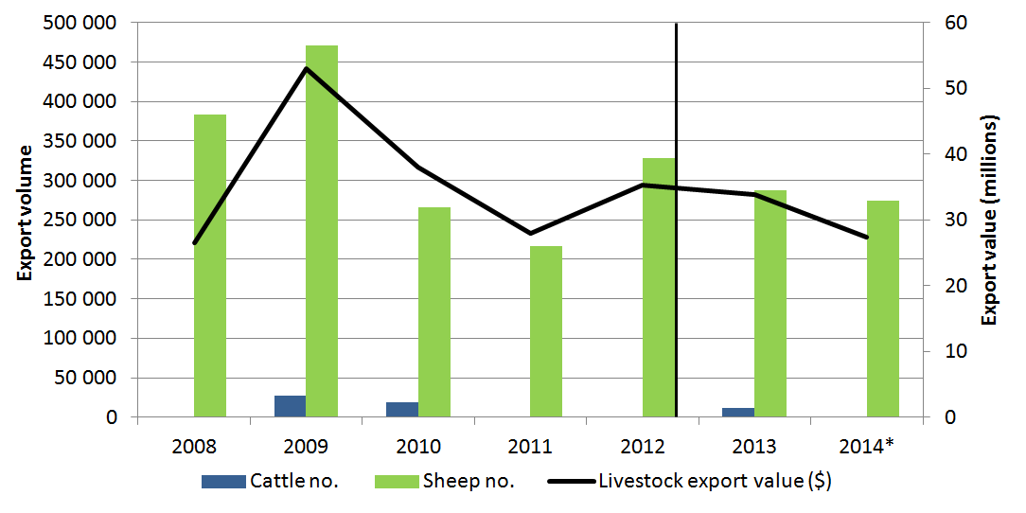
Note: No goats were exported to Jordan during this period. Vertical line indicates date of implementation of ESCAS in this market. Sheep figures may include a small number of breeder livestock. 2014 data includes exports up to 30 November 2014.
Source: ABS 2015.

Investigations/incidents
- There have been five self-reports or allegations of non-compliance with ESCAS requirements in sheep exported to Jordan.
- One self-report and two investigations have been finalised and published:
  - The self-report by the exporter was investigated and further actions were agreed to between the Department of Agriculture and the exporter.
  - The two investigations concluded that Australian animals were outside approved supply chains and so may not have been slaughtered in accordance with OIE standards. As a result, the department requires additional actions from exporters to detect and prevent the loss of sheep from approved supply chains to Jordan.
- A further four investigations, including three reports by a third party and one self-report from an exporter, are in progress.

Supply chain improvements and capacity building
- The Australian Government has also:
- supported OIE training for government officials on animal welfare guidelines.
- Australian industry has provided (since July 2012):
- twenty-one consultant training programs delivering technical advice, training and feedlot/abattoir support
- forty-two training days for approximately 150 participants
- implementation of an Eid-ul-Adha working group to explore solutions for supplying Eid-ul-Adha in Jordan. Members include industry and government.

State of Kuwait
ESCAS details  - ESCAS was introduced to the market in March 2012.  - There are a small number of simple supply chains in Kuwait.  - Six feedlots and five abattoirs have been approved under ESCAS. | ESCAS Statistics  Consignments  Exporters under ESCAS  Importers under ESCAS  Feedlots  Abattoirs | 72  4  4  6  5
Trade details
- Kuwait has been Australia’s largest sheep importing market for over a decade. From 2008–2013 the market imported 700 000 to 1 million live sheep per annum from Australia. In 2011, Kuwait accounted almost 40 per cent of Australia’s live sheep exports.
- Post introduction of ESCAS, Australia exported 2 153 872 sheep to Kuwait.
- Sheep exported to Kuwait have mostly departed from Fremantle Port, Port Adelaide and Portland.
- Kuwait was importing over one million Australian sheep a year at the height of demand. Trade dropped slightly in 2012 but picked up again in 2013.
- Kuwait has historically been a minor market for cattle but none have been exported since the introduction of ESCAS.
- No buffalo were exported to Kuwait between 2008 and 2013. A consignment of goats was exported to Kuwait by air in 2009, prior to implementation of ESCAS. No goats have been exported since.
Figure E7 Trade data – live cattle and sheep
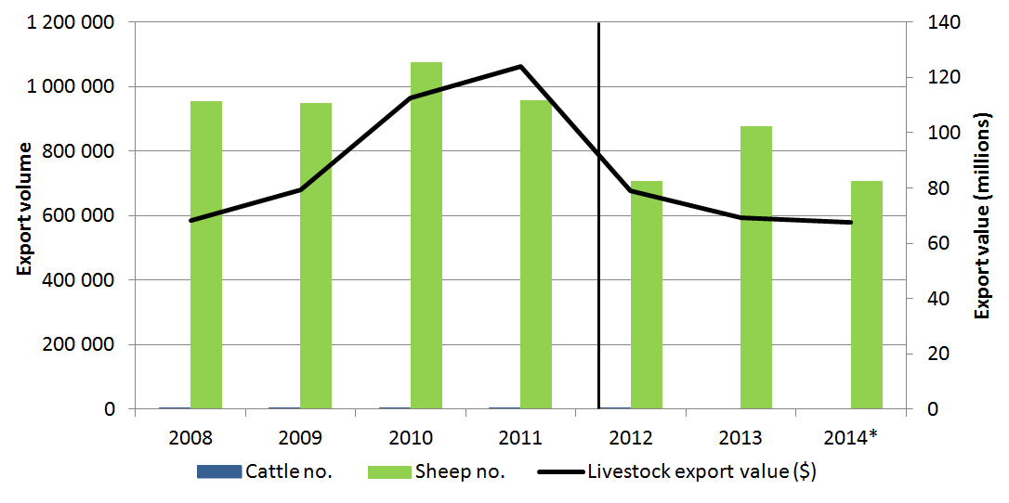
Note: Vertical line indicates date of implementation of ESCAS in this market. Sheep figures may include a small number of breeder livestock. 2014 data includes exports up to 30 November 2014.
Source: ABS 2015.

Investigations/incidents
- There have been five allegations and one self-report of non-compliance with ESCAS requirements involving consignments of sheep exported to Kuwait.
- The first three investigations have been finalised and published. The investigations concluded that it is highly likely that sheep exported under ESCAS arrangements were taken from approved facilities and moved to the Al Rai Market in Kuwait City.
- Regulatory action involved applying extra conditions on consignment approvals for all exporters of sheep to the Kuwait market which are designed to detect and prevent sheep being taken from ESCAS facilities.
- The remaining three investigations are ongoing.

Supply chain improvements and capacity building
- Australian industry has provided 123 days of training in the 2013–14 financial year. Three hundred participants have received training since the implementation of ESCAS.

Malaysia
ESCAS details  - ESCAS was introduced to the market in September 2012.  - Malaysia is a complex market characterised by large numbers of small consignments, often transported by air. There are many supply chains and there are large numbers of facilities in use, processing three different species of livestock.  - In many instances, feedlots and abattoirs are co-located.  - There are 140 feedlots and 89 abattoirs that have been approved under ESCAS.  - Since ESCAS was introduced, 374 consignments of sheep, goats and cattle have been exported to Malaysia. Three of these consignments were sent to the province of Sarawak, a market which has different import requirements. | ESCAS Statistics  Consignments  Exporters under ESCAS  Importers under ESCAS  Feedlots  Abattoirs | 374  14  19  140  89
Trade details
- Malaysia is Australia’s major market for live goat exports. It also imports sheep and cattle.
- Post introduction of ESCAS, Australia exported 73 740 sheep, 147 636 goats and 105 639 cattle to Malaysia.
- Cattle consignments are largely exported by sea and sheep and goat consignments exported by air.
- Animals exported to Malaysia by air have mostly departed from Adelaide, Perth or Sydney. Sea consignments have departed from Broome, Darwin, Fremantle, Karumba, Port Adelaide, Townsville and Wyndham.
Figure E8 Trade data – live cattle, sheep and goats
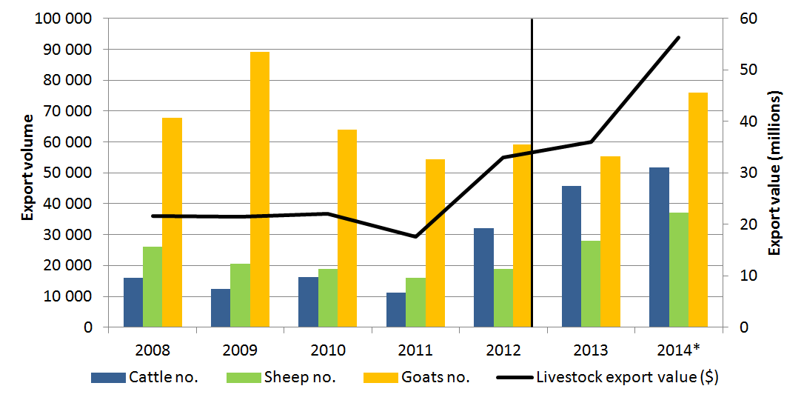
Note: Vertical line indicates date of implementation of ESCAS in this market. Sheep and goat figures may include a small number of breeder livestock. 2014 data includes exports up to 30 November 2014.
Source: ABS 2015.

Investigations/incidents
- There have been five allegations and one self-report of non-compliance with ESCAS requirements in sheep, goats and cattle exported to Malaysia.
- There was insufficient evidence to conduct an investigation or make a finding of non-compliance for one allegation.
- Three other allegations were investigated and have been finalised and published. The investigations confirmed the non-compliances and a number of facilities and a supply chain were removed from use. Additional actions have been required of exporters to prevent recurrence.
- Two further investigations are ongoing

Supply chain improvements and capacity building
- The Australian Government has:
- supported OIE training for government officials on animal welfare guidelines
- supported Southern Queensland Institute of TAFE (SQIT) training on livestock animal welfare and meat hygiene
- conducted workshops on animal welfare and ESCAS implementation assistance.
- Australian industry has provided (since 2011):
- assistance in the form of gap and risk analyses and internal audits
- training in animal welfare and ESCAS requirements to approximately 1 000 participants
- one hundred and forty-nine days of technical advice to various feedlots and abattoirs.

Republic of Mauritius
ESCAS details  - ESCAS was introduced to the market in 1 January 2013.  - There is a single, simple supply chain of one feedlot and one abattoir.  - Four consignments of cattle have been exported since ESCAS was introduced.  - Mauritius is a small market with imports closely linked to festivals.  - As an additional measure after ESCAS breaches were reported, authorities in Mauritius have introduced conditions preventing home slaughter of Australian origin animals | ESCAS Statistics  Consignments  Exporters under ESCAS  Importers under ESCAS  Feedlots  Abattoirs | 4  1  1  1  1
Trade details
- Mauritius a small market for Australian cattle and sheep. Prior to ESCAS implementation, the market peaked at 8825 cattle in 2012; however, the trade decreased to 2000 cattle in 2013.
- Post introduction of ESCAS, Australia exported 7900 cattle to Mauritius.
- Cattle exported to Mauritius depart from Fremantle.
Figure E9 Trade data – live cattle and sheep
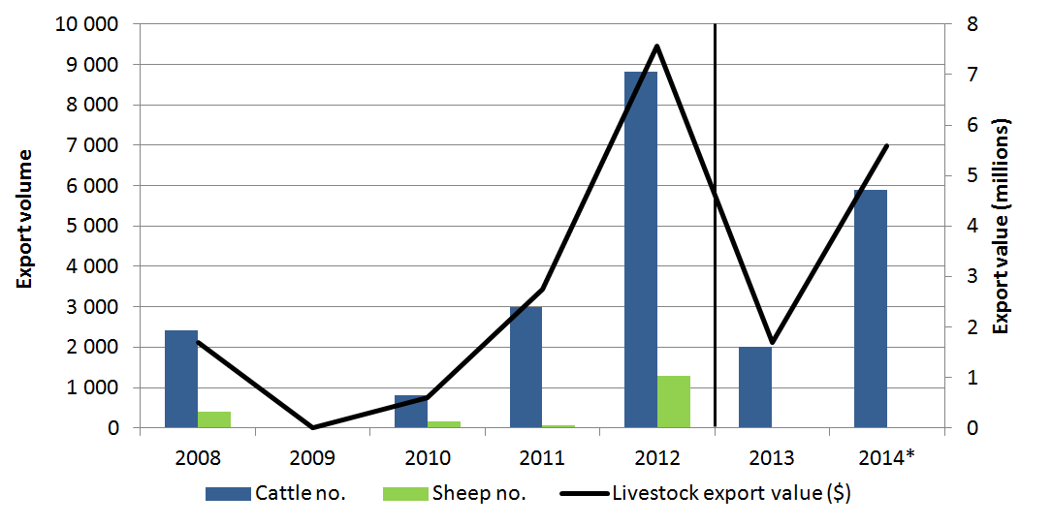
Note: Vertical line indicates date of implementation of ESCAS in this market. Sheep figures may include a small number of breeder livestock. 2014 data includes exports up to 30 November 2014.
Source: ABS 2015.

Investigations/incidents
- There has been one allegation of ESCAS non-compliance in Mauritius. The investigation found that animals were moved from the approved feedlot to non-approved locations where the cattle were slaughtered in a manner not compliant with OIE animal welfare standards. This occurred during a festival period. Additional conditions were applied to the exporter’s ESCAS.

Supply chain improvements and capacity building
- Mauritius is receiving assistance through the Official Development Assistance program.
- The Australian Government has supported OIE training for government officials on animal welfare guidelines.

Sultanate of Oman
ESCAS details  - ESCAS was introduced to the market in September 2012.  - Supply chains in Oman are simple with a small number of importers, exporters and facilities.  - All abattoirs are government owned and, with the exception of the largest abattoir, all operations are tendered out.  - Oman is a significant importer of live sheep and trade has occurred with minimal incidents.  - Five feedlots and seven abattoirs have been approved under ESCAS.  - Twenty-one consignments of sheep have been exported since ESCAS was introduced. | ESCAS Statistics  Consignments  Exporters under ESCAS  Importers under ESCAS  Feedlots  Abattoirs | 21  3  2  5  7
Trade details
- Oman is a stable live sheep export market for Australia. Australia was the third largest exporter of live sheep and goats to Oman in 2011.
- Post introduction of ESCAS, Australia has exported 128 242 sheep to Oman.
- Sheep that are exported to Oman most often depart from Fremantle, and some have also departed from Portland.
- Buffalo, cattle and goats were not exported to Oman between 2008 and 2013.
Figure E10 Trade data – live sheep
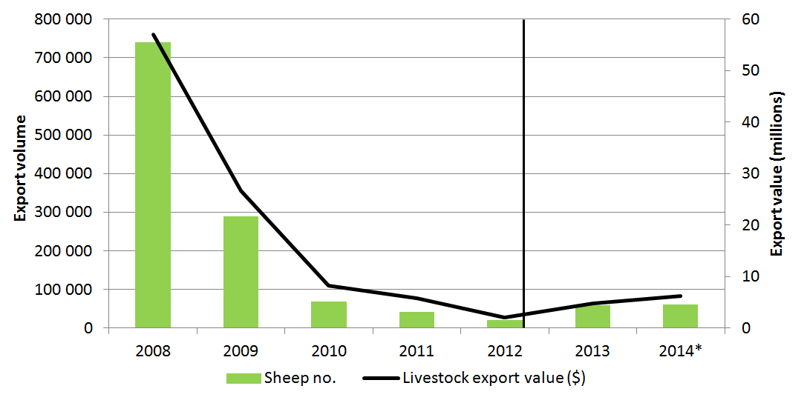
Note: Vertical line indicates date of implementation of ESCAS in this market. Sheep figures may include a small number of breeder livestock. 2014 data includes exports up to 30 November 2014.
Source: ABS 2015.

Investigations/incidents
- There has been one allegation about possible non-compliance with ESCAS arrangements in Oman but the allegation was not supported by any evidence, and an investigation was not conducted.
- One self-report of possible non-compliance is currently under investigation by the Department of Agriculture.

Supply chain improvements and capacity building
- Australian industry has provided (since September 2012):
- more than 12 in-market visits to deliver technical advice, training, the Eid-ul-Adha program and feedlot/abattoir support
- one hundred and twenty-one days training, involving approximately 120 participants.

Republic of the Philippines
ESCAS details  - ESCAS was introduced to the market in September 2012.  - The Philippines has moderately complex supply chains due to the number of exporters, importers and facilities.  - There are reported improvements in animal welfare standards for all livestock in the Philippines, not just Australian livestock.  - Seven feedlots and eight abattoirs have been approved under ESCAS. | ESCAS Statistics  Consignments  Exporters under ESCAS  Importers under ESCAS  Feedlots  Abattoirs | 22  2  7  7  8
Trade details
- The Philippines accounted for 3 per cent of Australia’s cattle exports in 2013.
- Post introduction of ESCAS, Australia exported 60 851 cattle and 199 buffalo to the Philippines.
- Export volume of cattle peaked in 2012, the year ESCAS was introduced.
Figure E11 Trade data – live cattle, sheep and goats
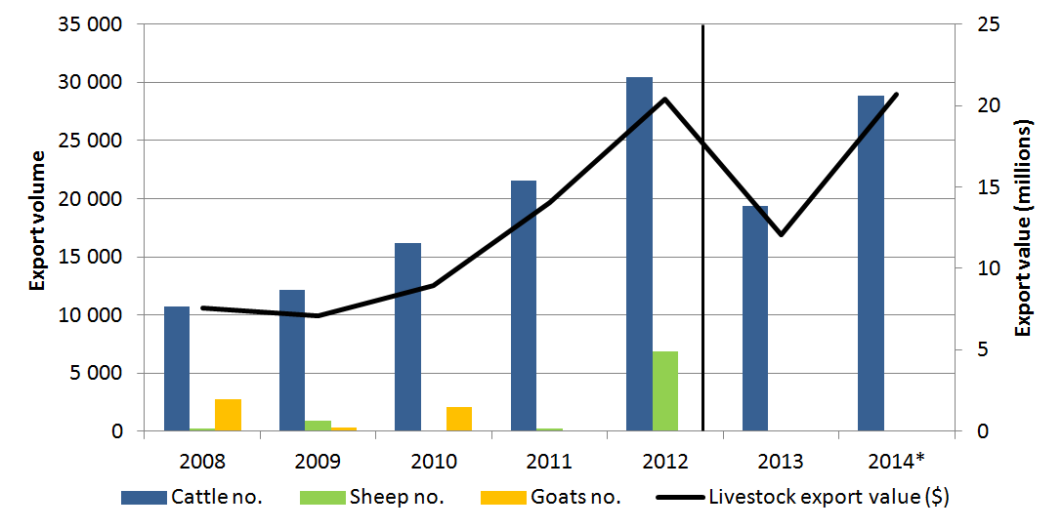
Note: Vertical line indicates date of implementation of ESCAS in this market. Sheep and goat figures may include a small number of breeder livestock. 2014 data includes exports up to 30 November 2014.
Source: ABS 2015.

Investigations/incidents
- There have been no ESCAS investigations for the Philippines.

Supply chain improvements and capacity building
- The Australian Government has also:
- supported OIE training for government officials on animal welfare guidelines
- supported installation of pneumatic stunning equipment in 10 abattoirs
- supported TAFE SA Certificate III in meat processing, which includes training on animal welfare and meat safety
- conducted workshops on animal welfare and ESCAS implementation assistance.
- Australian industry has provided (since 2011):
- thirty-five days of technical support and training, including workshops and animal handling and welfare sessions, have been delivered to approximately 65 participants.

State of Qatar
ESCAS details  - ESCAS was introduced to the market in March 2012.  - Supply chains in Qatar are simple with a single importer and small numbers of exporters and facilities.  - Qatar is a high-income country with a well-developed regulatory system.  - Qatar has had no documented animal welfare or ESCAS incidents.  - One feedlot and four abattoirs have been approved under ESCAS.  - Forty-two consignments of sheep and cattle have been exported since ESCAS was introduced. | ESCAS Statistics  Consignments  Exporters under ESCAS  Importers under ESCAS  Feedlots  Abattoirs | 42  4  1  1  4
Trade details
- Qatar was Australia’s second largest market for live sheep exports in 2013 and a smaller market for cattle. A total of 560 762 sheep were exported in 2013 to Qatar; this accounted for 28 per cent of the market.
- Post introduction of ESCAS, Australia exported 1 501 889 sheep and 3881 cattle to Qatar.
- Sheep and cattle exported to Qatar depart mostly from Fremantle with smaller numbers departing from Port Adelaide and Portland.
Figure E12 Trade data – live cattle and sheep
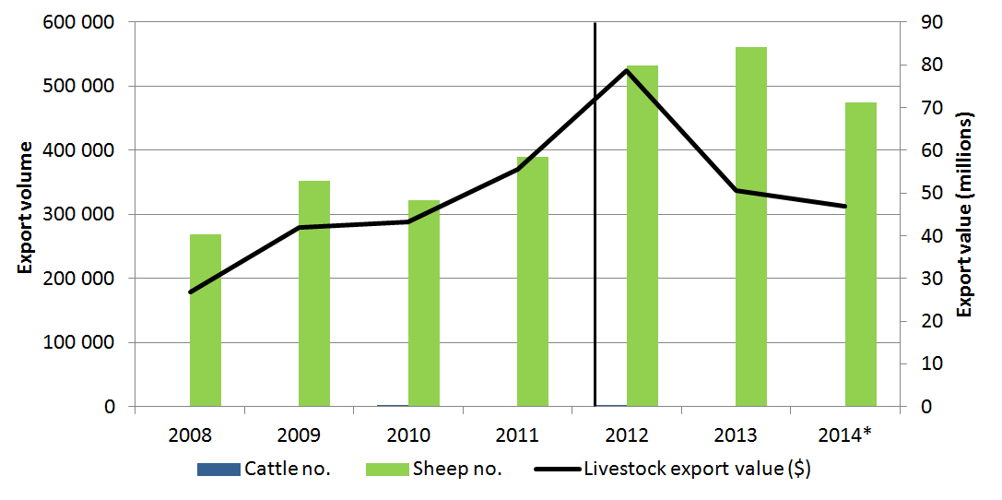
Note: Vertical line indicates date of implementation of ESCAS in this market. Sheep figures may include a small number of breeder livestock. 2014 data includes exports up to 30 November 2014.
Source: ABS 2015.

Investigations/incidents
- There have been no investigations relating to ESCAS for Qatar.

Supply chain improvements and capacity building
- Australian industry has provided (in 2013–14):
- more than 10 in-market visits to deliver strategic and technical advice for Eid-ul-Ahda, feedlot management, and meat hygiene and quality.

Republic of Singapore
ESCAS details  - ESCAS was introduced to the market in September 2012.  - Singapore is a unique as it only requires livestock in the lead-up to Korban and so has a simple supply chain where animals are transported directly to abattoirs.  - As slaughter of livestock from Australia only occurs at one time of year, different auditing requirements have been applied. There is also additional supervision of slaughter by local authorities. Officers from Singapore’s Agri-Food and Veterinary Authority oversee the live animal supply chain and can also undertake spot audits of mosques where slaughter takes place. The officers present have the authority to oversee slaughter to ensure that it is performed humanely and hygienically.  - Eighteen abattoirs (slaughter facilities) have been approved under ESCAS.  - Five consignments of sheep have been exported for slaughter in Singapore since ESCAS was introduced. | ESCAS Statistics  Consignments  Exporters under ESCAS  Importers under ESCAS  Feedlots  Abattoirs | 5  1  1  0  18
Trade details
- Singapore is a minor market for live sheep with consignments occurring in line with the Korban festival.
- Post introduction of ESCAS, Australia exported 7058 sheep to Singapore. No goats have been exported to Singapore since ESCAS was introduced – however some livestock, particularly goats, are commonly transhipped through Singapore during export from Australia to Malaysia.
- Pre-ESCAS, goats were imported along with sheep for Korban.
- Post introduction of ESCAS, sheep exported to Singapore departed by air from Perth. Previously sheep, goats and buffalo were exported to Singapore by air and sea from a number of ports and airports.
Figure E13 Trade data – live sheep and goats
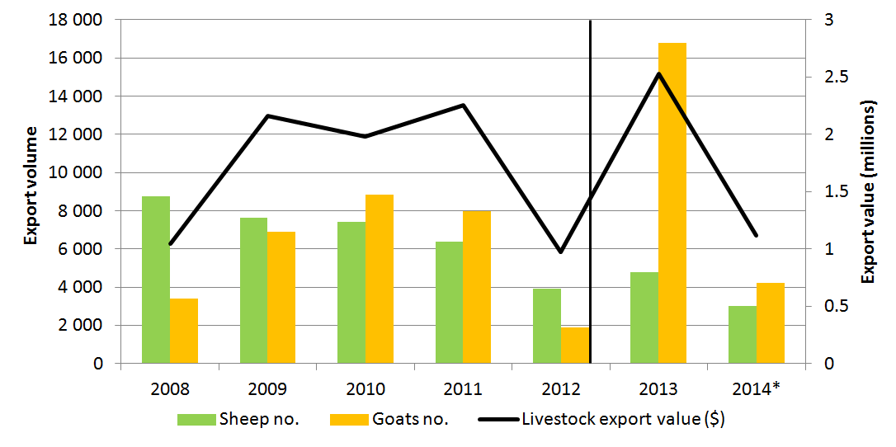
Note: Livestock, particularly goats, represented in this data are likely to have been transhipped through Singapore en-route to Malaysia. Vertical line indicates date of implementation of ESCAS in this market. Figures may include a small number of breeder livestock. 2014 data includes exports up to 30 November 2014.
Source: ABS 2015.

Investigations/incidents
- There have been no allegations of non-compliance with ESCAS requirements in Singapore.

Supply chain improvements and capacity building
- The Australian Government has provided grants to the Australian industry to support animal welfare improvements within the ESCAS supply chain.

United Arab Emirates
ESCAS details  - ESCAS was introduced to the market in September 2012.  - The supply chains are of intermediate complexity, with a limited number of facilities.  - All abattoirs are government owned and slaughter must be done in these facilities.  - United Arab Emirates is a consistently large market for sheep and has had few incidents.  - Four feedlots and 11 abattoirs have been approved under ESCAS.  - Thirty-three consignments of sheep and cattle have been exported since ESCAS was introduced. | ESCAS Statistics  Consignments  Exporters under ESCAS  Importers under ESCAS  Feedlots  Abattoirs | 33  3  2  4  11
Trade details
- United Arab Emirates was Australia’s fourth largest market for live sheep exports in 2013 and a smaller market for cattle and goats.
- Post introduction of ESCAS, Australia exported 224 838 sheep, 4050 cattle and 1807 goats to UAE.
- Sheep, cattle and goats exported to UAE departed from a number of ports including Fremantle, Port Adelaide, Portland, Melbourne and Sydney.
Figure E14 Trade data – live cattle, sheep and goats
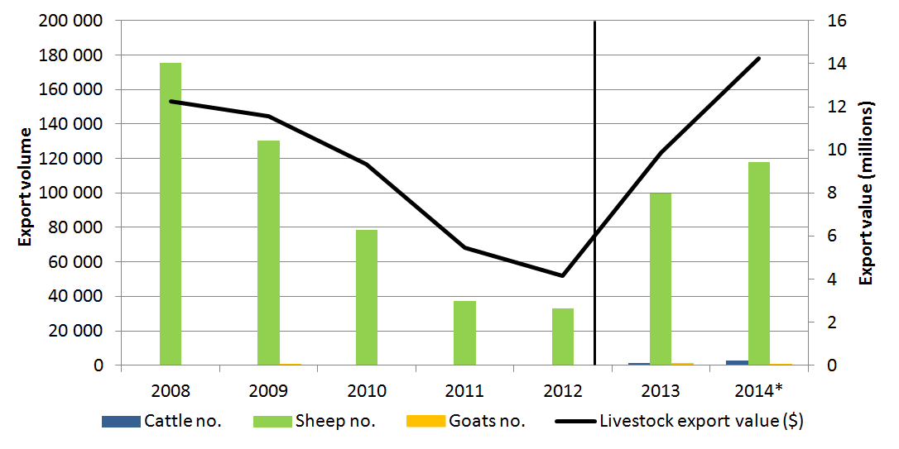
Note: Vertical line indicates date of implementation of ESCAS in this market. Sheep and goat figures may include a small number of breeder livestock. 2014 data includes exports up to 30 November 2014.
Source: ABS 2015.

Investigations/incidents
- There has been one investigation for UAE about non-compliance with ESCAS arrangements received from a third party. The incident occurred during the festival of Eid-ul-Adha in 2013 and was confirmed by an independent audit of the supply chain. Additional conditions were applied to the exporter’s ESCAS arrangements.
- A self-report of possible non-compliance is currently under investigation by the Department of Agriculture.

Supply chain improvements and capacity building
- The Australian Government has provided grants to industry to support animal welfare improvements within the ESCAS supply chains in the UAE.

Socialist Republic of Vietnam
ESCAS details  - ESCAS was introduced to the market in January 2013.  - Vietnam has a moderate number of supply chains with multiple interlinked facilities making complex supply chain arrangements.  - There have been four ESCAS incidents in Vietnam. Measures by industry have been directed at building capacity to consistently meet ESCAS requirements.  - Twenty-nine feedlots and 89 abattoirs have been approved under ESCAS.  - Eighty-seven consignments of cattle and buffalo have been exported since ESCAS was introduced. | ESCAS Statistics  Consignments  Exporters under ESCAS  Importers under ESCAS  Feedlots  Abattoirs | 87  6  12  29  89
Trade details
- Export of live animals to Vietnam commenced in 2012 and is growing rapidly, with large numbers of cattle and smaller but growing numbers of buffalo being exported under ESCAS arrangements. Vietnam was Australia’s third largest market for cattle in 2013.
- Post introduction of ESCAS, Australia exported 232 399 cattle and 3766 buffalo to Vietnam.
- Cattle and buffalo exported to Vietnam departed from a number of ports including Broome, Darwin, Fremantle, Geraldton, Karumba, Melbourne, Mourilyan, Townsville and Wyndham.
Figure E15 Trade data – live cattle
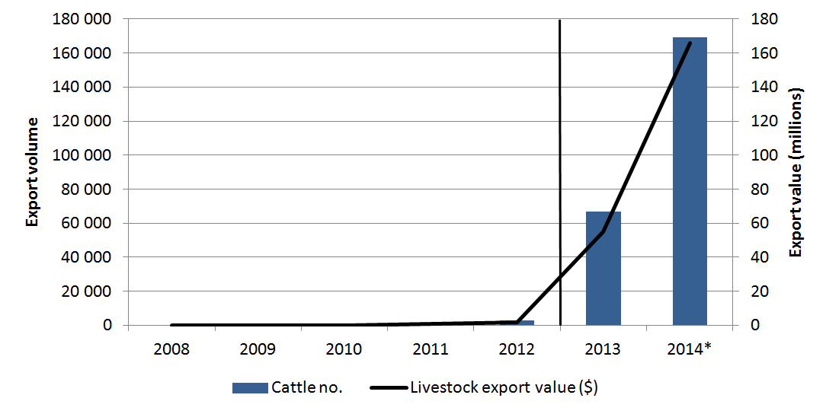
Note: Vertical line indicates date of implementation of ESCAS in this market. Buffalo numbers are not visible on this graph. 2014 data includes exports up to 30 November 2014.
Source: ABS 2015.

Investigations/incidents
- There have been four reports of possible non-compliance with ESCAS requirements in cattle exported to Vietnam.
- The investigations into the first three reports have been finalised and published. Cattle were found to be outside approved supply chains and a number of facilities and supply chains have been removed.
- Two of these incidents were self-reported by exporters to the department. In one case an exporter self-reported an incident where animals were slaughtered outside the supply chain but in accordance with ESCAS requirements. In a second case, animals were slaughtered in a variety of locations, including some that did not meet ESCAS requirements. The reports and actions taken by the exporters to prevent reoccurrence of these problems were assessed and accepted by the department.
- A fourth incident has been self-reported by an exporter and is currently under investigation by the Department of Agriculture.

Supply chain improvements and capacity building
- The Australian Government has:
- supported OIE training for government officials on animal welfare guidelines
- supported TAFE SA Certificate III in meat processing, which includes training on animal welfare and meat safety
- supported SQIT training on livestock animal welfare and meat hygiene
- conducted workshops on animal welfare and ESCAS implementation assistance.
- Australian industry has provided (since 2012):
- assistance in the form of gap and risk analyses
- assistance in feedlot design and layouts and abattoir advice including enabling the efficient use of pneumatic and hand-held penetrative stunners
- training for approximately 273 participants
- training videos on animal welfare up to the point of slaughter.

- — Definitions and acronyms
Definitions
Approved export program (for livestock exports) | Details any particular treatments or inspections to be performed by an Australian Government Accredited Veterinarian, for livestock to be exported, as required by the Department of Agriculture. This may include treatments and inspections required under the ASEL or by the importing country
Abattoir | A building or place where animals are slaughtered
Animal welfare officer | A person employed within a supply chain to perform designated tasks to ensure OIE-consistent animal handling and slaughter. They may also perform other tasks as required by their employer, both related and unrelated to ESCAS
Australian Government Accredited Veterinarian | A veterinarian who is accredited by the Department of Agriculture to carry out duties in relation to the export of livestock
Breeder (class of livestock) | Livestock primarily for breeding purposes and usually of a higher value than feeder or slaughter livestock
Consignment | In livestock exports, livestock of one or more species, exported together under the same notice of intention to export. The livestock must be on the same flight or vessel, from the same departure port, and exported by the same exporter
Depot | A small feedlot-like facility used to house animals prior to movement to an abattoir. A depot is usually located close to an abattoir, that is far from a main feedlot
Disembarkation/Unloading | Disembarkation commences after the arrival of the vessel at the first overseas port (and acceptance of the consignment, or part thereof, by the competent authority of the country). It commences with the unloading of the first animal and ends when the last animal is unloaded from the vessel. A single consignment may include unloading at multiple ports in multiple countries
Eid-ul-Adha | A religious holiday celebrated by Muslims worldwide. Also referred to as Korban, Qurban or Kurbani in some cultures. Eid-ul-Ahda is the second of two Eid holidays
Export permit | A permit issued by the Department of Agriculture, allowing export of live animals from Australia
Facility | A building, a complex of buildings, or a structure. Facilities can include abattoirs, feedlots, depots or lairages
Feeder (class of livestock) | Livestock requiring additional feeding in the importing country to reach a weight suitable for slaughter
Feedlot | A yard or facility for intensive feeding and raising of livestock
Health certificate | A certificate issued by the Department of Agriculture, stating that the animals to which the certificate relates meet importing country requirements
Importing country requirements | In relation to the export of live animals, the requirements of the relevant importing country protocol including health certification requirements
Lairage | A designated area, or pen for holding animals such as those awaiting slaughter at an abattoir, at a dockside, or at a market
Livestock | Cattle, sheep, goats, deer, buffalo and camelids (that is, camels, llamas, alpacas and vicuñas), including the young of these animals
Shipment | One or more consignments exported together on a single vessel or flight. Multiple consignments by one or more exporters, from multiple ports of loading, or destined for multiple ports of discharge may be exported on the same vessel or flight
Slaughter (class of livestock) | Livestock purchased for immediate slaughter after import; require little or no additional feeding before slaughter
Supply chain | A system of organisations, people, activities, information, and resources involved in moving a product or service from supplier to customer
Supply chain manager | A person employed within a supply chain to manage traceability and accounting of livestock, including supervision of other employees performing similar tasks. They may also perform other tasks as required by their employer, both related and unrelated to ESCAS
Supply chain officer | A person employed within a supply chain and with designated tasks relating to reconciliation of livestock numbers and accounting for livestock movement throughout supply chains. They may also perform other tasks as required by their employer, both related and unrelated to ESCAS
Traceability | Tracking and accounting of movements of livestock. In ESCAS this activity enables an exporter to show that exported livestock have been moved only to facilities within an approved supply chain
Turn-off | Sum of animals taken from the national herd for slaughter or live export
Vertical integration | Arrangement whereby one or more facilities in a company’s supply chain are owned by that company
Voyage | Journey by ship or aeroplane

Abbreviations and acronyms
ASEL | Australian Standards for the Export of Livestock (version 2.3)
AAVs | Australian Government Accredited Veterinarians
ASCIP | Approved Supply Chain Improvements Program
AWO | Animal Welfare Officer
CIE | Centre for International Economics
CRMP | Consignment risk management plan
ESCAS | Exporter Supply Chain Assurance System
GAP | Global Assurance Program
GCC | Gulf Cooperation Council
IGWG | Industry Government Working Group
LEP | Livestock Export Program
LiveCorp | Australian Livestock Export Corporation
MLA | Meat & Livestock Australia
MoU | Memorandum of understanding
NLIS | National Livestock Identification System
NOI | Notice of intention to export
NVD | National vendor declaration
OIE | World Organisation for Animal Health
OIE Code | World Organisation for Animal Health Terrestrial Animal Health Code (2011)
OIE standards | The standards set out in Section 7 of the Terrestrial Animal Health Code (2010) published by the World Organisation for Animal Health
QA | Quality assurance
RFID | Radio frequency identification device
RIS | Regulation impact statement
SCO | Supply chain officer
SQIT | Southern Queensland Institute of TAFE
TAFE SA | Technical And Further Education South Australia
UAE | United Arab Emirates
WTO | World Trade Organization
- — References
ABS, 2015, International trade, Australia, Information Consultancy Subscription Service, cat. no. 5465.0, Australian Bureau of Statistics, Canberra – data accessed on 5 January 2015
Caple, I, Gregory, N.G, Cusack, P, McGowan, P 2010, Independent study into animal welfare conditions for cattle in Indonesia from point of arrival from Australia to slaughter, report prepared for Meat & Livestock Australia, Sydney and LiveCorp‎, Sydney
Deards, B, Leith, R, Mifsud, C, Murray, C; Martin, P, Gleeson, T 2014, Live Export Trade Assessment, ABARES Report to client prepared for the Live Animal Export Reform Taskforce of the Department of Agriculture, Canberra
Department of Agriculture, 2015, Live Animal Export data
Department of Agriculture, 2014, Grants reporting requirements, available at: daff.gov.au/about/obligations/grants-reporting-requirements
Department of Agriculture, 2013a, Compliance Investigation Report 10: Performance of the closed loop system for cattle exports to Egypt, Department of Agriculture, Canberra, available at daff.gov.au/biosecurity/export/live-animals/livestock/regulatory-framework/compliance-investigations/investigations-regulatory-compliance/cattle-egypt-report-10
Department of Agriculture, 2013b, Live Animal Export data
Department of the Prime Minister and Cabinet, 2013, Business Cost Calculator available at dpmc.gov.au/deregulation/obpr/bcc/index.cfm
Department of the Prime Minister and Cabinet, 2011, ESCAS Post Implementation Regulation Impact Statement, Department of the Prime Minister and Cabinet, Canberra
Meat & Livestock Australia, 2014, Australian sheep industry projections 2014 mid-year update. Meat & Livestock Australia, North Sydney
Schuster, P 2014, Exporter Supply Chain Assurance System - Development of a risk management and quality assurance program, Meat & Livestock Australia, Sydney
Predicate Partners, 2014, Business Process Review - Live Animal Exports Program, Predicate Partners, Canberra.
Reserve Bank of Australia, 2015, Exchange Rates - Monthly July 1969 to December 2009 and Exchange rates – Monthly - January 2010 to last complete month, Reserve Bank of Australia, Sydney, available at rba.gov.au/statistics/historical-data.html

