Guidelines

Interpretation of KPIs using the MEDC System Dashboard
Summary of main points
This document outlines:
- How Department of Agriculture and Water Resources On-Plant Staff (OPS) and establishment management can interpret the key performance indicators (KPIs) and Product Hygiene Indicators (PHI) information in the Export Meat Data Collection (MEDC) System;
- Procedures for analysis of national and individual establishment data;
- Procedures for identification of weak KPIs with a view to implementing options for improvement.

Contents
This document contains the following topics and subtopics:
MEDC System Dashboard data analysis and interpretation 1
1 KPI Summary Dashboard 2
1.1 Data analysis 2
1.2 Interpretation of Data 6
2 Dashboards for daily data analysis 7
2.1 PHI Dashboard 7
2.2 MHA Dashboard 8
2.3 Microbial Dashboard 9
2.4 Carcase Micro Analysis Dashboard 10
2.5 Carton Micro Analysis Dashboard 12
3 Glossary and definition of the KPIs 13

KPI Summary Dashboard
The KPI Summary Dashboard within the MEDC System provides national benchmarking of Australian export meat slaughter and boning establishments. The information is intended to enable establishments and departmental officers to hold discussions about establishment performance. PHI data can be used to monitor individual establishment performance as well as performance against national averages. In the national context, data can be compared to other establishment trends which may identify seasonal or other factors that contribute to varied performances.
The KPI Summary Dashboard and KPI National Summary Dashboard have been designed for monthly data analysis.
National KPI Summary data are updated on the 20th of each month.
Definitions of each of the KPIs are provided in section 3 of this document.

Data analysis
- Log into the MEDC System to analyse data (contact the MEDC Helpdesk at MEDC@agriculture.gov.au to create your account)
- Click on Dashboards
- Click on KPI Summary Dashboard
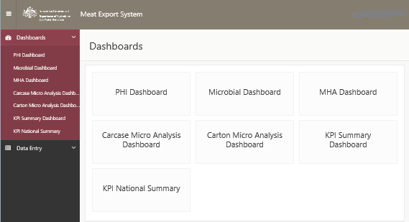
- Select or type your establishment number in the header section
- Enter relevant information in each field from the dropdown lists
- Select the KPI you want to review
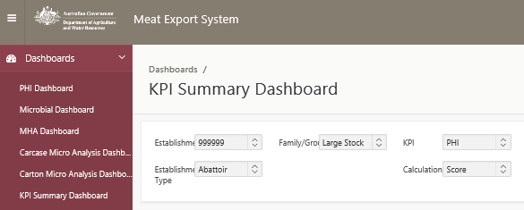
This action displays a number of options to assist establishment and departmental staff to assess the data and to compare it to data from other establishments of the same kind. These preferences include:
- a table showing establishment specific and national quartile data
- a line graph showing elements of the tabulated data with a zooming option
- a box plot graph of the tabulated data
- a table summarising red and yellow KPIs and trending KPIs.

Table
The table provides a 12 month rolling window view of the averaged monthly data for each KPI and a quick comparison against the following criteria for each month:
- the minimum result obtained from all similar plants
- the maximum result obtained from all similar plants
- the median value obtained from all similar plants
- the first and third quartiles (50% of establishments will sit between these numbers)
- the number observations from establishments submitting data in a month
- the DA value, which is the result obtained by the departmental officer on the establishment
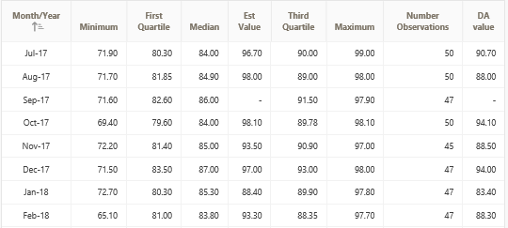
You can compare scores from your establishment (Est Value) with similar establishments using the table below. If an establishment’s PHI Index score is below the median value, the OPV and establishment management should discuss and monitor KPIs that contributed to low scores and should take necessary actions to ensure they do not deteriorate further.
Score | bottom 25% | bottom 50% | top 50% | top 25%
PHI Index | below First Quartile | below Median | equal or above Median | above Third Quartile
KPIs | above Third Quartile | above Median | below Median | below First Quartile

Line Graph
The line graph provides elements of the table in a visual format for reviewers that prefer a simpler, less cluttered format.
The establishment data are plotted against the 25th (First Quartile) and 75th percentile (Third Quartile) national data to provide a comparison of performance between establishments.
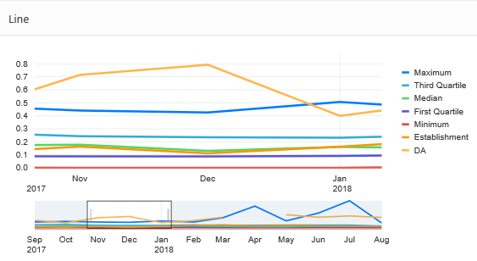
To zoom the graph on a particular month, place the cursor on that month on the graph and scroll the cursor wheel. You can also move the zoom by moving the white box that appears at the bottom of the graph
You can compare your establishment’s position in the graph with similar establishments using the table below. If the PHI Index score for an establishment is below the median value (green line), the OPV and establishment management should discuss and monitor KPIs that contributed to low scores and should take necessary actions to ensure they do not deteriorate further.
Line# | bottom 25% | bottom 50% | top 50% | top 25%
PHI Index | below First Quartile line | below Median line | equal or above Median line | equal or above Third Quartile line
KPIs | equal or above Third Quartile line | equal or above Median line | below Median line | below First Quartile line
#orange colour line in the graph ()

Boxed Plots
This is a graphical representation of the data in the table above. It provides a quick view of the data identifying where 50% of establishments are positioned (the boxes) and the spread of the remaining establishment data – 25% above the upper limit of the box and 25% below the box (the thin lines above and below the box).
Establishment data are in the form of a circle and show the position of the establishment against national data. Departmental data are only displayed for KPIs where these data are collected i.e. PHI Index, slaughter floor MHA etc.
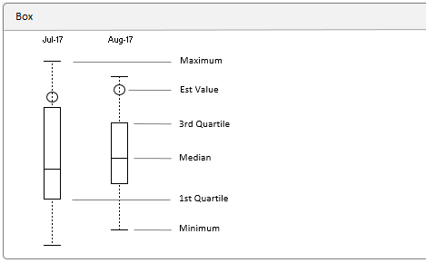

Trending KPIs
Provides lists of relatively weakly performing KPIs:
- The first column (‘red’) shows all establishment KPIs that are within the bottom 25% for the last month
- The second column (‘yellow’) shows KPIs that fall between the median and the 1st quartile range, i.e. 25% of data below the median value
- The third column shows establishment KPIs that are trending down (deteriorating KPIs – except for the PHI Index). These results are calculated by looking at the last three months data and identifying KPIs that have decrease consistently across the three months.
- The final columns show establishment KPIs that are improving. These results are calculated by looking at the last three months data and identifying KPIs that have increased consistently across the three months.
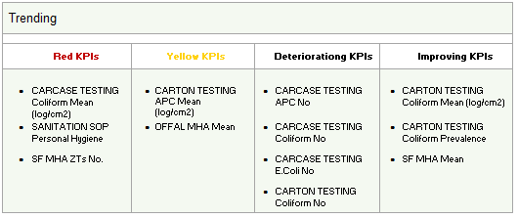

Interpretation of Data
It is very important that the PHI be seen as a tool rather than a definitive assessment of establishment performance. Many of the KPIs assessed are multi-component and therefore it may be that the real issue is not the KPI result but an element that helps determine that result.
For example, if you have a deteriorating KPI for TVCX, i.e. counts have been increasing over the previous 3 months (e.g. 800, then 900, then 1000) but all counts are less than 1000, is there a problem? The answer is most likely no as all values are reasonable and there is no cause for concern. The KPI will be noted in the spreadsheet as deteriorating because of increasing average counts, but the significance of the increase may not be high. However, it is worth noting this to the establishment or the OPV as it means that the increase is being monitored. The potential reasons for the observation should be considered (e.g. could the cause be seasonal, due to an unusual wet period or a change in stock?) Understanding normal performance is the first step to identifying and understanding unusual performance.
If the MHA score is high, does this require a corrective action? The answer is most likely no, however if the investigator goes into the plant and identifies that the increased MHA is due to high levels of hair contamination on product then the outcome is achieved, i.e. an understanding of why the high MHA arose and an understanding that there may be a dressing problem in keeping hair off the carcase.
The KPIs in the PHI are designed to collect objective data to support a dialogue between the company and the OPV. The dialogue can be based on evidence (the data collected) and the corrective action monitored through monitoring of the raw data used to create the PHI. The dialogue will determine the activities taken by each party and ensure the best outcome for the certification and export of Australian meat.

Dashboards for daily data analysis
To assist company and departmental staff use the data effectively and efficiently the MEDC System is equipped with a number of Dashboards to help in analysing data. Dashboards discussed in this section have been developed for daily or weekly data analysis of an individual establishment.
The graphs can be plotted throughout the month as the data are entered in the system. These graphs and the raw data can then be discussed at the weekly meeting as evidence of the success or otherwise of process control.
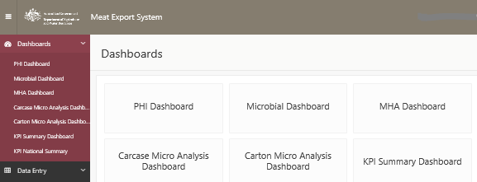
Note: Dashboards are update on a daily basis at 6:00 AM. Data entered during the day will not be available in Dashboards until 6:00 AM on the next day.

PHI Dashboard
In the PHI Dashboard you can review your establishment’s PHI scores and scores for individual KPIs and how they affect the total PHI scores. This page is equivalent to the Rank sheet in the earlier PHI platform. To review the scores:
- Click on Dashboards > PHI Dashboard
- Select or type your establishment number in the header section
- Enter relevant information in each field from the dropdown lists
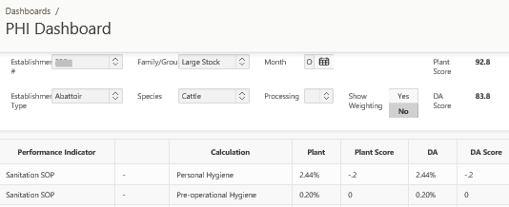

MHA Dashboard
- Click on Dashboards > MHA Dashboard
- Select or type your establishment number in the header section
- Enter relevant information in each field from the dropdown lists
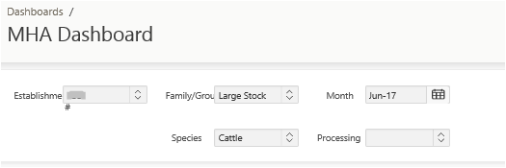
- Click on SFMHA, Offal MHA or BRMHA in the header to view the graphs

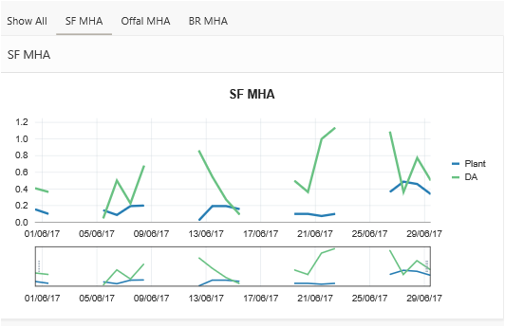
- To zoom the graph on a particular day, place the cursor on that day on the graph and scroll the cursor wheel. You can also move the zoom by moving the white box that appears at the bottom of the graph
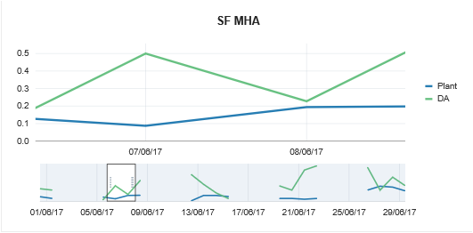

Interpretation of MHA:
The graphs have been provided to assist establishment staff and departmental officers review data throughout the month. Personnel will be able to identify trends; monitor performance within the establishment and identify areas where there are issues; or identify where there are differences between data collection or interpretation between departmental staff and company QA. The data and the graphs will provide an opportunity for discussion between the two parties.
Meat Hygiene Assessment: MHA scores are calculated by the plant according to the department’s MHA guidelines. Scores are entered as daily averages by the company (blue line) and the department (green line). The graphs can provide a visual depiction of trends and findings and assist in department/company discussions. Interpretation of the MHA data should be in accordance with the department’s MHA guidelines.
Note: All establishments should be meeting the Australian Standard and therefore high results may not necessarily indicate unacceptable product hygiene. High results should be assessed on their individual merits.

Microbial Dashboard
- Click on Dashboards > Microbial Dashboard
- Select or type your establishment number in the header section
- Enter relevant information in each field from the dropdown lists
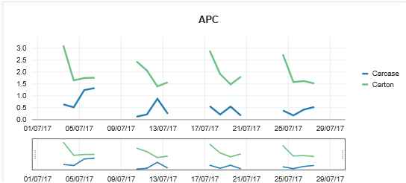

Interpretation of microbial data:
Microbiological counts (log cfu/cm² or g) show daily average aerobic plate count (APC), E. coli and coliform counts in carcase (blue) and carton (green) samples. It is reasonable to expect that counts from carton meat samples will be higher than counts from carcase samples for two reasons:
- carton meat samples are taken as tissue samples which under normal circumstances will give higher counts than swab samples taken from carcases; and
- growth of microorganisms will occur when the product is being boned, so boning room counts will invariably be higher than slaughter floor samples.
Aerobic plate count – (also called total viable count or TVC) is a count of microorganisms on meat that will grow under aerobic or oxygenated conditions. The presence of these bacteria may provide an indication of the effectiveness of overall hygienic measures taken and interventions applied during the slaughter and dressing process. There are many factors that can contribute to APC. These include but not limited to:
- cleanliness of the animal,
- plant operational hygiene,
- length of hair/wool,
- operator skills,
- dressing type,
- personal hygiene,
- carcase handling (washing, trimming), etc.
Coliforms – coliforms are bacteria normally present in the intestines and faeces of humans and animals although there are some coliforms that are found in the environment. Unlike faecal pathogens, coliforms can survive and grow in the food processing environment and some cold tolerant coliforms will grow at less than 7°C. Coliform counts can be used as an indicator of sanitation effectiveness, although it is important to understand that the presence of coliforms is unavoidable in raw meats. Provision of data on coliforms is voluntary.
E. coli – the presence of E. coli in meat samples indicates cross contamination of carcases or product with faeces, ingesta or milk and is considered to be a specific indicator of potential contamination with faecal pathogens (i.e. STEC, Salmonella, etc.). The department maintains a monitoring program for the detection of E. coli or Salmonella on carcases or product. These are explained in the departmental Microbiological Manual for the Sampling and Testing of Export Meat and Meat Products.

Carcase Micro Analysis Dashboard
This option allows an analysis of daily microbiological data. You can also plot individual carcase microbiology data for classes of stock processed within the month. To access and prepare the graphs:
- Click on Dashboards > Carcase Micro Analysis Dashboard
- Select or type your establishment number in the header section
- Enter relevant information in each field from the dropdown lists
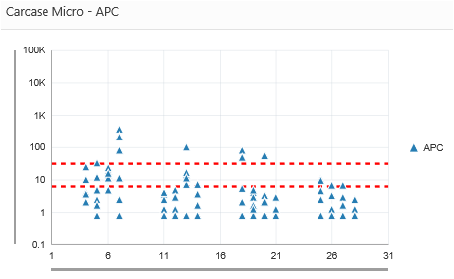
- You can change the stock class (i.e. sheer/heifer or cow/bull)

Interpretation of carcase microbiological data
The graphs produced from the individual daily plots provide a pictorial expression of the number of positives within a day for each of the culture types and show how the average in the previous section was obtained. The spread of the counts provides an estimate of the consistent nature of the data with the greater spread of counts, the greater the variability in the microbiological status of the sampled product or carcases. Again, this information is to provide assistance to the establishment and the OPV in identifying trends within process control and to facilitate a discussion rather than provide an absolute assessment of the carcases or product. All establishments should be meeting the Australian Standard and therefore high counts may not necessarily indicate unacceptable product hygiene.
Aerobic plate counts: The graph shows counts on individual samples for each day they were collected throughout the month. Indicator limits (red dotted lines) are displayed on these graphs and have been prepared from national species tercile data collected over a number of years. Values that fall above the upper line are the counts that are in the higher tercile or 33.33% of establishments with higher counts. APC indicates effectiveness of overall hygienic measures taken during slaughter process.
E. coli: Shows count on individual samples for each day they were collected throughout the month. Values that fall above the upper line are the counts that are in the higher tercile or 33.33% of establishments with higher counts. As indicated above, presence of E. coli indicates recent contamination or cross contamination with faeces or ingesta and is considered to be specific indicator of potential contamination with faecal pathogens (i.e. STEC, Salmonella). This information will also assist establishments and on plant veterinarians monitor whether an E. coli window should be open or monitored, especially when there are many E. coli detections in a day/month.

Carton Micro Analysis Dashboard
This option allows an analysis of daily carton microbiological data. You can also plot individual carton microbiology data for classes of stock processed within the month. To access and prepare the graphs:
- Click on Dashboards > Carton Micro Analysis Dashboard
- Select or type your establishment number in the header section
- Enter relevant information in each field from the dropdown lists
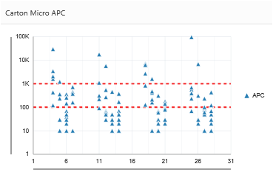

Interpretation of carton microbiological data:
Aerobic plate counts: The graph shows counts on individual samples for each day they were collected throughout the month. Indicator limits (red dotted lines) are displayed on these graphs and have been prepared from national species tercile data collected in over a number of years. Values that fall above the upper line are the counts that are in the higher tercile or 33.33% of establishments with higher counts. APC indicates effectiveness of overall hygienic measures taken during slaughter process.
Coliforms: Shows coliform count on individual samples for each day they were collected throughout the month. Values that fall above the upper line are the counts that are in the higher tercile or 33.33% of establishments with higher counts. Coliform counts can be used as an indicator of sanitation efficiency, although the presence of coliforms is unavoidable in raw meats. Provision of data on coliforms is voluntary.

Glossary and definition of the KPIs
Most of the KPIs currently collected under the PHI are displayed in the tool, however not all are used for calculating the PHI Index. A full list of KPIs with their explanation is provided below:
Acronym | Explanation | Interpretation
Plant PHI | Plant Product Hygiene Index | The Index provides a means of comparing overall assessment of an establishment against other similar establishments. The Index is a number produced from the weighted assessment of a range of key performance indicators described in this document. Plants start with a score of 100 and points are deducted for less than national average performance against each KPI
Hyg | Pre-operational personal hygiene microbiology | Pre-op personal hygiene microbiology results combined with Pre-op contact surface microbiology data provide an assessment of the effectiveness of cleaning. The personal hygiene microbiological data are divided into the proportion of results ≤ 5 CFU/cm2 and the proportion of results >5 CFU/cm2. The percentage of samples >5 CFU/cm² is then multiplied by -10 (minus ten) to obtain the weighting. Therefore if 50% of samples were >5 CFU/cm2 then a score of 0.5 x -10 = -5 (minus five), so 5 points would be subtracted from the Index score.
Preop | Pre-operational contact surface microbiology | An assessment of the effectiveness of cleaning surfaces based on the quantitative assessment of aerobic microorganisms grown from a swab or inoculation of an agar plate. Scores are calculated in the same way as for Pre-op personal hygiene scores.
SFMHA | Slaughter floor Meat Hygiene Assessment | The monthly slaughter floor MHA score is the average of the daily MHA scores entered by the company or the scores entered by the OPV. These are weighted for the detection of incidents of faecal, ingesta or milk contamination. If an incident of such contamination is detected on a particular day then the maximum MHA score for that species is entered for that day (i.e. 2.51 for carcases, 1.01 for boning and 0.71 for offal). The monthly average MHA is then compared to tercile values determined from historical data for that species. For example, for carcase MHA scores, if the calculated monthly MHA value is less than or equal to the second tercile (best 33% of the data) then a weighting of 0 is applied i.e. no reduction in the PHI Index score. If the
 |  | MHA value is greater than the 2nd and less than or equal to the 3rd tercile a weighting of -1 is applied to the PHI Index. If the MHA score is greater than the 3rd tercile then a weighting of -2 is applied to the PHI Index.
SFSD* | Standard deviation in SFMHA. | Standard deviation in SFMHA. The standard deviation (SD) of the daily MHA scores is used as a measure of the consistency of an operation. SD shows how much variation or dispersion from the mean. It is deemed that a plant that maintains the same performance level (low SD) is in better control than a plant that has large fluctuations (high SD) in their performance. It is important to remember that a small sample size may have a large impact on the SD, so the SD for the OPV will usually be greater than the SD for the establishment.
CCPM | Critical Control Point monitoring | Critical Control Point monitoring is the number of samples collected for faecal, ingesta or milk contamination monitoring, i.e. the number of MHA samples plus the number of additional samples examined as per CCP monitoring requirements.
SFZT | Slaughter Floor ZT | Faecal, ingesta or milk contamination on carcases or offal from the slaughter floor attract the maximum MHA scores (i.e. 2.6) for that species on a particular day. A detection of these defects on each working day will result in a monthly SFMHA average of 2.6 irrespective of the daily MHA reported.
OFFMHA | Offal MHA score | Calculation and weighting for monthly OFFMHA follows the same principles as those applied to SFMHA scores. The weighting of faecal, ingesta or milk contamination is less for offals (see below)
OffSD* | Standard deviation in averaged offal MHA scores. | Same as SFSD.
OffZT | The count of incidents of faeces, ingesta or milk on samples of offal examined. | Detections of faecal, ingesta or milk contamination attract the maximum OFFMHA scores (i.e. 1.0) on a particular day. A detection of faecal, ingesta or milk contamination on each working day will result in a monthly average OFFMHA score of 1.0 irrespective of the daily score.
BRMHA | Boning room MHA score | The monthly BRMHA score is the average of the daily BRMHA scores entered by the company or the OPV. The submission sheet also captures detections of faecal, ingesta or milk contamination incidents in addition to the BRMHA. Calculation and weighting for monthly BRMHA follows the same principles as those applied to SFMHA, with the exception that BRMHA scores attract a higher weighting than SFMHA scores (i.e. 0, -2 and -4).
BRSD* | Standard deviation in BRMHA. | Same as SFSD
BRZT | Count of incidents of faecal, ingesta or milk contamination identified in the boning room. | Same as SFZT, however it is important to consider that these detections are after the product has been finally cleared from the slaughter floor and may indicate a need to review the assessment of carcases on the slaughter floor. Detections of faecal, ingesta or milk contamination in the boning room attract the maximum BRMHA scores (i.e. 2.0) on a particular day. If a plant has a ZT defect detection on each working day their monthly BRMHA average would be 2.0 irrespective of the daily BRMHA reported.
CarEC% | Carcase E. coli percentage: is the prevalence of E. coli positive tests from carcase swab or tissue samples collected | The percentage is an indicator to the establishment and the OPV of the prevalence of the pathogen indicator organism Escherichia coli on carcase swabs collected under the National Carcase Microbiological Monitoring Program (NCMMP). It is also important as an alert to ensure that the E. coli windows under the the NCMMP are activated and actioned as required. Weightings for prevalence are calculated using tercile values determined from historical and published data for that species. As in the case of MHA scores, a weighting of zero is applied to values that fall on or below the second tercile, -1 above the 2nd tercile but less than or equal to the 3rd and -3 if greater than the 3rd tercile.
CarECX | E. coli count on carcasses (log CFU/cm2). | E. coli count on carcasses in log CFU/cm2. Weighting not set for this KPI.
ECWin | No of failed E. coli windows. | Failed windows create alerts under the NCMMP and must be managed accordingly. If an E. coli alert is triggered then a 1 is entered on the day the window is triggered. If a second window is triggered in the month then a 1 is entered on the day that the second window was triggered etc. Weighting for window failure is assigned based on the number of failures in a month, i.e. -3 for the first failure, -5 if two failures occurred and -10 if more than two failures occurred in the month.
CarTVCX | Aerobic plate counts (APC or TVC) on carcasses (NCMMP). | The microbiological count is transformed into logarithmic format. The average is calculated from the log values (geometric mean). PHI Index weightings for mean counts are calculated using tercile values determined from historical and published data for that species. As in the case of MHA scores a weighting of zero is applied to values that fall on or below the second tercile, -1 above the 2nd tercile but less than or equal to the 3rd and -3 if greater than the 3rd tercile.
CarTVCSD* | Standard deviation in aerobic plate counts of sampled carcasses. | SD are calculated from individual log₁₀ transformed data in the NCMMP sheet. As with MHA SDs these values indicate the consistency of the microbiological hygiene on carcases.
CarColiX* | Averaged coliform count on carcasses. | Calculations are similar to CarTVCX.
CarColiSD* | Standard deviation in averaged coliform count on carcasses. | Calculations are similar to CarTVCSD.
CarColi%* | % Prevalence of coliforms on carcasses. | Calculations are similar to CarEC%.
CtTVCX | TVC count in carton meat | Similar to CarTVCX.
CtTVCSD | Standard deviation in averaged aerobic plate counts of carton meat | Similar to CarTVCSD.
CtColiX* | Coliform count in carton meat | Similar to CarTVCX. Does not affect total PHI score.

Acronym | Explanation | Interpretation
CtColiSD* | Standard deviation in averaged coliform count in carton meat. | Similar to CarTVCSD. Does not affect total PHI score.
CMACrtC | Carton meat assessment critical contamination. | CMACrtC data are calculated as a percentage of detections of the defects identified by the plant. The percentage is determined by adding up the defects and dividing by the number of samples examined. Due to the very low prevalence rate no terciles are assigned. Instead a maximum score of -2 is applied.
CMACrtP | Carton meat assessment critical Pathology | Same as CMACrtC but maximum score is -3
CMACrM | Carton meat assessment critical Manufacturing. | Same as CMACrtC.
CMAMjC | Carton meat assessment major contamination | Same as CMACrtC.
* Provision of data for coliforms is voluntary. KPIs for coliforms and standard deviations do not contribute to the KPI Index score.

