# 



# How to use PEMS offline

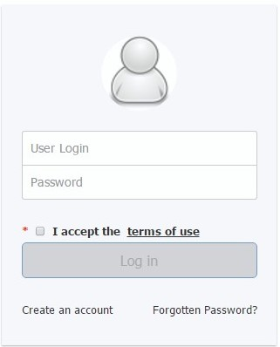

**1**

**2**

**3**

**4**

This factsheet explains how to use the Plant Exports Management Systems (PEMS) offline function to complete inspection and calibration records.

By following these simple steps, you can record inspection/calibration data in PEMS when you have no internet access or network connectivity.

## **Prepare for your inspections/calibrations in advance (internet needed)**

* Go to the PEMS homepage <https://online.agriculture.gov.au/selfservice>.
* Enter your **User Login1** and **Password2,** click the **‘I accept the terms of use’3** check box and then click **Log in4**(right).
* Open your PEMS **My Profile1** page to access your PEMS offline **PIN2** (below). You will need this PIN to log in to PEMS offline. You should always keep this PIN secure.

## 

**1**

**2**

## Bottom Banner**Y:\Administration\Communications\PEMS 3.0 Implementation\Factsheets\Factsheets mylink\Image 5.jpg**Actions Tab

## **Initiate and checkout your inspection /calibration records (internet needed)**

* Initiate all your relevant inspection/calibration records in PEMS online (as per the *PEMS Authorised Officer User Guide* under the ‘Systems’ tab on the  
  Plant Export Operations Manual (PEOM) at www.agriculture.gov.au/plantexportmanual.
* For EACH initiated record that you wish to access offline, click **Actions1** and then **Checkout2** (below).
* A confirmation message will display in green to confirm your checkout was successful.

**1**

## **Access PEMS offline and record data (no internet needed)**

* Open the following link <https://online.agriculture.gov.au/pems> in a browser when you are ready to perform your inspection/calibration.
* Log in to PEMS offline and, when prompted, enter your PEMS offline PIN.
* Access your checked-out record in your **My offline inspections1** or   
  **My offline calibrations** list to record data offline (bottom left).
* Be sure to “check-in” your records when you have internet connectivity so you can finalise the record and submit it to the department.

## **For more information**

* For more information on PEMS offline see the *PEMS Authorised Officer User Guide* under the ‘Systems’ tab on the PEOM: www.agriculture.gov.au/plantexportmanual
* For more information on PEMS visit  
  [agriculture.gov.au/pems](http://www.agriculture.gov.au/pems)
* For PEMS registration or job function enquiries contact  
  [PlantExportTraining@agriculture.gov.au](mailto:PlantExportTraining@agriculture.gov.au)
* For general PEMS enquiries and technical support contact  
  [PEMS@agriculture.gov.au](mailto:PEMS@agriculture.gov.au)

**1**

**2**