# Approved Arrangement

Nominated veterinary hospital reference

Information—Version 3.0

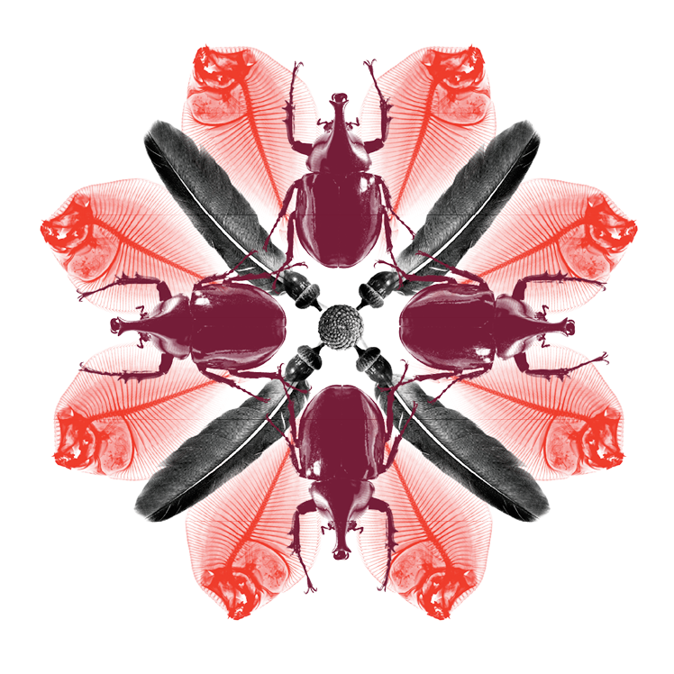

© Commonwealth of Australia 2016

**Ownership of intellectual property rights**

Unless otherwise noted, copyright (and any other intellectual property rights, if any) in this publication is owned by the Commonwealth of Australia (referred to as the Commonwealth).

**Creative Commons licence**

All material in this publication is licensed under a Creative Commons Attribution 3.0 Australia Licence, except for content supplied by third parties, logos and the Commonwealth Coat of Arms.

Description: C:\Documents and Settings\west merryn\Local Settings\Temporary Internet Files\Content.Word\by.png

The Creative Commons Attribution 3.0 Australia Licence is a standard form licence agreement that allows you to copy, distribute, transmit and adapt this publication provided you attribute the work. A summary of the licence terms is available from [creativecommons.org/licenses/by/3.0/au/deed.en](http://creativecommons.org/licenses/by/3.0/au/deed.en). The full licence terms are available from [creativecommons.org/licenses/by/3.0/au/legalcode](http://creativecommons.org/licenses/by/3.0/au/legalcode).

Inquiries about the licence and any use of this document should be sent to [copyright@agriculture.gov.au](mailto:copyright@agriculture.gov.au).

**Cataloguing data**

This publication (and any material sourced from it) should be attributed as: Department of Agriculture and Water Resources 2016, *Biosecurity Import Risk Analysis Guidelines 2016: managing biosecurity risks for imports into Australia*, Department of Agriculture and Water Resources, Canberra.

ISBN 978-1-7600-3118-3 (online)

This publication is available at agriculture.gov.au.

**Contact**

Department of Agriculture and Water Resources

Postal address GPO Box 858 Canberra ACT 2601  
Switchboard +61 2 6272 2000  
Facsimile +61 2 6272 2001  
Web [agriculture.gov.au](http://agriculture.gov.au/)

The Australian Government acting through the Department of Agriculture and Water Resources has exercised due care and skill in the preparation and compilation of the information and data in this publication. Notwithstanding, the Department of Agriculture and Water Resources, its employees and its advisers disclaim all liability, including liability for negligence, for any loss, damage, injury, expense or cost incurred by any person as a result of accessing, using or relying upon any of the information or data in this publication to the maximum extent permitted by law.

**Version Control**

Updates to this document will occur automatically on the department’s website and this revision table will list the amendments as they are approved.

|  |  |  |  |
| --- | --- | --- | --- |
| Date | Version | Amendments | Approved by |
| Jun 2013 | 1.0 | First release | Industry Arrangements Reform Program |
| Apr 2016 | 2.1 | Updated department branding | Approved Arrangements section |
| May 2016 | 3.0 | Updated to reflect the implementation of the Biosecurity Act 2015. | Approved Arrangements section |

Contents

1. Purpose 5

2. Related material 5

Internal instructional material 5

3. Biosecurity outcomes 5

4. Services of a NVH 5

4.1 Assessment and direction to move the dog to a NVH 5

4.2 Transport to the NVH 6

4.3 Biosecurity management at the NVH 6

4.4 Transport back to AA site or disposal of deceased dog 7

5. AA site/NVH relationship controls 7

### Purpose

This document is intended to provide guidance to biosecurity officers on approving and advising nominated veterinary hospitals (NVH) as service providers for the treatment of sick dogs from an AA for defence and police dogs.

It is also intended to provide background information for AA site applicants applying for registration as an AA site for defence and police dogs.

### Related material

This document should be read in conjunction with:

* AA for Defence and Police dogs requirements
* AA for Defence and Police dogs information.

#### Internal instructional material

* WI: Clearance and Biosecurity Management of Australian Defence and Police Dogs going into 7.8 Approved Arrangement Sites
* WI: Deceased Dogs and Cats
* WI: Dog and Cat Samples
* WI: Dog and Cat Transport Crates
* WI: Sick Dog or Cat to Offsite Veterinary Hospital.

### Biosecurity outcomes

NVHs must ensure ticks and these diseases associated with defence and police dogs are contained:

* Rabies
* Ehrlichiosis
* Leishmaniosis
* Brucellosis
* Leptospirosis.

### Services of a NVH

#### 4.1 Assessment and direction to move the dog to a NVH

* Nominated veterinarian assesses the dog and deems it necessary to be moved to the NVH.
* Biosecurity industry participant (BIP) to inform the Department of Agriculture and Water Resources regional office by phone or email of need to take dog to the NVH.
* The department provides verbal direction to move the dog to a NVH, followed by Direction Goods Ordered into Biosecurity Control for Treatment including the following information:
  + Full name and address of the NVH and contact person (e.g. handler) in control of the dog
  + Description of the dog including microchip number
  + Import Permit number
  + Protocols to be followed including isolation from other animals, treatment of equipment and destruction of biosecurity risk material
* Diagnostics to be carried out on-site or departmental approval required to send to an AA site.
* The dog must not be moved from the NVH without permission from the department.
* The department must be notified immediately if the dog dies or requires euthanasia.
* A deceased dog must not be disposed of without the permission of the department and disposal must be via a departmental approved method.

#### 4.2 Transport to the NVH

* Crate the dog for transportation in accordance with AA for defence and police dogs Criteria, requirements 3.8.3, to contain waste and to minimise risk of contact with other animals on arrival at the NVH.
* Where possible the dog is to enter the NVH via a separate entrance to the public, directly to the biosecurity area.

#### 4.3 Biosecurity management at the NVH

* Before entry into the biosecurity area, remove outer wear and observe barrier nursing protocols using disposable gloves, disposable surgical gowns, gum boots, which remain in the biosecurity area.
* Wash/sanitise hands after every contact with the dog.
* When the dog is going in and out of the biosecurity area for procedures, a person in the biosecurity area must be handling the dog, and on leaving pass the dog to staff outside, to minimise traffic in and out.
* Utilise a Virkon footbath at entry to the biosecurity area and change in accordance with the manufacturer’s instructions.
* The biosecurity area must be cleaned twice daily.
* Disposable absorbent pads must be used for bedding.
* Waste is to be placed in the contaminated waste bin kept in the biosecurity area and sharps placed into a dedicated sharps container. This waste must be bagged and collected by the department or returned to the AA site when the dog has left. Commonly used items such as food bowls, thermometers, stethoscopes, clippers, kidney dishes, etc., must be dedicated to the biosecurity area. If items are required to be brought out they must be thoroughly cleaned and soaked with Virkon in accordance with the manufacturer’s instructions before they can be removed from the biosecurity area.
* A log must be kept of all people who contact the dog and this must be as few personnel as possible.
* Any laboratory samples sent offsite for testing must go to the Australian Animal Health Laboratory (AAHL). Samples:
  + must be clearly labelled on the bag and submission form that they are from a dog in post entry quarantine (PEQ)
  + must be placed in a bag in the biosecurity area, sealed and passed to a clean person outside wearing gloves. The samples must then be put in an additional plastic bag and the entire surface disinfected before being packed for transport
  + must be submitted to a State Government Animal Health Laboratory for forwarding to AAHL in Victoria for testing for biosecurity diseases.
* If radiography, ultrasonography, general anaesthesia or surgery is required all staff handling the dog must wear gloves and disposable gowns. Disposable barriers must be created between the dog and all equipment where possible, e.g. incontinence pads and garbage bags. All anaesthetic hoses must be thoroughly disinfected and used soda lime goes into waste.
* Disposable equipment is placed in the bin in the biosecurity area and all equipment and surfaces that contact the dog must be cleaned of organic material and treated with Virkon in accordance with the manufacturer’s instructions before being thoroughly cleaned.
* Where possible procedures on dogs in PEQ must be scheduled last after treating other animals.
* At the end of the isolation period, all contaminated waste and sharps bins must be collected. All equipment, walls, floors, shelves, sinks, cages, boots must be scrubbed and hosed to remove organic material, sprayed with Virkon and left to dry.

#### 4.4 Transport back to AA site or disposal of deceased dog

* Crate the dog for transportation back to the AA site in accordance with the AA for defence and police dogs requirements.
* If the dog is euthanized or dies at the NVH it must be securely contained and labelled clearly that it is biosecurity material. NVH must confirm with the department whether a post mortem should be performed on site. Samples must be sent to AAHL.
* Where a post mortem examination is expected to be delayed by twelve (12) hours or more, the body must be stored at a temperature between 2° to 6°C at the NVH or moved to the AA site for storage at that temperature.

### AA site/NVH relationship controls

It is the responsibility of the biosecurity industry participant to make an agreement with the NVH that meets AA for defence and police dogs requirements.

Treatment and biosecurity management of a dog within the NVH is the responsibility of a nominated veterinarian.

Approval of a NVH is subject to inspection by a Department of Agriculture and Water Resources veterinary officer and may be revoked at any time.