Approved arrangement containment facilities

Multiple room approval

**Version 2.0**



© Commonwealth of Australia

Ownership of intellectual property rights

Unless otherwise noted, copyright (and any other intellectual property rights, if any) in this publication is owned by the Commonwealth of Australia (referred to as the Commonwealth).

**Creative commons licence**

All material in this publication is licensed under a Creative Commons Attribution 3.0 Australia Licence, save for content supplied by third parties, logos and the Commonwealth Coat of Arms.

Creative Commons Attribution 3.0 Australia Licence is a standard form licence agreement that allows you to copy, distribute, transmit and adapt this publication provided you attribute the work. A summary of the licence terms is available from creativecommons.org/licenses/by/3.0/au/deed.en. The full licence terms are available from creativecommons.org/licenses/by/3.0/au/legalcode.

This publication (and any material sourced from it) should be attributed as: Approved Arrangements section, 2015, Approved arrangement containment facilities multiple room approval, Canberra.

**Department of Agriculture and Water Resources**

Postal address GPO Box 1563 Canberra ACT 2601

Switchboard +61 2 6272 2010

Web agriculture.gov.au

Inquiries regarding the licence and any use of this document should be sent to: copyright@agriculture.gov.au.

The Australian Government acting through the Department of Agriculture and Water Resources has exercised due care and skill in the preparation and compilation of the information and data in this publication. Notwithstanding, the Department of Agriculture, its employees and advisers disclaim all liability, including liability for negligence, for any loss, damage, injury, expense or cost incurred by any person as a result of accessing, using or relying upon any of the information or data in this publication to the maximum extent permitted by law.

**Version history**

Updates to this document will occur automatically on the department’s website and the revision table below will list the amendments as they are approved.

| Date | Version | Amendments | Approved by |
| --- | --- | --- | --- |
| Dec 2015 | 1.0 | First issue. | Co-regulation and Support Program |
| 16 Jun 2016 | 2.0 | Updated references to the department and the *Biosecurity Act 2015.* | Approved Arrangements section |

**Table of contents**

Purpose 4

Introduction 4

Definitions 4

Additional reference material 4

Principles for determining the approval options 4

Examples of multiple rooms approved as a single AA site 5

Two rooms with an interconnecting door 5

Two rooms accessible by the same airlock 5

Two rooms accessible by the same airlock with an interconnecting door 5

Two rooms accessible by independent airlocks with an interconnecting door 6

Two rooms accessible by the same airlock with a connecting stairwell 6

Examples of rooms which must be approved as separate AA sites 7

Two adjacent rooms 7

Three different BC level adjacent rooms with interconnecting doors 7

Two adjacent rooms accessible by independent airlocks 7

# Purpose

The purpose of this document is to detail the Department of Agriculture and Water Resources (the department) requirements for determining when Biosecurity Containment (BC) facilities, made up of multiple rooms or laboratories, can be approved as a single Approved Arrangement (AA) site with one AA number or as separate AA sites.

# Introduction

The department’s AA class requirements for BC facilities allows a room or laboratory to be approved as an AA site for the purpose of research, analysis and/or testing of imported biological material. Each facility uses a combination of physical structures, support facilities and practices to provide containment to protect the environment external to the AA site.

The department may allow multiple separate rooms to be approved as a single AA site provided requirements for BC are maintained and the rooms share a single containment barrier.

# Definitions

Definitions that are not contained within the Approved Arrangements Glossary, on the department’s website, can be found in the *Biosecurity Act 2015* or the most recent edition of the Macquarie Dictionary.

# Additional reference material

The following reference material contains information that relates to the application of this document, they are available on the departments website:

* applicable class requirements
* Approved arrangements general policies
* the co-location policy.

# Principles for determining the approval options

To be eligible for approval as a single AA site all rooms must meet the requirements below. If both requirements are not met the rooms must be approved as separate AA sites.

### Unbroken biosecurity containment barrier

Rooms and/or laboratories must be within a single unbroken BC barrier. If access between separate rooms or laboratories requires movement outside of the BC barrier then rooms must be approved as separate AA sites.

### The same BC level

The BC level must be the same for classes within the BC barrier. For example a class 5.2 laboratory and a class 7.2 room may be approved as a single AA site provided they are both located in the same BC2 containment barrier. However a class 5.2 laboratory (BC2) and class 5.3 laboratory (BC3) cannot be approved as a single AA site as the BC level is different between the two laboratories.

# Examples of multiple rooms approved as a single AA site

The following examples detail common situations where multiple rooms or laboratories can be approved as a single AA site.

## Two rooms with an interconnecting door

Both rooms have the same BC containment level and the door between the two laboratories allows movement between the rooms without exiting the level 1 containment barrier. As a result the facility may be approved as a single AA site or alternatively as two separate AA sites.

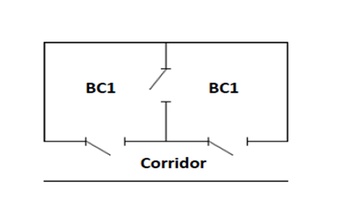

## Two rooms accessible by the same airlock

Access can only be achieved via entry through the air lock. Movement between the rooms is permitted as the two facilities are of an equivalent containment level and access between the two is possible without exiting the containment barrier. As such, the facility may be approved as a single AA site or as two separate AA sites.

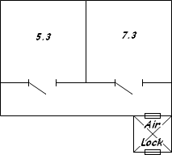

## Two rooms accessible by the same airlock with an interconnecting door

Access can only be achieved via entry through the air lock. Movement between the rooms is permitted as the two facilities are of an equivalent containment level and is possible without exiting the containment barrier. As a result the facility may be approved as a single AA site or as two separate AA sites.

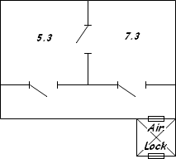

## Two rooms accessible by independent airlocks with an interconnecting door

Access can only be achieved via entry through the air lock. Movement between the rooms is permitted as the two facilities are of an equivalent containment level and access between the two is possible without exiting the containment barrier. As a result the facility may be approved as a single AA site or as two separate AA sites.

If single approval is granted the internal door must be equivalent to that on the door into the class 7 room. Should separate approval be applied the internal door must be equivalent in containment to that of the doors at the entry to each room.

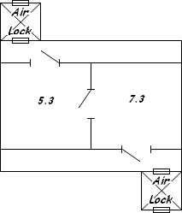

## Two rooms accessible by the same airlock with a connecting stairwell

Access can only be achieved via entry through the air lock. Movement between the rooms is permitted as the two facilities are of an equivalent containment level and access between the two is possible via a stairwell within the containment barrier. As a result the facility may be approved as a single AA site

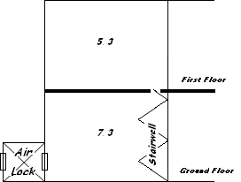

# Examples of rooms which must be approved as separate AA sites

The following examples detail common situations where multiple rooms or laboratories cannot be approved as a single AA site.

## Two adjacent rooms

These two facilities must be approved as separate QAPs as movement between the two rooms is only possible after exiting the containment barrier.



## Three different BC level adjacent rooms with interconnecting doors

The three rooms can be accessed internally; however as the containment level of room 2 is lesser than rooms 1 and 3 these facilities must be approved as three separate AA sites. Approval cannot be granted across different BC levels and movement between the two BC 2 rooms cannot be achieved without exiting the level 2 containment barrier. The internal access must be sealed at all times to a level maintaining the level 2 containment barrier for rooms 1 and 3.

**Room 1 Room 2 Room 3**

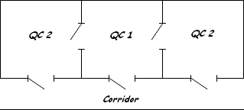

**BC2**

**BC2**

**Corridor**

**Corridor**

**BC1**

## Two adjacent rooms accessible by independent airlocks

Movement between the two rooms can only be achieved by exiting the containment barrier. These two rooms must be approved as separate AA sites.

