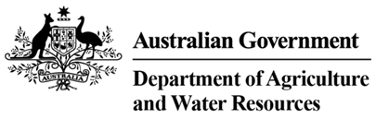

Food surface and equipment sanitisers

Suitable for clean surfaces and equipment when used in conjunction with food for human consumption at airline approved arrangement class 4.3 sites (only)
Type of sanitiser | Type of approved arrangement | Parameters for use
All food and equipment sanitisers | Class 4.3 airline approved sites (only) | As per manufacturer’s instructions

Note:
- Surfaces and equipment, once sanitised, must not be removed from the airline approved arrangement site except for direct movement to an international aircraft departing Australia.

