

**Biosecurity Import Conditions (BICON)**

# Important information about user registration

## About BICON Registration

To make the most of your experience using BICON, you can register as a user to access additional functionality of BICON. Registering is simple and only takes a small number of steps to complete.

## Why should I register as a user?

As a registered user you can:

1. subscribe to import conditions relating to commodities of interest and receive general alerts and notification when import conditions of interest change
2. apply for and manage import permit activities
   * track the status of your permit application
   * manage your permit including online payment of invoices
   * set permit expiry reminders
   * manage your account settings and preferences

Depending on which account type you choose, you can also access and share client contacts within your organisation.

## Which account type should I choose?

You can:

* register as a new single user account,
* register and manage a new multiple user account,
* or join an existing multiple user account.

It is important that you select the correct account type before proceeding with the registration process as the account type cannot be easily changed once registration is complete.

Please note that tax invoice/receipts relating to services such as permit applications are addressed to account organisation, i.e. if you are an administrator or member of a multiple user account the invoices will be sent to the organisation.

### 1. New single user account

A single user account should be used if you are an individual looking to apply for import permits yourself, or you only wish to register so that you can subscribe to commodities of interest and be alerted when import conditions change.

Select this account type if:

* you only wish to register so that you can subscribe to commodities of interest and be alerted when import conditions change.
* you are the only person who needs to access the permit applications that you have submitted, along with the associated correspondence, invoices, payments, and the resulting permits through BICON.

The department recommends that you do not choose this option if you:

* are part of an organisation managing import permits on behalf of clients who will be recipients of invoices
* would like to access your organisation’s client contacts list
* are a sole-trader or require tax invoices/receipts to be issued with an ABN.

For more information:

* See the ‘How do I register for a new single user account?’ task card from the BICON Help menu.

### 2. New multiple user account

A multiple user account should be created by an account administrator in order to set up an account on behalf of an organisation (for example a Customs brokerage). Selecting this account type allows you to become the initial administrator for the account, and you can then choose to add users and other administrators.

As an administrator you can (or appoint others to) perform for the following functions:

* subscribe to commodities of interest and be alerted when import conditions change.
* view all permit applications, variations, permits and additional information (correspondence, invoices and payments) associated with an account
* perform functions (such as paying invoices) for all permit applications, variations and permits managed by staff (other users) in your organisation
* manage additional users of the account
* create or remove administration rights for account users
* change the details of the organisation that are recorded in BICON
* transfer permit applications owned by one staff member to another within the same account

This account type should only be selected once per organisation (or entity if you would like to separately manage accounts within your organisation).

Select this account type if:

* you are authorised to be the nominated administrator for your organisation.
* you are responsible for the management of all staff members and/or work tasks including invoice payments, management of permit applications, and workload allocation.
* You want import related tax invoices/receipts be issued to the organisation, not individuals.

The department recommends:

* organisations identify which staff are to administer the BICON account.
* that, once registered, you invite other users to join your organisation’s account. When you invite other users to join your account, they will receive an automated email prompting them to complete their registration process.
* if newly added users aren’t appearing in your account, try logging into your account again which will refresh the database of users.
* the administrator notifies everyone in the organisation that the account has been created.

For more information:

* See the ‘How do I register for a new multiple user account?’ task card from the BICON Help menu.
* See the ‘How do I manage users within my multiple users account?’ task card from the BICON Help menu.
* Annex A to this information sheet illustrates three example multi-user account configurations.

### 3. Join an existing multiple user account

This option allows you to join an existing multiple user account that has already been set up by your organisation’s account administrator.

Select this account type if:

* you have been advised to do this by your BICON administrator.

The department recommends:

* that instead of using this option to join an account, you wait to be invited to join an existing multiple user account by an account administrator. Once invited, you will receive an email from BICON prompting you to complete the registration process through the link provided in the email.

or

* that you obtain your administrator’s email address so you can easily join an existing multiple user account. Your request to join an existing multiple user account will not be activated until an account administrator accepts this registration request.

For more information:

* See the ‘How do I register to join a multiple user account?’ task card from the BICON Help menu.

## How do I login?

Once you have registered, you can login to BICON by clicking the *Login or Register* link in the top right-hand corner of the BICON home page, and entering your email address and password provided during the initial registration process.

## Want further assistance registering for BICON?

If you require further information on the BICON registration process, please contact the department on:

🕿 1800 900 090 (select *imports*, then *import conditions and permits* when prompted)

🖂 [imports@agriculture.gov.au](mailto:imports@agriculture.gov.au)

Task cards guiding you through the registration process are also available from the BICON Help menu.

## Annex A – Example Multi-user Account Configurations

Each of the following examples is acceptable within the system - it depends on your operational requirements as to which is most suitable for you.

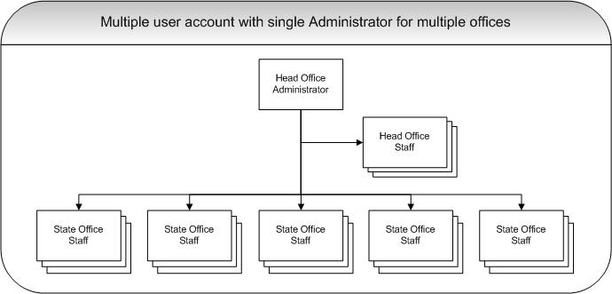

In the above example:

* the administrator will have visibility of all head office and state office permit-related activities.
* the administrator will administer the account for the entire organisation.
* permit application invoices will have the one billing address since there is only one multi-user account for the entire organisation.

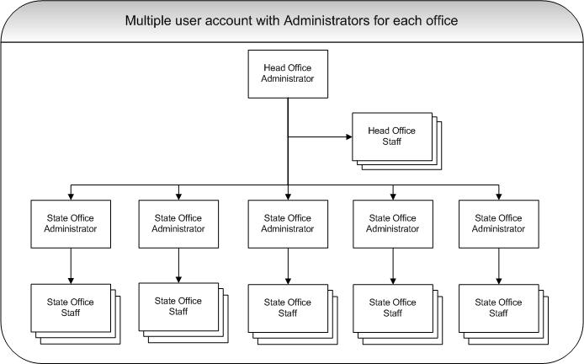

In the above example:

* the head office and state office administrators will have visibility of all permit-related activities (both head office and state office).
* the administration activity can be performed at the state office level.
* permit application invoices will have the one billing address since there is only one multi-user account for the entire organisation.

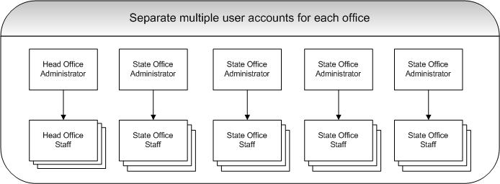

In the above example:

* each state office has its own account administrator.
* each state office administrator only has visibility of their state office’s permit-related activities.
* permit application invoices will be addressed according to the multi-user account details set up for each state office.