# Imported food inspection data

January to December 2017

Imported Food Inspection Scheme



© Commonwealth of Australia 2018

**Ownership of intellectual property rights**

Unless otherwise noted, copyright (and any other intellectual property rights, if any) in this publication is owned by the Commonwealth of Australia (referred to as the Commonwealth).

**Creative Commons licence**

All material in this publication is licensed under a Creative [Commons Attribution 4.0 International Licence](https://creativecommons.org/licenses/by/4.0/legalcode) except content supplied by third parties, logos and the Commonwealth Coat of Arms.

Inquiries about the licence and any use of this document should be emailed to [copyright@agriculture.gov.au](mailto:copyright@agriculture.gov.au).

C:\Documents and Settings\west merryn\Local Settings\Temporary Internet Files\Content.Word\by.png

**Cataloguing data**

This publication (and any material sourced from it) should be attributed as: Department of Agriculture and Water Resources 2018, *Imported food inspection data: January to December 2017*, Canberra, August. CC BY 4.0.

ISBN 9781760031701

This publication is available at [agriculture.gov.au/publications](http://agriculture.gov.au/publications).

Department of Agriculture and Water Resources

GPO Box 858 Canberra ACT 2601

Telephone 1800 900 090

Web [agriculture.gov.au](http://agriculture.gov.au/)

The Australian Government acting through the Department of Agriculture and Water Resources has exercised due care and skill in preparing and compiling the information and data in this publication. Notwithstanding, the Department of Agriculture and Water Resources, its employees and advisers disclaim all liability, including liability for negligence and for any loss, damage, injury, expense or cost incurred by any person as a result of accessing, using or relying on any of the information or data in this publication to the maximum extent permitted by law.

Contents

Introduction 1

1 Background 2

Australian food trade, 2016-2017 3

Australian food imports 3

Source of food imported into Australia 4

2 Import Food Inspection Scheme results summary 6

3 Results of inspection and testing 7

Compliance rates against all tests conducted 7

Labelling compliance 8

Analytical testing data 9

Results by commodity groups 11

Other test data 13

Review of standard plate count fails in cooked prawns 14

Comparing five years of inspection data reports 17

Appendix A: Analytical tests applied to food 2017 19

Appendix B: Tariff codes included in each food commodity group 21

Appendix C: Number of lines inspected per country 22

Glossary 26

**Tables**

Table 1 Compliance for all tests, 2017 7

Table 2 Analytical testing compliance, 2017 9

Table 3 Chemical test compliance, 2017 10

Table 4 Contaminant test compliance, 2017 10

Table 5 Microbiological test compliance, 2017 11

Table 6 Composition analytical test compliance, 2017 11

Table 7 Inspection and test data, by commodity group, 2017 13

Table 8 Bovine Spongiform Encephalopathy certificate check compliance, 2017 13

Table 9 Visual assessment compliance, 2017 14

Table 10 Number of inspections conducted, by country of origin, 2017 17

**Figures**

Figure 1 Trends in Australian food trade, 1992–93 to 2016–17 3

Figure 2 Foods imported into Australia, composition, 2006–07, 2015–16 and 2016–17 4

Figure 3 Value of imported food, by country of origin, 2006–07, 2015–16 and 2016–17 5

Figure 4 Non-compliant test results, 2017 8

Figure 5 Non-compliant labelling, 2017 8

Figure 6 Percentage of tests applied to each commodity group, 2017 12

Figure 7 Standard plate count tests, cooked prawns, 2015 to 2017 15

Figure 8 Standard plate count tests failed, cooked prawns, 2015 to 2017 15

Figure 9 Standard plate count tests, failure rate, cooked prawns, 2015 to 2017 16

Figure 10 Percentage of inspections, by country of origin, 2017 17

Figure 11 Inspection activity, January 2011 to December 2017 18

Figure 12 Tests conducted from January 2011 to December 2017 18

## Introduction

The Department of Agriculture and Water Resources is responsible for managing Australia’s biosecurity system. Every year the department helps millions of people, goods, vessels and aircraft move into and out of Australia while minimising harm to environmental, animal, plant and human health.

The department is also responsible for monitoring the safety of imported food at the border. Food entering Australia is subject to the *Imported Food Control Act 1992*, which provides for the inspection and control of imported food using a risk-based border inspection program, the [Imported Food Inspection Scheme](http://www.agriculture.gov.au/import/goods/food/inspection-compliance/inspection-scheme) (IFIS). Food Standards Australia New Zealand (FSANZ) advises the department on food that poses a medium or high risk to human health and safety, with the department classifying this food as risk for inspection under the IFIS.

In addition to the inspection activity undertaken at the border, state and territory authorities in Australia have responsibility for monitoring all food, including imported food that is available for sale.

This report provides summary data from imported food inspections conducted under the IFIS during 1 January to 31 December 2017. The department has published these reports every six months since July 2006; previous reports can be found on the [Imported food inspection data](http://www.agriculture.gov.au/import/goods/food/inspection-compliance/inspection-data) webpage. The department also publishes the [Failing food report](http://www.agriculture.gov.au/import/goods/food/inspection-compliance/failing-food-reports#2018) each month, identifying food that has failed an inspection or analysis.

## Background

The department is one of many government agencies responsible for regulating food in Australia. The department administers two sets of requirements with which imported food must comply. Food imported into Australia must meet biosecurity requirements under the Biosecurity Act 2015 (Cth). The Biosecurity Act (the Act) explains how we [manage biosecurity threats](http://www.agriculture.gov.au/biosecurity/australia) to plant, animal and human health in Australia and its external territories.

Imported food is also subject to the *Imported Food Control Act 1992* (Cth) and must meet requirements for food safety and compliance with Australia’s food standards. The department operates a risk-based border inspection scheme—the [Imported Food Inspection Scheme](http://www.agriculture.gov.au/import/goods/food/inspection-compliance/inspection-scheme) (IFIS). Under this scheme, the department monitors importers’ compliance with sourcing food that meets Australia’s food standards and does not pose a risk to human health. It is the responsibility of the importer to ensure imported food complies with the Act and Australian food safety requirements.

The department monitors and responds to emerging or emerged food incidents in support of the Australian food regulatory system, which provides safe and compliant food. Where an emerging food safety issue is identified with an imported food, the department works closely with Food Standards Australia New Zealand (FSANZ), and state and territory food regulatory authorities to manage the situations.

FSANZ is, an independent statutory authority, develops and maintains the Australia New Zealand Food Standards Code. The code lists Australia’s food standards requirements including for contaminants (such as microbiological and chemical), additives, labelling and genetically modified food, as well as production and processing standards.

FSANZ provides advice to the department on food that has the potential to pose a medium or high risk to public health. The Minister for Agriculture and Water Resources may then classify this food as risk food under the IFIS. All other food is classified as surveillance food.

Regulation 9 of the Imported Food Control Regulations 1993 provides that food may be classified as risk food if FSANZ has advised the Minister for Agriculture and Water Resources that the food has the potential to pose a medium or high risk to public health. In accordance with regulation 9 and the advice from FSANZ, the Minister may classify food as ‘risk food’ in the Imported Food Control Order 2001. All other food is classified as surveillance food. Risk food is initially referred for inspection and analysis at a rate of 100 per cent of consignments. Surveillance food is referred for inspection and analysis at a rate of five per cent of consignments.

Once food is referred, the department’s systems apply relevant tests and inspection based on the risk the food may pose and for some food, the compliance history of the food producer.

When imported food fails inspection, follow-up action such as labelling or treatment of the food to bring it into compliance, destruction or export is undertaken. Additionally, subsequent imports of the same food are subject to inspection at the rate of 100 per cent of consignments until a history of compliance is demonstrated.

In addition to the department’s imported food testing, the state and territory governments and local governments have responsibility for ensuring that all food, including imported food, meets the requirements of food legislation (include the Code) at the point of sale.

### Australian food trade

This information provides context for inspection data in this report. This information is used by the department to inform inspection and analysis activities to improve these performances.

The value of Australian food exports increased by 6.8 per cent (in real terms) to $43.5 billion in 2016–17, the highest ever recorded (Figure 1). The value of food imported by Australian food businesses was $16.6 billion in 2016–17, a 2.2 per cent decrease on the previous year. As a result, Australia's net exports of food, the difference between the value of food exports and food imports, increased by 13.1 per cent to $26.9 billion in 2016–17.

In value terms, the proportion of imports compared to exports decreased to 38.1 per cent in 2016–17.

Figure 1 Trends in Australian food trade, 1992–93 to 2016–17

Source: Australian Bureau of Statistics

### Australian food imports

The value of food imported by Australian food businesses decreased to $16.6 billion in 2016–17. The main contributors to the decrease were processed foods, soft drinks and cordials, and confectionary (Figure 2). Partially offsetting this decrease were higher imports of dairy products, seafood and fruit and nuts.

Over the past 20 years the value of food imported by Australian food businesses has increased. The kinds of food imported by Australian food businesses are generally processed products with major contributors being seafood and fruit and vegetables.

Figure 2 Foods imported into Australia, composition, 2006–07, 2015–16 and 2016–17

**Proc – processed**

**nec** – not elsewhere classified

Source: Australian Bureau of Statistics

### Source of food imported into Australia

New Zealand remains the major source of food imported by Australian food businesses, accounting for $3.0 billion or 18.6 per cent of the total value of food imported in 2016–17 (Figure 3). Other major sources of food imports in 2016–17 were the United States (10.4 percent), China (7.2 per cent) and Thailand (6.1 per cent).

The composition of Australian food imports have been stable over the last ten years with only minor fluctuations in the proportions of food imported from particular countries by Australian food businesses (Figure 3).

Figure 3 Value of imported food, by country of origin, 2006–07, 2015–16 and 2016–17

**UK** – United Kingdom

Source: Australian Bureau of Statistics

## Import Food Inspection Scheme results summary

The data contained in this report were obtained from imported food inspection data for 1 January to 31 December 2017.

During this reporting period, the compliance rate for all food inspected was 98.6 per cent.

In summary:

* 20,846 entries of imported food were referred for inspection or analysis
* 34,766 lines of imported food were inspected. Of these lines:
* 30.5 per cent were risk food
* 66.4 per cent were surveillance food
* 3.1 per cent were surveillance food subject to a Holding Order
* 61.7 per cent of food inspections were on food from 10 countries, with food from China, Thailand and Italy subject to the most inspection
* In total, 109,295 tests (including label and visual checks), comprising
* 43,394 label and composition assessments
* 23,037 analytical tests
* 42,864 other tests.

More detailed analysis of data is provided based on:

* commodity groups
* country of origin
* inspection data tests applied and compliance rates.

See Glossary for explanation of terms used in this document.

## Results of inspection and testing

Below are the results of inspection and testing undertaken from January to December 2017. This section includes:

* compliance rates against all tests conducted
* labelling compliance
* analytical testing data
* results by commodity groups.

### Compliance rates against all tests conducted

The overall compliance rate with Australian food standards was at 98.6 per cent of all tests applied to imported food under the IFIS. Table 1 Compliance for all tests, 2017 provides a breakdown of compliance rates per test group.

Non-compliant labelling accounted for most non-compliance (69.3 per cent of failures).

When labelling non-compliances are removed from the testing data, the compliance rate for imported food rises to 99.3 per cent.

Table 1 Compliance for all tests, 2017

| Test group | No. of tests applied | No. compliant | No. non-compliant | Compliance rate (%) |
| --- | --- | --- | --- | --- |
| Analytical | 23,037 | 22,645 | 392 | 98.3 |
| Labelling | 43,394 | 42,332 | 1,062 | 97.6 |
| Other | 42,864 | 42,786 | 78 | 99.8 |
| **Total** | **109,295** | **107,763** | **1,532** | **98.6** |

Source: AIMS database

Figure 4provides a summary of the 1,532 noncompliant tests from the 109,295 tests applied, with details of each specific test and the proportion each test contributed to the total.

Figure 4 Non-compliant test results, 2017

Source: AIMS database

### Labelling compliance

Figure 5provides a detailed summary of labelling non-compliances against Australian food standards. Absent, incomplete or incorrect nutrition information details on labelling is the largest contributor to noncompliant labelling, accounting for 38.3 per cent of non-compliances. Absent or incomplete importer details, country of origin labelling and ingredient information account for a further 40.6 per cent of label non-compliances.

Figure 5 Non-compliant labelling, 2017

Source: AIMS database

### Analytical testing data

Within the analytical test category, tests are grouped according to four main types: chemical, contaminant, composition (analytical assessment) and microbiological (Table 2). Each category consists of several tests, reported in detail in Table 3, Table 4, Table 5 and Table 6.

Analytical test results show a 98.3 per cent compliance rate with the tests applied under the IFIS.

Of the 23,037 analytical tests applied, 392 (1.7 per cent) of the products being tested failed against the standards.

The number of lines of food referred for inspection under the Scheme and the number of tests applied to food may differ. This is because food subject to inspection is sampled and analysed based on the number of:

* batches and lots within each batch of food on the line referred for inspection
* tests applied to each sample of that food taken during inspection.

For example, one line of a cooked and processed meat product may be referred for inspection under the Scheme. The line contains two batches of the product, each with one lot. An officer will take one sample from each batch and apply the test relevant to this food. The tests applied to cooked and processed meat products are *Listeria monocytogenes* and *Salmonella*. As a result, two samples have been taken from this one line of imported food with two microbiological tests applied to each sample.

This will be reported as one line, with four separate test results.

Table 2 Analytical testing compliance, 2017

| Test type | No. of tests applied | No. compliant | No. non-compliant | Compliance rate (%) |
| --- | --- | --- | --- | --- |
| Chemical | 3,380 | 3,297 | 83 | 97.5 |
| Contaminant | 8,788 | 8,678 | 110 | 98.7 |
| Microbiological | 10,795 | 10,596 | 199 | 98.2 |
| Composition | 74 | 74 | 0 | 100 |
| **Total** | **23,037** | **22,645** | **392** | **98.6** |

Source: AIMS database

Table 3 Chemical test compliance, 2017

| Chemical | No. of tests applied | No. compliant | No. non-compliant | Compliance rate (%) | Food type |
| --- | --- | --- | --- | --- | --- |
| Fluoroquinolones | 377 | 372 | 5 | 98.7 | Farmed fish and prawns |
| Fruit and veg residue screen | 1,774 | 1,705 | 69 | 96.1 | Fruit and vegetables |
| Malachite Green | 340 | 338 | 2 | 99.4 | Farmed fish |
| Nitrofurans | 48 | 44 | 4 | 91.7 | Farmed prawns, honey |
| Pesticides | 719 | 716 | 3 | 99.6 | Meat |
| Quinolones | 122 | 122 | 0 | 100 | Farmed fish |
| **Total** | **3,380** | **3,297** | **83** | **97.5** | **–** |

Source: AIMS database

Table 4 Contaminant test compliance, 2017

| Contaminant | No. of tests applied | No. compliant | No. non-compliant | Compliance rate (%) | Food type |
| --- | --- | --- | --- | --- | --- |
| Aflatoxins | 1,053 | 1,015 | 38 | 96.4 | Nuts |
| Arsenic total | 812 | 812 | 0 | 100 | Cereal grains, cereal flours and processed cereals |
| Buprofezin **a** | 2 | 0 | 2 | 0 | Rice |
| Domoic acid | 646 | 645 | 1 | 99.8 | Bivalve molluscs |
| Erucic acid | 379 | 379 | 0 | 100 | Edible plant oils |
| Histamine | 3,672 | 3,628 | 44 | 98.8 | Fish |
| Hydrocyanic acid | 84 | 80 | 4 | 95.2 | Cassava chips |
| Inorganic arsenic | 17 | 17 | 0 | 100 | Seaweed (Hijiki) |
| Iodine | 94 | 88 | 6 | 93.6 | Seaweed (brown algae) |
| Lead | 1,223 | 1,208 | 15 | 98.8 | Cereal grains, cereal flours, processed cereals, canned and preserved fruit |
| PSP Toxin | 554 | 554 | 0 | 100 | Bivalve molluscs |
| Tin | 252 | 252 | 0 | 100 | Canned fruit |
| **Total** | **8,788** | **8,678** | **110** | **98.7** | **–** |

**a** Buprofezin testing commenced in response to evidence of noncompliance for a specific pathway.

Source: AIMS database

Table 5 Microbiological test compliance, 2017

| Microbial agent | No. of tests applied | No. compliant | No. non-compliant | Compliance rate (%) | Food type |
| --- | --- | --- | --- | --- | --- |
| *Bacillus cereus* | 51 | 49 | 2 | 96.1 | Bean curd, tofu |
| Coagulase-positive staphylococci | 1,082 | 1,082 | 0 | 100 | Processed meats and cooked crustaceans |
| *Escherichia coli* | 586 | 572 | 14 | 97.6 | Processed meats, water, seafood, and cheese |
| *Listeria* *monocytogenes* | 2902 | 2883 | 19 | 99.3 | Cheese, ready-to-eat seafood, processed meats |
| *Listeria monocytogenes-*enumerated | 439 | 439 | 0 | 100 | cheese, RTE finfish, slow cured ham |
| *Salmonella* | 3717 | 3667 | 50 | 98.7 | Processed meats, seafood, dried coconut, dried chilli and pepper, sesame seeds, cheese |
| Standard plate count | 1196 | 1089 | 107 | 91.1 | Cooked crustaceans |
| *Vibrio cholerae* | 822 | 815 | 7 | 99.1 | Cooked prawns |
| **Total** | **10,795** | **10,596** | **199** | **98.2** | **–** |

Source: AIMS database

Table 6 Composition analytical test compliance, 2017

| Microbial agent | No. of tests applied | No. compliant | No. non-compliant | Compliance rate (%) | Food type |
| --- | --- | --- | --- | --- | --- |
| Allergen - Dairy | 11 | 11 | 0 | 100 | Coconut drinks and coconut powders |
| C4 adulteration | 21 | 21 | 0 | 100 | Honey |
| Moisture content | 21 | 21 | 0 | 100 | Honey |
| Reducing sugar content | 21 | 21 | 0 | 100 | Honey |
| **Total** | **74** | **74** | **0** | **100** | **–** |

Source: AIMS database

### Results by commodity groups

Figure 6 and Table 7 provide an overview of tests applied to food commodity groups. This data does not indicate the volume of trade in particular commodities, but the commodities most often tested. This will be influenced by these factors:

* commodity groups that contain more risk food or are imported more frequently will have a higher representation under the inspection activity
* the rate of inspection and analysis of food identified as failing food is increased to 100 per cent until compliance has again been demonstrated.

#### Test data by commodity groups

During the reporting period seafood was the single commodity subject to most testing. Testing of seafood accounted for 22.0 per cent of tests applied (Figure 10) under the IFIS. This commodity includes fresh, chilled, frozen and processed seafood products.

Horticulture (including fresh and processed fruit and vegetables) was the next highest single commodity inspected and was subject to 13.8 per cent of all tests applied to imported food under the Scheme.

Figure 6 Percentage of tests applied to each commodity group, 2017

Source: AIMS database

Appendix A provides an overview of the analytical tests applied to the commodity groups and Appendix B provides a list of the tariff codes associated with each commodity grouping used for this report.

Table 7 Inspection and test data, by commodity group, 2017

| Commodity group | No. of tests applied | No. compliant | No. non-compliant | Compliance rate (%) |
| --- | --- | --- | --- | --- |
| Beverages | 9,342 | 9,212 | 130 | 98.6 |
| Cereals, flours and milled products | 3,887 | 3,850 | 37 | 99.0 |
| Dairy | 8,604 | 8,557 | 47 | 99.5 |
| Eggs | 26 | 26 | 0 | 100 |
| Honey | 105 | 105 | 0 | 100 |
| Horticulture | 15,085 | 14,832 | 253 | 98.3 |
| Meat | 3,001 | 2,995 | 6 | 99.8 |
| Other (incl. processed food) | 45,184 | 44,412 | 772 | 98.3 |
| Seafood | 24,061 | 23,774 | 287 | 98.8 |
| **Total** | **109,295** | **107,763** | **1,532** | **98.6** |

Source: AIMS database

### Other test data

Other than labelling and analytical testing, other testing applied during the period January to December 2017 included composition assessments, Bovine Spongiform Encephalopathy (BSE) certification checks and visual assessments.

#### Composition assessments

Additives or ingredients that are not permitted, or are in excess of permitted levels, may be identified during a label assessment. Of the 43,394 label assessments conducted, 67 labels were found to be noncompliant with these requirements.

#### Bovine Spongiform Encephalopathy certificate checks

Food containing beef is inspected to ensure it is covered by the appropriate government certification, consistent with Australia’s BSE policy. A fail is recorded when the food containing beef is not covered by the appropriate government certification. Table 8 Bovine Spongiform Encephalopathy certificate check compliance, 2017 shows the compliance rate for BSE certification.

Table 8 Bovine Spongiform Encephalopathy certificate check compliance, 2017

| Type of test | No. of tests applied | No. compliant | No. noncompliant | Compliance rate (%) |
| --- | --- | --- | --- | --- |
| BSE Certificate | 742 | 741 | 1 | 99.9 |
| **Total** | **742** | **741** | **1** | **99.9** |

Source: AIMS database

#### Visual assessments

At every inspection the food is visually assessed for signs of unsafe or unsuitable condition such as foreign objects or deterioration. Table 9 Visual assessment compliance, 2017.

Table 9 Visual assessment compliance, 2017

| Type of test | No. of tests applied | No. compliant | No. noncompliant | Compliance rate (%) |
| --- | --- | --- | --- | --- |
| Visual | 41,971 | 41,961 | 10 | 99.9 |
| **Total** | **41,971** | **41,961** | **10** | **99.9** |

Source: AIMS database

### Review of standard plate count fails in cooked prawns

A review of imported food inspection data identified that the recent increase in failures for standard plate count (SPC) in cooked prawns is consistent with an increased volume of trade in these products.

As a risk food, cooked prawns are referred for inspection at the rate of 100 per cent, and assessed for compliance with the Australia New Zealand Food Standards Code.

An SPC test indicates the microbiological quality of food (the total number of bacteria in a food that grow in the presence of oxygen at 30 °C)—it does not relate to biosecurity requirements.

SPC counts vary markedly according to the type of food product and the processing it has received. High levels may indicate a lack of process hygiene therefore posing a potential risk to human health. The rate of failure for tests applied to cooked prawns was variable, with rates between 0 to 16 per cent for 2015 to 2017.

Figure 7 Standard plate count tests, cooked prawns, 2015 to 2017 shows a breakdown of all SPC tests applied to cooked prawns for the period 1 January 2015 to 31 December 2017.

Figure 7 Standard plate count tests, cooked prawns, 2015 to 2017

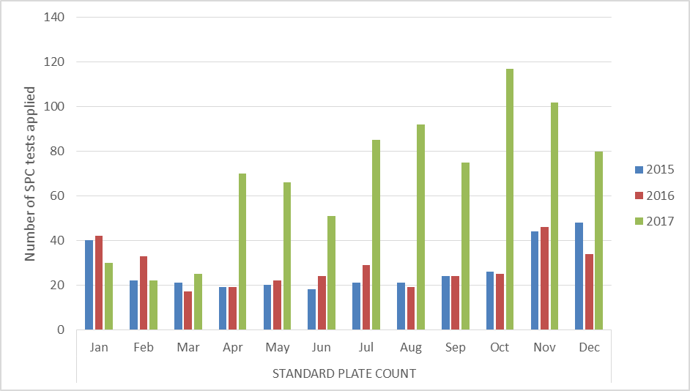

**SPC** Standard plate count.

Figure 8 Standard plate count tests failed, cooked prawns, 2015 to 2017 shows the number of SPC test results fail from 1 January 2015 to 31 December 2017.

Figure 8 Standard plate count tests failed, cooked prawns, 2015 to 2017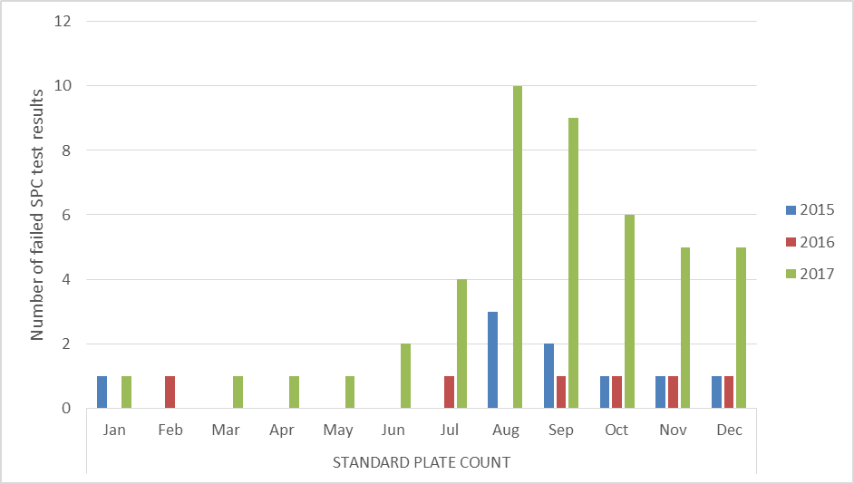

**SPC** Standard plate count.

Figure 9 Standard plate count tests, failure rate, cooked prawns, 2015 to 2017.

Figure 9 Standard plate count tests, failure rate, cooked prawns, 2015 to 2017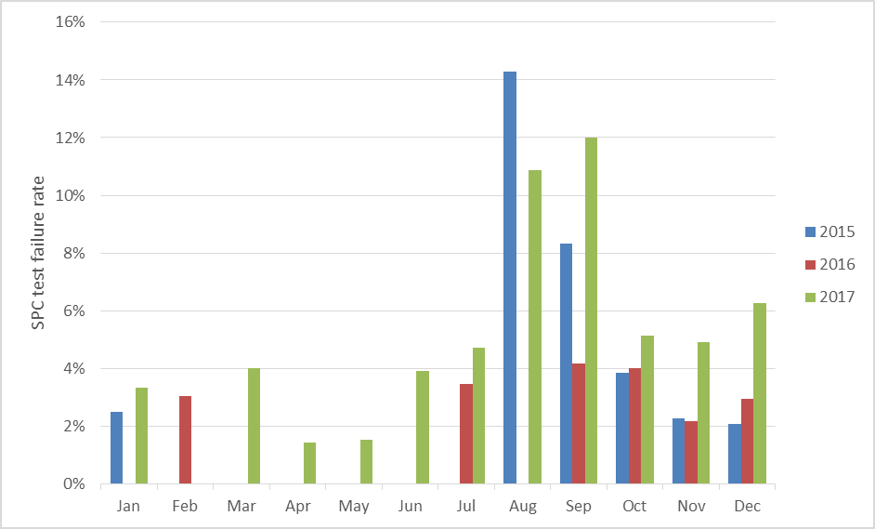

**SPC** Standard plate count.

#### Results by country of origin

Under the IFIS, food is inspected based on whether it is classified as risk food or not, irrespective of the country from which the food was exported. The exception to this is where a food has previously failed inspection. In these circumstances, future consignments of that food from the producer in the particular country are inspected and analysed at a 100 per cent rate of inspection and analysis, until a history of compliance is re-established for the producer of the food.

The countries from which importers more frequently source food will have a higher representation in the inspection data.

For the period 1 January to 31 December 2017:

* China, Italy and Thailand were the countries whose food was subject to most inspections
* 61.7 per cent of food inspections were conducted on food from 10 countries; the remaining 38.3 per cent were on food from 129 countries.

A significant proportion of food imports are from New Zealand. Most food from New Zealand is not subject to the *Imported Food Control Act 1992*. This is because Australia and New Zealand, under the Trans-Tasman Mutual Recognition Arrangement, have agreed that food produced or imported into one country that meets that country’s food standards, may be legally sold in the other country.

Therefore, food produced or imported into New Zealand that meets New Zealand’s food legislation can be legally sold in Australia. Table 10 Number of inspections conducted, by country of origin, 2017.

Table 10 Number of inspections conducted, by country of origin, 2017

| Country of origin | Number of lines inspected | Percentage of total lines inspected |
| --- | --- | --- |
| China | 3,562 | 10.2 |
| Italy | 2,806 | 8.1 |
| Thailand | 2,788 | 8.0 |
| India | 2,239 | 6.4 |
| United States | 2,236 | 6.4 |
| Japan | 2,149 | 6.2 |
| Korea Republic Of | 1,749 | 5.0 |
| France | 1,396 | 4.0 |
| Malaysia | 1,310 | 3.8 |
| Vietnam | 1,214 | 3.5 |
| Other | 13,316 | 38.3 |
| **Total** | **34,765** | **100** |

**Note:** For detail of all countries of origin see Appendix C.

Source: AIMS database

Figure 10 Percentage of inspections, by country of origin, 2017

Source: AIMS database

### Comparing five years of inspection data reports

Since July 2016 the department has published Imported Food Inspection Data reports on activities twice each year.

Figure 11 summarises the number of food entries and lines inspected for each calendar year period.

This shows an increase in both entries and lines for the 2017 reporting period. This is attributed to an increase in the overall volume of food imported for 2017.

Figure 11 Inspection activity, January 2011 to December 2017

Source: AIMS database

Figure 12 summarises the number of tests applied at inspection in each calendar year period. This graph reflects a similar pattern to Figure 11, in showing a reduction in the number of tests in 2013, reflecting changes made after a review of surveillance testing.

Figure 12 Tests conducted from January 2011 to December 2017

Source: AIMS database

## Appendix A: Analytical tests applied to food 2017

| Food group | Risk/surveillance test | Analytical test |
| --- | --- | --- |
| Coconut milk drinks | Surveillance | *Beta-lactoglobulin*  *Casein*  *Total milk* |
| Dairy products | Risk | *Listeria* *monocytogenes* |
| Surveillance | *Salmonella*  *E. coli*  *Listeria* *monocytogenes* |
| Edible plant oils | Surveillance | Erucic acid |
| Fruit | Surveillance | Fruit & veg residue screen  *E. coli* (ready-to-eat frozen berries only)  *Hepatitis A* (ready-to-eat frozen berries only) |
| Fruit—canned and preserved | Surveillance | Lead  Tin (canned only) |
| Fruit juices | Surveillance | Fruit & veg residue screen |
| Herbs and spices | Risk | *Salmonella* |
| Honey | Surveillance | C4 Adulteration  Moisture content  Reducing sugar content |
| Meat | Risk | BSE government certification  Coagulase-positive staphylococci  *E. coli*  *Listeria* *monocytogenes*  *Salmonella* |
| Surveillance | Pesticide screen  *Listeria* *monocytogenes*  *E. coli*  *Salmonella* |
| Nuts and nut products | Risk | *Salmonella* (coconut)  Aflatoxin |
| Seafood | Risk | Histamine  *Listeria* *monocytogenes*  Coagulase-positive staphylococci  *E. coli*  *Salmonella*  Standard plate count  Paralytic shellfish poison (PSP)  Domoic acid  *Vibrio cholerae* |
| Surveillance | Histamine  Fluoroquinolones  Malachite green  Nitrofurans  Quinolones |
| Plant based products | Risk | *Salmonella* (sesame seed and dried coconut)  Inorganic arsenic (Hijiki seaweed)  Iodine (Seaweed (brown algae))  Hydrocyanic acid (cassava chips) |
| Surveillance | Fruit & veg residue screen  *Bacillus cereus* (tofu, soy bean / milk curd)  Arsenic total (cereal grains, ready-to-eat cereal flours and processed cereals) |

## Appendix B: Tariff codes included in each food commodity group

| Commodity group | Tariff code |
| --- | --- |
| Beverages | 2009  2201–2208 |
| Cereals | 1001–1008  1101–1109 |
| Dairy | 0401–0406 |
| Eggs | 0407–0408 |
| Honey | 0409 |
| Horticulture | 0701–0714  0801–0814  0904–0910  1201–1208  1210–1212  1801–1802 |
| Meat | 0201–0212  0504  1601–1602 |
| Seafood | 0302–0307  1603–1605 |
| Other (including processed food) | 0410  0901–0903  1301–1302  1501–1504  1506–1517  1520–1521  1701–1704  1803–1806  1901–1905  2001–2008  2101–2106  2209  2501  3501–3503  3505  3507 |

## Appendix C: Number of lines inspected per country

| Country | Lines inspected |
| --- | --- |
| Afghanistan | 1 |
| Albania | 2 |
| Antigua and Barbuda | 2 |
| Argentina | 66 |
| Australia | 25 |
| Austria | 91 |
| Bahrain | 1 |
| Bangladesh | 87 |
| Barbados | 1 |
| Belarus | 9 |
| Belgium | 370 |
| Belize | 1 |
| Bolivia | 12 |
| Bosnia and Herzegovina | 33 |
| Brazil | 107 |
| Brunei Darussalam | 6 |
| Bulgaria | 36 |
| Burundi | 1 |
| Cambodia | 5 |
| Canada | 252 |
| Chile | 160 |
| China | 3,562 |
| Colombia | 38 |
| Costa Rica | 5 |
| Cote d’Ivoire | 11 |
| Croatia local name Hrvatska | 116 |
| Cuba | 5 |
| Cyprus | 27 |
| Czech Republic | 27 |
| Denmark | 388 |
| Dominican Republic | 1 |
| Ecuador | 15 |
| Egypt | 84 |
| El Salvador | 6 |
| Estonia | 1 |
| Ethiopia | 30 |
| Fiji | 103 |
| Finland | 17 |
| France | 1,396 |
| French Polynesia | 1 |
| Georgia | 6 |
| Germany | 732 |
| Ghana | 16 |
| Greece | 273 |
| Grenada | 1 |
| Guatemala | 10 |
| Guyana | 1 |
| Haiti | 1 |
| Honduras | 9 |
| Hong Kong | 182 |
| Hungary | 29 |
| Iceland | 6 |
| India | 2,239 |
| Indonesia | 840 |
| Iran | 138 |
| Ireland | 115 |
| Israel | 97 |
| Italy | 2,806 |
| Jamaica | 11 |
| Japan | 2,149 |
| Jordan | 41 |
| Kenya | 4 |
| Kiribati | 6 |
| Korea republic of | 1,749 |
| Latvia | 21 |
| Lebanon | 162 |
| Liberia | 2 |
| Lithuania | 8 |
| Luxembourg | 10 |
| Macedonia | 75 |
| Madagascar | 2 |
| Malaysia | 1,310 |
| Maldives | 44 |
| Malta | 8 |
| Mauritius | 10 |
| Mexico | 249 |
| Moldova | 1 |
| Morocco | 38 |
| Mozambique | 2 |
| Myanmar | 106 |
| Namibia | 7 |
| Nepal | 22 |
| Netherlands | 898 |
| New Caledonia | 8 |
| New Zealand | 294 |
| Nicaragua | 22 |
| Niger | 1 |
| Nigeria | 26 |
| Norway | 196 |
| Pakistan | 150 |
| Palestinian territory | 3 |
| Panama | 5 |
| Papua New Guinea | 29 |
| Paraguay | 5 |
| Peru | 71 |
| Philippines | 587 |
| Poland | 199 |
| Portugal | 88 |
| Puerto Rico | 4 |
| Reunion | 1 |
| Romania | 18 |
| Russian Federation | 34 |
| Rwanda | 2 |
| Samoa | 2 |
| Saudi Arabia | 13 |
| Serbia | 57 |
| Sierra Leone | 2 |
| Singapore | 345 |
| Slovakia Slovak republic | 3 |
| Slovenia | 30 |
| Solomon Islands | 6 |
| South Africa | 500 |
| Spain | 563 |
| Sri Lanka | 577 |
| St Helena | 2 |
| Sudan | 5 |
| Swaziland | 20 |
| Sweden | 116 |
| Switzerland | 248 |
| Syrian Arab Republic | 15 |
| Taiwan | 1,128 |
| Tajikistan | 1 |
| Tanzania United Republic of | 7 |
| Thailand | 2,788 |
| Timor-Leste | 13 |
| Tonga | 17 |
| Trinidad and Tobago | 2 |
| Tunisia | 2 |
| Turkey | 291 |
| Uganda | 1 |
| Ukraine | 14 |
| United Arab Emirates | 76 |
| United Kingdom | 1,181 |
| United States | 2,236 |
| Uruguay | 6 |
| Uzbekistan | 1 |
| Vietnam | 1,214 |
| Virgin Islands (US) | 1 |
| Zimbabwe | 3 |
| **Total** | **34,766** |

## Glossary

| Term | Definition |
| --- | --- |
| AIMS | The computer system that receives data on imported goods from the Integrated Cargo System (ICS) and processes entries for both imported food and quarantine purposes. |
| Australia New Zealand Food Standards Code | The Code details food standards applicable to food for human consumption in Australia and is available from the FSANZ website. |
| batch | Food of a particular kind made or packed in a distinct manner which may include one or more lots. |
| entry | Department of Home Affairs electronic document generated using the ICS. An entry may contain one or more lines or food. |
| food | Section 3 of the Imported Food Control Act 1992 describes food as:  (a) Any substance or thing of a kind used or capable of being used as food or drink by human beings; or  (b) any substance or thing of a kind used or capable of being used as an ingredient or additive in, or substance used in the preparation of, a substance or thing referred to in paragraph (a); or  (c) any other substance or thing that is prescribed; whether or not it is in a condition fit for human consumption, but does not include a therapeutic good within the meaning of the Therapeutic Goods Act 1989. |
| FSANZ | Food Standards Australia New Zealand is a bi-national government agency responsible for developing food standards and administering the Australia New Zealand Food Standards Code. FSANZ conducts the food risk assessment and advises the Department of Agriculture and Water Resources about food that poses a medium or high risk to public health. |
| holding order | An order made under section 15 of the Imported Food Control Act 1992 increasing the rate of inspection of a surveillance food that has failed an imported food inspection. This targets the specific food from the specific producer in a specific country at a rate of 100 per cent of consignments. |
| Imported Food Inspection Scheme | The inspection scheme, established under the Imported Food Control Regulations 1993, provides for inspection of food at the border to assess importer compliance with sourcing food that does not pose a risk to human health and meets Australian food standards. |
| inspection | Includes inspection (visual and label assessment), or inspection and analysis (samples taken and sent for analysis), as the case requires. |
| line | Items of food being imported are recorded within the ICS as lines within the import entry. An import entry may consist of one line or many lines of products. |
| lot | A quantity of a food prepared or packed under essentially the same conditions (ordinarily from a particular preparation or packing unit and during a particular time ordinarily not exceeding 24 hours). |
| lot code | A unique code that identifies a lot and can be used for recall purposes if necessary. |
| risk food | Food that is classified as risk food in the Imported Food Control Order 2001. This kind of food is referred to AIMS by the ICS for inspection at the rate of 100 per cent of imports, reducing with a history of compliance. |
| surveillance food | All other food not classified as risk. Referred to AIMS by the ICS for inspection at the rate of 5 per cent of consignments. |