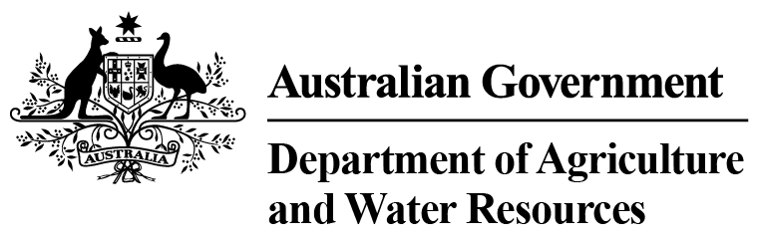

Imported Food Inspection Data
Report for July – December 2015
Imported Food Inspection Scheme


© Commonwealth of Australia 2016
Ownership of intellectual property rights
Unless otherwise noted, copyright (and any other intellectual property rights, if any) in this publication is owned by the Commonwealth of Australia (referred to as the Commonwealth).
Creative Commons licence
All material in this publication is licensed under a Creative Commons Attribution 3.0 Australia Licence, save for content supplied by third parties, logos and the Commonwealth Coat of Arms.

Creative Commons Attribution 3.0 Australia Licence is a standard form licence agreement that allows you to copy, distribute, transmit and adapt this publication provided you attribute the work. A summary of the licence terms is available from creativecommons.org/licenses/by/3.0/au/deed.en. The full licence terms are available from creativecommons.org/licenses/by/3.0/au/legalcode.
This publication (and any material sourced from it) should be attributed as Imported Food Inspection Data Report for July-December 2015, Imported Food, Department of Agriculture and Water Resources, Canberra, June 2016. CC BY 3.0.
Cataloguing data
Imported Food 2015, Imported Food Inspection Data Report for July-December 2015, Department of Agriculture and Water Resources, Canberra, June 2016.
Internet
Imported Food Inspection Data Report is available at agriculture.gov.au/biosecurity/import/food/inspection-data
Department of Agriculture and Water Resources
Postal address GPO Box 1563 Canberra ACT 2601
Switchboard +61 2 6272 2010
Facsimile +61 2 6272 2001
Email foodimp@agriculture.gov.au
Web agriculture.gov.au
Inquiries about the licence and any use of this document should be sent to copyright@agriculture.gov.au.
The Australian Government acting through the Department of Agriculture and Water Resources has exercised due care and skill in preparing and compiling the information and data in this publication. Notwithstanding, the Department of Agriculture and Water Resources, its employees and advisers disclaim all liability, including liability for negligence, for any loss, damage, injury, expense or cost incurred by any person as a result of accessing, using or relying upon any of the information or data in this publication to the maximum extent permitted by law.

Contents
Summary 1
Imported Food Inspection Scheme 3
Food Import Compliance Agreement notifications 3
Summary for July to December 2015 4
Application of tests to imported food 4
Commodity groups 4
Country of origin 5
Testing data 6
Analytical testing data, China 11
Analytical testing data, Thailand 12
Analytical testing data, Italy 13
Appendixes 15
Appendix 1: Analytical tests applied to food 15
Appendix 2: Tariff codes included in each food commodity group 16
Appendix 3: Number of lines inspected per country 17
Glossary 20

Tables
Table 1 Inspection and test data, by commodity group 5
Table 2 Number of inspections, by country of origin 6
Table 3 Compliance for all tests 7
Table 4 Compliance for BSE certificate checks 8
Table 5 Compliance for visual assessments 8
Table 6 Compliance for oysters ex Korea/Japan 9
Table 7 Compliance for analytical testing 9
Table 8 Compliance for chemical tests 9
Table 9 Compliance for contaminant tests 10
Table 10 Compliance for microbiological tests 10
Table 11 Compliance for composition analytical tests 10
Table 12 Compliance for chemical tests, China 11
Table 13 Compliance for contaminant tests, China 11
Table 14 Compliance for microbiological testing, China 11
Table 15 Compliance for composition analytical testing, China 12
Table 16 Compliance for chemical tests, Thailand 12
Table 17 Compliance for contaminant tests, Thailand 12
Table 18 Compliance for microbiological tests, Thailand 12
Table 19 Compliance for composition analytical tests, Thailand 13
Table 20 Compliance for chemical tests, Italy 13
Table 21 Compliance for contaminant tests, Italy 13
Table 22 Compliance for microbiological tests, Italy 13
Table 23 Compliance for composition analytical tests, Italy 14

Figures
Figure 1 Percentage of tests applied to each commodity group 5
Figure 2 Percentage of inspections, by country of origin 6
Figure 3 Non-compliant test results 7
Figure 4 Non-compliant labelling 8

Summary
The Department of Agriculture and Water Resources is responsible for managing Australia’s biosecurity system. Every year the department helps millions of people, goods, vessels and aircraft move into and out of Australia without harming the environment, animal, plant and human health.
This report provides summary data from imported food inspections under the Imported Food Inspection Scheme for the period 1 July to 31 December 2015. The department has published these reports every six months since July 2006; previous reports are available from the department’s website.
1 July to 31 December 2015
The department periodically reviews the monitoring of imported food. Through these reviews, tests may be added or removed to monitor imported food for compliance with Australian food standards as published in the Australia New Zealand Food Standards Code. These reviews are generally conducted on a food by food basis, considering a variety of factors specific to the food under review and involves consultation with imported food stakeholders.
During the period covered by this report, the department reviewed the tests applied to imported honey. The review identified that testing for the antimicrobials chloramphenicol, nitrofurans, streptomycin, sulphonamides and tetracyclines demonstrated high levels of compliance for many years. This testing ceased and new tests were introduced in response to concerns about artificial honey being labelled and sold as honey. Since 14 October 2015, consignments of honey are now tested for evidence of the addition of cane sugar or corn syrup (C4 sugar adulteration), reducing sugar content and moisture content to verify compliance with the honey standard in the Australia New Zealand Food Standards Code.
Between September 2015 and February 2016 the department participated in a joint action with state and territory government food authorities on coconut drinks and coconut powder to determine whether milk may be present as an undeclared allergen. Under this action, the department analysed 176 samples of products where the presence of milk was not declared on the label. Nine samples were found to contain the undeclared allergen and action has been taken on these non-compliant products. During that time, there were also 22 public recalls and trade withdrawals associated with the same issue. Through the department’s testing, the recalls and withdrawals, and actions taken by the Australian food authorities, the issue of allergen labelling has been highlighted to importing food businesses. The high compliance rate of the import testing and no recalls since November 2015 indicates that the joint action has been effective and products in this food category have recently demonstrated satisfactory compliance with Australia’s labelling requirements.
More information on the tests applied to imported food is available from the department’s website http://www.agriculture.gov.au/import/food.
Comparing five years of Inspection Data reports.
The department has been publishing twice yearly Imported Food Inspection Data reports on activities dating back to July 2006.
Figure 1 summarises the number of food entries and lines inspected for each six month reporting period. The table shows a regular pattern where the period January to June each year has lower activity than the period July to December.
Figure 1 Inspection activity January 2011 to December 2015

Figure 2 summarises the number of tests applied at inspections for each six month reporting period. This table reflects a similar pattern to Figure 1. This Figure 1 also shows a reduction in the number of tests in 2013, reflecting changes made after a review of surveillance testing.
Figure 2 Tests conducted January 2011 to December 2015

Imported Food Inspection Scheme
The Department of Agriculture and Water Resources is one of many government agencies responsible for regulating food in Australia. The department administers two sets of requirements with which imported food must comply. Food imported into Australia is subject to requirements under the Quarantine Act 1908 (Cwlth) to address biosecurity concerns and the Imported Food Control Act 1992 (Cwlth) to monitor compliance with sourcing food that meets Australia’s food standards. Biosecurity requirements must be met before food standards are considered.
To monitor importers’ compliance with sourcing food that meets Australia’s food standards, the Department of Agriculture and Water Resources operates a risk-based border inspection scheme—the Imported Food Inspection Scheme (IFIS).
Food Standards Australia New Zealand (FSANZ), within the Department of Health portfolio, develops and maintains the Australia New Zealand Food Standards Code (the Code). The Code lists Australia’s food standards requirements including contaminants (such as microbiological, chemical), additives, labelling and genetically modified food as well as production and processing standards.
FSANZ provides advice to the Department of Agriculture and Water Resources on food that poses a medium to high risk to public health. The department classifies these as risk food under the inspection scheme, and classifies all other food as surveillance. Risk food is subject to an inspection rate of 100 per cent and surveillance food is subject to an inspection rate of five per cent.
To identify which food is of interest, and the rate at which it should be referred (that is, whether at 100 per cent or 5 per cent of consignments), the department applies electronic profiles in the Department of Immigration and Border Protection’s Integrated Cargo System (ICS).
Once food is referred, the department’s systems apply relevant tests and inspection rates based on the risk the food may pose and for some food the compliance history of the producer and supplier.
When imported food fails inspection, follow-up action such as treatment of the food to bring it to compliance, destruction or export is undertaken. Additionally, subsequent imports of the same food are subject to inspection at the rate of 100 per cent of consignments until a history of compliance is again demonstrated.
In addition to the department's imported food testing, the state and territory jurisdictions also have responsibility for ensuring that all food, including imported food, meets the requirements of the Code at the point of sale.

Food Import Compliance Agreement notifications
Food Import Compliance Agreements offer food importers an alternative regulatory arrangement to inspection and testing of their products under the Imported Food Inspection Scheme. Compliance agreements are an assurance-based arrangement undertaken through formal recognition and audit of an importer’s documented food safety management system by the Department of Agriculture and Water Resources.
Importers under a compliance agreement must report non-compliant analytical test results to the department, which will then consider what further action is needed.

Summary for July to December 2015
The data contained in this report was obtained from imported food inspection data for the period 1 July to 31 December 2015. During this period:
- 9 796 entries of imported food were referred for inspection under the Imported Food Inspection Scheme
- 15 833 lines of imported food were inspected
- The compliance rate for all food inspected was approximately 98.6%, and the compliance rate for risk food was approximately 98.8%
- 50 031 tests were applied, including label and visual checks
- 19 680 label and composition assessments
- 11 083 analytical tests
- 19 268 other tests, including visual and certification assessments.
More detailed analysis of data is provided based on
- commodity groups
- country of origin
- inspection data tests applied and compliance rates.
See Glossary for explanation of terms used in this document.

Application of tests to imported food
The number of lines of food referred for inspection under the Scheme and the number of tests applied to those lines of food may differ. This is because food subject to inspection is sampled and tested based on the number of:
- batches and lots within each batch of food on the line referred for inspection
- tests to be applied to each sample of that food taken during inspection.
For example, one line of a cooked and processed meat product may be referred for inspection under the Scheme. The line contains two batches of the product, each with one lot. An officer will take one sample from each batch and apply the microbiological tests relevant to this food. The test for cooked and processed meat products are Escherichia coli, standard plate count, coagulase positive Staphylococcus, Listeria monocytogenes and Salmonella. As a result, two samples have been taken from this one line of imported food and five microbiological tests have been applied to each sample.
This will be reported as:
- number of lines – one
- number of tests applied – ten.

Commodity groups
While risk food is specifically targeted for inspection, surveillance food is subject to random inspection at the rate of five per cent of consignments. The numbers of tests applied reflects this approach. Commodity groups that contain more risk food and/or are imported more frequently have a higher representation under the inspection activity. It may also reflect where goods have previously failed and the inspection rate has increased to 100 per cent until compliance has again been demonstrated. This data cannot be used to indicate volumes of trade.

Test data by commodity groups
During the reporting period the single commodity subject to most testing was seafood which accounted for 16.6 per cent of tests applied (Figure 1) under the Imported Food Inspection Scheme. Captured under this category are fresh, chilled, frozen and processed seafood products.
Horticulture (including fresh and processed fruit and vegetables) was the next highest single commodity inspected and was subject to 14.2 per cent of all tests applied to imported food under the Imported Food Inspection Scheme.
Figure 3 Percentage of tests applied to each commodity group
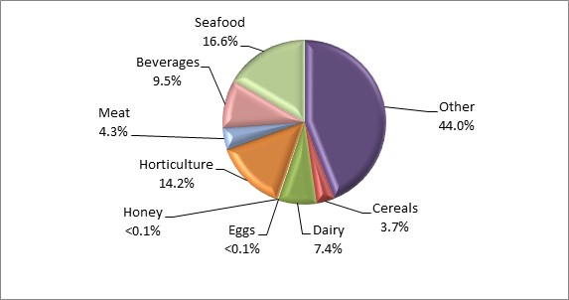
Data source: AIMS database
Appendix 1 provides an overview of the analytical tests applied to the commodity groups and Appendix 2 provides a list of the tariff codes associated with each commodity grouping used for this report.
Table 1 Inspection and test data, by commodity group
Commodity group | No. of tests applied | No. compliant / non-compliant | Compliance rate (%)
Beverages | 4 763 | 4 652 / 111 | 97.7
Cereals, flours and milled products | 1 836 | 1 824 / 12 | 99.3
Dairy | 3 715 | 3 690 / 25 | 99.3
Eggs | 18 | 18 / 0 | 100
Honey | 98 | 96 / 2 | 98.0
Horticulture | 7 104 | 7 015 / 89 | 98.7
Meat | 2 170 | 2 168 / 2 | 99.9
Seafood | 8 298 | 8 212 / 86 | 99.0
Other (incl. processed food) | 22 029 | 21 661 / 368 | 98.3
Total | 50 031 | 49 336 / 695 | 98.6
Source: AIMS database

Country of origin
Under the Imported Food Inspection Scheme, food is inspected based on its risk and/or frequency of importation. Country of origin is not generally targeted under routine inspections, but exceptions include where a food has previously failed inspection.
The numbers of inspections reflect those countries from which importers source food and/or import more regularly to Australia. The countries from which importers more frequently source food will have a higher representation in inspection activity for food safety. This data cannot be used to indicate volumes of food imported to Australia.
For the period 1 July to 31 December 2015:
- China, Thailand and Italy were the countries whose food was subject to most inspections
- 63.2 per cent of food inspections were on food from 10 countries; the remaining 36.8 per cent were on food from 114 countries.
A significant proportion of food imports are from New Zealand. However, under the Trans-Tasman Mutual Recognition Arrangement, most food from New Zealand is not subject to the Imported Food Control Act 1992 and is not inspected under the Imported Food Inspection Scheme.
Table 2 Number of inspections, by country of origin
Country of origin | No. of lines inspected | % of total lines inspected
China | 1 566 | 9.9
Thailand | 1 521 | 9.6
Italy | 1 161 | 7.3
United States | 1 064 | 6.7
Japan | 987 | 6.2
India | 969 | 6.1
Korea Republic Of | 941 | 5.9
France | 674 | 4.3
Malaysia | 586 | 3.7
Vietnam | 542 | 3.4
Other | 5 822 | 36.8
Total | 15 833
Note: For details of all countries of origin see Appendix 3.
Source: AIMS database
Figure 4 Percentage of inspections, by country of origin
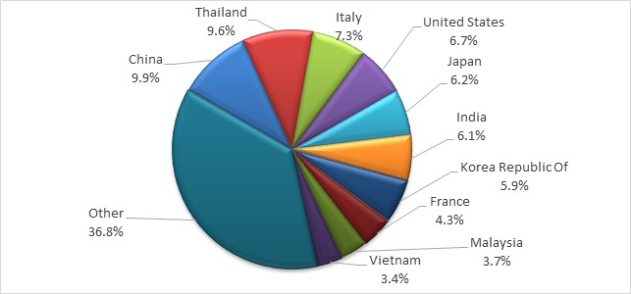
More detailed information about the countries with the largest number of inspections, China, Thailand and Italy is provided in the analytical testing data section.

Testing data

Summary for July to December 2015
- 98.6 per cent of all tests applied to imported food samples under the Imported Food Inspection Scheme complied with Australian standards for these tests.
- Incorrect labelling accounted for most non-compliance (77.0 per cent of failures).
- When labelling non-compliances are removed from testing data, the compliance rate for analytical and other tests applied to imported food rises to 99.5 per cent.
Table 3 Compliance for all tests
Test group | No. of tests applied | No. compliant / non-compliant | Compliance rate (%)
Analytical | 11 083 | 10 928 / 155 | 98.6
Labelling | 19 680 | 19 145 / 535 | 97.3
Other | 19 268 | 19 263 / 5 | 100
Total | 50 031 | 49 336 / 695 | 98.6
Figure 3 provides a summary of the 695 non-compliant tests from the 50 031 tests applied, with details of each specific test and the proportion each test contributed to the total.
Figure 5 Non-compliant test results

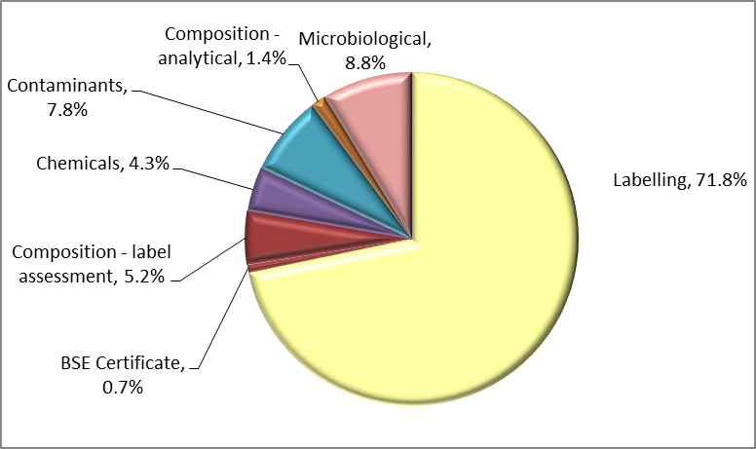

Labelling data
Figure 4 provides a detailed summary of labelling non-compliances against Australian food standards. Absent or incomplete importer details on labelling is the largest contributor to non-compliant labelling, accounting for 28.1 per cent of non-compliances. Ingredients list, country of origin and incorrect nutritional information labelling account for a further 48.6 per cent of label non-compliances.
Figure 6 Non-compliant labelling
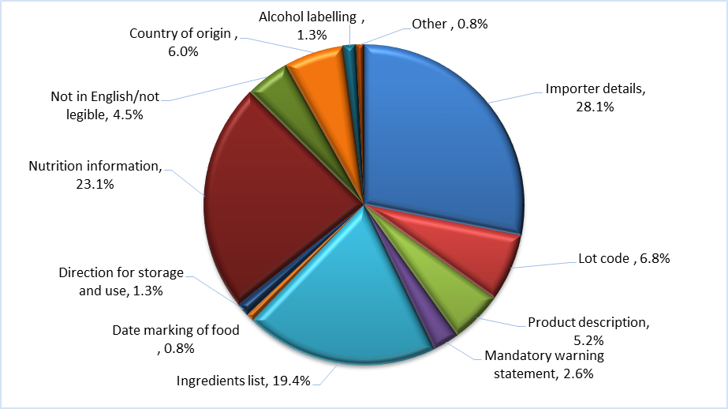

Other test data

Composition assessments
Additives or ingredients that are not permitted, or are in excess of permitted levels, may be identified during a label assessment. Of the 19 680 label assessments conducted, 36 were found to be non-compliant with these requirements.
Note: Where a food fails, composition is given a separate test code in the database and is applied for the purpose of holding order inspections. This adds 171 tests to the overall test data in this report but does not represent the actual test and compliance rate.

Bovine Spongiform Encephalopathy certificate checks
Food containing beef is referred as risk and government certification is assessed to determine compliance to Australia’s Bovine Spongiform Encephalopathy (BSE) policy. A fail is recorded when no compliant certificate is presented.

Table 4 Compliance for BSE certificate checks
Type of test | No. of tests applied | No. compliant / non-compliant | Compliance rate (%)
BSE Certificate | 360 | 355 / 5 | 98.6

Visual assessments
At every inspection the food is assessed for signs of unsafe or unsuitable condition such as foreign objects or deterioration.

Table 5 Compliance for visual assessments
Type of test | No. of tests applied | No. compliant / non-compliant | Compliance rate (%)
Visual | 18 908 | 18 908 / 0 | 100

Assessment of oysters ex. Korea/Japan
Oysters sourced from the Republic of Korea and specific marine areas of Hiroshima Prefecture, Japan are not permitted to be imported into Australia. The source of the oysters must be verified in writing by the national competent authority in Korea or Japan. A fail is recorded when the origin of the oysters is not able to be verified.
Table 6 Compliance for oysters ex Korea/Japan
Type of test | No. of tests applied | No. compliant / non-compliant | Compliance rate (%)
Oysters ex Korea/Japan | n/a | n/a | n/a

Analytical testing data
Within the analytical test category, tests are grouped according to four main types: chemical, contaminant, composition (analytical assessment) and microbiological (Table 7). Each category consists of several tests which are reported in detail in Tables 8, 9 and 10.
Analytical test results show a 98.6 per cent compliance rate with the tests applied under the Imported Food Inspection Scheme.
Of the 11 083 analytical tests applied, 155 (1.4 per cent) of the products being tested failed against the standards.
Table 7 Compliance for analytical testing
Type of test | No. of tests applied | No. compliant/non-compliant | Compliance rate (%)
Chemicals | 1 818 | 1 788 / 30 | 98.3
Contaminants | 3 705 | 3 651 / 54 | 98.5
Microbiological | 5 370 | 5 309 / 61 | 98.9
Composition | 190 | 180 / 10 | 94.7
Total | 11 083 | 10 928 / 155 | 98.6
Table 8 Compliance for chemical tests
Chemical | No. of tests applied | No. compliant / non-compliant | Compliance rate (%) | Types of food
Chloramphenicol | 6 | 6 / 0 | 100 | Honey
Ethylene chlorohydrin | 1 | 1 / 0 | 100 | Herbs and spices
Fluoroquinolones | 236 | 231 / 5 | 97.9 | Farmed fish and prawns
Fruit & veg residue screen | 918 | 893 / 25 | 97.3 | Fruit and vegetables
Malachite Green | 196 | 196 / 0 | 100 | Farmed fish
Nitrofurans | 35 | 35 / 0 | 100 | Farmed prawns, honey
Pesticides | 408 | 408 / 0 | 100 | Pig meat
Streptomycin | 6 | 6 / 0 | 100 | Honey
Sulphonamides | 6 | 6 / 0 | 100 | Honey
Tetracycline | 6 | 6 / 0 | 100 | Honey
Total | 1 818 | 1 788 / 30 | 98.3 | –
Table 9 Compliance for contaminant tests
Contaminant | No. of tests applied | No. compliant / non-compliant | Compliance rate (%) | Types of food
Aflatoxins | 560 | 533 / 27 | 95.2 | Nuts
Arsenic total | 372 | 372 / 0 | 100 | Cereal grains, cereal flours and processed cereals
Domoic acid | 269 | 269 / 0 | 100 | Bivalve molluscs
Erucic acid | 175 | 175 / 0 | 100 | Edible plant oils
Histamine | 1 190 | 1 179 / 11 | 99.1 | Fish
Hydrocyanic acid | 34 | 32 / 2 | 94.1 | Cassava chips
Inorganic arsenic | 6 | 6 / 0 | 100 | Seaweed
Iodine | 100 | 92 / 8 | 92.0 | Seaweed (brown algae)
Lead | 582 | 576 / 6 | 99.0 | Cereal grains, ready-to-eat cereal flours and processed cereals, canned and preserved fruit
PSP Toxin | 270 | 270 / 0 | 100 | Bivalve molluscs
Tin | 147 | 147 / 0 | 100 | Canned fruit
Total | 3 705 | 3 651 / 54 | 98.5 | –
Table 10 Compliance for microbiological tests
Microbial agent | No. of tests applied | No. compliant / non-compliant | Compliance rate (%) | Types of food
Bacillus cereus | 15 | 13 / 2 | 86.7 | Bean curd, tofu
E. coli | 1 074 | 1 056 / 18 | 98.3 | Processed meats, water, seafood, and cheese
Listeria monocytogenes | 1 169 | 1 150 / 19 | 98.4 | Cheese, ready-to-eat seafood, processed meats
Salmonella | 2 236 | 2 224 / 12 | 99.5 | Processed meats, seafood, dried coconut, dried chilli and pepper, sesame seeds, cheese
Standard plate count | 280 | 271 / 9 | 96.8 | Cooked prawns
Coagulase positive Staphylococcus | 387 | 386 / 1 | 99.7 | Processed meats and cooked prawns
Vibrio cholerae | 209 | 209 / 0 | 100 | Cooked prawns
Total | 5 370 | 5 309 / 61 | 98.9 | –
Table 11 Compliance for composition analytical tests
Microbial agent | No. of tests applied | No. compliant / non-compliant | Compliance rate (%) | Types of food
Allergen - dairy | 160 | 152 / 8 | 95.0 | Coconut drinks and coconut powders
C4 adulteration | 10 | 9 / 1 | 90.0 | Honey
Moisture content | 10 | 10 / 0 | 100 | Honey
Reducing sugar content | 10 | 9 / 1 | 90.0 | Honey
Total | 190 | 180 / 10 | 94.7 | –

Analytical testing data, China
In the period July to December 2015, food from China was subject to the highest number of inspections in comparison with other countries inspected under the Imported Food Inspection Scheme; representing 9.9 per cent of all food lines inspected.
Of the 1 161 analytical tests applied to imported food from China, 33 were found to be non-compliant, giving a 97.2 per cent compliance rate for tests applied.
Tests for contaminants were the most frequently applied followed by tests for microbiological, chemical content and non-permitted compositional content.
Table 12 Compliance for chemical tests, China
Chemical | No. of tests applied | No. compliant / non-compliant | Compliance rate (%)
Chloramphenicol | 5 | 5 / 0 | 100
Fluoroquinolones | 30 | 30 / 0 | 100
Fruit & veg residue screen | 193 | 184 / 9 | 95.3
Malachite Green | 20 | 20 / 0 | 100
Nitrofurans | 17 | 17 / 0 | 100
Streptomycin | 5 | 5 / 0 | 100
Sulphonamides | 5 | 5 / 0 | 100
Tetracycline | 5 | 5 / 0 | 100
Total | 280 | 271 / 9 | 96.8
Table 13 Compliance for contaminant tests, China
Contaminant | No. of tests applied | No. compliant/non-compliant | Compliance rate (%)
Aflatoxins | 129 | 114 / 15 | 88.4
Arsenic total | 9 | 9 / 0 | 100
Domoic acid | 67 | 67 / 0 | 100
Histamine | 69 | 69 / 0 | 100
Iodine | 22 | 21 / 1 | 95.5
Lead | 50 | 48 / 2 | 96.0
PSP toxin | 68 | 68 / 0 | 100
Tin | 27 | 27 / 0 | 100
Total | 441 | 423 / 18 | 95.9
Table 14 Compliance for microbiological testing, China
Microbial agent | No. of tests applied | No. compliant / non-compliant | Compliance rate (%)
Bacillus cereus | 6 | 4 / 2 | 66.7
Coagulase positive Staphylococcus | 42 | 41 / 1 | 97.6
E. coli | 57 | 56 / 1 | 98.2
Listeria monocytogenes | 41 | 40 / 1 | 97.6
Salmonella | 209 | 209 / 0 | 100
Standard plate count | 42 | 42 / 0 | 100
Vibrio cholerae | 33 | 33 / 0 | 100
Total | 430 | 425 / 5 | 98.8
Table 15 Compliance for composition analytical testing, China
Microbial agent | No. of tests applied | No. compliant / non-compliant | Compliance rate (%)
Allergen – dairy | 1 | 0 / 1 | 0
C4 adulteration | 3 | 3 / 0 | 100
Moisture content | 3 | 3 / 0 | 100
Reducing sugar content | 3 | 3 / 0 | 100
Total | 10 | 9 / 1 | 90.0

Analytical testing data, Thailand
In the period July to December 2015, food from Thailand was subject to the second highest number of inspections in comparison with other countries inspected under the Imported Food Inspection Scheme; representing 9.6 per cent of all food lines inspected.
Of the 1 260 analytical tests applied to imported food from Thailand, eight were found to be non-compliant, giving a 99.4 per cent compliance rate for tests applied.
Contaminant tests were the most frequently applied followed by tests for microbiological, chemical and non-permitted compositional content.
Table 16 Compliance for chemical tests, Thailand
Chemical | No. of tests applied | No. compliant / non-compliant | Compliance rate (%)
Fluoroquinolones | 12 | 11 / 1 | 91.7
Fruit & veg residue screen | 81 | 75 / 6 | 92.6
Malachite Green | 11 | 11 / 0 | 100
Nitrofurans | 1 | 1 / 0 | 100
Total | 105 | 98 / 7 | 93.3
Table 17 Compliance for contaminant tests, Thailand
Contaminant | No. of tests applied | No. compliant / non-compliant | Compliance rate (%)
Aflatoxins | 45 | 45 / 0 | 100
Arsenic total | 87 | 87 / 0 | 100
Domoic acid | 17 | 17 / 0 | 100
Erucic acid | 2 | 2 / 0 | 100
Histamine | 392 | 391 / 1 | 99.7
Hydrocyanic acid | 3 | 3 / 0 | 100
Lead | 164 | 164 / 0 | 100
PSP Toxin | 17 | 17 / 0 | 100
Tin | 69 | 69 / 0 | 100
Total | 796 | 795 / 1 | 99.9
Table 18 Compliance for microbiological tests, Thailand
Microbial agent | No. of tests applied | No. compliant / non-compliant | Compliance rate (%)
Coagulase positive Staphylococcus | 43 | 43 / 0 | 100
E. coli | 7 | 7 / 0 | 100
Listeria monocytogenes | 14 | 14 / 0 | 100
Salmonella | 98 | 98 / 0 | 100
Standard plate count | 40 | 40 / 0 | 100
Vibrio cholerae | 44 | 44 / 0 | 100
Total | 246 | 246 / 0 | 100
Table 19 Compliance for composition analytical tests, Thailand
Microbial agent | No. of tests applied | No. compliant / non-compliant | Compliance rate (%)
Allergen – dairy | 113 | 113 / 0 | 100
Total | 113 | 113 / 0 | 100

Analytical testing data, Italy
In the period July to December 2015, food from Italy was subject to the third highest number of inspections in comparison with other countries inspected under the Imported Food Inspection Scheme; representing 7.3 per cent of all food lines inspected.
Of the 789 analytical tests applied to imported food from Italy, seven were found to be non-compliant, giving a 99.1 per cent compliance rate for tests applied.
Microbiological tests were the most frequently applied followed by tests for chemical contaminants and non-permitted compositional content.
Table 20 Compliance for chemical tests, Italy
Chemical | No. of tests applied | No. compliant / non-compliant | Compliance rate (%)
Fruit & veg residue screen | 11 | 11 / 0 | 100
Total | 11 | 11 / 0 | 100
Table 21 Compliance for contaminant tests, Italy
Contaminant | No. of tests applied | No. compliant / non-compliant | Compliance rate (%)
Aflatoxins | 23 | 23 / 0 | 100
Arsenic total | 21 | 21 / 0 | 100
Domoic acid | 1 | 1 / 0 | 100
Erucic acid | 22 | 22 / 0 | 100
Histamine | 14 | 14 / 0 | 100
Lead | 23 | 23 / 0 | 100
PSP Toxin | 1 | 1 / 0 | 100
Tin | 2 | 2 / 0 | 100
Total | 107 | 107 / 0 | 100
Table 22 Compliance for microbiological tests, Italy
Microbial agent | No. of tests applied | No. compliant / non-compliant | Compliance rate (%)
Coagulase positive Staphylococcus | 28 | 28 / 0 | 100
E. coli | 217 | 212 / 5 | 97.7
Listeria monocytogenes | 198 | 196 / 2 | 99.0
Salmonella | 226 | 226 / 0 | 100
Total | 669 | 662 / 7 | 99.0
Table 23 Compliance for composition analytical tests, Italy
Microbial agent | No. of tests applied | No. compliant / non-compliant | Compliance rate (%)
Allergen – dairy | 2 | 2 / 0 | 100
Total | 2 | 2 / 0 | 100

Appendixes

Appendix 1: Analytical tests applied to food
Food group | Risk / Surveillance test | Analytical test
Dairy products | Risk | Listeria monocytogenes  Salmonella  E. coli
Dairy products | Surveillance | Salmonella  E. coli
Edible plant oils | Surveillance | Erucic acid
Fruit | Surveillance | Fruit & veg residue screen  E. coli (ready-to-eat frozen berries only)
Fruit – canned and preserved | Surveillance | Lead  Tin (canned only)
Fruit juices | Surveillance | Fruit & veg residue screen  Carbendazim (orange juice only)
Herbs and spices | Risk | Salmonella
Honey | Surveillance | Chloramphenicol  Nitrofurans  Streptomycin  Tetracycline  Sulphonamides  Adulteration
Meat | Risk | BSE government certification  Coagulase-positive Staphylococcus  E. coli  Listeria monocytogenes  Salmonella
Meat | Surveillance | Pesticide screen
Nuts and nut products | Risk | Salmonella  Aflatoxin
Seafood | Risk | Histamine  Listeria monocytogenes  Coagulase-positive Staphylococcus  E. coli  Salmonella  Standard plate count  Paralytic shellfish poison (PSP)  Domoic acid
Seafood | Surveillance | Histamine  Malachite green  Nitrofurans  Fluoroquinolones
Vegetables | Risk | Salmonella (sesame seeds)  Inorganic arsenic (hijiki seaweed)  Iodine (seaweed (brown algae))
Vegetables | Surveillance | Fruit & veg residue screen  Bacillus cereus (tofu, soy bean / milk curd)  Arsenic total (cereal grains, ready-to-eat cereal flours and processed cereals)  Lead (cereal grains, ready-to-eat cereal flours and processed cereals)

Appendix 2: Tariff codes included in each food commodity group
Commodity group | Tariff code
Beverages | 2009  2201 – 2208
Cereals | 1001 – 1008  1101 – 1109
Dairy | 0401 – 0406
Eggs | 0407 – 0408
Honey | 0409
Horticulture | 0701 – 0714  0801 – 0814  0904 – 0910  1201 – 1208  1210 – 1212  1801 – 1802
Meat | 0201 – 0212  0504  1601 - 1602
Seafood | 0302 – 0307  1603 – 1605
Other (incl. processed food) | 0410  0901 – 0903  1301 – 1302  1501 – 1504  1506 – 1517  1520 – 1521  1701 – 1704  1803 – 1806  1901 – 1905  2001 – 2008  2101 – 2106  2209  2501  3501 – 3503  3505  3507

Appendix 3: Number of lines inspected per country
Country | Lines inspected
Albania | 1
Algeria | 1
Argentina | 33
Australia | 8
Austria | 38
Bahamas | 1
Bangladesh | 41
Belgium | 170
Belize | 2
Bolivia | 10
Bosnia And Herzegovina | 6
Brazil | 55
Brunei Darussalam | 1
Bulgaria | 23
Cambodia | 4
Canada | 150
Chile | 55
China | 1 566
Colombia | 12
Cook Islands | 1
Costa Rica | 6
Cote Divoire | 3
Croatia | 33
Cuba | 1
Cyprus | 10
Czech Republic | 9
Denmark | 173
Ecuador | 9
Egypt | 32
El Salvador | 3
Estonia | 2
Ethiopia | 8
Fiji | 47
Finland | 5
France | 674
French Polynesia | 1
Georgia | 1
Germany | 327
Ghana | 6
Greece | 141
Guatemala | 4
Guinea | 3
Honduras | 4
Hong Kong | 125
Hungary | 10
Iceland | 1
India | 969
Indonesia | 379
Iran | 53
Ireland | 67
Israel | 44
Italy | 1 161
Japan | 987
Jordan | 15
Kenya | 4
Kiribati | 2
Korea, Republic Of | 941
Kyrgyzstan | 2
Latvia | 1
Lebanon | 76
Liberia | 4
Luxembourg | 3
Macedonia | 35
Malaysia | 586
Maldives | 1
Malta | 8
Mauritius | 7
Mexico | 85
Montenegro | 1
Morocco | 9
Myanmar | 48
Namibia | 2
Nepal | 12
Netherlands | 293
Netherlands Antilles | 1
New Zealand | 142
Nicaragua | 4
Nigeria | 4
Norway | 42
Oman | 2
Pakistan | 62
Papua New Guinea | 9
Paraguay | 2
Peru | 39
Philippines | 256
Poland | 57
Portugal | 49
Puerto Rico | 10
Romania | 7
Russian Federation | 20
Saint Barthelemy | 1
Samoa | 2
Saudi Arabia | 9
Serbia | 55
Sierra Leone | 1
Singapore | 201
Slovenia | 10
Solomon Islands | 1
South Africa | 188
Spain | 286
Sri Lanka | 339
St Helena | 1
Sudan | 5
Swaziland | 2
Sweden | 37
Switzerland | 133
Taiwan | 523
Tanzania | 1
Thailand | 1 521
Timor-Leste | 1
Tonga | 5
Trinidad And Tobago | 4
Tunisia | 5
Turkey | 116
Uganda | 3
Ukraine | 3
United Arab Emirates | 29
United Kingdom | 419
United States | 1 064
Uruguay | 2
Vanuatu | 1
Venezuela | 2
Vietnam | 542
Zimbabwe | 4
Grand total | 15 833

Glossary
AIMS
AIMS is the computer system that receives data on imported goods from the Integrated Cargo System (ICS) and processes entries for both imported food and biosecurity purposes.
Australia New Zealand Food Standards Code
The Code details food standards applicable to food for human consumption in Australia and is published on the FSANZ website.
Batch
Batch means food of a particular kind made or packed in a distinct manner which may include one or more lots.
Entry
An electronic document generated using the Integrated Cargo System (ICS). An entry may contain one or more lines/food.
Food
Section 3 of the Imported Food Control Act 1992 describes food as:
(a) Any substance or thing of a kind used or capable of being used as food or drink by human beings; or
(b) any substance or thing of a kind used or capable of being used as an ingredient or additive in, or substance used in the preparation of, a substance or thing referred to in paragraph (a); or
(c) any other substance or thing that is prescribed; whether or not it is in a condition fit for human consumption, but does not include a therapeutic good within the meaning of the Therapeutic Goods Act 1989.
FSANZ
Food Standards Australia New Zealand is a bi-national government agency responsible for developing food standards and administering the Australia New Zealand Food Standards Code. FSANZ conducts the food risk assessment and advises the Department of Agriculture and Water Resources about food that poses a medium to high risk to human health and safety.
Holding Order
An order made under the Imported Food Control Act 1992 increasing the rate of inspection of a surveillance food that has failed an imported food inspection. This targets the specific food from the specific manufacturer in a specific country at a rate of 100 per cent of consignments.
Imported Food Inspection Scheme
The inspection scheme, established under the Imported Food Control Regulations 1993, provides for inspection of food at the border to assess importer compliance with sourcing food that meets Australian food standards.
Inspection
Includes inspection (visual and label assessment), or inspection and analysis (samples taken and sent for analysis), as the case requires.
Line
Items of food being imported are recorded within the Integrated Cargo System (ICS) as lines within the import entry. An import entry may consist of one line or many lines of products.
Lot
A quantity of a food prepared or packed under essentially the same conditions (ordinarily from a particular preparation or packing unit and during a particular time ordinarily not exceeding 24 hours).
Lot Code
A unique code that identifies a lot and can be used for recall purposes if necessary.
Risk food
Food that FSANZ has assessed as representing a medium to high potential risk to consumer health are referred to AIMS by the Integrated Cargo System (ICS) for inspection at the rate of 100 per cent of imports, reducing with a history of compliance.
Surveillance food
All other food not classified as risk. Referred to AIMS by the Integrated Cargo System (ICS) for inspection at the rate of 5 per cent of consignments.
Trans-Tasman Mutual Recognition Arrangement
This is an arrangement between the Australian, state and territory governments and the government of New Zealand. It allows goods (including food) to be traded freely between New Zealand and Australia and enhances the freedom of individuals to work in both countries.

