Imported Food Inspection Data
Report for July - December 2014
Imported Food


© Commonwealth of Australia 2015
Ownership of intellectual property rights
Unless otherwise noted, copyright (and any other intellectual property rights, if any) in this publication is owned by the Commonwealth of Australia (referred to as the Commonwealth).
Creative Commons licence
All material in this publication is licensed under a Creative Commons Attribution 3.0 Australia Licence, save for content supplied by third parties, logos and the Commonwealth Coat of Arms.

Creative Commons Attribution 3.0 Australia Licence is a standard form licence agreement that allows you to copy, distribute, transmit and adapt this publication provided you attribute the work. A summary of the licence terms is available from creativecommons.org/licenses/by/3.0/au/deed.en. The full licence terms are available from creativecommons.org/licenses/by/3.0/au/legalcode.
This publication (and any material sourced from it) should be attributed as Imported Food Inspection Data Report for July-December 2014, Imported Food, Department of Agriculture, Canberra, May 2015. CC BY 3.0.
Cataloguing data
Imported Food 2014, Imported Food Inspection Data Report for July-December 2014, Department of Agriculture, Canberra, May 2015.
Internet
Imported Food Inspection Data Report is available at agriculture.gov.au/biosecurity/import/food/inspection-data
Department of Agriculture
Postal address GPO Box 1563 Canberra ACT 2601
Switchboard +61 2 6272 2010
Facsimile +61 2 6272 2001
Email foodimp@agriculture.gov.au
Web agriculture.gov.au
Inquiries about the licence and any use of this document should be sent to copyright@agriculture.gov.au.
The Australian Government acting through the Department of Agriculture has exercised due care and skill in preparing and compiling the information and data in this publication. Notwithstanding, the Department of Agriculture, its employees and advisers disclaim all liability, including liability for negligence, for any loss, damage, injury, expense or cost incurred by any person as a result of accessing, using or relying upon any of the information or data in this publication to the maximum extent permitted by law.

Contents
Summary 1
Imported Food Inspection Scheme 2
Food Import Compliance Agreement notifications 2
Summary for July to December 2014 3
Application of tests to imported food 3
Commodity groups 3
Country of origin 5
Testing data 6
Analytical testing data, China 10
Analytical testing data, Thailand 11
Analytical testing data, Italy 12
Appendixes 14
Appendix 1: Analytical tests applied to food 14
Appendix 2: Tariff codes included in each food commodity group 15
Appendix 3: No. of inspections per country 16
Glossary 18

Tables
Table 1 Inspection and test data, by commodity group 5
Table 2 Number of inspections, by country of origin 6
Table 3 Compliance for all tests 7
Table 4 Compliance for BSE certificate checks 9
Table 5 Compliance for visual assessments 9
Table 6 Compliance for oysters ex Korea/Japan 9
Table 7 Compliance for analytical testing 10
Table 8 Compliance for chemical tests 10
Table 9 Compliance for contaminant tests 11
Table 10 Compliance for microbiological tests 11
Table 11 Compliance for chemical tests, China 12
Table 12 Compliance for contaminant tests, China 12
Table 13 Compliance for microbiological testing, China 12
Table 14 Compliance for chemical tests, Thailand 13
Table 15 Compliance for contaminant tests, Thailand 13
Table 16 Compliance for microbiological tests, Thailand 13
Table 17 Compliance for chemical tests, Italy 14
Table 18 Compliance for contaminant tests, Italy 14
Table 19 Compliance for microbiological tests, Italy 14

Figures
Figure 1 Percentage of tests applied to each commodity group 4
Figure 2 Percentage of inspections, by country of origin 6
Figure 3 Non-compliant test results 7
Figure 4 Non-compliant labelling 7

Summary
The Department of Agriculture is responsible for managing Australia’s biosecurity system. Every year the department helps millions of people, goods, vessels and aircraft move into and out of Australia without harming the environment, animal, plant and human health.
The department is one of many Australian Government agencies responsible for regulating imported food. Its role includes ensuring imported food meets Australia’s biosecurity requirements and the requirements of the Imported Food Control Act 1992. This legislation allows the department to run a food safety inspection program known as the Imported Food Inspection Scheme (IFIS). In addition to the department's imported food testing, the state and territory jurisdictions also have responsibility for ensuring that all food, including imported food, meets the requirements of the Australia New Zealand Food Standards Code (the Code) at the point of sale.
This report provides summary data from imported food inspections under the IFIS for the period 1 July to 31 December 2014. The department has published these reports every six months since July 2006; previous reports are available from the department’s website.
The department periodically reviews the monitoring of imported food. Through this review, tests may be added or removed to monitor imported food for compliance with Australian food standards as published in the Code. The review considers a variety of factors and involves consultation with imported food stakeholders.
During the period covered by this report, the department implemented targeted border intervention of imported honey to include an assessment of honey for adulteration. This was an outcome of the findings from an investigation by the Australian Competition and Consumer Commission (ACCC) looking into a breach of Australian Consumer Law. The ACCC took action against a honey importer based on evidence of blended or artificial imported honey being misrepresented as ‘honey’. The department issued an Imported Food Notice to advise importers of this change.
A review of some surveillance testing was also completed during this period. Since the previous report, the number of chemical, contaminant and microbiological analytical tests applied to imported food increased from 9,868 to 11,505. During the period July to December 2014, the Department introduced a minor change to surveillance testing of cereal grains and edible plant oils whereby residue testing for these commodities was removed and replaced with contaminant testing for arsenic (total) and lead. Additionally, testing to monitor edible plant oils for erucic acid for compliance with the Code was introduced to replace previous chemical residue testing. A final outcome of the surveillance testing review was to cease analytical testing of highly processed fats and oils which showed a very high compliance rate with the Code over the duration of the testing. The department issued an Imported Food Notice to advise importers of these testing changes.
The changes were made in mid November 2014 and are unlikely to have impacted the overall number of tests reflected in the inspection data report. The increased number of tests applied in the period July to December 2014 reflects a regular increase in volumes of all imported food noted in the lead up to Christmas.
More information on the tests applied to imported food is available from the department’s website http://www.agriculture.gov.au/import/food.

Food Standards Australia New Zealand (FSANZ) is conducting a review of the risk assessment advice on risk foods (previously reviewed in 2007). FSANZ is generating separate risk statements for each food/hazard combination which determines the level of risk for that specific pairing. The department then determines the appropriate risk management measures for imported food based on the conclusions of the risk advice provided by FSANZ. For some foods, the risk management measures will require government certification attesting to the through-chain controls in the exporting country. Changes to imported food legislation are being prepared to support this requirement.
More information on the imported food risk statements is available from the FSANZ website http://www.foodstandards.gov.au/consumer/importedfoods/Pages/FSANZ-advice-on-imported-food.aspx.

Imported Food Inspection Scheme
The Department of Agriculture administers two sets of requirements with which imported food must comply. Food imported into Australia is subject to requirements under the Quarantine Act 1908 (Cwlth) to address quarantine concerns and the Imported Food Control Act 1992 (Cwlth) to monitor compliance with sourcing food that meets Australia’s food standards. Quarantine requirements must be met before food standards are considered.
To monitor importers’ compliance with sourcing food that meets Australia’s food standards, the Department of Agriculture operates a risk-based border inspection scheme—the Imported Food Inspection Scheme.
Food Standards Australia New Zealand (FSANZ), within the Department of Health portfolio, develops and maintains the Australia New Zealand Food Standards Code (the Code). The Code lists Australia’s food standards requirements including contaminants (such as microbiological, chemical), additives, labelling and genetically modified food as well as production and processing standards.
FSANZ provides advice to the Department of Agriculture on food that pose a medium to high risk to public health. The department classifies these as risk under the inspection scheme, and classifies all other food as surveillance.
To identify which food is of interest, and the rate at which they should be referred (that is, whether at 100 per cent or 5 per cent of consignments), the department applies electronic profiles in the Australian Customs and Border Protection Service’s Integrated Cargo System (ICS).
Once food is referred, the department’s systems apply relevant tests and inspection rates based on the risk the food may pose and for some food the compliance history of the producer and supplier.
When imported food fails inspection, follow-up action such as treatment of the food to bring it to compliance, destruction or export is undertaken. Additionally, subsequent imports of the same food are subject to inspection at the rate of 100 per cent of consignments until a history of compliance is again demonstrated.

Food Import Compliance Agreement notifications
Food Import Compliance Agreements offer food importers an alternative regulatory arrangement to inspection and testing of their products under the Imported Food Inspection Scheme. Compliance agreements are an assurance-based arrangement undertaken through formal recognition and audit of an importer’s documented food safety management system by the Department of Agriculture.
Importers under a compliance agreement must report non-compliant analytical test results to the department, which will then consider what further action is needed.
During the reporting period (July to December 2014), six non-compliant food notifications were reported for analytical results. The foods were subject to disposal by destruction and the importer implemented corrective action including an increased level of analytical testing for these products. The fails were also reported to the relevant state government authority.

Summary for July to December 2014
The data contained in this report was obtained from imported food inspection data for the period 1 July to 31 December 2014. During this period:
- 10 026 entries of imported food were referred for inspection under the Imported Food Inspection Scheme
- 16 168 lines of imported food were inspected
- Of these lines, 36.0 per cent were risk food, 61.5 per cent were surveillance food and 2.5 per cent were surveillance food subject to a Holding Order
- 51 745 tests were applied, including label and visual checks
- 20 336 label and composition assessments
- 11 505 analytical tests
- 19 904 other tests
More detailed analysis of data is provided based on
- commodity groups
- country of origin
- inspection data tests applied and compliance rates.
See Glossary for explanation of terms used in this document.

Application of tests to imported food
The number of lines of food referred for inspection under the Scheme and the number of tests applied to those lines of food may differ. This is because food subject to inspection is sampled and tested based on the number of:
- batches and lots within each batch of food on the line referred for inspection
- tests to be applied to each sample of that food taken during inspection.
For example, one line of a cooked and processed meat product may be referred for inspection under the Scheme. The line contains two batches of the product, each with one lot. An officer will take one sample from each batch and apply the microbiological tests relevant to this food. The test for cooked and processed meat products are E. coli, standard plate count, coagulase positive Staphylococci, Listeria monocytogenes and Salmonella. As a result, two samples have been taken from this one line of imported food and five microbiological tests have been applied to each sample.
This will be reported as:
- number of lines – one
- number of tests applied – ten.

Commodity groups
While risk food is specifically targeted for inspection, surveillance food is subject to random inspection at the rate of five per cent of consignments. The numbers of tests applied reflects this approach. Commodity groups that contain more risk food and/or are imported more frequently have a higher representation under the inspection activity. It may also reflect where goods have previously failed and the inspection rate has increased to 100 per cent until compliance has again been demonstrated. This data cannot be used to indicate volumes of trade.

Test data by commodity groups
During the reporting period the single commodity subject to most testing was seafood which accounted for 18.2 per cent of tests applied (Figure 1) under the Imported Food Inspection Scheme. Captured under this category are fresh, chilled, frozen and processed seafood products.
Horticulture (including fresh and processed fruit and vegetables) was the next highest single commodity inspected and was subject to 14.2 per cent of all tests applied to imported food under the Imported Food Inspection Scheme.
Figure 1 Percentage of tests applied to each commodity group
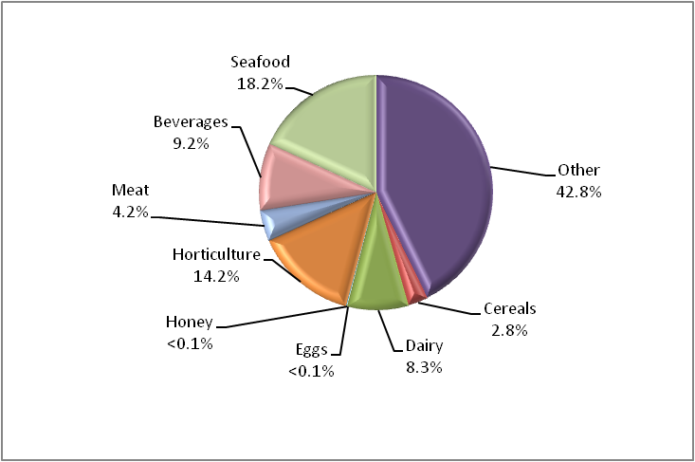
Data source: AIMS database
Appendix 1 provides an overview of the analytical tests applied to the commodity groups and Appendix 2 provides a list of the tariff codes associated with each commodity grouping used for this report.
Table 1 Inspection and test data, by commodity group
Commodity group | No. of tests applied | No. compliant / non-compliant | Compliance rate (%)
Beverages | 4 786 | 4 670 /116 | 97.6
Cereals, flours and milled products | 1 453 | 1 442 / 11 | 99.2
Dairy | 4 313 | 4 281 / 32 | 99.3
Eggs | 12 | 12 / 0 | 100
Honey | 94 | 93 / 1 | 98.9
Horticulture | 7 336 | 7 218 / 118 | 98.4
Meat | 2 189 | 2 183 / 6 | 99.7
Seafood | 9 407 | 9 322 / 85 | 99.1
Other (incl. processed food) | 22 155 | 21 824 / 331 | 98.5
Total | 51 745 | 51 045 / 700 | 98.6
Source: AIMS database

Country of origin
Under the Imported Food Inspection Scheme, food is inspected based on its risk and/or frequency of importation. Country of origin is not generally targeted under routine inspections, but exceptions include where a food has previously failed inspection.
The numbers of inspections reflect those countries from which importers source food and/or import more regularly to Australia. The countries from which importers more frequently source food will have a higher representation in inspection activity for food safety. This data cannot be used to indicate volumes of food imported to Australia.
For the period 1 July to 31 December 2014:
- China, Thailand and Italy were the countries whose food was subject to most inspections
- 61.9 per cent of food inspections were on food from 10 countries; the remaining 38.1 per cent were on food from 109 countries.
The Australian Food Statistics (published annually by the Department of Agriculture) indicates that a significant proportion of food imports are from New Zealand. However, under the Trans-Tasman Mutual Recognition Arrangement, most food from New Zealand is not subject to the Imported Food Control Act 1992 and is not inspected under the Imported Food Inspection Scheme.
Table 2 Number of inspections, by country of origin
Country of origin | No. of lines inspected | % of total lines inspected
China | 1634 | 10.1
France | 663 | 4.1
India | 964 | 6.0
Italy | 1 216 | 7.5
Japan | 750 | 4.6
Korea, Republic of | 867 | 5.4
Malaysia | 648 | 4.0
Thailand | 1 515 | 9.4
United States | 1 211 | 7.5
Taiwan | 532 | 3.3
Other | 6 168 | 38.1
Total | 16 168
Note: For details of all countries of origin see Appendix 3.
Source: AIMS database
Figure 2 Percentage of inspections, by country of origin
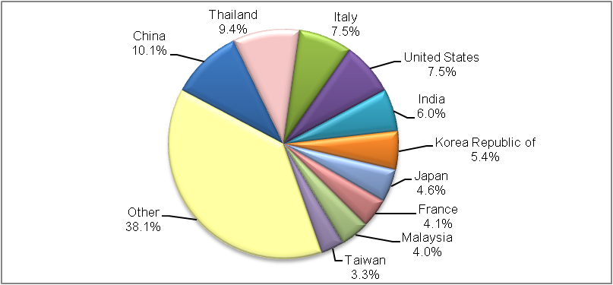
More detailed information about China, Thailand and Italy is provided in the analytical testing data section.

Testing data

Summary for July to December 2014
- 98.6 per cent of all tests applied to imported food samples under the Imported Food Inspection Scheme complied with Australian standards for these tests.
- Incorrect labelling accounted for most non-compliance (79.6 per cent of failures).
- When labelling non-compliances are removed from testing data, the compliance rate for analytical and other tests applied to imported food rises to 99.5 per cent.
Table 3 Compliance for all tests
Test group | No. of tests applied | No. compliant / non-compliant | Compliance rate (%)
Analytical | 11 505 | 11 366 / 139 | 98.8
Labelling | 20 336 | 19 779 / 557 | 97.3
Other | 19 904 | 19 900 / 4 | 100
Total | 51 745 | 51 045 / 700 | 98.6
Figure 3 provides a summary of the 700 non-compliant tests from the 51 745 tests applied, with details of each specific test and the proportion each test contributed to the total.
Figure 3 Non-compliant test results
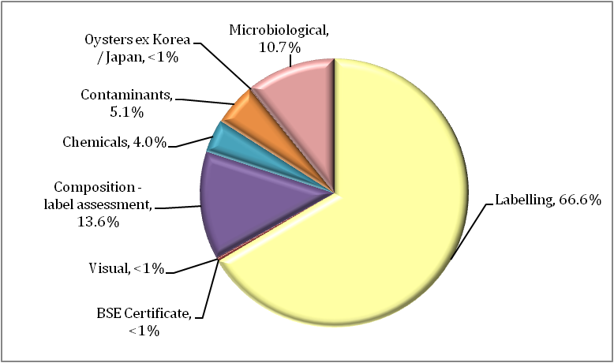

Labelling data
Figure 4 provides a detailed summary of labelling non-compliances against Australian food standards. Absent or incomplete importer details on labelling is the largest contributor to non-compliant labelling, accounting for 36.3 per cent of non-compliances. Ingredients list, country of origin and incorrect alcohol labelling account for a further 35.2 per cent of label non-compliances.
Figure 4 Non-compliant labelling
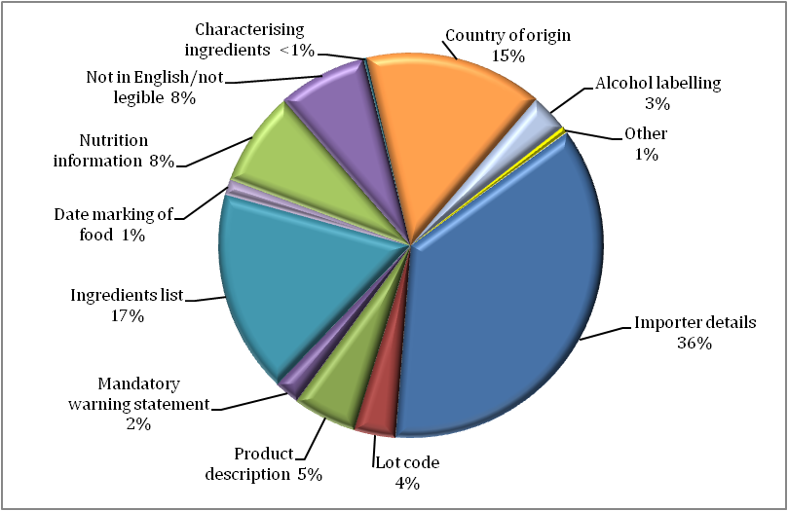

Other test data
Composition assessments
Additives or ingredients that are not permitted, or are in excess of permitted levels, may be identified during a label assessment. Of the 20 336 label assessments conducted, 91 were found to be non-compliant with these requirements.
Note: Where a food fails, composition is given a separate test code in the database and is applied for the purpose of holding order inspections. This adds 171 tests to the overall test data in this report but does not represent the actual test and compliance rate.
Food may also be sampled and tested for the presence and level of additives under the surveillance program. These tests are reported under the analytical data.
Bovine Spongiform Encephalopathy certificate checks
Food containing beef is referred as risk and government certification is assessed to determine compliance to Australia’s Bovine Spongiform Encephalopathy (BSE) policy. A fail is recorded when no compliant certificate is presented.
Table 4 Compliance for BSE certificate checks
Type of test | No. of tests applied | No. compliant / non-compliant | Compliance rate (%)
BSE Certificate | 277 | 275 / 2 | 99.3
Visual assessments
At every inspection the food is assessed for signs of unsafe or unsuitable condition such as foreign objects or deterioration.
Table 5 Compliance for visual assessments
Type of test | No. of tests applied | No. compliant / non-compliant | Compliance rate (%)
Visual | 19 626 | 19 625 / 1 | 99.9
Assessment of oysters ex. Korea/Japan
Oysters sourced from the Republic of Korea and specific marine areas of Hiroshima Prefecture, Japan are not permitted to be imported into Australia. The source of the oysters must be verified in writing by the national competent authority in Korea or Japan. A fail is recorded when the origin of the oysters is not able to be verified.
Table 6 Compliance for oysters ex Korea/Japan
Type of test | No. of tests applied | No. compliant / non-compliant | Compliance rate (%)
Oysters ex Korea/Japan | 1 | 0 / 1 | 0

Analytical testing data
Within the analytical test category, tests are grouped according to three main types: chemical, contaminant and microbiological (Table 7). Each category consists of several tests which are reported in detail in Tables 8, 9 and 10.
Analytical test results show a 98.8 per cent compliance rate with the tests applied under the Imported Food Inspection Scheme.
Of the 11 505 analytical tests applied, 139 (1.2 per cent) of the products being tested failed against the standards.
Table 7 Compliance for analytical testing
Type of test | No. of tests applied | No. compliant/non-compliant | Compliance rate (%)
Chemicals | 2 528 | 2 500 / 28 | 98.9
Contaminants | 2 705 | 2 669 / 36 | 98.7
Microbiological | 6 272 | 6 197 / 75 | 98.8
Total | 11 505 | 11 366 / 139 | 98.8
Table 8 Compliance for chemical tests
Chemical | No. of tests applied | No. compliant / non-compliant | Compliance rate (%) | Types of food
Carbendazim | 25 | 25 / 0 | 100 | Orange juice
Chloramphenicol | 12 | 12 / 0 | 100 | Honey
Ethylene Chlorohydrin | 1 | 1 / 0 | 100 | Horticulture
Fluoroquinolones | 302 | 287 / 15 | 95.0 | Farmed fish and prawns
Malachite Green | 217 | 214 / 3 | 98.6 | Farmed fish
Nitrofurans | 80 | 77 / 3 | 96.3 | Farmed prawns, honey
Pesticides | 1855 | 1848 / 7 | 99.6 | Fruit, vegetables, meat
Streptomycin | 12 | 12 / 0 | 100 | Honey
Sulphonamides | 12 | 12 / 0 | 100 | Honey
Tetracycline | 12 | 12 / 0 | 100 | Honey
Total | 2528 | 2 500 / 28 | 98.9 | –

Table 9 Compliance for contaminant tests
Contaminant | No. of tests applied | No. compliant / non-compliant | Compliance rate (%) | Types of food
Aflatoxins | 541 | 525 / 16 | 97.0 | Nuts
Arsenic total | 84 | 84 / 0 | 100 | Cereal grains, cereal flours and processed cereals
Domoic acid | 204 | 204 / 0 | 100 | Bivalve molluscs
Erucic acid | 61 | 61 / 0 | 100 | Edible plant oils
Histamine | 1398 | 1391 / 7 | 99.5 | Fish
Hydrocyanic acid | 21 | 18 / 3 | 85.7 | Cassava chips
Inorganic arsenic | 5 | 4 / 1 | 80.0 | Seaweed
Iodine | 101 | 92 / 9 | 91.1 | Seaweed (brown algae)
Lead | 84 | 84 / 0 | 100 | Cereal grains, ready-to-eat cereal flours and processed cereals, canned and preserved fruit
PSP Toxin | 206 | 206 / 0 | 100 | Bivalve molluscs
Total | 2705 | 2669 / 36 | 98.7 | –
Table 10 Compliance for microbiological tests
Microbial agent | No. of tests applied | No. compliant / non-compliant | Compliance rate (%) | Types of food
Bacillus cereus | 31 | 27 / 4 | 87.1 | Bean curd, tofu
E. coli | 1122 | 1092 / 30 | 97.3 | Processed meats, water, seafood, and cheese
Listeria monocytogenes | 1314 | 1298 / 16 | 98.8 | Cheese, ready-to-eat seafood, processed meats
Salmonella | 2585 | 2574 / 11 | 99.6 | Processed meats, seafood, dried coconut, dried chilli and pepper, sesame seeds, cheese
Standard plate count | 415 | 405 / 10 | 97.6 | Cooked prawns
Coagulase positive Staphylococcus | 539 | 539 / 0 | 100.0 | Processed meats and cooked prawns
Vibrio cholerae | 266 | 262 / 4 | 98.5 | Cooked prawns
Total | 6272 | 6197 / 75 | 98.8 | –

Analytical testing data, China
In the period July to December 2014, food from China was subject to the highest number of inspections in comparison with other countries inspected under the Imported Food Inspection Scheme; representing 10.1 per cent of all food lines inspected.
Of the 1 183 analytical tests applied to imported food from China, 30 were found to be non-compliant, giving a 97.5 per cent compliance rate for tests applied.
Microbiological tests were the most frequently applied followed by tests for contaminants and chemical content.
Table 11 Compliance for chemical tests, China
Chemical | No. of tests applied | No. compliant / non-compliant | Compliance rate (%)
Chloramphenicol | 3 | 3 / 0 | 100
Fluoroquinolones | 57 | 44 / 13 | 77.2
Malachite Green | 8 | 8 / 0 | 100
Nitrofurans | 33 | 33 / 0 | 100
Pesticides | 183 | 181 / 2 | 98.9
Streptomycin | 3 | 3 / 0 | 100
Sulphonamides | 3 | 3 / 0 | 100
Tetracycline | 3 | 3 / 0 | 100
Total | 293 | 278 / 15 | 94.9
Table 12 Compliance for contaminant tests, China
Contaminant | No. of tests applied | No. compliant/non-compliant | Compliance rate (%)
Aflatoxins | 107 | 102 / 5 | 95.3
Arsenic total | 1 | 1 / 0 | 100
Domoic acid | 86 | 86 / 0 | 100
Histamine | 43 | 43 / 0 | 100
Hydrocyanic acid | n/a | n/a | n/a
Inorganic arsenic | 1 | 0 / 1 | 0
Iodine | 34 | 30 / 4 | 88.2
Lead | 1 | 1 / 0 | 100
PSP toxin | 87 | 87 / 0 | 100
Total | 360 | 350 / 10 | 97.2
Note: n/a = not available – no tests applied
Table 13 Compliance for microbiological testing, China
Microbial agent | No. of tests applied | No. compliant / non-compliant | Compliance rate (%)
Bacillus cereus | 6 | 5 / 1 | 83.3
Coagulase positive Staphylococcus | 62 | 62 / 0 | 100
E. coli | 41 | 40 / 1 | 97.6
Listeria monocytogenes | 34 | 34 / 0 | 100
Salmonella | 263 | 263 / 0 | 100
Standard plate count | 63 | 62 / 1 | 98.4
Vibrio cholerae | 61 | 59 / 2 | 96.7
Total | 530 | 525 / 5 | 99.1

Analytical testing data, Thailand
In the period July to December 2014, food from Thailand was subject to the second highest number of inspections in comparison with other countries inspected under the Imported Food Inspection Scheme; representing 9.4 per cent of all food lines inspected.
Of the 1 062 analytical tests applied to imported food from Thailand, six were found to be non-compliant, giving a 99.4 per cent compliance rate for tests applied.
Contaminant tests were the most frequently applied followed by tests for microbiological and chemical content.
Table 14 Compliance for chemical tests, Thailand
Chemical | No. of tests applied | No. compliant / non-compliant | Compliance rate (%)
Fluoroquinolones | 8 | 8 / 0 | 100
Malachite Green | 3 | 3 / 0 | 100
Nitrofurans | 5 | 4 / 1 | 80.0
Pesticides | 162 | 161 / 1 | 99.4
Streptomycin | n/a | n/a | 0.0
Sulphonamides | n/a | n/a | 0.0
Tetracycline | n/a | n/a | 0.0
Total | 178 | 176 / 2 | 98.9
Note: n/a = not available – no tests applied
Table 15 Compliance for contaminant tests, Thailand
Contaminant | No. of tests applied | No. compliant / non-compliant | Compliance rate (%)
Aflatoxins | 39 | 37 / 2 | 94.9
Arsenic total | 24 | 24 / 0 | 100
Domoic acid | 14 | 14 / 0 | 100
Erucic acid | 2 | 2 / 0 | 100
Histamine | 447 | 447 / 0 | 100
Hydrocyanic acid | 4 | 4 / 0 | 100
Iodine | n/a | n/a | n/a
Lead | 24 | 24 / 0 | 100
PSP Toxin | 14 | 14 / 0 | 100
Total | 568 | 566 / 2 | 99.6
Note: n/a = not available – no tests applied
Table 16 Compliance for microbiological tests, Thailand
Microbial agent | No. of tests applied | No. compliant / non-compliant | Compliance rate (%)
Bacillus cereus | n/a | n/a | n/a
Coagulase positive Staphylococcus | 52 | 52 / 0 | 100
E. coli | 8 | 8 / 0 | 100
Listeria monocytogenes | 34 | 34 / 0 | 100
Salmonella | 114 | 114 / 0 | 100
Standard plate count | 52 | 52 / 0 | 100
Vibrio cholerae | 58 | 56 / 2 | 96.6
Total | 318 | 316 / 2 | 99.4
Note: n/a = not available – no tests applied

Analytical testing data, Italy
In the period July to December 2014, food from Italy was subject to the third highest number of inspections in comparison with other countries inspected under the Imported Food Inspection Scheme; representing 7.5 per cent of all food lines inspected.
Of the 994 analytical tests applied to imported food from Italy, 14 were found to be non-compliant, giving a 98.6 per cent compliance rate for tests applied.
Microbiological tests were the most frequently applied followed by tests for contaminants and chemical content.
Table 17 Compliance for chemical tests, Italy
Chemical | No. of tests applied | No. compliant / non-compliant | Compliance rate (%)
Chloramphenicol | 2 | 2 / 0 | 100
Fluoroquinolones | n/a | n/a | n/a
Malachite Green | n/a | n/a | n/a
Nitrofurans | 2 | 2 / 0 | 100
Pesticides | 48 | 47 / 1 | 97.9
Streptomycin | 2 | 2 / 0 | 100
Sulphonamides | 2 | 2 / 0 | 100
Tetracycline | 2 | 2 / 0 | 100
Total | 58 | 57 / 1 | 98.3
Note: n/a = not available – no tests applied
Table 18 Compliance for contaminant tests, Italy
Contaminant | No. of tests applied | No. compliant / non-compliant | Compliance rate (%)
Aflatoxins | 24 | 23 / 1 | 95.8
Arsenic total | 4 | 4 / 0 | 100
Domoic acid | n/a | n/a | n/a
Erucic acid | 5 | 5 / 0 | 100
Histamine | 26 | 25 / 1 | 96.2
Hydrocyanic acid | n/a | n/a | n/a
Lead | 4 | 4 / 0 | 100
PSP Toxin | n/a | n/a | n/a
Total | 63 | 61 / 2 | 96.8
Note: n/a = not available – no tests applied
Table 19 Compliance for microbiological tests, Italy
Microbial agent | No. of tests applied | No. compliant / non-compliant | Compliance rate (%)
Bacillus cereus | n/a | n/a | n/a
Coagulase positive Staphylococcus | 49 | 49 / 0 | 100
E. coli | 286 | 278 / 8 | 97.2
Listeria monocytogenes | 272 | 269 / 3 | 98.9
Salmonella | 266 | 266 / 0 | 100
Standard plate count | n/a | n/a | n/a
Vibrio cholerae | n/a | n/a | n/a
Total | 873 | 862 / 11 | 98.7
Note: n/a = not available – no tests applied

Appendixes

Appendix 1: Analytical tests applied to food
Food group | Risk / Surveillance test | Analytical test
Dairy products | Risk | Listeria monocytogenes  Salmonella  E. coli
Dairy products | Surveillance | Salmonella  E. coli
Edible plant oils | Surveillance | Erucic acid
Fruit | Surveillance | Pesticide screen  E. coli (ready-to-eat frozen berries only)
Fruit – canned and preserved | Surveillance | Lead  Tin (canned only)
Fruit juices | Surveillance | Pesticide screen  Carbendazim (orange juice only)
Herbs and spices | Risk | Salmonella
Honey | Surveillance | Chloramphenicol  Nitrofurans  Streptomycin  Tetracycline  Sulphonamides
Meat | Risk | BSE government certification  Coagulase positive Staph  E. coli  Listeria monocytogenes  Salmonella
Meat | Surveillance | Pesticide screen
Nuts and nut products | Risk | Salmonella  Aflatoxin
Seafood | Risk | Histamine  Listeria monocytogenes  Coagulase positive Staph  E. coli  Salmonella  Standard plate count  Paralytic shellfish poison (PSP)  Domoic acid
Seafood | Surveillance | Histamine  Malachite green  Nitrofurans  Fluoroquinolones
Vegetables | Risk | Salmonella (Sesame seeds)  Inorganic arsenic (Hijiki seaweed)  Iodine (Seaweed (brown algae))
Vegetables | Surveillance | Pesticide screen  Bacillus cereus (tofu, soy bean / milk curd)  Arsenic total (Cereal grains, ready-to-eat cereal flours and processed cereals)  Lead (Cereal grains, ready-to-eat cereal flours and processed cereals)

Appendix 2: Tariff codes included in each food commodity group
Commodity group | Tariff code
Beverages | 2009  2201 – 2208
Cereals | 1001 – 1008  1101 – 1109
Dairy | 0401 – 0406
Eggs | 0407 – 0408
Honey | 0409
Horticulture | 0701 – 0714  0801 – 0814  0904 – 0910  1201 – 1208  1210 – 1212  1801 – 1802
Meat | 0201 – 0212  0504  1601 - 1602
Seafood | 0302 – 0307  1603 – 1605
Other | 0410  0901 – 0903  1301 – 1302  1501 – 1504  1506 – 1517  1520 – 1521  1701 – 1704  1803 – 1806  1901 – 1905  2001 – 2008  2101 – 2106  2209  2501  3501 – 3503  3505  3507

Appendix 3: No. of inspections per country
Country | No. of inspections
Afghanistan | 1
Argentina | 21
Australia | 7
Austria | 43
Bahrain | 1
Bangladesh | 44
Barbados | 2
Belarus | 2
Belgium | 172
Bolivia | 3
Bosnia and Herzegovina | 6
Brazil | 53
Bulgaria | 24
Cambodia | 6
Canada | 161
Chile | 55
China | 1634
Colombia | 17
Costa Rica | 3
Cote d’Ivoire | 2
Croatia | 35
Cuba | 3
Cyprus | 14
Czech Republic | 7
Denmark | 161
Dominican Republic | 1
Ecuador | 10
Egypt | 24
El Salvador | 1
Estonia | 3
Ethiopia | 9
Fiji | 57
Finland | 7
France | 663
French Polynesia | 2
Georgia | 1
Germany | 375
Ghana | 17
Greece | 162
Guatemala | 5
Guinea | 2
Guyana | 1
Honduras | 5
Hong Kong | 152
Hungary | 24
Iceland | 4
India | 964
Indonesia | 376
Iran | 55
Iraq | 2
Ireland | 80
Israel | 44
Italy | 1216
Japan | 750
Jordan | 20
Kenya | 8
Kiribati | 4
Korea Republic of | 867
Latvia | 12
Lebanon | 91
Macedonia | 39
Madagascar | 3
Malaysia | 648
Maldives | 4
Malta | 3
Mauritius | 9
Mexico | 92
Montenegro | 1
Morocco | 4
Myanmar | 27
Namibia | 5
Nepal | 9
Netherlands | 267
Netherlands Antilles | 1
New Caledonia | 1
New Zealand | 115
Nicaragua | 5
Nigeria | 1
Norway | 98
Pakistan | 87
Panama | 1
Papua New Guinea | 15
Paraguay | 5
Peru | 37
Philippines | 272
Poland | 69
Portugal | 28
Puerto Rico | 4
Qatar | 1
Russian Federation | 20
Samoa | 2
Saudi Arabia | 14
Serbia | 26
Singapore | 184
Slovenia | 6
Solomon Islands | 1
South Africa | 229
Spain | 357
Sri Lanka | 327
St Helena | 2
Swaziland | 3
Sweden | 51
Switzerland | 107
Syria | 2
Taiwan | 532
Tanzania | 2
Thailand | 1515
Tonga | 8
Trinidad and Tobago | 1
Turkey | 168
Ukraine | 3
United Arab Emirates | 40
United Kingdom | 489
United States | 1211
Vanuatu | 4
Venezuela | 1
Vietnam | 509
Zambia | 1
Zimbabwe | 11
Total | 16 168

Glossary
AIMS
AIMS is the computer system that receives data on imported goods from the Integrated Cargo System (ICS) and processes entries for both imported food and quarantine purposes.
Australia New Zealand Food Standards Code
The Code details food standards applicable to food for human consumption in Australia and is available from the FSANZ website.
Batch
Batch means food of a particular kind made or packed in a distinct manner which may include one or more lots.
Entry
A Customs and Border Protection Services electronic document generated using the ICS. An entry may contain one or more lines/food.
Food
Section 3 of the Imported Food Control Act 1992 describes food as:
(a) Any substance or thing of a kind used or capable of being used as food or drink by human beings; or
(b) any substance or thing of a kind used or capable of being used as an ingredient or additive in, or substance used in the preparation of, a substance or thing referred to in paragraph (a); or
(c) any other substance or thing that is prescribed; whether or not it is in a condition fit for human consumption, but does not include a therapeutic good within the meaning of the Therapeutic Goods Act 1989.
FSANZ
Food Standards Australia New Zealand is a bi-national government agency responsible for developing food standards and administering the Australia New Zealand Food Standards Code. FSANZ conducts the food risk assessment and advises the Department of Agriculture about food that poses a medium to high risk to human health and safety.
Holding Order
An order made under the Imported Food Control Act 1992 increasing the rate of inspection of a surveillance food that has failed an imported food inspection. This targets the specific food from the specific manufacturer in a specific country at a rate of 100 per cent of consignments.
Imported Food Inspection Scheme
The inspection scheme, established under the Imported Food Control Regulations 1993, provides for inspection of food at the border to assess importer compliance with sourcing food that meets Australian food standards.
Inspection
Includes inspection (visual and label assessment), or inspection and analysis (samples taken and sent for analysis), as the case requires.

Line
Items of food being imported are recorded within the ICS as lines within the import entry. An import entry may consist of one line or many lines of products.
Lot
A quantity of a food prepared or packed under essentially the same conditions (ordinarily from a particular preparation or packing unit and during a particular time ordinarily not exceeding 24 hours).
Lot Code
A unique code that identifies a lot and can be used for recall purposes if necessary.
Risk food
Food that FSANZ has assessed as representing a medium to high potential risk to consumer health are referred to AIMS by the ICS for inspection at the rate of 100 per cent of imports, reducing with a history of compliance.
Surveillance food
All other food not classified as risk. Referred to AIMS by the ICS for inspection at the rate of 5 per cent of consignments.
Trans-Tasman Mutual Recognition Arrangement
This is an arrangement between the Australian, state and territory governments and the government of New Zealand. It allows goods (including food) to be traded freely between New Zealand and Australia and enhances the freedom of individuals to work in both countries.

