**Heat treatment**

**methodology**

Version 2.9

# Purpose

This methodology sets out the minimum requirements for treatment providers performing heat treatments on commodities and/or associated packaging suited to such treatments for Quarantine and Pre-shipment (QPS) purposes. This methodology is the basis for compliance auditing of treatment providers to monitor their performance of effective QPS treatments using hot forced air.

# Scope

This document applies to commercial and government treatment providers performing QPS heat treatments for countries that have adopted a specific heat treatment schedule.

All heat treatment methods included in this methodology use heated air that is forcibly circulated to raise the temperature of the target goods for a specified temperature and time.

The heat treatments covered by this methodology are limited to: forced dry air, humidity controlled forced air and kiln drying. While the intended outcome of each treatment method is the same, the mode of action of all three heat treatment methods is different.

This document is not intended to specifically cover the performance of heat treatment under ISPM 15. However, the basic principles, requirements and recommendations described in this methodology and the associated guideline are the basis for good treatment practice.

# General

Importing countries have the right to impose more stringent treatment conditions to address their individual biosecurity risks. In such cases, those additional conditions take precedence over the requirements of this methodology and must be complied with to the satisfaction of the relevant authority of the importing country.

Heat treatment providers performing official treatments in accordance with these requirements must have the equipment, facilities, accredited operators, management and administrative procedures necessary to ensure that all relevant treatments comply with these requirements.

Countries receiving heat treatment certification through this system expect the treatment has been undertaken in accordance with this methodology. Heat treatment providers found to be not complying with the requirements of this methodology and/or other specified treatment conditions will have their registration status changed to under investigation, suspended or withdrawn depending on the non-compliance.

# How to use this document

Some of the requirements in this methodology only apply in certain circumstances, generally related to the type of goods being treated. It is important for the heat treatment providers and compliance auditors to understand the purpose of the requirements and the outcomes they are intended to achieve, as well as the particular circumstances in which they apply.

**Document Version –the latest version must be used at all times.**

|  |  |  |
| --- | --- | --- |
| Date | Section | Description |
| March 2021 | Scope  General  1.4.2  Certificate example | Removed reference to “core” temperature  Replaced terminated with withdrawn  The entire target of heat treatment must be enclosed under the sheet  Removed BMSB title and added container as target option. |

## 

## Contents

Purpose ii

Scope ii

General ii

How to use this document iii

Contents iv

1 Prior to conducting the heat treatment 5

1.1 Target of heat treatment 5

1.2 Consignment Suitability 5

1.3 Loading and free air space 5

1.4 Enclosure suitability 5

2 Performing the heat treatment 5

2.1 Hot air delivery and circulation 5

2.2 Performing the heat treatment 6

3 Monitoring the heat treatment 6

3.1 Treatment measuring equipment 6

3.2 Temperature sensors requirements 6

3.3 Humidity sensors 7

3.4 Monitoring readings 8

3.5 End of treatment period 8

4 Documentation 8

4.1 Record of Heat Treatment 8

4.2 Heat treatment certificate 9

4.3 Record management 10

Appendix 1: Example record of heat treatment 11

Appendix 2: Example heat treatment certificate 12

Glossary 13

# Prior to conducting the heat treatment

## Target of heat treatment

### The target of the heat treatment must be identified.

## Consignment Suitability

### The consignment must be suitable for heat treatment.

## Loading and free air space

### The consignment must be loaded to allow even distribution of hot air throughout the enclosure.

### The consignment must be loaded in the enclosure with separation between items to allow for effective circulation of hot air. The consignment must be loaded in a way that exposes the target of the heat treatment to the hot air.

### Where the target of heat treatment has compartments that can be opened and closed, the compartments must be opened or exposed to ensure they reach the required temperature for the duration of the exposure period.

### The consignment must be loaded off the floor of the enclosure to provide free air space under the target of the heat treatment and to prevent cooling influences from the ground affecting the treatment.

### Where a treatment schedule specifies a maximum load factor, the volume of the consignment must not exceed the specified load factor as a proportion of the volume of the enclosure.

## Enclosure suitability

### The enclosure must be capable of achieving and maintaining the required treatment temperature for the duration of the required treatment period.

### Where a heat treatment is conducted in a sheeted enclosure, the:

### entire target of heat treatment must be enclosed under the sheet

### heat treatment surface must be hard and flat.

### Where a heat treatment is conducted in a chamber, the chamber must be:

### constructed from rigid materials on all sides, including the door

* be permanently sealed along all joins between the walls, roof and floor.

# Performing the heat treatment

## Hot air delivery and circulation

### The heat source must be able to raise and maintain the temperature of the enclosure to the required treatment temperature.

### The air within the enclosure must be circulated in a way that ensures the target of the heat treatment is raised and maintained at or above the required temperature.

## Performing the heat treatment

### All heat treatments must be undertaken in accordance with the specific treatment schedule for the target of the heat treatment.

### The start of the treatment period commences only when all temperature sensors are at or above the required temperature, allowing for the accuracy of the temperature sensor.

### Where the treatment schedule requires the relative humidity of the enclosure be maintained, the start of the treatment period commences only when all humidity sensors are also at or above the required humidity, allowing for the accuracy of the humidity sensor.

# Monitoring the heat treatment

## Treatment measuring equipment

### All measuring equipment must be fit for purpose and in good working order.

### All measuring equipment must be individually identified for data recording and calibration.

### All measuring equipment must be calibrated in accordance with the manufacturer’s instructions, international standards or appropriate national standards.

### Temperature sensors must be capable of measuring the range between 0°C and a temperature above the required treatment temperature.

## Temperature sensors requirements

### All treatments must be measured by a minimum of two ambient air temperature sensors.

### Ambient sensors must be placed in the coldest ambient air space identified by temperature mapping, or where temperature mapping has not been conducted, within the enclosure in a way that indicates that the free airspace temperature throughout the enclosure has been raised above the required treatment temperature for the required treatment period. The free air space temperature sensors must be placed away from the heat source so as to not to adversely affect their measurement readings.

### For timber, grain, seed and perishable treatments, the core temperature of the target of heat treatment must be monitored and recorded.

### For all other treatments, the temperature of the coldest surface of the target of heat treatment must be monitored and recorded.

### The number of core or surface temperature sensors depends on the size of the enclosure. Enclosures smaller than 100m3 must have at least three core or surface temperature sensors. Enclosures greater than 100m3 but smaller than 500m3 require four core or surface sensors. An additional core or surface temperature sensor is required for every additional 500m3 or part thereof (Table 1).

  Table 1 Number of temperature sensors required where core temperature requirements are specified

|  |  |  |  |
| --- | --- | --- | --- |
| Volume of enclosure (cubic meters) | Minimum Number of free air space sensors | Minimum number of core or surface temperature sensors | Minimum total number of sensors |
| 0-100 | 2 | 3 | 5 |
| 101-500 | 2 | 4 | 6 |
| 501-1,000 | 2 | 5 | 7 |
| 1,001-1,500 | 2 | 6 | 8 |
| 1,501-2,000 | 2 | 7 | 9 |
| 2,001-2,500 | 2 | 8 | 10 |
| 2,500-3,000 | 2 | 9 | 11 |

### Core temperature sensors must be inserted into the core of the target of the heat treatment.

### Where the target of heat treatment is not uniform in size, core temperature sensors must be inserted into the largest target of the heat treatment.

### Where treating mixed consignments, at least one core temperature sensors must be inserted into each type of commodity.

### Where inserting core temperature sensors will damage the commodity, substitutes of the same thickness and thermal properties may be used.

### Where holes must be drilled into the centre of the target of the heat treatment, holes must be:

* as small as practicable while allowing the probe to be inserted
* plugged behind the probe with heat resistant material
* away from heat conductors such as metal nails and screws.

### Where core temperature sensors cannot be inserted into the centre of target of the heat treatment because individual items are too small, probes must be inserted into the middle of the packaging encasing the items.

### Core and surface temperature sensors must be positioned to measure the temperature of the target of heat treatment as close as practicable to the coldest areas identified by temperature mapping, or where temperature mapping has not been conducted, throughout the enclosure in the areas expected to be the hardest to heat.

## Humidity sensors

### Where the treatment schedule requires the relative humidity of the ambient air inside the enclosure be measured, the relative humidity must be measured by a minimum of one humidity sensor.

### The relative humidity sensor must be placed in the free air space in the warmest part of the heat treatment enclosure.

## Monitoring readings

### The temperature must be monitored from the start of the heat application until the end of the treatment period.

### Temperature readings must be recorded at least once every 60 seconds.

### Where relative humidity monitoring is required by the treatment schedule, readings must be monitored and recorded at the same frequency as the temperature readings are recorded.

### All required readings must be monitored and recorded using data logging equipment.

## End of treatment period

### The treatment period ends when all temperature sensor readings and humidity sensor readings (where required) have been continuously at or above the required temperature and humidity for the required exposure period, allowing for the accuracy of the sensors.

### Where the temperature and humidity (where required) has fallen below the required reading, the treatment has failed and must be restarted.

# Documentation

## Record of Heat Treatment

### A Record of Heat Treatment must be completed for all successful and failed heat treatments. An example Record of Heat Treatment is provided at Appendix 1: Example record of heat treatment.

### The following information must be recorded in the Record of Heat Treatment to demonstrate that the heat treatment complied with requirements:

* job identification
* client or customer name
* date of the treatment
* location—the site address where the treatment was performed
* description of the consignment
* description of the target of heat treatment (commodity/non-commodity/both) – including quantity
* dimensions of the consignment
* country of destination
* consignment identification/link —container number/s, bill of lading, or other means to clearly identify the consignment
* required treatment temperature and exposure period
* temperature sensors used (identification number)
* humidity sensors used if required
* heat treatment method
* enclosure type (chamber/container/sheeted) and number/s
* whether a substitute was used, and if so, its dimensions and material composition
* start and completion time of the treatment period
* minimum temperature achieved during the exposure period
* name and signature of the heat treatment operator-in-charge.

### All monitoring readings must be documented and included as an attachment to the Record of Heat Treatment. The time, temperature and humidity (where relevant) of each reading must be documented and the location and identification of the sensor must be clearly stated.

### All sections of the Record of Heat Treatment must be completed accurately.

### The Record of Heat Treatment must be completed at the same time and location as the heat treatment.

## Heat treatment certificate

### A Heat Treatment Certificate must be issued by a suitably accredited person once they are satisfied that the heat treatment has been performed in accordance with the requirements of this methodology and the importing country requirements. An example heat treatment certificate is provided at Appendix 2: Example heat treatment certificate.

### The following information must be recorded on a Heat Treatment Certificate to demonstrate that the heat treatment complied with requirements:

* treatment provider’s letterhead including name and physical address
* treatment provider’s registration number
* certificate number
* description of the target of the heat treatment– including quantity
* consignment identification/link – container number/s, bill of lading, or other means to clearly identify the consignment
* country of origin, country of destination, and port of loading
* name and address of exporter
* name and address of importer
* date and time for the start of the heat treatment and when it was completed
* location—the site address where the treatment was performed
* required treatment temperature and exposure period
* minimum temperature achieved during the exposure period
* minimum humidity achieved during the exposure period (if required)
* enclosure type (chamber/container/sheeted)
* a declaration that the heat treatment met all of the compliance requirements set out in this methodology
* the name and signature of the heat treatment operator-in-charge.

### All sections of the Heat Treatment Certificate must be completed accurately.

### The Heat Treatment Certificate must accompany the consignment to state that it has been effectively treated for QPS purposes.

## Record management

### Copies of the Record of Heat Treatment, Heat Treatment Certificate, and all calibration records and/or certificates must be maintained for a minimum of two years.

# Appendix 1: Example record of heat treatment

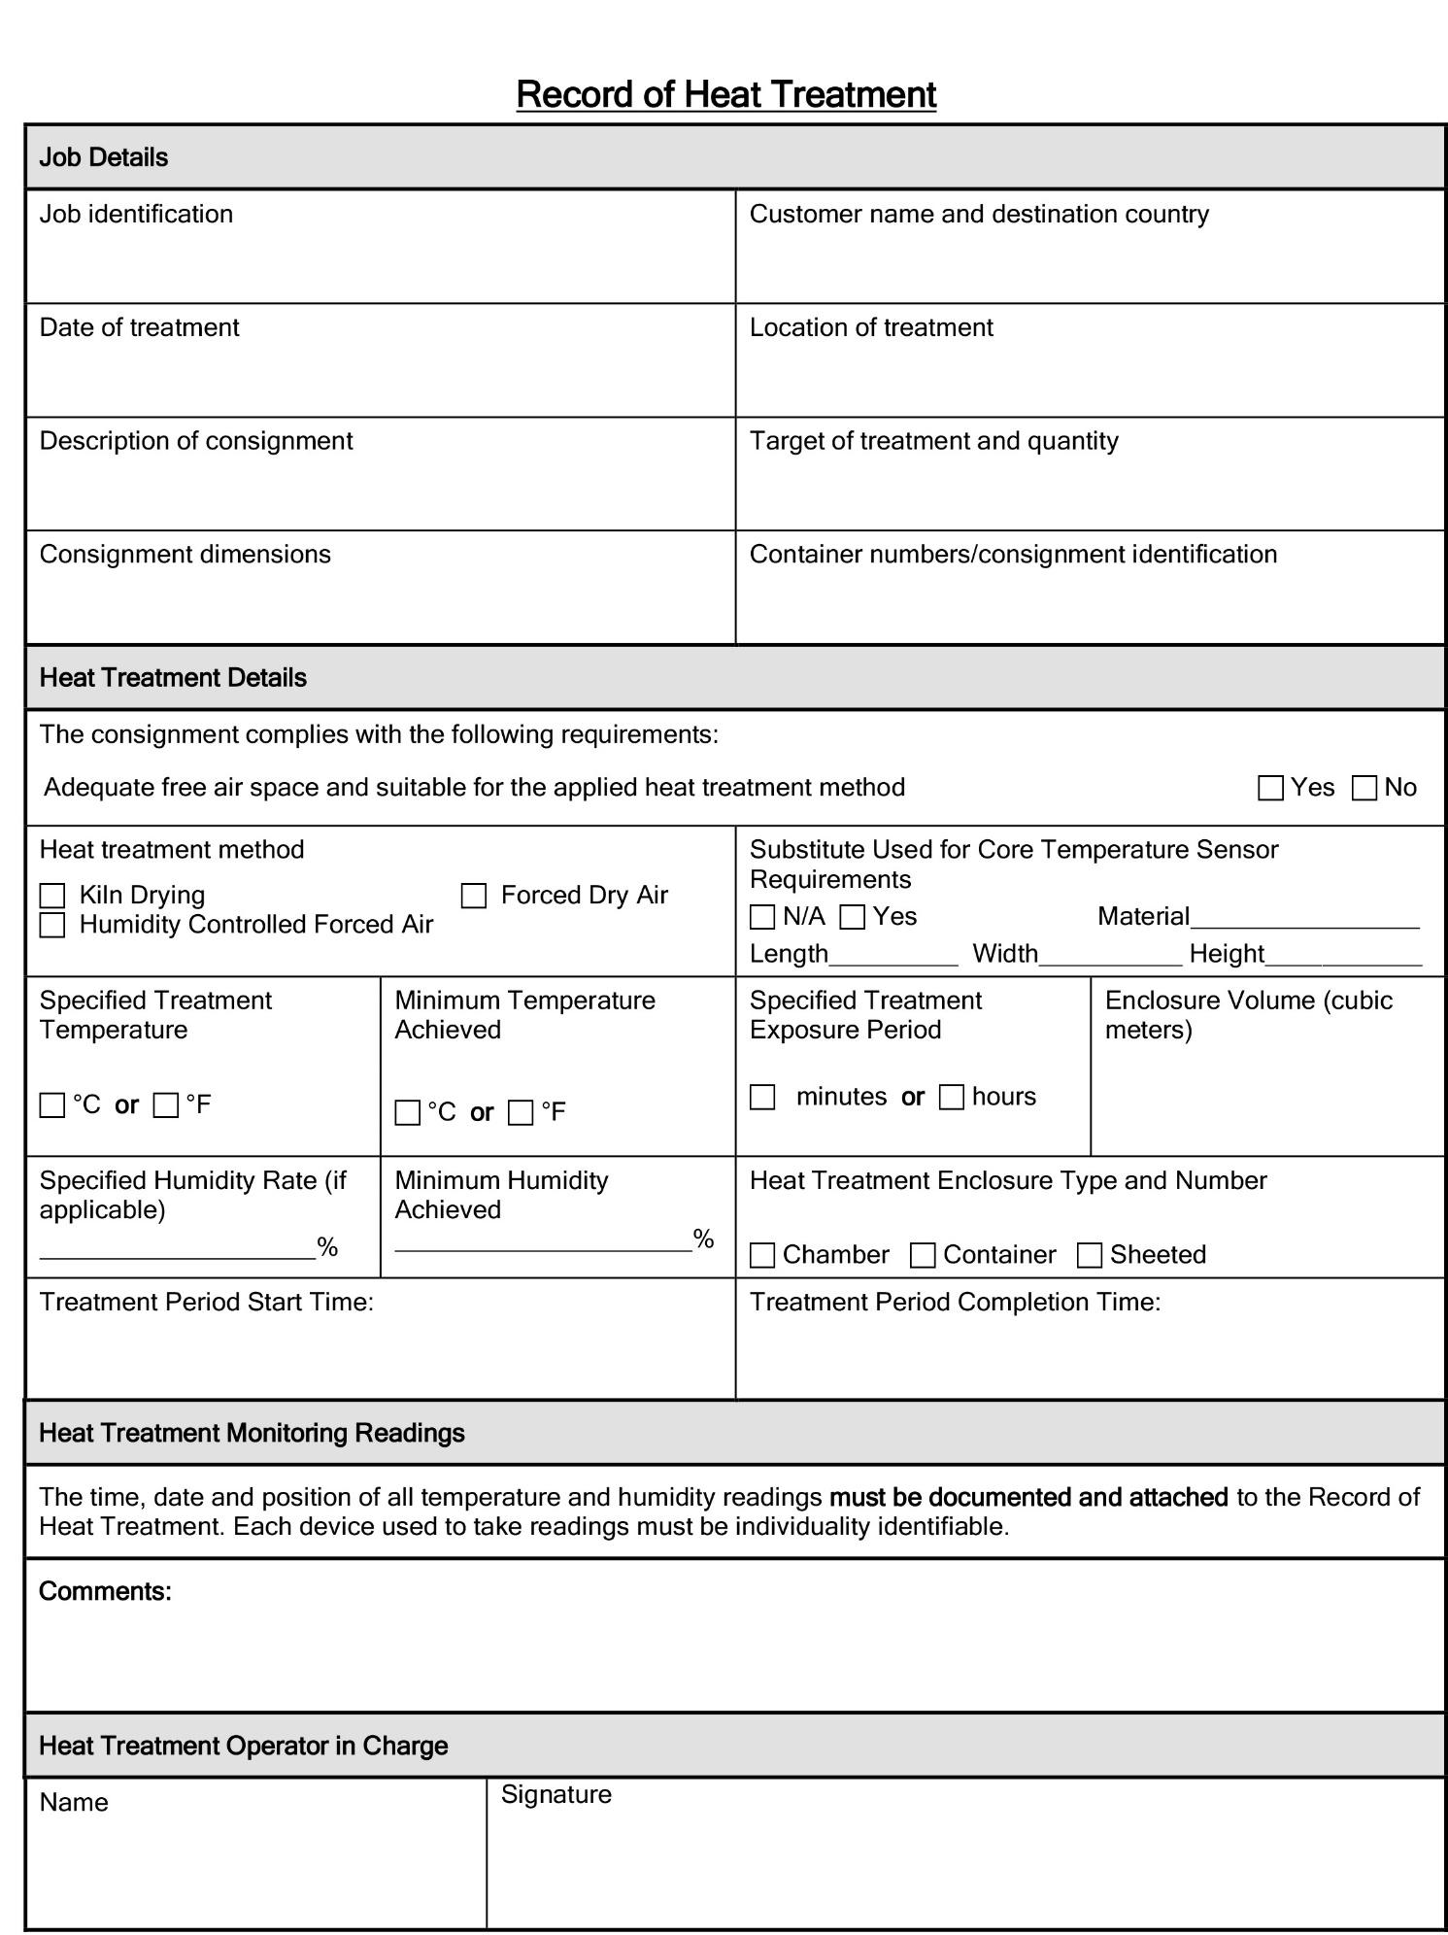

# Appendix 2: Example heat treatment certificate

# **Glossary**

| **Term** | **Definition** |
| --- | --- |
| Consignment | Refers collectively to the goods, any packing materials used and the mode of transport such as a shipping container. |
| Core | The central, most inner part of the goods/consignment being treated. |
| Core temperature | The temperature at the core of the target of the heat treatment, or an acceptable substitute. |
| Core temperature sensor | A temperature sensor inserted into the target of the heat treatment, or an acceptable substitute, to measure the core temperature. |
| Enclosure | A physical container or chamber, purposely built, temporary or mobile, used for performing heat treatments. |
| Exposure period | The amount of time, in one continuous block, that the consignment must be exposed to sufficient temperatures, and relative humidity where required, to be lethal to the targeted pests. |
| Forced dry air | A heat treatment method where hot air is forced into the enclosure to heat the consignment to the requirement treatment temperature. The humidity inside the enclosure is not monitored and loss of moisture from the goods will not result in adverse effects. This method is commonly used to treat wood packaging material. |
| Free air space | Empty space within an enclosure between, above or around the consignment. |
| Goods | The items that are being exported or imported. |
| Heat source | An object that produces or radiates heat. |
| Heat Treatment Certificate | Documentation certifying that a heat treatment has been conducted in accordance with the importing country’s requirements. |
| Heat Treatment provider | A heat treatment provider which has met certain requirements and is registered as an approved provider of QPS Heat Treatments by the relevant quarantine regulatory authority in the exporting country. |
| Humidity controlled forced air (also referred to as Variable humidity heat treatment) | A heat treatment method where a percentage of relative humidity (just below dew point) is included after the initial start of the treatment process. The humidity level is managed by adding, or removing, water vapour to the heat treatment enclosure. This is commonly used for commodities that may be damaged by:   * excessive moisture (wetting of the goods) that would occur during heat treatment methods, such as vapour; or * excessive moisture loss that has the potential to char, crack or combust the goods at the specified treatment temperature over a long period of time. |
| Humidity sensor | Refers to any instrument that is used to measure humidity. |
| Kiln drying | A heat treatment method where timber is heated to extract moisture. May also satisfy biosecurity requirements where required core temperatures are reached and maintained for the treatment period specified. |
| Load factor | Specifies the maximum volume of space that the goods can occupy in the enclosure to achieve rapid air circulation. Usually expressed as a percentage (for example, maximum load factor of 50%). |
| Quarantine and Pre-shipment (QPS) | **Quarantine and Pre-Shipment**  **Pre-Shipment**  a. Any treatments applied to meet:  i. The official requirements of the importing country; or  ii. The existing official requirements of the exporting country - being the official requirement performed or authorised by a national plant, animal, environmental, health, or stored product authority; but  b. Does not include quarantine applications  **Quarantine**  Any treatments to prevent the introduction, establishment and/or spread of quarantine pests (including diseases), or to ensure their official control, where:  a. Official control is that performed by, or authorised by, a national plant, animal or environmental protection or health authority.  b. Quarantine pests are pests of potential importance to the areas endangered thereby and not yet present there, or present but not widely distributed and being officially controlled. |
| Record of Heat Treatment | A document that records the relevant information to demonstrate that the heat treatment conducted complied with the requirements. |
| Relative humidity | The amount of water vapour in the air expressed as a percentage of the amount of water that would be present in an equal volume of saturated air at the same temperature. |
| Sheet | Any sheet, tarpaulin, blanket or barrier that can be used to limit or insulate the loss of heat from an enclosure. |
| Substitute | A separate item or object that has the same thermal conductivity properties as the goods/consignment targeted for heat treatment that can be used to house a core probe when the placement of the probe may cause damage to the consignment. |
| Surface temperature sensor | A temperature sensor placed on or attached to surface of the target of the heat treatment, to measure the surface temperature. |
| Target of the heat treatment | The target of the heat treatment may be the goods, packaging material or both. |
| Temperature sensor | Refers to any instrument that is used to measure temperature. |
| Treatment period | The time period for which the specified treatment temperature must be continuously maintained. |
| Treatment schedule | Refers to importing country requirements or conditions, or other conditions that apply to the consignment. |
| Treatment temperature | The minimum temperature required to ensure the efficacy of the treatment |