# Cargo pests guide



© Commonwealth of Australia 2019

**Ownership of intellectual property rights**

Unless otherwise noted, copyright (and any other intellectual property rights) in this publication is owned by the Commonwealth of Australia (referred to as the Commonwealth).

C:\Documents and Settings\west merryn\Local Settings\Temporary Internet Files\Content.Word\by.png

**Creative Commons licence**

All material in this publication is licensed under a [Creative Commons Attribution 4.0 International Licence](https://creativecommons.org/licenses/by/4.0/legalcode) except content supplied by third parties, logos and the Commonwealth Coat of Arms.

Inquiries about the licence and any use of this document should be emailed to [copyright@agriculture.gov.au](mailto:copyright@agriculture.gov.au).

**Cataloguing data**

This publication (and any material sourced from it) should be attributed as Department of Agriculture 2019, *Cargo pests guide*, Canberra, October. CC BY 4.0.

ISBN 978-1-76003-232-6

This publication is available at agriculture.gov.au/publications.

Department of Agriculture

GPO Box 858 Canberra ACT 2601

Telephone 1800 900 090

Web agriculture.gov.au

The Australian Government acting through the Department of Agriculture has exercised due care and skill in preparing and compiling the information and data in this publication. Notwithstanding, the Department of Agriculture, its employees and advisers disclaim all liability, including liability for negligence and for any loss, damage, injury, expense or cost incurred by any person as a result of accessing, using or relying on any of the information or data in this publication to the maximum extent permitted by law.

## Look for pests on imported cargo

This guide provides information on some of the most common pests found on cargo, but there are many more. Pests arriving from overseas can be a serious threat to our way of life here in Australia. Pests and diseases can wipe out entire food and fibre crops, affect our health, our pets and livestock, and damage our unique environment.

Some pests can even change the simple things in life that we take for granted. Take red imported fire ants for example. These ants will attack when disturbed and have a very nasty sting – as their name suggests. There are stories available online that describe how people in the United States cannot hang their clothes out to dry, or host a BBQ in their backyard because of fire ant infestations.

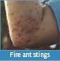

It is critical that pests are detected where they are likely to first appear – at our ports. This means you are on Australia’s frontline against pest and disease incursions.

The *Biosecurity Act 2015* requires persons in charge of goods that are subject to biosecurity control to notify the department of reportable biosecurity incidents such as live pests.

## We don’t expect you to be a bug expert but sometimes a biosecurity risk is not hard to spot.

### What to look for

* Live or dead animals, including insects.
* Egg masses on any surface (which can resemble pale furry lumps).
* Holes in timber or frass which is the powdery substance expelled from the timber when there is borer activity.
* Mosquito activity around pooled water.
* Plant matter, soil or mud – often combined and attached to a surface (e.g. on machinery).

### Where to look

* Inside and on the outside surface of shipping containers.
* Attached to machinery and vehicles (break bulk cargo).
* In timber (e.g. pallets).
* In packaging including plastic wrapping and cardboard boxes.
* Food stuffs.
* On vessels.

### Responding to cargo pests

If you see any unexpected pests, plant matter or soil, report them immediately to the Department of Agriculture.

This takes one simple phone call to our See. Secure. Report. Hotline on 1800 798 636.

We’ll give you advice on the best way to contain the problem, and prevent other cargo from being contaminated.

Some of the steps you might be asked to take include:

* Closing container or vessel doors or creating barriers.
* Isolating the affected cargo in an area away from other goods.
* Using tarpaulins or blankets to cover the area or restrict animal movement.
* Taking photos, recording the location and collecting a specimen if safe to do so. This will help us to identify the pest and determine the best treatment.
* Using knockdown spray as a last resort to prevent insects escaping, but don’t use a knockdown spray if you think it will cause the insects to disperse.

### Asian gypsy moth

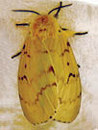

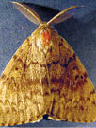

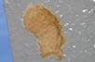

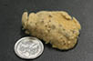

The Asian gypsy moth is a major threat to Australia’s horticulture and forestry industries, native forests and urban plants.

Adult moths are pale with black marks and have a wingspan of between 3 cm and 7 cm. Larvae are covered by tufts of long hair, and can be dispersed on the wind.

Egg masses are laid on surfaces near lights when vessels dock at temperate Asian ports (China, Taiwan, Japan, Korea and Russia) between May and October.

These masses contain up to 1,200 eggs that are covered in yellow scales, and can remain viable for months.

### Burnt pine longicorn beetle

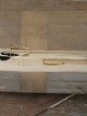

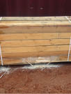

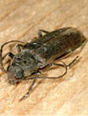

Burnt pine longicorn beetles lay their eggs into pine and spruce trees where their larvae bore into the timber.

This species is found in Europe, North Africa and New Zealand, and can fly aboard or can be brought in with cargo.

Burnt pine longicorn beetles shelter in crevices during daylight hours. They are active and attracted to lights on summer nights, generally between November and March.

Adults can be between 1 cm and 3 cm in length, are dark brown and have long antennae.

### Khapra beetle

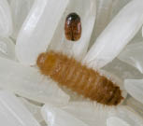

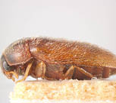

Khapra beetles feed on dried plant and animal products with a preference for grain and stored products. This is a risk to Australia’s grain industries and could jeopardise our export grain markets.

Larvae can survive being dormant for two or more years in varied conditions.

Adult beetles are reddish-brown, oval in shape and are about 2 to 3 mm long.

Larvae are typically very hairy (with distinctive tufts over the body and a short tail), are pale yellow to golden-brown, and range in size up to 5 mm long.

They go through several moulting stages, leaving behind numerous cast skins which can indicate their presence.

### Exotic honey bees

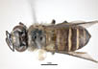

An overhead photo of a giant honey bee which is larger compared to the domestic European honey bee.

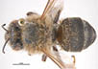

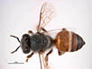

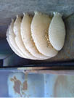

Exotic honey bees may be aggressive, and the parasites, such as varroa mite, and diseases they

carry pose a significant threat to Australia’s honey and agricultural industries.

Bees are usually between 1 cm and 2 cm in length, and are hairy and often patterned with black and yellow/orange markings.

Wax combs or insects flying to and from a nest can indicate the presence of bees. Nests may be found underneath a structure or in hollow spaces.

If a colony or swarm of bees is discovered on board, do not disturb them. Bees require specialist treatment.

### Mosquitoes and mosquito wrigglers

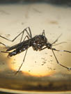

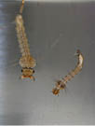

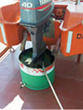

Mosquito larvae (wrigglers) are the life stage most likely to be found onboard vessels.

They live in pools of fresh or brackish water and they are very active (wriggle) when approached or disturbed.

Adults, which are slow fliers, often hide in dark, protected areas and lay their eggs (which look like black specks of pepper) where water pools.

Eggs can remain viable for up to a year.

### Brown marmorated stink bug

An overhead photo of an adult brown marmorated stink bug, showing the insect's distinct, brown, variegated colouring with dark and yellow highlights along the edge of its abdomen and along its antennae.
Photo: Melinda Fawver

A photo showing masses of brown marmorated stink bugs. These insects are prolific breeders and like to shelter in homes, businesses and even shipping cargo.
Photo: Baldo Villegas

Brown marmorated stink bugs are an Asian agricultural pest that has recently invaded Europe and the USA.

They are highly invasive and feed on about 300 known host plants including many fruits and vegetables.

They seek shelter from cold weather, and can aggregate in or on shipping containers, motor vehicles, machinery, boats and other items which may be loaded onto vessels.

Adult bugs are up to 1.7 cm in length, and have a shield-shaped body which is mottled brown, with black and white banding around the rear margin.

### Multicoloured Asian lady beetle

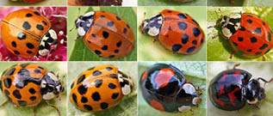

The multicoloured Asian lady beetle is another invasive insect which is rapidly spreading across overseas countries.

When seeking shelter from the cold, they can congregate on shipping containers and various other cargo items which may be loaded onto vessels.

These beetles are fairly circular and dome-shaped, and between 5 mm and 8 mm long. The colour may be yellow, orange, red or black, and they can have many, some or no spots.

### Exotic ants

Pictured is a yellow crazy ant worker with the much larger queen ant. Yellow crazy ants are distinguished by their yellow body, head and legs with contrasting darker abdomen, and long legs and antennae.
Photo: Phil lester, Victoria University, Welington, New Zealand

As the name implies, and this photo illustrates, the dark-coloured African big-headed ants have very large heads in relation to their body and abdomen.
Photo: Bob Taylor, CSIRO

Exotic ants may be aggressive and invasive. If they establish in Australia they could cause social, ecological and economic damage.

Being social insects they are often found in groups or associated with a nest.

Ants can range in size from 1 mm to 30 mm in length.

Each colony may contain ants with a variety of sizes, colours and forms, including winged individuals.

Fertilised queen ants which may have wings pose a high biosecurity risk, as they could start a new colony.

### Exotic snails and slugs

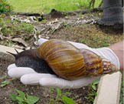

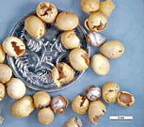

Exotic snails and slugs can cause severe damage to Australian agricultural systems and natural areas, and can spread diseases which affect humans, animals and plants.

They are able to spread as eggs, juveniles or adults, and these can be attached to vessel structures, cargo, shipping containers, machinery or motor vehicles.

The giant African snail (often referred to by biosecurity officers as GAS) can have a shell length of up to 20 cm, and eggs which are about 5 mm wide.

### Other plant pests and borers

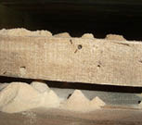

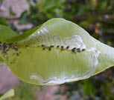

Plant pests can be found on any part of a plant, including roots, stems, leaves, flowers and seeds.

Some insects and mites on plants can be microscopic or hidden beneath a wax covering. Their presence may be indicated by leaves with webbing, marks or unusual growth.

Borers can live inside timber, stems or seeds, often leaving signs such as holes or frass (like sawdust).

**SEE. SECURE. REPORT.**

1800 798 636

agriculture.gov.au/report

Facebook: Australian Biosecurity

Twitter: @DeptAgNews

BIO4049_0819