

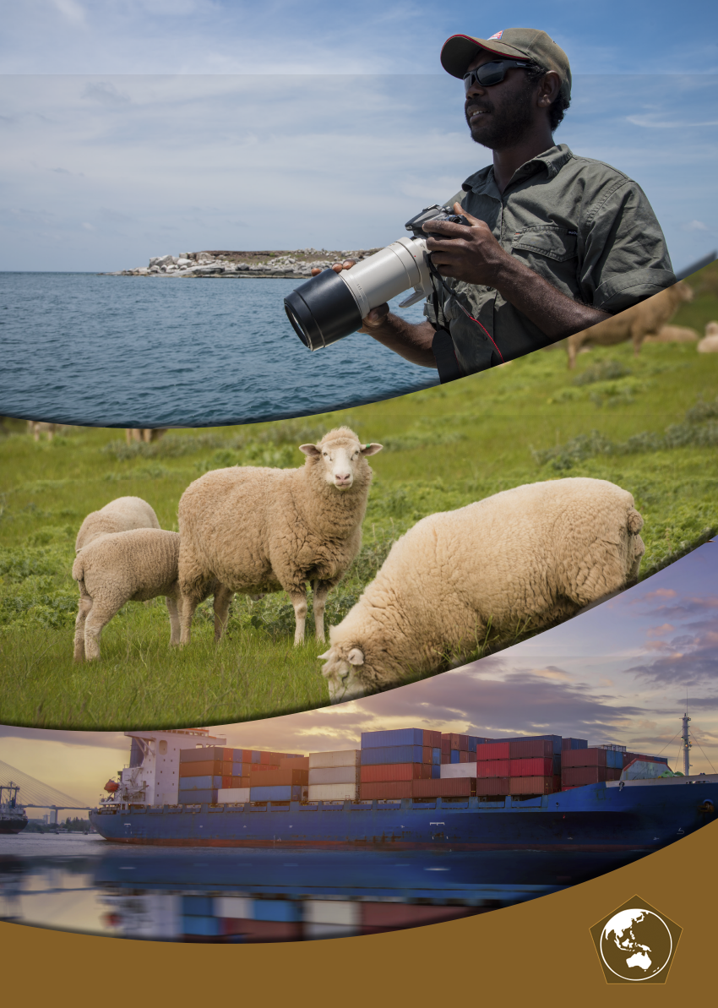

# Improving biosecurity surveillance and analysis

Agricultural Competitiveness White Paper

*stronger farmers, stronger economy*

© Commonwealth of Australia 2017

**Ownership of intellectual property rights**

Unless otherwise noted, copyright (and any other intellectual property rights, if any) in this publication is owned by the Commonwealth of Australia (referred to as the Commonwealth).

**Creative Commons licence**

All material in this publication is licensed under a Creative [Commons Attribution 4.0 International Licence](https://creativecommons.org/licenses/by/4.0/legalcode) except content supplied by third parties, logos and the Commonwealth Coat of Arms.

Inquiries about the licence and any use of this document should be emailed to [copyright@agriculture.gov.au](mailto:copyright@agriculture.gov.au).

C:\Documents and Settings\west merryn\Local Settings\Temporary Internet Files\Content.Word\by.png

**Cataloguing data**

This publication (and any material sourced from it) should be attributed as: Improving biosecurity surveillance and analysis. Agricultural Competitiveness White Paper, Department of Agriculture and Water Resources, Canberra,   
June 2017. CC BY 4.0.

This publication is available at [agriculture.gov.au/publications](http://agriculture.gov.au/publications).

Department of Agriculture and Water Resources

Postal address GPO Box 858 Canberra ACT 2601

Telephone 1800 900 090

Web [agriculture.gov.au](http://agriculture.gov.au/)

The Australian Government acting through the Department of Agriculture and Water Resources has exercised due care and skill in preparing and compiling the information and data in this publication. Notwithstanding, the Department of Agriculture and Water Resources, its employees and advisers disclaim all liability, including liability for negligence and for any loss, damage, injury, expense or cost incurred by any person as a result of accessing, using or relying upon any of the information or data in this publication to the maximum extent permitted by law.

Contents

1 Supporting access to premium markets by improving biosecurity surveillance and analysis 1

1.1 Biosecurity surveillance and analysis initiative funded by the White Paper 2

1.2 What this means for you 5

1.3 What this means for all of us 7

## Supporting access to premium markets by improving biosecurity surveillance and analysis

The Agricultural Competitiveness White Paper(the White Paper) is the Australian Government’s plan to grow agriculture. It is a $4 billion investment in our farmers and in the future of our nation. There are five key priorities to the White Paper:

1. a fairer go for farm businesses
2. building the infrastructure of the 21st century
3. strengthening our approach to drought and risk management
4. farming smarter
5. accessing premium markets.

Biosecurity is a key contributor to the White Paper’s fifth key priority ‘Accessing premium markets’.

Australia is free from many pests and diseases found around the world. This enables our farmers to be more productive and profitable, and makes our agricultural products more attractive overseas. This is only possible thanks to a strong biosecurity system that protects our agricultural industries, environment and economy from the threat of exotic pests and diseases.

The risks posed by exotic pests and diseases are changing due to growing international passenger and trade volumes, population expansion, the emergence of new pests and diseases and regional development. Now more than ever, it’s important that we ensure we are getting biosecurity right and that we have the resources to do so.

Through the White Paper, the government announced $200 million over four years for biosecurity surveillance and analysis to better target critical biosecurity risks and support market access.

The funds are being used to help keep pests and diseases out of Australia and identify and respond to pests and diseases when they arrive. They are also helping to enhance import and export processes. A review of all import conditions, based on our assessment of the risks they pose, has already resulted in changes to some conditions for certain commodities. This work will help us to manage biosecurity risks associated with imports in the best way possible—reducing biosecurity risks and limiting potential incursions and the establishment of pests and diseases. While the White Paperprovides funding over four years, the work is creating a legacy that will last beyond the four year funding timeframe.

### Biosecurity surveillance and analysis initiative funded by the White Paper

The biosecurity surveillance and analysis initiative funded through the White Papercontributes to four broad themes.



#### Strengthening surveillance

Surveillance is an important part of a strong biosecurity system. It helps to detect and respond to biosecurity threats, and provides information about what pests and diseases are present and where. It also importantly provides evidence to show freedom from pests and diseases to support market access. This funding is allowing us to extend our surveillance strategies and conduct additional surveillance activities, with a particular focus on the north, as well as near neighbouring countries.

With the increased focus on developing the north, we’re devising approaches to surveillance activities with our counterpart state and territory agencies, the community and industry. We are also improving diagnostic capabilities by upgrading infrastructure and equipment, sharing our information more effectively and providing training, where required, to address gaps.

Offshore, we’re identifying biosecurity risks in Australian island territories. In the Torres Strait, we’re conducting more surveillance, upgrading buildings and improving communications so we can do our jobs more effectively. Overseas, we’re delivering biosecurity training and conducting surveillance activities. And through the internet, we’re trawling for biosecurity trends and emerging risks overseas. This work helps to reduce biosecurity risks reaching Australia by dealing with threats before they arrive as well as responding more quickly when they do.

#### Community-based action

Biosecurity is a shared responsibility, and the more we can involve the community in understanding and addressing biosecurity issues, the better our biosecurity outcomes will be. To reduce risk associated with the north’s remoteness, we’re expanding the Indigenous Rangers Program and the important biosecurity work they do. Through targeted messaging in various formats, including supporting community events, we are raising biosecurity awareness across the north.

We are also improving the collection, analysis and distribution of information related to biosecurity surveillance and monitoring. This will include providing accessible ways for the community to more easily report on biosecurity threats.

Greater awareness of biosecurity will reduce the risk of threats establishing in Australia, benefiting our agricultural industries and the Australian economy.

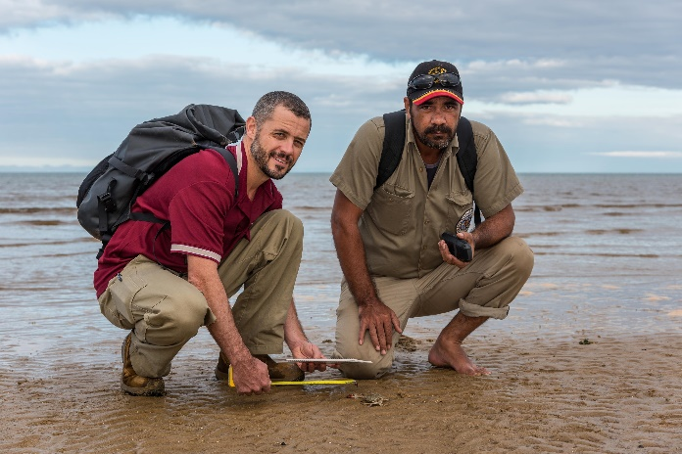

#### Improving scientific capability

Scientific analysis is an integral part of managing biosecurity risk. To boost our scientific capability, we’re employing more scientific staff to assess biosecurity risks for a range of animal and plant materials, analysing those risks through more efficient approaches, and working more closely with stakeholders through more liaison officers. We’re also scientifically reviewing all of Australia’s import conditions to ensure they remain based on the latest science and intelligence.

This work is helping to improve biosecurity outcomes to maintain and gain market access. To maximise the benefit, we’re investigating attitudes towards biosecurity amongst our stakeholders and continually tailoring our biosecurity communication. We’re improving knowledge of the requirements trading partners place on products we export, to ensure we meet each other’s biosecurity requirements. We’re also liaising with officials overseas on any changes to their importing country requirements, to assist exporters in accessing premium markets.

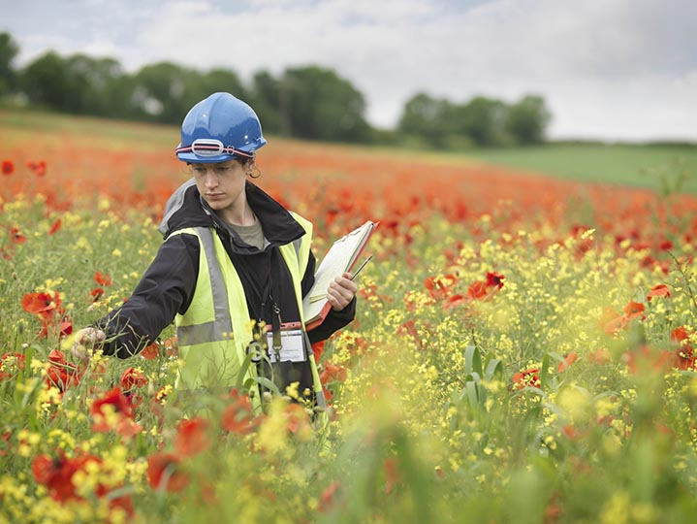

#### Improving information and analysis

Our surveillance, community and scientific work is generating a lot of new data, but that data has limited value if we lack the systems to capture and analyse it. So we’re improving our ability to collect, collate, store and analyse information and we’re replacing legacy systems. All biosecurity information is being consolidated to create a source of complete and accessible data.

Consolidated information will be connected and interrogated through an advanced analytics capability. This is helping us to answer questions like: what happened, why, what actions are needed, and what would happen if something changed? We’re recruiting and training data analysts, updating systems, and sharing even more data with states and territories to get a more complete biosecurity picture.



### What this means for you

#### The community

These initiatives will benefit the Australian community in a number of ways, including:

* improved outcomes for our agriculture sector such as increased profits, and the associated benefits for our communities including continued employment
* reducing biosecurity risks in key tourism destinations
* maintaining access to high quality food
* greater awareness of biosecurity and its importance to all of us
* better and simpler ways to report biosecurity issues.

#### Farmers and farm businesses

Good biosecurity makes our farmers more productive, efficient and profitable. When farmers don’t have to worry about pests and diseases affecting their crops and livestock, they spend less on pest and disease control and maintenance. This means better farm gate returns and better quality food on Australian tables.

For farmers that export their produce overseas, being free of pests and diseases allows them to attract a premium price. Stronger biosecurity surveillance and analysis will help reduce the risk of pests and diseases establishing in Australia, in turn helping our farmers to access premium markets overseas and making our agricultural products even more competitive.

A strong farming sector benefits local communities, the Australian economy and all Australians.

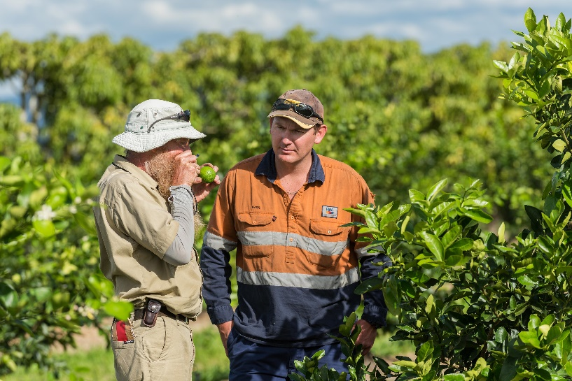

#### The environment

Strong biosecurity helps protect our environment from the threat of exotic diseases and prevent damage to our unique flora and fauna. The White Paperis:

* benefiting the environment through a range of surveillance activities that will help detect pests and diseases that could damage our natural ecosystems, and respond to them before they take hold
* expanding biosecurity work through the Indigenous Rangers Program, combining traditional knowledge with conservation training to protect and manage land, sea and culture across the north.

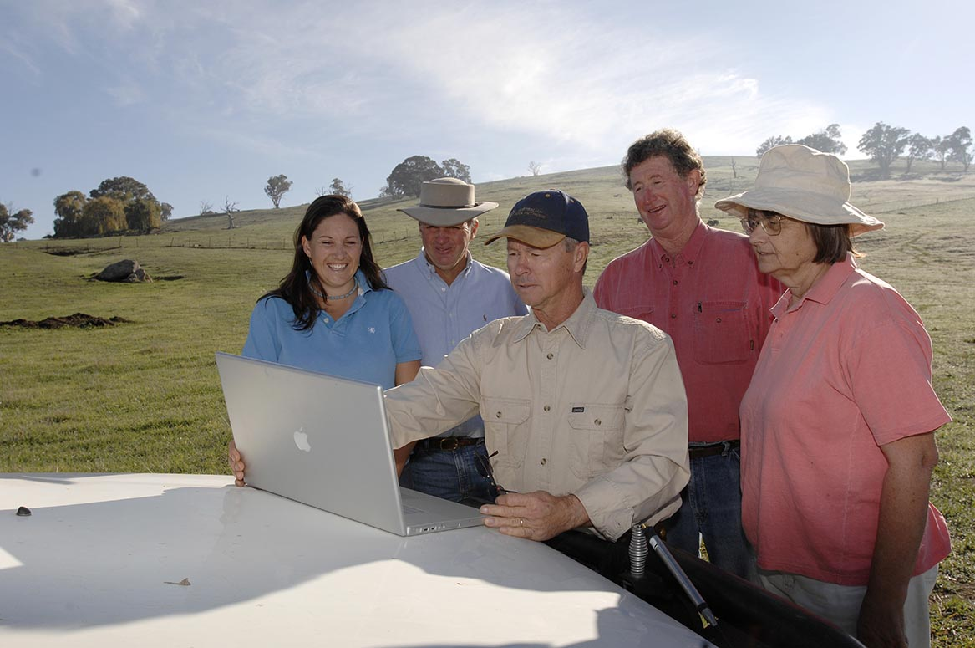

### What this means for all of us

Australia’s biosecurity system plays a critical role in safeguarding the health of our animals and plants, the environment and the community. It protects our position as a trading nation and our way of life. By improving biosecurity surveillance and analysis, we’re better managing biosecurity risks and we’ll be better prepared for biosecurity incidents when they occur. As always, prevention is better—and usually cheaper—than cure.

Strong biosecurity strengthens agriculture, opens markets, lowers production costs, supports our economy, protects the environment and safeguards our health and way of life. It benefits all Australians.

To find out more, visit [agriculture.gov.au/whitepaperbiosecurity](http://www.agriculture.gov.au/biosecurity/agwhitepaper-bio-surveillance-analysis) or agwhitepaper.agriculture.gov.au



#### Improving biosecurity in Australia’s north

The government has outlined a plan for developing northern Australia through the White Paper on Developing Northern Australia. This White Papercomplements the $4 billion investment in agriculture under the *Agricultural Competitiveness* White Paper.

A number of biosecurity activities funded through the Agricultural Competitiveness White Paperwill improve biosecurity in northern Australia. This includes $12.4 million for Indigenous Rangers to conduct biosecurity work.

Northern Australia’s proximity to neighbouring countries, tropical climate and the increased movement of people and products present different biosecurity risks to the rest of Australia.

Improving biosecurity in the north benefits all of Australia by keeping out pests and diseases that may enter and spread across Australia. It is in Australia’s national interest to develop the north, but we need to ensure there are appropriate biosecurity arrangements in place to manage the risk. Funds provided through the Agricultural Competitiveness White Paperwill ensure biosecurity is well managed to reduce the risk of entry, establishment and spread of exotic pests and diseases.

#### Contacts

Department of Agriculture and Water Resources

General inquiries: 1800 900 090

National office: +61 2 6272 3933

agriculture.gov.au/whitepaperbiosecurity

agwhitepaper.agriculture.gov.au

Email: [agwhitepaperbiosecurity@agriculture.gov.au](mailto:agwhitepaperbiosecurity@agriculture.gov.au)

Twitter: @DeptAgNews