# Modernising Australia’s approach to managing established pests and diseases of national significance: discussion paper

Summary of submissions

National Biosecurity Committee

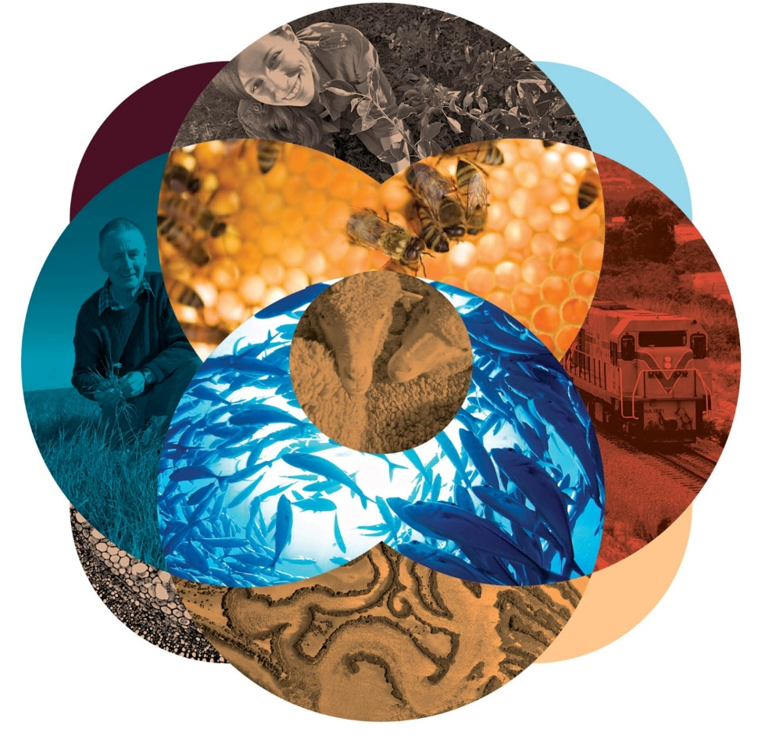

© Commonwealth of Australia 2016

**Ownership of intellectual property rights**

Unless otherwise noted, copyright (and any other intellectual property rights, if any) in this publication is owned by the Commonwealth of Australia (referred to as the Commonwealth).

**Creative Commons licence**

All material in this publication is licensed under a Creative Commons Attribution 3.0 Australia Licence, except for content supplied by third parties, logos and the Commonwealth Coat of Arms.

C:\Documents and Settings\west merryn\Local Settings\Temporary Internet Files\Content.Word\by.png

The Creative Commons Attribution 3.0 Australia Licence is a standard form licence agreement that allows you to copy, distribute, transmit and adapt this publication provided you attribute the work. A summary of the licence terms is available from [creativecommons.org/licenses/by/3.0/au/deed.en](http://creativecommons.org/licenses/by/3.0/au/deed.en). The full licence terms are available from [creativecommons.org/licenses/by/3.0/au/legalcode](http://creativecommons.org/licenses/by/3.0/au/legalcode).

Inquiries about the licence and any use of this document should be sent to [copyright@agriculture.gov.au](mailto:copyright@agriculture.gov.au).

**Cataloguing data**

This publication (and any material sourced from it) should be attributed as National Biosecurity Committee 2016, *Modernising Australia’s approach to managing established pests and diseases of national significance: discussion paper—summary of submissions,* Department of Agriculture and Water Resources.

ISBN XXX-X-XXXXX-XXX-X (printed)

ISBN XXX-X-XXXXX-XXX-X (online)

This publication is available at [agriculture.gov.au/publications](http://agriculture.gov.au/publications).

Department of Agriculture and Water Resources

Postal address GPO Box 858 Canberra ACT 2601

Telephone 1800 900 090

Web [agriculture.gov.au](http://agriculture.gov.au/)

The Australian Government acting through the Department of Agriculture and Water Resources has exercised due care and skill in preparing and compiling the information and data in this publication. Notwithstanding, the department, its employees and its advisers disclaim all liability, including liability for negligence and for any loss, damage, injury, expense or cost incurred by any person as a result of accessing, using or relying upon any of the information or data in this publication, to the maximum extent permitted by law.

Contents

Introduction iv

Views on the proposed policy principles 1

Principle 1: Onshore management of established pests and diseases focuses on asset-based protection to minimise impacts 1

Principle 2: The management of established pests and diseases is a shared responsibility between landholders, community, industry and government 1

Principle 3: To achieve asset-based protection, government gives priority to supporting industry and community leadership and actions 2

Principle 4: Governments will work with stakeholders to support innovation for more effective pest and disease management 2

Principle 5: Enforcement intervention should be the minimum necessary to achieve the desired result 2

Principle 6: Where there is a national interest to intervene, established pests and diseases assessed as being nationally significant will have an associated national management plan or strategy 2

Principle 7: The list of established pests and diseases deemed nationally significant is regularly reviewed against the relevant assessment criteria and principles 3

Views on the proposed national significance/national interest test 4

Listing and review 4

Time period for review 5

Views on the proposed roles and responsibilities of government and other stakeholders 6

Role of government 6

Role of industry and community groups 6

Role of landholders 7

Role of risk creators 7

Views on the benefits of a coordinated approach 8

Effective collective action 8

Implementation of a coordinated approach 8

Contributions 9

Appendix: List of submissions 10

## Introduction

On 1 June 2015 the Department of Agriculture and Water Resources and the National Biosecurity Committee (NBC) published a discussion paper, Modernising Australia’s approach to managing established pests and diseases of national significance. The paper outlined a proposed new framework for managing established pests and diseases of national significance (EPDNS).

The discussion paper was open for public comment from 1 June to 31 July 2015. The department invited submissions from individuals and organisations with an interest in how EPDNS are managed. The department received 32 submissions, from landholders, non-government organisations and industry and community groups (see Appendix A for a list).

This report summarises stakeholders’ responses to the questions raised in the discussion paper under these themes:

* proposed policy principles
* proposed national significance/national interest test
* proposed roles and responsibilities of government and other stakeholders
* benefits of a coordinated approach.

The submissions overall were supportive of the proposed framework. Stakeholders consistently found the proposed policy principles to be appropriate, practical and sufficient and in broad alignment with the processes already in place in state and territory organisations.

Stakeholders generally supported the proposed national significance/national interest test to identify EPDNS. Most stakeholders agreed with the need for regular reviews of EPDNS listings based on sound scientific evidence. The period suggested by respondents ranged from 12 months to 10 years.

Most comments on the proposed roles and responsibilities focused on clarifying the roles for service organisations, risk creators, and industry and community groups, and the responsibilities of governments as landholders.

Stakeholders endorsed the underpinning concepts of national coordination and collaboration—including shared responsibility between landholders, community, industry and government—as part of the new approach to managing EPDNS.

Stakeholders generally found the case studies in the discussion paper relevant and informative, but some suggested that more examples and information on eradication and containment would be useful. Several stakeholders identified a need for further explanation and definition of key concepts and terms, such as ‘prevention’ and ‘risk creators’.

The final framework for managing EPDNS was endorsed by the NBC in July 2016 and noted by Agriculture Senior Officials Committee in November 2016. The key points and themes raised in the submissions were considered in developing the final framework.

See [Managing established pests and diseases of national significance in a new way](http://www.agriculture.gov.au/biosecurity/australia/managing-established-pests-diseases) for the framework and submissions.

## Views on the proposed policy principles

The discussion paper proposed seven policy principles to guide management actions for EPDNS and deliver more cost-effective and sustainable outcomes for governments, industries and communities.

Stakeholders were asked to comment on two questions related to the management of EPDNS:

* Are the proposed policy principles appropriate and practical?
* Are the proposed policy principles sufficient?

### Principle 1: Onshore management of established pests and diseases focuses on asset-based protection to minimise impacts

Several stakeholders suggested that asset-based protection should not be the only tool used to minimise impacts of established pests and diseases. They noted that eradication or containment of an established pest is sometimes more appropriate, particularly when a new outbreak occurs or valuable resources are under threat. Stakeholders also suggested that asset-based protection should be considered in the context of multiple species or multiple threats and that the framework needs to more explicitly address the management of pests in aquatic (marine and freshwater) environments.

Stakeholders suggested that the approach should be applied at a regional level, with regional models that integrate public and private benefits. However, they cautioned that having a small set of national priorities could oversimplify Australia’s complex climates, industries and ecosystems.

Some responses highlighted ‘preparedness investment’ and ‘climate variations’ as issues requiring further consideration. Others suggested that the policy approach should include more on biosecurity impacts on primary producers and related impacts on national trade.

Some stakeholders made suggestions about terminology, such as changing ‘privately owned’ to ‘privately owned or leased’, and including marine waters and built structures such as dams in examples of land and water.

### Principle 2: The management of established pests and diseases is a shared responsibility between landholders, community, industry and government

Many stakeholders agreed that responsibility for managing EPDNS should be shared between landholders, community, industry and government. However, some noted that the term ‘community’ is open to interpretation and needs to be clearly defined.

Stakeholders suggested that government should have a supporting role—for example, providing access to technical information and facilitating coordination among landholders. Some suggested that project and stakeholder goals need to be set before decisions are made on collective actions. The stakeholders agreed that government should have a role in supporting collective action to protect private assets but suggested that protection of the environment should not necessarily rely on, or be conditional on, existing community action.

### Principle 3: To achieve asset-based protection, government gives priority to supporting industry and community leadership and actions

Stakeholders agreed that government should give priority to supporting industry and community leadership and actions to achieve asset-based protection. Several suggested that the Australian Government should provide leadership among governments in the absence of an effective national approach and focus on actions that encourage acting communally. Some called for greater clarity about which agencies are responsible for on-ground actions and funding the response.

### Principle 4: Governments will work with stakeholders to support innovation for more effective pest and disease management

Stakeholders broadly agreed that governments should work with stakeholders to support innovation for more effective pest and disease management. Some suggested that consideration needs to be given to the role of governments in research, development and extension. They noted that innovative methods of integrated control are beneficial investments for government and industry. Several stakeholders suggested that governments should have a role in providing or coordinating consistent funding or co-investment.

### Principle 5: Enforcement intervention should be the minimum necessary to achieve the desired result

Most stakeholders supported the principle that enforcement intervention should be the minimum necessary. Some made suggestions for further defining the term ‘minimum necessary’, the purpose of enforcement and the process for evaluating how enforcement is conducted. One submission noted that only government can undertake enforcement actions to limit the further spread of an established pest or disease and suggested that such actions should be part of a coordinated response and a public education campaign.

### Principle 6: Where there is a national interest to intervene, established pests and diseases assessed as being nationally significant will have an associated national management plan or strategy

Stakeholders generally supported the development of national plans and periodic reviews of the list.

### Principle 7: The list of established pests and diseases deemed nationally significant is regularly reviewed against the relevant assessment criteria and principles

Stakeholders generally agreed that the list of EPDNS should be regularly reviewed against the relevant assessment criteria and principles. One submission suggested that the assessment criteria should include a definition of ‘Australian culture, cultural assets, practice or custom’ in the context of the impacts of a pest or disease of national significance.

Stakeholders also suggested that the criteria should take into account the continued technical feasibility of eradication, whether eradication continues to be in the national interest, the cost-effectiveness of the programme, possible alternative options for eradication and the estimated time for eradication. Several stakeholders suggested that the national interest test should include Australia’s international obligations to protect biodiversity, including incorporating the impacts on matters of national environmental significance (as identified in the Environment Protection and Biodiversity Conservation Act 1999). One submission also suggested that threat abatement plans should be rolled into EPDNS plans and their scope broadened to include primary production where appropriate.

## Views on the proposed national significance/national interest test

The discussion paper outlined a proposed national significance/national interest test for listing EPDNS.

Stakeholders were asked to comment on three questions:

* Should listing of EPDNS be for a defined period or open-ended?
* What form of review should be required to maintain the listing of a pest or disease as an established pest or disease of national significance?
* What is an appropriate time for such a review?

### Listing and review

Stakeholders supported the concept of using a national significance/national interest test to identify EPDNS.

Respondents consistently agreed that the listing of EPDNS should be open-ended to allow pests, diseases or weeds to be added or removed as they became or ceased to be a priority.

Most agreed that EPDNS listings should be reviewed regularly against sound scientific evidence. However, suggested forms of review varied.

Some of the suggestions and opportunities for listing and review identified in submissions included that:

* The listing process include a transparent mechanism for EPDNS categorisation based on the need for, and benefit of, investment in national coordination.
* A list of established pests, diseases and weeds prioritisation be created (after rigorous assessment and risk management) and used to inform resourcing requirements.
* The review incorporate monitoring and mapping of pest incidence.
* A species be removed from listing when it is no longer an issue for the community and government and/or industry support no longer exists, or where sufficient management tools have been developed and provided to community/industry.
* In some cases a further test of activities and outcomes be done for EPDNS, even when they continue to meet the three assessment criteria. The test would consider whether several stakeholders are doing nationally strategic work and whether this is being monitored to show achievement of outcomes (such as a measured reduction in the impact of a pest).
* The current status of the listed pest or disease be reviewed by scientific investigation.
* A mechanism to allow rapid listing of any newly established species be included when eradication is not feasible.
* The phrase ‘spread and impacts are managed to an acceptable level’ be explained.

### Time period for review

Suggested periods for reviewing pest and disease listings ranged between 12 months and five years. One stakeholder suggested a review every five to 10 years. Several stakeholders suggested that an initial formal review should be conducted within 12 months, after which agreement could be reached on the ongoing review process.

Some suggested developing a list for a defined period of no more than three years and then reviewing it to determine whether action had been delivered to reduce the impact of the pest or disease. Others suggested introducing a process for conducting out-of-session reviews to allow for the rare situation when an immediate review is required.

## Views on the proposed roles and responsibilities of government and other stakeholders

The discussion paper outlined proposed roles and responsibilities for government, industry and community groups, landholders (including individual owners of assets on public or private land) and possible risk creators (including government, industry, community groups and landholders).

Stakeholders were asked to comment on two questions:

* Are the proposed roles and responsibilities clear, particularly in relation to your role?
* Are the proposed roles and responsibilities appropriate and practical?

### Role of government

Stakeholders’ suggestions for the role and responsibilities of government included leading the coordination of the prevention of spread of pests, diseases or weeds from existing contained areas. Some suggested that government is actually a landholder rather than a land manager. Another suggested optimising efforts to prevent further introductions from overseas, particularly those that are confined and contained within a region in Australia.

Other suggestions for the government’s role included working with risk creators where possible. Submissions consistently noted the government’s role in legislation, research and analysis, monitoring, review and coordination. The role of government in funding and co-investment was also identified, with further clarification on government role suggested. Comments on role clarity focused on a distinction between Australian Government and state or territory roles and responsibilities.

### Role of industry and community groups

One stakeholder suggested including roles and responsibilities for national and state task forces and primary producers. Another suggested separating the roles and responsibilities of farmers, industry and community. The role of science in decision-making—particularly in community engagement—was raised as an important consideration.

Another issue raised was expectations of community-based leadership models. Several stakeholders also noted that industry organisations and community groups have an important role in promoting collective action, supporting research and development and contributing to the identification of pests, diseases and weeds of national significance. They noted that community groups and government both have a lead role in supporting research into the management of established pests and diseases but many lack funding.

Another suggestion was to include roles and responsibilities for service organisations such as Animal Health Australia and Meat & Livestock Australia and regional natural resource management groups. Many of these promote integrated pest management across the landscape.

### Role of landholders

One stakeholder noted that landholders have a duty of care to protect environmental assets in addition to the assets that are valuable to them. Suggestions included adding to landholder responsibilities prevention, early detection and control to support containment of pests, weeds and diseases.

Another stakeholder noted that in marine areas the government is the primary landholder so the framework needed further clarification and description on this. A suggestion was also made that aquaculture lease and licence holders need to be considered the equivalent of landholders.

### Role of risk creators

Stakeholders suggested that the term ‘risk creators’ should be defined. Suggestions were made for strengthening the role of risk creators, such as by including responsibilities for control and management of established pests and diseases to mitigate effects on public and private assets as required by regulation.

One stakeholder also suggested that clarification is required on how government is expected to regulate itself in the context of being a risk creator.

## Views on the benefits of a coordinated approach

The discussion paper suggested that a coordinated approach would generate benefits for all stakeholders by better targeting individual and collective efforts, encouraging greater sharing of knowledge to tackle complex pest and disease issues, and reducing regulation and duplication of activities.

Stakeholders were asked to respond to three questions:

* What are the issues with establishing and maintaining effective collective action?
* How can the coordinated approach be best implemented across the various stakeholder groups?
* How do you see yourself (or your interest/industry/organisation) contributing?

Only a few stakeholders responded to these questions.

### Effective collective action

Stakeholders generally supported the proposed coordinated approach. Several stakeholders suggested ways to deliver effective outcomes through collective action, including through developing an effective community structure with support at national, state and local levels and making institutional changes to support community and industry.

Some suggested building community-wide shared responsibility for weed management through education, capacity-building and cooperative community-based responses.

One stakeholder called for a strong commitment to the new approach from the Australian Government, supported by states and territories through the Council of Australian Governments.

Another suggested that existing strategies, and what could be supported in those strategies, should be considered in decisions to fund collective action grants. It was also noted that long-term funding and long-term commitment can influence the management of pest species at a landscape level.

### Implementation of a coordinated approach

Stakeholders addressed the implementation question broadly in their submissions. Some suggested that implementation would be best if models were funded appropriately supported by demonstrable outcomes.

One suggested that implementation across the various stakeholder groups should include collaboration, with ongoing dialogue between stakeholders, and enforcement. Ensuring total industry support was considered important.

Others suggested that on-ground programmes should implement activities across their regional boundaries so that large-scale programmes can be more effectively managed.

Stakeholders also suggested that government funding for leadership and coordination should be consistent and common long-term goals should be set for on-ground programmes to maintain momentum. Stakeholders noted that a loss of momentum in many pest programmes is often caused by disruption to leadership and coordination. They also noted that a community or group that are not resourced effectively may shift priorities to be financially sustainable.

### Contributions

The question of how stakeholders saw themselves contributing was addressed broadly throughout submissions. Responses included:

* coordinating the efforts of industry
* supporting, promoting and implementing collective actions
* supporting research into management and control
* promoting partnerships between government, industry and the community
* providing collective contributions from a national perspective
* ensuring remote Indigenous landowners can work with government to identify assets (including cultural assets) and enable them to be protected through collaboration and capacity-building.

## Appendix: List of submissions

1. Alexander Arbuthnot AM
2. Animal Health Australia (Australian Lot Feeders’ Association and Sheepmeat Council of Australia)
3. Australian Pork Limited
4. Bruce Potts
5. Council of Australasian Weed Societies
6. Department of Land Resources Management, NT Government
7. Department of Parks and Wildlife, WA Government
8. Department of Primary Industries, Parks, Water and Environment, Tasmanian Government
9. Environmental Farmers Network
10. Ian Sauer, Drew English, Scott Chirnside and Jim Forwood AM
11. Indigenous Land Corporation, Australian Government
12. Invasive Species Council
13. Jacquie Foyel
14. La Perouse Coastcare
15. Local Land Services, NSW Government
16. National Farmers’ Federation
17. National Parks and Wildlife Service
18. National Resources Commission, NSW Government
19. Natural Resource Management Regions Australia
20. Natural Resources SA Murray–Darling Basin
21. Natural Resources South East, Department of Environment, Water and Natural Resources, SA Government
22. Parks and Wildlife Commission, NT Government
23. Powerlink Queensland
24. Primary Industries and Regions SA
25. Redland City Council, Queensland
26. Robert Lawrence
27. Sporting Shooters’ Association of Australia
28. Victorian Blackberry Taskforce
29. Wet Tropics Management Authority
30. – 32) Unpublished