# Priorities for Australia’s biosecurity system

June 2017

**An independent review of the capacity of the national biosecurity system and its underpinning Intergovernmental Agreement**

Wendy Craik, David Palmer and Richard Sheldrake

© Commonwealth of Australia 2017

**Ownership of intellectual property rights**

Unless otherwise noted, copyright (and any other intellectual property rights, if any) in this publication is owned by the Commonwealth of Australia (referred to as the Commonwealth).

**Creative Commons licence**

All material in this publication is licensed under a Creative Commons Attribution 3.0 Australia Licence, save for content supplied by third parties, logos and the Commonwealth Coat of Arms.

Creative Commons Attribution 3.0 Australia Licence is a standard form licence agreement that allows you to copy, distribute, transmit and adapt this publication provided you attribute the work. 

Creative Commons Attribution 3.0 Australia Licence is a standard form licence agreement that allows you to copy, distribute, transmit and adapt this publication provided you attribute the work. A summary of the licence terms is available from [creativecommons.org/licenses/by/3.0/au/deed.en](http://creativecommons.org/licenses/by/3.0/au/deed.en). The full licence terms are available from [creativecommons.org/licenses/by/3.0/au/legalcode](http://creativecommons.org/licenses/by/3.0/au/legalcode).

Inquiries about the licence and any use of this document should be sent to [copyright@agriculture.gov.au](mailto:copyright@agriculture.gov.au).

**Cataloguing data**

**Craik, W, Palmer, D & Sheldrake, R 2017,** *Priorities for Australia’s biosecurity system,* An independent review of the capacity of the national biosecurity system and its underpinning Intergovernmental Agreement, Canberra.

ISBN: 978-1-76003-130-5 (print)

ISBN: 978-1-76003-131-2 (online)

**Internet**

*Priorities for Australia’s biosecurity system* is available at [agriculture.gov.au/igabreview](http://www.agriculture.gov.au/igabreview).

**Contact**

Department of Agriculture and Water Resources

Postal address GPO Box 858 Canberra ACT 2601

Telephone 1800 900 090

Web [agriculture.gov.au](http://agriculture.gov.au/)

The views expressed in this report do not represent the views of the Australian Government. The Australian Government—including the Department of Agriculture and Water Resources, their employees and advisers—and the review panel members disclaim all liability, including liability for negligence and for any loss, damage, injury, expense or cost incurred by any person as a result of accessing, using or relying upon any of the information in this report to the maximum extent permitted by law.

## Letter of transmittal

Agriculture Ministers’ Forum

Dear Ministers

In accordance with the review’s terms of reference, we are pleased to present to members of the Agriculture Ministers’ Forum *Priorities for Australia’s biosecurity system*, the final report of the independent review of the capacity of Australia’s biosecurity system and the underpinning Intergovernmental Agreement on Biosecurity (IGAB). While this report fulfils the commitment within the IGAB for a review of the agreement within five years, the report also explicitly addresses a range of issues pertinent to the broader national system, as provided for by the terms of reference.

Australia’s biosecurity system is an essential national asset—its strength and effectiveness are paramount. This report provides findings, recommendations and advice on the priorities we believe will ensure an effective national system into the future. We strongly believe that adoption of the report’s recommendations will assist all governments—in partnership with other major system participants—to be better prepared for the significant, current and impending biosecurity challenges, including those brought about by the changing global biosecurity environment.

The IGAB has provided a significant foundation for further developing the national biosecurity system and the intergovernmental cooperation and relationships that underpin it. Nevertheless, this review has recommended changes for a refreshed intergovernmental agreement, including those which reflect the strengthened relationships and build on the substantial achievements since its first signing.

Separately, we have identified changes that would better reflect and acknowledge the critical roles of the many non-government stakeholders across the national system. There is ample opportunity for industries, community groups and others to realise a level of cooperation and relationship maturity comparable to that achieved by governments in recent years.

We commend governments’ willingness to review Australia’s biosecurity system and expose it to independent scrutiny. Regular periodic review is necessary to safeguard the national system, maintain confidence in its effectiveness and ensure its continuous improvement.

We record our appreciation for the efforts of many individuals, organisations and governments, and the considerable time and resources given to assist the review, including the provision of input, advice, research and written submissions, which have given the final report greater relevance and grounding.

Yours sincerely

Wendy Craik AM (Chair), David Palmer and Richard Sheldrake AM

## Acknowledgements

The panel thanks the many stakeholders who contributed to the review, especially those who gave their time to make written submissions, participate in meetings during national consultation and other targeted discussions, or assist with research and advice. This includes representatives from the Australian, state and territory governments, the New Zealand Government, peak industry and community groups, researchers, businesses and other individuals. These contributions have proven valuable in providing us with a diverse range of views and insights into the issues we were requested to consider.

The panel acknowledges the professional support of the review secretariat from the Australian Government Department of Agriculture and Water Resources. The secretariat supported the panel in drafting, reviewing submissions, conducting additional research, liaising with stakeholders, arranging travel and meeting logistics, and more. Primary members of the secretariat were Barbara Jones, Timothy Robertson, Jason Bakonji, Glenn McMellon, Teal Petri and Gloria Pantano; other departmental officers undertook specific tasks for the review. In particular, the panel would like to express its considerable gratitude to Barbara Jones, whose perceptive and thoughtful leadership of the secretariat added significantly to the quality and depth of analysis and conclusions.

The panel also appreciates the contributions made by Mr Russell Phillips and two independent reviewers who assisted the panel with their views and feedback on our draft and final reports.

The panel unanimously supports all of its recommendations and takes full responsibility for the views expressed.

Contents

Letter of transmittal iii

Acknowledgements iv

Summary vii

Recommendations xi

Acronyms and abbreviations xvii

1 Australia’s biosecurity system 1

1.1 Benefits of national biosecurity 2

1.2 An evolving system 2

1.3 Future risks and pathways 6

1.4 The 2012 IGAB 10

2 Knowing and owning our roles and responsibilities 11

2.1 Shared responsibility? 11

2.2 Greater ownership and participation 14

2.3 Improving communication and engagement 17

2.4 A National Biosecurity Statement 19

3 Market access is key 25

3.1 Biosecurity and trade 25

3.2 International exports 26

3.3 Domestic trade 31

3.4 Regulatory efficiency 32

3.5 Aligning the agendas 34

4 Stronger environmental biosecurity 36

4.1 The problem for governments 37

4.2 Views on environmental biosecurity 40

4.3 Governing for environmental outcomes 43

4.4 Institutionalising environmental biosecurity 45

5 Building the national system: pest by pest; disease by disease 49

5.1 Determining national priorities 50

5.2 Benefits and opportunities 58

6 Research and innovation 60

6.1 The key role of biosecurity R&I 60

6.2 Current state 62

6.3 Future-focused biosecurity R&I 71

7 Strengthening governance 76

7.1 A strong mandate 76

7.2 An empowered National Biosecurity Committee 77

7.3 Bringing others into the fold 87

7.4 Updated governance arrangements 89

8 Funding the national system 91

8.1 The shared funding challenge 91

8.2 Consideration of the three NBC projects listed in the terms of reference 97

8.3 Other guiding principles and frameworks 101

8.4 How much is enough? 103

8.5 Sustainable funding 108

8.6 Summary 121

9 Measuring system performance 123

9.1 Valuing national biosecurity 123

9.2 Performance measurement and reporting 124

9.3 Informed biosecurity: data availability and management 129

9.4 Smarter biosecurity: data analytics and intelligence 132

10 A future system; a future IGAB 135

10.1 A future system 135

10.2 A future IGAB 138

Appendix A Terms of reference and links to the report 155

Appendix B Review panel biographies 157

Appendix C Public consultation 158

Appendix D Risk Return Resource Allocation model 162

Appendix E Biosecurity performance frameworks: national government examples 163

Appendix F Comparing industry and environmental preparedness 165

Glossary 166

References 167

## Summary

Australia’s biosecurity system is a trade and economic asset. It underpins $59 billion in agricultural production, $45 billion of agricultural exports and our $38 billion inbound tourism industry. Equally, national biosecurity efforts protect human health and social amenity and help to maintain our unique, biodiverse, natural environments: the Australian Bureau of Statistics valued Australia’s environmental assets at over $6 trillion at 30 June 2016 (ABS 2017).

Our national biosecurity system does not exist as a single physical or legal entity. It is built on ‘shared responsibility’—the cooperation, investment and actions by all governments, industry bodies, exporters and importers, farmers, miners, tourists, researchers and the broader community. For governments, the sharing of responsibility occurs through a cooperative partnership under the Intergovernmental Agreement on Biosecurity (IGAB), which was signed by Australia’s then Prime Minister, Premiers and Chief Ministers (First Ministers) of all mainland states and territories in 2012.

The IGAB has created a framework for governments to coordinate and identify priority areas of reform and action to build a stronger and more effective national biosecurity system. The IGAB was an important step for governments, recognising the value of strengthening and institutionalising intergovernmental relationships and building on the previous memoranda of understanding between Australia’s governments. This review of the first IGAB (IGAB1) recognises its significant achievements, including a strong and healthy working partnership between all governments and the development of sound national policy principles and frameworks for an effective and well-regarded system.

This report fulfils the commitment within IGAB1 for a review of implementation and effectiveness of the IGAB and recommendations for amendment. The report also provides the panel’s assessment and recommendations of the capacity of key components of the national system, as detailed in the review’s terms of reference (Appendix A).

The review has confirmed that the challenges facing government stewardship of the national biosecurity system continue to build. Biosecurity risks are increasing due to increased global trade and travel, increased agricultural expansion and intensification, increased urbanisation close to farmlands, and other factors such as climate change. A tight fiscal environment for governments has placed significant pressure on biosecurity budgets and the ongoing capacity of jurisdictions to meet their biosecurity commitments. Biosecurity stakeholders, especially those bearing an increasing share of the costs, want a greater say in decision making about the national system, greater alignment of biosecurity and market access efforts, more efficient delivery of government biosecurity services, and stronger arrangements for environmental biosecurity, among other things. In addition, major biosecurity incidents continue to test public confidence in the national biosecurity arrangements.

Governments are committed to addressing these issues, but the efforts of biosecurity agencies are hampered by eroding biosecurity budgets, declining and uneven capability and expertise across the jurisdictions, leadership churn (ministerial and executive), patchy coverage by formal institutions and a lack of codified practices. That said, the policy and practical challenges of melding nine jurisdictional biosecurity agendas into one national system are significant, but progress is being made.

Australia’s biosecurity system must remain strong and focused to build the national capacity and capability required in the face of inevitable and growing biosecurity risks. The panel’s report sets out 42 recommendations aimed at strengthening the national system over the next five to ten-year period, to be advanced by governments, industry and other parties, including under a refreshed intergovernmental agreement (IGAB2). The panel recognises that implementation of this review’s recommendations is a substantial program of work and will increase the cost of the national system. While resourcing the national system is a key challenge, progress will be limited without new investment. This increased cost needs to be balanced against the cost of no additional action which, in the panel’s view, poses a significant risk to the durability and effectiveness of the national system.

**Key focus areas**

**National priority pests and diseases**

A central theme of the review, flowing through many of the recommendations, is that governments and industry/community should adopt a systematic approach to determining and planning for national priority animal, plant and environmental pests and diseases. Essentially, this involves building the national system from the ground up: pest by pest; disease by disease. It will not be possible to individually address the vast array of pests and pathogens, particularly those affecting plants, so the national system must also embrace some generic inspection and treatment practices to manage classes of pests. This is consistent with the purpose and intent of international standard development and harmonisation of risk management procedures.

Some work to prioritise national biosecurity risks has already occurred or is underway, but this process does not appear to be standardised, is incomplete and is far from comprehensive. The review proposes a specific process to profile and plan for each national priority pest and disease, inclusive of the parties involved and funding required. This approach will allow for the ‘rolling-up’ or ‘summing’ of the various components of the national system to provide national perspectives of system elements such as pre-border activity, surveillance, response, and research and development. Only then can effective national strategies be developed, costed and effectively actioned using the principles developed under IGAB1.

**Resourcing pressures**

Governments and industry are facing, and will continue to face, ongoing resourcing challenges. The review found that government appropriation funding has generally been static or in decline, while externally sourced funds (cost-recovered funds and levies) have been increasing. National system funding needs to be sufficient to fulfil governments’ obligations to the national system: the Australian Government’s components need to be sufficiently funded to achieve Australia’s legislated Appropriate Level of Protection (ALOP); and states and territories need to increase funding to meet their baseline, or core, commitments. The appropriate level of funding required—or ‘how much is enough’—to operate the national system will not be clear until the suite of high-priority pests and diseases and their biosecurity requirements have been agreed and worked through, including with key industry and community players.

Governments do have some options available to provide a more sustainable funding base, including reviewing their own cost-recovery arrangements and implementing new biosecurity levies (for example, on inbound shipping containers, inbound passengers and land-owners) to contribute further to funding the national system. Governments have agreed sound national investment principles and frameworks under the IGAB—the challenge is building support within governments and with industry for implementation.

**Research and innovation priorities**

Research and innovation (R&I) underpins Australia’s science-based approach to biosecurity, but targeted investments in technological innovations can also help reduce the cost of typically high‑cost activities, such as surveillance. Current arrangements do not optimise these outcomes. Clear national biosecurity R&I priorities are needed to focus investment, and improved coordination of biosecurity R&I is needed to drive cross-sectoral research, technological developments and behavioural change. Further investment, particularly by the Australian Government, will be needed to effect these changes.

**Shared responsibility: everyone’s priority**

The review has found that, while governments and industry have well-developed partnership arrangements for parts of the national system, the foundation principle of ‘shared responsibility’ is not clearly understood, agreed or broadly accepted across the system. Similarly, the roles and responsibilities of participants are not well defined or agreed. Agreeing roles and responsibilities will be an important first step in realising shared responsibility. To that end, the review has recommended a National Biosecurity Statement that outlines a common and unifying approach to biosecurity for all system participants. The review has developed a draft National Biosecurity Statement, which includes a simple definition of shared responsibility, as the basis for consultation and further development.

**Community and environmental biosecurity: an equal priority**

One of the strongest areas of debate during the course of this review concerned the adequacy of the national system in addressing biosecurity risks impacting on biodiversity and the environment. Incursions of exotic organisms harmful to Australia’s environment and social amenity are a regular occurrence and have been the focus of recent emergency responses, but national environmental pest and disease risks are yet to be systematically identified, prioritised and planned for. Community and environmental biosecurity considerations should be comparable to human health and primary production, and national arrangements need to be explicitly developed to address environmental risks. Environment agencies must play a far stronger and direct role in development of national biosecurity policy and in response arrangements, particularly in those situations where the primary impact of a newly introduced pest is environmental or impacts heavily on social amenity.

**A refreshed IGAB**

The panel has concluded that a refreshed agreement between Australia’s governments is appropriate and necessary to ensure robust national biosecurity arrangements into the future. The panel has proposed three priority reform areas and associated programs of work to be delivered under a streamlined intergovernmental agreement, which are detailed below. IGAB1 was a significant foundation agreement for government cooperation and collaboration. IGAB2 and subsequent agreements should build on achievements to date and demonstrate a measured and deliberate advancement in the commitments and achievements of jurisdictions. While the IGAB should remain a government agreement, its governance structures should provide the National Biosecurity Committee (NBC) with greater autonomy, and industry and community with a stronger role and voice in further developing the national system. Finally and importantly, First Ministers should continue to authorise a strong whole-of-government mandate for jurisdictions to advance the national biosecurity agenda. The review report includes a draft agreement or draft ‘IGAB2’ to demonstrate to jurisdictions how a refreshed IGAB would be constructed (Chapter 10).

**IGAB proposed priority reform areas\***

| Reform areas | Outcomes | Deliverables |
| --- | --- | --- |
| 1. Governance and strategy | A unified strategic framework for the national biosecurity system  Improved governance of the national system  A consistent approach to biosecurity risk prioritisation and investment across the system (for animal, plant and environmental^ streams) | Agreed roles and responsibilities for all system participants  A National Biosecurity Statement, developed in collaboration with key system participants  Formalised whole-of-government biosecurity arrangements within all jurisdictions, including through memoranda of understanding  Defined core commitments for jurisdictions under the national system  An empowered National Biosecurity Committee (NBC) and revised subcommittee structure, including an Industry and Community Biosecurity Committee, a Chief Community and Environmental Biosecurity Officer, and Community and Environmental Biosecurity Committee  A revised National Framework for Cost Sharing Biosecurity Activities  National biosecurity research and innovation priorities  Agreed uniform and fully inclusive categories of funding activity  A standalone website for the NBC |
| 2. National priority pests and diseases | Identification of national priority pests and diseases (animal, plant, environmental^)  Identification of prevention, emergency preparedness and response requirements and responsibilities  Early detection and accurate, timely diagnosis of national priority pests and diseases  Demonstration of Australia’s pest and disease status for market access  Identification of responsibilities for established pests and diseases | Implementation of a systematic approach for national priority pests and diseases, including environmental  Risk assessments for national priority pests and diseases  Action plans for managing national priority pests and diseases, agreed by all relevant participants, outlining risk mitigation measures, surveillance, diagnostics and response, as well as the relevant participants (including their roles and responsibilities and cost-sharing arrangements)  Alignment of biosecurity surveillance activities with major export market risks and tourism  Emergency response deeds for aquatic animals and exotic production weeds  Greater landowner-led resourcing and management of nationally significant established pests and diseases |
| 3. Knowledge management and system performance | Improved decision making and operational efficiency and effectiveness  Increased capacity to measure and demonstrate the performance of the national biosecurity system  Improved accountability of jurisdictions for commitments under the IGAB  Greater public understanding of the performance of the system | National collaboration on data and intelligence sharing  Agreement to common information architecture for the national system, including data sharing protocols and data standards  An independent comparative Report of Government Biosecurity Services (ROGBS)  An independent IGAB Evaluation Program of jurisdictional commitments  Nationally consistent system for property identification codes (PICs) |

*This table also appears in Chapter 10 (Table 12). ^Environmental biosecurity includes risks to social amenity.

## Recommendations

**Risk and capability**

Recommendation 11 The NBC should adopt a systematic approach to determine and plan for national priority pests and diseases:

* Three national priority lists—one each for animal, plant and environmental pests and diseases—should be developed in partnership with system participants.
* The three national lists should be completed by 2020.
* Thereafter, the NBC should lead reviews of the national priority lists at least every five years, reporting to AGSOC and AGMIN.

Recommendation 13 The NBC should authorise and drive development of an agreed set of National Biosecurity R&I Priorities, in consultation with key biosecurity R&I system participants, to guide national R&I investment:

* The sectoral committees of the NBC should lead the development of sectoral and cross-sectoral level national priorities in line with the national priority exotic animal, plant and environmental risks and their pathways, once agreed.
* The NBC, CSIRO, CEBRA and ABARES should jointly develop system-level national biosecurity priorities (including for the environment) focusing on the policy and decision-making frameworks, tools, innovations and behavioural changes needed to build an effective national system.
* The NBC should determine the final integrated list of National Biosecurity R&I Priorities. The priorities should be developed within eighteen months of the IGAB review report, and should be reviewed at least every five years.

Recommendation 14 To accelerate national system innovation the Australian Government should:

* establish a $25 million National Biosecurity Innovation Program to enable strategic co-investment in the system-level (including environmental) national priorities developed under Recommendation 13. The program should be funded initially for a five-year period from 2018–19 through the funding mechanisms in Chapter 8 and be administered by the Australian Government agriculture department
* increase the funding appropriation to the Rural Industries RDC by $2 million annually for a new cross-sectoral biosecurity R&I coordination and investment function for the RDCs. Cross-sectoral investments should be in line with the national cross-sectoral priorities developed under Recommendation 13
* require RDCs to invest in and report against the new National Biosecurity R&I Priorities through additional provisions in each RDC statutory funding agreement. Cross-sectoral biosecurity R&I will be coordinated by the Rural Industries RDC.

Recommendation 42 Jurisdictions should adopt the proposed new priority reform areas and associated work program for IGAB2 and amend the IGAB in line with the proposed revisions.

Recommendation 8 Jurisdictions should make clearer commitments to environmental biosecurity within IGAB2, including in relation to:

* a clear definition of environmental biosecurity such as that proposed by this review
* the principle of ecologically sustainable development
* acknowledgement of Australia’s international responsibilities under the Convention on Biological Diversity
* a program of work to determine, plan and prepare for national priority pests and diseases impacting on the community, environment and native species
* a focus on environment and community as well as industry partnerships
* diseases transmitted to humans by invertebrates as well as vertebrates.

Recommendation 5 IGAB2 should facilitate greater consideration by governments of market access priorities and outcomes within the national biosecurity system:

* Biosecurity surveillance activities should include pests and diseases and common pathways that pose the greatest threat to our export markets and tourism.
* IGAB2 should clarify the roles and responsibilities of the parties with regard to international and domestic market access, including proof of area freedom.

Recommendation 41 The Australian Government should establish, within the agriculture department, a dedicated National Biosecurity Analytics and Intelligence Centre, to centralise, coordinate and provide advice to the NBC, AGSOC and AGMIN on biosecurity intelligence covering emerging risks and pathways and international and domestic pest and disease detections.

Recommendation 37 The emergency response deeds for aquatic animals and exotic production weeds should be finalised within eighteen months of the IGAB review report.

Recommendation 6 Jurisdictions should develop a nationally consistent system for the allocation and use of property identification codes (PICs) across the animal and major plant production sectors.

**Engagement and communication with system participants**

Recommendation 25 AGSOC should establish, as a priority, an Industry and Community Biosecurity Committee as a forum for the NBC to discuss key national biosecurity policies and reforms.

Recommendation 2 The NBC and the Industry and Community Biosecurity Committee should, through an open, transparent and collaborative process, lead national consultation on a draft National Biosecurity Statement, such as that proposed by this review.

The consultation process should involve all levels of government (including local government), industry and the community, with the statement finalised and launched within eighteen months of the IGAB review report.

Recommendation 1 IGAB2 should include a core commitment by jurisdictions to ongoing stakeholder communication and engagement, building on existing partnerships, with activities scrutinised as part of jurisdictional evaluations under Recommendation 22.

Recommendation 21 The NBC should increase its public profile and openness, including by establishing a standalone website, to be maintained by but be separate from the Australian Government agriculture department. The website should centralise all information on the NBC, its committees and their activities. Key policy frameworks, agreements and reports of the NBC should be made public on the site.

Recommendation 3 The Primary Industries Technical Market Access and Trade Development Task Group should enhance engagement with industry to ensure that Australia’s market access strategies are aligned appropriately through an agreed priority-setting process and that the degree of transparency and communication is carefully weighed against its level of risk to trade activities.

Recommendation 26 The full membership of the NBC should meet annually with AHA and PHA members to discuss key national biosecurity policies and reforms.

**Financial sustainability of the system**

Recommendation 31 To provide greater system stability, Australian governments’ appropriations funding for biosecurity should be maintained at 2016–17 levels (in real terms) or more until after completion of the next review of the IGAB.

Recommendation 29 All governments should review their current biosecurity expenditure with a view to redirecting funding to areas that provide the greatest return on investment to producers, industry and the community. This approach will require a planned and coordinated strategy of engagement and communication.

Recommendation 35 AHA and PHA should coordinate an industry stocktake of national biosecurity system investments and make the results public.

Recommendation 27 The NBC and the Industry and Community Biosecurity Committee, in consultation with other key stakeholders, should review the National Framework for Cost Sharing Biosecurity Activities to enable its practical application and make it public.

Recommendation 32 State and territory governments should agree a common biosecurity cost-recovery framework and review their biosecurity cost-recovery arrangements to ensure they are nationally consistent, appropriate and transparent.

Recommendation 33 All levels of government could help meet their budgetary challenges by reviewing biosecurity levies and rates/charges currently or potentially applying to biosecurity system participants. These should be commensurate with agreed national cost-sharing principles.

Recommendation 34 Funding for the national biosecurity system should be increased by:

* implementing a per-container levy on incoming shipping containers of $10 per twenty-foot equivalent unit and a levy of $5 on incoming air containers, effective from 1 July 2019
* increasing the Passenger Movement Charge by $5, effective from 1 July 2022, with the revenue generated hypothecated to the Australian Government agriculture department for use nationally to enhance activities across Australia’s biosecurity system
* more widespread implementation by states and territories of land-based levies, with each jurisdiction to determine the magnitude of a levy based on its circumstances, but to include properties at least two hectares or greater.

The revenue raised by these mechanisms should be directed to those areas of the national biosecurity system that are currently most underfunded, with a priority for strengthening environmental biosecurity activities, national monitoring and surveillance activities, R&I and national communications and awareness activities.

Recommendation 36 The Australian Government should enact legislation to put in place a universal emergency response levy, with its activation for any particular industry group to be at the discretion of the Minister for Agriculture. The legislation should provide the Minister with discretion to set a positive levy rate to build an emergency response fund for an industry in advance of an incursion. The legislation should require that, for industries covered by an existing emergency response deed, the Minister is to comply with the requirements of the relevant deed in making any decisions.

Recommendation 28 The NBC, in collaboration with key industry and non-government partners, should agree uniform and fully inclusive categories of activity, including investment categories, for the national biosecurity system.

Recommendation 4 AGSOC, in conjunction with the Primary Industries Technical Market Access and Trade Development Task Group, should review the total effort and costs associated with demonstrating area freedom by jurisdictions and the value of that trade. The review should establish whether public investment is aligned with IGAB investment principles and the National Framework for Cost Sharing Biosecurity Activities (Recommendation 27).

Recommendation 30 The Risk Return Resource Allocation model should be extended to include all jurisdictions and their investments, with the Australian Government providing technical assistance to jurisdictions to build national capacity.

**Governance of the system**

Recommendation 16 IGAB2 must remain an agreement between the First Ministers of Australian, state and territory governments.

Recommendation 18 First Ministers should formally authorise the NBC and articulate its terms of reference in IGAB2.

Recommendation 17 First Ministers should, within IGAB2, identify lead ministers and agencies for biosecurity (assumed to be agriculture or primary industries) and require supporting whole-of-government arrangements to be in place, including through memoranda of understanding.

Recommendation 7 Jurisdictions should institute formal arrangements between agriculture and environment agencies, including through memoranda of understanding, to define the objectives of cooperation, leading and support roles, information flows, resources and deliverables.

Recommendation 9 The Australian Government should establish the senior, expert position of Chief Community and Environmental Biosecurity Officer within the environment department. A far less preferred alternative is to house the position in the agriculture department.

Recommendation 10 The NBC should establish a new Community and Environmental Biosecurity Committee (CEBC) to support the role of the Chief Community and Environmental Biosecurity Officer. The CEBC should comprise government and external community and environmental biosecurity experts and representatives from both the animal and plant sectoral committees of the NBC. The role of the CEBC should be reviewed following its work to prioritise national biosecurity risks impacting on the environment and social amenity (Recommendation 11).

Recommendation 12 The Australian Government should assign lead responsibility for driving and coordinating implementation of the National Environment and Community Biosecurity RD&E Strategy 2016–19 to the Australian Government environment department.

Recommendation 19 The NBC should include the CEO of the Australian Local Government Association.

Recommendation 20 The NBC should adopt a subcommittee structure that aligns with the revised national biosecurity system objectives and revised national reform priorities in IGAB2. All NBC sectoral committees should have a clear and transparent division of responsibilities for pest and disease risk. All NBC working groups and expert groups should be task-specific and, wherever possible, time-limited.

**Government performance and accountability**

Recommendation 22 AGSOC should establish and oversee an independent IGAB Evaluation Program to assess and report on implementation of each jurisdiction’s core commitments under IGAB2. Each evaluation, or a comprehensive summary, should be made public following ministerial consideration.

Recommendation 23 The NBC should define the ‘core’ or ‘normal’ commitments of jurisdictions under IGAB2 for use in the independent IGAB Evaluation Program.

Recommendation 38 The Productivity Commission should, commencing in 2018, undertake a comparative Report of Government Biosecurity Services (ROGBS) on a five-yearly basis. The report should draw on the existing framework provided by the Report of Government Services (Emergency Management).

Recommendation 24 The NBC should report annually to AGMIN on its progress against priority reform areas outlined in Chapter 10. The NBC’s annual report should be made public upon ministerial consideration.

Recommendation 39 Data and knowledge sharing should be a core commitment of jurisdictions under IGAB2. Minimum standards and specifications should be agreed for datasets.

Recommendation 40 Within the period covered by IGAB2, the Australian Government agriculture department should lead the development of a common information architecture for the national biosecurity system (including data-sharing protocols, standards and authority protocols) for all jurisdictions to share and access biosecurity data and information in the national interest.

Recommendation 15 The Australian Government should require public reporting of all Commonwealth-funded biosecurity R&I investments (sectoral, cross-sectoral and system-wide) in accordance with agreed categories of funding activity developed under Recommendation 28.

## Acronyms and abbreviations

ABARES Australian Bureau of Agricultural and Resource Economics and Sciences

AGMIN Agriculture Ministers’ Forum

AGSOC Agriculture Senior Officials Committee

AHA Animal Health Australia

AHC Animal Health Committee

ALOP Appropriate Level of Protection

BIRA Biosecurity Import Risk Analysis

CCEBO Chief Community and Environmental Biosecurity Officer

CEBC Community and Environmental Biosecurity Committee

CEBRA Centre of Excellence for Biosecurity Risk Analysis

COAG Council of Australian Governments

CSIRO Commonwealth Scientific and Industrial Research Organisation

EADRA Emergency Animal Disease Response Agreement

EPBC Act *Environment Protection and Biodiversity Conservation Act 1999* (Cwlth)

EPPRD Emergency Plant Pest Response Deed

IGAB Intergovernmental Agreement on Biosecurity

IGAE Intergovernmental Agreement on the Environment

IPAC Invasive Plants and Animals Committee

MPSC Marine Pest Sectoral Committee

NEBRA National Environmental Biosecurity Response Agreement

NBC National Biosecurity Committee

NPIRDEF National Primary Industries Research, Development and Extension Framework

OIE World Organisation for Animal Health

PHA Plant Health Australia

PHC Plant Health Committee

PICs Property identification codes

PITMATD Primary Industries Technical Market Access and Trade Development Task Group

R&I Research and innovation

RDCs Research and Development Corporations

RD&E Research, Development and Extension

RIFA Red Imported Fire Ant (*Solenopsis invicta* Buren)

RRRA model Risk Return Resource Allocation (RRRA) model, as developed by the Australian Government agriculture department

SPS Agreement Agreement on the Application of Sanitary and Phytosanitary Measures

WTO World Trade Organization

## Australia’s biosecurity system

Australia’s biosecurity system plays a critical role in protecting the quality of life of all Australians and our place on the world stage: our first-class produce is safe and available to domestic and international consumers; we have access to premium agricultural trade markets; our native fauna and flora (and their diversity) are unique and of immeasurable value; we are free from many of the major animal, plant and environmental pests and diseases found in other parts of the world; and our natural, social and urban amenities ensure we remain a highly desirable and rewarding destination for tourists and other visitors. These economic, environmental and social benefits, and Australia’s reputational advantages—worth many billions of dollars—rely on a strong and focused national biosecurity system.

All Australian governments have agreed, consistent with our obligations as a member of the World Trade Organization and signatory to the Agreement on the Application of Sanitary and Phytosanitary Measures (the SPS Agreement), to maintain a level of protection considered appropriate for life or health within our borders—the Appropriate Level of Protection (ALOP). Australia’s ALOP provides for a high-level biosecurity standard aimed at reducing risk to a very low level but not to zero, reflecting community expectations while recognising that zero risk is not feasible. This level applies across the full range of activities that encompass the biosecurity system, where risk-based measures are applied.

Australia’s biosecurity system is extensive and complex. There are many component parts covering the spectrum of pest and disease threats to Australia’s production systems, people and environment (Figure 1).

Figure Goal and objectives of Australia's biosecurity system

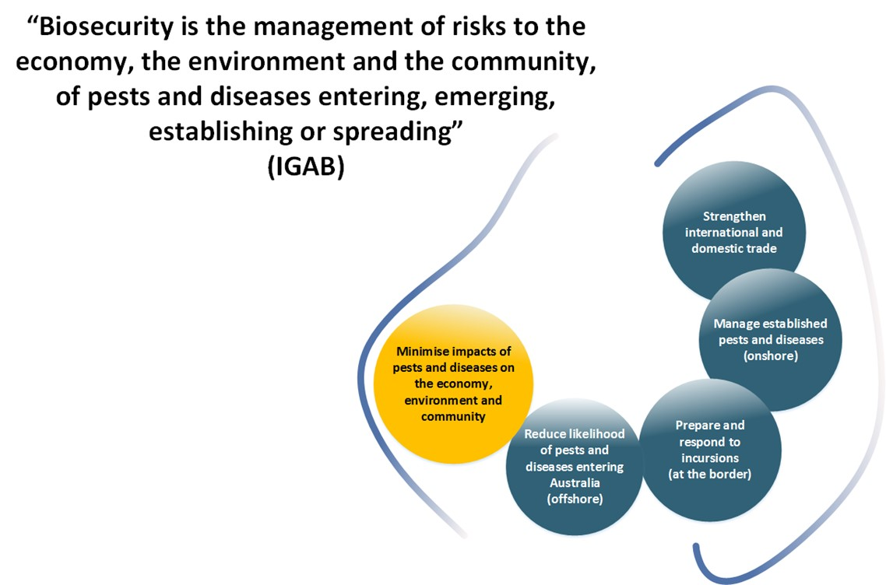

Source: 2012 IGAB.

The system is also multilayered, involving complementary measures applied offshore, at the border and onshore and a broad range of participants, covering all Australian governments (Australian, state, territory and local), industry bodies, exporters and importers, farmers, miners, tourists, researchers and the broader community. A strong and effective system would not be possible without contributions from, and cooperation between, all system participants across the full extent of biosecurity activities.

### Benefits of national biosecurity

Australia’s biosecurity system continues to protect the nation from many exotic pests and diseases. The Australian Government (sub. DP65) highlighted the many benefits of the national system, including:

* reducing the cost of agricultural production
* reducing the impact of pests and diseases on our environment (including associated negative impacts on agricultural productivity and amenity)
* safeguarding the health of our community
* supporting animal and plant health
* supporting a profitable agricultural industry through improving and maintaining market access
* supporting a healthy and biodiverse environment underlying much of Australia’s tourism.

### An evolving system

Australia’s biosecurity system has continuously evolved and adapted to address emerging challenges and opportunities and to reflect changing risks, priorities and circumstances. Since 2000, there has been significant activity across the national biosecurity system—particularly in recent years (Figure 2).

All jurisdictions have introduced a range of legislative, governance and system improvements. Industry has similarly been active and increasingly engaged. However, Australia continues to experience a notable, and seemingly increasing, number of incursions, reinforcing the need for constant vigilance and continuous review and reform of the national system to avoid, detect and respond to threats.

System-wide reviews have and continue to strengthen the national biosecurity system, driving structural and behavioural change and highlighting risks and improvements to be addressed by governments, industry and other system participants.

In 1996, Professor Malcolm Nairn AM chaired an independent review of Australia’s then quarantine system (Nairn et al. 1996). A key recommendation was the adoption of the principle of shared responsibility: namely, that a partnership approach be the foundation for the quarantine system, in recognition of the role that all stakeholders in the system—governments, industry and the community—have to play. The system of shared responsibility would be most effective when stakeholders were aware of each other’s roles and responsibilities and were working collaboratively toward achieving agreed outcomes.

Other recommendations focused on environmental considerations in quarantine, increasing the profile of plant quarantine through establishing an ‘Australian Plant Health Council’ and a Chief Plant Protection Officer position, carrying out risk analyses for imports, and considering the broad range of views from industry and the general public in quarantine matters.

In 2005, Mr Roger Smith, a former Director-General of the Northern Territory primary industries department, prepared a discussion paper on biosecurity in Australia for the former Primary Industries Standing Committee, highlighting the value of a national approach to biosecurity that brought together the various biosecurity components and functions from across all nine jurisdictions.

Figure 2 Major pest and disease activity 2000–2017

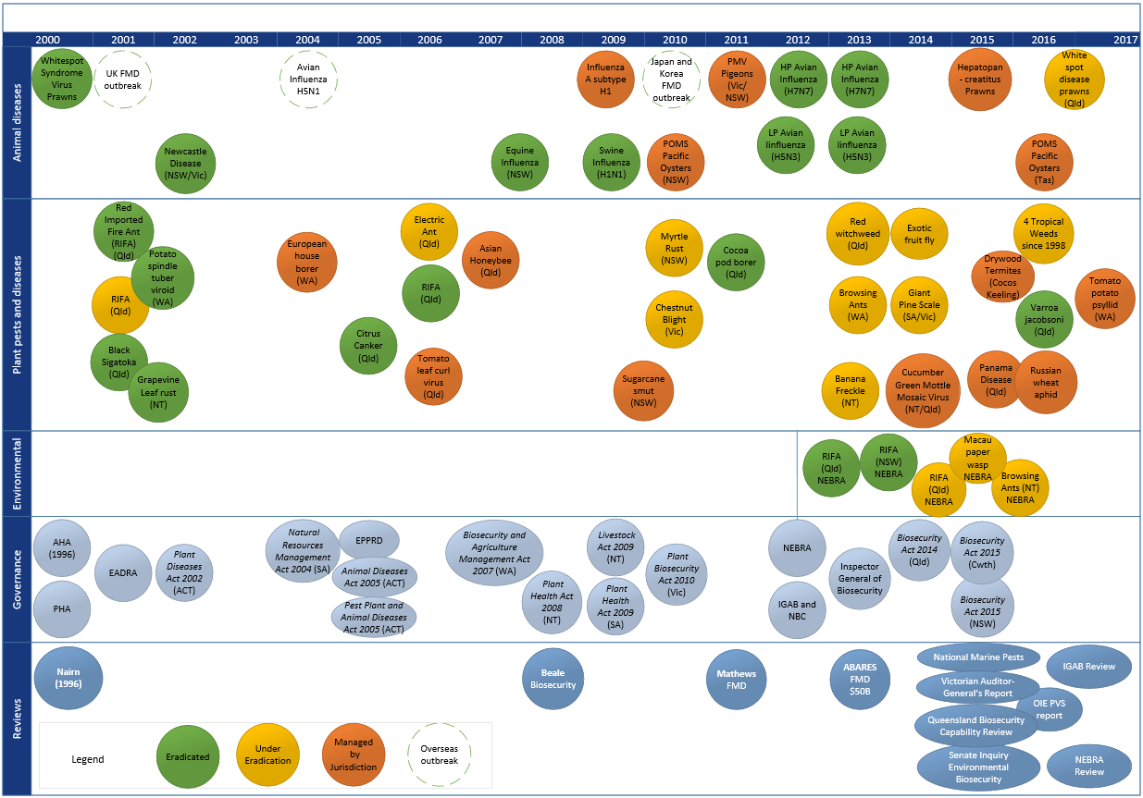

Source: Australian Government Department of Agriculture and Water Resources.

In 2008, a wide-ranging independent review chaired by Mr Roger Beale AO (Beale et al. 2008) (the Beale review) built on the shared responsibility principle, arguing for a seamless system that fully involved all players, and a move from the concept of quarantine to a broader concept of biosecurity which emphasised managed risk, not zero risk. This risk-based approach highlighted that the system includes a continuum of pre-border, border and post-border activities and sought to direct biosecurity controls and risk mitigation measures to where they were most effective.

The Beale review also recommended new institutional and legislative arrangements, funding models and the development of a National Agreement on Biosecurity to underpin a partnership approach between the Australian, state and territory governments on biosecurity, building on various existing agreements between governments. Governments’ pursuit of this recommendation has taken the form of the Intergovernmental Agreement on Biosecurity (IGAB), signed in 2012 by First Ministers from all governments except Tasmania. This agreement has become the principal agreement and collaborative mechanism for governments on biosecurity matters.

In 2011, Mr Ken Matthews AO conducted an independent assessment of Australia’s preparedness for the threat of foot-and-mouth disease (Matthews 2011), including the capacity to prevent and respond to an outbreak. Recommendations covered the areas of government leadership, a need for greater focus on prevention and preparedness and clarity on responsibility and accountability for disease planning processes.

A 2013 report by the Australian Bureau of Agricultural Resource Economics and Sciences (ABARES) put the cost of a large foot-and-mouth disease outbreak in Australia at more than $50 billion over ten years, encompassing very large adverse economic and social impacts and financial losses (Buetre et al. 2013). The findings highlighted the importance of response preparedness and stakeholder collaboration and the significance of market access considerations for biosecurity.

In 2015, the Australian Government conducted a review of national marine pest biosecurity arrangements (DAWR 2015). The review’s recommendations sought to provide a new prevention focus for marine pest biosecurity, develop stronger response arrangements for dealing with incursions, and improve relationships and sharing responsibility for marine pest biosecurity between researchers, industries, governments and the community. The review also highlighted the greater cost-effectiveness and efficiency of preventive measures to reduce the impacts of marine pests.

Other recent reviews and inquiries attest to the increasingly tight fiscal environment for governments, including declines in the resourcing for and capability of jurisdictional biosecurity systems. Agencies responsible for biosecurity across all governments have identified challenges in continuing to meet their national biosecurity commitments:

* In March 2015, the Queensland Government commissioned an independent review chaired by Ms Renata Brooks, on the capability of the Queensland biosecurity system (Brooks et al. 2015). The final report highlighted critical gaps in the state’s biosecurity system, including a pressing need to build capacity to respond to incursions. The report also noted a 26 per cent reduction in staffing between 2012 and 2015.
* In May 2015, the Australian Senate Environment and Communications References Committee released its report on environmental biosecurity (Commonwealth of Australia 2015), suggesting the effective operation of the national biosecurity system is threatened by a lack of resources, including within the Australian Government departments of agriculture and environment and within scientific bodies such as the Commonwealth Scientific and Industrial Research Organisation (CSIRO).
* In August 2015, the Victorian Auditor-General reported a reduction in the Victorian Government’s ability to detect, respond to and prepare for an emergency livestock disease outbreak (VAGO 2015). The report highlighted a 49 per cent reduction in state recurrent funding for core livestock biosecurity activities between 2009–10 and 2014–15; staffing reductions, including specialist positions, were also highlighted.
* In May 2016, the World Organisation for Animal Health (OIE) released its assessment of Australia’s veterinary services, measured against 47 criteria, with 38 given the highest competency level (Schneider et al. 2015). The report noted the high level of biosecurity in Australia but identified inadequate staffing levels as a key issue for jurisdictions to consider.

In addition, in June 2016 the Australian Government established the statutory position of the Inspector-General of Biosecurity (IGB) under the *Biosecurity Act 2015* (Cwlth); an interim IGB had been in place since July 2009. The position provides assurance over Australia’s biosecurity risk management systems through independent evaluation and verification, reviewing the performance of functions and exercise of powers by the Director of Biosecurity, and makes recommendations for overall system improvements. The IGB is currently reviewing the Australian Government agriculture department’s management of circumstances leading up to the 2017 suspension of uncooked prawns into Australia and the department’s management of risks posed by so-called ‘hitchhikers’ and contaminants associated with cargo containers, transport methods and conveyances. It is also examining what lessons can be learned from analysis of recent terrestrial pest and disease incursions, border breaches and high-risk interceptions.

This review of Australia’s biosecurity system and the underpinning 2012 IGAB is another step in the continuous improvement process, essential for maintaining the strength of the national system, its focus on priorities and ability to address areas of emerging need and concern.

### Future risks and pathways

Managing biosecurity risk has become more challenging due to increasing risks, the changing nature of risks, and increases in associated management costs. Factors such as globalisation, international and interstate migration, climate change, tourism, and the increasing movement of goods are all contributing to increases in biosecurity risks (CSIRO 2014; Grafton et al. 2015; Hajkowicz and Eady 2015; Cope et al. 2016).

Current transport volumes already present challenges requiring, in 2015–16, the border assessment, screening, inspection or clearance of:

* 46,000 sea containers on the Country Action List (containers on high-risk sea cargo pathways)
* 640,000 air freight consignments (under $1,000 in value)
* 138 million international mail articles
* 19 million arriving international passengers
* 800,000 sea passengers and crew (DAWR 2016).

Future global growth will lead to increased trade and passenger volumes across Australia, along with change in origin of trade and passengers—with more coming from what are considered higher-risk origins.

Some of the more compelling forecasts illustrating the ongoing challenges facing the national biosecurity system include the following:

* Total containerised trade (both imports and exports) is forecast to rise from 7.2 million twenty-foot equivalent units (TEUs) in 2012–13 to 19.4 million TEUs in 2032–33—a rise of 169 per cent (BITRE 2014).
* Total non-containerised trade is forecast to more than double from 2012–13 to 2032–33, from around 1 billion tonnes to over 2.2 billion tonnes (BITRE 2014).
* Air freight is expected to continue to grow as demand for just-in-time delivery increases for items such as high-value manufacturing and mining products, perishables such as food, time urgent medical products and market flowers (DIRD 2016).
* The average annual growth rate for international air passengers is forecast at 4.9 per cent between 2015 and 2034, with domestic and international passenger movements through capital cities expected to almost double by 2030 (DIRD 2016).
* The market share of passengers arriving from China is expected to rise to 25.7 per cent in 2024–25, up from 16.4 per cent in 2016–17, contributing around 43 per cent of total growth in visitor numbers between 2014–15 and 2024–25 (TRA 2016).
* The number of cruise ship passengers has increased annually on average by 19.4 per cent since 2007, reaching a record of over 1.2 million passengers in 2016. The industry’s target is for 2 million passengers by 2020 (CLIA 2017). Cruise ships are increasingly visiting low-volume regulated ports in New South Wales and Western Australia and are also anchoring offshore and transporting passengers to destinations in far north Queensland and north Western Australia (DIRD 2014).

In a constantly changing biosecurity environment, Australia’s biosecurity system must remain strong and focused and build national capacity and capability to address future challenges. Future and emerging global trends will significantly change and increase the magnitude and complexity of the biosecurity risks we face—Australia cannot rely on previous success or our geographic isolation. The Commonwealth Scientific and Industrial Research Organisation (CSIRO) has identified a number of intersecting global megatrends that point to a future where existing biosecurity processes and practices may not be sufficient (CSIRO 2014).

Based upon feedback and information provided as part of this review, the panel considers current and likely future risks to include:

* tourism, trade and market access
* increased global trade volumes (including the growth in online shopping), where increased transport and shipping will mean new pathways for new aquatic and other pests and diseases
* increased imports of processed food as processors continue to shift operations to their lowest-cost location
* increased international scrutiny. As trading partners strengthen their own biosecurity systems and requirements, Australia’s market access negotiations will be harder and there will be a growing need to demonstrate our pest and disease freedom
* increased passenger air and sea travel, bringing increased international tourist entry and activity, including to more remote parts of Australia, and increasingly from countries (and regions within these countries) which have not been historically represented
* other global trends
* increased agricultural expansion and intensification. The trend towards fewer, larger and often more concentrated farms may mean that outbreaks will have greater consequences for the owner of the farm and the markets supplied by the farm. Increased agricultural expansion will also have particular relevance to northern Australia, where increased agricultural production may create an environment for new pests and diseases to establish or spread
* increased urbanisation, bringing biosecurity risks closer to agriculturally and environmentally sensitive areas
* climate change, bringing biodiversity pressures and altering the geographical distribution of pests and diseases globally, including within and in the vicinity of Australia
* changing consumer expectations, covering the significant growth in products such as free-range meat and eggs and an increase in organic farming
* the rise of online retailers (noting their ability to provide, and rapidly deliver, an extensive range of goods, including produce) and the corresponding rapid increase in small parcel movements
* financial risks
* pressure on funding allocation, driving greater focus on innovation and cost-saving technologies, as well as greater efficiencies in and effectiveness of the methods used to manage biosecurity risks
* declining government resources, forcing greater government attention to areas of higher risk (and return on investment) and affecting access to qualified and experienced specialists (for example, veterinarians and plant pathologists). While this approach is logical under conditions of constrained resources, it will impact on the overall level of risk—that is, it is not a risk-free decision. For example, the review utilised the Australian Government agriculture department’s Risk Return Resource Allocation (RRRA) model (Appendix D) to illustrate the exposure to biosecurity risk arising from specific investment decisions at the Australian border (Box 1).

A strong national biosecurity system will require a sustained focus on all of these risk areas. The panel has sought to assist key decision makers to prepare for some of these risks by proposing a number of structural and systematic improvements, as outlined in this report.

Box Change in trade and patterns and exposure to biosecurity risk

The number of passengers, shipping and containerised cargo arrivals in Australia is forecast to increase by more than 70 per cent by 2025 (DIRD 2014). The possible effect of this increase on biosecurity risk to Australia, and its management by the Australian Government agriculture department, was explored using the department’s Risk Return Resource Allocation (RRRA) model.

Using the RRRA model, projected volume increases to 2025 for four entry pathways (responsible for around half of the residual biosecurity risk to Australia) were examined: air and sea passengers; commercial vessels; sea containers (external surfaces only); and timber (bulk timber and wooden manufactured articles). Trade data and costs (Australian Government only) for 2014–15 were used as a baseline for three possible 2025 scenarios to manage biosecurity risks associated with the projected volume increases at the border (the analysis assumed no other adjustments, pre- or post-border, are made to manage risk):

* **Scenario 1 (Fixed investment)**: Border clearance costs are maintained at 2014–15 levels.
* **Scenario 2 (Fixed intervention rate)**: Border clearance processes adjust to changing volume (document processing and intervention rates).
* **Scenario 3 (Fixed residual risk)**: Border clearance processes (intervention rates and effort) are increased in an attempt to maintain residual risk at the 2014–15 levels.

In 2014–15, around $90 million was spent managing biosecurity risk for the four pathways. The RRRA model calculated this investment to benefit Australia by $2.4 billion in avoided long-term losses1 to agricultural industries, with $1.7 billion in residual biosecurity risk2.

The analysis showed that, while increasing the investment in biosecurity interventions at the border does provide a benefit, it would not be sufficient to keep residual biosecurity risk at the 2014–15 level of $1.7 billion. Even almost tripling investment in interventions to $250 million (scenario 3), while providing an estimated benefit of $4.7 billion, only manages to reduce the residual biosecurity risk to $2.1 billion. The residual risk under scenario 2 was higher at $2.9 billion, with a lower estimated benefit of $3.8 billion. This highlights the importance of seeking innovative approaches, pre-border and post-border as well as at the border, to biosecurity risk management; simply increasing funding is not a ‘silver bullet’.

This finding is reinforced by the diminishing return on investment (ROI) for the four pathways in scenarios 2 and 3. In comparison to the current (2014–15) ROI (27:1), the marginal ROI3 on the additional investment is less than half under scenario 2 (12:1), and about one-quarter under scenario 3 (7:1). The overall ROI is also substantially reduced under scenario 3, dropping from 27:1 to 19:1.

Notes: 1. Avoided long-term loss is the estimated reduction in exposure to biosecurity risk as a result of having biosecurity controls in place; 2. Residual biosecurity risk is what remains with biosecurity controls in place. [The sum of 1. & 2. is the biosecurity risk if no controls were in place]; and 3. Marginal ROI is the return on the additional investment needed to maintain current policy settings for border interventions (scenario 2) or to attempt to maintain residual risk at current levels (scenario 3).

Source: Australian Government Department of Agriculture and Water Resources.

### The 2012 IGAB

The 2012 IGAB created a framework for governments to coordinate and identify priority areas of reform and action to build a stronger and more effective national biosecurity system. The agreement comprised two parts: the first part established the goal, objectives and principles of the system, as well as the purpose and scope of the agreement; the second part, the schedules, outlined the priority work areas for governments and their key decision-making committee, the NBC.

The 2012 IGAB was an important step for governments, recognising the value of further strengthening and institutionalising intergovernmental relationships—a sign of growing maturity in the national biosecurity system. The agreement has undoubtedly contributed to a stronger working partnership between all governments. While not a signatory, Tasmania has fully engaged and cooperated in the spirit of the agreement.

The achievements of the IGAB, while not necessarily well or publicly documented, are many and cover a broad range of activities across the system, including the development of significant and sound national policy principles and frameworks. Many of these achievements have been drawn upon throughout this report and include the development of:

* the National Environmental Biosecurity Response Agreement (NEBRA)
* the National Transition Program Policy Framework
* the National Framework for Benefit Cost Analysis
* the National Framework for Cost Sharing Biosecurity Activities
* the national portfolio investment optimisation model
* the national stocktake of biosecurity investment
* a framework for the management of the national surveillance and diagnostic capability
* the Plant, Animal, and Environment and Community biosecurity research, development and extension (RD&E) strategies
* a national policy framework for the management of Established Pests and Diseases of National Significance that provides a lead role for industry and community
* the National Biosecurity Engagement and Communications Framework and the revitalisation of the Biosecurity Incident National Communications Network
* self-assessment methods that assist jurisdictions to assess and improve their emergency preparedness capacity and capability.

The 2012 IGAB was ambitious, detailing more than forty priority areas for reform by governments. Not surprisingly, there remains work to complete. In 2015, the NBC conducted an internal assessment to identify the outstanding priority reform areas and determine how best to progress implementation. As a consequence, reform areas were further prioritised and streamlined. Governments have also recognised the value of regular ongoing review, stipulating a minimum review of the agreement every five years.

## Knowing and owning our roles and responsibilities

Key points

* ‘Shared responsibility’ is not clearly defined and hence poorly understood. A common understanding is yet to be realised.
* The roles and responsibilities of participants in the national biosecurity system are not comprehensively articulated and have not been agreed. Agreeing roles and responsibilities will be an important first step in realising shared responsibility.
* Acceptance of responsibility will be challenging without some conferred rights/benefits; and, while this may be easier to articulate for industry, community rights/benefits also need to be considered in exchange for accepting responsibility.
* To date, governments have been reluctant to provide other system participants with opportunities to take greater ownership of, and responsibility for, activities in the national system.
* A National Biosecurity Statement would outline a common and unifying approach to biosecurity for all system participants.
* Engagement and communication across the system is mixed; a change in culture is needed.

### Shared responsibility?

Shared responsibility has been seen as the mainstay of the national biosecurity system for some time. It has been a feature of many reviews (Nairn et al. 1996; Beale et al. 2008; Matthews 2011; DAWR 2015) and is one of the IGAB’s core principles. However, there is widespread confusion and a lack of clarity about what it means, made more difficult by unclear roles and responsibilities for system participants.

#### What does it mean?

Throughout this review, governments, industry and community members have drawn the panel’s attention to the concept. Feedback received clearly indicates that the application of shared responsibility has not been clearly understood or broadly accepted by participants across the national biosecurity system. This has led to misconceptions around the concept (seen by some only as a euphemism for cost-shifting) and has caused difficulties in its application:

This term [shared responsibility] whilst used extensively has never been properly articulated or achieved a common meaning amongst members of the biosecurity community. As a consequence, it means many things to many people and no-one has responsibility (Voice of Horticulture sub. DP11)

There remains a considerable lack of clarity about what shared responsibility means in practice … it is evident that a common position on what the concept does and should mean has yet to be achieved … A misunderstood rationale for why shared responsibility is necessary and a lack of clarity about the expected behavioural change is the key barrier to its use as a policy principle (Queensland Government Department of Agriculture and Fisheries sub. DP48)

The panel agrees with the assessment, although it notes parts of the system where the principle has been adopted and used effectively. The animal and plant emergency response deeds are founded on shared responsibility and provide strong evidence of the benefits that come from a partnership approach. Other examples include the establishment and regulatory underpinning of Animal Health Australia (AHA) and Plant Health Australia (PHA), and the General Biosecurity Duty, or General Biosecurity Obligation—a regulatory articulation of shared responsibility featured in biosecurity legislation in New South Wales and Queensland. Similarly, the panel notes the Tasmanian Government has, as part of legislative reforms underway, recently sought feedback on draft legislation, which includes a general biosecurity obligation.

The panel considers opportunities exist to learn from the work on natural disasters, and these should be explored by all Australian governments. Shared responsibility in disaster management has been described below:

The vision of Shared Responsibility in Australian disaster management is therefore ultimately a vision for how collective action to manage disaster risk should take place—particularly collective action involving government and non-government actors. Similarly, changing the way responsibility is shared to achieve this vision is a process of changing the institutions—‘rules of the game’—that guide collective action in disaster management. While formal, written institutions such as laws, regulations and codes are important for structuring collective action and attributing responsibility in disaster management, it is important to recognise that so too are informal, unwritten institutions such as workplace cultures and social norms. Collective action institutions, the interactions between them and the way stakeholders seek to shape them, are therefore central to the way responsibility for disaster management is shared … (McLennan and Handmer 2014)

In relation to shared responsibility and planning ahead, Handmer and O’Neill (2016) evaluated some of the sparse empirical evidence about the link between preparedness and actual behaviour in the face of a major disaster—the 2009 Victorian Black Saturday bushfires. Among other things, they found that being well prepared to leave is the safest option, but householders can find it very difficult to assess all the relevant factors. Since those bushfires, significant effort has been put towards wider acceptance and effective adoption of shared responsibility in natural disaster management throughout Australia, particularly bushfires (McLennan and Handmer 2014) and cyclone preparedness.

The Bushfire Cooperative Research Centre has undertaken significant work on shared responsibility, given a sharpened focus by the 2009 Victorian bushfires and the related 2010 Royal Commission (Teague et al. 2010). Reform has been pursued to change perspectives, behaviour and actions to be taken by individuals in disaster management (for example, in areas such as bushfire preparedness and response). Importantly, these changes had strong policy support through the COAG National Strategy for Disaster Resilience (COAG 2011), positioning shared responsibility as a key component of a national approach to disaster management. Despite the compelling logic, the panel is unaware of any analysis of their effectiveness to date.

The panel has sought to give further clarity to the shared responsibility concept by proposing a simple definition for inclusion in the IGAB and other key national biosecurity system policies. The panel acknowledges that all parties will have some, but not an equal, level of responsibility:

Shared responsibility means everyone takes responsibility for biosecurity matters under their control. Everyone has an obligation to take action to protect Australia from pests and diseases (IGAB review 2017)

#### Application of shared responsibility to biosecurity

The application of shared responsibility for biosecurity is difficult and challenging (Higgins et al. 2016), primarily because the roles and responsibilities of participants across the national biosecurity system are not clearly understood, accepted, or consistently recognised across the system by all involved:

Governments, and industry to some degree, have failed to raise the overall general awareness of the importance of the national biosecurity system and the roles stakeholders have particularly the general community … Government agencies generally have a very good understanding of the role[s] and responsibilities of each other however there is not the same amount of understanding around industry’s role by both parties … (Nursery and Garden Industry Australia sub. DP23)

Work done by [the Biosecurity Council of Western Australia] identified that stakeholders had relatively consistent perceptions about the broad roles and responsibilities of industry, government and communities—but were less sure of the more specific roles/responsibilities … (Biosecurity Council of Western Australia sub. DP52)

Also, the language used to identify stakeholders within the national biosecurity system—such as risk creators and risk beneficiaries—can be divisive. Biosecurity must be acknowledged as everyone’s responsibility, and it must be acknowledged that it is in everyone’s interest to be involved, as in the case of the ‘general biosecurity obligation’ under the *Biosecurity Act 2014* (Qld). Designating someone as a risk creator seems unlikely to engender a positive reaction. It may be more appropriate to recognise all stakeholders that interact with the national system as ‘participants’—as is the case for New Zealand’s biosecurity system.

For the national biosecurity system to be effective, everyone must be aware of and acknowledge their roles and responsibilities and those of other system participants. The panel considers defining the roles and responsibilities of key participants an important first step in helping to realise shared responsibility.

The IGAB review draft report proposed a set of draft roles and responsibilities for the major participant categories—these being the Australian Government, state and territory governments, local government, industry, community and non-government organisations. The majority of feedback received was positive, with most stakeholders acknowledging the considerable benefits of having an agreed set of roles and responsibilities for the national biosecurity system. A revised set of draft roles and responsibilities is included in the draft National Biosecurity Statement developed by this review (section 2.4). It is intended that these be further refined as part of the consultation process to further develop the national statement. Following agreement on the roles and responsibilities of the major participant categories, subsequent steps could capture, confirm or revise the roles and responsibilities of the major institutions in the system (including the National Biosecurity Committee (NBC), AHA, PHA and research agencies) as some stakeholders have suggested.

Separately, shared responsibility has been criticised by some industry stakeholders as a euphemism for cost-shifting. The panel’s proposed definition of shared responsibility emphasises the taking of action by participants in the system for matters under their control. Consideration of public and private benefits and appropriate cost attribution will need to be made where funding is an issue. A separate second step would involve developing a means to measure how effectively system participants are meeting their defined roles and responsibilities.

### Greater ownership and participation

At present, the national biosecurity system is heavily reliant on Australian and state and territory governments to ensure its ongoing effectiveness. During this review, stakeholders noted a reluctance by governments to provide other participants with opportunities to take greater ownership of and responsibility for activities in the national system.

Governments face a dilemma: whether to provide greater responsibility to participants to encourage behavioural change, or, to delay providing responsibility until behavioural change has been demonstrated. The existence of successful industry participation programs both outside biosecurity (for example, Landcare) and inside biosecurity (for example, grains programs discussed below) suggests that careful allocation of roles and responsibilities followed by evaluation, can be very successful. Also, there is no possibility that governments can undertake the biosecurity task alone.

While governments have clear responsibilities for some activities (for example, regulatory and international responsibilities), the panel considers opportunities exist for industry, local government and community members to play a greater role than they have in the past.

The willingness and ability of additional participants to take on greater roles must be recognised and acted on. At present, the full capacity and capability of all system participants is not appropriately recognised or utilised. In addition, some industry and community members do not fully understand how and when they can, or should, be involved in biosecurity activities—perhaps due to poorly understood roles and responsibilities.

* + 1. **Greater industry ownership**

The Australian, state and territory governments should provide greater opportunities for industry to be involved in what have traditionally been their areas of discrete responsibility; involvement has been more, though not exclusively, focused in the area of emergency response but particular opportunities lie in the areas of priority setting, decision making and funding, and on-ground activities such as surveillance, monitoring and reporting.

For example, a number of initiatives have been developed and implemented by industries, some of which are managed and reported through the PHA and AHA mechanisms. The grains and horticulture industries, for instance, have 136 industry surveillance programs in place. Most of these programs are run by industry groups, but some also invest with their state government in delivering the program (RSC 2015). For industry to realise a greater role across the national biosecurity system, it must be prepared for the additional commitments and accountability that will stem from this, including taking ownership of issues and working in a coordinated fashion for the national interest. In particular, industry should take greater ownership for biosecurity issues which it can drive with limited, or no, government involvement. The Livestock Biosecurity Network (LBN) and Grains Farm Biosecurity Program (GFBP) are examples of strong industry-led initiatives (Box 2).

Box Industry-led biosecurity initiatives

The Livestock Biosecurity Network (LBN)

The LBN is an industry-led initiative founded in 2013 by the peak industry councils for cattle, sheep and wool and is supported through ongoing contributions from the Cattle Council of Australia. The LBN plays a key role in managing on-farm biosecurity by working with producers and industry members to provide tools and information to minimise the risks to the health, productivity and market access of livestock.

One example of the LBN’s on-ground work includes farm biosecurity plans. The LBN has worked extensively with state farming organisations, animal health authorities and producers to develop and deliver tools and training to assist producers in developing biosecurity management plans for their businesses. For example, trigger factors in Queensland, such as bovine Johne’s disease management and increased activity related to gas and mineral exploration and extraction, have reinforced the need for better on-farm biosecurity management.

Source: The [Livestock Biosecurity Network](http://www.lbn.org.au/) website.

The Grains Farm Biosecurity Program (GFBP)

The GFBP is an initiative to improve the management of, and preparedness for, biosecurity risks in the Australian grains industry at the farm and industry levels. The program, launched in 2007, is managed by Plant Health Australia and is funded by growers through Grain Producers Australia together with the New South Wales, Queensland, South Australian, Victorian and Western Australian governments.

Under the program, Grains Biosecurity Officers are employed in these states to develop and deliver materials to raise awareness of the importance of biosecurity and provide training to growers, consultants and other industry stakeholders. They work closely with growers and consultants to promote biosecurity awareness and facilitate efforts to protect crops from exotic pest and disease threats at the farm level.

Source: The [Grains Farm Biosecurity Program](http://www.planthealthaustralia.com.au/national-programs/grains-farm-biosecurity-program/) website.

The panel is aware that major food retailers have their own sophisticated quality assurance programs in place to manage food quality and traceability. While biosecurity has not been the main focus to date, it is increasingly on the ‘risk radar’ for their supply chains. Fresh fruit product withdrawals due to fruit fly infestations and the 2015 outbreak of Panama disease tropical race 4 in Queensland bananas were considered prime examples of how biosecurity incidents can disrupt food supply. Food retailers move a significant amount of product to a large number of locations, including internationally, to maintain quality and supply, and there is significant potential for retailers to integrate biosecurity considerations into their existing assurance and traceability programs.

Industry assurance schemes (or third-party programs), developed and agreed in partnership with governments, are other examples of how greater ownership for biosecurity activities can be realised (Box 3). Stakeholders noted these benefits:

There are significant advantages to be gained through government/industry partnerships around third party programs including demonstrating the shared responsibility mantra, improving overall biosecurity at farm level and reducing business cost. Third party programs have the potential to be market drivers for change at the farm level and will improve grower’s adoption of shared responsibility (Nursery and Garden Industry Australia sub. DP23)

Box Australian production nurseries certification program—BioSecure HACCP

BioSecure HACCP comprises a set of protocols and procedures that enable businesses to manage biosecurity risks by establishing effective internal quarantine processes for both imported and exported plant material. It validates many of the best management practice strategies under the Nursey Industry Accreditation Scheme Australia (NIASA).

The program is designed to assist growers in assessing their current and future pest, disease and weed risks and guide businesses in the implementation of management strategies at critical control points. It seeks to identify internal and external (endemic and exotic) threats to the integrity of a business’s biosecurity processes and preparedness. Its risk management system encourages businesses to maintain strict internal quarantine procedures and to record actions taken at critical control points.

Source: Nursery and Garden Industry Australia’s [BioSecure HACCP](https://www.ngia.com.au/Category?Action=View&Category_id=258) website.

However, Australia’s trading partners want government certification, and the Australian Government needs to have sufficient confidence in industry programs to be able to defend them and demonstrate to other countries that audit and assurance systems are in place, such as for meat export arrangements. The proactive support and involvement of governments is essential for the long-term success and overall effectiveness of such arrangements, including by addressing any impediments to their implementation.

* + 1. **Greater local participation**

Local government, with its close connections to local, regional and rural Australia, has much to offer the national biosecurity system. The panel was reminded on numerous occasions of the positive contribution that local government could play in biosecurity. In the Northern Territory, industry and government stakeholders recognised the contribution and expertise that could be provided by local government in emergency responses—for example, to banana freckle. It was noted that local government could draw on its disaster management skills, and successfully apply these to biosecurity emergency response management. The panel notes there are different models in place across the jurisdictions. For example, in South Australia, Natural Resources Management (NRM) Boards play a leadership and facilitation role in invasive species management. In New South Wales, Local Land Services has the greater role in managing local and regional incursion response programs.

Australian governments are also increasingly recognising the benefits of community participation in biosecurity, especially where citizen science and citizen awareness initiatives can improve surveillance. Opportunities for strengthening participation could be encouraged through already established networks such as the regional NRM organisations and local governments.

While acknowledging the variable roles of local government and NRM bodies across jurisdictions and funding models for their activities, the panel believes these opportunities warrant greater consideration by Australian governments.

### Improving communication and engagement

During this review, industry stakeholders relayed variable experiences related to government communication and engagement on biosecurity issues. Some stakeholders characterised these activities as a one-way flow of information and lacking genuineness:

Industry is only engaged in an advisory fashion. There needs to be a national ‘true partnership’ forum between industry and government on the biosecurity system, providing industry with the opportunity to assist in shaping and designing biosecurity measures (National Farmers’ Federation sub. DP16)

… the operating model [for communications and engagement] is still very much working on the traditional paradigm of government making policy decisions and then providing information to industry in the guise of consultation. It is Voice of Horticulture’s view that this is notification. Even when funding is on the table the Commonwealth has proved extremely reluctant and reticent to engage in serious discussion, let alone share responsibility for its management (Voice of Horticulture sub. DP11)

On the other hand, positive comments were made about communication with government during an emergency response and in managing established pests and diseases. Recent changes to national biosecurity roundtables (joint government­­–industry fora)—from information provision to genuine discussion with tangible outcomes—were also seen as a step in the right direction. The panel acknowledges progress in these areas but considers that greater opportunities exist. Several of the recommendations of this review have been framed with the aim of providing a ‘greater say’ for industry and other stakeholders in biosecurity policies and processes (Recommendations 2, 10, 13, 19, 25, 26, 27 and 28).

While industry is rightly seeking greater communication and engagement from governments across Australia, there is also an expectation from governments and other system participants that industry will further commit to helping to address short-comings of the national biosecurity system. This maturing of the relationship between industry and governments will result in a far superior national system. However, it requires a cultural change which would see governments committing to better and more open communication and engagement, acknowledging that some issues must be handled sensitively. It would also mean bringing industry and community participants into decision-making processes, noting that a ‘seat at the table’ brings responsibilities and obligations for non-government participants—particularly in the case of a co-design model as the Queensland Government has suggested (sub. DP48). Where decisions are for governments only, this will mean timely and transparent communication with others.

The panel is particularly concerned that general community awareness, understanding of, and participation in, biosecurity is generally considered to be low. In the panel’s view, participation is hindered by the dominant agricultural focus of biosecurity and a limited knowledge of community-level biosecurity risks, with the exception of international and domestic travellers (who still relate to ‘quarantine’ rather than biosecurity) and those responsible for on-farm biosecurity.

In a positive move, the Australian (Mercer et al. 2016) and New South Wales governments (Colmar Brunton 2017) have recently but separately commissioned research to provide insights into social attitudes towards biosecurity to help develop new policies and communication projects. A key finding from the national research was that *‘*Biosecurity is a word without a narrative’:

Biosecurity needs to have a story behind it that is evoked by the use of the word. This requires the concept to be strategically positioned as part of everyone’s lives in a tangible way. The story should include pre-border, border and post-border and have touchpoints of relevance to different stakeholder groups (what does it mean for me?) (Mercer_et_al._2016)

Some stakeholders have suggested that a national communication framework, strategy or plan could be the solution to lifting biosecurity awareness and encouraging behavioural change. The panel notes the NBC endorsed a National Biosecurity Engagement and Communications Framework in 2013 which aimed to support and enhance government communications with a range of stakeholders, but it has not delivered the required change. This is not a fault of the framework itself, which articulates sound policy directions and priority reforms, but an issue of government leadership, priorities and resourcing for biosecurity in all jurisdictions.

The panel considers additional funding is needed to significantly improve awareness and understanding of biosecurity, shared responsibility, the national system, and the respective roles and responsibilities of participants in the system. The panel has recommended additional funding measures for this purpose (Chapter 8). A recommitment by all jurisdictions to genuine and sustained stakeholder communication and engagement, for which they will be accountable under IGAB2, is well timed given that most jurisdictions have recently refreshed their biosecurity strategies, with some having legislated ‘biosecurity obligations’. This should support broad debate on a National Biosecurity Statement (section 2.4).

The panel also believes that state and territory governments could build on their existing partnerships with local and regional organisations, such as NRM bodies, catchment management authorities and local governments (where appropriate), to build an informed and proactive biosecurity community in their jurisdictions. Finally, biosecurity communications and engagement could benefit significantly from understanding, adapting and building on the extensive work done in disaster resilience communications and engagement and, in particular, promoting shared responsibility.

Recommendation 1

IGAB2 should include a core commitment by jurisdictions to ongoing stakeholder communication and engagement, building on existing partnerships, with activities scrutinised as part of jurisdictional evaluations under Recommendation 22.

### A National Biosecurity Statement

There is no single, overarching national policy statement or strategy shared by all system participants. At present, the articulation of the national biosecurity system is made up of objectives, principles and policies embedded in various jurisdictional and industry policy documents, sectoral strategies and emergency response deeds, which have for the most part been developed in parallel but not always in conjunction with each other.

Stakeholders hold a range of views on the merits of an overarching national statement or strategy: some consider the lack of a strategy a major gap in the strategic biosecurity landscape; some consider that, while current arrangements are adequate, they would benefit from improved coordination; and others highlighted the need for a national policy document but recommended priority be given to more significant reforms (for example, strengthening environmental biosecurity). Nonetheless, the majority of stakeholders consulted as part of this review were generally supportive of a jointly developed overarching national policy document:

The development of a national strategy, for example, would also provide opportunities for all stakeholders to improve their awareness of what key partners in Australia’s national biosecurity systems are already doing to address biosecurity within their sectors (Australian Lot Feeders’ Association sub. DP38)

A national biosecurity statement of intent may provide a platform to establish a common understanding of the national biosecurity system among stakeholders and the broader community. It offers an opportunity to realise a shared vision of the challenges facing the system, including funding and capability (Queensland Government Department of Agriculture and Fisheries sub. DP48)

AHA sees the collective development of a National Statement of Intent as an important stepping stone to the eventual development of a national strategy, which would improve coordination, collaboration and biosecurity investment by setting the national strategic directions for all stakeholders over the long term and binding all to the expected outcomes through a genuine and transparent shared responsibility approach (Animal Health Australia sub. DR107).

A national statement of intent, and explanation of the role that different industry sectors can play in the national biosecurity [system], could support a joint commitment and cooperation with industry. This would also provide a policy platform whereby stakeholders have an expressed shared commitment to issues concerning the environment, regional economies and security (Queensland Tourism Industry Council sub. DP57)

The panel believes that system participants would benefit greatly from a unifying national biosecurity statement which recognises a common understanding of biosecurity, shared responsibility and Australia’s risk-based approach. The statement should articulate a national vision and goals for biosecurity and key biosecurity principles; provide clarity on roles, responsibilities and accountabilities of participants; and outline national priorities and principles for managing biosecurity. The statement will need to be periodically redrafted, both to keep it contemporary and to engage new participants.

The panel has developed a draft National Biosecurity Statement (included in full at the end of this chapter) which can be used as the basis for broad consultation and debate by system participants. As the inaugural document, the draft statement is pitched at a fairly high level and provides the capacity for organisations/individuals to opt in as sponsoring parties at any time. However, in doing so, all sponsoring parties would need to acknowledge they are accountable for delivering on their commitments. Australian governments will also need to be mindful of the variable capacity of others involved in biosecurity and be supportive of developing this capacity in others. In addition, the national statement should, over time, help individual governments to better align their activities and jurisdictional strategies to the priorities of the national biosecurity system as part of their broader jurisdictional responsibilities.

The panel sees the National Biosecurity Statement as pivotal in providing a solid foundation for an evolving government–industry–community partnership into the future. The parties involved in its further development should seek to finalise the statement within eighteen months of the IGAB review report.

Recommendation 2

The NBC and the Industry and Community Biosecurity Committee should, through an open, transparent and collaborative process, lead national consultation on a draft National Biosecurity statement, such as that proposed by this review.

The consultation process should involve all levels of government (including local government), industry and the community, with the statement finalised and launched within eighteen months of the IGAB review report.

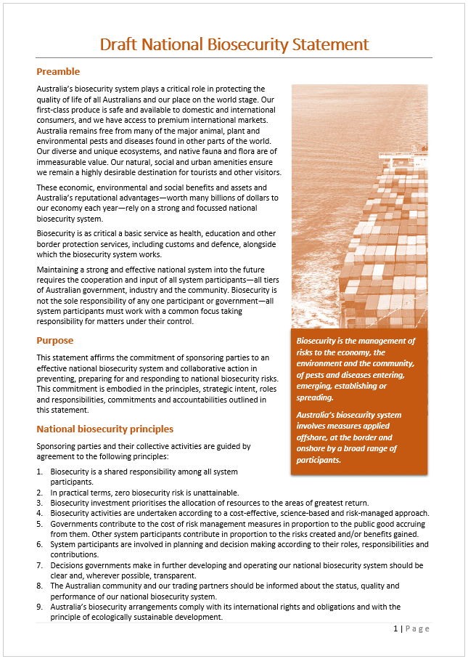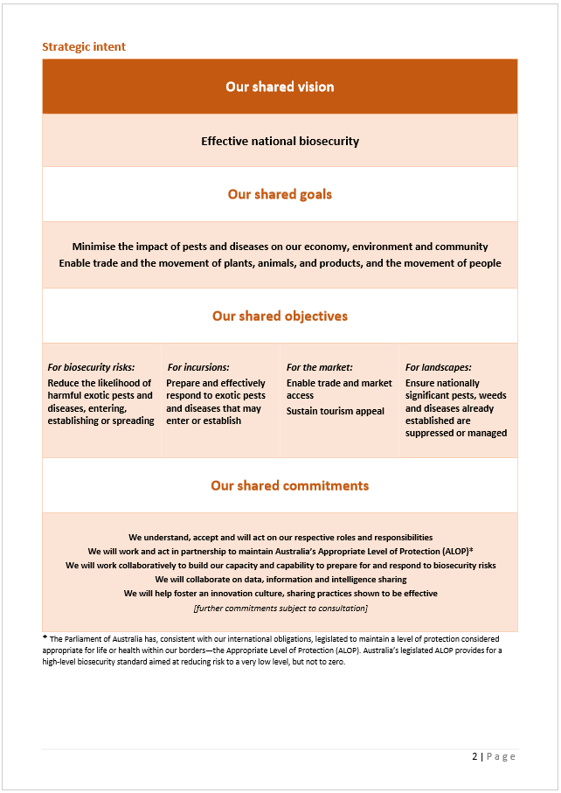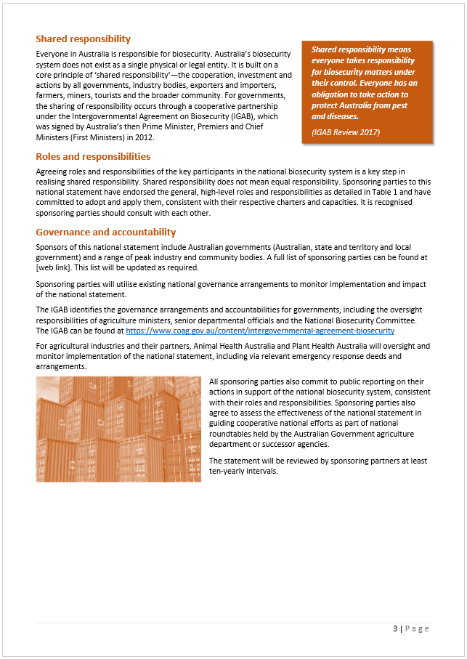

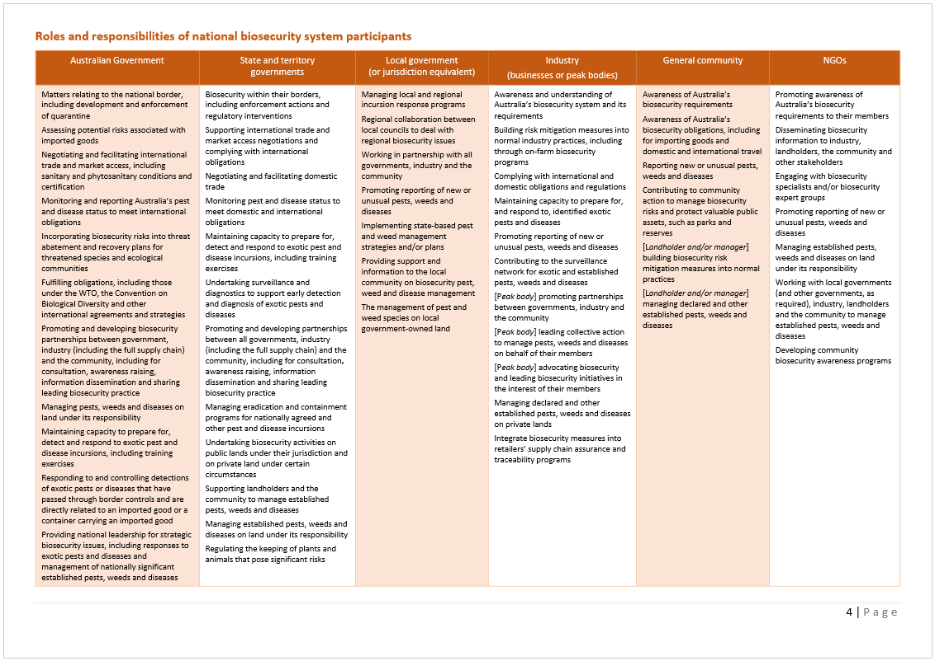

## Market access is key

Key points

* Australia’s world class biosecurity system is a trade and economic asset.
* There is scope to sharpen the focus on international market access within the national biosecurity system.
* Negotiating access to new markets will be harder in the future as trading partners strengthen their own biosecurity systems and requirements. Pest and disease freedom needs to be demonstrated.
* The effort and resources required to achieve, maintain and improve access to existing markets is significant and should not be underestimated.
* Jurisdictions, agricultural and other industries need to be proactive and work cooperatively to ensure Australia continues to remain competitive in international markets.
* Jurisdictions already have the mechanisms in place to streamline domestic market access requirements and resolve domestic trade disputes.

### Biosecurity and trade

Access to a broad range of international markets under least-cost importing country conditions is critical to the competitiveness of Australian agriculture. Australia’s clean, green image, a robust regulatory framework and favourable animal and plant health status give our industries and primary producers a competitive advantage in relation to other exporting nations.

Around two-thirds of Australia’s agricultural products are exported, with agricultural export earnings worth around $44.7 billion in 2015–16, forecast to increase to around $48.7 billion in 2017–18 (ABARES 2017). Australian producers are heavily reliant on exports to underpin their livelihoods, largely because the domestic market is small. Australian food exports are estimated to feed a population approximately three times the size of the Australian population.

Trade in agricultural commodities depends on the existence of agreements between importing and exporting countries on technical market access conditions which relate to biosecurity and food safety. Keeping technical market access and negotiating new or improved access conditions is increasingly complex and challenging. Other exporting countries are becoming more competitive in some key markets, and many importing countries are developing more sophisticated requirements to be met by exporters and certified by the Australian Government. Some markets will request that Australia provide scientific evidence of pest freedom, as we do of them.

Some trading partners have sought access to our market for certain commodities in return for access to their market—reciprocity. Australia conducts agricultural commodity import assessments in accordance with our international obligations, primarily the Agreement on the Application of Sanitary and Phytosanitary Measures (SPS Agreement). While discussion may occur on the level of resourcing and priority that can be applied to assessing other countries’ requests for market access, decisions around access to the Australian market and our biosecurity measures are based solely on achieving Australia’s Appropriate Level of Protection (ALOP). Our import policies are an essential element of maintaining a favourable animal and plant pest and disease status.

Stakeholders expressed a range of views during this review on the priority that market access considerations should be given in the national biosecurity system. These can be summarised as follows:

* Market access is the reason for investing in a national biosecurity system: ‘if you don’t have a good biosecurity system you can’t trade’ (key driver).
* Australia’s biosecurity system underpins international market access for Australia’s agriculture exports (key beneficiary).
* Market access is only one of the arguments for a strong national biosecurity system—environmental, human health and social amenity outcomes are also key (joint drivers and beneficiaries).

Our clean, green image also underpins our valuable tourism industry, much of which is dependent upon utilising the natural beauty and biodiversity of the distinctly Australian environment. In 2015–16, the industry’s direct contribution to Australia’s GDP was around $53 billion, with international visitors to Australia spending around $38.1 billion (TRA 2017). Nature-based tourism forms a significant component of Australia’s visitor economy. For example, Tourism Australia’s [nature-based tourism](http://www.tourism.australia.com/nature-based-tourism.aspx) website notes that, in the year ending June 2016, 68 per cent of international visitors engaged in some form of nature-based activity. The Queensland Tourism Industry Council highlighted the significant negative consequences that biosecurity incidents can have on Australia’s tourism industry:

The integrated nature of the visitor economy, across many sectors and sensitive to various global and local economic forces, means that any risk or impact on other sectors, including agriculture, can have flow-on impacts to the success of the tourism industry (Queensland Tourism Industry Council sub. DP57)

For example, the 2003 global outbreak of Severe Acute Respiratory Syndrome (SARS) resulted in the annual growth of Australia’s direct tourism GDP falling from 3.9 per cent in 2002–03 to 0.3 per cent in 2003–04 (TRA 2016a). Internationally, tourism in the United Kingdom suffered its largest financial impact from the 2001 foot-and-mouth disease outbreak, estimated to have been between £4.5 and £5.4 billion. The total direct costs to the public and private sectors across the UK economy from the outbreak were estimated at over £8.0 billion (UK NAO 2002).

### International exports

Agriculture has been one of the most significant beneficiaries of trade agreements and is well placed to capitalise on the free trade agreements with China (ChAFTA), Japan (JAEPA), and the Republic of Korea (KAFTA). It is also well placed to advance other market access opportunities for Australian products. However, our ambitions for market access will not be realised without a finely tuned national biosecurity system. The New Zealand Ministry for Primary Industries (NZ MPI 2016) captured the relationships this way:

**Biosecurity + Market access = Lasting two-way trade relationships**

#### Assessing the opportunities

The Australian Government has responsibility for market access negotiations. However, the export interests of multiple governments and multiple industries—with multiple export aspirations—mean that implementation is highly complex.

The arrangements for facilitating government and industry agreement on market access priorities can be opaque to those not directly party to the negotiations. For example, the recently released *International Strategy 2016–19* by the Australian Government Department of Agriculture and Water Resources (DAWR 2016a) provides very limited information on market access priorities and industry consultation mechanisms.

While acknowledging the sensitive nature of our market access strategy, governments should consider what scope there is to publicly clarify the priorities and consultative mechanisms for developing and reviewing them, without compromising our trade. Judgment will clearly be required to assess the desirable degree of transparency against the risk it poses to Australia’s interests.

The Primary Industries Technical Market Access and Trade Development Task Group (PITMATD)—comprising senior representatives of agriculture and trade departments—plays a key role in shaping the trade policy framework and coordinating market access efforts by the jurisdictions. Feedback received by the panel during this review indicates this can be an effective forum, although there are no public outputs for non-government stakeholders to judge. It is also unclear how the work of the National Biosecurity Committee (NBC), including any role in addressing biosecurity-related trade limitations, might be taken up by or through PITMATD. This seems largely dependent upon CEOs of agriculture departments, who are members of both PITMATD and the Agriculture Senior Officials Committee (AGSOC), the higher authority to the NBC.

Industry is seeking more predictable and greater opportunity to input into market access decisions by the Australian Government. While industry takes the lead on developing commodity market access strategies (with the input of governments), the Australian Government develops the overarching priorities for international market access and country strategies on key markets (with the input of industry and states and territories). Such arrangements have had variable outcomes for the parties depending on the balances struck during the negotiation process. Some industry stakeholders cited instances where market access wins did not align with industry priorities. On the other hand, government cited some instances where multiple market access requests by the horticulture sector were neither prioritised nor realistic; or, once access was granted, the market was not serviced to establish a strong trade credibility and evidence to seek better conditions:

Export industries need to demonstrate the viability of a particular market and its importance to the whole industry when requesting technical market access. For example, the citrus and table grape industries have developed detailed, evidence-based export strategies to demonstrate the viability of and potential benefits from their technical market access requests. Peak industry bodies in the red meat industry also have well-developed processes for identifying and progressing priorities (DAWR 2016a)

It is in the interests of industries, and firms within industries, to have as broad a range of trade options with as few receiving country import conditions as possible. This results in regular requests to seek access for different products to different countries and to improve the conditions to existing markets. However, there are limited resources, including technical expertise, that can be applied to achieve these outcomes. This means that, when access requests are made to other countries or opportunities to improve conditions arise, high-quality data must be available to support discussions. Alignment of industries’ access priorities with biosecurity activities to generate data or provide assurance is critical and will provide confidence that government resources can be applied effectively.

The panel also notes the positive role being played by the Grains Industry Market Access Forum and Horticulture Innovation Australia Limited to facilitate development of industry priorities for new and improved market access. The panel encourages other agricultural industries to robustly assess market readiness and quantify the return for effort required to gain access.

Recommendation 3

The Primary Industries Technical Market Access and Trade Development Task Group should enhance engagement with industry to ensure that Australia’s market access strategies are aligned appropriately through an agreed priority-setting process and that the degree of transparency and communication is carefully weighed against its level of risk to trade activities.

#### Balancing our efforts

In Australia’s quest to obtain new markets for our agricultural products, hard-won and improved access for existing markets must be continuously nurtured and our international reputation maintained. Key market access achievements since July 2013, published on the Australian Government Department of Agriculture and Water Resources [market access](http://www.agriculture.gov.au/market-access-trade/agricultural-trade-matters/achievements#2017) website, indicates that more than 50 per cent of ‘wins’ concerned improved access, maintained access or restored access in existing markets.

While incidents of temporary suspension of Australia’s market access are rare compared with our exporting competitors (New South Wales Government sub. DP58), the panel notes there were at least 22 instances where trade was restored in the past four years. Recent examples of non-compliance with importing countries’ requirements include the 2016 suspension of live cattle exports to Japan (Box 4) and repeated rejection of consignments of barley to China due to high snail numbers. Restoration of trade is usually achieved through agreement to new export certification requirements or bilateral negotiations with the importing country.

Box 2016 suspension of live cattle exports to Japan

In June 2016, Japan temporarily stopped accepting feeder and breeder cattle from Australia in response to some cattle testing positive for the wasting disease bovine Johne’s disease (BJD) in post-arrival quarantine. Japan is Australia’s only international live cattle export market that is actively eradicating BJD and has sanitary justification in applying strict import controls for this disease. An investigation into the matter by the Australian Government agriculture department confirmed that the consignment of 300 cattle from Victoria was not prepared according to the importing country requirements. In this case, certain preparation and isolation procedures within the supply chain were not adequately followed, resulting in the live cattle exporting business having its licence to send cattle overseas cancelled. Japanese authorities reopened the $14.6 million trade in feeder and breeder cattle from Australia in August 2016 following agreement on improved export certification processes for all consignments to ensure transparent information about the origin of all exported cattle.

Source: Australian Government Department of Agriculture and Water Resources.

However, there is a significant financial, reputational and opportunity cost to these events occurring, even though trade may be restored within twelve months. A national biosecurity system focused on supporting market access should have a very low tolerance for such occurrences. When incidents occur, considerable analysis is needed to establish where the supply chain or inspection and certification processes have broken down and to institute remedial action to avoid repeat disruption to the market.

While Australia’s strong regulatory framework, across all jurisdictions, has a critical role to play here, industry must ensure that systems are put in place to prevent a small number of operators from adopting substandard practices and potentially devastating a whole industry. Industries need to be proactive in encouraging the use of best-practice management systems across all sectors to minimise the threat of loss of reputation and credibility and of potentially being shut out of an export market. Active industry support for government decisions on withdrawal of export approvals or authorisations for individual firms or producers will also support the credibility of the broader system.

#### Regional differences / area freedom

The capacity to establish zones of area freedom from pests and diseases is highly valued by primary producers. Regional freedom can provide significant trade advantages, especially during a biosecurity outbreak.

Jurisdictions, however, hold a range of views on the strategic approach and value of demonstrating area freedom. The Western Australian Government considers there should be greater recognition of the market access benefits that regional freedom status can bring to jurisdictions (sub. DP59). Western Australia is free of many pests and diseases that are present in other states and territories, largely as a result of its natural barriers to pest and disease spread, and implements border protection arrangements to maintain its geographic and area freedom advantage. The same might be said for Tasmania.

The Australian Government, on the other hand, generally seeks to minimise internal border measures but recognises, under the *Biosecurity Act 2015* (Cwlth), regional differences where there is strong scientific evidence for taking action. However, the Victorian Government provides the following caution:

Zoning rules for international trade need to be carefully considered as they are very costly and can be more expensive to administer than the value of trade. Australia needs to carefully consider the need to have States and Territories recognised as zones, as this effectively results in the creation of ‘additional countries’ (Victorian Government sub. DP64)

Some governments expressed concern about the significant resources provided by governments to maintain proof of area freedom, despite the private benefit:

The concept to establish zones of area freedom from pests and diseases is highly valued by primary producers and is largely based on the absence of evidence rather than the evidence of absence. To provide the required rigor to claim area freedom would require significantly more resources tha[n] is currently applied to the biosecurity system and would unlikely provide significant costs benefit unless there is a natural barrier … that is minimising risk of spread (Northern Territory Government sub. DR117)

Every year the South Australian Government spends about $5 million keeping fruit fly and other plants pests out of the State, through a range of prevention, surveillance and eradication measures … the estimated farm-gate value of the state’s horticultural produce vulnerable to fruit fly infestation, including wine grapes and almonds, was $1.15 billion (South Australian Government, sub. DR111)

Victoria’s insistence on having Queensland Fruit Fly (QFF) restrictions in place imposed significant costs on NSW and Queensland producers and also imposed significant costs on the Victorian government to keep them in place. Up to the time that Victoria reduced their QFF regulation, it was costing the NSW Government in excess of $4.5 million and the Victorian Government in excess of $7 million per annum … In NSW, compliance is market driven, not regulatory driven, and QFF free fruit not subject to regulation is available at Sydney markets (New South Wales Government, sub. DR113)

The IGAB contains commitments (clause 7.10) around regional differences affecting imports (that is, they are a Biosecurity Import Risk Analysis (BIRA) consideration) but does not deal with area freedom for exports. Australia’s export markets are concerned about risks associated with pests and diseases already here, but trading partners are increasingly taking into account any local trade restrictions when assessing the import of product from Australia.

As a nation we need to ensure that local trade restrictions are based on robust scientific evidence, are no more stringent than our import measures and are consistent with our claims for exports. For example, all states recognise South Australia and Tasmania’s freedom from Mediterranean fruit fly (*Ceratitis capitate*; MedFly) and Queensland fruit fly (*Bactrocera tryoni*; Qfly)—our export market access claims of area freedom for South Australia and Tasmania are consistent with domestic measures. Conversely, all jurisdictions recognise that MedFly is present in Western Australia and require treatment of Western Australian fruit to allow interstate movement. The domestic measures in place to contain MedFly to Western Australia are consistent with our import measures (international) and protect the rest of Australia from this serious pest.

The feedback indicates the effort and costs associated with demonstrating area freedom can be considerable, as can be the value of the trade concerned. However, more analysis needs to be undertaken to fully establish the total effort and costs associated with demonstrating area freedom by governments and the return on this investment to the community.

Analysis needs to take into account different area freedom scenarios, two of which may be:

* where an outbreak of a pest or disease exotic to Australia occurs in a geographically isolated setting, such as south-western Western Australia or Tasmania (or the converse of this), and whether these restrictions would be temporary or permanent
* where area freedom restrictions are established to maintain freedom from a pest or disease which is already endemic to the remainder, or to a number of other regions of, the country.

Recommendation 4

AGSOC, in conjunction with the Primary Industries Technical Market Access and Trade Development Task Group, should review the total effort and costs associated with demonstrating area freedom by jurisdictions and the value of that trade. The review should establish whether public investment is aligned with IGAB investment principles and the National Framework for Cost Sharing Biosecurity Activities (Recommendation 27).

### Domestic trade

Trading and transporting goods across state and regional boundaries was a common concern raised by industry (producers and retailers) and government stakeholders during this review. Most domestic trade disputes appear to be long standing and primarily concern plant products.

Clause 7.19 of the IGAB commits signatories to limit the application of interstate biosecurity measures to those necessary to mitigate risks to the economy, environment and community; the least trade restrictive and scientifically-based measures; and those necessary to achieve Australia’s ALOP. However, the Productivity Commission (PC 2017) found there is little information available on the effectiveness of these provisions in limiting the use of trade restrictive measures—and the panel notes this concern is evident in some instances.

Some governments commented that the Interstate Certification Assurance Scheme, which provides opportunities to streamline domestic trade arrangements (only plant at present) could, with increased rigour and transparency, help minimise domestic trade disputes. The Queensland Department of Agriculture and Fisheries believes interstate certification agreements ‘largely operate independently of each other and would be complemented by a more strategic approach to domestic market access’ (sub. DP48)—for example, development of a harmonised policy framework.

The Nursery and Garden Industry Australia strongly addresses the need to fix domestic trade arrangements:

… our national biosecurity system is exposed to fundamental risks due to an increasingly complex and costly domestic market access system … The threat of non-compliance is increasing as government cost shifts and reduces business flexibility in servicing various supply chains. NGIA believes this is a direct result of governments across Australia failing to fund plant biosecurity at adequate and appropriate base levels particularly in recognition of the public good (sub. DP23)

The South Australian Government believes the Australian Government should have a proactive role in resolving significant post-border quarantine issues between the states and territories, including domestic trade disputes (sub. DP56). The IGAB (clause 7.19) envisaged such a role for the Commonwealth, and the panel understands this was the reason the Tasmanian Government did not sign the IGAB. The dispute resolution mechanism in the IGAB could not be drawn upon, even if there was a will to do so, as the Commonwealth had no legal basis for intervening. The *Biosecurity Act 2015* (Cwlth) similarly contains no such provisions.

A comprehensive and implementable dispute resolution mechanism was approved in 2010 by agriculture ministers and is still current. The arrangement includes a dispute resolution framework and principles, along with terms of reference for a committee of experts to assess the merits of a dispute. However, jurisdictions have shown little appetite for escalating issues to agriculture CEOs and ministers, and it does not appear this process has been utilised.

Jurisdictions assert that domestic trade disputes are, in the main, being suitably handled by the NBC, with escalation of issues as required and on a case-by-case basis. Given this view, the panel sees no purpose in including a prescriptive dispute resolution mechanism in the IGAB. Instead, clauses 7.18 and 7.19 of the current IGAB should be replaced with the following:

Where an interstate trade dispute arises between the Parties, the relevant Parties will seek to resolve the dispute through a process *agreed* by the Parties, and include determination on whether appropriate principles and processes were applied in imposing a biosecurity measure.

Ultimately, the resolution of disputes will be dictated by the willingness of the parties to engage in a genuine process or to defer to, and be bound by the decision of, a third party.

### Regulatory efficiency

The Australian Government agriculture department controls exports of agricultural products under *the Export Control Act 1982* (Cwlth) and associated regulations. While the legislation requires exporters to take responsibility for ensuring that Australian agricultural products meet importing country requirements, it is the department that bears responsibility for export certification. In 2015–16, the department issued more than 407,000 export certificates and managed the export of more than 3,000,000 animals (DAWR 2016).

The Australian Government has made a number of reforms to minimise regulatory burden and costs associated with its export and biosecurity functions. These include modernisation of the department’s information and communication technology (ICT) systems and service delivery arrangements, new cost-recovery arrangements, introduction of the *Biosecurity Act 2015* (Cwlth) and a review of agricultural export legislation (DAWR 2016b). Similarly, the states and territories have been reviewing their biosecurity arrangements and are committed to an ongoing process of reform.

Jurisdictions have also moved to accept some co-regulatory arrangements with industry, where appropriate (Box 5). The Australian Government Department of Agriculture and Water Resources informed the review that there were currently around 5,200 import arrangements in operation that are intended to facilitate trade and manage biosecurity risk. These arrangements provide for importers to undertake their own documentary assessments, biosecurity clearances or testing along their supply chain, as well as other incentives for participation. The *Biosecurity Act 2015* (Cwlth) also provides for entry into a wide range of approved arrangements, the application of a ‘fit and proper’ test for participants and specific sanctions for non-compliance with the approved arrangement.

Notwithstanding these moves, stakeholders continue to raise concerns around the red tape, time delays and costs associated with biosecurity inspection and certification services.

The panel believes potential exists for current compliance and assurance structures and schemes to continue to evolve. As part of this, the panel encourages governments to explore the potential for introduction of further incentive-based programs that reward a superior and sustained compliance culture by industry participants—with appropriately weighted sanctions. While there is always room for improvement, it is largely the case that the constraints applied are a combination of trading partner requirements on imports to meet their domestic legislation or to ensure a rogue event does not occur.

Box Government incentive-based programs

Australian Government Compliance-Based Inspection Scheme (CBIS)

The Australian Government agriculture department runs the CBIS (formerly known as the Plant Product Pathway Q-ruler and the Continuous Sampling Plan) for the importation of certain plant products into Australia. CBIS rewards importers of eligible products who demonstrate consistent compliance with biosecurity requirements by reducing the number of border inspections that they are subject to. These importers benefit from reduced inspection costs and faster clearance of goods. If non-compliance is detected at inspection or documentation assessment, the importer will return to 100 per cent inspection until they meet the number of clean consignments required to return to the reduced rate.

Source: Australian Government Department of Agriculture and Water Resources

Interstate Certification Assurance (ICA) Scheme

The ICA Scheme provides an alternative to traditional plant health certification involving government inspectors. This national scheme, administered by all states and territories, enables a business to be accredited by a state or territory plant quarantine authority to issue plant health assurance certificates for its produce. To be accredited, a business must be able to demonstrate it has effective in-house procedures in place that ensure produce consigned to intrastate or interstate markets meets specified plant quarantine requirements. The plant quarantine authority audits compliance by the business. The scheme seeks to provide a harmonised approach to the audit and accreditation of businesses throughout Australia and the mutual recognition of plant health assurance certificates accompanying consignments of produce moving intrastate or interstate.

Source: Australian Interstate Quarantine [certification](http://www.interstatequarantine.org.au/producers/interstate-certification-assurance/) website

Australian Trusted Trader (ATT)

The Australian Border Force’s (ABF) voluntary trade facilitation initiative, the ATT, recognises businesses with a secure supply chain and compliant trade practices, rewarding accredited businesses with a range of trade facilitation benefits, including: a dedicated account manager; priority services; differentiated examinations which apply as they are recognised as low risk; and use of the ATT logo. The ATT is open to Australian importers, exporters and service providers such as ports, brokers and freight companies that are active in the international supply chain. Agricultural enterprises (for example, Teys Australia) are participants in this program.

Mutual Recognition Arrangements are being established with Australia’s key trading partners (for example, New Zealand Customs Service) to enable Trusted Traders to access trade facilitation benefits of the reciprocal trading partner—reducing the customs regulatory burden for Australian exporters entering foreign markets. The ABF has established an Industry Advisory Group to bring together representatives from industry and government to provide advice, feedback and input into the design and development of the ATT. Minutes of meetings are publicly available.

Source: Australian Government Department of Immigration and Border Protection [ATT](http://www.border.gov.au/Busi/cargo-support-trade-and-goods/australian-trusted-trader) website.

### Aligning the agendas

The panel believes there is scope to better align the trade, market access, biosecurity and biodiversity agendas. As the Victorian Government (sub. DR118) points out, these functions are undertaken by various committees (including the NBC and PITMATD), so it is important that market access related roles of the committees and jurisdictions are clearly defined. Also, care will need to be exercised in arriving at a level of transparency in information that does not risk our trade.

Jurisdictions already have a sense of how ‘better alignment’ might be achieved. The New South Wales Government (sub. DP58) proposed the following approach:

* identifying biosecurity related trade limitations and agreeing to priorities and processes for overcoming these issues
* understanding what we need to do to demonstrate freedom from biosecurity threats to those markets
* using available data (presence and absence) to build a cohesive picture of status-based programs
* strengthening surveillance networks utilising government and non-government organisations.

The Victorian Government (sub. DP64) proposed that the IGAB formally recognise the Plant Health Committee’s Trade Framework, which guides government efforts to harmonise and streamline interstate and export trade conditions. The framework comprises:

* standards for entry requirements, which are informed by risk analysis; pest status of the importing/exporting jurisdiction; and market access needs
* controls to ensure standards are met (for example, certification, registered establishments, inspection, and documentation requirements)
* systems of compliance to provide assurance around implementation of the controls (for example, auditing, verification, and non-compliance detection).

The panel would support such efforts by jurisdictions to strengthen consideration of market access priorities and outcomes within the national biosecurity system and its components—and this should be facilitated through IGAB2. Enhancement and review of surveillance and diagnostic systems, research and innovation, and traceability systems to underpin existing and future market access arrangements would be obvious and fertile areas.

With regard to traceability, the Victorian Government (sub. DR118) proposed the development of a nationally consistent system for the allocation and use of property identification codes (PICs), which are currently administered separately by each jurisdiction according to different business rules. PICs are used extensively in the animal production industry for livestock identification and traceability, but they are used far less in the plant production sector. The panel strongly agrees that the value of PICs in market (domestic and international) and biosecurity terms would be substantial if a unified, national system tied to GPS data was adopted across the animal and major plant production sectors.

Recommendation 5

IGAB2 should facilitate greater consideration by governments of market access priorities and outcomes within the national biosecurity system:

* Biosecurity surveillance activities should include pests and diseases and common pathways that pose the greatest threat to our export markets and tourism.
* IGAB2 should clarify the roles and responsibilities of the parties with regard to international and domestic market access, including proof of area freedom.

Recommendation 6

Jurisdictions should develop a nationally consistent system for the allocation and use of property identification codes (PICs) across the animal and major plant production sectors.

## Stronger environmental biosecurity

Key points

* Environmental biosecurity encompasses natural ecosystems and social amenity.
* Incursions of exotic organisms harmful to Australia’s environment and its citizens are a regular occurrence.
* In recent years, pest incursions potentially impacting on the social amenity and wellbeing of Australian citizens have imposed the greatest challenge and financial burden to control and eradicate—for example, the red import fire ant (RIFA) eradication program in south-east Queensland has been going for over 15 years and has so far cost over $340 million.
* Australia’s success in both trade and tourism depends to an increasing degree on our clean, green, biodiverse and largely pristine natural environment. Australia’s environment also supports natural resource industries, including fisheries and aquaculture, which are embedded in natural environments.
* Environmental biosecurity efforts often have private as well as public benefits, but costs are largely borne by governments. Private contributions are minimal.
* Environmental considerations should be comparable to human health and primary production with respect to biosecurity, and comprehensive national arrangements need to be explicitly developed (pre-border, at the border and post-border) to address environmental biosecurity risks.
* Environment agencies need to be more engaged and play a far stronger and more direct role in the development of national biosecurity policy and in response arrangements, particularly in those situations where a newly introduced pest or disease primarily impacts on the natural environment.
* Environmental and social amenity stakeholders need to be involved in the biosecurity system.
* Stakeholders are divided on how to strengthen environmental biosecurity arrangements: create equivalent arrangements to agriculture; or integrate environment and social amenity into existing arrangements.

The Australian Government Department of the Environment and Energy’s [invasive species](http://www.environment.gov.au/biodiversity/invasive-species) website defines environmental biosecurity as follows:

Environmental biosecurity is the protection of the environment and social amenity from the negative effects associated with invasive species; including weeds, pests and diseases. It occurs across the entire biosecurity continuum: pre-border preparedness, border protection and post-border management and control.

This review has adopted the following definition of environmental biosecurity, which is more appropriately aligned with the definition of biosecurity under the IGAB:

Environmental biosecurity is the management of risks to the natural environment, and to social amenity, of pests and diseases entering, emerging, establishing or spreading (IGAB review 2017)

### The problem for governments

Environmental biosecurity has long been viewed as subordinate, including in funding terms, to agricultural biosecurity in the national biosecurity system. Biosecurity efforts for agriculture have clear economic drivers (for example, minimising production losses and maintaining and gaining market access), whereas environmental biosecurity efforts are viewed as ‘public good’ activities and are therefore left to governments to fund and implement. In reality, biosecurity incursions often have both production and environmental impacts, and this blurs roles and responsibilities and decisions around who benefits and who pays. For industry, its reputation and social licence to operate should drive its engagement on environmental biosecurity issues—for example, the involvement of port authorities and oil and gas companies in marine pest surveillance.

Agriculture and primary industry agencies, both at the Australian Government and state and territory levels, have explicitly or by default largely taken responsibility for environmental biosecurity, primarily because they have existing arrangements, technical expertise and structures in place upon which to draw—although they have less expertise in environmental management and risk identification to support decision making. These agencies have largely funded environmental biosecurity from within their existing budgets, leading some government and industry stakeholders to question the financial sustainability of such arrangements and opportunity costs for primary production outcomes.

The numbers of invasive species in a region or country have been shown to be related to gross levels of trade (Paini et al. 2016). The 2015 Senate Standing Committee on Environment and Communications References Committee inquiry into environmental biosecurity (Commonwealth of Australia 2015) found that incursions of exotic organisms harmful to Australia’s environment are a regular occurrence. The Australian Government’s submission to that inquiry (Australian Government 2014) detailed more than thirty incursions of exotic pests and diseases with the potential to impact the environment detected within Australia since 1 January 2009. A significant number of these were plant pests that were found not technically feasible to eradicate. However, the committee found that evaluating the significance of this pattern of incursions is not straightforward and there are no absolute markers of success or failure against Australia’s level of biosecurity protection of ‘very low but not zero’.

While the panel generally agrees with this finding, environmental biosecurity efforts (including for social amenity) have dominated the emergency response efforts and agency budgets in recent years (Table 1), particularly in relation to incursions of various tramp ants. Ongoing stakeholder concerns about the effectiveness of existing national arrangements to address environmental biosecurity risks elevated this issue as a key area for this review. Of note is the number of off-deed responses, which mostly pre-date the National Environmental Biosecurity Response Agreement (NEBRA). The agricultural parasitic weed, red witchweed (*Striga asiatica*), was excluded from the Emergency Plant Pest Response Deed (EPPRD) (because it is a weed) and from the NEBRA because its impact is agricultural, not environmental, illustrating a gap in the current system.

Table Current nationally funded emergency responses (as at 1 June 2017)

| Species | Location | Response plan duration | Response plan budget ($m) | Australian Government ($m) | State and territory ($m) | Industry ($m) |
| --- | --- | --- | --- | --- | --- | --- |
| EPPRD | . | . | . | . | . | . |
| Khapra beetle (*Trogoderma granarium*) | Adelaide and Kangaroo Island, SA | 2015–16 to 2016–17 | 2.57 | 1.03 | 1.03 | 0.51 |
| Exotic fruit fly | Torres Strait, Qld | 2015–16 to 2017–18 | 1.23 | 0.49 | 0.49 | 0.25 |
| Giant pine scale (*Marchalina hellenica*) | Harkaway and Mt Waverly, Vic. and Dernancourt, SA | 2014–15 to 2017–18 | 4.40 | 1.10 | 1.10 | 2.20 |
| Banana freckle | Howard Springs, Darwin, NT | 2013–14 to 2017–18 | 23.74 | 5.96 | 5.85 | 11.93 |
| Chestnut blight (*Cryphonectria parasitica*) | Ovens Valley, Vic. | 2010–11 to 2016–17 | 3.75 | 1.85 | 1.85 | 0.05 |
| Varroa mite (*V. jacobsoni*) | Townsville, Qld | 2016–17 to 2019–20 | 2.57 | 0.65 | 0.65 | 1.27 |
| Tomato potato psyllid (*Bactericera cockerelli*) | WA | 2017 | 3.10 | 1.24 | 1.27 | 0.62 |
| NEBRA | . | . | . | . | . | . |
| Red imported fire ant (*Solenopsis invicta*) | Brisbane Airport, Qld | 2015–16 to 2017–18 | 0.91 | 0.46 | 0.45 | N/A |
| Browsing ant (*Lepisiota frauenfeldi*) | Darwin Port, NT | 2015–16 to 2017–18 | 1.11 | 0.56 | 0.55 | N/A |
| Red imported fire ant1 | Port Botany, NSW* | 2014–15 to 2016–17 | 1.00 | 0.50 | 0.50 | N/A |
| Red imported fire ant | Yarwun, Qld* | 2013–14 to 2016–17 | 3.80 | 1.90 | 1.90 | N/A |
| Macao paper wasp (*Polistes olivaceus*) | Cocos (Keeling) Islands | 2015–16 to 2017–18 | 0.19 | 0.19 | 0 | N/A |
| Off-deed responses | . | . | . | . | . | . |
| Red witchweed (*Striga asiatica*) | Mackay, Qld | 2015–16 to 2024–25 | 5.86 | 1.80 | 1.16 | 2.90 |
| Browsing ant | Perth Airport, WA* | 2013–14 to 2015–16 | 0.14 | 0.14 | 0 | N/A |
| Electric ant (*Wasmannia auropunctata*) | Cairns, Qld | 2006–07 to 2015–16 | 12.88 | 6.44 | 6.44 | N/A |
| Red imported fire ant | South-east Qld | 2013–14 to 2017–18 | 92.95 | 37.47 | 55.482 | N/A |
| Four tropical weeds | Qld and NSW | 2010–11 to 2017–18 | 14.60 | 7.38 | 7.22 | N/A |
| **Total ($m)** | . | . | 174.80 | 69.16 | 85.91 | 19.73 |

EPPRD: the Emergency Plant Pest Response Deed; NEBRA: the National Environmental Biosecurity Response Agreement. 1. Figures are actual expenditure. 2. Total state and cost shared amount is $37.48 million, with an additional $18 million provided by the Queensland Government. *Responses that are complete.

Source: Figures supplied by the Australian Government Department of Agriculture and Water Resources.

There are no current emergency responses being funded under the Emergency Animal Disease Response Agreement (EADRA) as at 1 June 2017.

RIFA (Box 6) and myrtle rust are examples from the last two decades of incursions with significant environmental, community and cost impacts.

Box Red imported fire ant (*Solenopsis invicta* Buren)

The red imported fire ant (RIFA) is one of the world’s most invasive species, causing serious impacts for the environment, agriculture, social amenity, the economy, infrastructure and human and animal health.

RIFA was first detected in Port Brisbane and Richlands, Brisbane in 2001. Ants at Port Brisbane were eradicated in 2012, while south-east Queensland continues to be the subject of an eradication program costing over $340 million to date. In 2006, RIFA was detected in Yarwun, Queensland, and eradicated in 2010. This was the first time in the world that an established RIFA population had been eradicated (Wylie et al. 2016). In 2013, a new incursion was detected at the Port of Gladstone, Queensland, which was the first emergency response to be considered under the NEBRA.

Another detection in Port Botany in Sydney (2014) has been eradicated by a program cost-shared by all Australian governments. Under cost-sharing arrangements, three of Australia’s six established incursions of RIFA have been eradicated.

The south-east Queensland incursion was considered almost eradicated in 2003, but initial surveillance failed to gauge the extent of the outbreak. Subsequent surveillance showed the outbreak was about twice the size that it was originally thought to be. It is estimated that RIFA was present at least twenty years prior to 2003.

In 2016, an independent review of the national RIFA eradication program (Magee et al. 2016) found that it remains in the national interest to eradicate the ants and that it is technically feasible and cost beneficial to do so. All Australian governments have agreed to continue to cost-share the RIFA south-east Queensland eradication program in 2016–17 in accordance with the nationally agreed 2013–18 Response Plan. Further funding of $380 million for a ten-year eradication plan is under consideration.

Modelling by the Queensland Government indicates that failure to eradicate RIFA in south-east Queensland would impose costs of $43 billion over thirty years (Antony et al. 2009). In the United States, RIFA currently inhabits fourteen states and cost $7 billion a year in damage and control.

Source: Antony et al. 2009; QDAF RIFA [eradication program](https://www.daf.qld.gov.au/plants/weeds-pest-animals-ants/invasive-ants/fire-ants/national-red-imported-eradication-program/fire-ant-eradication) website; Wylie and Janssen-May 2016; Wylie et al. 2016.

RIFA is, and will continue to be, a major test for the national biosecurity system. It demonstrates the importance of all jurisdictions (ministers and senior officials and stakeholders) acting together in a transparent, timely and decisive manner. Concerns around ‘bureaucratic delays’ in funding and cost-sharing decisions were frequently raised during consultation for this review, particularly for off-deed emergency responses. These off-deed decisions take time because they do not have pre-existing agreement from the Australian, state or territory governments and, therefore, often require Cabinet or Cabinet Subcommittee approval. The panel is also aware that funding and delivery (lead agency) arrangements to contain yellow crazy ants (*Anoplolepis gracilipes*) in the Wet Tropics World Heritage Area are still subject to ongoing negotiation within and between relevant jurisdictions. Yellow crazy ants are considered an established pest, so they do not come under the national arrangements for cost-shared eradication.

Biosecurity efforts can lose significant traction from delays in funding decisions, impacting on eradication or containment, as the experience of RIFA in south-east Queensland and yellow crazy ants in far north Queensland illustrates.

### Views on environmental biosecurity

Governments and biosecurity stakeholders have long debated the best way to address environmental biosecurity concerns—whether to create separate and equivalent arrangements to agriculture or to embed environment within the animal and plant biosecurity streams. However, a necessary prerequisite must be clarity and agreement on the scope of environmental biosecurity efforts.

#### What the Beale and Hawke reviews said

The 2008 Beale review (Beale et al. 2008) concluded that more significant effort is needed on the terrestrial and aquatic environment reflecting the nature of the incursion risks involved:

The biosecurity of the environment is a concern not only for the sake of Australia’s environmental assets, but also because of the scope for wild animals and plants to act as a reservoir for pests and diseases that have broader effects …

The Beale review proposed, among other things, ensuring the then recommended National Biosecurity Authority was armed with the appropriate environmental (terrestrial and aquatic) technical expertise and broadening the membership of Animal Health Australia (AHA) and Plant Health Australia (PHA) to encompass environmental pest and disease issues.

In responding to the recommendations of the Beale review and environmental biosecurity arrangements under the *Environment Protection and Biodiversity Conservation Act 1999* (Cwlth) (the EPBC Act), Hawke (Hawke 2009) suggested:

* most of Australia’s ecosystems and species are threatened to some extent by invasion by diseases, pests, weeds and feral animals
* environmental considerations should be equal to human health and primary production in all stages of Australia’s approach to managing biosecurity—pre-border, at the border and post-border
* an integrated governance model is preferred for implementing the Beale review recommendations provided that environmental outcomes are not compromised by a ‘culture’ favouring trade and primary production.

#### What governments and stakeholders told us

The Australian Government Department of Agriculture and Water Resources asserts it is difficult and not desirable to manage biosecurity risk to the environment in isolation from managing biosecurity risk to animal, plant and human health. This view was reiterated in the joint submission of the Department of Agriculture and Water Resources and the Department of the Environment and Energy, which was largely based on resource use efficiency considerations (sub. DP65).

The 2015 Senate inquiry examined the framework in place for environmental biosecurity, including a proposal by the Invasive Species Council and others to establish Environment Health Australia. The proposal was resoundingly opposed by the Australian Government (agriculture and environment portfolios), AHA and PHA. The inquiry’s final report (Commonwealth of Australia 2015) proposed better coordination and information between existing organisations and agreements. The Australian Government’s response to the inquiry’s recommendations is expected to be tabled in Parliament later in 2017.

Within the current National Biosecurity Committee (NBC) model, environmental issues and risks appear to be distributed amongst the NBC’s subcommittees. For example, the Animal Health Committee deals with diseases impacting on native wildlife, and its members include Wildlife Health Australia—an environmental non-government organisation whose core funding is provided by the Australian Government. The Plant Health Committee’s ‘top forty’ priority plant pest and disease list includes environmental pests such as RIFA. The Marine Pest Sectoral Committee deals with marine pest biosecurity issues, and the Invasive Plants and Animals Committee deals with biodiversity and environmental impacts of established pests and diseases (including weeds and freshwater pests). While this could be presented as a feature of an ‘integrated environmental biosecurity model’, the structural logic of the arrangement is opaque, and there is no NBC body steering the environmental biosecurity agenda or that has a comprehensive grasp on the effectiveness of, or gaps in, these combined efforts.

Jurisdictions cited past attempts to treat environment issues as a separate stream under the NBC but consider this approach inefficient and duplicative. Additionally, some have highlighted that the environment also benefits from the broader system efforts (pre-border and border measures and surveillance). The Australian Government and representatives from other jurisdictions believe stakeholders are simply not aware of the full scope and breadth of activities undertaken by governments that support the management of biosecurity risks to the environment. That is, the issue is primarily one of awareness and transparency. Regardless, non-government stakeholders continue to view the arrangements for environmental biosecurity as immature, *ad hoc* and underfunded at all points in the system. For example, the Invasive Species Council states that:

The Invasive Plants and Animals Committee has given some attention to vertebrate pests and weeds that may impact on the environment, but has failed to advance work at the national level on several issues, including escaped garden plants and legal and illegal exotic pet birds, reptiles, mammals and fish. The recently exhibited draft Australian Pest Animal Strategy and Australian Weed Strategy are two examples of low ambition and little action by these committees … The marine pest sectoral committee has been progressing important work on ballast water and biofouling but has not to date adequately represented environmental interests (sub. DR95)

A contributing factor to the lack of transparency is that there is no equivalent to Wildlife Health Australia (WHA) for ‘non-wildlife biodiversity’, so there is no direct conduit to environment organisations or the community. WHA is funded by the Australian Government and public donations to coordinate and provide input on diseases in native wildlife which may affect the natural environment and be passed on to production animals. The governments and WHA could consider an expanded remit for WHA, covering biodiversity more broadly.

The Invasive Species Council, Wildlife Queensland, environmental stakeholders and others asserted that the issue lies in the fact that biosecurity is currently an agriculture commodity-based system. In its initial submission, the Invasive Species Council (sub. DP50) drew the panel’s attention to their view of the level of preparedness in agricultural biosecurity compared with environmental biosecurity, highlighting limited systematic surveillance for environmental biosecurity and few early detection and rapid response plans (Appendix F).

Biosecurity stakeholders, including government departments, have also expressed concerns about emergency response arrangements for environmental pests and diseases. The NEBRA establishes emergency response arrangements for responding to nationally significant biosecurity incidents where there are predominantly public benefits. It is a government-only agreement that has been triggered on five occasions to date, primarily for tramp ants.

The NEBRA is highlighted as one of the key achievements under the IGAB. However, the NEBRA signatories and environmental biosecurity stakeholders have questioned the workability of the NEBRA, including because:

* the need for consensus from all governments to trigger a biosecurity incident response ‘sets the bar too high’ and allows a single jurisdiction to block a national effort (although the EADRA and the EPPRD also require unanimous agreement to a response)
* neither the NEBRA nor any other response deed will be able to successfully address airborne environmental pest incursions, such as rusts and airborne insects, or incursions into marine and freshwater ecosystems, as these pests and diseases are rarely eradicable:

There is a diverse range of vectors, such as ballast water, biofouling of vessels which could transfer disease and pests into Tasmania’s marine waters. It is near impossible to fence off or isolate areas of the marine environment, meaning that disease or pest eradication is near impossible (Tasmanian Seafood Industry council sub. DR89)

* failure to meet the initial containment, verification assessment, notification and reporting requirements, all within twenty-four hours of the initial detection, can make an incursion ineligible under the NEBRA (Australian Government Department of Agriculture and Water Resources and Department of the Environment and Energy submission to the NEBRA review).

Addressing such issues will be fundamental to the success and optimal use of the NEBRA into the future, and are the rightful focus of the current 2017 NEBRA review.

It is worth noting that in the primary industry sectors, the relevant industry commits funds, along with the Australian, state and territory governments, to an agreed eradication program in accordance with the relevant deed. The relevant industry is financially exposed to the cost of a control program, and this in itself provides an additional external check to ensure a prudent assessment and evaluation prior to committing substantial funds to an eradication program. No such external party with financial exposure exists in the context of environmental pests and diseases, and governments are rightly concerned about the potential to inappropriately allocate taxpayer funds to eradication programs that have little or no chance of success. Accordingly, jurisdictions should put in place systems that ensure decisions of the National Biosecurity Management Group (the peak national decision-making group under the NEBRA) are evidence-based and transparent, in keeping with best risk management principles, and are timely and provide confidence to governments and the community that funds are being committed wisely and appropriately.

### Governing for environmental outcomes

Responsibility for environmental biosecurity is shared across jurisdictions, government agencies and other systems participants. However, despite best endeavours, current governance structures and relationships built around ‘integrating’ the consideration of environmental biosecurity risks are not advancing the scope of work needed to identify and mitigate those risks—and current activities and outcomes are largely invisible to those external to the NBC for whom Australia is perceived as failing to meet its commitments under international conventions and domestic legislation.

#### Clearly defined lead and support agencies

The national biosecurity system’s goal and objectives under the IGAB aim to minimise the harm that exotic pests and diseases can do to the Australian economy, environment and community. While the IGAB is the fundamental agreement among governments for biosecurity, national cooperation is reinforced by other government agreements including the 1992 Intergovernmental Agreement on the Environment (IGAE) and 1997 Heads of Agreement on Commonwealth and State and Territory Roles and Responsibilities for the Environment (COAG 1997), which respectively state:

The parties recognise the threat posed to both the natural environment and agricultural and maricultural production by pest species of introduced plants and animals and acknowledge that a cooperative national approach to their control has the potential to produce savings from a reduction of duplication of existing effort. The parties agree that the Commonwealth’s role should be one of facilitating the coordinated State efforts within this national approach. Due to the nature of the threat, coordination of a national approach should be undertaken through the Australian and New Zealand Environment and Conservation Council, the Australian Agricultural Council and the Australian Fisheries Council (1992 IGAE Schedule 9: Nature conservation)

The Commonwealth interest involves co-operation with the States to avoid or minimise risks to the environment arising from the import and export of animal and plant material that could contain anything that could threaten Australia's native flora or fauna and their natural environment (1997 Heads of agreement: Attachment 1)

With the streamlining of Council of Australian Governments (COAG) ministerial council arrangements in 2013, all Australian governments jointly tasked the Agriculture Ministers’ Forum (AGMIN) and its subcommittee, the NBC, with national coordination of biosecurity. This effectively assigned agriculture portfolios with lead responsibility for biosecurity in each of the jurisdictions and, to a significant extent, appears to have let environment agencies ‘off the hook’. At the Commonwealth and state and territory levels, there have been varied levels of engagement by environment agencies and a seeming willingness by them to let the agriculture portfolio have carriage of biosecurity.

While current arrangements can and do deal with environmental biosecurity matters, this does not occur on a systematic or transparent basis. The panel believes environment agencies and stakeholders must be more engaged in the formulation of national policy positions on biosecurity and provide agriculture agencies with the technical expertise on environmental risks.

The panel recommends that ‘lead’ biosecurity agencies (agriculture) should have formalised arrangements with their ‘support’ biosecurity agencies (environment, national parks, fisheries, regional development, defence et cetera). Some state agencies have formalised arrangements in place, but these are a minority. For example, the South Australian Department of Primary Industries and Regions South Australia (PIRSA) and Department of Environment, Water and Natural Resources have a memorandum of understanding (MoU) to facilitate resource and information sharing, including staff. For the Australian Government, MoUs have been signed between the then departments of agriculture and health, and between the then department of agriculture and the Customs and Border Protection Service. However, no such MoU exists between the Australian Government agencies responsible for agriculture and the environment.

The Australian Government environment department has international and statutory responsibilities relevant to biosecurity, including:

* control of live animal and plant imports under the EPBC Act
* post-border control of exotic/invasive species through threat abatement plans and recovery plans under the EPBC Act
* meeting Australia’s international obligations, including controlling alien species, under the Convention on Biological Diversity.

An MoU between the agriculture and environment agencies should capture how biosecurity risks will be addressed through live import controls and threat abatement and recovery planning processes under the EPBC Act. It should also capture, where these overlap with the NEBRA or another response deed, how responsibilities are assigned.

Recommendation 7

Jurisdictions should institute formal arrangements between agriculture and environment agencies, including through memoranda of understanding, to define the objectives of cooperation, leading and support roles, information flows, resources and deliverables.

### Institutionalising environmental biosecurity

Agricultural agencies consider that national arrangements under the IGAB and the NBC can and do address biosecurity risks to the environment and community (for example, RIFA), while environment groups and organisations have argued these arrangements can skew the focus of the biosecurity system towards the production sector, where the cost–benefit is clearer. Both of these perspectives are valid—expenditure on responses over the last fifteen years has overwhelmingly been towards pests with environmental and social amenity impacts—but evidence to date also indicates that environmental biosecurity risks are yet to be fully defined and prioritised, and preparedness, surveillance and response arrangements are not yet mature.

These issues should be addressed through clearer commitments to environmental biosecurity within IGAB2 and its priority reform areas.

Recommendation 8

Jurisdictions should make clearer commitments to environmental biosecurity within IGAB2, including in relation to:

* a clear definition of environmental biosecurity such as that proposed by this review
* the principle of ecologically sustainable development
* acknowledgement of Australia’s international responsibilities under the Convention on Biological Diversity
* a program of work to determine, plan and prepare for national priority pests and diseases impacting on the community, environment and native species
* a focus on environment and community as well as industry partnerships
* disease transmitted to humans by invertebrates as well as vertebrates.

The key environmental biosecurity deliverables under IGAB2 should comprise an agreed national list of exotic priority pests and diseases likely to impact the environment and the community; and development and implementation of a systematic national approach to preparing for and responding to national priority environmental biosecurity risks (Chapter 5)—enabled by establishing supporting NBC governance arrangements and accessing expertise across environment agencies.

A more strategic and transparent approach to addressing national environmental biosecurity risks is unlikely to occur without dedicated senior leadership, resources and technical expertise. The panel therefore recommends that the Australian Government establish the senior expert position of Chief Community and Environmental Biosecurity Officer (CCEBO), within the environment department, to perform a national policy leadership role similar to the Chief Veterinary Officer and Chief Plant Protection Officer in the national biosecurity system. The addition of the word ‘community’ to the title is to convey that the responsibilities of this position relate to Australia’s citizens as well as the natural environment, for example, the impact of RIFA. It is not intended to change or impact on human health arrangements in the health department or between the departments of agriculture and health.

The CCEBO would establish and chair a new Community and Environmental Biosecurity Committee (CEBC) to progress work on national priority pests and diseases (Box 7). Membership of this committee would comprise government and external community and environmental biosecurity experts (not representatives from environmental lobbying organisations) and include appropriate expertise from both the animal and plant sectoral committees of the NBC. The panel has proposed a new industry and community committee, on which environmental non-government organisations (NGOs) would have the opportunity to represent their interests (Chapter 7).

Box 7 A new Chief Community and Environmental Biosecurity Officer

**Establishment**

The Chief Community and Environmental Biosecurity Officer (CCEBO) should be a senior, expert scientific position located within the Australian Government environment department. The CCEBO should be appointed by the Environment Secretary following consultation with the Director of Biosecurity (Agriculture Secretary).

**Role**

Under the direction of NBC, develop and implement a more strategic and transparent approach to national environmental biosecurity investments and efforts.

**Responsibilities**

* Lead work to prioritise and plan for national biosecurity risks impacting on the environment (terrestrial, aquatic and aerial) and social amenity (Chapter 5).
* Establish and chair a new Community and Environmental Biosecurity Committee under the NBC.
* Contribute to the work of the Animal Health Committee and Plant Health Committee, as appropriate.
* Lead consultation with environmental and other biosecurity stakeholders, including through an annual Environmental Biosecurity Forum.
* Report on progress of the above at meetings of the NBC.

Once the CEBC’s work on national priority pests and diseases is completed, the future role of the committee could then be reviewed. Replicating the CCEBO at the state/territory level is not regarded as necessary under these new arrangements.

The establishment of new arrangements for environmental biosecurity under the NBC structure has been a highly debated and contentious area throughout the review consultation process. However, the panel considers the recommended arrangements are workable, and are necessary given the current and forecast operating environment.

While the Australian Government agriculture department manages biosecurity risks arising through the movement of people, goods and conveyances, it needs the expertise of the environment department in environmental risk identification and management, including for the environmental outcomes of ‘natural pathway’ environmental pest introductions (for example, things that ‘blow in’). The panel acknowledges that the environment department has significant resourcing pressures and will not be ‘expert’ in many areas, but it does have ‘expertise’ in many areas. It has well-developed networks of ‘experts’ and is more able than the agriculture department to identify and marshal these when needed. Additionally, it may be necessary to involve external experts to cover areas of impact on social amenity.

Further, while the Commonwealth’s current Administrative Arrangements Orders (AAOs) assign general responsibility for animal and plant biosecurity to the Department of Agriculture and Water Resources, the AAO’s would not capture the Department of the Environment and Energy’s international or statutory responsibilities relevant to biosecurity (section 4.3 above). In the panel’s view, the environment department should not ‘outsource’ key environmental biosecurity activities to the agriculture department. The panel notes that building support for ‘shared responsibility’ among environment stakeholders will require environment departments to also be exemplars of this principle. Accordingly, a far less preferred alternative is for the CCEBO to be located within the agriculture department, but the potential risk in doing this is that the environment department may retreat even further from its responsibilities for protecting the environment from exotic pest and disease incursions. As the Invasive Species Council observes:

The Chief Medical Officer is housed in the Health Department while the agriculture department has biosecurity lead responsibilities (sub. DR95)

In a positive move since the release of the IGAB review draft report, the Australian Government agriculture department has initiated work on a stocktake of environmental biosecurity activities and has established an Environmental Biosecurity Forum. However, this is work that would be best carried forward by the Australian Government’s environment department’s CCEBO (Recommendation 9). In the longer term, the government should consider, perhaps through a future IGAB review, whether the environment department should be the NEBRA custodian.

Recommendation 9

The Australian Government should establish the senior, expert position ofChief Community and Environmental Biosecurity Officer within the environment department. A far less preferred alternative is to house the position in the agriculture department.

Recommendation 10

The NBC should establish a new Community and Environmental Biosecurity Committee (CEBC) to support the role of the Chief Community and Environmental Biosecurity Officer. The CEBC should comprise government and external community and environmental biosecurity experts and representatives from both the animal and plant sectoral committees of the NBC. The role of the CEBC should be reviewed following its work to prioritise national biosecurity risks impacting on the environment and social amenity (Recommendation 11).

Consideration also needs to be given to how conservation and other community groups (for example, natural resource management and expert non-government representation) might best input to this work. In its submission, the Wildlife Preservation Society of Queensland rightly points out that community organisations, while resource poor, would be willing agents of environmental biosecurity if given such a role (sub. DP54). While conservation NGOs are many and varied, there are a number of umbrella organisations (for example, signatories to the Invasive Species Council submission) that could lend knowledge and expertise. WHA appears to be a good model where the government and community through donations contribute to its work. The review is proposing a new NBC biosecurity stakeholder committee, which would include environment and community representatives (section 7.3).

AHA and PHA, as national coordinators of the government-industry partnerships for animal and plant biosecurity, also carry some responsibility for environment issues where production-based pests and diseases also impact on the environment and native species. The panel notes there is scope to build board and company expertise in environmental issues, including through the recruitment of appropriate staff and member organisations: of AHA’s thirty-two members, only two associate member organisations (WHA and Zoo and Aquarium Association) have environmental affiliations; of PHA’s fifty-nine members, there are none with environmental biosecurity expertise.

To provide clearer evidence of the IGAB’s commitment to environmental biosecurity, the inclusion of the precautionary principle in the IGAB was suggested in submissions. This issue—the application of the precautionary principle, as spelt out in the EPBC Act, when considering biosecurity risks—was also reviewed by the 2008 Beale review (Beale et al. 2008). The Beale review panel concluded that, while it was sympathetic to the idea, the precautionary principle, as spelt out in the EPBC Act, was ‘unlikely to be consistent with the requirements of the SPS Agreement’, and its application might lead to Australia being in breach of its obligations under the agreement, leaving Australia open to challenge under the World Trade Organization (WTO) dispute settlement procedures. This panel agrees with the Beale review’s assessment but considers the Australian Government should review this matter, with a view to finding a resolution to, or developing guidelines to deal with, the apparent inconsistency between the precautionary principle and WTO rules.

## Building the national system: pest by pest; disease by disease

Key points

* In an environment of constrained and finite resources, there is a fundamental need to ensure that investment in biosecurity targets national priority risks with appropriate actions in order to yield the greatest return possible.
* Biosecurity risk identification and assessment requires ongoing attention.
* Some biosecurity risks and pathways are well known, but there are significant knowledge gaps, especially for non-traditional risks and pathways.
* Australia has a mixture of biosecurity strategies and policies that have been tailor-made for each jurisdiction, taxon and/or agency. There should be an agreed national approach for prioritising exotic pest and disease risks—across the taxa—to guide governments’ investments.

Managing biosecurity risks to Australia is a substantial and complex task involving multiple governments, a diverse range of industries and the general community. The complexity of the national biosecurity system is unlikely to lessen over time if parties continue to devise strategies, plans and other guiding documents that do not have a common foundation. For the national system to be effective, there needs to be a common set of objectives that every system participant knows, understands and works towards.

The IGAB is an articulation by Australian governments of how they see the task and how they will work together to deliver an effective national biosecurity system. It contains a number of provisions that point to the need to establish national priorities in order to deliver an effective national system. Of particular relevance are:

Clause 4.1(v):

Activity is undertaken and investment is allocated according to a cost-effective, science-based and risk-management approach, prioritising the allocation of resources to the areas of greatest return.

Clause 5.3(i):

Decisions and investments across these components will be supported by:

* + 1. Anational risk-based decision-making and investment framework that:
       1. applies principles that target biosecurity resources to those areas of greatest return from a risk management perspective;
       2. establishes transparent and objective decision-making procedures and guides the efficient allocation of biosecurity resources by each government and for nationally managed programs; and
       3. governs joint decisions on national priorities for co-investment.

These principles remain sound, so they are retained in the revised IGAB proposed by this review (Chapter 10). But in order to implement these principles it is clear that there has to be a nationally consistent, logical and transparent mechanism in which to determine where the greatest return on investment can be achieved. It follows that once a list of returns for investment has been determined it can be ordered from greatest return to least return and biosecurity investments can be made accordingly.

The IGAB review draft report recommended that three priority lists be developed to assist in the identification of the national priorities: one list for animal pests and diseases, one for plant pests and diseases and one for environmental pests and diseases. Submissions in response to this proposal were generally supportive of such an approach, some pointing out that this is already done in some instances—for example, the animal disease list generated by the Animal Health Committee (AHC) based on the list of diseases notifiable to the World Organisation for Animal Health (OIE)—and others suggesting a focus on classes of pests and diseases rather than on individuals. The Australian Government went further, suggesting that:

The Panel may also wish to consider the benefits of a single list of priority pests and diseases covering all sectors … As an alternative, it may be sufficient that all existing priority lists are consolidated in a centralised location to ensure greater accessibility. This may also make it easier to identify any gaps and make connections between pests and diseases in different sectors (sub. DR115).

Given the comments received on the proposal contained in the draft report, the panel remains of the view that a set of national priorities needs to be developed and publicly articulated.

### Determining national priorities

Determining national priority pests and diseases is not a new idea. The Beale review (Beale et al. 2008) identified the need for the development of a list of national priority exotic pests and diseases, with their respective pathways, on the basis of the likelihood of incursion and the pest and disease impacts (Beale Recommendation 45). The United States Government has a list of around fifty to sixty high-priority exotic plant pests and diseases identified as threats to domestic agriculture and/or the environment (RSC 2015), which forms the basis of its Cooperative Agricultural Pest Survey (CAPS) program, and the European Union (EU) has a list of invasive alien species of concern (EU Implementing Regulation 2016–1141).

While the concept of a national priority list is simple, its development would be far from simple. There are a myriad of factors to consider (for example, economic, environmental and social), many of which are not easily subject to quantification or comparison. Several submissions noted the difficulty in evaluating environmental values, for example. However, the Australian Government concluded that ‘this is not insurmountable’ (sub. DR115).

Some submissions also expressed concern that trade priorities would dominate such a list. The panel recognises that it is often easier to evaluate returns where there is substantial trade, and there is a risk that trade priorities may be seen as having too great a weight in generating the national priority lists. However, the principles in the IGAB (as outlined above) are clear that the investments should be directed to where the greatest return to Australia can be achieved, not where the greatest trade return can be achieved. The panel is confident that the National Biosecurity Committee (NBC) would focus on all relevant factors, not just trade alone—recognising, of course, that trade will be a significant component in any consideration.

The panel acknowledges that a number of priority lists have been generated in different sectors:

* The AHC has agreed to a national list of notifiable animal diseases, based on the list of diseases notifiable to the OIE. A [national list of reportable diseases of aquatic animals](http://www.agriculture.gov.au/animal/aquatic/reporting/reportable-diseases) (fifty as at April 2016) has also been agreed by the AHC.
* The Plant Health Committee (PHC) recently agreed its national ‘top 40’ priority plant pests and diseases—a list endorsed by PHC members through a national elicitation process based on the best available information. The process focused on plant pests and diseases with predominantly agricultural impacts; however, some pests and diseases with environmental/social amenity impacts are included (for example, tramp ants and phytophthora). The panel also notes research being funded by the Plant Biosecurity Cooperative Research Centre to develop a Pathways and Risk Assessment Framework for High Impact [Plant] Species (PRAFHIS; [project 1109](http://www.pbcrc.com.au/research/project/1109)).
* For environmental pests and diseases, work to determine national priorities cannot be readily located. The panel is aware that work to determine priority marine pests and diseases is underway and that a number of biosecurity key threatening processes have been identified under the *Environment Protection and Biodiversity Conservation Act 1999* (Cwlth). However, systematic prioritisation of risks to other ecosystems (freshwater, estuarine and terrestrial environments) is yet to be completed. The panel notes that the Australian Bureau of Agricultural and Resources Economics and Sciences (ABARES) has commenced a project to identify potential exotic invasive species with predominantly environmental impacts, expected for publication in 2017. In addition, the Invasive Species Council and Monash University have commenced a project to develop a national priority list of potential insect and plant disease invaders that could harm the natural environment and identify their likely pathways of arrival and impacts.
* For exotic weeds, the panel notes that ABARES has commenced a weed threat assessment and categorisation process to identify priority threats and segment them between environment and production, expected for publication in 2017. The panel also notes the wide adoption of the Australian Weed Risk Assessment process in Australia since the late 1990s and its key role in determining the weed potential of plants proposed for import into Australia (Pheloung et al. 1999).
* The Australian Government agriculture department’s Risk Return Resource Allocation (RRRA) model (Appendix D) also contains a matrix of high-priority pests and diseases by pathway.

These lists are a good starting point but lack the consistency of approach to enable comparison or placement into a single, consolidated national list. They also do not contain the level of detail that the panel envisages or the level of transparency desired. If investment decisions are to be made based on where the greatest return can be achieved then it is essential that a consistent national approach is applied across all sectors so that an ‘apples with apples’ comparison is possible.

As noted above, the Australian Government submitted that the panel should consider the benefits of a single list instead of three lists as proposed in the IGAB review draft report. There is merit in this suggestion given the IGAB’s requirement to invest where the greatest returns can be achieved. A single list could help facilitate this and could be a long-term objective. The panel is aware of the existence of various ‘taxa blind’ risk assessment frameworks and protocols that could facilitate the move to a single list—including full risk assessment protocols (considering impact and likelihood of introduction and spread) such as Harmonia+ (D’hondt et al. 2015), and impact-only protocols such as the Generic Impact Scoring System (GISS) (Nentwig et al. 2016)—and encourages the NBC to examine the applicability such tools. That said, the panel remains of the view that it is more practical in the short term to have three lists given the strong views and differences between the sectors. Creating three lists from the disparate lists that already exist, or are under preparation, will be challenging enough within the proposed timeframe without the complication of trying to consolidate animal, plant and environment lists into one list.

The panel has also considered the option of using pathways rather than pests and diseases as the first step in the prioritisation process. For border operations, a pathway first approach has merit. If the pathways are well controlled then the risk of any pest or disease getting through is reduced. However, the panel is not convinced that a pathway first approach suits all situations.

The panel has concluded that the outcome will likely be the same regardless of the approach taken. It will also be the case that the pests and diseases lists will interact and certain actions and measures, such as inspection, fumigation or surveillance, will mitigate risk for multiple pests or diseases. As part of process to determine national priority pests and diseases, pathways will be identified (section 5.1.1). When the full lists are compiled and compared, the common pathways will be clear. If pathways are considered first then the pests and diseases possible on that pathway will be identified, and when all the information is compiled it will be clear what pathways share common pests and/or diseases. This is not surprising, and the RRRA model’s pathway by pest/disease matrix is a good example of what the end result may well look like, although this matrix is not publicly available. The panel also considers that priority species lists will be more ‘user friendly’ for industry and community stakeholders, whereas governments may prefer to sort the final lists based on common or high-risk pathways, or by classes of pests and diseases.

On balance, the panel considers that the pest and disease first approach is preferable to the pathway first approach at this time.

For the national priority lists to have broad support and effective implementation, two further requirements are needed. First, the lists need to be developed in consultation with industry and the community so that they reflect their concerns. Second, the lists need to be transparent so the priorities are clear to all system participants and to enable participants to establish how they can contribute to the work.

While transparency may lead to disagreements between sectors on the prioritisation process and outcomes, and/or whether a sector is getting its share of investments, a lack of transparency may lead to even more disquiet due to concerns that a sector’s priorities may have been omitted. The panel also acknowledges that there is a chance that trading partners may seek to use the lists to their advantage but considers the benefits of transparency outweigh the costs. It is not intended that the lists impact on Australia’s trade obligations or override actions to consider priorities of countries wishing to export to Australia and where risk analysis will examine a range of potential pests and diseases.

#### Stage 1: Identifying national priority pests and diseases

The following process should be used to determine priority pests and diseases:

1. **Identify pests and diseases of concern: The relevant NBC sectoral committee should identify all exotic pests and diseases of concern (animal, plant and environmental), incorporating advice from industry or community members (as relevant), experts and other key system partners.**
2. **Conduct preliminary risk assessment: To be considered a national priority, the compiled list must be assessed against thresholds or criteria. This would include that they are limited to pests and diseases with national impact (economic (including trade), environmental or social); have a pathway of introduction; have the potential to spread or establish in Australia; and there is a clear benefit from national effort and/or response. This process, which would serve as a preliminary risk assessment, should involve subject matter experts and expertise beyond the relevant sectoral committee. Thematic thinking on targeting pests and pathways should also be incorporated in the assessment process.**

**Pests and diseases that do not meet the national thresholds or criteria could continue to be managed appropriately by jurisdictions and/or the relevant industry or industries.**

1. **Establish a priority list: The relevant NBC sectoral committee agrees and publishes the national lists for priority animal, plant and environmental pests and diseases.**

The priority lists will not be static. It should be expected that new and unanticipated risks will arise from time to time, and attention will need to be given to their inclusion. The United States Government reviews its prioritised exotic plant pests and diseases list every two years (RSC 2015), and the European Union reviews its list every six years. Given the resources that are likely required to complete the initial Australian lists, and their biosecurity requirements, a review at least every five years seems appropriate.

#### Stage 2: Completing the picture—pest and disease action plans

Once a national priority list has been agreed, the relevant NBC sectoral committee, with involvement of relevant system participants, should determine the planning activities required for each national priority pest and disease. This should include:

1. **Detailed risk assessment:** Complete a comprehensive risk assessment, building on the preliminary work (above), to determine the pathways and likelihood of entry (pre-border, at the border and post-border), intervention points and potential impacts on the various sectors and hosts.
2. **Risk management measures: Determine the measures available to reduce the risk of entry, spread or establishment (that is, prevention).**
3. **Surveillance measures:** Determine the measures (capability and/or programs) required to ensure adequate surveillance (pre-border, at the border, and post-border).
4. **Diagnostic capability:** Determine the measures required to ensure adequate diagnostic capacity, including likely future diagnostic capability.
5. **Response planning:** Determine the measures for responding to or managing an incursion, including contingency measures and measures to support trade and exports.
6. **Participation:** Determine those (from across the system—government, industry and community) involved in management of the national priority pests and diseases based on agreed roles and responsibilities.
7. **Research: Determine the research gaps in managing the risks, including where research may fill a gap from any of the above areas.**
8. **Communication:** Determine the communication needs for the national priority pests and diseases, including avenues for awareness raising.
9. **Funding:** Determine the funding required for all activities, including identifying funders and develop cost-sharing arrangements, as appropriate, reflecting the respective public and private good components of the activities.
10. **Develop action plans:** Develop plans outlining arrangements and expectations for the national priority pest or disease. A plan would include the range of measures from prevention to incursion response and would include responsibilities and cost-sharing for all relevant participants.

This process is illustrated in Figure 3 and shows the potential to undertake some planning activities concurrently, or in varying sequences, depending on the nature of the biosecurity risk and prevailing circumstances at the time.

It is highly likely there will be common elements to the action plans developed for the agreed priority pests and diseases, which the panel anticipates will reduce the overall effort required. In almost all cases, there will be existing activities underway to manage the identified risk; any gaps in activities must be a priority for action.

There may also be opportunities for cross-committee collaboration and efficiencies once the initial sectoral work has been completed. The panel believes there will need to be technical input from across the NBC’s sectoral committees to assist the finalisation of the plans for national priority environmental pests and diseases.

The panel is aware that self-interested groups may seek to use the process described above to create non-tariff barriers to trade by demanding excessive risk management measures. It is confident, though, that NBC will ensure that any risk management measures implemented will be appropriate and consistent with Australia’s international trade obligations.

The panel stresses that the creation of national priority lists in no way limits the ability of states, territories or industry to take actions to manage pests or diseases that are not on the national lists. There may well be reasons particular to a state, territory or industry for taking action on a pest or disease or environmental concern but not at the national level. The panel is not suggesting that states, territories or industry be limited to actioning only those items on the national lists and notes there would likely be efficiencies created in ‘bundling’ the work required on relevant national and state priority pests and diseases.

Figure 3 Determining national priority plant, animal and environmental pests and diseases

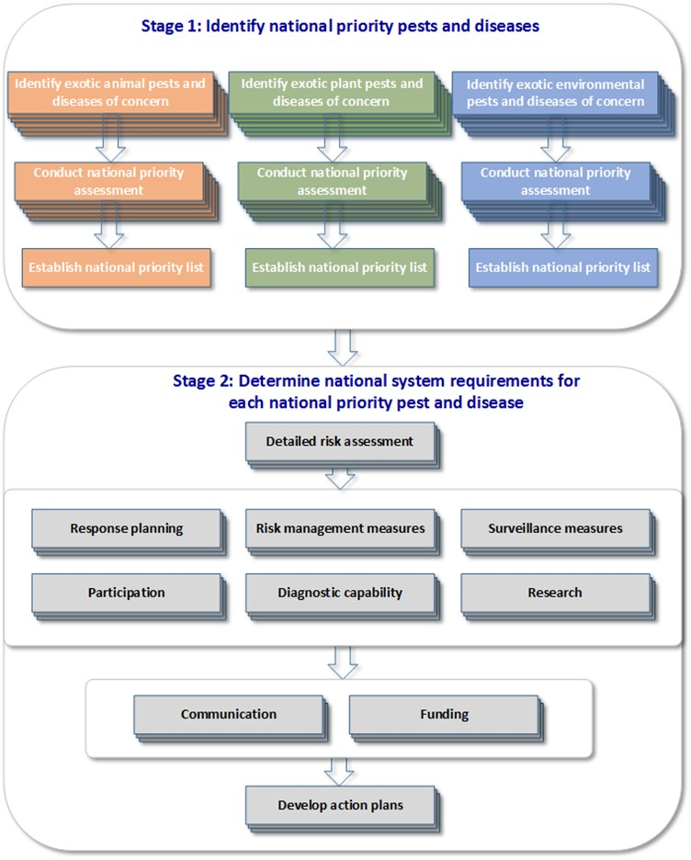

The panel notes at least three highly destructive pests and diseases—white spot disease, tomato potato psyllid and Russian wheat aphid—were detected in Australia in the last twelve months, despite being on the ‘national radar’ of priority pests and diseases (Box 8). While the exact pathway for these incursions may never be known, it underscores the need for constant vigilance (including by primary producers) and for robust action plans to be developed and in place for high-priority pests and diseases.

The planned review by the Inspector-General of Biosecurity to examine lessons learned from the analysis of recent pest and disease incursions (section 1.2) should provide valuable insights into biosecurity preparedness and will be of high interest to a broad range of stakeholders.

Box 8 Slipping under the radar (2016–17)

White spot disease

White spot disease is caused by the highly contagious white spot syndrome virus affecting crustaceans. It is capable of causing major production losses. Testing in December 2016 confirmed the presence of the exotic disease in the Logan River, Queensland—a total of seven prawn farms have been affected. As at May 2017, the Queensland Government is managing the incursion, including establishing a movement control order, and implementing disease control activities with a view to disease eradication.

White spot disease is included on Australia’s National List of Reportable Diseases of Aquatic Animals, which was endorsed by the Animal Health Committee in April 2016. The gross value of production (2014–15) for prawn aquaculture in Australia was $86 million; the production value of wild-caught prawns was $272 million.

Tomato potato psyllid

The tomato potato psyllid is an exotic plant pest that attacks a range of plants, including potato, tomato, eggplant, capsicum, chilli, and sweet potato. The exotic pest was first detected in Australia in February 2017, having been found in a range of crops (commercial and backyard) across the Perth metropolitan area. The psyllid is of particular concern given it is capable of carrying the bacterium associated with the devastating Zebra chip disease. The bacterium has not been found in Western Australia.

The National Management Group (NMG) has agreed that the psyllid is not technically feasible to eradicate. Management plans and a control zone are in place to limit further spread and to monitor and test for the presence of the bacterium. As at May 2017, some restrictions have been imposed on the movement of host plants into other states and territories.

The tomato potato psyllid and Zebra chip disease are included on Australia’s list of National Priority Plant Pests 2016, endorsed by the Plant Health Committee (PHC) in June 2016. The approximate gross values of production in 2014–15 for some commodities potentially affected by the psyllid were potatoes ($618 million), tomatoes ($311 million) and capsicum ($115 million).

Russian wheat aphid

Russian wheat aphid is a significant exotic pest that attacks all cereal crops, including wheat, barley and oats, by inhibiting growth—crop losses of up to 75 per cent can occur and heavy infestations can kill plants. Since its initial detection in South Australia in May 2016, the aphid has been detected in areas of Victoria, New South Wales and Tasmania. In June 2016, the NMG agreed that it is not technically feasible to eradicate the pest from Australia. As at May 2017, efforts are focused on helping farmers to prepare for and manage the aphid, including by developing management plans and longer-term control options.

Russian wheat aphid is included on the PHC-endorsed list of National Priority Plant Pests 2016. The gross values of production in 2014–15 for some commodities potentially affected by the aphid were wheat ($7.1 billion), barley ($2.4 billion), sorghum ($666 million), and oats ($300 million).

Source: The [National pest and disease outbreaks](http://www.outbreak.gov.au/) website (as at May 2017); ABS Cat. No. 7503.0.

* + 1. **Timing**

The work to prepare the three national priority lists as described above is substantial and will take some time to complete. However, their development should not be allowed to drag on, so the panel believes a target should be set for their completion. The panel notes that the Aichi Biological Diversity Targets under the Convention on Biological Diversity, to which Australia is a signatory, requires at Target 9 that:

By 2020, invasive alien species and pathways are identified and prioritized, priority species are controlled or eradicated and measures are in place to manage pathways to prevent their introduction and establishment.

Since Australia is obligated to identify and prioritise invasive alien species for its environmental commitments, it makes sense that this is done in tandem with the animal and plant lists. The panel considers, therefore, that 2020 should also be the timeframe for the completion of all three lists.

#### Ongoing work

Determining national priority biosecurity risks is not a one-off process. Ongoing risk identification and assessment is critical. Future and emerging global trends will significantly change, and increase, the complexity of the biosecurity risks facing Australia.

To this end, national priority animal, plant and environmental pests and diseases should be revised in light of intelligence and foresighting work on present or emerging risks on an ongoing basis. The panel recommends that the priority pest and disease lists be formally reviewed at least every five years, noting that there may be reasons to review these lists earlier (for example, identification of new pathways, behaviours, hosts and treatments).

The NBC’s sectoral committees should oversee this process, including through joint meetings and public consultation, to allow discussion of pests and diseases or pathways with cross-system impacts and guidance to subcommittees on cross-system efficiencies. The sectoral committees should report their progress to the NBC; progress reporting to the Agriculture Senior Officials Committee (AGSOC) and the Agriculture Ministers’ Forum (AGMIN) should be included in the NBC’s annual report to agriculture ministers.

The panel also considers there is scope in the future for greater disclosure of the pests and diseases intercepted by the national biosecurity system (by both governments and industry). The successes of the national system should be highlighted, not just its failures. Regularly publishing a list of items intercepted, thereby highlighting the potential problems avoided, will help to build awareness of the value of the national system and the role it plays in the nation’s wellbeing; and serve to alert all system participants to the need for added vigilance for the pest or disease via the pathway detected.

Recommendation 11

The NBC should adopt a systematic approach to determine and plan for national priority pests and diseases:

* Three national priority lists—one each for animal, plant and environmental pests and diseases—should be developed in partnership with system participants.
* The three national lists should be completed by 2020.
* Thereafter, the NBC should lead reviews of the national priority lists at least every five years, reporting to AGSOC and AGMIN.

### Benefits and opportunities

There are significant benefits to a systematic approach to national pest and disease prioritisation:

* **National clarity:** All participants in the national biosecurity system, including the public, will have a clear understanding of what is important in the national system and a clearer understanding of the full suite of activities that need to be funded under the national system. Perhaps less helpfully in some cases, Australia’s priorities will also be clear to our trading partners, which may use this information to their advantage.
* **The ‘sum’ of the national biosecurity system:** The proposed approach will allow a ‘rolling-up’ of the system, made up of its various components, including a national perspective on system elements such as surveillance, response, research and development needs and the total cost of these. While the nature of the task means that the financial commitment involved cannot be specified in advance of the prioritisation process, *ad hoc* and unstructured funding needs should be minimised. Over time, this process will yield significant cross-system efficiencies, as well as provide the base-level knowledge and information necessary for development of, for example:
* national investment strategies (for example, for the NBC, individual jurisdictions, agricultural industries)
* national surveillance plans (for example, for animal, plant and environment; geographic regions; industry, community or government; or area freedom purposes)
* a national biosecurity research and innovation (R&I) plan
* a national perspective on all pathways for exotic pests and diseases.
* **Enhanced market access work:** Giving greater focus to national priority exotic pests and diseases (including those with significant adverse economic impacts) will help align activities such as surveillance with Australia’s trade and market access priorities—the national system will be better prepared to generate evidence to underpin Australia’s claims of absence and area freedom.
* **Resource allocation:** Consistent with the IGAB principles, the finite resources within the national system will give a greater return if focused on exotic pests and diseases that will negatively impact on the national economy, national industries, the environment and social amenity.
* **Resource sharing:** There will be better identification of resource-sharing opportunities for managing national priority exotic pests and diseases. For example, resources, such as laboratories, used by the Australian Government’s Northern Australian Quarantine Strategy (NAQS) could be better shared with the governments of Queensland, Western Australia and the Northern Territory.
* **Jurisdictional collaboration:** Addressing agreed national priority pest and disease risks will focus national effort across all jurisdictions, creating formal opportunities for collaboration and sharing of resources and expertise.
* **Research to address gaps:** Gaps identified in managing national priority pests and diseases will receive significant focus above other competing areas of the national biosecurity system. Further, there will be a clear national system priority focus on research and opportunities for technological innovation to address and improve national system gaps and priorities; research and innovation is discussed below (Chapter 6).
* **Sharing responsibility:** Involving the relevant system participants in the development of these programs will achieve a clearer understanding of how the individual components of the national system can be better shared by its participants. Identifying a role for industry and community members will help give ‘shared responsibility’ a practical focus. Plans developed that outline responsibilities and costs should be based on a standard template.

The panel has taken on board the many comments received concerning the fragmented nature of the national biosecurity system and its activities and around declining resources allocated to, and capability in, surveillance and diagnostics. The recommended national prioritisation process and action planning approach provides the building blocks for comprehensively addressing these deficiencies.

## Research and innovation

Key points

* Research and innovation (R&I) underpin Australia’s science-based approach to biosecurity.
* There is no lead agency for, national prioritisation process for or coordination of biosecurity R&I in Australia. Multiple funders and providers are involved in these activities, with the role of some players unclear.
* The current mix of national biosecurity research development and extension (RD&E) strategies do not reflect the priority needs of the national biosecurity system.
* Cross-sectoral and system-level R&I are significant research gaps.
* New national biosecurity R&I priorities and new cross-sectoral biosecurity R&I mechanisms are needed to better target investment and enhance national research efforts.

### The key role of biosecurity R&I

Innovation driven by RD&E is vital to Australia’s scientific, risk-based approach to biosecurity. Research outcomes can: inform decisions of governments and industry; help to improve the efficiency of biosecurity operations; maintain Australia’s favourable pest and disease status through the ongoing development and application of science-based measures; and ensure an adequate scientific and technical capacity is maintained.

The 2016 National Research Infrastructure Roadmap (NRIR 2016), developed by Australia’s Chief Scientist and released in May 2017, identifies biosecurity as a critical function of Australia’s research infrastructure—which serves the national interest by enabling ‘transformational’ R&I. Under the roadmap, biosecurity is one of nine focus areas that will underpin research in which Australia must excel over the coming decade to deliver long-term national benefit and foster international partnerships.

The importance of R&I to the national biosecurity system was also highlighted by stakeholders throughout this review, with ongoing support needed for traditional science disciplines—such as animal and plant pathology, taxonomy, veterinary science, epidemiology and entomology—and the development of new technologies identified as equally important components of an appropriate research capacity. Stakeholders identified detection and surveillance, environmental biosecurity, market access assurance and technology transfer as areas that would benefit from future investment in targeted R&I.

Targeting investment to technological innovations has the potential to generate significant benefits for the national system, including helping to reduce the cost of typically high-cost activities such as surveillance and laboratory diagnostics (Box 9). New technologies can also improve early detection of exotic pests and diseases, leading to an increased likelihood of eradication, thereby avoiding the high costs associated with subsequent containment or management measures.

Box Technological innovations for biosecurity

Environmental DNA (eDNA) water sampling for tilapia species

Tilapia, a popular aquarium fish species, were illegally introduced into Australian waterways in the 1970s. Two species—Mozambique tilapia (*Oreochromis mossambicus*) and spotted tilapia (*Tilapia mariae*)—have established populations in various sites in Queensland, Victoria, Western Australia and on the New South Wales far north coast. Populations of Mozambique tilapia in southern Queensland are as little as three kilometres from the Murray–Darling Basin and pose a significant threat to the native fish of the basin (Hutchison et al. 2012). The biological and behavioural characteristics of tilapia, including traits such as aggressive behaviour, broad environmental tolerances and high fecundity, have aided the spread and subsequent establishment of new populations.

Early detection is a key factor in the success of eradicating an incursion by tilapia to a new region, as they cannot be effectively removed by current methods once they become established. Traditional surveillance methods, involving periodic fish surveys using various methods such as electrofishing and netting, are resource intensive and may not detect the presence of tilapia in low numbers. Technological advances like eDNA, capable of detecting the DNA of tilapia in a water sample, have proven to be an effective early detection tool and are likely to greatly enhance the capacity of future surveillance programs by providing rapid presence/absence data from a large number of sites.

Source: The NSW Government Department of Primary Industries [Tilapia](http://www.dpi.nsw.gov.au/fishing/pests-diseases/freshwater-pests/species/tilapia) website; Noble et al. 2015.

CYBERNOSE biosensor

The Commonwealth Scientific and Industrial Research Organisation (CSIRO) can now detect and measure odours and chemicals in a range of substances by mimicking the sophisticated smell receptors of nematode worms. Using DNA from nematode worms, the CSIRO has been able to make sensors in the lab and put them into an electronic device known as the CYBERNOSE sensor.

The receptors work by changing shape when an odour molecule binds to them. CSIRO scientists re-engineered these smell receptors so that they emit a mixture of blue and green light. When an odour binds to the sensor and it changes shape, the colour of the light changes, which is easy to see and measure. The detailed analysis of the light, using optical sensors, can indicate whether a particular substance is in the test sample. CSIRO is currently working to detect the smell of insect contamination in grain, while future projects will address the detection of other pests, weeds or diseases in commodities.

Source: The CSIRO’s [CYBERNOSE](https://www.csiro.au/en/Research/BF/Areas/Protecting-Australias-agricultural-industries/Bio-inspired-products/CYBERNOSE-biosensor?ref=/CSIRO/Website/Research/Farming-food/Innovation-and-technology-for-the-future/CYBERNOSE-biosensor) website.

Emerging technologies with potential to improve the efficiency of biosecurity activities identified by stakeholders include autonomous and drone surveillance (Jurdak et al. 2015), robotics and artificial intelligence (Mohanty et al. 2016), ‘big data’ and analytics (Li et al. 2015), ‘point of need’ field testing (Mumford et al. 2015; Thomas et al. 2017), alternative treatment methods (for example, a replacement for methyl bromide) (Kim et al. 2016; Hallman 2017), and innovations from various fields of science (for example, next-generation sequencing, antimicrobial resistance and new biological controls).

Research into new technologies must involve end users to ensure research outputs can be feasibly adopted. Greater potential exists for R&I that directly engages industry and the community in biosecurity activities, particularly in areas such as surveillance and diagnostics. The panel suggests that the research community further explore these opportunities as well as factors that limit the uptake of new biosecurity technologies, such as access to reliable internet services in rural and regional Australia (Commonwealth of Australia 2016).

### Current state

Australia’s biosecurity system has historically derived significant benefits from the current approach to R&I. However, there are limitations, and the system no longer has the required structure, focus or capacity to address existing and emerging national biosecurity challenges.

#### Many players but no captain

Biosecurity R&I in Australia is closely linked to the broader national agricultural RD&E system, which has evolved considerably over the last two decades (PC 2011; Hunt et al. 2014). Multiple funders and providers are involved; however, there is no lead agency for, national prioritisation process for or coordination of biosecurity R&I in Australia.

Biosecurity research activities are primarily funded by the Australian, state and territory governments, the rural Research and Development Corporations (RDCs) and Cooperative Research Centres (CRCs). Both the RDCs and CRCs receive significant funding from industry and government sources. Key providers of biosecurity R&I include the CSIRO, state and territory government agencies through their research and diagnostic facilities, and the university sector (Table 2).

Table 2 Key players in biosecurity R&I in Australia

| Funders | Providers | Other role (unclear) |
| --- | --- | --- |
| Australian1, and state and territory governments  Rural Research and Development Corporations2  Cooperative Research Centres (e.g. Plant Biosecurity; Invasive Animals) | CSIRO  State and territory research facilities  Universities  Private consultants | AGSOC R&I committee  Animal Health Australia  Plant Health Australia |

AGSOC: Agriculture Senior Officials Committee; CSIRO: Commonwealth Scientific and Industrial Research organisation; R&I: research and innovation.

1. Australian Government initiatives include the Australian Research Council’s Linkage and Discovery programmes, Rural R&D for Profit Programme and CRC Programme; 2. Both the RDCs and CRCs receive funding from industry and government sources.

The CSIRO also operates and manages the Australian Animal Health Laboratory (AAHL). This critical component of the national biosecurity infrastructure helps to protect Australia’s livestock and aquaculture industries, and the general public, from emerging disease threats. Its primary responsibility is to provide a diagnostic, surveillance and response service to the Australian Government to underpin Australia’s ability to trade in animal products. It also undertakes important research on infectious agents. The contribution made by AAHL to animal biosecurity in Australia is considerable. In the event of an incursion or threat, AAHL works closely and in partnership with diagnostic and research laboratories located in a number of jurisdictions.

As detailed above, various entities attempt to coordinate biosecurity research and implementation of a range of largely unfunded strategies.

#### Biosecurity as a national research priority

Biosecurity is one of many existing priorities for overarching national R&I. Under the Australian Government’s [National Science and Research Priorities](http://www.science.gov.au/scienceGov/ScienceAndResearchPriorities/Pages/default.aspx), biosecurity is embedded within the ‘food’ national science and research priority, with the challenge of ‘protection of food sources through enhanced biosecurity’. Under the [National Rural R&D Priorities](http://www.agriculture.gov.au/ag-farm-food/innovation/priorities), the biosecurity priority (as detailed below) is rightly given much more prominence:

To improve understanding and evidence of pest and disease pathways to help direct biosecurity resources to their best uses, minimising biosecurity threats and improving market access for primary producers (2015 Agricultural Competitiveness White Paper)

The National Rural R&D Priorities were developed under the 2015 Agricultural Competitiveness White Paper and have been subsequently adopted by all jurisdictions as part of the National Primary Industries Research, Development and Extension Framework (NPIRDEF). This framework aims to generate collaboration and continuous improvement in the investment of RD&E resources nationally, including for biosecurity.

These national research priorities replaced the Rural Research and Development Priorities adopted by governments in 2007 and are intended to guide the R&I investment decisions of the Australian, state and territory governments and other funders of biosecurity R&I. However, as they stand, they provide little clarity or substantive guidance for investment in the national biosecurity system.

#### Investment in biosecurity R&I

Biosecurity stakeholders have highlighted the necessity for a long-term, sustainable commitment to biosecurity R&I, including funding:

Research should be ongoing. Diagnostics, surveillance, response methodologies and treatments need to be continually developed as new technology becomes available and old systems become redundant. The research tap cannot be turned on and off and still expect effective innovation (Biosecurity Council of Western Australia sub. DP52)

Comprehensive data on public investment in biosecurity R&I is not currently available, and it is not an investment category captured by the National Biosecurity Committee (NBC) national stocktake of biosecurity investment (Chapter 8). As investment in biosecurity R&I is strongly linked to the overall funding of agricultural RD&E in Australia, the panel noted with interest recent work by the Australian Bureau of Agricultural Resource Economics and Sciences (ABARES) (forthcoming) which estimated that public funding of rural R&D increased only marginally in real terms in the ten-year period between 2005–06 and 2014–15, from $1.375 billion to $1.536 billion. ABARES also found that the Australian Government remains the major public funding source, and universities have now overtaken the state and territory governments in providing funding for rural R&D (Box 10).

Clearly, it is the funding decisions of the Australian Government, primarily through the science and agriculture departments and their portfolio agencies, that will continue to determine the relative priority of biosecurity R&I—compared to agricultural productivity, for example, in the national R&I system. This issue is further explored below with respect to the investment decisions by the Australian Government in biosecurity-related CRCs and investments in ‘biosecurity’ by the fifteen rural RDCs.

Box 10 Funding of rural R&D in Australia (2005–06 to 2014–15)

ABARES estimates that overall funding of rural R&D in Australia increased over the ten years between 2005–06 and 2014–15 from $2.3 billion to $3.0 billion, with public funding for rural R&D increasing from $1.375 to $1.536 billion (in real terms) driven by growth in funding from the Australian Government and universities.

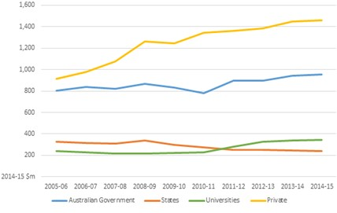Australian Government funding increased from $805 million to $952 million. The main source of this growth was from the increased cost of the R&D tax incentive provided to the private sector. Funding from state and territory governments fell from $330 million to $239 million in real terms. Universities’ own contribution to rural R&D increased from $240 million to $345 million.

The private sector funding for privately performed R&D and private contributions to the RDCs both grew over the ten years to 2014–15. Funding for privately performed rural R&D nearly doubled from $681 million to $1,185 million. Private funding provided to the RDCs grew more slowly, from $231 million to $276 million.

Rural R&D includes agriculture, forestry, fisheries, related environmental research and value chain (inputs and processing) R&D.

Source: ABARES (forthcoming).

##### Biosecurity-related Cooperative Research Centres

The Australian Government has previously directed significant funding to various biosecurity-related CRCs. These have included the CRC for Australian Weed Management (ceased in 2008), the Australian Biosecurity CRC for Emerging Infectious Disease (ceased in 2010), the Invasive Animals CRC (to cease in 2017) and the Plant Biosecurity CRC (PB CRC) (to cease in 2018). The continuation of many biosecurity-related CRCs has been contingent on securing extensions for further terms of operation under the CRC Programme. Changes to this program, following a 2015 review (Miles 2015), now limit CRC funding to a maximum of ten years with no funding extensions possible.

The panel notes work is underway to transition the Invasive Animals CRC to the Centre for Invasive Species Solutions (CISS). A successful transition will be a positive move for continuing the CRC’s work without interruption, particularly for development of biological control agents such as the recently released new strain of rabbit haemorrhagic disease (RHDV1 K5). The development of novel solutions to existing problems may also have relevance for responses to future exotic incursions. The panel understands the remit of CISS also includes established weeds.

Separately, the PB CRC has also considered options for transitioning its work beyond 2018 (Keogh and Goucher 2016), including proposals for SmartBiosecurity: Australasian Plant Biosecurity Collaborative Science Institute and the SmartBiosecurity Centre.

Stakeholders have highlighted the long-term impacts on biosecurity R&I that have occurred where CRCs have closed without appropriate transition or legacy arrangements. These include the loss of valuable scientific knowledge and expertise, subsequent fragmentation of research activities and difficulties in securing ongoing funding for research from other sources. With the continued retreat of biosecurity CRCs, other research funders such as the RDCs will be under considerable pressure to pick up the CRC-funded research agendas.

##### Rural Research and Development Corporations

The fifteen RDCs are key funders of biosecurity R&I. These industry-focused organisations receive significant funding each year from both industry (commodity-based levies) and the Australian Government (matching funding). In 2015–16, the RDCs collectively received around $716 million in levies and matching funding—$463 million from industry and $253 million from the Australian Government—which is invested in a portfolio of research and industry service activities for the benefit of their respective industry or industries.

The RDCs are ‘required’ to take into account both industry and nationally agreed government research priorities (including biosecurity) in their strategic planning processes and investment decisions. Acquitting the biosecurity research obligation has become somewhat of a ‘tick-the-box’ exercise for the RDCs, given the broad scope of the national biosecurity research priorities. The extent to which the RDCs take into account the national animal and plant biosecurity RD&E strategies is not clear, as this is not clearly reported.

This review examined the RDCs’ investments in biosecurity R&I as publicly reported in their various corporate documents (including annual reports, annual operating plans and strategic plans), which vary considerably and, in some cases, are relatively small when compared with their overall annual RD&E spend (Table 3). Based on a three-year average between 2013 and 2016, the RDCs’ collective annual investment on biosecurity R&I is estimated at around $62 million, which is 11.5 per cent of an average total annual RD&E spend of $541 million. However, this proportional figure of total RDC expenditure does not capture the highly variable investment levels across the RDCs, which ranges from 0.4 per cent to 27.7 per cent by individual RDCs.

Stakeholders identified various limitations for biosecurity R&I funded through the RDCs. Predominantly, that research generally addresses priorities with more immediate benefits for the producer (such as increased yield, improved nutrition, reduced production costs and management of established pests, weeds and diseases) and with application to a single industry or sector. For example, in 2015–16 the Grains RDC reported expenditure of around $42 million against the national biosecurity research priority, mostly under its ‘protecting your crop’ research theme (GRDC 2016). Most research activities under this theme are focused on endemic disease management and herbicide/pesticide resistance. In 2015–16, Australian Wool Innovation Limited reported expenditure of around $2.6 million against the national biosecurity research priority (AWI 2016). Of this around $1.8 million was spent on various wild dog management activities, and around $400,000 was provided to the Invasive Animals CRC.

Nonetheless, the estimated annual average investment ($62 million) made by the RDCs on biosecurity-related R&I is a sizeable amount for which the Australian Government, as the dominant investor in the RDC system, should be seeking a far better return for the national biosecurity system.

Table 3 Investments made by RDCs on biosecurity R&I

| **Organisation** | **.** | **2013–14** | **..** | **..** | **2014–15** | **..** | **..** | **2015–16** | **.** |
| --- | --- | --- | --- | --- | --- | --- | --- | --- | --- |
| **.** | **Total RD&E spend  ($)** | **Estimated biosecurity  R&I spend ($)** | **Biosecurity spend  (% of total)** | **Total RD&E spend  ($)** | **Estimated biosecurity  R&I spend ($)** | **Biosecurity spend  (% of total)** | **Total RD&E spend  ($)** | **Estimated biosecurity R&I spend ($)** | **Biosecurity spend  (% of total)** |
| Australian Livestock Export Corporation Ltd* | $1,440,000 | $0 | 0.0% | $1,640,000 | $0 | 0.0% | $984,000 | $0 | 0.0% |
| Dairy Australia Ltd* | $38,500,000 | $154,000 | 0.4% | $40,200,000 | $200,000 | 0.5% | $41,500,000 | $700,000 | 1.7% |
| Forest and Wood Products Australia Ltd* | $3,116,384 | $31,164 | 1.0% | $3,534,871 | $265,680 | 7.5% | $4,042,966 | $410,000 | 10.1% |
| Australian Egg Corporation Ltd* | $3,000,785 | $22,805 | 0.8% | $3,082,390 | $169,326 | 5.5% | $3,377,875 | $63,672 | 1.9% |
| Australian Wool Innovation Ltd* | $29,581,000 | $2,600,000 | 8.8% | $21,805,000 | $2,082,000 | 9.5% | $25,262,000 | $2,634,000 | 10.4% |
| Australian Pork Ltd* | $9,660,000 | $822,995 | 8.5% | $9,767,513 | $466,473 | 4.8% | $10,088,935 | $410,058 | 4.1% |
| Meat & Livestock Australia Ltd* | $95,800,000 | $5,556,400 | 5.8% | $92,900,000 | $4,830,800 | 5.2% | $88,000,000 | $6,952,000 | 7.9% |
| Australian Grape & Wine Authority^ | $22,160,000 | $986,120 | 4.5% | $21,880,000 | $1,162,000 | 5.3% | $20,044,987 | $936,300 | 4.7% |
| Australian Meat Processor Corporation Ltd* | $11,800,000 | $421,862 | 3.6% | $13,100,000 | $744,316 | 5.7% | $11,416,223 | $565,144 | 5.0% |
| Fisheries RDC^ | $22,870,000 | $1,921,000 | 8.4% | $24,850,000 | $1,840,000 | 7.4% | $24,575,116 | $2,575,649 | 10.5% |
| Rural Industries RDC^ | $14,580,000 | $1,071,000 | 7.4% | $13,240,000 | $1,494,000 | 11.3% | $14,704,000 | $1,184,000 | 8.1% |
| Horticulture Australia Ltd*/Horticulture Innovation Australia Ltd* | $76,700,000 | $6,903,000 | 9.0% | $51,970,000 | $6,236,400 | 12.0% | $78,172,778 | $8,599,006 | 11.0% |
| Cotton RDC^ | $18,200,000 | $4,368,000 | 24.0% | $19,240,000 | $2,501,200 | 13.0% | $17,505,758 | $4,856,000 | 27.7% |
| Sugar RDC^/ Sugar Research Australia Ltd* | $7,700,000 | $1,097,000 | 14.2% | $28,720,000 | $4,641,152 | 16.2% | $30,200,000 | $4,500,000 | 14.9% |
| Grains RDC^ | $166,370,000 | $22,780,000 | 13.7% | $194,100,000 | $34,700,000 | 17.9% | $192,796,000 | $42,450,000 | 22.0% |

*Industry-owned company; ^Corporate Commonwealth Entity; R&I: research and innovation; RD&E: research, development and extension; RDC: Research Development Corporations.  
Notes: 1. Comparisons between the RDCs are limited by inconsistent reporting (varying levels of detail of biosecurity R&I investment); 2. Livecorp’s biosecurity R&I is conducted through Meat & Livestock Australia Ltd.

#### Strategies upon strategies

A multitude of general and specific national strategies are ‘in place’ which seek to further define and direct national biosecurity research priorities (Table 4). The Animal Biosecurity and the Plant Biosecurity RD&E Strategies, which are achievements under the IGAB, were developed under the NPIRDEF.

Table Strategies relevant to biosecurity R&I

| **National biosecurity RD&E strategies** | **Other strategies related to biosecurity** | **National Industry RD&E Strategies** |
| --- | --- | --- |
| * Animal Biosecurity RD&E Strategy * Plant Biosecurity RD&E Strategy * Environment and Community Biosecurity RD&E Strategy | * Australian Pest Animal Strategy * Australian Weeds Strategy * National Fruit Fly Strategy * National Plant Biosecurity Strategy * National Plant Biosecurity Diagnostic Strategy * National Plant Biosecurity Surveillance Strategy | Fourteen industry-specific strategies under the NPIRDEF (e.g. Beef Production National RD&E Strategy, Cotton Sector National RD&E Strategy, Grains Industry National RD&E Strategy) |

NPIRDEF: National Primary Industries Research, Development and Extension Framework; RD&E: research, development and extension.

Stakeholders consistently raised concerns during the review consultation process about the plethora of strategies, their limited overall impact and effectiveness due to resourcing issues, and lack of a unified, national approach to coordination and delivery:

It is perhaps symptomatic of the current fragmented nature of Australia’s biosecurity system that there are already a number of national [plant] biosecurity strategies … The degree to which these strategies and others operate and achieve their aims is extremely variable and appears to rely as much on individuals rather than a supportive system (Voice of Horticulture sub. DP11)

Progress on the [Animal Biosecurity RD&E Strategy] is slow, essentially due to the competing priorities of participants who have already committed resources to their own respective organisational strategies and performance criteria, as well as the National Rural Research and Development Priorities. New sources of funds targeting the agreed identified priorities would accelerate progress (Animal Health Australia sub. DP33)

While the National Animal and Plant Biosecurity Strategies (coordinated by AHA and PHA respectively) have attempted to build on a collaborative approach and identified various areas requiring attention, actual achievements in R&I projects has been disappointing. There have been significant difficulties in attracting adequate investment by governments, industry and the RDCs (Rural Industries Research and Development Corporation sub. DR86)

While Animal Health Australia (AHA) and Plant Health Australia (PHA) have been ‘tasked’ with coordinating implementation of the Animal Biosecurity and the Plant Biosecurity RD&E Strategies, these strategies only outline generic areas of research, and the respective implementation committees (based within AHA and PHA) have no authority to prioritise or direct funding or resources. These factors have severely hampered the ability of AHA and PHA to effect implementation. Adding to the maze of accountabilities is that AHA and PHA report to the Agriculture Senior Officials Committee (AGSOC) Research & Innovation Committee—an advisory subcommittee of the AGSOC—rather than through (or to) the NBC.

In addition, a number of industry-specific RD&E strategies and several other biosecurity strategies also seek to direct R&I investment (Table 4). The biosecurity-specific strategies are predominantly sectoral and are not supported by funding, and stakeholders noted that some were developed without incorporating the views of a broad range of system participants. The various national industry-specific RD&E strategies often have an oblique and inconsistent focus on biosecurity and its importance to the particular industry in question.

Numerous stakeholders also drew the panel’s attention to the lack of an equivalent national environmental biosecurity RD&E strategy. The panel notes the *National Environment and Community Biosecurity RD&E Strategy 2016–19* (DAWR 2016c) was released by the NBC in November 2016. However, the panel understands that a lead agency or organisation responsible for implementing this strategy is yet to be determined. The panel notes that the scope of the strategy (as detailed below) should be an important guiding consideration:

This strategy addresses national biosecurity RD&E issues relating to the natural environment and the community (social amenities, infrastructure, transport, utilities, human lifestyles and wellbeing) … Social amenities are defined as desirable or useful facilities that provide members of the community a pleasant working and living environment, including for social, cultural or spiritual experiences …

Given this scope, lead implementation responsibility for the strategy should rest with the Australian Government. Consistent with the panel’s strong view on the lead agency for environment and community biosecurity (Chapter 4), the Australian Government environment department should be the owner and driver of National Environment and Community Biosecurity RD&E Strategy.

Recommendation 12

The Australian Government should assign lead responsibility for driving and coordinating implementation of the National Environment and Community Biosecurity RD&E Strategy  
2016–19 to the Australian Government environment department.

#### Cross-sectoral research: a substantial gap

Cross-sectoral R&I efforts are inadequate to support the national biosecurity system into the future. In the context of this review, cross-sectoral research is defined as research that generates outcomes which are applicable to, and benefit, more than one industry within a sector (for example, multiple horticulture industries) or more than one sector (for example, multiple plant industries or plant and animal industries) or the community overall. Examples of significant cross-sectoral research gaps put to the panel include technological solutions for detecting ‘hitchhiker’ pests at the border, electronic sampling for commodities (for example, contaminants in grain), improving pest and disease surveillance and monitoring across Australia, market access research, and social research, including behavioural change, practice change, collaboration, terminology and communication.

Biosecurity stakeholders have highlighted that cross-sectoral opportunities for biosecurity R&I benefits are clearly being missed and that there are inefficiencies in the research being undertaken:

While there still appears to be considerable investment in biosecurity research and development across the various agencies, institutions and organisations, and we pride ourselves on the strengths and benefits of the system, there are some significant gaps and deficiencies that need attention—including the coordination and delivery of cross-sectoral biosecurity R&I (Rural Industries Research and Development Corporations sub. DR86)

Analysis of the 2015 National Plant Biosecurity Status Report (NPBRDES IC 2016) by the Plant Biosecurity RD&E Strategy Implementation Committee showed that, of the 578 projects from the status report, 64 per cent (370 projects) were considered to be sectoral and 36 per cent (208 projects) were considered to be cross-sectoral (Figure 4). The committee concluded that 110 of the 370 sectoral projects could be adapted for use by other sectors (that is, they could be cross-sectoral). Adapting this research will now require additional resources, a proportion of which may have been avoided through better coordination during project development.

Figure Breakdown of projects under the 2015 National Plant Biosecurity Status Report

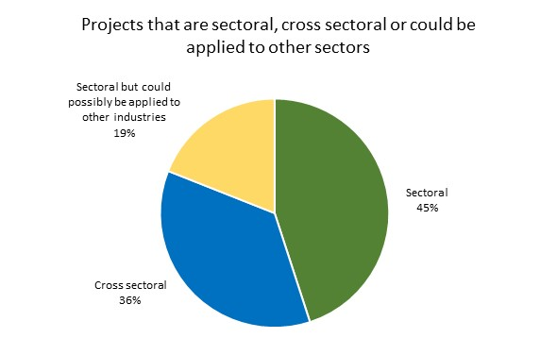

Source: NPBRDES IC 2016.

In another positive move following the release of the IGAB review draft report, the seven plant-based RDCs and PHA have formed the Plant Research Biosecurity Initiative to improve coordination and co-investment for plant biosecurity RD&E and strengthen the link between this research effort and the biosecurity community. This initiative is being led by Horticulture Innovation Australia Limited. The governance structure for the initiative, including the parties to the key investment decision-making body, is shown below (Figure 5).

Figure Plant Research Biosecurity Initiative

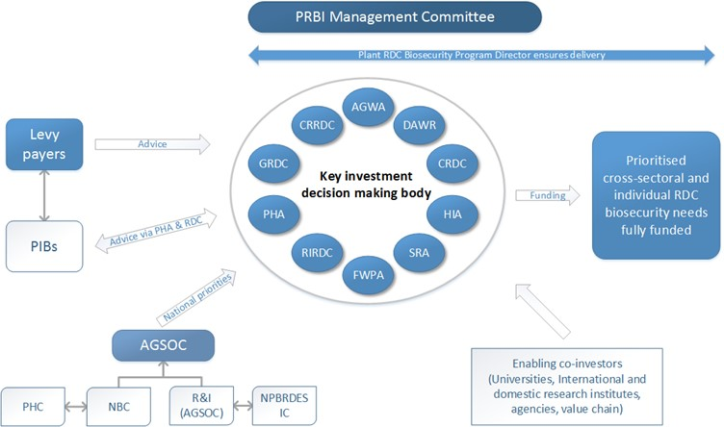

AGWA: Australian Grape and Wine Authority; AGSOC: Agriculture Senior Officials Committee; CRDC: Cotton RDC; CRRDC: Council of Rural RDCs; DAWR: Australia Government Department of Agriculture and Water Resources; FWPA: Forest and Wood Products Australia Ltd; GRDC: Grains RDC; HIA: Horticulture Innovation Australia Ltd; NBC: National Biosecurity Committee; NPBRDES IC: National Plant Biosecurity RD&E Strategy Implementation Committee; PHA: Plant Health Australia; PHC: Plant Health Committee; PIB: Peak Industry Body; PRBI: Plant Research Biosecurity Initiative; R&I (AGSOC): Research and Innovation Committee; RIRDC: Rural Industries RDC; SRA: Sugar Research Australia Ltd.

Source: Plant Health Australia.

The panel supports efforts to improve national plant biosecurity RD&E and encourages the animal-based RDCs and AHA to pursue a similar arrangement, with a view to improving coordination and co-investment for animal biosecurity RD&E and implementation of the national Animal Biosecurity RD&E Strategy.

The panel also notes there are some notable strategic partnerships seeking to generate practical solutions to key national biosecurity challenges, including the SITplus Partnership, the Rural Research and Development for Profit Programme and the Centre of Excellence for Biosecurity Risk Analysis (CEBRA) (Box 11). However, there is no overarching plan or funding mechanism to focus strategic investment in biosecurity R&I at the national system level (including for animal, plant and environmental). Building upon the proposed plant RDC–PHA model, there should be a national priority-setting and commissioning process for cross-system and environmental R&I, and this should be authorised and driven by the NBC.

Box Model R&I partnerships

SITplus Partnership

SITplus is a five-year, $45 million research and development partnership seeking to deliver a transformative pest management solution to Queensland fruit fly—a major horticultural pest. The partnership has brought together various stakeholders from across government, industry and research, including Horticulture Innovation Australia Limited, Macquarie University, the CSIRO, Plant and Food Research Australia and the Australian, New South Wales, Victorian and South Australian governments.

Source: Chapman 2016; Horticulture Innovation Australia Limited’s [SITplus](http://horticulture.com.au/how-we-invest-2/sitplus/) website.

Rural Research and Development for Profit Programme

The Rural Research and Development for Profit Programme provides additional funding to the RDCs for nationally coordinated, strategic research (including for biosecurity). The program was designed to establish significant new research collaborations with and between the RDCs, particularly for cross-sectoral research. The total funding for the program is $180.5 million over eight years, ending on 30 June 2022. Of that funding, $78.9 million, or 44 per cent, has been committed in the first two funding rounds.

A total of $24.9 million in grant funding has been provided by the Australian Government to biosecurity-related research projects under the first two funds rounds, including for projects to control Queensland fruit fly, develop technology-based monitoring tools for Australian tree crops, develop weed biocontrol agents and strengthen preparedness and facilitate return to trade in the event of an emergency animal diseases such as foot-and-mouth disease.

Source: The Australian Government Department of Agriculture and Water Resources [R&D for Profit](http://www.agriculture.gov.au/ag-farm-food/innovation/rural-research-development-for-profit) website.

The Centre of Excellence for Biosecurity Risk Analysis (CEBRA)

CEBRA was established on 1 July 2013 through an agreement between the University of Melbourne, the Australian Government agriculture department and the New Zealand Government Ministry for Primary Industries. It replaced the Australian Centre of Excellence in Risk Analysis (ACERA), which operated from 2006 to 2013. Its primary goal is to develop tools, methods, guidelines and protocols to improve biosecurity risk analysis, with the purpose of providing governments with practical solutions and advice for assessing and managing biosecurity risks. The centre also plays an important role in improving the way in which biosecurity is communicated to government, business and the community. The Australian Government provides almost $2 million to CEBRA annually.

Source: The CEBRA’s [About US](http://cebra.unimelb.edu.au/about) website.

### Future-focused biosecurity R&I

Investment and institutional structures for biosecurity R&I must be strengthened, better targeted and supported by more enduring, nationally coordinated arrangements than they have to date. These requirements were also highlighted in the 2016 National Research Infrastructure Roadmap (NRIR 2016). There must be better articulation, especially by all Australian governments, of the national investment priorities for biosecurity R&I.

Strategic investment in technological innovations must play a greater role in addressing current and emerging biosecurity challenges—and to assist the financial sustainability of the national biosecurity system. In addition, the broader national R&I agenda needs to be more cognisant of biosecurity R&I as a pathway to productivity gains and market access and for a broad range of cross-sectoral and environmental outcomes.

#### National Biosecurity R&I Priorities

Development of new National Biosecurity R&I Priorities are required to deliver clarity and direction for the national biosecurity and agricultural RD&E systems. Over time, the existing biosecurity RD&E strategies and frameworks should be aligned to the new National Biosecurity R&I Priorities.

The national priority-setting process must be authorised and driven by the NBC (Figure 6). The three sectoral committees of the NBC (Chapter 7), in consultation with key biosecurity R&I system participants, should lead the development of sectoral national R&I priorities, including relevant cross-sectoral priorities within each stream—particularly in areas such as surveillance, early detection and market access.

Figure Proposed national biosecurity R&I priority setting

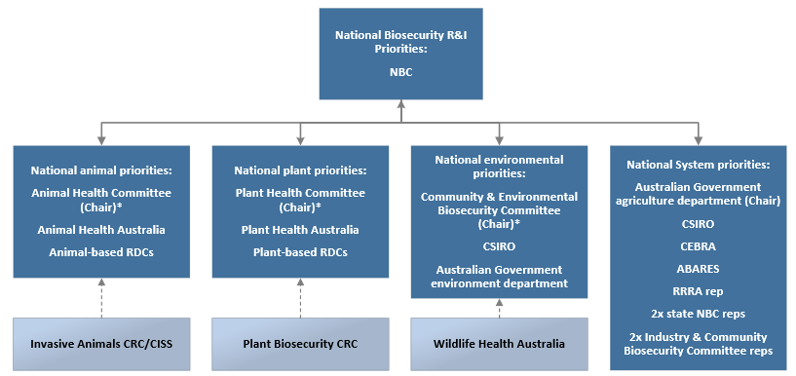

ABARES: Australian Bureau of Agricultural and Resource Economics and Sciences; CSIRO: Commonwealth Scientific and Industrial Research Organisation; CEBRA: Centre of Excellence for Biosecurity Risk Analysis; CISS: Centre for Invasive Species Solutions; CRC: Cooperative Research Centre; NBC: National Biosecurity Committee; R&I: research and innovation; RDCs: Research and Development Corporations; RRRA: Risk Return Resource Allocation model. *The Chairs of the NBC’s three sectoral committees (i.e. the Animal Health Committee, Plant Health Committee and Community & Environmental Biosecurity Committee) chair the respective national priority group.

The sectoral priority-setting process should involve AHA, PHA and the CCEBO/Australian Government environment department (as coordinators of the relevant biosecurity RD&E strategies), the RDCs, and other relevant key biosecurity R&I stakeholders as appropriate. The prioritisation processes should be informed by priority research areas and gaps arising from the national animal, plant and environmental pest and disease prioritisation process proposed by this Review (Chapter 5).

The development of system-level national biosecurity R&I priorities (including for environmental biosecurity) should be led by the Australian Government agriculture department with national research partners, nominated state/territory NBC members and two nominated representatives from the Industry and Community Biosecurity Committee. The priorities should focus on the policy and decision-making frameworks, tools, innovations and behavioural changes needed to build an effective national biosecurity system. The panel is aware that, following the release of the IGAB review draft report, the Australian Government commissioned the CSIRO to identify opportunities for technology-driven innovations in biosecurity operations covering inspection, surveillance and diagnostics to guide investment (CSIRO 2017). This work would be a useful input to the national priority-setting process.

Finally, NBC should determine the final, integrated list of National Biosecurity R&I Priorities in consultation with the chairs of the four sectoral/national system priority-setting processes.

Recommendation 13

The NBC should authorise and drive development of an agreed set of National Biosecurity R&I Priorities, in consultation with key biosecurity R&I system participants, to guide national R&I investment:

* The sectoral committees of the NBC should lead the development of sectoral and cross-sectoral level national priorities in line with the national priority exotic animal, plant and environmental risks and their pathways, once agreed.
* The NBC, CSIRO, CEBRA and ABARES should jointly develop system-level national biosecurity priorities (including for the environment) focusing on the policy and decision-making frameworks, tools, innovations and behavioural changes needed to build an effective national system.
* The NBC should determine the final integrated list of National Biosecurity R&I Priorities. The priorities should be developed within eighteen months of the IGAB review report, and should be reviewed at least every five years.

#### National leadership and funding of biosecurity R&I

A future-focused biosecurity R&I capability will help to ensure that Australia’s favourable pest and disease status is maintained and keep Australia ahead of the game. However, this is unlikely to occur without a lead ‘agency’ or national coordination mechanism for biosecurity R&I in Australia.

Throughout the review, stakeholders put forward various options for a new construct for biosecurity research, including a network of national and international universities; a new biosecurity R&I entity such as a CRC, an RDC or a centre of excellence; or better national coordination of current activities by housing biosecurity R&I within an existing RDC or other suitable organisation (such as CSIRO, AHA or PHA). The review of plant biosecurity RD&E in Australia by Keogh and Goucher (2016) proposed a new, enduring Plant Biosecurity Research Corporation to fund strategic and plant-sectoral biosecurity R&I projects and provide opportunities for training and development of future industry research capability. Funding was to be provided equally by industry and Australian, state and territory governments.

The IGAB review draft report proposed two suggestions to address gaps in cross-sectoral R&I: establishing a standalone entity or housing responsibility within an existing RDC (notably the Rural Industries RDC). Responses to these proposals were divided, and some submitters contended that such research could be dealt with through better coordination under current arrangements.

The panel is cognisant that past reviews recommending the establishment of new entities to progress biosecurity agendas (PC RDC review [Rural Research Australia]—PC 2011; Beale review [National Biosecurity Authority]—Beale et al. 2008) have not been taken up by governments. In the current fiscal and political environment, the establishment of a standalone entity for cross-sectoral R&I seems unlikely to be progressed by governments, although the panel recognises the merits of such a proposal.

The panel is proposing solutions which provide a pragmatic way forward, should be able to be implemented with relative ease and will ensure greater, more appropriate and more effective investment in biosecurity R&I.

However, the panel is not convinced that commitments by key national funders and providers of biosecurity R&I (Table 2) to better collaborate and coordinate on cross-sectoral R&I, in the absence of a formal mechanism, will be durable. As CEBRA points out:

… relatively little attention has been paid to developing mechanisms that ensure biosecurity research efforts focus on developing outcomes that will result in the best biosecurity outcomes. This alignment of supply and demand can only come about when the regulators and the research providers communicate clearly and regularly … the regulator must identify and communicate their most pressing research needs, and the research providers must focus their efforts on ensuring that the outcomes have operational relevance and value (sub. DR80)

For the Australian Government in particular, a formal R&I partnership arrangement between the agriculture department and Commonwealth-funded science and research bodies (particularly CSIRO, CEBRA and ABARES), would more effectively serve the needs of the national biosecurity system. For this reason, the panel recommends that the Australian Government establish a National Biosecurity Innovation Program and provide $25 million (over five years) to fund system-level biosecurity R&I projects, including environmental biosecurity, aligned to the system-level R&I priorities developed under Recommendation 13.

Further, to address the shortfall in funding being directed at cross-sectoral biosecurity R&I within the existing RDC system, the Rural Industries RDC should be tasked with the coordination of cross-sectoral biosecurity R&I within and between the plant and animal production sectors. The panel recognises that most RDCs do not hold responsibility for cross-sectoral biosecurity R&I, as the majority of their expertise lies in industry-specific issues. The Rural Industries RDC, however, has a broad mandate under its enabling legislation (the *Primary Industries Research and Development Act 1989* (Cwlth)). The corporation’s statutory funding agreement with the Commonwealth recognises its unique role among the RDCs in coordinating national rural R&D effort to address challenges affecting multiple or all rural industries. As such, the panel considers the corporation is well positioned to take on this additional key biosecurity function.

The panel believes the formal establishment of the Rural Industries RDC’s cross-sectoral biosecurity R&I role could be achieved through non-legislative means, through changes to each of the RDCs’ funding agreements with the Australian Government at renewal or through concurrent amendments within the agreement of the RDCs. Such changes should include strengthened requirements for RDCs to invest in and report against the new National Biosecurity R&I Priorities through additional provisions in each RDC statutory funding agreement, including reporting of investment against consistent categories. This proposal would limit the need for substantial change to existing RDC funding structures, and it would increase the pool of existing RDC funds directed to cross-sectoral biosecurity R&I issues, coordinated by the Rural Industries RDC. Public reporting should similarly occur for Australian Government funded biosecurity investments (sectoral and cross-sectoral) in accordance with agreed categories of funding activity developed under Recommendation 28.

The panel recognises there are some limitations due to the present size of the Rural Industries RDC, compared with other RDCs, and there is need for additional resourcing. To address funding for this additional function, the panel recommends that the Australian Government funding appropriation to the Rural Industries RDC be increased by $2 million per annum, to be utilised solely for the cross-sectoral projects. This funding is modest when compared with the funding being provided by the Australian Government to biosecurity projects under the Research and Development for Profit Programme (Box 11)—noting that, while this program terminates in 2022, it is likely to be fully committed in the next couple of years.

Recommendation 14

To accelerate national system innovation the Australian Government should:

* establish a $25 million National Biosecurity Innovation Program to enable strategic co-investment in the system-level (including environmental) national priorities developed under Recommendation 13. The program should be funded initially for a five-year period from 2018–19 through the funding mechanisms in Chapter 8 and be administered by the Australian Government agriculture department
* increase the funding appropriation to the Rural Industries RDC by $2 million annually for a new cross-sectoral biosecurity R&I coordination and investment function for the RDCs. Cross-sectoral investments should be in line with the national cross-sectoral priorities developed under Recommendation 13
* require RDCs to invest in and report against the new National Biosecurity R&I Priorities through additional provisions in each RDC statutory funding agreement. Cross-sectoral biosecurity R&I will be coordinated by the Rural Industries RDC.

Recommendation 15

The Australian Government should require public reporting of all Commonwealth-funded biosecurity R&I investments (sectoral, cross-sectoral and system-wide) in accordance with agreed categories of funding activity developed under Recommendation 28.

## Strengthening governance

Key points

* The IGAB and the National Biosecurity Committee (NBC) have been pivotal in fostering improved government collaboration.
* It is essential to institutionalise arrangements to ensure a durable and robust national biosecurity system.
* First Ministers should continue to provide jurisdictions with a strong mandate under the IGAB for advancing national biosecurity arrangements.
* IGAB governance arrangements should provide industry and community stakeholders with a stronger voice and role in further developing the national biosecurity system.
* The NBC must improve its transparency and accountability, including making more information publicly available.

### A strong mandate

The IGAB was authorised under previous Council of Australian Governments (COAG) arrangements intentionally as a government-to-government agreement. As an agreement between First Ministers, the IGAB provides a strong mandate for advancing national biosecurity capacity and capability. This review has reaffirmed that national biosecurity critically impacts whole-of economy and whole-of-government arrangements—affecting trade and market access, tourism, agricultural productivity, human health, environmental quality, biodiversity and social amenity. Subsequent agreements must maintain the authority provided by First Ministers of Australian, state and territory governments. Roles and responsibilities need to be articulated, and there is a need to institutionalise arrangements so they endure beyond the good personal relationships of the current participants. Anything less would effectively devalue national biosecurity efforts and impede further development of the national system.

First Ministers have tasked Australian, state and territory ministers responsible for biosecurity with implementation and administration of the IGAB, in consultation with other relevant ministers. This has traditionally been ministers responsible for agriculture or primary industries. In practice, it is difficult to judge the level of engagement of ‘lead’ ministers for biosecurity with other ‘support’ ministers within their respective jurisdictions (for example, environment, natural resources, fisheries, regional development, health and defence), as there are no formal mechanisms to facilitate this. While consultation between ‘lead’ and ‘support’ ministers may well occur, these key relationships warrant clearer and greater recognition in the IGAB.

For government agencies, the need for clearly defined ‘lead’ and ‘support’ biosecurity roles is particularly important, and this review has demonstrated this in the context of environmental biosecurity (Chapter 4). However, the delineation of roles should extend beyond agriculture and environment. Each jurisdiction should have whole-of-government arrangements in place, inclusive of central agencies, to support their role in the national biosecurity system and the delivery of their commitments under the IGAB.

First Ministers could facilitate this by identifying their lead minster and agency for biosecurity under the IGAB and requiring supporting agencies and arrangements to be in place and made public. Given the experience and knowledge accumulated, agriculture or primary industries agencies would be the logical lead discipline. Memoranda of understanding (MoUs) between relevant agencies would be appropriate, modelled on those between the Australian Government’s agriculture, health and immigration agencies. All jurisdictions should consider formalised arrangements between their agriculture agency and environment, fisheries and forestry (where this function is outside of agriculture or primary industry agencies), regional development, defence (Australian Government only) and others as relevant.

Recommendation 16

IGAB2 must remain an agreement between the First Ministers of Australian, state and territory governments.

Recommendation 17

First Ministers should, within IGAB2, identify lead ministers and agencies for biosecurity (assumed to be agriculture or primary industries) and require supporting whole-of-government arrangements to be in place, including through memoranda of understanding.

### An empowered National Biosecurity Committee

The NBC, established in 2008, is the key body responsible for implementing priority reform areas in the IGAB and coordinating national biosecurity arrangements. It provides advice and reports to the Agriculture Senior Officials Committee (AGSOC) and the Agriculture Ministers’ Forum (AGMIN).

#### Confirming NBC’s authority

There is a need to clarify the authorisation and remit of the NBC. The common understanding is that the NBC is formally established under the IGAB. However, the IGAB states:

[The NBC is] The committee established, independently of this Agreement, responsible for biosecurity matters, and tasked with managing a national, strategic approach to emerging and ongoing biosecurity policy issues (2012 IGAB, p. 19)

The NBC should be integral to and not independent of the IGAB, so First Ministers should formally authorise the NBC and articulate its terms of reference through the IGAB. Given the authority of the IGAB comes from it being agreed by First Ministers, it is logical that the main body responsible for implementing the IGAB be similarly authorised by First Ministers. This will ensure that the NBC’s authority is clearly aligned to the life of the agreement and not to government cycles and associated ministerial council structural issues.

There is no national biosecurity system without national cooperation by Australian governments, and this has been the NBC’s focus to date. The Australian Government Department of Agriculture and Water Resources [NBC](http://www.agriculture.gov.au/biosecurity/partnerships/nbc) website notes the committee’s core objective is ‘to promote cooperation, coordination, consistency and synergies across and between Australian governments’. This is an entirely appropriate role, but the NBC should equally be the policy powerhouse for the national system—and needs a remit and identity to match. The terms of reference for the NBC should reflect the policy and decision-making role the NBC needs to play under a future IGAB.

In the IGAB review draft report, the panel sought feedback on revised terms of reference for the NBC, to be included as a schedule in IGAB2. The proposed terms of reference were generally supported in submissions received, with minor changes suggested by both government and non-government stakeholders. The panel has updated the terms of reference, reflecting these changes (Box 12). The panel recommends they be included as a schedule in IGAB2.

Box Proposed NBC terms of reference

The National Biosecurity Committee (NBC) is authorised by First Ministers of all Australian governments, with a whole-of-government leadership role, under the Intergovernmental Agreement on Biosecurity (IGAB).

The objective of the NBC is to strengthen national biosecurity through:

* providing expert strategic and policy advice on animal, plant and environmental biosecurity matters to senior officials from the agencies responsible for biosecurity matters (primarily through the Agriculture Senior Officials Committee (AGSOC)) and ministers responsible for biosecurity (primarily through the Agriculture Ministers’ Forum (AGMIN))
* establishing and maintaining lists of national high-priority exotic animal, plant and environmental pests and diseases, their pathways and biosecurity requirements
* identifying requirements to ensure an effective national biosecurity capability is maintained
* agreeing principles underpinning biosecurity investment in the national interest
* fostering cooperation, collaboration and consistency among all Australian governments
* jointly investing in an annual program of work to strengthen national biosecurity arrangements
* establishing effective arrangements for the regular sharing of intelligence and performance information on the national biosecurity system
* fostering key biosecurity partnerships through effective engagement and communication with key industry and non-government stakeholders
* promoting, supporting and encouraging investment in community-driven biosecurity actions
* overseeing development of, and public reporting against, a performance framework and measures for the national biosecurity system.

The NBC is chaired by the Secretary of the Australian Government agriculture department. Membership comprises senior officials from the Australian, state and territory and New Zealand primary industry and/or environment departments. Jurisdictions may have up to two representatives but bring a single, whole-of-government position to the committee on matters for resolution. The CEO of the Australian Local Government Association is also a member. Plant Health Australia and Animal Health Australia are observers on the committee.

The NBC will establish sectoral subcommittees and, from time to time, will establish time-limited expert groups to facilitate effective operations. The NBC will task and monitor these subcommittees and subgroups.

Recommendation 18

First Ministers should formally authorise the NBC and articulate its terms of reference in IGAB2.

#### Membership

Membership of the NBC is primarily made up of senior officers from Australian, state and territory agriculture government agencies and some environment representatives; Animal Health Australia (PHA) and Plant Health Australia (PHA) are observers. Not surprisingly, the views of agriculture agencies tend to dominate NBC discussions and there is a need to bring a more balanced set of views to national discussions on biosecurity.

The IGAB and the NBC do not have local government as a party to the arrangements. Given local government’s role in biosecurity and the increasing risk from peri-urban activities, formal involvement would provide for a more inclusive structure. The expertise and support of local governments could be better recognised and utilised by other levels of government.

Accordingly, the panel recommends the NBC include the CEO of the Australian Local Government Association (ALGA). Separately, governments may also wish to consider the representation of local government at AGSOC and AGMIN—the ALGA is already represented on COAG, COAG councils and other intergovernmental fora, including in the areas of transport and infrastructure, disability reform, law, crime and community safety.

Since the release of the IGAB review draft report, the New Zealand Government is now represented on the NBC. This is a positive step and will help strengthen the existing Trans-Tasman partnership in biosecurity. As the New Zealand Government is already represented on AGSOC and AGMIN, any trade-sensitive matters could similarly be managed by NBC.

Finally, the panel considers that AHA and PHA’s observer status should be maintained. These companies were established primarily to act as an interface, and help to build partnerships, between government and industry. The panel met with the NBC on several occasions as part of this review and observed that the NBC’s positive culture and meeting protocols provide ample opportunity for AHA and PHA to input to its policy-setting and decision-making processes. Should an equivalent environment body to AHA/PHA be established in the future, it too should be afforded observer status on NBC.

Recommendation 19

The NBC should include the CEO of the Australian Local Government Association.

#### Committee structure

The NBC is supported by an extensive array of committees, subcommittees and working groups (Figure 7), noting its structure has been reviewed and adjusted at various points in the past. In total, there are currently thirty-three sub-entities, comprising:

* four primary sectoral committees—the Animal Health Committee (AHC), the Plant Health Committee (PHC), the Marine Pest Sectoral Committee (MPSC) and the Invasive Plants and Animals Committee (IPAC). These committees are supported by a further twenty-three subcommittees, working groups and expert groups. The AHC and PHC existed prior to NBC’s establishment and retain broader responsibilities. For example, the AHC has responsibility for and undertakes work on animal welfare, antimicrobial resistance, international trade standards and veterinary public health, including food safety
* two cross-system expert groups—the National Biosecurity Emergency Preparedness Expert Group (supported by a further three task groups) and the National Biosecurity Information Governance Expert Group
* one committee that operates in the event of a biosecurity response—the Biosecurity Incident National Communication Network.

In addition, two related groups are established under the emergency response deeds (that is, the Emergency Animal Disease Response Agreement (EADRA), the Emergency Plant Pest Response Deed (EPPRD) and the National Environmental Biosecurity Response Agreement (NEBRA)) in the event of an emergency response. These are the National Management Group (EADRA and EPPRD) and the National Biosecurity Management Group (NEBRA). A key role of these groups is to make a determination on the feasibility and cost-effectiveness of eradicating an exotic pest or disease incursion. Membership includes senior representatives from Australian governments, affected industries and (for EADRA and EPPRD only) deed custodians (AHA and PHA).

As there is no functional difference between the two management groups, the panel suggests a ‘National Management Group’ should be established by all deeds. The panel recognises this is largely a cosmetic change but is required given that the Australian Government Organisations Register (Australian Government finance department) formally recognises the two existing bodies.

To an outsider, the logic of the structure is far from immediately apparent and appears to be a legacy of history. The panel suggests that, if the NBC reviews the structure at some future date, it should consider the most appropriate underpinning basis.

Figure Current IGAB and related governance arrangements

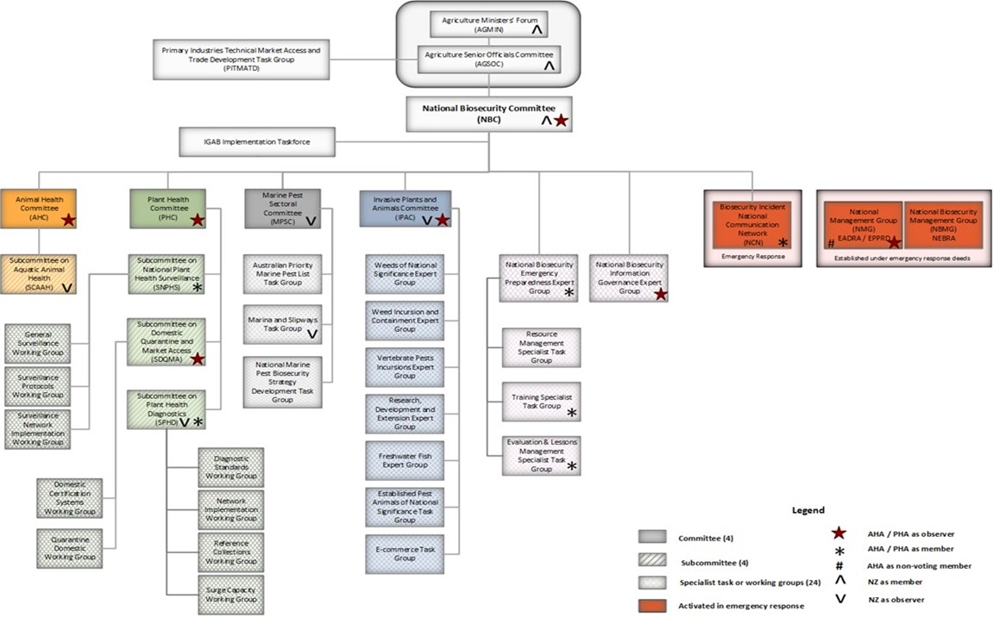

EADRA: the Emergency Animal Disease Response Agreement; EPPRD: the Emergency Plant Pest Response Deed; NEBRA: the National Environmental Biosecurity Response Agreement.

The Australian Government suggests (sub. DP65) there could be better coordination and linkages between the committees and subcommittees to ensure greater transparency, sharing of information and cross-sectoral utilisation of the work of the committees—and the panel agrees. In addition, the existing committee structure does not provide clarity about which committee is responsible for specific issues. For example, it is unclear which committee should deal with new pests or established pests, plant pests versus pests that are plants, and which committees should deal with environmental issues (Chapter 4). Further, as previously identified, two of NBC’s sectoral committees have broader responsibilities than biosecurity which only adds to the definitional issues that exist around biosecurity—when non-biosecurity activities fall under the umbrella of the NBC.

As a consequence, the panel recommends that NBC’s sectoral committees should have a clear and transparent division and articulation of pest and disease risk responsibilities (Table 5), and modifications should be made to the existing NBC sectoral committee structure (Figure 8). In summary, the existing MPSC and IPAC will become subcommittees under the new Community and Environmental Biosecurity Committee, along with a new Priority Risks Subcommittee (PRSC), focused on prioritising and planning for national biosecurity risks impacting on the environment and social amenity (Chapter 5). The new Chief Community and Environmental Biosecurity Officer (Chapter 4) will lead and oversee the Community and Environmental Biosecurity Committee and its subcommittees.

Table Proposed AHC, PHC and CEBC division of pest and disease risk responsibilities

| Committee | Clarified responsibilities |
| --- | --- |
| **Animal Health Committee (AHC)** | Nationally significant exotic and endemic diseases of production animals (terrestrial, freshwater, estuarine and marine) (e.g. foot-and-mouth disease, white spot syndrome virus, Johne’s disease)  Crossover environmental biosecurity issues where the impact is primarily production animals (including wildlife diseases where a native species is a possible vector) (e.g. Australian bat lyssavirus, Hendra)  Exotic invertebrate pests of production animals (e.g. screw-worm fly)  Diseases of wild fisheries (freshwater and marine) |
| **Plant Health Committee (PHC)** | Nationally significant exotic and endemic pests (mostly invertebrates, including exotic bee pests and pest bees) and diseases primarily of plant production (e.g. Panama disease TR4, Cucumber Green Mottle Mosaic Virus and fruit flies)  Crossover environmental biosecurity issues where impact is primarily plant production (e.g. Xylella)  Exotic production weeds (e.g. red witchweed) |
| **Community & Environmental Biosecurity Committee (CEBC)** | Nationally significant exotic pests and diseases (terrestrial, freshwater, estuarine, marine and airborne = ‘blown in’) where the impact is primarily environmental (e.g. myrtle rust) or affects social amenity (e.g. red imported fire ants)  Nationally significant established pests and weeds (production and non-production) |
| Priority Risks Subcommittee | Work to prioritise and plan for national biosecurity risks impacting on the environment (terrestrial, freshwater, estuarine, marine and airborne) and social amenity (Chapter 5) |
| Marine Pest  Subcommittee (MPSC) | Nationally significant exotic marine pests (vertebrates, invertebrates, plants and algae), including those associated with biofouling and ballast. Non-production focus |
| Invasive Plants and  Animals Subcommittee (IPASC) | Potential invasive species including those ‘already here’: vertebrate pests (e.g. ferrets) freshwater pests (including ornamental freshwater fish, invertebrates and algae), exotic wildlife trade (reptiles, amphibians, invertebrates etc.), and non-production weeds (future Weeds of National Significance)  Nationally significant endemic pests: terrestrial pests (e.g. foxes and wild dogs), freshwater pests (vertebrate and invertebrate) and weeds  IPASC has production and environmental elements, due to scale of impacts |

Recommendation 20

The NBC should adopt a subcommittee structure that aligns with the revised national biosecurity system objectives and revised national reform priorities in IGAB2. All NBC sectoral committees should have a clear and transparent division of responsibilities for pest and disease risk. All NBC working groups and expert groups should be task-specific and, wherever possible, time-limited.

#### Culture and transparency

The panel has had a number of opportunities to engage with members of the NBC during this review and has observed that the culture of the NBC is positive, with members that are committed, engaged and constructive. However, the committee is perhaps overly reliant on key people, goodwill and informal arrangements. As Matthews (Mathews 2011) pointed out in relation to foot-and-mouth disease, institutionalising processes is good public administration, not the least ‘to ensure regular review and updating’.

Non-government stakeholders have commented on the levels of change in government ministers and officials involved in the national biosecurity system, pointing out that all agriculture ministers and agency heads have changed during the period covered by the current IGAB. Similarly, most NBC members are relatively new. The panel believes there is scope to codify past and formalise present NBC decision-making processes to ensure that corporate knowledge and positions and decisions reached by the committee endure beyond the current NBC participants.

Stakeholders have also been critical that governments, the NBC and its subcommittees have not been sufficiently open about their activities—and the panel agrees:

It is very hard for industry to see the outcomes of the IGAB and even industry members who are active in the biosecurity space struggle with the complexity and hierarchy of the various governments committees and bodies that act in this area (Northern Territory Farmers Association sub. DP9)

The work of the National Biosecurity Committee and its committees is general [sic.] opaque to the public. Recently [the] National Biosecurity Committee has started issuing communiques after their meetings, but the level of detail in the communiques does not allow any meaningful understanding of what was discussed (Invasive Species Council sub. DP50)

The NBC structure and work program lack transparency. Publicly available information on the work of the NBC and its subcommittees is limited and outdated—for example, websites are not always kept up to date, and communiqués can lack meaningful information. Even taking into account the need to ensure that Australia’s trade interests are not compromised, there also appears to be a tendency for the NBC to be overly risk averse in sharing biosecurity information, data and intelligence. Submissions from Australian governments on the IGAB review draft report acknowledged the value of improving the transparency of the NBC and its operations.

The panel has already noted the significant achievements of the IGAB against its priority reform areas, since its introduction in 2012 (Chapter 1). However, many of these achievements, including key policy frameworks, are not publicly available to inform all system participants. The panel considers the NBC should do more to improve its transparency, including establishing and maintaining a standalone website to centralise all information on the NBC, its committees and their activities. This new site could also consolidate information from existing websites focused on national biosecurity matters, such as the national pest and disease outbreak website and the National System for the Prevention and Management of Marine Pest Incursions website.

Recommendation 21

The NBC should increase its public profile and openness, including by establishing a standalone website, to be maintained by but be separate from the Australian Government agriculture department. The website should centralise all information on the NBC, its committees and their activities. Key policy frameworks, agreements and reports of the NBC should be made public on the site.

#### Commitments and accountability

The success of the national biosecurity system depends on all governments meeting their ‘core’ or ‘normal’ commitments under the IGAB and the various emergency response deeds. However, recent reports have indicated that reductions in consolidated revenue budget allocations have compromised the ability of some jurisdictions to meet those commitments and to collaborate on significant national biosecurity policy initiatives under the IGAB, which are designed to create a more effective and sustainable national system.

For example, the August 2015 report by the Victorian Auditor-General (VAGO 2015) found that funding for core livestock biosecurity activities in Victoria had decreased by 49 per cent over the last five years. This has weakened Victoria’s capacity to detect, prepare for and respond to emergency animal disease outbreaks, which can have devastating economic impacts. The 2015 Queensland biosecurity capability review (Brooks et al. 2015) found that the increasing number, scale and scope of exotic pests and disease threats would be likely to exceed Biosecurity Queensland’s resources and capacity. Other jurisdictions have reported similar reductions in resourcing and identified associated increases in risk. The Australian Capital Territory has indicated that, due to its size, location and land tenure, it works closely with New South Wales to assist with delivery of biosecurity related to agricultural production.

The Northern Territory Government highlighted the importance of more formal arrangements with the Northern Australia Quarantine Strategy (NAQS), including via an MoU, to help ensure more support for the Northern Territory in meeting its biosecurity obligations.

The NBC members are rightly concerned that there is no material reduction in the combined or individual ability of jurisdictions to meet biosecurity responsibilities under the IGAB; or for industry under the emergency response deeds. However, there are no national mechanisms in place for ongoing accountability among jurisdictions.

The panel recommends that governments establish an independent IGAB Evaluation Program to provide the Australian community with a structured assessment of the performance of each jurisdiction, including the Australian Government, in meeting its commitments under the IGAB. These evaluations would be included in the list of priorities for the next five years under IGAB2. Jurisdictions’ commitments and other metrics for evaluation would be detailed by the NBC. These commitments and the evaluation process should acknowledge the operational constraints of the smaller jurisdictions—for example, the Australian Capital Territory relative to its neighbour, New South Wales.

Such evaluations can provide new insights and an independent or expert perspective. They are not punitive assessments; rather, they are designed to be facilitative and build capability and help manage risks and, importantly, promulgate the lessons learned among the jurisdictions. Further, they are not intended to replace the periodic capability reviews self-initiated by jurisdictions.

AGSOC should be the body that establishes and provides oversight to the independent IGAB Evaluation Program. All jurisdictions should be reviewed within the period of the next IGAB, so the evaluations should be targeted and time-limited. The evaluations should be conducted as an external review by independent assessors.

There is significant value in these evaluations being publicly available; however, there are likely to be trade sensitivities, for example, which, if made public, would not be in the national interest. AGSOC should give some consideration to the public release of full evaluation reports or a comprehensive summary. The panel’s preference would be for the release of the full reports.

The panel notes the commitment within the IGAB (Schedule 1, clause 5.1) that the NBC must report annually to ministers responsible for biosecurity on implementation of the activities carried out under the IGAB. The panel is aware that reports were provided to AGSOC and AGMIN in accordance with this clause in 2015 and 2016 only, but these reports are not yet public.

The panel reaffirms this important commitment. The NBC should report annually to AGMIN about its work program and implementation of the priority reform areas under the IGAB. Such reports should be concise and publicly available. The public report could usefully present national system data and information in the form of a National Biosecurity System at a Glance summary document, including the available data and information listed in Table 6 and highlight other achievements, which may, for example, include efforts to streamline and improve the efficiency of the national arrangements.

Table The National Biosecurity System at a Glance (proposed inclusions)

| Section | System metrics |
| --- | --- |
| Trade, tourism and transactions | * volume and value of imports (goods/merchandise) * gross value of agricultural production * volume and value of agricultural exports * inbound passenger numbers (air and sea) and inbound and domestic tourism numbers and expenditure * number of cargo consignments (air and sea) * number of international mail |
| Shared responsibility (descriptive) | * roles and responsibilities of system participants * jurisdictional core commitments under the IGAB * industry’s and jurisdictions’ core commitments under emergency response deeds * compliance rate for exporters, passengers and mail * public awareness of biosecurity risks and obligations |
| Market access | * market access (value) enabled by Australia’s pest and disease status * market access (value) enabled by accepted proof of freedom demonstrations * number of markets gained, maintained and lost due to biosecurity grounds * value of markets gained, maintained, and lost due to biosecurity grounds |
| Funding and investment | * total investment in biosecurity (all governments; industries, community) * cost-recovery levels for government biosecurity services in each jurisdiction * annual cost of emergency responses (total for all system participants, total government) * examples of risk return assessments * value and proportion of R&D spend on National Biosecurity R&I Priorities |
| National priority pests and diseases | * number of national priority pests and diseases—animal, plant, environment * number of national priority pests and diseases with known surveillance, monitoring (including pre-border) and diagnostics programs * number of national priority pests and diseases with cost-sharing arrangements * number of exotic species detected (yearly) * number (and examples) of exotic species detections resolved (yearly) * examples of time elapsed between suspected detection and diagnosis and decision on action * number of incursions of national priority pests or diseases (yearly) * number (and examples) of incursions eradicated/contained/not managed/occurrence diminished (yearly) |

Recommendation 22

AGSOC should establish and oversee an independent IGAB Evaluation Program to assess and report on implementation of each jurisdiction’s core commitments under IGAB2. Each evaluation, or a comprehensive summary, should be made public following ministerial consideration.

Recommendation 23

The NBC should define the ‘core’ or ‘normal’ commitments of jurisdictions under IGAB2 for use in the independent IGAB Evaluation Program.

Recommendation 24

The NBC should report annually to AGMIN on its progress against priority reform areas outlined in Chapter 10. The NBC’s annual report should be made public upon ministerial consideration.

### Bringing others into the fold

Throughout this review, many stakeholders were critical of the level of engagement with industry and community groups by governments in both the construct and implementation of the IGAB:

The IGAB construct is still based on the past 200 years of managing biosecurity across Australia with the participants being restricted to government agencies with the exclusion of other stakeholders. This also extends to the various committees, subcommittees and working groups that operate under the remit of IGAB … NGIA does not consider ‘engagement or having input’ as being a part of the decision making apparatus as history has shown this is often ‘process’ driven with decisions still made by government to suit government agendas (Nursery and Garden Industry Australia sub. DP23)

Jurisdictions acknowledge the desire of peak industry bodies and community groups to be part of the biosecurity decision-making process but defend the need for a government-only agreement in the first instance:

The IGAB was developed in order to allow Commonwealth, state and territory governments to agree on what the national biosecurity system should encompass … The IGAB was not intended to be the only document or mechanism to underpin the national biosecurity system. It was always envisage that there should be a higher level document outlining the national biosecurity system including stakeholders and partnerships (New South Wales Government sub. DP58)

The IGAB does not provide a means to adequately address the need to engage with industry and other stakeholders in implementing the national biosecurity system. However, this relationship between government and stakeholders within the national biosecurity system is important and should be captured through other mechanisms, rather than seeking to amend the primary purpose of the IGAB (Australian Government sub. DP65)

The panel strongly supports a greater role for non-government stakeholders in policy design and implementation of national biosecurity arrangements. However, in the panel’s view, the IGAB is not the appropriate mechanism for achieving this. As highlighted by this report, jurisdictions are yet to fully ‘network’ their biosecurity policies and systems to forge a truly national biosecurity capacity. As a result, the IGAB must remain a forward-facing agreement among governments on national reform priorities.

The IGAB promotes shared responsibility for biosecurity among a diverse range of participants and provides (under clause 2.3) opportunities for governments and other parties to work together to strengthen the national biosecurity system. While jurisdictions have developed a National Biosecurity Engagement and Communications Framework, they recognise this area is significantly underdone and there is considerable room for improvement to more effectively engage with a greater range of stakeholders on biosecurity. This was strongly brought out in the social attitudes surveys conducted by the Australian and New South Wales governments (Mercer et al. 2016; Colmar Brunton 2017).

The panel has recommended the development of a National Biosecurity Statement for the biosecurity system to be endorsed by major stakeholders in the national system (Recommendation 2). The statement would sit alongside the IGAB, the emergency response deeds and jurisdictional biosecurity strategies as foundations of the national biosecurity system.

The panel also recognises the efforts made by governments to engage with non-government stakeholders through the state and national Biosecurity Roundtables. The panel received consistent comment from non-government stakeholders on the positive nature of these events and the improvements in more recent times to effect genuine consultation through more open and robust discussion. There is, however, scope for non-government stakeholders to be afforded a more direct means of input to the work of the NBC.

The panel recommends that AGSOC establish a fifteen-person (minimum) Industry and Community Biosecurity Committee to sit alongside the NBC under the IGAB governance arrangements. The committee would provide initial views to the NBC on proposed key policies and activities, including the National Biosecurity Statement, and meet jointly with the NBC at least twice per year. Membership of the committee should comprise peak industry and community bodies, which should include shipping, tourism, trade, agriculture, environment and community representatives. Consideration should be given to rotating membership every three years. The Australian Government agriculture department should provide the secretariat for the committee.

To further strengthen the NBC’s consideration of the views of signatories to the emergency response deeds, the panel recommends that the full membership of the NBC meet annually with AHA and PHA members to discuss key policy issues and reforms. The panel understands that a joint AHA/PHA annual forum already exists—this would be one obvious opportunity. Information discussed and received will feed directly into the NBC, including relevant sectoral committee(s).

Recommendation 25

AGSOC should establish, as a priority, an Industry and Community Biosecurity Committee as a forum for NBC to discuss key national biosecurity policies and reforms.

Recommendation 26

The full membership of the NBC should meet annually with AHA and PHA members to discuss key national biosecurity policies and reforms.

There is also a potential range of alternative mechanisms for providing industry and community groups with a ‘seat at the decision-making table’ other than populating the NBC and its subcommittees and working groups with non-government representatives. Preliminary steps in this process would need to include: broad agreement to the respective roles and responsibilities of the major parties in the national system; and, agreement to a National Biosecurity Statement such as that proposed by this review. Building upon these steps, and to further facilitate the sharing of control and influence, the parties might explore negotiation of national animal, plant and environment ‘Preparedness Agreements’ to augment the emergency response deeds; Inter-Industry Agreements on Biosecurity focused on data sharing and surveillance or to support claims of area freedom; and industry–government partnership agreements with priorities and joint actions to drive national system improvements and joint investment.

Future IGABs provide the platform for governments to commit to such mechanisms. Industry and community groups must similarly be held to account for their decisions, commitments and actions.

### Updated governance arrangements

Effective governance of the national biosecurity system requires a strong mandate, strong leadership, a sound strategy, and supporting arrangements that are finely tuned and focused. This chapter, along with the panel’s discussion on environmental biosecurity (Chapter 4), has proposed a number of modifications to existing governance arrangements and these are summarised and illustrated below (Figure 8):

* a refreshed IGAB agreed by First Ministers of all jurisdictions
* identification by First Ministers of lead ministers and agencies for biosecurity from each jurisdiction, and jurisdictional arrangements that facilitate whole-of-government support
* AGMIN and AGSOC being the operational ministerial and senior officials fora
* a stronger and more transparent NBC authorised by First Ministers under the IGAB, with updated terms of reference and expanded membership (including local government)
* the establishment by AGSOC of the Industry and Community Biosecurity Committee to sit alongside the NBC
* a new position of Chief Community and Environmental Biosecurity Officer within the Australian Government environment department
* modified arrangements for sectoral committees, including a new Community and Environmental Biosecurity Committee responsible for nationally significant exotic pests and diseases (terrestrial, freshwater, estuarine, marine and airborne), where the impact is primarily environmental or affects social amenity, and nationally significant established pests and weeds (production and non-production). The committee will be supported by a Priority Risks Subcommittee, the Marine Pest Subcommittee and the Invasive Plants and Animals Subcommittee
* ensuring that NBC sectoral committees have a clear and transparent division of responsibilities for pest and disease risks
* ensuring that cross-system groups established by the NBC (existing and new) are task-specific and, wherever possible, time-limited
* the participation of partner agencies (AHA and PHA) and other bodies (Research and Development Corporations, the Commonwealth Scientific and Industrial Research Organisation (CSIRO), the Centre of Excellence for Biosecurity Risk Analysis, the Plant Biosecurity CRC and the Invasive Animals CRC/Centre for Invasive Species Solutions, among others) in subcommittees to be further considered by the NBC.

Figure Proposed IGAB and related governance arrangements

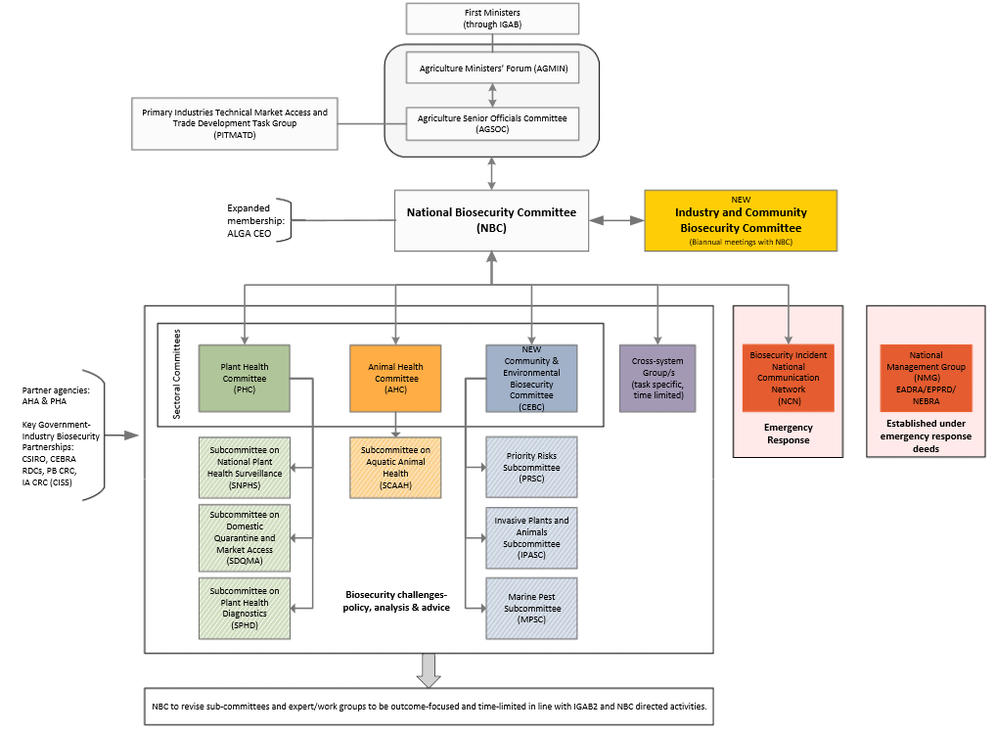

ALGA: Australian Local Government Association; CSIRO: Commonwealth Scientific and Industrial Research Organisation; CEBRA: Centre of Excellence for Biosecurity Risk Analysis; EADRA: Emergency Animal Disease Response Agreement; EPPRD: Emergency Plant Pest Response Deed; IA CRC (CISS): Invasive Animals CRC (Centre for Invasive Species Solutions; NBC: National Biosecurity Committee; NEBRA: National Environmental Biosecurity Response Agreement; PB CRC: Plant Biosecurity CRC; RDCs: Research and Development Corporations.

## Funding the national system

Key points

* Governments and industry are facing, and will continue to face, ongoing resourcing challenges.
* Some aspects of the national system continue to be funded through agreed arrangements and long-standing commitments, whereas other biosecurity priorities fall short of appropriate levels of funding.
* States and territories need to increase funding if they are to fulfil their obligations to the national biosecurity system. At the same time, there needs to be greater sharing of responsibility for established pests and weeds among government and non-government parties in the national system.
* The Parliament of Australia has legislated Australia’s Appropriate Level of Protection (ALOP). Funding for the Australian Government’s components of the national system needs to be sufficient to achieve this requirement.
* National investment principles and frameworks have been agreed by jurisdictions under the IGAB. The challenge is building support within governments for their implementation.
* Investments by industry and contributions from community, especially through rates and levies, warrant greater acknowledgement. In 2015–16, around 57 per cent of national system expenditure was funded by industry.
* At the Australian Government level the contribution by industry is even greater, with over 70 per cent of total biosecurity-related expenditure funded by industry in 2015–16.
* Industry involvement in investment decision making is primarily confined to emergency responses and sectoral activities in some cases. There is a strong case to increase industry’s involvement in decision making more broadly given its sizeable contribution.
* Governments have options available to support a more sustainable funding base for the national biosecurity system.

The review’s terms of reference require the panel to examine existing cost-sharing arrangements and the potential for implementation of new funding arrangements for all biosecurity activities. In doing so, the panel was asked to consider the National Biosecurity Committee’s (NBC) projects, including the National Framework for Cost Sharing Biosecurity Activities, the National Portfolio Investment Optimisation Model and the National Stocktake of Biosecurity Investment.

### The shared funding challenge

The success of Australia’s biosecurity system is reliant on sustained levels of well-targeted investment over time, underpinned by strong funding principles and arrangements that are nationally coordinated, consistently applied and well communicated.

The majority of submissions to the review agreed that the national system has experienced a period of declining budgets and that the national system is increasingly underfunded. However, they did not agree on how this problem should be rectified.

#### Government funding

There are obvious government funding pressures across the national biosecurity system, and these are not limited to a particular jurisdiction. Reports from the Australian (Commonwealth of Australia 2015), Victorian (VAGO 2015) and Queensland (Brooks et al. 2015) governments have identified that reductions to core government biosecurity resourcing (that is, overall financial and staffing levels) are placing further pressures on the national system to manage biosecurity risks; and several governments have responded to these reports with additional targeted funding injections.

From the panel’s perspective, funding pressures arise primarily from a combination of the following factors:

* increased government spending on competing priorities (for example, health, welfare and education) needing to be offset by reductions in other areas of government spending, including biosecurity
* the absence of an agreed suite of high-priority pests and diseases and their biosecurity requirements
* inefficient resource allocation (investments with low returns)
* an over‑dependence on public investment due to immature cost-sharing arrangements
* increasing biosecurity risks and efforts (Chapter 1)
* growing demand for biosecurity services (for example, export/domestic certification).

It is now generally accepted that resourcing the national biosecurity system is not the responsibility of governments alone. The panel acknowledges that the national system is funded through a variety of means: government appropriations, fees and charges for services, levies and other financial contributions. There are also noteworthy financial, in-kind and voluntary contributions made by landholders and other industry participants.

The panel received comments from across governments, industry, community organisations and individuals suggesting broad concern that existing funding and resourcing arrangements are inadequate and *ad hoc* and, if continued, they will not be able to support the national system into the future. Many industry members have commented that reductions in government expenditure on biosecurity correlate with increased ‘cost-shifting’ to industry. Industry has raised concerns about a decline in the number of specialists (including, for example, government veterinarians and plant pathologists). A selection of these comments, which other biosecurity stakeholders may dispute, is provided below:

[There is] no overall funding model for a national framework/and system. Individual components maybe funded but how the system should operate and be paid for has not been addressed. Under the current framework, initiatives are funded piecemeal and under ephemeral funding models. These initiatives run the risk of falling by the wayside when the focus turns to other aspects (other ‘hot topics’) of biosecurity. Logically, agreement on operation and funding cannot occur until there is some agreement amongst parties as to what a national framework should be … In many cases we have seen a diminution of capacity as jurisdictions have reduced commitments and funding to biosecurity. Similarly the resources at the Commonwealth level have not kept pace with the increase in risk as trade and passenger movements increase (Voice of Horticulture sub. DP11)

Industry has also witnessed the disproportionate reduction in government investment in plant biosecurity across Australia relevant to animal biosecurity which questions state/territory government capacity to meet their obligations. Industry faces significant pressure in sourcing general funding with most relying on industry RD&E levies … (Nursery and Garden Industry Australian sub. DP23)

Substantial reductions in State government services and funding now jeopardise our national system of biosecurity. For example, our experts dispute the claim [from the IGAB review discussion paper] that Australia enjoys a ‘robust diagnostic systems and capacity’ compared to international benchmarks. The national veterinary diagnostic system has been degraded as a result of State government funding cuts … (The University of Sydney sub. DP14).

On the other hand, some of the apparent reductions in biosecurity services by governments across the country have occurred when new systems, with built-in efficiencies that reduce costs to governments and at the same time maintain or enhance the service, have been implemented. For example, the reduction in the number of small veterinary laboratories has been addressed by significant capital investments in large, centralised and modern facilities with significantly superior diagnostic capacity and utilising modern transport logistics.

Also, state and territory treasuries rightly look to ensure that all system participants are sharing in the costs of the national biosecurity system. It is appropriate for governments to continually question whether all system participants are pulling their weight and to be assured that governments are not being used as automatic default funders. If this process is conducted in partnership with all system participants, it should be possible to identify appropriate cost-sharing versus inappropriate cost-shifting.

Given the comments and concerns expressed in submissions, the panel has attempted to quantify the extent of the funding problem. The Australian Government Department of Agriculture and Water Resources funding for biosecurity has been estimated using figures from its Portfolio Budget Statements (Outcome 2), being:

Outcome 2: Safeguard Australia’s animal and plant health status to maintain overseas markets and protect the economy and environment from the impact of exotic pests and diseases, through risk assessment, inspection and certification, and the implementation of emergency response arrangements for Australian agricultural, food and fibre industries.

The panel has examined the department’s actual expenditure by funding source from 2011–12 to 2015–16, and the budgeted expenditure for 2016–17, in 2011–12 dollars (Table 7). This analysis indicates that appropriation funding declined markedly from 2011–12 to 2014–15, falling by almost 30 per cent in real terms in just three years. While appropriation expenditure has increased since then, budgeted appropriation expenditure for 2016–17 remains approximately $26 million, or around 10 per cent below 2011–12 levels in real terms.

By comparison, cost-recovered funding has increased every year in real terms, illustrating the rising proportion of the biosecurity system being funded by industry. The panel notes, though, that this is not necessarily inappropriate. As trade volumes grow and fee-for-service activities become a larger part of the overall biosecurity task, it is to be expected that the cost-recovered proportion will increase. Indeed, in 2015 the department conducted an extensive review of its fees and charges. The review saw the cost base to be recovered increase by 8.6 per cent, a substantial reduction in the number of fees and charges to streamline the system, and significant changes in magnitude of fees (DAWR 2015a).

In total (appropriation plus cost recovered funds), the Australian Government Department of Agriculture and Water Resources budgeted expenditure for 2016–17 is now above the 2011–12 levels in real terms.

Table Australian Government Department of Agriculture and Water Resources selected financial information for Portfolio Budget Statement Outcome 2 ($ million, real terms)

| Funding source | 2011–121 | 2012–131 | 2013–141 | 2014–151 | 2015–161 | 2016–172 |
| --- | --- | --- | --- | --- | --- | --- |
| Appropriation | 254.08 | 203.39 | 188.96 | 178.49 | 201.16 | 227.65 |
| Cost recovered | 293.27 | 299.60 | 299.85 | 325.83 | 335.68 | 345.02 |
| * *import services* | *185.34* | *177.67* | *175.46* | *189.85* | *202.71* | *216.56* |
| * *export services* | *93.88* | *108.59* | *110.89* | *122.15* | *119.05* | *115.92* |
| * *other* | *14.05* | *13.34* | *13.50* | *13.83* | *13.92* | *12.54* |
| Total (appro. and cost recovered) | 547.35 | 502.99 | 488.81 | 504.32 | 536.84 | 572.67 |
| Proportion cost recovered | 53.6% | 59.6% | 61.3% | 64.6% | 62.5% | 60.2% |

1. Actual expenditure; 2. Budgeted expenditure. Figures converted to 2011–12 dollars using CPI.

Source: Australian Government Department of Agriculture and Water Resources Portfolio Budget Statements, various.

The panel notes, however, that this level of funding is not assured into the future. Some funding for biosecurity flowing from the 2015 Agricultural Competitiveness White Paper is scheduled to end in 2018–19. The Australian Government Department of Agriculture and Water Resources Portfolio Budget Statement for 2016–17 (DAWR 2016d, Table 2.2.1) lists departmental appropriation funding for Outcome 2 falling from $213 million in 2018–19 to $186 million in 2019–20. This represents a fall of approximately $27 million, or around 12.6 per cent, in just one year. Given the increasing level of risk, this is a significant reduction even taking increased efficiency into account.

It needs to be acknowledged that other Australian Government agencies, such as the Department of Defence and the Department of the Environment and Energy, also contribute to some biosecurity-related activities and their spending is in addition to that of the Department of Agriculture and Water Resources. However, their Portfolio Budget Statements do not provide sufficient information to be able to determine how much they may spend on biosecurity-related activities.

The panel has been unable to carry out a similar analysis across all jurisdictions due to the different reporting methods. As a proxy for biosecurity spending, an analysis of information collected by the Australian Bureau of Statistics on jurisdictions’ general government expenditure on agriculture, fisheries and forestry and other data between 2001–02 and 2015–16 was undertaken (Table 8). This analysis showed that, apart from Tasmania, the Northern Territory, and the Australian Capital Territory, general government expenditure on agriculture, fisheries and forestry has declined in real terms in most jurisdictions on an average annual basis. As noted above, several jurisdictions have increased spending since 2014–15 following various reviews. Expenditure on agriculture, fisheries and forestry is in stark contrast to the major budget categories of education, health, and social security, which have all experienced average annual increases in spending in real terms, well above population growth.

Table Government expenditure and comparative changes with time (%) for selected portfolio areas by Australian governments: 2001–02 to 2015–16 ($ million, real terms)

| Jurisdiction | Year | Education | Health | Social security | Ag., fisheries & forestry | Population (No.) |
| --- | --- | --- | --- | --- | --- | --- |
| Aust. Govt. | 2001–02 | 12,174 | 27,615 | 69,081 | 1,753 | 19,495,210 |
| . | 2015–16 | 22,586 | 48,444 | 106,279 | 1,568 | 24,128,876 |
| . | aagr | 4.51% | 4.10% | 3.12% | -0.79% | 1.54% |
| NSW | 2001–02 | 9,003 | 8,341 | 2,406 | 562 | 6,580,807 |
| . | 2015–16 | 12,603 | 13,611 | 4,451 | 525 | 7,726,924 |
| . | aagr | 2.43% | 3.56% | 4.49% | -0.49% | 1.15% |
| Vic. | 2001–02 | 6,679 | 6,102 | 2,080 | 433 | 4,817,774 |
| . | 2015–16 | 9,432 | 10,600 | 3,150 | 264 | 6,069,636 |
| . | aagr | 2.50% | 4.02% | 3.01% | -3.49% | 1.66% |
| Qld | 2001–02 | 4,945 | 3,793 | 728 | 614 | 3,653,123 |
| . | 2015–16 | 8,254 | 10,642 | 1,970 | 484 | 4,843,303 |
| . | aagr | 3.73% | 7.65% | 7.37% | -1.69% | 2.04% |
| WA | 2001–02 | 2,951 | 2,557 | 473 | 288 | 1,928,512 |
| . | 2015–16 | 4,905 | 5,806 | 1,478 | 270 | 2,617,074 |
| . | aagr | 3.70% | 6.03% | 8.48% | -0.46% | 2.21% |
| SA | 2001–02 | 2,239 | 2,114 | 541 | 274 | 1,511,567 |
| . | 2015–16 | 3,038 | 3,860 | 1,072 | 118 | 1,708,135 |
| . | aagr | 2.20% | 4.39% | 5.00% | -5.83% | 0.88% |
| Tas. | 2001–02 | 724 | 570 | 157 | 67 | 474,152 |
| . | 2015–16 | 949 | 1,137 | 275 | 94 | 519,063 |
| . | aagr | 1.95% | 5.06% | 4.08% | 2.48% | 0.65% |
| NT | 2001–02 | 484 | 438 | 67 | 39 | 202,251 |
| . | 2015–16 | 769 | 993 | 262 | 63 | 245,191 |
| . | aagr | 3.36% | 6.02% | 10.23% | 3.47% | 1.39% |
| ACT | 2001–02 | 474 | 442 | 114 | 2 | 324,627 |
| . | 2015–16 | 749 | 980 | 196 | 2 | 396,294 |
| . | aagr | 3.32% | 5.85% | 3.94% | 0.34% | 1.44% |
| Totals | 2001–02 | 39,673 | 51,972 | 75,647 | 4,032 | 19,495,210 |
| . | 2015–16 | 63,285 | 96,073 | 119,131 | 3,387 | 24,128,876 |
| . | aagr | 3.39% | 4.49% | 3.30% | -1.24% | 1.54% |

Expenditure figures converted to 2001–02 dollars using CPI. aagr: average annual growth rate; compound method (CAGR) used to calculate expenditure percentage, and average method (AAGR) used to calculate population percentage.

Source:ABS Cat. No. 5512.0 Government Finance Statistics (2015–16 release) and ABS Cat. No. 3101.0 Australian Demographic Statistics (September 2016 release).

The panel acknowledges that the ABS data needs to be understood in the context of key policy decisions by governments during the period. As noted above, several jurisdictions have also increased spending on biosecurity since 2014–15 following various reviews.

The overall decline in general government expenditure on agriculture, fisheries and forestry should also be viewed in the context of the significant growth in merchandise imports (Figure 9), container movements and inbound tourism (Chapter 1), which will contribute to significant shifts in biosecurity risks into the future.

Figure Selected general government expenditure (all levels of government) and other economic information 2001–02 to 2015–16 ($ billion, real terms)

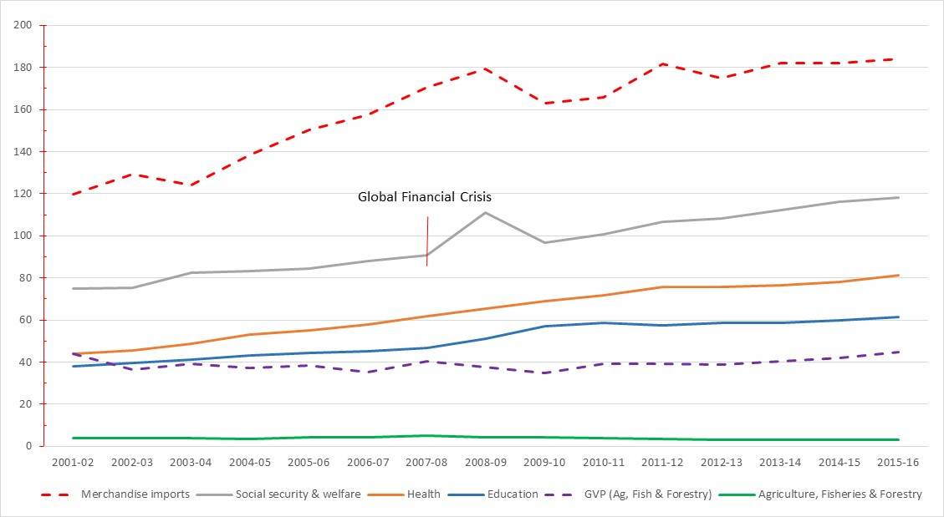

GVP: Gross Value of Production.

Source: ABS Cat. No. 5512 general government expenditure (2015–16 release). GVP information from ABARES. Merchandise imports from DFAT Jan. 2017 Composition of Trade statistics. Figures converted to 2001–02 dollars using CPI.

In addition, the panel was also provided with access to the results from the national stocktake of biosecurity investment for 2013–14, 2014–15 and 2015–16. While the detailed stocktake results are confidential, the results from these stocktakes are consistent with the information outlined above—namely, that government appropriations declined over the period and were offset by an even larger increase in ‘externally’ sourced funds (for more on the national stocktake of biosecurity investment see section 8.2.3 below).

#### Industry funding

The total financial contribution by industry to the national biosecurity system is unknown. The amounts paid to governments are known (as illustrated above), but the operational expenses and in-kind contributions made by industry are not collected and documented. As noted earlier (Chapter 2), some industries conduct their own monitoring and surveillance activities (for example, 136 programs in the grains and horticulture industries alone). There are also substantial contributions by industry to the activities managed by Animal Health Australia (AHA) and Plant Health Australia (PHA) and towards past and present incursion management.

The panel accepts the claims made by industry in submissions to this review that its contributions are more than just the amount reflected in government fees and charges and that they are likely to be significant. But without supporting data it is not possible to estimate these additional contributions.

### Consideration of the three NBC projects listed in the terms of reference

In its deliberations on funding, the panel has given consideration to the NBC projects listed under the IGAB review terms of reference and has sought to make some observations.

#### The National Framework for Cost Sharing Biosecurity Activities

The National Framework for Cost Sharing Biosecurity Activities, which is not yet publicly available, establishes for governments the key principles underpinning a cost-sharing model for biosecurity activities, including detailing available funding mechanisms. It represents a more comprehensive description of how the NBC interprets and will seek to implement the objectives and principles of the system as outlined in the IGAB at clause 4.1(v-vii), namely:

v) Activity is undertaken and investment is allocated according to a cost-effective, science-based and risk-management approach, prioritising the allocation of resources to the areas of greatest return.

vi) Relevant parties contribute to the cost of biosecurity activities:

a) Risk creators and risk beneficiaries contribute to the cost of risk management measures in proportion to the risks created and/or benefits gained (subject to the efficiency of doing so), and

b) Governments contribute to the cost of risk management measures in proportion to the public good accruing from them.

vii) Governments, industry and other relevant parties are involved in decision making, according to their roles, responsibilities and contributions.

The investment principles are sound and there is wide support for maintaining them in a future IGAB and as part of a future national biosecurity system. The national framework is consistent with these principles and is also consistent with funding principles published by Independent Pricing and Regulatory Tribunal (IPART) (IPART 2013), the Australian Government Department of Finance’s cost recovery guidelines (Finance 2014), and the Productivity Commission (PC 2001).

A key requirement of the funding principles is determining the split between public and private good—for example, IGAB clause 4.1(vi)(b) states governments should contribute in proportion to the public good. The current emergency response deeds imply a public versus private good split in responding to an incursion via the cost-sharing ratios as listed in the relevant schedules to the deeds (for example, Schedule 13 to the Plant Deed). However, for other national biosecurity system services or pests and diseases not covered by the deeds, there is no common understanding of the split between public and private good. In determining the lists of national priority exotic pests and diseases (Chapter 5), the analysis should include an assessment of the public and private good components.

The panel recognises the need for an agreed framework to guide the application of cost-sharing arrangements by all parties. However, the current framework does not provide sufficient guidance to facilitate practical implementation by national biosecurity system participants (especially given that it is not available publicly), is somewhat arbitrary on potential funding mechanisms (for example, a national biosecurity levy) and, to date, reflects a government-only view of cost-sharing. There would be significant benefit in the NBC and the proposed new Industry and Biosecurity Community Committee reviewing the framework, in consultation with key stakeholders, for publication and practical application by all system participants.

Recommendation 27

The NBC and the Industry and Community Biosecurity Committee, in consultation with other key stakeholders, should review the National Framework for Cost Sharing Biosecurity Activities to enable its practical application and make it public.

#### The national portfolio investment optimisation model

The NBC’s national portfolio investment optimisation model categorises government investments across the range of biosecurity activities. The model seeks to provide a considered and holistic approach to investment to help understand investment returns. The model provides five investment categories (IC) (Table 9), which reflect the suite of activities across the national biosecurity system. The Australian Government also reports on a sixth category (export facilitation).

Table The national portfolio investment optimisation model categories

| Investment category | Description |
| --- | --- |
| IC1 | Prevention of exotic/emergency pests and diseases (pre-border and border) |
| IC2 | Preparedness for exotic or emergency pests and diseases, including early detection (surveillance) |
| IC3 | National eradication/containment programs (cost-shared national programs) |
| IC4 | Management of established pests and diseases of national significance |
| IC5 | Management of other established pests and diseases |
| IC6 | Export facilitation (Australian Government only) |

The foundation for the investment model is the 2008 generalised invasion curve developed by the Victorian Government, as detailed in the IGAB review discussion paper. The invasion curve includes indicative economic returns, with the return on investment higher for prevention than for ongoing management of established pests and diseases. For the latter, return on governments’ investment is improved when their investment supports collective industry and/or community action (compared with government as sole investor). The sixth investment category, and its return on investment, does not feature in the invasion curve.

The invasion curve has been useful in demonstrating the correlation of activity, area occupied and time, and has helped system participants further the maturity of the national biosecurity system. However, given the complexity of the national system and further development of national arrangements, jurisdictions have seen a need to adapt the invasion curve. The NBC’s agreed categories of investment reflect the invasion curve’s next evolution, although there will be an ongoing need to validate returns on government investment across the national system for the model to remain valid.

#### The national stocktake of biosecurity investment

The national stocktake of biosecurity investment uses the national portfolio investment optimisation model’s six ICs to provide a structured assessment of how all Australian governments are investing in biosecurity.

Reported through the NBC, the annual stocktake captures estimates of jurisdictions’ overall investment in biosecurity with results available for total state and territory investment and total Australian Government investment. The stocktake has been completed for the 2013–14, 2014–15 and 2015–16 financial years.

Unfortunately, the three stocktakes are still considered confidential by governments and, as a result, are not public. The panel was provided with copies but with restrictions on what information can be reported publicly. The panel believes that greater transparency by jurisdictions and the NBC on biosecurity investments would facilitate the required debate in this critical area.

High-level summary results of the investment stocktakes are consistent with the anecdotal claims made in submissions to this review that proportionally government appropriation funding has been static or in decline while externally sourced funds (that is, cost recovery and levies) have been increasing (Figure 10). While there is no doubt there has been some change in how investment has been recorded over the three years as the stocktake has evolved, the trends and magnitude of them are illustrative.

Figure National stocktake of biosecurity investment summary results: 2013 to 2016 ($ million)

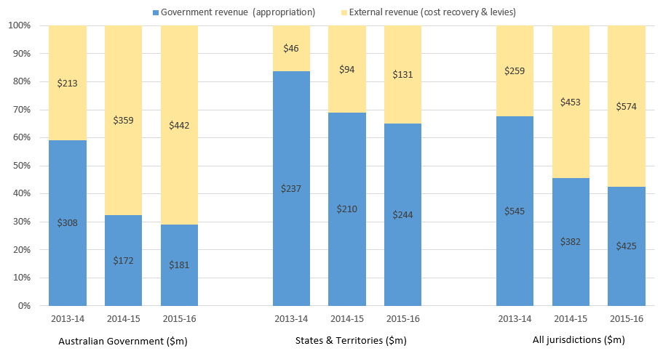

Figures include all six categories, IC1 to IC6.

Source: National stocktake of biosecurity investment 2013–14, 2014–15 and 2015–16.

Some notable observations are:

* Nationally, externally sourced funds in 2015–16 accounted for 57 per cent and budget appropriations 43 per cent of total investment—a marked change from 2013–14, when the corresponding figures were 32 and 68 per cent respectively.
* The Australian Government had the largest movement between budget appropriations and externally sourced funds. In 2013–14 budget appropriations represented 59 per cent of what the Australian Government invested in biosecurity, but by 2015–16 this had fallen considerably to 29 per cent.
* Cost-recovered funds by the Australian Government increased by 108 per cent over the period, and cost-recovered funds by the states and territories increased by 183 per cent.
* Budget funding increased significantly between 2014–15 and 2015–16, reflecting the injection of funds noted above following reviews in Queensland and Victoria and the 2015 Agricultural Competitiveness White Paper.
* Total funding in 2015–16 was $998 million—an increase of around 24 per cent on the 2013–14 figure of $804 million.

A breakdown of the most recent stocktake results for 2015–16, by investment category (that is, IC1 to IC6) and source of funds (Figure 11), shows that:

* the Australian Government spent 62 per cent of its appropriation funds (around $113 million) in prevention and preparedness (IC1 and IC2)
* states and territories spent 63 per cent of their appropriation funds (around $138 million) on management of established pests and diseases (IC4 and IC5)
* 58 per cent of the funds generated from industry (around $334 million) was spent on IC1 and IC2
* overall, around 51 per cent of funds ($510 million) was invested in prevention and preparedness (IC1 and IC2), 6 per cent ($55 million) was invested in eradication and containment programs (IC3), 26 per cent ($264 million) was invested in management of established pests and diseases, nationally significant and other (IC4 and IC5), and 17 per cent ($169 million) was invested in export facilitation (IC6).

Figure National biosecurity investment stocktake 2015–16 results by investment category and source of funds ($ million)

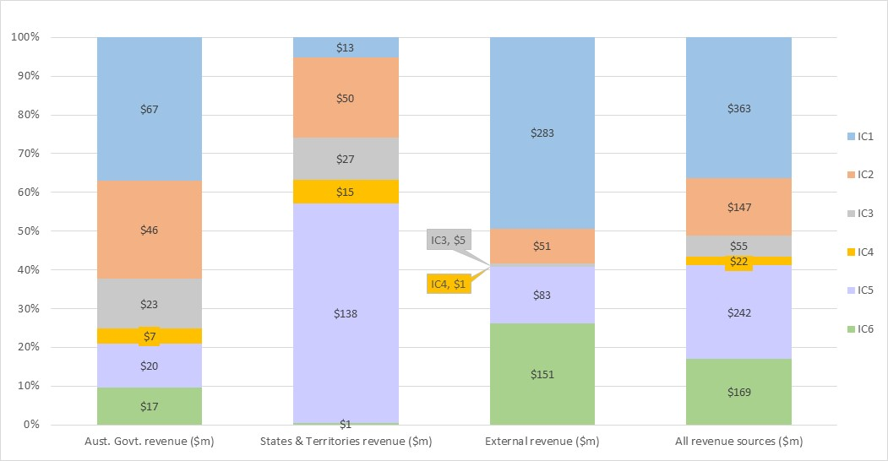

Source: National stocktake of biosecurity investment 2013–14, 2014–15 and 2015–16.

The panel considers the national stocktake of biosecurity investment is a positive development as it helps to quantify investment and identify trends. However, it is not without some issues. Some categories of activity are absent for example research and innovation. It relies on self‑reported estimates provided by jurisdictions and is therefore open to interpretations of spending and categorisation. Greater consistency, transparency and rigour could be achieved through appointing an independent body to undertake the work. The panel acknowledges that some jurisdictions have reservations about making such information public and the resource implications of a more rigorous process. But the panel remains of the opinion that the national biosecurity system should be able to produce such data as a standard management tool and the fact that it is not able to do so readily at the moment simply illustrates the shortcomings of the current approach.

The panel considers that the national stocktake should be replaced by the independent Report of Government Biosecurity Services (ROGBS), as recommended (Recommendation 38).

### Other guiding principles and frameworks

The panel has also considered a range of other factors in relation to funding the national biosecurity system.

#### The Appropriate Level of Protection (ALOP)

The panel notes that the *Biosecurity Act 2015* (Cwlth) articulates Australia’s ALOP, Section 5 states:

The Appropriate Level of Protection (or ALOP) for Australia is a high level of sanitary and phytosanitary protection aimed at reducing biosecurity risks to a very low level, but not to zero.

By legislating Australia’s ALOP, the Parliament of Australia has provided a clear statement that it expects the Minister and the Australian Government agriculture department to administer the components of the biosecurity system it is responsible for in such a way as to achieve the required ALOP. It follows, therefore, that the level of funding required for these components of the biosecurity system needs to be sufficient to maintain the ALOP.

#### Shared responsibility

Clause 4.1(i) of the IGAB states that biosecurity is a shared responsibility between all Australian governments, industry, natural resource managers, custodians or users, and the community. This concept is covered earlier (Chapter 2) and has relevance to the funding principles for the national biosecurity system.

As noted above, industry is sharing responsibility for funding the national system via the fees and charges it pays to governments as well as the other financial and operational contributions it makes through, for example, AHA, PHA, Research and Development Corporations (RDCs) and Cooperative Research Centres (CRCs).

However, several submissions expressed concern that there are ‘free riders’ in the national system and that this needs to be addressed. In relation to emergency response arrangements, an analysis undertaken by the Australian Bureau of Agricultural and Resource Economics and Sciences (ABARES) for the review has revealed that the problem is not as great as thought for land-based industries.

In 2014–15 approximately $51.4 billion (or 95 per cent) of Australia’s total Gross Value of Farm Production of $54.3 billion (excluding forestry and horse production) is covered by signatories to the emergency response deeds. This is a considerable commitment from industry and demonstrates the overwhelming partnership between industry and government in emergency responses. Of the 5 per cent not covered (approximately $2.8 billion), the panel has listed products (or categories of product) with a production value of more than $100 million (Table 10). Data from 2015–16 was not yet available at the time of the report.

Table Land-based commodities with a production value of more than $100 million not covered under existing emergency response deeds

| Product | Production in 2014–15 ($m) |
| --- | --- |
| Hay and silage | 1,402.6 |
| Cut flowers | 296.2 |
| Fresh tomatoes | 285.4 |
| Mushrooms | 273.6 |
| Cultivated turf | 217.3 |
| Livestock slaughter and other disposals, other NEC | 154.3 |
| Other fruit (not elsewhere classified) | 141.0 |

Source: ABARES.

ABARES also undertook an analysis of Australia’s total exports against the signatories to the emergency response deeds, which tells a similar story. The proportion of farm and forestry exports (excluding horses temporarily exported for racing) covered by signatories to the emergency response deeds is around 87 per cent.

The analyses undertaken by ABARES do not include fisheries (including aquaculture), which is currently in discussions with Australian Government about potential coverage. Encouraging all industries to sign up to, or establish, an emergency response deed would strengthen the national partnership and the national biosecurity system.

#### Categorising national system activities

While the panel supports the steps taken to establish new investment categories and recognises their value for decision-making purposes, these should have utility beyond funding and investment. Uniform categories for the national biosecurity system should reflect the full suite of activities for all system participants and support a range of analyses. All system participants should be encouraged to publicly report their activities, including investments, on a consistent basis to build a better understanding of the system’s efficiency and performance.

At present, there is limited ability for system participants beyond jurisdictions to categorise their contributions to and participation in the national system. This includes capturing the activity relevant to the IGAB priorities, as well as the activities and funding of AHA, PHA, the RDCs, CSIRO, and any state and territory level bodies.

The panel recommends a single categorisation of national biosecurity system activities be agreed by the NBC, in collaboration with key industry members and non-government partners. As part of this reconsideration, attention should be given to categories of the national priority planning process and the subsequent action planning (Chapter 5). National system categories must be clear to avoid confusion, distortion or manipulation. Consideration will need to be given to how these categories align with, or ‘roll-up’ into, other frameworks like the Rural R&D Priorities to limit reporting burden.

Recommendation 28

The NBC, in collaboration with key industry and non-government partners, should agree uniform and fully inclusive categories of activity, including investment categories, for the national biosecurity system.

### How much is enough?

The overall funding situation for Australia’s biosecurity system is complex, and there is no picture of total investment in the national system. This is primarily because the range of investments and contributions by key parties is not routinely captured, reviewed or invested on a national basis.

That said, there is widespread support for the view that the national system is currently underfunded and that, in particular, there is inadequate funding for those areas where the greatest return is likely to be achieved. These include the prevention activities on the left-hand side of the invasion curve model (see below), education and awareness building, cross-sectoral research and development and environmental biosecurity. It also needs to be recognised that, at least from a government perspective, the current funding arrangements contain an unknown contingent liability relating to incursion response and management.

#### Where should the funds be spent?

In 2014, the Productivity Commission was commissioned to examine Australia’s natural disaster funding arrangements (PC 2014). Among its findings were that:

* Australia is exposed to natural disasters on a recurring basis. Effective planning and mitigation of risks is an essential task for governments, businesses and households.
* Current government natural disaster funding arrangements are not efficient, equitable or sustainable. They are prone to cost-shifting, *ad hoc* responses and short-term political opportunism. Groundhog Day anecdotes abound.
* Governments overinvest in post-disaster reconstruction and underinvest in mitigation that would limit the impact of natural disasters in the first place. As such, natural disaster costs have become a growing, unfunded liability for governments.
* The funding arrangements matter because they impact on the incentives to manage risks, including by using potent but politically challenging levers like land use planning. The reform imperative is greatest for states most exposed to natural disaster risk, like Queensland.

The Productivity Commission’s findings are similar to the panel’s views about the national biosecurity system. Biosecurity could replace natural disaster in the findings above and be equally applicable. In both cases there is an understanding that it is wiser to spend money on prevention and mitigation measures in advance of an adverse event occurring rather than on recovery and rectification but that in most cases this does not happen. Investment in prevention and mitigation is more readily accepted and hence more common in areas such as human health (for example, breast and bowel cancer screening programs) than in natural disasters or biosecurity. Failure to invest in health prevention and mitigation would be regarded by many as unacceptable.

This view was reflected in a number of submissions, which highlighted the relative lack of investment in the left-hand side of the invasion curve, where the greatest returns can be achieved. These views were confirmed by the 2015–16 national stocktake of biosecurity investment, which revealed that approximately 63 per cent of state and territory investment is directed at areas where the return is generally lower—that is, established pests and diseases (Figure 12).

Figure State and territory government biosecurity investment in 2015–16

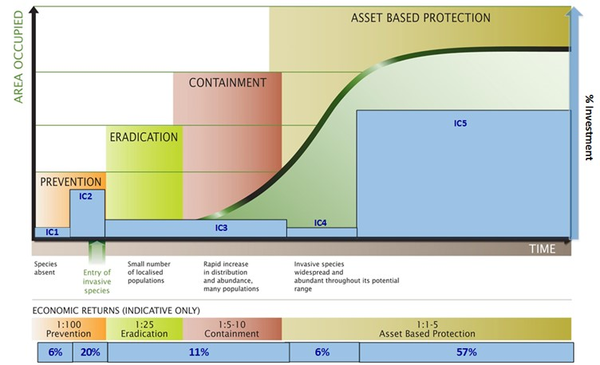

Source: 2015–16 national stocktake of biosecurity investment.

Benefits to farmers, industry and the community would flow if the current expenditure profile of the state and territory jurisdictions could be reformed to align more closely with agreed national biosecurity priorities. Further, greater sharing of responsibility for established pests and weeds among government and non-government parties in the national system is consistent with the NBC’s proposed approach to managing established pests and diseases of national significance under the National Framework for the Management of Established Pests and Diseases of National Significance.

The Productivity Commission also found that the failure to adequately invest in risk mitigation for natural disasters was leading to a growing, unfunded liability for governments (PC 2014). The same is true for biosecurity, for which incursion responses and management are, in the most part, unallocated in government budgets. The costs for the equine influenza response were over $342 million (Callinan 2008), while the response to red imported fire ants has cost $340 million so far, with a further $380 million likely to be committed over the next ten years (Joyce 2016). It is worth noting in this context that a major incursion has the potential to massively impact on the economy, with costs much broader than direct eradication costs. For example, ABARES has estimated that a large-scale foot-and-mouth disease outbreak would cost Australia in the region of $50 billion over ten years (ABARES 2013).

Unless there is greater investment in prevention, early detection and eradication activities then major response and management costs can be expected to increase in the future, placing a growing and unpredictable burden on government budgets and potentially leading to choices having to be made between eradication efforts to be funded even where the cost–benefit outcomes are clear.

For several years now, governments have acknowledged the superior return on investment at the prevention and early detection (left-hand) side of the invasion curve. However, governments appear hamstrung in redirecting investments there. The Australian Government submission to this review (sub. DP65) highlighted the need to reconsider allocation of resources in light of the results of the national stocktake of biosecurity investment but emphasised that it would be difficult to generate support for directing funding away from the right-hand side of the curve.

The panel acknowledges that some traditional patterns of investment can be driven by industry and political imperatives. However, the panel trusts that its recommendations will assist jurisdictions and facilitate the decision-making process as to where to invest their limited taxpayer funds. This should be into areas where the returns to the community are the greatest.

Jurisdictions need to do more to demonstrate and communicate ‘the case’ for particular investment approaches. Working with industry and the community, governments can establish long-term plans to transition arrangements to more equitably share responsibilities. Use of tools like the Australian Government agriculture department’s Risk Return Resource Allocation (RRRA) model (Appendix D) will assist in this process. The model can be used to inform advice on the return (in terms of reduced risk) for investments to manage biosecurity risk and improve confidence that resources are allocated to areas of greatest risk reduction (Box 13).

Box Risk reduction from Australian Government agriculture department investments

The Risk Return Resource Allocation (RRRA) model estimated the contribution, through pre-border, at-border and post-border investments, by the Australian Government agriculture department to reducing biosecurity risk. Post-border investments by the states and territories are not captured by the model and were therefore not considered as part of the analysis.

The RRRA model estimates risk reduction due to the effect of biosecurity controls in reducing the approach rate of organisms of biosecurity concern via goods, conveyances, people and natural means (influence), reducing the number of organisms that are released from biosecurity control and enter Australian territory (physical intervention at border), and reducing the number of those organisms that establish and spread (post-entry controls).

About two-thirds of the overall risk reduction is the result of biosecurity controls that influence the approach rate for organisms of biosecurity concern (pests, diseases and weeds). This includes the influence that border processes have on passengers and importers to reduce the approach rate. The corresponding return on investment (ROI) is very high (128) compared with the ROI for the direct effect of at-border interventions (20).

The study found that, with the modelled $340 million investment in biosecurity controls by the department, Australia avoids a $24 billion long-term cost to the economy. The contributions to overall reduction in risk across the continuum for each risk category are shown in the graph below.

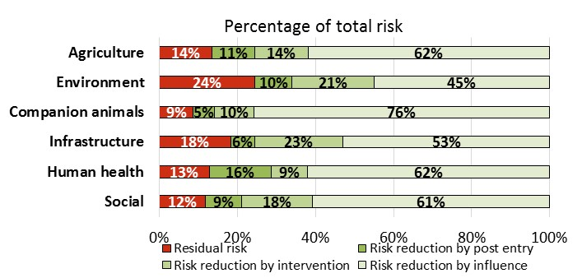

Influence refers to anything that affects the approach rate; intervention refers to border activities; and post-entry refers to the direct effects of surveillance, preparedness and response activities.

Source: Australian Government Department of Agriculture and Water Resources.

The panel considers that the RRRA model should be extended to all biosecurity investments. In the first instance, the model should be extended to investments from all jurisdictions. The Australian Government should provide the necessary assistance and technical expertise to all jurisdictions to build this capacity across the national biosecurity system and ensure national consistency of use.

Furthermore, all industry and farm lobby organisations have a responsibility to inform themselves and their constituents of where the real return on investment to farmers is. Issues that are often short-term, local, and sometimes high-profile and media susceptible can readily draw funds away from those biosecurity challenges that need to be addressed and that will have a superior financial benefit to farmers.

Recommendation 29

All governments should review their current biosecurity expenditure with a view to redirecting funding to areas that provide the greatest return on investment to producers, industry and the community. This approach will require a planned and coordinated strategy of engagement and communication.

Recommendation 30

The Risk Return Resource Allocation model should be extended to include all jurisdictions and their investments, with the Australian Government providing technical assistance to jurisdictions to build national capacity.

Of particular concern for the panel is funding for environmental biosecurity. While some participants see this as a classic public good which should be funded from the public purse, reality is a little different. For example, the food export and tourism sectors leverage Australia’s environmental qualities in their marketing and gain a commercial benefit.

The national biosecurity system has, in large part, evolved around the agriculture and trade sectors, with funding mechanisms naturally developed along similar lines. Environmental biosecurity was achieved more as a by-product of those systems than as a core objective. But that has changed, with an increasing expectation that environmental biosecurity should be on an equal footing with animal and plant biosecurity. It follows that funding for environmental biosecurity needs to evolve too. The worst outcome would be for existing, limited biosecurity funding to be spread even more thinly by diverting funds away from the animal and plant sectors to the environment sector.

### Sustainable funding

While there is general agreement that the funding principles in the IGAB are sound, the difficulty lies in deciding how and when to apply them. There are clear instances where a specific commercial benefit can be identified for a specific system participant (for example, export certification) and a direct fee for service is easy to justify and implement. However, the national system is full of activities where there is a mix of public and private benefits, and the appropriate funding mix is less clear.

The panel is proposing the items below as potential sources of funds to meet the need for increased investment in environmental biosecurity activities and in activities on the left-hand side of the invasion curve (prevention, monitoring and surveillance); accelerate national system innovation; improve awareness of biosecurity roles and responsibilities; and redress some of the funding cuts in recent years.

#### Governments

**Budget appropriations**

As noted frequently in submissions, government budgets for biosecurity have been under increasing pressure for some time and are likely to remain so. While there has been an increase in budget appropriations recently in some jurisdictions following various reviews, the situation is capable of being reversed as some of the increased funding is not ongoing (for example, funding for Australian Government Department of Agriculture and Water Resources that expires in 2018–19, as noted above).

Given the competing pressures on government budgets and the overall fiscal situation in most jurisdictions at present, an increase in budget funding would be difficult. Conversely, though, any further cuts in government appropriations would be detrimental and send the wrong signals to industry and the community about the national importance of biosecurity.

The panel recommends that budget appropriations to all Australian governments for biosecurity must be at least maintained at 2016–17 levels (in real terms) until after the next review of the IGAB. Stable funding commitments are critical for effective planning and delivery of biosecurity activities.

Recommendation 31

To provide greater system stability, Australian governments’ appropriations funding for biosecurity should be maintained at 2016–17 levels (in real terms) or more until after completion of the next review of the IGAB.

**Cost recovery: fees and charges**

The national stocktake of biosecurity investment for 2015–16 (all investment categories combined) shows that the Australian Government obtains 71 per cent of the funds it spent from external sources (that is, cost recovery and levies) and 29 per cent from budget appropriations. By comparison, the states and territories obtained around 35 per cent from external sources and 65 per cent from budget appropriations. For the national system (all jurisdictions combined), of the total funds spent ($998 million), around 57 per cent ($574 million) came from external sources and 43 per cent ($424 million) came from budget appropriations.

The panel acknowledges that there are differences in the services provided between the jurisdictions and that it is not sensible to expect the states and territories to recover the same amount as the Australian Government does through fees and charges. However, the Australian Government has clearly benefited from the review it conducted in 2015 (DAWR 2015a) and not only through the increased recovery of funds. The states and territories would similarly benefit from a thorough review.

There would be significant advantages for the states and territories in reviewing their cost-recovery arrangements. Importantly, determining the areas for improvement requires a comprehensive understanding of actual costs of delivering services, including identifying those benefiting from the service that may not previously have been identified, as well as the costs of staff and resources directly and indirectly involved. While it is recognised that state and territory treasury departments will have differing whole-of-government frameworks, increased consistency of approach for biosecurity across jurisdictions would also be a benefit, given that governments interact with a largely similar client base. This review was not in a position to conduct a detailed review of the cost-recovery arrangements for the states and territories but supports the Australian Government’s suggestion that all states and territories review the delivery of their biosecurity services and cost-recovery arrangements and that they seek guidance from the Australian Government on the process.

Recommendation 32

State and territory governments should agree a common biosecurity cost-recovery framework and review their biosecurity cost-recovery arrangements to ensure they are nationally consistent, appropriate and transparent.

**Levy on containers (sea and air)**

Much of the material of concern to the national biosecurity system, including of environmental concern, arrives via vessels and containers—either in the contents of the container or on the external surfaces of the container itself. More than one‑third of the pests and diseases included in the RRRA model have containers as a pathway. The panel is of the view that a broad-based levy on containers should be implemented to contribute towards a greater effort on environmental biosecurity and improved national monitoring and surveillance generally. The levy should be extended to non‑containerised imports as well.

The benefits of implementing a levy on incoming containers is that it is directly related to a primary risk-creating activity, revenue will reflect changes in the volume of risk material over time, and a collection mechanism has already been created.

The Australian Government Bureau of Infrastructure, Transport and Regional Economics (BITRE) forecasts the total number of incoming sea containers to increase from 3.6 million twenty-foot equivalent units (TEUs) in 2012–13 to approximately 9.8 million TEUs in 2032–33, growing at about 5 per cent per annum. In 2015–16 it is estimated that there were approximately 4.2 million incoming TEUs. In addition, non-containerised imports through Australian ports are forecast to be around 138.5 million tonnes in 2032–33 (BITRE 2014).

Current statistics on air container numbers is not readily available. This information is not recorded by the Australian Government Department of Immigration and Border Protection in its Integrated Cargo System (ICS), and the Department of Agriculture and Water Resources only captures data on air containers referred for inspection (a small subset of the total). The Australian Government should look to address this information gap. The last complete year of data is for 2008, where all incoming containers were inspected—this was prior to the Australian Government’s move to risk-based approach for interventions at the border. A total of 389,882 air containers were recorded in this year.

The panel considers that a $10 levy per incoming TEU for sea containers and a $5 levy per incoming air container be implemented in the first instance. This would generate approximately $44 million per annum ($42 million from sea containers and $2 million from a conservative estimate of 400,000 air containers). The panel believes that, on equity grounds, the levy should be expanded to include non-containerised incoming trade in the future, as the vessels themselves also create biosecurity risks. However, the panel notes the finding in the Cost Recovery Implementation Statement Biosecurity 2015–16 that:

[The Australian Government] did examine other options to apply a levy to all types of imported cargo, however, there are no other cost effective mechanisms available at this time (DAWR 2015a)

The panel acknowledges that the Australian Government’s 2015 cost recovery review removed the previous charge on air and sea containers as part of the overall restructuring package. A charge of $30 per full container and $8 per partially filled container had applied. Additional fees applied if the contents of the container were assessed as being of potential biosecurity concern and needed inspection. The charge covered the cost of the department examining 100 percent of sea containers, but, with the move towards risk-based inspections, it was decided to switch charging to another mechanism. Having considered the 2015 cost recovery review, the panel believes that a levy would be justifiable provided it is smaller than the previous charges and is implemented for the purpose of improving environmental biosecurity and national monitoring and surveillance.

**Full import declaration**

If a container levy (sea and air) is considered unacceptable, given a levy was removed in the 2015 cost recovery review, an alternative would be to supplement the charge on Full Import Declarations (FIDs) with a levy to collect a similar amount to the proposed container charge.

Information provided by the Australian Government Department of Immigration and Border Protection was that in 2015–16 there were around 4.1 million FIDs. Therefore, the levy required would need to be in the order of $10 per FID.

**Insurance model**

The panel has also considered whether an insurance approach may be possible for elements of the national biosecurity system. For example, if insurance for the cost of responding to and remediation from a major biosecurity incursion were available, would it be useful to the states and territories or industry?

While commercial insurance does offer some products that may be of limited use (for example, business disruption insurance), there is nothing at the moment for states and territories or peak industry bodies to use to insure against the large costs of responding to a major incursion.

The inability to obtain commercial insurance is not unique to biosecurity. It arose in the wake of the 9/11 attacks, when commercial providers withdrew from providing coverage for commercial losses arising from terrorist incidents. The Australian Government responded with the *Terrorist Insurance Act 2003* (Cwlth) and established the Australian Reinsurance Pool Corporation to fill the void. The Productivity Commission has also made a recommendation in relation to funding for natural disaster recovery costs—namely, that the Australian Government provide an option for state and territory governments to purchase top-up fiscal support at an actuarially fair price (PC 2014). In both examples the Australian Government is, or would be, the operator of the insurance model, reflecting the lack of commercial providers.

The panel considers that the same would have to happen if an insurance type approach were to be developed for elements of the national biosecurity system. The Australian Government would have to establish the insurance architecture and run it for some time until enough information was available to determine whether it would be a commercially appealing activity for the private sector to assume. An insurance model may be of most value to smaller jurisdictions and industries that have fewer resources and less budget flexibility to cope with potentially large costs involved in a major biosecurity incursion.

At this stage, however, the panel does not consider such a proposal as sufficiently high priority to warrant pursuing given the other work that needs to be done and the complexity in establishing such a model.

**Passenger Movement Charge**

The panel is of the view that inbound passengers are a significant source of biosecurity risk. Many are also tourists who come to experience Australia’s unique natural environment and are therefore beneficiaries of our national biosecurity system. If the principles contained in the IGAB, as well principles espoused in government charging guidelines, are applied then incoming passengers should contribute to the cost of biosecurity services. Using the Passenger Movement Charge (PMC) to collect a contribution towards the national system would be the most effective and efficient means of doing so.

While it is true that biosecurity activities were used to justify some past increases (part of the $2 increase in 1995 and the $8 increase in 2001 (Table 11), the fact is that the PMC is now considered a general tax and funds are not hypothecated to the Australian Government agriculture department for its biosecurity functions.

Table Passenger Movement Charge from 1995 to 2017

| Year | Charge |
| --- | --- |
| Before 1995 | Departure Tax $25 |
| 1995 | $27 (Offset costs of border agencies) |
| 1999 | $30 (Sydney 2000 Olympics levy) |
| 2001 | $38 (Foot-and-mouth disease levy) |
| 2008 | $47 (National aviation security measures) |
| 2012 | $55 (Asian marketing fund & tourism industry regional development grant) |
| From 1 July 2017 | $60 (part of changes to the Australian Government’s working holiday maker reform package) |

Source: Tourism and Transport Forum.

The panel believes that a claim for an increase to the PMC of $5 per passenger should be made. There were 18.9 million passenger arrivals in 2016 (DIBP 2017), so a $5 levy would raise in the order of $95 million. All revenue collected should be hypothecated to the Australian Government agriculture department, for use nationally in enhancing the national biosecurity system. In order for the PMC to be a hypothecated tax, it would need to be directly linked to biosecurity services. Therefore, the PMC would need to be changed so that arriving passengers were charged rather than departing ones.

The panel notes that in late 2016 the Parliament of Australia passed the *Passenger Movement Charge Amendment Act* *(No.2) 2016* (Cwlth) which placed a moratorium on any further increase in the PMC until 1 July 2022. Therefore the proposed increase should take effect from 1 July 2022.

The tourism industry made submissions opposing any increase to the PMC, for example:

The tourism industry does not receive fair re-investment from the revenue raised from the Passenger Movement Charge, and again to impose an increase on travel levies would further compromise the competitiveness of travel to Australia (Queensland Tourism Industry Council sub. DR97)

By way of precedent, in January 2016, the New Zealand Government imposed an additional border clearance levy of NZ$18.76 for air passengers and NZ$22.80 for cruise ship passengers, to be directed towards recovering biosecurity and border protection costs. This charge is additional to New Zealand’s existing passenger service charges (a NZ$12.50 charge to both incoming and outgoing passengers).

An alternative to an increase in the PMC would be to place a levy on every aircraft and cruise ship entering Australia to collect a similar amount of revenue. This would be in addition to the vessel inspection charges that already apply. The rationale for imposing this alternative is the same—namely, that the passengers being conveyed to Australia by the aircraft and ship operators are a source of risk. If the direct risk creator cannot be charged via a mechanism like the PMC then a proxy in the form of the carriage provider would be a fall-back option. However, this is not the panel’s preferred option.

**Self-Assessed Clearances**

The number of Self-Assessed Clearances (SACs) is growing as internet shopping grows. Information provided by the Australian Government Department of Immigration and Border Protection to the review shows that the number of SACs increased from 15.1 million in 2011–12 to 31.3 million in 2015–16—an average annual growth rate of almost 20 per cent. While the biosecurity risk of many SACs is considered low, they remain a potential source of biosecurity risk, and the sheer growth in volume means that the overall task is growing rapidly.

The growth in the number of SACs and the cost to clear them was raised during the Australian Government’s 2015 cost recovery review (DAWR 2015a):

Some [Industry Consultative Committee] members also raised concerns that the costs of clearing low-value imports (more commonly known as Self Assessed Clearances or SACs) were being cross-subsidised by importers of other cargo. Industry members sought the introduction of a specific SAC charge that would directly recover the costs of low value import clearance.

The proposal to introduce a specific SAC charge was also raised at public consultation sessions—with the primary concern being the potential for the current charges to lead to cross-subsidy of low value clearance costs. It was noted that a SAC charge is still under consideration by government.

However, it was decided not to impose a charge at that time. With the continuing growth in the number of SACs and the consequent increase in the clearance task, there is a growing case for imposing a charge. To do so would be consistent with the principles in the IGAB and Australian Government charging guidelines. The panel encourages the Australian Government agriculture department to continue investigations into whether an efficient and effective charging mechanism can be found to recover costs.

**Property-based levies**

Most comments received by the panel about funding pressures related to the budgets of the state and territory agencies. The findings of recent reviews of biosecurity systems in Queensland (Brooks et al. 2015) and Victoria (VAGO 2015) support the comments received.

The panel considers that the states and territories need to do more if they are to fulfil their obligations to the national biosecurity system. A comprehensive review of their fees and charges as recommended above would be a good start, but further consideration of funding to support the biosecurity system is required.

The panel is aware of some of the property-based levies being implemented by governments around Australia, particularly for contributions to emergency services (Box 14). Of note to the biosecurity community is that the Queensland emergency service agency received $457.4 million in levies in 2015–16 and Victoria is forecast to raise revenue of $674 million in 2016–17 from its fire services property levy.

Box 14 Property-based levies for emergency services

Queensland Government Emergency Management Levy

The emergency management levy is established by the *Fire and Emergency Services Act 1990* (Qld) which applies a levy on properties within levy districts. The Act places a legal obligation on local governments to administer the levy, which is collected through local government rate notices.

The levy is applied to all Queensland property to ensure there is a sustainable funding base for fire and emergency services and recognises that all Queenslanders are at risk from a wide range of emergencies including floods, cyclones and storms as well as fire and accidents.

The levy remains the primary source of funding for the Queensland Fire Emergency Services (QFES). In 2015–16, QFES received income from continuing operations totalling $622.2 million, of which 74 per cent (or a total of $457.4 million) came from emergency management levies.

Source: The Queensland Government’s [Emergency Management Fire and Rescue Levy](https://www.qfes.qld.gov.au/about/Pages/EmergencyManagementFireandRescue-Levy.aspx) website; Queensland Fire and Emergency Services 2015–16 Annual Report (QFES 2016).

Victorian Fire Services Property Levy

The Victorian Government replaced its insurance-based fire services levy with a Fire Services Property Levy (FSPL) in 2013, as recommended by the Victorian Bushfires Royal Commission. The FSPL is collected under the *Fire Services Property Levy Act 2012* (Vic.), which legislates that all Victorian property owners are liable for a financial contribution to Victoria’s fire services. The FSPL is collected through local government rate notices.

The Victorian Department of Treasury and Finance 2016–17 Budget forecasts revenue of $674 million from the FSPL. The Metropolitan Fire and Emergency Services Board (MFB) and the Country Fire Authority (CFA) are largely funded by the FSPL which is collected by councils, and the Victorian Government. Councils collect 87.5 per cent of MFB budget and 77.5 per cent of CFA budget from Victorian property owners. The Victorian Government contributes the remaining 12.5 per cent of the MFB budget and 22.5 per cent of the CFA budget.

Source: The Victorian Government’s [Fire Services Property Levy](http://www.firelevy.vic.gov.au/) website; Victorian Government sub. DR118.

The New South Wales Emergency Services Levy

The majority of the funding for the New South Wales State Emergency Services, NSW Rural Fire Service and Fire and Rescue NSW currently comes from an Emergency Services Levy (ESL) imposed on property insurance policy holders. The New South Wales Government determines the total budget for the emergency services authorities and requires insurance companies to contribute 73.7 per cent of the total. The balance is provided by the Treasury (14.6 per cent) and local councils (11.7 per cent).

In 2015, the New South Wales Government announced its intention to move away from the insurance-based ESL model to a new property-based model, called the Fire and Emergency Services Levy (FESL). While the New South Wales Government has recently announced a deferral to its implementation pending a review, it expects the change to result in a reduction in the cost of property insurance and encourage more people to insure their properties. The new FESL will be collected on behalf of the New South Wales Government alongside council rates.

Source: The NSW Government’s [Insurance Monitor](http://www.eslinsurancemonitor.nsw.gov.au/) website.

In some jurisdictions, biosecurity activities are already funded by contributions from local landholders or local governments; however, there is no consistent or necessarily equitable national application of levies on landholders for biosecurity activities:

Confusion is further exasperated by the fragmented biosecurity systems and programs adopted by state and national jurisdictions. On the whole in [Western Australia], producers and growers are contributing funding up to six times towards biosecurity programs without having clear understanding of how this money is being spent on the ground, whether outcomes are being achieved or analysis of budgetary breakdowns (The Western Australian Farmers’ Federation sub, DP32)

The New South Wales Government Department of Primary Industries highlighted to the panel the benefits of the existing model that captures landholder contributions and how it can be used as a model for increasing local and regional participation in decision making while still addressing regional, state and national biosecurity priorities (Box 15).

Box New South Wales Local Land Services

Under the *Local Land Services Act 2013* (NSW), Local Land Services (LLS) must charge rates on all parcels of land that are classified as rateable under the Act. Each region has a minimum rating area for properties. The rateable area is generally 10 hectares in coastal and tablelands areas and is larger (40 hectares in the Western Division and 20 hectares in some parts of the Murray and Riverina regions) in more western regions.

Rates are charged on a two-tier basis involving a general rate paid by all landholders and an animal health rate paid by eligible ratepayers. Each rate type consists of a base charge plus a variable component. The base charge is a uniform charge on all rateable land. Rates help pay for the biosecurity and animal health services in each region. Examples of biosecurity projects include outbreaks of fire ants and avian influenza, state-wide wild dog management programs, and pest and weed support programs to help minimise the impact on agricultural productivity.

LLS rates raised $32.6 million, or about 23 per cent of LLS funding, in 2015–16. As well as rates, the New South Wales and Australian governments contribute funding through Catchment Action NSW and the National Landcare Programme, respectively, for a range of environmental and natural resource management programs.

Source: The New South Wales Government’s [Local Land Services](http://www.lls.nsw.gov.au/about/annual-rates/rates-faqs) website; Local Land Services Annual Report 2015–16 (LLS 2016).

In its Pest Animal Management Review draft report (NRC 2016), the NSW Natural Resources Commission recommended reducing the minimum rateable area for landholders to better reflect the biosecurity risks created by smaller landholders—specifically, the commission proposed the minimum rateable area be reduced to two hectares (from 10 hectares). The panel suggests reducing the minimal rateable area to two hectares be considered by all state and territory governments, given the increasing risks attached to peri-urban activities.

The commission’s recommendation to reduce the minimum rateable area is entirely consistent with an intention to raise the profile and ownership of biosecurity issues for all landholders, especially those within peri-urban areas, and recognises the potential biosecurity risks directly associated with landholdings of two hectares or greater. The commission also highlighted the consistency of the recommendation with the 2008 Beale review (Beale et al. 2008).

In the longer term, all jurisdictions may wish to consider moving from a size threshold to a local-level levy for all landholders or rate payers. A levy applied to all landholders across the country would further increase the awareness of biosecurity issues and ensure biosecurity risk management is a responsibility shared by all Australians.

With increasing population density in our cities, there is likely to be an increase in the use of and reliance on public amenities such as community parks, sporting fields, golf courses and national parks. Incursions that threaten these increasingly popular environments and spaces should be the responsibility of all community members.

Recommendation 33

All levels of government could help meet their budgetary challenges by reviewing biosecurity levies and rates/charges currently or potentially applying to biosecurity system participants. These should be commensurate with agreed national cost-sharing principles.

**The environment**

Funding for environmental biosecurity needs a broader base to be more sustainable and less prone to short-term government budget decisions. The container levy proposed above would be a good start, as it targets international risk creators, but more needs to be considered on the domestic risk creators and beneficiaries side. For example, campers can facilitate the spread of exotic pests and diseases as they move through containment zones without taking proper precautions, while users of national parks and eco-tourism operators benefit from pristine environments.

The panel is aware of instances where charges are placed on users of national parks—for example, tourism operators on the Great Barrier Reef and individuals entering certain national parks, such as Kosciuszko National Park. However, these charges are usually for park maintenance or other services, not biosecurity, and are not consistently applied across parks or jurisdictions.

Trying to apply the charging principles proffered by IPART (IPART 2013) illustrates the problem. The first option—a direct fee for service—may be possible for some users, such as eco-tourism operators, but this is only a small subset of all users. The second option is a rate or levy to capture a fuller set of users. However, the diversity of users and the feasibility of a levy mechanism (outside general income taxation) make a rate or levy questionable. That leaves the third option of taxpayer funding.

The panel believes that the property-based levies discussed above, combined with the container levy (air and sea) and an increase to the PMC, offer the best option to recover additional funding for the national biosecurity system, including for the required improvements to environmental biosecurity.

Recommendation 34

Funding for the national biosecurity system should be increased by:

* implementing a per-container levy on incoming shipping containers of $10 per twenty-foot equivalent unit and a levy of $5 on incoming air containers, effective from 1 July 2019
* increasing the Passenger Movement Charge by $5, effective from 1 July 2022, with the revenue generated hypothecated to the Australian Government agriculture department for use nationally to enhance activities across Australia’s biosecurity system
* more widespread implementation by states and territories of land-based levies, with each jurisdiction to determine the magnitude of a levy based on its circumstances, but to include properties of two hectares or greater.

The revenue raised by these mechanisms should be directed to those areas of the national biosecurity system that are currently most underfunded, with a priority for strengthening environmental biosecurity activities, national monitoring and surveillance activities, R&I and national communications and awareness activities.

#### Industry

As noted above, the panel is unable to estimate how much industry contributes towards the operation of the national biosecurity system, outside of levies, fees and charges as insufficient data are available. Overall, the feedback from industry indicates that industry contributions are significant and increasing. It is the panel’s view that industry should give greater recognition to its significant investments by undertaking its own investment stocktake based upon future agreed categories of activity for the national system (section 8.3.3).

A more comprehensive understanding of total industry contributions would also aid its claim for greater involvement in decision making. As clause 4.1(vii) of the IGAB states, ‘Governments, industry, and other relevant parties are involved in decision making, according to their roles, responsibilities and *contributions*’ (emphasis added). In section 8.2.3 it was noted that 57 per cent of funds detailed in the 2015–16 national stocktake of biosecurity investment come  from industry. With further information on the other in-kind and financial contributions industry makes outside of government fees and charges, there will be a clearer understanding of the total investment by industry. In turn, it will assist industry’s claims for a greater role in decision making as envisaged by clause 4.1(vii).

The panel considers that AHA and PHA would be best placed to coordinate this task, with guidance from the NBC and the independent agency appointed to undertake the independent Report on Government Biosecurity Services (ROGBS) (Chapter 9), to ensure data integrity and compatibility with the ROGBS.

Recommendation 35

AHA and PHA should coordinate an industry stocktake of national biosecurity system investments and make the results public.

But there is more that industry could, and should, do. The panel has examined the practices of the grains industry, particularly the Grains Farm Biosecurity Program (GFBP) (Box 1). It considers that the model has potential for more widespread use and that more industries should be encouraged to follow the example (noting that some already do so).

Signatories to the Emergency Plant Pest Response Deed (EPPRD) are required to establish an emergency response levy mechanism (an EPPR levy) to repay the government for underwriting costs of an approved response plan (in the event of an incursion). They are also able to establish a PHA levy to pay their annual subscription costs and for certain other biosecurity activities (see the Australian Government Department of Agriculture and Water Resources [biosecurity levies](http://agriculture.gov.au/ag-farm-food/levies/biosecurity-levies) website). When most industries establish the emergency response levy mechanism they set the rate to zero and only set it at a higher level after an incursion has happened.

In the case of the grains industry, represented by Grain Producers Australia (GPA), a more progressive and proactive approach has been adopted. It has set its PHA levy at a rate which collects approximately $700,000 more per annum than the cost of its annual subscriptions and its EPPR levy rate at 0.005 per cent of the sale price rather than at zero. These funds are used to: (a) support the GFBP, which is aimed at improving awareness and farm management practices relating to grains industry biosecurity risks; and, (b) to build a reserve fund to cover the grains industry’s share of an approved emergency response plan.

The GFBP is managed by PHA in conjunction with GPA, and part of the partnership program includes funding for state government agencies to employ staff to work on the GFBP.

The funds collected through the EPPR levy built, over several years, to just over $5.1 million by the end of 2016. This reserve provides a ready source of funds to pay the grain industry’s share of approved emergency response plans and is currently being drawn on to cover costs associated with the Khapra beetle and Varroa incursions. Funds collected under the EPPR levy can also be used for purposes relating to emergency plant pests, within the meaning of the EPPRD, such as surveillance.

The panel considers the decisions by the grains industry to set the two levies above the minimum required as a positive example for other industries to follow (noting a few others do likewise already). It shows industry leadership in strengthening biosecurity activities for the industry and also building a fund ready to use when an incursion happens.

Some stakeholders suggested to the panel that there is a need for greater flexibility in agricultural levies received by the RDCs, AHA and PHA, especially around the components of the levies. In most cases levies are established for a specific purpose and the funds collected must be used for that purpose. Generally, industries wishing to change existing levy rates or the purpose of a levy must follow the same process as that required to establish a new levy. This can limit industry’s ability to redirect funding to new priorities, which may include biosecurity. Streamlining the process for amending existing levies could provide the flexibility industry needs to effectively respond to biosecurity risks.

The panel notes that these issues were canvassed in the 2015 Senate inquiry into agricultural levies (Commonwealth of Australia 2015a), with that inquiry recommending that the Australian Government agriculture department conduct ‘a review of the process to establish and amend agricultural levies including modifications to levy components’. The Australian Government agreed with this recommendation, and the agriculture department has commenced a work program to reform how levies processes operate. The aim is to deliver more flexible, less complex, contemporary levies processes that support industries in optimising their levy investments and responding to changing circumstances and that are well placed to adapt to the future needs of both government and industry over the longer term.

The panel encourages the Levies Process review to consider ways to streamline processes to facilitate the proposal in Recommendation 36.

#### Supplementing the emergency response deeds

Throughout the review the animal and plant emergency response deeds (that is, the Emergency Animal Diseases Response Agreement (EADRA) and the EPPRD) were cited as a key component of the national biosecurity system. The panel agrees with this assessment and notes they represent a world-leading practice.

The panel considers that all industries should contribute to an emergency response where it is appropriate for them to do so, not just if they are covered by a deed. To enable this, the panel believes that a universal emergency response levy facility should be enacted by the Australian Government. The levy could be activated by the Minister for Agriculture when he/she deems it necessary, with the rate and collection mechanism set at the discretion of the Minister.

However, the Minister’s discretion would be limited in situations where an industry is a signatory to a deed. The Minister would be obligated to comply with commitments already agreed by the government when entering into the deed. The deeds would continue to operate as now, but any industry not covered by a deed would be liable to having a positive levy placed upon it at the discretion of the Minister. To provide further incentive for industries not covered by a deed to join one, the legislation should permit the Minister to set a positive levy rate to build an emergency response fund for those industries up to a set limit of its gross value of production.

A pre-legislated mechanism would place industries not covered by a deed on a similar footing to those covered by a deed, eliminating the so-called free rider problem. It would circumvent potential lobbying against any future legislation seeking to implement an *ex poste* levy on an industry not covered by an existing deed. It would also increase certainty for the relevant jurisdictions in their decision making at the time of an incursion.

The panel considered the option of having the proposed legislation list only those industries not currently covered by a deed. However, it would leave open the prospect of an industry currently covered by a deed not being listed in the proposed legislation. Subsequently, withdrawal from the deed would leave no mechanism in place for that industry. To avoid this situation the proposed levy mechanism should apply universally but with the caveat described above that the Minister should apply the terms of a deed if one applies to the situation.

Recommendation 36

The Australian Government should enact legislation to put in place a universal emergency response levy, with its activation for any particular industry group to be at the discretion of the Minister for Agriculture. The legislation should provide the Minister with discretion to set a positive levy rate to build an emergency response fund for an industry in advance of an incursion. The legislation should require that, for industries covered by an existing emergency response deed, the Minister is to comply with the requirements of the relevant deed in making any decisions.

The panel has observed the progress on the development of emergency response deeds for aquatic animals (aquaculture and wild) and exotic production weeds. These deeds will address key gaps in the national emergency management arrangements and should help minimise the number and need for negotiation of special off-deed arrangements. While there is a range of discussions underway, the panel recommends that jurisdictions, relevant industries and community groups facilitate the prompt conclusion to these discussions to ensure the aquatic and exotic production weed deeds are prepared without delay.

Recommendation 37

The emergency response deeds for aquatic animals and exotic production weeds should be finalised within eighteen months of the IGAB review report.

### Summary

Funding Australia’s biosecurity system adequately will always be a challenge, and the sharing of the costs will always be disputed—this is the nature of the national system. While participants debate the elements of the national system, their costs and their effectiveness, no-one has suggested that funding for the system should be reduced.

The funding principles contained in the IGAB and the National Framework for Cost Sharing of Biosecurity Programs remain sound and should be retained in IGAB2. They already underpin the way the national biosecurity system is funded, with risk creators and beneficiaries contributing to the cost of the system. The data provided to the panel demonstrates that industry is already paying at least 57 per cent (in 2015–16) of the cost of the national system, although this includes payments for direct services, and likely significantly more when its in-kind contributions are included. But there are some groups that are not pulling their weight and it is appropriate for governments, industry and the community to continually look at who should be paying and how much they should be contributing.

The panel considers that additional funding is required to improve environmental biosecurity efforts, improve activities on the left-hand side of the invasion curve (for example, monitoring and surveillance), enhance awareness of roles and responsibilities to build support for the shared responsibility concept, improve communication about the national system, and aid implementation of the other recommendations contained in this report.

The panel considers the bulk of this additional funding should primarily come from a $10 per TEU levy on incoming sea containers and a $5 levy on incoming air containers (from 1 July 2019); an increase of $5 in the passenger movement charge (from 1 July 2022) expansion of land-based levies by the states and territories (preferably on a more uniform and consistent basis); and implementation of a universal, *ex ante* emergency response levy mechanism.

## Measuring system performance

Key points

* Evidence suggests that the national biosecurity system continues to protect Australia from many exotic pests and diseases.
* Good performance information is critical to being able to tell a cohesive biosecurity performance story. Public reporting of that performance information is also critical to maintaining the support of the community.
* Developing performance measures to assess whether the national biosecurity system as a whole, or different components of the system, are meeting agreed goals and objectives should be actioned under IGAB2.
* Datasets, and their requirements, need to be agreed in advance to enable appropriate and consistent data collection to ensure trends can be reliably identified and reported.
* Relying solely on administrative data and government sources for information will likely lead to system performance and intelligence gaps.
* All jurisdictions must contribute to national data and intelligence-sharing efforts.
* Newly commissioned projects by the Australian Government to determine the value and health of the national biosecurity system and develop an advanced data analytics capability, should assist jurisdictions in the medium term.

### Valuing national biosecurity

The feedback from governments, industry and the broader community throughout this review indicates that the national biosecurity system is highly valued and believed to be generally effective in protecting the nation from exotic pests and diseases. The Australian Government (sub. DP65) considers the national system inherently valuable, but its value is difficult to quantify because it has a ‘complex interplay of parts across supply chains, geographies, jurisdictions and stakeholders’. Many of the benefits are also intangible or non-market.

Stakeholders cited many instances where prevention, eradication and containment measures were proven to be effective—for example, recent detection and destruction of Khapra beetle larvae in South Australia and Western Australia; eradication of the red imported fire ant (RIFA) at Port Botany, New South Wales; containment of RIFA in south-east Queensland; proof of area freedom from a range of pests and diseases (for example, rabies and *Varroa destructor* mite); and securing market access for Australian nectarines to China. At the same time, it is widely acknowledged that there are many areas where the effectiveness of the national biosecurity system can and should be improved. The recommendations proposed throughout this report are directed towards these areas.

The Australian Government has also moved to fill key knowledge and information gaps, which should help jurisdictions to demonstrate to all key players the national benefits of an appropriately resourced national biosecurity system (Box 16).

These projects, being undertaken by the Centre of Excellence for Biosecurity Risks Analysis (CEBRA), have the potential to generate valuable information and insights, including shortcomings in assessing and reporting system performance, but they are recognised as multi-year projects with considerable challenges and uncertainties to resolve.

Box Australian Government knowledge-building projects

‘Value of Australia’s biosecurity system’

Australia’s biosecurity system provides substantial benefits to the Australian community by managing the risk of pests and diseases causing harm to human, animal and plant health, the environment and the economy. The system is inherently valuable, but this value is difficult to quantify.

This project will develop reliable methods to value the components of the biosecurity system—that is, the benefits obtained from the prevention of economic, environmental, social and human health losses. The net benefit will take into account direct and indirect costs, to taxpayers and businesses, of the operating parts of the biosecurity system.

It is anticipated that through this work, a better understanding of the importance, strengths and weaknesses of the biosecurity system will be obtained, which in turn will help guide investment for the system into the future. The project will run over several years, with methods developed and indicative results generated in the first year.

‘Health of Australia’s biosecurity system’

A substantial investment is made by governments, industry and the community to the Australian biosecurity system (Chapter 8). In a healthy system, these investments should be directed to ensuring Australia’s Appropriate Level of Protection (ALOP) is effectively applied and that the system is able to adapt quickly to new and emerging threats.

Building on results from the ‘Value of Australia’s biosecurity system’ project, this project will develop the means to clearly describe and measure the health of the biosecurity system against benchmarks of acceptability. This will provide a basis for identifying if and where improvements should be made. The project will run over several years, with methods developed and tested in the first year.

Source: Australian Government Department of Agriculture and Water Resources.

### Performance measurement and reporting

As part of its terms of reference (Appendix A) the panel was asked to provide recommendations on the development of measurable indicators to assess whether the national biosecurity system is achieving its objectives. Performance data can support and better direct investment decisions, identify key risk areas within the national system and improve the management and effectiveness of existing operations. Most biosecurity stakeholders supported this view. However, the national system is complex with many interrelated components and intangible outcomes. This makes measuring the system’s overall performance and success fundamentally difficult but not impossible.

Across the national system, there are many elements that can be measured, covering inputs (for example, dollars spent), outputs (for example, the passengers or containers cleared) or outcomes (for example, a pest or disease managed or access to a market gained). In the absence of appropriate data, qualitative assessments (for example, case studies) and expert opinions are accepted means of ‘filling in the gaps’.

Government agencies are required to have performance frameworks in place to assess the effectiveness of their activities, including for biosecurity. The performance frameworks for biosecurity are evolving but at present vary considerably in their sophistication and coverage. Jurisdictional performance measures are articulated in agency corporate plans, strategies and annual reports, but there is no consistency between them and no capacity to ‘roll them up’ to capture the *national* system and assesses *national* performance. However, there are still lessons to learn from existing jurisdictional systems.

#### Australian, New Zealand and Victorian government examples

A logical starting point for identifying performance measures for the national biosecurity system is to examine how organisations with national roles and responsibilities for biosecurity define and measure their success. Both the Australian and New Zealand governments have integrated biosecurity and food safety performance frameworks and measures (Appendix E).

The performance framework of the Australian Government is, not surprisingly, focused on the effectiveness of biosecurity controls: on the movement of people, animal, plants, food and cargo into and out of Australia; market access; and emergency responses. Of note is the inclusion of a target measure for the IGAB: that it ‘is found to be effective in managing the national biosecurity system’. This infers there will also be a set of performance measures for the IGAB.

New Zealand’s framework has similar coverage, but there are notable differences in emphasis—for example, less emphasis on imports and more emphasis on measuring stakeholder engagement, satisfaction and voluntary compliance. New Zealand’s approach appears to be more advanced, more positively framed and able to encompass a broader range of parties and system activities. It also includes a set of progress indicators.

These ‘national’ frameworks are useful examples upon which to draw but would need to be adapted and significantly built upon for the purpose of assessing whether the Australia’s biosecurity system is meeting its objectives. Like other performance frameworks, they exhibit a certain level of selectivity and pragmatism—reflecting the capacity of ‘responsible party’ in question to intervene or control an outcome.

The Victorian Government, through Agriculture Victoria, has developed and implemented its Biosecurity Evidence Framework (BEF) to collect, aggregate and analyse performance data. The BEF was introduced in response to past performance and audit findings by the Victorian Auditor-General (VAGO 2015), which indicated a need to improve evidence collection capability and a more accurate picture of the achievements of Victoria’s livestock biosecurity programs and efforts. Under the framework, performance indicators have been assigned to each biosecurity business area (for example, domestic animals, invasive species and plants), which progressively collect and enter data to support consistent measurement of performance against the state’s biosecurity goals.

The Victorian Government proposes that a similar program logic be developed and agreed for Australia’s biosecurity system to guide the selection of national measures of success. Such a process would articulate short-term and medium-term outcomes, identify strategic and targeted interventions (using a risk-based approach) and identify the data and supporting evidence required. The panel supports this view.

The panel notes that the scope of the BEF is broader than biosecurity and encompasses animal health and welfare and chemical streams, as do the performance indicators and metrics used to evaluate its success. The panel is not suggesting this scope for the national biosecurity system framework.

#### The Report on Government Services model

The Productivity Commission’s annual Report on Government Services (ROGS) provides comparative performance information on seventeen government service delivery areas spanning the child care, education and training, health, justice, community services, housing and homelessness and emergency management sectors. The social services, covered in the 2017 report (the 22nd report) collectively account for $205 billion, or around two-thirds, of government recurrent expenditure—equivalent of about 12 per cent of GDP (PC 2017a). In practical terms, the information contained in the ROGS is used by governments for budgeting (including to assess resource needs and performance of agencies), to inform planning and evaluation of policies and to demonstrate government accountability.

The panel strongly considers that significant potential exists for biosecurity agencies to draw upon the existing architecture of the ROGS, particularly the emergency management sector performance indicator framework (Figure 13), which has comparable challenges and objectives to biosecurity. The panel believes the application of the performance indicator framework more specific to emergency services for fire events (Figure 14) could be adapted for biosecurity purposes.

The annual ROGS is undertaken in cooperation with and on behalf of all Australian governments, and its coverage, focus and quality continue to evolve. Collectively, the ROGS (emergency services) has amassed a substantial repository of information, and the comparative indicators and data generated encourages jurisdictions to draw upon each other’s experience. It is a highly valuable resource of which biosecurity agencies should be envious, and should seek to build over time.

Figure Emergency management sector performance indicator framework

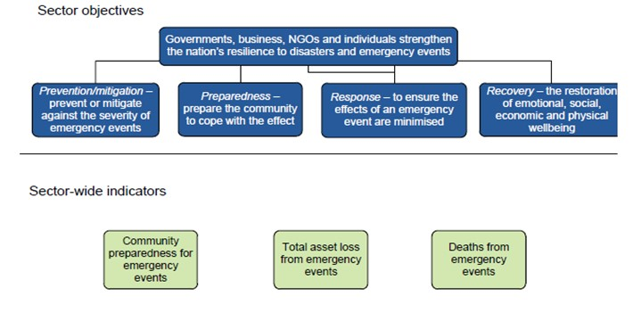

Source: SCRGSP 2017.

Figure Emergency services for fire events performance indicator framework

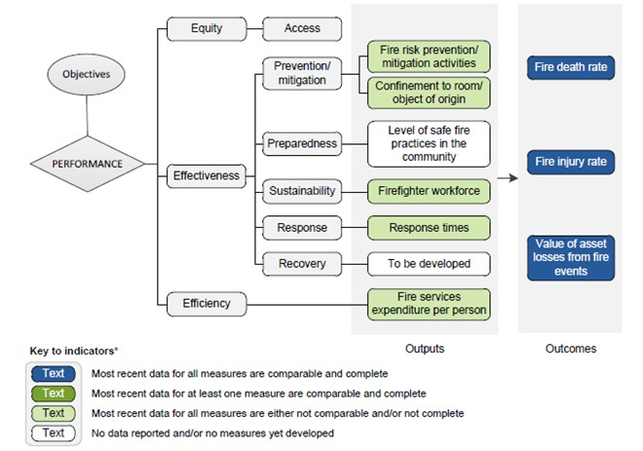

Source: adapted from SCRGSP 2017.

#### Next steps

Development of a biosecurity performance framework and meaningful performance indicators, to support both national decision making and public reporting, will require a commitment of effort and resources from all jurisdictions and key partner organisations. As the review’s discussion paper flagged, this also needs to be a cost-effective activity. Jurisdictions will need to establish, at the outset, the level and duration of resources they are prepared to allocate to this work. The Australian Government Department of Finance’s developing good performance information resource management guide (RMG 131) (Finance 2015) reinforces this point:

Performance reporting must be cost-effective. Elaborate performance measures are not good measures if the process of collecting and analysing data for them takes too much time away from the activities that contribute to delivering intended results …

The IGAB review draft report proposed that the National Biosecurity Committee (NBC) establish a time-limited task group to advance work on a performance framework for the national biosecurity system. However, performance measurement is a discipline in its own right and, in reality, few government biosecurity agencies would possess the breadth, depth of expertise and resources required to significantly advance performance design issues for the national system within the term of the IGAB2.

While the panel is aware that biosecurity may not fit the ‘social service criteria’ used by the Productivity Commission for the annual ROGS, the panel recommends the Productivity Commission, or similar independent body, should be charged with undertaking a separate ROGS-like process for government biosecurity services, drawing upon the ROGS (Emergency Management) performance framework and indicators. Such a process would be able to marshal the necessary performance and biosecurity expertise while providing the level of independence, rigor and ‘cut through’ needed, compared with alternative approaches (for example, an NBC-led process or one-off major consultancy). The first Report on Government Biosecurity Services (ROGBS) should be undertaken in 2018 and subsequent reports every five years.

As the panel has shown (Chapter 8), government biosecurity agencies continue to grapple with a range of funding and investment challenges but are hampered by a lack of reliable and consistent data on core government biosecurity resourcing (overall financial and staffing levels) and a systematic process for determining the appropriate level of resourcing for the national system. These are key issues that a ROGS-like process would be able to address and should be the focus of the inaugural report. Subsequent reports could draw upon the outcomes of CEBRA’s work (Box 16) to establish the value and health of the national system.

The panel would expect the biosecurity performance framework and measures to align with the single categorisation of national biosecurity system activities to be agreed under Recommendation 28 (for example, surveillance, eradication, containment, transition to management), funding and investment, and the interactions of biosecurity with areas including trade, market access and tourism.

A five-yearly ROGBS combined with the outcomes of the CEBRA projects should establish and provide governments with a strong basis for allowing informed judgments to be made about the extent to which the national biosecurity system is achieving its objectives and where adjustments are needed.

Recommendation 38

The Productivity Commission should, commencing in 2018, undertake a comparative Report of Government Biosecurity Services (ROGBS) on a five-yearly basis. The report should draw on the existing framework provided by the Report of Government Services (Emergency Management).

### Informed biosecurity: data availability and management

Ready access to comprehensive and reliable data and information is essential for anticipating, responding to and managing national biosecurity risks, substantiating Australia’s claims about its pest and disease status, and for decision making, policy development, and performance measurement. As the New South Wales Government Department of Primary Industries (sub. DP58) pointed out, all jurisdictions, industries and relevant non-government organisations hold data of relevance to the national biosecurity system. This brings both challenges and opportunities—for example:

Current [data] systems, many of which have manual processes, are non-integrated, inefficient and do not support assessments of risks or change to pest status where circumstances change (Australian Government sub. DP65)

The biosecurity system does not have, or necessarily need, a single holder of expert knowledge or national data repository. However, where there are multiple data and knowledge holders (as is currently the case), there must be agreed sources and common data format of data so that valid comparisons and assessments can be made (for example, Australian Bureau of Agricultural and Resource Economics and Sciences (ABARES) data in the case of agriculture) and IT systems capable of communicating with each other (that is, through interoperable technology platforms).

The NBC, through the National Biosecurity Information Governance Expert Group (NBIGEG), has made noteworthy progress towards improving cooperation between jurisdictions in collecting, collating, analysing, storing and sharing biosecurity information; there have been flow-on effects in improving decision making and operational efficiency. The panel recognises the work already completed in this area, including the development of nationally consistent minimum dataset specifications and standards, where the dominant focus has been emergency responses.

There are also various software and technology platforms in place to manage the collection, collation and analysis of biosecurity data. Recent developments by and across governments and key partners have contributed substantially to collating, integrating and sharing biosecurity information on a more national scale. These include the software platform ‘MAX’ developed by the Victorian Government, the virtual surveillance centre, called AUSPestCheck, developed by Plant Health Australia (PHA), and the FeralScan program developed by the Invasives Animals Cooperative Research Centre (Box 17).

Box 17 Software and technology platforms for biosecurity

MAX

Developed by the Victorian Government, MAX is a software platform for managing, collecting and reporting textual and spatial data. It can be customised for a variety of purposes, including real-time reporting, and in variety of settings (such as field work on mobile devices). For example, MAX was used by Victoria when responding to the 2014 giant pine scale outbreak in Melbourne, where there was no information system in place to manage the resulting biosecurity data at a tree level. A template for foot-and-mouth disease was adapted to manage trees instead of animals and field staff were able to use iPads to gather field surveillance data and report it in real time. MAX is also used by five other jurisdictions for different purposes, covering both routine and emergency biosecurity activities.

Source: Victorian Government sub. DP64.

National Surveillance System for Weeds and Plant Pests: Virtual Coordination Centre

AUSPestCheck output of the spread of Russian wheat aphid in South Australia, Victoria, New South Wales and Tasmania as at 23 January 2017.PHA has developed a sophisticated virtual surveillance centre, called AUSPestCheck, capable of providing and receiving national surveillance information on weeds and plant pests from a wide range of stakeholders. The project was completed in March 2016, and negotiations with funders are underway to enhance the system and to incorporate it into national biosecurity surveillance arrangements. The system uses mobile technology and a secure cloud environment to pull together surveillance data from multiple sources at minimal cost. It then produces a map of where checks for pests have been made and where pests are found or not found. The mapping facility has already been used to track the spread of Russian wheat aphid (*Diuphis noxia*) since its discovery in South Australia in May 2016 (see map insert).

Ultimately, the system will be capable of receiving and integrating data from multiple surveillance systems and delivering integrated surveillance data to those working in weed and pest management in Australia.

Source: AUSPestCheck output of Russian wheat aphid distribution as at 23 January 2017, available at [AUSPestCheck](https://portal.biosecurityportal.org.au/rwa/Documents/Russian%20Wheat%20Aphid%20Distribution%20Map.pdf).

FeralScan program

FeralScan, developed by the Invasive Animals Cooperative Research Centre, is a community website and smartphone app that allows farmers, community groups, local governments, natural resource management groups and the Australian public to map sightings of pest animals and record the problems they are causing in a particular area. It currently contains over 40,000 records of pest animals mapped by landholders and communities across Australia. This information can be used to document pest animal activity, communicate the problem to other people and identify priority areas for management activities.

The program currently hosts community engagement and citizen science programs for feral cats (FeralCatScan), wild dogs (WildDogScan), rabbits (RabbitScan), introduced pest fish (FeralFishScan), foxes (FoxScan), house mice (MouseAlert), feral camels (CamelScan), feral pigs (FeralPigScan), Indian Myna birds (MynaScan), feral goats (FeralGoatScan), European Starlings (StarlingScan) and cane toads (ToadScan). A program for feral deer (DeerScan) is under development.

Source: The Pestsmart [FeralScan](http://www.pestsmart.org.au/feralscan/) website.

In a positive move, the Australian Government agriculture department is developing a Biosecurity Integrated Information System (BIIS) which will provide a more sophisticated and modern technical architecture to enable better data capture, storage, access, sharing and analysis of data to support better and more timely decision making.

While significant progress is being made by the Australian Government, NBC, the National Biosecurity Information Governance Expert Group and others to address data constraints, the Queensland Department of Agriculture and Fisheries highlights the need for sustained commitment and momentum by all IGAB parties:

Queensland’s Biosecurity Capability Review was explicit that rapid technological change and structured research programs offer opportunities to address emerging biosecurity threats more effectively, and in less costly ways. It argues that greater use of data … is central to informing the design of biosecurity policies and programs. With an explicit focus on data, the national biosecurity system is in need of rules and standards to guide collection and analysis. A refreshed IGAB should continue to make provision for coordinated progress towards improved data frameworks (sub. DP48)

The panel strongly agrees with this statement.

The panel recognises the significant potential of the BIIS to inform the biosecurity efforts of all jurisdictions, not just the Australian Government. To that end, it will be important that the system allows for interoperability of information generated by the BIIS with relevant state and territory systems to allow near real-time and seamless data sharing. Equally, though, the states and territories will need to invest in upgrading their technology (where required) if the benefits of national interoperability are to be realised.

While the review’s terms of reference asked the panel to consider the availability of appropriate and consistent data to support development of measurable performance indicators for the national biosecurity system, the panel was unable to examine this issue in detail. However, the need for better and standardised datasets and interoperable data management systems is already a clear area of consensus and strong cooperation among jurisdictions. For NBC this is still very much a work in progress, but that work is on a positive course.

Recommendation 39

Data and knowledge sharing should be a core commitment of jurisdictions under IGAB2. Minimum standards and specifications should be agreed for datasets.

Recommendation 40

Within the period covered by IGAB2, the Australian Government agriculture department should lead the development of a common information architecture for the national biosecurity system (including data-sharing protocols, standards and authority protocols) for all jurisdictions to share and access biosecurity data and information in the national interest.

Finally, outside of government, opportunities likely exist for industry and the community to better contribute their data relevant to biosecurity. The panel was advised of several existing industry datasets which could be better utilised, including for substantiating future area freedom claims. Separately, one stakeholder highlighted the need to better address the availability of data generated through industry-funded research, especially where the findings could have market access impacts. The panel encourages industries to assess their existing and potential datasets and sources and the role they could play in strengthening the national biosecurity system, especially where there may be market access benefits.

### Smarter biosecurity: data analytics and intelligence

As previously noted, Australia takes a risk-based approach to biosecurity guided by Australia’s ALOP, which aims to reduce biosecurity risks to a very low level but not to zero. This stands in contrast to Australia’s historical approach of border intervention targets. In reality, a risk-based approach is the only cost-effective and sustainable way to manage the biosecurity risks posed by current and forecast levels of trade and passenger movements (Australian Government sub. DR115).

Data analytics is one way to help mitigate biosecurity risks. Data analytics is the process of examining data from multiple sources in order to draw conclusions about the information they contain. It provides a capacity to better understand the issues from perspectives that may have not yet been contemplated or are not yet apparent:

[Data analytics] will answer questions about what has happened and why (descriptive analytics), and what might happen in the future (predictive analytics), through the application of modelling and data analysis (Australian Government sub. DP65)

Combining, analysing and visualising information from various datasets—for example, combining geographic spatial data and business information (Szewrański et al. 2016)—has the potential to significantly enhance a range of biosecurity activities, including decision making, preparedness and response (East 2009; Lindgren 2011; Li et al. 2015). A recent example is the work by ABARES (forthcoming) to estimate the potential economic impact of an incursion of Pierce’s disease on Australia’s wine and grape industry (Box 18).

Box 18 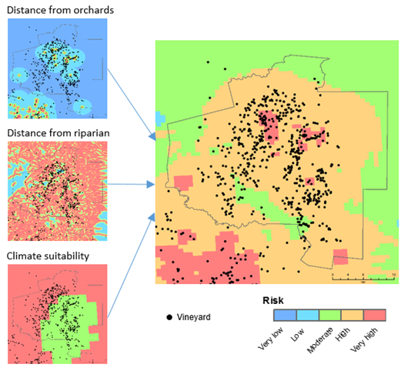Spatial data for biosecurity

Under the Australian Collaborative Land Use Mapping Program (ACLUMP), catchment-scale land use is mapped regularly in Australia using a nationally agreed classification and set of procedures—including the commodity location and extent for some of Australia’s major export industries, such as livestock, horticulture, dairy and cotton.

*Xylella fastidiosa* is a bacterial pathogen affecting a wide range of plants. It is known as Pierce’s disease in grapes. ABARES used land use data to develop a risk map, based on the proximity of vineyards to riparian vegetation, citrus orchards and climate suitability, as an input to help estimate the potential economic impact of an incursion of Pierce’s disease in Australia. This assisted in helping to reduce uncertainties related to the pathogen’s potential economic impact.

Source: ABARES (forthcoming).

However, the current use of advanced data analytics for biosecurity purposes appears to be both underdeveloped and underutilised—an issue the Australian Government has recently sought to address by committing almost $16 million to develop an advanced analytics capability for biosecurity, utilising the information captured by the BIIS. This is expected to improve biosecurity risk profiling and analysis, including invasive pathway modelling; pest and disease detection and prediction; demonstration of proof of area freedom; and the management of biosecurity regulatory compliance. By way of example, creating an ability to identify a pattern of incidents across importers, pest and disease pathways and/or countries of origin can focus assessment and inspection efforts and enable more efficient targeting of non-compliant imports and entities.

Throughout this review, the panel received feedback from government agencies critical of each other for not making data and information sources nationally available or accessible. In particular, consistent comments were made about the need for the Australian Government to share information and intelligence with jurisdictions on, for example, border interceptions.

It is critical that all jurisdictions, which have joint responsibility for the stewardship of the national biosecurity system, are willing and able to share knowledge and data in the national interest. The NBC could draw upon the approach taken by Australia’s national counter-terrorism agencies and its Australia – New Zealand Counter-Terrorism Committee, which have governance structures and data platforms in place to routinely gather, share and present intelligence information to senior government decision makers—including on a trusted basis with state and territory counterparts.

The panel recommends that the Australian Government agriculture department establish a dedicated National Biosecurity Analytics and Intelligence Centre (BAIC) to similarly equip the national biosecurity system leadership (NBC, the Agriculture Senior Officials Committee (AGSOC) and the Agriculture Ministers’ Forum (AGMIN)). To ensure its success, all parties would need to maintain a bipartisan approach to enable the BAIC to share intelligence and data with all jurisdictions on an ongoing, trusted and confidential basis.

The panel understands the Australian Government agriculture department has some existing areas of analytics and intelligence capability but questions the overall capacity of the department to look across all the data collected to identify patterns or anomalies using this devolved approach.

A centralised, advanced analytics and intelligence capability such as the BAIC, led by a senior officer dedicated to the task, is more likely to meet the requirements associated with biosecurity risks that face Australia into the future, including:

* intelligence-led and evidence-based decision making
* maturing Australia’s risk-based approach to biosecurity management
* establishing a national picture of surveillance to detect any changes in Australia’s pest and disease status that may affect imports, exports and onshore production.

Recommendation 41

The Australian Government should establish, within the agriculture department, a dedicated National Biosecurity Analytics and Intelligence Centre, to centralise, coordinate and provide advice to the NBC, AGSOC and AGMIN on biosecurity intelligence covering emerging risks and pathways and international and domestic pest and disease detections.

Strategic investment in enhanced gathering, analysis and sharing of intelligence is likely to be an extremely cost-effective way of identifying potential biosecurity threats. This will enable risk minimisation strategies to be put in place in advance of what is possible at present.

The panel noted that some biosecurity issues (for example, bioterrorism) also have links with national security arrangements.

## A future system; a future IGAB

An overarching theme for the IGAB review was the extent to which the national biosecurity system and its underpinning IGAB, is fit for the future.

### A future system

It is clear that governments and the National Biosecurity Committee (NBC) have made enormous progress over the last four years in developing principles, protocols and collegiate working relationships to operationalise the IGAB. It is also clear that governments are committed to a path of reform and continuous improvement of the national biosecurity system. Similarly, industry continues to adapt and respond to the evolving domestic and international biosecurity landscape, driven in large part by the trade and market access opportunities that beckon. Non-government stakeholders are also looking to play a more active role. There is much more that all parties in the national system need to do, and could do, in a spirit of partnership and collective action.

The panel has made a number of recommendations aimed at strengthening the national biosecurity system in the near term. The panel has consciously pitched its recommendations as achievable next steps to be implemented in the ensuing five- to ten-year period, noting that implementation of the recommendations will require substantial additional effort and is subject to provision or raising of adequate funding.

Additionally, the panel has taken a much longer-term perspective, having devised its recommendations in the context of a longer-term direction—say, ten to twenty years hence—for the national biosecurity system that might exhibit the following features and characteristics:

* a national biosecurity strategy devised, owned and implemented by governments, industry and the community
* community-wide understanding and ownership of biosecurity equal to that of bushfire preparedness and response
* a dedicated national data analytics and intelligence capability supporting decision making by all jurisdictions
* a research and innovation (R&I) model that nurtures world-leading surveillance and early detection technologies
* one emergency preparedness and response agreement for the national priority animal, plant and environmental pests and diseases
* one entity responsible for implementation and administration of the deed, potentially ‘Animal and Plant Health Australia’
* an Australia – New Zealand ‘IGAB’ (an agreement between Australia’s jurisdictions, including local government, and New Zealand)
* regional biosecurity agreements between the Australian Government and its key trading partners
* regular public reporting against key metrics on the state of Australian biosecurity supported by independent evaluation.

The panel has included an implementation pathway with this report (Figure 15) to support timely and effective adoption of recommendations, including through a detailed workplan to be developed by the NBC.

Figure Proposed implementation pathway for the review recommendations and potential features of a future system

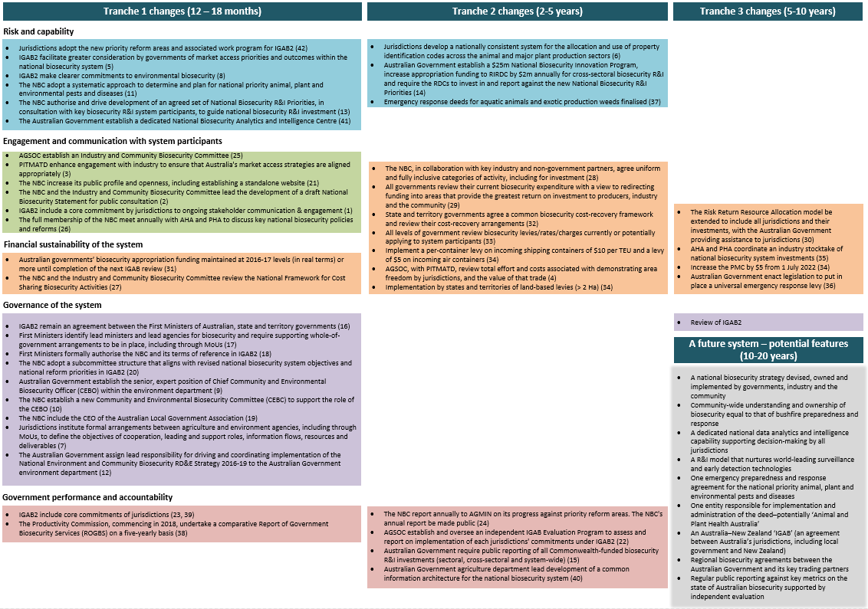

AHA: Animal Health Australia; AGMIN: Agriculture Ministers’ Forum; AGSOC: Agriculture Senior Officials Committee; MoUs: memoranda of understanding; NBC: National Biosecurity Committee; PHA: Plant Health Australia; PITMATD: Primary Industries Technical Market Access and Trade Development Task Group; PMC: Passenger Movement Charge; RDCs: Research and Development Corporations; ROGBS: Report of Government Biosecurity Services; TEU: twenty-foot equivalent units. (xx) indicates recommendation number.

### A future IGAB

The terms of reference for this review sought feedback on the suitability of the agreement to underpin Australia’s biosecurity system into the future. One of the key tests of the suitability of the agreement is whether the parties to that agreement, and parties impacted by that agreement, see its value. All governments provided submissions supporting the role of the IGAB in underpinning the national system, while at the same time identifying key areas for improvement:

The need for an agreement across jurisdictions is critical … Victoria considers that the IGAB needs to be contemporary, legally binding, evidence based and specific (Victorian Government sub. DP64)

The NSW Government is strongly committed to the IGAB … The IGAB has provided government parties with a strong framework for addressing national biosecurity issues. Through cooperation and collaboration with peak industry bodies, there has been much progress in many priory reform areas (New South Wales Government sub. DP58)

The IGAB is acknowledged as an important national initiative and should continue to improve national biosecurity effectiveness, capacity and integrated systems. It is appropriate that it stays at the First Ministers level for signing and flags investment priorities to central agencies (South Australian Government sub. DP56)

The Western Australian agencies involved in biosecurity strongly support the purpose of the IGAB. IGAB and the NEBRA are important tools for establishing a common vision and commitment to biosecurity between jurisdictions for management of pests and diseases (including zoonotics) (Western Australian Government sub. DP59)

Non-government stakeholders were generally supportive of a biosecurity agreement but have been almost uniformly critical of a lack of involvement in its development. The Queensland Department of Agriculture and Fisheries captured this feedback well:

IGAB seeks to build relations with industry and community groups, but did not involve them it its original development. As a result, implementation of the principles and directions of IGAB has suffered from a lack of stakeholder input. Moreover, industries and members of the community have not felt their contributions to the national biosecurity system have been appropriately recognised (sub. DP48)

While noting that the IGAB was intended as a government-to-government document, the panel clearly heard this message and has made a number of recommendations to assist in providing industry and community with a stronger voice in the national biosecurity system.

The panel’s view is clear: a refreshed agreement between Australia’s governments is appropriate and necessary to ensure robust national biosecurity arrangements into the future. IGAB1 was a significant foundation agreement for government cooperation and collaboration. IGAB2 and subsequent agreements should demonstrate a measured and deliberate advancement in the commitments by jurisdictions, reflective of the evolving partnership between governments and increasing sophistication of national biosecurity arrangements.

The 2012 National Healthcare Agreement provides a useful model of what might be achievable for a future mature biosecurity agreement. The agreement sets out the mutually agreed objective, outcomes, performance indicators, performance benchmarks and national minimum datasets that will guide Australian and states and territory governments in the delivery of services across the health sector. It also articulates policy and reform directions and the roles and responsibilities of the respective governments. As a mature agreement, its emphasis is on a robust primary agreement rather than on detailed schedules and work programs.

One of the key areas for simplification of the IGAB concerns its schedules. Governments acknowledge that the schedules proposed an extensive body of work which was not able to be matched by the individual and collective capacity of jurisdictions to implement it. The NBC has since reviewed and reprioritised the schedules in light of this and to reflect changed priorities for the national biosecurity system. This is appropriate, and the NBC should be afforded the flexibility without being overshadowed by an overly prescriptive list of tasks in the IGAB.

Accordingly, this review has proposed three priority reform areas (Table 12) for inclusion in IGAB2. The specific tasks and activities should be developed by the NBC and approved by ministers responsible for biosecurity separately, as part of the NBC work program. The NBC should report annually to ministers. The NBC’s work program under the IGAB and its annual report to ministers should be made publicly available. A periodic independent assessment of the effectiveness of IGAB should be undertaken and made public.

Recommendation 42

Jurisdictions should adopt the proposed new priority reform areas and associated work program for IGAB2 and amend the IGAB in line with proposed revisions.

Table 12 Proposed priority reform areas

| Reform areas | Outcomes | Deliverables |
| --- | --- | --- |
| 1. Governance and strategy | A unified strategic framework for the national biosecurity system  Improved governance of the national system  A consistent approach to biosecurity risk prioritisation and investment across the system (for animal, plant and environmental^ streams) | Agreed roles and responsibilities for all system participants  A National Biosecurity Statement, developed in collaboration with key system participants  Formalised whole-of-government biosecurity arrangements within all jurisdictions, including through memoranda of understanding  Defined core commitments for jurisdictions under the national system  An empowered NBC and revised subcommittee structure, including an Industry and Community Biosecurity Committee, a Chief Community and Environmental Biosecurity Officer, and Community and Environmental Biosecurity Committee  A revised National Framework for Cost Sharing Biosecurity Activities  National biosecurity research and innovation priorities  Agreed uniform and fully inclusive categories of funding activity  A standalone website for the NBC |
| 2. National priority pests and diseases | Identification of national priority pests and diseases (animal, plant, environmental^)  Identification of prevention, emergency preparedness and response requirements and responsibilities  Early detection and accurate, timely diagnosis of national priority pests and diseases  Demonstration of Australia’s pest and disease status for market access  Identification of responsibilities for established pests and diseases | Implementation of a systematic approach for national priority pests and diseases, including environmental  Risk assessments for national priority pests and diseases  Action plans for managing national priority pests and diseases, agreed by all relevant participants, outlining risk mitigation measures, surveillance, diagnostics, response, as well as the relevant participants (including their roles and responsibilities and cost-sharing arrangements)  Alignment of biosecurity surveillance activities with major export market risks and tourism  Emergency response deeds for aquatic animals and exotic production weeds  Greater landowner-led resourcing and management of nationally significant established pests and diseases |
| 3. Knowledge management and system performance | Improved decision making and operational efficiency and effectiveness  Increased capacity to measure and demonstrate the performance of the national biosecurity system  Improved accountability of jurisdictions for commitments under the IGAB  Greater public understanding of the performance of the system | National collaboration on data and intelligence sharing  Agreement to common information architecture for the national system, including data sharing protocols, and data standards  An independent comparative Report of Government Biosecurity Services (ROGBS)  An independent IGAB Evaluation Program of jurisdictional commitments  Nationally consistent system for property identification codes (PICs) |

^ Environmental biosecurity includes risks to social amenity.

As required by the review terms of reference, the panel has examined the structure and content of the 2012 IGAB document. The panel has made a number of comments, findings and recommendations that should be reflected in IGAB2 (Table 13).

Table 13 Proposed IGAB revisions

| Issue/section | Proposed changes |
| --- | --- |
| Structure | Structure needs to reflect a logical flow of issues and group sections concerned with the national system together, and sections concerned with the IGAB together. |
| Language | Language could be simplified, sharper and purposeful. Jurisdictions should look to make clear (versus heavily caveated) commitments in the agreement, reflective of the consensus progressively being reached on issues. |
| Front page of the agreement | Should list all jurisdictions who are signatories to the agreement.  Should state the following revised objective for the agreement: *The objective of this agreement is to strengthen Australia’s biosecurity system through enhanced national collaboration among Australian governments.* |
| 1. Preamble | Should be redrafted to provide a more refined and succinct precis of the national biosecurity system and its challenges. It should include reference to Australia and its external territories. |
| 2. Purpose [and scope] of the agreement | Should reflect the objective of the agreement (see front page above) in 2.1.  Should include a statement on the scope of the agreement, identify the IGAB as a major element of the national biosecurity architecture and acknowledge other major parties (industry and community).  2.2(ii) should focus on key components and refer to diseases transmitted between vertebrate and invertebrate animals and humans rather than zoonotic diseases.  Should include the roles and responsibilities of the Australian, state and territory governments (including for domestic and international market access) within Strengthening the Working Partnership (currently section 7) as the basis for 2.2(iii) remaining. |
| 3. Principles underpinning the National Biosecurity System | Principles should be articulated before goal/objectives.  Should include the principle of ecologically sustainable development. |
| 4. Goals and objectives of the National Biosecurity System | Include the following simplified goal: *The goal of the national biosecurity system is to minimise the impact of pests and diseases on Australia’s economy, environment and the community while facilitating trade and the movement of plants, animals, people and products.*  In old 3.2 add ‘*involving governments, industry and community*’ after frameworks.  In old 3.2(ii) add ‘*to minimise impact*’.  Include the following simplified objective for old 3.2(iii): *ensure that, where appropriate, national significant pests and diseases already in Australia are contained, suppressed or managed by relevant landowners*.  Include the following new objective at 4.2(iv): *enable international and domestic market access and tourism.* |
| 5. System components | Limit 5.1 to a short description of the components of the national biosecurity system, (currently a mix of components, features, principles, activities and outcomes). Include any key principles in 3. above.  Include the following new component in 5.2: *National list of exotic priority pests and diseases (animal, plant and environmental)*. |
| 6. Strengthening System components | Should simply read: *The Parties agree to further develop and continuously improve the national biosecurity system in accordance with the Priority Reform Areas (Schedule 1) within their jurisdiction and in partnership with other Parties, recognising that the rate of progress will be contingent on available resources*. |
| 7. Strengthening the working partnership | 7.2 should read: *The foundation of institutional relationships and arrangements between governments and the agricultural sector is already well developed. This agreement and the Priority Reform Areas (Schedule 1) will build on these and strengthen arrangements with other industries and the broader community*.  7.3–7.5 concerning national appointments are now redundant.  International responsibilities should include Australia’s commitment to the Convention on Biological Diversity.  7.13 should refer to the PITMATD as the vehicle for state/territory consultation.  7.18–7.19 should be removed.  Should insert a section on ‘Core Commitments’, which includes articulation of the following:   * a commitment to meet their obligations under the IGAB, for which they undertake to be accountable * a commitment to support financially, decisions agreed to under animal, plant, and environment emergency response deeds * a commitment to data and knowledge sharing between jurisdictions * a commitment to ongoing stakeholder engagement and communication, with activities scrutinised as part of jurisdictional evaluations under the IGAB. |
| 8. Implementing the agreement | Should succinctly outline governance arrangements and responsibilities for implementation and administration by AGMIN, AGSOC and the NBC.  Should constitute and authorise the NBC and include its terms of reference as a Schedule.  8.1–8.2 should identify ‘lead’ and ‘supporting’ biosecurity ministers and agencies and require formal mechanisms between agencies to define the relationship, roles and responsibilities, information flows, deliverables and resources.  8.3 Should state: *This agreement will commence operation on the date it is signed*.  Should succinctly outline the procedure for including new and amending existing IGAB clauses. |
| 9. (new) Performance and reporting | Should include and authorise the following:  1. Annual reporting to ministers on implementation of the IGAB priority reform areas, to be made public upon ministerial consideration.  2. Establishment of a program of independent evaluations to assess and report on implementation of jurisdictions’ commitments under the IGAB, to be made public following ministerial consideration.  3. A periodic, independent assessment of the effectiveness of IGAB (drawing on 1 and 2 above), to be made public. |
| Schedules | Should include three schedules only:  1. The IGAB Priority Reform Areas.  2. The NBC’s terms of reference.  3. Simplified glossary, inclusive of ‘core commitments’, ‘environmental biosecurity’ and ‘shared responsibility’. |

To demonstrate how these proposed changes could be reflected in IGAB2, the panel has provided a draft agreement, which provides jurisdictions a starting point for discussions and further development. The draft also demonstrates how several of the report’s recommendations would be implemented within IGAB2.

The panel reiterates the need for ongoing continuous improvement and review of the national system and its underpinning agreement. In this light, the panel strongly suggests that governments, together with industry and the community, schedule a significant independent review for around 2022.

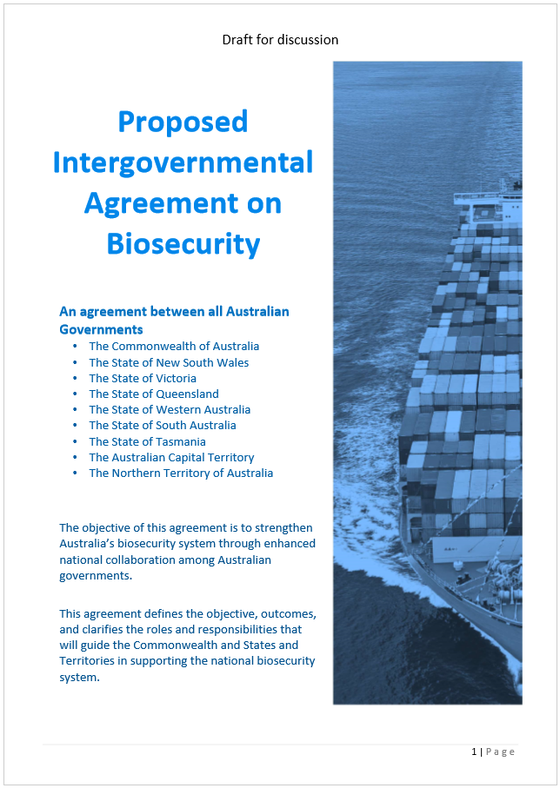 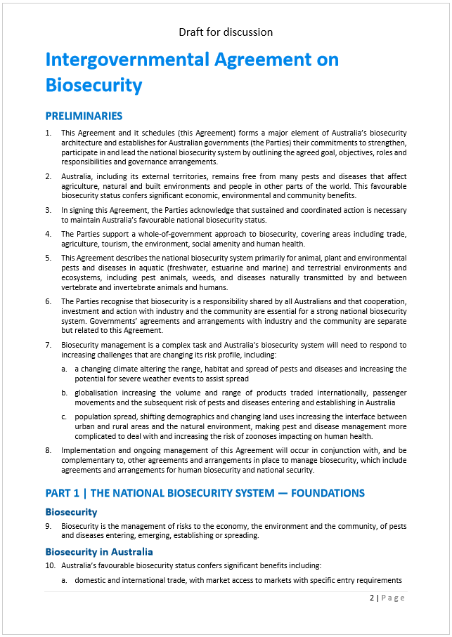 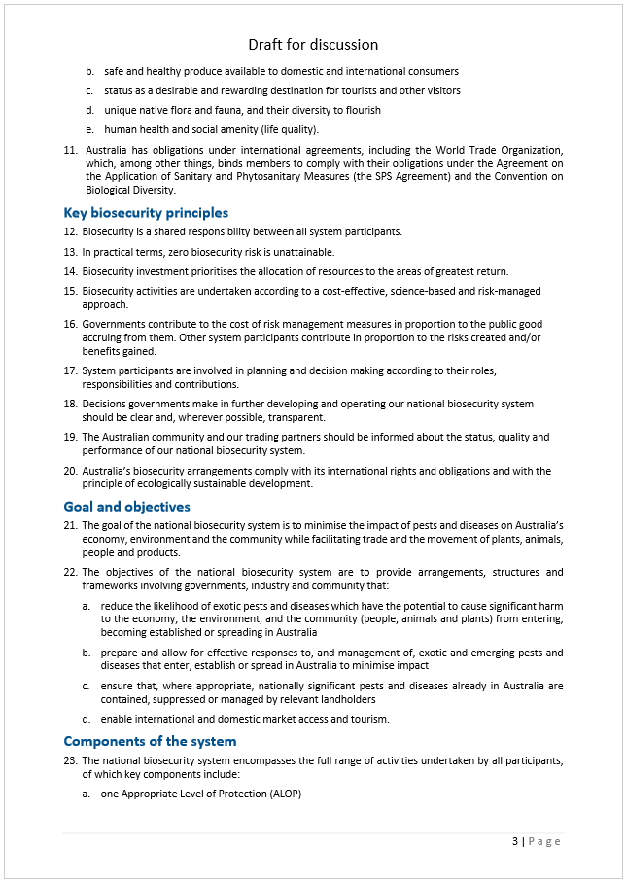 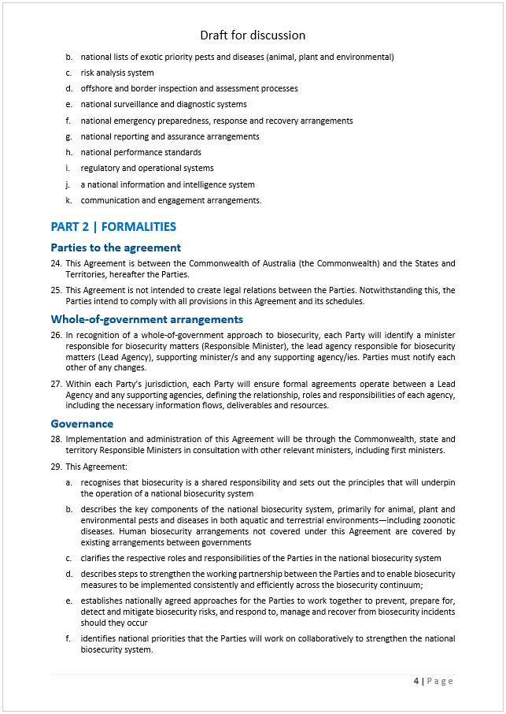 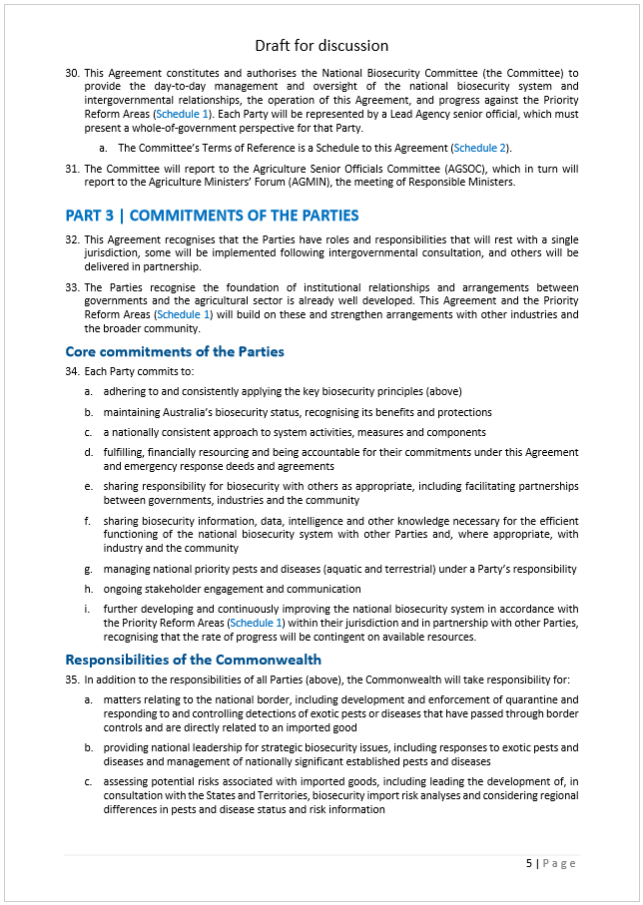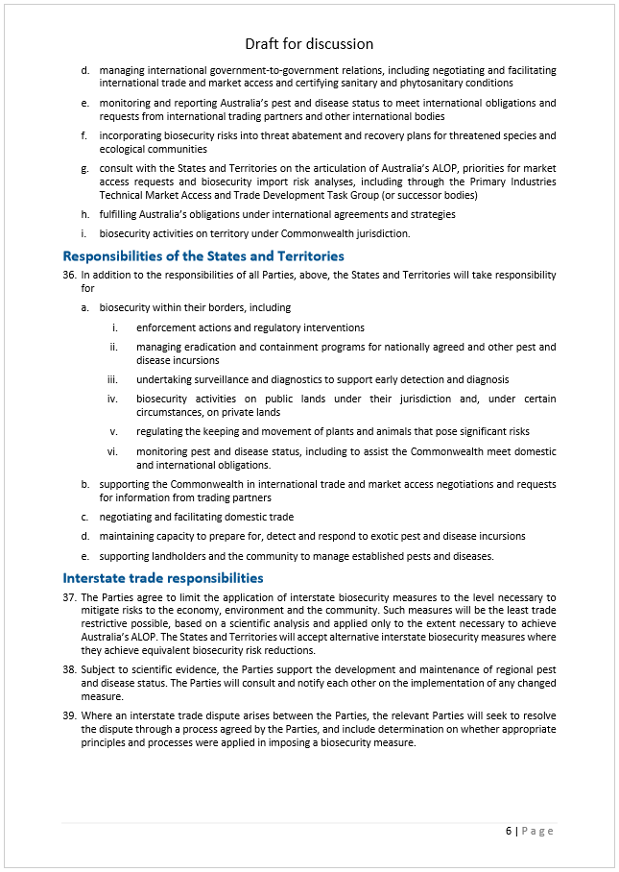 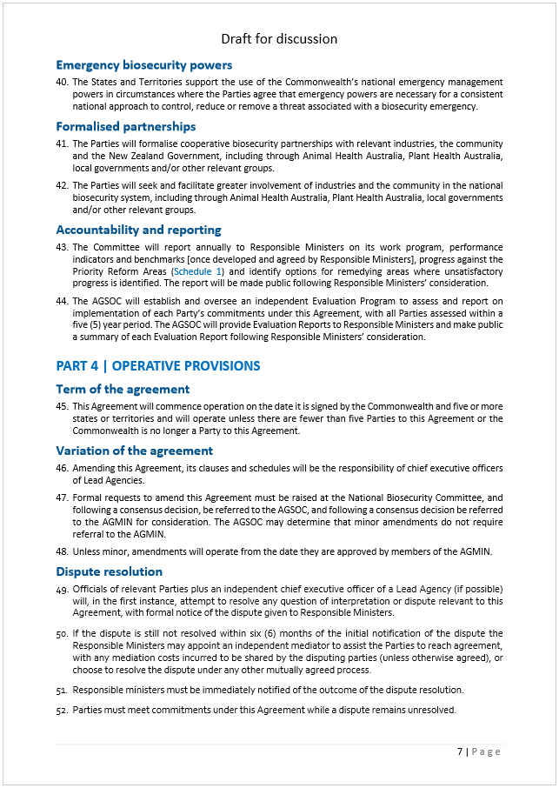 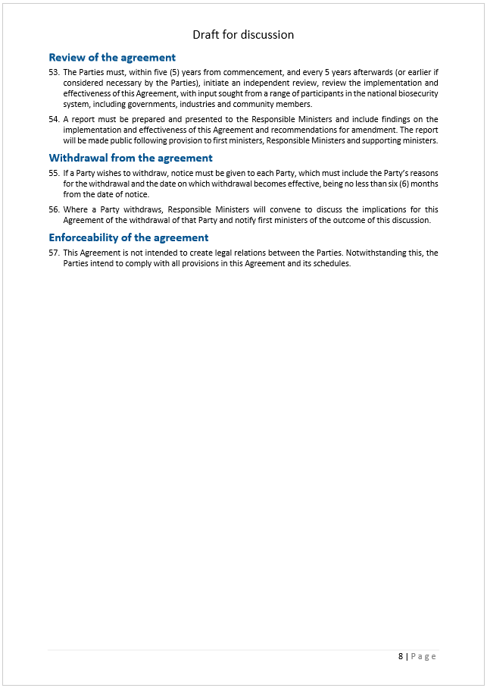 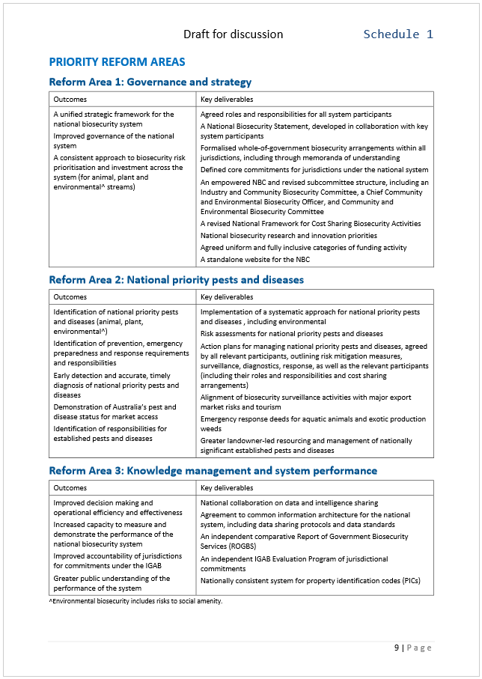 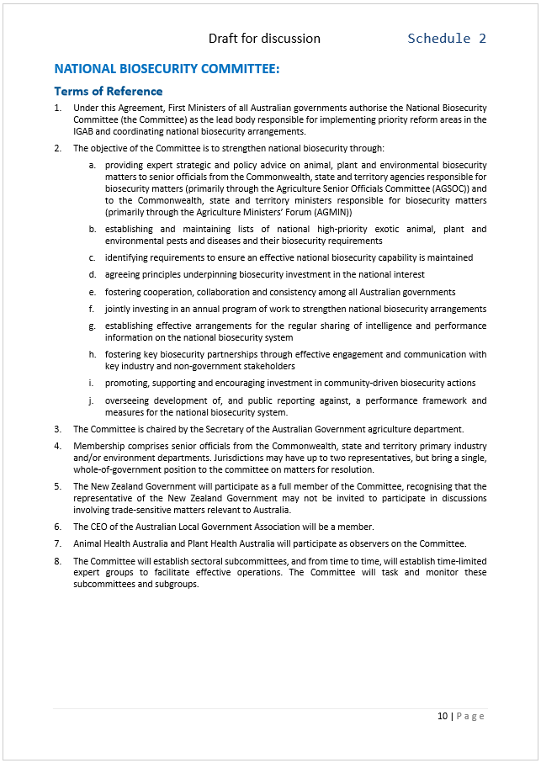 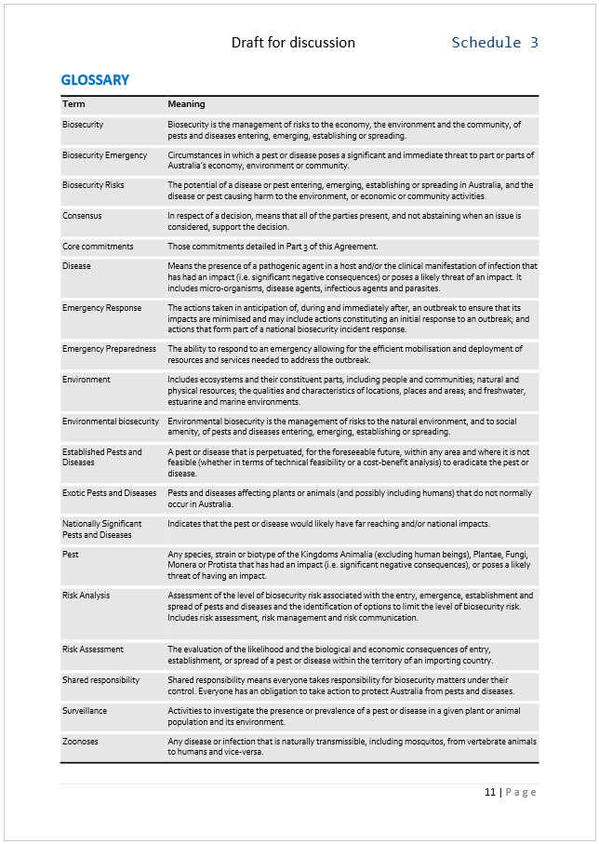 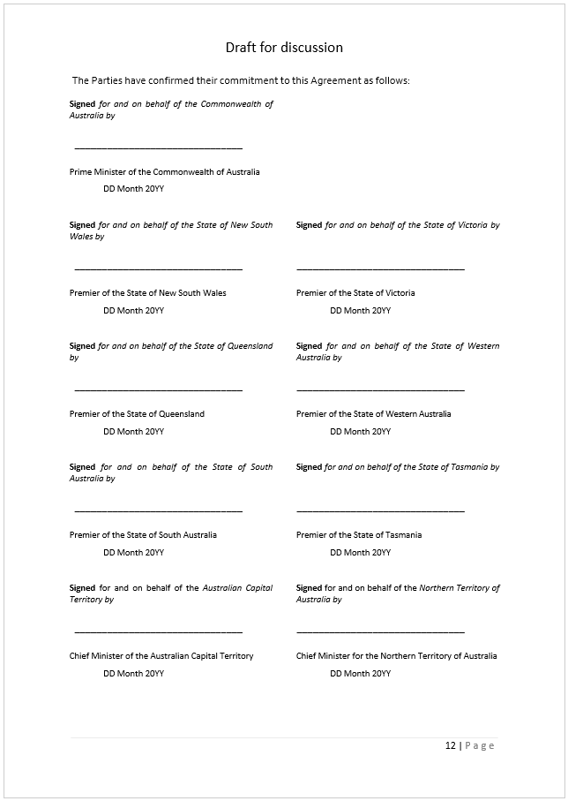

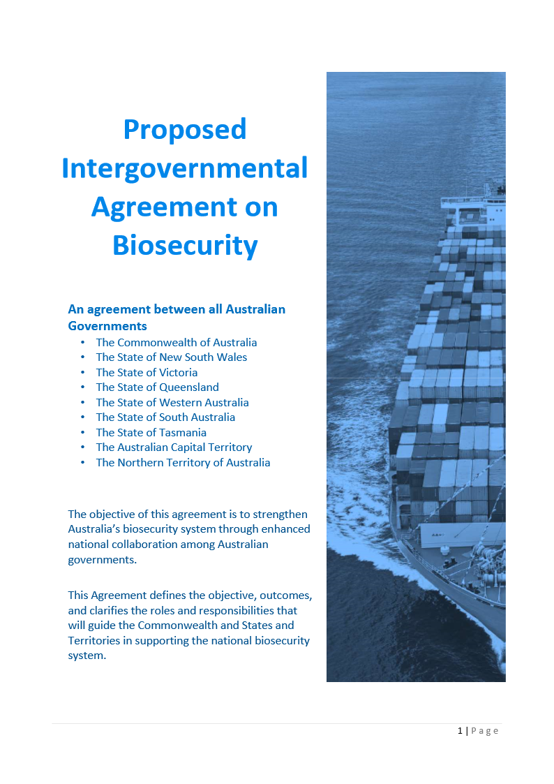

## Appendix A Terms of reference and links to the report

**Purpose of the review**

The review will assess the capacity of the national biosecurity system to manage increased biosecurity risk associated with an increasingly complex global environment; and, identify where adjustments are needed to ensure the system is effective, efficient and flexible and continues to support market access for Australian produce, to minimise primary production costs and to support a healthy economy, environment and community.

The review will also assess the implementation and effectiveness of the IGAB and its schedules, and report to Commonwealth, state and territory ministers responsible for biosecurity matters on findings and recommendations for amendments. The review will recommend if the purpose, goals and objectives, coverage, principles, key components and features of the IGAB are still relevant.

**Scope of the review**

The IGAB review will consider and provide recommendations on the following terms of reference:

1. The implementation and effectiveness of each section of the current agreement, progress against the priority reform areas outlined in schedules 2–8 and any requirements for revision of the schedules.
2. The suitability of the agreement to underpin the national biosecurity system into the future.
3. Current and likely future biosecurity risks and priorities, including the optimal allocation of resources and availability of required capability and capacity to address those risks and priorities, with particular consideration of risks that may impact Australia’s market access arrangements for agricultural products and the use of innovation in the system.
4. The development of a national statement of intent for the biosecurity system, encompassing the entire biosecurity continuum, including economic and market access, environmental and social considerations for governments, industry and the community.
5. Defining roles and responsibilities of all parties in the national biosecurity system. This should include advice on how the concept of a shared biosecurity responsibility can be better understood and implemented across government, industry, environmental and community groups and individuals.
6. The review of existing cost-sharing arrangements and the potential for implementation of new funding arrangements for all biosecurity activities. Consideration should be given to relevant National Biosecurity Committee projects including:
   1. the National Framework for Cost Sharing Biosecurity Activities
   2. the national portfolio investment optimisation model
   3. the national stocktake of biosecurity investment.
7. The development of measurable indicators to assess whether the national system is achieving its objectives, and to identify where adjustments are needed. Consideration should be given to the availability of appropriate and consistent data.

Table A Where this review’s terms of reference are addressed in the report

| Term of reference | Where addressed |
| --- | --- |
| 1. | The 2012 IGAB: 1.4  A future IGAB: 10.2 |
| 2. | Suitability of the IGAB: 10.2 |
| 3. | Future risks: 1.3  Determining priorities: 5.1  Resource allocation: 8.1; 8.4  Market access: 3.1  Innovation: 6.1 |
| 4. | National Biosecurity Statement: 2.4 |
| 5. | Roles and responsibilities: 2.1, 2.4  Shared responsibility: 2.1 |
| 6. | Funding arrangements: 8.5  Relevant NBC projects: 8.2  Sustainable funding opportunities: 8.5 |
| 7. | Performance and reporting: 9.2  Knowledge and data: 9.3, 9.4 |

NBC: National Biosecurity Committee.

As outlined in the IGAB review discussion paper, some aspects of the national biosecurity system were not considered as part of this review, including:

* biosecurity arrangements specific to human health
* biosecurity Import Risk Analyses (BIRAs)
* comprehensive reviews of emergency responses deeds
* response plans, such as the Australian Veterinary Emergency Plan (AUSVETPLAN)
* matters to do with specific biosecurity legislation
* matters to do with Australia’s international obligations relating to biosecurity.

## Appendix B Review panel biographies

**Dr Wendy Craik AM (Chair)**

Dr Craik has more than 25 years’ experience in senior roles in public policy, particularly on issues related to natural resource management. She is currently Chair of the Climate Change Authority, Deputy Chancellor for the University of South Australia (2010–2018), Chair of the New South Wales Marine Estate Management Authority, board member of the Australian Farm Institute and a member of the Advisory Board for the Centre for Strategy and Governance.

She has an extensive record of executive-level appointments in both public and private sectors, most recently as a Commissioner of the Productivity Commission (2009–2014). Prior to this, Dr Craik was CEO of the Murray–Darling Basin Commission (2004–2008) and Executive Director of the National Farmers’ Federation (1995–2000). Other previous roles include President of the National Competition Council, board member for Dairy Australia, Chair of the Australian Rural Leadership Foundation, Chair of the Australian Fisheries Management Authority and Chair of the National Rural Advisory Council.

**Mr David Palmer**

Mr Palmer is currently the Chair of the New South Wales Biosecurity Advisory Committee and the Board of the NSW Rural Assistance Authority. Mr Palmer is also an independent director on the Board of Animal Health Australia, the Invasive Animals CRC and the Greater Sydney Local Land Services.

He is the former Managing Director of Meat & Livestock Australia Limited and spent six years as the Executive Director of the Cattle Council of Australia. Other previous work includes the chairmanship of the Australia–Korea Foundation and employment with the New South Wales Meat Industry Authority, the NSW Farmer’s Association and the Australian Meat & Livestock Corporation.

**Dr Richard Sheldrake AM**

Dr Sheldrake is the Former Director-General of the New South Wales Department of Primary Industries. Prior to this appointment, Dr Sheldrake had been Director-General of the New South Wales Departments of Industry and Investment, Natural Resources and Agriculture. He has led the various departments in service delivery, policy development, compliance and regulation, research and development and technology transfer across a broad range of fields.

Dr Sheldrake has played a role in developing and guiding state and national policy in areas such as carbon offsets, plant and animal biosecurity, agricultural research and development, drought policy, rural and regional service delivery, native forest management, native vegetation, fisheries resource management, efficient water use, sustainable land use and export market development.

He has previously held the offices of Commissioner of the Murray–Darling Basin Commission, New South Wales Commissioner for Soil Conservation and New South Wales Commissioner of Forests. Dr Sheldrake was previously a Director of the Pig Research and Development Corporation and Animal Health Australia Limited and Chair of the Primary Industries Health Committee.

## Appendix C Public consultation

**Consultation process**

Over 65 submissions were received in response to the panel’s discussion paper (DP), released in May 2016. Over 50 submissions were received in response to the panel’s draft report (DR), released in December 2016. Non-confidential submissions can be found at [IGAB review](http://www.agriculture.gov.au/igabreview) on the Australian Government Department of Agriculture and Water Resources website.

Table C Submissions received

| Organisation/individual | Organisation/individual |
| --- | --- |
| Adelaide and Mt Lofty Ranges Natural Resources Management Board DP12 | New South Wales Government Department of Primary Industries DP58, DR113 |
| AgForce Queensland DP20, DR84 | Northern Territory Government D117 |
| Animal Health Australia Limited DP33, DR107 | Nursery and Garden Industry Association Australia Limited DP23, DR99 |
| Association of Biosafety Australia and New Zealand DR79 | Pearl Producers Association DR96 |
| Australian Barramundi Farmers Association DP45 | Plant Biosecurity Cooperative Research Centre DP42, DR103 |
| Australian Capital Territory Government (Environment, Planning and Sustainable Development Directorate) DP46, DR093 | Plant Health Australia Limited DP63, DR106 |
| Australian Forest Products Association DP19 | Ports Australia DP10, DR68 |
| Australian Forest Products Association’s subcommittee on Forest Health and Biosecurity DP26 | Pratley, James DP1 |
| Australian Government (Department of Agriculture and Water Resources; Department of the Environment and Energy) DP65, DR115 | QIMR Berghofer Medical Research Institute DR100 |
| Australian Lot Feeders’ Association DP38, DR76 | Queensland Government Department of Agriculture and Fisheries DP48 |
| Australian Pork Limited DP35, DR116 | Queensland Tourism Industry Council Limited DP57, DR97 |
| Australian Seed Federation Limited DP41 | Quinn, Nelson DP60, DR74 |
| Australian Vignerons DR90 | Ridley, Wayne DP17 |
| Australian Walnut Industry Association Incorporated, Chestnuts Australia Inc., Hazelnut Growers of Australia Inc., and Pistachio Growers’ Association Inc. DP21, DR94 | RSPCA Australia DP15 |
| AUSVEG DR88 | Rural Industries Research and Development Corporation DR86 |
| Blue Ribbon Group DP40 | Sheepmeat Council of Australia and WoolProducers Australia Limited DP29 |
| Biosecurity Council of Western Australia DP52, DR98 | Slowgrove, Gary DP3 |
| Brisbane City Council DR72 | South Australian Government DP56, DR111 |
| Cattle Council of Australia DP25, DR109 | Southern Cross Cargo Proprietary Limited DP5, DR67 |
| Centre of Excellence for Biosecurity Risk Analysis DR80 | Southern Gulf NRM Limited DP8 |
| Cotton Australia DR108 | Strawberry Growers Association of Western Australia Incorporated DP36 |
| Council of Natural Resource Management Presiding Members DR69 | Sydney Airport Limited DP28 |
| Council of Rural Research and Development Corporations DR114 | Tasmanian Government DR112 |
| CSIRO DR92 | Tasmanian Seafood Industry Council DR89 |
| Dairy Australia Limited and Australian Dairy Farmers DP39, DR104 | Teys Australia Proprietary Limited DP49 |
| Dreamtime Wholesale Nursery DP4 | The Australian Veterinary Association Limited DP24 |
| Export Council of Australia DP37 | The Tasmanian Salmonid Growers Association Limited DP43 |
| Fisheries Research Development Corporation DR78 | The Tourism and Transport Forum Australia Limited DP30 |
| Flower Association of Queensland Incorporated DP34 | The University of Sydney DP14 |
| Grains Research and Development Corporation DR101 | The Western Australian Farmers Federation Incorporated DP32 |
| Greatrex, Chris DP7 | Victorian Government (Agriculture Victoria, Department of Economic Development, Jobs, Transport and Resources) DP64, DR118 |
| Green Triangle regional Plantations Committee DR102 | Vinehealth Australia DR91 |
| Hills Orchard Improvement Group Incorporated DP47 | Voice of Horticulture Limited DP11 |
| Horticulture Innovation Australia Ltd DR82 | West Australian Pork Producers’ Association Incorporated DP44 |
| Invasive Animals Cooperative Research Centre DR75 | Western Australian Agricultural Produce Commission Stonefruit Committee DP51 |
| Invasive Species Council Incorporated DP50, DR95 | Western Australian Government DP58 |
| John Daniels DR71 | Western Australian Fishing Industry Council DR77 |
| Local Government Association of Queensland DR73 | Western Australian Local Government Association DP62, DR110 |
| National Aquaculture Council DR87 | Wildlife Health Australia Incorporated DP31, DR81 |
| National Farmers’ Federation Limited DP16, DR85 | Wildlife Preservation Society of Queensland Incorporated DP54 |
| Nature Conservation Society of South Australia Incorporated DP55, DR105 | Wine Tasmania DP13 |
| Northern Territory Farmers Association Incorporated DP9 | Zoo and Aquarium Association DR83 |
|  | *Confidential submissions (10)* |

The panel has consulted a range of stakeholders in the preparation of the report (Table C2):

Table C Stakeholders consulted

| Organisation/individual | Organisation/individual |
| --- | --- |
| AgForce Queensland | PrimeSafe (Victoria) |
| Agility Logistics Pty Ltd | Queensland Dairyfarmers’ Organisation Ltd |
| Animal Health Australia Ltd | Queensland Murray-Darling Committee Inc. |
| Apple and Pear Australia Ltd | Queensland Tourism Industry Council Ltd |
| Australian Chicken Growers Council | Reid Fruits |
| Australian Egg Corporation Ltd | Sheepmeat Council of Australia |
| Australian Farm Institute | Shipping Australia Ltd |
| Australian Federation of International Forwarders Ltd | South Australian Freight Council Inc. |
| Australian Fodder Industry Association Ltd | South Australia Oyster Growers Association Inc. |
| Australian Forest Products Association | South Australia Rock Lobster Advisory Council Inc. |
| Australian Grain Exporters Association | Strawberry Growers Association of Western Australia |
| Australian Horse Industry Council | Sugar Australia Pty Ltd |
| Australian Horticulture Exporters Association Ltd | Tasmanian Seafood Industry Council |
| Australian Local Government Association Ltd | The Australian Veterinary Association Ltd |
| Australian Mango Industry Association Ltd | The Australian Veterinary Association, Western Australian Division |
| Australian Meat Industry Council | The Commercial Egg Producers’ Association of Western Australia Inc. |
| Australian Nurserymen’s Fruit Improvement Company | The Northern Territory Livestock Exporters Association |
| Australian Prawn Farmers Association Inc. | The Tasmanian Salmonid Growers Association Ltd |
| Australian Wool Innovation Ltd | The University of Melbourne, Centre of Excellence for Biosecurity Risk Analysis |
| AUSVEG | The Western Australian Farmers Federation Inc. |
| Avocados Australia Ltd | The Western Australian Fishing Industry Council Inc. |
| Balco Australia Pty Ltd | Vegetables WA |
| Barossa Grape and Wine Association Inc. | Vinehealth Australia |
| Beechworth Honey Pty Ltd | Viterra Pty Ltd |
| Blue Ribbon Group | Weed Society of Queensland Inc. |
| Brisbane City Council | WA Citrus |
| Canegrowers | Western Australia Local Government Association |
| Cattle Council of Australia | Wildcatch Fisheries SA Inc. |
| Charles Sturt University | Wildlife Preservation Society of Queensland Inc. |
| Coles Supermarkets Australia Pty Ltd | Woolworths Ltd |
| Council of RDCs | **Government agencies** |
| Curtin University | *Australian Government* |
| Customs Brokers and Forwarders Council of Australia | Department of Agriculture and Water Resources |
| Dairy Australia Limited and Australian Dairy Farmers | Department of Foreign Affairs and Trade |
| Dairy NSW Ltd | Department of Health |
| Darwin Port | Department of Immigration and Border Protection |
| Export Council of Australia | Department of the Environment and Energy |
| Farm Pride Foods Ltd | Emergency Management Australia |
| Ferguson Australia Pty Ltd. | Inspector General of Biosecurity* |
| Fruit Growers Tasmania Inc. | CSIRO* |
| Fruit West Co-operative Ltd | *New South Wales Government* |
| Grain Growers Limited | Department of Premier and Cabinet |
| Grain Industry Association of Western Australia Inc. | Department of Primary Industries |
| Grains Research and Development Corporation | Office of Environment and Heritage |
| Grains Industry Market Access Forum Ltd | Natural Resources Commission* |
| Growcom Australia | New South Wales Treasury |
| Hills Orchard Improvement Group Inc. | *Victorian Government* |
| HortEx | Department of Economic Development, Jobs, Transport and Resources |
| Humpty Doo Barramundi Pty Ltd | Department of Environment, Land, Water and Planning |
| HVP Plantations | Department of Premier and Cabinet |
| Ingham’s Pty Ltd | Department of Treasury and Finance |
| Invasive Animals Cooperative Research Centre | *Queensland Government* |
| Invasive Species Council (also representing the Nature Conservation Council of NSW) | Department of Agriculture and Fisheries |
| Livestock Biosecurity Network Pty Ltd | Department of the Premier and Cabinet |
| Manbullo Mangoes | Queensland Treasury |
| McCain Foods (Aust.) Pty Ltd | *South Australian Government* |
| McLaren Vale Grape, Wine and Tourism Industry Association Inc. | Department of Environment, Water and Natural Resources |
| Meat and Livestock Australia Ltd | Department of the Premier and Cabinet |
| Murray Goulburn Co-operative Co. Ltd | Department of Primary Industry and Regions |
| National Farmers’ Federation Ltd | Department of Treasury and Finance |
| Natural Resource Management Regions Australia | *Western Australian Government* |
| North Queensland Bulk Ports Corporation Ltd | Department of Agriculture and Food |
| Northern Territory Beekeepers Association Inc. | Department of Environment Regulation |
| Northern Territory Cattlemen’s Association Inc. | Department of Fisheries |
| Northern Territory Farmers Association Inc. | Department of Parks and Wildlife |
| Northern Territory Pastoral Land Board | Department of State Development |
| Nursery and Garden Industry Victoria | Department of the Premier and Cabinet |
| Nursery and Garden Industry Western Australia | Department of Treasury |
| OneFortyOne Plantations Pty Ltd | Forest Products Commission |
| Oysters Tasmania | Biosecurity Council of WA* |
| Parmalat Australia Pty Ltd | *Tasmanian Government* |
| Consolidated Pastoral Company Pty Ltd | Department of Primary Industries, Parks, Water and Environment |
| Pearl Producers Association Inc. | *Northern Territory Government* |
| Plant Biosecurity Cooperative Research Centre | Department of Primary Industry and Fisheries |
| Plant Health Australia Ltd. | Department of Land Resource Management |
| Pork South Australia Inc. | Northern Australia Development Office |
| Ports Australia | *Australian Capital Territory Government* |
| . | Territory and Municipal Services Directorate  (from 1 July 2016, Environment, Planning and Sustainable Development Directorate) |
|  | *New Zealand Government* |
|  | Ministry for Primary Industries |

Notes: *Other government entity.

## Appendix D Risk Return Resource Allocation model

The Risk Return Resource Allocation (RRRA) model was developed to provide advice to the Australian Government agriculture department on the return, in terms of reduced risk, for its investment in controls to manage biosecurity risk and improved confidence that resources are allocated to achieve the greatest risk reduction.

The RRRA model is composed of a collection of interacting sub-models. A model for each entry pathway is used to describe the means by which an organism can enter Australia and the effect of biosecurity controls in modifying entry likelihood. Post-entry models determine the probability that establishment and spread will occur and the consequences for agriculture and other sectors. The model combines the frequency of entry, establishment and spread of each organism with the consequence to determine risk.

The model considers four types of departmental investment in biosecurity controls:

* Policy development, intelligence and communication: including import risk analyses, policy reviews, and intelligence monitoring and stakeholder engagement.
* Pre-border processes: those activities required to meet import conditions prior to arrival in Australia.
* Clearance activities: at-border activities to manage biosecurity risk, including document assessment, inspection, treatment, destruction, export and post-entry quarantine.
* Post-border activities: including surveillance, preparedness and response functions.

In the RRRA model, an organism of biosecurity concern (organism) can represent groups of species, such as ‘broadacre beetles’ or ‘livestock bacteria’. It can also represent special case species that warrant direct consideration, such as foot-and-mouth disease or Khapra beetle. Every organism that could enter or emerge in Australia via one or more pathways and have some probability of establishing, spreading and generating consequences is represented in the model.

All possible consequences are considered within the RRRA model, including for agricultural industries, domesticated and companion animals, environment, infrastructure and produced goods, human health and social impacts.

## Appendix E Biosecurity performance frameworks: national government examples

Table E Australian Government (Department of Agriculture and Water Resources)

|  |  |
| --- | --- |
| Strategic objectives (biosecurity related) | Managing biosecurity and imported food risk  Expanding agricultural, fisheries and forestry exports (Note: certification only elements details below) |
| Outcomes expectations | Use evidence-based risk management to ensure the safe movement into and out of Australia of people, animals, plants, food and cargo  Coordinate emergency responses to exotic pest and disease incursions  Provide certification of exports to meet importing country requirements |
| Performance measures | Targets |
| Australia maintains a favourable pest and disease status (a) | Qualitative assessment that the nature and impact of animal and plant biosecurity incursions has not significantly harmed Australia’s favourable pest and disease status (b)  Pest and disease eradication is funded throughout the year based on national priorities  The Intergovernmental Agreement on Biosecurity is found to be effective in managing the national biosecurity system |
| Export certification meets importing country requirements (a) | Less than 1% of consignments are rejected as a result of export certification failure  No markets are lost as a consequence of failed departmental certification services  Less than 5% of quota allocations are rejected because of quota certification failures |
| The effectiveness and efficiency of biosecurity and food interventions on import pathways improves (c) | The post-intervention compliance rate for passengers and mail is maintained or improved  Interventions on low-risk pathways are reduced (d)  The compliance rate for all food inspected is maintained or improved |
| Responses to biosecurity and imported food incidents improves | The department assesses that responses to biosecurity and imported food incidents have improved |
| Risk assessments for imported goods use science-based risk analysis, drawing on the best available scientific information and advice | 100% of import risk assessments are conducted in accordance with regulations and the best available science and advice |
| The ability of governments, industry and the community to quickly and effectively respond to exotic pest and disease incursions improves | Responses to pest and disease incursions and outbreaks are managed according to relevant frameworks  Requests for rapid response in the event of a significant exotic pest or disease outbreak are responded to immediately  100% of priority emergency plans (AUSVETPLAN, AQUAVETPLAN, EMPPLAN and PLANTPLAN) reflect contemporary science of emergency responses to plant and animal pests and diseases |
| Public awareness of biosecurity risks improves | The number of followers on and the total reach of the Australian Biosecurity Facebook page is maintained or increased |

Notes: a. Performance measure and targets published in the Portfolio Budget Statements 2016–17; b. Assessment based on information including OIE notifications, plant incursions and market access issues directly related to biosecurity; c. Performance measures for post-compliance rates for cargo will be developed; d. For imported plant products only.

Source: DAWR 2016; DAWR 2016e.

Table ENew Zealand Government (Ministry for Primary Industries)

|  |  |
| --- | --- |
| Long-term outcome | Protect from biological risk |
| Intermediate outcomes | The primary sector is protected from biological risks through the effective operation of the biosecurity and food safety systems. |
| Impacts | Protecting New Zealand‘s competitive advantage of a pest-free environment  Better preparing New Zealand to respond to pest and disease incursions  Increasing voluntary and assisted compliance |
| Progress indicators | Market access is maintained and opportunities enhanced, with trading partners having confidence in New Zealand’s biosecurity system  Health of the biosecurity system is improving  Number of response plans completed or reviewed  Completion of exercise testing readiness for an incursion  Adoption of previous recommendations that lead to faster, more effective responses  Compliance rates with biosecurity requirements increasing |
| Appropriation | Service performance measure |
| Biosecurity incursion response and long-term pest management | Number of industry sign-up for Government–Industry Agreement deeds  Percentage of key stakeholders are satisfied with major biosecurity responses |
| Border biosecurity monitoring and clearance | Percentage of international air passengers that comply with biosecurity requirements by the time they leave the airport  Percentage of international mail that complies with biosecurity requirements by the time it leaves the International Mail Centre  Percentage of import clearance processes completed within agreed time frames  Number of identified and mitigated biosecurity risks resulting from targeted evaluations of imported goods  Percentage of costs-recovered external stakeholders rate overall service as 4 out of 5 or higher |
| Border biosecurity systems development and maintenance | Percentage of OIE and IPPC standards that are accepted by New Zealand  Percentage of certificates issued that meet biosecurity technical requirements of importing countries are specified by overseas competent authorities  Percentage of milestones met for the Sanitary and Phytosanitary Standards Market Access Programme, as agreed with key meat, dairy, seafood and horticulture sector stakeholders |
| Domestic biosecurity surveillance | ISO 17025 accreditation maintained for all laboratory processing, testing and reporting  Percentage of incursion investigations reach an outcome decision within specified timeframes  With any suspected high risk or serious pest or disease notification, the investigation commences within 24 hours of notification  No export markets are closed due to the standard of MPI's active surveillance programs  Specifically targeted pests or diseases are detected early enough to enable effective risk management interventions |

IPPC: International Plant Protection Convention; OIE: World Organisation for Animal Health.

Source: NZ MPI 2015; NZ MPI 2016a.

## Appendix F Comparing industry and environmental preparedness

Table F Invasive Species Council (sub. DP50) comparing industry and environmental preparedness (2015)

| Measure | Agricultural biosecurity | Environmental biosecurity |
| --- | --- | --- |
| **Contingency planning** | . | . |
| Institutions | Plant Health Australia  Animal Health Australia  Wildlife Health Australia | Government implements NEBRA  Obligations  Few tangible outputs |
| Funds | $20M over 5 years to PHA, AHA | Minimal |
| Contingency plans | 90 industry plans | 2 tramp ant plans, 1 myrtle rust plan |
| **Risks identified** | . | . |
| Vertebrate pests | 159 mammal, bird, reptile and amphibian species rated extreme threat | . |
| Animal | 65 animal diseases | None identified |
| Plant | 348 priority plant pests | None identified |
| Marine | 23 priority species, 35 on trigger list | . |
| Invasive plants | None | None |
| **Strategies** | . | . |
| Biosecurity strategy | National plant biosecurity strategy  Animal Health Australia strategic plan | No equivalent |
| Diagnostic strategy | National plant biosecurity diagnostic strategy  National animal health data standards | No equivalent |
| Surveillance strategy | National plant biosecurity surveillance strategy  National animal health information standards  National sentinel hive program  National significant disease investigation program | No equivalent |
| RD&E strategy | National plant biosecurity RD&E  National Animal Biosecurity RD&E strategy | Draft national environment and community RD&E strategy |
| **Plans and Protocols** | . | . |
| Biosecurity plans | 17 plant industry biosecurity plans  30 animal disease strategies | No equivalent |
| Diagnostic protocols | 127 national diagnostic protocols | No equivalent (1 for myrtle rust relevant) |
| Biosecurity manuals | 17 industry-specific biosecurity manuals  15 livestock industry manuals | No equivalent |
| Emergency response agreement | 80 plant diseases  65 animal diseases | Response decided on national significance and other criteria |
| **Stakeholders** | . | . |
| Consultative committees | 14 industry-specific committees | No formal structure |
| Incursion responses | Industry stakeholder participation | No community involvement |
| Contingency planning | Industry membership of Plant Health Australia, Animal Health Australia | No community involvement |

Note: the panel has not verified the table elements.

## Glossary

| Term | Meaning |
| --- | --- |
| Appropriate Level of Protection (ALOP) | The level of protection deemed appropriate by a country establishing a sanitary or phytosanitary measure to protect human, animal or plant life or health within its territory (Source: IGAB). The ALOP for Australia is a high level of sanitary and phytosanitary protection aimed at managing and reducing biosecurity risks to a very low level, but not to zero. |
| Biosecurity | The management of risks to the economy, the environment and the broader community, of pests and diseases entering, emerging, establishing or spreading (Source: IGAB). |
| Biosecurity risks | The potential of a disease or pest entering, emerging, establishing or spreading in Australia; and the disease or pest causing harm to the environment, or economic or community activities (Source: IGAB). |
| Disease | The presence of a pathogenic agent in a host and/or the clinical manifestation of infection that has had an impact (that is, significant negative consequences) or poses a likely threat of an impact. It includes microorganisms, disease agents, infectious agents and parasites (Source: IGAB). |
| Established pest or disease | A pest or disease that is perpetuated, for the foreseeable future, within any area and where it is not feasible (economically and/or technically) to eradicate the pest or disease (Source: IGAB). |
| Exotic pest and disease | Pests and diseases affecting plants or animals (potentially human beings) that do not normally occur in a particular country (Source: adapted from the IGAB). |
| Incursion | An isolated population of a pest or disease recently detected in an area, not known to be established but expected to survive for the immediate future (Source: adapted from the International Standards on Phytosanitary Measures 5—Glossary of terms). |
| Intergovernmental Agreement on Biosecurity (IGAB) | An agreement between the Commonwealth and state and territory governments except Tasmania. The agreement aims to strengthen the working partnerships between governments, improve the national biosecurity system and minimise the impact of pests and diseases on Australia’s economy, environment and the community. |
| National biosecurity system | Australia’s biosecurity system encompasses and fully integrates import and export activities, services and functions—into, within, and from Australia—and covers the spectrum of pest and disease threats to Australia’s environment, production and people. |
| Participants | Stakeholders that in some way, and to varying degrees, interact with Australia’s biosecurity system, including individuals, businesses, sectors and industries, other organisations and governments. |
| Pest | Any species, strain or biotype of the Kingdoms Animalia (excluding human beings), Plantae, Fungi, Monera or Protista that has had an impact (that is, a significant negative consequences) or poses a likely threat of having an impact (Source: IGAB). |
| Shared responsibility | A core concept underpinning the national biosecurity system whereby all stakeholders—including Australian governments, industry and the broader community—have important roles and responsibilities in the management of biosecurity risks in Australia. Definition proposed by this review:  Shared responsibility means everyone takes responsibility for biosecurity matters under their control. Everyone has an obligation to take action to protect Australia from pests and diseases. |

## References

ABARES 2013, *Potential social–economic impacts of an outbreak of foot-and-mouth disease in Australia*, Research Report 13.11, Australian Bureau of Agricultural and Resource Economics and Sciences, Canberra.

ABARES 2017, *Agricultural commodities: March quarter* *2017*, Australian Bureau of Agricultural and Resource Economics and Sciences, Canberra.

ABS 2017, *Australian environmental–economics accounts, 2017*, Cat. No. 4655.0, Australian Bureau of Statistics, Canberra.

Antony, G, Scanlan, J, Francis, A, Kloessing, K & Nguyen, Y 2009, *Revised benefits and costs of eradicating the red imported fire ant*, paper presented at 53rd Australian Agricultural and Resource Economics Society conference, Cairns, 10–13 February.

Australian Government 2014, *Joint submission from the Department of Agriculture and Department of the Environment to the Standing Committee on Environment and Communications References Committee inquiry into environmental biosecurity*, August 2014, Canberra.

AWI 2016, *Annual report 2015–16*, Australian Wool Innovation Limited, Sydney.

Beale, R, Fairbrother, J, Inglis, A & Trebeck, D 2008, *One biosecurity: a working partnership. The independent review of Australia’s quarantine and biosecurity arrangements*, Quarantine and Biosecurity review panel report to the Australian Government, Canberra.

BITRE 2014, *Containerised and non-containerised trade through Australian ports to 2032–33*, Research Report 138, Bureau of Infrastructure, Transport and Regional Economics, Department of Infrastructure and Regional Development, Canberra.

Brooks, R, Glanville, R & Kompas, T 2015, *Queensland biosecurity capability review, final report to the Queensland Government*, Brisbane.

Buetre, B, Wicks, S, Kruger, H, Millist, N, Yainshet, A, Garner, G, Duncan, A, Abdalla, A, Trestrail, C, Hatt, M, Thompson, LJ & Symes, M 2013, *Potential socio-economic impacts of an outbreak of foot-and-mouth disease in Australia*, ABARES research report, Canberra.

Callinan, I 2008, *Equine influenza, the August 2007 outbreak in Australia*, Report of the equine influenza inquiry, Canberra.

Chapman, T 2016, ‘*Where there is export opportunity there is always a biosecurity risk … is Australian horticulture ready for both?*’ Farm Policy Journal, vol. 13 (3), Spring 2016, pp. 23–31.

CLIA 2017, *Cruise industry source market report—Ocean Cruise passengers: Australia 2016*, Cruise Lines International Association (Australasia), North Sydney.

COAG 1997, *Heads of agreement on Commonwealth and state roles and responsibilities for the environment*, Council of Australian Governments, Canberra.

COAG 2011, *National Strategy for Disaster Resilience*, Council of Australian Governments, Canberra.

Colmar Brunton 2017, *Biosecurity attitudinal research*, a research report prepared for the New South Wales Department of Primary Industries, Sydney.

Commonwealth of Australia 2015, *Environmental biosecurity*, report of the Environment and Communications References Committee, Parliament House, Canberra.

Commonwealth of Australia 2015a, *Industry structures and systems governing the imposition and disbursement of marketing and research and development (R&D) levies in the agriculture sector*, report of the Rural and Regional Affairs and Transport References Committee, Parliament House, Canberra.

Commonwealth of Australia 2016, *Smart farming—inquiry into agricultural innovation*, report of the House of Representatives Standing Committee on Agriculture and Industry, Parliament House, Canberra.

Cope, R, Ross, J, Wittmann, T, Prowse T & Cassey, P 2016, *Integrative analysis of the physical transport network into Australia,* PLOSONE.

CSIRO 2014, *Australia’s biosecurity future: preparing for future biological challenges*, Commonwealth Scientific and Industrial Research Organisation, Canberra.

CSIRO 2017, *Roadmaps to support technology driven innovation in biosecurity operations*, report to the Australian Government Department of Agriculture and Water Resources, Commonwealth Scientific and Industrial Research Organisation, Canberra.

D’hondt, B, Vanderhoeven, S, Roelandt, S, Mayer, F, Versteirt, V, Adriaens, T, Ducheyne, E, San Martin, G, Grégoire, JC, Stiers, I, Quoilin, S, Cigar, J, Heughebaert, A & Branquart, E 2015, ‘*Harmonia+ and Pandora+: risk screening tools for potentially invasive plants, animals and their pathogens*’, Biological Invasions, vol. 17(6), pp. 1896–1883.

DAWR 2015, *Review of national marine pest biosecurity*, Australian Government Department of Agriculture and Water Resources, Canberra.

DAWR 2015a, *Cost recovery implementation statement biosecurity 2015–16*, Australian Government Department of Agriculture and Water Resources, Canberra.

DAWR 2016, *Annual report 2015–16*, Australian Government Department of Agriculture and Water Resources, Canberra.

DAWR 2016a, *International Strategy 2016–2019*, Australian Government Department of Agriculture and Water Resources, Canberra.

DAWR 2016b, *Agricultural Export Regulation Review—Discussion Paper*, Australian Government Department of Agriculture and Water Resources, Canberra.

DAWR 2016c, *National Environment and Community Biosecurity RD&E Strategy 2016 to 2019*, Department of Agriculture and Water Resources, Canberra.

DAWR 2016d, *Portfolio Budget Statements 2016–17, Budget Related Paper No. 11*, Agriculture and Water Resources Portfolio, Australian Government Department of Agriculture and Water Resources, Canberra.

DAWR 2016e, *Corporate Plan 2016–17*, Australian Government Department of Agriculture and Water Resources, Canberra.

DIBP 2017, *Overseas arrivals and departures for 1 July 2015 to 30 June 2016*, Australian Government Department of Immigration and Border Protection.

DIRD 2014, *Transport security outlook to 2025*, Australian Government Department of Infrastructure and Regional Development, Canberra.

DIRD 2016, Trends—*Transport and Australia’s development to 2040 and beyond*, Australian Government Department of Infrastructure and Regional Development, Canberra.

East, IJ 2009, ‘*The role of land use patterns in limiting the spread of equine influenza in Queensland during the 2007 epidemic’*, Transboundary and Emerging Diseases, 56(8), pp. 292–302.

Finance 2014, Resource management guide No. 304: Australian Government cost recovery guidelines, Australian Government Department of Finance, Canberra.

Finance 2015, Resource management guide No. 131: Developing good performance information, Australian Government Department of Finance, Canberra.

Grafton, Q, Mullen, J & Williams, J 2015, *Australia’s agricultural future: returns, resources, and Risks*, final report for the Australian Council of Learned Academics, Melbourne.

GRDC 2016, *Annual report 2015–16*, Grains Research and Development Corporation, Canberra.

Hajkowicz, S & Eady, S 2015, *Rural industry futures: Megatrends impacting Australian agriculture over the coming twenty years*, report prepared for the Rural Industries Research and Development Corporation, Canberra.

Hallman, G 2017, ‘*Process control in phytosanitary irradiation of fresh fruits and vegetables as a model for other phytosanitary treatment processes*’, Food Control, vol. 72, Part B, pp. 372–377.

Handmer, J & O’Neill, S 2016, ‘*Examining bushfire policy in action: preparedness and behaviour in the 2009 Black Saturday fires’,* Environmental Science and Policy, vol. 63, pp. 55–62.

Hawke, A 2009, *The Australian Environment Act:* *Report of the Independent Review of the Environment Protection and Biodiversity Conservation Act 1999*, final report to the Australian Government, Canberra.

Higgins, V, Bryant, M, Hernández-Jover, M, McShane, C & Rast, L 2016, ‘*Harmonising devolved responsibility for biosecurity governance: The challenge of competing institutional logics’*, Environment and Planning A, vol. 48(6), pp. 1133–1151.

Hunt, W, Birch, C, Vanclay, F & Coutts, J 2014, ‘*Recommendations arising from an analysis of changes to the Australian agricultural research, development and extension system*’, Food Policy, vol. 44, pp. 129–141.

Hutchison, M, Sarac, Z & Norris, A 2012, *The potential for Mozambique tilapia Oreochromis mossambicus to invade the Murray–Darling Basin and the likely impacts: a review of existing information*, report to the Australian Government Murray–Darling Basin Authority, Canberra.

IPART 2013, *Review of funding framework for Local Land Services NSW: Other industries—Draft report*, Independent Pricing and Regulatory Tribunal of New South Wales, Sydney.

Joyce, B 2016, *Red imported fire ant eradication*, media release, Deputy Prime Minister, Minister for Agriculture and Water Resources, Canberra.

Jurdak, R, Elfes, A, Kusy, B, Tews, A, Hu, W, Hernandez, E, Kottege, N & Sikka, P 2015, ‘*Autonomous surveillance for biosecurity*’, Trends in Biotechnology, vol. 33, pp. 201–207.

Keogh, M & Goucher, G 2016, *A sustainable and nationally coordinated plant biosecurity RD&E system for Australia,* research report prepared for the Plant Biosecurity Cooperative Research Centre, Canberra.

Kim, B, Park, C, Moon, Y, Sung, B, Ren, Y, Wylie, S & Lee, B 2016, ‘*Quarantine treatments of imported nursery plants and exported cut flowers by phosphine gas (PH3) as methyl bromide alternative*’, Journal of Economic Entomology, vol.109 (6), pp. 2334–2340.

Li, Z, Yang, C, Jin, B, Yu, M, Liu, K, Sun, M & Zhan, M 2015, ‘*Enabling big geoscience data analytics with a cloud-based MapReduce-enabled and service-oriented workflow framework*’, PLOSONE.

Lindgren, CJ 2011, ‘*Biosecurity policy and the use of geospatial predictive tools to address invasive plants: updating the risk analysis toolbox*’, Risk Analysis, 32(1), pp. 9–15.

LLS 2016, *Annual report 2015–16*, NSW Government Local Land Services 2015–16.

Magee, B, Parkes, J, Adamson, D, Hyne, N, Langford, D, HoltKamp, R & Lawson, S 2016, *Report of the independent review panel,* Independent Review of the National Red Imported Fire Ant Eradication Program, Canberra.

Matthews, K 2011, *A review of Australia’s preparedness for the threat of foot-and-mouth disease*, report to the Australian Government Department of Agriculture, Fisheries and Forestry, Canberra.

McLennan, B & Handmer, J 2014, *Sharing responsibility in Australian disaster management*, final report for the sharing responsibility project prepared for the Bushfire Cooperative Research Centre, Melbourne.

Mercer, R, Hyam, L & McLean, F 2016, *Social attitudes and understanding of biosecurity to support market access and plant health surveillance*, report prepared for the Australian Government Department of Agriculture and Water Resources, Instinct and Reason Pty Ltd, Sydney.

Miles, D 2015, *Growing through innovation and collaboration. A review of the Cooperative Research Centres Programme*, report to the Australian Government, Canberra.

Mohanty, S, Hughes, D & Salathé, M 2016, ‘*Using deep learning for image-based plant disease detection*’, Frontiers in Plant Science, vol. 7, Article 1419.

Mumford, R, Macarthur, R & Boonham, N 2016, ‘*The role and challenges of new diagnostic technology in plant biosecurity*’, Food Security, vol. 8(1), pp.103–109.

Nairn, ME, Allen, PG, Inglis, AR & Tanner, C 1996, *Australian quarantine: A shared responsibility*, Department of Primary Industries and Energy, Canberra.

Nentwig, W, Bacher, S, Pyšek, P, Vilà, M & Kumschick, S 2016, ‘*The generic impact scoring system (GISS): a standardized tool to quantify the impacts of alien species*’, Environmental Monitoring and Assessment, 188(5), Article 315, pp. 1–13.

NRC 2016, *Shared problem, shared solutions: Pest Animal Management Review*, draft report March 2016, NSW Government Natural Resources Commission, Sydney.

NRIR 2016, *2016 National Research Infrastructure Roadmap*, Australian Government, Canberra.

NZ MPI 2015, *Strategic intentions 2015–*2020, New Zealand Government Ministry for Primary Industries, Wellington.

NZ MPI 2016, *Situation and outlook for primary industries 2016*, New Zealand Government Ministry for Primary Industries, Wellington.

NZ MPI 2016a, *Annual report 2015–*2016, New Zealand Government Ministry for Primary Industries, Wellington.

Noble, T, Robson, H, Saunders, R & Jerry, D 2015, *The utility of eDNA as a tilapia surveillance tool*, PestSmart toolkit publication, Invasive Animals Cooperative Research Centre, Canberra.

NPBRDES IC 2016, *Cross sectoral plant biosecurity RDE priorities analysis*, National Plant Biosecurity RD&E Strategy Implementation Committee report.

Paini, D, Sheppard, A, Cook, D, De Barro, P, Worner, S & Thomas, M 2016, ‘*Global threat to agriculture from invasive species*’, Proceedings of the National Academy of Sciences of the United States of America, vol. 113(27), pp. 7575–7579.

PC 2001, *Cost recovery by government agencies*, Report No. 15, Inquiry Report, Productivity Commission, Canberra.

PC 2011, *Rural Research and Development Corporations*, Report No. 52, Final Inquiry Report, Productivity Commission, Canberra.

PC 2014, *Natural disaster funding arrangements*, Report No. 74, Final Inquiry Report, Productivity Commission, Canberra.

PC 2017, *Regulation of Australian agriculture*, Report No. 79, Inquiry Report, Productivity Commission, Canberra.

PC 2017a, *Report on government services*, Annual Report 2017, Productivity Commission, Canberra.

Pheloung, P, Williams, P & Halloy & S 1999, ‘*A weed risk assessment model for use as a Biosecurity tool evaluating plan introductions*’, Journal of Environmental Management, vol. 57, pp. 239–251.

QFES 2016, *The State of Queensland, Queensland Fire and Emergency Services annual report 2015–16*, Queensland Fire and Emergency Services, Brisbane.

RSC 2015, *Analysis of plant pest preparedness capability: a report to the Department of Agriculture and Water Resources*, Rob Schwartz Consulting, October 2015.

Schneider, H, Batho, H, Stemshorn, B & Thiermann, A 2015, *PVS Evaluation Report—Australia, November 2015*, World Organisation for Animal Health, Paris.

SCRGSP 2017, *Report on government services 2017*, vol. D, *Emergency management*, Steering Committee for the Review of Government Service Provision, Productivity Commission, Canberra.

Szewrański, S, Kazak J, Sylla M & Świąder, M 2017, *Spatial data analysis with the use of ArcGIS and Tableau systems*, pp. 337–349. In: Ivan I, Singleton A, Horák, J & Inspektor, T (eds.), The Rise of Big Spatial Data, Lecture Notes in Geoinformation and Cartography, Springer, Switzerland.

Teague, B, McLeod, R & Pascoe, S 2010, *2009 Victorian Bushfires Royal Commission* final report, State of Victoria, Melbourne.

Thomas, J, Wood, T, Gullino, M & Ortu, G 2017, ‘*Diagnostic tools for plant biosecurity*’, Practical Tools for Plant and Food Biosecurity, vol. 8, pp. 209–226.

TRA 2016, *Tourism forecasts 2016,* Australian Government Austrade, Tourism Research Australia, Canberra.

TRA 2016a, *State tourism satellite accounts 2014–15*, Australian Government Austrade, Tourism Research Australia, Canberra.

TRA 2017, *State of the industry 2015–16,* Australian Government Austrade, Tourism Research Australia, Canberra.

UK NAO 2002, *The 2001 outbreak of foot and mouth disease:* R*eport by the Comptroller and Auditor General*, United Kingdom National Audit Office, London.

VAGO 2015, *Biosecurity: Livestock,* Victorian Auditor-General’s Office, Melbourne.

Wylie, R & Janssen-May, S 2016, ‘*Red imported fire ant in Australia: What if we lose the war?*’, Ecological Management and Restoration, October, early view article.

Wylie, R, Jennings, C, McKnaught, M & Harris, E 2016, ‘*Eradication of two incursions of the red imported fire ant in Queensland, Australia*’, Ecological Management & Restoration, vol. 17(1), pp. 22–32.