Post Entry Biosecurity

System

User Guide



© Commonwealth of Australia 2015

Ownership of intellectual property rights

Unless otherwise noted, copyright (and any other intellectual property rights, if any) in this publication is owned by the

Commonwealth of Australia (referred to as the Commonwealth).

Creative Commons licence

All material in this publication is licensed under a Creative Commons Attribution 3.0 Australia Licence, save for content supplied by third parties, logos and the Commonwealth Coat of Arms.



Creative Commons Attribution 3.0 Australia Licence is a standard form licence agreement that allows you to copy, distribute, transmit and adapt this publication provided you attribute the work. A summary of the licence terms is available from [creativecommons.org/licenses/by/3.0/au/deed.en](http://creativecommons.org/licenses/by/3.0/au/deed.en). The full licence terms are available from [creativecommons.org/licenses/by/3.0/au/legalcode.](http://creativecommons.org/licenses/by/3.0/au/legalcode)

Inquiries about the licence and any use of this document should be sent to [copyright@agriculture.gov.au.](mailto:copyright@agriculture.gov.au.)

This publication (and any material sourced from it) should be attributed as: Department of Agriculture 2013, *Our food future: trends and opportunities*. CC BY 3.0

Cataloguing data

Brown, A, De Costa, C & Guo, F 2013, *Our food future: trends and opportunities*, Department of Agriculture, Canberra, November.

ISBN XXX-X-XXXXX-XXX-X (printed) ISBN XXX-X-XXXXX-XXX-X (online)

This publication is available at [agriculture.gov.au/publications.](http://daff.gov.au/publications)

Department of Agriculture and Water Resources

Postal address GPO Box 858 Canberra ACT 2601

Switchboard +61 2 6272 2000

Facsimile +61 2 6272 2001

Web [agriculture.gov.au](http://daff.gov.au/)

The Australian Government acting through the Department of Agriculture and Water Resources has exercised due care and skill in preparing and compiling the information and data in this publication. Notwithstanding, the Department of Agriculture and Water Resources, its employees and advisers disclaim all liability, including liability for negligence and for any loss, damage, injury, expense or cost incurred by any person as a result of accessing, using or relying upon any of the information or data in this publication to the maximum extent permitted by law.

Acknowledgements

The authors thank interview and survey participants for their input. Thanks also to Harold Inglewood and Jerzy Kaminski for their support during the project and in preparing this report.

Table of Contents

Post Entry Biosecurity System user guide 5

PEBS overview 5

Initiating a booking into PEQ facility 5

What information do I need prior to initiating a booking into the PEQ facility? 5

When can I initiate a booking into PEQ facility for my plant? 5

How do I initiate a booking online for plants? 6

PEBS Main Screen 6

Creating a reservation using PEBS 7

Client Details Screen 7

Commodity Type: Plant 8

Authorising 3rd party to provide service 9

Edit, delete or adding additional authorisation 10

Notification 11

Edit, delete or adding additional notification 12

Declaration 13

Pay for your initial booking 13

Success Screen 15

Confirming a booking into PEQ facility 16

Confirming your booking 16

When am I expected to confirm my booking? 16

What information do I need prior to confirming a booking? 16

Main screen 16

Confirming a reservation 17

Uploading documentation 17

Transport Details 18

Declaration 18

Pay for confirming your booking 19

Success Screen 21

Modifying your booking 22

Main Screen 22

Uploading Documents 23

Authorisation 23

Transport 24

Declaration 24

Success Screen 25

Checking the status of your reservation 25

How do I enquire about my reservation? 26

Cancelling a reservation 26

Summary Screen 27

Declaration 28

Success Screen 28

Booking a release appointment 29

Support 34

# Post Entry Biosecurity System user guide

The Post Entry Biosecurity System (PEBS) enables you to reserve a space for seven different Post Entry Quarantine (PEQ) commodity in the new Quarantine facility at Mickleham Victoria. The commodity that you can reserve into the Quarantine facility at Mickleham Victoria includes:

1. Cat and/or Dog
2. Plants

There are two stages required in the reservation process. The first stage is initiating a new reservation. This stage allows you to provide:

* Your personal details (or the owner of the commodity if you are an agent acting on behalf of them)
* Commodity details
* Anticipated commodity arrival date in Australia
* Option to nominate a 3rd party vendor to provide services on your commodity during its stay at the PEQ facility as outlined inthe *Biosecurity Act 2015.*
* Option to nominate a 3rd party to receive system notifications
* Pay fees for assessing your application.

Once the Department receives your application, it will be assessed if it meets Quarantine criteria, and if PEQ facility can hold your commodity for the defined quarantine period as outlined in the *Biosecurity Act 2015*, you will receive an email notification from the Department to proceed to the next stage.

The second stage is to confirm your reservation. This stage allows you to provide:

* Additional and supporting information about your reservation
* Flight details into Melbourne airport
* Pay upfront fees for services provided during quarantine period

Based on the commodity you are importing, you will require an import permit prior to initiating a booking in the PEBS system. The table below outlines commodity type and if a permit is required:

There are no restricted timelines on when to initiate a booking to the PEQ Quarantine facility, provided that you have all information required to conclude the initiate a booking stage.

You are expected to confirm your reservation online seven days prior to your commodity declared arrival date in Australia at the initiate a booking stage. Your reservation will be canceled if it is not confirmed seven days from anticipated arrival in Australia.

## PEBS overview

### Initiating a booking into PEQ facility

This step allows you to notify the Department of your intention to reserve a space for your commodity in the PEQ facility at Mickleham Victoria.

The following sections takes you through the information you will need prior to initiating a booking process, timeline to initiate a booking, and a step-by-step guide for the online screens.

### What information do I need prior to initiating a booking into the PEQ facility?

This section outlines information and steps required prior to initiating an online booking into the PEQ facility.

### When can I initiate a booking into PEQ facility for my plant?

You should initiate a booking after you have obtained an [import permit](http://www.agriculture.gov.au/import/online-services/bicon) and prior to the expiry of the permit. You are also advised to initiate a booking at least seven days prior to your commodity arrival date in Australia.

### How do I initiate a booking online for plants?

This section provides step-by-step explanation on how to initiate a booking into the PEQ facility online. At the end of this step you will be issued with a PEQ Reference Number (PRN). This number is a unique 14 digit number that identifies your reservation. This number will be active throughout the life-cycle of managing your commodity till its release from quarantine.

## PEBS Main Screen

The main entry point to the Post Entry Biosecurity System (PEBS) system allows you to perform five main actions:

1. Initiate a booking (New reservation)
2. Confirm a booking (Confirm Reservation)
3. Change a reservation
4. Cancel a reservation
5. Book a Release appointment

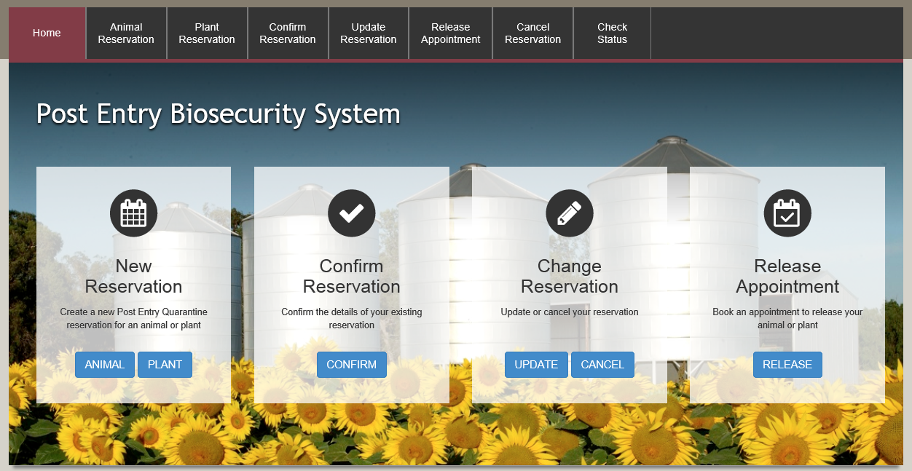

To initiate a booking; from the home page select ‘PLANT’ button under the ‘New Reservation’ box.

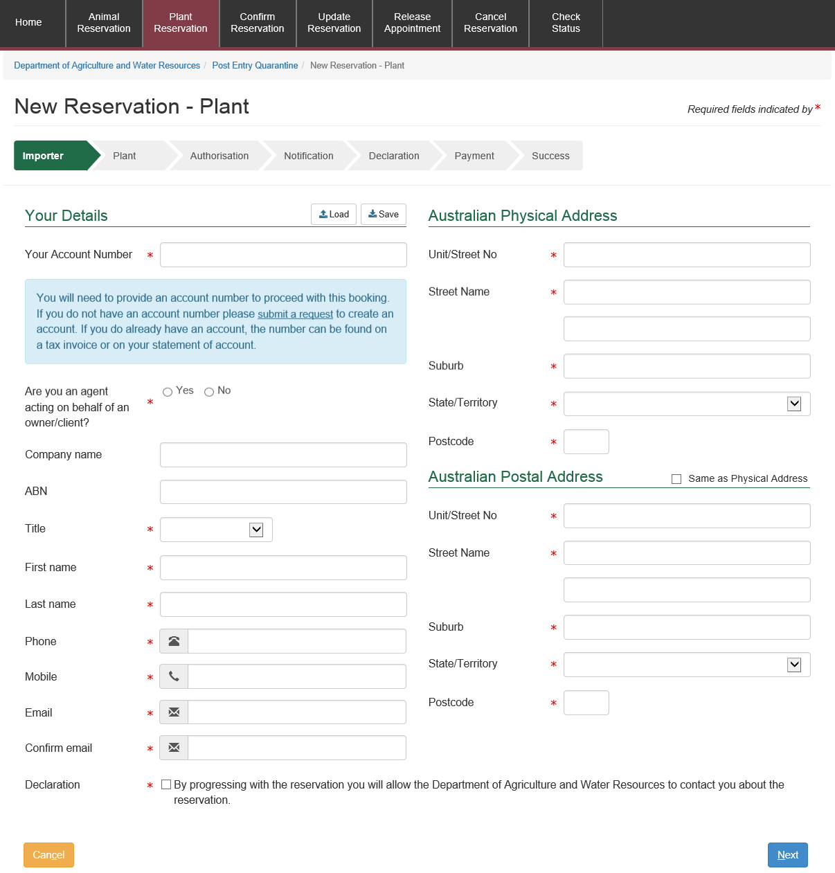

## Creating a reservation using PEBS

### Client Details Screen

The new reservation screen allows you to enter your personal details if you are the owner of the commodity or the agent details if you are an agent acting on behalf of the owner.

This screen allows you to enter your personal details.

* denotes a mandatory field.

The table below outlines expected value for each field appearing on the screen.

#### Saving client details into your browser cache

After filling the client details, you can click on the save button at the top of the main view.

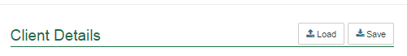

This will save details entered in the view into your browsers cache. Please ensure that you have enabled caching on your browser.

### Commodity Type: Plant

This view allows you to enter multiple Plant Details.

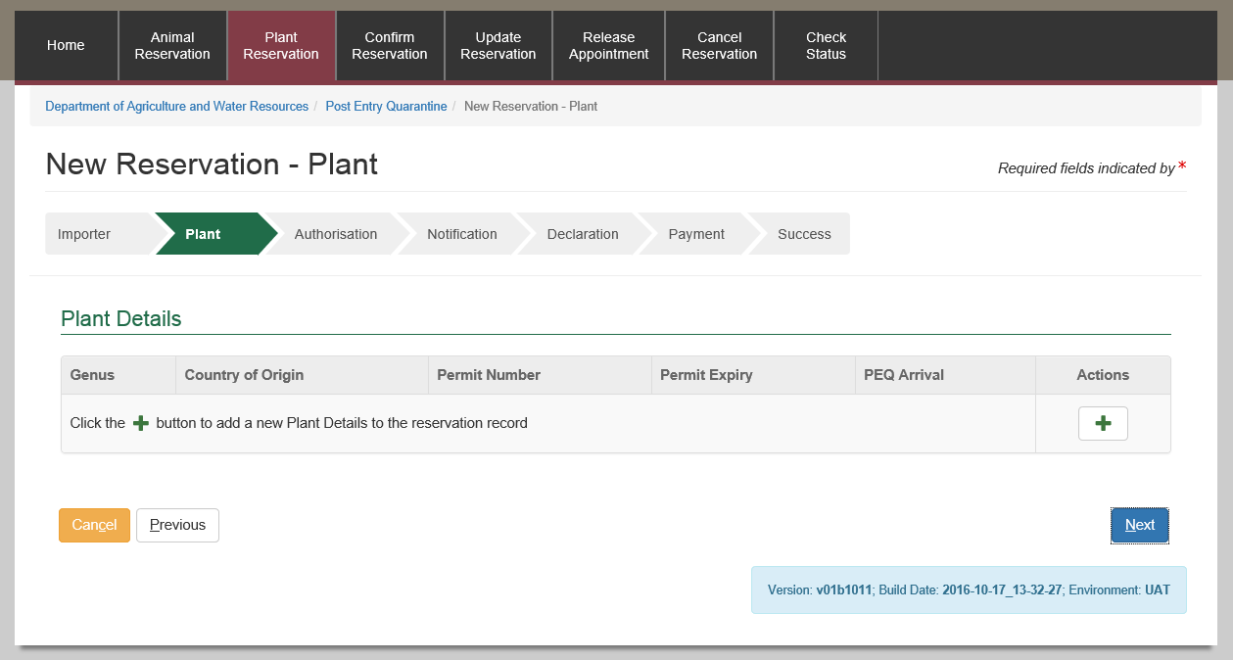

Select the Screenshot of plus button button under Actions to start entering your plant details. The view below will popup.

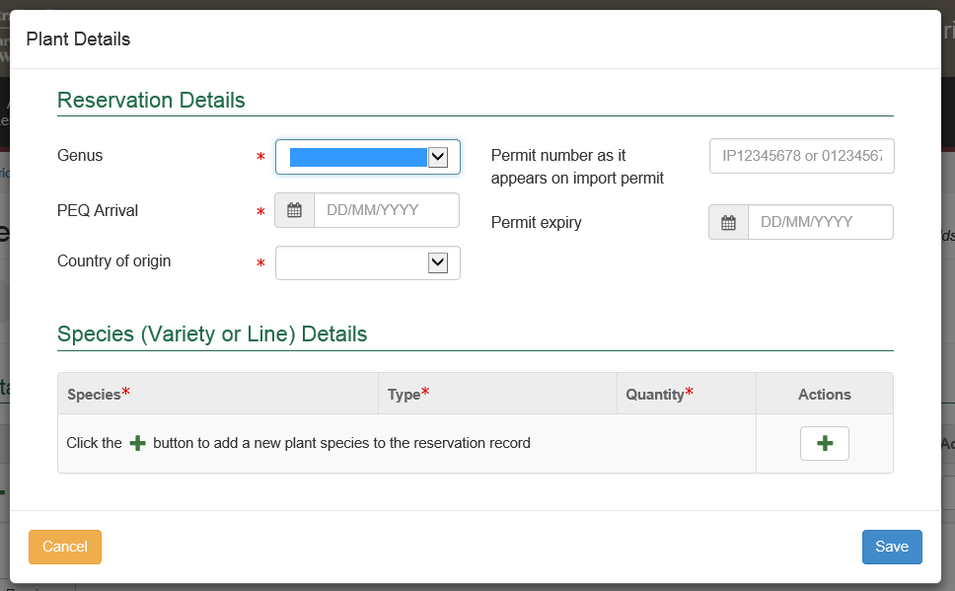

Complete the details.

Enter the Species (Variety or Line) Details

Select the Screenshot of plus button button under Actions to add the species information for your consignment.

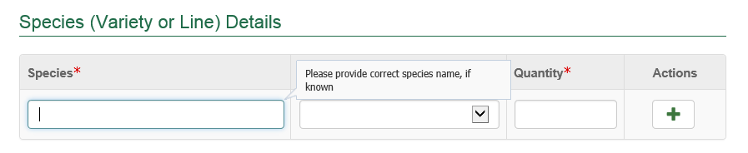

### Authorising 3rd party to provide service

This section allows you to provide information of either company or personnel who will be providing services to the commodity while at the PEQ Quarantine facility.

This step is **optional** so you can click ‘Next’ without providing any details.

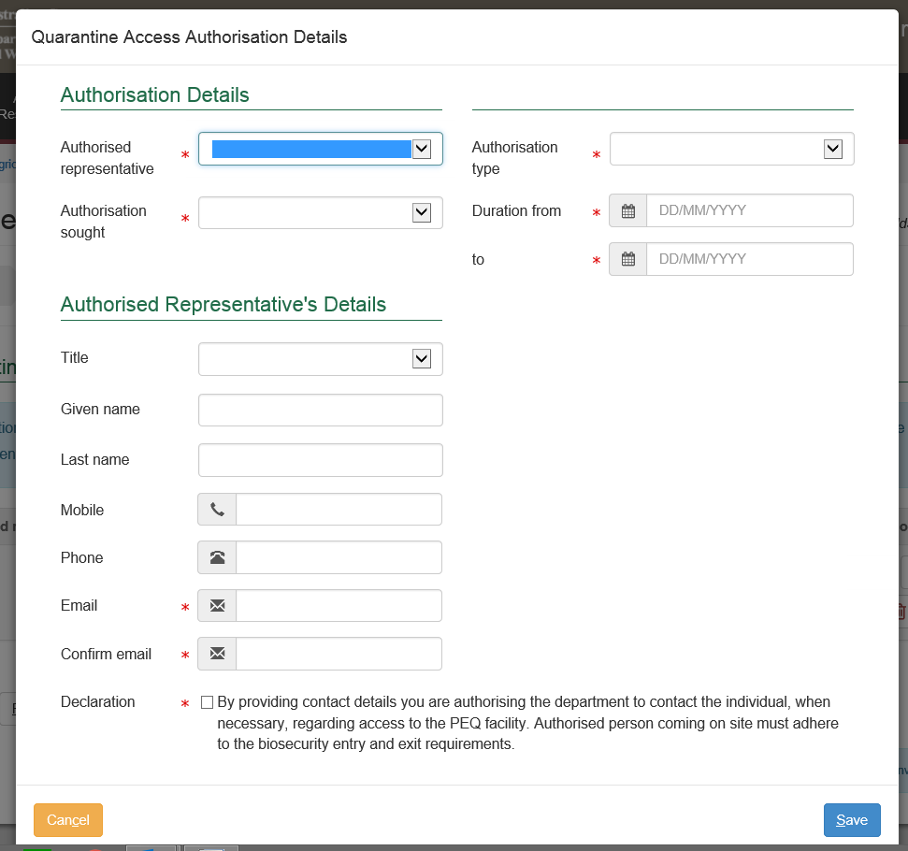

Based on the ‘Authorisation Type’ the details required will vary. The screen below is for company authorisation type.

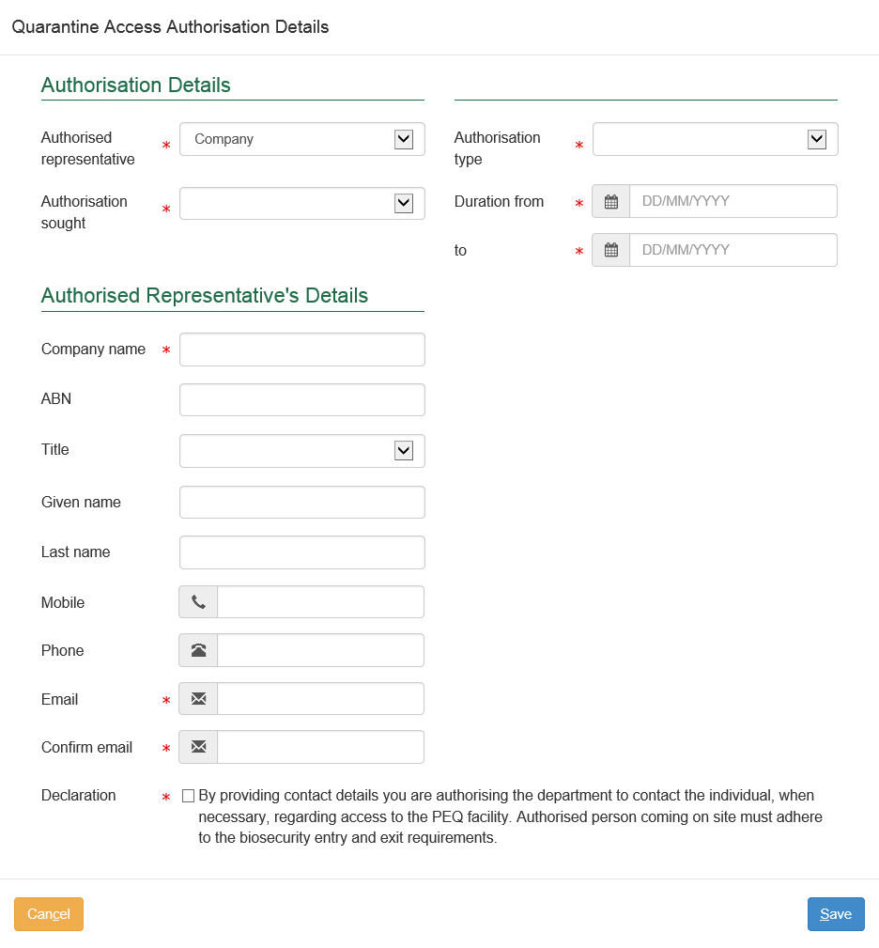

The below screen is for individual authorisation type:

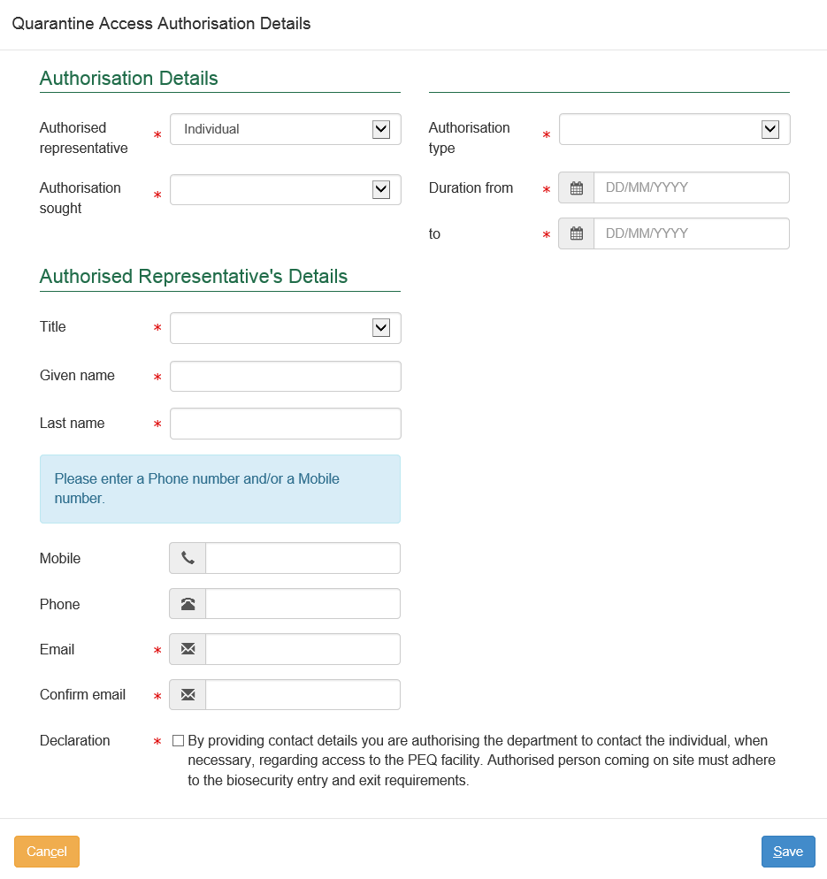

### Edit, delete or adding additional authorisation

Once you complete filling in the authorisation details, they will appear on the view as per below.

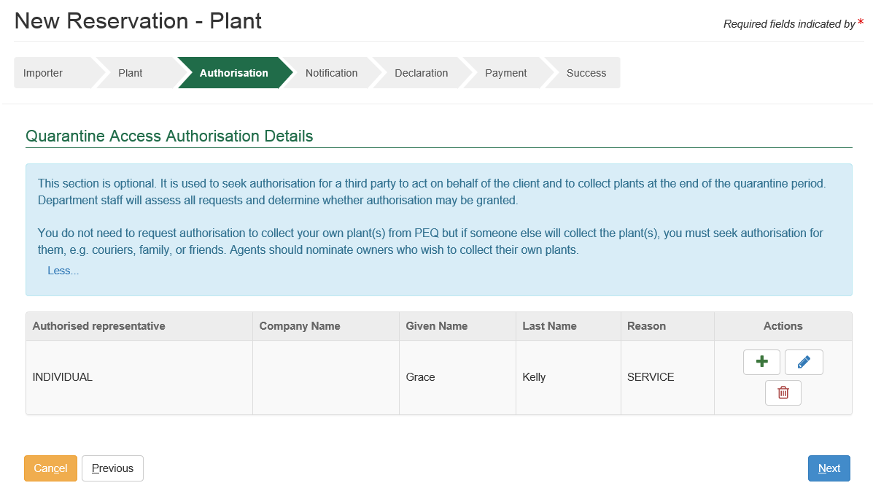

You can edit authorisation details by selecting the Screenshot of edit button; a blue pencil icon button.

You can remove the authorisation details by selecting the Screenshot of the delete buttion; a red garbage bin icon button.

You can add another authorisation detail by selecting the Screenshot of plus button button.

### Notification

This section allows you to nominate other parties to receive notification about this reservation. The system generates automatic notifications at various stages of the reservation life-cycle.

This step is **optional** so you can click ‘Next’ without providing any details.

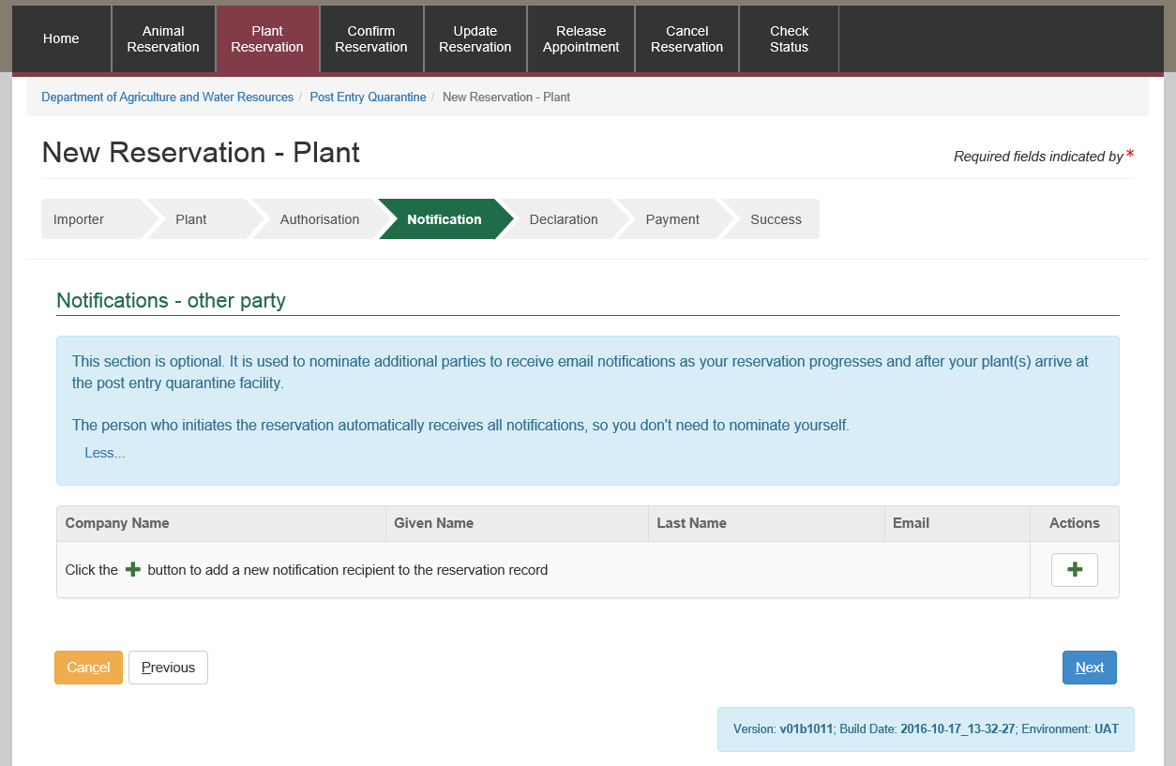

Select the Screenshot of plus button button under Actions to start entering the notification details. The below view will display.

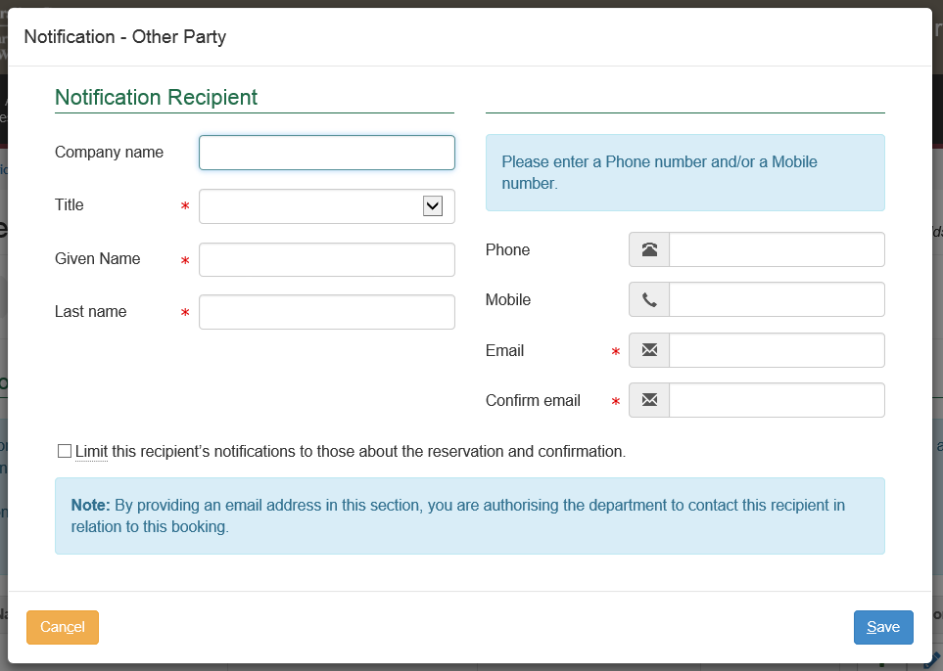

### Edit, delete or adding additional notification

Once you complete filling in the notification details, they will appear on the view.

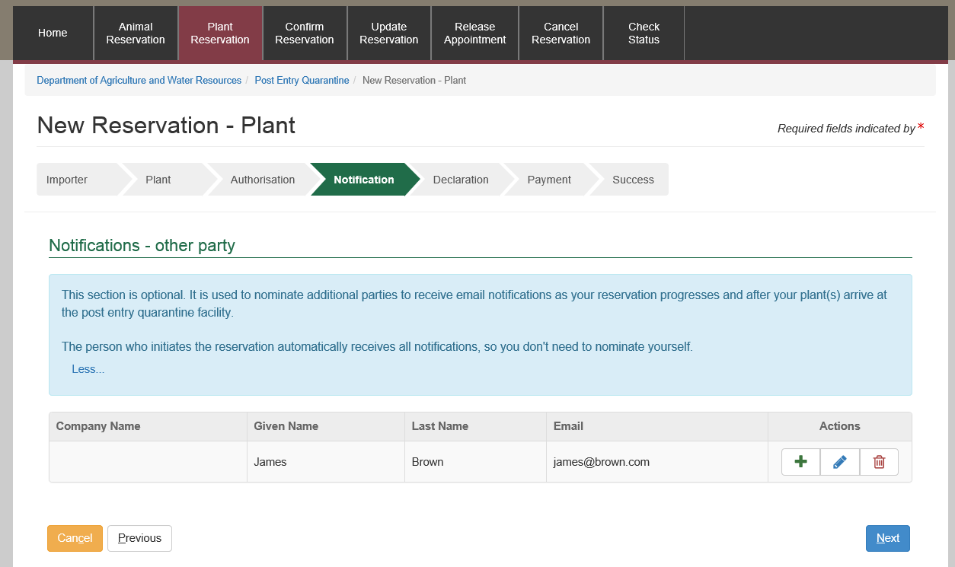

You can edit notification details by selecting the Screenshot of edit button; a blue pencil icon button.

You can remove the notification details by selecting the Screenshot of the delete buttion; a red garbage bin icon button.

You can add another notification detail by selecting the Screenshot of plus button button.

### Declaration

The last step of the initiate booking information is to provide additional information related to the reservation, if required.

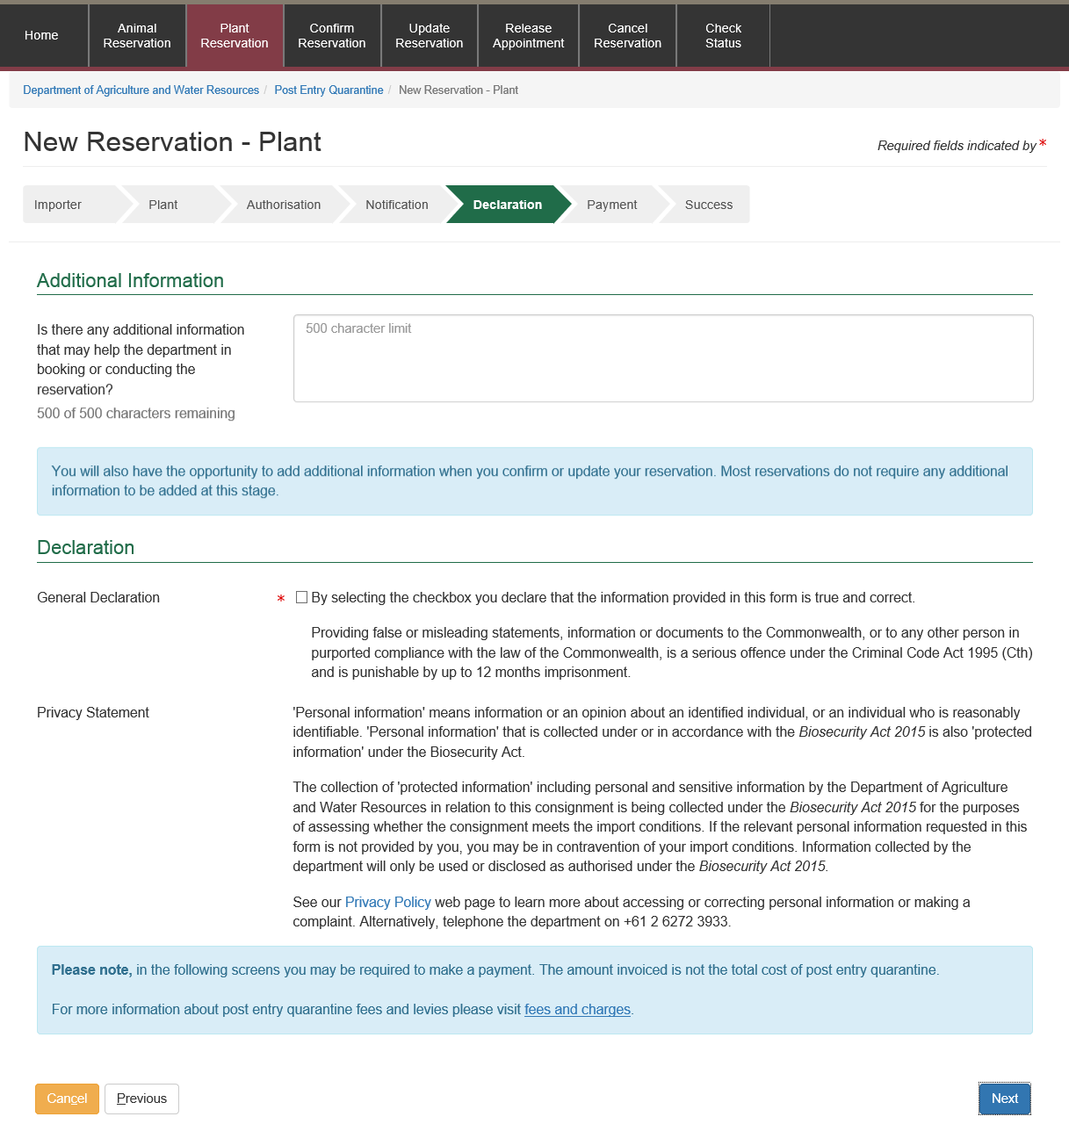

### Pay for your initial booking

You will be expected to make an initial booking payment. The system will present you with a payment summary screen. The payment summary contains:

1. *Service Reference Number:* This number identifies the services that charges are being paid for.
2. *Description of your commodity*: This section includes your commodity type, what pathway is applicable to your commodity, how many of your commodity types you are bringing to Australia and any additional comments.
3. *Service Description*: This section outlines services to be performed on your booking and outlines pricing.

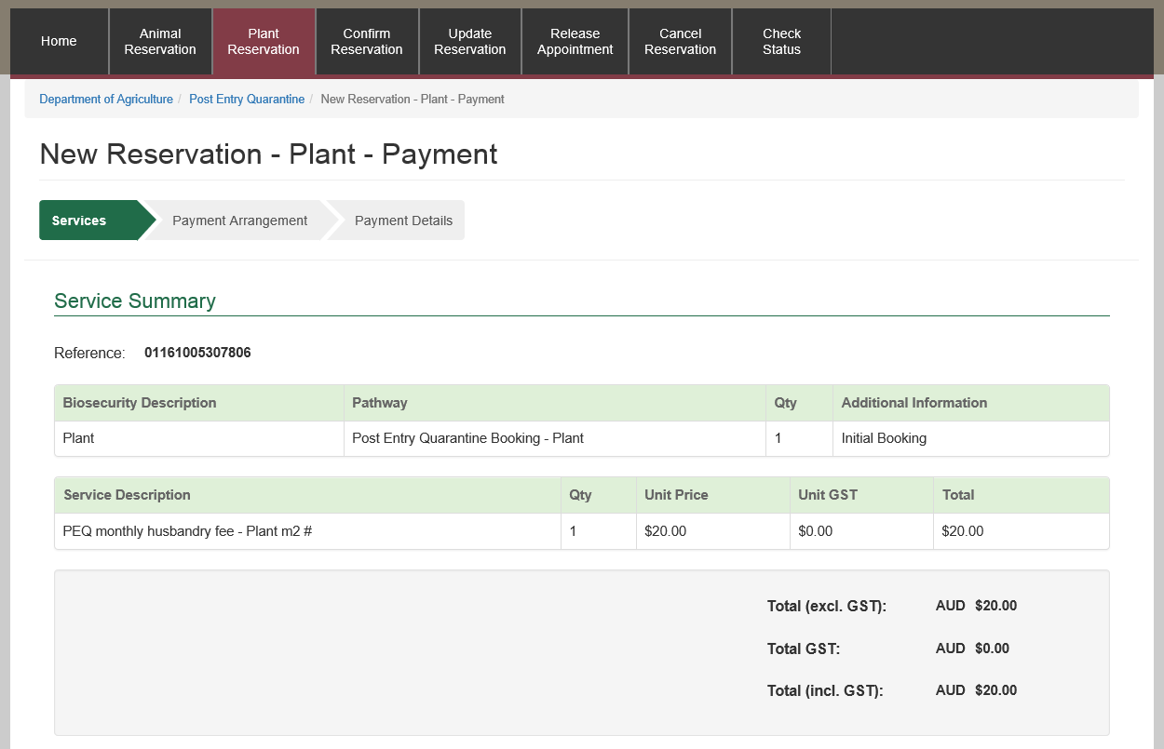

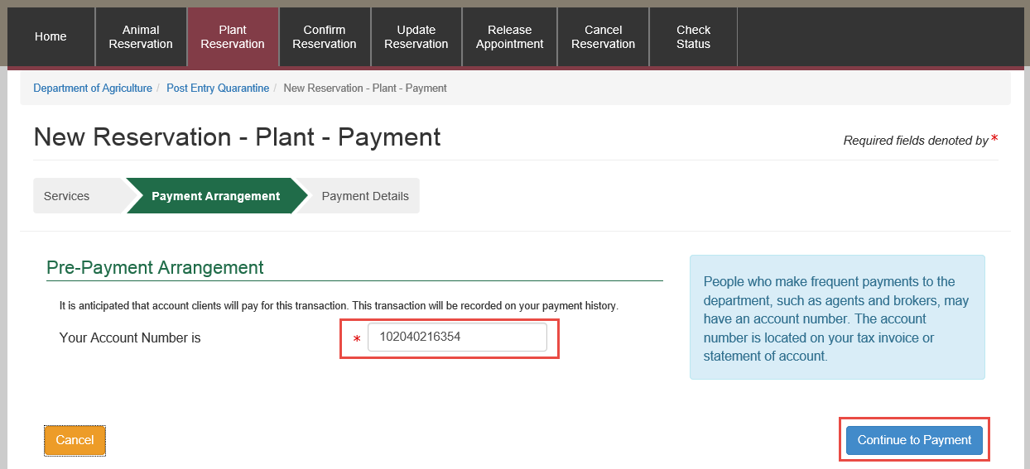

Check your account number.

Select Continue to Payment.

Once you select ‘Continue to Payment’ the system will present you with the payment screen. The screen will prompt you for your card details.

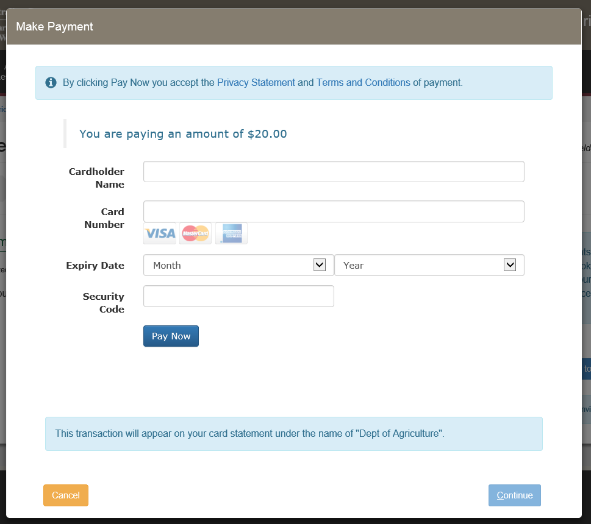

Once the payment is successful, you will be presented with the success screen.

### Success Screen

The system will generate a successful screen below. This screen contains your PEQ Reference Number (PRN). You will receive an email via the address you provided in the PEBS system.

PRN is used throughout your booking lifecycle. Please quote your PRN during your communications with PEQ Services Group.

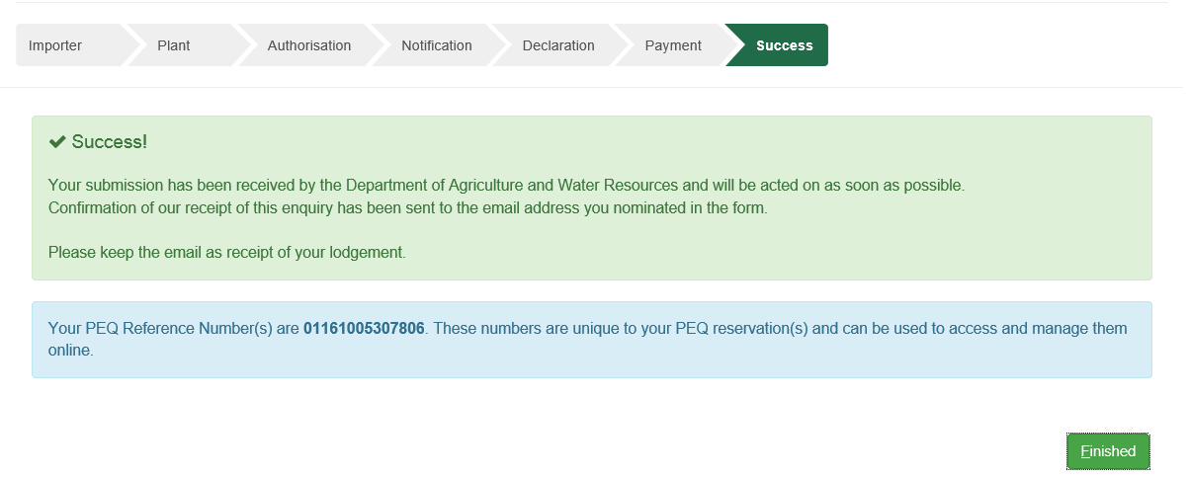

The system will send you an automatic email containing a proof Tax Invoice / Receipt for this transaction. If you are an account client the email will be sent to your finance nominated email address. Otherwise you will receive the email on the address you provided in the (PEBS) system.

### Confirming a booking into PEQ facility

The next step after initiating a booking is to confirm your booking. In this step you are expected to provide finalised information about your commodity’s transport into Australia and finalised commodity details. You are also required to pay for the services that will be provided during the minimum quarantine duration, as per the import conditions for your commodity.

## Confirming your booking

This section outlines the details for you to confirm your booking to the PEQ facility.

### When am I expected to confirm my booking?

Once you receive an email from the Department confirming that the facility can house your commodity, you will be able to confirm your booking online. Regardless of your commodity type, you are advised to confirm your booking at least seven days prior to your commodity arrival into Australia. Your booking will expire if you have not successfully confirmed your booking within the given timeline.

### What information do I need prior to confirming a booking?

This section outlines information required for you prior to confirming your booking online.

### Main screen

You will be able to confirm your booking by selecting ‘Confirm Reservation’ option in the main screen below.

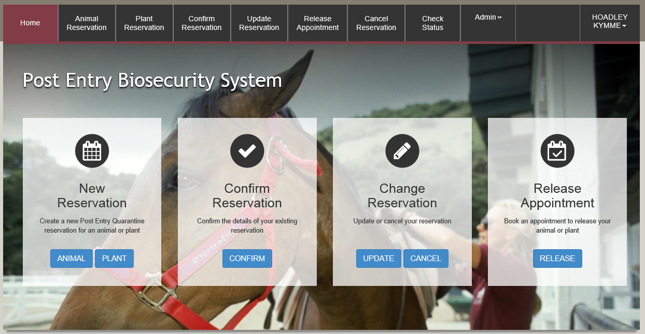

The screen below will appear. You will be expected to enter your PEQ Reservation Number (PRN) and the email address that was used in the initiate a booking stage.

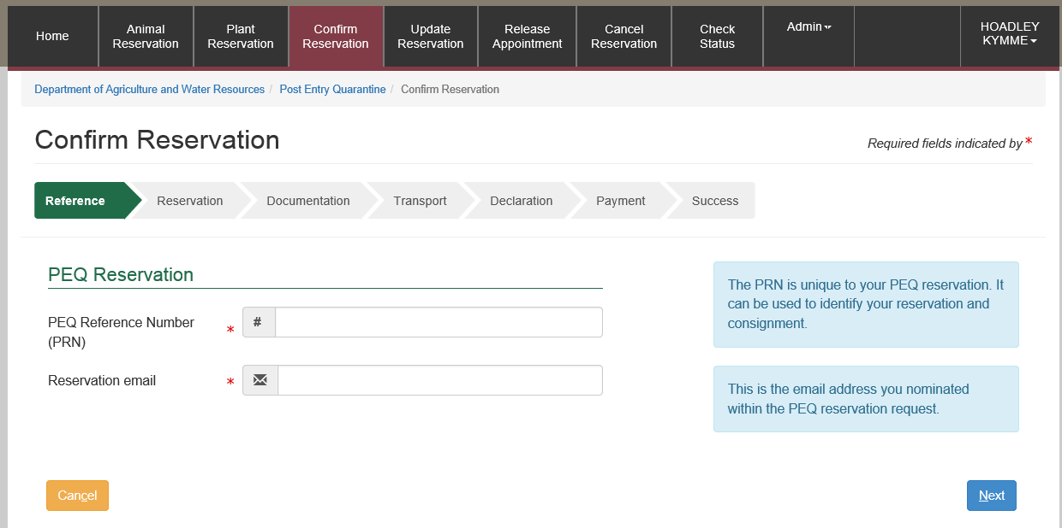

### Confirming a reservation

The system will display a summary of your reservation.

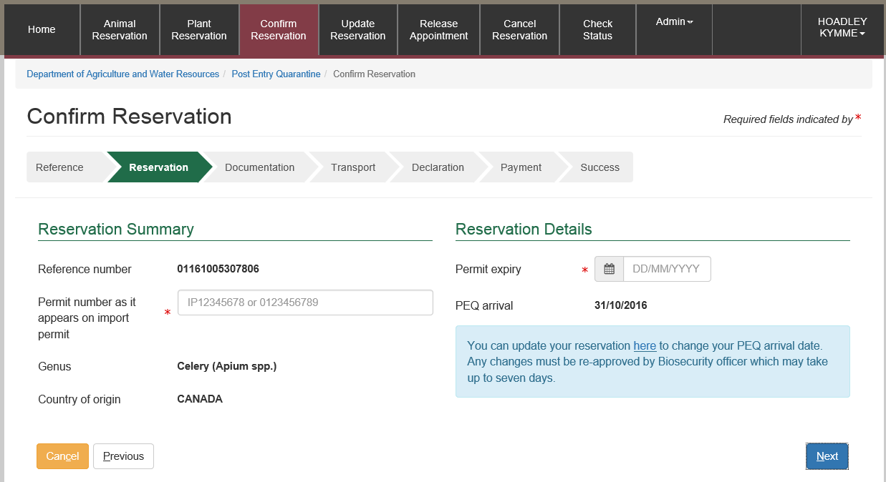

Enter the Permit number as it appears on import permit and the Permit expiry date.

### Uploading documentation

This section allows you to upload documents required for your reservation. You are able to upload as many files are required. However, each file is limited to 8MB. Additionally, you will be able to upload an image (JPG or JPEG) or a PDF document. It is recommended that you upload readable images (e.g. 100dpi). PEBS supports select and drop feature; you can select a file from your computer and drop it into the File Upload area. Alternatively, you can select the ‘Browse’ option in the File Upload view.

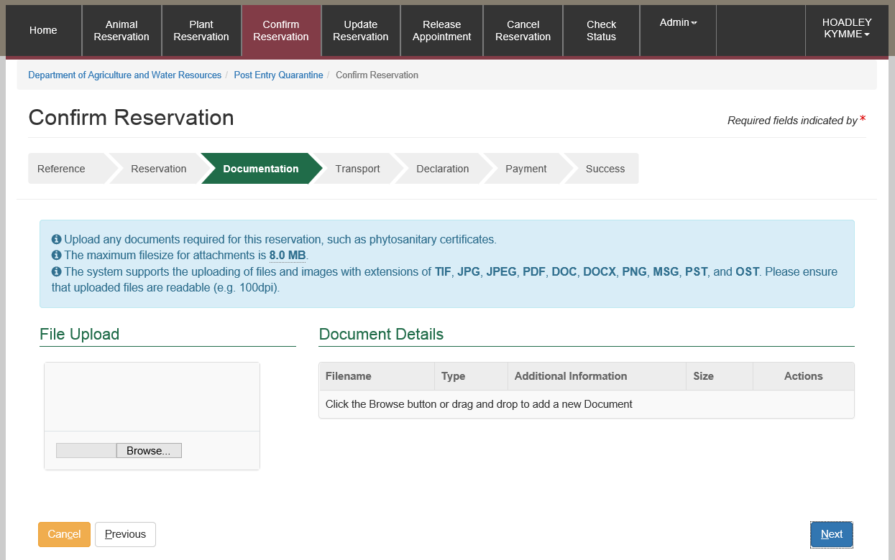

### Transport Details

This section allows you to provide transport details for your commodity.

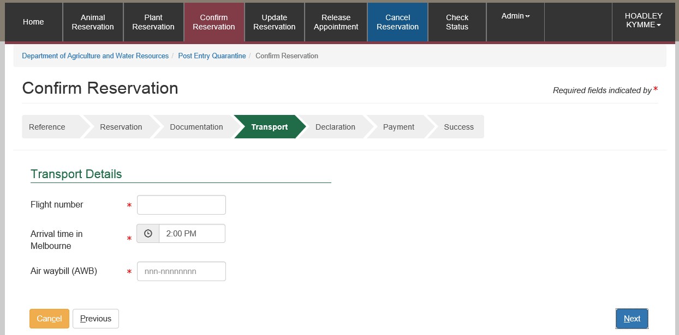

### Declaration

The last step of the initiate booking information gather steps is to provide additional information related to the reservation.

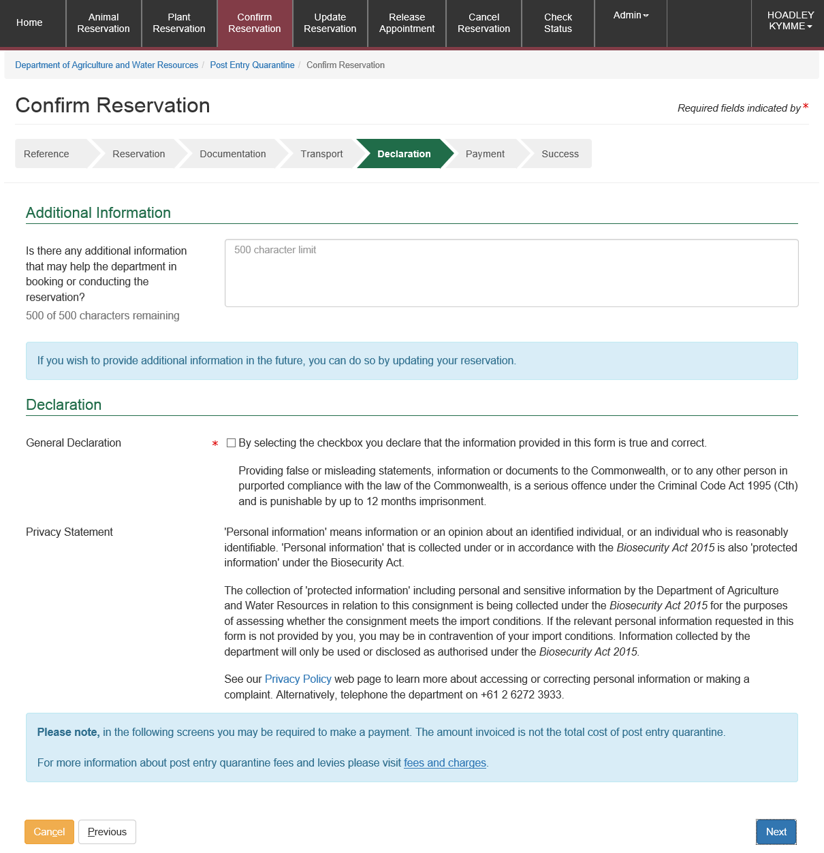

### Pay for confirming your booking

You will be expected to make an initial booking payment. The system will present you with a payment summary screen. The payment summary contains:

1. *Service Reference Number:* This number identifies the services that charges are being paid for.
2. *Description of your commodity*: This section includes your commodity type, what pathway is applicable to your commodity, how many of your commodity types are you bringing to Australia and additional comments.
3. *Service Description:* This section outlines services to be performed on your booking and outlines pricing.

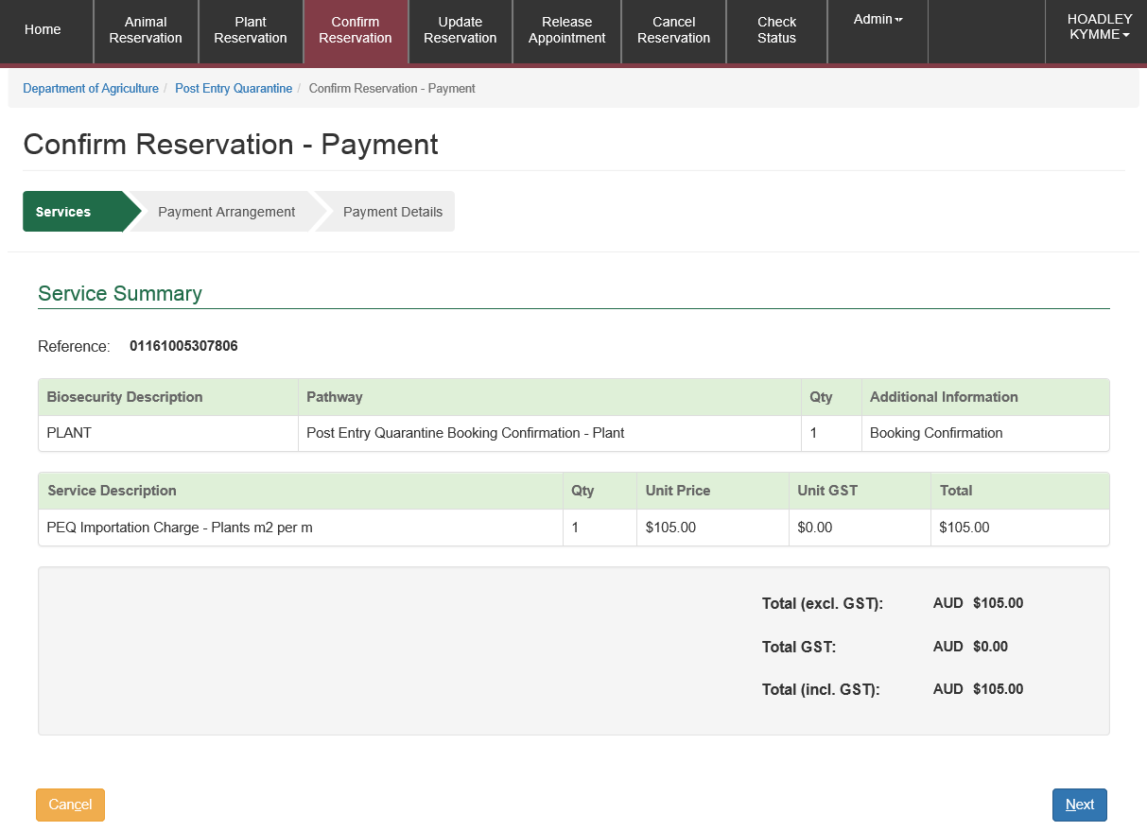

Select Next

Enter your credit card details and select Pay Now

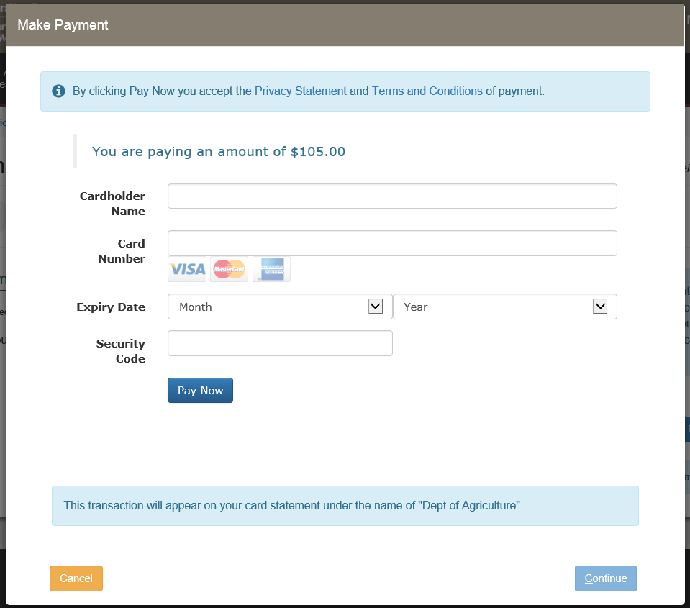

Once the payment is successful, you will be presented with the screen below.

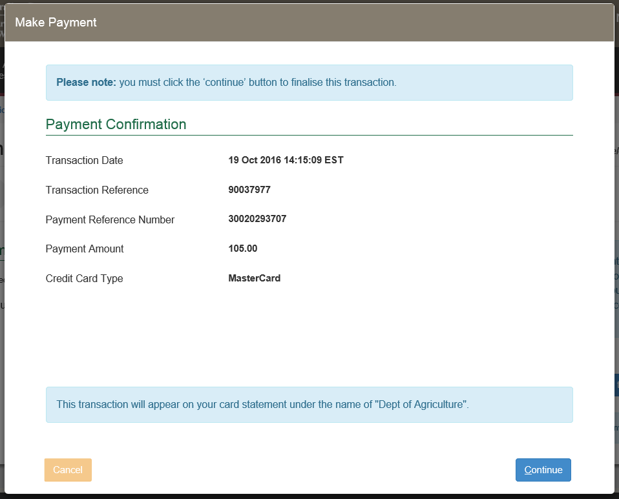

The system will automatically send you an email containing a Tax Invoice / Receipt for this transaction. If you are an account client the email will be sent to your finance nominated email address. Otherwise, you will receive the email on the address you provided in the PEBS system.

### Success Screen

The screen below will appear to confirm submission of your information.

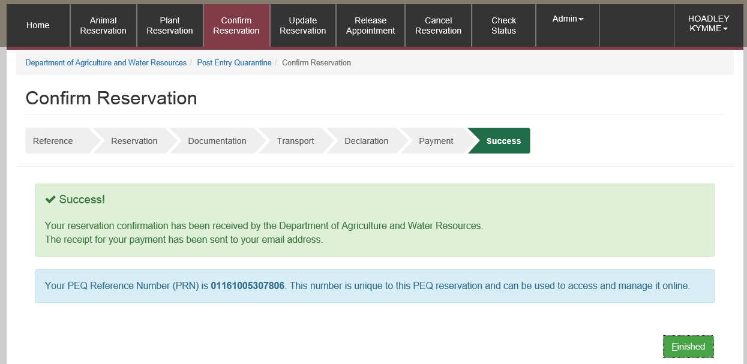

## Modifying your booking

You are able to modify your commodity’s arrival date prior to you confirming your booking. Once you confirm your booking you will not be able to modify your commodity’s arrival date. If you wish to change after confirmation you will need to contact the Department directly on 1800 900 090 or [PEQservices@agriculture.gov.au](mailto:PEQservices@agriculture.gov.au).

This section outlines steps required to change your commodity’s arrival date online via PEBS system.

### Main Screen

You update your commodity’s arrival date by selecting ‘Update Reservation’ from the main heading, or selecting ‘UPDATE’ from the ‘Change Reservation’ box.

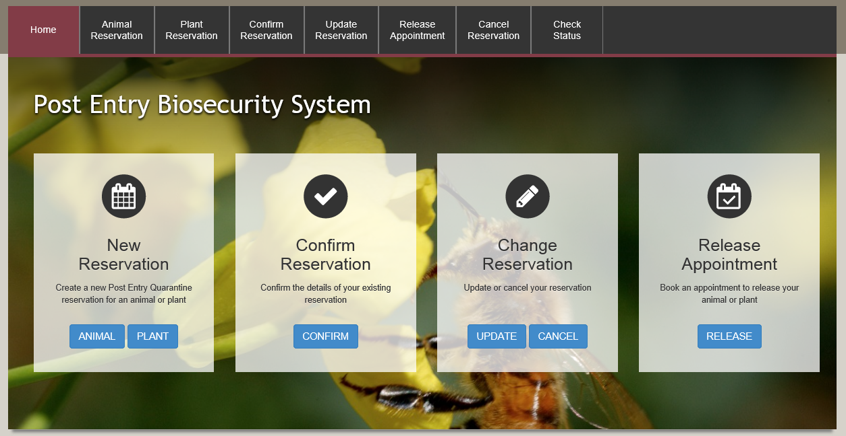

This screen displays. Enter your PEQ Reference Number (PRN) and your Reservation email. This is the email that you registered with.

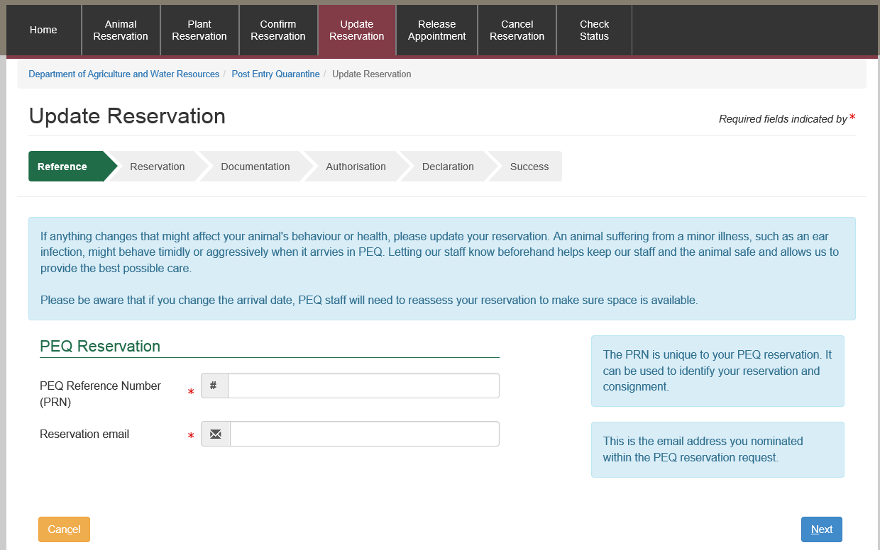

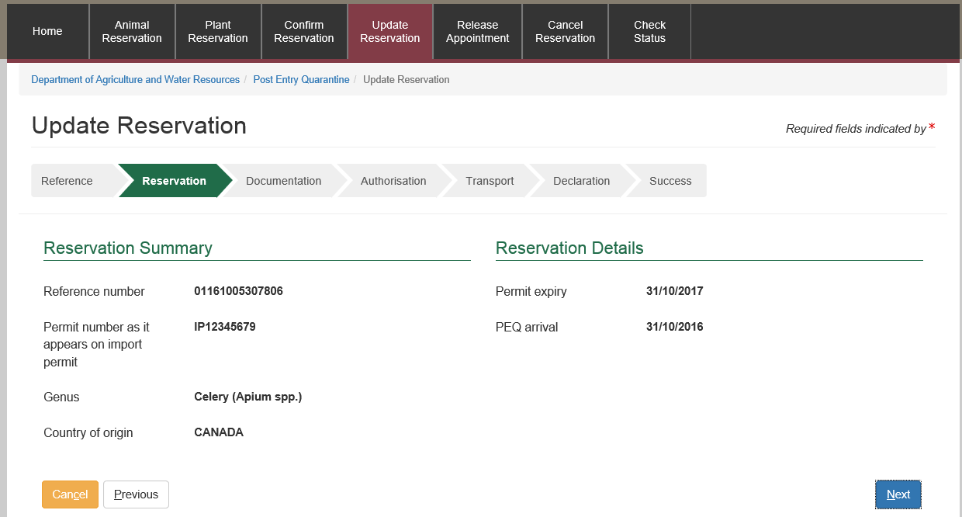

### Uploading Documents

This section allows you to upload documents required for your reservation. This section could also be used to upload documents throughout your reservation life-cycle till your commodity is released from quarantine. You are able to upload as many files as required. However, each file is limited to 8MB. Additionally, you will be able to upload an image (JPG or JPEG) or a PDF document. It is recommended that you upload readable images (e.g. 100dpi). PEBS supports select and drop feature; you can select a file from your computer and drop it into the File Upload area. Alternatively you can select the ‘Browse’ option in the File Upload view.

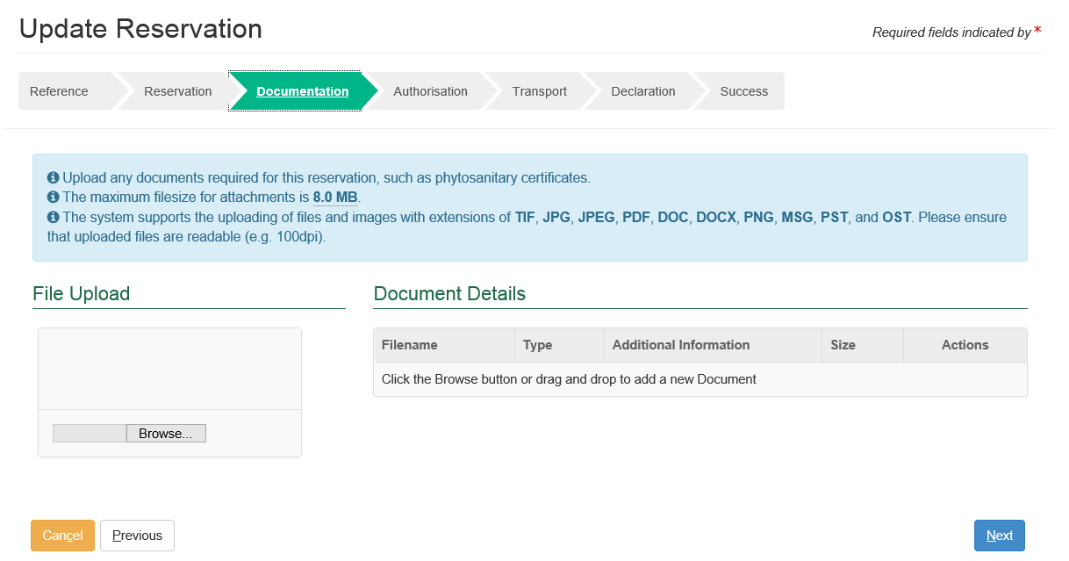

If you want to remove a file you have uploaded, you can press on the Screenshot of the delete buttion; a red garbage bin icon under ‘Actions’.

### Authorisation

This section allows you to update your authourisation of either company or personnel who will be providing services to the commodity while at the PEQ Quarantine facility.

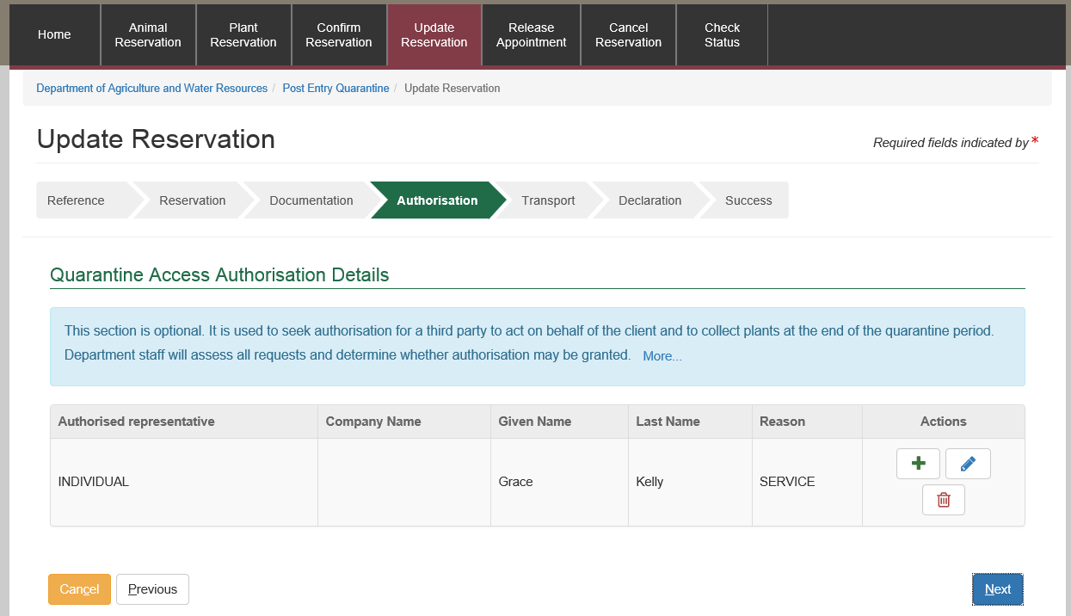

If you want to remove a person or company you can press on the Screenshot of the delete buttion; a red garbage bin icon under ‘Actions’. You can add a person or company here by selecting Screenshot of edit button; a blue pencil icon

### Transport

Here you can update the Transport Details for your consignment.

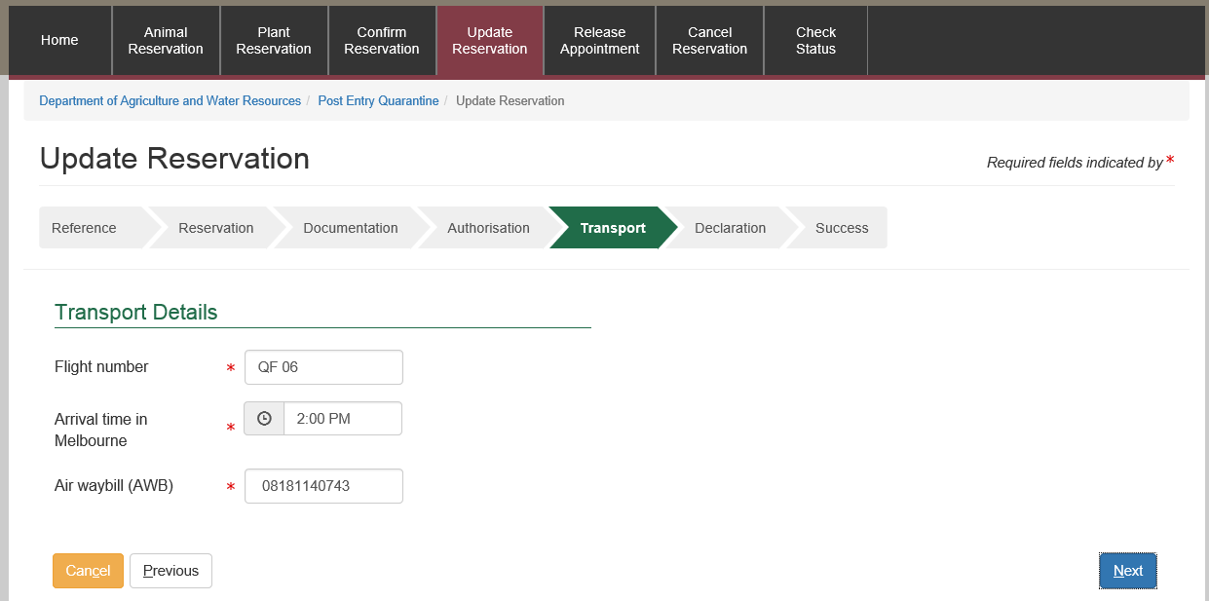

### Declaration

You will then be asked to optionally provide additional information to be recorded against your record.

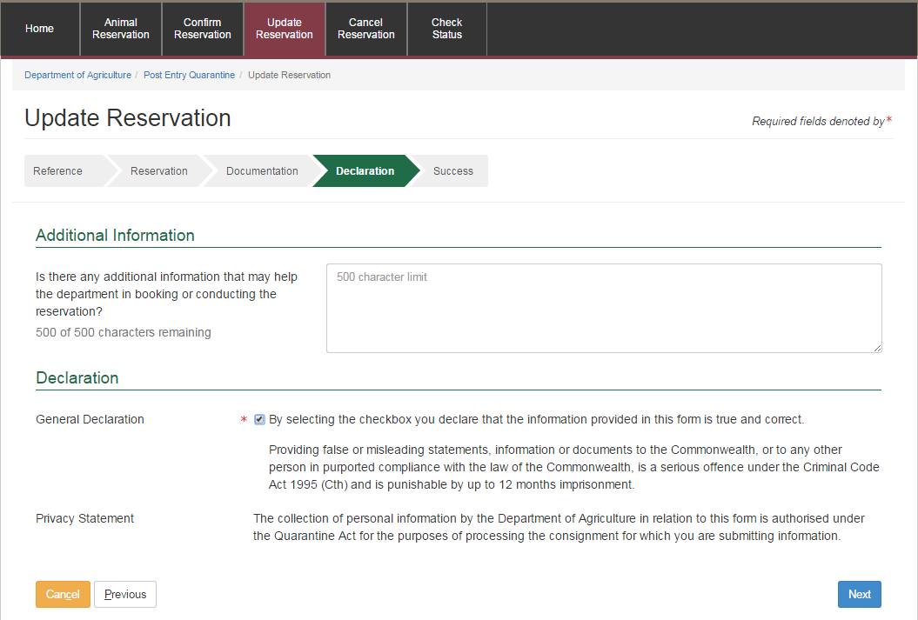

### Success Screen

A success screen will be displayed as below.

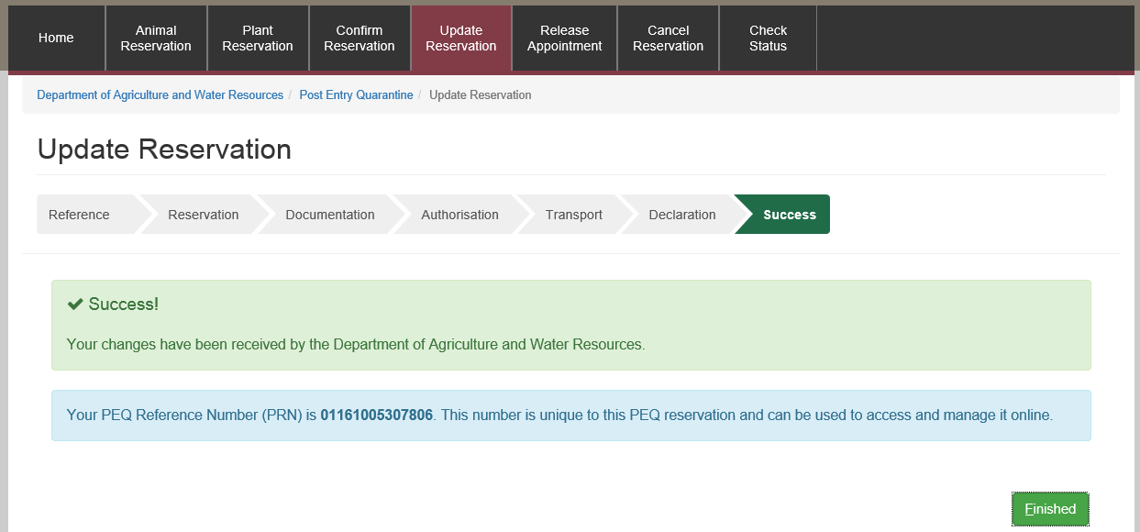

## Checking the status of your reservation

After you have successfully initiated a booking you will be able to check the status of your reservation online.

You can enquire the status of your reservation using the PEQ Reservation Number (PRN).

Select ‘Check Status’ from the main toolbar or ‘STATUS’ from the ‘Enquiry’ box.

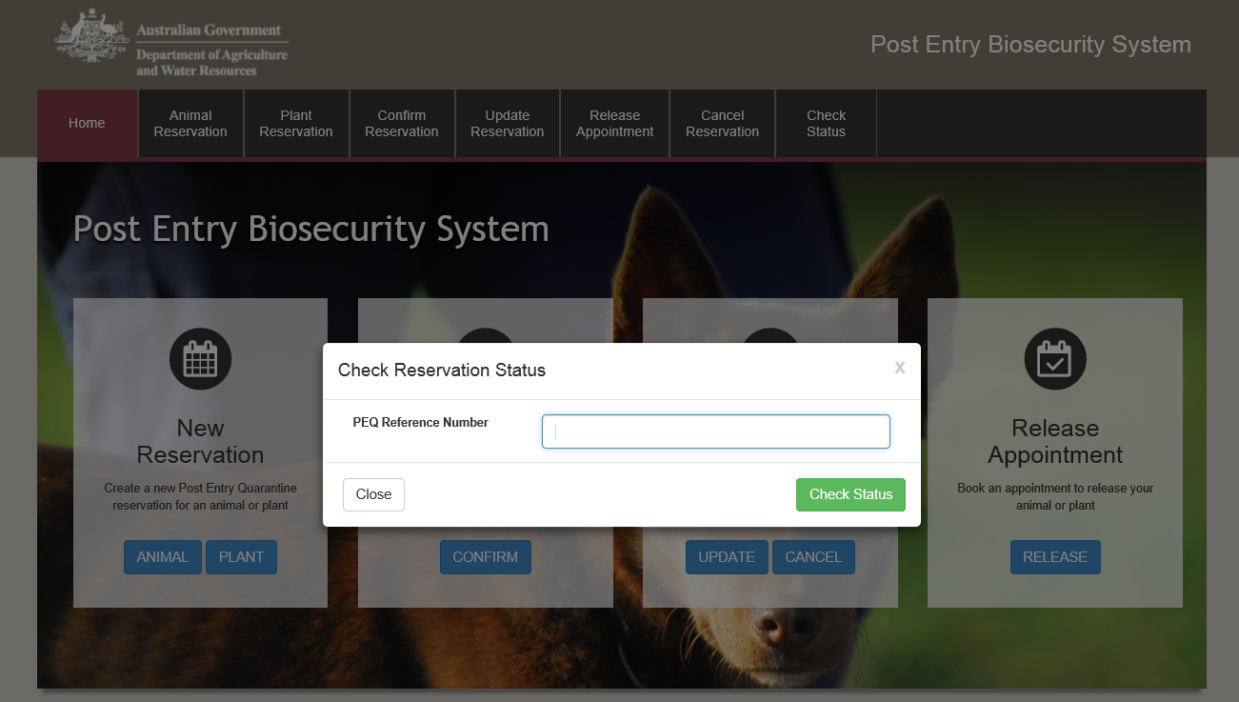

You will be able to enter the PRN and check the status of your reservation.

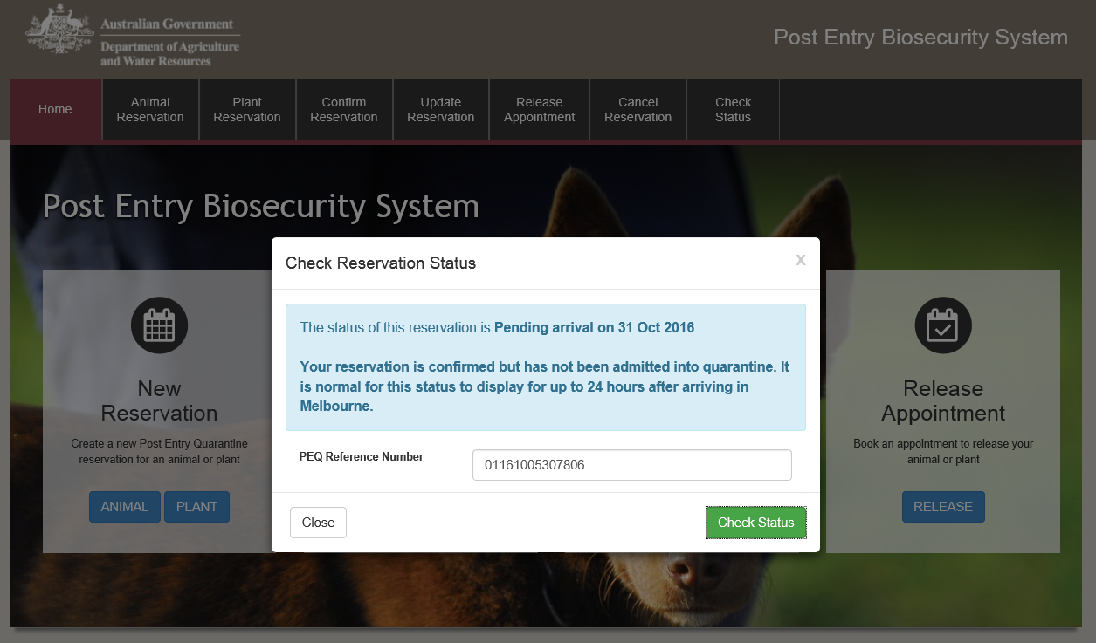

### How do I enquire about my reservation?

You can log in to your account in PEBS to check the status of your commodity. You can update or change your reservation at the Post Entry Quarantine.

## Cancelling a reservation

You will be able to cancel your reservation online prior to your commodity’s arrival date.

You can select ‘Cancel’ in the ‘Change Reservation’ box or ‘Cancel Reservation’ from the main toolbar.

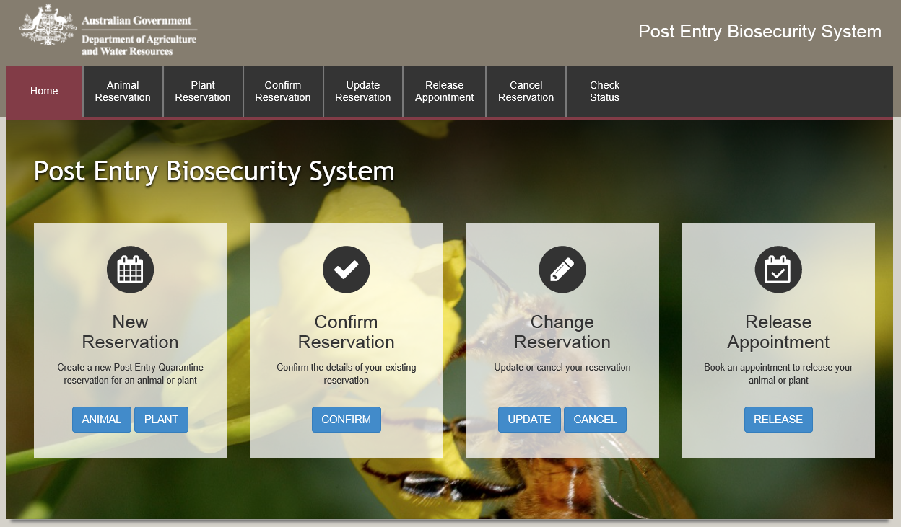

You will then be prompted to enter and the email address you specified at the time of initiating a booking and your PEQ Reservation Number (PRN), which was emailed to you at the time of initiating a booking.

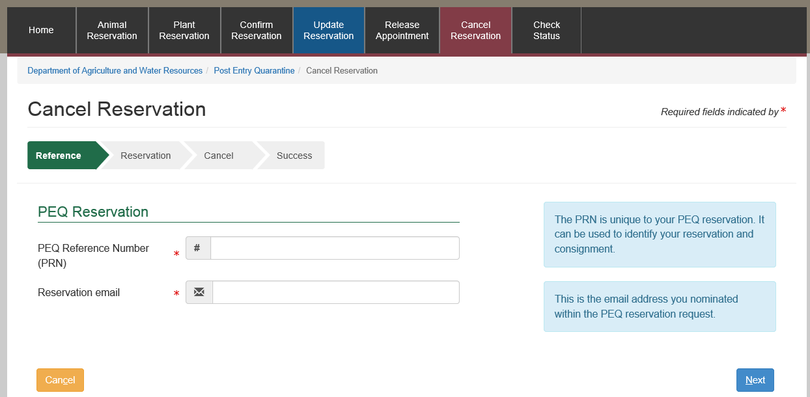

### Summary Screen

A summary of your reservation will be displayed to you.

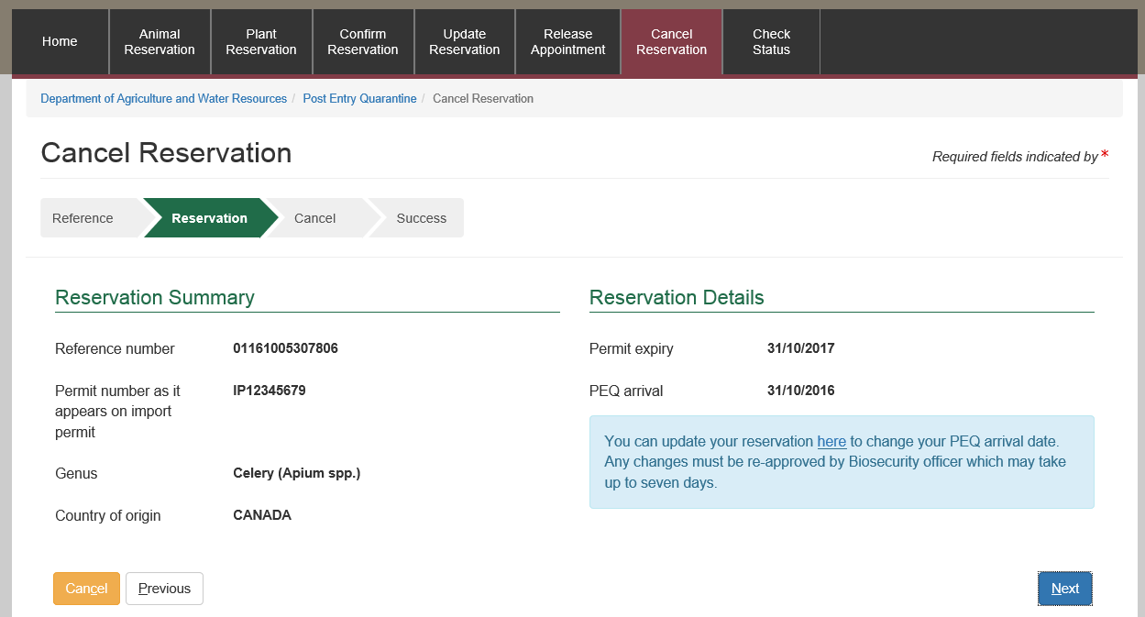

### Declaration

You will then be presented with the option to provide additional information to be recorded against your record.

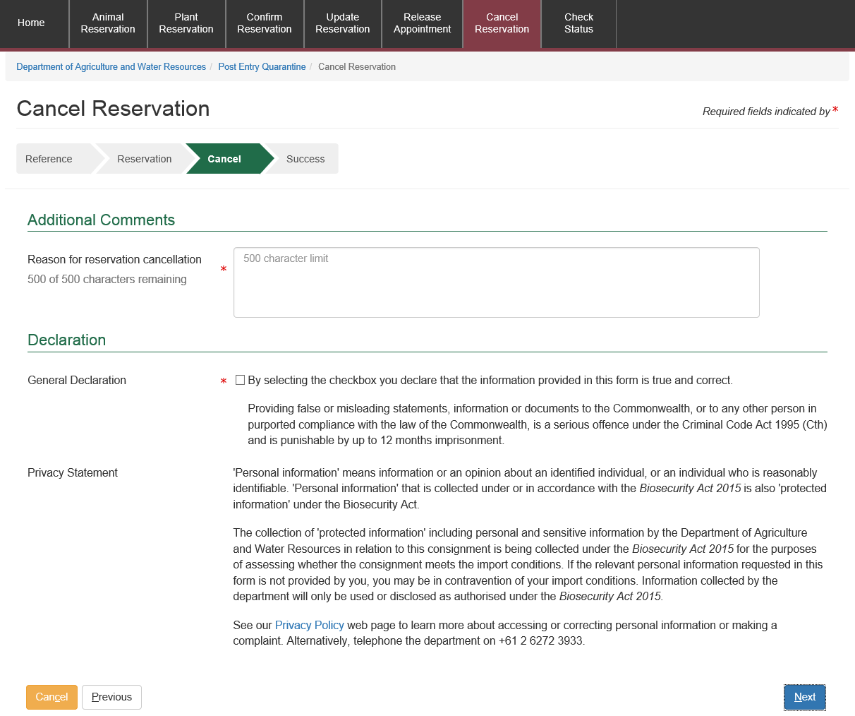

### Success Screen

A success message will be displayed for your reference.

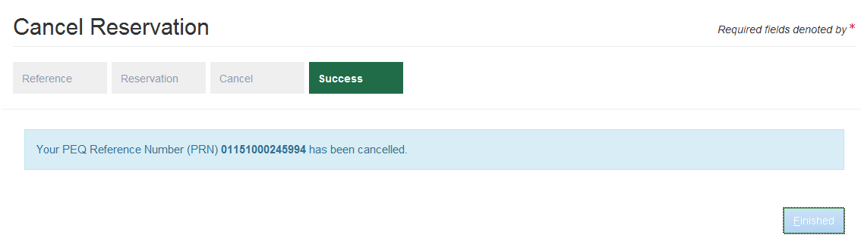

## Booking a release appointment

You will be able to book a release appointment online for your commodity.

You can select ‘RELEASE’ for the Release Appointment box or ‘Release Appointment’ from the main toolbar.

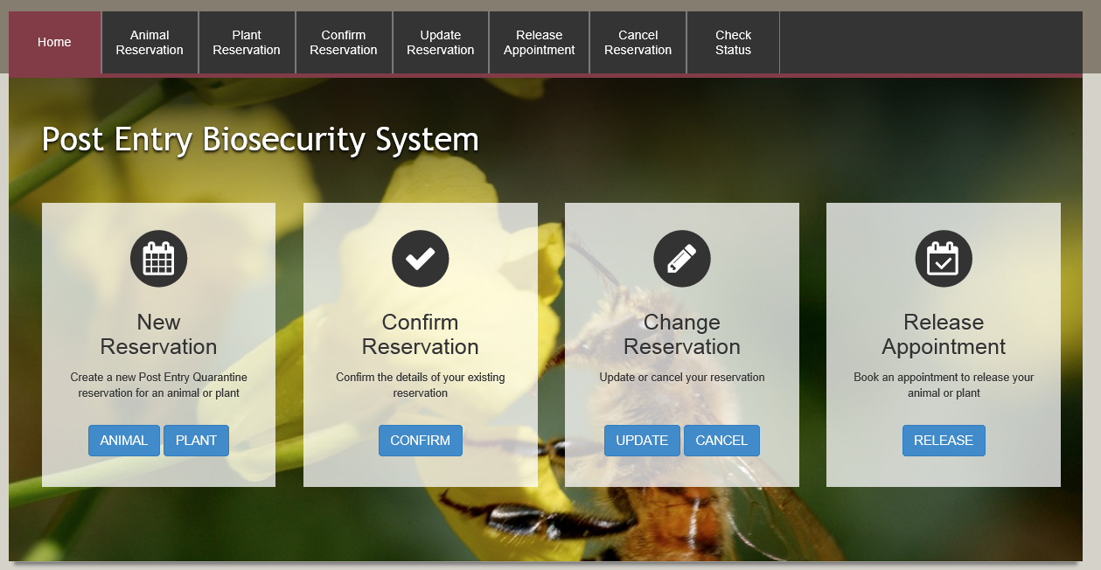

You will then be prompted to enter the email address you specified at the time of initiating a booking and your PEQ Reservation Number (PRN), which was emailed to you at the time of initiating a booking.

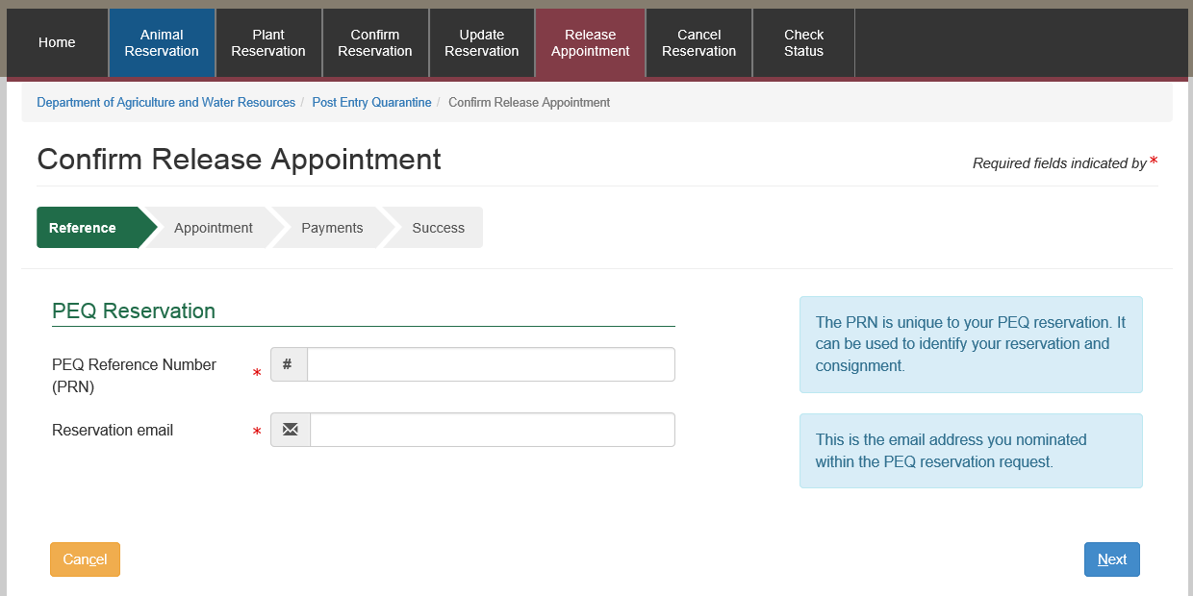

If there are any outstanding invoices these will need to be paid before the commodity can be released.

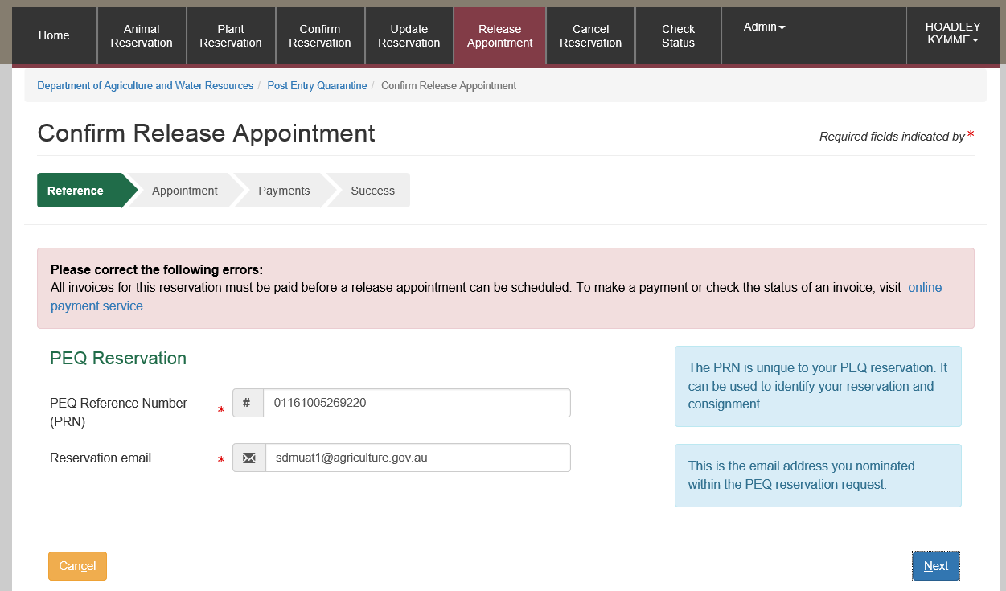

If there are outstanding invoices these can be paid online.

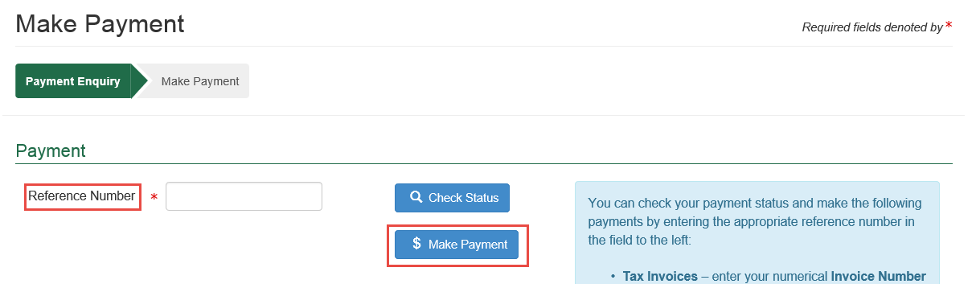

Enter the invoice number that you wish to pay.

Select Make Payment.

The payment screen will display.

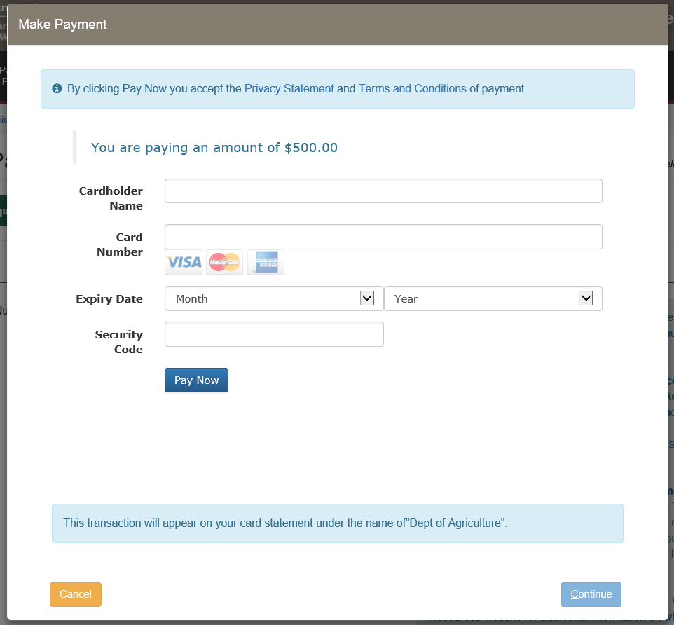

Enter your credit card details and select Pay Now

Payment Confirmation will display.

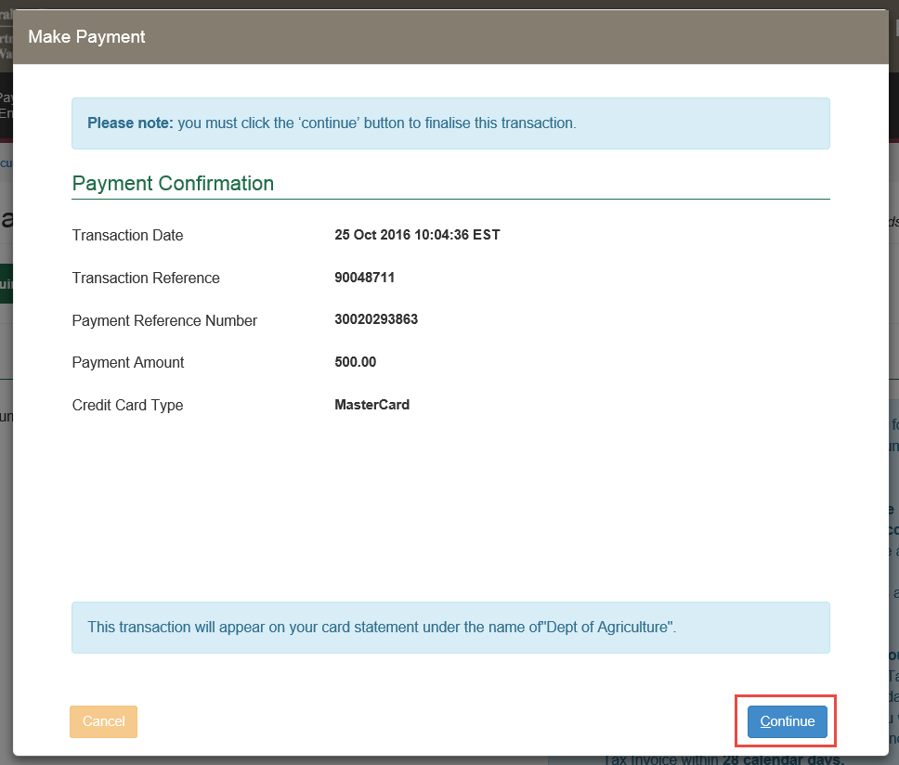

Select Continue to finalise the transaction.

You will now be able to complete the Release Appoinment booking.

Select your preferred Pickup Time, who will pick up the commodity and Commodity Name.

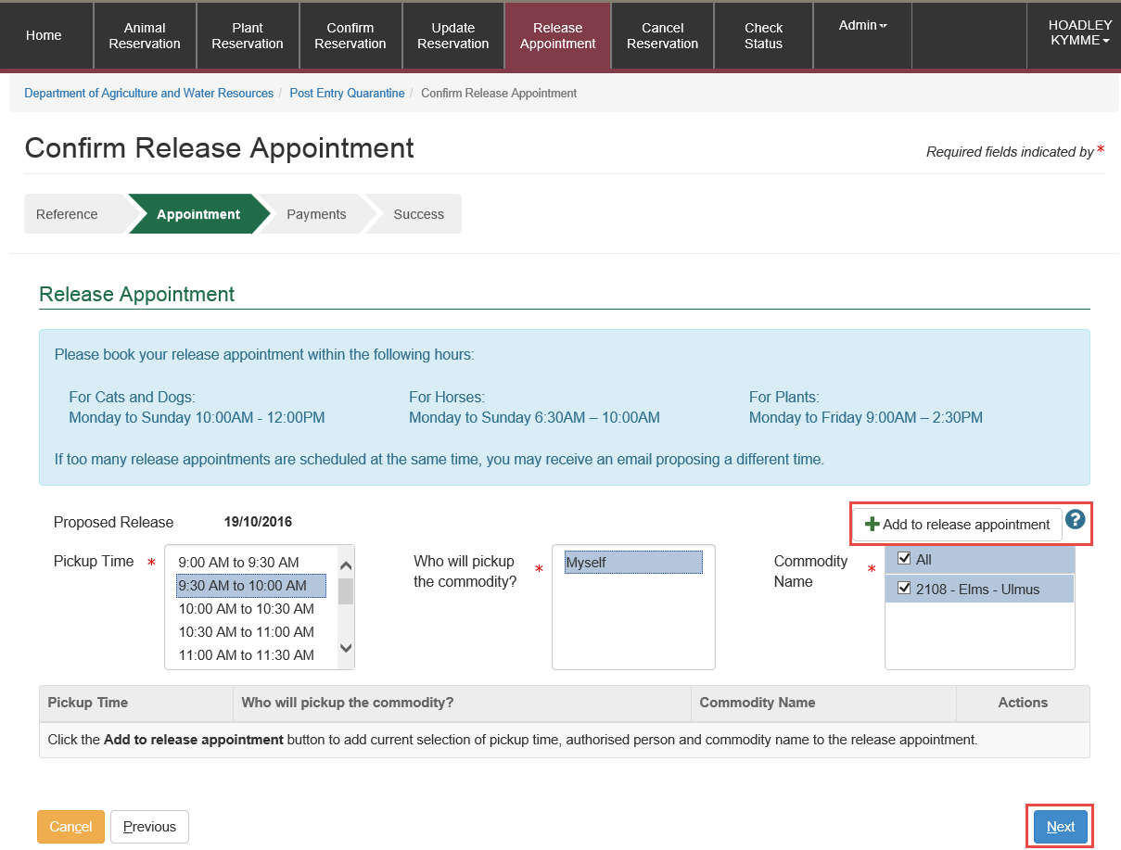

Then select Screenshot of plus button Add to release appointment.

Select Next

Make the necessary payments.

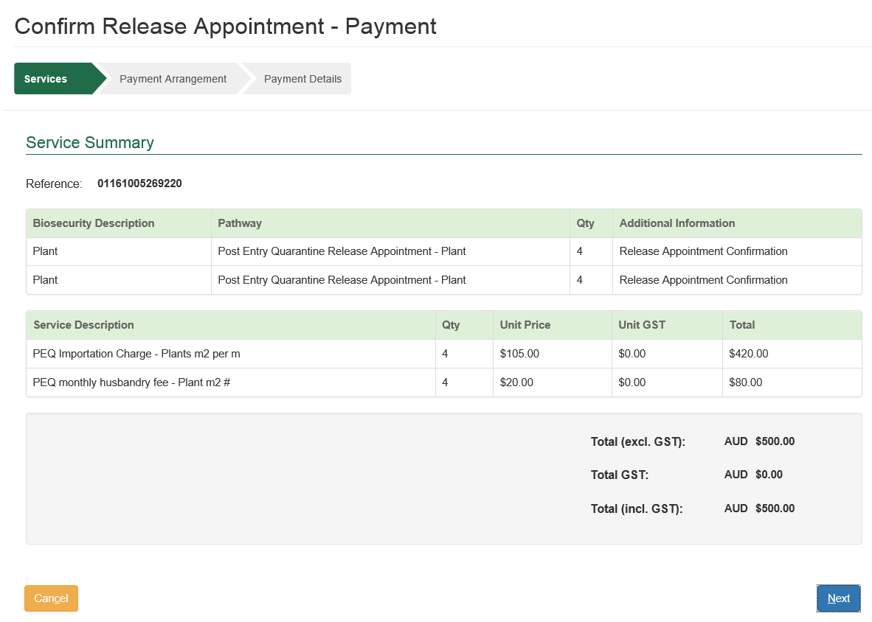

Select Make Payment.

The payment screen will display.



Enter your credit card details and select Pay Now

Payment Confirmation will display.



Select Continue to finalise the transaction.

## Support

Visit our website for additional help using PEBS:

* Visit [Post entry quarantine facility](http://www.agriculture.gov.au/import/arrival/post-entry-quarantine)
* Visit [PEQ reservations frequently asked questions](http://www.agriculture.gov.au/import/arrival/post-entry-quarantine/peq-faq)

If you require further assistance, please [email PEQ Services](mailto:PEQservices@agriculture.gov.au) or phone 1800 900 090 or +61 0 8318 6700 if outside Australia.

Hours: Monday – Friday (8.00am - 4.00pm)   
Weekends and Australian Public Holidays – Closed.