# Draft report for the review of biosecurity import requirements for fresh dragon fruit from Indonesia

January 2018



© Commonwealth of Australia 2018

**Ownership of intellectual property rights**

Unless otherwise noted, copyright (and any other intellectual property rights, if any) in this publication is owned by the Commonwealth of Australia (referred to as the Commonwealth).

**Creative Commons licence**

All material in this publication is licensed under a Creative Commons Attribution 3.0 Australia Licence, save for content supplied by third parties, photographic images, logos and the Commonwealth Coat of Arms.

by

Creative Commons Attribution 3.0 Australia Licence is a standard form licence agreement that allows you to copy, distribute, transmit and adapt this publication provided you attribute the work. A summary of the licence terms is available from [creativecommons.org/licenses/by/3.0/au/deed.en](https://creativecommons.org/licenses/by/3.0/au/deed.en). The full licence terms are available from [creativecommons.org/licenses/by/3.0/au/legalcode](https://creativecommons.org/licenses/by/3.0/au/legalcode).

Inquiries about the licence and any use of this document should be sent to [copyright@agriculture.gov.au](mailto:copyright@agriculture.gov.au).

This publication (and any material sourced from it) should be attributed as: Australian Government Department of Agriculture and Water Resources and Water Resources 2018, *Draft report for the review of biosecurity import requirements for fresh dragon fruit from Indonesia*. CC BY 3.0.

**Cataloguing data**

Australian Government Department of Agriculture and Water Resources 2018, *Draft report for the review of biosecurity import requirements for fresh dragon fruit from Indonesia*, Department of Agriculture and Water Resources, Canberra.

This publication is available at [agriculture.gov.au](http://www.agriculture.gov.au/).

Australian Government Department of Agriculture and Water Resources  
GPO Box 858 Canberra ACT 2601

Switchboard: +61 2 6272 3933 or 1800 900 090

Facsimile: +61 2 6272 3307

Email: [plantstakeholders@agriculture.gov.au](mailto:plantstakeholders@agriculture.gov.au)

**Liability**

The Australian Government acting through the Department of Agriculture and Water Resources has exercised due care and skill in preparing and compiling the information in this publication. Notwithstanding, the Australian Government Department of Agriculture and Water Resources, its employees and advisers disclaim all liability, including liability for negligence and for any loss, damage, injury, expense or cost incurred by any person as a result of accessing, using or relying upon any of the information or data in this publication to the maximum extent permitted by law.

**Stakeholder submissions on draft reports**

This draft report has been issued to give all interested parties an opportunity to comment on relevant technical biosecurity issues, with supporting rationale. A final report will then be produced taking into consideration any comments received.

Submissions should be sent to the Australian Government Department of Agriculture and Water Resources following the conditions specified within the related Biosecurity Advice, which is available at: <http://www.agriculture.gov.au/biosecurity/risk-analysis/memos>.

Contents

Acronyms and abbreviations v

Summary 1

1 Introduction 2

1.1 Australia’s biosecurity policy framework 2

1.2 This risk analysis 2

2 Method for pest risk analysis 6

2.1 Stage 1 Initiation 6

2.2 Stage 2 Pest risk assessment 7

2.3 Stage 3 Pest risk management 14

3 Indonesia’s commercial production practices for dragon fruit 16

3.1 Assumptions used in estimating unrestricted risk 16

3.2 Dragon fruit production areas 16

3.3 Climate in production areas 18

3.4 Pre-harvest 20

3.5 Harvesting and handling procedures 25

3.6 Post-harvest 25

3.7 Export capability 28

4 Pest risk assessments for quarantine pests 29

4.1 Fruit flies 30

4.2 Mealybugs 30

4.3 Pest risk assessment conclusions 32

5 Pest risk management 34

5.1 Pest risk management measures and phytosanitary procedures 34

5.2 Operational system for the maintenance and verification of phytosanitary status 37

5.3 Uncategorised pests 40

5.4 Review of processes 40

5.5 Meeting Australia’s food laws 40

6 Conclusion 42

Appendix A: Categorisation of pests of fresh dragon fruit from Indonesia and comparison with pests of dragon fruit from Vietnam 43

Glossary 60

References 64

Figures

Figure 1 Cross section of a dragon fruit showing key parts of the fruit 3

Figure 2 Mean monthly maximum and minimum temperatures and mean monthly rainfall in main dragon fruit production districts 19

Figure 3 Typical placement of cuttings against support post 21

Figure 4 Dragon fruit planting layout with live *Ceiba petandra* (Kapok) trees and artificial lighting system. 22

Figure 5 Dragon fruit farm using concrete borders around each planting site to conserve water because of low water availability and sandy soils. 23

Figure 6 Fruit growing on the plant protected in a mesh bag tied off with twine 24

Figure 7 Fruit fly lure on a farm growing dragon fruit and other fruit crops. 25

Figure 8 Fruit grading procedure in a packing house 26

Figure 9 Summary of operational steps from harvesting to export for dragon fruit grown in   
Indonesia 27

Tables

Table 2.1 Nomenclature of likelihoods 10

Table 2.2 Matrix of rules for combining likelihoods 11

Table 2.3 Decision rules for determining the consequence impact score based on the magnitude of consequences at four geographic scales 13

Table 2.4 Decision rules for determining the overall consequence rating for each pest 13

Table 2.5 Risk estimation matrix 14

Table 3.1 Major Indonesian provinces where dragon fruit is grown 17

Table 3.2 Summary of Indonesian Dragon fruit exports between 2013–2015 (all values in   
kilograms) 28

Table 4.1 Quarantine pests of dragon fruit from Indonesia for which the URE outcome is adopted from previous assessments 30

Table 4.2 Summary of unrestricted risk estimates for quarantine pests associated with dragon fruit from Indonesia 33

Table 5.1 Risk management measures proposed for quarantine pests of dragon fruit from   
Indonesia 34

Maps

Map 1 Main dragon fruit production areas in Indonesia (shown in green) 18

## Acronyms and abbreviations

| Term or abbreviation | Definition |
| --- | --- |
| ACT | Australian Capital Territory |
| ALOP | Appropriate level of protection |
| BICON | Australia’s Biosecurity Import Conditions System |
| BIRA | Biosecurity Import Risk Analysis |
| CSIRO | Commonwealth Scientific and Industrial Research Organisation |
| DAFF | The former Department of Agriculture , Fisheries and Forestry, which is now the Australian Government Department of Agriculture and Water Resources |
| The department | The Australian Government Department of Agriculture and Water Resources |
| EP | Existing policy |
| FAO | Food and Agriculture Organization of the United Nations |
| FSANZ | Food Standards Australia New Zealand |
| IAQA | Agency for Agricultural Quarantine of Indonesia |
| IPC | International Phytosanitary Certificate |
| IPPC | International Plant Protection Convention |
| ISPM | International Standard for Phytosanitary Measures |
| NSW | New South Wales |
| NPPO | National Plant Protection Organisation |
| NT | Northern Territory |
| PRA | Pest risk analysis |
| Qld | Queensland |
| SA | South Australia |
| SPS Agreement | WTO agreement on the Application of Sanitary and Phytosanitary Measures |
| Tas. | Tasmania |
| the department | The Australian Government Department of Agriculture and Water Resources |
| Vic. | Victoria |
| WA | Western Australia |
| WTO | World Trade Organization |

## Summary

The Australian Government Department of Agriculture and Water Resources has prepared this review of biosecurity import requirements to assess the proposal by Indonesia for market access to Australia for fresh dragon fruit.

Australia has recently permitted the importation of dragon fruit for human consumption from Vietnam. Pests considered in the policy for Vietnamese dragon fruit and other import policies were taken into consideration and included in this review of biosecurity import requirements, where appropriate.

This draft report proposes that importation of fresh dragon fruit to Australia from commercial production areas in Indonesia be permitted, subject to a range of biosecurity requirements.

This report contains details of pests that are of quarantine concern to Australia and are potentially associated with the importation of fresh dragon fruit from Indonesia, the risk assessments for the identified quarantine pests and the proposed risk management measures to reduce the biosecurity risk to an acceptable level.

Seven pests have been identified as requiring risk management measures. These pests are melon fly (*Bactrocera cucurbitae*), oriental fruit fly (*Bactrocera dorsalis*), grey pineapple mealybug (*Dysmicoccus neobrevipes*), papaya mealybug (*Paracoccus marginatus*), coffee mealybug (*Planococcus lilacinus*), Pacific mealybug (*Planococcus minor*) and Jack Beardsley mealybug (*Pseudococcus jackbeardsleyi*). These pests have been assessed previously by the department and risk management measures for these pests already exist to meet the appropriate level of protection (ALOP) for Australia on the fresh dragon fruit pathway.

The proposed risk management measures take account of regional differences in pest distribution within Australia. One pest requiring risk management, *Planococcus minor*, has been identified as a regional quarantine pest for Western Australia because interstate quarantine regulations and enforcement exist for this pest.

This draft report proposes a range of risk management measures, combined with operational systems to reduce the risks posed by the seven quarantine pests to achieve the ALOP for Australia. These measures include:

* area freedom, irradiation or vapour heat treatment for fruit flies
* consignment freedom for mealybugs verified by visual inspection and, if detected, remedial action for mealybugs.

This draft report has been published on the department’s website to allow interested parties to provide comments and submissions within the specified consultation period.

## Introduction

### Australia’s biosecurity policy framework

Australia’s biosecurity policies aim to protect Australia against the risks that may arise from exotic pests entering, establishing and spreading in Australia, thereby threatening Australia's unique flora and fauna, as well as those agricultural industries that are relatively free from serious pests.

The risk analysis process is an important part of Australia’s biosecurity policy development. It enables the Australian Government to formally consider the level of biosecurity risk that may be associated with proposals to import goods into Australia. If the biosecurity risks do not achieve the appropriate level of protection (ALOP) for Australia, risk management measures are proposed to reduce the risks to an acceptable level. If the risks cannot be reduced to an acceptable level, the goods will not be imported into Australia until suitable measures are identified or developed.

Successive Australian Governments have maintained a stringent, but not a zero risk, approach to the management of biosecurity risks. This approach is expressed in terms of the ALOP for Australia, which is defined in the *Biosecurity Act 2015* as providing a high level of protection aimed at reducing risk to a very low level, but not to zero. Australia’s approach is consistent with the SPS Agreement, which acknowledges that there is some level of risk associated with international movement of goods.

Australia’s risk analyses are undertaken by the Australian Government Department of Agriculture and Water Resources using technical and scientific experts in relevant fields and involve consultation with stakeholders at various stages during the process.

Risk analyses may take the form of a biosecurity import risk analysis (BIRA) or a non-regulated risk analysis (such as scientific review of existing policy and import conditions, pest-specific assessments, weed risk assessments, biological control agent assessments or scientific advice).

Further information about Australia’s biosecurity framework is provided in the *Biosecurity* *Import Risk Analysis Guidelines 2016* located on the [Australian Government Department of Agriculture and Water Resources website](http://www.agriculture.gov.au/biosecurity/risk-analysis/guidelines).

### This risk analysis

#### Background

The Indonesian Agricultural Quarantine Agency (IAQA) formally requested market access to Australia for dragon fruit in a submission received in July 2016. This submission contained information on the pests associated with dragon fruit in Indonesia, including the plant parts affected, and the standard commercial production practices for dragon fruit in Indonesia.

The preliminary pest categorisation for dragon fruit from Indonesia indicated that the pest species of quarantine concern are the same as, or similar to, those assessed previously by the department. For this reason the department is conducting a review of biosecurity import requirements of existing policy (a non-regulated analysis), to consider this market access request from Indonesia.

In April 2017, officers from the department visited major dragon fruit production areas in Indonesia to verify information on pests, observe commercial production and packing practices, and confirm whether Indonesia is capable of meeting Australia’s potential import requirements.

On 14 December 2017, the department formally announced the commencement of this risk analysis, advising that it would be progressed as a review of biosecurity import requirements.

#### Scope

The scope of this review of biosecurity import requirements is to consider the biosecurity risk that may be associated with the importation of commercially produced fresh dragon fruit (*Hylocereus* spp.) (henceforth dragon fruit), from Indonesia, for human consumption in Australia.

In this review of biosecurity import requirements, dragon fruit is defined as the entire fruit with flesh, seeds, skin including full bracts and a small portion (0.5–1 centimetre) of attached areole (Figure 1). This review of biosecurity import requirements covers all commercial dragon fruit cultivars of the genus *Hylocereus* produced for export in all Indonesian dragon fruit production regions.

Figure Cross section of a dragon fruit showing key parts of the fruit

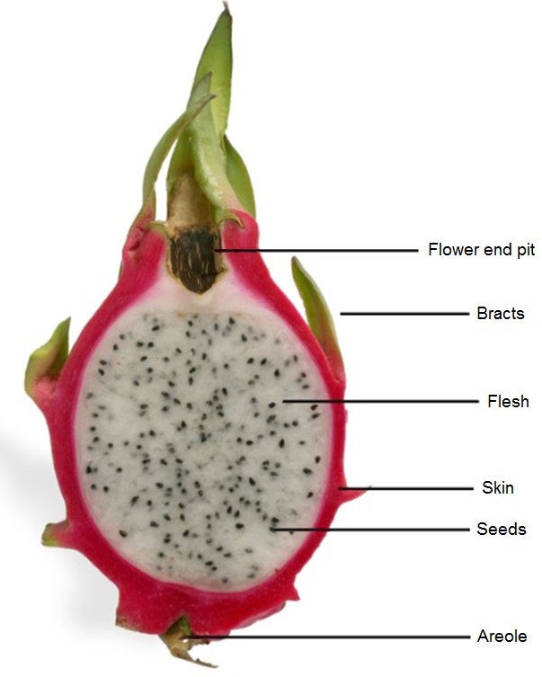

#### Existing policy

##### International policy

Import policy exists for dragon fruit from Vietnam (Department of Agriculture and Water Resources 2017b). For Indonesia, import policy exists for mangosteen (DAFF 2012), salacca (Australian Department of Agriculture 2014) and mango (Department of Agriculture and Water Resources 2015).

The import requirements for these commodity pathways can be found at the Biosecurity Import Conditions (BICON) system on the [department's website](https://bicon.agriculture.gov.au/BiconWeb4.0).

The department has considered all the pests previously identified in existing policies and, where relevant, the information in those assessments has been taken into account in this risk analysis. The department has also reviewed the latest literature up to July 2017 to ensure that information in previous assessments is still valid. The department has determined that the information in those assessments can be adopted for the species under consideration in this risk analysis.

##### Domestic arrangements

The Australian Government is responsible for regulating the movement of goods such as plants and plant products into and out of Australia. However, the state and territory governments are responsible for plant health controls applied to their individual jurisdictions. Legislation relating to resource management or plant health may be used by state and territory government agencies to control interstate movement of plants and plant products. Once plant and plant products have been cleared by Australian Government biosecurity officers, they may be subject to interstate movement regulations/arrangements. It is the importer’s responsibility to identify and ensure compliance with all requirements.

#### Contaminating pests

In addition to the pests of dragon fruit from Indonesia that are assessed in this risk analysis, there are other organisms that may arrive with the imported commodity. These organisms could include pests of other crops, or predators and parasitoids of other arthropods. The department considers these organisms to be contaminating pests that could pose sanitary or phytosanitary risks. These risks are identified and addressed using existing operational procedures that require a 600 unit inspection of all consignments, or equivalent. The department will investigate whether any pest identified through these processes may be of quarantine concern to Australia, and thus may require remedial action.

#### Consultation

On 14 December 2017 the department notified stakeholders, in Biosecurity Advice 2017/28, of the formal commencement of a review of biosecurity import requirements for fresh dragon fruit from Indonesia.

Prior to the release of this review the department communicated with Australian dragon fruit growers regarding this risk analysis process.

The department has consulted with Indonesian and Australian state and territory governments during the preparation of this report.

#### Next Steps

This draft report gives stakeholders the opportunity to comment and draw attention to any scientific, technical or other gaps in the data, or misinterpretations or errors.

The department will consider submissions received on the draft report and may consult informally with stakeholders. The department will revise the draft report as appropriate. The department will then prepare a final report, taking into account stakeholder comments.

The final report will be published on the department’s website along with a notice advising stakeholders of its release. The department will also notify the proposer, the registered stakeholders and the WTO Secretariat about the release of the final report. Publication of the final report represents the end of the risk analysis process. The conditions recommended in the final report will form the basis of the conditions published in the Biosecurity Import Conditions (BICON) system and subsequently any import permits issued.

## Method for pest risk analysis

This chapter sets out the method used for the pest risk analysis (PRA) in this report. The Australian Government Department of Agriculture and Water Resources has conducted this PRA in accordance with the International Standards for Phytosanitary Measures (ISPMs), including ISPM 2: *Framework for pest risk analysis* (FAO 2016a) and ISPM 11: *Pest risk analysis for quarantine pests* (FAO 2017b) that have been developed under the SPS Agreement (WTO 1995).

A PRA is ‘the process of evaluating biological or other scientific and economic evidence to determine whether an organism is a pest, whether it should be regulated, and the strength of any phytosanitary measures to be taken against it’ (FAO 2017a). A pest is ‘any species, strain or biotype of plant, animal, or pathogenic agent injurious to plants or plant products’ (FAO 2017a). This definition is also applied in the *Biosecurity Act 2015*.

Biosecurity risk consists of two major components: the likelihood of a pest entering, establishing and spreading in Australia from imports; and the consequences should this happen. These two components are combined to give an overall estimate of the risk.

Unrestricted risk is estimated taking into account the existing commercial production practices of the exporting country and that, on arrival in Australia, the department will verify that the consignment received is as described on the commercial documents and its integrity has been maintained.

Restricted risk is estimated with phytosanitary measure(s) applied. A phytosanitary measure is ‘any legislation, regulation or official procedure having the purpose to prevent the introduction and/or spread of quarantine pests, or to limit the economic impact of regulated non-quarantine pests’ (FAO 2017a).

A glossary of the terms used in the risk analysis is provided at the end of this report.

The PRAs are conducted in the following three consecutive stages: initiation, pest risk assessment and pest risk management.

The *Final group pest risk analysis for thrips and orthotospoviruses on fresh fruit, vegetable, cut-flower and foliage imports* (Department of Agriculture and Water Resources 2017a) has been applied in this risk analysis.

### Stage 1 Initiation

Initiation identifies the pest(s) and pathway(s) that are of quarantine concern and should be considered for risk analysis in relation to the identified PRA area, which is defined as Australia for this risk analysis.

Appendix A of this risk analysis report lists the pests with the potential to be associated with the exported commodity produced using commercial production and packing procedures. Appendix A does not present a comprehensive list of all the pests associated with the entire plant, but concentrates on the pests that could be on the assessed commodity. Contaminating pests that have no specific relation to the commodity or the export pathway have not been listed and would be addressed by Australia’s current approach to contaminating pests.

The identity of the pests is given in Appendix A. The species name is used in most instances but a lower taxonomic level is used where appropriate. Synonyms are provided where the current scientific name differs from that provided by the exporting country’s National Plant Protection Organisation (NPPO) or where the cited literature used a different scientific name.

For this risk analysis, the ‘PRA area’ is defined as Australia for pests that are absent, or of limited distribution and under official control. For areas with regional freedom from a pest, the ‘PRA area’ may be defined on the basis of a state or territory of Australia or may be defined as a region of Australia consisting of parts of a state or territory or several states or territories.

For pests that had been considered by the department in other risk assessments and for which import conditions already exist, this risk analysis considered the likelihood of entry of pests on the commodity and whether existing policy is adequate to manage the risks associated with its import. Where appropriate, previous risk assessments were taken into consideration in this risk analysis. The department will continue to review the literature and monitor changes in pest risk, and may amend this policy accordingly.

### Stage 2 Pest risk assessment

A pest risk assessment (for quarantine pests) is the ‘evaluation of the probability of the introduction and spread of a pest and of the magnitude of the associated potential economic consequences’ (FAO 2017a).

The following three, consecutive steps were used in pest risk assessment:

#### Pest categorisation

Pest categorisation identifies which of the pests with the potential to be on the commodity are quarantine pests for Australia and require pest risk assessment. A ‘quarantine pest’ is a pest of potential economic importance to the area endangered thereby and not yet present there, or present but not widely distributed and being officially controlled (FAO 2017a).

The pests identified in Stage 1 were categorised using the following primary elements to identify the quarantine pests for the commodity being assessed:

* identity of the pest
* presence or absence in the PRA area
* regulatory status
* potential for establishment and spread in the PRA area
* potential for economic consequences (including environmental consequences) in the PRA area.

The results of pest categorisation are set out in Appendix A. The quarantine pests identified during categorisation were carried forward for pest risk assessment and are listed in Table 4.1.

#### Assessment of the probability of entry, establishment and spread

Details of how to assess the ‘probability of entry’, ‘probability of establishment’ and ‘probability of spread’ of a pest are given in ISPM 11 (FAO 2017b). The SPS Agreement (WTO 1995) uses the term ‘likelihood’ rather than ‘probability’ for these estimates. In qualitative PRAs, the department uses the term ‘likelihood’ for the descriptors it uses for its estimates of likelihood of entry, establishment and spread. The use of the term ‘probability’ is limited to the direct quotation of ISPM definitions.

A summary of this process is given here, followed by a description of the qualitative methodology used in this risk analysis.

##### Likelihood of entry

The likelihood of entry describes the likelihood that a quarantine pest will enter Australia as a result of trade in a given commodity, be distributed in a viable state in the PRA area and subsequently be transferred to a host. It is based on pathway scenarios depicting necessary steps in the sourcing of the commodity for export, its processing, transport and storage, its use in Australia and the generation and disposal of waste. In particular, the ability of the pest to survive is considered for each of these various stages.

The likelihood of entry estimates for the quarantine pests for a commodity are based on the use of the existing commercial production, packaging and shipping practices of the exporting country. Details of the existing commercial production practices for the commodity are set out in Chapter 3. These practices are taken into consideration by the department when estimating the likelihood of entry.

For the purpose of considering the likelihood of entry, the department divides this step into two components:

* **Likelihood of importation**—the likelihood that a pest will arrive in Australia when a given commodity is imported.
* **Likelihood of distribution**— the likelihood that the pest will be distributed, as a result of the processing, sale or disposal of the commodity, in the PRA area and subsequently transfer to a susceptible part of a host.

Factors to be considered in the likelihood of importation may include:

* distribution and incidence of the pest in the source area
* occurrence of the pest in a life-stage that would be associated with the commodity
* mode of trade (for example, bulk, packed)
* volume and frequency of movement of the commodity along each pathway
* seasonal timing of imports
* pest management, cultural and commercial procedures applied at the place of origin
* speed of transport and conditions of storage compared with the duration of the lifecycle of the pest
* vulnerability of the life-stages of the pest during transport or storage
* incidence of the pest likely to be associated with a consignment
* commercial procedures (for example, refrigeration) applied to consignments during transport and storage in the country of origin, and during transport to Australia.

Factors to be considered in the likelihood of distribution may include:

* commercial procedures (for example, refrigeration) applied to consignments during distribution in Australia
* dispersal mechanisms of the pest, including vectors, to allow movement from the pathway to a host
* whether the imported commodity is to be sent to a few or many destination points in the PRA area
* proximity of entry, transit and destination points to hosts
* time of year at which import takes place
* intended use of the commodity (for example, for planting, processing or consumption)
* risks from by-products and waste.

##### Likelihood of establishment

Establishment is defined as the ‘perpetuation for the foreseeable future, of a pest within an area after entry’ (FAO 2017a). In order to estimate the likelihood of establishment of a pest, reliable biological information (for example, lifecycle, host range, epidemiology and survival) is obtained from the areas where the pest currently occurs. The situation in the PRA area can then be compared with that in the areas where it currently occurs and expert judgement used to assess the likelihood of establishment.

Factors to be considered in the likelihood of establishment in the PRA area may include:

* availability of hosts, alternative hosts and vectors
* suitability of the environment
* reproductive strategy and potential for adaptation
* minimum population needed for establishment
* cultural practices and control measures.

##### Likelihood of spread

Spread is defined as ‘the expansion of the geographical distribution of a pest within an area’ (FAO 2017a). The likelihood of spread considers the factors relevant to the movement of the pest, after establishment on a host plant or plants, to other susceptible host plants of the same or different species in other areas. In order to estimate the likelihood of spread of the pest, reliable biological information is obtained from areas where the pest currently occurs. The situation in the PRA area is then carefully compared with that in the areas where the pest currently occurs and expert judgement used to assess the likelihood of spread.

Factors to be considered in the likelihood of spread may include:

* suitability of the natural and/or managed environment for natural spread of the pest
* presence of natural barriers
* potential for movement with commodities, conveyances or by vectors
* intended use of the commodity
* potential vectors of the pest in the PRA area
* potential natural enemies of the pest in the PRA area.

##### Assigning likelihoods for entry, establishment and spread

Likelihoods are assigned to each step of entry, establishment and spread. Six descriptors are used: high; moderate; low; very low; extremely low; and negligible (Table 2.1). Definitions for these descriptors and their indicative probability ranges are given in Table 2.1. The indicative probability ranges are only provided to illustrate the boundaries of the descriptors and are not used beyond this purpose in qualitative PRAs. These indicative probability ranges provide guidance to the risk analyst and promote consistency between different pest risk assessments.

Table . Nomenclature of likelihoods

|  |  |  |
| --- | --- | --- |
| Likelihood | Descriptive definition | Indicative range |
| High | The event would be very likely to occur | 0.7 < to ≤ 1 |
| Moderate | The event would occur with an even likelihood | 0.3 < to ≤ 0.7 |
| Low | The event would be unlikely to occur | 0.05 < to ≤ 0.3 |
| Very low | The event would be very unlikely to occur | 0.001 < to ≤ 0.05 |
| Extremely low | The event would be extremely unlikely to occur | 0.000001 < to ≤ 0.001 |
| Negligible | The event would almost certainly not occur | 0 < to ≤ 0.000001 |

##### Combining likelihoods

The likelihood of entry is determined by combining the likelihood that the pest will be imported into the PRA area and the likelihood that the pest will be distributed within the PRA area, using a matrix of rules (Table 2.2). This matrix is then used to combine the likelihood of entry and the likelihood of establishment, and the likelihood of entry and establishment is then combined with the likelihood of spread to determine the overall likelihood of entry, establishment and spread.

For example, if the likelihood of importation is assigned a descriptor of ‘low’ and the likelihood of distribution is assigned a descriptor of ‘moderate’, then they are combined to give a likelihood of ‘low’ for entry. The likelihood for entry is then combined with the likelihood assigned for establishment of ‘high’ to give a likelihood for entry and establishment of ‘low’. The likelihood for entry and establishment is then combined with the likelihood assigned for spread of ‘very low’ to give the overall likelihood for entry, establishment and spread of ‘very low’. This can be summarised as:

importation x distribution = entry [E] **low x moderate = low**

entry x establishment = [EE] **low x high = low**

[EE] x spread = [EES] **low x very low = very low**

Table . Matrix of rules for combining likelihoods

|  |  |  |  |  |  |  |
| --- | --- | --- | --- | --- | --- | --- |
|  | High | Moderate | Low | Very low | Extremely low | Negligible |
| High | High | Moderate | Low | Very low | Extremely low | Negligible |
| Moderate | | Low | Low | Very low | Extremely low | Negligible |
| Low | | | Very low | Very low | Extremely low | Negligible |
| Very low | | | | Extremely low | Extremely low | Negligible |
| Extremely low | | | | | Negligible | Negligible |
| Negligible | | | | | | Negligible |

##### Time and volume of trade

One factor affecting the likelihood of entry is the volume and duration of trade. If all other conditions remain the same, the overall likelihood of entry will increase as time passes and the overall volume of trade increases.

The department normally considers the likelihood of entry on the basis of the estimated volume of one year’s trade. This is a convenient value for the analysis that is relatively easy to estimate and allows for expert consideration of seasonal variations in pest presence, incidence and behaviour to be taken into account. The consideration of the likelihood of entry, establishment and spread and subsequent consequences takes into account events that might happen over a number of years even though only one year’s volume of trade is being considered. This difference reflects biological and ecological facts, for example where a pest or disease may establish in the year of import but spread may take many years.

The use of a one year volume of trade has been taken into account when setting up the matrix that is used to estimate the risk and therefore any policy based on this analysis does not simply apply to one year of trade. Policy decisions that are based on the department’s method that uses the estimated volume of one year’s trade are consistent with Australia’s policy on appropriate level of protection and meet the Australian Government’s requirement for ongoing quarantine protection. If there are substantial changes in the volume and nature of the trade in specific commodities then the department will review the risk analysis and, if necessary, provide updated policy advice.

In assessing the volume of trade in this review of existing policy, the Department of Agriculture and Water Resources assumed that a low volume of trade will initially occur. This assumption is based on Indonesia’s current total export capacity for dragon fruit. In 2015 Indonesia exported approximately 50 tonnes (IAQA 2016).

#### Assessment of potential consequences

The objective of the consequence assessment is to provide a structured and transparent analysis of the potential consequences if the pests or disease agents were to enter, establish and spread in Australia. The assessment considers direct and indirect pest effects and their economic and environmental consequences. The requirements for assessing potential consequences are given in Article 5.3 of the SPS Agreement (WTO 1995), ISPM 5 (FAO 2017a) and ISPM 11 (FAO 2017b).

Direct pest effects are considered in the context of the effects on:

* plant life or health
* other aspects of the environment.

Indirect pest effects are considered in the context of the effects on:

* eradication, control
* domestic trade
* international trade
* non-commercial and environmental.

For each of these six criteria, the consequences were estimated over four geographic levels, defined as:

**Local**—an aggregate of households or enterprises (a rural community, a town or a local government area).

**District**—a geographically or geopolitically associated collection of aggregates (generally a recognised section of a state or territory, such as ‘Far North Queensland’).

**Regional**—a geographically or geopolitically associated collection of districts in a geographic area (generally a state or territory, although there may be exceptions with larger states such as Western Australia).

**National**—Australia wide (Australian mainland states and territories and Tasmania).

For each criterion, the magnitude of the potential consequence at each of these levels was described using four categories, defined as:

**Indiscernible**—pest impact unlikely to be noticeable.

**Minor significance**—expected to lead to a minor increase in mortality/morbidity of hosts or a minor decrease in production but not expected to threaten the economic viability of production. Expected to decrease the value of non-commercial criteria but not threaten the criterion’s intrinsic value. Effects would generally be reversible.

**Significant**—expected to threaten the economic viability of production through a moderate increase in mortality/morbidity of hosts, or a moderate decrease in production. Expected to significantly diminish or threaten the intrinsic value of non-commercial criteria. Effects may not be reversible.

**Major significance**—expected to threaten the economic viability through a large increase in mortality/morbidity of hosts, or a large decrease in production. Expected to severely or irreversibly damage the intrinsic ‘value’ of non-commercial criteria.

The estimates of the magnitude of the potential consequences over the four geographic levels were translated into a qualitative impact score (A–G) using Table 2.3. For example, a consequence with a magnitude of ‘significant’ at the ‘district’ level will have a consequence impact score of D.

Table . Decision rules for determining the consequence impact score based on the magnitude of consequences at four geographic scales

|  |  |  |  |  |
| --- | --- | --- | --- | --- |
| Magnitude | Geographic scale | | | |
| Local | District | Region | Nation |
| Indiscernible | A | A | A | A |
| Minor significance | B | C | D | E |
| Significant | C | D | E | F |
| Major significance | D | E | F | G |

Note: In earlier qualitative PRAs, the scale for the impact scores went from A to F and did not explicitly allow for the rating ‘indiscernible’ at all four levels. This combination might be applicable for some criteria. In this report, the impact scale of A to F has been changed to become B‑G and a new lowest category A (‘indiscernible’ at all four levels) was added. The rules for combining impacts in Table 2.4 were adjusted accordingly.

The overall consequence for each pest is achieved by combining the qualitative impact scores (A–G) for each direct and indirect consequence using a series of decision rules (Table 2.4). These rules are mutually exclusive, and are assessed in numerical order until one applies.

Table . Decision rules for determining the overall consequence rating for each pest

|  |  |  |
| --- | --- | --- |
| Rule | The impact scores for consequences of direct and indirect criteria | Overall consequence rating |
| 1 | Any criterion has an impact of ‘G’; or more than one criterion has an impact of ‘F’; or a single criterion has an impact of ‘F’ and each remaining criterion an ‘E’. | Extreme |
| 2 | A single criterion has an impact of ‘F’; or all criteria have an impact of ‘E’. | High |
| 3 | One or more criteria have an impact of ‘E’; or all criteria have an impact of ‘D’. | Moderate |
| 4 | One or more criteria have an impact of ‘D’; or all criteria have an impact of ‘C’. | Low |
| 5 | One or more criteria have an impact of ‘C’; or all criteria have an impact of ‘B’. | Very Low |
| 6 | One or more but not all criteria have an impact of ‘B’, and all remaining criteria have an impact of ‘A’. | Negligible |

#### Estimation of the unrestricted risk

Once the assessment of the likelihood of entry, establishment and spread and for potential consequences are completed, the unrestricted risk can be determined for each pest or groups of pests. This is determined by using a risk estimation matrix (Table 2.5) to combine the estimates of the likelihood of entry, establishment and spread and the overall consequences of pest establishment and spread. Therefore, risk is the combination of likelihood and consequence.

When interpreting the risk estimation matrix, note the descriptors for each axis are similar (for example, low, moderate, high) but the vertical axis refers to likelihood and the horizontal axis refers to consequences. Accordingly, a ‘low’ likelihood combined with ‘high’ consequences, is not the same as a ‘high’ likelihood combined with ‘low’ consequences—the matrix is not symmetrical. For example, the former combination would give an unrestricted risk rating of ‘moderate’, whereas the latter would be rated as a ‘low’ unrestricted risk.

Table . Risk estimation matrix

|  |  |  |  |  |  |  |
| --- | --- | --- | --- | --- | --- | --- |
| Likelihood of pest entry, establishment and spread | Consequences of pest entry, establishment and spread | | | | | |
| Negligible | Very low | Low | Moderate | High | Extreme |
| High | Negligible risk | Very low risk | Low risk | Moderate risk | High risk | Extreme risk |
| Moderate | Negligible risk | Very low risk | Low risk | Moderate risk | High risk | Extreme risk |
| Low | Negligible risk | Negligible risk | Very low risk | Low risk | Moderate risk | High risk |
| Very low | Negligible risk | Negligible risk | Negligible risk | Very low risk | Low risk | Moderate risk |
| Extremely low | Negligible risk | Negligible risk | Negligible risk | Negligible risk | Very low risk | Low risk |
| Negligible | Negligible risk | Negligible risk | Negligible risk | Negligible risk | Negligible risk | Very low risk |

#### The appropriate level of protection (ALOP) for Australia

The SPS Agreement defines the concept of an ‘appropriate level of sanitary or phytosanitary protection (ALOP)’ as the level of protection deemed appropriate by the WTO Member establishing a sanitary or phytosanitary measure to protect human, animal or plant life or health within its territory.

Like many other countries, Australia expresses its ALOP in qualitative terms. The ALOP for Australia, which reflects community expectations through government policy, is currently expressed as providing a high level of sanitary or phytosanitary protection aimed at reducing risk to a very low level, but not to zero. The band of cells in Table 2.5 marked ‘very low risk’ represents the ALOP for Australia.

### Stage 3 Pest risk management

Pest risk management describes the process of identifying and implementing phytosanitary measures to manage risks to achieve the ALOP for Australia, while ensuring that any negative effects on trade are minimised.

The conclusions from pest risk assessment are used to decide whether risk management is required and if so, the appropriate measures to be used. Where the unrestricted risk estimate does not achieve the ALOP for Australia, risk management measures are required to reduce this risk to a very low level. The guiding principle for risk management is to manage risk to achieve the ALOP for Australia. The effectiveness of any proposed phytosanitary measures (or combination of measures) is evaluated, using the same approach as used to evaluate the unrestricted risk, to ensure the restricted risk for the relevant pest or pests achieves the ALOP for Australia.

ISPM 11 (FAO 2017b) provides details on the identification and selection of appropriate risk management options and notes that the choice of measures should be based on their effectiveness in reducing the likelihood of entry of the pest.

Examples given of measures commonly applied to traded commodities include:

* options for consignments—for example, inspection or testing for freedom from pests, prohibition of parts of the host, a pre-entry or post-entry quarantine system, specified conditions on preparation of the consignment, specified treatment of the consignment, restrictions on end-use, distribution and periods of entry of the commodity
* options preventing or reducing infestation in the crop—for example, treatment of the crop, restriction on the composition of a consignment so it is composed of plants belonging to resistant or less susceptible species, harvesting of plants at a certain age or specified time of the year, production in a certification scheme
* options ensuring that the area, place or site of production or crop is free from the pest—for example, pest-free area, pest-free place of production or pest-free production site
* options for other types of pathways—for example, consider natural spread, measures for human travellers and their baggage, cleaning or disinfestations of contaminated machinery
* options within the importing country—for example, surveillance and eradication programs
* prohibition of commodities—if no satisfactory measure can be found.

Risk management measures are identified for each quarantine pest where the level of biosecurity risk does not achieve the ALOP for Australia. These are presented in Chapter 5: Pest risk management, of this report.

## 

## Indonesia’s commercial production practices for dragon fruit

This chapter provides information on the pre-harvest, harvest and post-harvest practices considered to be standard practices in Indonesia for the production of dragon fruit for export. The export capability of Indonesia is also outlined.

Officers from the department visited dragon fruit production areas in Indonesia’s production regions in Banyuwangi, Jember and the Special Region of Yogyakarta in April 2017 to observe the production, processing and packing procedures for commercially produced dragon fruit. The department’s observations and additional information provided during the visit confirmed the production and processing procedures described in this chapter as standard commercial production practices for dragon fruit for export.

The commercial production practices observed and described in this chapter are similar to those considered in the risk analysis for dragon fruit from Vietnam.

### Assumptions used in estimating unrestricted risk

On 19 July 2016, Indonesia provided Australia with information on the standard commercial practices used in the production of dragon fruit of the genus *Hylocereus* in different regions of Indonesia. This information was complemented with information from other sources, such as scientific reports and a verification visit to Indonesian dragon fruit production areas, and was taken into consideration when estimating the unrestricted risks of pests that may be associated with the import of this commodity.

In estimating the likelihood of pest introduction it was assumed that the pre-harvest, harvest and post-harvest production practices for dragon fruit, as described in this chapter, are implemented for all regions and for all dragon fruit varieties within the scope of this analysis. Where a specific practice described in this chapter is not taken into account to estimate the unrestricted risk, it is clearly identified and explained in Chapter 4.

### Dragon fruit production areas

Production of dragon fruit in Indonesia mainly occurs on the islands of Bali, Borneo, Java, Sulawesi and Sumatra (presentation by IAQA on 17 April 2017). Further details of the provinces where dragon fruit are grown in Indonesia are presented in Table 3.1 and in Map 1.

Table . Major Indonesian provinces where dragon fruit is grown

| Island | Province |
| --- | --- |
| Borneo | Central Kalimantan |
| East Kalimantan |
| South Kalimantan |
| West Kalimantan |
| Java | Banten |
| Central Java |
| Special Region of Yogyakarta (Daerah Istimewa Yogyakarta (DIY)) |
| East Java |
| West Java |
| Sumatra | Bengkulu |
| Jambi |
| Lampung |
| South Sumatra |
| West Sumatra |
| Sulawesi | South East Sulawesi |
| Bali | Bali |
| *Multiple islands within an individual province* | East Nusa Tenggara |
| West Nusa Tenggara |

Information on dragon fruit growing areas in Indonesia acquired from various sources (presentation by IAQA of 17 April 2017) (IAQA 2016; Muas & Jumjunidang 2015).

Dragon fruit has been grown in Indonesia for domestic markets since 2000 (Muas & Jumjunidang 2015), with relatively small volumes of up to 50 tonnes exported annually since 2013 (ITC Comtrade 2016).

Most dragon fruit farms in Indonesia are small-scale farming operations, which can be incorporated into farming groups. These farms typically range in size from 0.01–0.25 Ha and are registered by the agricultural provincial offices of the Ministry of Agriculture (MOA), based on the MOA INDO-GAP regulations 48 and 62 within Indonesia’s agricultural regulation framework. These regulations outline requirements for traceability systems, integrated pest management and standard operating procedures on farms. Registration is valid for two years with stringent compliance obligations and suspension of the registered farm in the event of non‑compliance.

Map Main dragon fruit production areas in Indonesia (shown in green)

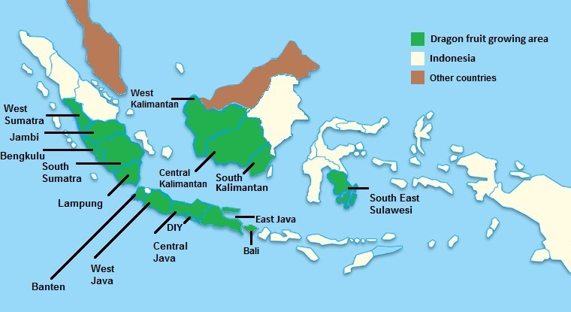

Source: [indonesia-tourism.com/map/indonesia-map.html](http://www.indonesia-tourism.com/map/indonesia-map.html). Modified based on information provided by IAQA (2016)

### Climate in production areas

Indonesia is an extensive archipelago comprising more than 13,000 islands straddling the equator and extending more than 5,000 kilometres from east to west (Hays 2013). Because of its proximity to the equator and being surrounded by considerable volumes of water, Indonesia’s climate is characterised as marine equatorial and comprising two major seasons—a rainy monsoon season and a hot dry season.

Air temperatures vary little from season to season or between regions, with temperatures averaging 28 °C on the coastal plains, 26 °C in inland and mountain areas, and 23 °C in the higher mountain regions. The main variable in Indonesia’s climate is rainfall, but this varies greatly across growing districts (Figure 2). The wet season for most of Indonesia is from September to March, and the dry season, depending on the region, is from March or June to September. Rainfall in the northern and western areas of Indonesia is typically caused by monsoonal winds from the north east, while the dry periods experienced by areas to the east of central Java are the result of dry winds coming from Australia.

Figure Mean monthly maximum and minimum temperatures and mean monthly rainfall in main dragon fruit production districts

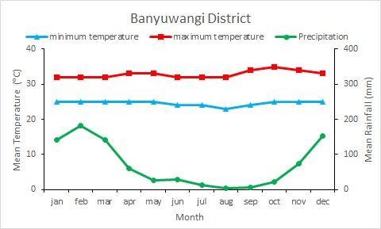 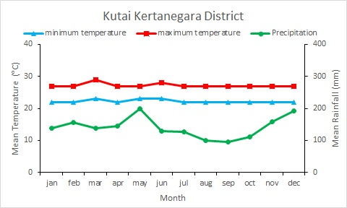

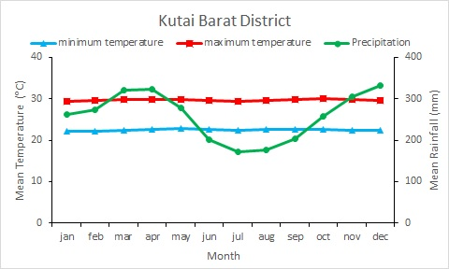 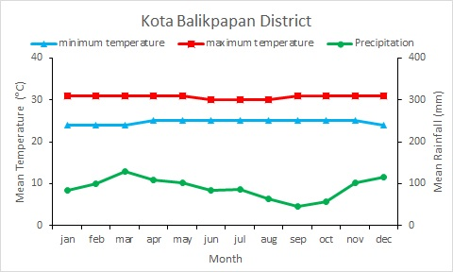

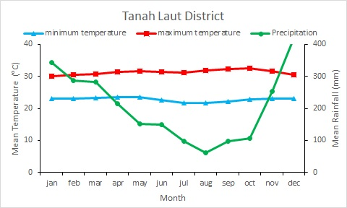 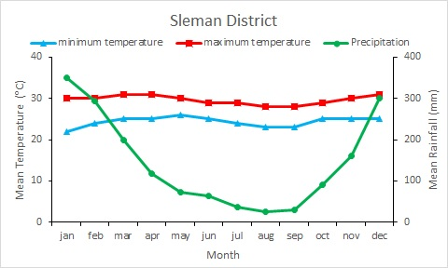

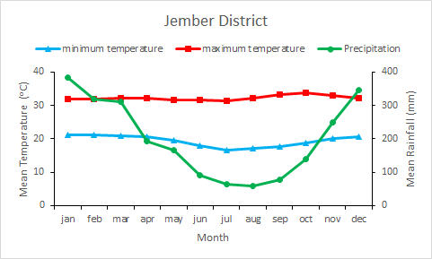

Source: (Climate-data.org 2017; World Weather Online 2017)

### Pre-harvest

#### Cultivars

All species of dragon fruit display certain similar fruit characteristics. The fruit is consistently spherical or oval shaped with waxy skin from which numerous bracts protrude over the whole fruit. At the tip of the fruit is a flower end pit and the base at the other end is connected directly to the plant stem. The fruit flesh is uniform and evenly filled with small edible black seeds (Le Bellec, Vaillant & Imbert 2006). The main species of dragon fruit grown in Indonesia are *Hylocereus monacanthus* (synonym *H. polyrhizus*), *H. costaricensis* and *H. undatus*. Indonesia intends to primarily export fruit of these species to Australia (IAQA 2016).

##### *Hylocereus monacanthus*

Fruit of *H. monacanthus* have red skin and red flesh. The fruit is slightly oblong in shape and typically grows to between 10–20 centimetres long and 150–400 grams in weight. The stems of the plant itself are slender. Flowers grow to 25 centimetres and have petals with red margins (Le Bellec, Vaillant & Imbert 2006).

##### *Hylocereus costaricensis*

Fruit of *H. costaricensis* have scarlet coloured skin with reddish purple flesh. The fruit is ovoid in shape and grows to between 10–15 centimetres in diameter and 250–600 grams in weight. Flowers are 25–30 centimetres long with red margins on the petals (Le Bellec, Vaillant & Imbert 2006).

##### *Hylocereus undatus*

Fruit of *H. undatus* have red skin and white flesh. Bracts are long and usually green at the tips. Fruit are 15–20 centimetres long and 300–800 grams in weight.

##### ***Hylocereus megalanthus***

Fruit of *H. megalanthus* have yellow skin and white flesh. Fruit are typically smaller and can weigh as little as 120 grams (Nerd & Mizrahi 1998). The bracts are also smaller and more uniform in shape than other species.

#### Cultivation practices

Dragon fruit are semi-epiphytic plants with aerial roots growing from the stems that enable them to attach to and climb over any natural or artificial support they come in contact with (Gunasena, Pushpakumara & Kariyawasam 2007; Le Bellec, Vaillant & Imbert 2006).

##### Cuttings

Commercially, new plants are mostly produced from stem cuttings selected from healthy, well established plants after the fruiting period has finished (IAQA 2016; Muas & Jumjunidang 2015; Suryanto 2016). Nursery stock was initially imported from Thailand and Vietnam. However, farmers now prepare their own propagation material. Cuttings approximately eight centimetres thick and 20–30 centimetres long are selected. The top surface of the cutting is cut flat and the bottom is tapered. Each cutting must have no fewer than four buds. Sap from the cutting wound is allowed to dry to prevent fungal infection before the cutting is planted. Cuttings are generally planted in plastic bags containing propagation media to promote root formation. Cuttings are often shaded and watered regularly for three weeks to promote establishment and bud development. At this stage the shading is removed and the cuttings are stored for three months prior to planting, at which time they are 50–80 centimetres tall (Muas & Jumjunidang 2015; Suryanto 2016). Cuttings may also be planted directly into the ground at the farm. Usually 3–4 cuttings are planted against each support post (Figure 3).

Figure Typical placement of cuttings against support post

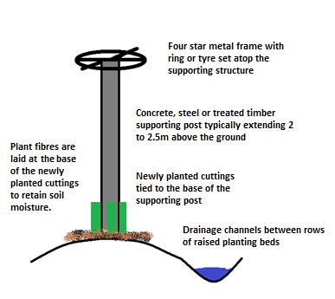

##### Planting

Dragon fruit plants are mostly supported by concrete or occasionally timber posts, generally with a square profile. However, the use of heavily pruned live trees as support structures is increasing (Figure 4) and dead tree branches are also used. Posts are generally 10–20 centimetres wide and are typically 2–2.5 metres tall. Posts are positioned in rows approximately 3–4 metres apart and each post is topped with a timber or iron cross extending horizontally, which supports an iron ring or bike tyre to train the shape and bear the weight of the plants (Suryanto 2016). The initial stem cuttings grow along the supporting structure, forming dense masses of multiple stems (Gunasena, Pushpakumara & Kariyawasam 2007).

Where live trees are used as a supporting structure, they are similarly spaced in rows. Tree species used include *Ceiba petandra* (Kapok), *Bombax malabarica* and *Garuga* spp. These trees can either be removed from the forest or plantation, defoliated and replanted at the production site, or grown at the site as saplings. Planting density is generally between 3000–4000 cuttings across 1000 posts or supports per hectare.

The planting holes are filled with a preparation of soil generally containing 10 kilograms of sand for drainage, 10–30 kilograms of composted manure, 300 grams of dolomite and 50 grams of *Trichoderma* as a biocontrol agent against fungal species (Harman 2006; IAQA 2016; Suryanto 2016). This mixture is piled against the posts in the planting holes and washed in with water. An application of 25 grams of triple superphosphate fertiliser is recommended 2–3 days later and planting can occur one day following the fertiliser application. Fertiliser is then applied every three months in the form of 10–50 kilograms of composted manure and 300 grams of dolomite per post. Alternatively, 500 grams of nitrogen, 500–700 grams of phosphate, 500 grams of potassium oxide and 20 kilograms of composted manure can be applied annually (Muas & Jumjunidang 2015; Suryanto 2016).

Figure Dragon fruit planting layout with live *Ceiba petandra* (Kapok) trees and artificial lighting system.

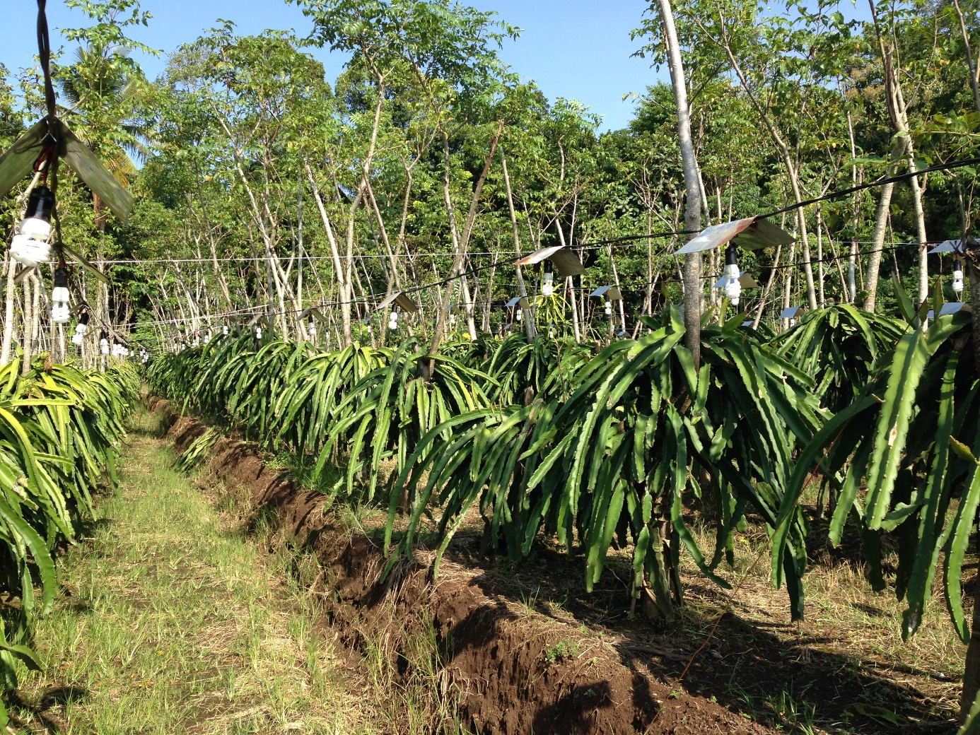

##### Planting time

Plants are typically replaced with new stock when a plant is 15–20 years old (Suryanto 2016). Dragon fruit plants can also be grafted to add new varieties of fruit onto established plants.

##### Pruning and sanitation

Pruning is conducted to promote good plant shape and to prepare cuttings, which can be acquired year round in Indonesia, but preferably following pruning after harvest (IAQA 2016; Muas & Jumjunidang 2015). After harvest, each post or support can have around 130 stems—grown from the original four stem cuttings—which are pruned back to 60 stems for the next season. Removal of weeds, plant debris and infected plant material is conducted regularly to maintain field sanitation.

##### Irrigation

Irrigation practices are dependent on soil type and water availability. Where water is abundant or soil drainage is poor, drainage channels up to 20 centimetres deep may be dug 80–100 centimetres between rows to prevent waterlogging (Suryanto 2016). Where water availability is limited, individual planting sites may be contained using concrete borders to reduce water runoff applied by irrigation during dry periods (Figure 5). Note that the farm pictured in Figure 5 is located opposite a beach on the southern coast of east Java and includes concrete borders around each planting site because of low water availability and sandy soils.

Drainage ditches between planting beds can also act as an irrigation reservoir when needed. During the dry season irrigation can be applied up to three times daily via drainage ditches or drip irrigation (Suryanto 2016).

Figure Dragon fruit farm using concrete borders around each planting site to conserve water because of low water availability and sandy soils.

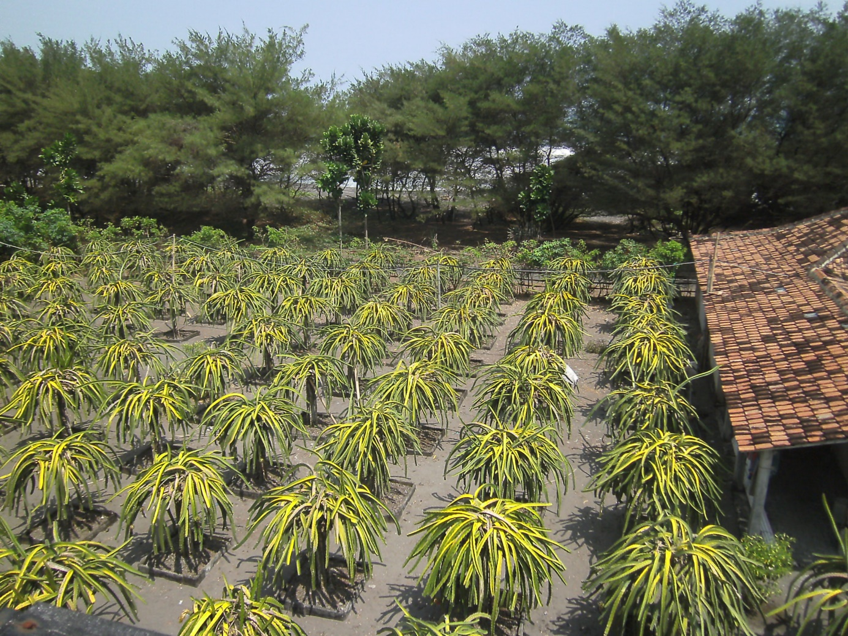

#### Pest management

One of the prerequisites for farm registration with MOA is that the farm has implemented an integrated pest management (IPM) program, including standard operating procedures and a recording system. There are currently 31 centres for Food and Horticulture Crop Protection at the provincial level and 84 laboratories at the district level supporting crop protection under the INDO‑GAP scheme, with pest monitors required to report to centres on a fortnightly basis.

Pest monitoring and surveillance are carried out by the farmers or staff from the responsible field laboratory/food crop and horticulture protection centre. General surveillance is carried out according to ISPM 6 (FAO 2016c), which includes recommendations for NPPOs to develop systems to collect, compile and verify appropriate information on pests of concern.

Pruning to promote air movement, removal of damaged or diseased stems from the farms, regular weeding and well aerated and drained planting beds are part of general farm hygiene practices that reduce the incidence of disease. Irrigation practices are important in disease management, especially in elevated areas with well-drained soils where water stress and sunburn can promote fungal infection. Avoidance of urea as a nitrogen fertiliser also reduces the incidence of stem rot (Muas & Jumjunidang 2015; Suryanto 2016).

Individual fruit bagging is commonly employed to protect fruit from birds, rats, fruit flies, snails, slugs and some small surface feeding arthropod pests (Figure 6). Liming is conducted as a means to raise the pH of the soil and reduce attack by giant African snail (IAQA 2016). Baited traps for fruit flies are employed on some farms (Figure 7). Detergents and plant-based (for example tobacco and neem oil) sprays are also used to repel or control pests. In some instances, biological control agents are used, such as *Trichoderma*, *Beauveria* and *Metahizium.*

Figure Fruit growing on the plant protected in a mesh bag tied off with twine

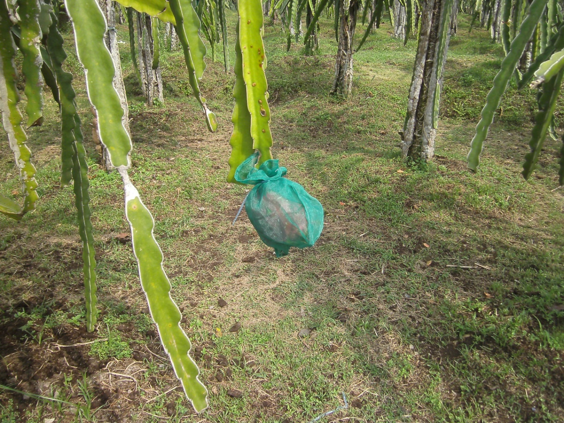

Figure Fruit fly lure on a farm growing dragon fruit and other fruit crops.

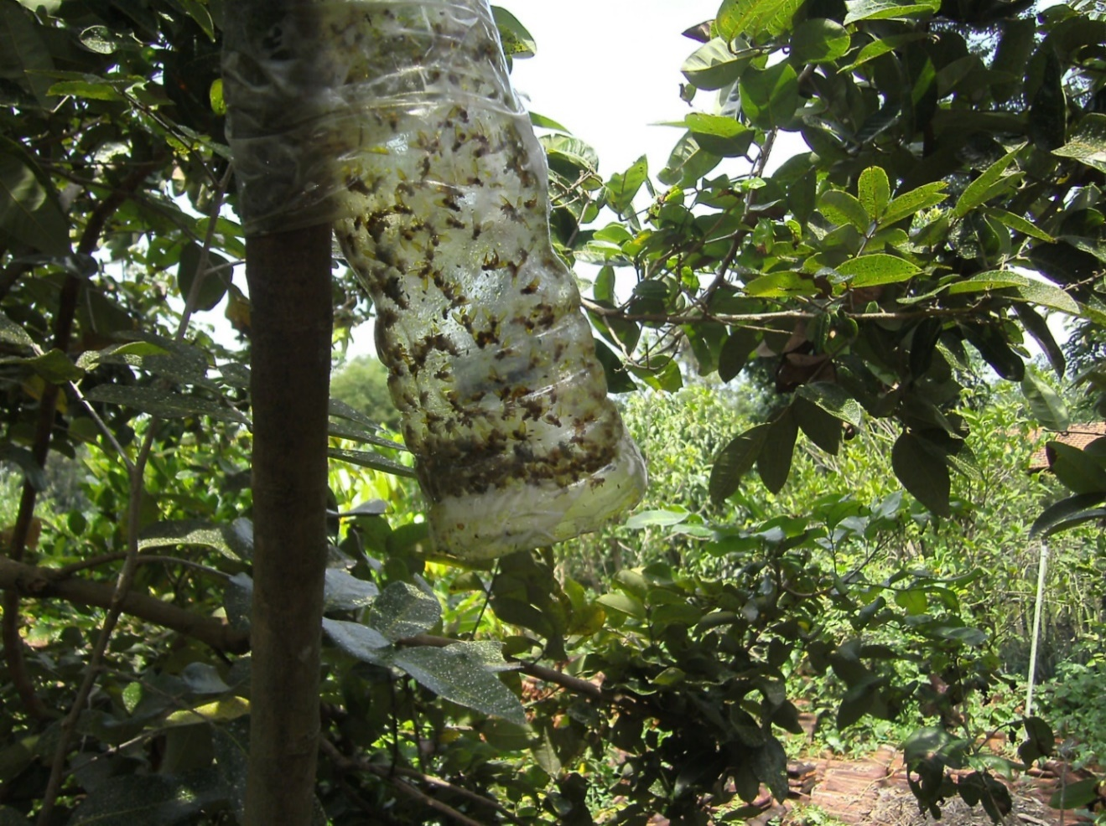

### Harvesting and handling procedures

In the equatorial regions of Sumatra, Kalimantan and Sulawesi, flowering and harvest occur year round. Further south in the Sumatran province of Lampung and the islands of Java, Madura, Bali, West Nusa Tenggara and East Nusa Tenggara flowering occurs from October to April, meaning a main harvest season from November to April (Muas & Jumjunidang 2015). Some farmers are beginning to trial forced flower induction using artificial lighting to extend the growing season and increase yields of dragon fruit.

Fruit is usually harvested for the international market 29–33 days after flowering. The fruit is harvested manually, cutting the fruit at the base without damaging the stems (IAQA 2016). Harvested fruit are collected into crates, which are covered in the field to reduce the temperature of fruit and maintain fruit quality, before being taken to the collection centre or packing house.

### Post-harvest

#### Collection centre and packing house

Harvested fruit are taken to a collection centre or packing house for cleaning and grading. It is an INDO-GAP requirement that fruit are washed in clean water and then dried and further cleaned with compressed air, cloths or brushes. Fruit are then graded based on skin colour and fruit weight (Figure 8). Fruit for export are required to have 30–40 per cent red colour on the fruit skin (IAQA 2016). There are also three weight grades that fruit are sorted into: A (>750 grams), B (500–750 grams) and C (<500 grams).

Fruit for export are fitted with a protective foam sleeve to prevent fruit damage, and packed directly into a cardboard carton. The packed fruit are weighed and labelled with the name, variety, quality class, quality certification, weight and place of origin. Packed fruit are stored at room temperature or under refrigeration until loading into sealed refrigerated trucks or containers for shipment (IAQA 2016).

Figure Fruit grading procedure in a packing house

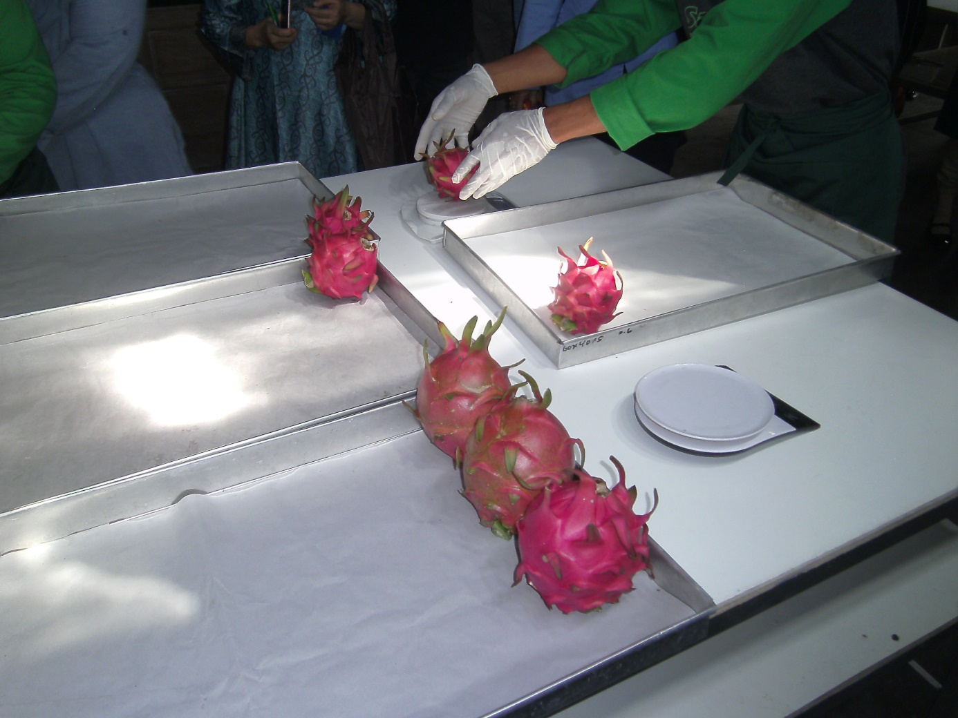

#### Transport

Shipments of dragon fruit are transported to the port or airport in enclosed refrigerated trucks (IAQA 2016). This usually occurs within 24 hours of packing, but can occur for up to ten days after storage at room temperature or under refrigeration.

Figure Summary of operational steps from harvesting to export for dragon fruit grown in Indonesia

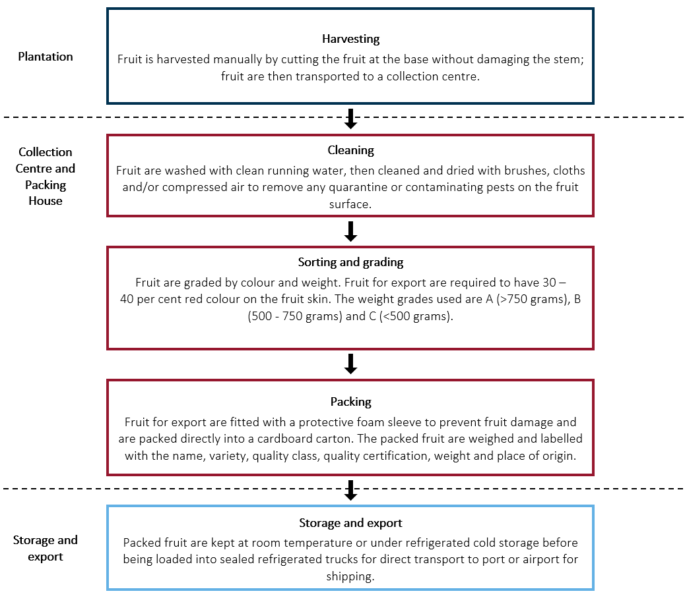

### Export capability

#### Production statistics

Dragon fruit farms currently produce up to 20 tonnes of dragon fruit per hectare per season. Further yield increases are expected with the introduction of forced flower induction through artificial lighting to allow for year round production on some farms.

#### Export statistics

There are currently 58 dragon fruit farms in Indonesia that are registered for export. Most of these are small farms of 0.01‑0.25 hectares in size with some larger farms operated by farmer groups or cooperatives. Dragon fruit production in Indonesia has expanded since 2000 (Suryanto 2016). International exports have grown rapidly from around one tonne in 2013 to almost 50 tonnes at a value of almost $200,000 equivalent in 2015 (ITC Comtrade 2016).

Indonesia exports dragon fruit to 16 countries and territories throughout the world. The main markets are Singapore, Vietnam and Hong Kong. Indonesia also exports dragon fruit to China, Thailand, Japan, United Arab Emirates, Saudi Arabia, Timor Leste, Kuwait, Qatar, Oman, Malaysia and Germany (IAQA 2016). A summary of recent export statistics is provided in Table 3.2.

Table . Summary of Indonesian Dragon fruit exports between 2013–2015 (all values in kilograms)

| Country | 2013 | 2014 | 2015 |
| --- | --- | --- | --- |
| Singapore | 0 | 5,587 | 14,486 |
| Vietnam | 0 | 0 | 10,504 |
| Hong Kong, China | 0 | 1,005 | 6,204 |
| All other | 1,137 | 3,648 | 18,178 |

Source; (ITC Comtrade 2016)

Dragon fruit is not yet a significant component of Indonesia’s total fresh fruit exports. The main fruits exported by Indonesia are banana, citrus, papaya, mango, salacca, mangosteen, rambutan and durian (Rafani 2015).

#### Export season

The peak harvest season of dragon fruit in Indonesia is from November to March (IAQA 2016). It is expected that exports to Australia would mainly occur during this period.

## Pest risk assessments for quarantine pests

Quarantine pests associated with dragon fruit from Indonesia are identified in the pest categorisation process (Appendix A) and are listed in

Table 4.1. Assessments of risks associated with these pests are presented in this chapter unless otherwise indicated.

All seven of the pest species considered here have been assessed previously by the department. Therefore, the outcomes of previous assessments have been adopted for these pests, unless new information is available that suggests the risk would be different in this case. The adoption of the outcomes of previous assessments is outlined here.

The likelihood of establishment and of spread of a pest in the PRA area will be comparable regardless of the fresh fruit commodity/country pathway in which the pest is imported into Australia, as these likelihoods relate specifically to events that occur in the PRA area and are independent of the importation pathway. The consequences of a pest are also independent of the importation pathway.

For pests that have been assessed previously, the department reviews the latest literature. If there is no new information available that would significantly change the likelihood risk ratings for establishment and for spread, or for the consequences the pests may cause, the risk ratings given in the previous assessments for these components will be adopted.

In this analysis, reassessment of the likelihood of distribution for pests that have been assessed previously is considered on a case-by-case basis, by comparing factors relevant to the distribution through the PRA area of dragon fruit from Indonesia with those assessed previously. These factors include the commodity type assessed previously, time of year at which import is likely to occur and availability and susceptibility of hosts during the time of import. After comparing these factors and reviewing the latest literature, the ratings of likelihood of distribution from the previous assessments will be adopted where the department considers that the likelihood of distribution through the PRA area for dragon fruit from Indonesia would be comparable to that determined in previous assessments.

The reassessment of the likelihood of importation of pests that have been assessed previously is also considered on a case-by-case basis, by comparing factors relevant to the importation of dragon fruit from Indonesia with those assessed previously. These factors include the commodity type previously assessed, pest species present and commercial production practices. After comparing these factors and reviewing the latest literature, the department considers it appropriate not to reassess the likelihood of importation of pests of dragon fruit from Indonesia, as it would be comparable to that determined in previous assessments. Consequently, the URE outcomes from previous assessments will be adopted for these pests (Table 4.1 and Table 4.2).

One pest identified in this assessment (Pacific mealybug; *Planococcus minor*) has been recorded in some regions of Australia. However, due to interstate quarantine regulations and enforcement, this pest is considered a pest of regional concern for Western Australia.

Table . Quarantine pests of dragon fruit from Indonesia for which the URE outcome is adopted from previous assessments

| Pest | Common name |
| --- | --- |
| **Fruit flies [Diptera: Tephritidae]** | |
| *Bactrocera cucurbitae* (EP) | Melon fly |
| *Bactrocera dorsalis* (EP) | Oriental fruit fly |
| **Mealybugs [Hemiptera: Pseudococcidae]** | |
| *Dysmicoccus neobrevipes* (EP) | Grey pineapple mealybug |
| *Paracoccus marginatus* (EP) | Papaya mealybug |
| *Planococcus lilacinus* (EP) | Coffee mealybug |
| *Planococcus minor* (EP, WA) | Pacific mealybug |
| *Pseudococcus jackbeardsleyi* (EP) | Jack Beardsley mealybug |

**EP:** Species has been assessed previously and import policy already exists. **WA:** Pest of quarantine concern for Western Australia.

### Fruit flies

#### *Bactrocera cucurbitae* (EP) *and Bactrocera dorsalis* (EP)

The species of fruit fly identified as quarantine pests associated with dragon fruit from Indonesia are the melon fly (*Bactrocera cucurbitae*) and Oriental fruit fly (*Bactrocera dorsalis*).

These two pests were identified as pests of quarantine concern in the *Final report of the review of biosecurity import requirements for fresh dragon fruit from Vietnam* (Department of Agriculture and Water Resources 2017b). This previous policy stipulated a requirement for area freedom or treatment for these pests. *Bactrocera dorsalis* and *B. cucurbitae* were also identified as present in Indonesia in the *Final report for the non-regulated analysis of existing policy for fresh mango fruit from Indonesia, Thailand and Vietnam* (Department of Agriculture and Water Resources 2015).

The department has reviewed scientific literature to identify any differences in pest risk between these previously assessed commodities and dragon fruit produced in Indonesia (Dohino et al. 2017; Kaneyuki et al. 2016; McQuate, Liquido & Nakamichi 2017). The review found no new information that would significantly change the risk ratings for importation, distribution, establishment, spread or consequences determined for these fruit flies in the existing policies.

### Mealybugs

#### *Dysmicoccus neobrevipes* (EP), *Paracoccus marginatus* (EP), *Planococcus lilacinus* (EP), *Planococcus minor* (EP, WA) and *Pseudococcus jackbeardsleyi* (EP)

The species of mealybug identified as quarantine pests associated with dragon fruit from Indonesia are grey pineapple mealybug (*Dysmicoccus neobrevipes*), papaya mealybug (*Paracoccus marginatus*), coffee mealybug (*Planococcus lilacinus*), Pacific mealybug (*Planococcus minor*) and Jack Beardsley mealybug (*Pseudococcus jackbeardsleyi*).

*Dysmicoccus neobrevipes*, *Planococcus lilacinus*, *Planococcus minor* and *Pseudococcus jackbeardsleyi* were identified as pests of quarantine concern in the *Final report for the review of biosecurity import requirements for fresh dragon fruit from Vietnam* (Department of Agriculture and Water Resources 2017b). *Paracoccus marginatus* was not included in that review because it is not present in Vietnam. *Paracoccus marginatus*, *Planococcus lilacinus*, *Planococcus minor* and *Pseudococcus jackbeardsleyi* were identified as present in Indonesia and as pests of quarantine concern in the *Final report for the non-regulated analysis of existing policy for fresh mango fruit from Indonesia, Thailand and Vietnam* (Department of Agriculture and Water Resources 2015). *Planococcus lilacinus* and *Planococcus minor* were identified as both present in Indonesia and as pests of quarantine concern in the *Final report for the non-regulated analysis of existing policy for fresh mangosteen fruit from Indonesia* (DAFF 2012). *Dysmicoccus neobrevipes* has not previously been assessed for commodities from Indonesia because, until recently, there were no records of this pest in Indonesia. However, *D. neobrevipes* has been recently reported in Indonesia (Kuswadi et al. 2016).

The department has reviewed scientific literature to identify any differences in pest risk between previously assessed commodities and dragon fruit produced in Indonesia (Doan et al. 2016; Hofmeyr et al. 2016; Kuswadi et al. 2016; Mani & Shivaraju 2016; Sartiami et al. 2017). The review found no new information that would significantly change the risk ratings for importation, distribution, establishment, spread or consequences determined for these mealybugs in the existing policies.

### Pest risk assessment conclusions

Key to Table 4.2 (starting next page)

Genus species (EP): pests for which policy already exists. The outcomes of previous assessments and/or reassessments in this risk analysis are presented in Table 4.2.

Genus species (Acronym for state/territory): state/territory in which regional quarantine pests have been identified.

Likelihoods for entry, establishment and spread

N negligible

EL extremely low

VL very low

L low

M moderate

H high

EES overall likelihood of entry, establishment and spread

Assessment of consequences from pest entry, establishment and spread

PLH plant life or health

OE other aspects of the environment

EC eradication, control

DT domestic trade

IT international trade

ENC environmental and non-commercial

A‑G consequence impact scores are detailed in section 2.2.3

A Indiscernible at the local level

B Minor significance at the local level

C Significant at the local level

D Significant at the district level

E Significant at the regional level

F Significant at the national level

G Major significance at the national level

URE unrestricted risk estimate. This is expressed on an ascending scale from negligible to extreme.

Table . Summary of unrestricted risk estimates for quarantine pests associated with dragon fruit from Indonesia

| Likelihood of | | | | | | | Consequences | URE |
| --- | --- | --- | --- | --- | --- | --- | --- | --- |
| Pest name | **Entry** | | | **Establishment** | **Spread** | **EES** |
| Importation | Distribution | **Overall** |
| **Fruit flies [Diptera: Tephritidae]** | | | | | | | | |
| *Bactrocera cucurbitae*(EP) | High | High | **High** | High | High | High | High | **High** |
| *Bactrocera dorsalis* (EP) |
| **Mealybugs [Hemiptera: Pseudococcidae]** | | | | | | | | |
| *Dysmicoccus neobrevipes* (EP) | High | Moderate | **Moderate** | High | High | Moderate | Low | **Low** |
| *Paracoccus marginatus* (EP) |
| *Planococcus lilacinus* (EP) |
| *Planococcus minor* (EP, WA) |
| *Pseudococcus jackbeardsleyi* (EP) |

## Pest risk management

This chapter provides information on the management of quarantine pests identified as having an unrestricted risk level that does not achieve the appropriate level of protection (ALOP) for Australia. The proposed risk management measures are described in this chapter.

### Pest risk management measures and phytosanitary procedures

Pest risk management evaluates and selects options for measures to reduce the risk of entry, establishment or spread of quarantine pests for the PRA area, in this case Australia, where they have been assessed as having an unrestricted risk level that does not achieve the ALOP for Australia. In calculating the unrestricted risk, existing commercial production practices and post‑harvest procedures in Indonesia have been considered.

Specific pest risk management measures, including operational systems, are proposed to achieve the ALOP for Australia. In this chapter, the Australian Government Department of Agriculture and Water Resources has identified risk management measures that may be applied to consignments of dragon fruit sourced from Indonesia. Finalisation of the import conditions may be undertaken with input from the Australian states and territories as appropriate.

#### Pest risk management for quarantine pests

The pest risk analysis identified the quarantine pests listed in Table 5.1 as having unrestricted risk levels that do not achieve the ALOP for Australia. Therefore, risk management measures are required to manage the risks posed by these pests, and those proposed measures are listed in Table 5.1.

Table . Risk management measures proposed for quarantine pests of dragon fruit from Indonesia

|  |  |  |
| --- | --- | --- |
| Pest | Common name | Measures |
| Fruit flies | | |
| *Bactrocera cucurbitae* (EP)  *Bactrocera dorsalis* (EP) | Melon fly  Oriental fruit fly | Area freedom **a**  OR  Fruit treatment considered to be effective against all life stages of fruit flies (e.g. vapour heat treatment or irradiation **b**) |
| Mealybugs | | |
| *Dysmicoccus neobrevipes* (EP)  *Paracoccus marginatus* (EP)  *Planococcus lilacinus* (EP)  *Planococcus minor* (EP, WA)  *Pseudococcus jackbeardsleyi* (EP) | Grey pineapple mealybug  Papaya mealybug  Coffee mealybug  Pacific mealybug  Jack Beardsley mealybug | Consignment freedom verified by pre-export visual inspection and remedial action **c**  OR  Irradiation at 400Gy **b** |

**a:** Area freedom may include pest free areas, pest free places of production and pest free production sites. **b**: The use of irradiation is subject to approval by Food Standards Australia New Zealand that irradiated dragon fruit is safe for human consumption **c:** Remedial action (by IAQA) may include applying approved treatment to a consignment to ensure that the pest is no longer viable, or withdrawing the consignment from export to Australia.

Risk management measures proposed here are based on existing policies for the import of dragon fruit from Vietnam (Department of Agriculture and Water Resources 2017b), as well as mangoes from India (Biosecurity Australia 2008), Indonesia, Thailand and Vietnam (Department of Agriculture and Water Resources 2015) and lychees from Taiwan and Vietnam (DAFF 2013). These risk analyses include consideration of all the pests identified in Table 5.1 of this report.

Outcomes of these existing risk analyses include trade in mangoes from India and Vietnam and lychees and dragon fruit from Vietnam, with over 26 tonnes of mangoes imported into Australia between 2011 and 2016 and over 55 tonnes of lychees between 2015 and 2016. The first imports of dragon fruit from Vietnam were in late September 2017. The risk management measures implemented for those commodities have successfully managed pests associated with those pathways. The risk management measures proposed for dragon fruit from Indonesia are the same as those established for dragon fruit from Vietnam.

This review of biosecurity import requirements proposes that, when the established risk management measures are followed, the restricted risks for all identified quarantine pests will achieve the ALOP for Australia. They include:

* area freedom or fruit treatment (such as vapour heat treatment) for fruit flies
* consignment freedom verified by visual inspection and, if detected, remedial action for mealybugs.

##### Management for *Bactrocera cucurbitae* and *Bactrocera dorsalis*

The Australian Government Department of Agriculture and Water Resources proposes the options of vapour heat treatment or area freedom as measures to reduce the risks associated with *B. cucurbitae* and *B. dorsalis*. The objective of each of these measures is to reduce the likelihood of importation of these pests to an assessed level of at least ‘extremely low’. The restricted risk would then also be reduced to an assessed level of at least ‘very low’, which would achieve the ALOP for Australia.

Irradiation treatment is considered a suitable measure for fruit flies of the family Tephritidae (FAO 2009). However, the use of irradiation on dragon fruit has not yet been approved by Food Standards Australia New Zealand (FSANZ). Therefore, irradiation cannot be used as a measure for dragon fruit until it is approved by FSANZ. Information on the irradiation of food and examples of previous FSANZ assessments can be found on the FSANZ website at <http://www.foodstandards.gov.au/consumer/foodtech/irradiation/Pages/default.aspx>.

###### Proposed measure 1: Vapour heat treatment

The Australian Government Department of Agriculture and Water Resources has reviewed efficacy data in support of use of vapour heat treatment and considered it suitable to manage *B. cucurbitae* and *B. dorsalis* in dragon fruit. The treatment is:

* forty minutes at a pulp temperature of 46.5 °C or greater with relative humidity 90 per cent or above.

###### Proposed measure 2: Area freedom

The requirements for establishing pest free areas, pest free places of production or pest free production sites are set out in ISPM 4: *Requirements for the establishment of pest free areas* (FAO 2016b), ISPM 10: *Requirements for the establishment of pest free places of production and pest free production sites* (FAO 2016d) and, more specifically, ISPM 26: *Establishment of pest free areas for fruit flies (Tephritidae)* (FAO 2016e).

*Bactrocera cucurbitae* and *B. dorsalis* are widespread in Indonesia (CABI 2017; Drew & Romig 2013). Therefore, area freedom may not be a viable option for these species in Indonesia. Should Indonesia wish to use area freedom as a measure to manage the risks posed by *B. cucurbitae* and *B. dorsalis*, IAQA would need to provide a submission demonstrating area freedom to the Australian Government Department of Agriculture and Water Resources. Any submission intended to demonstrate area freedom must fulfil requirements set out in ISPM 4 (FAO 2016b), ISPM 10 (FAO 2016d) and ISPM 26 (FAO 2016e) and would be subject to approval by the Australian Government Department of Agriculture and Water Resources.

###### Proposed measure 3: Irradiation

The Australian Government Department of Agriculture and Water Resources proposes a treatment schedule of 150 gray minimum absorbed dose, consistent with ISPM 28 Annex 7: *Irradiation treatment for fruit flies of the family Tephritidae (generic)* (FAO 2009) for *B. cucurbitae* and *B. dorsalis*, subject to FSANZ approval of this treatment for dragon fruit.

##### Management for *Dysmicoccus neobrevipes*, *Paracoccus marginatus*, *Planococcus lilacinus*, *Planococcus minor* and *Pseudococcus jackbeardsleyi*

The Australian Government Department of Agriculture and Water Resources proposes consignment freedom verified by visual inspection to confirm the absence of these pests and, if detected, application of remedial action as a measure for *Dysmicoccus neobrevipes* (grey pineapple mealybug), *Paracoccus marginatus* (papaya mealybug), *Planococcus lilacinus* (coffee mealybug), *Planococcus minor* (Pacific mealybug) and *Pseudococcus jackbeardsleyi* (Jack Beardsley mealybug). The objective of the proposed visual inspection is to ensure that any consignments of dragon fruit from Indonesia infested with these pests are identified and subjected to appropriate remedial action. The appropriate remedial action will reduce the risk associated with these pests to at least ‘very low’, which will achieve the ALOP for Australia.

###### Proposed measure 1: Pre-export visual inspection and remedial action by IAQA

All consignments of dragon fruit for export to Australia must be inspected by IAQA and found free of these species of mealybugs. Export consignments found to contain any of these pests must be subjected to remedial action. Remedial action may include withdrawing the consignment from export to Australia or treating the export consignment in such a way as to ensure that the pest is no longer viable.

###### Proposed measure 2: Irradiation

The Australian Government Department of Agriculture and Water Resources proposes a treatment schedule of 400Gy minimum absorbed dose (USDA 2016) for *Dysmicoccus neobrevipes*, *Paracoccus marginatus*, *Planococcus lilacinus*, *Planococcus minor* and *Pseudococcus jackbeardsleyi*, subject to FSANZ approval of this treatment for dragon fruit.

#### Consideration of alternative measures

Consistent with the principle of equivalence detailed in ISPM 11: *Pest risk analysis for quarantine pests* (FAO 2017b), the Australian Government Department of Agriculture and Water Resources will consider any alternative measure proposed by IAQA, providing that it manages the target pest in order to achieve the ALOP for Australia. Evaluation of such measures will require a technical submission from IAQA that details the proposed measures and includes appropriate information to support the efficacy.

### Operational system for the maintenance and verification of phytosanitary status

A system of operational procedures is necessary to maintain and verify the phytosanitary status of dragon fruit from Indonesia. This system will ensure that the proposed risk management measures have been met and continue to be maintained.

#### A system of traceability to source farms

The objectives of the recommended procedure are to ensure that:

* dragon fruit are sourced only from farms producing commercial quality fruit
* farms from which dragon fruit are sourced can be identified so any investigation and corrective action can be targeted rather than being applied to all contributing export farms, in the event that live pests are intercepted.

IAQA must ensure that dragon fruit for export to Australia can be traced back to farm level. IAQA would be responsible for ensuring that export dragon fruit growers are aware of pests of quarantine concern to Australia and the risk management measures applicable.

#### Registration of treatment providers and auditing of procedures

The objectives of this recommended procedure are to ensure that:

* dragon fruit are sourced only from treatment providers processing commercial quality dragon fruit approved by IAQA
* treatment providers are capable of applying a treatment that effectively manages the target pests.

Treatment of dragon fruit must be undertaken by the treatment providers that have been registered with and audited by IAQA for that purpose. Records of IAQA registration requirements and audits are to be made available to the Australian Government Department of Agriculture and Water Resources upon request.

Approval for treatment providers is subject to suitable systems to ensure compliance with the treatment requirements. This may include:

* documented procedures to ensure dragon fruit is appropriately treated and safeguarded post‑treatment
* staff training to ensure compliance with procedures
* record keeping procedures
* facilities and equipment are suitable
* IAQA system of oversight of treatment application or an alternative system of authorisation of treatment oversight.

#### Packaging and labelling

The objectives of this recommended procedure are to ensure that:

* Dragon fruit proposed for export to Australia and all associated packaging is not contaminated by quarantine pests or regulated articles (as defined in ISPM 5: Glossary of phytosanitary terms (FAO 2017a)).
* Unprocessed packaging material, for example unprocessed plant material—which are not permitted entry or which may vector pests identified as not being on the pathway or pests not known to be associated with dragon fruit—is not imported with the dragon fruit.
* All wood material used in packaging of dragon fruit complies with the Australian Government Department of Agriculture and Water Resources import conditions.
* Secure packaging is used during storage and transport to Australia to prevent re-infestation during storage and transport and escape of pests during clearance procedures on arrival in Australia. Packaging must meet Australia’s general import conditions for fresh fruits and vegetables, available on the Australian Government Department of Agriculture and Water Resources website.
* The packaged dragon fruit are labelled with sufficient identification information for the purposes of traceability. This may include:
  + for treated product: the treatment facility name/number and treatment identification reference/number
  + for commodity where the measures include farm freedom/area freedom: the farm reference/number
  + for commodity where phytosanitary measures are applied at the packing house: packing house reference/number.

Export packing houses and treatment providers (where applicable) ensure packaging and labelling are suitable to maintain phytosanitary status of the export consignments.

#### Specific conditions for storage and movement

The objective of this recommended procedure is to ensure that the quarantine integrity of the commodity is maintained during storage and movement.

Dragon fruit for export to Australia that have been treated and/or inspected must be kept secure and segregated at all times from any fruit for domestic or other markets, and untreated/non pre-inspected product to prevent mixing or cross-contamination.

#### Freedom from trash

The objective of this recommended procedure is to ensure that dragon fruit for export are free from trash (for example, stem and leaf material, seeds, soil, animal matter/parts or other extraneous material) and foreign matter.

Freedom from trash will be confirmed by pre-export inspection procedures. Export lots or consignments found to contain trash or foreign matter should be withdrawn from export unless approved remedial action such as reconditioning is available and applied to the export consignment, which is then re-inspected.

#### Pre-export phytosanitary inspection and certification by IAQA

The objectives of this recommended procedure are to ensure that Australia’s import conditions have been met.

All consignments must have been inspected in accordance with official procedures for visually detectable quarantine pests and other regulated articles (including soil, animal and plant debris) at a standard 600 unit sampling rate per phytosanitary certificate, or equivalent.

An international phytosanitary certificate (IPC) is issued for each consignment upon completion of pre-export inspection to verify that the required risk management measures have been undertaken offshore and that the consignment meets Australia’s import requirements

Each IPC includes:

* a description of the consignment (including traceability information)
* details of disinfestation treatments (for example, vapour heat treatment), including date, temperature, duration and/or attached treatment certificate (as appropriate)
* other statements that may be required.

#### Phytosanitary inspection by the Australian Government Department of Agriculture and Water Resources

The objectives of this recommended procedure are to ensure that:

* consignments comply with Australian import requirements
* consignments are as described on the phytosanitary certificate and quarantine integrity has been maintained.

On arrival in Australia, the Australian Government Department of Agriculture and Water Resources will:

* assess documentation to verify that the consignment is as described on the phytosanitary certificate, that required phytosanitary actions have been undertaken, and that product security has been maintained
* complete an inspection of dragon fruit consignments to verify that the biosecurity status of consignments of dragon fruit from Indonesia meets Australia’s import conditions, through the inspection of a random sample of 600 units of fruit per phytosanitary certificate.

#### Remedial action(s) for non-compliance

The objectives of remedial action(s) for non-compliance are to ensure that:

* any quarantine pest or regulated article is addressed by remedial action, as appropriate
* non-compliance with import requirements is addressed, as appropriate.

Any consignment that fails to meet Australia’s import conditions is subject to a suitable remedial treatment (if one is available), destroyed or exported in order to manage the biosecurity risk.

Other actions may be taken depending on the specific pest intercepted and the risk management strategy put in place for that pest.

If dragon fruit consignments are repeatedly non-compliant, the Australian Government Department of Agriculture and Water Resources reserves the right to suspend imports (either all imports or imports from specific pathways) and conduct an audit of the risk management systems. Imports will be allowed to recommence only when the Australian Government Department of Agriculture and Water Resources is satisfied that appropriate corrective action has been undertaken.

### Uncategorised pests

Any organism that has not been categorised, including a contaminant pest, detected on dragon fruit either in Indonesia or on arrival in Australia, will require assessment by the Australian Government Department of Agriculture and Water Resources to determine its quarantine status and whether phytosanitary action is required.

Assessment will also be required for any detected species that was categorised as not likely to be on the import pathway. The detection of any pests of quarantine concern not already identified in this analysis may result in remedial action and/or temporary suspension of trade while a review is conducted in order to ensure that the applied measures continue to provide the appropriate level of protection for Australia.

### Review of processes

#### Verification of protocol

Prior to or during the first season of trade, the Australian Government Department of Agriculture and Water Resources will verify the implementation of agreed import conditions and phytosanitary measures including registration, operational procedures and treatment providers, where applicable. This may involve representatives from the Australian Government Department of Agriculture and Water Resources visiting areas in Indonesia that produce dragon fruit for export to Australia.

#### Review of policy

The Australian Government Department of Agriculture and Water Resources will review the import policy after the first year of trade to ensure it is achieving the required biosecurity outcomes. In addition, the department reserves the right to review the import policy as deemed necessary, for example, if there is reason to believe that any pest or phytosanitary status in Indonesia has changed.

IAQA must inform the Australian Government Department of Agriculture and Water Resources immediately on detection in Indonesia of any new pests of dragon fruit that are of potential quarantine concern to Australia.

### Meeting Australia’s food laws

Imported food for human consumption must comply with the requirements of the *Imported Food Control Act 1992*, as well as Australian state and territory food laws. Among other things, these laws require all food, including imported food, to meet the standards set out in the Australia New Zealand Food Standards Code (the Code).

The Australian Government Department of Agriculture and Water Resources administers the *Imported Food Control Act 1992*. This legislation provides for the inspection and control of imported food using a risk-based border inspection program, the Imported Food Inspection Scheme. More information on this inspection scheme, including the testing of imported food, is available from the [department’s website](http://agriculture.gov.au/import/goods/food/inspection-compliance/inspection-scheme).

Food Standards Australia New Zealand (FSANZ) is responsible for developing and maintaining the Code, including Standard 1.4.2 - Agvet chemicals. This standard is available on the [Federal Register of Legislation](https://www.legislation.gov.au/) or through the [FSANZ website](http://www.foodstandards.gov.au/code/Pages/default.aspx).

Standard 1.4.2 and Schedules 20 and 21 of the Code set out the maximum residue limits (MRLs) and extraneous residue limits (ERLs) for agricultural or veterinary chemicals that are permitted in food, including imported food.

Standard 1.1.1 of the Code specifies that a food must not have, as an ingredient or a component, a detectable amount of an Agvet chemical or a metabolite or a degradation product of the Agvet chemical unless expressly permitted by the Code.

Standard 1.5.3 of the code stipulates the mandatory requirements where irradiation is applied as a phytosanitary measure, including the permitted fruit and vegetables, sources of irradiation, minimum and a maximum absorbed dose, and the record keeping and labelling requirements for irradiated produce.

## Conclusion

The findings of this *Draft report for the review of biosecurity import requirements for dragon fruit from Indonesia* are based on a comprehensive scientific analysis of relevant literature.

The Australian Government Department of Agriculture and Water Resources considers that the risk management measures proposed in this report will provide an appropriate level of protection against the pests identified as associated with the trade of dragon fruit from Indonesia.

## Appendix A: Categorisation of pests of fresh dragon fruit from Indonesia and comparison with pests of dragon fruit from Vietnam

The following pest categorisation table lists pests of dragon fruit from Indonesia and also highlights those pests that are shared with dragon fruit from Vietnam. The second column of the table lists the presence of the pests and pathogens in Indonesia, and whether they are also present in Vietnam. Species not present in Vietnam, but present in Indonesia, are shaded in grey. Species present in both countries are left unshaded—these pests and pathogens have already been assessed in the risk analysis for dragon fruit from Vietnam, the final policy for which was published on 12 January 2017.

The steps in the initiation and categorisation processes are considered sequentially, with the assessment terminating at ‘Yes’ for column 3 (except for pests that are present, but under official control and/or pests of regional concern) or at the first ‘No’ for columns 4, 5 or 6.

In the final column of the table (column 7) the acronyms ‘EP’ and ‘WA’ are used. The acronym EP (existing policy) is used for pests that had previously been assessed by Australia and for which policy existed before the publication of the dragon fruit from Vietnam report and final policy. The acronym WA is used to identify organisms that have been recorded in some regions of Australia but, due to interstate quarantine regulations, are considered pests of regional concern to Western Australia.

Details of the method used in this risk analysis are given in Section 2: Method for pest risk analysis.

The *Final group pest risk analysis for thrips and orthotospoviruses on fresh fruit, vegetable, cut-flower and foliage imports* (Department of Agriculture and Water Resources 2017a) has been applied in this risk analysis.

For the purposes of pest categorisation, the table does not provide a comprehensive list of all species associated with the entire plant, but concentrates on pests that could be on the fresh dragon fruit import pathway. References to soil‑borne nematodes, soil‑borne pathogens, wood‑borer pests, root pests or pathogens, stored product pests and secondary pests have not been listed, as they are not directly related to the import pathway of the fresh dragon fruit commodity and would be addressed by Australia’s current approach to contaminating pests.

The department is aware of the recent changes in fungal nomenclature, which ended the separate naming of different states of fungi with a pleomorphic life cycle. However, as the nomenclature for these fungi is in a phase of transition and many priorities of names are still to be resolved, this report uses the generally accepted names and provides alternatively used names as synonyms, where required. As official lists of accepted and rejected fungal names become available, the accepted names will be adopted.

| Pest | Present in Indonesia and Vietnam | Present within Australia | Potential to be on pathway | Potential for establishment and spread | Potential for economic consequences | Pest risk assessment required |
| --- | --- | --- | --- | --- | --- | --- |
| **ARTHROPODS** | | | | | | |
| Diptera | | | | | | |
| *Bactrocera cucurbitae* (Coquillett, 1899)  [Tephritidae]  Melon fly | Indonesia, Vietnam (CABI 2017; Drew & Romig 2013; Hoa et al. 2006; PPD 2012) | No. Records of *Bactrocera cucurbitae* in Australia refer to Christmas Island and occasional outbreaks in the Torres Strait Islands (CSIRO 2017). The Torres Strait Islands is a group of more than 270 islands in a narrow channel (150 km wide) between Australia and Papua New Guinea. There are quarantine measures in place to prevent the spread of *B. cucurbitae* to mainland Australia from the Torres Strait Islands (Department of Agriculture and Water Resources 2017c). Christmas Island is an external territory of Australia situated in the Indian Ocean lying more than 1500 km northwest of the mainland. | Yes. This species has been intercepted in infested fruit of commercial dragon fruit consignments (McQuate 2010). | Yes. *Bactrocera cucurbitae* infests commercially grown cucurbit species including squash, cucumber and watermelon (White & Elson-Harris 1992). It is widely distributed throughout India, South East Asia and Central Africa (CABI 2017; Dhillon et al. 2005). The host range and current geographic distribution of this pest suggest that there are suitable environments for this pest to establish and spread in Australia. | Yes. Depending on the host and season, losses due to *Bactrocera cucurbitae* can be up to 100% of a crop (Dhillon et al. 2005). | Yes (EP) |
| *Bactrocera dorsalis* (Hendel, 1912)  Synonyms: *Bactrocera invadens* Drew, Tsuruta & White, 2005, *B. papayae* Drew & Hancock, 1994 and *B. philippinensis* Drew & Hancock, 1994 have recently been synonymised with *B. dorsalis* (Schutze et al. 2014)  [Tephritidae]  Oriental fruit fly | Indonesia, Vietnam (Drew & Hancock 1994; Drew & Romig 2013; Hoa et al. 2006; IAQA 2016; PPD 2010) | No. An incursion into Australia was eradicated in 1996 (Hancock et al. 2000) | Yes. This species is known to infest the fruit of dragon fruit in both Vietnam (PPD 2010) and Indonesia (IAQA 2016). It has been intercepted in infested dragon fruit consignments from Vietnam to Japan (Hoa et al. 2006; McQuate 2010). | Yes. *Bactrocera dorsalis* attacks over 300 cultivated and wild fruits, and has a broad global distribution due to its ability to establish when introduced into new environments (Mau & Martin Kessing 2007). | Yes. Feeding by *Bactrocera dorsalis* larvae directly damages fruit and causes rotting due to bacteria and fungi (Mau & Martin Kessing 2007). *Bactrocera dorsalis* can infest unprotected fruit crops with rates up to 100% (CABI 2017). | Yes (EP) |
| Hemiptera | | | | | | |
| *Aphis gossypii* Glover, 1877  [Aphididae]  Cotton aphid | Indonesia, Vietnam (CABI 2017; PPD 2010; Waterhouse 1993) | Yes. NSW, NT, Qld, SA, Tas., Vic., WA (Plant Health Australia 2017) | Assessment not required | Assessment not required | Assessment not required | No |
| *Bemisia tabaci,* (Gennadius, 1889)  [Aleyrodidae]  Tobacco whitefly | Indonesia (IAQA 2016) | Yes. NSW, NT, Qld, SA, WA (Plant Health Australia 2017) | Assessment not required | Assessment not required | Assessment not required | No |
| *Brachycaudus helichrysi* (Kaltenbach, 1843)  [Aphididae]  Leaf-curl plum aphid | Indonesia (IAQA 2016) | Yes. NSW, Qld, SA, Tas., Vic., WA (Plant Health Australia 2017) | Assessment not required | Assessment not required | Assessment not required | No |
| *Coccus hesperidum* Linnaeus, 1758  [Coccidae]  Brown soft scale | Indonesia, Vietnam (García et al. 2017; PPD 2010) | Yes. ACT, NSW, NT, Qld, SA, Tas., Vic., WA (Plant Health Australia 2017) | Assessment not required | Assessment not required | Assessment not required | No |
| *Dysmicoccus brevipes* (Cockerell, 1893)  Synonym: *Pseudococcus brevipes* Fernald, 1903  [Pseudococcidae]  Pineapple mealybug | Indonesia, Vietnam (García et al. 2017; PPD 2010) | Yes. NSW, NT, Qld, SA, WA (Plant Health Australia 2017) | Assessment not required | Assessment not required | Assessment not required | No |
| *Dysmicoccus neobrevipes* Beardsley, 1959  [Pseudococcidae]  Grey pineapple mealybug | Indonesia, Vietnam (Kuswadi et al. 2016; PPD 2010; Williams 2004) | No records found | Yes. Attacks the flowers, fruit and stems of dragon fruit (PPD 2010). | Yes. *Dysmicoccus neobrevipes* feeds on a wide range of host plants including citrus and mango, and has been reported as an important economic pest of pineapple and banana throughout its pantropical distribution (CABI 2017). The host range and current geographic distribution of this pest suggest that there are suitable environments for this pest to establish and spread in Australia. | Yes. Mealybugs directly damage their plant hosts, reducing productivity. *Dysmicoccus neobrevipes* is an important pest of pineapple and is a vector of pineapple wilt disease (Khoo, Ooi & Ho 1991; Williams 2004) | Yes (EP) |
| *Ferrisia virgata* (Cockerell, 1893)  [Pseudococcidae]  Striped mealybug | Indonesia, Vietnam (García et al. 2017; PPD 2010) | Yes. NSW, NT, Qld, WA (Plant Health Australia 2017; Poole 2010) | Assessment not required | Assessment not required | Assessment not required | No |
| *Maconellicoccus hirsutus* (Green, 1908)  [Pseudococcidae]  Pink hibiscus mealybug | Indonesia (CABI 2017; Kalshoven 1981) | Yes. NSW, NT, Qld, Vic., WA (Plant Health Australia 2017) | Assessment not required | Assessment not required | Assessment not required | No |
| *Mictis longicornis* Westwood, 1842  [Coreidae]  Rose coreid | Indonesia, Vietnam (CABI 2017; Kalshoven 1981; PPD 2010) | No records found | No. Attacks the stem and shoots of dragon fruit (PPD 2010). | Assessment not required | Assessment not required | No |
| *Nezara viridula* (Linnaeus, 1758)  [Pentatomidae]  Green vegetable bug | Indonesia, Vietnam (CABI 2017; Kalshoven 1981; PPD 2010) | Yes. ACT, NSW, NT, Qld, SA, Tas., Vic., WA (Plant Health Australia 2017) | Assessment not required | Assessment not required | Assessment not required | No |
| *Paracoccus marginatus* Williams & Granara de Willink, 1992  [Pseudococcidae]  Papaya mealybug | Indonesia (IAQA 2016; Plant Health Australia 2017) | No records found | Yes. Attacks the stem and fruit of dragon fruit (IAQA 2016). | Yes. *Paracoccus marginatus* is widely distributed throughout the tropics and feeds on a broad range of hosts including papaya, hibiscus, pineapple, orange and avocado (CABI 2017). The host range and current geographic distribution of this pest suggest that there are suitable environments for this pest to establish and spread in Australia. | Yes. Mealybugs directly damage their plant hosts, reducing productivity. *Paracoccus marginatus* is an important pest of papaya and cassava across its tropical distribution (CABI 2017). | Yes (EP) |
| *Pentalonia nigronervosa* Coquerel, 1859  [Aphididae]  Banana aphid | Indonesia, Vietnam (CABI 2017; Kalshoven 1981; PPD 2010) | Yes. NSW, NT, Qld, limited distribution in WA (Plant Health Australia 2017). Regulated as a Declared Organism (Prohibited (s22(2))) of WA Biosecurity and Agriculture Management Act (2007) (Government of Western Australia 2017). | No. Attacks the stems of dragon fruit (PPD 2010). | Assessment not required | Assessment not required | No |
| *Planococcus citri* (Risso, 1813)  [Pseudococccidae]  Citrus mealybug | Indonesia, Vietnam (CABI 2017; García et al. 2017; Kalshoven 1981) | Yes. NSW, NT, Qld, SA, Tas., Vic., WA (Plant Health Australia 2017) | Assessment not required | Assessment not required | Assessment not required | No |
| *Planococcus lilacinus* (Cockerell, 1905)  [Pseudococcidae]  Coffee mealybug | Indonesia, Vietnam (García et al. 2017; Plant Health Australia 2017) | Yes. However, distribution is limited to the northern tip of Cape York (Government of Queensland 2016) and there is legislation in place to prevent the spread of this species(Department of Agriculture and Water Resources 2017c; Office of the Queensland Parliamentary Counsel 2016). | Yes. *Planococcus lilacinus* attacks the fruit of dragon fruit (USDA-APHIS 2008). | Yes. *Planococcus lilacinus* has a wide host range and is distributed throughout many tropical areas (Entwistle 1972). Reproduction is usually parthenogenetic (Khoo, Ooi & Ho 1991). | Yes. *Planococcus lilacinus* is common in southern Asia and has been reported attacking many economically important crops (Williams 2004). It is considered a major threat to agriculture (Miller, Miller & Watson 2002). | Yes (EP) |
| *Planococcus minor* (Maskell, 1897)  [Pseudococcidae]  Pacific mealybug | Indonesia, Vietnam (García et al. 2017; PPD 2010) | Yes. ACT, NSW, NT, Qld, SA, Vic. (Plant Health Australia 2017). Regulated as a Declared Organism (Prohibited (s12)) of WA Biosecurity and Agriculture Management Act (2007) (Government of Western Australia 2017). | Yes. As this species attacks the fruit of dragon fruit in Vietnam (PPD 2010) it is likely to be asociated with dragon fruit across its distribution. | Yes. *Planococcus minor* has a wide host range including mango, banana, mandarin, potato and grapevine (CABI 2017). It is distributed in the Australian states and territories of ACT, NSW, NT, Qld, SA and Vic. Internationally it is distributed in most of Asia, Eastern Europe and parts of Africa in environments ranging from temperate to tropical (García et al. 2017). | Yes. *Planococcus minor* is a significant pest of over 250 plant species, across almost 80 families, and including several commercial crops (Venette & Davis 2004).(Roda et al. 2013) | Yes (EP, WA) |
| *Pseudococcus jackbeardsleyi* Gimpel & Miller, 1996  [Pseudococcidae]  Jack Beardsley mealybug | Indonesia, Vietnam (García et al. 2017; PPD 2010) | Yes. However, distribution is limited to the northern tip of Cape York (Government of Queensland 2016) and there is legislation in place to prevent the spread of this species(Department of Agriculture and Water Resources 2017c; Office of the Queensland Parliamentary Counsel 2016). | Yes. As this species attacks the flowers, fruit and stems of dragon fruit in Vietnam (PPD 2010) it is likely to be asociated with dragon fruit across its distribution. | Yes. *Pseudococcus jackbeardsleyi* feeds on a wide variety of commercial fruit, including banana, tomato and hibiscus (CABI 2017). It is widely distributed over both tropical and temperate environments (García et al. 2017). The host range and current geographic distribution of this pest suggest that there are suitable environments for this pest to establish and spread in Australia. | Yes. *Pseudococcus jackbeardsleyi* is reported on many vegetable and ornamental crop species including banana, tomato, potato, pepper and Hibiscus (García et al. 2017). | Yes (EP) |
| *Pseudococcus viburni* (Signoret, 1875)  Synonym: *Pseudococcus affinis* (Maskell, 1894)  [Pseudococcidae] | Indonesia (García et al. 2017) | Yes. NSW, NT, Qld, SA, Tas., Vic., WA (Plant Health Australia 2017) | Assessment not required | Assessment not required | Assessment not required | No |
| *Spilococcus mamillariae* (Bouche, 1844)  [Pseudococcidae]  Cactus Mealybug | Indonesia (Suh, Yu & Hong 2013) | Yes. NSW, SA, Tas. (García et al. 2017; Plant Health Australia 2017) | Assessment not required | Assessment not required | Assessment not required | No |
| Thysanoptera | | | | | | |
| No thrips species associated with dragon fruit were identified by Indonesia. Application of the *Final group pest risk analysis for thrips and orthotospoviruses on fresh fruit, vegetable, cut-flower and foliage import*s (Department of Agriculture and Water Resources 2017a) did not identify any thrips that are associated with the fresh dragon fruit export pathway from Indonesia. A further literature search found no thrips species that are likely to be present on the fresh dragon fruit pathway. | | | | | | |
| **BACTERIA** | | | | | | |
| *Enterobacter cloacae* (Jordan, 1890) Hormaeche and Edwards 1960  [Enterobacteriales: Enterobacteriaceae] | Indonesia, Vietnam (Nagano et al. 2000; Suprapta, Maulina & Khalimi 2014) | Yes. NSW, Qld, WA (Plant Health Australia 2017) | Assessment not required | Assessment not required | Assessment not required | No |
| *Erwinia chrysanthemi* Burkholder *et al.*, 1953  [Enterobacteriales: Enterobacteriaceae]  Fruit soft rot  Note: *Erwinia chrysanthemi* has been split into at least six *Dickeya* species. It is not certain which *Dickeya* species these records refer to. | Indonesia, Vietnam (Haerani & Damayanti 2015; Hoa et al. 2014) | No. This species has been reclassified into multiple species within a new genus (Marrero et al. 2013; Samson et al. 2005). Due to the uncertainty around the taxonomy of this complex, the identity of the species recorded from either Australia or Indonesia cannot be confidently assessed without in‑depth molecular examination. | No. This species infects flowers and young fruit, forming water-soak blisters and obvious secondary infections that can spread to the whole fruit within  12–24 hours (Hieu & Hoa 2015; Hoa et al. 2014). Infected fruits will be culled during standard commercial production practices. | Assessment not required | Assessment not required | No |
| *Pectobacterium carotovorum* (Jones, 1901) Waldee 1945 (approved lists) emend. Hauben *et al.* 1998  Synonym: *Erwinia carotovora* (Jones, 1901) Berge *et al*. 1923 (Approved lists 1980)  [Enterobacteriales: Enterobacteriaceae] | Indonesia, Vietnam (Bhat et al. 2012; Do et al. 2011; IAQA 2016) | Yes. NSW, Qld, SA, Vic., WA (Plant Health Australia 2017) | Assessment not required | Assessment not required | Assessment not required | No |
| **CHROMALVEOLATA** | | | | | | |
| *Phytophthora cactorum* (Lebert & Cohn) J. Schröt.  [Peronosporales: Peronosporaceae]  Apple collar rot | Indonesia, Vietnam (CABI 2017; Drenth & Guest 2004; PPD 2010) | Yes. NSW, Qld, Vic., WA (Plant Health Australia 2017) | Assessment not required | Assessment not required | Assessment not required | No |
| *Phytophthora nicotianae* Breda de Haan  Synonym: *Phytophthora parasitica* Dastur  [Peronosporales: Peronosporaceae]  Black shank | Indonesia, Vietnam (CABI 2017; Discover Life 2017; Farr & Rossman 2017) | Yes. NSW, NT, Qld, SA, Vic. (Plant Health Australia 2017). Listed as Permitted under s11of WA Biosecurity and Agriculture management Act (2007) (Government of Western Australia 2017). | Assessment not required | Assessment not required | Assessment not required | No |
| *Pythium aphanidermatum* (Edson) Fitzp  [Peronosporales: Pythiaceae]  Damping-off | Indonesia, Vietnam (CABI 2017) | Yes. NSW, Qld, WA (Plant Health Australia 2017) | Assessment not required | Assessment not required | Assessment not required | No |
| **FUNGI** | | | | | | |
| *Aspergillus awamori* Nakaz.  Synonym: *Aspergillus niger* var. *awamori*  [Eurotiales: Trichocomaceae] | Indonesia, Vietnam (Hong Mien et al. 2012; Le et al. 2000) | No records found | No. There has been only one report of this pest on dragon fruit (Le et al. 2000). This Vietnamese quality assurance system report incidentally lists a number of fungi found on the stored fruit used in the study. There is no other evidence supporting *Aspergillus awamori* being a pest of dragon fruit. | Assessment not required | Assessment not required | No |
| *Aspergillus clavatus* Desm.  [Eurotiales: Trichocomaceae] | Indonesia, Vietnam (Le et al. 2000; Sjamsuridzal & Lisdiyanti 2008) | Yes. Qld, Vic., WA (Plant Health Australia 2017) | Assessment not required | Assessment not required | Assessment not required | No |
| *Aspergillus fumigatus* Fresen.  [Eurotiales: Trichocomaceae] | Indonesia, Vietnam (Farr & Rossman 2017; Le et al. 2000; Sjamsuridzal & Lisdiyanti 2008) | Yes. NSW, Qld, WA (Plant Health Australia 2017) | Assessment not required | Assessment not required | Assessment not required | No |
| *Aspergillus niger* Tiegh.  [Eurotiales: Trichocomaceae]  Collar rot | Indonesia, Vietnam (CABI 2017; Pitt & Hocking 2012; PPD 2010) | Yes. NSW, NT, Qld, Vic., WA (Plant Health Australia 2017) | Assessment not required | Assessment not required | Assessment not required | No |
| *Aspergillus oryzae* (Ahlburg)Cohn  [Eurotiales: Trichocomaceae] | Indonesia, Vietnam (Discover Life 2017; Hong Mien et al. 2012; Le et al. 2000) | No records found | No. There has been only one report of this pest on dragon fruit (Le et al. 2000). This Vietnamese quality assurance system report incidentally lists a number of fungi found on the stored fruit used in the study. There is no other evidence supporting *Aspergillus oryzae* being a pest of dragon fruit. | Assessment not required | Assessment not required | No |
| *Aspergillus tubingensis* Mosseray  [Eurotiales: Trichocomaceae] | Indonesia, Vietnam (Hong Mien et al. 2012; Le et al. 2000; Nugroho et al. 2013) | No records found | No. There has been only one report of this pest on dragon fruit (Le et al. 2000). This Vietnamese quality assurance system report incidentally lists a number of fungi found on the stored fruit used in the study. There is no other evidence supporting *Aspergillus tubingensis* being a pest of dragon fruit. | Assessment not required | Assessment not required | No |
| *Athelia rolfsii* (Curzi) C. C. Tu & Kimber.  Synonym: *Sclerotium rolfsii* Sacc.  [Atheliales: Atheliaceae]  Sclerotium rot | Indonesia (CABI 2017; Farr & Rossman 2017; IAQA 2016) | Yes. NSW, NT, Qld, SA, Vic., WA (Plant Health Australia 2017) | Assessment not required | Assessment not required | Assessment not required | No |
| *Bipolaris cactivora* (Petr.) Alcorn  Synonym: *Drechslera cactivora* (Petr.) M.B. Ellis,  [Pleosporales: Pleosporaceae]  Stem rot | Indonesia, Vietnam (He et al. 2012; IAQA 2016) | Yes. NSW, Vic. (Plant Health Australia 2017) | Assessment not required | Assessment not required | Assessment not required | No |
| *Botrytis cinerea* Pers.  [Helotiales: Screotiniaceae]  Grey mould | Indonesia, Vietnam (Discover Life 2017; Nene, Sheila & Sharma 1996) | Yes. NSW, Qld, SA, Tas., Vic., WA (Plant Health Australia 2017) | Assessment not required | Assessment not required | Assessment not required | No |
| *Cladosporium herbarum* (Pers.) Link  [Capnodiales: Cladosporiaceae] | Indonesia, Vietnam (Farr & Rossman 2017; PPD 2010) | Yes. NSW, Qld, SA, Tas., Vic., WA (Plant Health Australia 2017) | Assessment not required | Assessment not required | Assessment not required | No |
| *Colletotrichum coccodes* (Wallr.) S. Hughes  [Glomerellales: Glomerellaceae]  Anthracnose | Indonesia, Vietnam (CABI 2017; Duriat & van der Wolf 2006; PPD 2010) | Yes. NSW, NT, Qld, SA, Tas., Vic., WA (Plant Health Australia 2017) | Assessment not required | Assessment not required | Assessment not required | No |
| *Colletotrichum fructicola* Prihastuti, L. Cai & K.D. Hyde  Synonym: *Glomerella cingulata* var. *minor* Wollenw.  [Glomerellales, Glomerellaceae,]  Bitter rot | Indonesia (Farr & Rossman 2017; Liu et al. 2015)  Records of this species in Indonesia are only from *Camellia sinensis*. However, this fungus has hosts from multiple genera in multiple families (Farr & Rossman 2017) with a single unsubstantiated record of dragon fruit as a host (CABI 2017). | Yes. Qld (Plant Health Australia 2017; Simmonds 1966) | Assessment not required | Assessment not required | Assessment not required | No |
| *Colletotrichum gloeosporioides* (Penz.) Penz. & Sacc.  Synonym: *Glomerella cingulata* (Stonem.) Spaud. & H. Schrenk.  [Glomerellales: Glomerellaceae]  Anthracnose | Indonesia, Vietnam (CABI 2017; PPD 2010) | Yes. NSW, NT, Qld, SA, Tas., Vic., WA (Plant Health Australia 2017) | Assessment not required | Assessment not required | Assessment not required | No |
| *Colletotrichum musae* (Berk. & M.A. Curtis) Arx.  [Glomerellales: Glomerellaceae]  Tip rot of banana | Indonesia, Vietnam (Discover Life 2017; Farr & Rossman 2017; PPD 2010) | Yes. NSW, Qld, Vic., WA (Plant Health Australia 2017) | Assessment not required | Assessment not required | Assessment not required | No |
| *Colletotrichum truncatum* (Schwein) Andrus & W.D. Moore  Synonym: *Colletotrichum capsici* (Syd. & P. Syd.) E.J. Butler & Bisby  [Glomerellales: Glomerellaceae] | Indonesia, Vietnam (IAQA 2016; PPD 2010) | Yes. NSW, NT, Qld, Vic. (Plant Health Australia 2017) Qld, WA (Ash et al. 2014) | Assessment not required | Assessment not required | Assessment not required | No |
| *Corynespora cassiicola* (Berk. and M.A. Curtis) C.T. Wei  [Pleosporales: Corynesporascaceae]  Leaf spot/ target leaf spot of tomato | Indonesia (CABI 2017; IAQA 2016; Narayanan & Mydin 2012) | Yes. NSW, Qld, Vic., NT (Plant Health Australia 2017). Regulated as a Declared Organism (Prohibited (s12)) of WA Biosecurity and Agriculture Management Act (2007) (Government of Western Australia 2017). | No. This species causes a foliar disease, which presents as a leaf spot on capsicum, tomato (Vallad 2011), soybean (Virginia Tech 2014) and dragon fruit (IAQA 2016). | Assessment not required | Assessment not required | No |
| *Curvularia clavata* B.L. Jain  [Pleosporales: Pleosporaceae]  **Leaf spot of sorghum** | Indonesia (IAQA 2016) | Yes. NSW, NT, Qld, WA (Plant Health Australia 2017). Listed as Permitted under s11 of WA Biosecurity and Agriculture Management Act (2007) (Government of Western Australia 2017). | Assessment not required | Assessment not required | Assessment not required | No |
| *Curvularia lunata* (Wakker) Boedijn  Synonym: *Cochliobolus lunatus* R.R. Nelson & F.A. Haasis  [Pleosporales: Pleosporaceae] | Indonesia, Vietnam (Farr & Rossman 2017; Le et al. 2000) | Yes. NSW, Qld, Vic., WA (Plant Health Australia 2017) | Assessment not required | Assessment not required | Assessment not required | No |
| *Exserohilum rostratum* (Drechsler) K.J. Leonard & Suggs  **Synonym: *Drechslera halodes*** (Dreschler) Subrum. & B.L. Jain  [Pleosporales: Pleosporaceae]  Leaf spot of grasses | Indonesia (CABI 2017; Farr & Rossman 2017; IAQA 2016) | Yes. NSW, Qld, NT, Vic., Tas. (Plant Health Australia 2017). Listed as Permitted under s11 of WA Biosecurity and Agriculture Management Act (2007) (Government of Western Australia 2017). | Assessment not required | Assessment not required | Assessment not required | No |
| *Fusarium lateritium* Nees  Synonym: *Gibberella baccata* (Wallr.) Sacc.  [Hypocreales: Nectriaceae] | Indonesia, Vietnam (Le et al. 2000; PPD 2010) | Yes. NSW, Qld, SA, Tas., Vic., WA (Plant Health Australia 2017). Listed as Permitted under s11 of WA Biosecurity and Agriculture management Act (2007) (Government of Western Australia 2017). | Assessment not required | Assessment not required | Assessment not required | No |
| *Fusarium oxysporum* Schltdl.: Fr.  [Hypocreales: Nectriaceae] | Indonesia, Vietnam (Burgess et al. 2008; PPD 2010) | Yes. NSW, NT, Qld, SA, Tas., Vic., WA (Plant Health Australia 2017) | Assessment not required | Assessment not required | Assessment not required | No |
| *Fusarium incarnatum* (Desm.) Sacc.  Synonym: *Fusarium semitectum* Berk. & Ravenel  [Hypocreales: Nectriaceae] | Indonesia, Vietnam (IAQA 2016; Le et al. 2000) | Yes. NSW, Qld, SA, Tas., Vic., WA (Plant Health Australia 2017) | Assessment not required | Assessment not required | Assessment not required | No |
| *Fusarium solani* (Mart.) Sacc.  [Hypocreales: Nectriaceae]  Root rot | Indonesia, Vietnam (Burgess et al. 2008; Farr & Rossman 2017; IAQA 2016) | Yes. NSW, NT, Qld, SA, Tas., Vic., WA (Elmer et al. 1997; Pung & Cox 1999; Sangalang et al. 1995) | Assessment not required | Assessment not required | Assessment not required | No |
| *Gibberella fujikuroi* (Sawada) Wollenw.  Synonyms: *Fusarium verticillioides* (Sacc.) Nirenberg  *Gibberella moniliformis* Wineland  [Hypocreales: Nectriaceae]  Bakanae disease of rice | Indonesia, Vietnam (Farr & Rossman 2017; PPD 2010) | Yes. NSW, Qld, (Plant Health Australia 2017) | Assessment not required | Assessment not required | Assessment not required | No |
| *Lasiodiplodia theobromae* (Pat) Griffon & Maubl.  [Botryosphaeriales: Botryosphaeriaceae]  Diploid pod rot of cocoa | Indonesia, Vietnam (CABI 2017; PPD 2010) | Yes. NSW, NT, Qld, SA, WA (CABI 2017; Plant Health Australia 2017) | Assessment not required | Assessment not required | Assessment not required | No |
| *Mucor hiemalis* Wehmer  [Mucorales: Mucoraceae] | Indonesia, Vietnam (Le et al. 2000) | Yes. NSW, Qld, SA (Plant Health Australia 2017) | Assessment not required | Assessment not required | Assessment not required | No |
| *Neoscytalidium dimidiatum* (Penz.) Crous & Slippers  [Botryosphaeriales: Botryosphaeriaceae]  Stem canker disease | Indonesia, Vietnam (Hoa et al. 2014) | Yes. NT, WA (Plant Health Australia 2017) | Assessment not required | Assessment not required | Assessment not required | No |
| *Thanatephorus cucumeris* (A.B. Frank) Donk  Synonym: *Rhizoctonia solani* J.G. Kühn  [Cantharellales: Ceratobasidiaceae] | Indonesia, Vietnam (Matsumoto & Cuong 2014) | Yes. NSW, NT, Qld, Vic., SA, Tas., WA (Plant Health Australia 2017) | Assessment not required | Assessment not required | Assessment not required | No |

## Glossary

| Term or abbreviation | Definition |
| --- | --- |
| Appropriate level of protection (ALOP) | The level of protection deemed appropriate by the Member establishing a sanitary or phytosanitary measure to protect human, animal or plant life or health within its territory (WTO 1995). |
| Appropriate level of protection (ALOP) for Australia | The *Biosecurity Act 2015* defines the appropriate level of protection (or ALOP) for Australia as a high level of sanitary and phytosanitary protection aimed at reducing biosecurity risks to very low, but not to zero. |
| Area | An officially defined country, part of a country or all or parts of several countries (FAO 2017a). |
| Area of low pest prevalence | An area, whether all of a country, part of a country or all parts of several countries, as identified by the competent authorities, in which a specific pest occurs at low levels and which is subject to effective surveillance, control or eradication measures (FAO 2017a). |
| Areole | A modified axillary bud on a cactus from which spines grow (Altesor & Ezcurra 2003). The flowers (and subsequent fruit) of *Hylocereus* species (dragon fruit included within the scope of this risk analysis) grow from the areoles (Jiang et al. 2012). |
| Arthropod | The largest phylum of animals, including the insects, arachnids and crustaceans. |
| Australian territory | Australian territory as referenced in the *Biosecurity Act 2015* refers to Australia, Christmas Island and Cocos (Keeling) Islands. |
| Biosecurity | The prevention of the entry, establishment or spread of unwanted pests and infectious disease agents to protect human, animal or plant health or life and the environment. |
| Biosecurity import risk analysis (BIRA) | The *Biosecurity Act 2015* defines a BIRA as an evaluation of the level of biosecurity risk associated with particular goods, or a particular class of goods, that may be imported, or proposed to be imported, into Australian territory, including, if necessary, the identification of conditions that must be met to manage the level of biosecurity risk associated with the goods, or the class of goods, to a level that achieves the ALOP for Australia. The risk analysis process is regulated under legislation. |
| Biosecurity risk | The *Biosecurity Act 2015* refers to biosecurity risk as the likelihood of a disease or pest entering, establishing or spreading in Australian territory, and the potential for the disease or pest causing harm to human, animal or plant health, the environment, economic or community activities. |
| Bract | A specialised leaf or leaf-like part. In dragon fruit the bracts are part of the fruit skin and not connected to the stem. |
| Consignment | A quantity of plants, plant products or other articles being moved from one country to another and covered, when required, by a single phytosanitary certificate (a consignment may be composed of one or more commodities or lots) (FAO 2017a). |
| Control (of a pest) | Suppression, containment or eradication of a pest population (FAO 2017a). |
| The department | The Australian Government Department of Agriculture and Water Resources. |
| Entry (of a pest) | Movement of a pest into an area where it is not yet present, or present but not widely distributed and being officially controlled (FAO 2017a). |
| Establishment (of a pest) | Perpetuation, for the foreseeable future, of a pest within an area after entry (FAO 2017a). |
| Farm | A contiguous area of dragon fruit plants operated as a single entity. Within this report a single farm is covered under one registration and is issued a unique identifying number. |
| Fresh | Living; not dried, deep-frozen or otherwise conserved (FAO 2017a). |
| Fumigation | A method of pest control that completely fills an area with gaseous pesticides to suffocate or poison the pests within. |
| Genus | A taxonomic category ranking below a family and above a species and generally consisting of a group of species exhibiting similar characteristics. In taxonomic nomenclature the genus name is used, either alone or followed by a Latin adjective or epithet, to form the name of a species. |
| Host | An organism that harbours a parasite, mutual partner or commensal partner, typically providing nourishment and shelter. |
| Host range | Species capable, under natural conditions, of sustaining a specific pest or other organism (FAO 2017a). |
| Import permit | Official document authorising importation of a commodity in accordance with specified phytosanitary import requirements (FAO 2017a). |
| Infection | The internal ‘endophytic’ colonisation of a plant, or plant organ, and is generally associated with the development of disease symptoms as the integrity of cells and/or biological processes are disrupted. |
| Infestation (of a commodity) | Presence in a commodity of a living pest of the plant or plant product concerned. Infestation includes infection (FAO 2017a). |
| Inspection | Official visual examination of plants, plant products or other regulated articles to determine if pests are present or to determine compliance with phytosanitary regulations (FAO 2017a). |
| Intended use | Declared purpose for which plants, plant products or other regulated articles are imported, produced or used (FAO 2017a). |
| Interception (of a pest) | The detection of a pest during inspection or testing of an imported consignment (FAO 2017a). |
| International Plant Protection Convention (IPPC) | The IPPC is an international plant health agreement, established in 1952, that aims to protect cultivated and wild plants by preventing the introduction and spread of pests. The IPPC provides an international framework for plant protection that includes developing International Standards for Phytosanitary Measures (ISPMs) for safeguarding plant resources. |
| International Standard for Phytosanitary Measures (ISPM) | An international standard adopted by the Conference of the Food and Agriculture Organization, the Interim Commission on Phytosanitary Measures or the Commission on Phytosanitary Measures, established under the IPPC (FAO 2017a). |
| Introduction (of a pest) | The entry of a pest resulting in its establishment (FAO 2017a). |
| Larva | A juvenile form of animal with indirect development, undergoing metamorphosis (for example, butterflies or amphibians). |
| Lot | A number of units of a single commodity, identifiable by its homogeneity of composition, origin et cetera, forming part of a consignment (FAO 2017a). Within this report a ‘lot’ refers to a quantity of fruit of a single variety, harvested from a single production site during a single pick and packed at one time. |
| Mature fruit | Commercial maturity is the start of the ripening process. The ripening process will then continue and provide a product that is consumer-acceptable. Maturity assessments include colour, starch, index, soluble solids content, flesh firmness, acidity and ethylene production rate. |
| National Plant Protection Organization (NPPO) | Official service established by a government to discharge the functions specified by the IPPC (FAO 2017a). The NPPO of Indonesia is IAQA. |
| Non-regulated risk analysis | Refers to the process for conducting a risk analysis that is not regulated under legislation (Biosecurity import risk analysis guidelines 2016). |
| Official control | The active enforcement of mandatory phytosanitary regulations and the application of mandatory phytosanitary procedures with the objective of eradication or containment of quarantine pests or for the management of regulated non-quarantine pests (FAO 2017a). |
| Pathogen | A biological agent that can cause disease to its host. |
| Pathway | Any means that allows the entry or spread of a pest (FAO 2017a). |
| Pest | Any species, strain or biotype of plant, animal or pathogenic agent injurious to plants or plant products (FAO 2017a). |
| Pest categorisation | The process for determining whether a pest has or has not the characteristics of a quarantine pest or those of a regulated non-quarantine pest (FAO 2017a). |
| Pest free area (PFA) | An area in which a specific pest does not occur as demonstrated by scientific evidence and in which, where appropriate, this condition is being officially maintained (FAO 2017a). |
| Pest free place of production | Place of production in which a specific pest does not occur as demonstrated by scientific evidence and in which, where appropriate, this condition is being officially maintained for a defined period (FAO 2017a). |
| Pest free production site | A defined portion of a place of production in which a specific pest does not occur as demonstrated by scientific evidence and in which, where appropriate, this condition is being officially maintained for a defined period and that is managed as a separate unit in the same way as a pest free place of production (FAO 2017a). |
| Pest risk analysis (PRA) | The process of evaluating biological or other scientific and economic evidence to determine whether an organism is a pest, whether it should be regulated, and the strength of any phytosanitary measures to be taken against it (FAO 2017a). |
| Pest risk assessment (for quarantine pests) | Evaluation of the probability of the introduction and spread of a pest and of the magnitude of the associated potential economic consequences (FAO 2017a). |
| Pest risk assessment (for regulated non-quarantine pests) | Evaluation of the probability that a pest in plants for planting affects the intended use of those plants with an economically unacceptable impact (FAO 2017a). |
| Pest risk management (for quarantine pests) | Evaluation and selection of options to reduce the risk of introduction and spread of a pest (FAO 2017a). |
| Pest risk management (for regulated non-quarantine pests) | Evaluation and selection of options to reduce the risk that a pest in plants for planting causes an economically unacceptable impact on the intended use of those plants (FAO 2017a). |
| Pest status (in an area) | Presence or absence, at the present time, of a pest in an area, including where appropriate its distribution, as officially determined using expert judgement on the basis of current and historical pest records and other information (FAO 2017a). |
| Phytosanitary certificate | An official paper document or its official electronic equivalent, consistent with the model of certificates of the IPPC, attesting that a consignment meets phytosanitary import requirements (FAO 2017a). |
| Phytosanitary certification | Use of phytosanitary procedures leading to the issue of a phytosanitary certificate (FAO 2017a). |
| Phytosanitary measure | Phytosanitary relates to the health of plants. Any legislation, regulation or official procedure having the purpose to prevent the introduction and/or spread of quarantine pests, or to limit the economic impact of regulated non-quarantine pests (FAO 2017a). In this risk analysis the term ‘phytosanitary measure’ and ‘risk management measure’ may be used interchangeably. |
| Phytosanitary procedure | Any official method for implementing phytosanitary measures including the performance of inspections, tests, surveillance or treatments in connection with regulated pests (FAO 2017a). |
| Phytosanitary regulation | Official rule to prevent the introduction and/or spread of quarantine pests, or to limit the economic impact of regulated non-quarantine pests, including establishment of procedures for phytosanitary certification (FAO 2017a). |
| Pleomorphic | The property of a life cycle of fungi in which different stages have different morphology. |
| PRA area | Area in relation to which a pest risk analysis is conducted (FAO 2017a). In this report the PRA area is the country of Australia. |
| Production site | In this report, a production site is a continuous planting of dragon fruit plants treated as a single unit for pest management purposes. If a farm is subdivided into one or more units for pest management purposes, then each unit is a production site. If the farm is not subdivided, then the farm is also the production site. |
| Pupa | An inactive life stage that only occurs in insects that undergo complete metamorphosis; for example, butterflies and moths (Lepidoptera), beetles (Coleoptera) and bees, wasps and ants (Hymenoptera). |
| Quarantine | Official confinement of regulated articles for observation and research or for further inspection, testing or treatment (FAO 2017a). |
| Quarantine pest | A pest of potential economic importance to the area endangered thereby and not yet present there, or present but not widely distributed and being officially controlled (FAO 2017a). |
| Regulated article | Any plant, plant product, storage place, packaging, conveyance, container, soil and any other organism, object or material capable of harbouring or spreading pests, deemed to require phytosanitary measures, particularly where international transportation is involved (FAO 2017a). |
| Regulated pest | A quarantine pest or a regulated non-quarantine pest (FAO 2017a). |
| Restricted risk | Risk estimate when risk management measures are applied. |
| Risk analysis | Refers to the technical or scientific process for assessing the level of biosecurity risk associated with the goods, or the class of goods, and if necessary, the identification of conditions that must be met to manage the level of biosecurity risk associated with the goods, or class of goods to a level that achieves the ALOP for Australia. |
| Risk management measure | Conditions that must be met to manage the level of biosecurity risk associated with the goods or the class of goods, to a level that achieves the ALOP for Australia. In this risk analysis, the term ‘risk management measure’ and ‘phytosanitary measure’ may be used interchangeably. |
| Spread (of a pest) | Expansion of the geographical distribution of a pest within an area (FAO 2017a). |
| SPS Agreement | WTO Agreement on the Application of Sanitary and Phytosanitary Measures. |
| Stakeholders | Government agencies, individuals, community or industry groups or organizations, whether in Australia or overseas, including the proponent/applicant for a specific proposal, who have an interest in the policy issues. |
| Surveillance | An official process that collects and records data on pest occurrence or absence by surveying, monitoring or other procedures (FAO 2017a). |
| Trash | Soil, splinters, twigs, leaves and other plant material, other than fruit as defined in the scope of this risk analysis. For example, stem and leaf material, seeds, soil, animal matter/parts or other extraneous material. |
| Treatment | Official procedure for the killing, inactivation or removal of pests, or for rendering pests infertile or for devitalisation (FAO 2017a). |
| Unrestricted risk | Unrestricted risk estimates apply in the absence of risk management measures. |
| Vapour Heat Treatment | Measure for sterilisation of a fresh commodity through even heating with steam. |
| Vector | An organism that does not cause disease itself, but which causes infection by conveying pathogens from one host to another. |
| Viable | Alive, able to germinate or capable of growth. |

## References

Altesor, A & Ezcurra, E 2003, ‘Functional morphology and evolution of stem succulence in cacti’, *Journal of Arid Environments*, vol. 53, pp. 557-67.

Ash, A, Gleeson, T, Cui, H, Hall, M, Heyhoe, E, Higgins, A, Hopwood, G, MaclLeod, N, Paini, D, Pant, H, Poulton, P, Prestwidge, D, Webster, T & Wilson, P 2014, *Northern Australia: food and fibre supply chains study – appendixes*, CSIRO & ABARES, Australia.

Australian Department of Agriculture 2014, *Final import risk analysis report for fresh salacca fruit from Indonesia*, Department of Agriculture, Canberra.

Bhat, KA, Bhat, NA, Mohiddin, FA, Mir, SA & Mir, MR 2012, ‘Management of post-harvest *Pectobacterium* soft rot of cabbage (*Brassica oleracea* var *capitata L*.) by biocides and packing material’, *African Journal of Agricultural Research*, vol. 7, pp. 4066-74.

Biosecurity Australia 2008, *Final import risk analysis report for fresh mango fruit from India*, Biosecurity Australia, Department of Agriculture, Fisheries and Forestry, Canberra, available at <http://www.agriculture.gov.au/biosecurity/risk-analysis/plant/mangoes-from-india> (pdf 1.3 mb).

Burgess, LW, Knight, TE, Tesoriero, L & Phan, HT 2008, *Diagnostic manual for plant diseases in Vietnam*, ACIAR, Canberra.

CABI 2017, ‘Crop Protection Compendium’, CAB International, Wallingford, UK, available at <http://www.cabi.org/cpc/>, accessed 2017.

Climate-data.org 2017, *Climate-data.org - climate data for cities worldwide*, AM Online Projects, available at <https://en.climate-data.org/>.

CSIRO 2017, ‘Australian Insect Common Names Version 1.53’, available at <http://www.ces.csiro.au/aicn/name_s/b_1.htm>, accessed 2017.

DAFF 2012, *Final report for the non-regulated analysis of existing policy for fresh mangosteen fruit from Indonesia*, Department of Agriculture, Fisheries and Forestry, Canberra, available at <http://www.agriculture.gov.au/biosecurity/risk-analysis/plant/mangosteens-indonesia/ba2012-12-final-mangosteens> (pdf 32 kb).

-- -- 2013, *Final report for the non-regulated analysis of existing policy for fresh lychee fruit from Taiwan and Vietnam*, Department of Agriculture, Fisheries and Forestry, Canberra, available at <http://www.agriculture.gov.au/biosecurity/risk-analysis/plant/lychees-taiwan-vietnam/ba2013-07-final-lychees-taiwan-vietnam> (pdf 36 kb).

Department of Agriculture and Water Resources 2015, *Final report for the non-regulated analysis of existing policy for fresh mango fruit from Indonesia, Thailand and Vietnam*, Australian Government Department of Agriculture and Water Resources, Canberra, available at <http://www.agriculture.gov.au/biosecurity/risk-analysis/memos/ba2015-20> (pdf 3.6 mb).

-- -- 2017a, *Final group pest risk analysis for thrips and orthotospoviruses on fresh fruit, vegetable, cut-flower and foliage imports*, Department of Agriculture and Water Resources, Canberra, Australia. available at <http://www.agriculture.gov.au/biosecurity/risk-analysis/group-pest-risk-analyses/group-pra-thrips-orthotospoviruses/final-report> (pdf 3.95 mb).

-- -- 2017b, *Final report for the review of biosecurity import requirements for fresh dragon fruit from Vietnam*, Department of Agriculture and Water Resources, Canberra, Australia, available at <http://www.agriculture.gov.au/biosecurity/risk-analysis/plant/dragon-fruit-from-vietnam/final-report> (pdf 2.6 mb).

-- -- 2017c, *Northern Australia Quarantine Strategy (NAQS)*, Department of Agriculture and Water Resources, <http://www.agriculture.gov.au/biosecurity/australia/naqs>.

Dhillon, MK, Singh, R, Naresh, JS & Sharma, HC 2005, ‘The melon fruit fly, *Bactrocera cucurbitae*: a review of its biology and management’, *Journal of Insect Science*, vol. 5, no. 40, pp. 1-16.

Discover Life 2017, ‘Discover Life’, available at <http://www.discoverlife.org/>, accessed 2017.

Do, KT, Duong, LO, Nguyen, TTH & Ngo, TB 2011, *Orchid breeding (Phalaenopsis) for southern Vietnam*, Institute of Agricultural Science for Southern Viet Nam, Ho Chi Minh City (pdf 1 MB).

Doan, TT, Nguyen, TK, Vo, TKL, Nguyen, TL, Cao, CC, Tran, TTA & Nguyen, HHT 2016, ‘Phytosanitary irradiation of the mealybugs, *Dysmicoccus neobrevipes, Planococcus lilacinus*, and *Planococcus minor* (Hemiptera: Pseudococcidae), infesting dragon fruit in Vietnam’, *Florida Entomologist*, vol. 99, pp. 159-65.

Dohino, T, Hallman, GJ, Grout, TG, Clarke, AR, Follett, PA, Cugala, DR, Minh Tu, D, Murdita, W, Hernandez, E, Pereira, R & Myers, SW 2017, ‘Phytosanitary treatments against *Bactrocera dorsalis* (Diptera: Tephritidae): Current situation and future prospects’, *Commodity Treatment and Quarantine Entomology*, vol. 110, no. 1, pp. 67-79.

Drenth, A & Guest, DI 2004, *Diversity and management of Phytophthora in Southeast Asia*, ACIAR monograph no. 114, Australian Centre for International Agricultural Research, Canberra.

Drew, RAI & Hancock, DL 1994, ‘The *Bactrocera dorsalis* complex of fruit flies (Diptera: Tephritidae: Dacinae) in Asia’, *Bulletin of Entomological Research*, vol. Suppl. 2, pp. 1-68.

Drew, RAI & Romig, MC 2013, *Tropical fruit flies (Tephritidae: Dacinae) of South-East Asia: Indomalaya to North-West Australasia*, CAB International, Wallingford, UK.

Duriat, AS & van der Wolf, JM 2006, *Major seed-borne diseases in Indonesia*, available at <http://www.google.com.au/url?sa=t&rct=j&q=&esrc=s&source=web&cd=1&cad=rja&uact=8&ved=0ahUKEwjv_r2Bk6TPAhWPq5QKHVdPCOwQFggfMAA&url=http%3A%2F%2Fedepot.wur.nl%2F3617&usg=AFQjCNHMw9MWgH9BQVguBC_IrBgTc_jv2Q&bvm=bv.133700528,d.dGo>.

Elmer, WH, Summerell, BA, Burgess, LW, Backhouse, D & Abubaker, AA 1997, ‘*Fusarium* species associated with asparagus crowns and soil in Australia and New Zealand’, *Australasian Plant Pathology*, vol. 26, pp. 255-61.

Entwistle, PF 1972, ‘Coccoidea (scale insects, mealybugs and others)’, in *Pests of cocoa*, Longmans, London.

FAO 2009, *International Standards for Phytosanitary Measures (ISPM) no. 28: phytosanitary treatments pt 7: irradiation treatment for fruit flies of the family Tephritidae (generic)*, Food and Agriculture Organization of the United Nations, Rome, available at <https://www.ippc.int/en/core-activities/standards-setting/ispms/>.

-- -- 2016a, *International Standards for Phytosanitary Measures (ISPM) no. 2: Framework for pest risk analysis*, Secretariat of the International Plant Protection Convention, Food and Agriculture Organization of the United Nations, Rome, Italy, available at <https://www.ippc.int/en/core-activities/standards-setting/ispms/>.

-- -- 2016b, *International Standards for Phytosanitary Measures (ISPM) no. 4: Requirements for the establishment of pest free areas*, Secretariat of the International Plant Protection Convention, Food and Agriculture Organization of the United Nations, Rome, Italy, available at <https://www.ippc.int/en/core-activities/standards-setting/ispms/>.

-- -- 2016c, *International Standards for Phytosanitary Measures (ISPM) no. 6: Guidelines for surveillance*, Secretariat of the International Plant Protection Convention, Food and Agriculture Organization of the United Nations, Rome, Italy, available at <https://www.ippc.int/en/core-activities/standards-setting/ispms/>.

-- -- 2016d, *International Standards for Phytosanitary Measures (ISPM) no. 10: Requirements for the establishment of pest free places of production and pest free production sites*, Secretariat of the International Plant Protection Convention, Food and Agriculture Organization of the United Nations, Rome, Italy, available at <https://www.ippc.int/en/core-activities/standards-setting/ispms/>.

-- -- 2016e, *International Standards for Phytosanitary Measures (ISPM) no. 26: Establishment of pest free areas for fruit flies (Tephritidae)*,Secretariat of the International Plant Protection Convention, Food and Agriculture Organization of the United Nations, Rome, Italy, available at <https://www.ippc.int/en/core-activities/standards-setting/ispms/>.

-- -- 2017a, *International Standards for Phytosanitary Measures (ISPM) no. 5: Glossary of phytosanitary terms*, Secretariat of the International Plant Protection Convention, Food and Agriculture Organization of the United Nations, Rome, Italy, available at <https://www.ippc.int/en/core-activities/standards-setting/ispms/>.

-- -- 2017b, *International Standards for Phytosanitary Measures (ISPM) no. 11: Pest risk analysis for quarantine pests*, Secretariat of the International Plant Protection Convention, Food and Agriculture Organization of the United Nations, Rome, Italy, available at <https://www.ippc.int/en/core-activities/standards-setting/ispms/>.

Farr, DF & Rossman, AY 2017, ‘Fungal Databases, Systematic Mycology and Microbiology Laboratory, ARS, USDA’, available at <https://nt.ars-grin.gov/fungaldatabases/>, accessed 2017.

García, M, Denno, B, Miller, DR, Miller, GL, Ben-Dov, Y & Hardy, NB 2017, ‘ScaleNet: a literature-based model of scale insect biology and systematics’, available at <http://scalenet.info>, accessed 2017.

Government of Queensland 2016, *Plant Protection Amendment Regulation (No. 1) 2016 Explanatory notes for SL 2016 No. 46*, Office of the Queensland Parliamentary Counsel, Queensland, available at <https://www.legislation.qld.gov.au/LEGISLTN/SLS/RIS_EN/2016/16SL046E.pdf> (pdf 106 kb).

Government of Western Australia 2017, ‘Western Australia Organism List (WAOL)’, available at <https://www.agric.wa.gov.au/bam/western-australian-organism-list-waol>, accessed 2017.

Gunasena, HPM, Pushpakumara, DKNG & Kariyawasam, M 2007, ‘Dragon fruit *Hylocereus undatus* (Haw.) Britton and Rose’, in *Underutilized fruit trees in Sri Lanka*, World Agroforestry Centre, New Delhi.

Haerani, AAN & Damayanti, TA 2015, ‘Detection and identification of *Dickeya* sp. as A2 quarantine pest on potato in Java’, *Journal Fitopatologi Indonesia*, vol. 11, pp. 105-12.

Hancock, DL, Hamacek, E, Lloyd, AC & Elson-Harris, MM 2000, *The distribution and host plants of fruit flies (Diptera: Tephritidae) in Australia*, Department of Primary Industries, Brisbane.

Harman, GE 2006, ‘Overview of mechanisms and uses of *Trichoderma* spp.’, *Phytopathology*, available at doi 10.1094/PHYTO-96-0190. pp. 190-4.

Hays, J 2013, ‘Weather and climate in Indonesia’, *Facts and details*, available at <http://factsanddetails.com/>.

He, PF, Ho, H, Wu, XX, Hou, MS & He, YQ 2012, ‘*Bipolaris cactivora* causing fruit rot of dragon fruit imported from Vietnam’, *Plant Pathology & Quarantine*, vol. 2, no. 1, pp. 31-5.

Hieu, NT & Hoa, NV 2015, ‘Management strategies of major Pitaya diseases in Vietnam’, paper presented at International Workshop on Improving Pitaya Production and Marketing, Fengshan, Kaohsiung, Taiwan, 7-9 September.

Hoa, NV, Hieu, NT, Hahn, TTM, Uyen, DTK & Dien, LQ 2014, ‘Emerging infectious diseases and insect pests of dragon fruit, passionfruit, citrus, longan’, *Workshop on Increasing Production and Market Access for Tropical Fruit in Southeast Asia, Southern Horticultural Research Institute (SOFRI), Long Dihn, Chau Thanh, Tien Giang, Viet Nam*, pp. 63-76.

Hoa, TT, Clark, CJ, Waddell, BC & Woolf, AB 2006, ‘Postharvest quality of dragon fruit (*Hylocereus undatus*) following disinfesting hot air treatments’, *Postharvest Biology and Technology*, vol. 41, pp. 62-9.

Hofmeyr, H, Doan, TT, Indarwatmi, M, Seth, R & Zhan, G 2016, ‘Development of a generic radiation dose for the postharvest phytosanitary treatment of mealybug species (Hemiptera: Pseudococcidae)’, *Florida Entomologist*, vol. 99, pp. 191-6.

Hong Mien, DV, Hai, CN, Hien, LT & Huong, TT 2012, ‘Hệ nấm mốc và hàm lượng Ochratoxin A (OTA) trên cà phê nhân (Coffea robusta) ở Việt Nam’ (Study on the mycoflora and the production of Ochratoxin a (OTA) by mould on *Coffea robusta* in Vietnam), *Tap Chi Sinh Hoc*, vol. 33, pp. 68–73.

IAQA 2016, *Technical information of dragon fruits of Indonesia*, Ministry of Agriculture, Indonesia Agriculture Quarantine Agency, Center for Plant Quarantine and Biosafety, Indonesia.

ITC Comtrade 2016, *UN Comtrade database*, United Nations, <http://comtrade.un.org/>.

Jiang, Y, Liao, Y, Lin, T, Lee, C, Yen, C & Yang, W 2012, ‘The photoperiod-regulated bud formation of red pitaya (*Hylocereus* sp.)’, *Horticultural Science*, vol. 47, pp. 1063-7.

Kalshoven, LGE 1981, *Pests of crops in Indonesia*, P.T. Ichtiar Baru - Van Hoeve, Jakarta, Indonesia.

Kaneyuki, M, Kobashigawa, Y, Yamamoto, T, Kikukawa, K, Miyazaki, I & Adachi, H 2016, ‘Effect of age and feeding on heat tolerance in each larval instar period of *Bactrocera dorsalis* and *Bactrocera cucurbitae* (Diptera: Tephritidae)’, *Research Bulletin of Plant Protection of Japan*, vol. 52, pp. 29-36.

Khoo, KC, Ooi, PAC & Ho, CT 1991, *Crop pests and their management in Malaysia*, Tropical Press, Kuala Lumpur.

Kuswadi, AN, Indarwatmi, M, Nasution, IA & Sasmita, HI 2016, ‘Minimum gamma irradiation dose for phytosanitary treatment of *Exallomochlus hispidus* (Hemiptera: Pseudococcidae)’, *Florida Entomologist*, vol. 99, pp. 69-75.

Le Bellec, F, Vaillant, F & Imbert, E 2006, ‘Pitahaya (*Hylocereus* spp.): a new fruit crop, a market with a future’, *Fruits*, vol. 61, no. 4, pp. 237-50.

Le, VT, Nguyen, N, Nguyen, DD, Dang, TKT, Nguyen, CT, Dang, VHM, Chau, NH & Trinh, NL 2000, ‘Quality assurance system for dragon fruit’, *ACIAR Proceedings Series, Ho Chi Minh City, 9-12 November 1999*, ACIAR, pp. 101-14.

Liu, F, Weir, BS, Damm, U, Crous, PW, Wang, Y, Liu, B, Wang, M, Zhang, M & Cai, L 2015, ‘Unravelling *Colletotrichum* species associated with *Camellia*: employing ApMat and GS loci to resolve species in the *C. gloeosporioides* complex’, *Persoonia*, vol. 35, pp. 63-86.

Mani, M & Shivaraju, C, (eds) 2016, *Mealybugs and their management in agricultural and horticultural crops* 1st edn, Springer, India.

Marrero, G, Schneider, KL, Jenkins, DM & Alvarez, AM 2013, ‘Phylogeny and classification of *Dickeya* based on multilocus sequence analysis’, *International Journal of Systematic and Evolutionary Microbiology*, vol. 63, pp. 3524-39.

Matsumoto, M & Cuong, HV 2014, ‘Genetic charecterization of the rice sheath blight pathogen *Rhizoctonia solani* AG1-1A in north Vitenam by RED-PCR and sequence analysis ’, *Journal of Plant Pathology*, vol. 96, no. 2, pp. 377-80.

Mau, RFL & Martin Kessing, JL 2007, *Bactrocera dorsalis (Hendel)*, Crop Knowledge Master, available at <http://www.extento.hawaii.edu/kbase/crop/Type/bactro_d.htm>.

McQuate, GT 2010, ‘Tephritid fruit fly populations in a dragonfruit orchard in Hawaii: border plant use and infestation rate’, *Proceedings of the Hawaiian Entomological Society*, vol. 42, pp. 41-8.

McQuate, GT, Liquido, NJ & Nakamichi, KAA 2017, ‘Annotated world bibliography of host plants of the melon fly, *Bactrocera cucurbitae* (Coquillett) (Diptera: Tephritidae)’, *Insecta Mundi*, vol. 1032, no. 0527, pp. 1-339.

Miller, DR, Miller, GL & Watson, GW 2002, ‘Invasive species of mealybugs (Hemiptera: Pseudococcidae) and their threat to US agriculture’, *Proceedings of the Entomological Society of Washington*, vol. 104, no. 4, pp. 825-36.

Muas, I & Jumjunidang 2015, ‘Status of dragon fruit cultivation and marketing in Indonesia’, *Workshop on Improving Pitaya Production and Marketing on 7- 9 September 2015 at Kaohsiung, Taiwan*.

Nagano, H, Shoji, Z, Tamura, A, Kato, M, Omori, M, To, KT, Dang, TT & Le, VN 2000, ‘Some characteristics of rice paper of Vietnamese traditional food (Vietnamese spring rolls)’, *Food Science and Technology Research*, vol. 6, no. 2, pp. 102-5.

Narayanan, C & Mydin, KK 2012, ‘Breeding for disease resistance in *Hevea* spp. - Status, Potential Threats, and Possible Strategies’, *Proceedings of the 4th International Workshop on Genetics of Host-Parasite Interactions in Forestry, Disease and insect resistance in forest trees., July 31-August 5, 2011*, US Department of Agriculture.

Nene, YL, Sheila, VK & Sharma, SB 1996, *A world list of chickpea and pigeonpea pathogens: 5th edition*, International Crops Research Institute for the Semi-Arid Tropics (Semi-formal publication), Andhra Pradesh, India.

Nerd, A & Mizrahi, Y 1998, ‘Fruit development and ripening in yellow pitaya’, *Journal of the American Society for Horticultural Science*, vol. 123, no. 4, pp. 560-2.

Nugroho, AD, Setyabudi, FMCS, Salleh, B & Rahayu, ES 2013, ‘Ochratoxigenic black aspergilli isolated from dried agricultural products in Yogyakarta, Indonesia’, *Journal of Food Science and Engineering*, vol. 3, pp. 472-80.

Office of the Queensland Parliamentary Counsel 2016, *Plant protection regulation 2002*, Queensland legislation, Queensland Government, available at <https://www.legislation.qld.gov.au/LEGISLTN/CURRENT/P/PlantProtR02.pdf> (pdf 1.59 mb).

Pitt, JI & Hocking, AD 2012, *Fungi and food spoilage*, Springer Science & Business Media, Sydney.

Plant Health Australia 2017, ‘Australian Plant Pest Database, online database’, The Atlas of Living Australia, available at http://www.planthealthaustralia.com.au/resources/australian-plant-pest-database/, accessed 2017.

Poole, MC 2010, *An annotated catalogue of insect and allied species associated with Western Australian agriculture and related industries: perennial draft, July 2010*, Department of Agriculture and Food, Government of Western Australia.

PPD 2010, *A proposal to export dragon fruit (Hylocereus undatus) from Vietnam to Australia*, Plant Protection Department (PPD), Ministry of Agriculture and Rural Development, Vietnam (pdf 761 kb).

-- -- 2012, *Additional information for PRA of lychees from Vietnam (PPD, Vietnam_Feb_2012). Attachment 1 to letter dated 14 February 2012. Plant Protection Department (PPD)*, Ministry of Agriculture and Rural Development, Hanoi, Vietnam.

Pung, H & Cox, P 1999, ‘The development of crown rot disease on carrots’, *12th Biennial Australasian Plant Pathology Conference 27-30 September 1999, Devonport, Tasmania*, Serve-Ag Research, Tasmania.

Rafani, MI 2015, ‘Overview of fruit production, marketing, research and development system in Indonesia’, *Food and Fertilizer Technology Center*, Food and Fertilizer Technology Center, Taipei, available at <http://www.fftc.agnet.org/library.php?func=view&id=20150806102619&type_id=4>.

Roda, A, Francis, A, Kairo, MTK & Culik, M 2013, ‘*Planococcus minor* (Hemiptera: Pseudococcidae): bioecology, survey and mitigation strategies’, in *Potential invasive pests of agricultural crops*, Peña, J (ed), CABI.

Samson, R, Legendre, JB, Christen, R, Saux, MF, Achouak, W & Gardan, L 2005, ‘Transfer of *Pectobacterium chrysanthemi* (Burkholder et al. 1953) Brenner et al. 1973 and *Brenneria paradisiaca* to the genus *Dickeya* gen. nov. as *Dickeya chrysanthemi* comb. nov. and *Dickeya paradisiaca* comb. nov. and deliniation of four novel species, *Dickeya dadantii* sp. nov., *Dickeya dianthicola* sp. nov., *Dickeya dieffenbachiae* sp. nov. and *Dickeya zeae* sp. nov’, *International Journal of Systematic and Evolutionary Microbiology*, vol. 55, pp. 1415-27.

Sangalang, AE, Burgess, LW, Backhouse, D, Duff, J & Wurst, M 1995, ‘Mycogeography of *Fusarium* species in soils from tropical, arid and mediterranean regions of Australia’, *Mycological Research*, vol. 99, no. 5, pp. 523-8.

Sartiami, D, Watson, GW, Roff, MMN & Idris, AB 2017, ‘New Indonesian country records and species informaiton for mealybugs (Hemiptera Pseudococcidae) in Wirjati's historic collection’, *Redia*, vol. 99, no. 1, pp. 155-61.

Schutze, MK, Aketarawong, N, Amornsak, W, Armstrong, KF, Augustinos, AA, Barr, N, Bo, W, Bourtzis, K, Boykin, LM, Cáceres, C, Cameron, SL, Chapman, TA, Chinvinijkul, S, Chomic, A, de Meyer, M, Drosopoulou, E, Englezou, A, Ekesi, S, Gariou-Papalexiou, A, Geib, SM, Hailstones, D, Hasanuzzaman, M, Haymer, D, Hee, AKW, Hendrichs, J, Jessup, A, Ji, Q, Khamis, FM, Krosch, MN, Leblanc, L, Mahmood, K, Malacrida, AR, Mavragani-Tsipidou, P, Mwatawala, M, Nishida, R, Ono, H, Reyes, J, Rubinoff, D, Sanjose, M, Shelly, TE, Spikachar, S, Tan, KH, Thanaphum, S, Haq, I, Vijaysegaran, S, Wee, SL, Yesmin, F, Zacharopoulou, A & Clarke, AR 2014, ‘Synonymization of key pest species within the *Bactrocera dorsalis* species complex (Diptera: Tephritidae): taxonomic changes based on a review of 20 years of integrative morphological, molecular, cytogenetic, behavioural and chemoecological data’, *Systematic Entomology*, vol. DOI: 10.1111/syen.12113, pp. 1-16.

Simmonds, JH 1966, *Host index of plant diseases in Queensland*, Department of Primary Industries, Brisbane.

Sjamsuridzal, W & Lisdiyanti, P, (eds) 2008, *Forkomikro catalogue of cultures of indonesian microorganisms: Bacteria, fungi, microalgae, protozoa, viruses*, Communication Forum of Indonesia Culture Collection Curators.

Suh, S, Yu, H & Hong, K 2013, ‘List of intercepted scale insects at Korean ports of entry and potential invasive species of scale insects to Korea (Hemiptera: Coccoidea)’, *Korean Journal of Applied Entomology*, vol. 52, no. 2, pp. 141-60.

Suprapta, DN, Maulina, NMI & Khalimi, K 2014, ‘Effectiveness of *Enterobacter cloacae* to promote the growth and increase the yield of rice’, *Journal of Biology, Agriculture and Healthcare*, vol. 4, pp. 44-50.

Suryanto, W 2016, ‘Technical guidelines dragon fruit cultivation’, *Farm agriculture*, available at http://www.ternakagro.com/2016/01/technical-guidelines-dragon-fruit.html.

USDA-APHIS 2008, *Importation of red dragon fruit (red pitaya) (Hylocereus spp.*) from Vietnam: a pathway-initiated risk assessment*, United States Department of Agriculture, Raleigh, NC (pdf 450 kb).

USDA 2016, *USDA treatment manual*, USA, United States Department of Agriculture, available at <https://www.aphis.usda.gov/import_export/plants/manuals/ports/downloads/treatment.pdf>.

Vallad, G 2011, ‘Initial Characterization of *Corynespora cassiicola* Affecting Florida Tomatoes’, *26th Annual Tomato Disease Workshop October 11-13, 2011, Proceedings*, Cornell University, Ithaca, New York

Venette, RC & Davis, EE 2004, *Mini risk assessment: passionvine mealybug: Planococcus minor (Maskell) [Pseudococcidae: Hemiptera]*, University of Minnesota, St Paul, Minnesota, available at <http://www.aphis.usda.gov/plant_health/plant_pest_info/pest_detection/downloads/pra/pminorpra.pdf> (pdf 7.31 mb).

Virginia Tech 2014, *The Plant disease clinic and weed identification lab annual report 2014*, Department of Plant Pathology, Physiology and Weed Science, Virginia Polytechnic Institute and State University, Blacksburg, Virginia, available at <http://www.ppws.vt.edu/content/dam/ppws_vt_edu/extension/plant-disease-clinic/files/clinic-report-2014.pdf>.

Waterhouse, DF 1993, *The major arthropod pests and weeds of agriculture in southeast Asia: distribution, importance and origin*, ACIAR, Canberra.

White, IM & Elson-Harris, MM 1992, *Fruit flies of economic significance: their identification and bionomics*, CAB International, Wallingford, UK.

Williams, DJ 2004, *Mealybugs of Southern Asia*, Natural History Museum and Southdene, Kuala Lumpur.

World Weather Online 2017, *Monthly climate average*, World Weather Online, available at <http://www.worldweatheronline.com/>.

WTO 1995, *Agreement on the application of sanitary and phytosanitary measures*, World Trade Organization, Geneva, available at <https://www.wto.org/english/docs_e/legal_e/15-sps.pdf> (pdf 90.58kb).