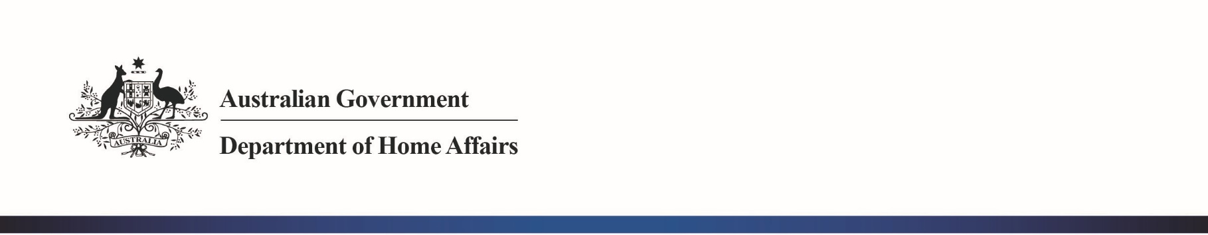

Export Air Cargo Security is changing on 1 March 2019

Dear Exporters,

I am writing to you with information critical to the future of your export business.

It is now just **six (6) weeks until 1 March 2019** when export air cargo, regardless of destination, will need to be examined at piece-level or originate from a Known Consignor.

This change is necessary to ensure that Australia is responding to the evolving terrorist threat.

**If you haven’t already done so, you now need to finalise arrangements with your air cargo supply chain about:**

* If and how the change will impact your current export arrangements.

For example:

* + Possible changes to delivery times or delays
  + Possible increases in costs
* Your options to minimise the impact of the change.

For example:

* + Packaging of your products
  + Handling of consolidated cargo
  + Scheduling of your deliveries
  + How your cargo is transported

The Department is currently managing a large number of Known Consignor applications. Businesses considering joining the Known Consignor Scheme can find out more on the Department’s website [www.homeaffairs.gov.au/about-us/our-portfolios/transport-security/air-cargo-and-aviation/air-cargo/known-consignor-scheme](http://www.homeaffairs.gov.au/about-us/our-portfolios/transport-security/air-cargo-and-aviation/air-cargo/known-consignor-scheme)

If you have questions please contact the Department of Home Affairs at [guidancecentre@homeaffairs.gov.au](mailto:guidancecentre@homeaffairs.gov.au) or call 1300 791 581.

Yours sincerely

**Angus Kirkwood**

A/g Executive Director Transport Security

14 January 2019