# Guidelines for the Implementation of the Commonwealth Fisheries Harvest Strategy Policy



© Commonwealth of Australia 2018

**Ownership of intellectual property rights**

Unless otherwise noted, copyright (and any other intellectual property rights, if any) in this publication is owned by the Commonwealth of Australia (referred to as the Commonwealth).

**Creative Commons licence**

All material in this publication is licensed under a Creative [Commons Attribution 4.0 International Licence](https://creativecommons.org/licenses/by/4.0/legalcode) except content supplied by third parties, logos and the Commonwealth Coat of Arms.

Inquiries about the licence and any use of this document should be emailed to [copyright@agriculture.gov.au](mailto:copyright@agriculture.gov.au).

C:\Documents and Settings\west merryn\Local Settings\Temporary Internet Files\Content.Word\by.png

**Cataloguing data**

This publication (and any material sourced from it) should be attributed as: Department of Agriculture and Water Resources 2018, *Guidelines for the Implementation of the Commonwealth Fisheries Harvest Strategy Policy,* Canberra, November. CC BY 4.0.

ISBN 978-1-76003-158-9

This publication is available at www.agriculture.gov.au/fisheries/domestic/harvest_strategy_policy

Department of Agriculture and Water Resources

GPO Box 858 Canberra ACT 2601

Telephone 1800 900 090

Web [agriculture.gov.au](http://agriculture.gov.au/)

The Australian Government acting through the Department of Agriculture and Water Resources has exercised due care and skill in preparing and compiling the information and data in this publication. Notwithstanding, the Department of Agriculture and Water Resources, its employees and advisers disclaim all liability, including liability for negligence and for any loss, damage, injury, expense or cost incurred by any person as a result of accessing, using or relying on any of the information or data in this publication to the maximum extent permitted by law.

Contents

1 Introduction 6

2 Harvest strategy policy principles explained 8

2.1 Stocks managed under the Harvest Strategy Policy 8

2.2 Risk–cost–catch trade-off 8

2.3 Indicators, performance measures and reference points 10

2.4 Harvest control rules 11

2.5 Interpretation of the 90% risk criterion 12

2.6 Appropriate to the biology of the stock 13

2.7 Ecological considerations 13

2.8 Spatial management 13

2.9 Application to jointly managed international stocks 14

2.10 Recognising the interests of other sectors 15

3 Categorisation of stocks 17

3.1 Identification of key commercial stocks 17

3.2 Transitioning between categories 18

3.3 Determining which stocks are key commercial 19

4 The maximum economic yield objective 20

4.1 Legislation and policy requirements 20

4.2 Benefits of an MEY target 20

4.3 Operationalising the MEY objective 20

4.4 Setting targets 21

4.5 Maintaining risk equivalency across harvest strategies 25

4.6 Multi-species MEY 25

5 Determining limit reference points 29

5.1 Policy requirements 29

5.2 The B20 proxy and alternatives 29

5.3 Ecological risk assessment and the LRP 30

5.4 Other management controls to address risk 30

6 Rebuilding overfished stocks 31

6.1 Rebuilding time frames 31

6.2 Other factors to consider 32

6.3 Performance monitoring 33

6.4 Recommencing targeted fishing 33

6.5 Review of rebuilding strategies 33

7 Variability, regime shift and climate change 34

7.1 Background 34

7.2 Application to harvest strategy design 36

7.3 Conclusion 37

8 Performance assessment and reporting 39

8.1 Technical evaluation of harvest strategies 39

8.2 Collection and maintenance of records 39

8.3 Role of fishery management strategies 40

8.4 Reporting against the Harvest Strategy Policy 41

9 Harvest strategy reviews 43

10 Harvest strategy examples 44

10.1 Example 1: High information, full bioeconomic model, tropical prawn trawl fishery 44

10.2 Example 2: Moderate information, MEY target setting, multi-jurisdictional/multi-fleet tuna stock 45

10.3 Example 3: Harvest strategy using annual surveys and spatial management 46

10.4 Example 4: Moderate information, quota controlled multi-stock demersal fishery 48

10.5 Example 5: Low information, small, catch-controlled demersal fishery 49

Appendix A: The Theory of MEY 51

MEY and maximising net economic returns 51

Appendix B: A potential tier structure and risk equivalency 57

Potential tier structure for harvest strategies in a TAC managed fishery with buffers 57

Guiding principles for achieving risk equivalency 59

Developing a tier structure 60

Glossary 62

References 63

**Tables**

Table B1 Tier number and related buffer for application to recommended catch level when no simulation testing has been made of the harvest strategy based on the proposed tier system in Figure B1 58

Table B2 Detail of the potential tier system with example approaches that fall into each tier 60

**Figures**

Figure 1 Relationship between indicators, performance measures and reference points 10

Figure 2 A harvest control rule illustrating the relationships between biomass, reference points and exploitation rate 12

Figure 3 Species accumulation curve for 91 species, showing categorisation into key commercial, byproduct and bycatch 18

Figure 4 Standardised catch rate for silver trevally in the SESSF, including target and limit reference points, reference period and current catch rate 24

Figure 5 Effect of inter-annual environmental variability, regime shift and directional climate change on biomass 34

Figure 6 Economic yield plotted against biomass depletion under different scenarios of vessel costs (high and low) and fish prices (high, medium and low) 46

Figure 7 Harvest function for single species sedentary stock 47

Figure 8 Spatial extent of the fishery and the spatial units employed in the harvest strategy 47

Figure A1 MEY in a single species fishery 51

Figure A2 Effect of a change in fish price on BMEY 53

Figure A3 Effect of a change in fuel price on BMEY 53

Figure A4 Maximum economic yield in a multi‑species fishery 55

Figure A5 Maximum economic yield in a multi species fishery when biomass limits for individual species constrain the economic return to the fishery as a whole 56

Figure B1 Flowchart of example tier system 58

Figure B 2 Flow diagram explaining the different options for achieving risk equivalency for a specific harvest strategy 59

**Boxes**

Box 1 Categorisation example 18

Box 2 CPUE-based harvest strategy used in the SESSF 24

## Introduction

The *Commonwealth Fisheries Harvest Strategy Policy* (Harvest Strategy Policy) establishes the requirement for developing a harvest strategy in Commonwealth-managed fisheries. Objectives for fishery harvest strategies are prescribed by the Harvest Strategy Policy, along with the need for assessment and evaluation of performance against those objectives.

These guidelines aim to provide practical assistance in the development of fishery-specific harvest strategies in Commonwealth-managed fisheries that meet the intent of the Harvest Strategy Policy. The guidelines provide important contextual information to assist interpretation of the Harvest Strategy Policy and to support harvest strategy development and implementation. While the guidelines have made every attempt to cover the latest scientific and economic thinking, there will likely be technical and scientific advancement relevant to harvest strategies during the lifetime of these guidelines. Such advancements should be monitored for their utility in pursuing the objectives and requirements for harvest strategies in Commonwealth-managed fisheries. Throughout the document, examples are provided to illustrate key points or provide practical examples of how to address specific challenges associated with harvest strategy implementation.

Operating in parallel with the Harvest Strategy Policy is the Commonwealth Fisheries Bycatch Policy (the Bycatch Policy). The Australian Government has also developed *Guidelines for the Implementation of the Commonwealth Fisheries Bycatch Policy*. These two sets of guidelines are intended to be complementary and provide guidance across the full suite of stocks and species interacted with by Commonwealth-managed fisheries.

**Section 2** of these guidelines elaborates on principles introduced or articulated in the policy. These include principles of risk–cost–catch (RCC), the use of indicators, performance measures, reference points and harvest control rules (HCR) in harvest strategies, interpretation of the 90% risk criterion, spatial and temporal management, and application of the Harvest Strategy Policy to jointly managed, shared and international stocks.

**Section 3** of these guidelines focuses on the key elements of categorisation including how to distinguish key commercial stocks from byproduct stocks.

**Section 4** expands on the requirements for developing harvest strategies in Commonwealth-managed fisheries, including the legislation and policy requirements, the maximum economic yield (MEY) target, operationalising the MEY objective and maintaining risk equivalency across stocks.

**Section 5** provides guidance on determining limit reference points, including the policy requirements, proxies and alternatives for limit reference points, indicators, ecological risk assessment (ERA), ecological risk management (ERM) and other controls to manage risk.

**Section 6** discusses aspects of rebuilding overfished stocks, including selecting rebuilding time frames, performance monitoring, recommencing targeted fishing and reviewing rebuilding strategies.

**Section 7** explains concepts of variability, regime shift and climate change and applying these concepts to harvest strategy design.

**Section 8** provides guidance on performance assessment and reporting, including technical evaluation of harvest strategies, collection and maintenance of records, the role of fishery management strategies and reporting requirements.

**Section 9** discusses implementation and review and **Section 10** provides a number of examples that demonstrate how harvest strategies or elements of harvest strategies may be developed and implemented across different fisheries and stocks.

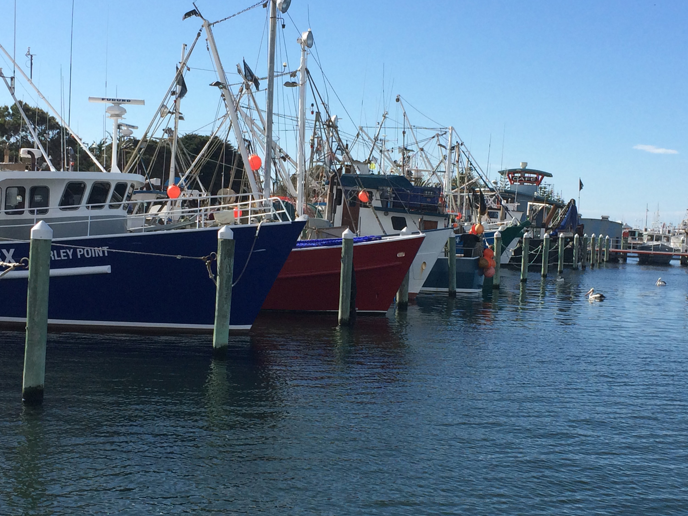

## Harvest strategy policy principles explained

### Stocks managed under the Harvest Strategy Policy

Across the spectrum of species and stocks caught in Commonwealth-managed fisheries, the Harvest Strategy Policy advocates objectives and requirements for commercial stocks. The balance of species or stocks caught or interacted with in Commonwealth-managed fisheries are managed under the Bycatch Policy.

Commercial stocks in Commonwealth-managed fisheries are split into two categories—those that are key commercial and those that are byproduct. Key commercial stocks are those stocks that are most relevant to the objective of maximising net economic returns (NER) to the Australian community from that fishery. Harvest strategies are developed for key commercial stocks, which use an indicator of stock condition and one or more harvest control rules to pursue predefined targets and avoid predefined limits. These stocks are subject to the 90% risk criterion (see section 2.5). In a multi-stock fishery, the combination of stock‑level targets should be designed to pursue the fishery-level target of maximum economic yield (MEY).

Byproduct stocks, by definition, make some contribution to the economic performance of a fishery, but not enough such that the benefits of managing these stocks to a target outweigh the costs of estimating or implementing that target through formal harvest control rules. Byproduct stocks are subject to the limit reference point and the 90% risk criterion for breaching the limit reference point (LRP). Byproduct stocks will generally be assessed through ecological risk assessment (ERA) and managed through the ecological risk management (ERM) process or an alternative assessment mechanism that allows unacceptable risks or unacceptable levels of fishing mortality to be identified and managed. The Bycatch Policy and associated guidelines provide further detail on the use of ERA and ERM for managing Commonwealth fisheries resources.

### Risk–cost–catch trade-off

Fishing mortality should always be managed to levels that ensure a species or stock is not exposed to an unacceptable risk. For stocks managed under harvest strategies, that risk is expressed in two ways. The first is the biological risk or the risk of breaching the limit reference point (LRP) and exposing the stock to an unacceptable risk of recruitment impairment. The second is the economic risk or risk of not maximising NER from the fishery to the Australian community (or achieving MEY).

The RCC trade-off seeks to balance the amount of resources invested in data collection, analysis and management of a stock or fishery with the level of catch (or fishing mortality) taken from that stock or fishery. The higher the level of uncertainty about the state of a stock or fishery and how that stock or fishery is performing against limits and targets, the more fishery management should mitigate or offset the risk of getting things wrong (for example, overfishing or overcapitalising) by being precautionary.

In designing a harvest strategy, consideration should be given to the information needs and administration requirements of potential harvest strategies and costs and benefits associated with the available options. In this context, fishery managers need to decide which strategy best delivers against the objectives and requirements of the policy while at the same time meeting the restrictions and needs of the fishery. Fishery managers need to decide what type of harvest strategy best pursues the requirements of the policy in the context of their fishery.

#### Risk

In the context of the Harvest Strategy Policy, the risk being managed is that of not achieving the objectives of the Harvest Strategy Policy. As described in section 2.2, there are two principle risks—breaching the LRP and not achieving MEY). Neither of these risks can be traded away. The trade-off in this context occurs at the time when management balances how much is invested in the development and implementation of a harvest strategy with the benefits derived from that harvest strategy, including the returns received from the catch that the harvest strategy delivers.

#### Cost

Costs are the expenses associated with the collection and analysis of data to inform management (for example, harvest control rules), and the management processes and activities required to administer and operationalise the harvest strategy (including the catch control system and the monitoring and compliance processes). A suite of less obvious costs should also be factored into the development of a harvest strategy and its harvest control rules. These include the cost of setting the catch level too high and subsequently having to rebuild the stock, resulting in some level of reduced catch for a period of time while the stock is rebuilt. The converse may also occur with costs associated with protracted and overly conservative catch levels that have a cost from lost economic yield. There may also be reputation risk or cost resulting from a public perception of poor fisheries management. This may manifest itself as increased pressure for demonstration of sustainability from non-government entities (incurring cost) or restricted trade opportunities resulting from the perception of compromised sustainability credentials (a lack of desire to sell and consume fish from unsustainable or poorly managed fisheries), which may also represent costs.

#### Catch

Catch in this context is a proxy for the precaution of a harvest strategy. If a higher level of catch (fishery mortality) is provided for within a harvest strategy then, without additional investment in information (at a cost) this brings a higher level of risk (conversely a lower level of catch would reduce the level of risk). The RCC trade-off is about balancing these aspects. If fishery managers choose a strategy resulting in relatively high levels of fishing mortality, costs will be incurred to collect the necessary information to ensure risks do not exceed acceptable levels. The marginal costs associated with this extra information needs to be at least offset by the associated marginal benefits in terms of increased fishery net economic returns.

**Challenges with data-poor stocks**

Commonwealth fisheries vary in size and complexity and not all fisheries can support highly specified and high-information harvest strategies. Significant advances have occurred in assessment approaches for stocks with low levels of data or information (for example, Dowling et al. 2016). Harvest strategies and harvest control rules may be formulated around data poor assessments with due consideration given to the potential for greater uncertainty in the key assessment outputs. This uncertainty may be addressed through appropriate testing using management strategy evaluation (MSE) or through applying a buffer or discount to the recommended catch or effort level resulting from the harvest control rule. Appendix B: A potential tier structure and risk equivalency provides some guidance on potential default buffers for data rich, data moderate and data limited approaches (that is, for differing conditions of potential bias and uncertainty).

### Indicators, performance measures and reference points

Indicators and performance measures are key components of a harvest strategy (Figure 1). The types of indicators, performance measures and reference points used in harvest strategies will differ, reflecting the level of knowledge of the stocks and fishery and the nature of the assessments undertaken.

Indicators are used to provide information on the state of the stock or fishery while performance measures are used to provide information on management performance regarding pre-determined reference points. Indicators can be an observation of the state of the stock (for example, catch per unit effort [CPUE]) or the output from a more formal assessment (for example, biomass or fishing mortality). Performance measures are used to measure achievement against (management) objectives. They are a measure of where an indicator is in relation to a reference point. Reference points can be either a target (a desirable outcome) or a limit (an outcome to be avoided) and are expressed in terms of a particular indicator (for example, CPUE, biomass or fishing mortality).

Figure 1 Relationship between indicators, performance measures and reference points

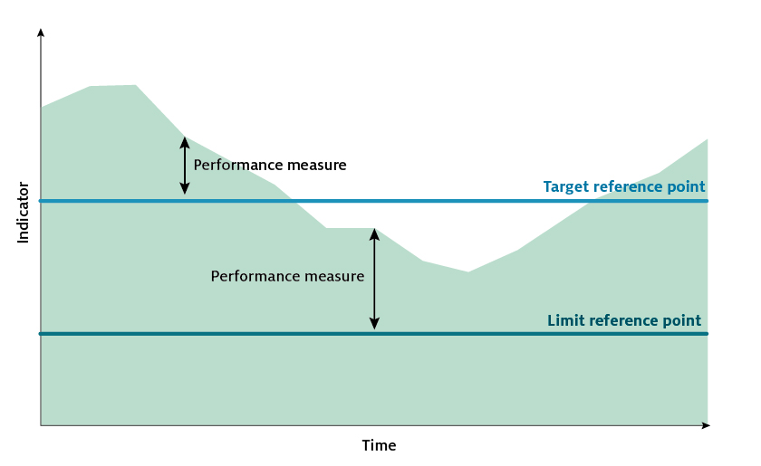

#### Fishing mortality based reference points

Although the Harvest Strategy Policy specifies biomass-based reference points, the requirements of the Harvest Strategy Policy can be met through the use of reference points based on fishing mortality that give the same or similar outcomes in terms of the policy’s objectives. Fishing mortality (F) is the rate of deaths due to fishing a designated component of the fish stock. F-based reference points may be applied to the entire stock or a segment of the stock and should match the scale of the management (for example, the part of the stock being fished).

Fishing mortality based reference points can be defined in terms of targets and limits. A fishing mortality based target reference point (FTARG) that achieves the MEY objective (FMEY) may be estimated directly in the case of some key commercial stocks. In other cases, a proxy value for FTARG should be used. A generic proxy for this target is F48, which is the fishing mortality that results in biomass depletion to 48 per cent of the unfished biomass. Differing species biology and fishery operating conditions means that other proxy values will deliver the FMEY outcome.

With regard to the limit reference point, the fishing mortality limit reference point (FLIM) is the point above which the removal rate from the stock is too high and will result in the stock falling below the biomass limit reference point (BLIM).

#### Dynamic reference points

Typically, fisheries are managed by controlling levels of fishing mortality to maintain biomass, on average, at a target level relative to estimates of the unfished, equilibrium biomass level (B0). Such approaches assume a long-term average or equilibrium level at which the population would settle under zero or constant exploitation. However, many stocks exhibit variable or episodic dynamics, even in the absence of fishing, and so managing based on an assumption of equilibrium may be inappropriate.

The policy allows for dynamic reference points to be set where equilibrium reference points are inappropriate. The use of dynamic B(F=0) (with an associated LRP proxy of 20%B(F=0)) is supported by the emerging understanding of natural ecosystem dynamics and the system-level effects of climate change and other anthropogenic effects (Sainsbury 2008). Dynamic reference points may be provided by assessment models and the expected outcomes in the absence of fishing or by reference to unfished sites, populations or stocks.

Where dynamic limit reference points are applied, consideration needs to be given to their consequences during extended periods of high or low productivity/recruitment. During a low productivity period, the limit reference point will equate to a substantially lower level of absolute spawning biomass and the risk of recruitment impairment at 20%BF=0 may be higher when compared with the same reference point in periods of high productivity. Examples of dynamic reference point application are provided in sections 10.2 and 10.3.

### Harvest control rules

Harvest strategies use harvest control rules (HCRs) to adjust the level of fishing (catch or effort) in response to the level of an indicator of the stock relative to a reference point (Figure 2).

HCRs will seek to reduce fishing pressure and rebuild the stock as the performance indicator moves away from the target level towards the limit. Conversely, HCRs will also adjust fishing pressure (for example, increase catch) on a stock where the performance indicator is above the target. Other types of HCRs also exist that seek to maintain some pre-determined level of fishing mortality or provide for some level of escapement.

Harvest strategies may also incorporate intermediate triggers, or review triggers, intended to detect change and trigger further investigation (research or monitoring) but not require an immediate response in terms of fishing activity.

The specific form of the control rules will depend on the management tools being used in the fishery. If output controls such as total allowable catch (TAC) are in use, the control rules will specify the TAC for a given stock size. Where input controls are used, the control rules will specify the levels of input (such as effort level or season length) for a given stock size. Control rules should specify clear and quantified management responses.

HCRs are one of the key elements of the harvest strategy that require testing. Such testing is done to evaluate the performance of the harvest strategy against the requirements of the policy—that is, performance against the biological risk with regard to breaching the LRP (that harvest strategies maintain the biomass of all stocks above the LRP at least 90% of the time), while at the same time, delivering against a pre-defined target.

Figure 2 A harvest control rule illustrating the relationships between biomass, reference points and exploitation rate

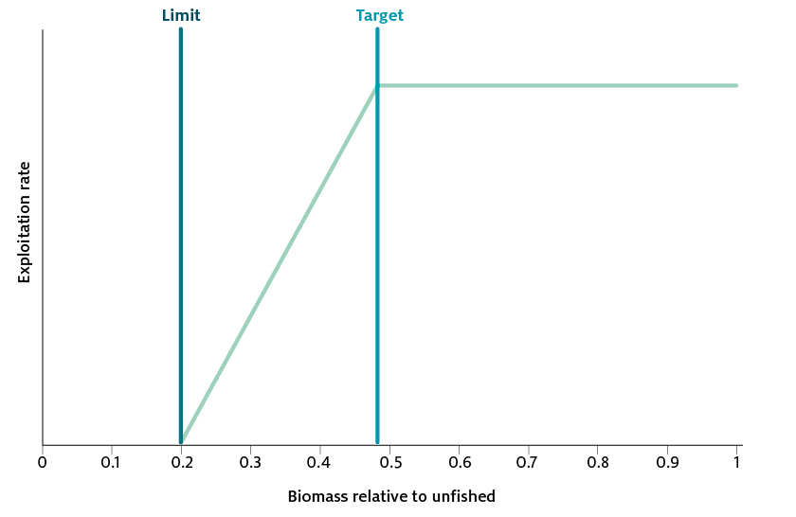

### Interpretation of the 90% risk criterion

The Harvest Strategy Policy requires that harvest strategies maintain the biomass of all commercial stocks above the LRP at least 90% of the time.

The correct interpretation of this criterion is that the stock should stay above the limit biomass level at least 90% of the time (that is, a 1-in-10-year risk that stocks will fall below BLIM), under the application of the harvest strategy. The 90% probability forms a key performance criterion when evaluating candidate harvest strategies through MSE.

A different interpretation of the 90% risk criterion calls for a 90% probability that the stock be above the limit in each and every year. This is not the correct interpretation of the Harvest Strategy Policy 90% risk criterion. However, this interpretation (with a different percentage probability) is applied when determining when a stock is considered to have recovered to above the LRP (see Section 6.4).

As harvest strategies are typically applied to key commercial stocks, this risk criterion is more readily applied to these stocks. There is currently no technical way to undertake such testing for byproduct or bycatch stocks assessed and managed through ERA and ERM (see Section 5.3).

### Appropriate to the biology of the stock

Harvest strategies should be tailored to the productivity characteristics of the stock being managed under that harvest strategy. Limit and target reference points should be set at levels appropriate to the biology of the stock and, wherever possible, based on reliable scientific information. More information is provided in Sections 4 and 5.

### Ecological considerations

Interactions and dependencies exist between species within and across fisheries. This adds significant complexity to the ability of fisheries to achieve pre-defined target reference points (TRPs) for all key commercial stocks. Harvest strategy development and review should be cognisant of the significant complexity that operates across fisheries, particularly in multi-stock and multi-gear fisheries and be responsive to indications that targets for key commercial stocks should be reviewed. More information is provided in Section 4.6.

### Spatial management

Harvest strategies often include or operate alongside some level of spatial management (permanent or temporary closures). Reconciling how these closures impact or contribute to pursuit of the objectives of the Harvest Strategy Policy can be difficult. In its simplest theoretical form, one might consider that a spatial closure encompassing 50% of the distribution of a stock would be protecting 50% of the biomass of that stock. However, this assumes that the resource is uniformly distributed in both space and time, and that no movement of animals occurs between open and closed areas. Such conditions never exist in fisheries. Even when dealing with relatively sedentary animals like scallops and sea cucumbers, movement of animals between open and closed areas can still occur during the larval phase.

Closures may be used for a number of purposes, including to protect areas of high habitat value, to protect threatened, endangered or protected (TEP) species, for cultural reasons, to reduce bycatch, to protect juvenile or spawning areas, or to avoid conflict with other users of the marine environment. There are also instances where commercial fishing is impacted by spatial controls that are introduced for reasons outside of fisheries management, such as the system of Commonwealth marine parks, shipping channels, jurisdictional borders, oil and gas exploration and mining. When developing and implementing harvest strategies, the impact of spatial management on the ability of a fishery to achieve the objectives of the Harvest Strategy Policy should be considered.

To assist with evaluating these impacts, these guidelines make the distinction between spatial management measures that are developed and implemented as a component of a harvest strategy and spatial management that is implemented independent of a harvest strategy.

Taking the single species example, where a significant proportion of the stock is effectively closed to fishing through mechanisms outside of the harvest strategy (such as through a no-take marine park), the Harvest Strategy Policy requirements for the limit and target reference points need to be considered separately. For the LRP, stock condition is assessed at the aggregate level (total stock = closed + open) and the harvest strategy should demonstrate acceptable performance in avoiding of the limit in aggregate. However, the TRP should still be selected to pursue the MEY objective from the accessible area of the fishery—the component of the stock that the fishery experiences and that part of the stock that will contribute economic benefit. In practice, this may mean a biomass target that applies only to the open area and makes no reference to the aggregate biomass (while noting that there may be productivity benefits from a closed area through export of adults and propagules). In the case of multispecies fisheries, there will be additional considerations for achieving the overall MEY objective from the fishery as a whole.

Guidance is not provided here on the use of spatial management measures outside of their impacts on harvest strategy performance. Like any other aspect of a harvest strategy, spatial management measures implemented as part of the harvest strategy should be tested through MSE to determine whether they deliver on the objectives of the Harvest Strategy Policy. If required, the impacts of spatial management outside of the formal harvest strategy should also be evaluated.

Aspects to consider in evaluating the impact of spatial management measures on the ability of a fishery to achieve the objectives articulated by the Harvest Strategy Policy include:

* the proportion of the stock protected
* the degree of fish movement between open and closed areas
* that spatial management does not provide for sequential or serial depletion
* that the necessary data collection and analysis processes are in place to investigate any impacts of spatial management on pursuit of Harvest Strategy Policy objectives
* the implications of spatial management on stock assessment.

### Application to jointly managed international stocks

In the context of jointly managed international stocks, domestic harvest strategies are required where Australia is a major harvester of the stock and no harvest strategy has been determined internationally. HCRs will be most effective in achieving the Harvest Strategy Policy objectives where those rules control all of the fishing mortality applied to the stock. With an increase in fishing mortality that is not subject to the HCR, a progressive loss of HCR performance will occur across a range of criteria (for example, achieving the TRP, avoiding the LRP, or year-to-year domestic catch variability). In circumstances where Australia controls a small fraction of the total catch and without complementary management for foreign fleets, the domestic harvest strategy will not be effective in achieving the Harvest Strategy Policy objectives. In these circumstances, the full conservation burden would fall to a harvest strategy that controls too little of the catch to effect change—there is a lack of feedback between the HCR and the stock status (biomass).

There are important considerations for determining the likely effectiveness of a domestic harvest strategy for an internationally shared stock.

* Stock structure—a reasonable understanding of the stock structure is required to place the Australian catches in the context of total extractions from that stock. In the absence of clear stock delineations, it can be useful to examine plausible scenarios (localised through to wider/ocean scale) and consider whether conclusions on the significance of Australian catch change under alternative scenarios.
* Proportion of Australian catch—there is unlikely to be a specific point at which Australia is no longer a major harvester of the stock and a domestic harvest strategy is no longer effective. As general guidance, Australian catch shares above 60% would be desirable and catch shares below 30% are unlikely to be an appropriate circumstance for a domestic harvest strategy. MSE is an appropriate method to explore the impact of catch shares on HCR performance—for billfish, Hillary et al. (2016) found a continual decline in management effectiveness as the domestic proportion of the total catch decline.
* Trends in foreign fisheries—foreign catches from a stock are likely to change through time and will require monitoring. If changes made to domestic catches through the HCR are offset by equal and opposite catches by foreign fleets, then the effectiveness of the harvest strategy will be dissipated. Demonstrated upward or downward trends and likely future trends in foreign catch are a consideration for whether to develop a domestic harvest strategy and for monitoring an existing harvest strategy.

In cases where domestic harvest strategies are developed for international shared stocks, fishery managers should regularly review the harvest strategy and conditions in the fishery to be confident that the strategy is capable of delivering against the Harvest Strategy Policy objectives, noting any changes to the above assumptions and circumstances.

### Recognising the interests of other sectors

Maximising the net economic return from a fish stock or fishery to the Australian community will in most cases be consistent with maximising the net economic returns from the commercial fishery. However, the Harvest Strategy Policy articulates a requirement for the interests of the recreational and Indigenous sectors to be considered when developing harvest strategies for commercial fisheries. Consistent with the role of these guidelines, the interest to be considered is confined to the economic benefit to the Australian community.

The Harvest Strategy Policy requires that all known sources of mortality be taken into account in the development of harvest strategies. Where harvest strategies are supported by a stock assessment, that assessment should attempt to account for all known sources of mortality to operationalise this requirement. Two potential approaches to further account for recreational and Indigenous sectors within harvest strategies are shown. These examples are intended to illustrate the two ends of a spectrum of analytical complexity and cost, and are not specifically advocated.

The first example approach involves use of an assessment (for example, CPUE or an integrated assessment) that accounts for all sources of mortality, which feeds into a HCR that generates a total recommended biological catch (RBC). This RBC may include a discount based on the type of assessment or its uncertainty (see Appendix B). The RBC is the total catch (regardless of who will take it) that should be applied to the stock to achieve a pre-defined commercial fishery target that maximises returns for the fishery and returns to the Australian community. This RBC can then be treated in a number of ways:

* A commercial TAC can be derived by subtracting the estimated catches of other sectors (and any other sources of mortality such as discards) from the RBC. In this circumstance, the commercial sector bears the conservation burden. If stock abundance trends downward below the target, only commercial catches would be affected in an attempt to return the stock to the target, while the catch of other sectors are not constrained (at least by the harvest strategy). Under this treatment, the principles discussed in Section 2.9 may also relevant to the likely effectiveness of a Commonwealth commercial harvest strategy for achieving Harvest Strategy Policy objectives.
* If a formal catch sharing (allocation) arrangement has been developed, the RBC may be apportioned according to that arrangement. This may be through catch limits or equivalent management measures (for example, seasons and bag limits in the case of the recreational sector) that would appropriately constrain catch. In addition, mechanisms for effective monitoring would be needed to ensure the RBC is achieved. In this circumstance the conservation burden would be shared between sectors.

In the second example approach, there is the potential (in theory) to quantify and explicitly consider the interests of other sectors in the target-setting and harvest strategy design process. In this approach, the objective of maximising net economic returns from the stock to the Australian community may be addressed directly through bioeconomic modelling (see Section 4). This approach combines a stock assessment with robust information on the economics of the different sectors and may seek to optimise the stock (biomass) target and provide a recommended biological catch with allocation by sector. In this example, all sectors with an interest in the stock or fishery would be subject to cost recovery to support the data collection and analyses required to estimate optimal harvest levels or shares of total harvest. All sectors would be subject to the outcomes of the HCR and subject to controls on catch, effort or equivalent measures. While such an approach may be attractive in principle, it is extremely data demanding from all sectors and therefore expensive to develop and maintain.

The Harvest Strategy Policy does not outline the government’s policy on resource sharing. However, there may be stocks or situations where resources need to be objectively shared between sectors to maximise returns to the Australian community. The second approach described is one possible mechanism that would allocate shares to interested sectors in an optimal way. A number of less formalised and non-optimised approaches to allocation are also likely. However, because allocation is out of scope for the Harvest Strategy Policy, it is also out of scope for these guidelines.

## Categorisation of stocks

### Identification of key commercial stocks

In the context of the Harvest Strategy Policy, the purpose of categorisation is to distinguish key commercial stocks from byproduct. By definition, key commercial stocks are those stocks that are most important to the pursuit of the MEY objective. Targets should be determined for key commercial stocks and HCR should be implemented to pursue those targets.

#### Characterisation of the fishery

Characterisation of a fishery is the process of ordering the commercial stocks according to their relative economic importance. Categorisation is the act of identifying or separating out the key commercial stocks from byproduct.

Where possible, the characterisation of the fishery should be undertaken objectively; that is, through the use of data. Data should be used that allows the determination of relative economic importance of the stocks within a fishery. This will usually require data on the quantity of each stock landed and the unit value (for example, $/kg) of that stock at the point of landing. Depending on the availability of data and resources to support the characterisation exercise, other ways of characterisation may also be possible or desirable. These include the analyses of the contribution of a stock to the profitability of the fishery or the contribution of a stock to the net economic returns of the fishery.

Characterisation of a fishery using data requires decisions to be made about how much data to consider (or how many years of data to consider). Fisheries will likely want to avoid having to categorise too regularly due to the costs associated with such processes and to allow a level of management stability. As such, the time frame for the data considered for characterisation should sufficiently capture the extent of variability in the recent history of the fishery. Deciding how much data to consider may be an iterative process and require some level of expert judgement. The past 5 to 10 years of data may be an appropriate starting point for the categorisation process.

#### Categorisation of the fishery

After the objective characterisation of a fishery (according to the relative economic importance of stocks within the fishery), the fishery must then identify the key commercial stocks in that fishery. Given the large differences in the size and scale of Commonwealth fisheries, it is not practical or appropriate to prescribe a single threshold value for the boundary between key commercial stocks and byproduct stocks that would apply to all Commonwealth-managed fisheries. This boundary must be determined fishery by fishery. In fisheries where a limited number of species are landed, the identification of key commercial stocks will be relatively easy. In fisheries with a relatively larger number of species landed and where the landing of particular species changes spatially and temporally, an appropriate categorisation will be more complex. For these fisheries, the appropriate categorisation may require a substantial amount of expert judgement. An example of categorisation for a fishery that lands a relatively large number of species is provided in Box 1.

Box 1 Categorisation example

Cumulative contribution to gross value of production (GVP) was used initially to separate key commercial stocks from byproduct (and in this example, bycatch). All species were ranked by contribution to GVP in decreasing order. Species that contributed more than 5% to either GVP or total catch were categorised as key commercial. Key commercial stocks represented a cumulative contribution to GVP of more than 93% (86% of cumulative catch), while byproduct represented a cumulative contribution to GVP of around 7% (13.9% of cumulative catch). All other species were identified bycatch, contributing less than 0.1% to the cumulative GVP and around the same amount to the cumulative catch.

Species-specific catch levels (in numbers) and percentage retained (versus discarded) were used to separate byproduct and bycatch species. In this example, those species for which greater than 5% were retained, and for which greater than 10 fish were landed each year, were categorised as byproduct species. All other species were categorised as bycatch.

Using these criteria, of the 91 species considered, 5 were classified as key commercial, 19 as byproduct and the remaining 67 as bycatch. Contributions of each category to annual GVP and catch are presented in Figure 3.

Figure 3 Species accumulation curve for 91 species, showing categorisation into key commercial, byproduct and bycatch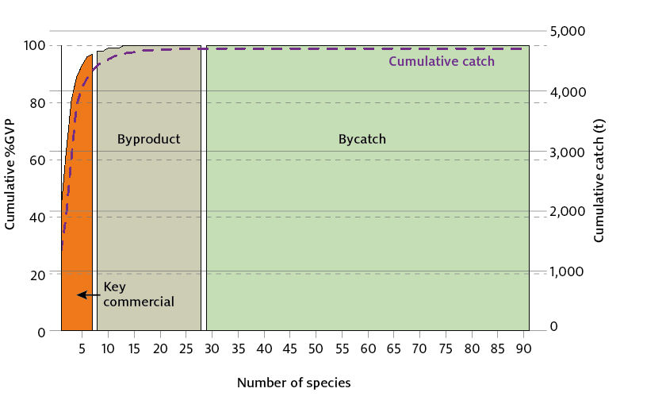

### Transitioning between categories

The relative importance of a commercial stock to the overall economic performance of a fishery and its pursuit of the MEY objective may change over time. Stocks may transition from byproduct to key commercial categories as their relative economic importance in a fishery increases or from key commercial to byproduct as that relative importance declines. It is appropriate to re-categorise stocks as a result of changes to the relative economic importance, but it is not appropriate to re-categorise a key commercial stock as byproduct, where that key commercial stock was fished down to a point of reduced economic importance through overfishing.

Where only a few stocks are transitioning, the same principles (and ultimately thresholds) that applied to the original characterisation and categorisation of the fishery should apply to transitioning stocks. Where a large number of stocks are found to be transitioning, this may indicate that the fishery has markedly changed from the original characterisation and that a wholescale re-characterisation and categorisation process may be required.

The categorisation process should document rules for monitoring the fishery and the process through which a stock changes or transitions between categories.

### Determining which stocks are key commercial

It is not practical (nor likely affordable) to expect all commercial stocks in a fishery to be managed to an optimal economic target. Through objective characterisation, it is anticipated that those stocks of relatively greater importance to the economic performance of the fishery (those that are key commercial) can be distinguished from those of lesser economic importance. At some point in the ordering of relative economic importance of stocks, the costs of managing a commercial stock to a target will outweigh the economic benefits derived from applying that target.

Those stocks where that benefit outweighs the cost, should be considered as key commercial stocks and managed accordingly. The remaining commercial stocks should be considered as byproduct and managed according to the requirements for such stocks.

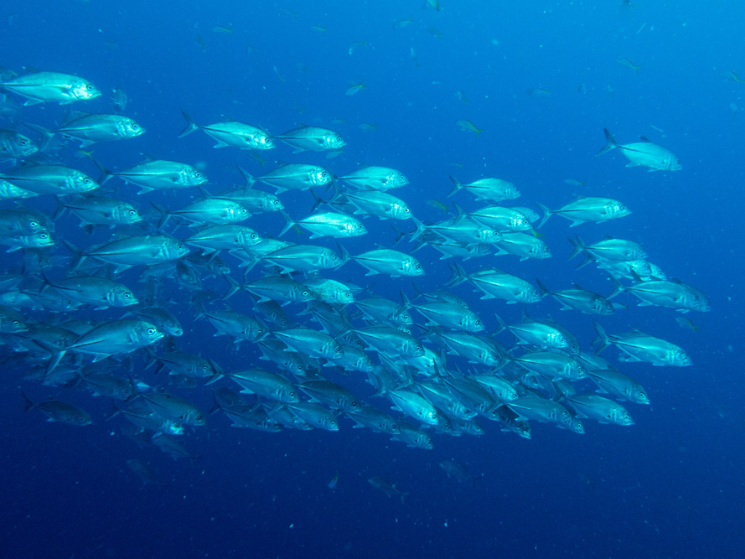

## The maximum economic yield objective

### Legislation and policy requirements

A key objective of the Commonwealth *Fisheries Management Act 1991* is to maximise the net economic returns to the Australian community from the management of Australian fisheries. The Harvest Strategy Policy reflects this objective and articulates fishery-level maximum economic yield (MEY) as an overarching objective for the implementation of harvest strategies in Commonwealth fisheries.

Some commercial fish stocks around the world are managed to a biomass target that achieves maximum sustainable yield (BMSY). This target maximises the long-term catch that can be taken in a fishery, but ignores the increasing costs of fishing as stocks are fished down to BMSY levels. MEY is generally achieved at a lower catch level (and conversely a higher biomass, BMEY) and aims to maximise the economic returns from fishing rather than maximise the quantity of fish landed.

The Harvest Strategy Policy requires maximum economic returns from the fishery as a whole and seeks to achieve this by specifying an appropriate target for each of the key commercial stocks taken in that fishery.

### Benefits of an MEY target

A well-managed fishery provides a range of benefits to the local and broader Australian community—directly, by providing food, employment and incomes, and indirectly, through supporting infrastructure, businesses in the supply chain and social aspects of fishing in a coastal community. Managing fisheries with an objective of maximising the economic returns to the community, through actively pursuing MEY, generally results in more profitable fisheries (when compared with an MSY target), while at the same time avoiding both biological and economic overexploitation. In most cases, if MEY is achieved for the commercial fishery, the net economic returns to the Australian community will be maximised and resources will be optimally allocated within the fleet. See Appendix A for further detail on the theory of MEY.

### Operationalising the MEY objective

Operationalising MEY requires the identification of key commercial stocks within a fishery and the designation of a TRP for those stocks where possible. As described in Section 3, the designation of biomass targets across the suite of key commercial stocks within a fishery should collectively pursue the fishery-level objective of MEY.

MEY is more than just a catch level. It is the combination of fishing effort, stock biomass and catch that maximises total fisheries profit overall. In a single stock fishery, MEY equates to the optimal catch level of that stock, given optimal fishing effort and stock size. It is more difficult to determine MEY for multi-stock fisheries, because it is derived from the biomass and catch from a combination of stocks harvested by a given level of fishing effort. It is acknowledged that it may be difficult to maintain all stocks within a multi-stock fishery at their individual or stock-specific BMEY level (that is, the BMEY assuming a single stock fishery). Achieving MEY in multi-stock fisheries will likely result in the biomass of some stocks being above their single-stock MEY level, while others are likely to be below that level.

Target-setting processes should also consider the potential impact of choke stocks on the ability of fishers to maximise returns across all commercial stocks. Choke stocks are generally those that, when caught in combination with other commercial stocks, restrict the ability of a fishery to catch other commercial stocks at the desired level. This situation often results from there being a disproportionately low TAC for the choke stock. Although it may not be possible to completely mitigate against choke stocks, the Harvest Strategy Policy allows fisheries to set targets (and TACs) across commercial stocks that, in combination, maximise returns from the fishery. In this context, careful consideration should be given to which stocks attract a TAC.

### Setting targets

A range (or a hierarchy) of approaches to the development of harvest strategies can pursue the fishery-level MEY objective. These range from simple, expert opinion‑based approaches that only consider catch or effort and some indication of the risks associated with levels of catch or effort (generally applied in relatively data poor fisheries), through to data-demanding and resource-intensive, integrated bioeconomic models that combine biological stock assessments with economic data to provide quantitative estimates of optimal harvest levels. This spectrum of approaches can be applied at either the stock level or the fishery level. Fisheries should adopt an approach that balances the costs of implementation with the benefits of increased profitability.

In general, data needs and analytical requirements, and therefore costs, increase as the complexity of the harvest strategy increases and fisheries should choose between the relative costs and benefits of each available approach. As a guiding principle, the benefits derived from a more complex or more sophisticated harvest strategy need to outweigh the higher cost associated with the implementation of such a strategy. A description of the key aspects of each level within the hierarchy is explained in this chapter, starting at the top of the hierarchy with the optimised bioeconomic model and ending with the expert opinion–based approach.

#### Optimised bioeconomic models

Optimised bioeconomic models are the most resource intensive and costly of all the methods available to estimate targets for key commercial stocks. These models combine an integrated stock assessment model with detailed information on fishery economics to produce a model that can estimate the optimal biomass and harvest levels through time, consistent with MEY. The objective function within such models is to maximise fisheries profits in the long run.

Where sufficient data exists and the cost of development can be justified (now and into the future), optimised bioeconomic models provide the best estimates of TRPs for key commercial stocks within a fishery and the economic conditions under which it is operating at that time.

Only one such model currently operates in Commonwealth-managed fisheries—the tiger prawn sub-fishery of the Northern Prawn Fishery. This is a sophisticated fishery-level model that aims to pursue MEY from two tiger prawn stocks and one endeavour prawn stock.

#### Basic bioeconomic models

The development of a fishery-wide bioeconomic model may not be always be feasible (or desirable). Instead, partial fishery models may be developed using simpler approaches (for example, surplus production models) for the key commercial stocks. These may be developed as either optimisation or simulation bioeconomic models depending on the level of information available and reliability of this information. For example, stock-level models (as opposed to fishery-level) may use scenario outputs from a stock assessment model (for example, catch and catch rates) through time for different biomass targets, combined with some basic fishery economic data (such as fish prices and major fishing costs). These may be developed as simple spreadsheet-based models allowing fishery managers to explore the likely net economic returns and profitability of different biomass targets. There is no pre-specified objective function. Section 10.2 provides an example of this approach.

Although such an approach will not provide an optimised biomass target for each stock within a fishery, it will provide information on the likely range of biomass targets that will approach MEY. They will also provide information about the sensitivity of net economic returns for different biomass target scenarios and different fish prices and fishing costs. As with the more detailed fishery-level models, these models can also be used to compare the costs and benefits of alternative trajectories to reach the target biomass.

Such a model may also be used to explore the impacts of potential future economic conditions on a candidate TRP to explore the range of price and cost conditions under which the target will continue to provide levels of net economic returns and profitability that approach MEY.

This is an extension of the ‘pretty good yield’ concept (Hilborn 2010; Rindorf et al. 2016), which recognises that considerable uncertainty exists in the choice of an optimal TRP and that a high proportion of the benefits can still be realised by being close to the true optimal level even if the latter is not known with certainty. The ‘pretty good yield’ is a range rather than an absolute value, and the aim is to manage the fishery within the acceptable range. The acceptable economic operating conditions of a target can be specified along with the circumstances where the target would need to be reviewed (exceptional circumstances).

#### Proxies

Next in the hierarchy is the use of proxies. The Harvest Strategy Policy allows the use of proxies for MEY when a fishery bioeconomic model is not available. There are two categories of proxies—those that are set out in the Harvest Strategy Policy and other estimated proxies.

Proxies are applied at the stock level and may be used when fishery managers have an estimate of biomass for a key commercial stock, but not an estimate of stock-specific BMEY or fishery-level MEY. In multi-stock fisheries, the complement of targets for key commercial stocks are used to pursue fishery-level MEY.

Proxies for MEY can be applied across a broad range of data and analysis approaches, from those determined through model‑based analyses (for example, see Pascoe et al. 2014, 2015) or the application of very basic economic data to outputs of a stock assessment. All methods depend on having a reliable estimate of some biological reference points (for example, BMSY and B0), an understanding of the biological characteristics of the stock for which a target is being set and the relative economic importance of the stock to the fishery.

##### Proxies from the Harvest Strategy Policy

The TRP for key commercial stocks in the Harvest Strategy Policy is BMEY, which has a proxy of 1.2BMSY. However, for many stocks a reliable estimate of BMSY is not available, so the policy provides a default value for BMSY of B40% (40% depletion from unfished levels). The default value for BMSY is multiplied by 1.2 to produce a BMEY proxy of B48%.

The policy articulates that the proxies are only to be applied in the absence of better information. If better information is available to determine a TRP (or suite of TRPs) that better suits the stock (or fishery), then an alternate TRP (or TRPs) should be used, keeping in mind the RCC trade-off.

##### Estimated proxies

Where biological and economic information are available for stocks in a fishery, and an evaluation of the cost and benefits of undertaking such analyses find in favour of resourcing a model-based approach, generic bioeconomic modelling may be used to derive targets for key commercial stocks. Such approaches typically require a biological stock assessment, capable of outputting reliable estimates of BMSY, along with key indicators of economic performance such as a breakdown of the costs of operation and prices received for the products produced.

Pascoe et al. (2014, 2015) explored a number of methods to estimate alternative proxies for MEY. The authors found that key drivers in determining MEY targets through such approaches in multi-stock fisheries were a stock’s intrinsic growth rate, the catchability of that stock, and the contribution of that stock to total revenue. In addition, for single stock fisheries, a significant driver is the ratio of total costs to total revenue.

The general findings of the analysis were that:

* stocks with a low catchability generally have a higher optimal BMEY/BMSY ratio
* stocks with a low intrinsic growth rate generally have a lower optimal BMEY/BMSY ratio.

As a proof of concept exercise, these analyses have advanced the thinking and exploration of analytical techniques applied to the challenge of estimating fishery‑level MEY. However, these analyses have not yet generated usable alternate proxies.

#### Indicator-based targets

MEY proxies may be derived through the application of expert judgement to a reliable indicator of stock abundance/biomass. An example of this approach is already being applied to stocks in the Southern and Eastern Scalefish and Shark Fishery (SESSF). For some species in this fishery, a long-term catch rate series (standardised CPUE) is used as a metric of relative biomass. Based on historical information, expert opinion is used to determine a target and limit catch rate. HCRs are then used to control catch (that is, designate a recommended biological catch (RBC)), in an attempt to drive the current CPUE in the direction of the target and away from the limit. Fundamental to this approach is an assumption that the standardised CPUE series is a reliable index of stock abundance. Box 2 provides an example of how this indicator-based rule is applied to silver trevally in the SESSF.

Box 2 CPUE-based harvest strategy used in the SESSF

The harvest strategy for silver trevally in the SESSF uses standardised catch rates as the assessment which indexes stock abundance (Figure 4). The harvest strategy relies on selecting a reference period from the history of the fishery, which is used to establish a target reference catch rate and a target reference catch during that reference period. The historical time series of silver trevally catch and catch rates were reviewed and the period 1992–2001 was selected for this reference period. The period of high catch rates during 1989–1991 was regarded as anomalous because it resulted from a short-term participation of highly efficient vessels in the fishery. The limit catch rate was set at 40% of the target catch rate.

The HCR compares the current catch rate (average over the last four years) to the target catch rate and adjusts the target reference catch (average from the reference period) to achieve that target catch rate. The form of the HCR is similar to Figure 2 in Section 2.4.

MSE has demonstrated that this approach is effective at achieving the selected target and avoiding the limit. However, selecting the target catch rate that aligns with a biomass depletion proxy such as B48% can be challenging.

Figure 4 Standardised catch rate for silver trevally in the SESSF, including target and limit reference points, reference period and current catch rate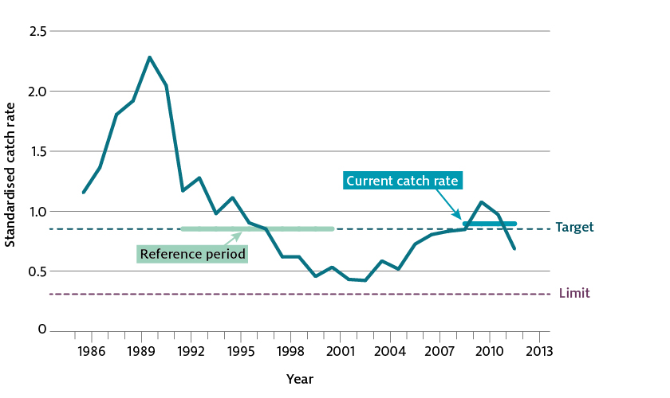

For highly variable, short-lived stocks, a time series of CPUE that extends beyond the lifespan of the animal is unlikely to be a good indicator of current biomass. However, a shorter time series of catch rates (within season or over the duration of the lifespan of the animal) may be appropriate to use for HCRs within a harvest strategy.

Dowling et al. 2014 provide a review empirical approaches for the setting of targets and development of harvest strategies for data-poor fisheries.

#### Expert opinion

Small fisheries are unlikely to have the data necessary to estimate stock or fishery‑level MEY. These fisheries are also unlikely to generate the level of economic returns to justify the significant investment for such estimation. For these fisheries, expert opinion may be the most appropriate means of identifying sustainable and profitable catch levels or effort controls. These controls are typically not described or operationalised as targets in the same way that targets are described elsewhere in these guidelines because they do not optimise fishing effort, catch or stock size. They deliver against the overarching fishery-level MEY objective by ensuring that the fishery does not over-invest or incur too much cost for management (stock assessments, HCRs and quota systems), while at the same time providing enough flexibility within the management controls (including the harvest strategy) to allow the fishers to be profitable without putting the stock at risk of becoming overfished.

These fisheries typically have relatively few operators and low catch levels, so are also likely to have low net economic returns (in absolute terms). The costs of collecting the necessary biological and economic data to determine more precise TRPs are likely to be substantial. Further, the expected gains in terms of higher profitability from more precise estimates of fishing effort are likely to be small. Considering the costs of fishery management and the expected benefits means that in the majority of cases simple indicators based on expert judgement will be consistent with the objective of maximising returns to the broader community.

Controls within expert opinion–derived harvest strategies are typically based on historical catch or effort levels. Gabriel and Mace (1999) suggest that, in such fisheries, a reasonable proxy for MSY would be the average catch over a period when there was no evidence of declining abundance. Similarly, average fishing effort levels (or fleet sizes) over periods where there was no evidence of stock decline could also be used to estimate the maximum sustainable effort. While MEY cannot be defined for fisheries that apply such approaches, one can assume that boats within these fisheries will attempt to maximise their individual returns within management constraints. One can also assume that the selection of catch or effort controls in line with the principles of MSY are unlikely to result in stocks becoming overfished, thereby meeting the Harvest Strategy Policy requirements for maintaining all stocks above a level where they are exposed to an unacceptable risk of recruitment impairment.

### Maintaining risk equivalency across harvest strategies

In some multi-stock and TAC‑managed fisheries globally, assessment and harvest strategy approaches have been placed in tiers that roughly move from data rich to more data limited approaches (Dichmont et al. 2016). In many of these fisheries, buffers have been used to offset assessment uncertainty. In this context, buffers take the form of the gap between the assessment or harvest strategy produced recommended management control (for example, RBC) and the final management decision (for example, the TAC). After simulation tests for the SESSF (Fulton et al. 2016), the work of Dowling et al. (2014) on tier systems, and the international tier review (Dichmont et al. 2016), it is recommended that, if tier systems are to be applied, they be based in the first instance on the quantities that can be estimated (such as fishing mortality and biomass) and then on the level of uncertainty in the estimate of that quantity. Appropriate buffers can be used to maintain risk equivalency between tiers. A tier system based on these principles can be found in Appendix 2.

### Multi-species MEY

There are two principle forms of interaction that should be considered when determining MEY‑based target reference points for stocks in a multi-species fishery. The first of these are technical interactions, or the catch of a mix of stocks with a non-selective gear in a specific time and place. The second are ecosystem interactions. Ecosystem interaction can be either between target stocks (the effect of the catch of one target species on another) or more broadly where there is a direct or indirect effect of the catch of one stock on the abundance or distribution of another (for example, a habitat forming or prey species) (Caddy & Mahon 1995; Zhang, Chen & Ren 2016). Ecosystem interactions are also impacted by environmental conditions and so any changes to that condition can have impacts for the interactions between stocks and ecosystem structuring. The degree to which these interactions have been considered in the setting of TRPs has varied globally.

Several approaches can be used to consider technical interactions between stocks. One of the simplest approaches is to group stocks into metiers—a collective term that has been used for a group of stocks taken together in space and time by a specific set of gear. By grouping stocks into metiers, the challenge of target setting across multiple stocks at the fishery level is contained to a smaller number of stocks and may therefore become a more manageable task. In the case of the NPF, endeavour prawns are consistently caught while targeting tiger prawns (themselves a complex of two species) and managing tiger prawns affects endeavour prawns. The resulting multi-stock bioeconomic model developed for the tiger prawn fishery included an endeavour prawn stock, with each stock having estimated BMEY/BMSY values that differ from one another and from the 1.2BMSY proxy.

Intermediate complexity models (also known as minimum realistic models) fit in between simple models and full-scale multi-species or ecosystem models. They consider the key processes important to a specific question within the ecosystem in which the fishery operates (Plagányi et al. 2014). One of the first of this type of model was used to determine whether the fishing industry and seals compete for the same hake resource (Punt & Butterworth 1995). Importantly, these models estimate some key parameters, rather than requiring their input from other sources. These intermediate complexity models can be used for tactical decision-making within fishery management.

Larger scale (and more elaborate) multi-species models have been used to look at species interactions either considering only the main target species or a larger range of species. They have been used for a range of purposes, including to investigate how fishing one species impacts another. A study in the Baltic Sea ecosystem investigated how each species interacted; the result was a matrix of impacts of each species on the others (Rindorf et al. 2013). This work highlighted which species impacted the most on others and, particularly, which would be choke species or stocks. This type of work has highlighted that TRPs relative to BMSY may be better implemented as ranges, rather than a single value—the concept has been termed ‘pretty good multi-species yield’ (Hilborn 2010; Rindorf et al. 2017). Several of these multi-species models also include economics (see Nielsen et al. 2017), either by taking an existing biological model and forward projecting them with economic modules or as integrated multi-species models. These models can explore the difference between a BMSY based proxy for BMEY and the whole of fishery BMEY, albeit strategically. In the Baltic Sea example (summarised in Rindorf et al. 2016), the economic implications of rebuilding of the cod stock led to an increase in profit for all cod-fishing countries, but the amount of gain was different between countries.

Fully integrated biological (and economic) ecosystem models are the most complex and are suitable for providing strategic advice but may be less able to provide tactical advice. An example of these is Atlantis, which has been widely used, including in Australian fisheries such as the SESSF. Investigations using Atlantis, combined with Ecopath with Ecosim (Christiansen & Walters 2004), showed that estimates of TRPs and LRPs were very fishery‑specific (unpublished data). The work also found that choke species or stocks will remain despite setting stock-specific targets (noting a stock‑specific approach is better than setting all targets to the same biological proxy, which was close to impossible to achieve in most ecosystems). MEY has not been explored extensively with ecosystem models as yet, but multiple studies (using ecosystem or multi‑species models) have considered MSY across species. These studies have shown that it is an impossible universal target and that pursuing it can be detrimental to ecosystem functioning (Link et al. 2012; Stäbler et al. 2016; Walters et al. 2005). Many ecosystem models include different fisheries, gears or jurisdictions (for example, countries in the case of the European Union and states plus federal in the United States and Australia). In most cases, these studies highlight that the different groups need to work together to manage a fish stock within an ecosystem and that sectoral impacts may be uneven.

Qualitative models have also been used in fisheries and other fields to investigate the impact of users on the ecosystem (Dambacher et al. 2009). These models are quick to develop, rely on expert input and are often intuitive. Several versions of an ecosystem can also be developed and modelled to show how various options influence the system and its users (and vice versa).

#### Take home messages

1. Global experience indicates there are no universal rules of ecosystem structure and function. This makes generalisation difficult and can also make selecting indicators and reference points ecosystem specific.
2. Reviews such as Nielsen et al. (2017) have highlighted that most integrated biological and economic models are case specific; only a few use more generic platforms that can be parameterised for specific use. Most integrated models are complex and require a substantial volume of quality data. While multi-species models have been used for tactical decision-making, most broad-scale or ecosystem models are too uncertain for tactical use (such as for setting TACs) and are better suited to strategic use.
3. Metier analyses for multi-species fisheries are typically a simple, reasonably cheap first step to articulate the technical interactions in a fishery. The inclusion of commercial data at the appropriate spatial scale often enhances this work. These metiers are also a useful basis for including fisheries in any multi-species and ecosystem models that may be developed.
4. A single tool is not likely to resolve all issues associated with pursuing fishery wide MEY at the species level, particularly while also considering choke species. Progress to a satisfactory solution can be provided by tackling technical interactions using multi-species bioeconomic models for metiers and considering ecosystem (and other interactions) with intermediate complexity models and more complex ecosystem models.
5. While ecosystem models are data hungry, investing in the data for such models should at least be considered. The success of these models in the European Union and the United States can be partially attributed to the large amounts of diet and relative biomass data available over a long period.
6. Ecosystems are interconnected, interacting and not static (especially under climate change) and non-fishery effects can see species abundance change away from historical values. Any rules put in place will need to remain flexible and recognise drivers beyond fisheries (for example, climate effects and shifting potential productivity).
7. When defining reference points, especially for stocks from the same or linked sub-webs, all efforts should be made to make those reference points consistent (for example, drawn from a similar point in time). Without this kind of consistency reference points will be incompatible across stocks within an ecosystem.
8. Achieving a fishery’s objectives for all stocks on the same timescale may not be possible. A long-term (multi-year) approach to management should be taken that considers these multi-stock and ecosystem interactions.
9. International Council for the Exploration of the Sea (ICES) advice on considering multi-species interactions (including reference points) is to provide:
   1. a description of the ecosystem including species interactions
   2. an identification of the most important interactions that affect management of fisheries
   3. advice on the important trade-offs that should be considered in fisheries management (Rindorf et al. 2016).
10. The treatment of technical and ecosystem interactions in the development of targets and harvest strategies is an area of active research. Harvest strategies should be designed to adapt to this emerging science.

#### Targets set for other reasons

Targets may be set for reasons other than in pursuit of the MEY objective. This may be for reasons of ecological importance (for example, forage or keystone species) or societal reasons (for example, society will not accept a greater level of mortality). In such cases, the objectives and requirements will be species/stock and fishery specific.

## Determining limit reference points

### Policy requirements

The LRP is defined in the policy as the biomass level where the risk to the stock (in terms of recruitment impairment) is regarded as unacceptably high.

The Harvest Strategy Policy prescribes a proxy value for the LRP of 20% of the unfished spawning biomass (B20). The Harvest Strategy Policy also prescribes B20 as a minimum level, with no LRPs to be designated below B20. The Harvest Strategy Policy provides for the designation of an LRP above B20 where this has been estimated or is deemed appropriate (for example, for low productivity stocks or in acknowledgment of the role of a species in the ecosystem). Section 2.3 provides further explanation of the role of reference points within harvest strategies as well as the use of dynamic reference points.

For data‑limited stocks, determining an appropriate biomass-based LRP may be difficult or not possible. For these stocks, alternative approaches may be required, but these should still conform to the intent of designating an LRP as prescribed by the Harvest Strategy Policy.

### The B20 proxy and alternatives

There is good empirical support for the proxy value of BLIM adopted by the Harvest Strategy Policy. Studies of stocks from around the world (Myers et al. 1994) show that LRPs can vary over a considerable range, but a common assumption is that B20 is a suitable proxy that avoids recruitment overfishing for productive stocks (Sainsbury 2008).

In the case of less productive stocks (such as some sharks), more conservative biomass LRPs may be adopted—B30 being advocated as best practice in some cases (Sainsbury 2008). If BMSY can be reliably estimated and BMSY is above B40, then 0.5BMSY may be an appropriate alternative.

An LRP above the proxy value articulated by the Harvest Strategy Policy may be prescribed for other reasons, such as where a stock is a key forage species (Pikitch et al. 2012). Where such situations arise, the reference points selected should be tested (see Section 8.1) to ensure they meet the intent of the Harvest Strategy Policy —to ensure the stock is not exposed to an unacceptable risk of recruitment impairment.

The development of constant escapement strategies (for example to regularly adjust fishing mortality to maintain a constant stock size) may be considered for highly variable stocks, provided it can be demonstrated that these can deliver on the policy objectives.

Quantitative assessment of a stock may not be possible for a number of reasons, including cost or paucity of data. In such cases, LRPs based directly on biomass may not be appropriate. The limit reference point for such stocks may be a specified indicator level that acts as a proxy for B20—such as a specified level of catch per unit effort (CPUE). If such approaches are adopted for use in harvest strategies to manage the risk of recruitment impairment, they should be tested to ensure they meet the requirements of the Harvest Strategy Policy.

### Ecological risk assessment and the LRP

ERA may be an appropriate mechanism for achieving the Harvest Strategy Policy objectives for many byproduct species. In cases where an ecological risk assessment is the only assessment option available for a stock, a reliable high risk rating may be interpreted as a level of fishing mortality that, if it persists, could see a stock reduced to or below the LRP. For such stocks, fishing mortality should be constrained to reduce the risk of breaching the LRP. Such stocks may be a priority for a more detailed assessment to better understand stock status in relation to reference points.

The 90% risk criterion (that is, a 1-in-10-year risk that stocks will fall below BLIM) (see Section 2.5) has limited application for byproduct stocks that are assessed using ERA methods but without pre-agreed and MSE-tested harvest control rules. There is currently no technical way to undertake such testing for byproduct or bycatch stocks assessed and managed through ERA and ERM.

### Other management controls to address risk

Fishery managers may adopt other controls to manage the risk to stocks. These may include permanent or temporary closures (including spawning closures, rotational zoning and move on provisions) and gear controls (including bycatch reduction devices). If such approaches are adopted for use in harvest strategies, and in particular to manage the risk of recruitment impairment, they should be tested to ensure they can meet the requirements of the Harvest Strategy Policy.

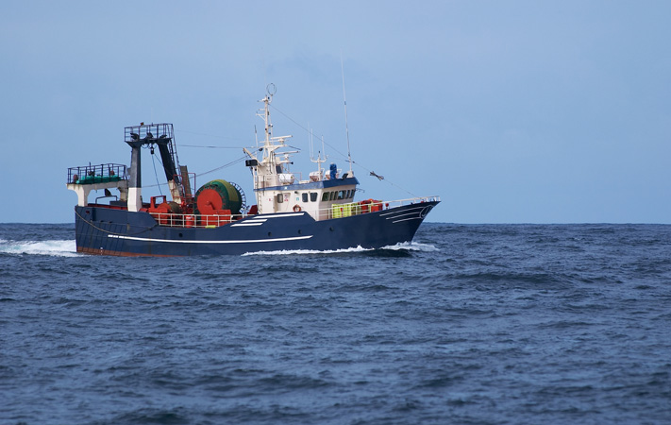

## Rebuilding overfished stocks

A stock is considered overfished either if, in the most recent accepted assessment (as accepted by the Resource Assessment Group; RAG), the median spawning or mature stock biomass is below the agreed LRP for that stock (Section 5) or if an agreed indicator breaches a pre-defined LRP. If this occurs, the policy requires that a rebuilding strategy be developed and implemented. The Harvest Strategy Policy states that the objective of a rebuilding strategy is to cease overfishing and rebuild the overfished stock to above its LRP with a reasonable level of certainty, within a specified time frame.

Once the stock has recovered to above the LRP, targeted fishing may recommence under a harvest strategy that continues to rebuild the stock towards the target. That harvest strategy should have been tested to ensure it meets the requirements of the policy, including that it maintains biomass above the LRP 90% of the time.

In general, a stock rebuilding strategy should include, but is not limited to, these elements:

* clear specification of objectives, including rebuilding targets and time frames
* actions required to achieve the objectives of the rebuilding strategy
* performance criteria to evaluate the effectiveness of the rebuilding strategy against its objectives, throughout the rebuilding period
* key threats to the recovery of the stock in question and strategies to counter these threats
* significant related environmental impacts (positive or negative).

It may be appropriate to consider in advance the anticipated cost of the rebuilding process and the apportionment of those costs across stakeholders. It may also be informative to document the parties impacted by the strategy and describe the anticipated extent of that impact.

### Rebuilding time frames

The Harvest Strategy Policy outlines that the rebuilding time frame is the specified time for the stock to rebuild to above its LRP with a reasonable level of certainty. To account for differences in level of depletion, productivity and life span (and differences in recovery times) between stocks, the policy states that the rebuilding time frame should be specified relative to the minimum time that would be taken to rebuild in the absence of any commercial fishing in a Commonwealth-managed fishery (TMIN). Typically, time frames should be defined within the range of TMIN and 2TMIN. Longer time frames may be justifiable after assessing the trade-off between costs and benefits of alternative recovery trajectories. Estimating TMIN reliably is likely only possible for relatively data-rich stocks for which biological productivity and fishing mortality rates are reasonably well known. In circumstances where TMIN cannot be estimated with reasonable confidence, it may be appropriate to define the rebuilding time frame in terms the estimated generation time of the stock (defined as the average age of a reproductively mature animal in an unexploited population). In this case, rebuilding times may be defined as the lesser of the mean generation time plus 10 years, or three times the mean generation time.

### Other factors to consider

#### Costs and benefits

Science can inform some aspects of the recovery time frame (like TMIN and generation time), but how fast a stock is rebuilt is a trade-off between the costs and benefits of different time frames or recovery trajectories. The fastest rebuilding time will likely be achieved by complete closure of a fishery. This may be the best outcome for the stock but can come at considerable cost to the fishery and entities associated with the fishery (for example, reliant businesses). Complete closure can also result in the cessation of data and information necessary to understand the stock and how it is responding to management intervention (such as efforts to recover). Fishery managers need to strike an appropriate balance between costs and benefits of their chosen recovery time frame. In some cases it may be appropriate to allow some level of fishing under scientific permit to gauge the level of recovery of a stock.

#### Controlling fishing mortality

A key step in a rebuilding strategy for a depleted stock is to ensure that any targeted fishing is stopped and fishing mortality is reduced as much as possible after the consideration of costs and benefits. Any targeted fishing of an overfished stock will be considered to constitute overfishing. The Harvest Strategy Policy recognises that reducing the TACs for other stocks in a fishery may be necessary to avoid or minimise the incidental catch of a stock under a rebuilding strategy. Once efforts to stop targeted fishing in a multi-stock fishery have been made, and if bycatch levels of the depleted stocks remain too high to allow rebuilding, reducing the TACs of companion or associated stocks may be necessary. In this case, the composition of catches should be monitored to detect and respond to changes in the relative proportions of stocks over time.

The Harvest Strategy Policy notes that, where sources of mortality exist that cannot be managed or constrained by the Commonwealth, these must be taken into account when designing the rebuilding strategy. Where the stock is also fished by other jurisdictions, efforts should be made to ensure that catches by these other jurisdictions are reasonably constrained, consistent with catch sharing arrangements. The risks associated with achieving aspects of a rebuilding strategy (such as those related to controlling total fishing mortality) should be documented in the rebuilding strategy, and measures implemented to reduce these risks.

#### Accounting for natural and climate induced variability

Rebuilding strategies must adequately take into account the natural variability of the stock. Aspects of the stock such as productivity, growth and recruitment may not be static through time and rebuilding strategies must be robust to this variability (see Section 7).

Where rebuilding is not occurring as expected (using the specified performance measures), reasons for this should be determined and the rebuilding strategy revised to account for these factors. Where evidence suggests that rebuilding has been affected by environmental factors, the rebuilding strategy and time frame may need to be revised to account for resulting productivity changes. The evidence for this should be documented in the revised rebuilding strategy because it will have ongoing implications for the potential success of management actions aimed at rebuilding the stock.

### Performance monitoring

The Harvest Strategy Policy requires that a rebuilding strategy must specify performance measures to be used to monitor how well the strategy is working to rebuild the stock. Cessation of targeted fishing will typically result in loss or bias in fishery-dependent data (for example, CPUE). Management agencies may need to consider dedicated data collection and analyses to provide such performance measures.

### Recommencing targeted fishing

The policy requires that an overfished stock is rebuilt to above its LRP with a reasonable level of certainty. A reasonable level of certainty is defined by these guidelines as the stock being at or above the LRP with a 75% probability based on the most recent accepted assessment (see Section 2.5 for clarity on risk interpretations). This probability level is derived from the Intergovernmental Panel on Climate Change (IPCC) standard term ‘likely’, meaning a 66% to 90% probability and the 75% level has been selected as close to the mid-point of this range. When this level of confidence (75%) is reached, the policy allows for the recommencement of targeted fishing in line with an appropriately specified harvest strategy. In such cases, the revised HCRs will likely specify reduced catch levels, only increasing in proportion to the degree of recovery towards the target. Any harvest strategy implemented for a previously overfished stock will need to comply with the normal 90% risk criterion for breaching the LRP (see Section 2.5).

### Review of rebuilding strategies

The Harvest Strategy Policy requires that a review of the rebuilding strategy be undertaken where there is no credible evidence that a stock is rebuilding as expected or will rebuild in the specified time. The reasons for this lack of rebuilding should be determined and action taken to address these.

Such reviews should document and evaluate the performance of the present rebuilding strategy and detail possible reasons for its failure. The review should identify how the failings will be addressed (including revised actions), and whether a new rebuilding strategy or time frame is required. Following consideration of the review, the rebuilding strategy should be revised as necessary and re-implemented.

## Variability, regime shift and climate change

### Background

Productivity and biomass of marine resources is intrinsically linked to oceanographic conditions. In favourable conditions, recruitment, growth and survival are high, stock size will tend to increase and sustainable fishing levels may be higher. The converse is true in periods of unfavourable conditions and the total biomass supported by the environment in the absence of fishing (dynamic B0 or B(F=0)) may be lower. Understanding the state of the environment with respect to biomass and productivity of a particular stock or ecosystem is critical for fisheries management. Likely environmental effects should be formally recognised in any harvest strategy. Attention must be given to existing or new monitoring required to detect environmental change. Even if a change in stock productivity is not due to fishing, fishery management agencies might still need to respond.

Environmental variation between favourable and unfavourable conditions can occur on a range of time scales, which will influence the particular harvest arrangements. Inter-annual variation shows no long-term trend but with evidence of cycles, regime shift shows a persistent increase in average biomass between two periods, and directional climate change shows a continual increase in biomass over time (Figure 5).

Figure 5 Effect of inter-annual environmental variability, regime shift and directional climate change on biomass

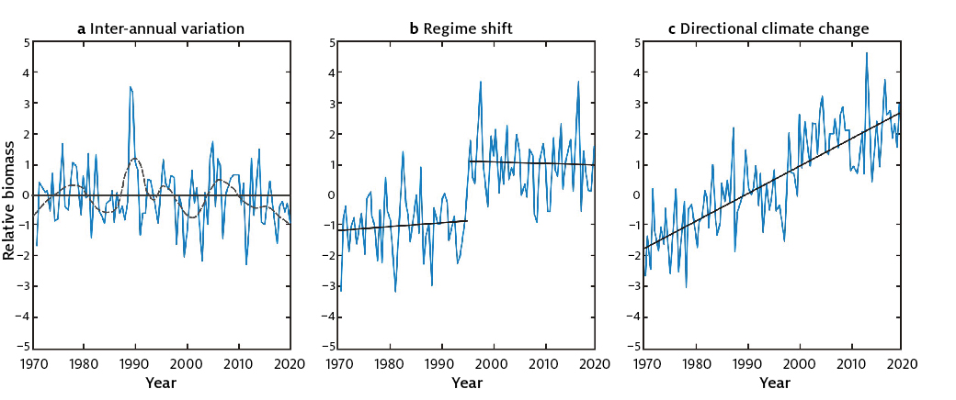

* **Inter-annual variability:** Inter-annual environmental variability operates typically at time scales of 1–5 years. Inter-annual variability can manifest itself either as unpredictable noise or relatively predictable episodic or periodic cycles, even where there is no long-term trend (Figure 5a).
* **Regime shifts:** Marine ecosystems are occasionally subject to sudden, dramatic, long-lasting changes in ecosystem structure and function (Figure 5b). Regime shifts operate at large spatial scales (for example, regional to basin scales) and are characterised by temporal variability that is coherent across multiple taxa and trophic levels within a community. Regime shifts can occur as responses to natural (such as low-frequency climate variability) or anthropogenic causes (such as overfishing, eutrophication or habitat loss). Regime shifts are best known from the north-east and south-east Pacific Ocean, where spatially extensive, multi-decadal observational time series allow changes in ecological structure to be documented. Long-term biological observations are scarce in most marine ecosystems globally, which may make the formal detection of regime shifts difficult or impossible on a time scale that is useful for management (that is, if only identified many years later).
* **Directional climate change:** Long-term sustained environmental change is occurring in a particular direction or is projected to occur over many decades (Figure 5c). This may be due to anthropogenic climate change, resulting in long-term warming and acidification of the ocean. Long time series are needed to detect these changes.

Changes in the environment on these time scales can influence a range of factors relevant to design of a harvest strategy, including:

* reference points—target and limit reference points may need to be changed to reflect changes in stock productivity, and the formula used to estimate TAC and TAE may also need to be changed.
* estimating an appropriate B0—estimates of B0 may be larger when conditions are good and smaller when conditions are poor. Setting a dynamic B0 or B(F=0) allows for response to changing environmental conditions
* rebuilding targets—rebuilding targets and time frames may not be achieved if the environmental conditions have shifted to a new state (for example, a less productive regime). Alternately, rebuilding may be quicker than expected if conditions have improved.
* spatial and temporal closures—a particular species may not occur at the time and space previously inhabited due to geographic shifts in suitable environmental conditions. As a consequence, a portion of a population previously protected in a closed area may now be exposed to human activities, rendering the closure ineffective.
* companion species—changing species compositions (including the entry of new species not previously recorded for the area), resulting in increased or decreased susceptibility of species to a fishery, need to be considered when evaluating any aspect of the harvest strategy that may be influenced by changing natural mortality rates or gear interactions.

#### Monitoring to detect environmental change

Monitoring programs to detect change in the environment can include data collection from the commercial fishery (catch, size, species composition and effort), as well as fishery-independent estimates of stock recruitment and stock size. Monitoring of key parameters characterising the environment and ecosystem that support the fishery can also be informative, including remote sensing or oceanographic data logging.

A range of existing monitoring programs can provide data useful for detecting changes relevant to fisheries. These may include large-scale or regional parameters (for example, climate and ocean circulation) and local coastal monitoring (for example, runoff, water quality and inshore habitat). Fishery agencies and the fishing industry alone cannot support the cost of an adequate monitoring program. A coordinated program serving a number of stakeholders in the coastal zone is much more likely to succeed (Hobday & Cvitanovic 2017).

For example, the Integrated Marine Observation System (IMOS) was established in 2005 and has been very important in providing physical information about the ocean conditions (Lynch et al. 2014). This program has supported development of cost-effective monitoring tools and integration and exchange of many datasets. These have been widely used to help understand oceanographic and fisheries trends and have informed climate models used to project changes in fish distribution.

The ability to detect change depends on:

* the rate of change in relation to the frequency of monitoring
* the variation over time in the particular environmental variable
* the length of the time series.

Simulation testing can be used to determine the ability to detect significant change in a monitored variable (Hobday & Evans 2013) and used to design effective monitoring programs.

### Application to harvest strategy design

Management strategies are usually designed to account for some inter-annual environmental variability—for example, by expecting the stock size to vary around the target biomass. Regime shifts and longer‑term changes that affect management by shifting productivity and biological reference points are less frequent and not often catered for in harvest strategy design.

Updating of proxy reference points has been suggested as the best approach for adapting current management strategies for change (Brown et al. 2012). However, reference points are difficult to estimate reliably, given variation and short-term, non-stationary information contained in monitoring data.

Modifying harvest strategies on the basis of assumed but untested environmental explanations, rather than fishing-related causes for decline, should be avoided. Accepting an explanation of environmental change should be subject to considerable scrutiny and supported by monitoring data. A weight-of-evidence approach should be applied to use available scientific evidence to test a causal hypothesis. Hypotheses should be articulated prior to evaluation, and the evidence for and against each hypothesis should be evaluated according to pre-determined criteria.

Criteria that could be used to evaluate a claim of regime shift (Klaer et al. 2015) and that may be appropriate for establishment of long-term change include:

1. An observed change in a stock productivity indicator, such as growth rate
2. Confidence in observational data
3. Confidence in species life history knowledge
4. Theoretical explanation of how change is linked to the environment

For example, the difference between a stock like Jackass morwong in the SESSF, for which a regime shift has been accepted by the South East Resource Assessment Group, and eastern gemfish in the SESSF is that morwong has a more developed explanatory mechanism (criterion 4; Wayte 2013) even though gemfish has a longer period of observed change (criterion 1).

The nature of the perceived environmental impact on the stock should be considered when considering changes in the harvest strategy. Changes in spatial availability, increased natural mortality and decreased reproductive potential due to stress or lower growth rates and body size all have different implications in the context of harvest strategy design and the setting of reference points. The RCC trade-off between the industry and the stock in question may also need to be considered.

For example, a change in spatial distribution of a species may result in local changes in availability (such as shifts in east coast yellowfin tuna), without the overall stock status being compromised. From a sustainability perspective, quotas could remain unchanged (although there may be pressure for access rights in a different fishery in response to a shifting stock), but local economic objectives may be compromised. As such, while the outcome of an overall stock assessment may be unchanged, more spatially structured assessments may be preferred so that quotas may be determined based more directly on local availability. In general, changes in spatial availability will not require special harvest strategy considerations.

Alternatively, if the overall productivity changes due to the environment, then this should be accounted for by ensuring that any assessment inputs and assumptions (such as natural mortality and stock-recruitment parameters) are not temporally static, but reflect environmental conditions being experienced by the stock (reflecting a dynamic B0) over time. The effect of changing reference points should be considered in MSEs used to test future harvest strategies, which could also test the frequency with which they should be updated. Long-term climate change (Figure 5c) could be managed with a series of updates to reference points every decade or so, depending on the species life span. Section 2.3 provides some further explanation and consideration on applying dynamic limit reference points. Changing stock productivity may also have implications for setting rebuilding targets and time-frames. The challenge is to predict current and future climate change impacts on life history (for example, reproductive success and changes in natural mortality) that directly affect the stock and its productivity. In the absence of direct estimates of such impacts (based on data and scientific evidence), they will either have to be indirectly estimated from other projected environmental indicator changes or catered for by introducing a wider range of parameter estimates or building in higher levels of uncertainty.

### Conclusion

Harvest strategies should be designed to recognise the potential influence of the environment on fish productivity over three timescales—short-term inter-annual environmental variability, medium-term regime shifts and long-term climate change. Classical regime shifts fluctuate between two or more states, without a long-term trend, although permanent regime changes may result in impacts similar to that associated with long-term climate change.

Harvest strategy reference points will need to be adjusted if persistent changes occur in stock productivity over medium or longer timescales because existing harvest strategies have usually been designed in the context of inter-annual variation. For regime shifts and long-term climate-related change, special consideration will be required.

Timely responses by management to changes in stock productivity and distribution are important in areas where climate is shown to be changing rapidly.

The potential influence of the environment on fish productivity and appropriate management responses is an area of active research. Harvest strategies should be designed to adapt to this emerging science including through review (Section 8).



## Performance assessment and reporting

Ongoing and iterative assessment of performance against objectives and public reporting of that performance are important aspects in demonstrating outcomes consistent with the overarching policy objectives and requirements. This section outlines the types of data and information that will be important for assessing performance against the objectives of the Harvest Strategy Policy and foundational to public reporting of that performance.

### Technical evaluation of harvest strategies

The Harvest Strategy Policy requires that harvest strategies be formally tested to demonstrate that they are highly likely to meet the objectives of the Harvest Strategy Policy. Where appropriate, such testing should be conducted using methods such as MSE—a procedure where alternative management strategies are tested and compared using simulations of stock and fishery dynamics.

MSE testing should be conducted as part of the development of new or updated harvest strategies to ensure that, before any such strategies are adopted, they have a high probability of achieving the objectives of the policy. Harvest strategy testing should identify conditions or circumstances under which the harvest strategy should be subject to review, revision and re-evaluation, including when MSE testing should be redone.

Where MSE testing is not feasible for a fishery or stock (due to data deficiency or cost/benefit considerations), suitable alternative testing should be conducted. Risk‑based methods may be considered for this task. However, where risk‑based methods are intended to be used for this purpose, they should first be calibrated against more quantitative methods. Doing so would provide confidence that they can appropriately estimate the risk of fishing on the stock, and that the determination of low risk in relation to breaching the LRP is comparable to that tested under MSE. Such testing is particularly important when information is incomplete or imprecise and when the relationship between the control rule and fisheries-specific objectives or management outcomes is complex.

### Collection and maintenance of records

Adequate information needs to be collected and stored by AFMA to enable performance against the objectives of the Harvest Strategy Policy to be assessed and reported. Data and information which should be collected, organised and securely stored on an ongoing basis for each fishery includes:

* characterisation and categorisation of commercial stocks, including details of the data, methodology and criteria used to allocate stocks to categories. Circumstances under which stocks would transition between categories, and under which the categorisation process should be more broadly reviewed and revised, should also be identified
* descriptions of harvest strategies developed for each fishery or stock, including details of:
  + any fishery specific objectives in addition to those prescribed in the Harvest Strategy Policy
  + assessment methods, applied to each stock
  + stock-specific indicators and/or performance measures adopted
  + target and limit reference points expressed in terms of the specified indicators or performance measures
  + details of HCRs adopted
  + description of any additional meta-rules incorporated into the harvest strategy, including conditions under which the harvest strategy would be considered to require review, revision or re-testing
  + assumptions made in developing the harvest strategy, such as limited mixing or recreational catch estimates
  + details of how estimates of discards are taken into account in harvest strategies
* results of MSE or other testing conducted on draft harvest strategies, confirming that the adopted harvest strategy and HCRs have a high probability of achieving the objectives of the policy
* data used in stock assessments and application of the harvest strategy for each stock, including:
  + participation and effort data—such as number of vessels, days fished, number of sets
  + catches by stock—including any available data on retained versus discarded catch
  + size composition of stocks in the catch—including data on size composition of retained versus discarded fish, if collected
  + other ancillary data used in stock assessments for each stock
* record of assessments conducted for each stock, documenting the date and results of assessments, including:
  + best assessment estimate of stock status relative to specified limit and target reference points, including confidence intervals around that estimate, if the assessment method provides this
  + results of the application of the harvest strategy and HCR using the best estimate of stock size in relation to reference levels
  + record of resulting management action taken in response to the results of application of the HCR.

### Role of fishery management strategies

Aspects of the data and information requirements can be pursued through drafting and adopting fishery management strategies for each fishery. These strategies provide a convenient vehicle for the documentation of:

* high-level objectives for the fishery, as required under the Harvest Strategy Policy
* shorter-term operational objectives adopted in support of achieving the high-level objectives—such as objectives relating to improving some aspect of monitoring or data collection to either improve current assessments or allow a more reliable assessment method to be applied
* methodology used and results of categorisation for the fishery
* specification of the indicators to be used for each stock (such as B estimates, F estimates or available and appropriate proxies for these) and the target and limit reference points for each stock expressed in terms of the specified indicators
* details of the harvest strategy, including HCRs for the fishery
* assessment methods to be applied to each stock, including the stocks that will only be subject to risk assessment
* overview of monitoring and data collection requirements to support the chosen assessment methods
* the extent of discarding of commercial species and the actions taken to both monitor and reduce discarding
* where a fishery contains an overfished stock that is subject to a rebuilding strategy, provide an overview of the objectives and requirements of that strategy.

### Reporting against the Harvest Strategy Policy

#### General reporting

The Harvest Strategy Policy requires AFMA to report on the implementation of the policy in annual reports, and as requested by the minister responsible for fisheries. Annual reporting against the Harvest Strategy Policy by AFMA should include:

* the extent of implementation of harvest strategies consistent with the Harvest Strategy Policy
* summarised information on the state of stocks in each fishery with regard to their LRP
* summarised information on the state of stocks in each fishery with regard to their stock-specific TRP (where individual stock-specific targets are specified)
* in situations where a fishery‑level MEY target is articulated, summarised information on the state of fisheries with regard to the fishery‑level MEY target
* summarised results of risk assessments, showing the risk classification for stocks not subject to harvest strategies.

#### Reporting against rebuilding strategies

Section 6 of these guidelines detail the types of information to be included in a rebuilding strategy. Reporting against implementation of the rebuilding strategy should naturally flow from these inclusions. However, as a minimum, reporting on the implementation of the rebuilding strategy should include:

* performance of the rebuilding strategy against the objectives, targets and time frames as articulated by the strategy; specifically, to what extent have the actions contained in the rebuilding strategy delivered against the objectives, targets and time frames articulated in the strategy
* where recovery has not occurred as expected or intended, the reasons for this occurrence, including the extent to which incidental/unavoidable catch has been minimised
* any anticipated or suggested amendments to the strategy that may better deliver against the objectives, targets and time frames.

## Harvest strategy reviews

The Harvest Strategy Policy requires that harvest strategies consistent with the policy must be in place in all major Commonwealth-managed fisheries within three years of the commencement of the policy, and in all Commonwealth fisheries within four years. Fisheries that have a current harvest strategy must take into account the requirements of the policy when reviewing and updating harvest strategies (provided that occurs within the three or four year period). Consistent with the objectives and requirements of the policy, additional harvest strategies may need to be developed for new fisheries or new key commercial stocks.

Harvest strategies are to be reviewed every five years. However, it may be necessary to amend harvest strategies earlier if:

* a marked change in stocks targeted occurs, leading to a change in which stocks are categorised as key commercial
* new information substantially changes understanding of the fishery, leading to revised estimates of indicators relative to reference points
* external drivers have unexpectedly increased the risk to a fishery and fish stocks, including environmental or climate drivers that have substantially altered the productivity characteristics (growth or recruitment) of the stock
* performance indicators show that harvest strategies are not working effectively, and that the intent of the Harvest Strategy Policy is not being met.

Early review may be triggered when either:

* harvest strategies are implemented without formal testing or evaluation using methods such as MSE
* MSE testing did not take adequate account of the changes in risk factors subsequently observed, or
* subsequent estimates of the performance indicators used in the HCR are biased or uncertain to the extent that application of the control rule using these indicators fails to appropriately adjust fishing pressure.

In addition to regularly scheduled reviews, harvest strategies should include review triggers to respond to significant and unexpected changes in fishery conditions outside the ranges tested. This would include situations where a stock’s biomass has declined below the LRP while subject to a harvest strategy, indicating that the stock productivity has been overestimated, or that the control rule is not responding adequately to declines in performance indicators. In such situations, the settings of the harvest strategy should be reviewed and amended to ensure that it has a high probability of achieving objectives under the changed circumstances.

Where a harvest strategy is significantly amended, it should be re-tested to ensure it has a high likelihood of achieving the objectives of the Harvest Strategy Policy under the changed circumstances.

## Harvest strategy examples

The examples in this chapter demonstrate how harvest strategies or elements of harvest strategies may be developed and implemented across different types of fisheries and stocks. These are not intended to show all possible approaches but rather are illustrative of some potential approaches. For any particular fishery or stock/s, a variety of approaches to harvest strategy design are likely to be of similar effectiveness in meeting the policy’s requirements.

### Example 1: High information, full bioeconomic model, tropical prawn trawl fishery

#### Description

This example is for a tropical trawl fishery that primarily targets three species of prawn and has a spectrum of byproduct species. The fishery is relatively high value and has invested significantly in data collection, analysis and research to actively pursue maximum profitability. The fishery applies an optimised bioeconomic model to pursue fishery-level MEY, primarily through the control of fishing effort, with options for spatial or seasonal closures to adjust the fishing mortality applied as necessary. Seasonality is also managed to maximise the capture of larger prawns (avoiding inefficient growth overfishing). Effort units in the fishery are individually allocated and fully tradeable.

#### Target setting and controlling catch

##### Key commercial

The target for the harvest strategy is maximum economic yield from the fishery as a whole, which for operational purposes is defined as maximising the net present value of profits over a specified period. The harvest control rule specifies that effort for each year over the projection period be set at the level that is estimated to maximise profit.

The assessment is undertaken every two years using updated biological and economic data from the fishery as well as updated forecasts of economic conditions (such as prices). The dynamic pathway to MEY is re-estimated and is used to set effort levels for the following two years.

This approach has been tested through management strategy evaluation (MSE) and found to be consistent with the objectives of the Harvest Strategy Policy.

##### Byproduct

TACs are also set for some byproduct species. These have been determined through the estimation of allowable biological catches (ABCs). All byproduct (and bycatch) species are subject to a five-yearly ERA and ERM process.

#### Limit reference point

A limit reference point of 0.5 SBMSY has been set for each of the key commercial species, assessed over the most recent five years moving average. If the LRP is exceeded for a species, spatial or temporal measures will be used to prevent targeted fishing on that species.

The limit reference point for the majority of byproduct species is FLIM as determined through the sustainability analysis for fishing effects (SAFE) risk assessment process (AFMA 2017).

#### Risk–cost–catch

The fishery adopted an MEY target following a period of overfishing and then declining economic performance due to increasing fuel prices and decreasing prawn prices. After considering the potential benefits and costs of alternatives, the fishery elected to invest in the development and application of a full bioeconomic model that would dynamically set effort levels to maximise profits under prevailing and expected fishery conditions. This provides a solution to fishery viability that is robust to future changes in biological and, more particularly, economic conditions.

### Example 2: Moderate information, MEY target setting, multi-jurisdictional/multi-fleet tuna stock

#### Description

This example is for a subtropical/temperate pelagic longline fishery that targets a single species of tuna within a broader fishery for which other tuna and billfish species are also important. The species that is the focus of this particular harvest strategy can be selectively targeted through the use of particular gear configurations, fishing areas and times.

The fishery for this species comprises several distinct fleets, each of which have a different economic efficiency (relative costs to deploy each fishing hook) and the profitability of all fleets is affected by variations in input (particularly fuel) and output (price of fish) prices. This example focuses on the development of an appropriate biomass target for the species of interest. It also briefly covers the application of dynamic reference points within this context.

#### Target setting

Candidate biomass targets for the target stock were assessed using a basic bioeconomic model that provided estimates of economic yield under different assumptions of fleet efficiency and future economic conditions. These analyses were used to select a single biomass target that would provide for profitability and reasonable economic yields (approaching MEY) for all fleets and would be robust to changes in future economic conditions (such as future fish prices).

Figure 6 provides some of the results of the economic modelling and illustrates the impact of different economic conditions on BMEY as well as the overall economic yield. Across the scenarios BMEY was observed to vary from B40% for efficient low cost fleets when prices were high through to B50% for less efficient, high cost fleets when prices were low. Similarly, total economic yield was greatest for efficient low cost fleets when prices are high and economic yield was lowest (approaching zero or unviable) for less efficient, high cost fleets when prices are low.

A compromise target of B45% was selected. This target provided yields close to MEY across the different fleets and was similarly robust to the expected range of future fish prices. The B45% target reference point was used in the development of harvest control rules within the broader harvest strategy that included a set of breakout rules requiring review of the target if prevailing fishery economic conditions moved outside the ranges examined.

The theoretical foundations relating to MEY are further explored in Appendix A.

Figure 6 Economic yield plotted against biomass depletion under different scenarios of vessel costs (high and low) and fish prices (high, medium and low)

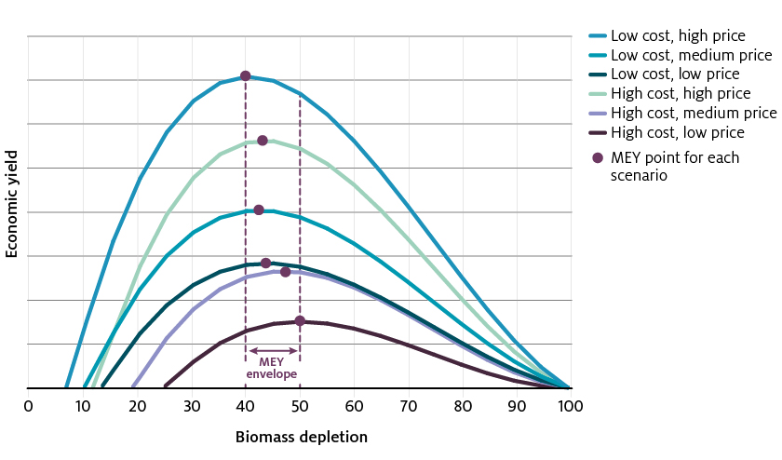

Note: For each scenario the biomass at MEY is indicated with a circle and the envelope of BMEY levels is illustrated.

#### Dynamic reference points

This example harvest strategy uses dynamic target and limit reference points where biomass depletion is calculated relative to the average stock size that would have been present in the absence of fishing over the most recent 10 years (the B45% target is more precisely specified as 45% SBF=0, years t−10 to t−1). The limit reference point is specified as 20% SBF=0, years t−10 to t−1.

These reference points have the advantage of not relying on equilibrium (on average) assumptions and can take account of periods of above or below average recruitment that are known to occur for tuna. The 10-year time-window defining the unfished state was considered to best represent current and likely future average environmental and stock productivity conditions.

Biomass depletion for stock status purposes is the spawning biomass in the most recent four‑year period relative to the average spawning potential predicted to occur in the absence of fishing for the most recent 10-year period.

### Example 3: Harvest strategy using annual surveys and spatial management

#### Description

This example is for a sedentary single species stock, the abundance of which is highly variable, both spatially and temporally. The stock has a relatively long history of fishing—historical levels of overfishing have led to closure, followed by regeneration and reopening of the fishery. The current fishery operates over a significantly smaller area than that of the historical fishery. Due to the highly variable nature of the stock, TACs are determined annually through a pre-season survey, the extent of which is determined by the industry. Each year the survey covers only a subset of the potential area of the stock as represented by the historical extent of the fishery. The harvest strategy takes account of the likely underestimate of stock levels and the presence of inter-annual variability. Pre-defined harvest control rules are applied to outputs of the survey to ensure that exploitation rate does not exceed 50% in any given year. A graphical representation of the harvest function is provided at Figure 7.

Figure 7 Harvest function for single species sedentary stock

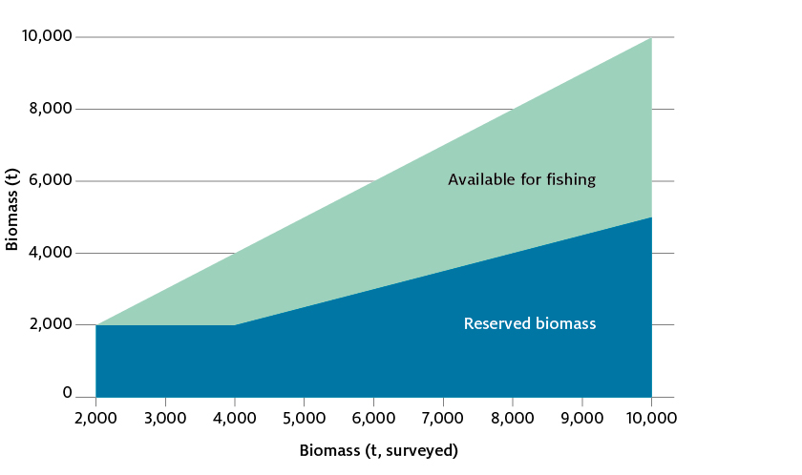

Figure 8 Spatial extent of the fishery and concepts employed in the harvest strategy

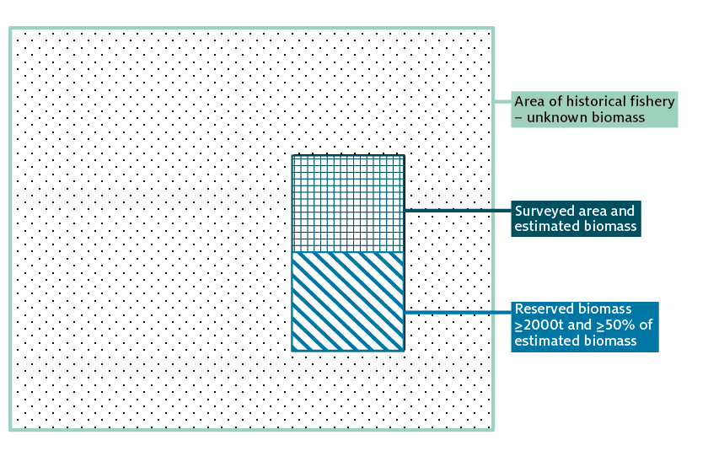

Surveyed area and estimated biomass

Reserved biomass. ≥2000t and ≥50% of estimated biomass

#### Harvest control rule

The harvest function is essentially a fixed exploitation rate, where the maximum TAC is a constant fraction (50%) of the known stock in each year—modified to ensure a minimum reserve in low biomass years (Figure 7). This harvest control rule applies a dynamic reference point (maintaining a minimum 50% of the known biomass) coupled with an absolute biomass floor in recognition of the potential elevated risk of recruitment impairment during periods of low productivity and biomass.

Season length may also be altered on the basis of in-season information to maximise returns. Indicators of the price received per kilogram of landed product and the average cost of fishing for the fleet ($ per hours fished) are used to determine the point at which the additional cost per unit of catch begins to exceed the additional revenue earned on that catch (that is, cost is greater than revenue). The fishery is closed shortly after this point is detected so as not to dissipate profits.

#### Limit reference point

The threshold for the amount of biomass protected each year was selected based on historical data and the experience of the fishery which indicates that the stock has a capacity to rebuild from that level. The actual biomass of the stock may well be larger than that estimated by the preseason survey given that the survey covers only a subset of the extent of the historical range. However, the harvest strategy makes no assumptions about the level of biomass outside of the surveyed area, and any such biomass cannot be fished.

In addition to the protection of a minimum amount of biomass, the animals within that protected area must be of a certain size as a proxy for an ability to contribute to spawning and future recruitment.

#### Risk–cost–catch

This example meets the risk–cost–catch principles advocated by the Harvest Strategy Policy through a relatively low cost harvest strategy design whereby industry ultimately decides how much of the historical fishery area they wish to survey (where more survey area roughly correlates to increased cost). Pre-determined rules protect the stock against adverse risks of recruitment impairment and within season data is collected to monitor and respond to indicators of profitability.

### Example 4: Moderate information, quota controlled multi-stock demersal fishery

#### Description

This example is for a sub-fishery within a larger multi-species, multi-gear fishery. The fishery primarily targets one species of shark (a single key commercial stock), with two byproduct stocks (also sharks). A fourth stock was historically key commercial but was subsequently overfished (before commencement of the Harvest Strategy Policy) and is now the subject of a rebuilding strategy.

#### Target setting and controlling catch

Biomass-based targets have been set for the key commercial and byproduct stocks taking into account their relative economic contribution to the fishery.

The single key commercial stock is managed to a B48 target, applied as a multi-year TAC (MYTAC). Break-out rules are in place to trigger a review of the MYTAC if conditions change substantially. The MYTAC is set based on the outputs of an integrated stock assessment.

The two byproduct stocks are managed to B40 target because they are relatively less economically important and so that operations focused on the key commercial stock are not overly constrained. The two byproduct stocks are assessed through standardised CPUE.

The fourth stock (previously key commercial) is currently overfished, so remains the subject of a rebuilding strategy. Once the stock has recovered to above the LRP, targeted fishing may recommence in line with a harvest strategy that has been appropriately tested to ensure it meets the requirements of the Harvest Strategy Policy. A target for this stock will be determined at this time.

#### Limit reference points

The four commercial stocks in this sector are sharks and as such exhibit relatively lower productivity characteristics than most teleosts. Given this, the LRP for all four stocks has been set at 0.30B0.

#### Risk–cost–catch

Investment in assessments for the four species reflects their biological status and relative economic contribution to the fishery. The key commercial stock and the overfished stock are assessed using relatively expensive integrated stock assessment models, while the two byproduct stock are assessed using relatively less costly standardised CPUE series.

Assessments using standardised CPUE series are considered to be relatively more uncertain than integrated stock assessments. As such, a 15% discount factor is applied to the RBC for the stocks assessed using this method.

The use of MYTACs reduces costs in terms of assessment interval and increases certainty to the fishing industry by fixing catch for the fishery over a specified period.

### Example 5: Low information, small, catch-controlled demersal fishery

#### Description

This example is for a temperate demersal trawl fishery targeting a broad spectrum of finfish. The fishery operates over wide spatial area and takes relatively small quantities of a relatively large number of fish species. Fishing effort is relatively low and often sporadic. Operators often schedule their operations in this fishery around the down times in other fisheries. The number of permits issued in the fishery are limited, but actual active vessels has been much lower than this limit over the past two decades.

The harvest strategy takes a relatively low cost approach to what is a relatively low information and low value fishery. The harvest strategy principally relies on triggers associated with thresholds of catch or CPUE that prompt further investigation into the sustainability of fishing operations. These thresholds are not set at levels at which we would expect stocks to be at risk of recruitment impairment or at which returns are maximised (MEY). They are set at relatively conservative levels, which in effect control expansion of the fishery and force the fishery to evaluate its impacts on stocks prior to expansion.

#### Target setting and controlling catch

There are no explicit biological or economic targets. Historic catch and effort levels, which are considered to be low and well below any sustainability threshold, are used to set catch and/or CPUE triggers. Catch is not explicitly capped or constrained through the harvest strategy but triggers are set at pre-defined thresholds that result in review of operations in terms of sustainability.

Additionally, risk assessments have established that most species are at low risk from fishing. Those species that were found to be at greater than low risk are being overtly managed through species-specific triggers.

The fishery pursues the economic objective of the Harvest Strategy Policy through an approach whereby the operations of fishers are not overly restricted to allow fishers the flexibility to maximise their profitability within reasonable bounds. This approach is considered to be appropriate in fisheries with few operators, low effort and low GVP. The costs associated with more sophisticated and stringent management arrangements would outweigh the ability of the operators to support it.

No fishing has occurred in the past couple of years, indicating that it is often not profitable to enter the fishery, let alone support more intensive assessment or more stringent management. More intensive management arrangements with higher associated costs would likely reduce the effort further and preclude more activity in the fishery.

#### Limit reference points

There are no explicit biological or economic limits. The risk of recruitment impairment in this fishery is mitigated through two mechanisms. The first is that all aspects of the fishery are assessed through risk assessment. Any species considered to be at greater than low risk from fishing are actively managed.

The second is through its approach to the setting of the catch triggers within the harvest strategy. Triggers are set based on historical catch levels that have been demonstrated through MSE to be unlikely to result in overfishing of the stock. These triggers effectively control expansion of the fishery from an acceptable and sustainable state. Should a trigger level be reached, the fishery must undergo investigation and analysis prior to expansion (and increased levels of fishing mortality).

#### Risk–cost–catch

The fishery is low effort and low value. Because of the low effort (both in recent years, but also historically), the risk to stocks in this fishery is considered to be low. As such, the fishery takes a low cost and precautionary approach to the design of its harvest strategy. This is consistent with the principles of risk–cost–catch trade-off.

## Appendix A: The Theory of MEY

### MEY and maximising net economic returns

Net economic returns (NER) refers to the total revenue generated from a fishery less the total costs of fishing. The point of maximum NER occurs at the largest difference between total revenue and total cost of fishing. When the catch from this harvest point has limited ability to influence the beach price at landing, then this catch level is the maximum economic yield (MEY) and is a function of the level of fishing effort, biomass, price and fishing cost. The level of biomass that corresponds to the MEY is referred to as BMEY.

Figure A1 shows how BMEY is determined in a stylised model of a single species fishery. Assumed in this model is that price does not change in response to the level of catch, there is no uncertainty in the fishery and all relevant biological and economic data are known (Kompas, Grafton & Che 2011).

Figure A1 MEY in a single species fishery

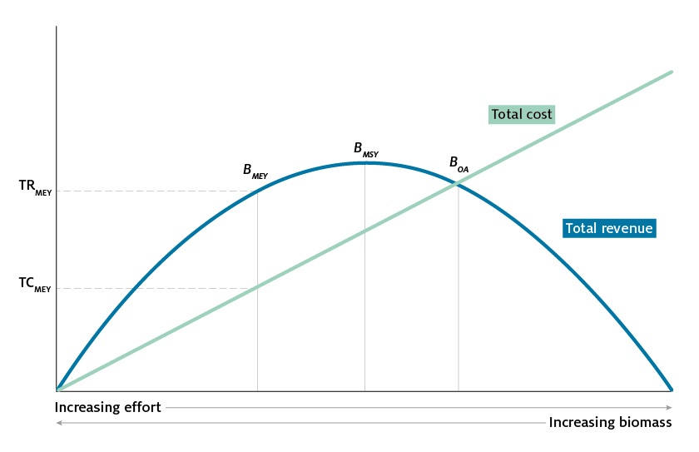Note: BMEY Biomass at maximum economic yield. BMSY Biomass at maximum sustainable yield. BOA Biomass at open

access equilibrium. TCMEY Total cost at maximum economic yield. TRMEY Total revenue at maximum economic yield.

Source: Adapted from Larkin et al. 2011

Fishing effort (for example hours fished) is represented along the horizontal axis of Figure A1. Each level of fishing effort corresponds to a sustainable rate of harvest (catch rate that results in no net change of biomass in the fishery). Higher levels of fishing effort are associated with lower fish stocks.

Total revenue is a function of price and volume of catch. Total revenue initially increases with effort as more fish are harvested and rises to a maximum at BMSY. To the right of BMSY decreasing stock size results in lower sustainable rates of harvest and further increases of effort will further reduce sustainable total revenue. Fishing costs rise as effort increases because additional fishing effort is required to harvest a given level of catch as stocks are depleted. Total costs of the fishery include vessel fishing costs, but also management costs and opportunity costs.

At BMEY net economic return is maximised and is equal to TRMEY minus TCMEY. At levels of fishing efforts greater than BMEY, additional fishing cost exceeds the additional revenue generated and NER falls. Conversely reducing effort levels lower than BMEY, results in forgone total revenue that exceeds savings from reducing total fishing costs, resulting in lower NER.

#### MEY verses MSY

In Figure A1 total revenue is maximised at BMSY, but profit from fishing at BMSY is lower than BMEY. In many cases, BMEY occurs at higher levels of biomass because the cost of fishing is lower at higher levels of biomass (Kompas, Grafton & Che 2011). NER at BMSY could be zero or negative depending on the biology of the fishery, cost of fishing and fish prices.

#### MEY can be difficult to achieve

In an open access fishery where vessels are free to enter a fishery or expand effort, positive NER generated by the fishery at BMEY will result in an expansion of effort in the fishery. Each vessel that enters or expands effort in a fishery imposes a cost on all other vessel by further depleting the stock. As more vessels enter the fishery and expand effort, total cost increases and fish stocks become further depleted. This results in a rightwards movement along the horizontal axis (Figure A1). This will continue to occur until total revenue is equal to total costs and profits are reduced to zero. This level of fishing effort and biomass is referred to as the open access equilibrium, shown as BOA in Figure A1.

A fishery operating at BOA is undesirable for a number of reasons. Net economic returns, which could be used for increasing the welfare of the Australian community, are zero at BOA. Fisheries operating at the bionomic equilibrium also represents an inefficient use of resources. This is because the same volume and value of catch could be attained sustainably at lower level of effort and cost (Kompas, Grafton & Che 2011). Resources employed in the fishery at BOA could be freed up for other productive uses in the economy (Larkin et al. 2011).

#### MEY is a moving target

The level of biomass that corresponds to the BMEY depends on a range of biological and economic variables that are subject to change. For example, the price of fish may fall or the cost of fuel may rise. Changes to the output prices or input prices change profitability of the fishery and could move BMEY away from or toward BMSY depending on the direction of a price change. Despite a movement in the efficient level of catch implied by the MEY target, NER may be lower or higher, but will always be maximised.

##### An increase in the price of fish

An increase in fish price results in revenue generated by the fishery increasing for any given level of fishing effort (Figure A2). This is illustrated by the total revenue curve rising. Higher prices result in fishing becoming more profitable at a higher level of effort and the biomass associated with BMEY moves closer (decreasing) to BMSY. This is shown in Figure A2 by a movement from $B_{MEY}^{ }$ and to $B_{MEY}^{ '}$ and profits are higher after the increase in fish price. Conversely, a fall in the price of fish results in the NER being maximised at fishing levels further to the left of BMSY.

Figure A2 Effect of a change in fish price on BMEY

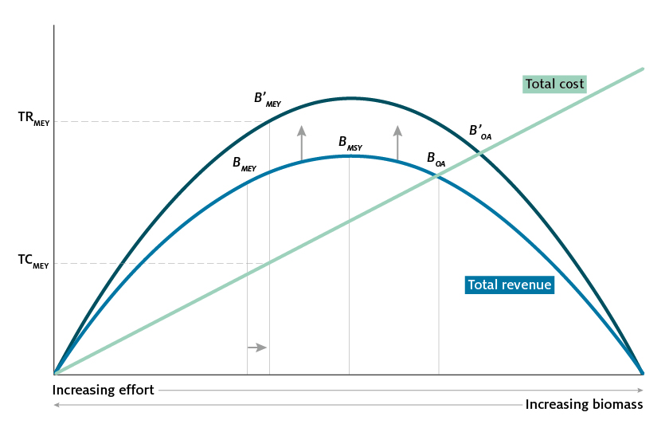

Note: BMEY Biomass at maximum economic yield. B’MEY represents the new level of biomass at maximum economic yield

following an increase in _sh price. BMSY Biomass at maximum sustainable yield. BOA Biomass at open access equilibrium. B’OA

represents the new level of biomass at open access equilibrium following an increase in _shing boats. TCMEY Total cost at

maximum economic yield. TRMEY Total revenue at maximum economic yield.

Source: Adapted from Larkin et al. 2011

##### An increase in fishing costs

An increase in the costs of fishing might occur from rising fuel prices. An increase in the cost of fuel will result in cost rising for each level of effort. This is represented in Figure A3 by an upwards pivot of the cost curve. NER is maximised at a lower effort level and higher biomass. An increase in fishing costs results in $B_{MEY}^{ }$ shifting left to $B_{MEY}^{ '}$.

Figure A3 Effect of a change in fuel price on BMEY

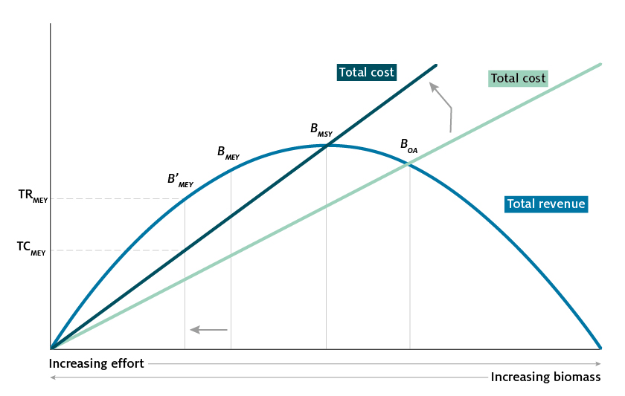

Note: BMEY Biomass at maximum economic yield. B’MEY represents the new level of biomass at maximum economic yield

following an increase in _shing costs. BMSY Biomass at maximum sustainable yield. BOA Biomass at open

access equilibrium. TCMEY Total cost at maximum economic yield. TRMEY Total revenue at maximum economic yield.

Source: Adapted from Larkin et al. 2011

##### Changes to the discount rate

MEY is a long-run concept meant to describe the maximum sustainable net economic returns from a fishery. The value of future net economic returns from harvesting the fishery should be considered when setting the BMEY target. Although not able to be represented graphically, changes to the discount rate will move the BMEY target. A typical (positive) rate of discount will mean that profits received today are valued more highly than profits received in future periods. From an economic point of view it pays to work the fishery harder in the current period and moves BMEY closer to BMSY (Kompas, Grafton & Che 2011).

#### MEY for multi‑species fisheries

The preceding discussion presented a stylised model of a single species fishery where maximum economic yield for a single species corresponded to the MEY for the fishery as a whole. However, many fisheries are characterised by having a number of economically important species, along with a number of byproduct and bycatch species. MEY for a fishery containing multiple key commercial species is complicated if these species cannot be caught without also catching an amount of other commercial species (Pascoe et al. 2015).

The single species case is extended in Figure A4 for the case of a multispecies fishery containing three commercial species—species A, species B and species C. Each species sustainable revenue curve is a function of price and biological variables. Maximum revenue for each species occurs at the top of each curve at the level of biomass corresponding to maximum sustainable yield. Like the single species case, price is assumed to not change with the level of catch.

Where the multispecies fishery differs from the single species case is if it is not possible to catch one species without also catching an amount of another commercial species. This is assumed to occur for the example in Figure A4. The total revenue curve in the lower chart of Figure A4 is the sum of each species revenue curves and represents the total revenue from a given amount of fishing effort.

MEY occurs at the level of biomass that corresponds to the widest point between total revenue and total cost. In Figure A4 this is shown at the point $B_{MEY}^{F}$. For the example in Figure A4, fishery profit is maximised at a level of effort and biomass that is beyond the maximum sustainable yield of species A, near the MSY of species B and below the MSY of species C. At the point $B_{MEY}^{F}$, all species have a biomass greater than 20 per cent of their unfished biomass.

The multispecies fishery in Figure A5 shows how constraints on the minimum levels of biomass could result in the economic returns to the fishery as a whole differing from the economic return at $B_{MEY}^{F}$. Figure A5 is identical to Figure A4 except that the price of species B and species C have increased. The level of catch that maximises profit in the fishery $B_{MEY}^{F}$ results in species A being fished to less than 20 per cent of its unfished biomass. If there is a requirement that each species to have a biomass of no less than 20 per cent of unfished biomass then this will limit fishing effort at the level of biomass corresponding to $B_{20}^{A}$. Net economic returns in the fishery as a whole at this level of effort are lower compared with the fishing effort associated with $B_{MEY}^{F}$.

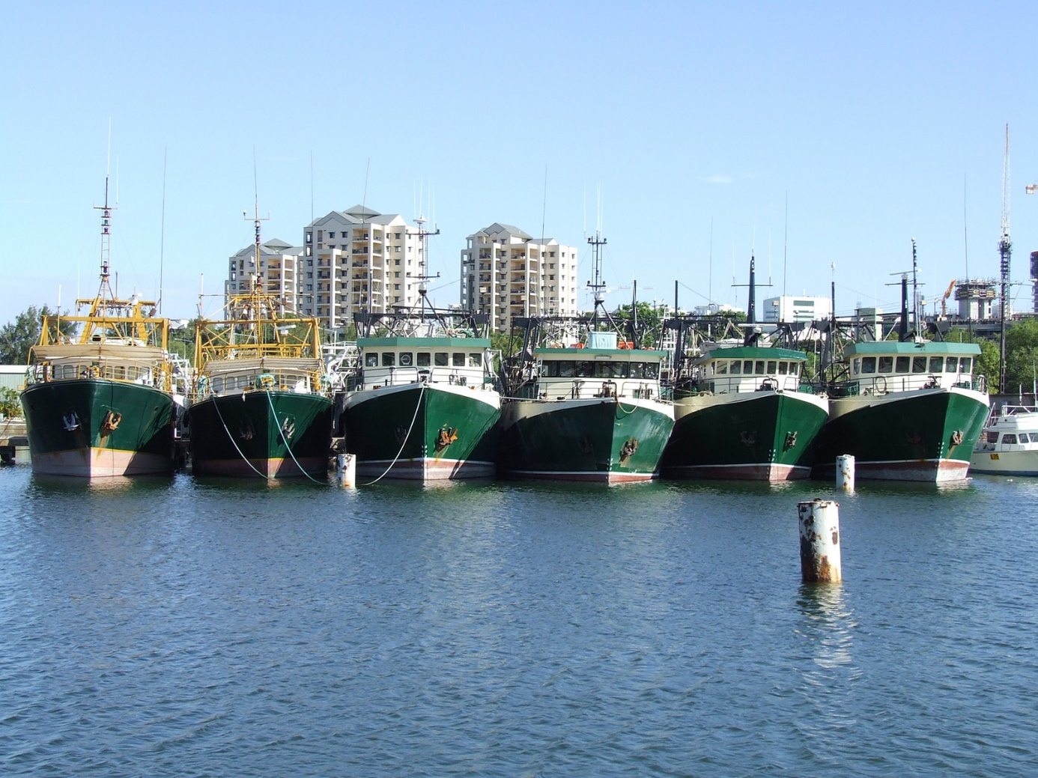

Figure A4 Maximum economic yield in a multi‑species fishery

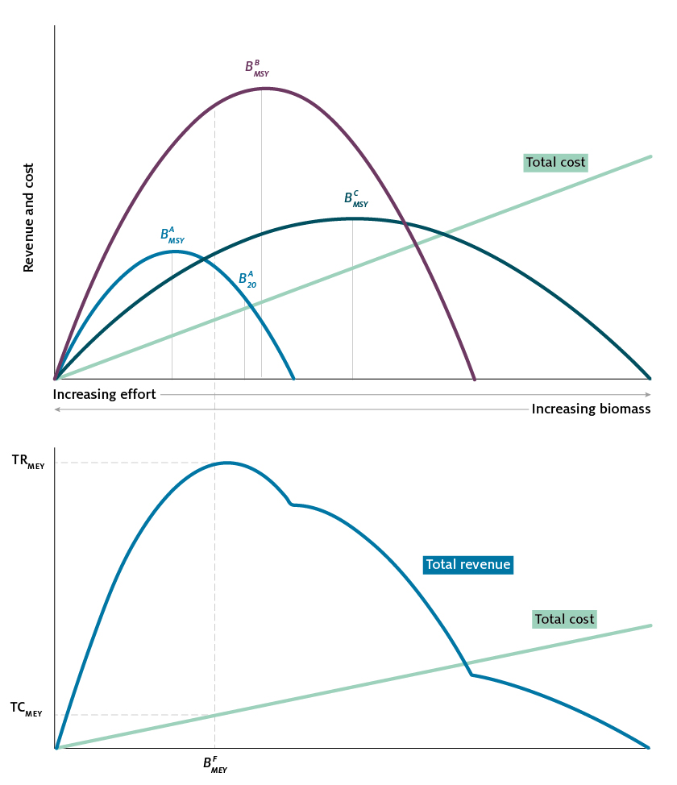

Note: BMEY Biomass at maximum economic yield. BMSY Biomass at maximum sustainable yield. TCMEY Total cost at maximum

economic yield. TRMEY Total revenue at maximum economic yield. Total revenue curve is the summation of each species

revenue curves at each level of e_ort/biomass. Total cost curve is identical between charts. The angle of the total cost curve

in the lower chart appears lower re_ecting the larger scale of the vertical axis.

Source: Adapted from Pascoe et al. 2015

Figure A5 Maximum economic yield in a multi species fishery when biomass limits for individual species constrain the economic return to the fishery as a whole

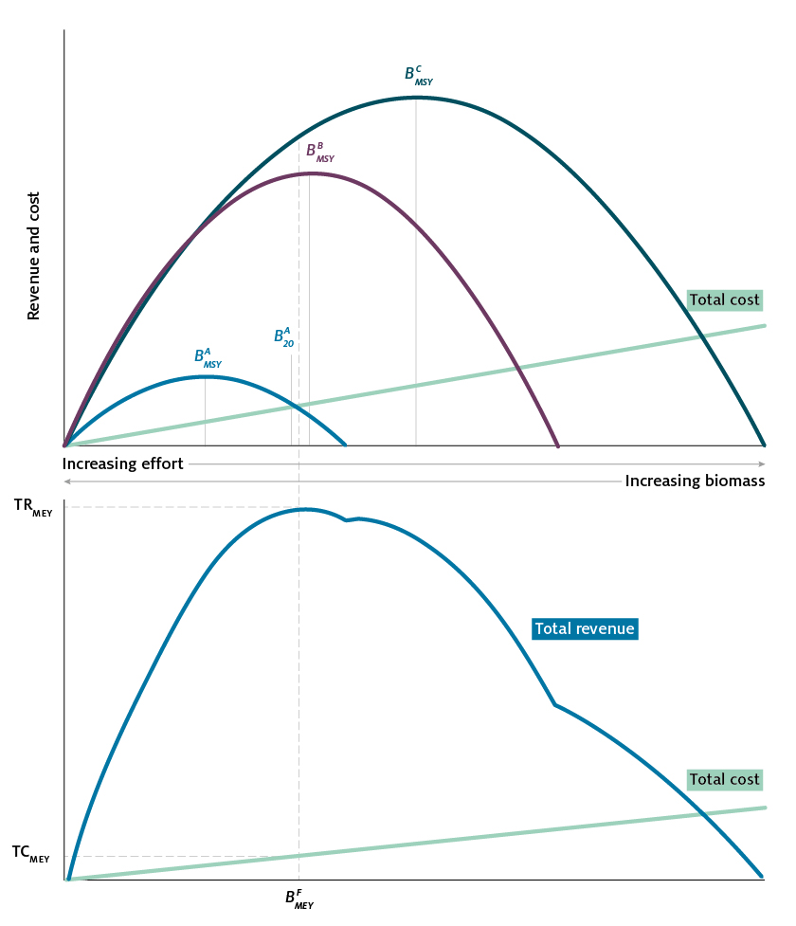

Note: BMEY Biomass at maximum economic yield. BMSY Biomass at maximum sustainable yield. TCMEY Total cost at maximum

economic yield. TRMEY Total revenue at maximum economic yield. Total revenue curve is the summation of each species

revenue curves at each level of e_ort/biomass. Total cost curve is identical between charts. The angle of the total cost curve

in the lower chart appears lower re_ecting the larger scale of the vertical axis.

Source: Adapted from Pascoe et al. 2015

## Appendix B: A potential tier structure and risk equivalency

This appendix provides a potential tier structure that can ensure a consistent risk for breaching the LRP across the range of stock assessment approaches and their uncertainty level. It is not intended to be prescriptive but rather to provide an example of good practice. There may be other approaches to a tier system that can be demonstrated to be effective in meeting the policy’s requirements.

In some multi-species and TAC managed fisheries globally, harvest strategy approaches have been placed in tiers that roughly move from data rich to more data limited approaches (see review in Dichmont et al. 2016). In many of these fisheries, buffers have been used to trade catch and cost—if one trades catch against cost for a specific risk of breaching the limit reference point, there is a risk equivalent TAC that acknowledges assessment uncertainty. Buffers are the gap between the harvest strategy-produced recommended management control (the RBC) and the final management decision that accounts for risk under uncertainty (the final TAC). After simulation tests of the Southern and Eastern Scalefish and Shark Fishery and Dowling et al. (2014) tier systems, and the international tier review (Dichmont et al. 2016), it was recommended that tier systems should be based on what they can determine (estimate or calculate through proxies) relative to the Harvest Strategy Policy requirements, rather than focused entirely on a particular tool. Such a proposed tier system with associated buffers can be found in the next section.

An alternative to placing harvest strategies into a tier system to maintain LRP risk equivalency is to undertake simulation tests to determine whether a harvest strategy (and its component HCRs) conforms to the requirements of the Harvest Strategy Policy. This approach would be beneficial especially for single species or input controlled fisheries. If a harvest strategy has been simulation tested using MSE, for example, and shown to conform to the Harvest Strategy Policy in terms of achieving risk equivalency, then no buffer is required (Figure B2).

### Potential tier structure for harvest strategies in a TAC managed fishery with buffers

A potential tier structure is described in Figure B1. Required buffers have been estimated for data rich, data moderate and data limited approaches using Ralston et al. (2011) based on simulation tests undertaken using the Atlantis framework (Table B1). If the best estimates from the assessments are without bias and uncertainty (that is, one has perfect information) one can implement the TAC that is calculated by this harvest strategy without a buffer. However, since it is more precautionary to assume that a more data-limited tier is positively biased and has higher variance, then the buffer should address assessment uncertainty. Importantly however, many studies have shown that bias and uncertainty do generally increase with less information, but the degree of uncertainty for the same harvest strategy can be very species-specific, highlighting that broad generic guidelines should ideally be tested on a species by species basis.

Figure B1 Flowchart of example tier system

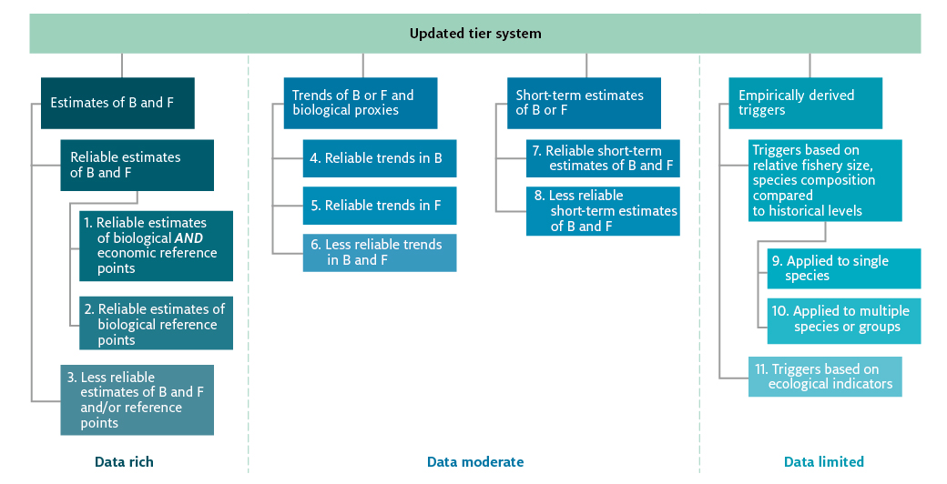

Note: B biomass. Fishing mortality. More information on each category is provided in Table B_.

Table B1 Tier number and related buffer for application to recommended catch level when no simulation testing has been made of the harvest strategy based on the proposed tier system in Figure B1

|  |  |
| --- | --- |
| Tier | Default buffer |
| 1-2 (data rich) | 0.91 as a default or use directly calculated values using Ralston et al. (2011) a |
| 3 (data rich) | 0.87; or use Ralston et al. (2011) directly b |
| 4-8 (data moderate) | 0.82-0.87; or use Ralston et al. (2011) directly b |
| < 9 (Data limited) | 0.68 b |

**a** This is the average value of Ralston et al. (2011) approach from the SESSF where the percentile was set to 0.45. Other fisheries may need to calculate the relevant amount based on their assessments (if possible). Individual species values can also be used. **b** These buffer values use the Ralston et al. (2011) approach and simulation tested in Fulton et al. ( 2016)5, but with the percentile set to 0.4.

Figure B 2 Flow diagram explaining the different options for achieving risk equivalency for a specific harvest strategy

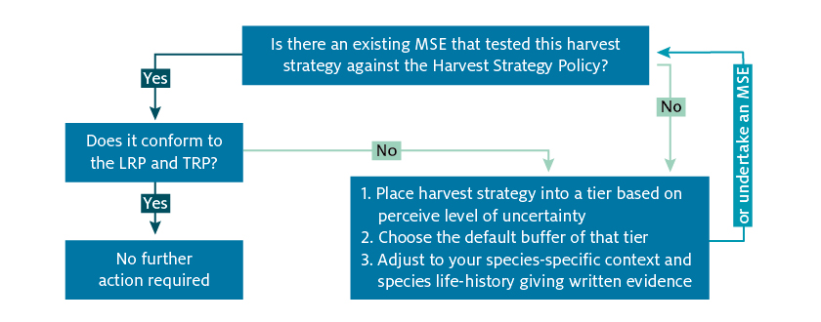

LRP Limit reference point. TRP Target reference point.

### Guiding principles for achieving risk equivalency

These guiding principles should apply when developing and implementing tiered harvest strategies in accordance with the Harvest Strategy Policy:

1. A hierarchical system of tiers should be used for setting the TAC or TAE to achieve risk equivalency.
2. When defining the tiers to be used, the tiers should be based on relative uncertainty, in terms of both bias and variance in the harvest strategy.
3. Data-limited tiers should be assumed to have higher variance and positive bias in the assessment and RBC.
4. Bias and variance in a category should be addressed in one of two ways—by developing a harvest strategy that, through simulation testing (such as MSE), is shown to conform to the policy, or by adding buffers so that the uncertainty is addressed.
5. The RCC trade-off should be implemented at the species level.
6. There is not one universally appropriate set of buffer values that can be applied across all stocks with equal cost and risk implications. Default or generic values may be used in the absence of species-specific information, but simulation testing for a specific species or life history is recommended to avoid unnecessary risk or cost (in terms of foregone catch).
7. The costs and benefits of investing in immediate data collection should be assessed for the more data-limited tiers, including what data might be needed in preparation for a time when a trigger is reached and a more data rich assessment may be needed (data banking for the future).

### Developing a tier structure

The example tier system distinguished between reliable and unreliable assessments (Figure B1). As per all technical discussions, the relevant resource assessment group (RAG) would have ultimate responsibility for determining whether an assessment is reliable. However, some guiding principles can be provided.

A reliable assessment is difficult to define in advance, but some exploratory approaches can be applied to determine the reliability of an assessment. Approaches such as residuals analyses, reweighting approaches, sensitivity tests, chain analyses for Monte Carlo Markov Chain (MCMC) approaches, retrospective trends, historical trends of the assessment, harvest projections and decision tables can be used. Lack of a reliable index of abundance or uncertainty about stock structure would be examples of factors that would cast doubt on an assessment. A detailed description of what an assessment report should contain is provided in a US Pacific Fisheries Management Council document (Pacific Fishery Management Council 2016), as an example. Such approaches do not tend to be applied in data limited situations where empirical assessments and harvest strategies are implemented.

The age of an assessment is also a factor that should be considered in determining reliability. In a prioritisation process in the United States by Methot (2015), assessment frequency was based on the mean age in the catch (or a proxy) multiplied by a fishery capacity scaling factor (that is, the assessment capacity available to a specific fishery). This metric was then adjusted based on the stocks variability, with the underlying principle being that slow growing species can afford longer periods between assessments as short-term changes in biomass are less likely. The results were also influenced by stock status and the value of the fishery, among other factors. Additional considerations should include whether there is evidence of large-scale environmental factors, such as regime shifts, which may require more frequent updates to the assessments.

Multiple tools are available for data moderate and limited fisheries that can assist with the choice of assessment methods and harvest strategies. One option would be to use the FishPath tool (Dowling et al. 2016) to help narrow down the harvest strategy and assessment methods available given the available data, knowledge of the fishery and capacity (among others). An MSE simulation tool, such as the Data Limited Methods (DLM) Toolkit (Carruthers & Hordyk 2016) could then be used to test the harvest strategy and assessment method chosen.

Table B2 Detail of the potential tier system with example approaches that fall into each tier

| Tier | Description | Example approach |
| --- | --- | --- |
| 1 | Reliable estimates of B, F, biological and economic reference points | Bioeconomic assessment |
| 2 | Reliable estimation of B, F and biological reference points (MEY can be proxies) | Integrated stock assessment  Reliable biomass dynamic model |
| 3 | Less reliable estimation of B and F, and/or less reliable reference points | Catch only methods such as depletion corrected average catch (DCAC), stock reduction analysis (see MSE review in Carruthers et al. (2015)  Less reliable stock assessment  Out of date stock assessment (see text) |
| 4 | Reliable trends in B (e.g. no direct estimates of B) and reference points are proxies | Biomass proxy indexes such as CPUE or survey indexes  Reliable within season management approaches using biomass proxy indexes such as CPUE or survey indexes |
| 5 | Reliable trends analysis for F (e.g. no direct estimates of F) and reference points are proxies | Regular catch curve analyses |
| 6 | Less reliable trends analysis in B and F, and reference points are proxies | Regular catch curve analyses where some assumptions are breached or data is less consistent year on year  Regular eSAFE (AFMA 2017) or other reliable spatially resolved distribution approaches based on recent spatial distributions |
| 7 | Reliable short-term F based on presence/absence spatial distribution of species and reliable fishing pressure distribution (F reference points are proxies) | Once-off catch curve analysis  Once-off or out of date eSAFE  Once-off GIS mapping overlap methods  Spatial overlap approaches using tier 6 approaches, but on species where regime shift may be happening |
| 8 | Less reliable short term indexes of B or F based on reliable catch or catch rate data (e.g. within season escapement) which provide an immediate but only relative categorical measure of F (along the lines of high/med/low scale) and F reference points are proxies (and B reference points are unavailable) | Once-off catch curve analyses where some assumptions are breached or data is less consistent year on year  Once off bSAFE (AFMA 2017) or other spatial distribution approaches where the spatial distributions are out of date or is not spatially well resolved (e.g. presence/absence) |
| 9 | Empirically derived triggers with no available reference points (at least initially) applied to single species for fisheries of small size | Relative levels of current and historical catch (or snapshot catch rates) |
| 10 | Empirically derived triggers with no available reference points (at least initially) applied to multiple species or groups for fisheries of small size | Relative levels of current and historical catch and catch composition |
| 11 | Empirically derived triggers based on ecological indicators—for multispecies fisheries of small size (these indicators need to have been shown to have true information content, whether based on local work or by testing in the literature such as the list of indicators from ‘indicators of the sea’ (Coll et al. 2016); these indicators will provide a binary/ordinal style impression of stock status, as a ‘good’ status for the indicator infers that the majority of the constituent species are also in ‘good’ condition, although more vulnerable stocks may still be in a poor state, if the indicator is in a ‘bad’ state then it is likely the majority of constituent species are too). It may be possible to develop reference points for these indicators, although it is unlikely these will be directly comparable to B and F based indicators | Patchy catch and survey data  Patchy data from a single source (e.g. survey or catch) |

## Glossary

| Term | | Definition | |
| --- | --- | --- | --- |
| Term | Definition | |
| Allowable biological catch (ABC) | A term used by a management agency, which refers to the range of allowable catch for a species or species group. | |
| Biomass (B) | Total weight or volume of a stock or of a component of a stock. For example, see ‘spawning biomass’. | |
| Biomass limit reference point (BLIM) | The point beyond which the risk to the stock is regarded as unacceptably high. | |
| Biomass at maximum economic yield (BMEY) | The average biomass which corresponds to maximum economic yield. See also ‘maximum economic yield’. | |
| Biomass at maximum sustainable yield (BMSY) | The average biomass which corresponds to maximum sustainable yield. See also ‘maximum sustainable yield’. | |
| Biomass target (BTARG) | The desired biomass of the stock. | |
| Bycatch | A species that is incidentally either:   * taken in a fishery and returned to the sea * killed or injured as a result of interacting with fishing equipment in the fishery, but not taken.   Bycatch can include EPBC Act–listed species | |
| Bycatch policy | The Commonwealth Fisheries Bycatch Policy provides a framework for managing the risk of fishing related impacts on bycatch species in Commonwealth fisheries. | |
| Byproduct | Byproduct stocks make some contribution to the value of the catch in a fishery but less than that of key commercial species. These stocks may be rarely encountered and usually retained, or frequently encountered and occasionally retained. | |
| Catch | In relation to fishing, means capture, take or harvest. | |
| Categorisation | The act of identifying and partitioning components of a fishery’s catch into categories. Typically categories include key commercial, byproduct and bycatch. | |
| Choke species (or stock) | Generally those species (or stocks) that are caught in combination with a key commercial stock, but the management of which restricts the ability of fishers to fully catch or access the quota for a key commercial stock. | |
| Catch-per-unit-effort (CPUE) | The number or weight of fish caught by a unit of fishing effort. Can be used as an index of relative abundance or indicator of change in the fishery. | |
| Data-poor stock | Relative term for stocks with a relatively small or uncertain knowledge base and/or data. | |
| Decision rules | See ‘harvest control rules’. | |
| Discard | Any part of the catch which is returned to the sea, whether dead or alive. In Commonwealth fisheries, the term is predominantly used to refer to commercial species that are not retained. | |
| Discarding | The practice of returning any part of the catch to the sea. | |
| Dynamic unfished biomass (B(F=0)) | The biomass expected to be present over a specific (usually recent) time period in the absence of fishing (that is, where fishing mortality, F, is set to zero). May change through time. | |
| Ecological risk assessment (ERA) | An assessment process that evaluates the relative risk posed by fishing on species, habitats and communities within a fishery. | |
| Ecological risk management (ERM) | The management framework for undertaking and responding to outcomes of ecological risk assessment. | |
| Ecologically sustainable development (ESD) | Using, conserving and enhancing the community’s resources so that ecological processes are maintained, and the total quality of life, now and in the future, can be increased.  Principles of ecologically sustainable development (as per the Fisheries Management Act 1991):   * decision‑making processes should effectively integrate both long‑term and short‑term economic, environmental, social and equity considerations * if there are threats of serious or irreversible environmental damage, lack of full scientific certainty should not be used as a reason for postponing measures to prevent environmental degradation * the principle of inter‑generational equity—that the present generation should ensure that the health, diversity and productivity of the environment is maintained or enhanced for the benefit of future generations * the conservation of biological diversity and ecological integrity should be a fundamental consideration in decision‑making * improved valuation, pricing and incentive mechanisms should be promoted. | |
| Economic efficiency | A fishery is economically efficient when fishery-level efficiency and vessel-level efficiency are achieved, and management costs are as low as they can be while still providing the necessary level of management. Fishery-level and vessel-level efficiency means that effort is restricted to the point where the difference between fishing revenue and cost is greatest, and fishers are applying that level of effort at least cost. | |
| Effort | Also, called fishing effort. A measure of the resources (such as fishing hours or hook sets) used to harvest a fishery’s stocks. | |
| Environment Protection and Biodiversity Conservation Act 1999 (EPBC Act) | The central piece of Commonwealth environmental legislation. It provides a legal framework to protect and manage nationally and internationally important flora, fauna, ecological communities and heritage places—defined in the EPBC Act as matters of national environmental significance. Parts 10, 13 and 13A relate specifically to aspects of fisheries. | |
| EPBC Act–listed species  (also known as TEP) | EPBC Act–listed species comprises all those protected under Part 13 of the EPBC Act including whales and other cetaceans and listed threatened, marine and migratory species (except for conservation-dependent species which are managed through rebuilding strategies under the Harvest Strategy Policy). | |
| Equilibrium unfished or virgin biomass (B0) | Biomass level if fishing had not occurred. May be calculated as the long-term average biomass value expected in the absence of fishing. In production models equates to carrying capacity. May be assumed to equate with the biomass at the start of fishing. | |
| Fisheries Administration Act 1991 (FA Act) | Commonwealth Act that establishes the Australian Fisheries Management Authority (AFMA) and its Commission. | |
| Fisheries Management Act 1991 (FM Act) | Commonwealth Act that provides the legal framework for fisheries managed by the Australian Government. The Act sets out, among other things: fisheries management objectives and arrangements for regulating; permitting; and taking enforcement action with respect to fishing operations. | |
| Fishery management strategy (FMS) | An all-encompassing document containing key fishery-level management measures including the harvest strategy and ERA/ERM objectives and requirements. | |
| Fishing | Fishing includes:   * searching for, or taking, fish * attempting to search for, or take, fish * engaging in any other activities that can reasonably be expected to result in the locating, or taking, of fish * placing, searching for or recovering fish aggregating devices or associated electronic equipment such as radio beacons * any operations at sea directly in support of, or in preparation for, any activity described in this definition * aircraft use relating to any activity described in this definition except flights in emergencies involving the health or safety of crew members or the safety of a boat * the processing, carrying or transhipping of fish that have been taken. | |
| Fishing mortality rate (F) | The rate of fish deaths due to fishing a stock or a designated component of a stock. | |
|  |  | |
| Fishing mortality limit reference point (FLIM) | The fishing mortality above which the removal rate from the stock is regarded as too high. | |
| Fishing mortality at maximum economic yield (FMEY) | Fishing mortality rate which corresponds to maximum economic yield. | |
| Fishing mortality at maximum sustainable yield (FMSY) | Fishing mortality rate which corresponds to maximum sustainable yield. Note: FMSY is generally greater than FMEY. | |
| Fishing mortality target (FTARG) | The target fishing mortality rate. | |
| Fishing mortality reference level (FREFERENCE) | Fishing mortality rate which corresponds to, a specified biomass (that is, the chosen reference biomass). | |
| Forage species or stocks | Species or stocks that are an important food source for other species in the ecosystem. | |
| General bycatch | All bycatch that is not listed under the EPBC Act (see ‘EPBC Act–listed species’). | |
| Generation time | The average time taken for an individual to replace itself within the population. | |
| Guidelines for the Ecologically Sustainable Management of Fisheries (2nd Edition) | Developed to support the assessment of fisheries in pursuing sustainability objectives under the EPBC Act. The guidelines outline the principles and objectives for evaluating the environmental performance of management arrangements for export fisheries and fisheries which operate in Commonwealth waters. | |
| Gross value of production (GVP) | A value obtained by multiplying the volume of catch (whole-weight equivalent) by the average per-unit beach price. In the case of a multispecies fishery, the fishery’s GVP is the sum of the GVPs of each species. | |
| Harvest control rules (HCR) | Pre-determined rules that control fishing activity according to the biological and economic conditions of the fishery (as defined by monitoring or assessment). Also called ‘decision rules’. HCR are a key element of a harvest strategy. | |
| Harvest strategy | A decision framework designed to pursue defined biological and economic objectives for commercial fish stocks in a given fishery (also known as a management procedure). Key elements include: operational objectives, performance indicators, reference points, acceptable levels of risk, a monitoring strategy, an assessment and harvest control rules. | |
| Harvest Strategy Policy | The policy that establishes the requirement for the development of harvest strategies in Commonwealth-managed fisheries. | |
| Highly variable stock | Stocks which naturally undergo large changes in biomass or productivity through time. For such stocks, the concept of long-term average or equilibrium stock levels have less utility for fisheries management. | |
| Incidental catch | The portion of the catch that was not the intended target of a fishing operation. | |
| Indicator | Provides information on the state of the stock. | |
| Input controls | Management measures that place restraints on fishing, e.g. who fishes (licence limitations), where they fish (closed areas), when they fish (closed seasons) or how they fish (gear restrictions). | |
| Key commercial stock | Stocks that are most relevant to the objective of maximising net economic returns to the Australian community from the management of the fishery. | |
| Keystone species or stock | An organism that has a greater role in maintaining ecosystem function than may be predicted based on its relative abundance. | |
| Limit reference point (LRP) | The level of an indicator (such as biomass or fishing mortality) beyond which the risk to the stock is regarded as unacceptably high. | |
| Management procedure | See ‘Harvest strategy’. | |
| Management strategy evaluation | A procedure whereby alternative management strategies are tested and compared using simulations of stock and fishery dynamics. | |
| Maximum economic yield (MEY) | The sustainable catch or effort level for a commercial fishery that allows net economic returns to be maximised. In this context, maximised equates to the largest positive difference between total revenue and total cost of fishing. | |
| Maximum sustainable yield (MSY) | The maximum average annual catch that can be removed from a stock over an indefinite period under prevailing environmental conditions. | |
| Natural mortality rate (M) | Deaths of fish from all natural causes except fishing. Usually expressed as an instantaneous rate or as a percentage of fish dying in a year. | |
| Net economic return (NER) | A fishery’s NER over a particular period is equal to fishing revenue less fishing costs. Fishing costs include the usual accounting costs of fuel, labour, and repairs and maintenance, as well as various economic costs such as the opportunity cost of owner labour and capital (see ‘Opportunity cost’). The concept of NER is very closely related to economic efficiency, a necessary condition for NER to be maximised. | |
| Opportunity cost | The compensation a resource forgoes by being employed in its present use and not in the next best alternative. For example, the opportunity cost incurred by the skipper of a fishing vessel is the amount they would have received by applying their skill and knowledge in the next best alternative occupation. The opportunity cost of owning a fishing vessel might be the interest that could be earned if the vessel were sold and the capital invested elsewhere. Although these costs are not usually reflected in a firm’s financial accounts, they are very important. | |
| Output controls | Management measures that place restrictions on the outputs from fishing, including how much is caught, what species are taken and the size of those species. | |
| Overfished | A fish stock with a biomass below its biomass limit reference point or below its specified indicator limit reference point. | |
| Overfishing | A stock that is experiencing too much fishing. The rate of removals from a stock is likely to result in the stock becoming overfished. For a stock that is overfished, overfishing is a rate of removals that will prevent stock recovery in accordance with its rebuilding strategy. | |
| Performance measure | Provides information on management performance. They are a measure of where an indicator is in relation to a reference point. | |
| Precautionary principle | Where there are threats of serious or irreversible environmental damage, lack of full scientific certainty should not be used as a reason for postponing measures to prevent environmental degradation. In the application of the precautionary principle, public and private decisions should be guided by:   * careful evaluation to avoid, wherever practicable, serious or irreversible damage to the environment; and * an assessment of the risk-weighted consequences of various options. | |
| Probability of occurrence | The estimated probability that the animal occurs in a specified location at a specified time. | |
| Productivity susceptibility analysis (PSA) | PSA is a method that assigns to each species in each fishery a score on two axes, the first representing its susceptibility to being caught and the second, its biological productivity. | |
| Population | All the organisms of the same species, which live in a particular geographical area, and have the capability of interbreeding. | |
| Productivity (of a fish) | The rate of generation of biomass in an ecosystem. | |
| Proxy | In the context of the Harvest Strategy Policy, a more easily estimated figure used to represent the value of a reference point. For example a target biomass of 0.48B0 is a proxy for BMEY where the actual value of BMEY may be unknown. | |
| Quota | Amount of catch or effort allocated to a fishery as a whole (total allowable catch/effort), or to an individual fisher or company (individual transferable quota). | |
| Recommended biological catch (RBC) | An output from (certain) harvest control rules. Provides an estimate of the total fishing mortality (landings from all sectors plus discards) recommended to achieve a predefined target. Distinct from total allowable catch (TAC). | |
| Rebuilding strategy | A strategy designed to rebuild an overfished stock to above its limit reference point and towards its target reference point. | |
| Recruit | Usually, a fish that has just become susceptible to the fishery. Sometimes used in relation to population components (for example, a recruit to the spawning stock). | |
| Recruitment | The amount of fish added to the exploitable stock each year due to growth and/or migration into the fishing area. For example, the number of fish that grow to become vulnerable to the fishing gear in one year would be the recruitment to the fishable population that year. This term is also used in referring to the number of fish from a year class reaching a certain age. | |
| Recruitment impairment | A sustained and significant reduction in recruits to below average levels. Typically associated with recruitment overfishing. | |
| Recruitment overfishing | Recruitment impairment that results from fishing. | |
| Reference point | Specified level of an indicator used as a benchmark within a harvest strategy. | |
| Resource assessment group (RAG) | Fishery-specific group that (*inter alia*) provides advice to the Australian Fisheries Management Authority on the status of fish stocks, species, fishery economics and on the impact of fishing on the marine environment. | |
| Risk–catch–cost (RCC) | The RCC trade-off seeks to balance the amount of resources invested in data collection, analysis and management of a fishery, with the level of catch (or fishing mortality) taken from that fishery. | |
| Risk equivalency | An equivalent level of risk between two comparable stocks or species. | |
| Sustainability assessment for fishing effects (SAFE) | An analysis that estimates fishing mortality based on the overlap between a species’ range and fishing effort, and similar biological and fishing attributes as are used to derive indicators in productivity susceptibility analysis. | |
| Spawning biomass (SB) | The total weight of all adult (reproductively mature) fish in a population (also referred to as spawning stock biomass). | |
| Spawning stock biomass (SSB) | See ‘spawning biomass’. | |
| Species | A group of animals in which members can breed with one another and produce fertile offspring | |
| Species accumulation curve | Statistical approach of plotting the number of new species that accumulate with additional sampling. A species accumulation curve may be used to estimate the likely total number of species under very high (or infinite) sampling rates. May be used to assess adequacy of fisheries sampling, such as observer coverage levels, for detecting interactions. | |
| Stock (stock structure) | A unit of management (subpopulation) of a particular fish species with common intrinsic population parameters (growth, recruitment, mortality and fishing mortality) and for which extrinsic factors (immigration and emigration) may be ignored. A stock may encompass the whole distribution of a species, in which case the stock and species are in effect the same thing. Or it may be some subset of the distribution of a species, in which case a species would have stock structure and comprise multiple stocks. | |
| Stock assessment | A scientific analysis of a fish stock to estimate quantities of management or scientific interest such as fishing mortality and biomass, particularly in the context of reference levels. | |
| Take (taken) | See ‘catch’. | |
| Targeting (also known as targeted fishing) | The tailoring of fishing practices (including fishing gear) to pursue a particular stock, species or size of fish. | |
| Target reference point (TRP) | The desired state of the stock or fishery (for example, MEY or BTARG) | |
| Teleost | A fish of a large group that comprises all ray-finned fishes apart from the primitive bichirs, sturgeons, paddlefishes, freshwater garfishes, and bowfins. | |
| HSP 90% risk criterion | A one-in-ten-year risk that stocks will fall below BLIM. Forms part of the testing of harvest strategies for stocks managed under the Harvest Strategy Policy. | |
| Threatened, endangered or protected species (TEP) | Species or stocks listed as either threatened, endangered or protected under the EPBC Act. | |
| Total allowable catch (TAC) | The annual catch limit set for a stock, species or species group. Used to control fishing mortality within a fishery. | |
| Total allowable effort (TAE) | The annual effort limit set for a stock, species or species group. Used to control fishing mortality within a fishery. | |

## References

AFMA 2017, [Guide to AFMA's Ecological Risk Management](http://www.afma.gov.au/wp-content/uploads/2017/08/Final-ERM-Guide_June-2017.pdf), Australian Fisheries Management Authority, Canberra.

Brown, CJ, Fulton, B, Possingham, HP & Richardson AJ 2012, [How long can fisheries management delay action in response to ecosystem and climate change](https://esajournals.onlinelibrary.wiley.com/doi/abs/10.1890/11-0419.1)?, Ecological Applications, vol. 22, no. 1, pp. 298–310.

Caddy, JF & Mahon, R 1995, [Reference points for fisheries management](http://www.fao.org/docrep/003/v8400e/v8400e00.HTM), FAO Fisheries Technical Paper no. 347, Food and Agriculture Organization of the United Nations, Rome.

Carruthers, TR & Hordyk, A 2016, DLMtool: Data-Limited Methods Toolkit. SEDAR 46. A. a. R. South-east Data, University of British Columbia, Vancouver, Canada.

Carruthers, TR, Kell, LT, Butterworth, DDS, Maunder, MN, Geromont, HF, Walters, C, McAllister, MK, Hillary, R, Levontin, P, Kitakado, T & Davies, CR 2015, [Performance review of simple management procedures](https://academic.oup.com/icesjms/article/73/2/464/2614445), *ICES Journal of Marine Science*, vol 73, issue 2, pp. 464–482.

Christensen, V & Walters, CJ 2004, [Ecopath with Ecosim: methods, capabilities and limitations](https://www.sciencedirect.com/science/article/pii/S030438000300365X), Ecological Modelling, vol. 172, pp. 109–139.

Coll, M, Shannon, LJ, Kleisner, KM, Juan-Jordá, MJ, Bundy, A, Akoglu, AG, Banaru, D, Boldt, JL, Borges, MF, Cook, A, Diallo, I, Fu, C, Fox, C, Gascuel, D, Gurney, LJ, Hattab, T, Heymans, JJ, Jouffre, D, Knight, BR, Kucukavsar, S, Large, SI, Lynam, C, Machias, A, Marshall, KN, Masski, H, Ojaveer, H, Piroddi, C, Tam, J, Thiao, D, Thiaw, M, Torres, MA, TraversTrolet, M, Tsagarakis, K, Tuck, I, van der Meeren, GI, Yemane, D, Zador, SG & Shin, YJ 2016, [Ecological indicators to capture the effects of fishing on biodiversity and conservation status of marine ecosystems](https://www.sciencedirect.com/science/article/pii/S1470160X1500480X), *Ecological Indicators*, vol 60, pp. 947–962.

Dambacher, JM, Gaughan, DJ, Rochet, M-J, Rossignol, PA & Trenkel, VM 2009, [Qualitative modelling and indicators of exploited ecosystems](https://onlinelibrary.wiley.com/doi/abs/10.1111/j.1467-2979.2008.00323.x), Fish and Fisheries, vol. 10, pp. 305–322.

Dichmont, CM, Punt, AE, Dowling, N, De Oliveira, JAA, Little, LR, Sporcic, M, Fulton, E, Gorton, R, Klaer, N, Haddon, M & Smith, DC 2016, [Is risk consistent across tier-based harvest control rule management systems? A comparison of four case-studies](https://onlinelibrary.wiley.com/doi/abs/10.1111/faf.12142), Fish and Fisheries, vol. 17, pp. 731–747.

Dowling, N, Dichmont, C, Haddon, M, Smith, DC, Smith, ADM & Sainsbury, K 2014, [Empirical harvest strategies for data-poor fisheries: A review of the literature](https://www.sciencedirect.com/science/article/pii/S0165783614003300), *Fisheries Research,* vol. 171, pp. 141–153.

Dowling, NA, Wilson, JR, Rudd, MB, Babcock, EA, Caillaux, M, Cope, J, Dougherty, D, Fujita, R, Gedamke, T, Gleason, M, Gutierrez, N, Hordyk, A, Maina, GW, Mous, PJ, Ovando, D, Parma, AM, Prince, J, Revenga, C, Rude, J, Szuwalski, C. Valencia, S and Victor S 2016, FishPath: A Decision Support System for Assessing and Managing Data- and Capacity-Limited Fisheries, In: Quinn, TJ II, Armstrong, JL, Baker, MR, Heifetz, J and Witherell, D (eds.), *Assessing and Managing Data-Limited Fish Stocks*, Alaska Sea Grant, University of Alaska Fairbanks.

Fulton, EA, Punt, AE, Dichmont, CM, Gorton, R, Sporcic, M, Dowling, N, Little, LR, Haddon, M, Klaer, N and Smith, DC 2016, [Developing risk equivalent data-rich and data-limited harvest strategies](https://www.sciencedirect.com/science/article/pii/S0165783616302168), *Fisheries Research*, vol. 183, pp. 574–587.

Gabriel, WL & Mace, PM 1999[, A review of biological reference points in the context of the precautionary approach](https://www.st.nmfs.noaa.gov/Assets/stock/documents/workshops/nsaw_5/gabriel_.pdf), National Oceanic and Atmospheric Administration Technical Memorandum NMFS-F/SPO-40.

Hilborn R 2010, [Pretty good yield and exploited fishes](https://www.sciencedirect.com/science/article/pii/S0308597X09000682), *Marine Policy*, vol. 34, pp. 193–196.

Hillary, R, Preece, A, Kolody, D, Evans, K and Davies, C 2016, [Development of an approach to harvest strategy management of internationally managed multi-species fisheries](http://frdc.com.au/Archived-Reports/FRDC%20Projects/2013-203-DLD.pdf), Fisheries Research and Development Corporation final report 2013/203.

Hobday, A and Cvitanovic, C 2017, [Preparing Australian fisheries for the critical decade: insights from the past 25 years](http://www.publish.csiro.au/mf/mf16393), *Marine and Freshwater Research* vol. 68(10), pp. 1779–1787.

Hobday, AJ and Evans, K 2013, [Detecting climate impacts with oceanic fish and fisheries data](https://link.springer.com/article/10.1007/s10584-013-0716-5), *Climatic Change*, vol 119, pp. 49–62.

Klaer, NL, O’Boyle, RN, Deroba, JJ, Wayte, SE, Little, LR, Alade, LA and Rago PJ 2015, [How much evidence is required for acceptance of productivity regime shifts in fish stock assessments: Are we letting managers off the hook?](https://www.sciencedirect.com/science/article/pii/S0165783615001113), *Fisheries Research*, vol. 168, pp. 49–55.

Kompas, T, Grafton, RQ & Che, N 2011, [*Target and Path: Maximum Economic Yield in Fisheries Management*](http://www.agriculture.gov.au/abares/publications/display?url=http://143.188.17.20/anrdl/DAFFService/display.php?fid=pe_abares99010704_12a.xml), ABARES technical report 11.3, Australian Bureau of Agricultural and Resource Economics and Sciences, Canberra, July.

Larkin SL, Alvarez, A, Sylvia, G, & Harte, M 2011[, *Practical Considerations in Using Bioeconomic Modelling for Rebuilding Fisheries*](https://www.oecd-ilibrary.org/docserver/5kgk9qclw7mv-en.pdf?expires=1525654058&id=id&accname=guest&checksum=12540B29364548F9259859DCAB3158F2), OECD Food, Agriculture and Fisheries Papers, No. 38, OECD Publishing, Paris.

Link, JS, Gaichas, S, Miller, TJ, Essington, T, Bundy, A, Boldt, J, Drinkwater, KF & Moksness, E 2012, [Synthesizing lessons learned from comparing fisheries production in 13 northern hemisphere ecosystems: emergent fundamental features](https://brage.bibsys.no/xmlui/handle/11250/109134), *Marine Ecology Progress Series*, vol. 459, pp. 293–302.

Lynch, TP, Morello, EB, Evans, K, Richardson, AJ, Rochester, W, Steinberg, CR, Roughan, M, Thompson, P, Middleton, JF, Feng, M & Sherrington R 2014, [IMOS National Reference Stations: a continental-wide physical, chemical and biological coastal observing system](http://journals.plos.org/plosone/article/authors?id=10.1371/journal.pone.0113652), *PloS one*, vol. 9, e113652.

Methot Jr, RD 2015, [Prioritizing Fish Stock Assessments](https://spo.nmfs.noaa.gov/technical-memoranda/fspo-152), National Oceanic and Atmospheric Administration Technical Memorandum NMFS-F/SPO-152.

Myers, RA, Rosenberg, AA, Mace, PM, Barrowman, N & Restrepo VR 1994, [In search of thresholds for recruitment overfishing](https://academic.oup.com/icesjms/article-abstract/51/2/191/674482), *ICES Journal of Marine Science* vol. 51, pp. 191–205.

Nielsen, JR, Thunberg, E, Holland, D, Schmidt, JO, Fulton, EA, Bastardie, F, Punt, AE, Allen, I, Bartelings, H, Bertignac, M, Bethke, E, Bossier, S, Buckworth, R, Carpenter, G, Christensen, A, Christensen, V, Da-Rocha, JM, Deng, R, Dichmont, CM, Doering, R, Esteban, A, Fernandes, JA, Frost, H, Garcia, D, Gasche, L, Gascuel, D, Gourguet, S, Groeneveld, RA, Guillen, J, Guyader, O, Hamon, K, Hoff, A, Horbowy, J, Hutton, T, Lehuta, S, Little, LR, Lleonart, J, Macher, C, Mackinson, S, Mahevas, S, Marchal, P, Mato-Amboage, R, Mapstone, B, Maynou, F, Merzéréaud, M, Palacz, A, Pascoe, S, Paulrud, A, Plaganyi-Lloyd, E, Prellezo, R, Putten, van, EI, Quaas, M, Ravn-Jonsen, L, Sanchez, S, Simons, S, Thébaud, O, Tomczak, M, Ulrich, C, Van Dijk, D, Vermard, Y, Voss, R & Waldo, S 2017, [Integrated Ecological-Socioeconomic Fisheries Models – Evaluation, Review and Challenges for Implementation](https://onlinelibrary.wiley.com/doi/abs/10.1111/faf.12232), *Fish and Fisheries¸* vol. 19, pp. 1–29.

Pacific Fishery Management Council 2016, [Terms of reference for the groundfish and coastal pelagic species stock assessment review process for 2017-2018](http://www.pcouncil.org/wp-content/uploads/2017/01/Stock_Assessment_ToR_2017-18.pdf), Pacific Fishery Management Council.

Pascoe, S, Thebaud, O & Vieira, S 2014, [Estimating proxy economic target reference points in data-poor single-species fisheries](https://www.tandfonline.com/doi/abs/10.1080/19425120.2014.966215), *Marine and Coastal Fisheries,* vol. 6(1), pp. 247–259.

Pascoe, S, Hutton, T, Thebaud, O, Deng, R, Klaer, N & Vieira, S 2015, [Setting economic target reference points for multiple species in mixed fisheries,](http://www.afma.gov.au/wp-content/uploads/2017/02/FRDC-Project-2011-200-Setting-economic-target-reference-points-for-multiple-species-in-mixed-fisheries-Sean-Pascoe.pdf) FRDC Project No. 2011/200, Canberra.

Pikitch, E, Boersma, PD, Boyd, IL, Conover, DO, Cury, P, Essington, T, Heppell, SS, Houde, ED, Mangel, M, Pauly, D, Plagányi, É, Sainsbury, K & Steneck, RS 2012, [Little Fish, Big Impact: Managing a Crucial Link in Ocean Food Webs](http://www.lenfestocean.org/~/media/legacy/lenfest/pdfs/littlefishbigimpact_revised_12june12.pdf?la=en), Lenfest Ocean Program, Washington, D.C. 108 pp.

Plagányi, ÉE, Punt, AE, Hillary, R, Morello, EB, Thébaud, O, Hutton, T, Pillans, RD, Thorson, JT, Fulton, EA, Smith, ADM, Smith, F, Bayliss, P, Haywood, M, Lyne, V & Rothlisberg, PC 2014, [Multispecies fisheries management and conservation: tactical applications using models of intermediate complexity](https://onlinelibrary.wiley.com/doi/abs/10.1111/j.1467-2979.2012.00488.x), *Fish and Fisheries*, vol. 15(1), pp. 1–22.

Punt, AE & Butterworth, DS 1995, [The effects of future consumption by the Cape fur seal on catches and catch rates of the Cape hakes. 4. Modelling the biological interaction between Cape fur seals *Arctocephalus pusillus pusillus* and Cape hakes *Merluccius capens*is and M. paradoxus](https://www.tandfonline.com/doi/abs/10.2989/025776195784156494), *South African Journal of Marine Science*, vol. 16, pp. 255–285.

Ralston, S, Punt, A, DeVore, J & Conser, R 2011, [A meta-analytic approach to quantifying scientific uncertainty in stock assessments,](https://www.st.nmfs.noaa.gov/spo/FishBull/1092/ralston.pdf) *Fisheries Bulletin*, vol. 109, pp. 217–231.

Rindorf, A, Schmidt, J, Bogstad, B, Reeves, S & Walther, Y 2013, [A Framework for Multispecies Assessment and Management, An ICES/NCM Background Document](http://www.ices.dk/publications/Documents/Miscellaneous%20pubs/A%20framework%20for%20multispecies%20assessment%20and%20management.pdf), Rosendahls-Schultz Grafisk, Denmark, 47 pp.

Rindorf, A, Dichmont, CM, Levin, PS, Mace, P, Pascoe, S, Prellezo, R, Punt, AE, Reid, DG, Stephenson, R, Ulrich, C, Vinther, M & Clausen, LW 2017, [Food for thought: pretty good multispecies yield](https://academic.oup.com/icesjms/article/74/2/475/2907929), *ICES Journal of Marine Science*, vol. 74, pp. 475–486.

Sainsbury, K 2008, [Best practice reference points for Australian fisheries](http://www.afma.gov.au/wp-content/uploads/2010/06/rep_sainsbury_best-practice_jan08_20080228.pdf), Australian Fisheries Management Authority, Canberra.

Stäbler, M, Kempf, A, Mackinson, S, Poos, JJ,Garcia, C & Temming, A 2016, [Combining efforts to make maximum sustainable yields and good environmental status match in a food-web model of the southern North Sea](https://www.sciencedirect.com/science/article/pii/S0304380016300084), *Ecological Modelling*, vol. 331, pp. 17–30.

Wayte, S 2013, [Management implications of including a climate-induced recruitment shift in the stock assessment for jackass morwong (Nemadactylus macropterus) in south-eastern Australia](https://www.sciencedirect.com/science/article/pii/S0165783612002159), *Fisheries Research*, vol. 142, pp. 47–55.

Walters, CJ, Christensen, V, Martell, SJ & Kitchell, JF 2005, [Possible ecosystem impacts of applying MSY policies from single-species assessment](https://academic.oup.com/icesjms/article/62/3/558/665660), *ICES Journal of Marine Science*, vol. 62, pp. 558–568.

Zhang, C, Chen, Y & Ren, Y 2016, [An evaluation of implementing long-term MSY in ecosystem-based fisheries management: Incorporating trophic interaction, bycatch and uncertainty](https://www.sciencedirect.com/science/article/pii/S0165783615301041), *Fisheries Research*, vol. 174, pp. 179–189.