# Commonwealth Fisheries Harvest Strategy Policy

Framework for applying an evidence-based approach to setting harvest levels in Commonwealth fisheries

Second Edition

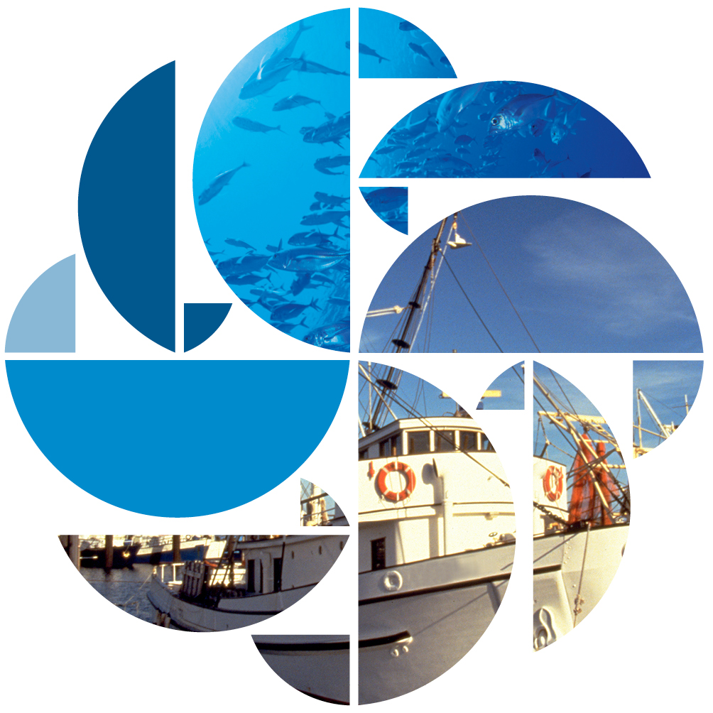© Commonwealth of Australia 2018

**Ownership of intellectual property rights**

Unless otherwise noted, copyright (and any other intellectual property rights, if any) in this publication is owned by the Commonwealth of Australia (referred to as the Commonwealth).

**Creative Commons licence**

All material in this publication is licensed under a Creative Commons Attribution 4.0 Australia Licence, save for content supplied by third parties, logos and the Commonwealth Coat of Arms.

C:\Documents and Settings\west merryn\Local Settings\Temporary Internet Files\Content.Word\by.png

Creative Commons Attribution 4.0 Australia Licence is a standard form licence agreement that allows you to copy, distribute, transmit and adapt this publication provided you attribute the work. A summary of the licence terms is available from creativecommons.org/licenses/by/4.0. The full licence terms are available from creativecommons.org/licenses/by/4.0/legalcode.

**Cataloguing data**

This publication (and any material sourced from it) should be attributed as: Department of Agriculture and Water Resources 2018, Commonwealth Fisheries Harvest Strategy Policy, Canberra, June. CC BY 4.0.

ISBN: 978-1-76003-157-2

**Internet**

This publication is available at <http://agriculture.gov.au/fisheries/domestic/harvest_strategy_policy>

**Contact**

Department of Agriculture and Water Resources

GPO Box 858 Canberra ACT 2601

Telephone 1800 900 090

Web [agriculture.gov.au](http://agriculture.gov.au/)

The Australian Government acting through the Department of Agriculture and Water Resources has exercised due care and skill in preparing and compiling the information and data in this publication. Notwithstanding, the Department of Agriculture and Water Resources, its employees and advisers disclaim all liability, including liability for negligence and for any loss, damage, injury, expense or cost incurred by any person as a result of accessing, using or relying on any of the information or data in this publication to the maximum extent permitted by law.

## Foreword

As Australians, we can take great pride in our world-leading, sustainable fisheries management practices. Our oceans are a shared resource and the Australian Government is committed to ensuring that our Commonwealth fisheries are sustainably managed for the benefit of all Australians—now and into the future.

Following the release of the first edition of the Commonwealth Fisheries Harvest Strategy Policy and Guidelines in 2007, all major Commonwealth fisheries are now managed through a harvest strategy. I am pleased to now release this second edition, which has been developed in collaboration with industry, scientists and the broader community to underpin continued sustainable catch levels.

By using the best available science and research—including stock assessments, quantitative decision rules, ecosystem-based fisheries management and the application of the precautionary principle—we can be confident that our fisheries management practices remain among the most sustainable in the world.

The new policy builds on the pillars of the first edition and includes the following key improvements:

* bringing the management of byproduct species under this policy, so all species we interact with in Commonwealth fisheries are now managed under either this policy or the Commonwealth Fisheries Bycatch Policy
* providing greater flexibility and guidance for the development of harvest strategies in complex, multi-species fisheries
* giving more guidance on managing for variability such as regime shifts in our marine environment
* providing more explicit consideration of recreational and Indigenous fishing activity when determining fish stock management arrangements
* ensuring consistency of management across fisheries to provide the fishing industry with a more certain operating environment.

The policy is a cornerstone of the government’s continuing commitment to Australia’s fishing industry and the importance of preserving the future demand for fisheries resources. It maximises the economic viability of the commercial fleet, recognises the interests of other users of the resource, and ensures Australian seafood is available for future generations.

The Australian Government will continue to lead and promote a sustainable, productive, internationally competitive and profitable fisheries industry.

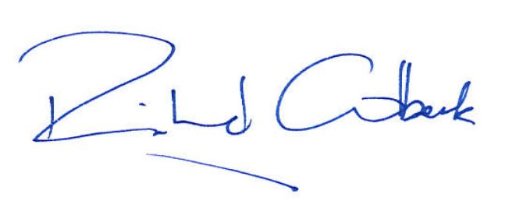

**Senator the Hon. Richard Colbeck**

Assistant Minister for Agriculture and Water Resources

Schoool – silver trevally *@Shutterstock*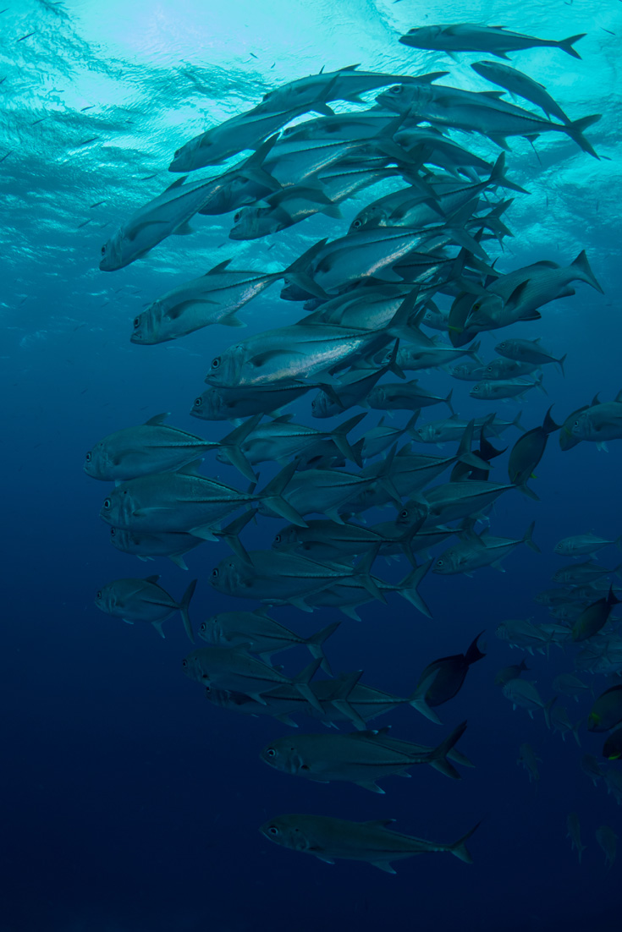

Contents

Foreword iii

1 Introduction 1

1.1 Harvest strategy defined 2

1.2 Scope 2

2 Objective 4

2.1 Strategy 4

3 Applying the Harvest Strategy Policy 5

3.1 Species categorisation 5

3.2 Accounting for all sources of mortality 5

3.3 Variability, regime shift and climate change 6

3.4 Establishing and applying harvest control rules 6

3.5 Balancing risk, cost and catch 6

3.6 Reference points 6

3.7 Discarding 7

3.8 Spatial and temporal management 7

3.9 Technical evaluation of harvest strategies 7

3.10 Performance assessment, review and reporting 8

3.11 Jointly managed domestic stocks 8

3.12 Jointly managed international stocks 8

3.13 Rebuilding overfished stocks 9

3.14 Rebuilding timeframes 10

3.15 Relationship between the Harvest Strategy Policy and the *Environment Protection and Biodiversity Conservation Act 1999* 10

4 Implementation and review 12

4.1 Guidelines 12

4.2 Harvest strategies 12

4.3 Roles and responsibilities 12

4.4 Reporting and review 12

Glossary 13

**Figures**

Figure 1 Relationship between the Harvest Strategy Policy and the Bycatch Policy 2

## Introduction

The [*Commonwealth Fisheries Harvest Strategy Policy*](http://www.agriculture.gov.au/fisheries/domestic/harvest_strategy_policy)(Harvest Strategy Policy) provides a framework for applying an evidence-based, precautionary and transparent approach to setting harvest levels in Commonwealth fisheries. It defines biological and economic objectives for Commonwealth fisheries and identifies reference points to be used in harvest strategies to achieve these objectives. The [*Guidelines for Implementation of the Commonwealth Fisheries Harvest Strategy Policy*](http://www.agriculture.gov.au/fisheries/domestic/harvest_strategy_policy) support this policy and provide practical assistance for developing and implementing fishery-specific harvest strategies. This policy and the guidelines, together with the *[Commonwealth Fisheries Bycatch Policy](http://www.agriculture.gov.au/fisheries/environment/bycatch/review)* (Bycatch Policy) and the [Guidelines for the Ecologically Sustainable Management of Fisheries (2nd edition)](http://www.environment.gov.au/marine/publications/guidelines-ecologically-sustainable-management-fisheries), provide a basis for managing the risk to all species impacted by the commercial harvest of Commonwealth fisheries resources.

Owing to the diverse nature of Commonwealth fisheries, the Harvest Strategy Policy allows flexibility in using harvest strategies to meet the needs of each fishery while still meeting the objective of this policy. Harvest strategies developed under the policy use available information about particular fish stocks and apply an evidence-based approach to setting catch levels. Harvest strategies consistent with this policy provide industry and the Australian community with confidence that Commonwealth commercial fish stocks are being managed for long-term ecological sustainability and economic viability. Implementation of clear harvest strategies also provides the fishing industry with a more certain operating environment.

The legislative framework that establishes the objectives, obligations and powers of the Commonwealth fisheries regulator, the Australian Fisheries Management Authority (AFMA), includes the Fisheries Management Act 1991 and the Fisheries Administration Act 1991. The Environment Protection and Biodiversity Conservation Act 1999 also imposes requirements on Commonwealth fisheries and their management.

This policy continues to progress the formal direction given by the Australian Government fisheries minister to AFMA in 2005. That direction required AFMA to take immediate action in all Commonwealth fisheries to:

* cease overfishing and recover overfished stocks to levels that will ensure long-term sustainability and productivity
* avoid further species from becoming overfished in the short and long term
* manage the broader environmental impacts of fishing, including on threatened species and others protected under the Environment Protection and Biodiversity Conservation Act 1999.

An objective of the Fisheries Management Act 1991 is exploitation of fisheries resources in a manner consistent with the principles of ecological sustainable development. The principles include the effective integration of long-term and short-term economic, environmental, social and equity considerations.

In pursuing its ecologically sustainable development objective, AFMA applies an ecosystem-based fisheries management approach—that is, it manages the effects of fishing on the broader marine ecosystem. Harvest strategies consider the relationship the species has with others in the food web and the marine environment. This may require a stock or group of stocks to be managed more conservatively.

A further objective of the Fisheries Management Act 1991 is to pursue maximisation of net economic returns to the Australian community from the management of fisheries. The interests of the commercial, recreational and Indigenous fishing sectors may all be relevant to the pursuit of this objective and the development of harvest strategies.

Implementing harvest strategies by themselves will not necessarily achieve ecologically sustainable or economically optimal fisheries. Other tools are available to Commonwealth fisheries managers, including the Australian Government’s ecological risk assessment and ecological risk management framework, and bycatch management under the Bycatch Policy. Harvest strategies in combination with the other elements of the Commonwealth fisheries management system constitute a comprehensive approach to ecosystem-based fisheries management. In some cases cooperation will be required with other jurisdictions in the management of shared resources to ensure objectives can be met for Commonwealth fisheries.



Prawns on barbeque *@ Shutterstock*

### Harvest strategy defined

A harvest strategy sets out a decision framework necessary to achieve defined biological and economic objectives for commercial fish stocks in a given fishery. It is sometimes referred to as a management procedure. Harvest strategies outline:

* processes for monitoring and assessing the biological and economic conditions of commercial fish species within fisheries against fishery-specific reference levels (a reference point or points)
* pre-determined rules that control fishing activity according to the biological and economic conditions of the fishery (as defined by monitoring or assessment)—these rules are referred to as harvest control rules or decision rules.

### Scope

The Harvest Strategy Policy applies to management of Commercial species (key commercial and byproduct) in Commonwealth fisheries managed by AFMA. Non-commercial bycatch species (general bycatch and EPBC Act-listed species) are managed under the Bycatch Policy and the Environment Protection and Biodiversity Conservation Act 1999 (Figure 1).

Figure 1 Relationship between the Harvest Strategy Policy and the Bycatch Policy

Image showing the relationship between the harvest strategy and bycatch policies.
Commercial species (key-commercial and byproduct species) are managed under the Harvest Strategy Policy, while Non-commercial species (bycatch and EPBC Act listed species) are managed under the Bycatch Policy 


Where overlap between domestic jurisdictional management exists (for example, stocks that are managed jointly by the Commonwealth and other Australian jurisdictions) the Australian Government will seek to apply and encourage the adoption of this policy in negotiating and implementing joint or cooperative management arrangements. In the case of fisheries that are managed jointly by an international organisation or arrangement, the Harvest Strategy Policy does not prescribe management arrangements. However, it does articulate the government’s preferred approach. Where Australia is a major harvester of the stock and no harvest strategy has been determined internationally, AFMA must develop and implement a harvest strategy consistent with the objective of this policy.

## Objective

The objective of the Harvest Strategy Policy is the ecologically sustainable and profitable use of Australia’s Commonwealth commercial fisheries resources (where ecological sustainability takes priority)—through implementation of harvest strategies.

### Strategy

To pursue this objective the Australian Government will implement harvest strategies that:

* ensure exploitation of fisheries resources and related activities are conducted in a manner consistent with the principles of ecologically sustainable development, including the exercise of the precautionary principle
* maximise net economic returns to the Australian community from management of Australian fisheries—always in the context of maintaining commercial fish stocks at sustainable levels
* maintain key commercial fish stocks, on average, at the required target biomass to produce maximum economic yield from the fishery
* maintain all commercial fish stocks, including byproduct, above a biomass limit where the risk to the stock is regarded as unacceptable (BLIM), at least 90 per cent of the time
* ensure fishing is conducted in a manner that does not lead to overfishing—where overfishing of a stock is identified, action will be taken immediately to cease overfishing
* minimise discarding of commercial species as much as possible
* are consistent with the *Environment Protection and Biodiversity Conservation Act 1999* and the [Guidelines for the Ecologically Sustainable Management of Fisheries (2nd edition)](http://www.environment.gov.au/marine/publications/guidelines-ecologically-sustainable-management-fisheries).

Maximising the net economic return from a fishery to the Australian community will in most cases be consistent with maximising the net economic returns from the commercial fishery. While the Harvest Strategy Policy does not outline the government’s policy on resource sharing*,* where it is clear there is a significant non-commercial interest in a fishery, the need to share the resources appropriately will be considered.

In multi-species fisheries managing individual stocks to different target reference points may be necessary to achieve fishery level maximum economic yield. Sustainable harvesting of all stocks over the long term must still be ensured (avoiding approaching limit reference points).

For a stock assessed as below the biomass limit reference point (that is, overfished), targeted fishing must cease and a stock rebuilding strategy developed to rebuild the stock to above the limit biomass level (see section 3.13 on rebuilding overfished stocks).

## Applying the Harvest Strategy Policy

This section outlines the requirements to provide a transparent and systematic approach for developing harvest strategies to assist in meeting the objective of the Harvest Strategy Policy.

### Species categorisation

All species landed and sold in Commonwealth fisheries are considered commercial species. All commercial species in a fishery are to be categorised as either key commercial or byproduct.

The categorisation of each species (or group of species) in a fishery, along with justification for that categorisation, will be documented and made publicly available. Justification for any grouping of stocks or species will also form part of that documentation.

Factors such as consumer demand, changing cost structures, changes in regulation or changes in technology may require the transition of species in a fishery (based on definitions provided in sections 3.1.1 and 3.1.2) between categories.

While the objective of this policy applies generally at the fishery level, this policy also sets out key principles that apply to each individual category of species.

#### Key commercial

Key commercial species are those most relevant to the objective of maximising net economic returns to the Australian community from management of the fishery. Their contribution to the value of the fishery will vary but the combined management of these stocks, through appropriate targets, will contribute substantially to meeting maximum economic yield for the fishery.

Because of their value, more resources are generally directed to the assessment, management and monitoring of key commercial species and a higher level of data is generally available for these stocks.

#### Byproduct

Byproduct species make a lesser contribution to the value of the catch in a fishery. They are occasionally landed and retained—ranging from rarely encountered and usually retained, to frequently encountered and rarely retained. Biological or economic information for byproduct stocks or species is often limited. These species must be managed in line with the objective of this policy, but management actions may vary depending on the level of data available and the cost-effectiveness of the actions.

### Accounting for all sources of mortality

Harvest strategies will account for all known sources of fishing mortality on a stock, including recreational and Indigenous fishing, discards, and fishing under the management of another jurisdiction.

Harvest strategies should also account for all known non–fishing related sources of mortality that cannot be managed or constrained by AFMA.

### Variability, regime shift and climate change

Variability in ocean conditions, due to natural variability, climate change or other factors, can affect the productivity of stocks. Fisheries should seek to account for that variability when developing and implementing harvest strategies.

### Establishing and applying harvest control rules

Harvest strategies use harvest control rules to adjust the level of fishing mortality applied to a stock. This is done in response to the level of an indicator for that stock, relative to a pre-defined reference point. Harvest control rules are designed to pursue the ecological and economic management objectives for the fishery.

### Balancing risk, cost and catch

This policy establishes a risk-based management approach to developing and implementing harvest strategies in Commonwealth fisheries—that is, more caution is used when uncertainty about stock status increases.

Fishing mortality will always be constrained so the species within that fishery are not exposed to an unacceptable risk. For commercial stocks, risk is expressed as both an unacceptable risk of recruitment impairment at the stock level and the risk that objectives for both the stock and the fishery will not be achieved (noting the limit reference point cannot be breached).

In the context of this policy, and acknowledging the requirements about risk, the risk–cost–catch trade-off refers to a trade-off between the level of fishing mortality applied to one or more stocks (catch) and the cost of managing the fishery in pursuit of specified objectives.

### Reference points

A reference point is a specified level of an indicator used as a basis for managing a stock or fishery. Reference points will generally be based on indicators of either the total or spawning stock size (biomass) or the amount of harvest (fishing mortality).

Harvest strategies for stocks in Commonwealth fisheries will generally be based on target reference points and limit reference points. Target reference points express the desired status of stocks (BTARG) and desired fishing intensity (FTARG). Limit reference points (BLIM and FLIM) express situations to be avoided because they represent a point beyond which the risk to the stock is regarded as unacceptably high.

The development of harvest strategies and the selection of reference points within those harvest strategies need to be realistic with respect to the scale or nature of the fishery and the resources available to manage it. Reference points should be set at levels appropriate to the biology of the species and the proper functioning of the broader marine ecosystem.

The target reference point for key commercial fish stocks is the stock biomass required to produce maximum economic yield from the fishery (BMEY). For multispecies fisheries, the biomass target level for individual stocks may vary in order to achieve overall maximum economic yield from the fishery. In cases where stock-specific BMEY is unknown or not estimated, a proxy of 0.48 times the unfished biomass, or 1.2 times the biomass at maximum sustainable yield (BMSY), should be used. Where BMSY is unknown or poorly estimated, a proxy of 0.4 times unfished biomass should be used. Alternative target proxies may be applied provided they can be demonstrated to be compliant with the policy objective.

As stated in section 2, all stocks must be maintained above their biomass limit reference point (BLIM) at least 90 per cent of the time. Where information to support selection of a stock-specific limit reference point is not available, a proxy of 0.2 times unfished biomass should be used. In all cases, the species’ role in the proper functioning of the marine ecosystem should be considered and the limit reference point must be no less than 0.2 times unfished biomass.

### Discarding

Discarding commercial species to retain higher value catch shall not be supported by management arrangements and fishers must minimise discarding of commercial species to the greatest extent possible. Where evidence suggests systematic and avoidable discarding, steps to halt it will be developed and implemented. AFMA will monitor and report on the ongoing level of discarding and processes in place to monitor and reduce discarding.

Estimates of fishing mortality from discarding must be taken into account when undertaking stock assessments and risk assessments, implementing management measures, assessing quota usage and in operating harvest control rules to minimise the incentives for discarding.

### Spatial and temporal management

Spatial management can be used as a tool to complement other management measures. Temporal management can also be useful to address seasonal issues, such as preventing the catch of some spawning stocks. The effect of a spatial or temporal closure on the pursuit of fishery objectives must be evaluated and reflected in the harvest strategy.

Consistent with ecosystem-based fisheries management and the need to consider a fish stock across its full distribution, the impact of any relevant Commonwealth or state marine reserve on the likely abundance and distribution of the stock should be considered when developing harvest strategies for fisheries.

### Technical evaluation of harvest strategies

Harvest strategies will be formally tested to assess whether they are highly likely to meet the objective of this policy. Outcomes of that testing should be made publicly available.

Methods such as management strategy evaluation—a procedure where alternative management strategies are tested and compared using simulations of stock and fishery dynamics—can be used to test harvest strategies. However, this form of evaluation may not be cost-effective for all species in Commonwealth fisheries. Risk-based evaluation methods may also be used but should be calibrated against more quantitative methods to provide greater confidence that the strategy will meet the objective of the policy.

Technical evaluation is particularly important when information is incomplete or imprecise and when the relationship between the harvest control rule and fisheries specific objectives or management outcomes is complex.

### Performance assessment, review and reporting

The ongoing performance of each harvest strategy against its objectives must be assessed and publicly reported. To enable this performance assessment AFMA must collect and maintain adequate records, including data used in stock assessments and information on how the harvest strategy has been applied for each stock.

Individual harvest strategies will be reviewed at least every five years. Reviews should also occur when fishery conditions change or new knowledge on a species’ biology emerges.

Major amendments to harvest strategies are not anticipated to occur frequently. However, when significantly amending or developing a new harvest strategy is necessary, this should be based on current scientific and economic analysis and involve appropriate stakeholder consultation.

### Jointly managed domestic stocks

The Australian Government will pursue the sustainable use of shared domestic stocks. The Australian Government will seek an equitable allocation of catch and management costs for Commonwealth fishers in negotiations with other jurisdictions that share in the management of a stock. The government will consider all available mechanisms, including revisiting Offshore Constitutional Settlement arrangements and Commonwealth fisheries legislation to ensure these objectives are met. The Australian Government will also cooperate with state and territory jurisdictions in rebuilding overfished stocks that are harvested in Commonwealth fisheries.



Sardines on a plate @Shutterstock

### Jointly managed international stocks

For fisheries that are managed jointly by an international organisation or arrangement, the Harvest Strategy Policy does not prescribe management arrangements. This includes management arrangements for commercial and traditional fishing in the Torres Strait Protected Zone, which are governed by provisions of the Torres Strait Treaty and the Torres Strait Fisheries Act 1984.

However, it does articulate the government’s preferred approach. In the case of highly migratory/straddling stocks, the government is bound by all international treaties and arrangements that Australia has ratified or acceded to. The government (including AFMA) must implement decisions taken by all relevant regional fisheries management organisations and other international arrangements that Australia is a party to, except where Australia has made a permissible reservation about the decision. Through these forums, Australia will continue to pursue the adoption of measures that are consistent with this policy and domestic management measures in order to achieve the long-term sustainability of the stocks. All available information about the stock status, the impact of Australian fishing on that stock and any other relevant information such as catch and effort history will be taken into account when deciding on the Australian negotiating position.

AFMA will set Commonwealth fishery catch levels taking into account available science and evidence, the Australian negotiating position, advice from government and any relevant decisions of the applicable regional organisation. AFMA must determine a domestic catch level that is the same or less than that permitted under the relevant international arrangement. AFMA may also impose additional constraints on fishing effort, biomass-based recommendations or rebuilding targets.

In setting catch levels for Commonwealth fisheries, AFMA’s primary consideration will be the harvest strategies for the fishery. Where Australia is not a major harvester of the stock and no harvest strategy has been determined internationally, the key consideration will be Australia’s negotiating position in bilateral, regional or international negotiations. If Australia is a major harvester of the stock and no harvest strategy has been determined internationally, AFMA must develop and implement a harvest strategy consistent with the objective of this policy.

### Rebuilding overfished stocks

If a stock that is managed solely by AFMA is identified as overfished, immediate action is required to cease overfishing and rebuild overfished stocks to levels that ensure long-term sustainability and productivity, while avoiding further stocks becoming overfished. For such overfished stocks, AFMA must cease targeted fishing and develop a rebuilding strategy to rebuild the stock to above its limit reference point, for agreement by the fisheries and environment ministers as relevant. A rebuilding strategy will be required until the stock is above the limit reference point with a reasonable level of certainty. Adequate monitoring and data collection must be in place to assess the status of the stock and rebuilding progress and satisfy requirements of the Environment Protection and Biodiversity Conservation Act 1999.

Incidental mortality on overfished stocks should be constrained as much as possible to levels that allow rebuilding to above the limit reference point within the specified timeframe.

Once a stock has been rebuilt to above the limit reference point with a reasonable level of certainty, it may be appropriate to recommence targeted fishing in line with its harvest strategy, which will continue to rebuild the stock towards its target reference point. Under the typical functioning of a harvest control rule, a lower level of fishing pressure is applied to a stock when it is close to its limit reference point. The usual harvest strategy requirements regarding the risk of breaching the limit reference point will also apply. If a stock became overfished while being managed under a harvest strategy, that harvest strategy must be reviewed, and if necessary revised, to ensure it delivers on its objectives. In these circumstances, the harvest strategy should be tested to ensure it meets the requirements of the policy.

Rebuilding strategies should note where sources of mortality exist that cannot be managed or constrained by the Australian Government, and must take this mortality into account. Where practical and appropriate, the government will work with other jurisdictions to ensure other sources of mortality from fishing are reasonably constrained, consistent with any catch sharing agreement.

To adequately constrain the level of fishing mortality applied to overfished stocks by avoiding or minimising incidental catch, reducing the total allowable catches for other stocks in that fishery may be necessary. Reductions in the total allowable catches of other stocks should be considered when other strategies are unsuccessful or not considered viable.

A rebuilding strategy must include performance measures and detail on how and when these measures will be reported on. Where there is no evidence that a stock is rebuilding or is going to rebuild in the required timeframe, AFMA will review the rebuilding strategy and make the result of the review public. If changes to the rebuilding strategy are considered necessary, such changes must be made in a timely manner.

### Rebuilding timeframes

Rebuilding timeframes should be specified relative to the minimum timeframe for rebuilding in the absence of Commonwealth commercial fishing. Rebuilding timeframes should take into account variations in species productivity and recruitment, the relationship between spawning biomass and recruitment, and the stock’s current level of depletion.

### Relationship between the Harvest Strategy Policy and the Environment Protection and Biodiversity Conservation Act 1999

The Environment Protection and Biodiversity Conservation Act 1999 (EPBC Act) sets out Australia’s environmental objectives for fisheries and outlines aspects of fisheries that require approval. Additionally, native species such as commercially harvested marine fish species can be listed as threatened species, including in the conservation-dependent category, which may have implications for the fishing of these species.

In administering the legislation, the Department of the Environment and Energy conducts environmental assessments of fisheries for impacts on matters of national environmental significance, for interactions with species and ecological communities protected under the EPBC Act for fisheries operating in Commonwealth waters, and for fisheries seeking to trade their product internationally. These matters are considered through a single assessment process based on the [Guidelines for the Ecologically Sustainable Management of Fisheries (2nd edition)](http://www.environment.gov.au/marine/publications/guidelines-ecologically-sustainable-management-fisheries). Harvest strategies created in accordance with this policy are expected to be key documents in demonstrating consistency with these guidelines and form part of the information assessed by the Department of the Environment and Energy under the EPBC Act. Environmental approvals relating to EPBC Act–listed species and international trade can be subject to conditions that are designed to encourage fishery managers to optimise management arrangements to meet environmental outcomes and objectives.

The Threatened Species Scientific Committee, an independent scientific advisory committee that provides advice to the Environment Minister, undertakes assessments to determine if native species are eligible for listing as a threatened species. Assessments are informed by criteria closely aligned with those of the International Union for Conservation of Nature. The assessment is also informed, but not bound by, the policy and management settings (including biological reference and trigger points) of the Harvest Strategy Policy. This includes that variations in the extent of acceptable decline depend on the biology of the individual species and, for commercially harvested marine fish species, declines of up to 60 per cent from pre-fishing biomass levels are considered acceptable under the Harvest Strategy Policy where depletion is a management outcome. In all cases biomass targets and limits should consider the role of species in the ecosystem.

A fish species can be listed in the conservation-dependent category of the threatened species list if:

* it is the focus of a plan of management (i.e. a rebuilding strategy) that provides for management actions necessary to stop its decline and support its recovery
* the plan of management is in force under law, and
* cessation of the plan of management would adversely affect the conservation status of the species.

When a species is listed in the conservation-dependent category, further restrictions or limitations are not necessarily imposed on fishing beyond those provided in the plan of management (rebuilding strategy). Rebuilding strategies must outline the actions to be taken to rebuild a conservation-dependent stock. Generally, commercially harvested marine fish species are not assessed and listed in the conservation-dependent category unless stock biomass is below the limit reference point, but the Threatened Species Scientific Committee and the Environment Minister reserves judgement on which species it will assess.

AFMA can advise the Threatened Species Scientific Committee or the Environment Minister that a recovering conservation-dependent species has rebuilt above its limit reference point and is rebuilding strongly towards its target reference point under the harvest strategy for that stock. Any organisation, or member of the public, can nominate the species for delisting. Subject to its assessment findings, the Threatened Species Scientific Committee may consider recommending the removal of the species from the relevant listing category. Removing a species from the list of protected species under the EPBC Act is a decision made by the Environment Minister.

For a conservation-dependent listed species, if the rebuilding strategy is unsuccessful in meeting its targets and the biomass falls more substantially (so the risk of irreversible impacts is higher), the species may be considered for listing under a higher threatened species category.

If a species is listed in any of the vulnerable, endangered or critically endangered categories, it is then considered an EPBC Act-listed species and is managed in Commonwealth fisheries under the Bycatch Policy and the Environment Protection and Biodiversity Conservation Act 1999, as appropriate.



## Implementation and review

### Guidelines

The Guidelines for Implementation of the Commonwealth Fisheries Harvest Strategy Policy provide advice and guidance to assist in applying the Harvest Strategy Policy.

### Harvest strategies

For fisheries that have a current harvest strategy, the requirements of this policy must be taken into account when these strategies are reviewed and updated. Harvest strategies consistent with this policy must be in place in all major Commonwealth fisheries within three years of the commencement of this policy and in all Commonwealth fisheries within four years.

Harvest strategies for new fisheries or commercial stocks that currently do not have a harvest strategy will be developed by AFMA in consultation with the relevant management advisory committee and resource assessment group, and other relevant expert groups and individuals. Harvest strategies will be made publicly available.

### Roles and responsibilities

Ultimate responsibility for the management of Commonwealth fisheries rests with the Australian Government minister responsible for fisheries legislation, including the Fisheries Management Act 1991 and the Fisheries Administration Act 1991.

The key Australian Government agencies involved in Commonwealth fisheries are the Department of Agriculture and Water Resources, AFMA and the Department of the Environment and Energy.

The Department of Agriculture and Water Resources oversees implementation of the Harvest Strategy Policy. This includes ensuring the long-term environmental sustainability and economic productivity of Commonwealth fisheries, ensuring harvest strategies are implemented in line with the Fisheries Management Act 1991, and working with the Department of the Environment and Energy to meet environmental requirements arising from legislation and policy.

AFMA is the Australian Government regulator responsible for developing, implementing and monitoring fishery-specific harvest strategies in Commonwealth fisheries consistent with this policy.

### Reporting and review

AFMA must report on implementation of the Commonwealth Fisheries Harvest Strategy Policy in its annual reports and as requested by the minister. The guidelines provide further guidance on reporting on implementation of the policy.

The implementation of this policy, through implementation of fishery-specific harvest strategies, will be reviewed by the Department of Agriculture and Water Resources within four years of the release of this policy.

This policy will be reviewed, including progress on achieving its objective and a report provided to ministers, five years after its commencement.

## Glossary

| Term | Definition |
| --- | --- |
| Biomass | Total weight or volume of a stock or of a component of a stock. For example, see ‘Spawning biomass’. |
| Biomass limit reference point (BLIM) | The point beyond which the risk to the stock is regarded as unacceptably high. |
| Biomass at maximum economic yield (BMEY) | The average biomass which corresponds to maximum economic yield. See also ‘Maximum economic yield’. |
| Biomass at maximum sustainable yield (BMSY) | The average biomass which corresponds to maximum sustainable yield. See also ‘Maximum sustainable yield’. |
| Biomass target (BTARG) | The desired biomass of the stock. |
| Bycatch | A species that is incidentally either:   * taken in a fishery and returned to the sea * killed or injured as a result of interacting with fishing equipment in the fishery, but not taken.   Bycatch can include EPBC Act–listed species |
| Bycatch policy | The Commonwealth Fisheries Bycatch Policy provides a framework for managing the risk of fishing related impacts on bycatch species in Commonwealth fisheries. |
| Byproduct | Byproduct stocks make some contribution to the value of the catch in a fishery but less than that of key commercial species. These stocks may be rarely encountered and usually retained, or frequently encountered and occasionally retained. |
| Catch | In relation to fishing, means capture, take or harvest. |
| Categorisation | The act of identifying and partitioning components of a fishery’s catch into categories. Typically categories include key commercial, byproduct and bycatch. |
| Decision rules | See ‘Harvest control rules’. |
| Discard | Any part of the catch which is returned to the sea, whether dead or alive. In Commonwealth fisheries, the term is predominantly used to refer to commercial species that are not retained. |
| Discarding | The practice of returning any part of the catch to the sea. |
| Ecologically sustainable development (ESD) | Using, conserving and enhancing the community’s resources so that ecological processes are maintained, and the total quality of life, now and in the future, can be increased.  Principles of ecologically sustainable development (as per the Fisheries Management Act 1991):   * decision‑making processes should effectively integrate both long‑term and short‑term economic, environmental, social and equity considerations * if there are threats of serious or irreversible environmental damage, lack of full scientific certainty should not be used as a reason for postponing measures to prevent environmental degradation * the principle of inter‑generational equity—that the present generation should ensure that the health, diversity and productivity of the environment is maintained or enhanced for the benefit of future generations * the conservation of biological diversity and ecological integrity should be a fundamental consideration in decision‑making * improved valuation, pricing and incentive mechanisms should be promoted. |
| Ecosystem-based fisheries management | A management approach that considers the impact fishing has on all of the aspects of the marine ecosystem, including commercial species, non-commercial species, habitats and communities. |
| Effort | Also, called fishing effort. A measure of the resources (such as fishing hours or hook sets) used to harvest a fishery’s stocks. |
| Environment Protection and Biodiversity Conservation Act 1999 (EPBC Act) | The central piece of Commonwealth environmental legislation. It provides a legal framework to protect and manage nationally and internationally important flora, fauna, ecological communities and heritage places—defined in the EPBC Act as matters of national environmental significance. Parts 10, 13 and 13A relate specifically to aspects of fisheries. |
| EPBC Act–listed species | EPBC Act–listed species comprises all those protected under Part 13 of the EPBC Act including whales and other cetaceans and listed threatened, marine and migratory species (except for conservation-dependent species which are managed through rebuilding strategies under the Harvest Strategy Policy). |
| Fisheries Administration Act 1991 (FA Act) | Commonwealth Act that establishes the Australian Fisheries Management Authority (AFMA) and its Commission. |
| Fisheries Management Act 1991 (FM Act) | Commonwealth Act that provides the legal framework for fisheries managed by the Australian Government. The Act sets out, among other things: fisheries management objectives and arrangements for regulating; permitting; and taking enforcement action with respect to fishing operations. |
| Fishing | Fishing includes:   * searching for, or taking, fish * attempting to search for, or take, fish * engaging in any other activities that can reasonably be expected to result in the locating, or taking, of fish * placing, searching for or recovering fish aggregating devices or associated electronic equipment such as radio beacons * any operations at sea directly in support of, or in preparation for, any activity described in this definition * aircraft use relating to any activity described in this definition except flights in emergencies involving the health or safety of crew members or the safety of a boat * the processing, carrying or transhipping of fish that have been taken. |
| General bycatch | All bycatch that is not listed under the EPBC Act (see ‘EPBC Act–listed species’). |
| Guidelines for the Ecologically Sustainable Management of Fisheries (2nd edition) | Developed to support the assessment of fisheries in pursuing sustainability objectives under the Environment Protection and Biodiversity Conservation Act 1999. The guidelines outline the principles and objectives for evaluating the environmental performance of management arrangements for export fisheries and fisheries which operate in Commonwealth waters. |
| Harvest control rules (HCR) | Pre-determined rules that control fishing activity according to the biological and economic conditions of the fishery (as defined by monitoring or assessment). Also called ‘decision rules’. HCR are a key element of a harvest strategy. |
| Highly migratory stock | Refers to fish species or stocks that carry out extensive movement or migrations and can occur in both EEZs and high seas. This term is usually used to denote tuna and tuna-like species, marlins and swordfish. |
| Incidental catch | The portion of the catch that was not the intended target of a fishing operation. |
| Indicator | Provides information on the state of the stock. |
| Limit reference point | The level of an indicator (such as biomass or fishing mortality) beyond which the risk to the stock is regarded as unacceptably high. |
| Management advisory committee | Fishery-specific committees that (inter alia) provide advice to AFMA on stocks and/or species and on the impacts of fishing on the marine environment. |
| Management strategy evaluation | A procedure whereby alternative management strategies are tested and compared using simulations of stock and fishery dynamics. |
| Maximum sustainable yield | The maximum average annual catch that can be removed from a stock over an indefinite period under prevailing environmental conditions. |
| Net economic return | A fishery’s NER over a particular period is equal to fishing revenue less fishing costs. Fishing costs include the usual accounting costs of fuel, labour, and repairs and maintenance, as well as various economic costs such as the opportunity cost of owner labour and capital (see ‘Opportunity cost’). The concept of NER is very closely related to economic efficiency, a necessary condition for NER to be maximised. |
| Overfished | A fish stock with a biomass below its biomass limit reference point or below its specified indicator limit reference point. |
| Overfishing | A stock that is experiencing too much fishing. The rate of removals from a stock is likely to result in the stock becoming overfished. For a stock that is overfished, overfishing is a rate of removals that will prevent stock recovery in accordance with its rebuilding strategy. |
| Performance measure | Provides information on management performance. They are a measure of where an indicator is in relation to a reference point. |
| Precautionary principle | Where there are threats of serious or irreversible environmental damage, lack of full scientific certainty should not be used as a reason for postponing measures to prevent environmental degradation. In the application of the precautionary principle, public and private decisions should be guided by:   * careful evaluation to avoid, wherever practicable, serious or irreversible damage to the environment; and * an assessment of the risk-weighted consequences of various options. |
| Productivity (of a fish) | The rate of generation of biomass in an ecosystem. |
| Proxy | In the context of the Harvest Strategy Policy, a more easily estimated figure used to represent the value of a reference point. For example a target biomass of 0.48B0 is a proxy for BMEY where the actual value of BMEY may be unknown. |
| Quota | Amount of catch or effort allocated to a fishery as a whole (total allowable catch/effort), or to an individual fisher or company (individual transferable quota). |
| Rebuilding strategy | A strategy designed to rebuild an overfished stock to above its limit reference point and towards its target reference point. |
| Recruitment | The amount of fish added to the exploitable stock each year due to growth and/or migration into the fishing area. For example, the number of fish that grow to become vulnerable to the fishing gear in one year would be the recruitment to the fishable population that year. This term is also used in referring to the number of fish from a year class reaching a certain age. |
| Recruitment impairment | A sustained and significant reduction in recruits to below average levels. Typically associated with recruitment overfishing. |
| Reference point | Specified level of an indicator used as a benchmark within a harvest strategy. |
| Resource assessment group (RAG) | Fishery-specific group that (*inter alia*) provides advice to AFMA on the status of fish stocks, species, fishery economics and on the impact of fishing on the marine environment. |
| Risk–catch–cost | The RCC trade-off seeks to balance the amount of resources invested in data collection, analysis and management of a fishery, with the level of catch (or fishing mortality) taken from that fishery. |
| Spawning biomass (SB) | The total weight of all adult (reproductively mature) fish in a population (also referred to as spawning stock biomass). |
| Species | A group of animals in which members can breed with one another and produce fertile offspring. |
| Stock (stock structure) | A unit of management (subpopulation) of a particular fish species with common intrinsic population parameters (growth, recruitment, mortality and fishing mortality) and for which extrinsic factors (immigration and emigration) may be ignored. A stock may encompass the whole distribution of a species, in which case the stock and species are in effect the same thing. Or it may be some subset of the distribution of a species, in which case a species would have stock structure and comprise multiple stocks. |
| Stock assessment | A scientific analysis of a fish stock to estimate quantities of management or scientific interest such as fishing mortality and biomass, particularly in the context of reference levels. |
| Straddling stock | Migratory species that spend part of their life cycles in two or more jurisdictions, especially those that migrate between Exclusive Economic Zones and the high seas. |
| Take (taken) | See ‘Catch’. |
| Target reference point (TRP) | The desired state of the stock or fishery (for example, MEY or BTARG) |
| Total allowable catch (TAC) | The annual catch limit set for a stock, species or species group. Used to control fishing mortality within a fishery. |