**Commonwealth Fisheries Bycatch Policy**

Framework for managing the risk of fishing-related impacts on bycatch species in Commonwealth fisheries

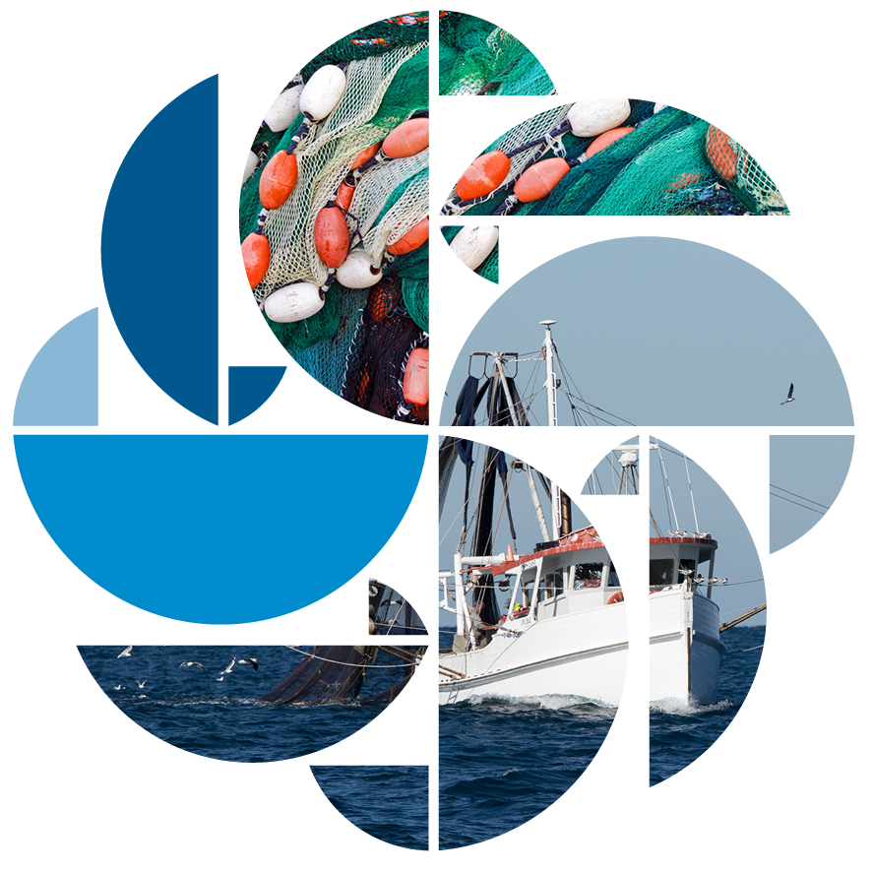© Commonwealth of Australia 2018

**Ownership of intellectual property rights**

Unless otherwise noted, copyright (and any other intellectual property rights, if any) in this publication is owned by the Commonwealth of Australia (referred to as the Commonwealth).

**Creative Commons licence**

All material in this publication is licensed under a Creative [Commons Attribution 4.0 International Licence](https://creativecommons.org/licenses/by/4.0/legalcode) except content supplied by third parties, logos and the Commonwealth Coat of Arms.

Inquiries about the licence and any use of this document should be emailed to [copyright@agriculture.gov.au](mailto:copyright@agriculture.gov.au).

C:\Documents and Settings\west merryn\Local Settings\Temporary Internet Files\Content.Word\by.png

**Cataloguing data**

This publication (and any material sourced from it) should be attributed as: Department of Agriculture and Water Resources 2018, Commonwealth Fisheries Bycatch Policy, Canberra, May. CC BY 3.0.

ISBN 978-1-76003-159-6

This publication is available at www.agriculture.gov.au/fisheries/environment/bycatch/review.

Department of Agriculture and Water Resources

GPO Box 858 Canberra ACT 2601

Telephone 1800 900 090

Web [agriculture.gov.au](http://agriculture.gov.au/)

The Australian Government acting through the Department of Agriculture and Water Resources has exercised due care and skill in preparing and compiling the information and data in this publication. Notwithstanding, the Department of Agriculture and Water Resources, its employees and advisers disclaim all liability, including liability for negligence and for any loss, damage, injury, expense or cost incurred by any person as a result of accessing, using or relying on any of the information or data in this publication to the maximum extent permitted by law.

## Foreword

We are pleased to release thesecondedition of the *Commonwealth Fisheries Bycatch Policy.*

The Australian Government has revised the first Bycatch Policywith a commitment to a sustainable, productive, internationally competitive and profitable fisheries industry. The policy focuses on managing the direct and indirect impacts of fishing activities on the marine environment.

The first Bycatch Policy was released by the Australian Government in 2000, and provided a strategic approach to address bycatch in Commonwealth fisheries. The policy was supported by agricultural and environmental leaders across Australia and implemented in collaboration with the commercial fishing industry.

Thissecond edition strengthens Australia’s commitment to world class fisheries management and focuses on applying principles of ecological sustainable development. The policy and its supporting guidelines encourage a consistent approach to minimising bycatch and provide practical and cost-effective mitigation strategies, such as improved fishing practices and equipment.

The Australian Government takes pride in its marine stewardship and Australians can be confident that our fisheries are managed for both economic benefit and conservation of the broader marine environment.

In conjunction with the revised *Commonwealth Fisheries Harvest Strategy Policy*, the second edition of the *Commonwealth Fisheries Bycatch Policy* complements and supports Australia’s strong, sustainable and environmentally responsible fisheries management framework, including the *Fisheries Management Act 1991* and the *Environment Protection and Biodiversity Conservation Act 1999*.

We are committed to delivering ecosystems based fisheries management practices, and this policy supports our commercial fishing industry to reduce its impact on the marine environment.



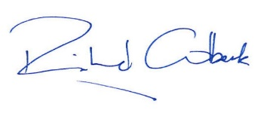

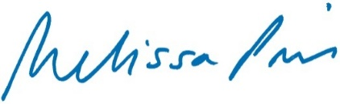

**Senator the Hon. Richard Colbeck**Assistant Minister for Agriculture and Water Resources

**The Hon.** **Melissa Price MP**Minister for the Environment

Contents

Foreword 3

1 Introduction 6

1.1 What is bycatch? 8

1.2 Treatment of *Environment Protection and Biodiversity Conservation Act 1999* listed species 9

1.3 Scope 10

2 Objective 12

2.1 Strategy 12

3 Applying the Bycatch Policy 13

3.1 Species categorisation 13

3.2 Risk-based framework 13

3.3 Cumulative impacts 14

3.4 Continuous improvement 15

3.5 The management toolbox 15

3.6 Data collection, reporting and monitoring 15

3.7 Performance monitoring and evaluation 16

4 Implementation and Review 17

4.1 Guidelines 17

4.2 Bycatch strategies 17

4.3 Roles and responsibilities 17

4.4 Reporting and review 18

Glossary 19

**Figures**

Figure 1 The relationship between the harvest strategy and bycatch policies 10

## Introduction

All food production activities have some level of impact on the environment. For commercial fishing, one of the most direct and visible impacts from the harvest of commercial species is the incidental catch (or take) of species not retained—known as bycatch. Bycatch occurs in many fisheries in Australia and internationally and is often difficult to avoid. However, bycatch can be avoided or minimised by applying various management and mitigation measures.

Sustainable fisheries management safeguards long-term species and ecosystem viability and is consistent with optimising the economic output of fisheries resources over time. In addition, fishing businesses will have greater investment and operating certainty through the codifying of government approaches to sustainable fishing. Policies to manage bycatch can help align environmental and economic objectives for the benefit of fishing businesses and the communities within which they operate.

Public accountability for the management of shared community resources continues to increase. Concurrently, consumers and food supply-chain agents are seeking assurances that their seafood is sustainably sourced. This includes evidence that Australia’s fisheries and their interactions with the marine environment are well managed.

Australia’s Commonwealth fisheries use a combination of regulatory processes, industry incentives and technological solutions to reduce bycatch and maximise the chance of captured animals surviving. These encourage best practice in the treatment and handling of bycatch. The [*Commonwealth Fisheries Bycatch Policy*](http://www.agriculture.gov.au/fisheries/environment/bycatch/review) aims to reduce fishing-related impacts on bycatch species by ensuring the exploitation of fisheries resources is consistent with the principles of ecologically sustainable development. It provides the basis for a transparent and systematic approach to assessing, managing, monitoring and reporting fisheries bycatch in Commonwealth fisheries based on the precautionary principle. This ensures fisheries management considers the impact of fishing activities on the long-term sustainability of the marine environment.

The Bycatch Policy’s central theme of avoiding or minimising bycatch is supported by the *[Guidelines for the Implementation of the Commonwealth Fisheries Bycatch Policy](http://www.agriculture.gov.au/fisheries/environment/bycatch/review)*. These guidelines provide practical assistance to fisheries managers when implementing the Bycatch Policy while offering greater regulatory certainty to fishing businesses operating in wild-capture fisheries.

Commonwealth fisheries management is broadly based on a robust and transparent approach to ecological sustainability, which considers the effects of fishing activities on the marine ecosystem and undertakes management actions, where appropriate, to mitigate these impacts. Fishery-specific ecological risk assessments are undertaken for all Commonwealth fisheries to identify the direct and indirect impacts of fishing on the marine environment. These inform ecological risk management plans, which are designed to safeguard the health of those marine ecosystems that are subject to fishing.

The Bycatch Policy aligns with Australia’s international obligations and voluntary agreements, including those established by international treaty or under the United Nations Convention on the Law of the Sea, the United Nations Fish Stocks Agreement and the Food and Agriculture Organization of the United Nations Code of Conduct for Responsible Fisheries, which includes the International Guidelines on Bycatch Management and Reduction of Discards and other instruments such as international plans of action.

The Australian Government is also bound by all international environmental treaties and arrangements that Australia has ratified or acceded to, including:

* the Convention on International Trade in Endangered Species of Wild Fauna and Flora
* the Convention on the Conservation of Migratory Species of Wild Animals
* the Convention on Biological Diversity
* the Agreement on the Conservation of Albatrosses and Petrels.

### Commonwealth Fisheries Management Framework

The Australian Government has an ecosystem-based fisheries management (EBFM) approach to fisheries management whereby the Australian Government has incorporated ecological sustainability requirements into Commonwealth environmental and fisheries legislation.

The legislative framework that establishes the objectives, obligations and powers of the Commonwealth fisheries regulator, the Australian Fisheries Management Authority (AFMA), includes the Fisheries Management Act 1991 and the Fisheries Administration Act 1991. The Environment Protection and Biodiversity Conservation Act 1999 (EPBC Act) also imposes certain requirements on Commonwealth fisheries and their management.

This policy continues to progress the formal direction given by the Australian Government fisheries minister to AFMA in 2005. That direction requires that AFMA take immediate action in all Commonwealth fisheries, including to:

* cease overfishing and recover overfished stocks to levels that will ensure long-term sustainability and productivity
* avoid further species from becoming overfished in the short and long term
* manage the broader environmental impacts of fishing, including on threatened species or those otherwise protected under the EPBC Act.

The Bycatch Policy works in concert with the Commonwealth Fisheries Harvest Strategy Policy and the Australian Government [Guidelines for the Ecologically Sustainable Management of Fisheries (2nd edition)](http://www.environment.gov.au/system/files/resources/97ff9461-5ccf-49cb-9368-8bde5f243c0b/files/guidelines.pdf). These documents form the basis for managing species risks arising from the commercial harvest of Commonwealth fisheries resources.

This management framework sets out decision rules and guidance for realising the long-term sustainability and profitability of Commonwealth fisheries. These are evidence-based and precautionary, and ensure fisheries management decisions are clear and transparent. These decision rules and guidelines provide accountability to the Australian community and certainty to fishing businesses. They recognise that without sustainable management of our fisheries resources, the long-term economic interests of the fishing industry and coastal communities will be compromised.

The Bycatch Policy is a key element of the Australian Government’s overall EBFM approach and promotes adaptive management and continuous improvement. It seeks to ensure fisheries management reflects best international practice. The government recognises that additional policy and technical work may be required to further address ecosystem impacts from commercial fishing, including on habitats and ecological communities. In the interim, these impacts will continue to be considered and reported through the Australian Government’s ecological risk assessment and management framework. Fishing should seek to reduce waste and minimise stress to species and ecosystems while taking all reasonable steps to avoid interactions with EPBC Act–listed species.

### Bycatch

Commercial fishing may result in incidental catch or interaction with species that are not retained for sale or are not able to be sold (non-commercial). This includes finfish, invertebrates and benthic species such as corals and sponges. It may also include marine wildlife, such as birds, mammals and reptiles. The species composition of bycatch and the level and frequency of interactions in each fishery are influenced by factors including fishing method, season, duration of fishing, time of day and the area fished.

Left unmanaged, bycatch may have a negative impact on the status of marine life including mammals, reptiles, seabirds, sharks and bony fishes. Some species populations may be detrimentally impacted when subject to additional mortality from fishing and other sources. Bycatch can be wasteful and diminish the efficiency of commercial fishing, through the misdirection of resources and fishing effort.

More than 2,000 species are categorised as bycatch across Commonwealth fisheries, but many aspects of the biology of these species, such as their range, life cycle and population size, remain uncertain or unknown. These data constraints present significant challenges to bycatch management. Information on the biology of bycatch species and related fisheries interactions is often limited. Under the Australian Government’s fisheries management framework, data limitations are taken into consideration by applying cost-effective and practical risk-based approaches to minimising the ecological impact of fishing.

Significantly, under legislation the exploitation of Commonwealth fisheries resources and related activities must be conducted in a manner consistent with the principles of ecologically sustainable development. This includes exercising the precautionary principle and considering the impact of fishing activities on non-target species and the long-term sustainability of the marine environment.

#### Defining bycatch

In Commonwealth fisheries, bycatch is defined as a species that is incidentally either:

* taken in a fishery and returned to the sea
* killed or injured as a result of interacting with fishing equipment in the fishery, but not taken.

Typically, bycatch can be considered as either general bycatch or bycatch relating to EPBC Act–listed species.

**General bycatch** describes all bycatch species in a fishery that are not listed under the EPBC Act. The large variation of species in this category calls for various assessment and management approaches.

**EPBC Act–listed species** are managed separately to other bycatch species due to their special status under Australia’s national environmental legislation. EPBC Act–listed species comprise those species protected under Part 13 of the EPBC Act, including whales and other cetaceans and listed threatened, marine and migratory species (except for conservation-dependent species managed through rebuilding strategies under the Harvest Strategy Policy in line with the requirements of the EPBC Act).

Although bycatch can be considered as being discarded and returned to the sea, within the scope of this policy the term ‘discards’ refers to non-retained commercial species—that is, key commercial or byproduct species. Discarding is addressed under the Harvest Strategy Policy and through AFMA’s related operational policies, which aim to minimise discards.

Certain fishing mortality may not be readily detectable. Such cryptic mortality must be acknowledged and considered when managing bycatch. The adaptive nature of the Australian Government’s fisheries management framework allows the incorporation of emerging information and technical advancements, including monitoring to detect suspected cryptic mortality.

### Treatment of *Environment Protection and Biodiversity Conservation Act 1999* listed species

The EPBC Act prescribes additional protections for some species. These EPBC Act–listed species include whales and other cetaceans and listed threatened, marine and migratory species. Under Part 13 of the Act, it is an offence to harm listed species in Commonwealth waters (other than those prescribed as conservation dependent) unless fishers have a permit or management arrangements for the fishery are accredited by the environment minister. The Bycatch Policy complements the EPBC Act assessment of fisheries, particularly in relation to the principle that fishing operations are managed to minimise their impact on the structure, productivity, function and biological diversity of a marine ecosystem.

The Australian Government [Guidelines for the Ecologically Sustainable Management of Fisheries (2nd edition)](http://www.environment.gov.au/system/files/resources/97ff9461-5ccf-49cb-9368-8bde5f243c0b/files/guidelines.pdf) were developed to ensure Commonwealth fisheries and exporting fisheries meet ecological sustainable development requirements under the EPBC Act. The guidelines and assessment process have supported the implementation of ecosystem-based fisheries management and continuous improvement in fishery management performance.

Fishing interactions with EPBC Act–listed species are treated differently than interactions with general bycatch species and management as prescribed under the EPBC Act. This involves ensuring that:

* fishing operations take all reasonable steps to avoid the mortality of, or injury to, species protected under the EPBC Act and species prohibited from take under the Fisheries Management Act 1991, recognising that species in these categories may need to be recovered
* all interactions with EPBC Act–listed species, whether authorised or not, must be reported to the Department of the Environment and Energy
* fishing operations do not adversely affect the survival or recovery in nature of EPBC Act–listed species
* bycatch management gives priority to implementation of relevant threat abatement plans, recovery plans and conservation advices.

### Scope

The Bycatch Policy applies in Commonwealth fisheries managed by AFMA. Key commercial and byproduct species (whether retained or discarded) are managed under the Harvest Strategy Policy (Figure 1.)

Figure 1 Relationship between the Harvest Strategy Policy and the Bycatch Policy

Image showing the relationship between the harvest strategy and bycatch policies.
Commercial species (key-commercial and byproduct species) are managed under the Harvest Strategy Policy, while Non-commercial species (bycatch and EPBC Act listed species) are managed under the Bycatch Policy 


This policy applies to the Commonwealth commercial fishing sector, but other fishing activities not regulated by AFMA also impact bycatch species and must be considered when applying this policy. This includes state commercial, recreational and Indigenous customary fishing.

Where overlap between jurisdictional responsibilities exists (for example, stocks that are managed jointly by the Commonwealth and other Australian jurisdictions), the Australian Government will seek to apply and encourage the adoption of this policy in negotiating and implementing joint management arrangements.

Although the Bycatch Policy does not apply to recreational fishers, the National Code of Practice for Recreational and Sport Fishing promotes socially responsible fishing, including catch and release, minimising interactions with the fishing environment and playing a stewardship role in protecting fisheries resources and habitats. The Australian Government will continue to engage with other fishing sectors and regulators, including state governments where appropriate, to improve approaches to bycatch mitigation.

For fisheries that are managed jointly by an international organisation or arrangement, the Bycatch Policy does not prescribe management arrangements for those organisations. However, it does articulate the Australian Government’s preferred approach. Through these forums, the government will continue to pursue the adoption of bycatch measures that are consistent with this policy and domestic fisheries management arrangements. Australian fishers are bound by domestic fisheries management arrangements regardless of where they fish. Domestic fisheries arrangements for straddling and highly migratory stocks may exceed those adopted in international organisations or arrangements.

## Objective

The Bycatch Policy aims to minimise fishing-related impacts on general bycatch species in a manner consistent with the principles of ecologically sustainable development and with regard to the structure, productivity, function and biological diversity of the ecosystem.

### Strategy

To pursue this objective the Australian Government will implement bycatch mitigation strategies for general bycatch species (see Section 3.1) that:

* draw on best-practice approaches to avoid or minimise all bycatch, and minimise the mortality of bycatch that cannot be avoided
* manage fishing-related impacts on general bycatch species to ensure that populations (that is, discrete biological stocks) are not depleted below a level where the risk of recruitment impairment is regarded as unacceptably high
* in instances where fishing-related impacts have caused a bycatch population to fall below a level where the risk of recruitment impairment is regarded as unacceptably high, implement management arrangements to support those populations rebuilding to biomass levels above that level.

No general bycatch species should be exposed to any greater risk than that faced by a commercial species managed under the Harvest Strategy Policy. Both the Bycatch and Harvest Strategy policies apply the same test that species should not be exposed to an unacceptable risk of recruitment impairment. Where fishing interactions with bycatch species precipitates an unacceptable risk to the functioning of the marine ecosystem, that risk should be mitigated.

Assessment and management decisions about general bycatch species must consider the best available science, evidence and information. Reporting, monitoring and performance evaluation form central pillars of the Bycatch Policy, with the fishing industry incentivised to continuously improve bycatch management. The adoption of new technologies and practices can assist in improving bycatch management.

The EPBC Act (see Section 1.2) requires that fishers take all reasonable steps to avoid mortality of, or injury to, species listed under the Act.

## Applying the Bycatch Policy

The framework in this policy provides the basis for a transparent and systematic approach for assessing, managing, monitoring and reporting fisheries bycatch to assist in meeting the objectives of the Bycatch Policy. In applying the Bycatch Policy, AFMA must take into account the precautionary principle.

Bycatch strategies (which form part of a fishery management strategy) may be fishery, sector or species-specific. At a minimum they should detail:

* the species or groups of species of relevance
* the risk assessment methodology and results for each species, or groups of species, including specific detail on why particular assessment approaches have been taken
* consideration of cumulative impacts on bycatch populations
* management responses for areas of identified risk, including relevant quantitative approaches and indicators
* data collection, reporting and monitoring processes and minimum requirements that support the assessment, monitoring and management of bycatch
* performance and evaluation processes and outcomes.

Further guidance on implementation is provided in the Bycatch guidelines.

### Species categorisation

The policy framework for Commonwealth fisheries (the Harvest Strategy and Bycatch policies) requires that all species (or group of species) that are taken or interact with Commonwealth fisheries are categorised as either key commercial, byproduct, general bycatch or EPBC Act–listed species (Figure 1.).

Key commercial and byproduct species are managed in accordance with the Harvest Strategy Policy and bycatch species are managed in accordance with the Bycatch Policy and the EPBC Act where appropriate.

The categorisation of each species (or group of species) in a fishery, along with justification for that categorisation, will be documented and made publicly available. Justification for any grouping of stocks or species will also form part of that documentation.

### Risk-based framework

The Bycatch Policy applies a risk-based approach to assessing and managing bycatch species to support the minimisation of bycatch. For bycatch species, information is often limited and the costs of additional data collection high. Risk-based approaches recognise that fisheries need to be managed and decisions made in the absence of perfect information. They also accommodate the large variation in the biological attributes of bycatch species and the substantial variation across Commonwealth fisheries in the intensity of fishing, levels of bycatch interaction and selectivity of fishing gear. This allows the objectives of the Bycatch Policy to be met in minimising fishing-related impacts on bycatch species while providing regulators and industry sufficient flexibility to tailor bycatch mitigation methods to their specific circumstances.

#### Risk assessment and management

Risk assessments identify and rank potential risks to bycatch species. Screening and further assessment is undertaken where those risks are identified as high. Management responses are used to address unacceptable levels of risk (see Section 3.2.2). The degree of caution inherent in those management responses reflects the uncertainty around population status and the risk-rating of species. This includes taking account of the precision and accuracy of assessments and application of the precautionary principle. Further, data collection and analysis systems must be sufficiently robust to ensure that risk is assessed and managed appropriately.

#### Risk equivalency

The Bycatch Policy seeks to ensure that general bycatch populations are not subject to unacceptable risks from the harvest of commercial fish species.

For general bycatch species this is achieved through a risk equivalency approach, whereby general bycatch species are not exposed to any greater risk than that accepted for commercial stocks managed under the Harvest Strategy Policy. General bycatch species are subject to an equivalent limit reference point as commercial stocks and general bycatch populations must be maintained above a limit where the risk of recruitment impairment is unacceptably high. Where evidence shows that a general bycatch population has fallen below that limit, the Bycatch Policy requires fishery managers respond in a way that facilitates recovery of that population to above the limit.

The EPBC Act prescribes additional protections for EPBC Act–listed species. These require fishers to take all reasonable steps to avoid mortality of, or injury to, the species as well as adherence to national plans of action, threat abatement plans and other risk mitigation measures.

#### Balancing risk, cost and catch

An integral feature of the Bycatch Policy’s risk-based approach is the concept of risk–cost–catch. This seeks to balance the risk of fishing interactions on bycatch species with the costs of fisheries management and the returns from fishing. Fishing mortality will always be constrained such that the species interacted with in a fishery are not exposed to an unacceptable risk.

Decisions made on the basis of risk–cost–catch trade-offs are likely to be iterative and should be clearly documented and publicly accessible. Balancing commercial considerations against the risk to bycatch populations through applying the risk–cost–catch concept does not alter the need to comply with the legislative requirements for managing fishing interactions with EPBC Act–listed species. These require fishers to take all reasonable steps to avoid mortality of, or injury to, EPBC Act–listed species.

### Cumulative impacts

The assessment and management of bycatch species should account for all sources of mortality. Where all fishing on a designated general bycatch population occurs within Commonwealth fisheries managed by AFMA, the Australian Government must ensure that the population is not exposed to unacceptable risk of recruitment impairment. This means accounting for all known threats and causes, including regime shift, climate variability factors, mortalities from fishing and any other factors that a species may face across its range. This policy recognises that AFMA is only responsible for managing the risk of fishing-related mortalities in Commonwealth-managed fisheries.

Where a bycatch species in a Commonwealth fisheries managed by AFMA is taken in a fishery managed by another jurisdiction, and that bycatch species forms part of the same population, the Australian Government should work with that jurisdiction on assessing and managing the cumulative impact of all fishing on that population. Where co-operative arrangements cannot be agreed with other jurisdictions, the risk of adverse impacts to bycatch species from Commonwealth fisheries should be minimised. This is particularly the case for species that are known to be taken predominantly in or primarily impacted by Commonwealth fisheries.

### Continuous improvement

Wherever possible, the fishing industry should be actively incentivised through fisheries management to continually lower their rates of bycatch. By encouraging fishers to adopt new technologies and practices to continuously improve their bycatch management, bycatch in the fishery will be kept to a minimum. This allows industry to play an active role in finding solutions to bycatch management in a practical, effective and cost-efficient manner. It also helps to ensure business and industry performance remains at the frontier of best practice.

Adopting fishing approaches that align with sound bycatch management may have commercial benefits. For example, improved gear selectivity may lead to increased quality of retained product and higher market prices for commercial fishers while reducing the impact on bycatch species. Industry-driven codes of practice, voluntary guidelines and standards of behaviour should be encouraged to allow for reduced cost and intervention by the government under a cost-recovery framework.

### Management toolbox

A range of management and mitigation tools can be used to avoid and minimise interactions with bycatch and reduce risk to bycatch populations. These include input and output controls on the catch of target species and could include catch restrictions or triggers, spatial and temporal closures, gear restrictions, mandated use of mitigation devices, incentives for fisher behavioural change and individual accountability through escalating management responses. Bycatch management should consider opportunities to apply quantitative approaches, such as indicators (for example, catch rates) and trigger limits. These may be particularly useful for some EPBC Act–listed species. These approaches can increase the transparency and predictability of fisheries management decisions by identifying consequential management responses for different mortality levels.

### Data collection, reporting and monitoring

Bycatch management benefits from increased knowledge of fishing impacts on bycatch species and the efficacy of mitigation and management measures. Data collection should be sufficiently robust to support appropriate risk assessments, inform effective management options, monitor bycatch interactions and industry compliance and enable assessment of the efficacy of any management measures. Decisions around data collection and monitoring need to be aligned with risk–cost–catch principles. Where bycatch species interact across more than one fishery covered by this policy, data collection, reporting and monitoring arrangements are encouraged to be consistent across fisheries to allow quantification of cumulative impacts and to support the effective implementation of the Bycatch Policy.

Independent verification of fishing activity supports an effective reporting and monitoring framework. Independent auditing should also be used to provide transparency and public confidence in the performance of self-regulatory initiatives within a fishery.

Data collection, reporting and monitoring requirements for interactions with EPBC Act–listed species must meet requirements under the EPBC Act.

### Performance monitoring and evaluation

Performance of bycatch management in Commonwealth fisheries is monitored and evaluated on a regular basis and reported publicly. This is an important element of best practice management and is essential to providing transparency and accountability of Commonwealth fisheries management. Performance indicators are used to evaluate mitigation and management measures, levels of industry compliance, catch levels and interaction rates for bycatch and changes in ecological risk levels. Indicators and other benchmarking measures are described in the guidelines.

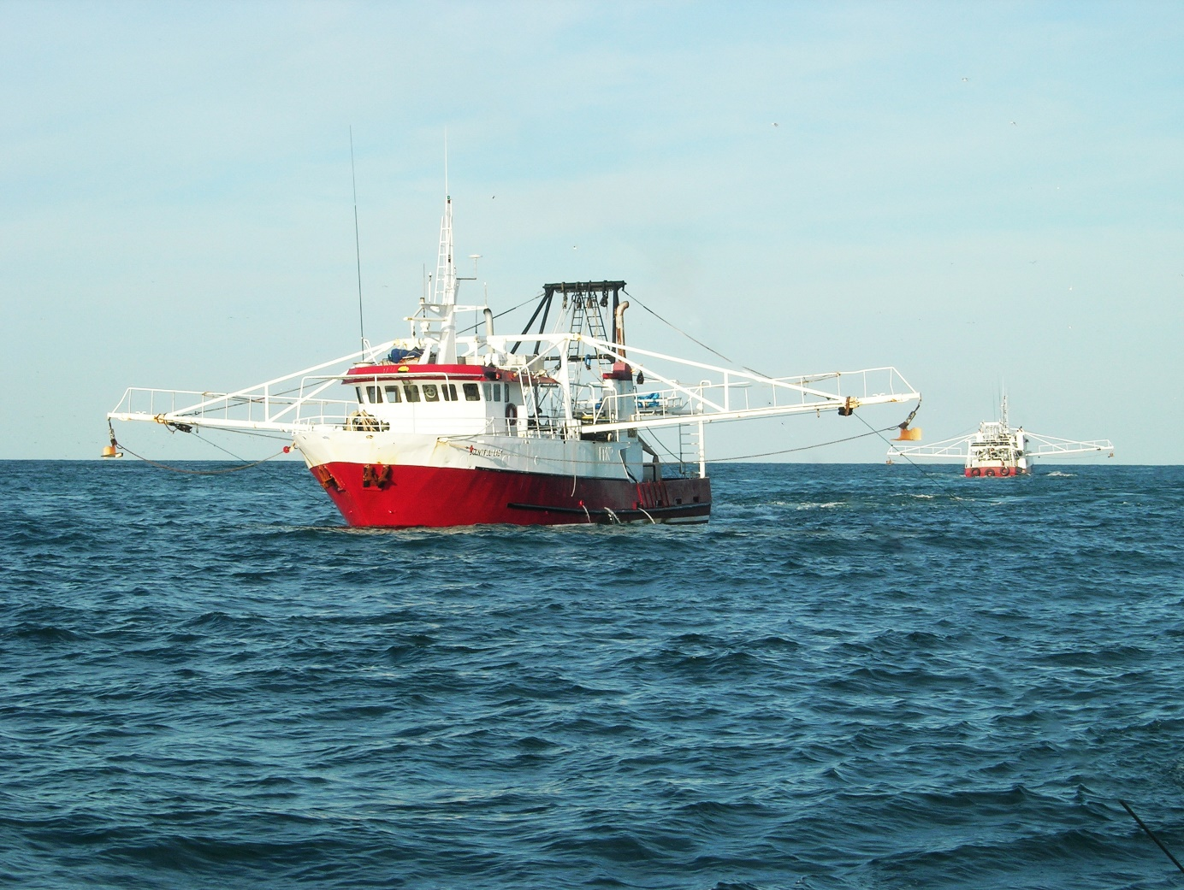

Image: Prawn Trawler at seat

*Copyright Australian Fisheries Management Authority*

## Implementation and review

### Guidelines

Management of bycatch species should be transparent and have a high level of community accountability. The Guidelines for the Implementation of the Commonwealth Fisheries Bycatch Policy provide guidance for interpretation and implementation of the Bycatch Policy across all Commonwealth fisheries. The guidelines outline assessment methodologies, management tools, reference points and standards to support a transparent and systematic approach to the assessment, management and monitoring of fisheries bycatch.

### Bycatch strategies

AFMA is responsible for implementing the Bycatch Policy through its operational policies and supporting fisheries management strategies. These should be developed in consultation with stakeholders and be publicly accessible. Operational policies and supporting strategies should be regularly reviewed in response to changes in fishing intensity or as new knowledge emerges about the impacts of fishing activity on bycatch species.

### Roles and responsibilities

Responsibility for management of Commonwealth fisheries resides with the Australian Government minister responsible for fisheries.

The Australian Government agencies involved in bycatch management for Commonwealth fisheries are the Department of Agriculture and Water Resources, AFMA and the Department of the Environment and Energy. The fisheries and environment ministers provide oversight of their respective agencies’ fisheries functions, including administration of legislation and associated regulations.

The Department of Agriculture and Water Resources oversees implementation of the Bycatch Policy by AFMA. The department also works to ensure the long-term sustainability, productivity and competitiveness of Commonwealth fisheries while assisting the Department of the Environment and Energy to ensure compliance with relevant environmental legislation and policy. The Department of Agriculture and Water Resources also coordinates national and international actions on fisheries bycatch, including to ensure consistency with the Bycatch Policy.

AFMA is the lead agency for implementing bycatch management in Commonwealth fisheries. This includes developing species-specific operational plans and bycatch strategies. It also reports fisher interactions with EPBC Act–listed species to the Department of the Environment and Energy on behalf of the fishing industry. AFMA’s advisory bodies are also responsible for considering bycatch matters and making recommendations where appropriate.

The Department of the Environment and Energy administers the EPBC Act, which includes a number of provisions on the sustainable management of fisheries. These include assessments of the impacts of Commonwealth fisheries on protected marine species and communities, and the impacts on bycatch species, to ensure that fisheries are managed to minimise their impact on the structure, productivity, function and biological diversity of the ecosystem.

Under the EPBC Act, assessments and decisions are made about fisheries in relation to impacts on matters of national environmental significance (Part 10 of the Act), impacts on EPBC Act–listed species (Part 13) and export of products derived from fisheries (Part 13A). Assessments are based on the Australian Government [Guidelines for the Ecologically Sustainable Management of Fisheries (2nd edition)](http://www.environment.gov.au/system/files/resources/97ff9461-5ccf-49cb-9368-8bde5f243c0b/files/guidelines.pdf). The Department of the Environment and Energy provides support to the Threatened Species Scientific Committee in its assessments of native species or ecological communities for listing as threatened, and processes for listing as key threatening processes under the EPBC Act. The Department of the Environment and Energy is also responsible for developing conservation advices and recovery plans for threatened species and communities and threat abatement plans for key threatening processes.

The Australian Government encourages the fishing industry to play an active role in bycatch management, through reporting and logbook requirements, developing and implementing codes of practice, supporting research, developing and trialling mitigation devices and undertaking education and extension within and across industry sectors.

### Reporting and review

The Bycatch Policy and guidelines are to be reviewed by the Department of Agriculture and Water Resources within five years of commencement. AFMA must report annually on the implementation of the Bycatch Policy and as requested by the fisheries minister.



Image: Boats at Lakes Entrance

Copyright Australian Fisheries Management Authority

## Glossary

| Term | | Definition | |
| --- | --- | --- | --- |
| Biomass (B) | | Total weight or volume of a stock or of a component of a stock. For example, see ‘spawning biomass’. | |
| Bycatch | | A species that is incidentally either:   * taken in a fishery and returned to the sea * killed or injured as a result of interacting with fishing equipment in the fishery, but not taken.   Bycatch can include EPBC Act–listed species | |
| Bycatch policy | | The Commonwealth Fisheries Bycatch Policy provides a framework for managing the risk of fishing related impacts on bycatch species in Commonwealth fisheries. | |
| Byproduct | | Byproduct stocks make some contribution to the value of the catch in a fishery but less than that of key commercial species. These stocks may be rarely encountered and usually retained, or frequently encountered and occasionally retained. | |
| Catch | | In relation to fishing, means capture, take or harvest. | |
| Categorisation | | The act of identifying and partitioning components of a fishery’s catch into categories. Typically categories include key commercial, byproduct and bycatch. | |
| Cryptic mortality | | Mortality resulting from fishing that is not observed, detected or monitored. | |
| Cumulative impact | | The accumulation of all known impacts. | |
| Decision rules | | See ‘harvest control rules’. | |
| Discard | | Any part of the catch which is returned to the sea, whether dead or alive. In Commonwealth fisheries, the term is predominantly used to refer to commercial species that are not retained. | |
| Discarding | | The practice of returning any part of the catch to the sea. | |
| Ecological risk assessment (ERA) | | An assessment process that evaluates the relative risk posed by fishing on species, habitats and communities within a fishery. | |
| Ecological risk management (ERM) | | The management framework for undertaking and responding to outcomes of ecological risk assessment. | |
| Ecologically sustainable development (ESD) | | Using, conserving and enhancing the community’s resources so that ecological processes are maintained, and the total quality of life, now and in the future, can be increased.  Principles of ecologically sustainable development (as per the Fisheries Management Act 1991):   * decision‑making processes should effectively integrate both long‑term and short‑term economic, environmental, social and equity considerations * if there are threats of serious or irreversible environmental damage, lack of full scientific certainty should not be used as a reason for postponing measures to prevent environmental degradation * the principle of inter‑generational equity—that the present generation should ensure that the health, diversity and productivity of the environment is maintained or enhanced for the benefit of future generations * the conservation of biological diversity and ecological integrity should be a fundamental consideration in decision‑making   improved valuation, pricing and incentive mechanisms should be promoted. | |
| Ecosystem-based fisheries management | | A management approach that considers the impact fishing has on all of the aspects of the marine ecosystem, including commercial species, non-commercial species, habitats and communities. | |
| Effort | | Also, called fishing effort. A measure of the resources (such as fishing hours or hook sets) used to harvest a fishery’s stocks. | |
| Environment Protection and Biodiversity Conservation Act 1999 (EPBC Act) | | The central piece of Commonwealth environmental legislation. It provides a legal framework to protect and manage nationally and internationally important flora, fauna, ecological communities and heritage places—defined in the EPBC Act as matters of national environmental significance. Parts 10, 13 and 13A relate specifically to aspects of fisheries. | |
| EPBC Act–listed species  (also known as TEP) | | EPBC Act–listed species comprises all those protected under Part 13 of the EPBC Act including whales and other cetaceans and listed threatened, marine and migratory species (except for conservation-dependent species which are managed through rebuilding strategies under the Harvest Strategy Policy). | |
| Fisheries Administration Act 1991 (FA Act) | | Commonwealth Act that establishes the Australian Fisheries Management Authority (AFMA) and its Commission. | |
| Fisheries Management Act 1991 (FM Act) | | Commonwealth Act that provides the legal framework for fisheries managed by the Australian Government. The Act sets out, among other things: fisheries management objectives and arrangements for regulating; permitting; and taking enforcement action with respect to fishing operations. | |
| Fishery management strategy (FMS) | | An all-encompassing document containing key fishery-level management measures including the harvest strategy and ERA/ERM objectives and requirements. | |
| Fishing | | Fishing includes:   * searching for, or taking, fish * attempting to search for, or take, fish * engaging in any other activities that can reasonably be expected to result in the locating, or taking, of fish * placing, searching for or recovering fish aggregating devices or associated electronic equipment such as radio beacons * any operations at sea directly in support of, or in preparation for, any activity described in this definition * aircraft use relating to any activity described in this definition except flights in emergencies involving the health or safety of crew members or the safety of a boat * the processing, carrying or transhipping of fish that have been taken. | |
| Fishing mortality rate (F) | | The rate of fish deaths due to fishing a stock or a designated component of a stock. | |
| General bycatch | | All bycatch that is not listed under the EPBC Act (see ‘EPBC Act–listed species’). | |
| Guidelines for the Ecologically Sustainable Management of Fisheries (2nd Edition) | | Developed to support the assessment of fisheries in pursuing sustainability objectives under the EPBC Act. The guidelines outline the principles and objectives for evaluating the environmental performance of management arrangements for export fisheries and fisheries which operate in Commonwealth waters. | |
| Harvest control rules (HCR) | | Pre-determined rules that control fishing activity according to the biological and economic conditions of the fishery (as defined by monitoring or assessment). Also called ‘decision rules’. HCR are a key element of a harvest strategy. | |
| Harvest strategy | | A decision framework designed to pursue defined biological and economic objectives for commercial fish stocks in a given fishery (also known as a management procedure). Key elements include: operational objectives, performance indicators, reference points, acceptable levels of risk, a monitoring strategy, an assessment and harvest control rules. | |
| Harvest Strategy Policy | | The policy that establishes the requirement for the development of harvest strategies in Commonwealth-managed fisheries. | |
| Highly migratory stock | | Refers to fish species or stocks that carry out extensive movement or migrations and can straddle both water of national jurisdiction and high seas. This term is usually used to denote tuna and tuna-like species, marlins and swordfish. | |
| Incidental catch | | The portion of the catch that was not the intended target of a fishing operation. | |
| Indicator | | Provides information on the state of the stock. | |
| Input controls | | Management measures that place restraints on fishing, e.g. who fishes (licence limitations), where they fish (closed areas), when they fish (closed seasons) or how they fish (gear restrictions). | |
| Interaction | | Includes any physical contact between a species and a fishing operation and includes all catch, and any discards or releases. Collisions (that is, an animal that makes contact with the fishing operation but is not caught) are also considered to be interactions. | |
| Key commercial stock | | Stocks that are most relevant to the objective of maximising net economic returns to the Australian community from the management of the fishery. | |
| Limit reference point (LRP) | | The level of an indicator (such as biomass or fishing mortality) beyond which the risk to the stock is regarded as unacceptably high. | |
| Non-targeted catch | | The portion of the catch that was not the intended target of a fishing operation. | |
| Output controls | Management measures that place restrictions on the outputs from fishing, including how much is caught, what species are taken and the size of those species. | |
| Overfished | A fish stock with a biomass below its biomass limit reference point or below its specified indicator limit reference point. | |
| Overfishing | A stock that is experiencing too much fishing. The rate of removals from a stock is likely to result in the stock becoming overfished. For a stock that is overfished, overfishing is a rate of removals that will prevent stock recovery in accordance with its rebuilding strategy. | |
| Performance measure | Provides information on management performance. They are a measure of where an indicator is in relation to a reference point. | |
| Precautionary principle | Where there are threats of serious or irreversible environmental damage, lack of full scientific certainty should not be used as a reason for postponing measures to prevent environmental degradation. In the application of the precautionary principle, public and private decisions should be guided by:   * careful evaluation to avoid, wherever practicable, serious or irreversible damage to the environment; and * an assessment of the risk-weighted consequences of various options. | |
| Population | All the organisms of the same species, which live in a particular geographical area, and have the capability of interbreeding. | |
| Productivity (of a fish) | The rate of generation of biomass in an ecosystem. | |
| Rebuilding strategy | A strategy designed to rebuild an overfished stock to above its limit reference point and towards its target reference point. | |
| Recruit | Usually, a fish that has just become susceptible to the fishery. Sometimes used in relation to population components (for example, a recruit to the spawning stock). | |
| Recruitment | The amount of fish added to the exploitable stock each year due to growth and/or migration into the fishing area. For example, the number of fish that grow to become vulnerable to the fishing gear in one year would be the recruitment to the fishable population that year. This term is also used in referring to the number of fish from a year class reaching a certain age. | |
| Recruitment impairment | A sustained and significant reduction in recruits to below average levels. Typically associated with recruitment overfishing. | |
| Reference point | Specified level of an indicator used as a benchmark within a harvest strategy. | |
| Risk-based approach | An approach to fisheries management that recognises that decisions are made in the absence of perfect information. The approach requires that risks of action and inaction are known and appropriately managed. | |
| Risk–catch–cost (RCC) | The RCC trade-off is a concept that seeks to balance the amount of resources invested in data collection, analysis and management of a fishery, with the level of catch (or fishing mortality) taken from that fishery. | |
| Risk equivalency | An equivalent level of risk between two comparable stocks or species. | |
| Selectivity | Selection of fish by a fishing gear is the process which causes the catch to have a different composition to that of the fish populations in the fished area. Fishing gear can select for particular species, or certain sizes within or across species. | |
| Species | A group of animals in which members can breed with one another and produce fertile offspring | |
| Stock (stock structure) | A unit of management (subpopulation) of a particular fish species with common intrinsic population parameters (growth, recruitment, mortality and fishing mortality) and for which extrinsic factors (immigration and emigration) may be ignored. A stock may encompass the whole distribution of a species, in which case the stock and species are in effect the same thing. Or it may be some subset of the distribution of a species, in which case a species would have stock structure and comprise multiple stocks. | |
| Take (taken) | See ‘catch’. | |
| Targeting (also known as targeted fishing) | The tailoring of fishing practices (including fishing gear) to pursue a particular stock, species or size of fish. | |
| Threatened, endangered or protected species (TEP) | Species or stocks listed as either threatened, endangered or protected under the EPBC Act. | |