**Revised Commonwealth Fisheries Bycatch Policy**

**Submission No.:** 08

**Submission by:** Fishwell Consulting

**Submission:**

My greatest concern with this document is that the definition of bycatch is inconsistent with that of all other countries. As a result, this Policy could create a huge, unnecessary regulatory and financial burden to Australia’s fisheries, which will disadvantage Australia’s commercial fishers.

The definition of bycatch in the Draft Bycatch Policy is:

*“Species that physically interact with fishing vessels and /or fishing gear which are not usually kept by commercial fishers and do not make a contribution to the economic value of the fishery”.*

…where an interaction is defined as:

*“any physical contact with a species”*

ie regardless of whether this interaction results in mortality.

This definition does not mention that to be bycatch, the species actually has to be caught by or “*killed*” the gear. This makes Australia’s definition of bycatch inconsistent with that of the rest of the world.

It is inconsistent with the English Oxford living dictionary’s definition:

*“The unwanted fish and other marine creatures caught during commercial fishing for a different species”.*

It is inconsistent with the Meriam-Webster definition:

*“the portion of a commercial fishing catch that consists of marine animals caught unintentionally”*

It is inconsistent with the FAO definition (Saila, 1983[1]).

*“That part of the gross catch which is captured incidentally to the species toward which there is directed effort. Some, all, or none of the by-catch may become the discard catch.”*

It is inconsistent with the Marine Stewardship Council (MSC) definition:

*“Organisms that have been taken incidentally and are not retained (usually because they have no commercial value)”.*

It is inconsistent with the European Union definition (COM(2007) 136 final[2]):

*“The accidental catching of non-target species or species that do not meet certain criteria for fisheries, including marine mammals, birds, turtles and other marine species”.*

It is even inconsistent with NOAA’s recent definition in the USA’s National Bycatch Reduction Strategy (2016), which broadens the standard definition to include unobserved or “cryptic” mortality. (Note: in the NOAA document the phrase “unobserved mortality” is not mentioned again throughout the document – only in the definition).

*“…bycatch means discarded catch of marine species and unobserved mortality due to a direct encounter with fishing vessels and gear”.*

Apart from being out of step with fisheries management policy around the world, it is important that the definition of bycatch adopted by Australia in its Bycatch Policy is consistent for a number of very practical reasons.

Many of our fishing gears are designed to be selective towards our target species but they do interact with many other species – often without causing any harm or injury, much less mortality. By definition, all of these animals —not just those subject to cryptic mortality— would be considered as “bycatch” under the current policy definition.

* A killer what the depredates blue-eye from a longline or dropline fishery physically interacts with fishing gear and would have to be considered as “bycatch” under the current draft policy definition.
* Fish or crustaceans that enter a trap and escape unharmed through the specifically designed escape gaps would have to be considered as “bycatch” under the current draft policy definition.
* Large or small sharks that either pass through or “bounce off” the gill nets specifically designed with a mesh size to be selective towards a sustainable sub-adult population would have to be considered as “bycatch” under the current draft policy definition.
* In mobile fishing gear such as trawls, dredges and seine nets, fish and animals that pass through the meshes or escape through bycatch reduction devices unharmed would have to be considered as “bycatch” under the current draft policy definition. To put this into perspective, four times more fish escape through a SESSF 90mm trawl codend than are retained in it[3].

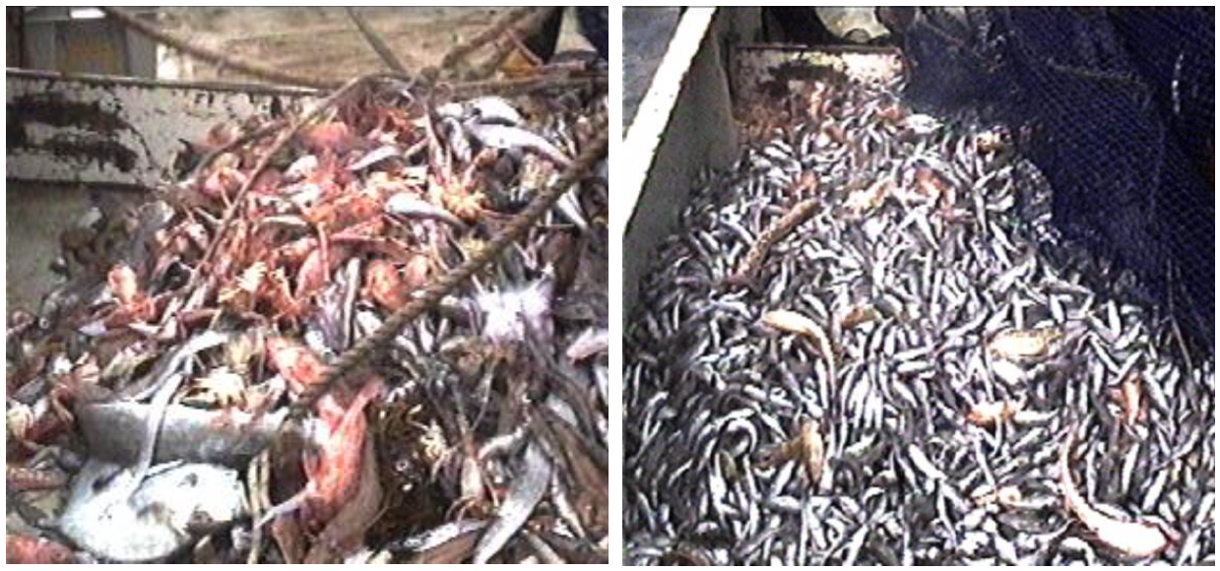

Photographs of the catch from the codend (left) and the catch that escaped through the codend into the cover (right).

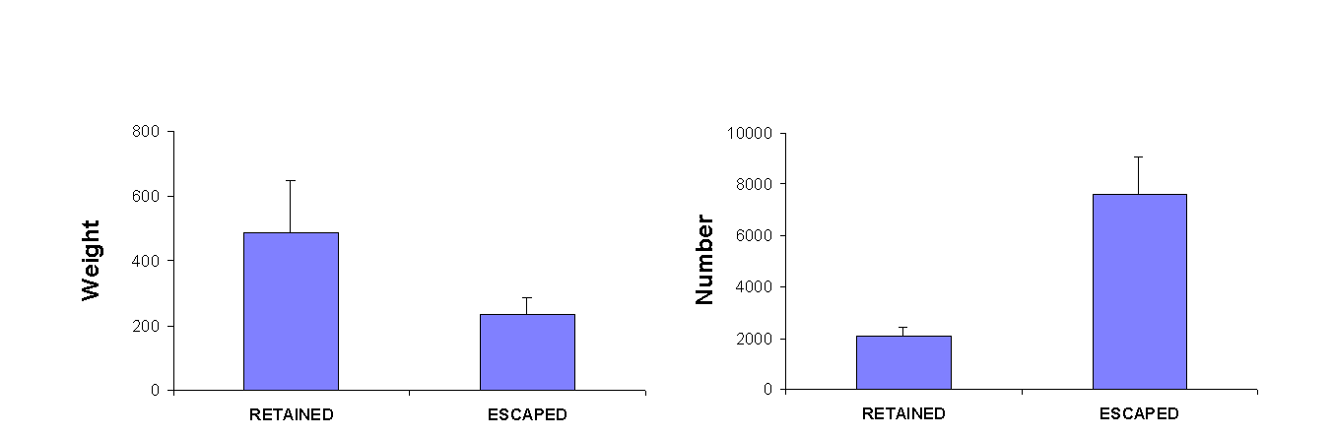

Histogram displaying the mean (+SE) of the weight (kg) and number of organisms that were retained in the codend or escaped into the cover.

Thus, under the current draft definition, the 30% reduction in the catch of fish recently achieved through the Kon’s Covered Fisheye in the NPF does not actually rate as “bycatch reduction”; the use of turtle excluder devices (TEDs) in the NPF and seal excluder devices (SEDs) in the SESSF blue grenadier fishery do not actually reduce the “bycatch” of turtles or seals, because they still actually physically interact with the gear and therefore, by definition, remain as bycatch.

Further, the Draft Policy requires “…data collection, reporting and monitoring processes and minimum requirements that support the assessment, monitoring and management of bycatch”. Such processes are costly to industry and for them to now apply to anything that simply interacts with the gear while underwater is unnecessary and extremely impractical.

In summary, I urge the government to reconsider the definition of bycatch currently in the Draft Bycatch Policy so that it aligns with commonly accepted (and sensible) definitions used elsewhere around the world. If the definition is not changed, then the final Policy is going to create a huge, unnecessary regulatory and financial burden to Australia’s sustainable Commonwealth fishing industries.

My suggestion: keep the definition of bycatch so that it aligns with the majority of the definitions around the world i.e. it has to be first captured before it can be called bycatch. If you want the policy to also include interactions with animals that are not caught, keep this as a separate component (like habitats and ecosystems - acknowledging that it is difficult to measure) and restrict the definition of “interaction” so that it only includes animals that suffer harm/mortality as a result of that interaction.

1. Saila, S. B. Importance and assessment of discards in commercial fisheries, FAO Fisheries Circular, 1983, vol. 765 pg. 62
2. Brussels, 28.3.2007 COM(2007) 136 final Communication from the Commission to the Council and the European Parliament. A policy to reduce unwanted by-catches and eliminate discards in European fisheries.
3. Knuckey, I.A. and C.J.T. Ashby. (2009). Effects of Trawling Subprogram: Maximising yields and reducing

   discards in the South East Trawl Fishery through gear development and evaluation. FRDC Project

   1998/204. Fisheries Victoria – Fisheries Research Branch 279pp.