STATUTORY FISHING RIGHTS ALLOCATION REVIEW PANEL

IN THE MATTER OF:

F & B COSTA and F & M PUGLISI
Applicant
- and -

AUSTRALIAN FISHERIES MANAGEMENT AUTHORITY
Respondent

ORDER

For the reasons reflected in the Draft Consent Orders signed by the parties and the Explanatory Note to those orders, collectively attached to this Order and marked with the letter “A” the Statutory Fishing Rights Allocation Review Panel orders as follows that:
- AFMA’s decision of 9 November 2007 as to the persons to whom a grant of Statutory Fishing Rights (SFRs) is to be made under the Eastern Tuna and Billfish Fishery Management Plan 2005 be varied so as to provide that the number of statutory fishing rights to be allocated to F. & B Costa and F. & M. Puglisi be calculated on the basis that permit 402195C is categorised as ‘historical/inactive’ for the purpose of the formula found in Section 32(2) of the Plan.

DATED: Twenty-third of December 2008

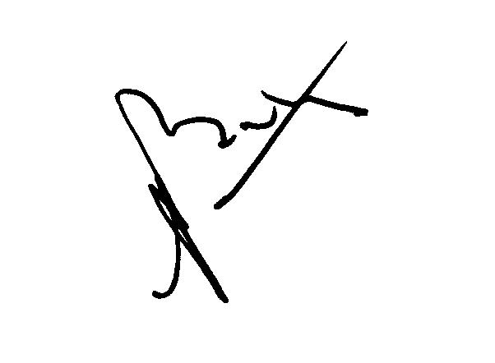

Peter Baston
Principal Member
Statutory Fishing Rights Allocation Review Panel
“A”

