STATUTORY FISHING RIGHTS ALLOCATION REVIEW PANEL

IN THE MATTER OF:

CHESTER AND HELEN MALIN
Applicant
- and -

AUSTRALIAN FISHERIES MANAGEMENT AUTHORITY
Respondent

ORDER

- The Panel dismisses the Application of Review filed by Chester and Helen Malin dated 5 December 2007.

DATED Twenty-third of December 2008

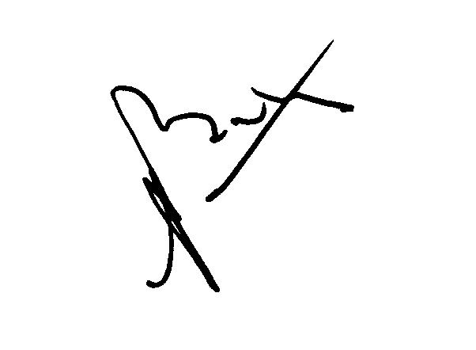

Peter Baston
Principal Member
Statutory Fishing Rights Allocation Review Panel

