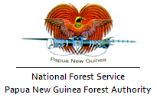
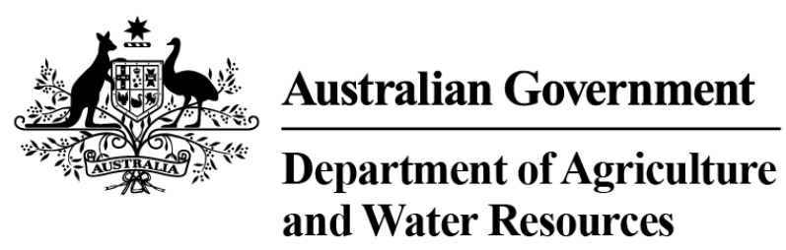
This Quick Reference Guide supports the Country Specific Guideline for Papua New Guinea. These documents may be used by Australian importers of regulated timber products from Papua New Guinea (PNG) to carry out their due diligence in accordance with the Illegal Logging Prohibition Act 2012 and the Illegal Logging Prohibition Regulation 2012.

General Information
In PNG, the Forestry Act 1991, as amended, provides the legislative basis for forest resources management. The Ministry of Forests has responsibility for the conservation and management of PNG’s forests with Papua New Guinea Forest Authority (PNGFA) as the delivery agency.

Legal requirements of timber harvesting in Papua New Guinea
The Forestry Act 1991 recognises customary ownership of PNG’s forest resources. Any company or person wishing to remove timber from a forest area in PNG shall have a valid timber permit or timber licence, as issued by the PNGFA. These activities must be conducted under one of the following arrangements:
- Forest Management Agreement
- Timber Authority
- Forest Clearing Authority.
There are also some harvesting activities are continuing to operate under repealed forestry legislation:
- Timber Rights Purchase
- Local Forest Area.

Identifying legal product from Papua New Guinea
Importers of regulated timber products from PNG can identify the legality of regulated timber products based upon the provision of one of the following primary documents issued under the Forestry Act 1991, depending on the arrangement type:
- Timber Permit – issued by the Minister for Forests to an operator to carry out specific activities e.g. harvesting within a Forest Management Agreement (FMA) area, Timber Rights Purchase (TRP) areas or Local Forest Area (LFA) (see Figure 1).
- Timber Authority – issued by the Provincial Chairman for Forestry Matters over customary land not subject to a FMA, TRP or LFA (see Figure 2).
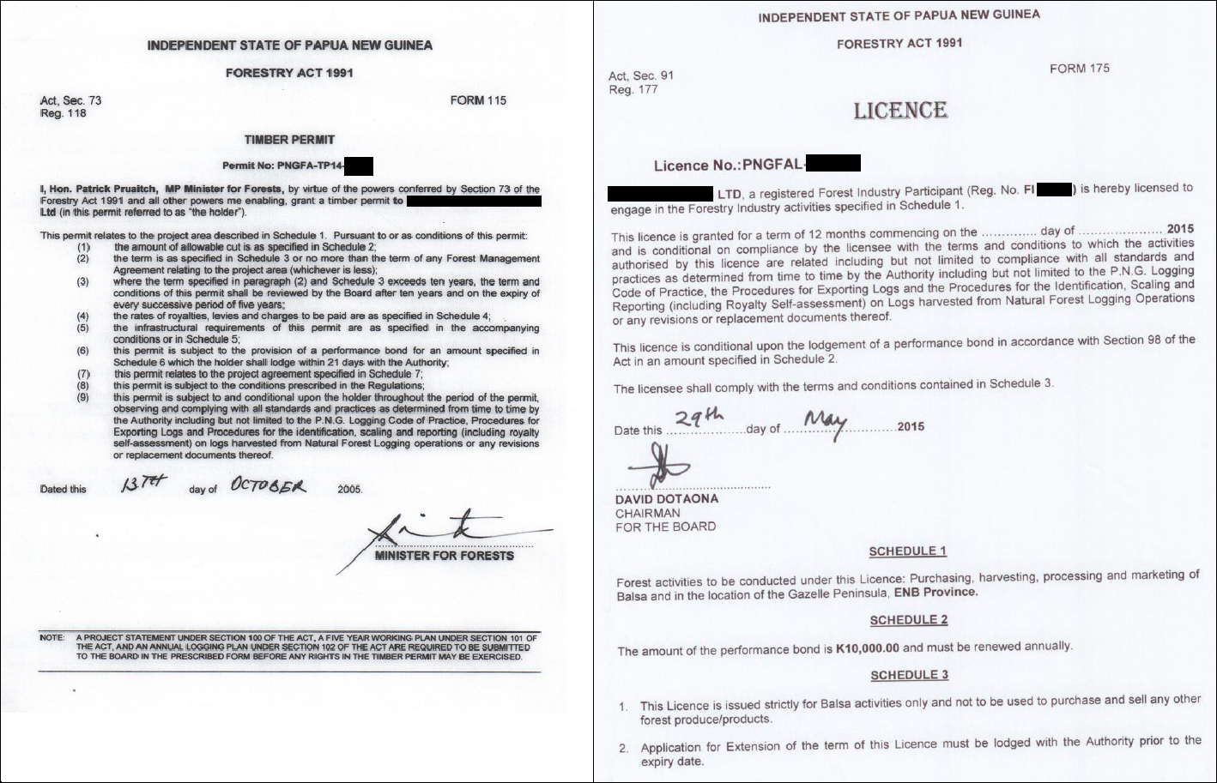
Figure 1: Timber Permit Figure 2: Timber Licence
To help with the due diligence process, importers of logs, timber and timber products from PNG may be able to source from their suppliers a copy of the export document(s) applicable to the products within their consignment.
Note: the export of logs, as defined on page 2 of the Country Specific Guideline for Papua New Guinea, requires both an Export Permit Type 1 and an Export Licence. Timber exported in forms other than logs require an Export Permit Type 1 or Export Permit Type 2. Details on each permit is below:
- Export Licence – issued by the Minister for Trade, Commerce and Industry and is a document required for exporting logs, in addition to the Export Permit Type 1 (see Figure 3).
- Export Permit Type 1 – issued by the Minister for Forests following endorsement by the PNGFA for logs and timber products harvested under a Timber Permit from Timber Licence areas (see Figure 4).
- Export Permit Type 2 – issued by the Minister for Forests for non-timber forest products (see Figure 5).
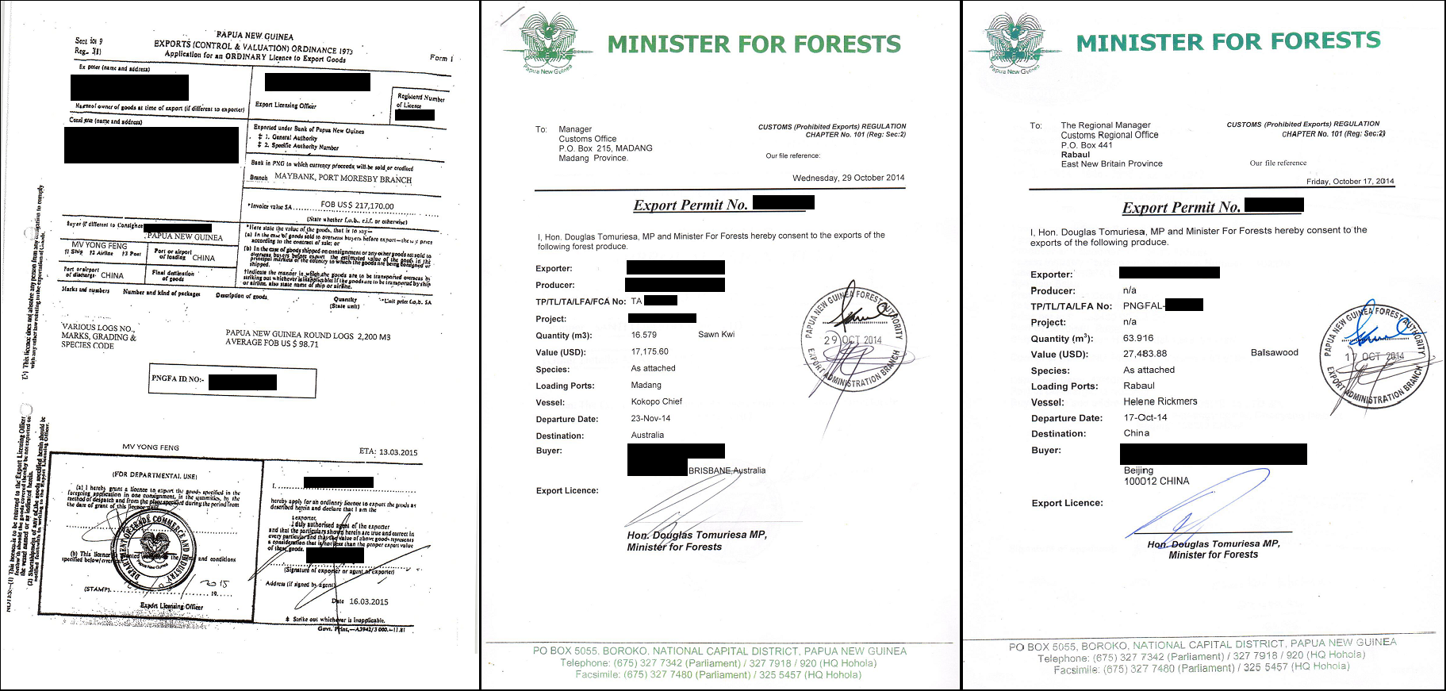
Figure 3: Export Licence Figure 4: Export Permit Type 1 Figure 5: Export Permit Type 2
To carry out forestry related activities in PNG, a proponent has to obtain a Forest Industry Participant Certificate (see Attachment G in the Country Specific Guideline for Papua New Guinea), certifying that all requirements to undertake forest related activities have been met. This document will be required as part of demonstrating the legality of the product.
The PNGFA has also compiled a list of timber species that shall be protected from export due to their scarcity in the natural forest. A company or person issued with a valid timber permit or licence must ensure that all regulations related to protected species are observed during harvesting and processing. The list of excluded species can be found in the Country Specific Guideline for Papua New Guinea (p. 11).
For further details on timber legality in Papua New Guinea, see the Country Specific Guideline for Papua New Guinea.

