# Country Specific Guideline for the Republic of Korea

This guideline has been prepared by the Australian Government and the Government of the Republic of Korea. It is intended to assist businesses importing regulated timber products from the Republic of Korea into Australia in understanding the regulatory framework in the Republic of Korea in order for them to carry out their due diligence obligations under the *Illegal Logging Prohibition Regulation 2012*, which supports the *Illegal Logging Prohibition Act 2012*.

This guideline was co-endorsed by the Australian and Republic of Korea governments on 26 June 2018.

Contents

1 What is required under Australia’s Illegal Logging Laws? 3

2 How to use the Country Specific Guideline (CSG) 3

3 Scope of the CSG for the Republic of Korea 4

3.1 Timber harvested outside of Korea 4

4 Overview of forest management in Korea 5

4.1 Forest ownership 6

4.2 Bans or limitations on harvest of specific species 6

5 Timber products exported to Australia 7

6 Laws and regulations governing forestry in Korea 8

6.1 Domestic timber harvesting 8

6.2 Domestic timber processing 10

7 Identifying legal product from Korea 11

7.1 Legality of timber products manufactured in Korea 12

8 Who should I contact for further information 13

Annex 1.1a: Confirmation of Delivery of Forest Products (Sample) 14

Annex 1.1b: Confirmation of Delivery of Forest Products 15

Annex 2.1a: Permit for Felling Standing Timber (Sample) 16

Annex 2.1b: Permit for Felling Standing Timber 17

Annex 2.2: Licence (alteration) application form – logging or digging standing timber and collecting forest products 18

Annex 3.1a: Acceptance of Report on Logging Standing Timber (Form) 21

Annex 3.1b: Acceptance of Report on Logging Standing Timber 22

Annex 3.2a: Acceptance of Report on Implementation of Forest Management Plan (Form) 23

Annex 3.2b: Acceptance of Report on Implementation of Forest Management Plan 24

Annex 4.1: Registration form of Timber Production Business (Raw Timber Production, Sawmilling Industry, Timber Imports and Distribution) 25

Annex 4.2a: Registration Certificate (Sample) of Timber Production Business (Raw Timber Production, Sawmilling Industry, Timber Imports and Distribution) 27

Annex 4.2b: Registration Certificate of Timber Production Business (Raw Timber Production, Sawmilling Industry, Timber Imports and Distribution) 28

Annex 4.3: Requirements for Registration of Timber Production Business by Type 29

## What is required under Australia’s Illegal Logging Laws?

Australia’s *Illegal Logging Prohibition Regulation 2012* (the Regulation) prescribes due diligence for businesses importing ‘regulated timber products’[1] and for Australian processors of domestic raw logs. Under the Regulation, importers and processors have to undertake due diligence to minimise the risk of sourcing illegally logged timber.

Due diligence requirements for importers include the following steps:

**Step 1:** Information gathering

**Step 2:** Assessing and identifying risk against a timber legality framework or a country specific guideline or the regulated risk factors

**Step 3:** Risk assessment

**Step 4:** Risk mitigation (if required)

Further information about the Regulation is available at the Australian Government Department of Agriculture and Water Resource’s website ([www.agriculture.gov.au/illegallogging)](http://www.agriculture.gov.au/illegallogging)).

## How to use the Country Specific Guideline (CSG)

This CSG is intended to assist an importer of regulated timber products from the Republic of Korea to Australia to comply with the due diligence requirements of the Regulation.

An importer must gather information about the product in accordance with section 10 of the Regulation, this includes gathering information or evidence contained in this CSG.

Information listed in this CSG is not an exhaustive list of evidence or documentation required to satisfy the due diligence requirements under the Regulation.

The information gathered by applying this CSG, along with any other information gathered in accordance with the Regulation, needs to be assessed in accordance with the processes outlined in section 12 of the Regulation (including considering any other information the importer knows, or ought reasonably to know, but is not contained in the CSG), to identify the risk that a regulated timber product is, is made from, or contains illegally logged timber.

All data included in this document is the most current as available at time of publishing.

## Scope of the CSG for the Republic of Korea

This CSG provides detailed information on the control of pathways for timber harvested and originating from within the Republic of Korea (Korea) and informs Australian importers of what is considered legal timber. It is also only applicable for timber products with a Korean origin of harvest.

### Timber harvested outside of Korea

There may be timber, forest products or products which contain timber, wholly or in-part, which was harvested in another country, before it was imported to Korea. These products are not in-scope of this CSG, however information contained in this document may assist importers in conducting due diligence through another available pathway.

## Overview of forest management in Korea

Forests play a significant role in Korea, covering 64% of the country’s total land area. In comparison, approximately 20% of the total land area is used for agriculture.

The Korean peninsula’s distinct seasonal temperature and precipitation has resulted in a range of different forest types which support an array of timber and forest product industries (see Table 1 and Figure A respectively).

**Table 1 - Forest Zones of Korea**

|  |  |  |  |
| --- | --- | --- | --- |
| **Forest Zone** | **North Latitude** | **Annual Mean Temperature** | **Forest Cover Type and Tree Species** |
| Warm temperate forest | Below 35⁰C | Above 14⁰C | Broad-leaved deciduous forests, conifer and deciduous mixed forests: evergreen broad-leaved trees, Camellia japonica, etc. |
| Cool temperate forest | Between 35~43⁰C except for alpine regions | 5-14⁰C | Mostly conifer forests with some broad-leaved deciduous forests: deciduous broad-leaved trees, oak trees, pine trees, bamboos, etc. |
| Sub-boreal forest | Uplands and alpine regions | Below 5⁰C | Mixed forests: spruce trees, Korean pines, etc. |

**Source: Korean Government Korea Forest Service, 2018**

Korea’s forest areas were devastated following the Korean War and other land activities in the 1950s. The national reforestation campaign in the 1960-70s has seen forest regenerated and restored. Korea’s total forest volume increased from 6 m3/ha in 1952 to 146 m3/ha in 2015. Between 2005 and 2015, Korea saw an 83% increase in forest volume from 506,376,806 m3 to 924,809,875 m3.

As a result of the increased forest volume, Korea’s domestically produced timber (as of 2016) is now being used for: *board - 29%, pulp - 23%, lumber - 12%, biomass - 4%, and other use - 25%*. While imported timber is being used for: *lumber - 84%, plywood - 19%, board – 4%, and other use - 14%.*

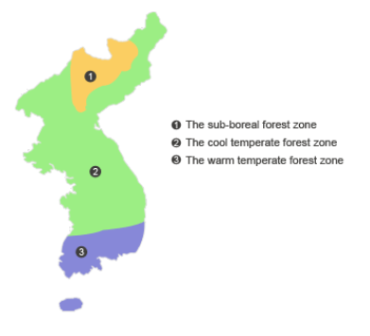

**Figure A - Forest Zones of Korea**

**Source: Korean Government Korea Forest Service, 2018**

### Forest ownership

Any local resident, resident from another region or corporate body can trade in forest tenure/ownership.

There are three categories of forest ownership (further detailed in Table 2):

1. National forests: forest owned by the state.
2. Public forests: forest owned by local governments or other public organisations.
3. Private forests: other forests not included in national and public forests.

Table - Ownership of forest and forest volume per unit area (as of 2015)

|  |  |  |  |  |  |
| --- | --- | --- | --- | --- | --- |
| **Classification** | **Area** | | **Forest volume** | | **Forest volume per ha** |
| Total | 6,334,615 ha | 100% | 925 million m3 | 100% | 146.0 m3 |
| Private forest | 4,249,885 ha | 67.1% | 588 million m3 | 63.6% | 138.3 m3 |
| National forest | 1,617,658 ha | 25.5% | 264 million m3 | 28.5% | 163.3 m3 |
| Public forest | 467,072 ha | 7.4% | 73 million m3 | 7.9% | 155.9 m3 |

Table 3 breaks down the total forest area and volume set out in Table 2 into four different tree types.

Table - Current status by tree type (as of 2015)

|  |  |  |  |  |
| --- | --- | --- | --- | --- |
| **Total** | **Coniferous forest** | **Deciduous forest** | **Mixed forest** | **Other\*** |
| 6,334,615 ha (100%) | 2,339,022 ha (37%) | 2,028,855 ha (32%) | 1,705,876 ha (27%) | 260,862 ha (4%) |
| 924,809,875 m3 | 403,971,330 m3 | 263,738,277 m3 | 257,100,268 m3 | Unavailable |

* refers to un-stocked forest land and bamboo.

### Bans or limitations on harvest of specific species

There are areas within Korea where logging is restricted. Article 41 of the *Enforcement Decree* of the *Creation and Management of Forest Resources Act* designates a scenic spot, historic site, recreation area, and areas vulnerable to landslide as a restricted area.

Korea is a party to the *Convention on International Trade in Endangered Species of Wild Fauna and Flora* (CITES). Korea bans and/or restricts the harvest or collection of flora and fauna species listed in accordance with the [CITES Appendices](https://www.cites.org/eng/app/appendices.php). All trade in CITES listed species (e.g. Korean pine) is strictly regulated and must be accompanied by the appropriate documentation where trade is permissible.

## Timber products exported to Australia

Korea’s major regulated timber products exported to Australia by value are at Table 4. The list spans three Customs HS codes: namely Wood and articles of wood (Chapter 44), Paper and paperboard (Chapter 48), and Furniture and prefabricated buildings (Chapter 94). For the full list of regulated timber products that are subject to due diligence requirements refer to [Schedule 1 to the *Illegal Logging Prohibition Regulation 2012*](https://www.legislation.gov.au/Details/F2018C00100).

Table 4 - List of major regulated timber products exported to Australia by value (2017)

|  |  |  |
| --- | --- | --- |
| **Products** | **HS Codes** | **Value** |
| Paper | 4811 | $ 156,787,814 |
| Wooden furniture | 9401 + 9403 | $ 1,882,422 |
| Particleboard Fibreboard (MDF) | 4410 + 4411 | $ 539,206 |
| Plywood | 4412 | $ 35,455 |
| Wooden frames | 4414 | $20,534 |

**Source**: Australian Government Department of Agriculture and Water Resources, 2018

For trade in timber with all countries, Korea is a net importer (see Figure B).

**Figure B – Trend in import and export values for Korea from 1971 – 2014**

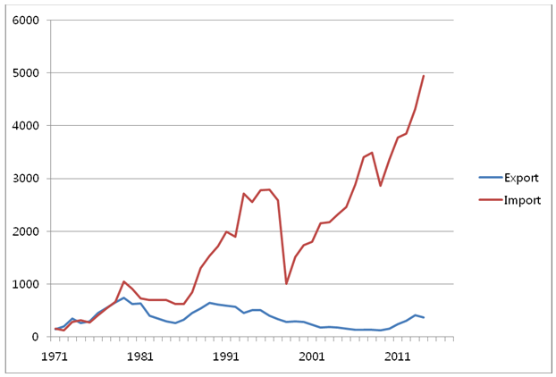

## Laws and regulations governing forestry in Korea

Korea’s forest management system is comprised of several primary laws which govern commercial forest and timber resource management and use in Korea. These include:

1. [*Creation and Management of Forest Resources Act* – Established in 2005](http://elaw.klri.re.kr/kor_service/lawView.do?hseq=27139&lang=ENG)
2. [*State Forest Administration and Management Act* – Established in 2005](http://elaw.klri.re.kr/kor_service/lawView.do?hseq=21930&lang=ENG)
3. [*Special Act on the Extermination of Pine Wilt Disease* – Established in 2005](http://elaw.klri.re.kr/kor_service/lawView.do?hseq=22707&lang=ENG)
4. [*Act on the Sustainable Use of Timbers*](http://elaw.klri.re.kr/eng_service/lawView.do?hseq=40222&lang=ENG)– Established in 2012

These Acts define a number of key terms. The terms used in this CSG are consistent with those definitions, and are as follows:

* Timber – A product obtained by cutting standing timber.
* Timber product – A product produced by processing timber or any other material physically or chemically which contains timber as its constituent at a ratio not less than that prescribed by Presidential Decree.
* Timber production business – Business for cutting, sawmilling or distributing standing timber (including sawmilling and distribution of raw timber and imported products).
* Forest product – Wood, trees, fallen leaves, earth, stone, etc. that are produced in forests, and others prescribed by Presidential Decree, including trees for landscaping and bonsai trees.

### Domestic timber harvesting

Korea operates a logging license regime that includes strict procedures when cutting standing timber or the extraction and collection of forest products. A license is required for logging in compliance with the *Creation and Management of Forest Resources Act.*

The Korea Forest Service and local governments jointly address unauthorised logging. In 2016, an area of 147.3 ha was identified as unauthorised logging which is equivalent to 0.06% of Korea’s total annual authorised logging area of 265,684 ha. Consequently, timber supplied for industrial use in Korea, with accompanying official Korean documentation (as outlined in this CSG), may be considered to be a low risk timber.

***National Forests***

* Timber felling of national forests is performed by the national government (through the Regional Office of the Forest Service or a raw log production business chosen via a bid process).
* **Timber legality** can be verified through the issuance of the “***Confirmation of Delivery of Forest Products***” when selling standing timber and raw logs in accordance with Article 27 of the *State Forest Administration and Management Act* (see Annex 1.1a for sample).
* The “***Confirmation of Delivery of Forest Products***” document is issued by the Regional Office of the Forest Service to:
  + the buyer: when a Regional Office of the Forest Service harvests and sells the timber
  + the registered raw log production business: when a Regional Office of the Forest Service sells standing timber.

Table 5 below sets out the process for granting permission for the cutting of standing timber (*Permits for, or Reporting on Felling Standing Timber*) within private forests.

***Private Forests***

* A logging license is required for harvesting private forests in accordance with Article 36 of the *Creation and Management of Forest Resources Act*.
* No payment is required to obtain the license.
* **Timber legality** for the harvesting of private forests can be verified through the issuance of the “***Permits for, or Reporting on Felling Standing Timber***”
* The **Permit for Felling Standing Timber** is issued by the local government (Si/Gun/Gu) before harvesting of timber takes place following a field inspection and check of the applicants’ documentation, in the case of logging standing timber pursuant to Article 36(1) of the *Creation and Management of Forest Resources Act* (see Table 5 for harvesting process and Annex 2.1a for permit).
* The **Acceptance of** **Report on Felling Standing Timber** is issued by the local government before harvesting of timber takes place following check of the applicants’ documentation, in the case of logging standing timber pursuant to Article 36(4) of the *Creation and Management of Forest Resources Act*.

**Table 5 – Harvesting process under *‘Permits for, or Reporting on Felling Standing Timber’* regime**

|  |  |  |
| --- | --- | --- |
| **Step 1** | *Applicant*  Submits logging license application | Applicant is required to submit information including:   * name, address, contact point * location/address and size of harvest area * type of trees to be harvested (primary species) * harvesting volume (m3) * harvest zone (forest land map with size of logging indicated) * harvest purpose * harvesting period * post-harvesting forestation plans * forest ownership, or the right for using, and the right to benefit from the forest to be harvested. |
| **Step 2** | *Local Government*  Approves logging license application | The local government will approve the application once the logging is deemed proper under Article 36 of the *Creation and Management of Forest Resources Act*.  The logging license certificate for standing timber logging will stipulate the tree species, region, size, and harvesting amount for the area prescribed (see example at Annex 2.1a and 2.1b). |
| **Step 3** | *Applicant*  Logging | The applicant will undertake logging of the approved harvest area in accordance with the license issued. |
| **Step 4** | *Local Government*  Inspection | The local government conducts an inspection on the compliance of the logging procedure under Article 36(9) of the *Creation and Management of Forest Resources Act*. |
| **Step 5** | *Applicant*  Forestation | The applicant should conduct forestation pursuant to Article 10 of the *Creation and Management of Forest Resources Act.* |

According to Article 36 of the *Creation and Management of Forest Resources Act*, there are other felling activities that are **deemed to be granted** *“permits for or reporting on felling standing timber”*. There are two cases where persons shall **report** only to the local government in advance of felling standing timber (Note: these are rare cases and the cutting amount will be relatively small):

1. Persons who intend to cut standing timber, etc. due to any cause such as the removal of trees, etc. damaged by germs, harmful insects, forest fires, or any other natural disasters (Article 36(4)).

See example at Annex 3.1a, Annex 3.1b

1. Where cutting of standing timber is to occur in a forest which is being efficiently managed through the implementation of an authorised Forest Management Plan (Articles 13-14).

See example at Annex 3.2a, Annex 3.2b

Additionally, where an ‘area prohibited from removal of trees’ has been designated under Article 9 of the *Special Act on the Extermination of Pine Wilt Disease*, Article 16-3 of the same Act stipulates that *“permits for, or reporting on felling standing timber”* is **deemed to be granted** under Article 36 of the *Creation and Management of Forest Resources Act*. In the case of shredded timber, carrying-out is allowed under supervision of a relevant public officer. In these circumstances, the official notification sent out by the local authority designating and announcing ‘areas prohibited from removal of trees’ under Article 9 of the *Special Act on the Extermination of Pine Wilt Disease* can be used to demonstrate legality of timber.

Legal timber felling may be performed **without permission or reporting** on felling standing timber for the purpose of minor felling of weed scraping, pruning, etc. that are felled for non-distribution purposes (Article 36(7) of the *Creation and Management of Forest Resources Act*).

### Domestic timber processing

Korean law stipulates that timber processors should not distribute or use timber illegally cut inside or outside of Korea. Article 4 of the revised *Act on the Sustainable Use of Timbers* provides countermeasures against illegally harvested timber, including:

* The Minister of the Korea Forest Service shall establish and implement necessary policies to ensure the distribution and use of timber or timber products produced (hereinafter referred to as “legally harvested”) in accordance with timber harvest-related statutes of Korea or the country of origin.
* Each timber producer shall endeavour to import, distribute, produce, and sell legally harvested timber or timber products.

Timber processors (as well as other timber product producers) are required to retain, as part of their record keeping system, the document verifying the legality of the harvested timber, such as the logging license, for five years as stated in Article 27 of the revised *Act on the Sustainable Use of Timbers.*

The process for how timber processors collect domestically harvested timber is shown at Figure C.

**Figure C – How a timber processor collects domestically-produced timber**

***Logger***

Harvests timber with a logging license, and then sells the timber to a collector/dealer.

***Collector/Dealer***

Collects timber from a logger, and then sells the timber to a processor.

Collects the by-products, and then sells them to a processor.

***Processor***

Collects timber from a logger (large purchases)/collector/dealer, and then processes the timber.

Collects the by-products from a logger/collector/dealer, and then processes them.

## Identifying legal product from Korea

For timber to be harvested, processed and distributed legally, registration of a timber production business is mandatory in Korea. Legal timber product distribution can be verified through the registration certificate of the timber production business in accordance with Article 24 (Registration, etc. of Timber Production Business) of the *Act on the Sustainable Use of Timbers*.

The registration certificate can be divided into two categories: raw log production/sawmilling business; and imported timber distribution business. Businesses are required to meet qualification standards such as capital, facilities, labour skills, etc., as defined in Annex 2 of the *Enforcement Regulation* of the *Act on the Sustainable Use of Timbers*. An example of the registration certificate is at Annex 4.2a and Annex 4.2b.

#### Evidence of timber legality

The main documents that are available to importers to support legality of harvest in Korea (as outlined in more detail at section 6.1) include:

* Confirmation of Delivery of Forest Products (see Annex 1.1a, Annex 1.1b)
* Permit for Felling Standing Timber (see Annex 2.1a, Annex 2.1b)
* Acceptance of Report on Logging Standing Timber (see Annex 3.1a, Annex 3.1b)
* Acceptance of Report on Implementation of Forest Management Plan (see Annex 3.2a, Annex 3.2b)

#### Obtaining evidence of timber legality

Australian importers can check the logging and distribution history for Korean harvested timber through the certificates (as outlined above) provided by the Korean exporter.

Collectors, dealers and processors can obtain copies of the relevant logging licenses for the verification of legally harvested timber at each distribution stage.

### Legality of timber products manufactured in Korea

While third country harvested timber is not in scope of this CSG, the following information on manufactured timber products exported from Korea may support importers to Australia in conducting their risk assessment in relation to pulp and paper products, and medium-density fibreboard.

#### Pulp and paper products

Korea uses approximately 2.74 million tons of pulp for paper manufacturing every year. In 2017, the amount of paper and paperboard produced in Korea was 11.6 million tons, ranked fifth in the world. Korea exported about 30% of the paper and paperboard that was produced. Over 50% of the produced newspaper, printing paper, and white paper board was exported.

Virgin pulp accounts for 21.5% of the raw material for paper manufacturing, while recycled materials account for 78.5%. As of 2017, the recycling rate of waste paper is 89.2%. Korea imports 80% of the pulp it uses, with all imported pulp having international forest certification (Forest Stewardship Council (FSC), Programme for the Endorsement of Forest Certification (PEFC), etc.) in order to export products to Europe, Australia and the United States of America (Note: international forest certification is not a legal requirement for imported pulp). 450,000 tons of pulp is supplied domestically.

Korean paper manufacturing companies have established systems to verify the legality of their products made of pulp by way of international forest certifications (FSC, PEFC, etc.), although certification systems vary depending on export destinations and products. Some paper manufacturing companies manage plantations directly.

#### Medium-density fibreboard

Raw materials for medium-density fibreboard (MDF) include raw logs produced in Korea (about 60%) and by-products created from saw milling imported logs (about 40%). 80% of the saw milling by-products used in Korea come from raw logs originating from [New Zealand](http://www.agriculture.gov.au/forestry/policies/illegal-logging/information-resources#country-specific-guidelines) (mostly Radiata pine), with the remaining 20% sourced from raw logs originating from North America (mostly Douglas fir). Most by-products from New Zealand and North America are FSC or PEFC certified. While chain of custody is not maintained throughout processing in Korea, the relevant documentation obtained can still be used to inform any risk assessment.

## Who should I contact for further information

|  |  |  |
| --- | --- | --- |
|  |  | EMB00001d080198 |
| **Australian Government**  Address: Department of Agriculture and Water Resources  GPO Box 858  Canberra ACT 2601  Phone: +61 2 6272 3933  Web: [www.agriculture.gov.au/illegal-logging](http://www.agriculture.gov.au/illegal-logging)  Email: [illegallogging@agriculture.gov.au](mailto:illegallogging@agriculture.gov.au) |  | **Korean Government**  Address: Korea Forest Service  1-1805, 189, Cheongsa-ro, Seo-gu, Daejeon 35208, Republic of Korea  Phone: +82 42-481-4085  Web: [www.forest.go.kr](http://www.forest.go.kr)  Email: [forestrytrade@korea.kr](mailto:forestrytrade@korea.kr) |

**Disclaimer**

While reasonable efforts have been made to ensure that the contents of this guideline and the associated quick reference guide are factually correct, the Commonwealth of Australia does not accept responsibility for the accuracy or completeness of the contents and expressly disclaims liability for any loss or damage, however caused, that may be occasioned directly or indirectly through the use of, or reliance on, the contents of this guideline or associated quick reference guide.

This guideline and its associated quick reference guide is made available on the understanding that the Commonwealth of Australia is not providing professional advice. Before relying on this guideline or its associated quick reference guide, readers should obtain appropriate professional advice suitable to their particular circumstances.

Readers should also confirm that this is the most up-to-date available guideline by referring to the Department of Agriculture and Water Resources website.

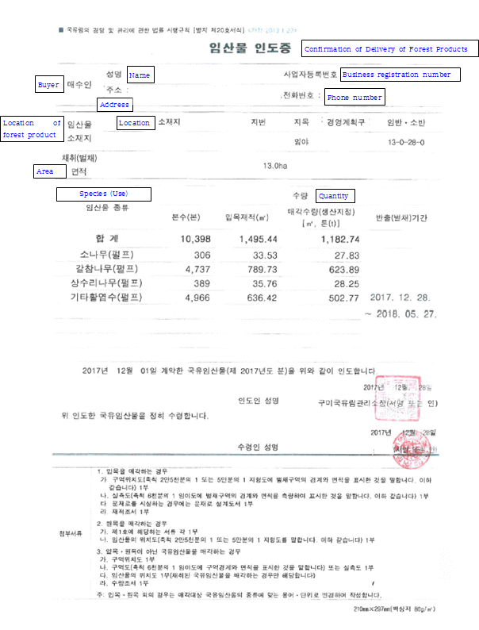Annex 1.1a: Confirmation of Delivery of Forest Products (Sample)

Annex 1.1b: Confirmation of Delivery of Forest Products

|  |  |  |  |  |  |  |  |  |  |  |
| --- | --- | --- | --- | --- | --- | --- | --- | --- | --- | --- |
| ■ Enforcement Regulation of the State Forest Administration and Management Act [Annex 20] <Revised on 23 Jan 2013 > | | | | | | | | | | |
| **Confirmation of Delivery of Forest Products** | | | | | | | | | | |
|  | | | | | | | | | | |
| Buyer | | Name | | | | Date of Birth | | | | |
| Address | | | | Phone Number | | | | |
|  | | | | | | | | | | |
| Location of Forest Product | | Location | | Lot number | Land Category | Forest Management Plan Area | | | | Compartmentㆍ  Sub compartment |
|  | |  |  |  | | | |  |
| Area Size for Collecting(logging) | | ㎡ | | | | | | | | |
|  | | | | | | | | | | |
| Species (Use) | | Quantity | | | | | | | | |
| Number of trees | Timber Volume(㎥) | | Amount of Sales  [㎥, ton(t)] | | | | Carry- out(logging) Period | |
|  | |  |  | |  | | | |  | |
| The deliverer delivers the State forest product with regards to the contract signed in day month year as above. | | | | | | | | | | |
| Year Month Date | | | | | | | | | | |
| Signature of Deliverer | | | | | | | (Signature or Seal) | | | |
| The receiver receives the above mentioned State forest product. | | | | | | | | | | |
| **년 월 일** | | | | | | | | | | |
| Signature of Receiver | | | | | | | | (Signature or Seal) | | |
|  | | | | | | | | | | |
| Attached Document | 1. In case of the sales of standing timber  A. A copy of map of the logging zone (the area and boundary of logging zone on a scale of 1:25000 to 1:50000 of topographic map. The same applies hereinafter)  B. A copy of surveyed map (the area and boundary of logging zone on a scale of 1:6000 of forest land map. The same applies hereinafter)  C.A copy of the design for cart track In case of constructing the cart track  D. A copy of record of timber volume  2. In case of the sales of raw timber  A. Each copy of above mentioned document in 1.  B. A copy of the location of forest product (the area and boundary of logging zone on a scale of 1:25000 to 1:50000 of topographic map. The same applies hereinafter)  3. In case of the sales of state forest product, not standing timber and raw timber  A. A copy of map of the logging zone  B. A copy of zone or a surveyed map (the area and boundary of logging zone on a scale of 1:6000 of forest land map)  C. The location of forest product (only in case of the sales of state forest product)  D.A copy of record of timber quantity.  * In case of timbers apart from standing and raw timber, appropriate terms and units will be applied considering the type of state forest product subject to sales. | | | | | | | | | |

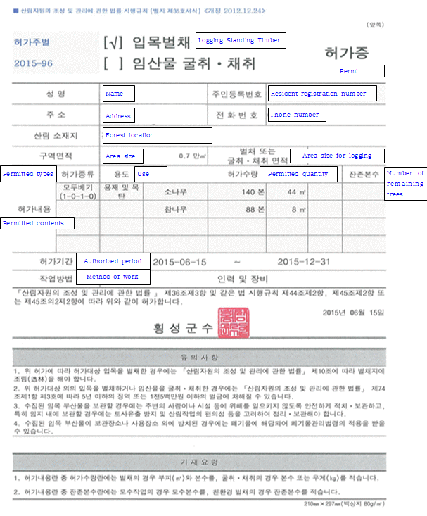Annex 2.1a: Permit for Felling Standing Timber (Sample)

Annex 2.1b: Permit for Felling Standing Timber

|  |  |  |  |  |  |  |  |  |
| --- | --- | --- | --- | --- | --- | --- | --- | --- |
| ■ Enforcement Regulation of the Creation and Management of Forest Resources Act [Annex 35] <Revised on Sep 25 2014.> | | | | | | | | |
|  | | | | | | | | |
| Applicant | Name | | | | | Resident registration number | | |
| Address  (Phone number: ) | | | | | | | |
|  | | | | | | | | |
| Location of Forest |  | | | | | | | |
| Area Size | ㎡ | | Area size for logging, or digging  and collecting | | | | | ㎡ |
| Permitted Contents | Type | Use | | | Permitted Quantity | | | Number of remaining trees |
|  |  | | |  | | |  |
| Authorized  Period |  | | | | | | | |
| Method of Work |  | | | | | | | |
| The applicant applies for a license for logging or digging standing timber and collecting forest products as above, pursuant to Article 36 Paragraph 3 of the *Creation and Management of Forest Resources Act* and Article 44 Paragraph 2, Article 45 Paragraph 2 or Article 45 Paragraph 2-2, of *the Enforcement Regulation of the Act*. | | | | | | | | |
| Year Month Date | | | | | | | | |
| Applicant | | | | (signature) | | | | |
| **Head of Local government,**  **Head of Regional Office of the Forest Service** | | | | | | |  | |
|  | | | | | | | | |
| Note | | | | | | | | |
| 1. In case of logging standing timber in accordance with the license issued, forestation should be conducted in the harvested area pursuant to Article 10 of the *Creation and Management of Forest Resources Act* 2. Logging or digging standing timber and collecting forest products without permission may be punished by imprisonment for not more than five years, or may be subject to a fine not exceeding 15 million won pursuant to Article 74 Paragraph 1-3 of the *Creation and Management of Forest Resources Act.* 3. Logged residues should be piled up and stored properly so that they may not cause damage to people and/or property. In particular, the prevention of soil erosion and implementation of forest operation, etc. should be considered in case of arranging and storing collected logged residues in forest lands. 4. Wastes Control Act may apply to logged residues which are not stored in the storage place or place of use. | | | | | | | | |
| How to fill out form | | | | | | | | |
| 1. The blank space for "Permitted Quantity" in the application form should be filled out with volume (㎥) and the number of trees in case of logging and with the number of plants or weight (kg) in case of digging and collecting.  2. The blank space for "Number of remaining trees" in the application form should be filled out with the number of mother trees in case of mother tree system and with the number of remaining trees in case of environmental logging. | | | | | | | | |
|  | | | | | | | | |
|  | | | | | | | | |
| 210㎜×297㎜(백상지 80g/㎡) | | | | | | | | |

Annex 2.2: Licence (alteration) application form – logging or digging standing timber and collecting forest products

|  |  |  |  |  |  |  |  |  |  |  |
| --- | --- | --- | --- | --- | --- | --- | --- | --- | --- | --- |
| ■ Enforcement Regulation of the Creation and Management of Forest Resources Act [Annex 34]  <Revised on September 25, 2014> | | | | | | | | | | |
| [ ] Logging Standing Timber  [ ] Digging and Collecting Forest Products | | | | | | (Alteration)  License Application Form | | | | |
| ※ Dark blanks are not filled out by the applicant. | | | | | | | | | | |
| Receipt number | | Date of receipt | | | Date of process | | | | Process period 7 days | |
|  | | | | | | | | | | |
| Applicant | Name | | | | | | | Resident registration number | | |
| Address | | | | | | | Phone number | | |
| Relation to the subject forest | | | | | | | | | |
| Location of forest |  | | | | | | | | | |
| Record of land registration | m2 | | Area size | m2 | | | Area size for logging, or digging and collecting | | | m2 |
| Application details | Type | | Use | | | | Quantity of application | | | Number of remaining trees |
|  | |  | | | |  | | |  |
| Period of logging or digging and collecting |  | | | | | | | | | |
| Method of Work |  | | | | | | | | | |
| Reason for alteration |  | | | | | | | | | |
| The applicant applies for a license (alteration) for logging or digging standing timber and collecting forest products as above, pursuant to Article 36 Paragraph 1 of the Creation and Management of Forest Resources Act and Article 44 Paragraph 1, Article 45 Paragraph 1, or Article 45.2 Paragraph 1 of the Enforcement Regulation of the Act. | | | | | | | | | | |
| Year Month Date | | | | | | | | | | |
| Applicant | | | | | | | (signature) | | | |
|  | | | | | | |  | | | |
| **Head of Local government,**  **Head of Regional Office of the Forest Service** | | | | | | |  | | | |

|  |  |  |
| --- | --- | --- |
|  | | |
|  | | |
| Documents that an applicant should submit | ○ In case of license application for logging standing timber  1. A copy of a map of logging zone (forest land map with the size of logging on a scale of 1:6,000 to 1:1,200) or a copy of a surveyed map using GPS  2. A copy of an estimate paper on the amount of timber to be logged drawn in accordance with investigation methods and standards designated and notified by the Minister of the Korea Forest Service  3. A copy of a business plan (purpose of standing timber logging, etc., duration, use plan of forest products, forestation plan, etc. should be included)  4. Documents pursuant to Article 15.3 Paragraph 2 of the Enforcement Regulation of the Mountainous Districts Management Act (only in cases where roads for work and transportation of forest products are built and plans for establishment and restoration, etc. should be included)  5. Documents that verify ownership or right of usingㆍright to benefit of the forest to be logged (only in cases where such information cannot be identified in a certification of land registration and documents that verify right of usingㆍright to benefit should indicate the scope of the rights and duration)  6. Documents that the Minister of the Korea Forest Service designates and notifies in regard to assisting forest project expenses according to Article 64 Paragraph of the Act [only in case of forestation projects (including mandatory forestation) according to Article 68 Paragraph 3 of the Enforcement Decree of the Act]  ○ In case of license application for digging and gathering forest products  1. A copy of a map of zone scheduled for digging and collecting (forest land map indicating the size of areas scheduled for digging and collecting on a scale of 1:6,000 to 1:1,200) or a copy of a surveyed map using GPS  2. A copy of an estimate paper on the amount of forest products to be dug and collected drawn in accordance with investigation methods and standards designated and notified by the Minister of the Korea Forest Service  3. A copy of a restoration plan  4. A copy of documents that verify ownership or right of usingㆍright to benefit of the forest for digging and collecting (only in case where such information cannot be identified in a certification of land registration and documents that verify right of usingㆍright to benefit should indicate the scope of the rights and duration)  5. A copy of a business plan (purpose of digging or collecting, duration, use plan of forest products, forestation plan, etc. should be included)  6. Documents pursuant to Article 15.3 Paragraph 2 of the Enforcement Regulation of the Mountainous Districts Management Act (only in case where roads for work and transportation of forest products are built and plans for establishment and restoration, etc. should be included)  ○ In case of alteration of approved details  1. Document that proves alterations  2. License for logging or digging standing timber and collecting forest products | No fee required |
| Information that a public officer should confirm | Certification of land registration |  |

|  |  |  |  |  |  |  |  |  |
| --- | --- | --- | --- | --- | --- | --- | --- | --- |
| How to fill out form | | | | | | | | |
| 1. The blank space for "Quantity applied" in the application form should be filled out with volume (㎥) and the number of remaining trees in case of logging and with the number of trees or weight (kg) in case of digging and collecting.  2. The blank space for "Number of remaining trees" in the application form should be filled out with the number of mother trees in case of mother tree system and with the number of remaining trees in case of environmental logging. | | | | | | | | |
|  | | | | | | | | |
| Process procedure | | | | | | | | |
|  | | | | | | | | |
| Filling out an application form | ➔ | Receipt | ➔ | Field inspection | ➔ | Authorization | ➔ | Issuing and returning license |
| Applicant |  | Processing organization (Local Government, Regional Office of Forest Service) | | | | | | |
|  | | | | | | | | |
| 210㎜×297㎜ (Woodfree paper 80g/㎡) | | | | | | | | |

Annex 3.1a: Acceptance of Report on Logging Standing Timber (Form)

|  |  |  |  |  |  |  |  |
| --- | --- | --- | --- | --- | --- | --- | --- |
| ■ 산림자원의 조성 및 관리에 관한 법률 시행규칙 [별지 제36호의2서식] <신설 2017. 12. 11.> | | | | | | | |
| (앞쪽) | | | | | | | |
| **입목 벌채·굴취 신고수리증** | | | | | | | |
|  | | | | | | | |
| 신고인 | | 성명 | | | | 생년월일 | |
| 주소 | | | | | |
| 산림 소재지 | |  | | | | | |
| 구역면적 | | ㎡ | | 벌채 또는  굴취 면적 | | ㎡ | |
|  | | | | | | | |
| 신  고  내  용 | 종류 | 방법 | 용도 | 신청수량 | | | 잔존면적ㆍ  본수ㆍ군상수 |
| 수종 | 수량(㎥, 본) | |
|  |  |  |  |  | |  |
|  |  | |
|  |  | |
|  |  | |
|  |  | |
| 벌채ㆍ굴취  기간 | |  | | | | | |
| 「산림자원의 조성 및 관리에 관한 법률」 제36조제5항 및 같은 법 시행규칙 제46조제4항에 따라 위와 같이 신고를 수리합니다. | | | | | | | |
| 년 월 일 | | | | | | | |
| |  |  | | --- | --- | | **특별자치도지사ㆍ특별자치시장**  **시장ㆍ군수ㆍ구청장**  **지방산림청국유림관리소장** | **직인** | | | | | | | | |
|  | | | | | | | |

Annex 3.1b: Acceptance of Report on Logging Standing Timber

|  |  |  |  |  |  |  |  |
| --- | --- | --- | --- | --- | --- | --- | --- |
| ■ Enforcement Regulation of the Creation and Management of Forest Resources Act [Annex 36-2] <Revised on 11 Dec 2017 > | | | | | | | |
| (Front) | | | | | | | |
| **Acceptance of Report**  **on Logging·Digging Standing Timber** | | | | | | | |
|  | | | | | | | |
| Applicant | | Name | | | | Date of Birth | |
| Address | | | | | |
| Location of Forest | |  | | | | | |
| Area size | | ㎡ | | Area size for Logging·digging | | ㎡ | |
|  | | | | | | | |
| Application details | Business Type | Method | use | Quantity of application | | | size of remaining area/number of trees |
| Species | Quantity  (㎥, number of trees) | |
|  |  |  |  |  | |  |
|  |  | |
|  |  | |
| Period of logging or digging | |  | | | | | |
| The applicant applies for a report certificate for standing timber logging or digging and collecting forest products as above, pursuant to Article 36 Paragraph 5 of the Creation and Management of Forest Resources Act and Article 46 Paragraph 4 of the Enforcement Regulation of the Act. | | | | | | | |
| Year Month Date | | | | | | | |
| |  |  | | --- | --- | | **Head of Local government**  **ㆍHead of Regional Office of the Forest Service** | **Seal** | | | | | | | | |

Annex 3.2a: Acceptance of Report on Implementation of Forest Management Plan (Form)

|  |  |  |  |  |  |  |  |
| --- | --- | --- | --- | --- | --- | --- | --- |
| ■ 산림자원의 조성 및 관리에 관한 법률 시행규칙 [별지 제3호의2서식] <신설 2017. 12. 11.> | | | | | | | |
| (앞쪽) | | | | | | | |
| **산림경영계획 산림사업 신고수리증** | | | | | | | |
|  | | | | | | | |
| 신고인 | | 성명 | | | | 생년월일 | |
| 주소 | | | | | |
| 산림 소재지 | |  | | | | | |
| 산림경영계획구  명 칭 | |  | | | | | |
| 사업면적 | | ㎡ | | 벌채 또는  굴취ㆍ채취 면적 | | ㎡ | |
|  | | | | | | | |
| 신  고  내  용 | 종류 | 방법 | 용도 | 신청수량 | | | 잔존면적ㆍ  본수ㆍ군상수 |
| 수종 | 수량(㎥,본,㎏) | |
|  |  |  |  |  | |  |
|  |  | |
|  |  | |
|  |  | |
|  |  | |
| 산림사업  기간 | |  | | | | | |
| 「산림자원의 조성 및 관리에 관한 법률」 제14조제4항 및 같은 법 시행규칙 제10조제5항에 따라 위와 같이 신고를 수리합니다. | | | | | | | |
| 년 월 일 | | | | | | | |
| |  |  | | --- | --- | | **특별자치도지사ㆍ특별자치시장**  **시장ㆍ군수ㆍ구청장** | **직인** | | | | | | | | |
| 210㎜×297㎜[백상지(80g/㎡) 또는 중질지(80g/㎡)] | | | | | | | |

Annex 3.2b: Acceptance of Report on Implementation of Forest Management Plan

|  |  |  |  |  |  |  |  |
| --- | --- | --- | --- | --- | --- | --- | --- |
| ■ Enforcement Regulation of the Creation and Management of Forest Resources Act [Annex 3-2] <Revised on 11 Dec 2017 > | | | | | | | |
| (front) | | | | | | | |
| **Acceptance of Report**  **on Implementation of Forest Management Plan** | | | | | | | |
|  | | | | | | | |
| Applicant | | Name | | | | Date of Birth | |
| Address | | | | | |
| Location of Forest | |  | | | | | |
| Forest Management Plan Area | |  | | | | | |
| Area size | | ㎡ | | Area size for Logging·digging | | ㎡ | |
|  | | | | | | | |
| Application details | Business Type | Method | use | Quantity of application | | | size of remaining area/number of trees |
| Species | Quantity  (㎥, number of trees, ㎏) | |
|  |  |  |  |  | |  |
|  |  | |
|  |  | |
|  |  | |
|  |  | |
| Period of logging or digging | |  | | | | | |
| The applicant applies for an acceptance of report on implementation of forest management plan as above, pursuant to Article 14 Paragraph 4 of the *Creation and Management of Forest Resources Act* and Article 10 Paragraph 5 of the Enforcement Regulation of the Act. | | | | | | | |
| Year Month Date | | | | | | | |
| |  |  | | --- | --- | | **Head of Local government** | **Seal** | | | | | | | | |
| 210㎜×297㎜[백상지(80g/㎡) 또는 중질지(80g/㎡)] | | | | | | | |

Annex 4.1: Registration form of Timber Production Business (Raw Timber Production, Sawmilling Industry, Timber Imports and Distribution)

|  |  |  |  |  |  |  |  |  |  |  |  |  |  |  |
| --- | --- | --- | --- | --- | --- | --- | --- | --- | --- | --- | --- | --- | --- | --- |
| Timber Production Business | | | **[ ] Raw Timber Production**  **[ ]Sawmilling Industry**  **[ ] Timber Imports and Distribution** | | | | | | | Registration form | | | | |
|  | | | | | | | | | | | | | |
| ※ [ ]Check in the relevant bracket. | | | | | | | | | | | | |
| Receipt number | | | | Date of receipt | | | | | | | Process period 20 days | |
|  | | | | | | | | | | | | |
| Applicant | | Name of the Business | | | | Business Registration number | | | | | | |
| Address | | | | | | | | | | |
| Name of the | | | | | | | Date of birth | | | |
| Phone number | | | Mobile | | | | Email | | | |
|  | | | | | | | | | | | | |
| Application  Details | | Business Type | | | | | | | | | | |
| The type of Timber or Timber products | | | | | | Annual production/imports | | | | |
| Capital KRW 1 mil | | | | | | | | | | |
| Number of Technical Manpower | | | | | | | | | | |
| The applicant applies for a registration for timber production business([ ]Raw timber production, [ ]Sawmilling industry, [ ]Timber Imports and Distribution) as above, pursuant to Article 24 the Act on Sustainable Use of Timber and Article 22 Paragraph 1, of the Enforcement Regulation of the Act. | | | | | | | | | | | | |
| Year Month Date | | | | | | | | | | | | |
| Applicant | | | | | | | (signature) | | | | | |
| **Head of Local government** | | | | | | | | | | | | |
|  | | | | | | | | | | | | |
| Documents that  an  applicant  should  submit | 1. Raw Timber Production and Sawmilling Industry  A. A copy of document that verifies the number Manpower and Facility capacity in regards to annex 32  B. A copy of document that verifies the technical capacity and employment of manpower  C. A copy of document that verifies the amount of capital owned by the corporate  D. A copy of document that verifies the ownership and right of use of the facility (only in case where such information cannot be identified in a certification of land registration and documents that verify right of usingㆍright to benefit should indicate the scope of the rights and duration)  2. Timber Imports and Distribution: The above mentioned document in 1-(A) and (D) | | | | | | | | | | | No fee  required |
| Information  that a responsible  government  official  should  confirm | 1. Certificate of Corporation Registration(exclusively for corporation)  2. Certificate of Real Estate Register | | | | | | | | | | |
|  | | | | | | | | | | | | |
| Process procedure | | | | | | | | | | | | |
| |  |  |  |  |  |  |  | | --- | --- | --- | --- | --- | --- | --- | | Filling out an  application form | ⎝ | Receipt | ⎝ | Review | ⎝ | Issuance of Registration | | Applicant |  | Processing organization (Local Government) | | | | | | | | | | | | | | | | | |

Annex 4.2a: Registration Certificate (Sample) of Timber Production Business (Raw Timber Production, Sawmilling Industry, Timber Imports and Distribution)

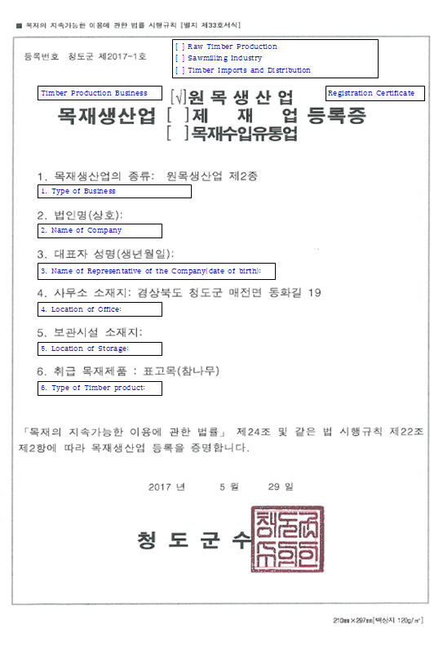

Annex 4.2b: Registration Certificate of Timber Production Business (Raw Timber Production, Sawmilling Industry, Timber Imports and Distribution)

|  |  |  |  |
| --- | --- | --- | --- |
| ■ Enforcement Regulation of the Act on the Sustainable Use of Timber [Annex 33] | | | |
| Registration Number | | | |
| Registration Certificate of  Timber Production Business | | [ ]Raw Timber Production  [ ]Sawmilling Industry  [ ]Timber Imports and Distribution |  |
|  | | | |
|  | 1. Type of Business: | | |
|  | 2. Name of Company: | | |
|  | 3. Name of representative of the Company(Date of birth): | | |
|  | 4. Location of Office: | | |
|  | 5. Location of Storage: | | |
|  | 6. Type of Timber Product | | |
|  | | | |
| This is to certify that above-mentioned Timber production business is appropriately registered pursuant to Article 24 of the *Act on the Sustainable Use of Timbers* and Article 22 Paragraph 2 of the Enforcement Regulation of the Act. | | | |
| Year Month Date   |  |  | | --- | --- | | **Head of Local government** | **Seal** | | | | |

Annex 4.3: Requirements for Registration of Timber Production Business by Type

|  |  |  |  |  |  |
| --- | --- | --- | --- | --- | --- |
| 1. Logging: A business that cuts standing trees and bamboo in accordance with the *Creation and Management of Forest Resources Act* (including distribution of the felled timber; hereinafter the same shall apply in this subparagraph) | | | | | |
| **Classification** | **Business Scope** | **Registration Requirements** | | | |
| **Technical Personnel** | | **Capital** | **Facilities** |
| Type 1 | Felling  (no limit to felling volume) | At least one certified technician (Grade 2 or over) and one professional engineer (Grade 2 or over) in accordance with Table 2 attached to the *Enforcement Decree* of the *Creation and Management of Forest Resources Act* | | 50 million won or more | Office |
| Type 2 | Felling  (annual felling volume: 5,000㎥ or less) | At least one certified technician (Grade 2 or over) in accordance of Table 2 attached to the *Enforcement Decree* of the *Creation and Management of Forest Resources Act* or more than one person who received training for over 35 hours on logging from a professional training institution designated pursuant to Article 31 (1) of the Act. | | 10 million won or more | Office |
| 2. Sawmilling: A business that makes logs into timber (referring to production of wood panels such as timber and plywood, heat or chemically-treated wood products, and charcoal, including distribution of the timber products; hereinafter the same shall apply in this subparagraph.) | | | | | |
| **Classification** | **Business Scope** | **Registration Requirements** | | | |
| **Technical Personnel** | | **Capital** | **Facilities** |
| Type 1 | Production of timber or veneer (including products made of processed or modified timber or veneer) | At least one person with certification of forest product processing technician or higher in accordance of the *National Technical Qualifications Act* or more than one person who received training for over 35 hours on forest product processing from a professional training institution designated pursuant to Article 31 (1) of the Act. | | 30 million won or more | Office |
| Type 2 | Production of wood panels such as plywood | At least one person with certification of forest product processing engineer, industrial engineer or higher in accordance of the *National Technical Qualifications Act* | | 100 million won or more | Office |
| Type 3 | Production of heat or chemically- treated wood products or laminated wood | At least one person with certification of forest product processing technician or higher in accordance of the *National Technical Qualifications Act* or more than one person who received training for over 35 hours on forest product processing from a professional training institution designated pursuant to Article 31 (1) of the Act. | | 50 million won or more | Office |
| Type 4 | Production of charcoal, molded charcoal, wood pellets, forest pellets, wood chips, sawdust, wood flour | At least one person with certification of forest product processing technician or higher in accordance of the *National Technical Qualifications Act* or more than one person who received training for over 35 hours on forest product processing from a professional training institution designated pursuant to Article 31 (1) of the Act. | | 30 million won or more | Office |
| 3. Timber import & distribution: A business that imports and distributes timber or timber products | | | | | |
| **Business Scope** | | | **Registration Requirements** | | |
| Import & distribution of timber or timber products | | | Office and storage facilities | | |

1. For the purposes of the *Illegal Logging Prohibition Act 2012* a ‘regulated timber product’ is a product listed in Schedule 1 to the Regulation.