
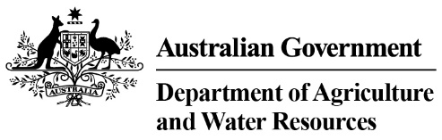

Quick Reference Guide: identifying legal timber from the Republic of Korea
This Quick Reference Guide supports the Country Specific Guideline for the Republic of Korea. These documents may be used by Australian importers of regulated timber products from the Republic of Korea (Korea) to carry out their due diligence in accordance with the Illegal Logging Prohibition Act 2012 and the Illegal Logging Prohibition Regulation 2012.

Legal requirements of timber harvesting in Korea
Korea operates a logging license regime that includes strict procedures when cutting standing timber or the extraction and collection of forest products. A license is required for logging in compliance with the Creation and Management of Forest Resources Act.

Identifying legal product from Korea
Importers of regulated timber products from Korea can identify the legality of regulated timber products with a Korean origin of harvest, based upon the provision of the following primary documents issued under the Act:
- Where timber has been legally harvested from national forests:
  - Confirmation of Delivery of Forest Products – document issued by the Regional Office of the Forest Service (see example at Figure 1).
- Where timber has been legally harvested from private forests:
  - Permit for Felling Standing Timber – issued by the local government prior to harvesting (see example at Figure 2). No payment is required to obtain the license.
  - Acceptance of Report on Logging Standing Timber – issued by the local government prior to harvesting (see example at Figure 3).
  - Acceptance of Report on Implementation of Forest Management Plan – issued by the local government prior to harvesting (see example at Figure 4).

Obtaining evidence of timber legality
Korean exporters can provide Australian importers with the relevant documentation (as outlined above) to verify the logging and distribution history of regulated timber products with a Korean harvest of origin.

Timber producers are required to retain documents verifying legally harvested timber for five years. Timber collectors, dealers and processors at each distribution stage are able to obtain copies of the relevant logging licenses in order to verify legally harvested timber. Detailed information on logging licenses is available from the local government, following a request from the logger.

Other requirements
For further details on timber legality in Korea, see the Country Specific Guideline for the Republic of Korea.
Figures 1 to 4 provide examples of the main documents that demonstrate timber legality
Figure 1: Confirmation of Delivery of Forest Products  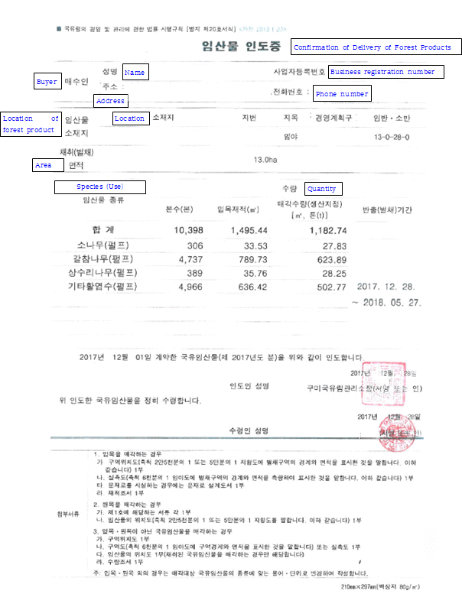 | Figure 2: Permit for Felling Standing Timber  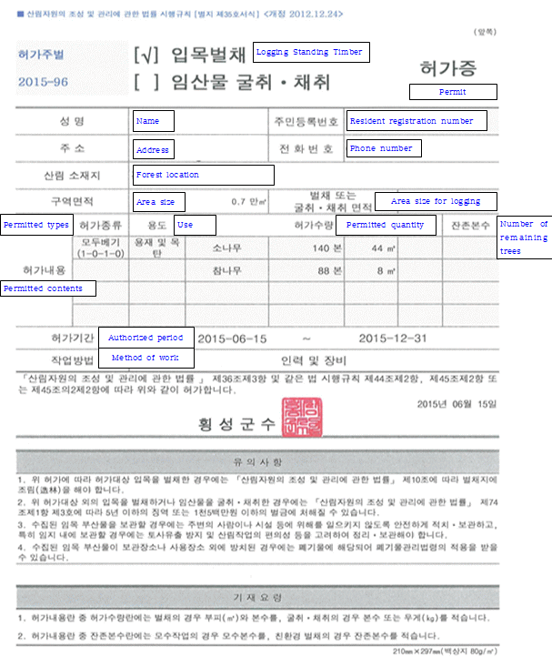
Figure 3: Acceptance of Report on Logging Standing Timber  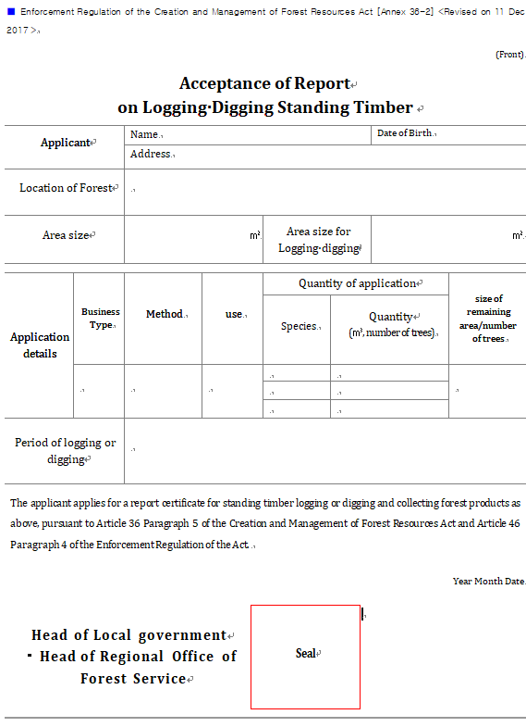 | Figure 4: Acceptance of Report on Implementation of Forest Management Plan  