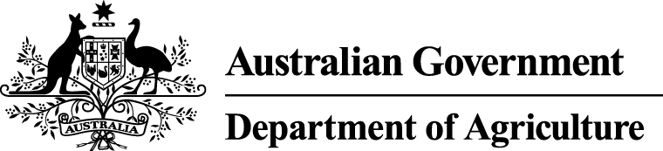

State Specific Guideline for Victoria

This guideline has been prepared by the Australian Government and the Victorian Government. It is intended to assist processors of Victorian sourced logs, who process these raw logs into another form, in understanding the regulatory frameworks around timber harvesting in Victoria in order for them to carry out their due diligence obligations under the Illegal Logging Prohibition Amendment Regulation 2013 which supports the Illegal Logging Prohibition Act 2012.

This Guideline was co-endorsed by the Australian and
Victorian Governments on 15 October 2014.

Contents
What is required under the new law? 3
How is timber harvesting regulated in Victoria? 4
Regulating the areas where harvesting is permitted 4
Regulating timber harvesting operations 5
Other relevant laws that relate to legally harvested timber 6
Identifying legally harvested product from Victoria 7
Public land native forest timber harvesting 7
Private land (including leased or licenced crown land) timber harvesting 7
Other relevant non-government resources 7
Who should I contact for further information? 8
Attachment 1 – Legislation, regulations and policies applying to forest management for timber harvesting operations on public and private land 9
Attachment 2 – Example of VicForests delivery docket 11
Attachment 3 – Examples of DEPI log docket 12
Attachment 4 – Example of a plantation log delivery docket 13

What is required under the new law?

Australia’s Illegal Logging Prohibition Act 2012 (the Act) restricts the movement of illegally logged timber into Australia at the border, for imported timber and timber products; and at timber processing mills, for domestically grown raw logs.
The Act seeks to address the harmful environmental, social and economic impacts of illegal logging, including forest degradation, habitat loss and threats to sustainable livelihoods.
The Act defines illegally logged as:
‘…in relation to timber, means harvested in contravention of laws in force in the place (whether or not in Australia) where the timber was harvested’.
The Illegal Logging Prohibition Amendment Regulation 2013 (the Regulation) prescribes due diligence for the regulated community, that is, Australian importers of regulated timber products (for these purposes a regulated timber product is a product listed in Schedule 1 to the Regulation) and Australian processors of domestic raw logs. Under the Regulation the regulated community have to undertake a due diligence process to minimise the risk of sourcing illegally logged timber.
Due diligence requirements for processors include the following steps:
Step 1: Information gathering
Step 2: Assessing and identifying risk against a timber legality framework (optional) or a state specific guideline (optional)
Step 3: Risk assessment (if required)
Step 4: Risk mitigation (if required)

Further information about the Act and the Regulation is available at www.agriculture.gov.au/illegallogging.
This guideline is intended to assist a processor of Victorian sourced raw logs to comply with the due diligence requirements of the Regulation.
Information or evidence listed in this guideline is not an exhaustive list of evidence or documentation required to satisfy due diligence requirements under the Regulation. The Regulation should be referred to for a complete list of the information required to be gathered to satisfy due diligence requirements.
Information gathered by applying this guideline, along with any other information gathered in accordance with the Regulation, needs to be assessed in accordance with the processes outlined in the Regulation to identify the risk that a regulated timber product is, is made from, or contains illegally logged timber.

How is timber harvesting regulated in Victoria?

Different regulations apply to timber harvesting depending on whether the forest being harvested is located on public or private land (private land includes leased or licenced Crown land).

Victoria has a range of laws and regulations to govern timber harvesting. In Victoria this comprises two important elements:
- regulating where and when timber harvesting can occur
- regulating appropriate standards to govern how timber harvesting is conducted.

Regulating the areas where harvesting is permitted

Public land native forest timber harvesting
Both the Department of Environment and Primary Industries (DEPI) and VicForests have responsibilities for managing timber harvesting on public land.

DEPI is the environmental regulator for commercial timber harvesting activities in Victoria's State forests. This includes harvesting operations managed by VicForests, and harvesting operations managed by operators given access to timber via forest produce licences.

An important function for the environmental regulator is to ensure that commercial timber harvesting activities are compliant with Victoria's regulatory framework. This includes checking compliance with relevant legislation, regulations and guidelines.

State forests are zoned by DEPI to determine appropriate land use, including areas that are available for timber harvesting.

The areas available for harvesting by VicForests are identified in an Allocation Order and an associated map (available from the DEPI website) created under Part 3 of the Sustainable Forests (Timber) Act 2004 (SFT Act). The Allocation Order vests the relevant timber resources with VicForests. VicForests harvests and/or sells the timber resources in accordance with the established conditions.

VicForests prepares Timber Release Plans (TRP) to identify its planned timber harvesting operations. Each operation is divided into a forest ‘coupe’ and each coupe is given a specific coupe number.

VicForests harvests eucalypt forests designated as ash species or mixed species forest as well as small volumes of acacia species.

For smaller timber volumes, forest produce licences can be issued under section 52 of the Forests Act 1958. Coupes permitted to be harvested are recorded in a document called a Wood Utilisation Plan (WUP). A WUP is a three year schedule of areas to be harvested with a map showing their location. They can be viewed on the DEPI website.

It should be noted that neither VicForests nor DEPI are permitted to harvest tree species or forest types that are protected under legislation, including under the Flora and Fauna Guarantee Act 1988. For example, the harvesting of rainforest communities is prohibited in Victoria.

Private land (including leased or licenced Crown land) plantation timber harvesting
Under the Victorian Planning and Environment Act 1987, the Minister for Planning has approved a state-wide reference document, the Victoria Planning Provisions (VPP). Local planning schemes set out policies and requirements for the use, development and protection of land. Using the VPP to source and construct local planning schemes ensures consistent regulation across Victoria.

Timber production, including timber harvesting, is a ‘defined land use’ in the VPP and all local planning schemes. The VPP recognises that plantations are established primarily for timber production, thus planning controls concerned with the development of plantations explicitly allow for subsequent management and harvest.

The harvest of plantations, including thinning operations, must be consistent with a Timber Harvesting Plan (THP). A THP is current for 24 months following lodgement with the relevant local government. It may apply to a single coupe, a number of coupes or to an entire plantation’s harvesting operations.

There is no regulation covering agroforestry and small plantations or woodlots of 5 hectares or less. This means that timber can be legally harvested and sold on a small scale basis and no documentation is required from the relevant Victorian government agency. If processors are purchasing timber from these areas, they may request information which identifies the legal owner of the land or information that the timber is coming from agroforestry or small plantations or woodlots of 5 hectares or less.

Private land native forest timber harvesting
The harvesting of native forests on private land is regulated in a similar manner to plantations; that is, by local government as part of the land use planning system. Native vegetation laws and regulations apply.

Approval of timber production activities in native forest on private land is obtained through the relevant local government planning scheme, and requires a planning permit which must be approved prior to operations commencing. Similarly to plantations, a THP must also be prepared and submitted to local government.

Private native forest harvesting must also be carried out in accordance with Permitted clearing of native vegetation – Biodiversity assessment guidelines, an incorporated document in the VPPs and all local planning schemes.

Regulating timber harvesting operations
Timber production is regulated by the Code of Practice for Timber Production (the Code), prepared under Part 5 of the Conservation, Forests and Lands Act 1987. The Code sets out appropriate and responsible standards for timber production, and applies to all commercial timber harvesting operations (native forest and plantation timber) on both public and private land.

The purpose of the Code is to ensure that commercial timber growing and harvesting operations are carried out in a way that:
- permits an economically viable, internationally competitive, sustainable timber industry
- is compatible with the conservation of the wide range of environmental, social and cultural values associated with timber production forests
- provides for the ecologically sustainable management of native forests proposed for continuous timber production
- enhances public confidence in the management of Victoria's forests and plantations for timber production.
For timber harvesting on public land, compliance with the Code is required under the SFT Act.

For timber harvesting on private land and leased Crown land, the Code is an incorporated document of the VPP. Clause 52.18 of the VPP specifies that all timber production activities must comply with the Code. THPs must be prepared in accordance with the requirements of the Code (with the exception of agroforestry or small plantations or woodlots under 5 hectares, where THP documentation is not required by the Code).

Other relevant laws that relate to legally harvested timber
Appendix A of the Code lists other relevant laws, regulations and policies that may apply to forest management and timber harvesting on public and private land in Victoria (see Attachment 1). Protection of landscape values must comply with the requirements of any local planning scheme and policies as applicable. Refer to your relevant Municipal Strategic Statement for such requirements. Below are examples of legislation and regulations that may need to be considered.

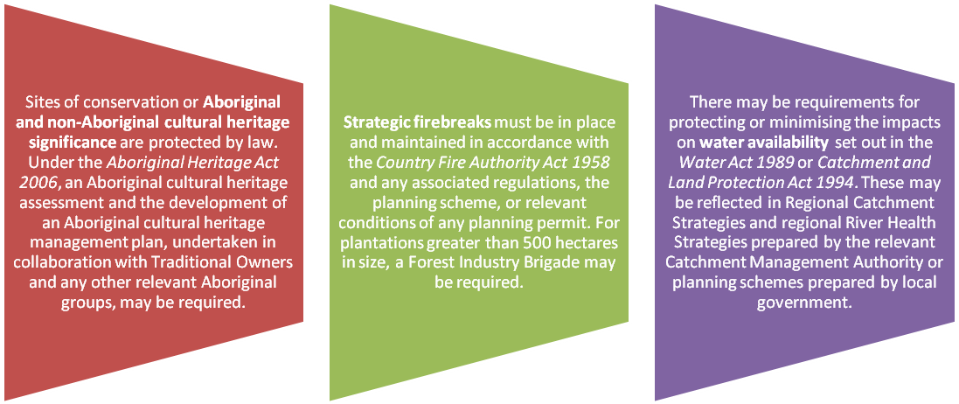

Identifying legally harvested product from Victoria

Public land native forest timber harvesting
Processors should be able to demonstrate that the wood was harvested from an authorised coupe which is identified on a TRP or a WUP.

Documentation that could be required to determine this includes:
- a VicForests delivery docket identifying the coupe of origin (which could be cross-referenced against an approved TRP – see Attachment 2) or
- a Victorian Government log docket identifying the coupe of origin (which could be cross-referenced against an approved WUP – see Attachment 3).
DEPI monitors compliance with the Code for timber harvesting operations conducted on public land. This may include inspections conducted by authorised officers or compliance auditing conducted under the DEPI Forest Audit Program.

Private land (including leased or licenced crown land) timber harvesting
Processors should be able to demonstrate that the timber was harvested as part of an authorised operation under the local planning scheme.

Documentation that could be required includes:
- a plantation delivery docket (Attachment 4) and a copy of the THP or permit from local government
- a private native forest delivery docket and a copy of the THP or permit from local government.
While the format and appearance of such documents will vary depending on the harvesting operator and the local government area, the objective is to match an identifier of a delivered log product (e.g. a coupe number) with a common identifier on a local government THP or permit.

Local government is responsible for ensuring compliance with the Code, regardless of whether or not a permit is required. DEPI provides management guidelines to assist local government to interpret the Code and monitor code compliance.

Other relevant non-government resources
Relevant certification systems recognised by the Victorian Government include:
- the Australian Forestry Standard, endorsed by the Program for the Endorsement of Forest Certification
- the Forest Stewardship Council, Interim Australian Standard.
These certification organisations provide forest management and chain of custody certification that may assist in demonstrating the legality of harvested logs in Australia.

Who should I contact for further information?

  Australian Government  Department of Agriculture  GPO Box 858  Canberra City ACT 2601  Phone: 02 6272 3933  http://www.agriculture.gov.au/illegallogging  illegallogging@agriculture.gov.au |  | 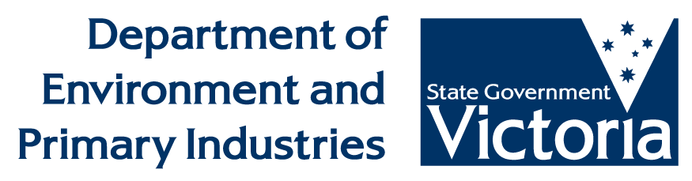  Victorian Government  Department of Environment and Primary Industries  GPO Box 4440  Melbourne VICTORIA 3001  Phone: 136 186  www.depi.vic.gov.au

Attachment 1 – Legislation, regulations and policies applying to forest management for timber harvesting operations on public and private land

Commonwealth Legislation | Public Land | Private Land
Aboriginal and Torres Strait Islander Heritage Protection Act 1984 | ✓ | ✓
Australian Heritage Commission Act 1975 | ✓ | ✓
Environment Protection and Biodiversity Conservation Act 1999 | ✓ | ✓
Export Control Act 1982 |  | ✓
National Environment Protection Measures (Implementation) Act 1998 | ✓ | ✓
Native Title Act 1993 | ✓ | ✓
Quarantine Act 1908 | ✓ | ✓
Regional Forests Agreement Act 2002 | ✓ | ✓

State legislation | Public Land | Private Land
Aboriginal Heritage Act 2006 | ✓ | ✓
Accident Compensation Act 1985 | ✓ | ✓
Agricultural and Veterinary Chemicals (Control of Use) Act 1992 | ✓ | ✓
Agricultural and Veterinary Chemicals Act 1994 | ✓ | ✓
Building Act 1993 | ✓ | ✓
Catchment and Land Protection Act 1994 | ✓ | ✓
Conservation, Forests and Lands Act 1987 | ✓ | ✓
Country Fire Authority Act 1958 | ✓ | ✓
Crown Land (Reserves) Act 1978 | ✓
Dangerous Goods Act 1958 | ✓ | ✓
Electricity Safety Act 1998 | ✓ | ✓
Emergency Management Act 1986 | ✓ | ✓
Environment Protection Act 1970 | ✓ | ✓
Extractive Industries Development Act 1995 | ✓ | ✓
Fences Act 1968 |  | ✓
Firearms Act 1996 | ✓ | ✓
Fisheries Act 1995 | ✓ | ✓
Flora and Fauna Guarantee Act 1988 (Vic) | ✓ | ✓
Forests Act 1958 | ✓ | ✓
Heritage Act 1995 | ✓ | ✓
Heritage Rivers Act 1992 | ✓ | ✓
Land Act 1958 | ✓ | ✓
Land Conservation (Vehicle Control) Act 1972 | ✓
Local Government Act 1989 |  | ✓
Occupational Health and Safety Act 2004 | ✓ | ✓
Planning and Environment Act 1987 (Vic) | ✓ | ✓
Planning and Environment (Planning Schemes) Act 1996 |  | ✓
Plant Health and Plant Products Act 1995 | ✓ | ✓
Prevention of Cruelty to Animals Act 1986 | ✓ | ✓
Reference Areas Act 1978 | ✓
Road Management Act 2004 | ✓ | ✓
Safety on Public Land Act 2004 | ✓
Summary Offences Act 1966 | ✓
Sustainable Forests (Timber) Act 2004 | ✓
Water Act 1989 | ✓ | ✓
Wildlife Act 1975 | ✓ | ✓

Regulations | Public Land | Private Land
Agricultural and Veterinary Chemicals (Control of Use) Regulations 2007 | ✓ | ✓
Country Fire Authority Regulations 2004 |  | ✓
Dangerous Goods (Explosives) Regulations 2011 | ✓ | ✓
Dangerous Goods (HCGD) Regulations 2005 | ✓ | ✓
Dangerous Goods (Storage and Handling) Regulations 2012 | ✓ | ✓
Electricity Safety (Electric Line Clearance) Regulations 2010 | ✓ | ✓
Electricity Safety (Network Assets) Regulations 1999 | ✓ | ✓
Extractive Industries Development Regulations 2007 | ✓ | ✓
Flora and Fauna Guarantee Regulations 2011 | ✓ | ✓
Forests (Fire Protection) Regulations 2004 | ✓
Forests (Miscellaneous) Regulations 2000 | ✓
Land Act Regulations 1996 | ✓ | ✓
Land Conservation (Vehicle Control) Regulations 2013 | ✓
Road Management (General) Regulations 2005 | ✓
Sustainable Forests (Timber Harvesting) Regulations 2006 | ✓

Attachment 2 – Example of VicForests delivery docket

Sawlog docket Pulplog docket

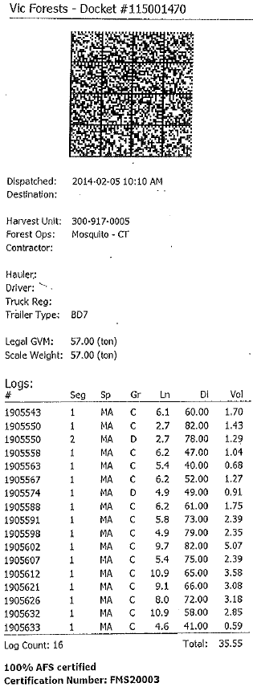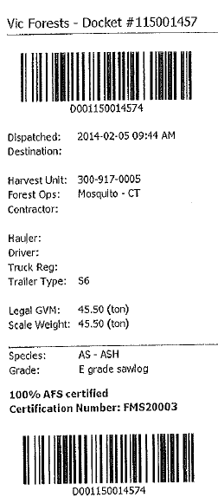

‘Harvest Unit’ is the coupe number, which could be cross-referenced with the TRP which is available on VicForests’ website

Attachment 3 – Examples of DEPI log docket

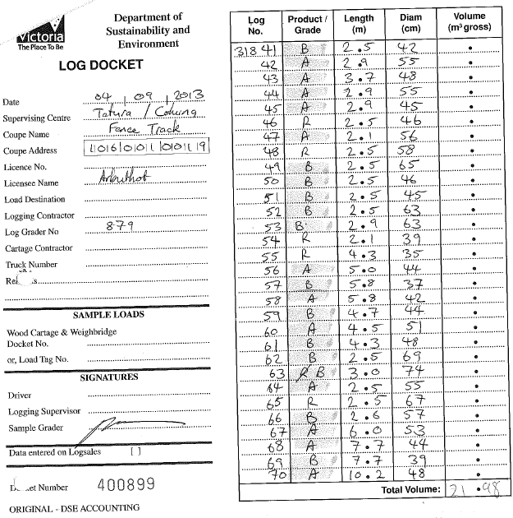
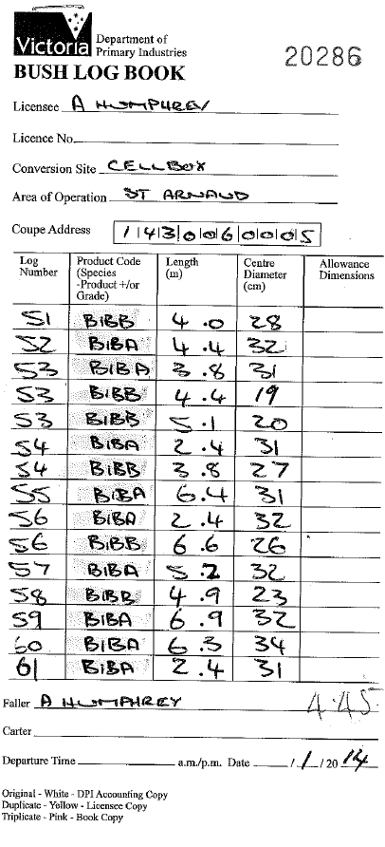
‘Coupe Address’ could be cross-referenced with the address listed in the WUP which is available on DEPI’s website

Attachment 4 – Example of a plantation log delivery docket

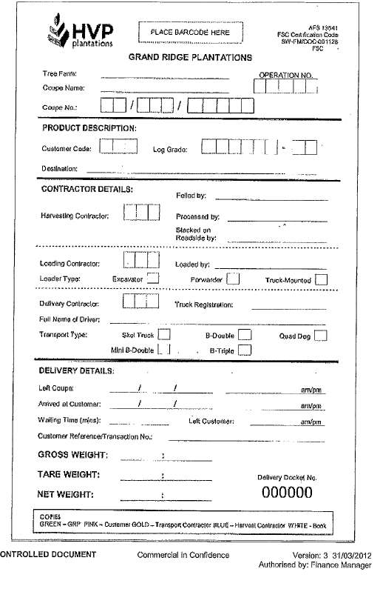
‘Coupe no.’ can be cross-referenced with the THP or permit

