Appendix: Descriptive profiles of floristic assemblages.

MAP UNIT 1: Dry Rainforest

Species richness: 28 ± 5 (0.04 ha)
Extant area: 42 ha
Proportion cleared: 11% (probably an underestimate)
Number of samples: 6

Table A1.1. Diagnostic plant species of Map Unit 1.

Species | Target frequency | Target C/A | Residual frequency | Residual C/A | Fidelity class
Brachychiton populneum | 0.833 | 2(1-3) | 0.02 | 1(1-1) | positive
Celastrus australis | 0.833 | 3(2-3) | 0.008 | 1(1-1) | positive
Ficus rubiginosa | 1 | 5.5(5-6) | 0.005 | 1.5(1-4) | positive
Geitonoplesium cymosum | 1 | 2(2-2) | 0.106 | 1(1-1) | positive
Notelaea venosa | 0.5 | 3(1-3) | 0.112 | 1(1-2) | positive
Pellaea falcata var falcata | 1 | 2(2-3) | 0.094 | 1(1-2) | positive
Pittosporum undulatum | 0.833 | 3(2-3) | 0.089 | 1(1-2) | positive
Plectranthus graveolens | 0.5 | 2(1-3) | 0.009 | 1(1-2) | positive
Sigesbeckia orientalis | 0.5 | 2(1-2) | 0.076 | 1(1-2) | positive
Solanum aviculare | 0.167 | 2(2-2) | 0 | 0(0-0) | positive
Alectryon subcinereus | 0.667 | 1(1-3) | 0.005 | 1(1-2) | frequent
Asplenium flabellifolium | 0.833 | 1(1-2) | 0.119 | 1(1-2) | frequent
Clematis glycinoides | 0.667 | 1.5(1-3) | 0.113 | 1(1-2) | frequent
Dichondra repens | 0.833 | 1(1-1) | 0.282 | 2(1-2) | frequent
Hymenanthera dentata | 1 | 1(1-2) | 0.066 | 1(1-2) | frequent
Oplismenus imbecillis | 0.667 | 1.5(1-2) | 0.106 | 2(1-2) | frequent
Urtica incisa | 0.667 | 1.5(1-2) | 0.067 | 1(1-2) | frequent
Eucalyptus polyanthemos ssp vestita | 0.167 | 3(3-3) | 0.012 | 2(2-3) | uninformative
Eucalyptus sieberi | 0.167 | 1(1-1) | 0.283 | 3(2-4) | uninformative
Eucalyptus tereticornis | 0.333 | 2(1-3) | 0.046 | 3(1-3) | uninformative
Lomandra longifolia | 0 | 0(0-0) | 0.551 | 2(1-2) | negative
Poa meionectes | 0 | 0(0-0) | 0.541 | 2(1-3) | negative
Pteridium esculentum | 0 | 0(0-0) | 0.579 | 2(1-3) | negative

Table A1.2. Vegetation structure of Map Unit 1. Frequency is the proportion of samples in which strata were present. Height and cover data are means with standard errors in parentheses (n=6).

Stratum | Frequency (%) | Height (m) | Cover (%)
Tree | 50 | 23.0(2.4) | 6(2)
Small tree | 100 | 10.8(0.7) | 80(5)
Shrub | 100 | 1.7(0.3) | 16(6)
Ground cover | 100 | 0.3(0.0) | 8(2)

Table A1.3. Habitat characteristics of Map Unit 1. Means and interquartile ranges for altitude and slope were calculated from n field samples, while those for annual rain were calculated from ESOCLIM predictions (see Table 5, text). Frequency terrain and parent material refers to number of samples (n) recorded in respective classes. Terrain classes: flat (slope≤5°); north (slope>5° and aspect<30° or >300°); intermediate (slope>5° and aspect 30-120° or 210-300°); and south (slope>5° and aspect 120-210°).

 |  | Frequency (%) | Mean | Interquartile Range | n
Annual rain (mm) |  |  |  | 881 | 856 - 915 | 7
Altitude (m) |  |  |  | 283 | 230 - 335 | 7
Slope (degrees) |  |  |  | 34 | 31 - 37 | 7
Terrain class
 | North | 57 |  |  | 4
 | Intermediate | 29 |  |  | 2
 | South | 14 |  |  | 1
 | Flat | 0 |  |  | 0
Parent material
 | Devonian granitoids | 71 |  |  | 5
 | Devonian high quartz sedimentaries | 14 |  |  | 1
 | Ordovician high quartz sedimentaries | 14 |  |  | 1

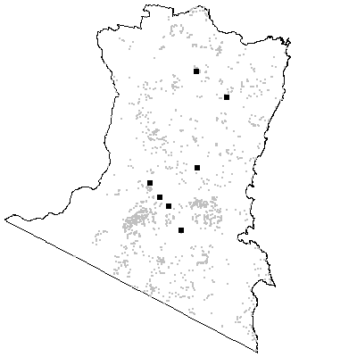

Map Unit 2: Myanba Dry Scrub Forest

Species richness: 32 ± 3 (0.04 ha)
Extant area: 333 ha
Proportion cleared: 0%
Number of samples: 5

Table A2.1. Diagnostic plant species of Map Unit 2.

Species | Target frequency | Target C/A | Residual frequency | Residual C/A | Fidelity class
Asplenium trichomanes ssp quadrivalens | 0.2 | 2(2-2) | 0 | 0(0-0) | positive
Bulbine bulbosa | 0.2 | 1(1-1) | 0 | 0(0-0) | positive
Celtis australis | 0.2 | 1(1-1) | 0 | 0(0-0) | positive
Acacia falciformis | 0.8 | 1(1-1) | 0.188 | 2(1-3) | frequent
Asplenium flabellifolium | 0.8 | 1(1-2) | 0.119 | 1(1-2) | frequent
Cassinia aculeata | 0.8 | 1(1-1) | 0.161 | 1(1-2) | frequent
Cassinia trinerva | 0.6 | 1(1-1) | 0.082 | 1(1-3) | frequent
Danthonia longifolia | 0.6 | 1(1-2) | 0.074 | 1(1-2) | frequent
Dendrobium speciosum | 0.6 | 1(1-2) | 0.016 | 1(1-2) | frequent
Einadia nutans | 0.8 | 1(1-1) | 0.018 | 1(1-1) | frequent
Eucalyptus bosistoana | 0.8 | 1(1-1) | 0.05 | 2(1-3) | frequent
Ficus rubiginosa | 0.6 | 1(1-3) | 0.007 | 5(2-6) | frequent
Hymenanthera dentata | 0.6 | 1(1-1) | 0.068 | 1(1-2) | frequent
Lepidosperma laterale | 0.6 | 1(1-1) | 0.344 | 1(1-2) | frequent
Notelaea venosa | 0.6 | 1(1-1) | 0.112 | 1(1-2) | frequent
Pandorea pandorana | 0.8 | 1(1-2) | 0.119 | 1(1-1) | frequent
Pellaea falcata var falcata | 0.8 | 1(1-1) | 0.095 | 1(1-2) | frequent
Pimelea axiflora | 0.8 | 1(1-2) | 0.117 | 1(1-2) | frequent
Solanum pungentium | 0.6 | 1(1-1) | 0.061 | 1(1-1) | frequent
Stellaria flaccida | 0.6 | 1(1-2) | 0.21 | 1(1-2) | frequent
Urtica incisa | 0.8 | 1(1-1) | 0.067 | 1(1-2) | frequent
Eucalyptus cypellocarpa | 0.2 | 1(1-1) | 0.314 | 3(2-3) | uninformative
Eucalyptus elata | 0.2 | 1(1-1) | 0.113 | 3(2-3) | uninformative
Eucalyptus obliqua | 0.2 | 1(1-1) | 0.19 | 3(2-4) | uninformative
Eucalyptus polyanthemos ssp vestita | 0.2 | 1(1-1) | 0.012 | 2.5(2-3) | uninformative
Eucalyptus smithii | 0.2 | 1(1-1) | 0.045 | 2(1-3) | uninformative
Lomandra longifolia | 0 | 0(1-0) | 0.551 | 2(1-2) | negative
Poa meionectes | 0.2 | 1(1-1) | 0.54 | 2(1-3) | negative
Pteridium esculentum | 0 | 0(1-0) | 0.579 | 2(1-3) | negative

Table A2.3. Habitat characteristics of Map Unit 2. Means and interquartile ranges for altitude and slope were calculated from n field samples, while those for annual rain were calculated from ESOCLIM predictions (see Table 5, text). Frequency terrain and parent material refers to number of samples (n) recorded in respective classes. Terrain classes: flat (slope≤5°); north (slope>5° and aspect<30° or >300°); intermediate (slope>5° and aspect 30-120° or 210-300°); and south (slope>5° and aspect 120-210°).

 |  | Frequency (%) | Mean | Interquartile Range | n
Annual rain (mm) |  |  |  | 910 | 898 - 928 | 5
Altitude (m) |  |  |  | 532 | 500 - 550 | 5
Slope (degrees) |  |  |  | 45 | 45 - 45 | 1
Terrain class
 | North | 100 |  |  | 1
 | Intermediate | 0 |  |  | 0
 | South | 0 |  |  | 0
 | Flat | 0 |  |  | 0
Parent material
 | Devonian granitoids | 100 |  |  | 5

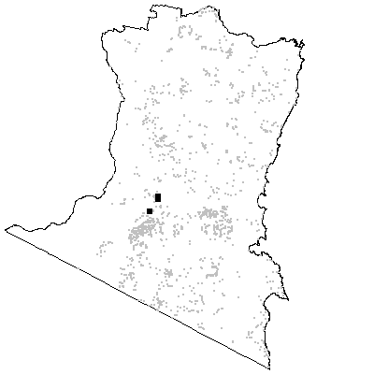

MAP UNIT 3: Rocky Tops Dry Scrub Forest

Species richness: 27 ± 3 (0.04 ha)
Extant area: 1188 ha
Proportion cleared: 0%
Number of samples: 13

Table A3.1. Diagnostic plant species of Map Unit 3.

Species | Target frequency | Target C/A | Residual frequency | Residual C/A | Fidelity class
Acacia falciformis | 0.769 | 2.5(1-3) | 0.184 | 2(1-3) | positive
Australopyrum pectinatum | 0.077 | 1(1-1) | 0 | 0(0-0) | positive
Beyeria lasiocarpa | 0.923 | 3(1-4) | 0.023 | 2(1-2) | positive
Cassinia longifolia | 0.615 | 2(1-2) | 0.184 | 1(1-3) | positive
Cassinia trinerva | 0.615 | 2(1-3) | 0.079 | 1(1-3) | positive
Eucalyptus smithii | 0.769 | 2(1-3) | 0.039 | 2(1-3) | positive
Geitonoplesium cymosum | 0.692 | 2(1-2) | 0.105 | 1(1-2) | positive
Haloragodendron baeuerlenii | 0.077 | 1(1-1) | 0 | 0(0-0) | positive
Notelaea venosa | 0.846 | 2(1-3) | 0.107 | 1(1-1) | positive
Pittosporum undulatum | 0.769 | 1(1-2) | 0.086 | 1(1-2) | frequent
Acmena smithii | 0.154 | 2.5(2-3) | 0.031 | 3(1-4) | uninformative
Brachychiton populneum | 0.077 | 3(3-3) | 0.023 | 1(1-1) | uninformative
Eucalyptus agglomerata | 0.385 | 3(1-3) | 0.106 | 3(2-3) | uninformative
Eucalyptus bosistoana | 0.077 | 1(1-1) | 0.053 | 2(1-3) | uninformative
Eucalyptus cypellocarpa | 0.077 | 1(1-1) | 0.316 | 3(2-3) | uninformative
Eucalyptus elata | 0.231 | 2(2-3) | 0.112 | 3(2-3) | uninformative
Eucalyptus maidenii | 0.077 | 3(3-3) | 0.063 | 3(2-3) | uninformative
Eucalyptus melliodora | 0.077 | 3(3-3) | 0.011 | 1.5(1-3) | uninformative
Eucalyptus muelleriana | 0.077 | 1(1-1) | 0.143 | 3(2-4) | uninformative
Eucalyptus polyanthemos ssp vestita | 0.231 | 1(1-1) | 0.012 | 2(2-3) | uninformative
Eucalyptus sieberi | 0.154 | 2(2-2) | 0.284 | 3(2-4) | uninformative
Ficus rubiginosa | 0.077 | 1(1-1) | 0.009 | 4(2-6) | uninformative
Lomandra longifolia | 0.154 | 1(1-1) | 0.552 | 2(1-2) | negative
Poa meionectes | 0.231 | 1(1-1) | 0.542 | 2(1-3) | negative
Pteridium esculentum | 0.077 | 1(1-1) | 0.581 | 2(1-3) | negative

Table A3.2. Vegetation structure of Map Unit 3. Frequency is the proportion of samples in which strata were present. Height and cover data are means with standard errors in parentheses (n=7).

Stratum | Frequency (%) | Height (m) | Cover (%)
Tree | 100 | 20.0(1.1) | 20(2)
Small tree | 85.7 | 9.5(1.1) | 20(5)
Shrub | 85.7 | 3.3(0.4) | 29(8)
Ground cover | 85.7 | 0.7(0.1) | 5(2)

Table A3.3. Habitat characteristics of Map Unit 3. Means and interquartile ranges for altitude and slope were calculated from n field samples, while those for annual rain were calculated from ESOCLIM predictions (see Table 5, text). Frequency terrain and parent material refers to number of samples (n) recorded in respective classes. Terrain classes: flat (slope≤5°); north (slope>5° and aspect<30° or >300°); intermediate (slope>5° and aspect 30-120° or 210-300°); and south (slope>5° and aspect 120-210°).

 |  | Frequency (%) | Mean | Interquartile Range | n
Annual rain (mm) |  |  |  | 917 | 898 - 943 | 13
Altitude (m) |  |  |  | 465 | 360 - 540 | 13
Slope (degrees) |  |  |  | 30 | 23 - 38 | 13
Terrain class
 | North | 46 |  |  | 6
 | Intermediate | 46 |  |  | 6
 | South | 8 |  |  | 1
 | Flat | 0 |  |  | 0
Parent material
 | Devonian granitoids | 46 |  |  | 6
 | Devonian high quartz sedimentaries | 31 |  |  | 4
 | Low quartz sedimentaries | 8 |  |  | 1
 | Ordovician high quartz sedimentaries | 15 |  |  | 2

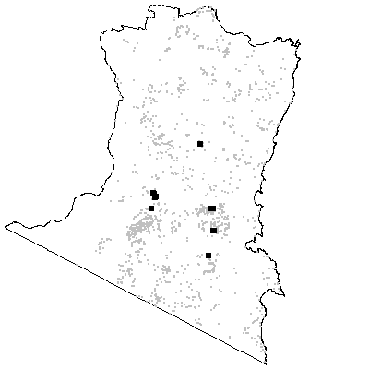

MAP UNIT 4: Acacia Scrub

Species richness: 8 ± 2 (0.04 ha)
Extant area: 6288 ha
Proportion cleared: 6%
Number of samples: 13

Table A4.1. Diagnostic plant species of Map Unit 4.

Species | Target frequency | Target C/A | Residual frequency | Residual C/A | Fidelity class
Acacia silvestris | 1 | 5(4-5) | 0.001 | 2.5(1-4) | positive
Eriostemon trachyphyllus | 1 | 3(1-4) | 0.007 | 1(1-2) | positive
Pomaderris brogoensis | 1 | 3(1-4) | 0.002 | 1(1-3) | positive
Hymenanthera dentata | 0.667 | 1(1-1) | 0.069 | 1(1-2) | frequent
Lomandra longifolia | 0 | 0(1-0) | 0.55 | 2(1-2) | negative
Poa meionectes | 0 | 0(2-0) | 0.54 | 2(1-3) | negative
Pteridium esculentum | 0 | 0(2-0) | 0.578 | 2(1-3) | negative

Table A4.2. Vegetation structure of Map Unit 4. Frequency is the proportion of samples in which strata were present. Height and cover data are means with standard errors in parentheses (n=3).

Stratum | Frequency (%) | Height (m) | Cover (%)
Tree | 100 | 15.3(2.7) | 65(3)
Small tree | 100 | 7.0(0.6) | 37(3)
Shrub | 66.7 | 1.3(0.3) | 21(19)
Ground cover | 33.3 | 0.5(-) | 1(-)

Table A4.3. Habitat characteristics of Map Unit 4. Means and interquartile ranges for altitude and slope were calculated from n field samples, while those for annual rain were calculated from ESOCLIM predictions (see Table 5, text). Frequency terrain and parent material refers to number of samples (n) recorded in respective classes. Terrain classes: flat (slope≤5°); north (slope>5° and aspect<30° or >300°); intermediate (slope>5° and aspect 30-120° or 210-300°); and south (slope>5° and aspect 120-210°).

 |  | Frequency (%) | Mean | Interquartile Range | n
Annual rain (mm) |  |  |  | 940 | 923 - 962 | 13
Altitude (m) |  |  |  | 402 | 310 - 500 | 13
Slope (degrees) |  |  |  | 31 | 27 - 35 | 13
Terrain class
 | North | 38 |  |  | 5
 | Intermediate | 54 |  |  | 7
 | South | 8 |  |  | 1
 | Flat | 0 |  |  | 0
Parent material
 | Devonian high quartz sedimentaries | 46 |  |  | 6
 | Low quartz sedimentaries | 23 |  |  | 3
 | Ordovician high quartz sedimentaries | 31 |  |  | 4

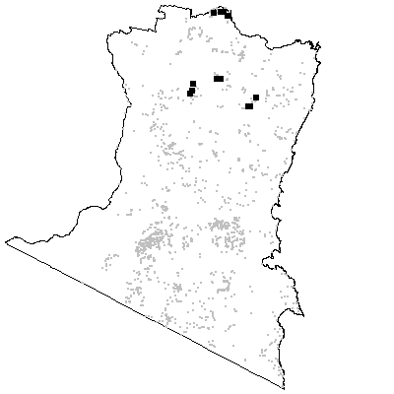

Map Unit 5: Bunga Head Rainforest

Species richness: 47 (0.04 ha)
Extant area: 9 ha
Proportion cleared: 0%
Number of samples: 1

Table A5.1. Diagnostic plant species of Map Unit 5.

Species | Target frequency | Target C/A | Residual frequency | Residual C/A | Fidelity class
Acmena smithii | 1 | 3(3-3) | 0.031 | 3(1-4) | positive
Aphanopetalum resinosum | 1 | 3(3-3) | 0.009 | 2(1-3) | positive
Asplenium flabellifolium | 1 | 2(2-2) | 0.121 | 1(1-2) | positive
Beyeria lasiocarpa | 1 | 3(3-3) | 0.031 | 2(1-3) | positive
Carex appressa | 1 | 2(2-2) | 0.084 | 1(1-2) | positive
Cassytha phaeolasia | 1 | 2(2-2) | 0.045 | 1(1-2) | positive
Entolasia stricta | 1 | 2(2-2) | 0.181 | 1(1-2) | positive
Eupomatia laurina | 1 | 3(3-3) | 0.014 | 3(2-3) | positive
Eustrephus latifolius | 1 | 2(2-2) | 0.174 | 1(1-1) | positive
Ficus rubiginosa | 1 | 4(4-4) | 0.009 | 4(1-6) | positive
Gahnia aspera | 1 | 2(2-2) | 0.017 | 1(1-1) | positive
Gahnia melanocarpa | 1 | 3(3-3) | 0.074 | 1(1-2) | positive
Hibbertia dentata | 1 | 2(2-2) | 0.075 | 1(1-2) | positive
Marsdenia rostrata | 1 | 2(2-2) | 0.086 | 2(1-2) | positive
Notelaea longifolia | 1 | 3(3-3) | 0.001 | 1.5(1-2) | positive
Oplismenus imbecillis | 1 | 2(2-2) | 0.108 | 2(1-2) | positive
Pellaea falcata var falcata | 1 | 3(3-3) | 0.097 | 1(1-2) | positive
Pittosporum undulatum | 1 | 3(3-3) | 0.091 | 1(1-2) | positive
Senecio linearifolius | 1 | 2(2-2) | 0.239 | 1(1-2) | positive
Smilax australis | 1 | 2(2-2) | 0.203 | 1(1-2) | positive
Themeda australis | 1 | 2(2-2) | 0.114 | 2(1-3) | positive
Pteridium esculentum | 1 | 2(2-2) | 0.577 | 2(1-3) | constant
Lomandra longifolia | 0 | 0(1-0) | 0.549 | 2(1-2) | negative
Poa meionectes | 0 | 0(2-0) | 0.539 | 2(1-3) | negative

Table A5.2. Vegetation structure of Map Unit 5. Frequency is the proportion of samples in which strata were present. Height and cover data are means with standard errors in parentheses (n=1).

Stratum | Frequency (%) | Height (m) | Cover (%)
Tree | 0 | -(-) | -(-)
Small tree | 100 | 7.0(-) | 75(-)
Shrub | 100 | 1.5(-) | 20(-)
Ground cover | 100 | 0.3(-) | 45(-)

Table A5.3. Habitat characteristics of Map Unit 5. Means and interquartile ranges for altitude and slope were calculated from n field samples, while those for annual rain were calculated from ESOCLIM predictions (see Table 5, text). Frequency terrain and parent material refers to number of samples (n) recorded in respective classes. Terrain classes: flat (slope≤5°); north (slope>5° and aspect<30° or >300°); intermediate (slope>5° and aspect 30-120° or 210-300°); and south (slope>5° and aspect 120-210°).

 |  | Frequency (%) | Mean | Interquartile Range | n
Annual rain (mm) |  |  |  | 887 | 887 - 887 | 1
Altitude (m) |  |  |  | 15 | 15 - 15 | 1
Slope (degrees) |  |  |  | 12 | 12 - 12 | 1
Terrain class
 | North | 0 |  |  | 0
 | Intermediate | 100 |  |  | 1
 | South | 0 |  |  | 0
 | Flat | 0 |  |  | 0
Parent material
 | Devonian rhyolite | 100 |  |  | 1

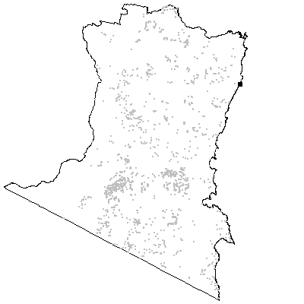

MAP UNIT 6: Coastal Warm Temperate Rainforest

Species richness: 31 ± 2 (0.04 ha)
Extant area: 6393 ha
Proportion cleared: 1%
Number of samples: 15

Table A6.1. Diagnostic plant species of Map Unit 6.

Species | Target frequency | Target C/A | Residual frequency | Residual C/A | Fidelity class
Acmena smithii | 1 | 4(4-5) | 0.023 | 2(1-4) | positive
Asplenium flabellifolium | 0.539 | 2(2-2) | 0.118 | 1(1-1) | positive
Blechnum patersonii | 0.539 | 3(2-3) | 0.006 | 1(1-2) | positive
Cissus hypoglauca | 0.846 | 3(3-3) | 0.016 | 1(1-2) | positive
Cyathea australis | 0.846 | 3(2-3) | 0.11 | 1(1-2) | positive
Cyathea leichhardtiana | 0.077 | 4(4-4) | 0 | 0(0-0) | positive
Dicksonia antarctica | 0.539 | 3(3-3) | 0.064 | 2(1-3) | positive
Eupomatia laurina | 0.923 | 3(2-3) | 0.007 | 2(1-3) | positive
Korthalsella rubra ssp. | 0.077 | 1(1-1) | 0 | 0(0-0) | positive
Lastreopsis microsora | 0.846 | 4(3-5) | 0.007 | 2(1-3) | positive
Marsdenia rostrata | 0.846 | 2(2-3) | 0.08 | 1(1-2) | positive
Microsorum scandens | 0.692 | 2(1-2) | 0.006 | 3(2-4) | positive
Morinda jasminoides | 0.769 | 2(1-2) | 0.017 | 1(1-2) | positive
Pittosporum undulatum | 0.692 | 2(1-3) | 0.086 | 1(1-2) | positive
Plectorrhiza tridentata | 0.077 | 2(2-2) | 0 | 0(0-0) | positive
Pteris umbrosa | 0.539 | 4(2-5) | 0.008 | 3(2-4) | positive
Sarcochilus australis | 0.077 | 1(1-1) | 0 | 0(0-0) | positive
Smilax australis | 0.846 | 2(2-3) | 0.197 | 1(1-2) | positive
Tmesipteris parva | 0.308 | 1(1-1) | 0 | 0(0-0) | positive
Blechnum cartilagineum | 0.923 | 1.5(1-3) | 0.093 | 2(1-3) | frequent
Notelaea venosa | 0.692 | 1(1-2) | 0.108 | 1(1-1) | frequent
Olearia argophylla | 0.615 | 1.5(1-3) | 0.1 | 2(1-3) | frequent
Pandorea pandorana | 0.846 | 1(1-2) | 0.115 | 1(1-1) | frequent
Acacia melanoxylon | 0.231 | 2(1-3) | 0.104 | 1(1-3) | uninformative
Acacia subporosa | 0.154 | 2.5(2-3) | 0.003 | 1(1-2) | uninformative
Acronychia oblongifolia | 0.154 | 1(1-1) | 0.001 | 1(1-1) | uninformative
Alectryon subcinereus | 0.077 | 2(2-2) | 0.007 | 1(1-2) | uninformative
Backhousia myrtifolia | 0.077 | 3(3-3) | 0.002 | 1(1-4) | uninformative
Doryphora sassafras | 0.231 | 4(3-4) | 0.004 | 3(2-4) | uninformative
Elaeocarpus reticulatus | 0.462 | 1(1-2) | 0.073 | 1(1-2) | uninformative
Eucryphia moorei | 0.154 | 4(3-5) | 0.001 | 3.5(1-6) | uninformative
Pittosporum revolutum | 0.154 | 1(1-1) | 0.037 | 1(1-2) | uninformative
Polyscias murrayi | 0.231 | 3(2-4) | 0.001 | 1(1-1) | uninformative
Synoum glandulosum | 0.154 | 3.5(3-4) | 0.005 | 1(1-2) | uninformative
Lomandra longifolia | 0.077 | 1(1-1) | 0.553 | 2(1-2) | negative
Poa meionectes | 0 | 0(2-0) | 0.544 | 2(1-3) | negative
Pteridium esculentum | 0 | 0(1-0) | 0.582 | 2(1-3) | negative

Table A6.2. Vegetation structure of Map Unit 6. Frequency is the proportion of samples in which strata were present. Height and cover data are means with standard errors in parentheses (n=11).

Stratum | Frequency (%) | Height (m) | Cover (%)
Tree | 0 | -(-) | -(-)
Small tree | 100 | 17.7(1.4) | 72(6)
Shrub | 100 | 4.0(0.4) | 31(8)
Ground cover | 100 | 0.9(0.1) | 60(7)

Table A6.3. Habitat characteristics of Map Unit 6. Means and interquartile ranges for altitude and slope were calculated from n field samples, while those for annual rain were calculated from ESOCLIM predictions (see Table 5, text). Frequency terrain and parent material refers to number of samples (n) recorded in respective classes. Terrain classes: flat (slope≤5°); north (slope>5° and aspect<30° or >300°); intermediate (slope>5° and aspect 30-120° or 210-300°); and south (slope>5° and aspect 120-210°).

 |  | Frequency (%) | Mean | Interquartile Range | n
Annual rain (mm) |  |  |  | 916 | 884 - 947 | 15
Altitude (m) |  |  |  | 229 | 138 - 365 | 14
Slope (degrees) |  |  |  | 14 | 6 - 19 | 14
Terrain class
 | North | 21 |  |  | 3
 | Intermediate | 43 |  |  | 6
 | South | 21 |  |  | 3
 | Flat | 14 |  |  | 2
Parent material
 | Devonian granitoids | 20 |  |  | 3
 | Devonian high quartz sedimentaries | 47 |  |  | 7
 | Low quartz sedimentaries | 20 |  |  | 3
 | Ordovician high quartz sedimentaries | 13 |  |  | 2

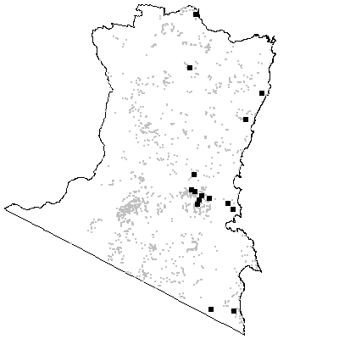

MAP UNIT 7: Hinterland Warm Temperate Rainforest

Species richness: 28 ± 3 (0.04 ha)
Extant area: 3027 ha
Proportion cleared: 1%
Number of samples: 10

Table A7.1. Diagnostic plant species of Map Unit 7.

Species | Target frequency | Target C/A | Residual frequency | Residual C/A | Fidelity class
Acacia melanoxylon | 0.6 | 3(2-3) | 0.102 | 1(1-3) | positive
Acmena smithii | 1 | 4(4-5) | 0.025 | 3(1-4) | positive
Asplenium australasicum | 0.3 | 2(1-2) | 0 | 0(0-0) | positive
Asplenium flabellifolium | 0.7 | 2(1-2) | 0.118 | 1(1-2) | positive
Blechnum cartilagineum | 0.5 | 2(2-4) | 0.097 | 2(1-3) | positive
Coprosma quadrifida | 0.5 | 2(1-2) | 0.244 | 1(1-2) | positive
Cyathea australis | 0.9 | 3(2-3) | 0.112 | 1(1-2) | positive
Dicksonia antarctica | 0.7 | 3(2-4) | 0.064 | 2(1-3) | positive
Lastreopsis microsora | 0.6 | 2(2-3) | 0.01 | 4(3-4) | positive
Marsdenia rostrata | 0.9 | 2(2-2) | 0.081 | 2(1-2) | positive
Microsorum scandens | 0.7 | 3(2-4) | 0.008 | 2(1-2) | positive
Olearia argophylla | 0.9 | 2(2-3) | 0.099 | 2(1-3) | positive
Pandorea pandorana | 0.9 | 2(1-2) | 0.116 | 1(1-1) | positive
Polystichum proliferum | 0.7 | 3(2-4) | 0.089 | 2(1-3) | positive
Pomaderris aspera | 0.5 | 2(2-3) | 0.159 | 2(1-3) | positive
Pteris umbrosa | 0.8 | 4(2-5) | 0.007 | 2(2-4) | positive
Pyrrosia rupestris | 0.5 | 2(2-3) | 0.019 | 1(1-2) | positive
Smilax australis | 0.8 | 2(1-3) | 0.199 | 1(1-2) | positive
Australina muelleri | 0.6 | 1.5(1-2) | 0.016 | 1(1-2) | frequent
Pellaea falcata var falcata | 0.6 | 1.5(1-2) | 0.094 | 1(1-2) | frequent
Acronychia oblongifolia | 0.1 | 1(1-1) | 0.001 | 1(1-1) | uninformative
Doryphora sassafras | 0.3 | 4(3-4) | 0.004 | 3(2-4) | uninformative
Elaeocarpus holopetalus | 0.3 | 1(1-3) | 0.018 | 1(1-3) | uninformative
Pittosporum undulatum | 0.4 | 1(1-3) | 0.09 | 1(1-2) | uninformative
Lomandra longifolia | 0 | 0(1-0) | 0.553 | 2(1-2) | negative
Poa meionectes | 0.1 | 2(2-2) | 0.542 | 2(1-3) | negative
Pteridium esculentum | 0 | 0(1-0) | 0.581 | 2(1-3) | negative

Table A7.2. Vegetation structure of Map Unit 7. Frequency is the proportion of samples in which strata were present. Height and cover data are means with standard errors in parentheses (n=5).

Stratum | Frequency (%) | Height (m) | Cover (%)
Tree | 20 | 22.0(-) | 20(-)
Small tree | 100 | 16.4(1.4) | 78(4)
Shrub | 100 | 3.8(0.1) | 33(8)
Ground cover | 100 | 0.7(0.1) | 70(8)

Table A7.3. Habitat characteristics of Map Unit 7. Means and interquartile ranges for altitude and slope were calculated from n field samples, while those for annual rain were calculated from ESOCLIM predictions (see Table 5, text). Frequency terrain and parent material refers to number of samples (n) recorded in respective classes. Terrain classes: flat (slope≤5°); north (slope>5° and aspect<30° or >300°); intermediate (slope>5° and aspect 30-120° or 210-300°); and south (slope>5° and aspect 120-210°).

 |  | Frequency (%) | Mean | Interquartile Range | n
Annual rain (mm) |  |  |  | 966 | 895 - 1011 | 10
Altitude (m) |  |  |  | 446 | 350 - 500 | 9
Slope (degrees) |  |  |  | 16 | 10 - 21 | 5
Terrain class
 | North | 0 |  |  | 0
 | Intermediate | 0 |  |  | 0
 | South | 80 |  |  | 4
 | Flat | 20 |  |  | 1
Parent material
 | Devonian granitoids | 80 |  |  | 8
 | Ordovician high quartz sedimentaries | 20 |  |  | 2

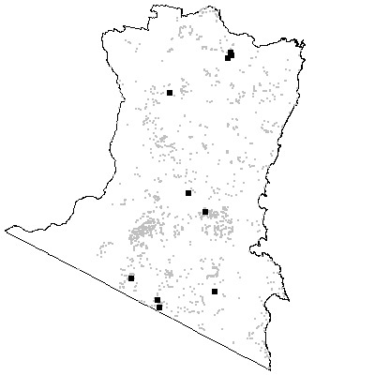

MAP UNIT 8: Cool Temperate Rainforest

Species richness: 17 ± 2 (0.04 ha)
Extant area: 1053 ha
Proportion cleared: 0%
Number of samples: 7

Table A8.1. Diagnostic plant species of Map Unit 8.

Species | Target frequency | Target C/A | Residual frequency | Residual C/A | Fidelity class
Blechnum wattsii | 1 | 4(4-5) | 0.042 | 2(1-3) | positive
Dicksonia antarctica | 1 | 5(3-5) | 0.065 | 2(1-3) | positive
Elaeocarpus holopetalus | 0.8 | 4.5(3-6) | 0.017 | 1(1-2) | positive
Fieldia australis | 0.6 | 3(1-3) | 0.018 | 1.5(1-2) | positive
Grammitis billardieri | 0.6 | 2(1-2) | 0 | 0(0-0) | positive
Hymenophyllum flabellatum | 0.2 | 1(1-1) | 0 | 0(0-0) | positive
Hypolepis amaurorachis | 0.2 | 1(1-1) | 0 | 0(0-0) | positive
Tasmannia lanceolata | 0.6 | 2(1-3) | 0.042 | 2(1-3) | positive
Uncinia tenella | 0.2 | 1(1-1) | 0 | 0(0-0) | positive
Coprosma quadrifida | 0.6 | 1(1-1) | 0.245 | 1(1-2) | frequent
Gahnia sieberiana | 0.6 | 1(1-3) | 0.075 | 1(1-2) | frequent
Histiopteris incisa | 0.8 | 1(1-3) | 0.016 | 1(1-1) | frequent
Hymenophyllum cupressiforme | 0.6 | 1(1-3) | 0.01 | 1(1-2) | frequent
Parsonsia brownii | 0.8 | 1.5(1-3) | 0.025 | 1(1-2) | frequent
Acacia dealbata | 0.4 | 2.5(0-3) | 0.137 | 2(0-3) | uninformative
Acacia melanoxylon | 0.2 | 3(3-3) | 0.105 | 1(1-3) | uninformative
Atherosperma moschatum | 0.2 | 4(4-4) | 0.001 | 2(2-2) | uninformative
Eucalyptus fastigata | 0.2 | 3(3-3) | 0.14 | 3(3-4) | uninformative
Eucryphia moorei | 0.2 | 6(6-6) | 0.002 | 3(1-5) | uninformative
Pittosporum bicolor | 0.4 | 1(1-1) | 0.007 | 1(1-1) | uninformative
Lomandra longifolia | 0 | 0(1-0) | 0.551 | 2(1-2) | negative
Poa meionectes | 0 | 0(1-0) | 0.541 | 2(1-3) | negative
Pteridium esculentum | 0 | 0(1-0) | 0.579 | 2(1-3) | negative

Table A8.2. Vegetation structure of Map Unit 8. Frequency is the proportion of samples in which strata were present. Height and cover data are means with standard errors in parentheses (n=4).

Stratum | Frequency (%) | Height (m) | Cover (%)
Tree | 25 | 40.0(-) | 10(-)
Small tree | 100 | 23.5(1.7) | 74(8)
Shrub | 100 | 3.8(0.4) | 35(12)
Ground cover | 100 | 0.7(0.2) | 48(16)

Table A8.3. Habitat characteristics of Map Unit 8. Means and interquartile ranges for altitude and slope were calculated from n field samples, while those for annual rain were calculated from ESOCLIM predictions (see Table 5, text). Frequency terrain and parent material refers to number of samples (n) recorded in respective classes. Terrain classes: flat (slope≤5°); north (slope>5° and aspect<30° or >300°); intermediate (slope>5° and aspect 30-120° or 210-300°); and south (slope>5° and aspect 120-210°).

 |  | Frequency (%) | Mean | Interquartile Range | n
Annual rain (mm) |  |  |  | 1041 | 911 - 1208 | 7
Altitude (m) |  |  |  | 910 | 819 - 1038 | 7
Slope (degrees) |  |  |  | 19 | 8 - 29 | 7
Terrain class
 | North | 0 |  |  | 0
 | Intermediate | 43 |  |  | 3
 | South | 29 |  |  | 2
 | Flat | 29 |  |  | 2
Parent material
 | Devonian granitoids | 57 |  |  | 4
 | Devonian high quartz sedimentaries | 14 |  |  | 1
 | Low quartz sedimentaries | 29 |  |  | 2

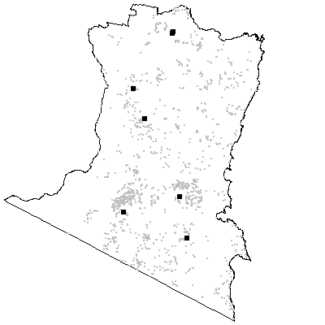

MAP UNIT 9: High Mountain Wet Layered Forest

Species richness: 21 ± 2 (0.04 ha)
Extant area: 1813 ha
Proportion cleared: 20%
Number of samples: 11

Table A9.1. Diagnostic plant species of Map Unit 9.

Species | Target frequency | Target C/A | Residual frequency | Residual C/A | Fidelity class
Acacia dealbata | 0.909 | 3.5(3-4) | 0.132 | 2(1-3) | positive
Coprosma quadrifida | 0.546 | 2(2-3) | 0.244 | 1(1-2) | positive
Dicksonia antarctica | 0.909 | 2.5(1-3) | 0.062 | 2(1-3) | positive
Eucalyptus fastigata | 0.636 | 3(3-5) | 0.137 | 3(3-4) | positive
Eucalyptus nitens | 0.727 | 4(3-4) | 0.007 | 3(3-4) | positive
Olearia argophylla | 1 | 4(3-4) | 0.098 | 2(1-3) | positive
Parsonsia brownii | 0.546 | 2(1-3) | 0.023 | 1(1-2) | positive
Polystichum proliferum | 0.818 | 3(2-5) | 0.088 | 2(1-3) | positive
Prostanthera lasianthos | 0.636 | 3(1-3) | 0.06 | 1(1-2) | positive
Clematis aristata | 0.818 | 1(1-1) | 0.337 | 1(1-1) | frequent
Gahnia sieberiana | 0.727 | 1.5(1-2) | 0.072 | 1(1-3) | frequent
Acacia melanoxylon | 0.182 | 2.5(2-3) | 0.105 | 1(1-3) | uninformative
Elaeocarpus holopetalus | 0.091 | 3(3-3) | 0.019 | 1(1-3) | uninformative
Eucalyptus badjensis | 0.182 | 3(3-3) | 0.006 | 3(2-4) | uninformative
Eucalyptus elata | 0.091 | 3(3-3) | 0.113 | 3(2-3) | uninformative
Eucalyptus fraxinoides | 0.091 | 4(4-4) | 0.028 | 4(3-4) | uninformative
Eucalyptus obliqua | 0.091 | 2(2-2) | 0.19 | 3(2-4) | uninformative
Lomandra longifolia | 0 | 0(1-0) | 0.553 | 2(1-2) | negative
Poa meionectes | 0 | 0(1-0) | 0.543 | 2(1-3) | negative
Pteridium esculentum | 0.455 | 1(1-2) | 0.578 | 2(1-3) | negative

Table A9.2. Vegetation structure of Map Unit 9. Frequency is the proportion of samples in which strata were present. Height and cover data are means with standard errors in parentheses (n=10).

Stratum | Frequency (%) | Height (m) | Cover (%)
Tree | 100 | 43.0(3.4) | 45(4)
Small tree | 100 | 9.8(1.8) | 46(8)
Shrub | 80 | 2.7(0.4) | 25(6)
Ground cover | 100 | 0.8(0.2) | 35(9)

Table A9.3. Habitat characteristics of Map Unit 9. Means and interquartile ranges for altitude and slope were calculated from n field samples, while those for annual rain were calculated from ESOCLIM predictions (see Table 5, text). Frequency terrain and parent material refers to number of samples (n) recorded in respective classes. Terrain classes: flat (slope≤5°); north (slope>5° and aspect<30° or >300°); intermediate (slope>5° and aspect 30-120° or 210-300°); and south (slope>5° and aspect 120-210°).

 |  | Frequency (%) | Mean | Interquartile Range | n
Annual rain (mm) |  |  |  | 1063 | 916 - 1202 | 11
Altitude (m) |  |  |  | 923 | 840 - 1000 | 11
Slope (degrees) |  |  |  | 15 | 9 - 21 | 11
Terrain class
 | North | 18 |  |  | 2
 | Intermediate | 18 |  |  | 2
 | South | 64 |  |  | 7
 | Flat | 0 |  |  | 0
Parent material
 | Devonian granitoids | 91 |  |  | 10
 | Ordovician high quartz sedimentaries | 9 |  |  | 1

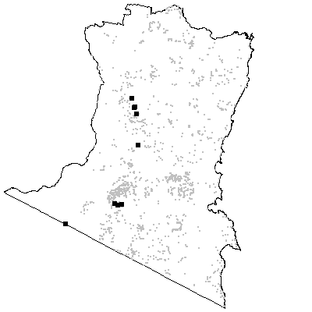

MAP UNIT 10: Mountain Wet Layered Forest

Species richness: 29 ± 1 (0.04 ha)
Extant area: 17 940 ha
Proportion cleared: 10%
Number of samples: 82

Table A10.1. Diagnostic plant species of Map Unit 10.

Species | Target frequency | Target C/A | Residual frequency | Residual C/A | Fidelity class
Bedfordia arborescens | 0.8 | 3.5(3-4) | 0.114 | 2(1-3) | positive
Coprosma quadrifida | 0.825 | 2(1-2) | 0.213 | 1(1-2) | positive
Dicksonia antarctica | 0.525 | 2(1-3) | 0.042 | 2(1-3) | positive
Eucalyptus fastigata | 0.925 | 4(3-4) | 0.096 | 3(2-4) | positive
Olearia argophylla | 0.838 | 3(1-3) | 0.063 | 1(1-3) | positive
Polystichum proliferum | 0.763 | 3(1-3) | 0.055 | 2(1-2) | positive
Pomaderris aspera | 0.875 | 3(2-4) | 0.121 | 1.5(1-3) | positive
Smilax australis | 0.713 | 2(1-2) | 0.174 | 1(1-2) | positive
Stellaria flaccida | 0.638 | 2(1-2) | 0.187 | 1(1-2) | positive
Pteridium esculentum | 0.688 | 2(1-2) | 0.57 | 2(1-3) | constant
Clematis aristata | 0.75 | 1(1-1) | 0.318 | 1(1-1) | frequent
Viola hederacea ssp hederacea | 0.763 | 1(1-2) | 0.419 | 2(1-2) | frequent
Acacia dealbata | 0.45 | 3(2-4) | 0.12 | 2(1-3) | uninformative
Acacia melanoxylon | 0.363 | 1(1-3) | 0.091 | 1(1-3) | uninformative
Eucalyptus badjensis | 0.075 | 3.5(2-4) | 0.004 | 3(2-4) | uninformative
Eucalyptus cypellocarpa | 0.388 | 3(1-3) | 0.31 | 3(2-3) | uninformative
Eucalyptus dalrympleana ssp dalrympleana | 0.013 | 1(1-1) | 0.019 | 3(1-3) | uninformative
Eucalyptus elata | 0.038 | 2(1-2) | 0.117 | 3(2-3) | uninformative
Eucalyptus fraxinoides | 0.075 | 2.5(1-3) | 0.026 | 4(3-4) | uninformative
Eucalyptus globoidea | 0.025 | 1(1-1) | 0.255 | 3(1-3) | uninformative
Eucalyptus maidenii | 0.013 | 2(2-2) | 0.066 | 3(2-3) | uninformative
Eucalyptus nitens | 0.063 | 3(3-4) | 0.009 | 4(3-4) | uninformative
Eucalyptus obliqua | 0.1 | 1(1-2) | 0.195 | 3(2-4) | uninformative
Eucalyptus radiata | 0.013 | 3(3-3) | 0.08 | 3(1-3) | uninformative
Eucalyptus sieberi | 0.013 | 1(1-1) | 0.298 | 3(2-4) | uninformative
Eucalyptus smithii | 0.013 | 2(2-2) | 0.047 | 2(1-3) | uninformative
Eucalyptus viminalis | 0.025 | 2(1-3) | 0.059 | 3(1-3) | uninformative
Lomandra longifolia | 0.2 | 1(1-2) | 0.569 | 2(1-2) | negative
Poa meionectes | 0.288 | 1(1-2) | 0.553 | 2(1-3) | negative

Table A10.2. Vegetation structure of Map Unit 10. Frequency is the proportion of samples in which strata were present. Height and cover data are means with standard errors in parentheses (n=42).

Stratum | Frequency (%) | Height (m) | Cover (%)
Tree | 97.6 | 35.1(1.2) | 38(3)
Small tree | 100 | 10.2(0.5) | 54(4)
Shrub | 71.4 | 2.6(0.3) | 25(4)
Ground cover | 100 | 0.7(0.1) | 40(3)

Table A10.3. Habitat characteristics of Map Unit 10. Means and interquartile ranges for altitude and slope were calculated from n field samples, while those for annual rain were calculated from ESOCLIM predictions (see Table 5, text). Frequency terrain and parent material refers to number of samples (n) recorded in respective classes. Terrain classes: flat (slope≤5°); north (slope>5° and aspect<30° or >300°); intermediate (slope>5° and aspect 30-120° or 210-300°); and south (slope>5° and aspect 120-210°).

 |  | Frequency (%) | Mean | Interquartile Range | n
Annual rain (mm) |  |  |  | 973 | 911 - 1014 | 82
Altitude (m) |  |  |  | 811 | 730 - 910 | 81
Slope (degrees) |  |  |  | 11 | 5 - 15 | 78
Terrain class
 | North | 4 |  |  | 3
 | Intermediate | 35 |  |  | 27
 | South | 38 |  |  | 30
 | Flat | 23 |  |  | 18
Parent material
 | Devonian granitoids | 84 |  |  | 69
 | Devonian high quartz sedimentaries | 4 |  |  | 3
 | Low quartz sedimentaries | 1 |  |  | 1
 | Tertiary Basalt | 11 |  |  | 9

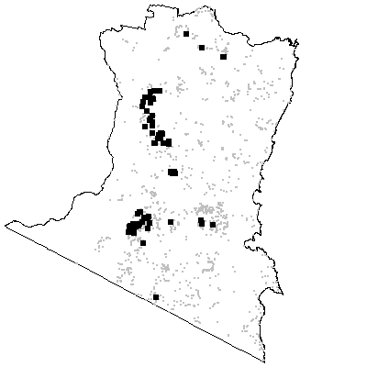

MAP UNIT 11: Tantawangalo Wet Shrub Forest

Species richness: 31 ± 1 (0.04 ha)
Extant area: 790 ha
Proportion cleared: 0%
Number of samples: 18

Table A11.1. Diagnostic plant species of Map Unit 11.

Species | Target frequency | Target C/A | Residual frequency | Residual C/A | Fidelity class
Acacia melanoxylon | 0.778 | 4(3-4) | 0.097 | 1(1-2) | positive
Bedfordia arborescens | 0.611 | 3(2-3) | 0.145 | 2(1-4) | positive
Eucalyptus cypellocarpa | 0.944 | 3(3-4) | 0.306 | 3(2-3) | positive
Eucalyptus fastigata | 0.833 | 4(4-4) | 0.132 | 3(3-4) | positive
Eucalyptus obliqua | 0.944 | 4(3-5) | 0.18 | 3(2-4) | positive
Gahnia sieberiana | 0.722 | 3(1-3) | 0.069 | 1(1-2) | positive
Pomaderris aspera | 0.667 | 3(1-3) | 0.155 | 2(1-3) | positive
Tasmannia lanceolata | 1 | 3(1-3) | 0.032 | 1.5(1-3) | positive
Billardiera scandens | 0.833 | 1(1-1) | 0.323 | 1(1-1) | frequent
Clematis aristata | 0.944 | 1(1-1) | 0.334 | 1(1-1) | frequent
Coprosma quadrifida | 0.889 | 1(1-1) | 0.238 | 1(1-2) | frequent
Dianella tasmanica | 0.722 | 1(1-1) | 0.229 | 1(1-2) | frequent
Gonocarpus teucrioides | 0.722 | 1(1-1) | 0.311 | 2(1-2) | frequent
Goodenia ovata | 0.722 | 1(1-3) | 0.166 | 2(1-2) | frequent
Hakea eriantha | 0.667 | 1(1-3) | 0.059 | 1(1-2) | frequent
Lepidosperma laterale | 0.722 | 1(1-3) | 0.34 | 1(1-2) | frequent
Leucopogon lanceolatus var lanceolatus | 0.611 | 1(1-1) | 0.403 | 1(1-2) | frequent
Olearia argophylla | 0.722 | 1(1-2) | 0.097 | 2(1-3) | frequent
Smilax australis | 0.889 | 1(1-1) | 0.195 | 1(1-2) | frequent
Tylophora barbata | 0.667 | 1(1-1) | 0.262 | 2(1-2) | frequent
Viola hederacea ssp hederacea | 1 | 1(1-1) | 0.431 | 2(1-2) | frequent
Acacia dealbata | 0.278 | 1(1-3) | 0.136 | 2(1-3) | uninformative
Elaeocarpus holopetalus | 0.556 | 1(1-1) | 0.013 | 2(1-3) | uninformative
Eucalyptus elata | 0.278 | 3(2-3) | 0.111 | 3(2-3) | uninformative
Eucalyptus radiata | 0.222 | 3(2-4) | 0.075 | 3(1-3) | uninformative
Eucalyptus sieberi | 0.167 | 3(3-5) | 0.284 | 3(2-4) | uninformative
Lomandra longifolia | 0.889 | 1(1-1) | 0.545 | 2(1-2) | negative
Poa meionectes | 0.556 | 1(1-1) | 0.539 | 2(1-3) | negative
Pteridium esculentum | 1 | 1(1-1) | 0.572 | 2(1-3) | negative

Table A11.2. Vegetation structure of Map Unit 11. Frequency is the proportion of samples in which strata were present. Height data are unavailable. Cover data are means with standard errors in parentheses (n=18).

Stratum | Frequency (%) | Height (m) | Cover (%)
Tree | 100 | - | 39(2)
Small tree | 88.9 | - | 19(3)
Shrub | 100 | - | 33(3)
Ground cover | 100 | - | 25(2)

Table A11.3. Habitat characteristics of Map Unit 11. Means and interquartile ranges for altitude and slope were calculated from n field samples, while those for annual rain were calculated from ESOCLIM predictions (see Table 5, text). Frequency terrain and parent material refers to number of samples (n) recorded in respective classes. Terrain classes: flat (slope≤5°); north (slope>5° and aspect<30° or >300°); intermediate (slope>5° and aspect 30-120° or 210-300°); and south (slope>5° and aspect 120-210°).

 |  | Frequency (%) | Mean | Interquartile Range | n
Annual rain (mm) |  |  |  | 957 | 952 - 960 | 18
Altitude (m) |  |  |  | 890 | 865 - 908 | 18
Slope (degrees) |  |  |  | 8 | 6 - 10 | 18
 | Terrain class
 | North | 33 |  |  | 6
 | Intermediate | 22 |  |  | 4
 | South | 22 |  |  | 4
 | Flat | 22 |  |  | 4
Parent material
 | Devonian granitoids | 100 |  |  | 18

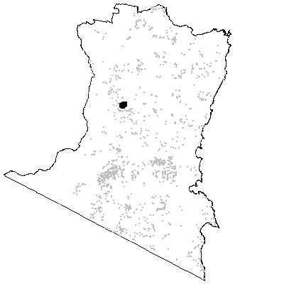

MAP UNIT 12: Mountain Wet Fern Forest

Species richness: 33 ± 2 (0.04 ha)
Extant area: 2 259 ha
Proportion cleared: 2%
Number of samples: 31

Table A12.1. Diagnostic plant species of Map Unit 12.

Species | Target frequency | Target C/A | Residual frequency | Residual C/A | Fidelity class
Bedfordia arborescens | 0.677 | 2(2-4) | 0.14 | 2(1-3) | positive
Blechnum nudum | 0.613 | 4(3-5) | 0.068 | 2(1-3) | positive
Coprosma quadrifida | 0.742 | 2(1-2) | 0.235 | 1(1-2) | positive
Cyathea australis | 0.548 | 3(2-3) | 0.108 | 1(1-2) | positive
Eucalyptus cypellocarpa | 0.903 | 3(3-4) | 0.301 | 3(2-3) | positive
Eucalyptus fastigata | 0.807 | 3(3-4) | 0.126 | 3(3-4) | positive
Geranium potentilloides | 0.807 | 2(1-2) | 0.203 | 1(1-2) | positive
Hierochloe rariflora | 0.613 | 2(2-3) | 0.173 | 2(1-3) | positive
Pimelea axiflora | 0.71 | 2(1-2) | 0.106 | 1(1-2) | positive
Senecio linearifolius | 0.613 | 2(1-2) | 0.232 | 1(1-2) | positive
Stellaria flaccida | 0.839 | 2(1-2) | 0.198 | 1(1-2) | positive
Tylophora barbata | 0.839 | 2(1-2) | 0.255 | 2(1-2) | positive
Viola hederacea ssp hederacea | 0.871 | 2(1-2) | 0.428 | 2(1-2) | positive
Poa meionectes | 0.613 | 2(1-3) | 0.537 | 2(1-3) | constant
Pteridium esculentum | 1 | 2(2-4) | 0.568 | 2(1-3) | constant
Hydrocotyle acutiloba | 0.645 | 1(1-2) | 0.187 | 1(1-2) | frequent
Smilax australis | 0.807 | 1(1-2) | 0.19 | 1(1-2) | frequent
Acacia melanoxylon | 0.258 | 2(1-3) | 0.102 | 1(1-3) | uninformative
Eucalyptus badjensis | 0.032 | 5(5-5) | 0.007 | 3(2-4) | uninformative
Eucalyptus croajingolensis | 0.032 | 2(2-2) | 0.002 | 3(2-3) | uninformative
Eucalyptus elata | 0.129 | 4(3-4) | 0.112 | 3(2-3) | uninformative
Eucalyptus globoidea | 0.065 | 1.5(1-2) | 0.246 | 3(1-3) | uninformative
Eucalyptus muelleriana | 0.032 | 3(3-3) | 0.144 | 3(2-4) | uninformative
Eucalyptus obliqua | 0.387 | 2(1-3) | 0.185 | 3(2-4) | uninformative
Eucalyptus radiata | 0.097 | 2(2-3) | 0.076 | 3(1-3) | uninformative
Eucalyptus sieberi | 0.032 | 1(1-1) | 0.288 | 3(2-4) | uninformative
Lomandra longifolia | 0.29 | 1(1-2) | 0.555 | 2(1-2) | negative

Table A12.2. Vegetation structure of Map Unit 12. Frequency is the proportion of samples in which strata were present. Height and cover data are means with standard errors in parentheses (n=25).

Stratum | Frequency (%) | Height (m) | Cover (%)
Tree | 100 | 33.1(1.5) | 45(3)
Small tree | 64 | 9.9(1.9) | 34(7)
Shrub | 96 | 2.9(0.3) | 22(4)
Ground cover | 100 | 1.0(0.1) | 59(6)

Table A12.3. Habitat characteristics of Map Unit 12. Means and interquartile ranges for altitude and slope were calculated from n field samples, while those for annual rain were calculated from ESOCLIM predictions (see Table 5, text). Frequency terrain and parent material refers to number of samples (n) recorded in respective classes. Terrain classes: flat (slope≤5°); north (slope>5° and aspect<30° or >300°); intermediate (slope>5° and aspect 30-120° or 210-300°); and south (slope>5° and aspect 120-210°).

 |  | Frequency (%) | Mean | Interquartile Range | n
Annual rain (mm) |  |  |  | 1018 | 996 - 1039 | 31
Altitude (m) |  |  |  | 695 | 660 - 763 | 31
Slope (degrees) |  |  |  | 15 | 5 - 26 | 31
Terrain class
 | North | 6 |  |  | 2
 | Intermediate | 35 |  |  | 11
 | South | 45 |  |  | 14
 | Flat | 13 |  |  | 4
Parent material
 | Devonian granitoids | 94 |  |  | 29
 | Ordovician high quartz sedimentaries | 6 |  |  | 2

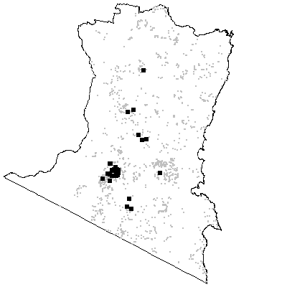

MAP UNIT 13: Hinterland Wet Fern Forest

Species richness: 40 ± 1 (0.04 ha)
Extant area: 44 040 ha
Proportion cleared: 9%
Number of samples: 75

Table A13.1. Diagnostic plant species of Map Unit 13.

Species | Target frequency | Target C/A | Residual frequency | Residual C/A | Fidelity class
Blechnum cartilagineum | 0.614 | 2(1-4) | 0.074 | 2(1-3) | positive
Calochlaena dubia | 0.657 | 3.5(2-5) | 0.085 | 2(1-3) | positive
Desmodium varians | 0.629 | 2(1-2) | 0.231 | 1(1-2) | positive
Doodia aspera | 0.671 | 2(2-3) | 0.074 | 2(1-2) | positive
Eucalyptus cypellocarpa | 0.843 | 3(3-3) | 0.287 | 3(2-3) | positive
Omalanthus populifolius | 0.014 | 1(1-1) | 0 | 0(0-0) | positive
Panicum queenslandicum | 0.014 | 5(5-5) | 0 | 0(0-0) | positive
Pomaderris aspera | 0.557 | 2(1-3) | 0.142 | 2(1-3) | positive
Psychotria loniceroides | 0.014 | 1(1-1) | 0 | 0(0-0) | positive
Schizomeria ovata | 0.014 | 1(1-1) | 0 | 0(0-0) | positive
Smilax australis | 0.771 | 2(1-2) | 0.175 | 1(1-2) | positive
Tylophora barbata | 0.929 | 2(1-2) | 0.234 | 1(1-2) | positive
Poa meionectes | 0.729 | 2(1-3) | 0.529 | 2(1-3) | constant
Pteridium esculentum | 0.786 | 2(2-3) | 0.566 | 2(1-3) | constant
Eustrephus latifolius | 0.6 | 1(1-2) | 0.153 | 1(1-1) | frequent
Glycine clandestina | 0.671 | 1(1-2) | 0.31 | 1(1-2) | frequent
Stellaria flaccida | 0.657 | 1(1-2) | 0.189 | 1(1-2) | frequent
Viola hederacea ssp hederacea | 0.786 | 1(1-2) | 0.42 | 2(1-2) | frequent
Acacia melanoxylon | 0.243 | 1(1-3) | 0.098 | 1(1-3) | uninformative
Acmena smithii | 0.171 | 1(1-3) | 0.025 | 4(2-4) | uninformative
Angophora floribunda | 0.071 | 2(2-3) | 0.096 | 2(1-3) | uninformative
Corymbia gummifera | 0.029 | 2(2-2) | 0.02 | 3(2-4) | uninformative
Eucalyptus agglomerata | 0.057 | 2(1-3) | 0.111 | 3(2-3) | uninformative
Eucalyptus baxteri | 0.014 | 3(3-3) | 0.008 | 3(2-3) | uninformative
Eucalyptus elata | 0.271 | 3(2-4) | 0.105 | 3(2-3) | uninformative
Eucalyptus fastigata | 0.271 | 3(2-4) | 0.134 | 3(3-4) | uninformative
Eucalyptus fraxinoides | 0.014 | 3(3-3) | 0.029 | 4(3-4) | uninformative
Eucalyptus globoidea | 0.171 | 2(1-3) | 0.246 | 3(1-3) | uninformative
Eucalyptus maidenii | 0.029 | 2.5(2-3) | 0.065 | 3(2-3) | uninformative
Eucalyptus muelleriana | 0.443 | 3(2-4) | 0.127 | 3(3-4) | uninformative
Eucalyptus obliqua | 0.157 | 4(2-4) | 0.191 | 3(2-4) | uninformative
Eucalyptus radiata | 0.014 | 1(1-1) | 0.08 | 3(1-3) | uninformative
Eucalyptus sieberi | 0.143 | 1.5(1-4) | 0.29 | 3(2-4) | uninformative
Eucalyptus smithii | 0.071 | 1(1-4) | 0.044 | 2(1-3) | uninformative
Eucalyptus viminalis | 0.014 | 1(1-1) | 0.059 | 3(1-3) | uninformative
Eucryphia moorei | 0.014 | 1(1-1) | 0.002 | 5(3-6) | uninformative
Lomandra longifolia | 0.429 | 1.5(1-2) | 0.555 | 2(1-2) | negative

Table A13.2. Vegetation structure of Map Unit 13. Frequency is the proportion of samples in which strata were present. Height and cover data are means with standard errors in parentheses (n=44).

Stratum | Frequency (%) | Height (m) | Cover (%)
Tree | 100 | 31.5(1.2) | 34(2)
Small tree | 79.5 | 8.9(0.8) | 31(3)
Shrub | 93.2 | 2.1(0.2) | 21(3)
Ground cover | 100 | 0.7(0.1) | 57(4)

Table A13.3. Habitat characteristics of Map Unit 13. Means and interquartile ranges for altitude and slope were calculated from n field samples, while those for annual rain were calculated from ESOCLIM predictions (see Table 5, text). Frequency terrain and parent material refers to number of samples (n) recorded in respective classes. Terrain classes: flat (slope≤5°); north (slope>5° and aspect<30° or >300°); intermediate (slope>5° and aspect 30-120° or 210-300°); and south (slope>5° and aspect 120-210°).

 |  | Frequency (%) | Mean | Interquartile Range | n
Annual rain (mm) |  |  |  | 933 | 877 - 974 | 75
Altitude (m) |  |  |  | 389 | 180 - 550 | 67
Slope (degrees) |  |  |  | 16 | 4 - 26 | 62
Terrain class
 | North | 13 |  |  | 8
 | Intermediate | 27 |  |  | 17
 | South | 32 |  |  | 20
 | Flat | 27 |  |  | 17
Parent material
 | Devonian granitoids | 44 |  |  | 33
 | Devonian high quartz sedimentaries | 20 |  |  | 15
 | Low quartz sedimentaries | 19 |  |  | 14
 | Ordovician high quartz sedimentaries | 16 |  |  | 12
 | Tertiary Alluvium | 1 |  |  | 1

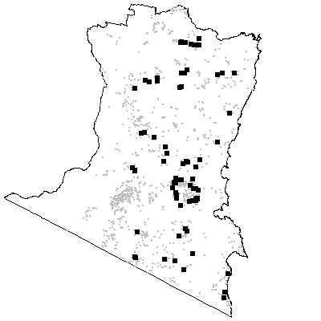
MAP UNIT 14: Hinterland Wet Shrub Forest

Species richness: 33 ± 2 (0.04 ha)
Extant area: 25 882 ha
Proportion cleared: 4%
Number of samples: 36

Table A14.1. Diagnostic plant species of Map Unit 14.

Species | Target frequency | Target C/A | Residual frequency | Residual C/A | Fidelity class
Acacia cognata | 0.639 | 4(3-4) | 0.033 | 2(1-3) | positive
Acacia maidenii | 0.028 | 3(3-3) | 0 | 0(0-0) | positive
Eucalyptus cypellocarpa | 0.917 | 2(1-3) | 0.299 | 3(2-3) | positive
Eucalyptus muelleriana | 0.917 | 4(3-4) | 0.123 | 3(2-3) | positive
Gonocarpus teucrioides | 0.583 | 2(1-3) | 0.309 | 2(1-2) | positive
Goodenia ovata | 0.778 | 2(1-3) | 0.158 | 2(1-2) | positive
Hibbertia dentata | 0.556 | 2(1-2) | 0.063 | 1(1-2) | positive
Pultenaea flexilis | 0.028 | 2(2-2) | 0 | 0(0-0) | positive
Smilax australis | 0.556 | 2(1-2) | 0.194 | 1(1-2) | positive
Tetrarrhena juncea | 0.722 | 3(2-3) | 0.169 | 2(1-3) | positive
Tylophora barbata | 0.778 | 2(1-2) | 0.254 | 2(1-2) | positive
Viola hederacea ssp hederacea | 0.778 | 2(1-2) | 0.429 | 2(1-2) | positive
Poa meionectes | 0.806 | 2(1-2) | 0.532 | 2(1-3) | constant
Pteridium esculentum | 0.833 | 2(2-3) | 0.57 | 2(1-3) | constant
Billardiera scandens | 0.722 | 1(1-2) | 0.319 | 1(1-1) | frequent
Clematis aristata | 0.722 | 1(1-2) | 0.332 | 1(1-1) | frequent
Leucopogon lanceolatus var lanceolatus | 0.806 | 1(1-2) | 0.396 | 1(1-2) | frequent
Lomandra longifolia | 0.583 | 1(1-2) | 0.548 | 2(1-2) | frequent
Acmena smithii | 0.083 | 1(1-2) | 0.031 | 3(1-4) | uninformative
Angophora floribunda | 0.028 | 3(3-3) | 0.097 | 2(1-3) | uninformative
Backhousia myrtifolia | 0.028 | 1(1-1) | 0.002 | 3(1-4) | uninformative
Elaeocarpus reticulatus | 0.5 | 1(1-2) | 0.065 | 1(1-2) | uninformative
Eucalyptus agglomerata | 0.028 | 3(3-3) | 0.111 | 3(2-3) | uninformative
Eucalyptus bosistoana | 0.028 | 2(2-2) | 0.054 | 2(1-3) | uninformative
Eucalyptus botryoides | 0.056 | 2(1-3) | 0.01 | 2(1-3) | uninformative
Eucalyptus elata | 0.278 | 2(1-3) | 0.109 | 3(2-3) | uninformative
Eucalyptus fastigata | 0.028 | 2(2-2) | 0.144 | 3(3-4) | uninformative
Eucalyptus globoidea | 0.083 | 3(1-3) | 0.247 | 3(1-3) | uninformative
Eucalyptus maidenii | 0.028 | 3(3-3) | 0.064 | 3(2-3) | uninformative
Eucalyptus obliqua | 0.222 | 2(1-3) | 0.189 | 3(2-4) | uninformative
Eucalyptus radiata | 0.028 | 1(1-1) | 0.078 | 3(1-3) | uninformative
Eucalyptus sieberi | 0.389 | 2(1-3) | 0.28 | 3(2-4) | uninformative
Eucalyptus smithii | 0.083 | 3(1-3) | 0.045 | 2(1-3) | uninformative

Table A14.2. Vegetation structure of Map Unit 14. Frequency is the proportion of samples in which strata were present. Height and cover data are means with standard errors in parentheses (n=17).

Stratum | Frequency (%) | Height (m) | Cover (%)
Tree | 100 | 31.9(1.5) | 35(2)
Small tree | 70.6 | 9.3(0.9) | 30(6)
Shrub | 100 | 3.6(0.6) | 30(4)
Ground cover | 100 | 0.8(0.1) | 58(6)

Table A14.3. Habitat characteristics of Map Unit 14. Means and interquartile ranges for altitude and slope were calculated from n field samples, while those for annual rain were calculated from ESOCLIM predictions (see Table 5, text). Frequency terrain and parent material refers to number of samples (n) recorded in respective classes. Terrain classes: flat (slope≤5°); north (slope>5° and aspect<30° or >300°); intermediate (slope>5° and aspect 30-120° or 210-300°); and south (slope>5° and aspect 120-210°).

 |  | Frequency (%) | Mean | Interquartile Range | n
Annual rain (mm) |  |  |  | 990 | 928 - 1041 | 36
Altitude (m) |  |  |  | 390 | 318 - 475 | 35
Slope (degrees) |  |  |  | 16 | 11 - 23 | 31
Terrain class
 | North | 16 |  |  | 5
 | Intermediate | 26 |  |  | 8
 | South | 45 |  |  | 14
 | Flat | 13 |  |  | 4
Parent material
 | Devonian granitoids | 25 |  |  | 9
 | Devonian high quartz sedimentaries | 47 |  |  | 17
 | Low quartz sedimentaries | 8 |  |  | 3
 | Ordovician high quartz sedimentaries | 19 |  |  | 7

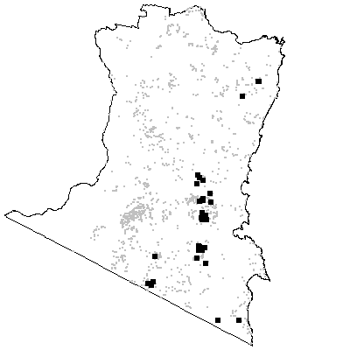

MAP UNIT 15: Mountain Wet Herb Forest

Species richness: 33 ± 1 (0.04 ha)
Extant area: 30 875 ha
Proportion cleared: 26%
Number of samples: 132

Table A15.1. Diagnostic plant species of Map Unit 15.

Species | Target frequency | Target C/A | Residual frequency | Residual C/A | Fidelity class
Caladenia dilatata | 0.008 | 1(1-1) | 0 | 0(0-0) | positive
Daviesia virgata | 0.008 | 1(1-1) | 0 | 0(0-0) | positive
Dianella tasmanica | 0.697 | 2(1-2) | 0.19 | 1(1-2) | positive
Eucalyptus cypellocarpa | 0.803 | 3(3-3) | 0.266 | 3(1-3) | positive
Eucalyptus obliqua | 0.886 | 3(3-4) | 0.121 | 3(1-3) | positive
Hierochloe rariflora | 0.599 | 3(2-3) | 0.141 | 2(1-3) | positive
Juncus sandwithii | 0.008 | 1(1-1) | 0 | 0(0-0) | positive
Lagenifera stipitata | 0.705 | 2(1-2) | 0.287 | 1(1-2) | positive
Leucopogon lanceolatus var lanceolatus | 0.902 | 2(1-2) | 0.357 | 1(1-2) | positive
Podolepis jaceoides | 0.008 | 2(2-2) | 0 | 0(0-0) | positive
Viola hederacea ssp hederacea | 0.955 | 2(1-2) | 0.387 | 2(1-2) | positive
Lomandra longifolia | 0.818 | 2(1-2) | 0.522 | 2(1-2) | constant
Poa meionectes | 0.932 | 2(2-3) | 0.5 | 2(1-3) | constant
Pteridium esculentum | 0.947 | 3(2-3) | 0.54 | 2(1-3) | constant
Clematis aristata | 0.712 | 1(1-1) | 0.305 | 1(1-1) | frequent
Coprosma quadrifida | 0.621 | 1(1-2) | 0.209 | 1(1-2) | frequent
Acacia melanoxylon | 0.106 | 1(1-2) | 0.105 | 1(1-3) | uninformative
Eucalyptus angophoroides | 0.015 | 1.5(1-2) | 0.047 | 2(1-3) | uninformative
Eucalyptus dalrympleana ssp dalrympleana | 0.008 | 3(3-3) | 0.019 | 2.5(1-3) | uninformative
Eucalyptus dives | 0.008 | 1(1-1) | 0.011 | 3(2-3) | uninformative
Eucalyptus elata | 0.144 | 3(2-3) | 0.11 | 3(2-3) | uninformative
Eucalyptus fastigata | 0.205 | 2(1-3) | 0.134 | 4(3-4) | uninformative
Eucalyptus fraxinoides | 0.045 | 3(3-4) | 0.027 | 4(3-4) | uninformative
Eucalyptus globoidea | 0.318 | 2(1-3) | 0.235 | 3(1-3) | uninformative
Eucalyptus maidenii | 0.008 | 3(3-3) | 0.069 | 3(2-3) | uninformative
Eucalyptus muelleriana | 0.038 | 3(1-3) | 0.152 | 3(2-4) | uninformative
Eucalyptus nitens | 0.015 | 4(4-4) | 0.012 | 3.5(3-4) | uninformative
Eucalyptus radiata | 0.152 | 3(1-3) | 0.069 | 3(1-3) | uninformative
Eucalyptus sieberi | 0.318 | 2(1-3) | 0.279 | 3(2-4) | uninformative
Eucalyptus smithii | 0.023 | 3(3-4) | 0.048 | 2(1-3) | uninformative
Eucalyptus sp. aff. radiata | 0.121 | 3(2-4) | 0.027 | 3(1-3) | uninformative
Eucalyptus viminalis | 0.015 | 2(1-3) | 0.061 | 3(1-3) | uninformative

Table A15.2. Vegetation structure of Map Unit 15. Frequency is the proportion of samples in which strata were present. Height and cover data are means with standard errors in parentheses (n=97).

Stratum | Frequency (%) | Height (m) | Cover (%)
Tree | 100 | 32.3(0.6) | 42(1)
Small tree | 44.3 | 8.1(0.7) | 20(2)
Shrub | 99 | 2.4(0.1) | 24(2)
Ground cover | 100 | 0.7(0.0) | 46(3)

Table A15.3. Habitat characteristics of Map Unit 15. Means and interquartile ranges for altitude and slope were calculated from n field samples, while those for annual rain were calculated from ESOCLIM predictions (see Table 5, text). Frequency terrain and parent material refers to number of samples (n) recorded in respective classes. Terrain classes: flat (slope≤5°); north (slope>5° and aspect<30° or >300°); intermediate (slope>5° and aspect 30-120° or 210-300°); and south (slope>5° and aspect 120-210°).

 |  | Frequency (%) | Mean | Interquartile Range | n
Annual rain (mm) |  |  |  | 1031 | 990 - 1061 | 132
Altitude (m) |  |  |  | 736 | 608 - 850 | 132
Slope (degrees) |  |  |  | 12 | 4 - 20 | 125
Terrain class
 | North | 8 |  |  | 10
 | Intermediate | 36 |  |  | 44
 | South | 30 |  |  | 37
 | Flat | 26 |  |  | 32
Parent material
 | Devonian granitoids | 89 |  |  | 117
 | Devonian high quartz sedimentaries | 3 |  |  | 4
 | Low quartz sedimentaries | 2 |  |  | 3
 | Ordovician high quartz sedimentaries | 5 |  |  | 7
 | Tertiary Basalt | 1 |  |  | 1

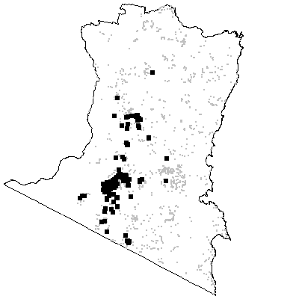

MAP UNIT 16: Basalt Wet Herb Forest

Species richness: 35 ± 1 (0.04 ha)
Extant area: 12 209 ha
Proportion cleared: 18%
Number of samples: 32

Table A16.1. Diagnostic plant species of Map Unit 16.

Species | Target frequency | Target C/A | Residual frequency | Residual C/A | Fidelity class
Acaena novae-zelandiae | 0.75 | 2(1-2) | 0.118 | 1(1-2) | positive
Asperula scoparia | 0.688 | 2(1-2) | 0.055 | 1(1-2) | positive
Baumea gunnii | 0.031 | 1(1-1) | 0 | 0(0-0) | positive
Danthonia nudiflora | 0.031 | 1(1-1) | 0 | 0(0-0) | positive
Dianella tasmanica | 0.906 | 2(2-3) | 0.22 | 1(1-2) | positive
Eucalyptus fastigata | 0.688 | 3(3-4) | 0.129 | 3(3-4) | positive
Geranium potentilloides | 0.563 | 2(1-2) | 0.208 | 1(1-2) | positive
Glycine clandestina | 0.594 | 2(1-2) | 0.322 | 1(1-2) | positive
Gonocarpus tetragynus | 0.656 | 2(1-2) | 0.155 | 2(1-2) | positive
Hydrocotyle laxiflora | 0.563 | 2(1-2) | 0.198 | 2(1-2) | positive
Luzula densiflora | 0.031 | 1(1-1) | 0 | 0(0-0) | positive
Sclerolaena uniflora | 0.031 | 1(1-1) | 0 | 0(0-0) | positive
Stellaria pungens | 0.5 | 2(2-2) | 0.058 | 1(1-2) | positive
Viola hederacea ssp hederacea | 0.938 | 2(2-2) | 0.426 | 2(1-2) | positive
Lomandra longifolia | 0.656 | 2(2-2) | 0.547 | 2(1-2) | constant
Poa meionectes | 0.938 | 3(3-4) | 0.53 | 2(1-3) | constant
Pteridium esculentum | 0.906 | 3(2-4) | 0.569 | 2(1-3) | constant
Clematis aristata | 0.906 | 1(1-2) | 0.329 | 1(1-1) | frequent
Lagenifera stipitata | 0.719 | 1(1-2) | 0.315 | 1(1-2) | frequent
Microlaena stipoides var stipoides | 0.656 | 1(1-2) | 0.347 | 2(1-2) | frequent
Veronica calycina | 0.781 | 1(1-1) | 0.192 | 1(1-1) | frequent
Acacia melanoxylon | 0.125 | 2.5(1-3) | 0.105 | 1(1-3) | uninformative
Elaeocarpus holopetalus | 0.031 | 1(1-1) | 0.019 | 1(1-3) | uninformative
Eucalyptus badjensis | 0.063 | 2(1-3) | 0.006 | 3(3-4) | uninformative
Eucalyptus bosistoana | 0.063 | 3.5(3-4) | 0.053 | 2(1-3) | uninformative
Eucalyptus cypellocarpa | 0.438 | 3.5(3-4) | 0.311 | 3(2-3) | uninformative
Eucalyptus dalrympleana ssp dalrympleana | 0.156 | 2(1-3) | 0.015 | 3(1-3) | uninformative
Eucalyptus elata | 0.063 | 2.5(2-3) | 0.114 | 3(2-3) | uninformative
Eucalyptus nitens | 0.094 | 1(1-3) | 0.01 | 4(3-4) | uninformative
Eucalyptus obliqua | 0.25 | 3(2-4) | 0.188 | 3(2-4) | uninformative
Eucalyptus pauciflora | 0.063 | 2(1-3) | 0.022 | 2(1-3) | uninformative
Eucalyptus radiata | 0.313 | 2.5(2-3) | 0.072 | 3(1-3) | uninformative
Eucalyptus rubida | 0.063 | 1(1-1) | 0.006 | 1(1-3) | uninformative
Eucalyptus smithii | 0.031 | 1(1-1) | 0.046 | 2(1-3) | uninformative
Eucalyptus viminalis | 0.219 | 3(1-3) | 0.053 | 3(1-3) | uninformative

Table A16.2. Vegetation structure of Map Unit 16. Frequency is the proportion of samples in which strata were present. Height and cover data are means with standard errors in parentheses (n=21).

Stratum | Frequency (%) | Height (m) | Cover (%)
Tree | 100 | 30.5(1.3) | 38(4)
Small tree | 47.6 | 7.4(0.8) | 25(4)
Shrub | 100 | 2.2(0.2) | 12(2)
Ground cover | 100 | 0.6(0.1) | 73(5)

Table A16.3. Habitat characteristics of Map Unit 16. Means and interquartile ranges for altitude and slope were calculated from n field samples, while those for annual rain were calculated from ESOCLIM predictions (see Table 5, text). Frequency terrain and parent material refers to number of samples (n) recorded in respective classes. Terrain classes: flat (slope≤5°); north (slope>5° and aspect<30° or >300°); intermediate (slope>5° and aspect 30-120° or 210-300°); and south (slope>5° and aspect 120-210°).

 |  | Frequency (%) | Mean | Interquartile Range | n
Annual rain (mm) |  |  |  | 929 | 891 - 954 | 32
Altitude (m) |  |  |  | 915 | 848 - 1070 | 31
Slope (degrees) |  |  |  | 9 | 4 - 14 | 31
Terrain class
 | North | 16 |  |  | 5
 | Intermediate | 32 |  |  | 10
 | South | 23 |  |  | 7
 | Flat | 29 |  |  | 9
Parent material
 | Devonian Basalt | 3 |  |  | 1
 | Devonian granitoids | 56 |  |  | 18
 | Low quartz sedimentaries | 3 |  |  | 1
 | Tertiary Basalt | 38 |  |  | 12

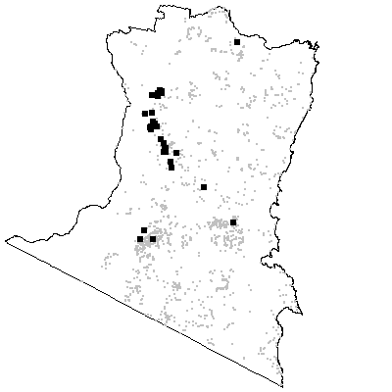

MAP UNIT 17: Flats Wet Herb Forest

Species richness: 43 ± 3 (0.04 ha)
Extant area: 2 931 ha
Proportion cleared: 18%
Number of samples: 19

Table A17.1. Diagnostic plant species of Map Unit 17.

Species | Target frequency | Target C/A | Residual frequency | Residual C/A | Fidelity class
Acacia dealbata | 0.684 | 3(2-3) | 0.131 | 2(1-3) | positive
Acaena novae-zelandiae | 0.684 | 2(1-2) | 0.125 | 1(1-2) | positive
Blechnum nudum | 0.684 | 2(2-3) | 0.072 | 2(1-4) | positive
Carex appressa | 0.737 | 2(1-2) | 0.076 | 1(1-2) | positive
Carex polyantha | 0.053 | 2(2-2) | 0 | 0(0-0) | positive
Cassinia aculeata | 0.526 | 2(2-3) | 0.158 | 1(1-2) | positive
Eucalyptus viminalis | 0.79 | 3(3-3) | 0.047 | 3(1-3) | positive
Geranium potentilloides | 0.895 | 2(2-2) | 0.207 | 1(1-2) | positive
Juncus pallidus | 0.105 | 2(1-3) | 0 | 0(0-0) | positive
Phebalium squameum | 0.053 | 1(1-1) | 0 | 0(0-0) | positive
Pimelea axiflora | 0.526 | 2.5(2-3) | 0.114 | 1(1-2) | positive
Podolepis hieracioides | 0.053 | 2(2-2) | 0 | 0(0-0) | positive
Pomaderris aspera | 0.579 | 2(2-3) | 0.156 | 2(1-3) | positive
Senecio linearifolius | 0.684 | 2(1-4) | 0.234 | 1(1-2) | positive
Stellaria flaccida | 0.684 | 2(1-2) | 0.205 | 1(1-2) | positive
Stellaria pungens | 0.842 | 2(1-3) | 0.057 | 1(1-2) | positive
Viola hederacea ssp hederacea | 0.737 | 2(2-2) | 0.434 | 2(1-2) | positive
Lomandra longifolia | 0.842 | 2(1-4) | 0.545 | 2(1-2) | constant
Poa meionectes | 0.737 | 2(2-4) | 0.536 | 2(1-3) | constant
Pteridium esculentum | 0.895 | 2(2-4) | 0.573 | 2(1-3) | constant
Lagenifera stipitata | 0.632 | 1(1-2) | 0.32 | 1(1-2) | frequent
Rubus parvifolius | 0.632 | 1(1-2) | 0.134 | 1(1-2) | frequent
Acacia melanoxylon | 0.526 | 1.5(1-3) | 0.1 | 1(1-3) | uninformative
Eucalyptus agglomerata | 0.105 | 1.5(1-2) | 0.109 | 3(2-3) | uninformative
Eucalyptus angophoroides | 0.158 | 1(1-2) | 0.043 | 2(1-3) | uninformative
Eucalyptus bosistoana | 0.053 | 2(2-2) | 0.053 | 2(1-3) | uninformative
Eucalyptus cypellocarpa | 0.053 | 2(2-2) | 0.317 | 3(2-3) | uninformative
Eucalyptus dalrympleana ssp dalrympleana | 0.105 | 1(1-1) | 0.017 | 3(1-3) | uninformative
Eucalyptus elata | 0.421 | 3(3-4) | 0.109 | 3(1-3) | uninformative
Eucalyptus fastigata | 0.158 | 1(1-1) | 0.14 | 3(3-4) | uninformative
Eucalyptus maidenii | 0.158 | 1(1-3) | 0.062 | 3(3-3) | uninformative
Eucalyptus obliqua | 0.263 | 1(1-2) | 0.189 | 3(2-4) | uninformative
Eucalyptus ovata | 0.105 | 2.5(2-3) | 0.022 | 3(1-3) | uninformative
Eucalyptus pauciflora | 0.053 | 1(1-1) | 0.023 | 2(1-3) | uninformative
Eucalyptus polyanthemos ssp vestita | 0.053 | 2(2-2) | 0.012 | 2.5(2-3) | uninformative
Eucalyptus radiata | 0.263 | 3(3-3) | 0.074 | 3(1-3) | uninformative
Eucalyptus sp. aff. radiata | 0.211 | 2(1-4) | 0.033 | 3(2-3) | uninformative

Table A17.2. Vegetation structure of Map Unit 17. Frequency is the proportion of samples in which strata were present. Height and cover data are means with standard errors in parentheses (n=13).

Stratum | Frequency (%) | Height (m) | Cover (%)
Tree | 92.3 | 31.8(1.3) | 34(2)
Small tree | 76.9 | 12.5(2.1) | 15(4)
Shrub | 92.3 | 3.0(0.5) | 33(6)
Ground cover | 100 | 0.9(0.1) | 76(5)

Table A17.3. Habitat characteristics of Map Unit 17. Means and interquartile ranges for altitude and slope were calculated from n field samples, while those for annual rain were calculated from ESOCLIM predictions (see Table 5, text). Frequency terrain and parent material refers to number of samples (n) recorded in respective classes. Terrain classes: flat (slope≤5°); north (slope>5° and aspect<30° or >300°); intermediate (slope>5° and aspect 30-120° or 210-300°); and south (slope>5° and aspect 120-210°).

 |  | Frequency (%) | Mean | Interquartile Range | n
Annual rain (mm) |  |  |  | 912 | 896 - 951 | 19
Altitude (m) |  |  |  | 518 | 425 - 558 | 19
Slope (degrees) |  |  |  | 4 | 0 - 3 | 19
Terrain class
 | North | 0 |  |  | 0
 | Intermediate | 11 |  |  | 2
 | South | 5 |  |  | 1
 | Flat | 84 |  |  | 16
Parent material
 | Devonian granitoids | 95 |  |  | 18
 | Ordovician high quartz sedimentaries | 5 |  |  | 1

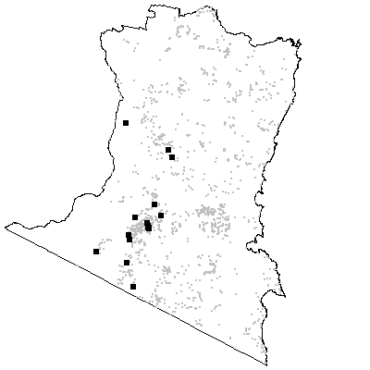

MAP UNIT 18: Brogo Wet Vine Forest

Species richness: 42 ± 2 (0.04 ha)
Extant area: 4 306 ha
Proportion cleared: 45%
Number of samples: 16

Table A18.1. Diagnostic plant species of Map Unit 18.

Species | Target frequency | Target C/A | Residual frequency | Residual C/A | Fidelity class
Acacia implexa | 0.875 | 2(1-3) | 0.042 | 1(1-2) | positive
Asplenium flabellifolium | 0.563 | 2(1-2) | 0.117 | 1(1-2) | positive
Cassinia trinerva | 0.563 | 2(1-3) | 0.078 | 1(1-3) | positive
Cissus antarctica | 0.063 | 2(2-2) | 0 | 0(0-0) | positive
Davallia pyxidata | 0.063 | 1(1-1) | 0 | 0(0-0) | positive
Deeringia amaranthoides | 0.313 | 1(1-2) | 0 | 0(0-0) | positive
Dichondra repens | 1 | 2(2-2) | 0.276 | 1(1-2) | positive
Eucalyptus tereticornis | 0.625 | 3(3-3) | 0.041 | 3(1-3) | positive
Geranium solanderi | 0.938 | 2(1-2) | 0.084 | 1(1-2) | positive
Hydrocotyle laxiflora | 0.688 | 2(1-2) | 0.201 | 2(1-2) | positive
Hymenanthera dentata | 1 | 3(2-3) | 0.06 | 1(1-2) | positive
Marsdenia rostrata | 0.625 | 2(2-2) | 0.08 | 2(1-2) | positive
Microlaena stipoides var stipoides | 0.938 | 3(2-4) | 0.348 | 1(1-2) | positive
Oplismenus imbecillis | 0.875 | 2(2-3) | 0.1 | 2(1-2) | positive
Pellaea falcata var falcata | 1 | 2(2-3) | 0.088 | 1(1-2) | positive
Sigesbeckia orientalis | 0.813 | 2(1-2) | 0.07 | 1(1-1) | positive
Stellaria flaccida | 0.875 | 2(1-3) | 0.204 | 1(1-2) | positive
Urtica incisa | 0.875 | 2(2-3) | 0.06 | 1(1-1) | positive
Breynia oblongifolia | 0.75 | 1(1-2) | 0.023 | 1(1-1) | frequent
Carex appressa | 0.625 | 1(1-2) | 0.078 | 1(1-2) | frequent
Clematis glycinoides | 0.813 | 1(1-2) | 0.108 | 1(1-2) | frequent
Desmodium varians | 0.625 | 1.5(1-2) | 0.246 | 1(1-2) | frequent
Echinopogon ovatus | 0.688 | 1(1-2) | 0.159 | 1(1-2) | frequent
Geitonoplesium cymosum | 0.813 | 1(1-1) | 0.102 | 1(1-2) | frequent
Glycine clandestina | 0.875 | 1(1-2) | 0.321 | 1(1-2) | frequent
Poa labillardieri var labillardieri | 0.625 | 1(1-3) | 0.164 | 2(1-2) | frequent
Rubus parvifolius | 0.75 | 1(1-2) | 0.133 | 1(1-2) | frequent
Stephania japonica var discolor | 0.75 | 1.5(1-2) | 0.017 | 1(1-1) | frequent
Acacia subporosa | 0.063 | 2(2-2) | 0.004 | 1.5(1-2) | uninformative
Acmena smithii | 0.188 | 1(1-2) | 0.03 | 3(1-4) | uninformative
Alectryon subcinereus | 0.188 | 1(1-3) | 0.005 | 1(1-2) | uninformative
Angophora floribunda | 0.375 | 1(1-2) | 0.092 | 2(1-3) | uninformative
Eucalyptus baueriana | 0.063 | 1(1-1) | 0.026 | 2(1-3) | uninformative
Eucalyptus bosistoana | 0.375 | 2(1-3) | 0.049 | 2(1-3) | uninformative
Eucalyptus globoidea | 0.313 | 3(1-3) | 0.242 | 3(1-3) | uninformative
Ficus rubiginosa | 0.188 | 2(1-5) | 0.008 | 4(1-6) | uninformative
Lomandra longifolia | 0.188 | 1(1-2) | 0.553 | 2(1-2) | negative
Poa meionectes | 0 | 0(1-0) | 0.545 | 2(1-3) | negative
Pteridium esculentum | 0.313 | 2(1-2) | 0.58 | 2(1-3) | negative

Table A18.2. Vegetation structure of Map Unit 18. Frequency is the proportion of samples in which strata were present. Height and cover data are means with standard errors in parentheses (n=16).

Stratum | Frequency (%) | Height (m) | Cover (%)
Tree | 93.8 | 20.9(2.0) | 21(5)
Small tree | 81.3 | 10.7(1.1) | 27(6)
Shrub | 100 | 2.3(0.2) | 24(6)
Ground cover | 100 | 0.5(0.1) | 56(6)

Table A18.3. Habitat characteristics of Map Unit 18. Means and interquartile ranges for altitude and slope were calculated from n field samples, while those for annual rain were calculated from ESOCLIM predictions (see Table 5, text). Frequency terrain and parent material refers to number of samples (n) recorded in respective classes. Terrain classes: flat (slope≤5°); north (slope>5° and aspect<30° or >300°); intermediate (slope>5° and aspect 30-120° or 210-300°); and south (slope>5° and aspect 120-210°).

 |  | Frequency (%) | Mean | Interquartile Range | n
Annual rain (mm) |  |  |  | 934 | 886 - 989 | 16
Altitude (m) |  |  |  | 216 | 193 - 245 | 16
Slope (degrees) |  |  |  | 23 | 20 - 27 | 16
Terrain class
 | North | 44 |  |  | 7
 | Intermediate | 31 |  |  | 5
 | South | 25 |  |  | 4
 | Flat | 0 |  |  | 0
Parent material
 | Devonian granitoids | 75 |  |  | 12
 | Devonian high quartz sedimentaries | 6 |  |  | 1
 | Ordovician high quartz sedimentaries | 19 |  |  | 3

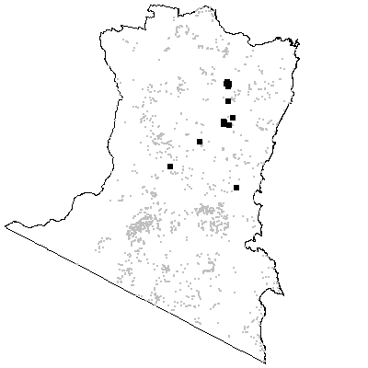

MAP UNIT 19: Bega Wet Shrub Forest

Species richness: 48 ± 2 (0.04 ha)
Extant area: 16 908 ha
Proportion cleared: 65%
Number of samples: 38

Table A19.1. Diagnostic plant species of Map Unit 19.

Species | Target frequency | Target C/A | Residual frequency | Residual C/A | Fidelity class
Acacia mearnsii | 0.895 | 3(1-3) | 0.144 | 2(1-3) | positive
Adiantum aethiopicum | 0.553 | 2(1-2) | 0.065 | 1(1-2) | positive
Cassinia trinerva | 0.605 | 2(1-3) | 0.07 | 1(1-2) | positive
Clematis glycinoides | 0.684 | 2(1-2) | 0.1 | 1(1-1) | positive
Cyperus sphaeroideus | 0.026 | 1(1-1) | 0 | 0(0-0) | positive
Desmodium varians | 0.842 | 2(1-2) | 0.234 | 1(1-2) | positive
Dichondra repens | 0.868 | 2(2-2) | 0.269 | 1(1-2) | positive
Eucalyptus elata | 0.605 | 3(1-4) | 0.1 | 3(2-3) | positive
Geranium retrorsum | 0.053 | 1(1-1) | 0 | 0(0-0) | positive
Glycine clandestina | 0.947 | 2(1-2) | 0.311 | 1(1-2) | positive
Hydrocotyle laxiflora | 0.868 | 2(2-2) | 0.188 | 1(1-2) | positive
Mentha satureioides | 0.053 | 1.5(1-2) | 0 | 0(0-0) | positive
Microlaena stipoides var stipoides | 0.947 | 2(2-3) | 0.338 | 1(1-2) | positive
Oplismenus imbecillis | 0.737 | 2(1-3) | 0.092 | 2(1-2) | positive
Oxalis chnoodes | 0.026 | 1(1-1) | 0 | 0(0-0) | positive
Oxalis rubens | 0.026 | 1(1-1) | 0 | 0(0-0) | positive
Paspalum orbiculare | 0.026 | 1(1-1) | 0 | 0(0-0) | positive
Pellaea falcata var falcata | 0.632 | 2(1-3) | 0.084 | 1(1-2) | positive
Stellaria flaccida | 0.711 | 2(1-2) | 0.198 | 1(1-2) | positive
Poa meionectes | 0.632 | 2(1-3) | 0.536 | 2(1-3) | constant
Pteridium esculentum | 0.684 | 2(1-2) | 0.574 | 2(1-3) | constant
Arthropodium milleflorum | 0.632 | 1(1-2) | 0.048 | 1(1-1) | frequent
Echinopogon ovatus | 0.868 | 1(1-2) | 0.146 | 1(1-2) | frequent
Galium propinquum | 0.658 | 1(1-1) | 0.126 | 1(1-1) | frequent
Gnaphalium gymnocephalum | 0.632 | 1(1-1) | 0.172 | 1(1-1) | frequent
Hymenanthera dentata | 0.658 | 1(1-3) | 0.054 | 1(1-2) | frequent
Lomandra longifolia | 0.763 | 1(1-2) | 0.543 | 2(1-2) | frequent
Oxalis perennans | 0.605 | 1(1-1) | 0.212 | 1(1-1) | frequent
Plantago debilis | 0.605 | 1(1-2) | 0.1 | 1(1-1) | frequent
Rubus parvifolius | 0.79 | 1(1-2) | 0.123 | 1(1-2) | frequent
Angophora floribunda | 0.368 | 1(1-2) | 0.088 | 2(1-3) | uninformative
Eucalyptus angophoroides | 0.158 | 2(1-3) | 0.041 | 2(1-3) | uninformative
Eucalyptus baueriana | 0.368 | 3(1-4) | 0.017 | 2(1-3) | uninformative
Eucalyptus bosistoana | 0.132 | 1(1-3) | 0.051 | 2(1-3) | uninformative
Eucalyptus botryoides - E. saligna | 0.132 | 3(2-4) | 0.008 | 1(1-2) | uninformative
Eucalyptus cypellocarpa | 0.053 | 3(3-3) | 0.321 | 3(2-3) | uninformative
Eucalyptus globoidea | 0.368 | 1(1-3) | 0.239 | 3(1-3) | uninformative
Eucalyptus maidenii | 0.105 | 3(3-3) | 0.062 | 3(2-3) | uninformative
Eucalyptus melliodora | 0.053 | 1.5(1-2) | 0.01 | 2(1-3) | uninformative
Eucalyptus muelleriana | 0.026 | 2(2-2) | 0.145 | 3(2-4) | uninformative
Eucalyptus ovata | 0.026 | 3(3-3) | 0.023 | 3(1-3) | uninformative
Eucalyptus polyanthemos ssp vestita | 0.026 | 1(1-1) | 0.014 | 2(2-3) | uninformative
Eucalyptus radiata | 0.053 | 2(1-3) | 0.077 | 3(1-3) | uninformative
Eucalyptus sieberi | 0.026 | 1(1-1) | 0.289 | 3(2-4) | uninformative
Eucalyptus tereticornis | 0.158 | 2(1-3) | 0.044 | 3(1-3) | uninformative
Eucalyptus viminalis | 0.105 | 1.5(1-3) | 0.056 | 3(1-3) | uninformative

Table A19.2. Vegetation structure of Map Unit 19. Frequency is the proportion of samples in which strata were present. Height and cover data are means with standard errors in parentheses (n=28).

Stratum | Frequency (%) | Height (m) | Cover (%)
Tree | 100 | 24.9(1.0) | 25(2)
Small tree | 96.4 | 9.3(0.7) | 19(3)
Shrub | 96.4 | 2.6(0.2) | 25(5)
Ground cover | 100 | 0.4(0.1) | 68(5)

Table A19.3. Habitat characteristics of Map Unit 19. Means and interquartile ranges for altitude and slope were calculated from n field samples, while those for annual rain were calculated from ESOCLIM predictions (see Table 5, text). Frequency terrain and parent material refers to number of samples (n) recorded in respective classes. Terrain classes: flat (slope≤5°); north (slope>5° and aspect<30° or >300°); intermediate (slope>5° and aspect 30-120° or 210-300°); and south (slope>5° and aspect 120-210°).

 |  | Frequency (%) | Mean | Interquartile Range | n
Annual rain (mm) |  |  |  | 884 | 832 - 955 | 38
Altitude (m) |  |  |  | 193 | 129 - 268 | 38
Slope (degrees) |  |  |  | 20 | 10 - 24 | 38
Terrain class
 | North | 16 |  |  | 6
 | Intermediate | 26 |  |  | 10
 | South | 50 |  |  | 19
 | Flat | 8 |  |  | 3
Parent material
 | Devonian granitoids | 66 |  |  | 25
 | Devonian high quartz sedimentaries | 3 |  |  | 1
 | Ordovician high quartz sedimentaries | 32 |  |  | 12

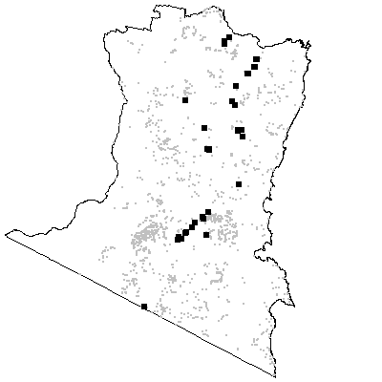

MAP UNIT 20: Bega Dry Grass Forest

Species richness: 39 ± 1 (0.04 ha)
Extant area: 3 809 ha
Proportion cleared: 88%
Number of samples: 48

Table A20.1. Diagnostic plant species of Map Unit 20.

Species | Target frequency | Target C/A | Residual frequency | Residual C/A | Fidelity class
Bursaria spinosa | 0.604 | 2(1-3) | 0.107 | 1(1-2) | positive
Dichondra repens | 0.979 | 2(1-2) | 0.261 | 1(1-2) | positive
Echinopogon caespitosus | 0.5 | 2(1-2) | 0.024 | 1(1-1) | positive
Echinopogon ovatus | 0.542 | 2(1-2) | 0.152 | 1(1-2) | positive
Eucalyptus tereticornis | 0.521 | 3(1-3) | 0.031 | 3(1-3) | positive
Glycine sp. hairy | 0.063 | 1(1-1) | 0 | 0(0-0) | positive
Laxmannia gracilis | 0.063 | 1(1-1) | 0 | 0(0-0) | positive
Microlaena stipoides var stipoides | 0.979 | 3(2-4) | 0.333 | 1(1-2) | positive
Polygala japonica | 0.021 | 1(1-1) | 0 | 0(0-0) | positive
Stipa densiflora | 0.021 | 2(2-2) | 0 | 0(0-0) | positive
Themeda australis | 0.896 | 3(2-4) | 0.088 | 2(1-3) | positive
Vittadinia dissecta var dissecta | 0.021 | 1(1-1) | 0 | 0(0-0) | positive
Acacia mearnsii | 0.667 | 1(1-3) | 0.146 | 2(1-3) | frequent
Cheilanthes sieberi ssp sieberi | 0.75 | 1(1-2) | 0.039 | 1(1-1) | frequent
Desmodium varians | 0.625 | 1(1-2) | 0.237 | 2(1-2) | frequent
Eragrostis leptostachya | 0.667 | 1(1-2) | 0.025 | 2(1-2) | frequent
Glycine clandestina | 0.833 | 1(1-2) | 0.31 | 1(1-2) | frequent
Hydrocotyle laxiflora | 0.792 | 1.5(1-2) | 0.186 | 2(1-2) | frequent
Hypericum gramineum | 0.604 | 1(1-1) | 0.23 | 1(1-2) | frequent
Ozothamnus diosmifolius | 0.708 | 1(1-2) | 0.058 | 1(1-1) | frequent
Lomandra longifolia | 0.75 | 1(1-1) | 0.542 | 2(1-2) | frequent
Angophora floribunda | 0.458 | 3(1-4) | 0.083 | 2(1-3) | uninformative
Eucalyptus agglomerata | 0.042 | 3(3-3) | 0.111 | 3(2-3) | uninformative
Eucalyptus angophoroides | 0.021 | 1(1-1) | 0.045 | 2(1-3) | uninformative
Eucalyptus baueriana | 0.167 | 1(1-3) | 0.022 | 2(2-3) | uninformative
Eucalyptus bosistoana | 0.104 | 3(2-3) | 0.051 | 2(1-3) | uninformative
Eucalyptus botryoides | 0.042 | 1.5(1-2) | 0.011 | 2(1-3) | uninformative
Eucalyptus dives | 0.021 | 3(3-3) | 0.011 | 3(2-3) | uninformative
Eucalyptus elata | 0.208 | 3(3-4) | 0.11 | 3(1-3) | uninformative
Eucalyptus globoidea | 0.438 | 3(2-4) | 0.236 | 3(1-3) | uninformative
Eucalyptus maidenii | 0.042 | 2(1-3) | 0.064 | 3(2-3) | uninformative
Eucalyptus melliodora | 0.042 | 2(1-3) | 0.011 | 2(1-3) | uninformative
Eucalyptus pauciflora | 0.021 | 1(1-1) | 0.023 | 2(1-3) | uninformative
Eucalyptus polyanthemos ssp vestita | 0.021 | 1(1-1) | 0.014 | 2(2-3) | uninformative
Eucalyptus radiata | 0.042 | 2(1-3) | 0.078 | 3(1-3) | uninformative
Eucalyptus sieberi | 0.063 | 3(1-4) | 0.29 | 3(2-4) | uninformative
Eucalyptus viminalis | 0.083 | 3(2-4) | 0.056 | 3(1-3) | uninformative
Poa meionectes | 0.125 | 1(1-1) | 0.553 | 2(1-3) | negative
Pteridium esculentum | 0.25 | 1(1-2) | 0.588 | 2(1-3) | negative

Table A20.2. Vegetation structure of Map Unit 20. Frequency is the proportion of samples in which strata were present. Height and cover data are means with standard errors in parentheses (n=47).

Stratum | Frequency (%) | Height (m) | Cover (%)
Tree | 100 | 21.3(0.7) | 23(2)
Small tree | 80.9 | 8.9(0.5) | 15(2)
Shrub | 97.9 | 2.4(0.1) | 19(2)
Ground cover | 100 | 0.4(0.0) | 62(4)

Table A20.3. Habitat characteristics of Map Unit 20. Means and interquartile ranges for altitude and slope were calculated from n field samples, while those for annual rain were calculated from ESOCLIM predictions (see Table 5, text). Frequency terrain and parent material refers to number of samples (n) recorded in respective classes. Terrain classes: flat (slope≤5°); north (slope>5° and aspect<30° or >300°); intermediate (slope>5° and aspect 30-120° or 210-300°); and south (slope>5° and aspect 120-210°).

 |  | Frequency (%) | Mean | Interquartile Range | n
Annual rain (mm) |  |  |  | 822 | 768 - 835 | 48
Altitude (m) |  |  |  | 132 | 99 - 176 | 48
Slope (degrees) |  |  |  | 14 | 8 - 19 | 48
Terrain class
 | North | 32 |  |  | 15
 | Intermediate | 47 |  |  | 22
 | South | 17 |  |  | 8
 | Flat | 4 |  |  | 2
Parent material
 | Devonian granitoids | 33 |  |  | 16
 | Devonian high quartz sedimentaries | 13 |  |  | 6
 | Ordovician high quartz sedimentaries | 54 |  |  | 26

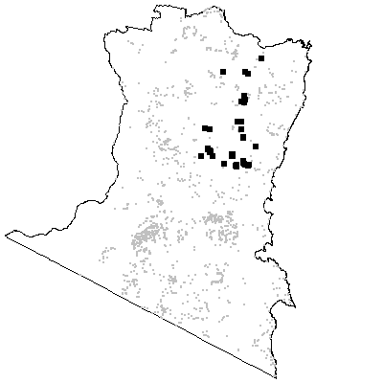

MAP UNIT 21: Candelo Dry Grass Forest

Species richness: 35 ± 3 (0.04 ha)
Extant area: 1463 ha
Proportion cleared: 92%
Number of samples: 28

Table A21.1. Diagnostic plant species of Map Unit 21.

Species | Target frequency | Target C/A | Residual frequency | Residual C/A | Fidelity class
Angophora floribunda | 0.679 | 3(1-4) | 0.084 | 2(1-3) | positive
Brachycome ciliata var ciliata | 0.071 | 1(1-1) | 0 | 0(0-0) | positive
Chloris ventricosa | 0.036 | 2(2-2) | 0 | 0(0-0) | positive
Danthonia racemosa var. racemosa | 0.679 | 2(1-2) | 0.039 | 1(1-2) | positive
Dichanthium sericeum | 0.429 | 1(1-2) | 0 | 0(0-0) | positive
Dichondra repens | 0.893 | 2(2-3) | 0.272 | 1(1-2) | positive
Eragrostis leptostachya | 0.75 | 2(2-3) | 0.033 | 1(1-2) | positive
Eucalyptus globoidea | 0.643 | 3(1-3) | 0.235 | 3(1-3) | positive
Eucalyptus tereticornis | 0.786 | 3(1-3) | 0.033 | 3(1-3) | positive
Glycine tabacina | 0.536 | 2(1-2) | 0.024 | 1(1-2) | positive
Hydrocotyle laxiflora | 0.75 | 2(1-2) | 0.195 | 2(1-2) | positive
Microlaena stipoides var stipoides | 0.857 | 2(2-3) | 0.344 | 1(1-2) | positive
Plantago hispida | 0.036 | 4(4-4) | 0 | 0(0-0) | positive
Themeda australis | 0.821 | 4(3-4) | 0.1 | 2(1-3) | positive
Zornia dyctiocarpa | 0.036 | 1(1-1) | 0 | 0(0-0) | positive
Acacia mearnsii | 0.607 | 1(1-3) | 0.154 | 2(1-3) | frequent
Desmodium varians | 0.679 | 1(1-2) | 0.242 | 1(1-2) | frequent
Dichelachne micrantha | 0.714 | 1(1-2) | 0.073 | 1(1-2) | frequent
Geranium solanderi | 0.714 | 1(1-2) | 0.081 | 1(1-2) | frequent
Glycine clandestina | 0.786 | 1(1-2) | 0.319 | 1(1-2) | frequent
Gnaphalium gymnocephalum | 0.714 | 1(1-1) | 0.173 | 1(1-1) | frequent
Eucalyptus baueriana | 0.036 | 1(1-1) | 0.026 | 2(1-3) | uninformative
Eucalyptus bosistoana | 0.071 | 1.5(1-2) | 0.053 | 2(1-3) | uninformative
Eucalyptus elata | 0.071 | 1(1-1) | 0.114 | 3(2-3) | uninformative
Eucalyptus maidenii | 0.107 | 3(3-3) | 0.062 | 3(2-3) | uninformative
Eucalyptus melliodora | 0.429 | 1.5(1-3) | 0.003 | 2(1-3) | uninformative
Eucalyptus viminalis | 0.036 | 1(1-1) | 0.057 | 3(1-3) | uninformative
Lomandra longifolia | 0.321 | 1(1-1) | 0.553 | 2(1-2) | negative
Poa meionectes | 0.429 | 1.5(1-3) | 0.541 | 2(1-3) | negative
Pteridium esculentum | 0.179 | 1(1-2) | 0.585 | 2(1-3) | negative

Table A21.2. Vegetation structure of Map Unit 21. Frequency is the proportion of samples in which strata were present. Height and cover data are means with standard errors in parentheses (n=28).

Stratum | Frequency (%) | Height (m) | Cover (%)
Tree | 100 | 22.4(0.8) | 24(2)
Small tree | 50 | 8.4(0.8) | 20(4)
Shrub | 89.3 | 1.9(0.2) | 12(3)
Ground cover | 100 | 0.3(0.0) | 77(4)

Table A21.3. Habitat characteristics of Map Unit 21. Means and interquartile ranges for altitude and slope were calculated from n field samples, while those for annual rain were calculated from ESOCLIM predictions (see Table 5, text). Frequency terrain and parent material refers to number of samples (n) recorded in respective classes. Terrain classes: flat (slope≤5°); north (slope>5° and aspect<30° or >300°); intermediate (slope>5° and aspect 30-120° or 210-300°); and south (slope>5° and aspect 120-210°).

 |  | Frequency (%) | Mean | Interquartile Range | n
Annual rain (mm) |  |  |  | 792 | 774 - 816 | 28
Altitude (m) |  |  |  | 149 | 105 - 183 | 28
Slope (degrees) |  |  |  | 14 | 8 - 21 | 28
Terrain class
 | North | 14 |  |  | 4
 | Intermediate | 61 |  |  | 17
 | South | 18 |  |  | 5
 | Flat | 7 |  |  | 2
Parent material
 | Devonian granitoids | 86 |  |  | 24
 | Ordovician high quartz sedimentaries | 14 |  |  | 4

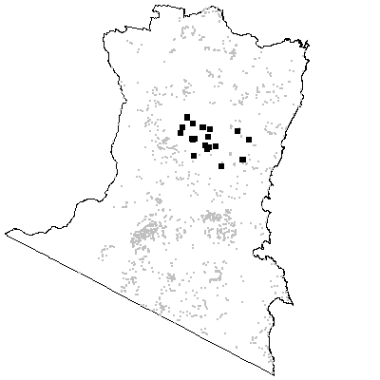

Map Unit 22A: Monaro Dry Grass Forest

Species richness: 16 ± 1 (0.04 ha)
Extant area: 3 625 ha
Proportion cleared: 33%
Number of samples: 5

Table A22A.1. Diagnostic plant species of Map Unit 22A.

Species | Target frequency | Target C/A | Residual frequency | Residual C/A | Fidelity class
Acacia dealbata | 0.6 | 3(3-3) | 0.136 | 2(1-3) | positive
Asperula scoparia | 0.8 | 2.5(2-3) | 0.066 | 1(1-2) | positive
Bossiaea foliosa | 0.6 | 2(1-3) | 0.016 | 1(1-2) | positive
Dichelachne inaequiglumis | 0.2 | 3(3-3) | 0 | 0(0-0) | positive
Eucalyptus parvula | 0.2 | 1(1-1) | 0 | 0(0-0) | positive
Eucalyptus pauciflora | 1 | 3(1-3) | 0.02 | 2(1-3) | positive
Eucalyptus rubida | 0.6 | 3(1-3) | 0.005 | 1(1-1) | positive
Eucalyptus viminalis | 0.6 | 3(3-3) | 0.055 | 3(1-3) | positive
Gompholobium minus | 0.4 | 1.5(1-2) | 0 | 0(0-0) | positive
Gonocarpus tetragynus | 0.6 | 2(2-2) | 0.164 | 2(1-2) | positive
Mirbelia oxylobioides | 0.4 | 2.5(2-3) | 0 | 0(0-0) | positive
Themeda australis | 0.8 | 2(1-3) | 0.112 | 2(1-3) | positive
Poa labillardieri var labillardieri | 0.8 | 1.5(1-2) | 0.167 | 1(1-3) | frequent
Lomandra longifolia | 0.4 | 1.5(1-2) | 0.549 | 2(1-2) | negative
Poa meionectes | 0.2 | 3(3-3) | 0.54 | 2(1-3) | negative
Pteridium esculentum | 0 | 0(0-0) | 0.579 | 2(1-3) | negative

Table A22A.2. Habitat characteristics of Map Unit 22A. Means and interquartile ranges for altitude and slope were calculated from n field samples, while those for annual rain were calculated from ESOCLIM predictions (see Table 5, text). Frequency terrain and parent material refers to number of samples (n) recorded in respective classes. Terrain classes: flat (slope≤5°); north (slope>5° and aspect<30° or >300°); intermediate (slope>5° and aspect 30-120° or 210-300°); and south (slope>5° and aspect 120-210°).

 |  | Frequency (%) | Mean | Interquartile Range | n
Annual rain (mm) |  |  |  | 635 | 711 - 828 | 5
Altitude (m) |  |  |  | 1084 | 1080 - 1120 | 5
Slope (degrees) |  |  |  | - | - | 0
Terrain class
 | North | 0 |  |  | 0
 | Intermediate | 0 |  |  | 0
 | South | 20 |  |  | 1
 | Flat | 80 |  |  | 4
Parent material
 | Devonian granitoids | 80 |  |  | 4
 | Low quartz sedimentaries | 20 |  |  | 1

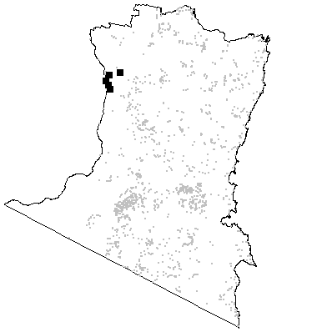

Map Unit 22B: Numeralla Dry Grass Woodland

Species richness: 13 ± 3 (0.04 ha)
Extant area: 8 248 ha
Proportion cleared: 31%
Number of samples: 3

Table A22B.1. Diagnostic plant species of Map Unit 22B.

Species | Target frequency | Target C/A | Residual frequency | Residual C/A | Fidelity class
Acacia falciformis | 1 | 2(2-2) | 0.188 | 2(1-3) | positive
Chrysocephalum semipapposum | 1 | 3(2-3) | 0.008 | 1(1-2) | positive
Eucalyptus dives | 1 | 3(3-3) | 0.01 | 3(2-3) | positive
Exocarpos strictus | 0.667 | 2(2-2) | 0.17 | 1(1-2) | positive
Gompholobium huegelii | 0.667 | 2(2-2) | 0.015 | 1(1-1) | positive
Leucopogon hookeri | 0.333 | 2(2-2) | 0 | 0(0-0) | positive
Persoonia rigida | 0.333 | 2(2-2) | 0 | 0(0-0) | positive
Poa meionectes | 1 | 2(2-3) | 0.538 | 2(1-3) | constant
Acacia dealbata | 0.667 | 1.5(1-2) | 0.137 | 2(1-3) | frequent
Acaena novae-zelandiae | 1 | 1(1-2) | 0.13 | 1(1-2) | frequent
Lomandra longifolia | 1 | 1(1-2) | 0.548 | 2(1-2) | frequent
Eucalyptus dalrympleana ssp dalrympleana | 0.3333 | 1(1-1) | 0.01868 | 3(1-3) | uninformative
Eucalyptus pauciflora | 0.3333 | 1(1-1) | 0.02253 | 2(1-3) | uninformative
Pteridium esculentum | 0 | 0(2-0) | 0.578 | 2(1-3) | negative

Table A22B.2. Vegetation structure of Map Unit 22B. Frequency is the proportion of samples in which strata were present. Height and cover data are means with standard errors in parentheses (n=3).

Stratum | Frequency (%) | Height (m) | Cover (%)
Tree | 100 | 14.3(0.7) | 20(0)
Small tree | 33.3 | 6.0(-) | 5(-)
Shrub | 100 | 2.2(0.9) | 25(8)
Ground cover | 100 | 0.3(0.1) | 20(6)

Table A22B.3. Habitat characteristics of Map Unit 22B. Means and interquartile ranges for altitude and slope were calculated from n field samples, while those for annual rain were calculated from ESOCLIM predictions (see Table 5, text). Frequency terrain and parent material refers to number of samples (n) recorded in respective classes. Terrain classes: flat (slope≤5°); north (slope>5° and aspect<30° or >300°); intermediate (slope>5° and aspect 30-120° or 210-300°); and south (slope>5° and aspect 120-210°).

 |  | Frequency (%) | Mean | Interquartile Range | n
Annual rain (mm) |  |  |  | 658 | 647 - 677 | 3
Altitude (m) |  |  |  | 1003 | 970 - 1050 | 3
Slope (degrees) |  |  |  | 17 | 11 - 22 | 3
Terrain class
 | North | 0 |  |  | 0
 | Intermediate | 33 |  |  | 1
 | South | 67 |  |  | 2
 | Flat | 0 |  |  | 0
Parent material
 | Low quartz sedimentaries | 100 |  |  | 3

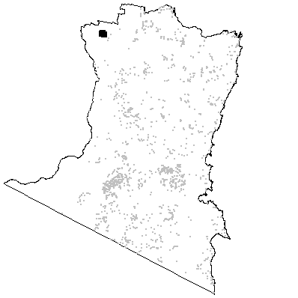

Map Unit 23A: Monaro Grassland

Species richness: 11.0 ± 2.5 (0.01ha)
Extant area: 334 ha
Proportion cleared: 95%
Number of samples: 5

Table A23A.1. Diagnostic plant species of Map Unit 23A.

Species | Target frequency | Target C/A | Fidelity class
Poa sieberiana | 0.6 | 3(2-4) | positive
Acaena ovina | 0.6 | 1(1-1) | positive
Poa labillardieri | 0.4 | 5(5-5) | positive
Themeda australis | 0.4 | 4(2-6) | positive
Geranium antrorsum | 0.4 | 2.5(1-4) | positive
Asperula conferta | 0.4 | 2(2-2) | positive
Chrysocephalum apiculatum | 0.4 | 2(2-2) | positive
Leptorhynchos squamatus | 0.4 | 1.5(1-2) | positive
Plantago varia | 0.4 | 1.5(1-2) | positive
Carex inversa | 0.4 | 1(1-1) | positive
Danthonia caespitosa | 0.4 | 1(1-1) | positive
Elymus scaber | 0.4 | 1(1-1) | positive
Psoralea tenax | 0.4 | 1(1-1) | positive
Pimelea glauca | 0.2 | 3(3-3) | positive
Poa meionectes | 0.2 | 3(3-3) | positive
Bothriochloa macra | 0.2 | 2(2-2) | positive
Carex appressa | 0.2 | 2(2-2) | positive
Danthonia monticola | 0.2 | 2(2-2) | positive
Helichrysum scorpioides | 0.2 | 2(2-2) | positive
Juncus filicaulis | 0.2 | 2(2-2) | positive
Schoenus apogon | 0.2 | 2(2-2) | positive
Scleranthus biflorus | 0.2 | 2(2-2) | positive
Scleranthus diander | 0.2 | 2(2-2) | positive
Acaena novae-zelandiae | 0.2 | 1(1-1) | positive
Agrostis avenacea var avenacea | 0.2 | 1(1-1) | positive
Carex longebrachiata | 0.2 | 1(1-1) | positive
Convolvulus erubescens | 0.2 | 1(1-1) | positive
Crassula sieberiana | 0.2 | 1(1-1) | positive
Danthonia pilosa | 0.2 | 1(1-1) | positive
Desmodium varians | 0.2 | 1(1-1) | positive
Enneapogon nigricans | 0.2 | 1(1-1) | positive
Epilobium billardierianum | 0.2 | 1(1-1) | positive
Geranium retrorsum | 0.2 | 1(1-1) | positive
Haloragis heterophylla | 0.2 | 1(1-1) | positive
Luzula densiflora | 0.2 | 1(1-1) | positive
Oreomyrrhis eriopoda | 0.2 | 1(1-1) | positive
Ranunculus lappaceus | 0.2 | 1(1-1) | positive
Swainsona behriana | 0.2 | 1(1-1) | positive
Vittadinia muelleri | 0.2 | 1(1-1) | positive
Wahlenbergia communis | 0.2 | 1(1-1) | positive

Table A23A.2. Vegetation structure of Map Unit 23A. Frequency is the proportion of samples in which strata were present. Height and cover data are means with standard errors in parentheses (n=5).

Stratum | Frequency | Height (m) | Cover (%)
Tree | 0 | - | -
Small tree | 0 | - | -
Shrub | 0 | - | -
Ground cover | 100 | 0.5(0.1) | 81(6)

Table A23A.3. Habitat characteristics of Map Unit 23A. Means and interquartile ranges for altitude and slope were calculated from n field samples, while those for annual rain were calculated from ESOCLIM predictions (see Table 5, text). Frequency terrain and parent material refers to number of samples (n) recorded in respective classes. Terrain classes: flat (slope≤5°); north (slope>5° and aspect<30° or >300°); intermediate (slope>5° and aspect 30-120° or 210-300°); and south (slope>5° and aspect 120-210°).

 |  | Frequency (%) | Mean | Interquartile Range | n
Annual rain (mm) |  |  |  | - | - | 0
Altitude (m) |  |  |  | 982 | 930 - 1020 | 5
Slope (degrees) |  |  |  | 3 | 2 - 5 | 5
Terrain class
 | North | 0 |  |  | 0
 | Intermediate | 20 |  |  | 1
 | South | 20 |  |  | 1
 | Flat | 60 |  |  | 3
Parent material
 | Devonian granitoids | 40 |  |  | 2
 | Tertiary Basalt | 60 |  |  | 3

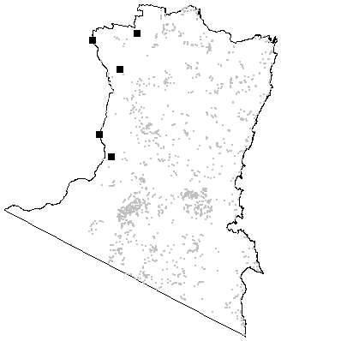

Map Unit 23B: Monaro Basalt Grass Woodland

Species richness: 17 ± 3 (0.04 ha)
Extant area: 3 406 ha
Proportion cleared: 86%
Number of samples: 14

Table A23B.1. Diagnostic plant species of Map Unit 23B.

Species | Target frequency | Target C/A | Residual frequency | Residual C/A | Fidelity class
Acaena novae-zelandiae | 0.5 | 2(2-2) | 0.128 | 1(1-2) | positive
Asperula conferta | 0.786 | 2(2-3) | 0.021 | 1(1-1) | positive
Bothriochloa macra | 0.071 | 3(3-3) | 0 | 0(0-0) | positive
Chrysocephalum apiculatum | 0.357 | 2(2-3) | 0 | 0(0-0) | positive
Discaria pubescens | 0.143 | 1(1-1) | 0 | 0(0-0) | positive
Eucalyptus pauciflora | 0.643 | 3(2-3) | 0.017 | 1(1-3) | positive
Festuca asperula | 0.071 | 1(1-1) | 0 | 0(0-0) | positive
Leptorhynchos squamatus | 0.143 | 1(1-1) | 0 | 0(0-0) | positive
Poa sieberiana var sieberiana | 0.714 | 3(3-4) | 0.064 | 1(1-2) | positive
Psoralea adscendens | 0.5 | 2(1-2) | 0.001 | 1.5(1-2) | positive
Sorghum leiocladum | 0.286 | 1(1-2) | 0 | 0(0-0) | positive
Stipa blackii | 0.071 | 1(1-1) | 0 | 0(0-0) | positive
Themeda australis | 0.857 | 3(2-3) | 0.107 | 2(1-3) | positive
Trachymene humilis | 0.071 | 1(1-1) | 0 | 0(0-0) | positive
Wahlenbergia planiflora ssp planiflora | 0.143 | 1(1-1) | 0 | 0(0-0) | positive
Acacia melanoxylon | 0.357 | 1(1-1) | 0.103 | 1(1-3) | uninformative
Eucalyptus cypellocarpa | 0.071 | 3(3-3) | 0.316 | 3(2-3) | uninformative
Eucalyptus dalrympleana ssp dalrympleana | 0.071 | 3(3-3) | 0.018 | 2.5(1-3) | uninformative
Eucalyptus radiata | 0.071 | 3(3-3) | 0.077 | 3(1-3) | uninformative
Eucalyptus stellulata | 0.143 | 2.5(2-3) | 0.001 | 1(1-1) | uninformative
Eucalyptus viminalis | 0.429 | 3(3-3) | 0.054 | 3(1-3) | uninformative
Lomandra longifolia | 0.071 | 1(1-1) | 0.554 | 2(1-2) | negative
Poa meionectes | 0.357 | 3(3-4) | 0.541 | 2(1-3) | negative
Pteridium esculentum | 0 | 0(2-0) | 0.582 | 2(1-3) | negative

Table A23B.2. Vegetation structure of Map Unit 23B. Frequency is the proportion of samples in which strata were present. Height and cover data are means with standard errors in parentheses (n=5).

Stratum | Frequency (%) | Height (m) | Cover (%)
Tree | 100 | 16.4(3.9) | 17(3)
Small tree | 0 | -(-) | -(-)
Shrub | 80 | 3.6(1.0) | 11(6)
Ground cover | 100 | 0.6(0.1) | 49(11)

Table A23B.3. Habitat characteristics of Map Unit 23B. Means and interquartile ranges for altitude and slope were calculated from n field samples, while those for annual rain were calculated from ESOCLIM predictions (see Table 5, text). Frequency terrain and parent material refers to number of samples (n) recorded in respective classes. Terrain classes: flat (slope≤5°); north (slope>5° and aspect<30° or >300°); intermediate (slope>5° and aspect 30-120° or 210-300°); and south (slope>5° and aspect 120-210°).

 |  | Frequency (%) | Mean | Interquartile Range | n
Annual rain (mm) |  |  |  | 762 | 732 - 790 | 14
Altitude (m) |  |  |  | 938 | 823 - 1070 | 14
Slope (degrees) |  |  |  | 9 | 3 - 11 | 6
Terrain class
 | North | 0 |  |  | 0
 | Intermediate | 17 |  |  | 1
 | South | 33 |  |  | 2
 | Flat | 50 |  |  | 3
Parent material
 | Ordovician high quartz sedimentaries | 14 |  |  | 2
 | Tertiary Alluvium | 7 |  |  | 1
 | Tertiary Basalt | 79 |  |  | 11

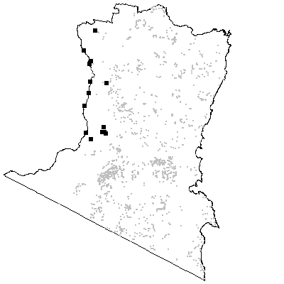

MAP UNIT 24: Subalpine Dry Shrub Forest

Species richness: 26 ± 2 (0.04 ha)
Extant area: 26 604 ha
Proportion cleared: 72%
Number of samples: 32

Table A24.1. Diagnostic plant species of Map Unit 24.

Species | Target frequency | Target C/A | Residual frequency | Residual C/A | Fidelity class
Eucalyptus dalrympleana ssp dalrympleana | 0.5 | 3(2-3) | 0.012 | 2(1-3) | positive
Eucalyptus radiata | 0.5 | 3(2-3) | 0.071 | 3(1-3) | positive
Gonocarpus tetragynus | 0.6 | 2(1-2) | 0.16 | 2(1-2) | positive
Monotoca scoparia | 0.55 | 2(2-3) | 0.12 | 2(1-2) | positive
Lomandra longifolia | 0.7 | 2(2-3) | 0.547 | 2(1-2) | constant
Poa meionectes | 0.7 | 2.5(2-4) | 0.537 | 2(1-3) | constant
Acacia dealbata | 0.35 | 1(1-2) | 0.135 | 2(1-3) | uninformative
Bossiaea foliosa | 0.45 | 3(2-4) | 0.012 | 1(1-2) | uninformative
Eucalyptus cypellocarpa | 0.15 | 2(1-3) | 0.316 | 3(2-3) | uninformative
Eucalyptus dives | 0.35 | 3(3-3) | 0.006 | 3(1-3) | uninformative
Eucalyptus fastigata | 0.05 | 1(1-1) | 0.142 | 3(3-4) | uninformative
Eucalyptus globoidea | 0.05 | 2(2-2) | 0.245 | 3(1-3) | uninformative
Eucalyptus obliqua | 0.05 | 3(3-3) | 0.192 | 3(2-4) | uninformative
Eucalyptus ovata | 0.1 | 2(2-2) | 0.022 | 3(1-3) | uninformative
Eucalyptus pauciflora | 0.45 | 2(1-3) | 0.017 | 2(1-3) | uninformative
Eucalyptus rubida | 0.1 | 2(1-3) | 0.006 | 1(1-3) | uninformative
Eucalyptus sp. aff. radiata | 0.05 | 3(3-3) | 0.035 | 3(2-3) | uninformative
Eucalyptus stellulata | 0.05 | 1(1-1) | 0.001 | 2.5(2-3) | uninformative
Eucalyptus viminalis | 0.45 | 3(3-4) | 0.052 | 3(1-3) | uninformative
Oxylobium procumbens | 0.3 | 1.5(1-2) | 0.007 | 2(1-2) | uninformative
Persoonia chamaepeuce | 0.3 | 1(1-2) | 0.007 | 1.5(1-2) | uninformative
Poa sieberiana | 0.3 | 3(3-4) | 0.014 | 1(1-3) | uninformative
Pteridium esculentum | 0.25 | 2(1-2) | 0.581 | 2(1-3) | negative

Table A24.2. Vegetation structure of Map Unit 24. Frequency is the proportion of samples in which strata were present. Height and cover data are means with standard errors in parentheses (n=15).

Stratum | Frequency (%) | Height (m) | Cover (%)
Tree | 100 | 18.6(1.3) | 29(2)
Small tree | 6.7 | 10.0(-) | 10(-)
Shrub | 100 | 1.7(0.2) | 28(5)
Ground cover | 100 | 0.3(0.0) | 32(7)

Table A24.3. Habitat characteristics of Map Unit 24. Means and interquartile ranges for altitude and slope were calculated from n field samples, while those for annual rain were calculated from ESOCLIM predictions (see Table 5, text). Frequency terrain and parent material refers to number of samples (n) recorded in respective classes. Terrain classes: flat (slope≤5°); north (slope>5° and aspect<30° or >300°); intermediate (slope>5° and aspect 30-120° or 210-300°); and south (slope>5° and aspect 120-210°).

 |  | Frequency (%) | Mean | Interquartile Range | n
Annual rain (mm) |  |  |  | 846 | 787 - 917 | 32
Altitude (m) |  |  |  | 924 | 785 - 1020 | 30
Slope (degrees) |  |  |  | 8 | 2 - 11 | 30
Terrain class
 | North | 7 |  |  | 2
 | Intermediate | 30 |  |  | 9
 | South | 17 |  |  | 5
 | Flat | 47 |  |  | 14
Parent material
 | Devonian granitoids | 53 |  |  | 17
 | Devonian high quartz sedimentaries | 6 |  |  | 2
 | Low quartz sedimentaries | 13 |  |  | 4
 | Ordovician high quartz sedimentaries | 22 |  |  | 7
 | Tertiary Basalt | 6 |  |  | 2

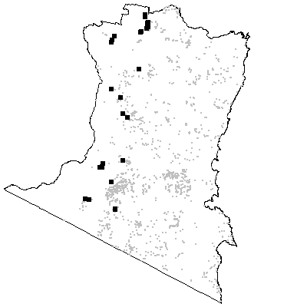

MAP UNIT 25: Sandstone Dry Shrub Forest

Species richness: 22 ± 1 (0.04 ha)
Extant area: 822 ha
Proportion cleared: 28%
Number of samples: 10

Table A25.1. Diagnostic plant species of Map Unit 25.

Species | Target frequency | Target C/A | Residual frequency | Residual C/A | Fidelity class
Acacia mucronata | 0.8 | 4(2-4) | 0.049 | 1(1-3) | positive
Amperea xiphoclada | 0.6 | 2(1-2) | 0.057 | 1(1-2) | positive
Dianella tasmanica | 0.5 | 2(2-3) | 0.233 | 1(1-2) | positive
Epacris impressa | 0.9 | 3(2-3) | 0.192 | 2(1-2) | positive
Eucalyptus obliqua | 0.7 | 3(1-3) | 0.186 | 3(2-4) | positive
Eucalyptus sp. aff. radiata | 0.5 | 3(2-3) | 0.032 | 3(2-3) | positive
Platysace lanceolata | 0.9 | 2(2-3) | 0.247 | 2(1-2) | positive
Tetrarrhena juncea | 0.5 | 2(2-3) | 0.18 | 2(1-3) | positive
Viola hederacea ssp hederacea | 0.5 | 2(1-2) | 0.437 | 2(1-2) | positive
Lomandra longifolia | 1 | 3(3-4) | 0.546 | 2(1-2) | constant
Poa meionectes | 0.7 | 2(1-4) | 0.538 | 2(1-3) | constant
Pteridium esculentum | 0.8 | 2.5(2-4) | 0.575 | 2(1-3) | constant
Gonocarpus teucrioides | 0.6 | 1.5(1-2) | 0.314 | 2(1-2) | frequent
Lomatia ilicifolia | 0.8 | 1(1-1) | 0.127 | 1(1-2) | frequent
Oxylobium arborescens | 0.6 | 1.5(1-3) | 0.014 | 2(1-3) | frequent
Eucalyptus angophoroides | 0.1 | 3(3-3) | 0.044 | 2(1-3) | uninformative
Eucalyptus consideniana | 0.1 | 4(4-4) | 0.021 | 2(1-3) | uninformative
Eucalyptus cypellocarpa | 0.2 | 3(3-3) | 0.315 | 3(2-3) | uninformative
Eucalyptus elata | 0.1 | 3(3-3) | 0.113 | 3(2-3) | uninformative
Eucalyptus globoidea | 0.1 | 2(2-2) | 0.244 | 3(1-3) | uninformative
Eucalyptus mackintii | 0.1 | 4(4-4) | 0.003 | 3(3-4) | uninformative
Eucalyptus radiata | 0.2 | 2(2-2) | 0.076 | 3(1-3) | uninformative
Eucalyptus sieberi | 0.4 | 3(2-4) | 0.282 | 3(2-4) | uninformative

Table A25.2. Vegetation structure of Map Unit 25. Frequency is the proportion of samples in which strata were present. Height and cover data are means with standard errors in parentheses (n=10).

Stratum | Frequency (%) | Height (m) | Cover (%)
Tree | 100 | 21.4(2.1) | 30(4)
Small tree | 0 | -(-) | -(-)
Shrub | 100 | 1.6(0.2) | 38(6)
Ground cover | 100 | 0.5(0.1) | 44(6)

Table A25.3. Habitat characteristics of Map Unit 25. Means and interquartile ranges for altitude and slope were calculated from n field samples, while those for annual rain were calculated from ESOCLIM predictions (see Table 5, text). Frequency terrain and parent material refers to number of samples (n) recorded in respective classes. Terrain classes: flat (slope≤5°); north (slope>5° and aspect<30° or >300°); intermediate (slope>5° and aspect 30-120° or 210-300°); and south (slope>5° and aspect 120-210°). Note extreme values for one sample have been ommitted from the annual rain (955 mm) and altitude (380 m) summary statistics.

 |  | Frequency (%) | Mean | Interquartile Range | n
Annual rain (mm) |  |  |  | 1200 | 1193 - 1230 | 9*
Altitude (m) |  |  |  | 850 | 830 - 980 | 9*
Slope (degrees) |  |  |  | 6 | 2 - 7 | 10
Terrain class
 | North | 10 |  |  | 1
 | Intermediate | 40 |  |  | 4
 | South | 0 |  |  | 0
Flat |  | 50 |  |  | 5
 | Parent material
 | Devonian granitoids | 10 |  |  | 1
 | Devonian high quartz sedimentaries | 80 |  |  | 8
 | Ordovician high quartz sedimentaries | 10 |  |  | 1

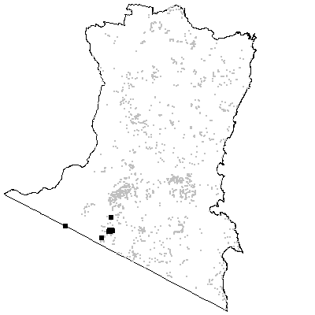

MAP UNIT 26: Tableland Dry Shrub Forest

Species richness: 32± 2 (0.04 ha)
Extant area: 16 115 ha
Proportion cleared: 43%
Number of samples: 34

Table A26.1. Diagnostic plant species of Map Unit 26.

Species | Target frequency | Target C/A | Residual frequency | Residual C/A | Fidelity class
Dichelachne rara | 0.5 | 2(1-2) | 0.162 | 1(1-2) | positive
Epacris impressa | 0.853 | 2(1-2) | 0.181 | 2(1-2) | positive
Eucalyptus cypellocarpa | 0.5 | 3(2-3) | 0.31 | 3(2-3) | positive
Eucalyptus globoidea | 0.677 | 3(2-3) | 0.232 | 3(1-3) | positive
Eucalyptus radiata | 0.588 | 3(2-3) | 0.065 | 3(1-3) | positive
Gonocarpus tetragynus | 0.5 | 2(1-2) | 0.158 | 2(1-2) | positive
Helichrysum rutidolepis | 0.029 | 2(2-2) | 0 | 0(0-0) | positive
Leucopogon lanceolatus var lanceolatus | 0.824 | 2(1-2) | 0.396 | 1(1-2) | positive
Microtis parviflora | 0.029 | 1(1-1) | 0 | 0(0-0) | positive
Viola hederacea ssp hederacea | 0.588 | 2(1-2) | 0.434 | 2(1-2) | positive
Lomandra longifolia | 1 | 2(2-2) | 0.538 | 2(1-2) | constant
Poa meionectes | 0.971 | 2(2-3) | 0.529 | 2(1-3) | constant
Pteridium esculentum | 0.677 | 2(2-3) | 0.574 | 2(1-3) | constant
Dianella caerulea | 0.882 | 1(1-2) | 0.264 | 1(1-2) | frequent
Hibbertia obtusifolia | 0.677 | 1(1-2) | 0.073 | 1(1-2) | frequent
Microlaena stipoides var stipoides | 0.647 | 1(1-2) | 0.347 | 2(1-2) | frequent
Monotoca scoparia | 0.618 | 1(1-2) | 0.114 | 2(1-2) | frequent
Eucalyptus angophoroides | 0.265 | 3(2-4) | 0.039 | 2(1-3) | uninformative
Eucalyptus croajingolensis | 0.059 | 3(3-3) | 0.001 | 2(2-2) | uninformative
Eucalyptus dalrympleana ssp dalrympleana | 0.177 | 2.5(1-3) | 0.015 | 3(1-3) | uninformative
Eucalyptus dives | 0.029 | 3(3-3) | 0.01 | 3(2-3) | uninformative
Eucalyptus elata | 0.029 | 1(1-1) | 0.115 | 3(2-3) | uninformative
Eucalyptus mackintii | 0.029 | 3(3-3) | 0.003 | 3(3-4) | uninformative
Eucalyptus muelleriana | 0.029 | 3(3-3) | 0.145 | 3(2-4) | uninformative
Eucalyptus obliqua | 0.265 | 3(2-3) | 0.188 | 3(2-4) | uninformative
Eucalyptus ovata | 0.059 | 1(1-1) | 0.022 | 3(1-3) | uninformative
Eucalyptus polyanthemos ssp vestita | 0.029 | 1(1-1) | 0.014 | 2(2-3) | uninformative
Eucalyptus sieberi | 0.235 | 3(2-3) | 0.284 | 3(2-4) | uninformative
Eucalyptus sp. aff. radiata | 0.088 | 4(3-4) | 0.034 | 3(2-3) | uninformative
Eucalyptus viminalis | 0.206 | 1(1-3) | 0.054 | 3(1-3) | uninformative

Table A26.2. Vegetation structure of Map Unit 26. Frequency is the proportion of samples in which strata were present. Height and cover data are means with standard errors in parentheses (n=29).

Stratum | Frequency (%) | Height (m) | Cover (%)
Tree | 100 | 28.6(1.0) | 29(2)
Small tree | 37.9 | 8.0(0.9) | 18(3)
Shrub | 100 | 2.1(0.2) | 27(4)
Ground cover | 100 | 0.5(0.0) | 18(2)

Table A26.3. Habitat characteristics of Map Unit 26. Means and interquartile ranges for altitude and slope were calculated from n field samples, while those for annual rain were calculated from ESOCLIM predictions (see Table 5, text). Frequency terrain and parent material refers to number of samples (n) recorded in respective classes. Terrain classes: flat (slope≤5°); north (slope>5° and aspect<30° or >300°); intermediate (slope>5° and aspect 30-120° or 210-300°); and south (slope>5° and aspect 120-210°).

 |  | Frequency (%) | Mean | Interquartile Range | n
Annual rain (mm) |  |  |  | 972 | 944 - 1002 | 34
Altitude (m) |  |  |  | 549 | 383 - 714 | 34
Slope (degrees) |  |  |  | 8 | 3 - 10 | 34
Terrain class
 | North | 21 |  |  | 7
 | Intermediate | 29 |  |  | 10
 | South | 18 |  |  | 6
 | Flat | 32 |  |  | 11
Parent material
 | Devonian granitoids | 74 |  |  | 25
 | Devonian high quartz sedimentaries | 9 |  |  | 3
 | Ordovician high quartz sedimentaries | 18 |  |  | 6

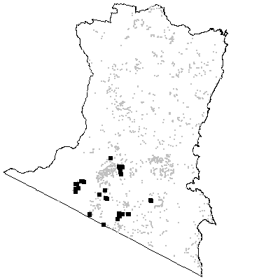
MAP UNIT 27: Waalimma Dry Grass Forest

Species richness: 38 ± 2 (0.04 ha)
Extant area: 1 324 ha
Proportion cleared: 0%
Number of samples: 5

Table A27.1. Diagnostic plant species of Map Unit 27.

Species | Target frequency | Target C/A | Residual frequency | Residual C/A | Fidelity class
Acacia mucronata | 0.6 | 3(1-3) | 0.052 | 1(1-3) | positive
Astroloma humifusum | 1 | 2(1-4) | 0.05 | 1(1-2) | positive
Epacris impressa | 0.6 | 3(3-3) | 0.195 | 2(1-2) | positive
Eucalyptus angophoroides | 0.8 | 2.5(1-3) | 0.042 | 2(1-3) | positive
Eucalyptus globoidea | 0.8 | 2(2-3) | 0.241 | 3(1-3) | positive
Eucalyptus sieberi | 0.6 | 2(1-3) | 0.282 | 3(2-4) | positive
Eucalyptus tricarpa | 0.6 | 3(3-4) | 0.02 | 2(1-3) | positive
Gahnia radula | 1 | 3(3-4) | 0.088 | 2(1-3) | positive
Gonocarpus tetragynus | 0.6 | 2(2-2) | 0.164 | 2(1-2) | positive
Helichrysum scorpioides | 0.8 | 2(1-2) | 0.13 | 1(1-2) | positive
Lepidosperma laterale | 1 | 2(1-2) | 0.342 | 1(1-2) | positive
Lissanthe strigosa | 1 | 2(1-3) | 0.009 | 1(1-3) | positive
Lomandra filiformis ssp flavior | 0.6 | 2(1-3) | 0.017 | 1(1-2) | positive
Pultenaea scabra var scabra | 0.6 | 2(1-3) | 0.005 | 2(1-3) | positive
Themeda australis | 1 | 2(1-3) | 0.111 | 2(1-3) | positive
Billardiera scandens | 0.8 | 1.5(1-2) | 0.327 | 1(1-1) | frequent
Bossiaea prostrata | 0.8 | 1.5(1-2) | 0.027 | 1(1-1) | frequent
Burchardia umbellata | 0.6 | 1(1-1) | 0.019 | 1(1-2) | frequent
Deyeuxia quadriseta | 0.6 | 1(1-1) | 0.041 | 1(1-1) | frequent
Dianella caerulea | 0.8 | 1.5(1-2) | 0.277 | 1(1-2) | frequent
Dianella revoluta var revoluta | 0.6 | 1(1-2) | 0.08 | 1(1-1) | frequent
Dichelachne micrantha | 0.6 | 1(1-2) | 0.084 | 1(1-2) | frequent
Dichelachne rara | 0.6 | 1(1-2) | 0.168 | 1(1-2) | frequent
Eucalyptus polyanthemos ssp vestita | 0.6 | 1(1-3) | 0.011 | 2.5(2-3) | frequent
Hibbertia empetrifolia | 0.6 | 1(1-2) | 0.063 | 1(1-2) | frequent
Hypericum gramineum | 0.8 | 1(1-2) | 0.24 | 1(1-2) | frequent
Lomandra multiflora | 1 | 1(1-2) | 0.249 | 1(1-2) | frequent
Eucalyptus agglomerata | 0.4 | 2(1-3) | 0.108 | 3(2-3) | uninformative
Eucalyptus bosistoana | 0.2 | 4(4-4) | 0.052 | 2(1-3) | uninformative
Lomandra longifolia | 0.4 | 2(1-3) | 0.549 | 2(1-2) | negative
Poa meionectes | 0.4 | 3.5(3-4) | 0.539 | 2(1-3) | negative
Pteridium esculentum | 0.2 | 1(1-1) | 0.578 | 2(1-3) | negative

Table A27.2. Vegetation structure of Map Unit 27. Frequency is the proportion of samples in which strata were present. Height and cover data are means with standard errors in parentheses (n=5).

Stratum | Frequency (%) | Height (m) | Cover (%)
Tree | 100 | 22.6(2.2) | 25(3)
Small tree | 20 | 12.0(-) | 20(-)
Shrub | 100 | 1.6(0.2) | 29(7)
Ground cover | 100 | 0.5(0.0) | 58(6)

Table A27.3. Habitat characteristics of Map Unit 27. Means and interquartile ranges for altitude and slope were calculated from n field samples, while those for annual rain were calculated from ESOCLIM predictions (see Table 5, text). Frequency terrain and parent material refers to number of samples (n) recorded in respective classes. Terrain classes: flat (slope≤5°); north (slope>5° and aspect<30° or >300°); intermediate (slope>5° and aspect 30-120° or 210-300°); and south (slope>5° and aspect 120-210°).

 |  | Frequency (%) | Mean | Interquartile Range | n
Annual rain (mm) |  |  |  | 1036 | 1018 - 1040 | 5
Altitude (m) |  |  |  | 405 | 370 - 405 | 5
Slope (degrees) |  |  |  | 8 | 6 - 9 | 5
Terrain class
 | North | 20 |  |  | 1
 | Intermediate | 40 |  |  | 2
 | South | 40 |  |  | 2
 | Flat | 0 |  |  | 0
Parent material
 | Devonian granitoids | 60 |  |  | 3
 | Ordovician high quartz sedimentaries | 40 |  |  | 2

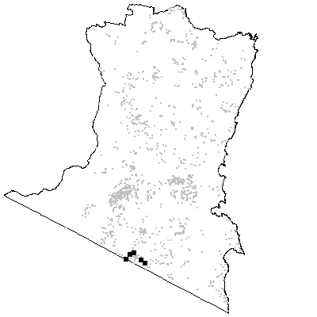
MAP UNIT 28: Wog Wog Dry Grass Forest

Species richness: 34 ± 2 (0.1 ha)
Extant area: 922 ha
Proportion cleared: 29%
Number of samples: 10

Table A28.1. Diagnostic plant species of Map Unit 28.

Species | Target frequency | Target C/A | Residual frequency | Residual C/A | Fidelity class
Ajuga australis | 0.5 | 2(2-2) | 0.04 | 1(1-1) | positive
Eucalyptus agglomerata | 0.9 | 3(3-4) | 0.103 | 3(2-3) | positive
Eucalyptus maidenii | 0.9 | 3(2-3) | 0.057 | 3(3-3) | positive
Geranium potentilloides | 0.6 | 2(1-2) | 0.213 | 1(1-2) | positive
Leptospermum parvifolium | 0.2 | 3(2-4) | 0 | 0(0-0) | positive
Poranthera microphylla | 0.9 | 2(1-2) | 0.219 | 1(1-1) | positive
Viola hederacea ssp hederacea | 0.7 | 2(1-2) | 0.436 | 2(1-2) | positive
Poa meionectes | 1 | 5(4-6) | 0.536 | 2(1-3) | constant
Acaena novae-zelandiae | 0.7 | 1(1-1) | 0.128 | 1(1-2) | frequent
Agrostis avenacea | 0.7 | 1(1-2) | 0.023 | 1(1-1) | frequent
Astroloma humifusum | 0.8 | 1(1-2) | 0.048 | 1(1-2) | frequent
Danthonia pilosa var. pilosa | 0.8 | 1(1-2) | 0.06 | 1(1-1) | frequent
Desmodium varians | 0.7 | 1(1-1) | 0.247 | 1(1-2) | frequent
Glycine clandestina | 0.7 | 1(1-2) | 0.325 | 1(1-2) | frequent
Gonocarpus teucrioides | 0.8 | 1(1-2) | 0.313 | 2(1-2) | frequent
Hibbertia obtusifolia | 0.6 | 1(1-2) | 0.083 | 1(1-2) | frequent
Hydrocotyle acutiloba | 0.9 | 1(1-2) | 0.192 | 1(1-2) | frequent
Hypericum gramineum | 0.8 | 1(1-2) | 0.238 | 1(1-2) | frequent
Lagenifera stipitata | 0.8 | 1.5(1-2) | 0.321 | 1(1-2) | frequent
Leucopogon lanceolatus var lanceolatus | 1 | 1.5(1-2) | 0.402 | 1(1-2) | frequent
Lomandra multiflora | 0.6 | 1(1-2) | 0.249 | 1(1-2) | frequent
Oxalis perennans | 0.7 | 1(1-2) | 0.219 | 1(1-1) | frequent
Plantago debilis | 0.7 | 1(1-2) | 0.109 | 1(1-1) | frequent
Senecio linearifolius | 0.9 | 1(1-2) | 0.235 | 1(1-2) | frequent
Senecio sp. E | 0.6 | 1(1-2) | 0.19 | 1(1-2) | frequent
Wahlenbergia gracilis | 0.6 | 1(1-1) | 0.135 | 1(1-1) | frequent
Wahlenbergia stricta ssp stricta | 0.7 | 1(1-2) | 0.069 | 1(1-1) | frequent
Eucalyptus angophoroides | 0.4 | 1(1-3) | 0.042 | 2(1-3) | uninformative
Eucalyptus dalrympleana ssp dalrympleana | 0.1 | 1(1-1) | 0.018 | 3(1-3) | uninformative
Eucalyptus elata | 0.1 | 2(2-2) | 0.113 | 3(2-3) | uninformative
Eucalyptus globoidea | 0.1 | 4(4-4) | 0.244 | 3(1-3) | uninformative
Eucalyptus muelleriana | 0.1 | 1(1-1) | 0.142 | 3(2-4) | uninformative
Eucalyptus sieberi | 0.1 | 2(2-2) | 0.284 | 3(2-4) | uninformative
Lomandra longifolia | 0.4 | 2.5(1-3) | 0.55 | 2(1-2) | negative
Pteridium esculentum | 0.4 | 2(1-2) | 0.578 | 2(1-3) | negative

Table A28.2. Vegetation structure of Map Unit 28. Frequency is the proportion of samples in which strata were present. Height and cover data are means with standard errors in parentheses (n=10).

Stratum | Frequency (%) | Height (m) | Cover (%)
Tree | 100 | 28.5(1.1) | 34(3)
Small tree | 30 | 6.3(0.9) | 11(5)
Shrub | 100 | 2.5(0.4) | 14(5)
Ground cover | 100 | 0.4(0.1) | 69(8)

Table A28.3. Habitat characteristics of Map Unit 28. Means and interquartile ranges for altitude and slope were calculated from n field samples, while those for annual rain were calculated from ESOCLIM predictions (see Table 5, text). Frequency terrain and parent material refers to number of samples (n) recorded in respective classes. Terrain classes: flat (slope≤5°); north (slope>5° and aspect<30° or >300°); intermediate (slope>5° and aspect 30-120° or 210-300°); and south (slope>5° and aspect 120-210°).

 |  | Frequency (%) | Mean | Interquartile Range | n
Annual rain (mm) |  |  |  | 920 | 916 - 927 | 10
Altitude (m) |  |  |  | 467 | 453 - 480 | 10
Slope (degrees) |  |  |  | 9 | 8 - 10 | 10
Terrain class
 | North | 10 |  |  | 1
 | Intermediate | 50 |  |  | 5
 | South | 30 |  |  | 3
 | Flat | 10 |  |  | 1
Parent material
 | Devonian granitoids | 100 |  |  | 10

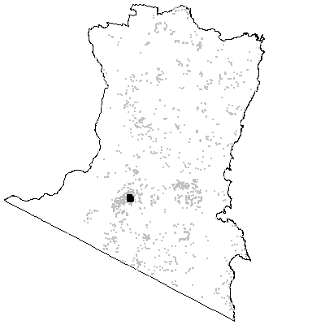
MAP UNIT 29: Nalbaugh Dry Grass Forest

Species richness: 39 ± 3 (0.1 ha)
Extant area: 1 936 ha
Proportion cleared: 25%
Number of samples: 17

Table A29.1. Diagnostic plant species of Map Unit 29.

Species | Target frequency | Target C/A | Residual frequency | Residual C/A | Fidelity class
Cassinia aculeata | 0.824 | 2.5(1-3) | 0.155 | 1(1-2) | positive
Dillwynia retorta | 0.059 | 3(3-3) | 0 | 0(0-0) | positive
Drosera glanduligera | 0.059 | 1(1-1) | 0 | 0(0-0) | positive
Eucalyptus cypellocarpa | 0.824 | 3(2-4) | 0.308 | 3(2-3) | positive
Eucalyptus globoidea | 0.941 | 4(3-4) | 0.234 | 3(1-3) | positive
Gonocarpus tetragynus | 0.529 | 2(2-3) | 0.162 | 2(1-2) | positive
Viola hederacea ssp hederacea | 0.765 | 2(1-2) | 0.434 | 2(1-2) | positive
Lomandra longifolia | 0.941 | 2(2-3) | 0.544 | 2(1-2) | constant
Poa meionectes | 0.882 | 3(2-4) | 0.535 | 2(1-3) | constant
Epacris impressa | 0.765 | 1(1-2) | 0.19 | 2(1-2) | frequent
Geranium potentilloides | 0.647 | 1(1-1) | 0.211 | 1(1-2) | frequent
Helichrysum scorpioides | 0.647 | 1(1-2) | 0.126 | 1(1-2) | frequent
Hydrocotyle acutiloba | 0.765 | 1(1-2) | 0.19 | 1(1-2) | frequent
Lagenifera stipitata | 0.941 | 1(1-2) | 0.317 | 1(1-2) | frequent
Leucopogon lanceolatus var lanceolatus | 0.882 | 1(1-2) | 0.4 | 1(1-2) | frequent
Luzula flaccida | 0.882 | 1(1-1) | 0.092 | 1(1-1) | frequent
Microlaena stipoides var stipoides | 0.706 | 1(1-2) | 0.35 | 2(1-2) | frequent
Poranthera microphylla | 0.824 | 1(1-2) | 0.217 | 1(1-1) | frequent
Senecio sp. E | 0.706 | 1(1-1) | 0.187 | 1(1-2) | frequent
Eucalyptus maidenii | 0.059 | 1(1-1) | 0.063 | 3(2-3) | uninformative
Eucalyptus obliqua | 0.059 | 1(1-1) | 0.191 | 3(2-4) | uninformative
Eucalyptus ovata | 0.294 | 1(1-4) | 0.02 | 3(2-3) | uninformative
Eucalyptus radiata | 0.059 | 3(3-3) | 0.077 | 3(1-3) | uninformative
Eucalyptus sieberi | 0.235 | 1(1-3) | 0.283 | 3(2-4) | uninformative
Eucalyptus sp. aff. radiata | 0.471 | 3(2-3) | 0.03 | 3(2-3) | uninformative
Eucalyptus viminalis | 0.177 | 3(1-4) | 0.056 | 3(1-3) | uninformative
Pteridium esculentum | 0.471 | 2(1-3) | 0.578 | 2(1-3) | negative

Table A29.2. Vegetation structure of Map Unit 29. Frequency is the proportion of samples in which strata were present. Height and cover data are means with standard errors in parentheses (n=8).

Stratum | Frequency (%) | Height (m) | Cover (%)
Tree | 100 | 27.1(1.5) | 44(3)
Small tree | 12.5 | 8.0(-) | 20(-)
Shrub | 100 | 3.1(0.3) | 33(7)
Ground cover | 100 | 0.4(0.1) | 47(7)

Table A29.3. Habitat characteristics of Map Unit 29. Means and interquartile ranges for altitude and slope were calculated from n field samples, while those for annual rain were calculated from ESOCLIM predictions (see Table 5, text). Frequency terrain and parent material refers to number of samples (n) recorded in respective classes. Terrain classes: flat (slope≤5°); north (slope>5° and aspect<30° or >300°); intermediate (slope>5° and aspect 30-120° or 210-300°); and south (slope>5° and aspect 120-210°).

 |  | Frequency (%) | Mean | Interquartile Range | n
Annual rain (mm) |  |  |  | 969 | 957 - 987 | 17
Altitude (m) |  |  |  | 606 | 560 - 650 | 17
Slope (degrees) |  |  |  | 9 | 4 - 12 | 17
Terrain class
 | North | 6 |  |  | 1
 | Intermediate | 41 |  |  | 7
 | South | 24 |  |  | 4
 | Flat | 29 |  |  | 5
Parent material
 | Devonian granitoids | 100 |  |  | 17

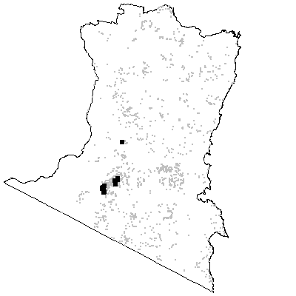
MAP UNIT 30: Wallagaraugh Dry Grass Forest

Species richness: 42 ± 2 (0.04 ha)
Extant area: 914 ha
Proportion cleared: 45%
Number of samples: 17

Table A30.1. Diagnostic plant species of Map Unit 30.

Species | Target frequency | Target C/A | Residual frequency | Residual C/A | Fidelity class
Acacia mearnsii | 0.588 | 2.5(1-4) | 0.158 | 2(1-3) | positive
Bracteantha viscosa | 0.059 | 2(2-2) | 0 | 0(0-0) | positive
Dichondra repens | 0.647 | 2(1-2) | 0.28 | 2(1-2) | positive
Eucalyptus cypellocarpa | 0.647 | 3(2-3) | 0.31 | 3(2-3) | positive
Eucalyptus globoidea | 0.529 | 2(1-3) | 0.239 | 3(1-3) | positive
Microlaena stipoides var stipoides | 0.765 | 2(1-2) | 0.349 | 2(1-2) | positive
Pultenaea polifolia | 0.059 | 1(1-1) | 0 | 0(0-0) | positive
Thelymitra cyanea | 0.059 | 1(1-1) | 0 | 0(0-0) | positive
Viola hederacea ssp hederacea | 0.882 | 2(1-2) | 0.432 | 2(1-2) | positive
Lomandra longifolia | 0.765 | 2(1-5) | 0.546 | 2(1-2) | constant
Poa meionectes | 0.882 | 2(1-2) | 0.535 | 2(1-3) | constant
Pteridium esculentum | 0.706 | 2(1-3) | 0.575 | 2(1-3) | constant
Exocarpos strictus | 0.647 | 1(1-2) | 0.165 | 1(1-2) | frequent
Glycine clandestina | 0.765 | 1(1-2) | 0.322 | 1(1-2) | frequent
Hypericum gramineum | 0.765 | 1(1-2) | 0.236 | 1(1-2) | frequent
Lagenifera stipitata | 0.824 | 1(1-1) | 0.318 | 1(1-2) | frequent
Senecio sp. E | 0.647 | 1(1-2) | 0.188 | 1(1-2) | frequent
Angophora floribunda | 0.059 | 1(1-1) | 0.096 | 2(1-3) | uninformative
Eucalyptus agglomerata | 0.059 | 1(1-1) | 0.109 | 3(2-3) | uninformative
Eucalyptus angophoroides | 0.235 | 2(1-3) | 0.042 | 2(1-3) | uninformative
Eucalyptus bosistoana | 0.118 | 3(2-4) | 0.052 | 2(1-3) | uninformative
Eucalyptus elata | 0.177 | 4(3-4) | 0.112 | 3(2-3) | uninformative
Eucalyptus longifolia | 0.059 | 4(4-4) | 0.03 | 3(2-3) | uninformative
Eucalyptus muelleriana | 0.177 | 3(1-3) | 0.142 | 3(2-4) | uninformative
Eucalyptus obliqua | 0.118 | 2(1-3) | 0.19 | 3(2-4) | uninformative
Eucalyptus ovata | 0.177 | 3(3-4) | 0.021 | 2(1-3) | uninformative
Eucalyptus radiata | 0.353 | 1(1-2) | 0.074 | 3(1-3) | uninformative
Eucalyptus sieberi | 0.059 | 3(3-3) | 0.285 | 3(2-4) | uninformative
Eucalyptus viminalis | 0.294 | 3(1-3) | 0.054 | 3(1-3) | uninformative

Table A30.2. Vegetation structure of Map Unit 30. Frequency is the proportion of samples in which strata were present. Height and cover data are means with standard errors in parentheses (n=11).

Stratum | Frequency (%) | Height (m) | Cover (%)
Tree | 100 | 26.0(3.2) | 25(3)
Small tree | 54.5 | 10.8(1.0) | 24(7)
Shrub | 90.9 | 2.5(0.4) | 28(5)
Ground cover | 100 | 0.4(0.1) | 46(7)

Table A30.3. Habitat characteristics of Map Unit 30. Means and interquartile ranges for altitude and slope were calculated from n field samples, while those for annual rain were calculated from ESOCLIM predictions (see Table 5, text). Frequency terrain and parent material refers to number of samples (n) recorded in respective classes. Terrain classes: flat (slope≤5°); north (slope>5° and aspect<30° or >300°); intermediate (slope>5° and aspect 30-120° or 210-300°); and south (slope>5° and aspect 120-210°).

 |  | Frequency (%) | Mean | Interquartile Range | n
Annual rain (mm) |  |  |  | 949 | 930 - 982 | 17
Altitude (m) |  |  |  | 313 | 230 - 380 | 17
Slope (degrees) |  |  |  | 8 | 2 - 11 | 17
Terrain class
 | North | 18 |  |  | 3
 | Intermediate | 18 |  |  | 3
 | South | 18 |  |  | 3
 | Flat | 47 |  |  | 8
Parent material
 | Devonian granitoids | 65 |  |  | 11
 | Low quartz sedimentaries | 12 |  |  | 2
 | Ordovician high quartz sedimentaries | 18 |  |  | 3
 | Tertiary Alluvium | 6 |  |  | 1

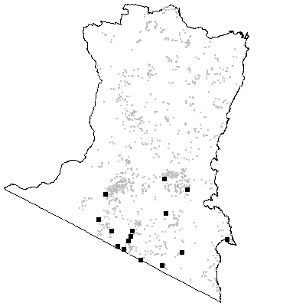

MAP UNIT 31: Hinterland Dry Grass Forest

Species richness: 38 ± 1 (0.04 ha)
Extant area: 27 586 ha
Proportion cleared: 16%
Number of samples: 54

Table A31.1. Diagnostic plant species of Map Unit 31.

Species | Target frequency | Target C/A | Residual frequency | Residual C/A | Fidelity class
Desmodium varians | 0.704 | 2(1-2) | 0.233 | 1(1-2) | positive
Eucalyptus globoidea | 0.833 | 3(1-3) | 0.22 | 3(1-3) | positive
Gonocarpus tetragynus | 0.574 | 2(1-2) | 0.15 | 2(1-2) | positive
Hydrocotyle laxiflora | 0.685 | 2(1-2) | 0.188 | 1(1-2) | positive
Hypericum gramineum | 0.833 | 2(1-2) | 0.219 | 1(1-1) | positive
Leucopogon lanceolatus var lanceolatus | 0.667 | 2(1-2) | 0.396 | 1(1-2) | positive
Senecio diaschides | 0.019 | 1(1-1) | 0 | 0(0-0) | positive
Viola hederacea ssp hederacea | 0.519 | 2(2-3) | 0.434 | 2(1-2) | positive
Lomandra longifolia | 0.852 | 2(1-2) | 0.537 | 2(1-2) | constant
Poa meionectes | 0.833 | 3(2-4) | 0.528 | 2(1-3) | constant
Pteridium esculentum | 0.611 | 2(2-3) | 0.576 | 2(1-3) | constant
Dichelachne rara | 0.667 | 1(1-2) | 0.151 | 1(1-2) | frequent
Glycine clandestina | 0.741 | 1(1-2) | 0.312 | 1(1-2) | frequent
Gnaphalium gymnocephalum | 0.63 | 1(1-2) | 0.166 | 1(1-1) | frequent
Lagenifera stipitata | 0.63 | 1.5(1-2) | 0.312 | 1(1-2) | frequent
Lomandra multiflora | 0.611 | 1(1-2) | 0.238 | 1(1-2) | frequent
Microlaena stipoides var stipoides | 0.648 | 1(1-2) | 0.343 | 2(1-2) | frequent
Senecio sp. E | 0.704 | 1(1-2) | 0.174 | 1(1-1) | frequent
Veronica calycina | 0.778 | 1(1-2) | 0.183 | 1(1-1) | frequent
Eucalyptus agglomerata | 0.111 | 2.5(2-3) | 0.109 | 3(2-3) | uninformative
Eucalyptus angophoroides | 0.333 | 3(1-3) | 0.033 | 2(1-3) | uninformative
Eucalyptus baueriana | 0.019 | 4(4-4) | 0.027 | 2(1-3) | uninformative
Eucalyptus bosistoana | 0.111 | 2.5(1-3) | 0.051 | 2(1-3) | uninformative
Eucalyptus cypellocarpa | 0.37 | 3(1-3) | 0.312 | 3(2-3) | uninformative
Eucalyptus dives | 0.037 | 2.5(2-3) | 0.01 | 3(2-3) | uninformative
Eucalyptus elata | 0.185 | 2.5(2-3) | 0.11 | 3(2-3) | uninformative
Eucalyptus fastigata | 0.019 | 3(3-3) | 0.145 | 3(3-4) | uninformative
Eucalyptus maidenii | 0.389 | 3(2-3) | 0.051 | 3(2-3) | uninformative
Eucalyptus muelleriana | 0.222 | 3(1-4) | 0.139 | 3(3-4) | uninformative
Eucalyptus obliqua | 0.019 | 2(2-2) | 0.196 | 3(2-4) | uninformative
Eucalyptus polyanthemos ssp vestita | 0.13 | 3(3-3) | 0.017 | 2(2-3) | uninformative
Eucalyptus radiata | 0.185 | 3(1-3) | 0.073 | 3(1-3) | uninformative
Eucalyptus sieberi | 0.333 | 3(2-4) | 0.281 | 3(2-4) | uninformative
Eucalyptus viminalis | 0.148 | 3(1-3) | 0.054 | 3(1-3) | uninformative

Table A31.2. Vegetation structure of Map Unit 31. Frequency is the proportion of samples in which strata were present. Height and cover data are means with standard errors in parentheses (n=46).

Stratum | Frequency (%) | Height (m) | Cover (%)
Tree | 100 | 25.1(0.9) | 36(2)
Small tree | 17.4 | 8.9(1.3) | 11(2)
Shrub | 95.7 | 2.1(0.2) | 20(2)
Ground cover | 100 | 0.5(0.0) | 38(3)

Table A31.3. Habitat characteristics of Map Unit 31. Means and interquartile ranges for altitude and slope were calculated from n field samples, while those for annual rain were calculated from ESOCLIM predictions (see Table 5, text). Frequency terrain and parent material refers to number of samples (n) recorded in respective classes. Terrain classes: flat (slope≤5°); north (slope>5° and aspect<30° or >300°); intermediate (slope>5° and aspect 30-120° or 210-300°); and south (slope>5° and aspect 120-210°).

 |  | Frequency (%) | Mean | Interquartile Range | n
Annual rain (mm) |  |  |  | 961 | 910 - 1010 | 54
Altitude (m) |  |  |  | 510 | 396 - 605 | 54
Slope (degrees) |  |  |  | 11 | 7 - 13 | 52
Terrain class
 | North | 38 |  |  | 20
 | Intermediate | 37 |  |  | 19
 | South | 17 |  |  | 9
 | Flat | 8 |  |  | 4
Parent material
 | Devonian granitoids | 93 |  |  | 50
 | Low quartz sedimentaries | 2 |  |  | 1
 | Ordovician high quartz sedimentaries | 6 |  |  | 3

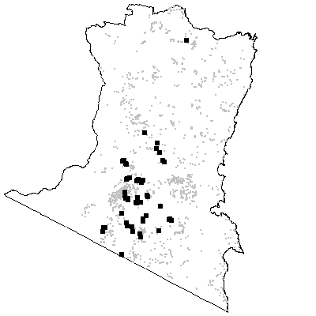

MAP UNIT 32: Coastal Foothills Dry Shrub Forest

Species richness: 31 ± 2 (0.04 ha)
Extant area: 23 401 ha
Proportion cleared: 5%
Number of samples: 42

Table A32.1. Diagnostic plant species of Map Unit 32.

Species | Target frequency | Target C/A | Residual frequency | Residual C/A | Fidelity class
Acacia irrorata ssp irrorata | 0.024 | 1(1-1) | 0 | 0(0-0) | positive
Acacia mabellae | 0.024 | 1(1-1) | 0 | 0(0-0) | positive
Allocasuarina littoralis | 0.762 | 3(1-4) | 0.147 | 2(1-3) | positive
Chionochloa pallida | 0.857 | 3(2-4) | 0.083 | 2(1-3) | positive
Entolasia stricta | 0.571 | 2(1-2) | 0.17 | 1(1-2) | positive
Eucalyptus longifolia | 0.548 | 3(2-3) | 0.015 | 3(2-3) | positive
Eucalyptus muelleriana | 0.524 | 3(2-3) | 0.131 | 3(2-4) | positive
Eucalyptus paniculata | 0.024 | 3(3-3) | 0 | 0(0-0) | positive
Goodenia hederacea var hederacea | 0.024 | 1(1-1) | 0 | 0(0-0) | positive
Melaleuca hypericifolia | 0.024 | 2(2-2) | 0 | 0(0-0) | positive
Ozothamnus obcordatus | 0.024 | 1(1-1) | 0 | 0(0-0) | positive
Platysace lanceolata | 0.881 | 2(1-3) | 0.233 | 2(1-2) | positive
Stipa verticillata | 0.024 | 1(1-1) | 0 | 0(0-0) | positive
Xanthosia atkinsoniana | 0.024 | 1(1-1) | 0 | 0(0-0) | positive
Lomandra multiflora | 0.762 | 1(1-2) | 0.236 | 1(1-2) | frequent
Acacia subporosa | 0.024 | 2(2-2) | 0.004 | 1.5(1-2) | uninformative
Angophora floribunda | 0.5 | 1(1-2) | 0.083 | 2(1-3) | uninformative
Backhousia myrtifolia | 0.024 | 1(1-1) | 0.002 | 3(1-4) | uninformative
Corymbia gummifera | 0.167 | 4(3-4) | 0.016 | 3(2-3) | uninformative
Corymbia maculata | 0.095 | 3.5(2-5) | 0.003 | 3.5(2-5) | uninformative
Eucalyptus agglomerata | 0.452 | 3(1-3) | 0.099 | 3(2-3) | uninformative
Eucalyptus bosistoana | 0.095 | 1.5(1-3) | 0.052 | 2(1-3) | uninformative
Eucalyptus botryoides | 0.048 | 1.5(1-2) | 0.01 | 2(1-3) | uninformative
Eucalyptus cypellocarpa | 0.071 | 1(1-3) | 0.321 | 3(2-3) | uninformative
Eucalyptus elata | 0.048 | 1(1-1) | 0.115 | 3(2-3) | uninformative
Eucalyptus globoidea | 0.238 | 3(1-3) | 0.243 | 3(1-3) | uninformative
Eucalyptus radiata | 0.024 | 3(3-3) | 0.078 | 3(1-3) | uninformative
Eucalyptus sieberi | 0.333 | 1.5(1-3) | 0.281 | 3(2-4) | uninformative
Eucalyptus smithii | 0.095 | 1.5(1-3) | 0.044 | 2(1-3) | uninformative
Eucalyptus tricarpa | 0.452 | 2(1-3) | 0.01 | 1.5(1-3) | uninformative
Lomandra longifolia | 0.381 | 1(1-2) | 0.554 | 2(1-2) | negative
Poa meionectes | 0.476 | 2(1-2) | 0.541 | 2(1-3) | negative
Pteridium esculentum | 0.214 | 2(1-3) | 0.587 | 2(1-3) | negative

Table A32.2. Vegetation structure of Map Unit 32. Frequency is the proportion of samples in which strata were present. Height and cover data are means with standard errors in parentheses (n=35).

Stratum | Frequency (%) | Height (m) | Cover (%)
Tree | 100 | 25.0(0.9) | 30(2)
Small tree | 68.6 | 11.5(0.7) | 18(2)
Shrub | 100 | 2.1(0.2) | 22(3)
Ground cover | 100 | 0.5(0.0) | 36(5)

Table A32.3. Habitat characteristics of Map Unit 32. Means and interquartile ranges for altitude and slope were calculated from n field samples, while those for annual rain were calculated from ESOCLIM predictions (see Table 5, text). Frequency terrain and parent material refers to number of samples (n) recorded in respective classes. Terrain classes: flat (slope≤5°); north (slope>5° and aspect<30° or >300°); intermediate (slope>5° and aspect 30-120° or 210-300°); and south (slope>5° and aspect 120-210°).

 |  | Frequency (%) | Mean | Interquartile Range | n
Annual rain (mm) |  |  |  | 917 | 883 - 949 | 42
Altitude (m) |  |  |  | 129 | 93 - 160 | 42
Slope (degrees) |  |  |  | 15 | 8 - 20 | 41
Terrain class
 | North | 34 |  |  | 14
 | Intermediate | 44 |  |  | 18
 | South | 10 |  |  | 4
 | Flat | 12 |  |  | 5
Parent material
 | Devonian granitoids | 2 |  |  | 1
 | Devonian high quartz sedimentaries | 19 |  |  | 8
 | Low quartz sedimentaries | 14 |  |  | 6
 | Ordovician high quartz sedimentaries | 64 |  |  | 27

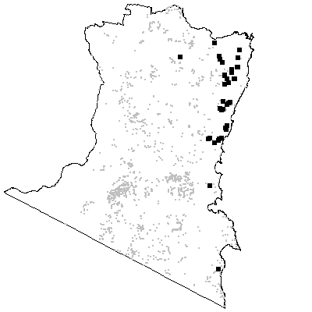

MAP UNIT 33: Coastal Range Dry Shrub Forest

Species richness: 27 ± 1 (0.04 ha)
Extant area: 16 136 ha
Proportion cleared: 1%
Number of samples: 55

Table A33.1. Diagnostic plant species of Map Unit 33.

Species | Target frequency | Target C/A | Residual frequency | Residual C/A | Fidelity class
Acacia falciformis | 0.746 | 2(1-3) | 0.168 | 2(1-3) | positive
Eucalyptus muelleriana | 0.855 | 3(3-4) | 0.114 | 3(2-4) | positive
Pimelea humilis | 0.018 | 2(2-2) | 0 | 0(0-0) | positive
Zieria arborescens | 0.018 | 1(1-1) | 0 | 0(0-0) | positive
Lomandra longifolia | 0.582 | 2(1-2) | 0.548 | 2(1-2) | constant
Poa meionectes | 0.764 | 2(1-3) | 0.53 | 2(1-3) | constant
Cassinia longifolia | 0.655 | 1(1-2) | 0.17 | 1(1-3) | frequent
Lomandra multiflora | 0.6 | 1(1-2) | 0.238 | 1(1-2) | frequent
Acacia subporosa | 0.018 | 1(1-1) | 0.004 | 2(1-2) | uninformative
Angophora floribunda | 0.018 | 1(1-1) | 0.098 | 2(1-3) | uninformative
Corymbia gummifera | 0.036 | 2(2-2) | 0.02 | 3(2-4) | uninformative
Eucalyptus agglomerata | 0.291 | 2.5(2-3) | 0.102 | 3(2-3) | uninformative
Eucalyptus baueriana | 0.018 | 3(3-3) | 0.027 | 2(1-3) | uninformative
Eucalyptus bosistoana | 0.146 | 2(2-3) | 0.049 | 2(1-3) | uninformative
Eucalyptus consideniana | 0.018 | 2(2-2) | 0.021 | 2(1-3) | uninformative
Eucalyptus cypellocarpa | 0.327 | 3(2-3) | 0.313 | 3(2-3) | uninformative
Eucalyptus elata | 0.036 | 3.5(3-4) | 0.116 | 3(2-3) | uninformative
Eucalyptus fastigata | 0.018 | 3(3-3) | 0.145 | 3(3-4) | uninformative
Eucalyptus globoidea | 0.164 | 3(3-3) | 0.246 | 3(1-3) | uninformative
Eucalyptus longifolia | 0.073 | 2(1-2) | 0.028 | 3(2-3) | uninformative
Eucalyptus polyanthemos ssp vestita | 0.073 | 2(2-2) | 0.011 | 3(2-3) | uninformative
Eucalyptus sieberi | 0.436 | 3(1-4) | 0.277 | 3(2-4) | uninformative
Eucalyptus smithii | 0.273 | 3(1-3) | 0.037 | 2(1-3) | uninformative
Eucalyptus tricarpa | 0.146 | 1.5(1-3) | 0.018 | 2(1-3) | uninformative
Lepidosperma laterale | 0.564 | 1(1-2) | 0.336 | 1(1-2) | uninformative
Persoonia linearis | 0.509 | 1(1-2) | 0.277 | 1(1-2) | uninformative
Pteridium esculentum | 0.382 | 2(1-2) | 0.584 | 2(1-3) | negative

Table A33.2. Vegetation structure of Map Unit 33. Frequency is the proportion of samples in which strata were present. Height and cover data are means with standard errors in parentheses (n=25).

Stratum | Frequency (%) | Height (m) | Cover (%)
Tree | 100 | 25.6(1.2) | 35(3)
Small tree | 60 | 9.2(0.8) | 24(4)
Shrub | 100 | 1.9(0.2) | 25(4)
Ground cover | 100 | 0.5(0.1) | 19(3)

Table A33.3. Habitat characteristics of Map Unit 33. Means and interquartile ranges for altitude and slope were calculated from n field samples, while those for annual rain were calculated from ESOCLIM predictions (see Table 5, text). Frequency terrain and parent material refers to number of samples (n) recorded in respective classes. Terrain classes: flat (slope≤5°); north (slope>5° and aspect<30° or >300°); intermediate (slope>5° and aspect 30-120° or 210-300°); and south (slope>5° and aspect 120-210°).

 |  | Frequency (%) | Mean | Interquartile Range | n
Annual rain (mm) |  |  |  | 938 | 888 - 967 | 55
Altitude (m) |  |  |  | 333 | 254 - 398 | 42
Slope (degrees) |  |  |  | 17 | 10 - 22 | 39
Terrain class
 | North | 38 |  |  | 15
 | Intermediate | 49 |  |  | 19
 | South | 3 |  |  | 1
 | Flat | 10 |  |  | 4
Parent material
 | Devonian granitoids | 15 |  |  | 8
 | Devonian high quartz sedimentaries | 42 |  |  | 23
 | Low quartz sedimentaries | 5 |  |  | 3
 | Ordovician high quartz sedimentaries | 38 |  |  | 21

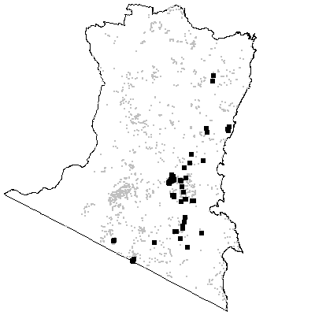

MAP UNIT 34: Coastal Gully Shrub Forest

Species richness: 46 ± 3 (0.04 ha)
Extant area: 14 155 ha
Proportion cleared: 12%
Number of samples: 24

Table A34.1. Diagnostic plant species of Map Unit 34.

Species | Target frequency | Target C/A | Residual frequency | Residual C/A | Fidelity class
Acacia mearnsii | 0.667 | 2(1-3) | 0.155 | 2(1-3) | positive
Citriobatus pauciflorus | 0.125 | 1(1-2) | 0 | 0(0-0) | positive
Desmodium varians | 0.667 | 2(1-2) | 0.243 | 1(1-2) | positive
Dichondra repens | 0.833 | 2(1-2) | 0.275 | 2(1-2) | positive
Doodia caudata var caudata | 0.042 | 1(1-1) | 0 | 0(0-0) | positive
Entolasia stricta | 0.667 | 2(2-3) | 0.173 | 1(1-2) | positive
Glycine clandestina | 0.792 | 2(1-2) | 0.32 | 1(1-2) | positive
Goodenia ovata | 0.75 | 2(1-2) | 0.164 | 2(1-2) | positive
Hibbertia aspera | 0.542 | 2(2-2) | 0.06 | 2(1-2) | positive
Marsdenia rostrata | 0.625 | 2(1-2) | 0.077 | 2(1-2) | positive
Microlaena stipoides var stipoides | 0.708 | 2(1-2) | 0.348 | 1.5(1-2) | positive
Muellerina celastroides | 0.042 | 1(1-1) | 0 | 0(0-0) | positive
Oplismenus imbecillis | 0.833 | 2(1-2) | 0.097 | 2(1-2) | positive
Pimelea axiflora | 0.5 | 2(2-3) | 0.113 | 1(1-2) | positive
Pittosporum undulatum | 0.625 | 2(1-3) | 0.083 | 1(1-2) | positive
Sarcochilus hillii | 0.042 | 1(1-1) | 0 | 0(0-0) | positive
Zieria cytisoides | 0.042 | 2(2-2) | 0 | 0(0-0) | positive
Zieria littoralis | 0.042 | 1(1-1) | 0 | 0(0-0) | positive
Poa meionectes | 0.75 | 2(1-3) | 0.535 | 2(1-3) | constant
Eustrephus latifolius | 0.917 | 1(1-1) | 0.162 | 1(1-1) | frequent
Gahnia melanocarpa | 0.625 | 1(1-2) | 0.066 | 1(1-2) | frequent
Geitonoplesium cymosum | 0.75 | 1(1-2) | 0.099 | 1(1-2) | frequent
Lepidosperma laterale | 0.667 | 1(1-2) | 0.339 | 1(1-2) | frequent
Lomandra longifolia | 0.833 | 1(1-1) | 0.544 | 2(1-2) | frequent
Notelaea venosa | 0.75 | 1(1-2) | 0.103 | 1(1-2) | frequent
Ozothamnus diosmifolius | 0.625 | 1(1-3) | 0.07 | 1(1-2) | frequent
Pandorea pandorana | 0.625 | 1(1-2) | 0.113 | 1(1-1) | frequent
Pratia purpurascens | 0.667 | 1(1-2) | 0.094 | 1(1-2) | frequent
Acacia silvestris | 0.083 | 2.5(1-4) | 0.002 | 5(4-5) | uninformative
Acmena smithii | 0.042 | 1(1-1) | 0.032 | 3(1-4) | uninformative
Alectryon subcinereus | 0.083 | 1(1-1) | 0.006 | 1(1-3) | uninformative
Angophora floribunda | 0.292 | 3(1-3) | 0.092 | 2(1-3) | uninformative
Backhousia myrtifolia | 0.042 | 4(4-4) | 0.002 | 1(1-3) | uninformative
Eucalyptus baueriana | 0.083 | 3(2-4) | 0.026 | 2(1-3) | uninformative
Eucalyptus bosistoana | 0.333 | 2(1-3) | 0.048 | 2(1-3) | uninformative
Eucalyptus cypellocarpa | 0.375 | 3(1-4) | 0.313 | 3(2-3) | uninformative
Eucalyptus elata | 0.25 | 2.5(2-3) | 0.111 | 3(2-3) | uninformative
Eucalyptus globoidea | 0.333 | 3(1-3) | 0.241 | 3(1-3) | uninformative
Eucalyptus longifolia | 0.417 | 2.5(1-3) | 0.023 | 3(2-3) | uninformative
Eucalyptus muelleriana | 0.375 | 3(1-3) | 0.138 | 3(3-4) | uninformative
Eucalyptus pilularis | 0.042 | 1(1-1) | 0.003 | 3.5(2-4) | uninformative
Eucalyptus smithii | 0.042 | 1(1-1) | 0.046 | 2(1-3) | uninformative
Eucalyptus tricarpa | 0.042 | 1(1-1) | 0.022 | 2(1-3) | uninformative
Pteridium esculentum | 0.417 | 2(1-4) | 0.579 | 2(1-3) | negative

Table A34.2. Vegetation structure of Map Unit 34. Frequency is the proportion of samples in which strata were present. Height and cover data are means with standard errors in parentheses (n=22).

Stratum | Frequency (%) | Height (m) | Cover (%)
Tree | 100 | 28.0(1.5) | 36(2)
Small tree | 86.4 | 10.3(1.0) | 25(4)
Shrub | 100 | 2.8(0.5) | 25(3)
Ground cover | 100 | 0.6(0.1) | 40(6)

Table A34.3. Habitat characteristics of Map Unit 34. Means and interquartile ranges for altitude and slope were calculated from n field samples, while those for annual rain were calculated from ESOCLIM predictions (see Table 5, text). Frequency terrain and parent material refers to number of samples (n) recorded in respective classes. Terrain classes: flat (slope≤5°); north (slope>5° and aspect<30° or >300°); intermediate (slope>5° and aspect 30-120° or 210-300°); and south (slope>5° and aspect 120-210°).

 |  | Frequency (%) | Mean | Interquartile Range | n
Annual rain (mm) |  |  |  | 911 | 881 - 938 | 24
Altitude (m) |  |  |  | 95 | 40 - 165 | 24
Slope (degrees) |  |  |  | 16 | 10 - 23 | 24
Terrain class
 | North | 17 |  |  | 4
 | Intermediate | 38 |  |  | 9
 | South | 38 |  |  | 9
 | Flat | 8 |  |  | 2
Parent material
 | Devonian high quartz sedimentaries | 4 |  |  | 1
 | Low quartz sedimentaries | 8 |  |  | 2
 | Ordovician high quartz sedimentaries | 88 |  |  | 21

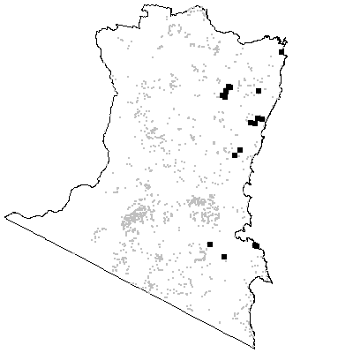

MAP UNIT 35: Escarpment Dry Grass Forest

Species richness: 37 ± 1 (0.04 ha)
Extant area: 22 007 ha
Proportion cleared: 36%
Number of samples: 51

Table A35.1. Diagnostic plant species of Map Unit 35.

Species | Target frequency | Target C/A | Residual frequency | Residual C/A | Fidelity class
Chenopodium carinatum | 0.039 | 1(1-1) | 0 | 0(0-0) | positive
Desmodium varians | 0.863 | 2(2-2) | 0.228 | 1(1-2) | positive
Dichondra repens | 0.784 | 2(1-2) | 0.266 | 1.5(1-2) | positive
Eucalyptus globoidea | 0.588 | 3(2-3) | 0.23 | 3(1-3) | positive
Eucalyptus maidenii | 0.824 | 3(3-4) | 0.036 | 3(2-3) | positive
Indigofera australis | 0.608 | 2(2-3) | 0.089 | 1(1-2) | positive
Plectranthus parviflorus | 0.588 | 2(1-2) | 0.039 | 1(1-2) | positive
Senecio linearifolius | 0.608 | 2(1-3) | 0.227 | 1(1-2) | positive
Stipa scabra | 0.02 | 1(1-1) | 0 | 0(0-0) | positive
Poa meionectes | 0.667 | 3(2-3) | 0.534 | 2(1-3) | constant
Glycine clandestina | 0.863 | 1(1-2) | 0.308 | 1(1-2) | frequent
Lomandra longifolia | 0.706 | 1(1-2) | 0.543 | 2(1-2) | frequent
Microlaena stipoides var stipoides | 0.686 | 1(1-2) | 0.342 | 2(1-2) | frequent
Acmena smithii | 0.02 | 1(1-1) | 0.032 | 3(1-4) | uninformative
Alectryon subcinereus | 0.02 | 1(1-1) | 0.007 | 1(1-2) | uninformative
Brachychiton populneum | 0.137 | 1(1-1) | 0.019 | 1(1-1) | uninformative
Eucalyptus agglomerata | 0.02 | 3(3-3) | 0.112 | 3(2-3) | uninformative
Eucalyptus angophoroides | 0.039 | 2(1-3) | 0.044 | 2(1-3) | uninformative
Eucalyptus baueriana | 0.216 | 2(2-3) | 0.02 | 2.5(1-4) | uninformative
Eucalyptus bosistoana | 0.392 | 3(2-3) | 0.041 | 2(1-3) | uninformative
Eucalyptus cypellocarpa | 0.137 | 1(1-2) | 0.32 | 3(2-3) | uninformative
Eucalyptus elata | 0.255 | 3(2-3) | 0.108 | 3(1-3) | uninformative
Eucalyptus fastigata | 0.118 | 2(2-3) | 0.141 | 3(3-4) | uninformative
Eucalyptus muelleriana | 0.294 | 3(2-3) | 0.137 | 3(2-4) | uninformative
Eucalyptus polyanthemos ssp vestita | 0.137 | 1(1-2) | 0.01 | 2(2-3) | uninformative
Eucalyptus sieberi | 0.078 | 2.5(2-4) | 0.29 | 3(2-4) | uninformative
Eucalyptus smithii | 0.118 | 2(2-3) | 0.043 | 2(1-3) | uninformative
Eucalyptus tereticornis | 0.02 | 3(3-3) | 0.048 | 3(1-3) | uninformative
Eucalyptus tricarpa | 0.02 | 1(1-1) | 0.023 | 2(1-3) | uninformative
Pteridium esculentum | 0.314 | 1.5(1-2) | 0.586 | 2(1-3) | negative

Table A35.2. Vegetation structure of Map Unit 35. Frequency is the proportion of samples in which strata were present. Height and cover data are means with standard errors in parentheses (n=24).

Stratum | Frequency (%) | Height (m) | Cover (%)
Tree | 100 | 27.4(1.3) | 31(2)
Small tree | 50 | 8.8(0.9) | 21(3)
Shrub | 100 | 2.0(0.2) | 21(3)
Ground cover | 100 | 0.4(0.0) | 30(6)

Table A35.3. Habitat characteristics of Map Unit 35. Means and interquartile ranges for altitude and slope were calculated from n field samples, while those for annual rain were calculated from ESOCLIM predictions (see Table 5, text). Frequency terrain and parent material refers to number of samples (n) recorded in respective classes. Terrain classes: flat (slope≤5°); north (slope>5° and aspect<30° or >300°); intermediate (slope>5° and aspect 30-120° or 210-300°); and south (slope>5° and aspect 120-210°).

 |  | Frequency (%) | Mean | Interquartile Range | n
Annual rain (mm) |  |  |  | 938 | 873 - 1010 | 51
Altitude (m) |  |  |  | 400 | 320 - 485 | 51
Slope (degrees) |  |  |  | 15 | 10 - 20 | 36
Terrain class
 | North | 33 |  |  | 12
 | Intermediate | 47 |  |  | 17
 | South | 8 |  |  | 3
 | Flat | 11 |  |  | 4
Parent material
 | Devonian Basalt | 4 |  |  | 2
 | Devonian granitoids | 75 |  |  | 38
 | Low quartz sedimentaries | 2 |  |  | 1
 | Ordovician high quartz sedimentaries | 20 |  |  | 10

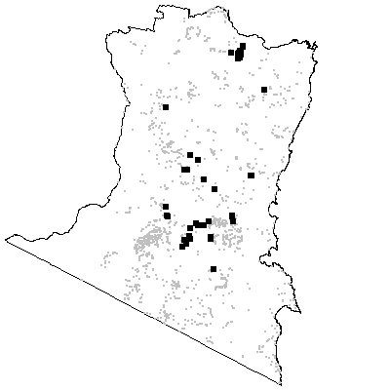
MAP UNIT 36: Dune Dry Shrub Forest

Species richness: 22 ± 2 (0.04 ha)
Extant area: 604 ha
Proportion cleared: 41%
Number of samples: 6

Table A36.1. Diagnostic plant species of Map Unit 36.

Species | Target frequency | Target C/A | Residual frequency | Residual C/A | Fidelity class
Astroloma pinifolium | 0.167 | 1(1-1) | 0 | 0(0-0) | positive
Banksia serrata | 0.5 | 2(1-3) | 0.04 | 1(1-2) | positive
Banksia integrifolia | 1 | 1(1-2) | 0.031 | 1(1-2) | frequent
Dichondra repens | 0.667 | 1(1-1) | 0.282 | 2(1-2) | frequent
Eucalyptus botryoides | 0.667 | 1.5(1-4) | 0.009 | 2(1-3) | frequent
Lomandra longifolia | 0.667 | 1(1-1) | 0.548 | 2(1-2) | frequent
Macrozamia communis | 0.667 | 1.5(1-3) | 0.011 | 1.5(1-2) | frequent
Monotoca elliptica | 1 | 1(1-1) | 0.017 | 1(1-1) | frequent
Poa meionectes | 0.667 | 1(1-1) | 0.538 | 2(1-3) | frequent
Pratia purpurascens | 0.667 | 1(1-1) | 0.101 | 1(1-2) | frequent
Pteridium esculentum | 1 | 1(1-3) | 0.575 | 2(1-3) | frequent
Themeda australis | 0.667 | 1.5(1-2) | 0.112 | 2(1-3) | frequent
Acacia longifolia var sophorae | 0.5 | 1(1-1) | 0.033 | 1(1-2) | uninformative
Correa reflexa | 0.5 | 1(1-1) | 0.126 | 1(1-2) | uninformative
Corymbia maculata | 0.167 | 2(2-2) | 0.005 | 4(3-5) | uninformative
Eucalyptus tereticornis | 0.167 | 2(2-2) | 0.046 | 3(1-3) | uninformative
Hibbertia obtusifolia | 0.5 | 1(1-1) | 0.085 | 1(1-2) | uninformative
Imperata cylindrica var major | 0.5 | 1(1-1) | 0.051 | 1(1-2) | uninformative

Table A36.2. Vegetation structure of Map Unit 36. Frequency is the proportion of samples in which strata were present. Height and cover data are means with standard errors in parentheses (n=1).

Stratum | Frequency (%) | Height (m) | Cover (%)
Tree | 100 | 10.0(-) | 45(-)
Small tree | 0 | -(-) | -(-)
Shrub | 100 | 1.0(-) | 15(-)
Ground cover | 100 | 0.5(-) | 90(-)

Table A36.3. Habitat characteristics of Map Unit 36. Means and interquartile ranges for altitude and slope were calculated from n field samples, while those for annual rain were calculated from ESOCLIM predictions (see Table 5, text). Frequency terrain and parent material refers to number of samples (n) recorded in respective classes. Terrain classes: flat (slope≤5°); north (slope>5° and aspect<30° or >300°); intermediate (slope>5° and aspect 30-120° or 210-300°); and south (slope>5° and aspect 120-210°).

 |  | Frequency (%) | Mean | Interquartile Range | n
Annual rain (mm) |  |  |  | 724 | 851 - 876 | 6
Altitude (m) |  |  |  | 8 | 5 - 5 | 6
Slope (degrees) |  |  |  | 2 | 2 - 2 | 1
Terrain class
 | North | 0 |  |  | 0
 | Intermediate | 0 |  |  | 0
 | South | 0 |  |  | 0
 | Flat | 100 |  |  | 1
 | Parent material
 | Holocene Coastal Sands | 100 |  |  | 6

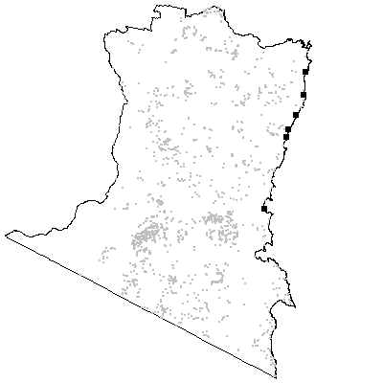

MAP UNIT 37: Lowland Gully Shrub Forest

Species richness: 35± 2 (0.04 ha)
Extant area: 15 147 ha
Proportion cleared: 6%
Number of samples: 17

Table A37.1. Diagnostic plant species of Map Unit 37.

Species | Target frequency | Target C/A | Residual frequency | Residual C/A | Fidelity class
Acacia longifolia var longifolia | 0.647 | 3(2-3) | 0.135 | 2(1-3) | positive
Allocasuarina littoralis | 0.529 | 2(1-3) | 0.16 | 2(1-3) | positive
Angophora floribunda | 0.824 | 3(3-4) | 0.087 | 2(1-3) | positive
Dianella caerulea | 0.706 | 2(1-2) | 0.274 | 1(1-2) | positive
Entolasia stricta | 0.588 | 2(2-3) | 0.177 | 1(1-2) | positive
Eucalyptus pseudoglobulus | 0.059 | 3(3-3) | 0 | 0(0-0) | positive
Gonocarpus teucrioides | 0.529 | 2(1-3) | 0.313 | 2(1-2) | positive
Goodenia ovata | 0.706 | 3(2-4) | 0.167 | 2(1-2) | positive
Hibbertia aspera | 0.529 | 2(2-3) | 0.063 | 2(1-2) | positive
Viola hederacea ssp hederacea | 0.706 | 2(1-2) | 0.434 | 2(1-2) | positive
Lomandra longifolia | 0.824 | 3(2-4) | 0.546 | 2(1-2) | constant
Poa meionectes | 0.882 | 2(2-3) | 0.535 | 2(1-3) | constant
Pteridium esculentum | 0.882 | 3(2-4) | 0.573 | 2(1-3) | constant
Glycine clandestina | 0.706 | 1(1-2) | 0.323 | 1(1-2) | frequent
Corymbia gummifera | 0.059 | 3(3-3) | 0.02 | 3(2-4) | uninformative
Eucalyptus angophoroides | 0.059 | 4(4-4) | 0.044 | 2(1-3) | uninformative
Eucalyptus baxteri | 0.294 | 3(2-4) | 0.005 | 3(2-3) | uninformative
Eucalyptus cypellocarpa | 0.412 | 1(1-4) | 0.313 | 3(2-3) | uninformative
Eucalyptus elata | 0.059 | 1(1-1) | 0.113 | 3(2-3) | uninformative
Eucalyptus globoidea | 0.235 | 2.5(1-4) | 0.243 | 3(1-3) | uninformative
Eucalyptus longifolia | 0.177 | 3(3-3) | 0.028 | 3(2-3) | uninformative
Eucalyptus muelleriana | 0.118 | 3.5(3-4) | 0.142 | 3(2-4) | uninformative
Eucalyptus obliqua | 0.118 | 2.5(1-4) | 0.19 | 3(2-4) | uninformative
Eucalyptus ovata | 0.177 | 3(3-3) | 0.021 | 2(1-3) | uninformative
Eucalyptus sieberi | 0.118 | 3(2-4) | 0.285 | 3(2-4) | uninformative
Eucalyptus smithii | 0.059 | 1(1-1) | 0.045 | 2(1-3) | uninformative

Table A37.2. Vegetation structure of Map Unit 37. Frequency is the proportion of samples in which strata were present. Height and cover data are means with standard errors in parentheses (n=15).

Stratum | Frequency (%) | Height (m) | Cover (%)
Tree | 100 | 23.3(2.2) | 42(3)
Small tree | 33.3 | 7.8(0.7) | 37(9)
Shrub | 100 | 5.0(2.2) | 40(7)
Ground cover | 100 | 1.1(0.2) | 65(7)

Table A37.3. Habitat characteristics of Map Unit 37. Means and interquartile ranges for altitude and slope were calculated from n field samples, while those for annual rain were calculated from ESOCLIM predictions (see Table 5, text). Frequency terrain and parent material refers to number of samples (n) recorded in respective classes. Terrain classes: flat (slope≤5°); north (slope>5° and aspect<30° or >300°); intermediate (slope>5° and aspect 30-120° or 210-300°); and south (slope>5° and aspect 120-210°).

 |  | Frequency (%) | Mean | Interquartile Range | n
Annual rain (mm) |  |  |  | 899 | 881 - 917 | 17
Altitude (m) |  |  |  | 71 | 15 - 120 | 17
Slope (degrees) |  |  |  | 5 | 2 - 6 | 16
Terrain class
 | North | 6 |  |  | 1
 | Intermediate | 13 |  |  | 2
 | South | 25 |  |  | 4
 | Flat | 56 |  |  | 9
Parent material
 | Devonian high quartz sedimentaries | 6 |  |  | 1
 | Holocene Coastal Sands | 18 |  |  | 3
 | Low quartz sedimentaries | 6 |  |  | 1
 | Ordovician high quartz sedimentaries | 24 |  |  | 4
 | Tertiary Alluvium | 47 |  |  | 8

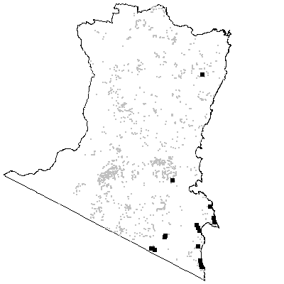

MAP UNIT 38: Southern Riparian Scrub

Species richness: 22 ± 14 (0.04 ha)
Extant area: 516 ha
Proportion cleared: 16%
Number of samples: 3

Table A38.1. Diagnostic plant species of Map Unit 38.

Species | Target frequency | Target C/A | Residual frequency | Residual C/A | Fidelity class
Acacia floribunda | 0.667 | 2.5(2-3) | 0.016 | 2(1-3) | positive
Baeckea virgata | 0.667 | 2(1-3) | 0.029 | 2(1-2) | positive
Calytrix tetragona | 0.667 | 2(1-3) | 0.004 | 2.5(2-3) | positive
Grevillea parviflora | 0.333 | 3(3-3) | 0 | 0(0-0) | positive
Kunzea ericoides | 0.667 | 2(2-2) | 0.043 | 2(1-3) | positive
Leptospermum lanigerum | 0.667 | 3(3-3) | 0.007 | 2(1-3) | positive
Leptospermum scoparium | 0.667 | 2(1-3) | 0.016 | 2(1-3) | positive
Tristaniopsis laurina | 1 | 4(3-5) | 0.001 | 1.5(1-2) | positive
Utricularia lateriflora | 0.333 | 1(1-1) | 0 | 0(0-0) | positive
Vallisneria gigantea | 0.333 | 1(1-1) | 0 | 0(0-0) | positive
Lomandra longifolia | 0.667 | 3.5(3-4) | 0.549 | 2(1-2) | constant
Adiantum aethiopicum | 0.667 | 1(1-1) | 0.076 | 1(1-2) | frequent
Gahnia sieberiana | 0.667 | 1(1-1) | 0.076 | 1(1-2) | frequent
Eucalyptus elata | 0.333 | 1(1-1) | 0.112 | 3(2-3) | uninformative
Poa meionectes | 0 | 0(2-0) | 0.54 | 2(1-3) | negative
Pteridium esculentum | 0.333 | 1(1-1) | 0.577 | 2(1-3) | negative

Table A38.2. Vegetation structure of Map Unit 38. Frequency is the proportion of samples in which strata were present. Height and cover data are means with standard errors in parentheses (n=3).

Stratum | Frequency (%) | Height (m) | Cover (%)
Tree | 0 | -(-) | -(-)
Small tree | 66.7 | 8.5(3.5) | 25(15)
Shrub | 100 | 2.0(0.3) | 37(18)
Ground cover | 100 | 0.5(0.0) | 18(7)

Table A38.3. Habitat characteristics of Map Unit 38. Means and interquartile ranges for altitude and slope were calculated from n field samples, while those for annual rain were calculated from ESOCLIM predictions (see Table 5, text). Frequency terrain and parent material refers to number of samples (n) recorded in respective classes. Terrain classes: flat (slope≤5°); north (slope>5° and aspect<30° or >300°); intermediate (slope>5° and aspect 30-120° or 210-300°); and south (slope>5° and aspect 120-210°).

 |  | Frequency (%) | Mean | Interquartile Range | n
Annual rain (mm) |  |  |  | 921 | 904 - 949 | 3
Altitude (m) |  |  |  | 235 | 168 - 348 | 3
Slope (degrees) |  |  |  | 0 | 0 - 0 | 3
Terrain class
 | North | 0 |  |  | 0
 | Intermediate | 0 |  |  | 0
 | South | 0 |  |  | 0
 | Flat | 100 |  |  | 3
Parent material
 | Devonian granitoids | 67 |  |  | 2
 | Tertiary Alluvium | 33 |  |  | 1

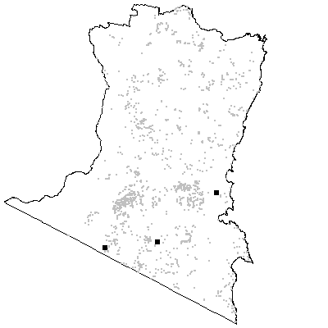
MAP UNIT 39: Northern Riparian Scrub

Species richness: 37 ± 7 (0.04 ha)
Extant area: 485 ha
Proportion cleared: 36%
Number of samples: 5

Table A39.1. Diagnostic plant species of Map Unit 39.

Species | Target frequency | Target C/A | Residual frequency | Residual C/A | Fidelity class
Acacia floribunda | 1 | 3(2-3) | 0.014 | 2(1-3) | positive
Entolasia stricta | 0.6 | 2(1-2) | 0.18 | 1(1-2) | positive
Kunzea ericoides | 0.6 | 2(2-3) | 0.042 | 2(1-3) | positive
Leptospermum emarginatum | 1 | 2(2-3) | 0.003 | 3(2-3) | positive
Leptospermum polygalifolium ssp polygalifolium | 0.2 | 3(3-3) | 0 | 0(0-0) | positive
Lomatia myricoides | 0.6 | 2(2-2) | 0.074 | 1(1-2) | positive
Themeda australis | 0.6 | 2(1-2) | 0.113 | 2(1-3) | positive
Lomandra longifolia | 1 | 2(3-3) | 0.547 | 2(1-2) | constant
Acacia mearnsii | 1 | 1(1-2) | 0.16 | 2(1-3) | frequent
Bursaria spinosa | 0.6 | 1(2-3) | 0.121 | 1(1-2) | frequent
Correa reflexa | 0.6 | 1(1-2) | 0.125 | 1(1-2) | frequent
Dianella revoluta var revoluta | 0.6 | 1(1-1) | 0.08 | 1(1-1) | frequent
Exocarpos cupressiformis | 0.6 | 1(1-2) | 0.047 | 1(1-2) | frequent
Microlaena stipoides var stipoides | 0.8 | 1(1-2) | 0.352 | 2(1-2) | frequent
Opercularia aspera | 0.6 | 1(1-2) | 0.138 | 1(1-1) | frequent
Persicaria decipiens | 0.6 | 1(1-1) | 0.003 | 1(1-2) | frequent
Eucalyptus elata | 0.4 | 1.5(1-2) | 0.112 | 3(2-3) | uninformative
Eucalyptus maidenii | 0.4 | 3(2-4) | 0.062 | 3(2-3) | uninformative
Eucalyptus muelleriana | 0.2 | 2(2-2) | 0.142 | 3(2-4) | uninformative
Eucalyptus polyanthemos ssp vestita | 0.2 | 2(2-2) | 0.012 | 2.5(2-3) | uninformative
Eucalyptus tereticornis | 0.2 | 3(3-3) | 0.046 | 3(1-3) | uninformative
Poa meionectes | 0.2 | 2(2-2) | 0.54 | 2(1-3) | negative
Pteridium esculentum | 0.2 | 1(1-1) | 0.578 | 2(1-3) | negative

Table A39.2. Vegetation structure of Map Unit 39. Frequency is the proportion of samples in which strata were present. Height and cover data are means with standard errors in parentheses (n=5).

Stratum | Frequency (%) | Height (m) | Cover (%)
Tree | 0 | -(-) | -(-)
Small tree | 60 | 13.0(3.1) | 15(10)
Shrub | 100 | 3.6(0.7) | 43(11)
Ground cover | 100 | 0.4(0.1) | 19(9)

Table A39.3. Habitat characteristics of Map Unit 39. Means and interquartile ranges for altitude and slope were calculated from n field samples, while those for annual rain were calculated from ESOCLIM predictions (see Table 5, text). Frequency terrain and parent material refers to number of samples (n) recorded in respective classes. Terrain classes: flat (slope≤5°); north (slope>5° and aspect<30° or >300°); intermediate (slope>5° and aspect 30-120° or 210-300°); and south (slope>5° and aspect 120-210°).

 |  | Frequency (%) | Mean | Interquartile Range | n
Annual rain (mm) |  |  |  | 803 | 796 - 815 | 5
Altitude (m) |  |  |  | 171 | 95 - 250 | 5
Slope (degrees) |  |  |  | 4 | 0 - 5 | 5
Terrain class
 | North | 20 |  |  | 1
 | Intermediate | 0 |  |  | 0
 | South | 20 |  |  | 1
 | Flat | 60 |  |  | 3
Parent material
 | Devonian granitoids | 100 |  |  | 5

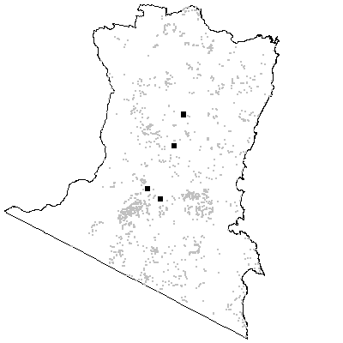
MAP UNIT 40: Riverine Forest

Species richness: 27 ± 9 (0.04 ha)
Extant area: 65 ha
Proportion cleared: 19% (probably an underestimate)
Number of samples: 4

Table A40.1. Diagnostic plant species of Map Unit 40.

Species | Target frequency | Target C/A | Residual frequency | Residual C/A | Fidelity class
Acacia floribunda | 1 | 2.5(1-3) | 0.015 | 2(1-3) | positive
Acacia mearnsii | 1 | 3(2-3) | 0.161 | 2(1-3) | positive
Aneilema biflorum | 0.25 | 1(1-1) | 0 | 0(0-0) | positive
Casuarina cunninghamiana | 1 | 4(3-4) | 0 | 0(0-0) | positive
Cyperus imbecillis | 0.25 | 1(1-1) | 0 | 0(0-0) | positive
Microlaena stipoides var stipoides | 1 | 2.5(2-3) | 0.352 | 1(1-2) | positive
Omalanthus stillingiifolius | 0.25 | 1(1-1) | 0 | 0(0-0) | positive
Entolasia marginata | 1 | 1(1-1) | 0.044 | 1(1-2) | frequent
Geranium solanderi | 0.75 | 1(1-1) | 0.091 | 1(1-2) | frequent
Hymenanthera dentata | 1 | 1.5(1-3) | 0.067 | 1(1-2) | frequent
Oplimensus aemulus var aemulus | 1 | 1.5(1-2) | 0.007 | 2(1-2) | frequent
Sigesbeckia orientalis | 0.75 | 1(1-1) | 0.076 | 1(1-2) | frequent
Lomandra longifolia | 1 | 1(1-2) | 0.548 | 2(1-2) | frequent
Poa meionectes | 0 | 0(1-0) | 0.54 | 2(1-3) | negative
Pteridium esculentum | 0.25 | 1(1-1) | 0.578 | 2(1-3) | negative

Table A40.2. Vegetation structure of Map Unit 40. Frequency is the proportion of samples in which strata were present. Height and cover data are means with standard errors in parentheses (n=4).

Stratum | Frequency (%) | Height (m) | Cover (%)
Tree | 100 | 28.0(1.8) | 26(6)
Small tree | 100 | 8.0(1.4) | 11(3)
Shrub | 75 | 2.7(0.3) | 21(10)
Ground cover | 100 | 0.3(0.1) | 52(20)

Table A40.3. Habitat characteristics of Map Unit 40. Means and interquartile ranges for altitude and slope were calculated from n field samples, while those for annual rain were calculated from ESOCLIM predictions (see Table 5, text). Frequency terrain and parent material refers to number of samples (n) recorded in respective classes. Terrain classes: flat (slope≤5°); north (slope>5° and aspect<30° or >300°); intermediate (slope>5° and aspect 30-120° or 210-300°); and south (slope>5° and aspect 120-210°).

 |  | Frequency (%) | Mean | Interquartile Range | n
Annual rain (mm) |  |  |  | 875 | 862 - 887 | 4
Altitude (m) |  |  |  | 26 | 15 - 36 | 4
Slope (degrees) |  |  |  | 3 | 1 - 5 | 4
Terrain class
 | North | 0 |  |  | 0
 | Intermediate | 25 |  |  | 1
 | South | 25 |  |  | 1
 | Flat | 50 |  |  | 2
Parent material
 | Devonian granitoids | 100 |  |  | 4

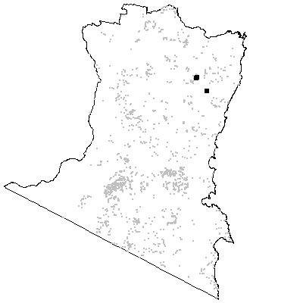

MAP UNIT 41: Mountain Intermediate Shrub Forest

Species richness: 21 ± 1 (0.04 ha)
Extant area: 1 864 ha
Proportion cleared: 0%
Number of samples: 28

Table A41.1. Diagnostic plant species of Map Unit 41.

Species | Target frequency | Target C/A | Residual frequency | Residual C/A | Fidelity class
Eucalyptus fraxinoides | 0.893 | 4(4-5) | 0.012 | 3(2-4) | positive
Eucalyptus sieberi | 0.536 | 2(1-3) | 0.278 | 3(2-4) | positive
Gaultheria appressa | 0.036 | 1(1-1) | 0 | 0(0-0) | positive
Hierochloe rariflora | 0.536 | 2(1-3) | 0.175 | 2(1-3) | positive
Leucopogon lanceolatus var lanceolatus | 0.893 | 2(2-3) | 0.396 | 1(1-2) | positive
Persoonia silvatica | 0.5 | 2(1-2) | 0.035 | 1(1-2) | positive
Lomandra longifolia | 0.714 | 2(1-2) | 0.546 | 2(1-2) | constant
Pteridium esculentum | 0.821 | 3(2-3) | 0.572 | 2(1-3) | constant
Dianella tasmanica | 0.857 | 1(1-2) | 0.223 | 1(1-2) | frequent
Platysace lanceolata | 0.714 | 1(1-2) | 0.242 | 2(1-2) | frequent
Poa meionectes | 0.571 | 1(1-2) | 0.538 | 2(1-3) | frequent
Angophora floribunda | 0.036 | 3(3-3) | 0.096 | 2(1-3) | uninformative
Eucalyptus agglomerata | 0.036 | 3(3-3) | 0.11 | 3(2-3) | uninformative
Eucalyptus cypellocarpa | 0.107 | 1(1-1) | 0.318 | 3(2-3) | uninformative
Eucalyptus fastigata | 0.036 | 4(4-4) | 0.143 | 3(3-4) | uninformative
Eucalyptus globoidea | 0.036 | 2(2-2) | 0.247 | 3(1-3) | uninformative
Eucalyptus obliqua | 0.179 | 1(1-4) | 0.19 | 3(2-4) | uninformative

Table A41.2. Vegetation structure of Map Unit 41. Frequency is the proportion of samples in which strata were present. Height and cover data are means with standard errors in parentheses (n=22).

Stratum | Frequency (%) | Height (m) | Cover (%)
Tree | 100 | 25.3(1.1) | 42(3)
Small tree | 22.7 | 8.4(1.9) | 29(9)
Shrub | 100 | 2.4(0.3) | 24(4)
Ground cover | 100 | 0.6(0.1) | 23(3)

Table A41.3. Habitat characteristics of Map Unit 41. Means and interquartile ranges for altitude and slope were calculated from n field samples, while those for annual rain were calculated from ESOCLIM predictions (see Table 5, text). Frequency terrain and parent material refers to number of samples (n) recorded in respective classes. Terrain classes: flat (slope≤5°); north (slope>5° and aspect<30° or >300°); intermediate (slope>5° and aspect 30-120° or 210-300°); and south (slope>5° and aspect 120-210°).

 |  | Frequency (%) | Mean | Interquartile Range | n
Annual rain (mm) |  |  |  | 1116 | 1045 - 1199 | 28
Altitude (m) |  |  |  | 854 | 740 - 1013 | 27
Slope (degrees) |  |  |  | 20 | 10 - 29 | 27
Terrain class
 | North | 15 |  |  | 4
 | Intermediate | 41 |  |  | 11
 | South | 37 |  |  | 10
 | Flat | 7 |  |  | 2
Parent material
 | Devonian granitoids | 68 |  |  | 19
 | Devonian high quartz sedimentaries | 29 |  |  | 8
 | Ordovician high quartz sedimentaries | 4 |  |  | 1

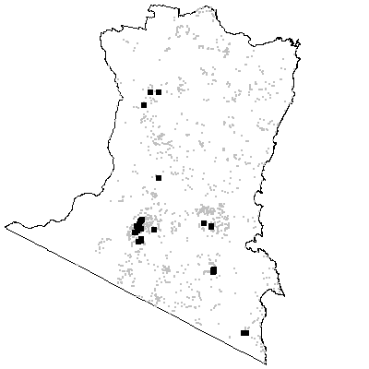

MAP UNIT 42: Inland Intermediate Shrub Forest

Species richness: 30 ± 1 (0.04 ha)
Extant area: 21 556 ha
Proportion cleared: 2%
Number of samples: 64

Table A42.1. Diagnostic plant species of Map Unit 42.

Species | Target frequency | Target C/A | Residual frequency | Residual C/A | Fidelity class
Acacia aculeatissima | 0.016 | 1(1-1) | 0 | 0(0-0) | positive
Acacia obtusifolia | 0.547 | 3(3-3) | 0.068 | 3(2-3) | positive
Epacris impressa | 0.641 | 2(1-2) | 0.176 | 2(1-2) | positive
Eucalyptus obliqua | 0.672 | 3(1-3) | 0.168 | 3(2-4) | positive
Eucalyptus sieberi | 0.797 | 3(3-4) | 0.259 | 3(2-4) | positive
Gonocarpus teucrioides | 0.875 | 3(2-3) | 0.291 | 1(1-2) | positive
Lepidosperma elatius | 0.016 | 1(1-1) | 0 | 0(0-0) | positive
Leucopogon lanceolatus var lanceolatus | 0.813 | 2(1-2) | 0.387 | 1(1-2) | positive
Pultenaea daphnoides | 0.75 | 2(1-3) | 0.067 | 1(1-2) | positive
Tetrarrhena juncea | 0.672 | 2(2-3) | 0.16 | 2(1-3) | positive
Lomandra longifolia | 0.578 | 2(1-2) | 0.548 | 2(1-2) | constant
Poa meionectes | 0.672 | 2(1-2) | 0.533 | 2(1-3) | constant
Pteridium esculentum | 0.938 | 3(2-3) | 0.56 | 2(1-3) | constant
Billardiera scandens | 0.828 | 1(1-1) | 0.306 | 1(1-1) | frequent
Dianella caerulea | 0.672 | 1(1-2) | 0.261 | 1(1-2) | frequent
Persoonia linearis | 0.844 | 1(1-2) | 0.261 | 1(1-1) | frequent
Angophora floribunda | 0.016 | 2(2-2) | 0.099 | 2(1-3) | uninformative
Eucalyptus agglomerata | 0.203 | 3(2-3) | 0.104 | 3(2-3) | uninformative
Eucalyptus croajingolensis | 0.016 | 2(2-2) | 0.002 | 3(2-3) | uninformative
Eucalyptus cypellocarpa | 0.438 | 3(1-3) | 0.308 | 3(2-3) | uninformative
Eucalyptus elata | 0.047 | 2(1-3) | 0.116 | 3(2-3) | uninformative
Eucalyptus fastigata | 0.031 | 3.5(3-4) | 0.146 | 3(3-4) | uninformative
Eucalyptus globoidea | 0.234 | 2(1-2) | 0.243 | 3(1-3) | uninformative
Eucalyptus longifolia | 0.016 | 3(3-3) | 0.031 | 3(2-3) | uninformative
Eucalyptus muelleriana | 0.234 | 3(3-3) | 0.138 | 3(2-4) | uninformative
Eucalyptus radiata | 0.094 | 2(1-2) | 0.076 | 3(1-3) | uninformative
Eucalyptus smithii | 0.031 | 2.5(1-4) | 0.046 | 2(1-3) | uninformative
Eucalyptus sp. aff. radiata | 0.047 | 4(3-4) | 0.035 | 3(2-3) | uninformative

Table A42.2. Vegetation structure of Map Unit 42. Frequency is the proportion of samples in which strata were present. Height and cover data are means with standard errors in parentheses (n=16).

Stratum | Frequency (%) | Height (m) | Cover (%)
Tree | 100 | 29.3(1.5) | 37(2)
Small tree | 12.5 | 12.0(3.0) | 21(19)
Shrub | 100 | 3.3(0.4) | 39(4)
Ground cover | 100 | 0.9(0.1) | 56(7)

Table A42.3. Habitat characteristics of Map Unit 42. Means and interquartile ranges for altitude and slope were calculated from n field samples, while those for annual rain were calculated from ESOCLIM predictions (see Table 5, text). Frequency terrain and parent material refers to number of samples (n) recorded in respective classes. Terrain classes: flat (slope≤5°); north (slope>5° and aspect<30° or >300°); intermediate (slope>5° and aspect 30-120° or 210-300°); and south (slope>5° and aspect 120-210°).

 |  | Frequency (%) | Mean | Interquartile Range | n
Annual rain (mm) |  |  |  | 993 | 952 - 1031 | 64
Altitude (m) |  |  |  | 418 | 330 - 540 | 39
Slope (degrees) |  |  |  | 13 | 7 - 17 | 32
Terrain class
 | North | 16 |  |  | 5
 | Intermediate | 34 |  |  | 11
 | South | 47 |  |  | 15
 | Flat | 3 |  |  | 1
Parent material
 | Devonian Basalt | 2 |  |  | 1
 | Devonian granitoids | 69 |  |  | 44
 | Devonian high quartz sedimentaries | 11 |  |  | 7
 | Low quartz sedimentaries | 13 |  |  | 8
 | Ordovician high quartz sedimentaries | 6 |  |  | 4

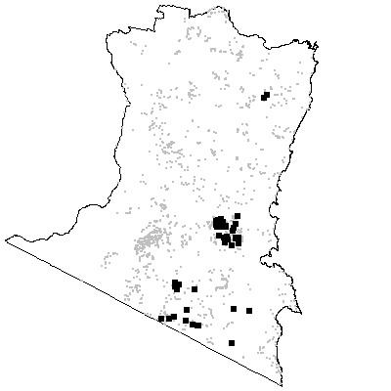
MAP UNIT 43: Mountain Sandstone Shrub Forest

Species richness: 34 ± 2 (0.04 ha)
Extant area: 2 479 ha
Proportion cleared: 1%
Number of samples: 13

Table A43.1. Diagnostic plant species of Map Unit 43.

Species | Target frequency | Target C/A | Residual frequency | Residual C/A | Fidelity class
Acacia falciformis | 0.846 | 3(2-4) | 0.184 | 2(1-3) | positive
Asterolasia asteriscophora | 0.077 | 3(3-3) | 0 | 0(0-0) | positive
Daviesia ulicifolia | 0.539 | 2(1-2) | 0.055 | 1.5(1-2) | positive
Deyeuxia nudiflora | 0.077 | 1(1-1) | 0 | 0(0-0) | positive
Dianella caerulea | 0.539 | 2(1-2) | 0.276 | 1(1-2) | positive
Epacris impressa | 0.769 | 2(1-2) | 0.191 | 2(1-2) | positive
Eucalyptus cypellocarpa | 0.923 | 3(1-3) | 0.308 | 3(2-3) | positive
Eucalyptus globoidea | 0.692 | 2(1-3) | 0.239 | 3(1-3) | positive
Eucalyptus sieberi | 0.692 | 3(3-4) | 0.279 | 3(2-4) | positive
Exocarpos strictus | 0.846 | 2(1-3) | 0.165 | 1(1-2) | positive
Gonocarpus teucrioides | 0.769 | 2(1-2) | 0.312 | 2(1-2) | positive
Leucopogon lanceolatus var lanceolatus | 0.923 | 2(2-2) | 0.401 | 1(1-2) | positive
Persoonia linearis | 0.846 | 2(1-2) | 0.281 | 1(1-1) | positive
Platysace lanceolata | 1 | 3(2-4) | 0.245 | 2(1-2) | positive
Viola hederacea ssp hederacea | 0.692 | 2(1-2) | 0.435 | 2(1-2) | positive
Lomandra longifolia | 0.846 | 2(1-2) | 0.546 | 2(1-2) | constant
Poa meionectes | 0.769 | 2.5(2-3) | 0.537 | 2(1-3) | constant
Pteridium esculentum | 0.692 | 2(2-3) | 0.576 | 2(1-3) | constant
Olearia erubescens | 0.615 | 1(1-2) | 0.062 | 1(1-1) | frequent
Senecio sp. E | 0.692 | 1(1-2) | 0.189 | 1(1-2) | frequent
Eucalyptus agglomerata | 0.308 | 3(3-3) | 0.107 | 3(2-3) | uninformative
Eucalyptus angophoroides | 0.154 | 2.5(1-4) | 0.043 | 2(1-3) | uninformative
Eucalyptus elata | 0.154 | 2.5(2-3) | 0.112 | 3(2-3) | uninformative
Eucalyptus mackintii | 0.231 | 3(3-3) | 0.002 | 4(3-4) | uninformative
Eucalyptus muelleriana | 0.154 | 3(2-4) | 0.142 | 3(2-4) | uninformative
Eucalyptus obliqua | 0.077 | 4(4-4) | 0.191 | 3(2-4) | uninformative
Eucalyptus sp. aff. radiata | 0.077 | 2(2-2) | 0.035 | 3(2-3) | uninformative

Table A43.2. Vegetation structure of Map Unit 43. Frequency is the proportion of samples in which strata were present. Height and cover data are means with standard errors in parentheses (n=12).

Stratum | Frequency (%) | Height (m) | Cover (%)
Tree | 100 | 23.8(1.9) | 35(2)
Small tree | 41.7 | 4.9(1.1) | 37(3)
Shrub | 100 | 1.3(0.2) | 40(4)
Ground cover | 100 | 0.5(0.1) | 34(6)

Table A43.3. Habitat characteristics of Map Unit 43. Means and interquartile ranges for altitude and slope were calculated from n field samples, while those for annual rain were calculated from ESOCLIM predictions (see Table 5, text). Frequency terrain and parent material refers to number of samples (n) recorded in respective classes. Terrain classes: flat (slope≤5°); north (slope>5° and aspect<30° or >300°); intermediate (slope>5° and aspect 30-120° or 210-300°); and south (slope>5° and aspect 120-210°).

 |  | Frequency (%) | Mean | Interquartile Range | n
Annual rain (mm) |  |  |  | 1065 | 1014 - 1131 | 13
Altitude (m) |  |  |  | 632 | 490 - 740 | 13
Slope (degrees) |  |  |  | 19 | 15 - 24 | 13
Terrain class
 | North | 8 |  |  | 1
 | Intermediate | 62 |  |  | 8
 | South | 23 |  |  | 3
 | Flat | 8 |  |  | 1
Parent material
 | Devonian granitoids | 23 |  |  | 3
 | Devonian high quartz sedimentaries | 77 |  |  | 10

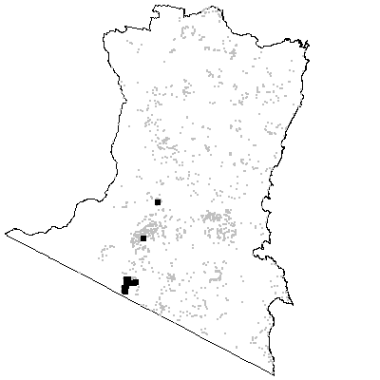
MAP UNIT 44: Foothills Dry Shrub Forest

Species richness: 30 ± 1 (0.04 ha)
Extant area: 3 142 ha
Proportion cleared: 6%
Number of samples: 29

Table A44.1. Diagnostic plant species of Map Unit 44.

Species | Target frequency | Target C/A | Residual frequency | Residual C/A | Fidelity class
Acacia falciformis | 0.759 | 2(2-3) | 0.178 | 2(1-3) | positive
Actinotus minor | 0.034 | 1(1-1) | 0 | 0(0-0) | positive
Eucalyptus sieberi | 1 | 4(3-4) | 0.268 | 3(2-4) | positive
Hierochloe rariflora | 0.724 | 2(2-4) | 0.171 | 2(1-3) | positive
Leucopogon lanceolatus var lanceolatus | 0.897 | 2(1-2) | 0.396 | 1(1-2) | positive
Tetrarrhena juncea | 0.517 | 2(1-2) | 0.175 | 2(1-3) | positive
Lomandra longifolia | 1 | 2(1-2) | 0.54 | 2(1-2) | constant
Poa meionectes | 0.724 | 2(1-3) | 0.535 | 2(1-3) | constant
Pteridium esculentum | 1 | 3(2-3) | 0.568 | 2(1-3) | constant
Persoonia linearis | 0.828 | 1(1-2) | 0.275 | 1(1-2) | frequent
Platysace lanceolata | 0.655 | 1(1-2) | 0.243 | 2(1-2) | frequent
Poranthera microphylla | 0.69 | 1(1-2) | 0.214 | 1(1-1) | frequent
Viola hederacea ssp hederacea | 0.621 | 1(1-2) | 0.434 | 2(1-2) | frequent
Eucalyptus agglomerata | 0.069 | 2.5(2-3) | 0.11 | 3(2-3) | uninformative
Eucalyptus cypellocarpa | 0.241 | 1(1-3) | 0.315 | 3(2-3) | uninformative
Eucalyptus elata | 0.103 | 1(1-4) | 0.113 | 3(2-3) | uninformative
Eucalyptus fastigata | 0.034 | 1(1-1) | 0.143 | 3(3-4) | uninformative
Eucalyptus globoidea | 0.414 | 1.5(1-4) | 0.239 | 3(1-3) | uninformative
Eucalyptus muelleriana | 0.034 | 3(3-3) | 0.144 | 3(2-4) | uninformative
Eucalyptus obliqua | 0.276 | 3(2-4) | 0.188 | 3(2-4) | uninformative
Eucalyptus radiata | 0.034 | 1(1-1) | 0.078 | 3(1-3) | uninformative
Eucalyptus smithii | 0.034 | 2(2-2) | 0.046 | 2(1-3) | uninformative
Eucalyptus sp. aff. radiata | 0.138 | 3(2-3) | 0.033 | 3(2-3) | uninformative

Table A44.2. Vegetation structure of Map Unit 44. Frequency is the proportion of samples in which strata were present. Height and cover data are means with standard errors in parentheses (n=21).

Stratum | Frequency (%) | Height (m) | Cover (%)
Tree | 100 | 24.5(1.0) | 41(2)
Small tree | 9.5 | 10.0(0.0) | 15(10)
Shrub | 100 | 2.7(0.2) | 24(4)
Ground cover | 100 | 0.7(0.1) | 28(5)

Table A44.3. Habitat characteristics of Map Unit 44. Means and interquartile ranges for altitude and slope were calculated from n field samples, while those for annual rain were calculated from ESOCLIM predictions (see Table 5, text). Frequency terrain and parent material refers to number of samples (n) recorded in respective classes. Terrain classes: flat (slope≤5°); north (slope>5° and aspect<30° or >300°); intermediate (slope>5° and aspect 30-120° or 210-300°); and south (slope>5° and aspect 120-210°).

 |  | Frequency (%) | Mean | Interquartile Range | n
Annual rain (mm) |  |  |  | 1033 | 992 - 1080 | 29
Altitude (m) |  |  |  | 700 | 600 - 850 | 29
Slope (degrees) |  |  |  | 13 | 3 - 22 | 28
Terrain class
 | North | 41 |  |  | 11
 | Intermediate | 22 |  |  | 6
 | South | 4 |  |  | 1
 | Flat | 33 |  |  | 9
Parent material
 | Devonian granitoids | 83 |  |  | 24
 | Devonian high quartz sedimentaries | 10 |  |  | 3
 | Ordovician high quartz sedimentaries | 7 |  |  | 2

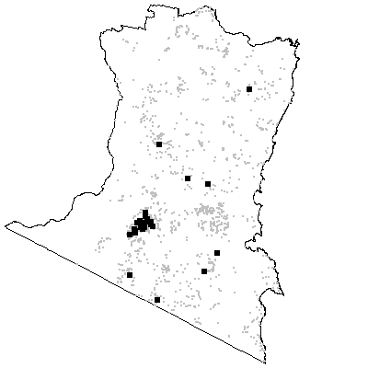
MAP UNIT 45: Mountain Dry Shrub Forest

Species richness: 29 ± 3 (0.04 ha)
Extant area: 1 915 ha
Proportion cleared: 5%
Number of samples: 23

Table A45.1. Diagnostic plant species of Map Unit 45.

Species | Target frequency | Target C/A | Residual frequency | Residual C/A | Fidelity class
Acacia terminalis | 0.826 | 3(1-3) | 0.108 | 2(1-3) | positive
Eucalyptus sieberi | 1 | 4(4-4) | 0.271 | 3(2-4) | positive
Leucopogon lanceolatus var lanceolatus | 0.739 | 2(1-3) | 0.4 | 1(1-2) | positive
Lomatia ilicifolia | 0.913 | 2(1-2) | 0.119 | 1(1-2) | positive
Monotoca scoparia | 0.87 | 2(1-3) | 0.114 | 2(1-2) | positive
Platysace lanceolata | 0.696 | 2(1-2) | 0.244 | 2(1-2) | positive
Spyridium parvifolium | 0.043 | 2(2-2) | 0 | 0(0-0) | positive
Lomandra longifolia | 1 | 2(2-3) | 0.542 | 2(1-2) | constant
Pteridium esculentum | 0.913 | 3(2-3) | 0.571 | 2(1-3) | constant
Persoonia linearis | 0.696 | 1(1-2) | 0.28 | 1(1-2) | frequent
Eucalyptus consideniana | 0.043 | 3(3-3) | 0.021 | 2(1-3) | uninformative
Eucalyptus cypellocarpa | 0.13 | 1(1-3) | 0.317 | 3(2-3) | uninformative
Eucalyptus fraxinoides | 0.13 | 3(1-4) | 0.027 | 4(3-4) | uninformative
Eucalyptus globoidea | 0.217 | 2(1-5) | 0.243 | 3(1-3) | uninformative
Eucalyptus obliqua | 0.261 | 2(1-3) | 0.188 | 3(2-4) | uninformative
Eucalyptus radiata | 0.043 | 1(1-1) | 0.077 | 3(1-3) | uninformative
Eucalyptus sp. aff. radiata | 0.174 | 1(1-3) | 0.033 | 3(2-3) | uninformative
Poa meionectes | 0.478 | 2(1-2) | 0.54 | 2(1-3) | negative

Table A45.2. Vegetation structure of Map Unit 45. Frequency is the proportion of samples in which strata were present. Height and cover data are means with standard errors in parentheses (n=15).

Stratum | Frequency (%) | Height (m) | Cover (%)
Tree | 100 | 21.4(2.0) | 38(3)
Small tree | 20 | 6.0(1.5) | 18(11)
Shrub | 100 | 1.6(0.2) | 34(3)
Ground cover | 100 | 0.5(0.1) | 21(5)

Table A45.3. Habitat characteristics of Map Unit 45. Means and interquartile ranges for altitude and slope were calculated from n field samples, while those for annual rain were calculated from ESOCLIM predictions (see Table 5, text). Frequency terrain and parent material refers to number of samples (n) recorded in respective classes. Terrain classes: flat (slope≤5°); north (slope>5° and aspect<30° or >300°); intermediate (slope>5° and aspect 30-120° or 210-300°); and south (slope>5° and aspect 120-210°).

 |  | Frequency (%) | Mean | Interquartile Range | n
Annual rain (mm) |  |  |  | 1047 | 986 - 1104 | 23
Altitude (m) |  |  |  | 737 | 608 - 950 | 23
Slope (degrees) |  |  |  | 11 | 3 - 18 | 23
Terrain class
 | North | 30 |  |  | 7
 | Intermediate | 35 |  |  | 8
 | South | 4 |  |  | 1
 | Flat | 30 |  |  | 7
Parent material
 | Devonian granitoids | 87 |  |  | 20
 | Low quartz sedimentaries | 4 |  |  | 1
 | Ordovician high quartz sedimentaries | 4 |  |  | 1
 | Tertiary Alluvium | 4 |  |  | 1

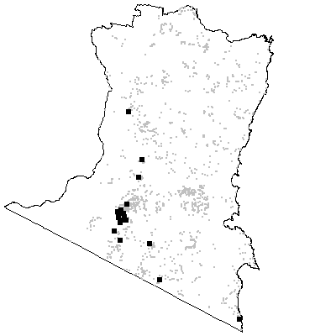
MAP UNIT 46A: Timbillica Dry Shrub Forest

Species richness: 36 ± 0 (0.04 ha)
Extant area: 22 792 ha
Proportion cleared: 1%
Number of samples: 24

Table A46A.1. Diagnostic plant species of Map Unit 46A.

Species | Target frequency | Target C/A | Residual frequency | Residual C/A | Fidelity class
Acacia lanigera | 0.083 | 2.5(2-3) | 0 | 0(0-0) | positive
Acacia terminalis | 0.583 | 2(1-2) | 0.112 | 2(1-3) | positive
Allocasuarina littoralis | 0.542 | 3(1-3) | 0.158 | 2(1-3) | positive
Caustis flexuosa | 0.667 | 2(1-2) | 0.028 | 2(1-3) | positive
Epacris impressa | 0.833 | 2(1-2) | 0.186 | 2(1-2) | positive
Eucalyptus agglomerata | 0.583 | 3(3-3) | 0.101 | 3(2-3) | positive
Eucalyptus consideniana | 0.833 | 3(1-3) | 0.008 | 2(1-3) | positive
Eucalyptus sieberi | 0.667 | 2.5(1-3) | 0.276 | 3(2-4) | positive
Gahnia radula | 0.625 | 2(2-3) | 0.082 | 2(1-3) | positive
Gonocarpus teucrioides | 0.958 | 2(2-2) | 0.305 | 2(1-2) | positive
Hibbertia empetrifolia | 0.583 | 2(1-2) | 0.057 | 1(1-2) | positive
Lasiopetalum ferrugineum var cordatum | 0.083 | 1.5(1-2) | 0 | 0(0-0) | positive
Monotoca scoparia | 0.833 | 2(1-3) | 0.114 | 2(1-2) | positive
Platysace lanceolata | 0.542 | 2(2-2) | 0.247 | 2(1-2) | positive
Pomaderris andromedifolia | 0.083 | 1.5(1-2) | 0 | 0(0-0) | positive
Pomaderris discolor | 0.042 | 1(1-1) | 0 | 0(0-0) | positive
Tetrarrhena juncea | 0.5 | 2(1-2) | 0.177 | 2(1-3) | positive
Tetratheca pilosa ssp latifolia | 0.625 | 2(1-2) | 0.017 | 1(1-2) | positive
Poa meionectes | 0.792 | 2(1-2) | 0.535 | 2(1-3) | constant
Pteridium esculentum | 0.958 | 2(2-3) | 0.57 | 2(1-3) | constant
Billardiera scandens | 0.625 | 1(1-1) | 0.324 | 1(1-1) | frequent
Lepidosperma laterale | 0.917 | 1.5(1-2) | 0.335 | 1(1-2) | frequent
Patersonia glabrata | 0.917 | 1.5(1-2) | 0.053 | 1(1-2) | frequent
Persoonia linearis | 0.917 | 1(1-1) | 0.276 | 1(1-2) | frequent
Callitris rhomboidea | 0.042 | 1(1-1) | 0.003 | 1(1-2) | uninformative
Eucalyptus angophoroides | 0.167 | 2(1-3) | 0.042 | 2(1-3) | uninformative
Eucalyptus cypellocarpa | 0.042 | 1(1-1) | 0.318 | 3(2-3) | uninformative
Eucalyptus globoidea | 0.458 | 2(1-3) | 0.239 | 3(1-3) | uninformative
Eucalyptus muelleriana | 0.042 | 3(3-3) | 0.144 | 3(2-4) | uninformative
Eucalyptus obliqua | 0.083 | 1(1-1) | 0.191 | 3(2-4) | uninformative
Eucalyptus radiata | 0.083 | 3(3-3) | 0.077 | 3(1-3) | uninformative
Eucalyptus sp. aff. radiata | 0.042 | 3(3-3) | 0.035 | 3(2-3) | uninformative
Eucalyptus viminalis | 0.042 | 1(1-1) | 0.057 | 3(1-3) | uninformative
Lomandra longifolia | 0.208 | 2(1-2) | 0.555 | 2(1-2) | negative

Table A46A.2. Vegetation structure of Map Unit 46A. Frequency is the proportion of samples in which strata were present. Height and cover data are means with standard errors in parentheses (n=19).

Stratum | Frequency (%) | Height (m) | Cover (%)
Tree | 100 | 26.6(1.5) | 24(1)
Small tree | 52.6 | 8.1(1.1) | 18(4)
Shrub | 100 | 1.9(0.3) | 21(3)
Ground cover | 100 | 0.6(0.0) | 13(2)

Table A46A.3. Habitat characteristics of Map Unit 46A. Means and interquartile ranges for altitude and slope were calculated from n field samples, while those for annual rain were calculated from ESOCLIM predictions (see Table 5, text). Frequency terrain and parent material refers to number of samples (n) recorded in respective classes. Terrain classes: flat (slope≤5°); north (slope>5° and aspect<30° or >300°); intermediate (slope>5° and aspect 30-120° or 210-300°); and south (slope>5° and aspect 120-210°).

 |  | Frequency (%) | Mean | Interquartile Range | n
Annual rain (mm) |  |  |  | 926 | 886 - 966 | 24
Altitude (m) |  |  |  | 264 | 185 - 338 | 19
Slope (degrees) |  |  |  | 6 | 3 - 10 | 19
Terrain class
 | North | 26 |  |  | 5
 | Intermediate | 26 |  |  | 5
 | South | 11 |  |  | 2
 | Flat | 37 |  |  | 7
Parent material
 | Devonian granitoids | 100 |  |  | 24

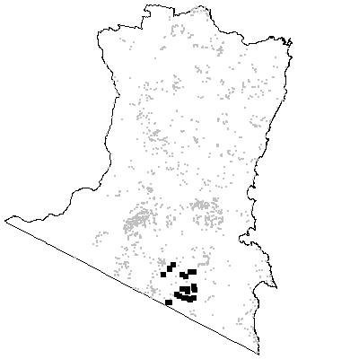
MAP UNIT 46B: Lowland Dry Shrub Forest

Species richness: 35 ± 2 (0.04 ha)
Extant area: 15 121 ha
Proportion cleared: 5%
Number of samples: 19

Table A46B.1. Diagnostic plant species of Map Unit 46B.

Species | Target frequency | Target C/A | Residual frequency | Residual C/A | Fidelity class
Acacia terminalis | 0.842 | 2(1-3) | 0.11 | 2(1-3) | positive
Allocasuarina littoralis | 0.579 | 2(2-4) | 0.159 | 2(1-3) | positive
Bossiaea obcordata | 0.526 | 2(2-2) | 0.021 | 2(2-3) | positive
Chionochloa pallida | 0.579 | 3(3-4) | 0.098 | 2(1-3) | positive
Corymbia gummifera | 0.632 | 3(3-4) | 0.012 | 3(2-3) | positive
Entolasia stricta | 0.526 | 2(1-2) | 0.177 | 1(1-2) | positive
Eucalyptus globoidea | 0.526 | 2.5(1-3) | 0.239 | 3(1-3) | positive
Eucalyptus sieberi | 0.79 | 3(2-4) | 0.276 | 3(2-4) | positive
Gompholobium glabratum | 0.105 | 1.5(1-2) | 0 | 0(0-0) | positive
Gonocarpus teucrioides | 0.842 | 2(2-2) | 0.309 | 2(1-2) | positive
Grevillea baueri | 0.053 | 2(2-2) | 0 | 0(0-0) | positive
Leptospermum trinervium | 0.526 | 2(1-2) | 0.023 | 2(1-3) | positive
Patersonia glabrata | 0.737 | 2(2-2) | 0.059 | 1(1-2) | positive
Pimelea linifolia ssp linifolia | 0.632 | 2(1-2) | 0.03 | 1(1-2) | positive
Platysace lanceolata | 0.737 | 2(2-2) | 0.245 | 2(1-2) | positive
Xanthosia pilosa | 0.579 | 2(1-2) | 0.052 | 1(1-2) | positive
Pteridium esculentum | 0.842 | 3(1-4) | 0.573 | 2(1-3) | constant
Correa reflexa | 0.737 | 1(1-2) | 0.119 | 1(1-2) | frequent
Persoonia linearis | 0.895 | 1(1-2) | 0.278 | 1(1-1) | frequent
Angophora floribunda | 0.316 | 1.5(1-2) | 0.092 | 2(1-3) | uninformative
Eucalyptus agglomerata | 0.158 | 3(1-3) | 0.108 | 3(2-3) | uninformative
Eucalyptus consideniana | 0.105 | 2.5(2-3) | 0.02 | 2(1-3) | uninformative
Eucalyptus muelleriana | 0.053 | 2(2-2) | 0.143 | 3(2-4) | uninformative
Eucalyptus pilularis | 0.105 | 4(4-4) | 0.002 | 1(1-3) | uninformative
Lomandra longifolia | 0.316 | 1(1-3) | 0.552 | 2(1-2) | negative
Poa meionectes | 0.211 | 2(1-3) | 0.543 | 2(1-3) | negative

Table A46B.2. Vegetation structure of Map Unit 46B. Frequency is the proportion of samples in which strata were present. Height and cover data are means with standard errors in parentheses (n=15).

Stratum | Frequency (%) | Height (m) | Cover (%)
Tree | 100 | 22.1(1.3) | 30(3)
Small tree | 66.7 | 8.3(0.8) | 21(4)
Shrub | 100 | 1.7(0.3) | 30(4)
Ground cover | 100 | 0.5(0.0) | 40(4)

Table A46B.3. Habitat characteristics of Map Unit 46B. Means and interquartile ranges for altitude and slope were calculated from n field samples, while those for annual rain were calculated from ESOCLIM predictions (see Table 5, text). Frequency terrain and parent material refers to number of samples (n) recorded in respective classes. Terrain classes: flat (slope≤5°); north (slope>5° and aspect<30° or >300°); intermediate (slope>5° and aspect 30-120° or 210-300°); and south (slope>5° and aspect 120-210°).

 |  | Frequency (%) | Mean | Interquartile Range | n
Annual rain (mm) |  |  |  | 887 | 860 - 915 | 19
Altitude (m) |  |  |  | 104 | 65 - 135 | 19
Slope (degrees) |  |  |  | 8 | 4 - 12 | 19
Terrain class
 | North | 5 |  |  | 1
 | Intermediate | 42 |  |  | 8
 | South | 16 |  |  | 3
 | Flat | 37 |  |  | 7
Parent material
 | Devonian granitoids | 5 |  |  | 1
 | Devonian high quartz sedimentaries | 58 |  |  | 11
 | Ordovician high quartz sedimentaries | 16 |  |  | 3
 | Tertiary Alluvium | 21 |  |  | 4

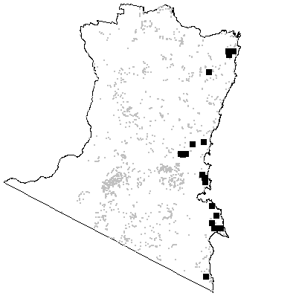

MAP UNIT 47: Eden Dry Shrub Forest

Species richness: 26 ± 1 (0.04 ha)
Extant area: 17 141 ha
Proportion cleared: 4%
Number of samples: 19

Table A47.1. Diagnostic plant species of Map Unit 47.

Species | Target frequency | Target C/A | Residual frequency | Residual C/A | Fidelity class
Acacia terminalis | 0.79 | 3(2-4) | 0.111 | 2(1-3) | positive
Allocasuarina littoralis | 0.684 | 2(1-4) | 0.158 | 2(1-3) | positive
Angophora floribunda | 0.526 | 3(2-3) | 0.089 | 2(1-3) | positive
Epacris impressa | 0.79 | 2(2-3) | 0.189 | 2(1-2) | positive
Eucalyptus sieberi | 0.895 | 3(3-4) | 0.275 | 3(2-4) | positive
Gahnia radula | 0.737 | 2(2-3) | 0.083 | 2(1-3) | positive
Gonocarpus teucrioides | 0.79 | 2(2-3) | 0.31 | 2(1-2) | positive
Hibbertia saligna | 0.053 | 2(2-2) | 0 | 0(0-0) | positive
Pultenaea daphnoides | 0.526 | 2(1-2) | 0.091 | 1(1-2) | positive
Tetrarrhena juncea | 0.737 | 3(2-3) | 0.175 | 2(1-3) | positive
Xanthosia pilosa | 0.79 | 2(1-2) | 0.05 | 1(1-2) | positive
Pteridium esculentum | 0.947 | 3(2-3) | 0.572 | 2(1-3) | constant
Dianella caerulea | 0.632 | 1(1-2) | 0.274 | 1(1-2) | frequent
Leucopogon lanceolatus var lanceolatus | 0.684 | 1(1-2) | 0.402 | 1(1-2) | frequent
Persoonia linearis | 0.684 | 1(1-2) | 0.281 | 1(1-2) | frequent
Platysace lanceolata | 0.947 | 1.5(1-2) | 0.242 | 2(1-2) | frequent
Acacia subporosa | 0.053 | 1(1-1) | 0.004 | 2(1-2) | uninformative
Eucalyptus agglomerata | 0.158 | 1(1-3) | 0.108 | 3(2-3) | uninformative
Eucalyptus baxteri | 0.053 | 3(3-3) | 0.008 | 3(2-3) | uninformative
Eucalyptus elata | 0.053 | 1(1-1) | 0.114 | 3(2-3) | uninformative
Eucalyptus globoidea | 0.105 | 2.5(2-3) | 0.244 | 3(1-3) | uninformative
Eucalyptus longifolia | 0.053 | 3(3-3) | 0.03 | 3(2-3) | uninformative
Eucalyptus muelleriana | 0.053 | 3(3-3) | 0.143 | 3(2-4) | uninformative
Eucalyptus obliqua | 0.105 | 1.5(1-2) | 0.191 | 3(2-4) | uninformative
Eucalyptus smithii | 0.053 | 3(3-3) | 0.045 | 2(1-3) | uninformative
Lomandra longifolia | 0.474 | 2(1-3) | 0.55 | 2(1-2) | negative
Poa meionectes | 0.158 | 1(1-2) | 0.544 | 2(1-3) | negative

Table A47.2. Vegetation structure of Map Unit 47. Frequency is the proportion of samples in which strata were present. Height and cover data are means with standard errors in parentheses (n=19).

Stratum | Frequency (%) | Height (m) | Cover (%)
Tree | 100 | 20.2(1.5) | 21(3)
Small tree | 47.4 | 5.6(0.9) | 30(9)
Shrub | 100 | 2.5(0.3) | 40(4)
Ground cover | 100 | 0.8(0.1) | 42(6)

Table A47.3. Habitat characteristics of Map Unit 47. Means and interquartile ranges for altitude and slope were calculated from n field samples, while those for annual rain were calculated from ESOCLIM predictions (see Table 5, text). Frequency terrain and parent material refers to number of samples (n) recorded in respective classes. Terrain classes: flat (slope≤5°); north (slope>5° and aspect<30° or >300°); intermediate (slope>5° and aspect 30-120° or 210-300°); and south (slope>5° and aspect 120-210°).

 |  | Frequency (%) | Mean | Interquartile Range | n
Annual rain (mm) |  |  |  | 1031 | 949 - 1089 | 19
Altitude (m) |  |  |  | 372 | 195 - 525 | 19
Slope (degrees) |  |  |  | 13 | 6 - 21 | 19
Terrain class
 | North | 21 |  |  | 4
 | Intermediate | 37 |  |  | 7
 | South | 26 |  |  | 5
 | Flat | 16 |  |  | 3
Parent material
 | Devonian high quartz sedimentaries | 95 |  |  | 18
 | Tertiary Alluvium | 5 |  |  | 1

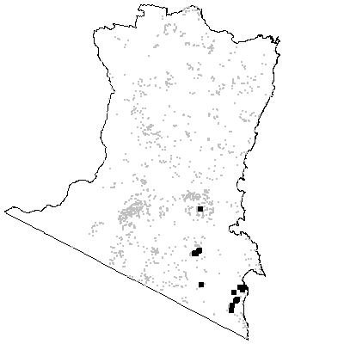
MAP UNIT 48: Mumbulla Dry Shrub Forest

Species richness: 28 ± 2 (0.04 ha)
Extant area: 4 455 ha
Proportion cleared: 1%
Number of samples: 19

Table A48.1. Diagnostic plant species of Map Unit 48.

Species | Target frequency | Target C/A | Residual frequency | Residual C/A | Fidelity class
Allocasuarina littoralis | 0.842 | 2(1-4) | 0.156 | 2(1-3) | positive
Bossiaea obcordata | 0.579 | 2(2-3) | 0.021 | 2(2-2) | positive
Chionochloa pallida | 0.632 | 3(3-4) | 0.098 | 2(1-3) | positive
Cryptostylis erecta | 0.053 | 1(1-1) | 0 | 0(0-0) | positive
Entolasia stricta | 0.526 | 2(1-2) | 0.177 | 1(1-2) | positive
Eucalyptus sieberi | 0.895 | 3(3-3) | 0.275 | 3(2-4) | positive
Helichrysum collinum | 0.053 | 2(2-2) | 0 | 0(0-0) | positive
Lepidosperma urophorum | 0.842 | 2(2-3) | 0.061 | 1(1-2) | positive
Lomandra confertifolia ssp rubiginosa | 0.579 | 2(1-2) | 0.03 | 1(1-2) | positive
Myoporum bateae | 0.053 | 1(1-1) | 0 | 0(0-0) | positive
Persoonia linearis | 0.947 | 2(1-2) | 0.277 | 1(1-1) | positive
Platysace lanceolata | 0.947 | 2(2-2) | 0.242 | 2(1-2) | positive
Senna odorata | 0.053 | 1(1-1) | 0 | 0(0-0) | positive
Solanum cinereum | 0.053 | 1(1-1) | 0 | 0(0-0) | positive
Correa reflexa | 0.737 | 1(1-2) | 0.119 | 1(1-2) | frequent
Lomandra multiflora | 0.632 | 1(1-1) | 0.246 | 1(1-2) | frequent
Angophora floribunda | 0.158 | 3(1-3) | 0.094 | 2(1-3) | uninformative
Eucalyptus agglomerata | 0.368 | 3(2-3) | 0.105 | 3(2-3) | uninformative
Eucalyptus elata | 0.053 | 1(1-1) | 0.114 | 3(2-3) | uninformative
Eucalyptus globoidea | 0.211 | 3(3-3) | 0.243 | 3(1-3) | uninformative
Eucalyptus smithii | 0.053 | 4(4-4) | 0.045 | 2(1-3) | uninformative
Lomandra longifolia | 0.158 | 1(1-1) | 0.554 | 2(1-2) | negative
Poa meionectes | 0.211 | 1(1-2) | 0.543 | 2(1-3) | negative
Pteridium esculentum | 0.421 | 2(1-2) | 0.579 | 2(1-3) | negative

Table A48.2. Vegetation structure of Map Unit 48. Frequency is the proportion of samples in which strata were present. Height and cover data are means with standard errors in parentheses (n=15).

Stratum | Frequency (%) | Height (m) | Cover (%)
Tree | 100 | 19.2(1.1) | 23(3)
Small tree | 53.3 | 6.6(1.1) | 21(7)
Shrub | 93.3 | 2.0(0.5) | 21(6)
Ground cover | 100 | 0.6(0.1) | 29(5)

Table A48.3. Habitat characteristics of Map Unit 48. Means and interquartile ranges for altitude and slope were calculated from n field samples, while those for annual rain were calculated from ESOCLIM predictions (see Table 5, text). Frequency terrain and parent material refers to number of samples (n) recorded in respective classes. Terrain classes: flat (slope≤5°); north (slope>5° and aspect<30° or >300°); intermediate (slope>5° and aspect 30-120° or 210-300°); and south (slope>5° and aspect 120-210°).

 |  | Frequency (%) | Mean | Interquartile Range | n
Annual rain (mm) |  |  |  | 990 | 942 - 1031 | 19
Altitude (m) |  |  |  | 330 | 215 - 450 | 19
Slope (degrees) |  |  |  | 19 | 11 - 31 | 19
Terrain class
 | North | 21 |  |  | 4
 | Intermediate | 47 |  |  | 9
 | South | 11 |  |  | 2
 | Flat | 21 |  |  | 4
Parent material
 | Devonian granitoids | 84 |  |  | 16
 | Devonian high quartz sedimentaries | 11 |  |  | 2
 | Ordovician high quartz sedimentaries | 5 |  |  | 1

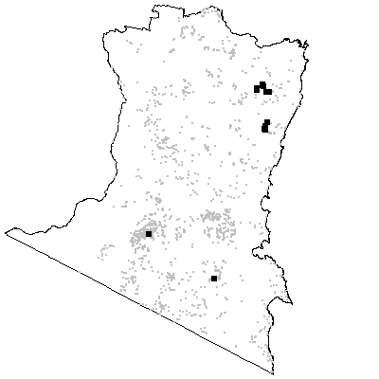
MAP UNIT 49: Coastal Dry Shrub Forest

Species richness: 28 ± 1 (0.04 ha)
Extant area: 31 837 ha
Proportion cleared: 2%
Number of samples: 52

Table A49.1. Diagnostic plant species of Map Unit 49.

Species | Target frequency | Target C/A | Residual frequency | Residual C/A | Fidelity class
Acacia obtusifolia | 0.667 | 2.5(2-3) | 0.07 | 3(2-3) | positive
Allocasuarina littoralis | 0.563 | 3(1-4) | 0.151 | 2(1-3) | positive
Caleana major | 0.021 | 1(1-1) | 0 | 0(0-0) | positive
Eucalyptus agglomerata | 0.75 | 3(2-3) | 0.087 | 3(2-3) | positive
Eucalyptus sieberi | 0.958 | 3(3-4) | 0.26 | 3(2-4) | positive
Lobelia gibbosa | 0.042 | 1(1-1) | 0 | 0(0-0) | positive
Monotoca scoparia | 0.625 | 2(1-2) | 0.109 | 2(1-2) | positive
Oxylobium ilicifolium | 0.688 | 2(1-2) | 0.059 | 1(1-2) | positive
Platysace lanceolata | 0.771 | 2(2-2) | 0.234 | 2(1-2) | positive
Stylidium graminifolium | 0.5 | 2(1-2) | 0.136 | 1(1-2) | positive
Billardiera scandens | 0.708 | 1(1-1) | 0.316 | 1(1-1) | frequent
Dianella caerulea | 0.667 | 1(1-2) | 0.265 | 1(1-2) | frequent
Lepidosperma laterale | 0.604 | 1(1-1) | 0.336 | 1(1-2) | frequent
Persoonia linearis | 0.917 | 1(1-2) | 0.265 | 1(1-2) | frequent
Angophora floribunda | 0.146 | 1(1-1) | 0.093 | 2(1-3) | uninformative
Corymbia gummifera | 0.063 | 1(1-3) | 0.019 | 3(2-4) | uninformative
Eucalyptus angophoroides | 0.021 | 3(3-3) | 0.045 | 2(1-3) | uninformative
Eucalyptus cypellocarpa | 0.042 | 1(1-1) | 0.323 | 3(2-3) | uninformative
Eucalyptus elata | 0.021 | 1(1-1) | 0.116 | 3(2-3) | uninformative
Eucalyptus globoidea | 0.021 | 1(1-1) | 0.25 | 3(1-3) | uninformative
Eucalyptus muelleriana | 0.063 | 2(1-3) | 0.145 | 3(3-4) | uninformative
Eucalyptus obliqua | 0.021 | 1(1-1) | 0.195 | 3(2-4) | uninformative
Eucalyptus smithii | 0.083 | 1.5(1-3) | 0.044 | 2(1-3) | uninformative
Eucalyptus tricarpa | 0.021 | 1(1-1) | 0.022 | 2(1-3) | uninformative
Lomandra longifolia | 0.271 | 1(1-2) | 0.558 | 2(1-2) | negative
Poa meionectes | 0.188 | 2(1-2) | 0.551 | 2(1-3) | negative
Pteridium esculentum | 0.458 | 2(1-2) | 0.581 | 2(1-3) | negative

Table A49.2. Vegetation structure of Map Unit 49. Frequency is the proportion of samples in which strata were present. Height and cover data are means with standard errors in parentheses (n=24).

Stratum | Frequency (%) | Height (m) | Cover (%)
Tree | 100 | 21.5(0.9) | 29(2)
Small tree | 58.3 | 8.6(0.9) | 17(4)
Shrub | 95.8 | 2.0(0.3) | 21(3)
Ground cover | 100 | 0.6(0.1) | 14(3)

Table A49.3. Habitat characteristics of Map Unit 49. Means and interquartile ranges for altitude and slope were calculated from n field samples, while those for annual rain were calculated from ESOCLIM predictions (see Table 5, text). Frequency terrain and parent material refers to number of samples (n) recorded in respective classes. Terrain classes: flat (slope≤5°); north (slope>5° and aspect<30° or >300°); intermediate (slope>5° and aspect 30-120° or 210-300°); and south (slope>5° and aspect 120-210°).

 |  | Frequency (%) | Mean | Interquartile Range | n
Annual rain (mm) |  |  |  | 954 | 898 - 992 | 53
Altitude (m) |  |  |  | 399 | 245 - 545 | 51
Slope (degrees) |  |  |  | 16 | 10 - 22 | 50
Terrain class
 | North | 30 |  |  | 15
 | Intermediate | 50 |  |  | 25
 | South | 16 |  |  | 8
 | Flat | 4 |  |  | 2
Parent material
 | Devonian granitoids | 15 |  |  | 8
 | Devonian high quartz sedimentaries | 40 |  |  | 21
 | Devonian rhyolite | 8 |  |  | 4
 | Low quartz sedimentaries | 26 |  |  | 14
 | Ordovician high quartz sedimentaries | 11 |  |  | 6

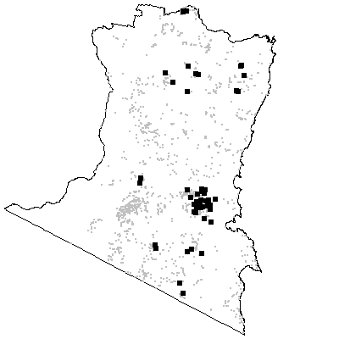

MAP UNIT 50: Genoa Dry Shrub Forest

Species richness: 21 ± 3 (0.04 ha)
Extant area: 3 026 ha
Proportion cleared: 18%
Number of samples: 5

Table A50.1. Diagnostic plant species of Map Unit 50.

Species | Target frequency | Target C/A | Residual frequency | Residual C/A | Fidelity class
Acacia falciformis | 0.8 | 2(2-4) | 0.188 | 2(1-3) | positive
Acacia terminalis | 0.6 | 3(2-3) | 0.118 | 2(1-3) | positive
Chionochloa pallida | 0.8 | 2.5(1-3) | 0.102 | 2(2-3) | positive
Eucalyptus agglomerata | 0.8 | 4(3-4) | 0.106 | 3(2-3) | positive
Monotoca scoparia | 1 | 3(2-3) | 0.123 | 2(1-2) | positive
Oxylobium ilicifolium | 0.8 | 2(1-3) | 0.077 | 1(1-2) | positive
Persoonia linearis | 0.8 | 2.5(1-3) | 0.284 | 1(1-2) | positive
Platysace lanceolata | 1 | 2(2-2) | 0.249 | 2(1-2) | positive
Pomax umbellata | 0.8 | 2.5(1-3) | 0.048 | 1(1-2) | positive
Lomandra longifolia | 0.6 | 2(2-2) | 0.549 | 2(1-2) | constant
Cassinia longifolia | 0.6 | 1(1-1) | 0.187 | 1(1-2) | frequent
Caustis flexuosa | 0.6 | 1(1-3) | 0.037 | 2(1-2) | frequent
Hardenbergia violacea | 0.6 | 1(1-3) | 0.099 | 1(1-1) | frequent
Lomatia ilicifolia | 0.8 | 1(1-2) | 0.129 | 1(1-2) | frequent
Eucalyptus angophoroides | 0.2 | 1(1-1) | 0.044 | 2(1-3) | uninformative
Eucalyptus globoidea | 0.2 | 3(3-3) | 0.243 | 3(1-3) | uninformative
Eucalyptus mackintii | 0.2 | 4(4-4) | 0.003 | 3(3-4) | uninformative
Eucalyptus radiata | 0.2 | 3(3-3) | 0.076 | 3(1-3) | uninformative
Poa meionectes | 0.2 | 1(1-1) | 0.54 | 2(1-3) | negative
Pteridium esculentum | 0.4 | 1.5(1-2) | 0.577 | 2(1-3) | negative

Table A50.2. Vegetation structure of Map Unit 50. Frequency is the proportion of samples in which strata were present. Height and cover data are means with standard errors in parentheses (n=5).

Stratum | Frequency (%) | Height (m) | Cover (%)
Tree | 100 | 17.4(1.3) | 32(5)
Small tree | 40 | 3.8(1.3) | 18(3)
Shrub | 100 | 1.2(0.3) | 32(12)
Ground cover | 100 | 0.4(0.1) | 18(4)

Table A50.3. Habitat characteristics of Map Unit 50. Means and interquartile ranges for altitude and slope were calculated from n field samples, while those for annual rain were calculated from ESOCLIM predictions (see Table 5, text). Frequency terrain and parent material refers to number of samples (n) recorded in respective classes. Terrain classes: flat (slope≤5°); north (slope>5° and aspect<30° or >300°); intermediate (slope>5° and aspect 30-120° or 210-300°); and south (slope>5° and aspect 120-210°).

 |  | Frequency (%) | Mean | Interquartile Range | n
Annual rain (mm) |  |  |  | 957 | 938 - 981 | 5
Altitude (m) |  |  |  | 456 | 360 - 465 | 5
Slope (degrees) |  |  |  | 26 | 21 - 29 | 5
Terrain class
 | North | 40 |  |  | 2
 | Intermediate | 60 |  |  | 3
 | South | 0 |  |  | 0
 | Flat | 0 |  |  | 0
Parent material
 | Devonian high quartz sedimentaries | 80 |  |  | 4
 | Ordovician high quartz sedimentaries | 20 |  |  | 1

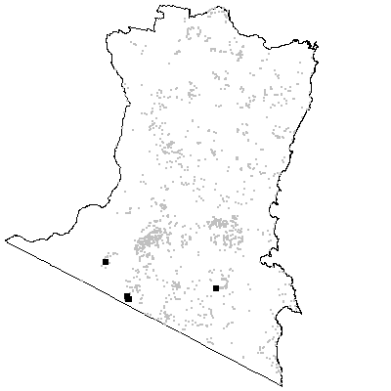
MAP UNIT 51: Rhyolite Rock Scrub

Species richness: 34 ± 4 (0.04 ha)
Extant area: 51 ha
Proportion cleared: 0%
Number of samples: 14

Table A51.1. Diagnostic plant species of Map Unit 51.

Species | Target frequency | Target C/A | Residual frequency | Residual C/A | Fidelity class
Acacia subtilinervis | 0.143 | 2(2-2) | 0 | 0(0-0) | positive
Calochilus robertsonii | 0.071 | 1(1-1) | 0 | 0(0-0) | positive
Cryptandra amara | 0.071 | 3(3-3) | 0 | 0(0-0) | positive
Danthonia longifolia | 0.714 | 2(1-2) | 0.07 | 1(1-2) | positive
Kunzea ambigua | 0.857 | 3(3-3) | 0.023 | 2(1-3) | positive
Lepidosperma laterale | 0.643 | 2(1-2) | 0.342 | 1(1-2) | positive
Melaleuca armillaris | 0.929 | 3(2-3) | 0.022 | 3(1-4) | positive
Mirbelia pungens | 0.071 | 1(1-1) | 0 | 0(0-0) | positive
Myriophyllum propinquum | 0.071 | 1(1-1) | 0 | 0(0-0) | positive
Phebalium ralstonii | 0.786 | 2(1-2) | 0.003 | 1(1-3) | positive
Platysace lanceolata | 0.929 | 2(2-2) | 0.245 | 2(1-2) | positive
Prasophyllum rhyoliticum | 0.071 | 1(1-1) | 0 | 0(0-0) | positive
Prostanthera phylicifolia | 0.071 | 3(3-3) | 0 | 0(0-0) | positive
Pultenaea retusa | 0.571 | 2(1-2) | 0.019 | 1(1-2) | positive
Sticherus flabellatus | 0.071 | 1(1-1) | 0 | 0(0-0) | positive
Westringia davidii | 0.286 | 2(1-3) | 0 | 0(0-0) | positive
Allocasuarina littoralis | 0.929 | 1(1-2) | 0.157 | 2(1-3) | frequent
Entolasia stricta | 0.786 | 1(1-2) | 0.176 | 1.5(1-2) | frequent
Lepidosperma urophorum | 0.786 | 1(1-2) | 0.064 | 1(1-2) | frequent
Stypandra glauca | 0.643 | 1(1-1) | 0.021 | 1(1-2) | frequent
Eucalyptus agglomerata | 0.286 | 1(1-3) | 0.107 | 3(2-3) | uninformative
Eucalyptus elata | 0.071 | 1(1-1) | 0.113 | 3(2-3) | uninformative
Eucalyptus sieberi | 0.357 | 2(1-3) | 0.282 | 3(2-4) | uninformative
Eucalyptus smithii | 0.214 | 2(1-2) | 0.044 | 2(1-3) | uninformative
Lomandra longifolia | 0.214 | 2(1-3) | 0.552 | 2(1-2) | negative
Poa meionectes | 0.357 | 1(1-2) | 0.541 | 2(1-3) | negative
Pteridium esculentum | 0.143 | 1.5(1-2) | 0.581 | 2(1-3) | negative

Table A51.2. Vegetation structure of Map Unit 51. Frequency is the proportion of samples in which strata were present. Height and cover data are means with standard errors in parentheses (n=14).

Stratum | Frequency (%) | Height (m) | Cover (%)
Tree | 57.1 | 14.4(2.0) | 7(2)
Small tree | 71.4 | 6.9(0.8) | 18(6)
Shrub | 100 | 2.6(0.3) | 32(6)
Ground cover | 100 | 0.6(0.1) | 8(3)

Table A51.3. Habitat characteristics of Map Unit 51. Means and interquartile ranges for altitude and slope were calculated from n field samples, while those for annual rain were calculated from ESOCLIM predictions (see Table 5, text). Frequency terrain and parent material refers to number of samples (n) recorded in respective classes. Terrain classes: flat (slope≤5°); north (slope>5° and aspect<30° or >300°); intermediate (slope>5° and aspect 30-120° or 210-300°); and south (slope>5° and aspect 120-210°).

 |  | Frequency (%) | Mean | Interquartile Range | n
Annual rain (mm) |  |  |  | 937 | 881 - 969 | 14
Altitude (m) |  |  |  | 314 | 210 - 408 | 14
Slope (degrees) |  |  |  | 22 | 10 - 31 | 14
Terrain class
 | North | 36 |  |  | 5
 | Intermediate | 29 |  |  | 4
 | South | 14 |  |  | 2
 | Flat | 21 |  |  | 3
Parent material
 | Devonian rhyolite | 100 |  |  | 14

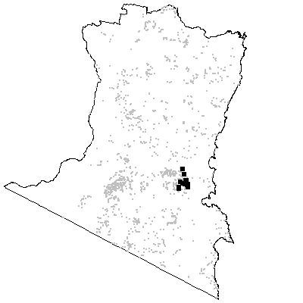

Map Unit 52: Mountain Rock Scrub

Species richness: 24 ± 2 (0.04 ha)
Extant area: 202 ha
Proportion cleared: 0%
Number of samples: 8

Table A52.1. Diagnostic plant species of Map Unit 52.

Species | Target frequency | Target C/A | Residual frequency | Residual C/A | Fidelity class
Acacia longifolia var longifolia | 0.625 | 2(2-2) | 0.138 | 2(1-3) | positive
Boronia anemonifolia | 0.125 | 2(2-2) | 0 | 0(0-0) | positive
Bulbostylis barbata | 0.125 | 1(1-1) | 0 | 0(0-0) | positive
Calandrinia calyptrata | 0.125 | 1(1-1) | 0 | 0(0-0) | positive
Correa reflexa | 0.875 | 2(1-2) | 0.123 | 1(1-2) | positive
Eucalyptus smithii | 0.5 | 2(2-3) | 0.043 | 2(1-3) | positive
Goodenia ovata | 0.75 | 2(1-2) | 0.17 | 2(1-3) | positive
Grevillea victoriae | 0.5 | 2(2-3) | 0.01 | 2(1-3) | positive
Hakea macraeana | 0.5 | 2.5(2-4) | 0.035 | 1(1-2) | positive
Hierochloe rariflora | 0.5 | 2(1-2) | 0.18 | 2(1-3) | positive
Kunzea ambigua | 0.625 | 4(3-6) | 0.028 | 2(1-3) | positive
Lepidosperma laterale | 0.875 | 2(2-2) | 0.342 | 1(1-2) | positive
Pomaderris prunifolia | 0.125 | 1(1-1) | 0 | 0(0-0) | positive
Stypandra glauca | 0.75 | 2(2-2) | 0.023 | 1(1-2) | positive
Lomandra longifolia | 0.625 | 2(2-2) | 0.549 | 2(1-2) | constant
Eucalyptus sieberi | 0.75 | 1(1-2) | 0.28 | 3(2-4) | frequent
Lepidosperma urophorum | 0.75 | 1.5(1-2) | 0.068 | 1(1-2) | frequent
Platysace lanceolata | 0.75 | 1(1-2) | 0.249 | 2(1-2) | frequent
Eucalyptus elata | 0.125 | 1(1-1) | 0.113 | 3(2-3) | uninformative
Eucalyptus globoidea | 0.125 | 1(1-1) | 0.243 | 3(1-3) | uninformative
Poa meionectes | 0.125 | 1(1-1) | 0.541 | 2(1-3) | negative
Pteridium esculentum | 0 | 0(2-0) | 0.58 | 2(1-3) | negative

Table A52.2. Vegetation structure of Map Unit 52. Frequency is the proportion of samples in which strata were present. Height and cover data are means with standard errors in parentheses (n=3).

Stratum | Frequency (%) | Height (m) | Cover (%)
Tree | 0 | -(-) | -(-)
Small tree | 66.7 | 13.5(1.5) | 8(3)
Shrub | 100 | 4.0(1.0) | 47(14)
Ground cover | 100 | 0.5(0.0) | 15(8)

Table A52.3. Habitat characteristics of Map Unit 52. Means and interquartile ranges for altitude and slope were calculated from n field samples, while those for annual rain were calculated from ESOCLIM predictions (see Table 5, text). Frequency terrain and parent material refers to number of samples (n) recorded in respective classes. Terrain classes: flat (slope≤5°); north (slope>5° and aspect<30° or >300°); intermediate (slope>5° and aspect 30-120° or 210-300°); and south (slope>5° and aspect 120-210°).

 |  | Frequency (%) | Mean | Interquartile Range | n
Annual rain (mm) |  |  |  | 1134 | 1126 - 1166 | 8
Altitude (m) |  |  |  | 749 | 660 - 770 | 8
Slope (degrees) |  |  |  | 39 | 30 - 46 | 4
Terrain class
 | North | 75 |  |  | 3
 | Intermediate | 25 |  |  | 1
 | South | 0 |  |  | 0
 | Flat | 0 |  |  | 0
Parent material
 | Devonian granitoids | 100 |  |  | 8

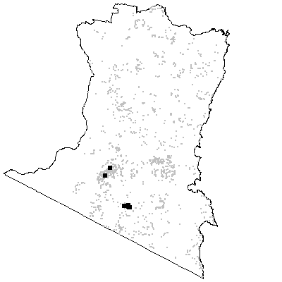
MAP UNIT 53: Montane Heath

Species richness: 17 ± 2 (0.04 ha)
Extant area: 1 350 ha
Proportion cleared: 23%
Number of samples: 21

Table A53.1. Diagnostic plant species of Map Unit 53.

Species |  | Target frequency | Target C/A |  | Residual frequency |  | Residual C/A |  |  | Fidelity class
Acacia lucassii | 0.143 |  |  | 1(1-3) |  | 0 |  | 0(0-0) | positive
Allocasuarina nana | 1 |  |  | 6(6-6.5) |  | 0.005 |  | 3(1-3) | positive
Aristida jerichoensis var jerichoensis | 0.048 |  |  | 1(1-1) |  | 0 |  | 0(0-0) | positive
Baeckea denticulata | 0.238 |  |  | 3(2.5-3.5) |  | 0 |  | 0(0-0) | positive
Boronia algida | 0.143 |  |  | 1(1-3) |  | 0 |  | 0(0-0) | positive
Brachyloma daphnoides | 0.857 |  |  | 2(1-2) |  | 0.018 |  | 1(1-2) | positive
Chionochloa pallida | 0.524 |  |  | 2(1-3) |  | 0.099 |  | 2(2-3) | positive
Chloanthes parviflora | 0.095 |  |  | 3(2-4) |  | 0 |  | 0(0-0) | positive
Dampiera fusca | 0.191 |  |  | 1(1-2) |  | 0 |  | 0(0-0) | positive
Deyeuxia parviseta var boormanii | 0.191 |  |  | 1(1-1) |  | 0 |  | 0(0-0) | positive
Dillwynia phylicoides | 0.095 |  |  | 3(2-4) |  | 0 |  | 0(0-0) | positive
Hakea dactyloides | 0.524 |  |  | 2(1-4) |  | 0.007 |  | 2(1-2) | positive
Haloragodendron monospermum | 0.238 |  |  | 2(1-4.5) |  | 0 |  | 0(0-0) | positive
Hibbertia pedunculata | 0.333 |  |  | 3(1-4) |  | 0 |  | 0(0-0) | positive
Kunzea parvifolia | 0.095 |  |  | 2(2-2) |  | 0 |  | 0(0-0) | positive
Kunzea sp. C | 0.288 |  |  | 3(2-4) |  | 0 |  | 0(0-0) | positive
Lomandra glauca | 0.619 |  |  | 2(1-3) |  | 0.036 |  | 1(1-2) | positive
Patersonia longifolia | 0.191 |  |  | 1(1-2.5) |  | 0 |  | 0(0-0) | positive
Poa sieberiana var cyanophylla | 0.095 |  |  | 1(1-1) |  | 0 |  | 0(0-0) | positive
Stipa pubinodis | 0.571 |  |  | 2(1-3) |  | 0.006 |  | 1.5(1-2) | positive
Danthonia tenuior | 0.524 |  |  | 1(1-1) |  | 0.002 |  | 1(1-2) | frequent
Banksia canei | 0.191 |  |  | 3(1-5) |  | 0.001 |  | 3.5(3-4) | uninformative
Eucalyptus consideniana | 0.048 |  |  | 2(2-2) |  | 0.021 |  | 2(1-3) | uninformative
Eucalyptus dalrympleana ssp dalrympleana | 0.048 |  |  | 1(1-1) |  | 0.018 |  | 2.5(1-3) | uninformative
Eucalyptus dives | 0.143 |  |  | 1(1-4) |  | 0.009 |  | 3(2.5-3) | uninformative
Eucalyptus pauciflora | 0.191 |  |  | 1(1-2) |  | 0.021 |  | 2.5(1-3) | uninformative
Eucalyptus rubida | 0.095 |  |  | 1(1-1) |  | 0.006 |  | 1(1-3) | uninformative
Eucalyptus sieberi | 0.048 |  |  | 3(3-3) |  | 0.286 |  | 3(2-4) | uninformative
Gonocarpus tetragynus | 0.57 |  |  | 1(1-2) |  | 0.16 |  | 2(1-2) | uninformative
Isopogon prostratus | 0.238 |  |  | 3(1-3) |  | 0.001 |  | 1(1-1) | uninformative
Lepidosperma gunnii | 0.524 |  |  | 1(1-2) |  | 0.004 |  | 1(1-2) | uninformative
Persoonia chamaepeuce | 0.238 |  |  | 1(1-2) |  | 0.008 |  | 1(1-2) | uninformative
Schoenus apogon | 0.238 |  |  | 2(1.5-3) |  | 0.023 |  | 1(1-2) | uninformative
Stylidium graminifolium | 0.81 |  |  | 1(1-3) |  | 0.139 |  | 1(1-2) | uninformative
Lomandra longifolia | 0.333 |  |  | 1(1-1) |  | 0.552 |  | 2(1-2) | negative
Poa meionectes | 0 |  |  | 0(0-0) |  | 0.547 |  | 2(1-3) | negative
Pteridium esculentum | 0 |  |  | 0(0-0) |  | 0.585 |  | 2(1-3) | negative

Table A53.2. Vegetation structure of Map Unit 53. Frequency is the proportion of samples in which strata were present. Height and cover data are means with standard errors in parentheses (n=21).

Stratum | Frequency (%) | Height (m) | Cover (%)
Tree | 14.3 | 10.0(2.9) | 15(10)
Small tree | 19 | 1.3(0.1) | 3(1)
Shrub | 100 | 1.3(0.2) | 86(3)
Ground cover | 100 | 0.3(0.0) | 7(2)

Table A53.3. Habitat characteristics of Map Unit 53. Means and interquartile ranges for altitude and slope were calculated from n field samples, while those for annual rain were calculated from ESOCLIM predictions (see Table 5, text). Frequency terrain and parent material refers to number of samples (n) recorded in respective classes. Terrain classes: flat (slope≤5°); north (slope>5° and aspect<30° or >300°); intermediate (slope>5° and aspect 30-120° or 210-300°); and south (slope>5° and aspect 120-210°). One extreme value was excluded from the summary statistics for annual rain (1004 mm).

 |  | Frequency (%) | Mean | Interquartile Range | n
Annual rain (mm) |  |  |  | 815 | 799 - 814 | 19
Altitude (m) |  |  |  | 950 | 818 - 1060 | 20
Slope (degrees) |  |  |  | 10 | 4 - 15 | 21
Terrain class
 | North | 29 |  |  | 6
 | Intermediate | 38 |  |  | 8
 | South | 5 |  |  | 1
 | Flat | 29 |  |  | 6
Parent material
 | Devonian granitoids | 5 |  |  | 1
 | Devonian high quartz sedimentaries | 14 |  |  | 3
 | Low quartz sedimentaries | 52 |  |  | 11
 | Ordovician high quartz sedimentaries | 29 |  |  | 6

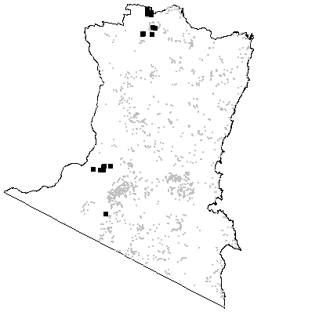

MAP UNIT 54: Mt Nadgee Heath

Species richness: 37 ± 3 (0.04 ha)
Extant area: 371 ha
Proportion cleared: 0%
Number of samples: 6

Table A54.1. Diagnostic plant species of Map Unit 54.

Species | Target frequency | Target C/A | Residual frequency | Residual C/A | Fidelity class
Acacia terminalis | 0.5 | 2(1-3) | 0.118 | 2(1-3) | positive
Baeckea linifolia | 0.167 | 1(1-1) | 0 | 0(0-0) | positive
Banksia paludosa | 0.833 | 3(2-3) | 0.007 | 2.5(1-3) | positive
Baumea acuta | 0.167 | 2(2-2) | 0 | 0(0-0) | positive
Bossiaea heterophylla | 0.5 | 2(1-2) | 0.002 | 2(1-2) | positive
Conospermum taxifolium | 0.333 | 1.5(1-2) | 0 | 0(0-0) | positive
Dillwynia glaberrima | 0.667 | 2(2-2) | 0.006 | 2(1-3) | positive
Epacris impressa | 0.833 | 2(2-3) | 0.194 | 2(1-2) | positive
Epacris microphylla var microphylla | 0.667 | 3(2-3) | 0.01 | 1.5(1-3) | positive
Eucalyptus baxteri | 0.833 | 3(2-3) | 0.005 | 3(2-4) | positive
Gonocarpus tetragynus | 0.667 | 2(2-2) | 0.164 | 2(1-2) | positive
Lepidosperma filiforme | 0.667 | 2(1-3) | 0.014 | 2(2-3) | positive
Lepidosperma gladiatum | 0.667 | 2.5(1-4) | 0.003 | 1(1-1) | positive
Lepidosperma neesii | 0.667 | 2(2-3) | 0.008 | 2.5(1-3) | positive
Leptospermum trinervium | 1 | 3(2-4) | 0.026 | 2(1-3) | positive
Lindsaea linearis | 0.833 | 2(2-2) | 0.029 | 1(1-2) | positive
Lomandra glauca | 0.667 | 2(2-3) | 0.042 | 1(1-2) | positive
Phebalium diosmeum | 0.667 | 2.5(1-3) | 0.002 | 3(1-3) | positive
Plinthanthesis paradoxa | 0.667 | 2(1-2) | 0.002 | 1(1-2) | positive
Lomandra longifolia | 0.5 | 2(1-3) | 0.549 | 2(1-2) | constant
Aotus ericoides | 0.667 | 1.5(1-2) | 0.024 | 1(1-2) | frequent
Cassytha glabella | 1 | 1(1-2) | 0.019 | 1(1-2) | frequent
Dampiera stricta | 0.833 | 1(1-2) | 0.029 | 1(1-2) | frequent
Gahnia sieberiana | 0.667 | 1(1-2) | 0.074 | 1(1-3) | frequent
Leptospermum continentale | 0.667 | 1(1-2) | 0.056 | 1(1-2) | frequent
Lepyrodia scariosa | 0.833 | 1(1-3) | 0.002 | 1(1-3) | frequent
Leucopogon esquamatus | 0.667 | 1.5(1-3) | 0.001 | 2(1-3) | frequent
Monotoca scoparia | 0.667 | 1(1-2) | 0.124 | 2(1-2) | frequent
Persoonia levis | 1 | 1(1-2) | 0.023 | 1(1-1) | frequent
Xanthosia pilosa | 0.667 | 1.5(1-2) | 0.057 | 1(1-2) | frequent
Angophora floribunda | 0.167 | 1(1-1) | 0.095 | 2(1-3) | uninformative
Banksia serrata | 0.333 | 3(3-3) | 0.04 | 1(1-2) | uninformative
Eucalyptus sieberi | 0.5 | 1(1-2) | 0.282 | 3(2-4) | uninformative
Poa meionectes | 0 | 0(1-0) | 0.541 | 2(1-3) | negative
Pteridium esculentum | 0.167 | 2(2-2) | 0.578 | 2(1-3) | negative

Table A54.2. Vegetation structure of Map Unit 54. Frequency is the proportion of samples in which strata were present. Height and cover data are means with standard errors in parentheses (n=6).

Stratum | Frequency (%) | Height (m) | Cover (%)
Tree | 83.3 | 12.2(4.4) | 10(2)
Small tree | 50 | 5.3(1.8) | 32(2)
Shrub | 100 | 1.2(0.4) | 43(7)
Ground cover | 100 | 0.5(0.1) | 33(4)

Table A54.3. Habitat characteristics of Map Unit 54. Means and interquartile ranges for altitude and slope were calculated from n field samples, while those for annual rain were calculated from ESOCLIM predictions (see Table 5, text). Frequency terrain and parent material refers to number of samples (n) recorded in respective classes. Terrain classes: flat (slope≤5°); north (slope>5° and aspect<30° or >300°); intermediate (slope>5° and aspect 30-120° or 210-300°); and south (slope>5° and aspect 120-210°).

 |  | Frequency (%) | Mean | Interquartile Range | n
Annual rain (mm) |  |  |  | 1013 | 930 - 1088 | 6
Altitude (m) |  |  |  | 283 | 159 - 389 | 6
Slope (degrees) |  |  |  | 5 | 3 - 8 | 6
Terrain class
 | North | 0 |  |  | 0
 | Intermediate | 33 |  |  | 2
 | South | 0 |  |  | 0
 | Flat | 67 |  |  | 4
Parent material
 | Devonian high quartz sedimentaries | 100 |  |  | 6

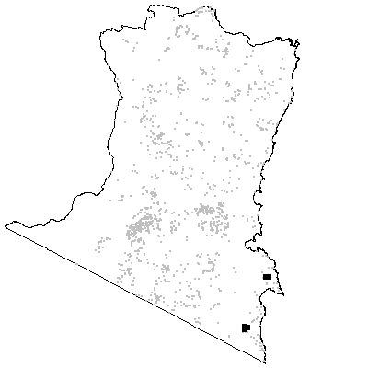
MAP UNIT 55: Coastal Lowland Heath

Species richness: 35 ± 4 (0.04 ha)
Extant area: 1 630 ha
Proportion cleared: 3%
Number of samples: 8

Table A55.1. Diagnostic plant species of Map Unit 55.

Species | Target frequency | Target C/A | Residual frequency | Residual C/A | Fidelity class
Acacia suaveolens | 0.5 | 2(1-2) | 0.013 | 1(1-2) | positive
Allocasuarina paludosa | 0.75 | 4(2-5) | 0.014 | 3(1-4) | positive
Almaleea paludosa | 0.125 | 2(2-2) | 0 | 0(0-0) | positive
Banksia paludosa | 0.75 | 3(1-3) | 0.006 | 2(2-3) | positive
Burchardia umbellata | 0.625 | 2(1-2) | 0.018 | 1(1-1) | positive
Cryptandra ericoides | 0.5 | 2(1-3) | 0.002 | 1(1-1) | positive
Epacris impressa | 0.875 | 3(2-3) | 0.193 | 2(1-2) | positive
Euphrasia collina ssp collina | 0.25 | 1.5(1-2) | 0 | 0(0-0) | positive
Hakea sericea | 0.5 | 2.5(1-3) | 0.022 | 1(1-2) | positive
Helichrysum obtusifolium | 0.375 | 3(3-3) | 0 | 0(0-0) | positive
Hypolaena fastigiata | 0.625 | 2(2-3) | 0.002 | 1(1-2) | positive
Lepidosperma neesii | 0.75 | 2.5(1-3) | 0.007 | 2(2-3) | positive
Leptocarpus tenax | 0.5 | 3(2-5) | 0.005 | 3(2-3) | positive
Leptospermum continentale | 0.875 | 2(1-3) | 0.054 | 1(1-2) | positive
Lindsaea linearis | 0.625 | 2(1-2) | 0.029 | 1(1-2) | positive
Lomandra glauca | 0.875 | 2(1-2) | 0.04 | 1(1-2) | positive
Mirbelia rubiifolia | 0.25 | 1.5(1-2) | 0 | 0(0-0) | positive
Patersonia glabrata | 0.5 | 2(1-3) | 0.065 | 1(1-2) | positive
Persoonia juniperina | 0.125 | 1(1-1) | 0 | 0(0-0) | positive
Ptilothrix deusta | 0.125 | 2(2-2) | 0 | 0(0-0) | positive
Thysanotus juncifolius | 0.125 | 1(1-1) | 0 | 0(0-0) | positive
Xanthosia pusilla | 0.375 | 2(1-2) | 0 | 0(0-0) | positive
Xanthosia tridentata | 0.5 | 2(2-3) | 0.018 | 1(1-2) | positive
Banksia serrata | 0.75 | 1(1-2) | 0.038 | 1(1-2) | frequent
Cassytha glabella | 0.75 | 1(1-2) | 0.019 | 1(1-2) | frequent
Dampiera stricta | 0.625 | 1(1-2) | 0.029 | 1(1-2) | frequent
Entolasia stricta | 0.625 | 1(1-1) | 0.179 | 2(1-2) | frequent
Pimelea linifolia ssp linifolia | 0.75 | 1(1-2) | 0.033 | 1(1-2) | frequent
Selaginella uliginosa | 0.625 | 1(1-3) | 0.008 | 2(1-3) | frequent
Callitris rhomboidea | 0.125 | 2(2-2) | 0.003 | 1(1-2) | uninformative
Corymbia gummifera | 0.125 | 1(1-1) | 0.02 | 3(2-4) | uninformative
Eucalyptus conspicua | 0.125 | 3(3-3) | 0.001 | 1.5(1-2) | uninformative
Eucalyptus globoidea | 0.125 | 3(3-3) | 0.243 | 3(1-3) | uninformative
Lomandra longifolia | 0 | 0(1-0) | 0.552 | 2(1-2) | negative
Poa meionectes | 0 | 0(1-0) | 0.542 | 2(1-3) | negative
Pteridium esculentum | 0 | 0(1-0) | 0.58 | 2(1-3) | negative

Table A55.2. Vegetation structure of Map Unit 55. Frequency is the proportion of samples in which strata were present. Height and cover data are means with standard errors in parentheses (n=8).

Stratum | Frequency (%) | Height (m) | Cover (%)
Tree | - | -(-) | -(-)
Small tree | 12.5 | 5.0(-) | 15(-)
Shrub | 100 | 0.8(0.2) | 59(9)
Ground cover | 100 | 0.4(0.0) | 53(10)

Table A55.3. Habitat characteristics of Map Unit 55. Means and interquartile ranges for altitude and slope were calculated from n field samples, while those for annual rain were calculated from ESOCLIM predictions (see Table 5, text). Frequency terrain and parent material refers to number of samples (n) recorded in respective classes. Terrain classes: flat (slope≤5°); north (slope>5° and aspect<30° or >300°); intermediate (slope>5° and aspect 30-120° or 210-300°); and south (slope>5° and aspect 120-210°).

 |  | Frequency (%) | Mean | Interquartile Range | n
Annual rain (mm) |  |  |  | 901 | 884 - 917 | 8
Altitude (m) |  |  |  | 42 | 24 - 65 | 8
Slope (degrees) |  |  |  | 2 | 1 - 3 | 8
Terrain class
 | North | 0 |  |  | 0
 | Intermediate | 0 |  |  | 0
 | South | 13 |  |  | 1
 | Flat | 88 |  |  | 7
Parent material
 | Low quartz sedimentaries | 13 |  |  | 1
 | Tertiary Alluvium | 88 |  |  | 7

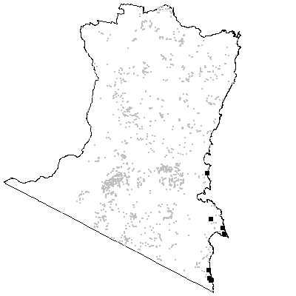

MAP UNIT 56: Hinterland Heath

Species richness: 29 ± 4 (0.04 ha)
Extant area: 385 ha
Proportion cleared: 0%
Number of samples: 5

Table A56.1. Diagnostic plant species of Map Unit 56.

Species | Target frequency | Target C/A | Residual frequency | Residual C/A | Fidelity class
Acacia brownii | 0.2 | 2(2-2) | 0 | 0(0-0) | positive
Allocasuarina paludosa | 1 | 4(3-5) | 0.015 | 2.5(1-4) | positive
Amphipogon strictus | 0.2 | 2(2-2) | 0 | 0(0-0) | positive
Empodisma minus | 0.6 | 2(1-3) | 0.012 | 2(1-3) | positive
Epacris impressa | 0.6 | 2(1-2) | 0.195 | 2(1-2) | positive
Eucalyptus ignorabilis | 0.2 | 3(3-3) | 0 | 0(0-0) | positive
Gahnia radula | 0.6 | 2(2-3) | 0.089 | 2(1-3) | positive
Gonocarpus tetragynus | 0.6 | 2(1-2) | 0.164 | 2(1-2) | positive
Goodenia humilis | 0.2 | 1(1-1) | 0 | 0(0-0) | positive
Goodenia paniculata | 0.4 | 1(1-1) | 0 | 0(0-0) | positive
Hypericum gramineum | 0.6 | 2(1-2) | 0.241 | 1(1-2) | positive
Leptospermum continentale | 1 | 3(2-3) | 0.055 | 1(1-2) | positive
Patersonia fragilis | 0.6 | 2(2-3) | 0.004 | 1(1-1) | positive
Schoenus lepidosperma ssp lepidosperma | 0.2 | 3(3-3) | 0 | 0(0-0) | positive
Drosera peltata | 0.6 | 1(1-2) | 0.008 | 1(1-1) | frequent
Lindsaea linearis | 1 | 1(1-2) | 0.029 | 1(1-2) | frequent
Poa meionectes | 0.6 | 1(1-3) | 0.539 | 2(1-3) | frequent
Eucalyptus angophoroides | 0.2 | 2(2-2) | 0.044 | 2(1-3) | uninformative
Eucalyptus consideniana | 0.2 | 2(2-2) | 0.02 | 2(1-3) | uninformative
Eucalyptus conspicua | 0.2 | 2(2-2) | 0.001 | 2(1-3) | uninformative
Eucalyptus globoidea | 0.4 | 1(1-1) | 0.242 | 3(1-3) | uninformative
Eucalyptus ovata | 0.2 | 2(2-2) | 0.022 | 3(1-3) | uninformative
Eucalyptus radiata | 0.2 | 1(1-1) | 0.076 | 3(1-3) | uninformative
Eucalyptus sp. aff. radiata | 0.2 | 1(1-1) | 0.035 | 3(2-3) | uninformative
Eucalyptus viminalis | 0.2 | 1(1-1) | 0.057 | 3(1-3) | uninformative
Lomandra longifolia | 0.2 | 1(1-1) | 0.55 | 2(1-2) | negative
Pteridium esculentum | 0 | 0(1-0) | 0.579 | 2(1-3) | negative

Table A56.2. Vegetation structure of Map Unit 56. Frequency is the proportion of samples in which strata were present. Height and cover data are means with standard errors in parentheses (n=3).

Stratum | Frequency (%) | Height (m) | Cover (%)
Tree | 0 | -(-) | -(-)
Small tree | 66.7 | 5.5(0.5) | 4(3)
Shrub | 100 | 3.2(0.4) | 63(12)
Ground cover | 100 | 0.6(0.2) | 65(16)

Table A56.3. Habitat characteristics of Map Unit 56. Means and interquartile ranges for altitude and slope were calculated from n field samples, while those for annual rain were calculated from ESOCLIM predictions (see Table 5, text). Frequency terrain and parent material refers to number of samples (n) recorded in respective classes. Terrain classes: flat (slope≤5°); north (slope>5° and aspect<30° or >300°); intermediate (slope>5° and aspect 30-120° or 210-300°); and south (slope>5° and aspect 120-210°).

 |  | Frequency (%) | Mean | Interquartile Range | n
Annual rain (mm) |  |  |  | 965 | 958 - 999 | 5
Altitude (m) |  |  |  | 447 | 330 - 560 | 5
Slope (degrees) |  |  |  | 4 | 4 - 5 | 5
Terrain class
 | North | 40 |  |  | 2
 | Intermediate | 0 |  |  | 0
 | South | 0 |  |  | 0
 | Flat | 60 |  |  | 3
Parent material
 | Devonian granitoids | 100 |  |  | 5

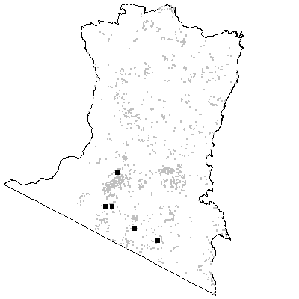
MAP UNIT 57: Lowland Swamp

Species richness: 28 ± 4 (0.04 ha)
Extant area: 1 892 ha
Proportion cleared: 6%
Number of samples: 9

Table A57.1. Diagnostic plant species of Map Unit 57.

Species | Target frequency | Target C/A | Residual frequency | Residual C/A | Fidelity class
Baumea teretifolia | 0.222 | 1.5(1-2) | 0 | 0(0-0) | positive
Boronia parviflora | 0.333 | 1(1-1) | 0 | 0(0-0) | positive
Callistemon citrinus | 0.667 | 3(1-3) | 0.004 | 2.5(1-3) | positive
Comesperma retusum | 0.111 | 2(2-2) | 0 | 0(0-0) | positive
Drosera binata | 0.111 | 1(1-1) | 0 | 0(0-0) | positive
Empodisma minus | 1 | 2(2-4) | 0.008 | 2(1-3) | positive
Epacris paludosa | 0.556 | 2(2-3) | 0.005 | 2(1-4) | positive
Gahnia radula | 0.556 | 3(2-4) | 0.088 | 2(1-3) | positive
Gahnia sieberiana | 0.556 | 2(2-3) | 0.074 | 1(1-2) | positive
Lepidosperma limicola | 0.556 | 3(2-4) | 0.002 | 1(1-3) | positive
Leptocarpus tenax | 0.778 | 3(2-3) | 0.003 | 3(2-5) | positive
Leptospermum continentale | 0.889 | 2.5(2-3) | 0.053 | 1(1-2) | positive
Melaleuca squarrosa | 1 | 4(3-4) | 0.006 | 2(2-3) | positive
Sowerbaea juncea | 0.111 | 1(1-1) | 0 | 0(0-0) | positive
Sprengelia incarnata | 0.667 | 2(2-3) | 0.001 | 2(1-3) | positive
Tetrarrhena juncea | 0.556 | 2(2-3) | 0.18 | 2(1-3) | positive
Tetrarrhena turfosa | 0.111 | 2(2-2) | 0 | 0(0-0) | positive
Villarsia exaltata | 0.111 | 1(1-1) | 0 | 0(0-0) | positive
Viminaria juncea | 0.111 | 1(1-1) | 0 | 0(0-0) | positive
Selaginella uliginosa | 0.778 | 1(1-2) | 0.007 | 2(1-3) | frequent
Eucalyptus agglomerata | 0.111 | 1(1-1) | 0.109 | 3(2-3) | uninformative
Eucalyptus angophoroides | 0.111 | 1(1-1) | 0.044 | 2(1-3) | uninformative
Eucalyptus consideniana | 0.444 | 1(1-1) | 0.018 | 3(2-3) | uninformative
Eucalyptus conspicua | 0.111 | 1(1-1) | 0.001 | 2.5(2-3) | uninformative
Eucalyptus ovata | 0.222 | 1(1-1) | 0.022 | 3(1-3) | uninformative
Lomandra longifolia | 0.333 | 1(1-3) | 0.55 | 2(1-2) | negative
Poa meionectes | 0.111 | 1(1-1) | 0.541 | 2(1-3) | negative
Pteridium esculentum | 0 | 0(1-0) | 0.58 | 2(1-3) | negative

Table A57.2. Vegetation structure of Map Unit 57. Frequency is the proportion of samples in which strata were present. Height and cover data are means with standard errors in parentheses (n=9).

Stratum | Frequency (%) | Height (m) | Cover (%)
Tree | 0 | -(-) | -(-)
Small tree | 55.6 | 9(0.5) | 2(1)
Shrub | 100 | 1.8(0.1) | 52(7)
Ground cover | 100 | 1.2(0.1) | 91(4)

Table A57.3. Habitat characteristics of Map Unit 57. Means and interquartile ranges for altitude and slope were calculated from n field samples, while those for annual rain were calculated from ESOCLIM predictions (see Table 5, text). Frequency terrain and parent material refers to number of samples (n) recorded in respective classes. Terrain classes: flat (slope≤5°); north (slope>5° and aspect<30° or >300°); intermediate (slope>5° and aspect 30-120° or 210-300°); and south (slope>5° and aspect 120-210°).

 |  | Frequency (%) | Mean | Interquartile Range | n
Annual rain (mm) |  |  |  | 910 | 869 - 927 | 9
Altitude (m) |  |  |  | 179 | 70 - 250 | 9
Slope (degrees) |  |  |  | 3 | 2 - 4 | 9
Terrain class
 | North | 0 |  |  | 0
 | Intermediate | 22 |  |  | 2
 | South | 0 |  |  | 0
 | Flat | 78 |  |  | 7
Parent material
 | Devonian granitoids | 67 |  |  | 6
 | Holocene Riverine Alluvuim | 11 |  |  | 1
 | Tertiary Alluvium | 22 |  |  | 2

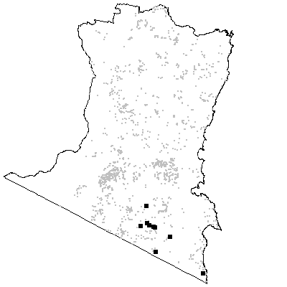

MAP UNIT 58: Swamp Forest

Species richness: 30 ± 4 (0.04 ha)
Extant area: 953 ha
Proportion cleared: 12%
Number of samples: 14

Table A58.1. Diagnostic plant species of Map Unit 58.

Species | Target frequency | Target C/A | Residual frequency | Residual C/A | Fidelity class
Carex appressa | 0.5 | 3(1-4) | 0.08 | 1(1-2) | positive
Carex gaudichaudiana | 0.571 | 3(2-5) | 0.005 | 1(1-2) | positive
Cyperus lucidus | 0.5 | 3(1-3) | 0.011 | 2(1-2) | positive
Eleocharis gracilis | 0.5 | 2(1-3) | 0.003 | 2(1-3) | positive
Eucalyptus ovata | 0.786 | 3(2-3) | 0.016 | 2(1-3) | positive
Geranium neglectum | 0.571 | 2(1-2) | 0.005 | 1(1-1) | positive
Hydrocotyle peduncularis | 0.643 | 2(1-2) | 0.01 | 1(1-2) | positive
Juncus homalocaulis | 0.071 | 1(1-1) | 0 | 0(0-0) | positive
Juncus sarophorus | 0.357 | 2(2-3) | 0 | 0(0-0) | positive
Olearia glandulosa | 0.143 | 2(1-3) | 0 | 0(0-0) | positive
Poa labillardieri var labillardieri | 0.643 | 3(3-4) | 0.165 | 1(1-2) | positive
Potamogeton tricarinatus | 0.071 | 1(1-1) | 0 | 0(0-0) | positive
Ranunculus amphitrichus | 0.071 | 1(1-1) | 0 | 0(0-0) | positive
Stellaria palustris | 0.143 | 1.5(1-2) | 0 | 0(0-0) | positive
Lomandra longifolia | 0.929 | 3(2-5) | 0.545 | 2(1-2) | constant
Gratiola peruviana | 0.929 | 1(1-2) | 0.015 | 1.5(1-2) | frequent
Acacia melanoxylon | 0.429 | 1.5(1-2) | 0.102 | 1(1-3) | uninformative
Eucalyptus cypellocarpa | 0.071 | 2(2-2) | 0.316 | 3(2-3) | uninformative
Eucalyptus globoidea | 0.143 | 1(1-1) | 0.244 | 3(1-3) | uninformative
Eucalyptus radiata | 0.071 | 1(1-1) | 0.077 | 3(1-3) | uninformative
Eucalyptus sieberi | 0.071 | 1(1-1) | 0.285 | 3(2-4) | uninformative
Eucalyptus sp. aff. radiata | 0.071 | 1(1-1) | 0.035 | 3(2-3) | uninformative
Eucalyptus viminalis | 0.286 | 3(2-4) | 0.055 | 3(1-3) | uninformative
Poa meionectes | 0.143 | 2(2-2) | 0.543 | 2(1-3) | negative
Pteridium esculentum | 0.214 | 1(1-2) | 0.58 | 2(1-3) | negative

Table A58.2. Vegetation structure of Map Unit 58. Frequency is the proportion of samples in which strata were present. Height and cover data are means with standard errors in parentheses (n=8).

Stratum | Frequency (%) | Height (m) | Cover (%)
Tree | 75 | 20.8(3.6) | 28(7)
Small tree | 12.5 | 8.0(-) | 4(-)
Shrub | 87.5 | 1.7(0.1) | 25(9)
Ground cover | 100 | 0.6(0.1) | 81(9)

Table A58.3. Habitat characteristics of Map Unit 58. Means and interquartile ranges for altitude and slope were calculated from n field samples, while those for annual rain were calculated from ESOCLIM predictions (see Table 5, text). Frequency terrain and parent material refers to number of samples (n) recorded in respective classes. Terrain classes: flat (slope≤5°); north (slope>5° and aspect<30° or >300°); intermediate (slope>5° and aspect 30-120° or 210-300°); and south (slope>5° and aspect 120-210°).

 |  | Frequency (%) | Mean | Interquartile Range | n
Annual rain (mm) |  |  |  | 982 | 964 - 997 | 14
Altitude (m) |  |  |  | 487 | 399 - 530 | 14
Slope (degrees) |  |  |  | 2 | 0 - 3 | 14
Terrain class
 | North | 14 |  |  | 2
 | Intermediate | 0 |  |  | 0
 | South | 0 |  |  | 0
 | Flat | 86 |  |  | 12
Parent material
 | Devonian granitoids | 93 |  |  | 13
 | Holocene Riverine Alluvuim | 7 |  |  | 1

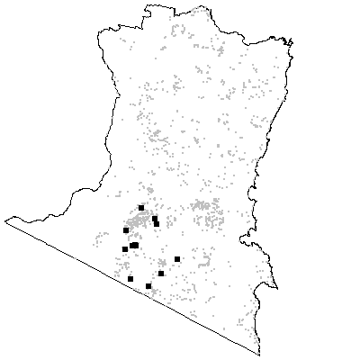

MAP UNIT 59: Subalpine Bog

Species richness: 29 ± 4 (0.04 ha)
Extant area: 1 869 ha
Proportion cleared: 72%
Number of samples: 9

Table A59.1. Diagnostic plant species of Map Unit 59.

Species | Target frequency | Target C/A | Residual frequency | Residual C/A | Fidelity class
Agrostis 'hiemalis' | 0.143 | 1(1-1) | 0 | 0(0-0) | positive
Almaleea subumbellata | 0.143 | 1(1-1) | 0 | 0(0-0) | positive
Asperula gunnii | 0.571 | 2(1-2) | 0.018 | 1(1-1) | positive
Baeckea gunniana | 0.143 | 4(4-4) | 0 | 0(0-0) | positive
Baeckea utilis | 0.571 | 3(2-3) | 0.002 | 1(1-1) | positive
Boronia deanei | 0.143 | 4(4-4) | 0 | 0(0-0) | positive
Callistemon pityoides | 0.143 | 3(3-3) | 0 | 0(0-0) | positive
Carex capillacea | 0.143 | 1(1-1) | 0 | 0(0-0) | positive
Celmisia longifolia | 0.143 | 2(2-2) | 0 | 0(0-0) | positive
Cotula alpina | 0.143 | 1(1-1) | 0 | 0(0-0) | positive
Danthonia eriantha | 0.143 | 1(1-1) | 0 | 0(0-0) | positive
Empodisma minus | 0.571 | 3(2-4) | 0.012 | 2(1-3) | positive
Epacris breviflora | 0.286 | 1(1-1) | 0 | 0(0-0) | positive
Epacris paludosa | 0.571 | 3.5(2-4) | 0.005 | 2(1-3) | positive
Epacris petrophila | 0.143 | 3(3-3) | 0 | 0(0-0) | positive
Festuca hookeriana | 0.143 | 1(1-1) | 0 | 0(0-0) | positive
Hydrocotyle algida | 0.143 | 1(1-1) | 0 | 0(0-0) | positive
Hydrocotyle peduncularis | 0.571 | 2(1-3) | 0.013 | 1(1-2) | positive
Isolepis aucklandica | 0.143 | 1(1-1) | 0 | 0(0-0) | positive
Juncus phaeanthus | 0.143 | 1(1-1) | 0 | 0(0-0) | positive
Lepyrodia anarthria | 0.571 | 3(2-3) | 0.003 | 2(1-4) | positive
Nertera granadensis | 0.143 | 1(1-1) | 0 | 0(0-0) | positive
Poa costiniana | 0.143 | 1(1-1) | 0 | 0(0-0) | positive
Pratia surrepens | 0.429 | 1(1-2) | 0 | 0(0-0) | positive
Restio australis | 0.857 | 2.5(1-3) | 0.001 | 1(1-1) | positive
Trisetum spicatum | 0.143 | 1(1-1) | 0 | 0(0-0) | positive
Velleia montana | 0.143 | 1(1-1) | 0 | 0(0-0) | positive
Viola caleyana | 0.143 | 1(1-1) | 0 | 0(0-0) | positive
Gonocarpus micranthus | 0.714 | 1(1-2) | 0.01 | 1(1-1) | frequent
Hakea microcarpa | 0.857 | 1(1-3) | 0.001 | 1(1-1) | frequent
Eucalyptus pauciflora | 0.429 | 1(1-3) | 0.021 | 2(1-3) | uninformative
Eucalyptus rubida | 0.143 | 1(1-1) | 0.006 | 1(1-3) | uninformative
Eucalyptus viminalis | 0.143 | 1(1-1) | 0.057 | 3(1-3) | uninformative
Lomandra longifolia | 0 | 0(1-0) | 0.552 | 2(1-2) | negative
Poa meionectes | 0.286 | 2(2-2) | 0.54 | 2(1-3) | negative
Pteridium esculentum | 0 | 0(1-0) | 0.58 | 2(1-3) | negative

Table A59.2. Vegetation structure of Map Unit 59. Frequency is the proportion of samples in which strata were present. Height and cover data are means with standard errors in parentheses (n=5).

Stratum | Frequency (%) | Height (m) | Cover (%)
Tree | 0 | -(-) | -(-)
Small tree | 40 | 9.8(2.3) | 27(23)
Shrub | 100 | 1.2(0.3) | 53(12)
Ground cover | 100 | 0.4(0.1) | 69(12)

Table A59.3. Habitat characteristics of Map Unit 59. Means and interquartile ranges for altitude and slope were calculated from n field samples, while those for annual rain were calculated from ESOCLIM predictions (see Table 5, text). Frequency terrain and parent material refers to number of samples (n) recorded in respective classes. Terrain classes: flat (slope≤5°); north (slope>5° and aspect<30° or >300°); intermediate (slope>5° and aspect 30-120° or 210-300°); and south (slope>5° and aspect 120-210°).

 |  | Frequency (%) | Mean | Interquartile Range | n
Annual rain (mm) |  |  |  | 923 | 857 - 930 | 9
Altitude (m) |  |  |  | 974 | 938 - 1036 | 8
Slope (degrees) |  |  |  | 2 | 1 - 2 | 8
Terrain class
 | North | 13 |  |  | 1
 | Intermediate | 0 |  |  | 0
 | South | 0 |  |  | 0
 | Flat | 88 |  |  | 7
Parent material
 | Devonian granitoids | 67 |  |  | 6
 | Devonian high quartz sedimentaries | 11 |  |  | 1
 | Holocene Riverine Alluvuim | 11 |  |  | 1
 | Ordovician high quartz sedimentaries | 11 |  |  | 1

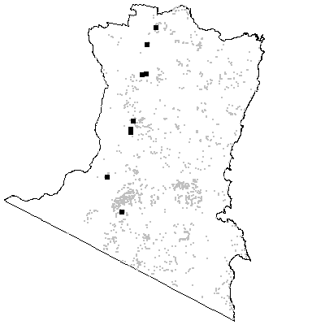

Map Unit 60: Floodplain Wetlands

Species richness: 39 ± 7 (0.04 ha)
Extant area: 3 281 ha
Proportion cleared: 65%
Number of samples: 3

Table A60.1. Diagnostic plant species of Map Unit 60.

Species | Target frequency | Target C/A | Residual frequency | Residual C/A | Fidelity class
Blechnum minus | 0.667 | 2(1-3) | 0.01 | 1(1-1) | positive
Callitriche muelleri | 0.667 | 2(1-3) | 0 | 0(0-0) | positive
Carex appressa | 0.667 | 2(1-3) | 0.083 | 1(1-2) | positive
Carex brownii | 0.333 | 1(1-1) | 0 | 0(0-0) | positive
Carex longebrachiata | 0.667 | 2.5(2-3) | 0.035 | 1(1-2) | positive
Eleocharis acuta | 0.333 | 2(2-2) | 0 | 0(0-0) | positive
Eucalyptus ovata | 0.667 | 2(1-3) | 0.022 | 3(1-3) | positive
Gahnia clarkei | 0.333 | 1(1-1) | 0 | 0(0-0) | positive
Gratiola pedunculata | 0.333 | 1(1-1) | 0 | 0(0-0) | positive
Hymenanthera dentata | 1 | 2(1-3) | 0.068 | 1(1-2) | positive
Isolepis habra | 0.667 | 2(2-2) | 0.01 | 1(1-2) | positive
Melaleuca ericifolia | 1 | 5(4-6) | 0.004 | 3.5(3-6) | positive
Microlaena stipoides var stipoides | 0.667 | 2.5(2-3) | 0.353 | 2(1-2) | positive
Oplismenus imbecillis | 0.667 | 2(2-2) | 0.108 | 2(1-2) | positive
Persicaria decipiens | 0.667 | 2(2-2) | 0.004 | 1(1-1) | positive
Acaena novae-zelandiae | 0.667 | 1(1-1) | 0.131 | 1(1-2) | frequent
Adiantum aethiopicum | 0.667 | 1.5(1-2) | 0.076 | 1(1-2) | frequent
Cassytha phaeolasia | 0.667 | 1(1-1) | 0.044 | 1(1-2) | frequent
Centella asiatica | 0.667 | 1(1-1) | 0.005 | 1(1-2) | frequent
Coprosma quadrifida | 0.667 | 1(1-1) | 0.245 | 1(1-2) | frequent
Dichondra repens | 1 | 1(1-2) | 0.283 | 2(1-2) | frequent
Entolasia marginata | 0.667 | 1(1-1) | 0.045 | 1(1-2) | frequent
Geranium solanderi | 1 | 1(1-1) | 0.091 | 1(1-2) | frequent
Juncus planifolius | 1 | 1(1-1) | 0.014 | 1(1-1) | frequent
Lagenifera stipitata | 1 | 1(1-2) | 0.323 | 1(1-2) | frequent
Lobelia alata | 1 | 1(1-1) | 0.007 | 1(1-1) | frequent
Pratia purpurascens | 1 | 1(1-2) | 0.101 | 1(1-2) | frequent
Pteris tremula | 0.667 | 1.5(1-2) | 0.008 | 1(1-1) | frequent
Ranunculus plebeius | 0.667 | 1.5(1-2) | 0.059 | 1(1-2) | frequent
Rubus parvifolius | 0.667 | 1(1-1) | 0.139 | 1(1-2) | frequent
Rumex brownii | 1 | 1(1-1) | 0.054 | 1(1-1) | frequent
Senecio minimus | 1 | 1(1-1) | 0.022 | 1(1-1) | frequent
Viola hederacea ssp hederacea | 0.667 | 1.5(1-2) | 0.437 | 2(1-2) | frequent
Lomandra longifolia | 0.333 | 1(1-1) | 0.549 | 2(1-2) | negative
Poa meionectes | 0 | 0(1-0) | 0.54 | 2(1-3) | negative
Pteridium esculentum | 0 | 0(1-0) | 0.578 | 2(1-3) | negative

Table A60.2. Vegetation structure of Map Unit 60. Frequency is the proportion of samples in which strata were present. Height and cover data are means with standard errors in parentheses (n=3).

Stratum | Frequency | Height (m) | Cover (%)
Tree | 67 | 12.5(2.5) | 12(9)
Small tree | 100 | 7.0(0.6) | 63(9)
Shrub | 100 | 2.7(0.3) | 17(7)
Ground cover | 100 | 0.3(0.1) | 23(7)

Table A60.3. Habitat characteristics of Map Unit 60. Means and interquartile ranges for altitude and slope were calculated from n field samples, while those for annual rain were calculated from ESOCLIM predictions (see Table 5, text). Frequency terrain and parent material refers to number of samples (n) recorded in respective classes. Terrain classes: flat (slope≤5°); north (slope>5° and aspect<30° or >300°); intermediate (slope>5° and aspect 30-120° or 210-300°); and south (slope>5° and aspect 120-210°).

 |  | Frequency (%) | Mean | Interquartile Range | n
Annual rain (mm) |  |  |  | 814 | 812 - 819 | 3
Altitude (m) |  |  |  | 53 | 15 - 75 | 3
Slope (degrees) |  |  |  | 1 | 0 - 1 | 3
Terrain class
 | North | 0 |  |  | 0
 | Intermediate | 0 |  |  | 0
 | South | 0 |  |  | 0
 | Flat | 100 |  |  | 3
Parent material
 | Holocene Riverine Alluvuim | 100 |  |  | 3

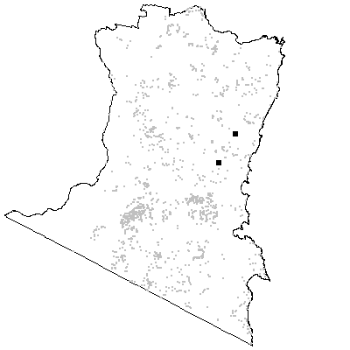
MAP UNIT 61: Coastal Scrub

Species richness: 17 ± 1 (0.04 ha)
Extant area: 1 505 ha (includes a small area of Beach Strand, Map Unit 62)
Proportion cleared: 34%
Number of samples: 41

Table A61.1. Diagnostic plant species of Map Unit 61.

Species | Target frequency | Target C/A | Residual frequency | Residual C/A | Fidelity class
Allocasuarina verticillata | 0.024 | 3(3-3) | 0 | 0(0-0) | positive
Alyxia buxifolia | 0.122 | 1(1-2) | 0 | 0(0-0) | positive
Apalochlamys spectabilis | 0.024 | 1(1-1) | 0 | 0(0-0) | positive
Clematis microphylla var leptophylla | 0.098 | 1(1-1) | 0 | 0(0-0) | positive
Correa alba | 0.049 | 2(1-3) | 0 | 0(0-0) | positive
Kunzea capitata | 0.024 | 1(1-1) | 0 | 0(0-0) | positive
Solanum stelligerum | 0.024 | 1(1-1) | 0 | 0(0-0) | positive
Acacia longifolia var sophorae | 0.927 | 1(1-2) | 0.009 | 1(1-1) | frequent
Banksia integrifolia | 0.854 | 1(1-2) | 0.012 | 1(1-2) | frequent
Carpobrotus glaucescens | 0.683 | 1(1-1) | 0.011 | 1(1-1) | frequent
Isolepis nodosa | 0.683 | 1(1-1) | 0.01 | 1(1-2) | frequent
Leucopogon parviflorus | 0.634 | 1(1-1) | 0.002 | 1(1-1) | frequent
Oxalis perennans | 0.683 | 1(1-1) | 0.209 | 1(1-1) | frequent
Eucalyptus botryoides | 0.024 | 1(1-1) | 0.011 | 2(1-3) | uninformative
Eucalyptus longifolia | 0.024 | 2(2-2) | 0.03 | 3(2-3) | uninformative
Eucalyptus sieberi | 0.024 | 1(1-1) | 0.29 | 3(2-4) | uninformative
Eucalyptus tereticornis | 0.024 | 1(1-1) | 0.048 | 3(1-3) | uninformative
Lomandra longifolia | 0.366 | 1(1-1) | 0.554 | 2(1-2) | negative
Poa meionectes | 0.195 | 1(1-1) | 0.549 | 2(1-3) | negative
Pteridium esculentum | 0.561 | 1(1-1) | 0.577 | 2(1-3) | negative

Table A61.2. Vegetation structure of Map Unit 61. Frequency is the proportion of samples in which strata were present. Height and cover data are means with standard errors in parentheses (n=5).

Stratum | Frequency (%) | Height (m) | Cover (%)
Tree | 60 | 9.7(0.9) | 50(26)
Small tree | 0 | -(-) | -(-)
Shrub | 100 | 2.7(0.5) | 51(15)
Ground cover | 100 | 0.7(0.2) | 38(18)

Table A61.3. Habitat characteristics of Map Unit 61. Means and interquartile ranges for altitude and slope were calculated from n field samples, while those for annual rain were calculated from ESOCLIM predictions (see Table 5, text). Frequency terrain and parent material refers to number of samples (n) recorded in respective classes. Terrain classes: flat (slope≤5°); north (slope>5° and aspect<30° or >300°); intermediate (slope>5° and aspect 30-120° or 210-300°); and south (slope>5° and aspect 120-210°).

 |  | Frequency (%) | Mean | Interquartile Range | n
Annual rain (mm) |  |  |  | 813 | 838 - 897 | 41
Altitude (m) |  |  |  | 5 | 5 - 5 | 41
Slope (degrees) |  |  |  | 9 | 5 - 11 | 5
Terrain class
 | North | 0 |  |  | 0
 | Intermediate | 80 |  |  | 4
 | South | 0 |  |  | 0
 | Flat | 20 |  |  | 1
Parent material
 | Holocene Coastal Sands | 98 |  |  | 40
 | Low quartz sedimentaries | 2 |  |  | 1

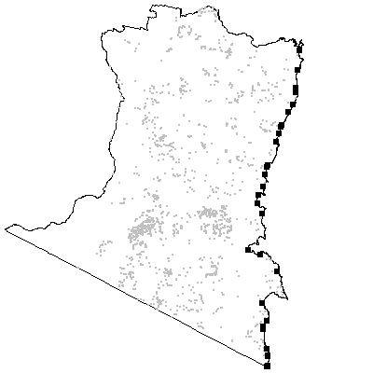

MAP UNIT 62: Beach Strand Grassland

Species richness: 5 ± 1 (0.04 ha)
Extant area: 100 ha (approximation only, mapped in mosaic with Map Unit 61)
Proportion cleared: <10% (approximation only, mapped in mosaic with Map Unit 61)
Number of samples: 30

Table A62.1. Diagnostic plant species of Map Unit 62.

Species | Target frequency | Target C/A | Residual frequency | Residual C/A | Fidelity class
Agrostis billardieri | 0.067 | 1(1-1) | 0 | 0(0-0) | positive
Apium prostratum var prostratum | 0.067 | 1(1-1) | 0 | 0(0-0) | positive
Festuca littoralis | 0.667 | 1(1-1) | 0.003 | 1(1-1) | frequent
Spinifex sericeus | 1 | 1(1-2) | 0.011 | 1(1-1) | frequent
Carpobrotus glaucescens | 0.533 | 1(1-1) | 0.019 | 1(1-1) | uninformative
Lomandra longifolia | 0.033 | 1(1-1) | 0.56 | 2(1-2) | negative
Poa meionectes | 0 | 0(3-0) | 0.55 | 2(1-3) | negative
Pteridium esculentum | 0 | 0(2-0) | 0.589 | 2(1-3) | negative

Table A62.2. Habitat characteristics of Map Unit 62. Means and interquartile ranges for altitude and slope were calculated from n field samples, while those for annual rain were calculated from ESOCLIM predictions (see Table 5, text). Frequency terrain and parent material refers to number of samples (n) recorded in respective classes. Terrain classes: flat (slope≤5°); north (slope>5° and aspect<30° or >300°); intermediate (slope>5° and aspect 30-120° or 210-300°); and south (slope>5° and aspect 120-210°).

 |  | Frequency (%) | Mean | Interquartile Range | n
Annual rain (mm) |  |  |  | 726 | 836 - 883 | 30
Altitude (m) |  |  |  | 2 | 2 - 2 | 30
Slope (degrees) |  |  |  | 0 | 0-2 | 30
Terrain class
 | North | 0 |  |  | 30
 | Intermediate | 0 |  |  | 30
 | South | 0 |  |  | 30
 | Flat | 100 |  |  | 30
Parent material
 | Holocene Coastal Sands | 100 |  |  | 30

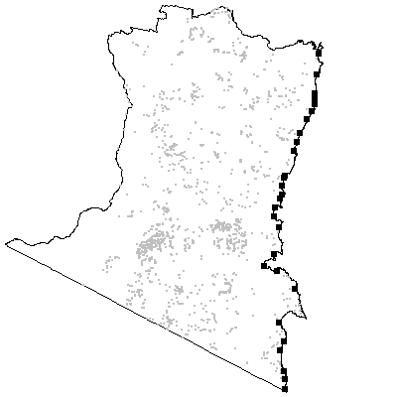

Map Unit 63: Estuarine Wetland Scrub

Species richness: 22 ± 2 (0.04 ha)
Extant area: 932 ha
Proportion cleared: 69%
Number of samples: 4

Table A63.1. Diagnostic plant species of Map Unit 63.

Species | Target frequency | Target C/A | Residual frequency | Residual C/A | Fidelity class
Acacia floribunda | 0.5 | 2(1-3) | 0.016 | 2(1-3) | positive
Acaena novae-zelandiae | 0.5 | 2(2-2) | 0.131 | 1(1-2) | positive
Alternanthera denticulata | 0.75 | 1(1-2) | 0 | 0(0-0) | positive
Apium prostratum var filiforme | 0.25 | 3(3-3) | 0 | 0(0-0) | positive
Carex appressa | 1 | 2(1-2) | 0.082 | 1(1-2) | positive
Carex longebrachiata | 0.5 | 2(2-2) | 0.035 | 1(1-2) | positive
Casuarina glauca | 0.25 | 1(1-1) | 0 | 0(0-0) | positive
Commelina cyanea | 0.75 | 2(2-2) | 0.006 | 1(1-1) | positive
Echinopogon ovatus | 0.5 | 2(2-2) | 0.164 | 1(1-2) | positive
Entolasia marginata | 0.5 | 2(2-2) | 0.045 | 1(1-2) | positive
Geranium potentilloides | 0.5 | 2(2-2) | 0.215 | 1(1-2) | positive
Hymenanthera dentata | 0.5 | 2.5(2-3) | 0.069 | 1(1-2) | positive
Isolepis nodosa | 0.5 | 2(2-2) | 0.027 | 1(1-1) | positive
Melaleuca ericifolia | 0.75 | 4(3-6) | 0.004 | 4.5(3-6) | positive
Microlaena stipoides var stipoides | 0.75 | 2(2-2) | 0.354 | 2(1-2) | positive
Myoporum acuminatum | 0.5 | 3(3-3) | 0.001 | 1(1-1) | positive
Oplismenus imbecillis | 0.75 | 2(2-3) | 0.107 | 2(1-2) | positive
Parsonsia straminea | 1 | 2(2-3) | 0.003 | 1(1-2) | positive
Phragmites australis | 0.5 | 2(2-2) | 0.003 | 1(1-2) | positive
Pratia purpurascens | 0.5 | 2(2-2) | 0.102 | 1(1-2) | positive
Samolus repens | 0.25 | 2(2-2) | 0 | 0(0-0) | positive
Sarcocornia quinquefaria | 0.25 | 2(2-2) | 0 | 0(0-0) | positive
Senecio linearifolius | 0.5 | 2(2-2) | 0.239 | 1(1-2) | positive
Stephania japonica var discolor | 0.75 | 2(1-2) | 0.023 | 1(1-2) | positive
Suaeda australis | 0.25 | 2(2-2) | 0 | 0(0-0) | positive
Urtica incisa | 0.5 | 2.5(2-3) | 0.068 | 1(1-2) | positive
Viola hederacea ssp hederacea | 0.5 | 2(2-2) | 0.437 | 2(1-2) | positive
Lomandra longifolia | 0.5 | 1.5(1-2) | 0.549 | 2(1-2) | frequent
Eucalyptus bosistoana | 0.5 | 1(1-1) | 0.052 | 2(1-3) | uninformative
Poa meionectes | 0 | 0(3-0) | 0.54 | 2(1-3) | negative
Pteridium esculentum | 0 | 0(2-0) | 0.578 | 2(1-3) | negative

Table A63.2. Habitat characteristics of Map Unit 63. Means and interquartile ranges for altitude and slope were calculated from n field samples, while those for annual rain were calculated from ESOCLIM predictions (see Table 5, text). Frequency terrain and parent material refers to number of samples (n) recorded in respective classes. Terrain classes: flat (slope≤5°); north (slope>5° and aspect<30° or >300°); intermediate (slope>5° and aspect 30-120° or 210-300°); and south (slope>5° and aspect 120-210°).

 |  | Frequency (%) | Mean | Interquartile Range | n
Annual rain (mm) |  |  |  | 919 | 918 - 919 | 4
Altitude (m) |  |  |  | 15 | 10 - 20 | 4
Slope (degrees) |  |  |  | 0 | 0 - 0 | 4
Terrain class
 | North | 0 |  |  | 0
 | Intermediate | 0 |  |  | 0
 | South | 0 |  |  | 0
 | Flat | 100 |  |  | 4
Parent material
 | Holocene Riverine Alluvuim | 50 |  |  | 2
 | Ordovician high quartz sedimentaries | 50 |  |  | 2

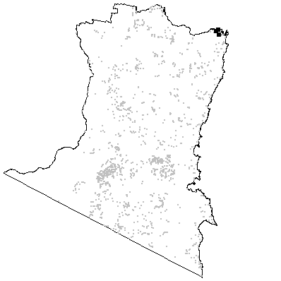

MAP UNIT 64: Saltmarsh

Species richness: 4 ± 0 (0.0025 ha)
Extant area: 296 ha
Proportion cleared: 20%
Number of samples: 141

Table A64.1. Diagnostic plant species of Map Unit 64.

Species | Target frequency | Target C/A | Fidelity class
Sarcocornia quinqueflora ssp quinqueflora | 0.716 | 3(1-5) | positive
Juncus kraussii | 0.369 | 3(1-4) | positive
Samolus repens | 0.319 | 3(1-4) | positive
Sporobolus virginicus | 0.319 | 3(1-4) | positive
Stipa stipoides | 0.220 | 4(3-5) | positive
Avicennia marina | 0.184 | 3(3-4) | positive
Limonium australe | 0.170 | 1(1-4) | positive
Sclerostegia arbuscula | 0.163 | 4(3-4) | positive
Selliera radicans | 0.142 | 3(1-3.75) | positive
Baumea juncea | 0.142 | 3(1.5-5) | positive
Suaeda australis | 0.142 | 1(1-3) | positive
Apium prostratum | 0.135 | 1(1-1) | positive
Melaleuca armillaris | 0.106 | 5(4-5) | positive
Zoysia macrantha | 0.106 | 4(3-5) | positive
Atriplex australasica | 0.099 | 1(1-1) | positive
Gahnia filum | 0.092 | 1(1-3) | positive
Wilsonia backhousei | 0.078 | 4(4-4) | positive
Phragmites australis | 0.078 | 3(3-4) | positive
Disphyma crassifolium ssp. clavellatum | 0.078 | 3(1-3) | positive
Myoporum acuminatum | 0.064 | 3(3-4) | positive
Isolepis nodosa | 0.064 | 1(1-1) | positive
Aegiceras corniculatum | 0.050 | 4(3-4) | positive
Melaleuca ericifolia | 0.043 | 4.5(3.75-6) | positive
Spergulia sp. | 0.043 | 1(1-1) | positive
Triglochin striata | 0.035 | 1(1-3) | positive
Lobelia alata | 0.036 | 1(1-1) | positive
Carpobrotus glaucescens | 0.028 | 1(1-1) | positive
Rhagodia candolleana | 0.028 | 1(1-1) | positive
Tetragonia tetragonoides | 0.028 | 1(1-1) | positive
Juncus usitatus | 0.014 | 1(1-1) | positive
Pseudognaphalium luteoalbum | 0.014 | 1(1-1) | positive
Carex pumila | 0.007 | 1(1-1) | positive
Mimulus repens | 0.007 | 1(1-1) | positive

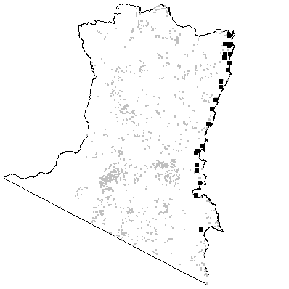

Map Unit 65: Estuarine Wetland (River Mangrove)

No quantitative data are available for this assemblage. The dominant species is Aegiceras corniculata which varies in stature from a shrub to a small tree. There may be a sparse cover of herbaceous species which are associated more commonly with Saltmarsh (Map Unit 64). Estuarine Wetland (River Mangrove) is restricted to the upper tidal zone on mudflats. The principal occurrence is at Merimbula Lake where the dominant species reaches its southern limit. This is a small stand, although A. corniculata also occurs as an emergent in Saltmarsh of other estuaries within the region (e.g. Bermagui River). Its distribution continues further north along the New South Wales coast. Mangroves have an important role in estuarine productivity and in supporting breeding populations of fish and other marine organisms. The principal threats entail degradation associated with foreshore and catchment development, and intensifying recreational use of the lake.

Species richness: no data
Extant area: 1 ha
Proportion cleared: 0%
Number of samples: 0

Map Unit 66: Estuarine Wetland (Grey Mangrove)

No quantitative data are available for this unit. The dominant species is Avicennia marina which varies in stature from a shrub to a small tree and usually occurs in pure stands. Occasional co-occurring species include Aegiceras corniculata and some herbaceous species which are associated more commonly with Saltmarsh (Map Unit 64). Estuarine Wetland (Grey Mangrove) is restricted to the lower tidal zone on mudflats. It is more widespread and in more frequently inundated habitat than River Mangrove (Map Unit 65). Small stands are scattered from Wonboyn to Wallaga Lake and extend well north along the coast. Mangroves have an important role in estuarine productivity and in supporting breeding populations of fish and other marine organisms. The principal threats entail degradation associated with foreshore and catchment development, and intensifying recreational use of the lake. Most stands of Grey Mangrove adjoin freehold or crown land, although many of these are protected from direct disturbance under NSW state environmental planning policy. As for River Mangrove (Map Unit 65), the principal threats entail degradation associated with foreshore and catchment development, and intensifying recreational use of coastal lakes.

Species richness: no data
Extant area: 101 ha
Proportion cleared: 19%
Number of samples: 0

Map Unit 67: Seagrass Meadows (Halophila)

No quantitative data are available for this unit. The dominant species is Halophila ovalis which may co-occur with other seagrass species (Map Units 68-70). Seagrass Meadows (Halophila) are restricted to soft substrates in the sub-tidal zone of coastal estuaries. The principal stands are in Wallagoot and Cuttagee Lakes, with a smaller stand in Wallaga Lake. Similar assemblages are likely to occur in estuaries further north and south. More work is required to establish its relationship to other seagrass assemblages. Sea grass meadows have an important role in estuarine productivity and in supporting breeding populations of fish and other marine organisms. Potential threats include degradation caused by development or pasture improvement in estuary catchments, although the relevant catchments are partially protected in conservation reserves.

Species richness: no data
Extant area: 63 ha
Proportion cleared: 0%
Number of samples: 0

Map Unit 68: Seagrass Meadows (Posidonia)

No quantitative data are available for this unit. The dominant species is Posidonia australis which may co-occur with other seagrass species (Map Units 67, 68 & 70). Seagrass Meadows (Posidonia) are restricted to soft substrates in the sub-tidal zone of coastal estuaries. The principal stands are in Merimbula Lake and the Bermagui River estuary, although its distribution extends well north and south of the study area. More work is required to establish its relationship to other seagrass assemblages in the region. Sea grass meadows have an important role in estuarine productivity and in supporting breeding populations of fish and other marine organisms. Potential threats include degradation caused by development or pasture improvement in estuary catchments.

Species richness: no data
Extant area: 33 ha
Proportion cleared: 0%
Number of samples: 0

Map Unit 69: Seagrass Meadows (Ruppia)

No quantitative data are available for this unit. The dominant species are Ruppia polycarpa and R. megacarpa which may co-occur with other seagrass species (Map Units 67, 68 & 70). Seagrass Meadows (Ruppia) are restricted to soft substrates in the sub-tidal zone of coastal estuaries. Scattered occurrences include Curalo Lagoon near Eden, Middle Lagoon, Baragoot Lake and Wallaga Lake. Similar assemblages are likely to occur in estuaries further north and south. More work is required to establish its relationship to other seagrass assemblages in the region. Sea grass meadows have an important role in estuarine productivity and in supporting breeding populations of fish and other marine organisms. Potential threats include degradation caused by development or pasture improvement in estuary catchments, although the some of the catchments are partially protected in conservation reserves.

Species richness: no data
Extant area: 49 ha
Proportion cleared: 0%
Number of samples: 0

Map Unit 70: Seagrass Meadows (Zostera)

No quantitative data are available for this unit. The dominant species is Zostera capricorni which may co-occur with other seagrass species (Map Units 67-69). Seagrass Meadows (Zostera) are restricted to soft substrates in the sub-tidal zone of coastal estuaries. Further work is required to establish its relationship to other seagrass assemblages in the region. This is the most widespread seagrass assemblage in the Eden region, with occurrences in most coastal lagoon and estuaries between Wonboyn and Wallaga Lakes. Similar assemblages are likely to occur in estuaries further north and south. Sea grass meadows have an important role in estuarine productivity and in supporting breeding populations of fish and other marine organisms. Potential threats include degradation caused by development or pasture improvement in estuary catchments, although some of these catchments are partially protected in conservation reserves.

Species richness: no data
Extant area: 258 ha
Proportion cleared: 0%
Number of samples: 0

Map Unit W1: Wadbilliga Dry Shrub Forest

Species richness: 18 ± 1 (0.05 ha)
Extant area: 27 341 ha
Proportion cleared: 0%
Number of samples: 28

Table AW1.1. Diagnostic plant species of Map Unit W1.

Species | Target frequency | Residual frequency | Fidelity class
Acacia obtusifolia | 0.6 | 0.054 | positive
Allocasuarina distyla | 0.025 | 0 | positive
Dianella caerulea | 0.65 | 0.257 | positive
Eucalyptus blaxlandii | 0.025 | 0 | positive
Leucopogon lanceolatus var. lanceolatus | 0.8 | 0.062 | positive
Oxylobium ilicifolium | 0.575 | 0.08 | positive
Persoonia linearis | 0.85 | 0.270 | positive
Platysace lanceolata | 0.75 | 0.264 | positive
Lomandra longifolia | 0.65 | 0.537 | constant
Eucalyptus agglomerata | 0.25 | 0.090 | uninformative
Eucalyptus consideniana | 0.05 | 0.011 | uninformative
Eucalyptus cypellocarpa | 0.2 | 0.307 | uninformative
Eucalyptus dalrympleana ssp. dalrympleana | 0.05 | 0.040 | uninformative
Eucalyptus elata | 0.15 | 0.114 | uninformative
Eucalyptus fastigata | 0.1 | 0.167 | uninformative
Eucalyptus fraxinoides | 0.35 | 0.047 | uninformative
Eucalyptus globoidea | 0.3 | 0.228 | uninformative
Eucalyptus muellerana | 0.1 | 0.117 | uninformative
Eucalyptus radiata | 0.125 | 0.073 | uninformative
Eucalyptus smithii | 0.075 | 0.058 | uninformative
Poa meionectes | 0.275 | 0.590 | negative
Pteridium esculentum | 0.45 | 0.558 | negative

Table AW1.2. Habitat characteristics of Map Unit W1. Means and interquartile ranges for altitude and slope were calculated from n field samples, while those for annual rain were calculated from ESOCLIM predictions (see Table 5, text). Frequency terrain and parent material refers to number of samples (n) recorded in respective classes. Terrain classes: flat (slope≤5°); north (slope>5° and aspect<30° or >300°); intermediate (slope>5° and aspect 30-120° or 210-300°); and south (slope>5° and aspect 120-210°).

 |  | Frequency (%) | Mean | Interquartile Range | n
Annual rain (mm) |  |  |  | 930 | 911 - 949 | 28
Altitude (m) |  |  |  | 686 | 553 - 810 | 28
Slope (degrees) |  |  |  | 22 | 11 - 35 | 28
Terrain class
 | North | 36 |  |  | 10
 | Intermediate | 25 |  |  | 7
 | South | 21 |  |  | 6
 | Flat | 18 |  |  | 5
Parent material
 | Devonian granitoids | 7 |  |  | 2
 | Devonian high quartz sedimentaries | 75 |  |  | 21
 | Low quartz sedimentaries | 14 |  |  | 4
 | Ordovician high quartz sedimentaries | 4 |  |  | 1

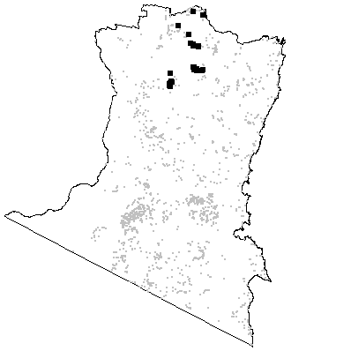

Map Unit W2: Wadbilliga Range Shrub Forest

Species richness: 20 ± 1 (0.05 ha)
Extant area: 1 007 ha
Proportion cleared: 0%
Number of samples: 15

Table AW2.1. Diagnostic plant species of Map Unit W2.

Species | Target frequency | Residual frequency | Fidelity class
Acrotriche serrulata | 0.875 | 0.048 | positive
Banksia canei | 0.625 | 0.017 | positive
Choretrum candollei | 0.563 | 0.014 | positive
Deyeuxia rodwayi | 0.063 | 0 | positive
Dianella tasmanica | 0.625 | 0.247 | positive
Eucalyptus fraxinoides | 0.813 | 0.046 | positive
Oxylobium ellipticum | 0.938 | 0.013 | positive
Persoonia silvatica | 0.563 | 0.061 | positive
Platysace lanceolata | 0.813 | 0.272 | positive
Stylidium graminifolium | 0.688 | 0.143 | positive
Lomandra longifolia | 0.625 | 0.540 | constant
Eucalyptus dalrympleana ssp. dalrympleana | 0.125 | 0.038 | uninformative
Eucalyptus fastigata | 0.313 | 0.163 | uninformative
Eucalyptus latiuscula | 0.125 | 0.002 | uninformative
Eucalyptus nitens | 0.25 | 0.012 | uninformative
Eucalyptus pauciflora | 0.313 | 0.019 | uninformative
Eucalyptus sieberi | 0.125 | 0.286 | uninformative
Poa meionectes | 0.313 | 0.584 | negative
Pteridium esculentum | 0.438 | 0.556 | negative

Table AW2.2. Habitat characteristics of Map Unit W2. Means and interquartile ranges for altitude and slope were calculated from n field samples, while those for annual rain were calculated from ESOCLIM predictions (see Table 5, text). Frequency terrain and parent material refers to number of samples (n) recorded in respective classes. Terrain classes: flat (slope≤5°); north (slope>5° and aspect<30° or >300°); intermediate (slope>5° and aspect 30-120° or 210-300°); and south (slope>5° and aspect 120-210°).

 |  | Frequency (%) | Mean | Interquartile Range | n
Annual rain (mm) |  |  |  | 973 | 939 - 1004 | 15
Altitude (m) |  |  |  | 1173 | 1133 - 1225 | 14
Slope (degrees) |  |  |  | 16 | 6 - 26 | 14
Terrain class
 | North | 7 |  |  | 1
 | Intermediate | 36 |  |  | 5
 | South | 36 |  |  | 5
 | Flat | 21 |  |  | 3
Parent material
 | Devonian high quartz sedimentaries | 93 |  |  | 14
 | Low quartz sedimentaries | 7 |  |  | 1

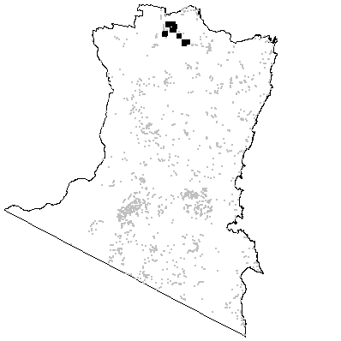

Map Unit W3: Wadbilliga Heath Forest

Species richness: 20 ± 2 (0.05 ha)
Extant area: 3 085 ha
Proportion cleared: 0%
Number of samples: 13

Table AW3.1. Diagnostic plant species of Map Unit W3.

Species | Target frequency | Residual frequency | Fidelity class
Allocasuarina nana | 0.667 | 0.010 | positive
Boronia algida | 0.533 | 0 | positive
Dillwynia sericea | 0.667 | 0.007 | positive
Epacris robusta | 0.267 | 0 | positive
Eucalyptus kybeanensis | 0.6 | 0 | positive
Eucalyptus paliformis | 0.067 | 0 | positive
Gahnia sieberiana | 0.8 | 0.082 | positive
Hakea dactyloides | 0.733 | 0.014 | positive
Hibbertia pedunculata | 0.533 | 0.002 | positive
Kunzea sp. C | 0.6 | 0.002 | positive
Leptospermum lanigerum | 0.733 | 0.013 | positive
Monotoca scoparia | 0.533 | 0.134 | positive
Platysace lanceolata | 0.6 | 0.275 | positive
Schoenus ericetorum | 0.067 | 0 | positive
Stylidium graminifolium | 0.533 | 0.145 | positive
Eucalyptus dalrympleana ssp. dalrympleana | 0.4 | 0.035 | uninformative
Eucalyptus fraxinoides | 0.067 | 0.056 | uninformative
Eucalyptus latiuscula | 0.133 | 0.002 | uninformative
Eucalyptus pauciflora | 0.333 | 0.019 | uninformative
Eucalytpus radiata | 0.133 | 0.074 | uninformative
Eucalytpus sieberi | 0.067 | 0.286 | uninformative
Lomandra longifolia | 0.333 | 0.543 | negative
Poa meionectes | 0.133 | 0.586 | negative
Pteridium esculentum | 0 | 0.561 | negative

Table AW3.2. Habitat characteristics of Map Unit W3. Means and interquartile ranges for altitude and slope were calculated from n field samples, while those for annual rain were calculated from ESOCLIM predictions (see Table 5, text). Frequency terrain and parent material refers to number of samples (n) recorded in respective classes. Terrain classes: flat (slope≤5°); north (slope>5° and aspect<30° or >300°); intermediate (slope>5° and aspect 30-120° or 210-300°); and south (slope>5° and aspect 120-210°).

 |  | Frequency (%) | Mean | Interquartile Range | n
Annual rain (mm) |  |  |  | 956 | 888 - 1008 | 13
Altitude (m) |  |  |  | 1197 | 1120 - 1260 | 13
Slope (degrees) |  |  |  | 12 | 3 - 19 | 13
Terrain class
 | North | 15 |  |  | 2
 | Intermediate | 15 |  |  | 2
 | South | 38 |  |  | 5
 | Flat | 31 |  |  | 4
Parent material
 | Devonian high quartz sedimentaries | 85 |  |  | 11
 | Low quartz sedimentaries | 15 |  |  | 2

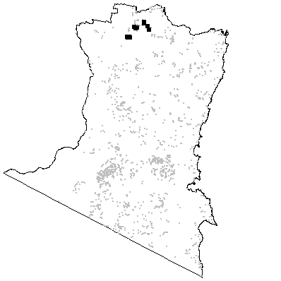

Map Unit W4: Kydra Flats Grass Forest

Species richness: 24 ± 2 (0.05 ha)
Extant area: 3 214 ha
Proportion cleared: 8%
Number of samples: 6

Table AW4.1. Diagnostic plant species of Map Unit W4.

Species | Target frequency | Residual frequency | Fidelity class
Clematis aristata | 0.643 | 0.337 | positive
Dianella tasmanica | 0.643 | 0.247 | positive
Leucopogon lanceolatus var. lanceolatus | 0.643 | 0.079 | positive
Lomatia fraseri | 0.5 | 0.034 | positive
Persoonia silvatica | 0.5 | 0.062 | positive
Poa clivicola | 0.571 | 0.0048 | positive
Podolepis robusta | 0.071 | 0 | positive
Senecio glomeratus | 0.714 | 0.020 | positive
Lomandra longifolia | 0.786 | 0.538 | constant
Poa meionectes | 0.714 | 0.579 | constant
Pteridium esculentum | 0.857 | 0.551 | constant
Elaeocarpus holopetalus | 0.143 | 0.021 | uninformative
Eucalyptus cypellocarpa | 0.143 | 0.305 | uninformative
Eucalyptus dalrympleana ssp. dalrympleana | 0.357 | 0.036 | uninformative
Eucalyptus fraxinoides | 0.286 | 0.054 | uninformative
Eucalyptus muellerana | 0.071 | 0.117 | uninformative
Eucalyptus radiata | 0.286 | 0.073 | uninformative
Eucalyptus sieberi | 0.071 | 0.286 | uninformative
Eucalyptus viminalis | 0.357 | 0.054 | uninformative

Table AW4.2. Habitat characteristics of Map Unit W4. Means and interquartile ranges for altitude and slope were calculated from n field samples, while those for annual rain were calculated from ESOCLIM predictions (see Table 5, text). Frequency terrain and parent material refers to number of samples (n) recorded in respective classes. Terrain classes: flat (slope≤5°); north (slope>5° and aspect<30° or >300°); intermediate (slope>5° and aspect 30-120° or 210-300°); and south (slope>5° and aspect 120-210°).

 |  | Frequency (%) | Mean | Interquartile Range | n
Annual rain (mm) |  |  |  | 848 | 827 - 858 | 6
Altitude (m) |  |  |  | 1083 | 1053 - 1108 | 6
Slope (degrees) |  |  |  | 7 | 4 - 10 | 6
Terrain class
 | North | 17 |  |  | 1
 | Intermediate | 33 |  |  | 2
 | South | 17 |  |  | 1
 | Flat | 33 |  |  | 2
Parent material
 | Devonian granitoids | 17 |  |  | 1
 | Devonian high quartz sedimentaries | 33 |  |  | 2
 | Low quartz sedimentaries | 50 |  |  | 3

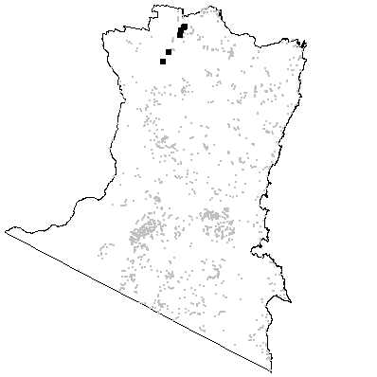

Map Unit W5: Wadbilliga Gorge Dry Forest

Species richness: 22 ± 1 (0.05 ha)
Extant area: 7 239 ha
Proportion cleared: 7%
Number of samples: 22

Table AW5.1. Diagnostic plant species of Map Unit W5.

Species | Target frequency | Residual frequency | Fidelity class
Allocasuarina littoralis | 0.5 | 0.158 | positive
Angophora floribunda | 0.667 | 0.102 | positive
Callitris endlicheri | 0.095 | 0 | positive
Cryptandra spinescens | 0.024 | 0 | positive
Eucalyptus globoidea | 0.595 | 0.218 | positive
Glycine clandestina | 0.5 | 0.282 | positive
Hibbertia riparia | 0.048 | 0 | positive
Mentha satureioides | 0.119 | 0 | positive
Oxalis perennans | 0.571 | 0.204 | positive
Persoonia linearis | 0.810 | 0.271 | positive
Pterostylis obtusa | 0.0238 | 0 | positive
Lomandra longifolia | 0.786 | 0.532 | constant
Pteridium esculentum | 0.548 | 0.554 | constant
Eucalyptus agglomerata | 0.286 | 0.088 | uninformative
Eucalyptus angophoroides | 0.333 | 0.034 | uninformative
Eucalyptus baueriana | 0.024 | 0.016 | uninformative
Eucalyptus bosistoana | 0.024 | 0.033 | uninformative
Eucalyptus consideniana | 0.071 | 0.011 | uninformative
Eucalyptus cypellocarpa | 0.238 | 0.306 | uninformative
Eucalyptus dives | 0.048 | 0.011 | uninformative
Eucalyptus elata | 0.238 | 0.110 | uninformative
Eucalyptus fastigata | 0.071 | 0.168 | uninformative
Eucalyptus maidenii | 0.167 | 0.052 | uninformative
Eucalyptus mannifera | 0.048 | 0.001 | uninformative
Eucalyptus muellerana | 0.191 | 0.114 | uninformative
Eucalyptus radiata | 0.048 | 0.076 | uninformative
Eucalyptus sieberi | 0.214 | 0.286 | uninformative
Eucalyptus smithii | 0.119 | 0.056 | uninformative
Eucalyptus stenostoma | 0.024 | 0.010 | uninformative
Eucalyptus tereticornis | 0.024 | 0.051 | uninformative
Eucalyptus viminalis | 0.071 | 0.056 | uninformative
Poa meionectes | 0.476 | 0.584 | negative

Table AW5.2. Habitat characteristics of Map Unit W5. Means and interquartile ranges for altitude and slope were calculated from n field samples, while those for annual rain were calculated from ESOCLIM predictions (see Table 5, text). Frequency terrain and parent material refers to number of samples (n) recorded in respective classes. Terrain classes: flat (slope≤5°); north (slope>5° and aspect<30° or >300°); intermediate (slope>5° and aspect 30-120° or 210-300°); and south (slope>5° and aspect 120-210°).

 |  | Frequency (%) | Mean | Interquartile Range | n
Annual rain (mm) |  |  |  | 948 | 905 - 990 | 22
Altitude (m) |  |  |  | 372 | 243 - 478 | 22
Slope (degrees) |  |  |  | 20 | 11 - 26 | 22
Terrain class
 | North | 45 |  |  | 10
 | Intermediate | 45 |  |  | 10
 | South | 9 |  |  | 2
 | Flat | 0 |  |  | 0
Parent material
 | Devonian granitoids | 36 |  |  | 8
 | Devonian high quartz sedimentaries | 18 |  |  | 4
 | Low quartz sedimentaries | 18 |  |  | 4
 | Ordovician high quartz sedimentaries | 27 |  |  | 6

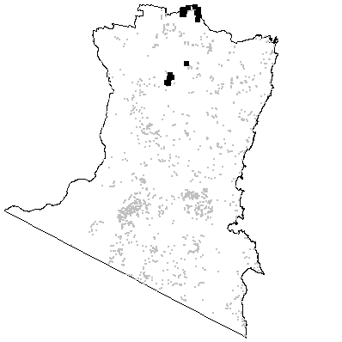

Map Unit W6: Wadbilliga River Valley Forest

Species richness: 33 ± 3 (0.05 ha)
Extant area: 1 897 ha
Proportion cleared: 0%
Number of samples: 7

Table AW6.1. Diagnostic plant species of Map Unit W6.

Species | Target frequency | Residual frequency | Fidelity class
Angophora floribunda | 0.539 | 0.117 | positive
Bursaria lasiophylla | 0.539 | 0.018 | positive
Casuarina cunninghamiana | 0.539 | 0.004 | positive
Dichondra repens | 0.769 | 0.248 | positive
Entolasia marginata | 0.692 | 0.060 | positive
Eucalyptus elata | 0.692 | 0.109 | positive
Hymenanthera dentata | 0.539 | 0.069 | positive
Lomatia myricoides | 0.615 | 0.077 | positive
Oxalis perinnans | 0.692 | 0.212 | positive
Pellaea falcata var. falcata | 0.692 | 0.095 | positive
Phyllanthus gasstroemii | 0.615 | 0.011 | positive
Pratia purpurascens | 0.615 | 0.089 | positive
Rubus parviflora | 0.539 | 0.125 | positive
Solanum pungentium | 0.539 | 0.071 | positive
Lomandra longifolia | 0.692 | 0.539 | constant
Pteridium esculentum | 0.615 | 0.554 | constant
Eucalyptus angophoroides | 0.077 | 0.044 | uninformative
Eucalyptus badjensis | 0.077 | 0.006 | uninformative
Eucalyptus cypellocarpa | 0.231 | 0.304 | uninformative
Eucalyptus fastigata | 0.077 | 0.166 | uninformative
Eucalyptus fraxinoides | 0.077 | 0.056 | uninformative
Eucalyptus globoidea | 0.154 | 0.231 | uninformative
Eucalyptus maidenii | 0.077 | 0.055 | uninformative
Eucalyptus viminalis | 0.385 | 0.054 | uninformative
Poa meionectes | 0.231 | 0.584 | negative

Table AW6.2. Habitat characteristics of Map Unit W6. Means and interquartile ranges for altitude and slope were calculated from n field samples, while those for annual rain were calculated from ESOCLIM predictions (see Table 5, text). Frequency terrain and parent material refers to number of samples (n) recorded in respective classes. Terrain classes: flat (slope≤5°); north (slope>5° and aspect<30° or >300°); intermediate (slope>5° and aspect 30-120° or 210-300°); and south (slope>5° and aspect 120-210°).

 |  | Frequency (%) | Mean | Interquartile Range | n
Annual rain (mm) |  |  |  | 986 | 971 - 1003 | 7
Altitude (m) |  |  |  | 199 | 180 - 228 | 7
Slope (degrees) |  |  |  | 4 | 1 - 2 | 7
Terrain class
 | North | 14 |  |  | 1
 | Intermediate | 0 |  |  | 0
 | South | 0 |  |  | 0
 | Flat | 86 |  |  | 6
Parent material
 | Devonian granitoids | 57 |  |  | 4
 | Devonian high quartz sedimentaries | 29 |  |  | 2
 | Ordovician high quartz sedimentaries | 14 |  |  | 1

