Management requirements
for rare and threatened burrowing
crayfish in Tasmania

Niall Doran and Karen Richards,
Forestry Tasmania

Report to the Tasmanian RFA Environment
and Heritage Technical Committee,
November 1996

National Library of Australia Cataloguing-in-publication data:
a report to the Tasmania RFA Environment and Hertiage Technical Committee, November 1996

ISBN 0 7246 4569 1

Published by:
Tasmanian Public Land Use Commission
GPO Box 2036
Hobart Tasmania
Australia 7001
March 1997

Copyright

© Commonwealth of Australia and the State of Tasmania, 1996.

This work is copyright. Apart from fair dealing for the purpose of private study, research, criticism or review as permitted under the Copyright Act 1968, no part of this document may be reproduced by any means without the joint written permission of the Joint Commonwealth and Tasmanian RFA Steering Committee.

Disclaimer

The views and opinions expressed in this report are those of the authors and do not necessarily reflect those of the Tasmanian and Commonwealth governments.

Foreword

Under the National Forest Policy Statement signed by Tasmania in April 1995, the Tasmanian and Commonwealth governments agreed to a framework and a joint scientific and public consultation process for a comprehensive regional assessment (CRA) of Tasmanian forests leading to negotiation of a Regional Forest Agreement (RFA) for Tasmania.

The CRA information is being gathered in two separate assessment processes:
• a social & economic assessment which covers issues such as social impacts, forest resources including wood, mineral and other resources, forest uses such as tourism and apiculture, and industry development options; and
• an environment and heritage assessment which covers issues such as cultural heritage, biodiversity, endangered species, old growth, wilderness, national estate and world heritage.
This report is one of a series of reports being produced for the environment and heritage assessment component of the CRA.

Acknowledgements

This project was carried out with funding from the Commonwealth via the Australian Nature Conservation Agency, and in-kind support from the Tasmanian government through Forestry Tasmania. Specific thanks must be given to Dr Alastair Richardson and Dr Pierre Horwitz for specialist advice and identification of recalcitrant specimens, and to Dr Rob Taylor and Dr Sally Bryant for advice and assistance in the structure and running of the project. Thanks are also due to Sean Blake and the staff at Forestry Tasmania's Bass District Office (Scottsdale) for mapping and other assistance, to Bill Walker and the Burnie City Council for assistance and co-operation during field work in that city, to Ron Mawbey and Dr Kevin Doran for photographic equipment and assistance, to Mark Wapstra for project support and plant identifications, to Martin Doran for computer time and expertise, to Vicki Colville, Glenn Colville and Kate Greenhill who gave time and effort to the project as volunteer field assistants, and to Peter Nun and Jeni de Plater at Plovers Ridge Host Farm, who allowed their property to be used as a home-base over the muddy four months of field work for the project. This project was conducted under permit from the Parks and Wildlife Service and the Inland Fisheries Commission.

Summary

Engaeus orramakunna

A four month field investigation of the Mt Arthur burrowing crayfish extended the known distribution of the species from the three original sites to seventy nine. The species is now estimated to cover a range of some 215 km2, with at least another 50 km2 to the south of its distribution over which abundance is lower. The distribution of the species covers several gazetted reserves, comprising approximately 7% of its extent. An estimated 50-55% of the species distribution occurs in State forest.

Habitat requirements of the species appear to be relatively simple, with the presence of sufficient moisture and suitable soil for burrowing being its major requirements. Provided these needs are met, the species is found over a wide range of altitudes, slopes, vegetation types, and stream classes, although it tends to favour broad seeps and flat, marshy pans next to streams. E. orramakunna seems to be highly tolerant of disturbance, and was found in high numbers in culverts, streams through standing pine plantation, and even class 4 seeps in the middle of cleared and burned plantation. Specimens collected from burrows in such places were found to be healthy and reproductively active.

In view of E. orramakunna's extended distribution, abundance and apparent tolerance of disturbance, it is recommended that the conservation status of this species be downgraded from 'Vulnerable' to 'Low Risk' according to IUCN Red List criteria (1994). Existing buffer zone requirements are considered adequate for the protection of the species, it occurs in several reserves within its distributional range, and forestry activities do not appear to represent a direct threat to its survival as previously thought. It is suggested, however, that some further field monitoring would provide a safety-check on the down-graded status of the species, and that drainage activities, waste management practices, and other potentially damaging processes should be conducted with care in areas where species abundance is high.

Engaeus spinicaudatus

The Scottsdale burrowing crayfish has been the subject of two previous management plans, and following field work to determine the status quo, this report endorses their findings and recommendations. The species is known from only a very limited area north-east of Scottsdale, with estimates that only 3.881 km2 of suitable habitat are available to it. Several threatening processes are operating in the area, including drainage and cattle grazing.

Because of its limited distribution, poor reservation status and potential threats, it is recommended that the species remain listed as 'Vulnerable' according to application of the relevant IUCN criteria. To prevent deterioration in this conservation status, areas should be reserved or protected to safeguard the limited available habitat of this species, and lease-holders to Crown land and owners of private land should be instructed and encouraged to limit potentially harmful activities in areas where the crayfish is present.

Engaeus yabbimunna

A three week period of field work in Burnie collected further distribution data for Engaeus yabbimunna, extending the known number of sites from three to ten, and confirming that the range of the species is limited to three small creek systems as previously identified. The species is largely restricted to isolated pockets of remnant native vegetation within the Burnie urban environment.

Due to the exceptionally restricted distributional range of this species and its exposure to directly threatening processes (habitat removal, disturbance and decreasing water quality), it is recommended that the status of this species be upgraded from 'Vulnerable' to 'Endangered' under IUCN Red List criteria. Immediate management actions need to be undertaken to ensure that no further deterioration of the species and its habitat occurs, and that recovery is possible. The stability of the species hinges on decisions regarding future development within catchments in the Burnie area.

Engaeus martigener

No field work was conducted on this species, with investigation limited to a review of existing information. Again, this species is of very limited geographic distribution, found only in isolated and small communities at higher altitudes on Flinders Island and Cape Barren Island. The species is protected in the Strzelecki National Park on Flinders Island.

This species has previously been classified as naturally 'Rare' by the Invertebrate Advisory Committee (1994), but is currently omitted from the Tasmanian Threatened Species Protection Act (1995). Application of IUCN criteria indicate that it should be considered 'Vulnerable' due to its severely restricted range. Field investigations need to be conducted to confirm the current status of the species and to evaluate the effectiveness of the management measures suggested here.

Other Engaeus species: new and known

During the field work conducted on Engaeus orramakunna, a single specimen of a potentially unknown Engaeus species was collected from State forest in the north-east of the state. As this area has been extensively sampled over many previous studies, any new species must be considered limited in its distribution. It is therefore important that further specimens are examined, and, if confirmed, that the distribution, habitat requirements, and management needs of the new species are determined.

Finally, the current study has also provided some significant range extensions for other Engaeus species, representing important information on the biogeographical distribution of the genus as a whole. While each species has its own specific requirements, habitat preferences, tolerances and sensitivities, the primary considerations in the management of these species would appear to relate to the level of available moisture, soil type, and degree of disturbance to which they are subject.

1.0 General Introduction

Species of the genus Engaeus are small freshwater/burrowing crayfish, with a general body length of under ten centimeters. The genus belongs to the decapod family Parastacidae, and is found in south-east Australia, including Tasmania. Consisting of thirty five species (Horwitz 1990a, 1994), the genus displays remarkable diversity given the relatively small geographic area over which it occurs. Twenty species are endemic to mainland Australia and thirteen to Tasmania; two are found in both.

The Tasmanian species are mostly found in the north of the state, with both the north-east and north-west characterised by their own distinct subgroups. The distribution of most of these has been extensively studied (Horwitz 1986, 1988b, 1990a, & in press). Some species have very broad geographical ranges, while others are very restricted. A handful of other species are less well known and require attention.

Engaeus species can be distinguished by various combinations of the following characters: rostrum shape and length, the presence or absence of sutures on the outer rami of the tail fan, differences in the antennal scale, antennal length, and the third maxilliped and its exopodite, and the presence or absence of pores on the lateral processes. Comprehensive taxonomic descriptions and a key to thirty four of the thirty five species are given by Horwitz (1990a), and a supplemental description of the most recently discovered member of the genus, Engaeus yabbimunna, is given by the same author (1994). Keys to genera of the Parastacidae can be found in Riek (1969) and, specifically for Tasmania, Horwitz (1988a).

Several studies have been carried out on Engaeus species, covering such topics as habitat partitioning and preferences, burrow structure, food, and other general ecology (Suter & Richardson 1977, Richardson & Swain 1980, Horwitz et al. 1985a+b, Horwitz 1986, Richardson & Horwitz 1987). Most species of Engaeus are characterised by their ability to burrow, often to considerable depths, and specimens are only rarely seen above ground or in standing water (Horwitz 1990a). Burrows can be quite simple and shallow, or complex and extensive; while crayfish may not be communal per se (Horwitz et al. 1985b), a burrow can often be the product of several generations of crayfish activity (A. Richardson, pers. comm.).

Crayfish burrows can be classified according to their location and hydrologic character (Horwitz & Richardson 1986). Type 1a and type 1b burrows are found respectively in or connected to permanent waters such as streams or lakes, and this provides their source of water. Type 2 burrows are found connected to the water-table and receive their water from both groundwater and surface runoff, while type 3 burrows are independent of the water-table and derive their water from runoff only.

Type 3 burrows are only found in Australia, and are only known to be constructed by Engaeus species (Horwitz & Richardson 1986, A. Richardson pers. comm.). As a result they are the most terrestrial of the world's freshwater crayfish, which may limit their dispersal through waterways and promote restricted ranges and speciation. These factors may in turn play a role in the high diversity of the genus over such a small geographical area, while leaving species particularly prone to environmentally threatening processes.

Given their proximity to streams and forest areas, crayfish species may be adversely impacted by forestry activities and land use practices associated with land clearing and plantation harvesting (Horwitz 1990b, 1991). Clearing, burning, siltation and other effects may all exert significant pressure on crayfish habitat in general and on the crayfish and their burrows in particular. For this reason, there is significant concern regarding disturbance to areas containing species of limited or unknown distribution and sensitivity.

Four Tasmanian Engaeus species are currently listed as threatened; E. orramakunna, E. spinicaudatus and E. yabbimunna are all listed as 'Vulnerable' under Schedule 4 of the Tasmanian Threatened Species Protection Act (1995), while E. martigener has been listed as 'Rare' by the Invertebrate Advisory Committee (1994). Prior to this study, E. orramakunna was considered to be the species potentially at greatest risk, as it was the least well known and is found in areas of high forestry activity. This project was therefore established to examine the distribution, habitat requirements, and conservation status of E. orramakunna in particular, and to formulate management guidelines for all four of Tasmania's threatened burrowing crayfish species.

A copy of the original project terms of reference is included in the Appendices (Section 8.1).

2.0 Engaeus orramakunna, the Mt. Arthur burrowing crayfish

2.1 Introduction
Engaeus orramakunna, the Mount Arthur burrowing crayfish, was first described by Horwitz (1990a). The species has an adult cephalothorax length, or occipital carapace length (OCL), of 3 - 4cm. It is usually a striking orange in colour, grading from pale ventrally to darker dorsally, but may also be a darker reddish brown, or even a translucent grey-blue in younger specimens (Plates 2.1 & 2.2). E. orramakunna can construct both type 2 and type 3 burrows, according to the classification system of Horwitz and Richardson (1986: see Section 1.0). Burrows often have chimneys of pelleted soil at the openings (Plate 2.2), as is characteristic of crayfish that burrow in sheltered places.

Prior to this study, the Mount Arthur burrowing crayfish had only been recorded from three localities in north-east Tasmania (Horwitz 1990a), falling on the eastern and western sides of Mt Arthur: a tributary of Rocky Creek south of Lilydale, a tributary of Pipers River near Underwood, and a site near Myrtle Bank (Figure 2.1). In all cases, burrows were found near creeks, in wet sclerophyll vegetation.

The restricted nature of this distributional data warranted the species to be termed 'Insufficiently Known' (Horwitz 1990b). It is currently classified as 'Vulnerable' under Schedule 4 of the Tasmanian Threatened Species Protection Act (1995), on the basis of its apparently restricted distribution and occurrence on predominantly unreserved private land. The Threatened Fauna Manual for Production Forests in Tasmania (Jackson and Taylor 1995) requires notification of the Forest Practices Board in regard to logging activity and potential impacts on this species in the areas of the Lilydale, Dilston and Patersonia 1: 25 000 scale Tasmap sheets.

As one of the least-well known of the Tasmanian burrowing crayfish, and as one potentially most at risk from forestry activities (Horwitz 1990b, Invertebrate Advisory Committee 1994), E. orramakunna was chosen as the main focus of the work described in this report. The objectives of this project were to clarify the distribution, habitat requirements, management requirements and reservation status of the species. Within this framework, the project aimed to pay particular attention to a comparison of the presence and prevalence of E. orramakunna in logged and unlogged areas, with emphasis on class 4 seepages and streams. Based on this information, the conservation status of the species was also to be reassessed.
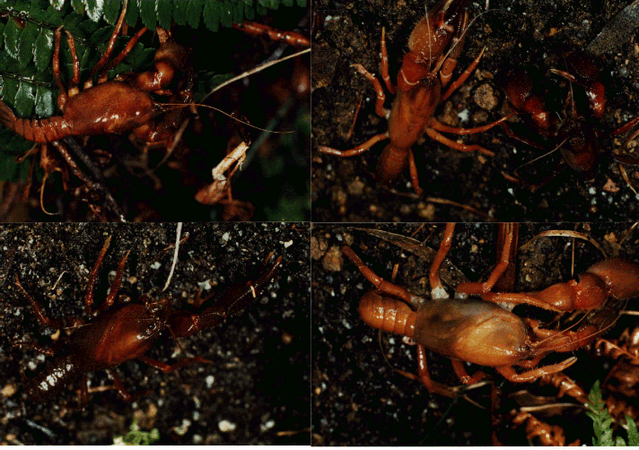

Plate 2.1
Engaeus orramakunna (a)-(d), clockwise from top left:
(a) very large male, OCL = 38.95mm, ferny buffer zone between pine and eucalypt forest GR 5260-4384;
(b) medium sized male, buffer in pine plantation (cleared upstream) GR 5371-4376;
(c) medium to large male, roadside culvert (Patersonia road) GR 5252-4214;
- medium to large sized male & female, class 4 seep in fully grown pine plantation GR5367-4370. Despite the definite differences in colouration, the two morphs were found in burrows less than 1m apart (male = darker one).

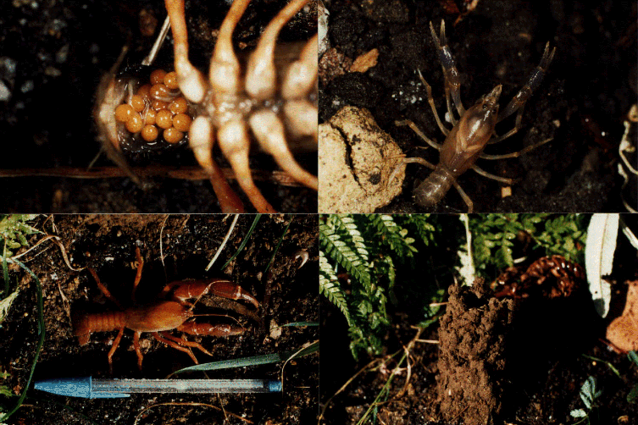

Plate 2.2
Engaeus orramakunna (e)-(h), clockwise from top left:
(e) medium sized ovigerous female, with a much smaller clutch of eggs than seen on other (larger) specimens, tree-fern covered seepage GR 5176-4356;
(f) juvenile (developing as a female), collected from seep crossing old forestry road, GR 5191-4199 approx (unconfirmed GPS reading);
(g) typical burrow chimney, 9-10 cm in height (largest seen was approximately 40 cm);
(h) large male again [Plate 2.1(a)], with pen giving a measure of scale.
Photos: ND

2.2 Methods

2.2.1 Location of field work

Given the three previously recorded locations of the species (Horwitz 1990a) and suggestions that the distribution may prove to be slightly more widespread to the west and north of these (Horwitz 1990b), the original search area defined for the project consisted of that denoted by the four 1:25 000 scale Tasmap sheets surrounding Mt. Arthur. The mountain falls on the low south-west corner of the Lisle map sheet, with the Lilydale, Dilston and Patersonia sheets to the west, south-west and south of this respectively. Each sheet but for Lisle contained one of the previously recorded localities of the species.

Field work involved visiting as many accessible stream-side and seepage sites within the encompassed area as possible, mostly over the period of June to September 1996. Some follow-up field work was also conducted in late October/early November 1996. Work began between the known localities to determine whether the distribution was a continuous one, and then expanded outwards to determine the boundaries of the overall geographic range. Within the overall search area, some regions of particular interest (such as cleared and extant pine plantation) were sampled very intensively and at short intervals, while others were sampled at a coarser scale. Work at each chosen site was divided into three approaches, as outlined below.

2.2.2 Presence or absence of E. orramakunna

Sites were first searched extensively for any sign of crayfish burrows, with searches extending fifty to a hundred metres along stream beds if necessary. Where burrows were found, site location was compared to the position of locations recorded prior to and during this study. Where necessary, burrow excavations were conducted to obtain crayfish specimens for species identification. This was done for burrows that were found some distance from other recorded sites, that were outside the known/perceived distribution pattern, or that fell near distributional boundaries with other species.

Most crayfish were released following identification, although some were retained as voucher specimens. Specimens seriously damaged during collection were kept, as were specimens of other crayfish species found outside their previously recorded distributions. Ovigerous (egg-bearing) E. orramakunna were released as soon as possible after capture.

For sites well within the general distribution area, away from inter-species borders, or close to sites at which digging had confirmed the presence of E. orramakunna, burrows were taken to represent the occurrence of the species. This saved habitat, avoided disturbance to the species and eliminated the need for lengthy burrow excavations, which could often take several hours (see Plate 2.5 and description).

2.2.3 Abundance of E. orramakunna

Early in field work, the abundance of burrows at sites was determined by both a general abundance index (0-4 scale), and quadrat counts of burrow numbers to help determine the accuracy of this scale. Quadrat counts consisted of choosing one burrow entrance at random and then counting all burrow entrances within a two-metre radius of that burrow. Three quadrat counts were conducted per site where possible. This approach posed problems due to quadrats overlapping stream edges to different degrees in some cases, and an inability to determine whether individual burrows represented part of the same burrow systems. However, the quadrat counts provided reasonably reliable indicators of crayfish activity within an area and allowed the less time-consuming abundance index to be refined.

Quadrat counts also included a count of the number of burrows with and without pelleted soil chimneys. As chimneys were observed to weather and wash away quickly in accordance with their degree of exposure to the general elements and stream flooding, this ratio provided another potential indicator of recent crayfish activity within an area.

In later field work, quadrat counts were no longer conducted and the index alone was used. 0 denoted absent, 1 low abundance, 2 average to reasonably good abundance, 3 high abundance, and 4 extremely high abundance. In some cases, split indices were assigned (e.g. 1.5 for abundances falling between average and low).

2.2.4 Habitat variables

At each site, including those where no crayfish activity were found, habitat variables were recorded according to pre-determined survey criteria. Surveys were designed to maximise the amount of information that could be obtained per site while minimising the time taken. Sites were characterised according to:
• grid reference (GR) and date of survey;
• altitude (m) and aspect;
• location description;
• stream width, depth, flow rate (whether the body represented a pool, seep or stream) and slope (°);
• stream class (1-4, as per the Forest Practices Code (Forestry Tasmania 1993); most later determined at Bass District Office);
• vegetation cover (%; canopy and ground);
• vegetation type (at ground level, scrub, and canopy height);
• soil type and consistency;
• soil moisture/depth of water table;
• bank slope (°) and micro-drainage patterns;
• surrounding land use; and
• any disturbance to the area (e.g. clearing, run-off, cattle, blackberries).

Other information recorded included:
• any general notes and observations viewed to be of importance;
• data on crayfish specimens collected (size measurements, colouration, sex, reproductive status, presentation of variable characters (e.g. presence of uropod suture) and when and if the specimen was released);
• general chimney prevalence and clustering; and
• in earlier surveys, vertical and horizontal distances of burrow clusters from streams.

2.2.5 Data analysis

The PRIMER multivariate statistics software package was used to analyse the vegetation data compiled. The CLUSTER and MDS programs were used to group the sites according to similarity in vegetative character, which could then be examined for trends coinciding with species presence and abundance. The SIMPER program was then used to determine which, if any, elements of the vegetation were contributing most to the degree of similarity and dissimilarity within and between groups of sites on the basis of that abundance. SIMPER analysis was run twice, initially on data divided into the classes of 0, 1, 2, 3, and 4 abundance, and then with classes 0 + 1 and 3 + 4 combined. For the SIMPER groups, split-indices (e.g. 1.5) were rounded down.

Direct comparisons were also made between the suite of logged and unlogged sites sampled to determine whether in crayfish abundance varied between them. Particular attention was paid to streams and seeps of class 4 status.

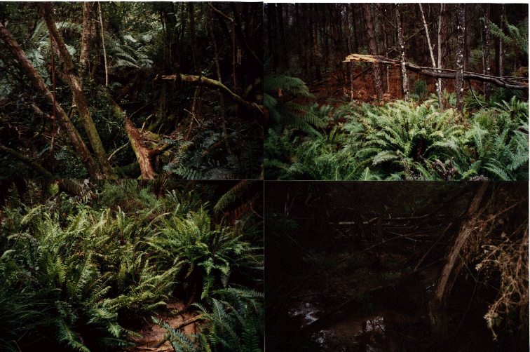

Plate 2.3
Sites where E. orramakunna was found (a)-(d), clockwise from top left:
(a) undisturbed rainforest stream and seeps, Mt Arthur MDC protection zone GR 5244-4319 (burrow abundance = 2.5);
(b) ferny buffer zone in pine plantation, below cleared class 4 seep, Koomeela Plantation GR 5368-4375 (e) (abund. = 2.5);
(c) wide marshy seep in pine plantation, below cleared class 4 seep, Koomeela Plantation GR 5363-4378 (e) (abund. = 4);
- same area as (b), showing high siltation around the bases of ferns.

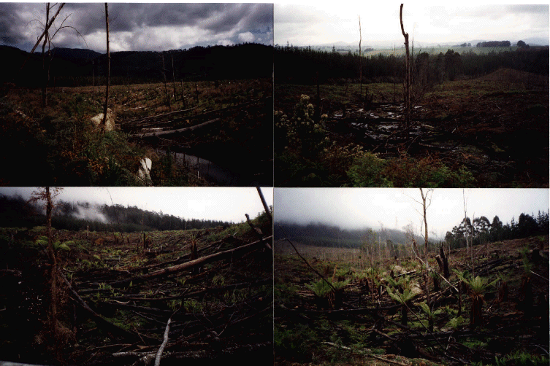

Plate 2.4
Sites where E. orramakunna was found (e)-(h), clockwise from top left:
(e) class 4 seep and dammed backwater above road in cleared, burnt, and reseeded/early regrowth pine plantation, Lisle Plantation GR 5263-4354 (s) (abundance = 2.5). Large, ovigerous female and juvenile collected here [see Plate 2.5 (c)];
(f) class 4 seep in more recently cleared & burnt pine plantation, Koomeela Plantation GR 5363-4376 (abundance= 3-4). Large ovigerous female collected here;
(g) downstream of (f), upstream of Plate 2.3 (b+d), siltation high, Koomeela Plantation, GR 5368-4375 (w) (abund. = 3);
(h) class 4 seep in recently cleared & burnt plantn [near Plate 2.3(c)], Koomeela Plantn GR 5363-4379 (w) (abund = 3-4).

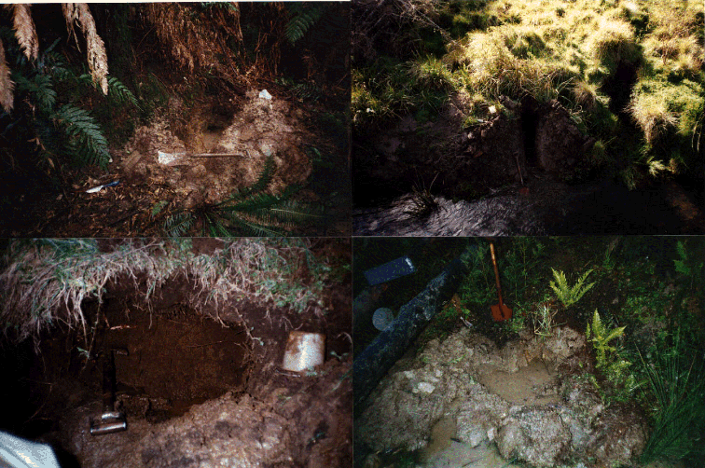

Plate 2.5
Excavations for E. orramakunna (a)-(d), clockwise from top left.
Note: excavations could often take several hours, as burrow systems could be complicated and crayfish would frequently manage to reach their most inaccessible limits, whether below the water table or staright back into the soil. Digging had to be careful so as not to destroy or lose tunnels, or to damage specimens.
(a) same ferny buffer zone where the male of Plate 2.1(a)/2.2(h) was found GR 5260-4384 (burrow abundance = 2);
(b) grassy stream bank where class 1 stream passes under road, 2 juveniles caught here, GR 5254-4204 (abund. = 1.5);
(c) cleared & burnt pine plantation of Plate 2.4(e), ovigerous female and juvenile caught here GR 5263-4354 (abundance = 2.5). Other burrows can be seen on the slope to the right of diggings;
(d) grassy banks of a public recreation area next to a class 1 river (St Patricks), GR 5306-4267 (abundance variable, av. 1.5). The species at this site was not caught or identified, but occurs on a border between E. orramakunna and E. leptorhynchus.
Photos: ND

2.3 Results

2.3.1 Geographic distribution of E. orramakunna

The distribution of this species has been expanded from the original three sites to seventy nine (Figure 2.1). These cover at least eighteen entirely separate locations (see key opposite Table 2.1) and contain numerous sub-site habitat types.

The species has been confirmed as present at twenty four of the seventy nine sites (Table 2.1), including the original sites and two where specimens were collected earlier in 1996 by Jeff Meggs and Rob Taylor respectively. Of the remaining fifty five sites, where excavations were either not conducted or were unsuccessful, fifty one are contained within the distributional boundaries marked by the confirmed sites and so can be considered as almost certainly representing E. orramakunna (Table 2.2). A further four sites (marked as '*' in Table 2.2) lie close to a potential distributional boundary along a tributary of Pipers River, and, as these sites are not far from confirmed E. orramakunna sites along that river, it is also likely that these represent the same species.

A further thirty two sites were examined at which no crayfish burrows were found (Figure 2.1; Table 2.3). Twenty of these were within the distributional range determined for the species, while the others fell on or beyond its boundaries. A further six sites were recorded as representing micro-scale absences rather than complete site absences per se.

Several other Engaeus species were collected bordering on the E. orramakunna distributional range (Figures 2.1 & 2.3; Table 2.4). These include seven sites for E. tayatea, three sites for E. mairener, two sites for E. nulloporius, and four sites for E. leptorhynchus. Another seven sites were recorded with crayfish burrows present, but excavations were unsuccessful and the proximity of sites to likely distributional borders precluded any definite assumptions regarding the species involved. In some cases, the distribution of catchments where these burrows occurred indicates which species may be present, but these suppositions require further investigation (Table 2.5).

Importantly, a specimen of initially indeterminate species was collected sharing a site with E. nulloporius. This specimen has been identified by Pierre Horwitz as a potential new species, referred to here as "Engaeus sp. nov.?" The significance of this discovery is discussed in Section 2.4.4.

2.3.2 General habitat variables

Engaeus orramakunna was found in high abundance at sites in a wide variety of situations. These included undisturbed rainforest, eucalypt forest, open pasture, cattle trampled pasture, roadside gutters and culverts, full (40m) buffers around class 1 streams, medium (20-30m) stream buffers within eucalypt plantation, and class 4 seeps in both standing and harvested, cleared and burnt pine plantation (see Plates 2.3-2.5). The Mt Arthur crayfish was found at altitudes ranging from 150 to 630m. Apocryphal tales had reported that burrows were found higher still, but searches of streams and seeps between 650 and 1150m (at the fire observation tower) on Mt Arthur did not reveal any burrows.

While most occupied sites faced north, north-east or north-west, they were not consistently found on any one aspect, and some sites faced to the south. Regions of higher abundance for the species fell to the north of Mt Arthur, however, and may be related to water availability and soil type (see below).

Within sites, burrow abundance could be either patchy or uniformly distributed. Burrows could be found in steep sided banks and on steep stream slopes as well as in flat marshy seeps and pans. They were found in areas with high canopy cover, high ground cover, low canopy cover and low ground cover, and all combinations of these. Sites with high and low burrow abundances were recorded in both completely enclosed and totally open habitats.

Of all the attributes measured, only two physical factors were consistently observed for all and near all sites where active burrows were found: high soil moisture and high clay content. In all areas there was high available moisture in the soil. While bank and stream slopes per se did not appear to be directly important, they did have an effect if they influenced the moisture of the banks themselves. On drier banks, abundance was notably lower; Shepherds Rivulet and Second River were subject to sharp descents as they passed down the slope of Mt Arthur, and burrow abundance indices fell from 2.5 to 1.5 over the space of metres as flatter, wetter beds of soil gave way to steeper, drier ones (e.g. GR 5244-4319). Similarly, abundance indices on the gentler slopes of the Koomeela Plantation were noted to fall from the level 3 and 4 values of cleared and non-cleared muddy seeps, to values of 2.5 where the seeps developed into more defined, faster draining and drier-banked stream channels (GR 5368-4375; 5363-4379).

This pattern was repeated for several class 4 streams that were followed for some length. As they developed from wide seeps into channelled streams, abundance decreased from extremely high and widely distributed, to lower (if not necessarily low) and tightly focussed around the more distinctly defined channel. This occurred even if bank and stream slopes were low, whereas abundance was still high even on the steepest banks where seepages remained flowing. At one site (Whites Mill Road, GR 5188-4306), the stream slope and bank height were relatively low and burrows absent; twenty to thirty metres further on the banks became high and steep (50°+), but had good numbers of burrows in flowing seeps (2 overall; higher in seeps and wet depressions).

In short, the steepness of some banks and stream slopes appeared to aid drainage and drying, while in others it either did not, or sufficient seepages and drainages remained. For this reason, it would appear that seepages and marshy pans alongside streams are the stronghold of the species as opposed to the actual river-banks themselves.

Wetness permitting, burrows could be found some distance from streams, both vertically and horizontally. Indeed, evidence recounted by farmers describes burrows appearing in the middle of paddocks and fields in the wetter conditions of winter, well away from any major water source beyond the ground itself. At these times, water levels could be so high that water would literally spout from the burrows; so much so that one farmer believed the chimneys to be caused by water pressure! This was observed directly during this survey in pasture land on Mt Arthur road (GR 5262-4304), where burrows were found on a steep grassy slope over thirty metres above the stream.

Other land holders have reported seeing crayfish moving over the surface of fields between dams and creeks in wetter weather. While these were implied to be Engaeus species in some instances, however, these identifications cannot be confirmed. Astacopsis species are known to cross land in such a manner, but little information exists regarding similar movement in Engaeus (A. Richardson, pers. comm.). Given the potentially restricted dispersal abilities of the genus (Section 1.0), verifiable observations of such movement would be of note.

The second consistent physical factor at most of the sites at which burrows were found was a moderate (to high) clay content in the soil. Within and between sites, burrows were often notably absent from areas where the soil possessed no cohesive properties, and while burrows were occasionally found in sand and non-cohesive grit or litter-based top soil, these usually descended to a lower, more cohesive clay layer.

To the southern side of the species' distribution there is a general change in the character of the soil; the richer, darker topsoils and underlaying reddy-grey clays that characterise the high abundance sites in Lisle give way to a paler brown topsoil over varying red to darker clays beneath. The former represents a soil type known as 'Excalibur', while the latter represents both 'Holloway' and 'Eastfield' soil types. Excalibur is usually found under wet forests, and contains a significantly higher number of nutrients; Holloway and Eastfield are more often found in dryer rainfall zones, under sparser more open forest (Mike Laffan, pers. comm.). This was certainly observed here, with the vegetation of a much different character - lighter and more open eucalypt and tea-tree scrub - than the wetter, thicker forests to the north.

With the exception of a tea-tree swamp in the Pipers River Forest Reserve, where burrow abundances were extremely high (3-4), the few sites sampled in this southern area were of generally lower abundance (1.5s and 2s), and the number of sites where burrows were present was also lower. In the few places where seeps were present, however, burrows were observed in high densities over their extent (e.g. GR 5191-4199; 5252-4214).

2.3.3 Vegetation type

Burrows were usually found in the presence of ferns and manferns, and were found under a range of canopy species including eucalypt, tea-tree, paperbarks, radiata pine and sassafras, but tended not to be found in association with myrtle. Where burrows were found near myrtle, root-matting in the soil was not very dense, such as in recently turned road-sides and gutters. Similarly, while burrows were found in grass, they again tended not to be found where grass roots were exceptionally thick. Burrows found in the midst of pine plantation were always associated with reasonable amounts of other types of vegetation; where pine plantation directly met bare or sparsely vegetated class 4 streams there was usually no or little crayfish activity respectively (e.g. absences at GRs 5261-4359 and 5259-4395; lower abundance 5298-4342 'n-stream' versus the higher abundance 's-stream' at the same site).

PRIMER analysis showed that no particular plant species or group of species appears to be solely associated with the observed differences in the presence and abundance of E. orramakunna. From a subsample matrix of 112 site and sub-site vegetative profiles involving 62 plant species and groups (Appendix 1), dendrograms and ordinations produced no obvious patterns or groupings of absence or low/medium/high abundance sites. (Dendrograms and ordinations are not reproduced here due to their complexity and the absence of meaningful patterns, but can be found in crude form in the Appendices).

The SIMPER program, in ranking the contribution of species to the similarities within and differences between these groupings, did not show any major associations. Open soil (treated as a 'species' for the analysis due to its apparent importance) was responsible for the greatest degree of similarity within groupings (22.24, 42.87, 25.37, 20.04, and 17.11% and 28.35 and 25.37% for groupings 0-4 and 0+1 and 2 respectively). For the grouping of abundance classes 3+4, ferns constituted the greatest amount of within group similarity (19.27%), followed by open soil (19.25%).

Open soil and the presence of ferns were ranked low, however, in their contribution to the degree of difference between groups, and no factor rated over 8%. Within group similarities were not high (35.99, 35.13, 42.97, 40.18, and 55.55, and 35.15, 42.97, and 43.89% respectively), and no between group dissimilarities were exceptionally pronounced (over 70%). In short, no dominant vegetative factors were found to be responsible for the observed variations in abundance.

2.3.4 Major disturbance

Logged and unlogged areas, with particular reference to class 4 streams

Burrows were found alongside streams of all classes in both logged and unlogged areas (Tables 2.1 & 2.2). Unexpectedly, high abundances were found at several locations in both extant and recently clear-felled and burnt pine plantation, including class 4 streams where no buffer zones were retained (e.g. GRs 5363-4378 (e), 5268-4346 (s), & 5367-4370 for standing plantation, and 5255-4353 (w), 5269-4348, & 5368-4375 (w) for cleared). Large numbers of chimneyed burrows were found in such locations, and excavations revealed healthy looking juveniles, males, and ovigerous females (GRs 5263-4354, 5363-4376, & 5367-4370).

Burrows were found in high abundances in areas where siltation was high, whether due to logging in that area or at various distances upstream (e.g. GRs 5263-4354, 5363-4379, 5363-4378 , & 5371-4376). Siltation was particularly high in the adjacent cleared and downstream/fern-buffered areas of GR 5368-4375 (w) + (e). Burrows protruded through silt, or were found in clusters on patches of mud amongst the sandy material. In some places dense low fern cover aided in the removal of silt from the stream.

Table 2.6 shows the abundance of crayfish in various sites and sub-site habitats, as determined from the information in Tables 2.1-2.3. Class 4 seeps that had recently been cleared, where clearing had occurred upstream, and where pine plantation had attained medium height are all shown to exhibit generally good to high abundances, as do buffered class 3-1 streams in logged areas . No low abundances were recorded in these areas, and only one absence: in a cleared class 4 seep that was particularly dry (GR 5364-4363). In contrast, unlogged areas tend to show a more even spread of abundances, although absences are exacerbated by the large area of consistently 'absent' sites in the central north part of the distribution.

Other disturbances

Abundances were also notably high in wet gutters, drains, and the turned and disturbed soil of culverts, but crayfish were not as well represented in streams through pasture and grass.(Table 2.6). While burrows were present on the fringe of highly cattle-trampled soil (just north of the type locality 5181-4307), where trampled areas met stream banks, burrows of both E. orramakunna and other species (e.g. E. tayatea at Plovers Ridge 5169-4324) were more prevalent in seeps and creek banks where vegetation and bank characteristics afforded more protection, and trampling was less.

1080 poison had been laid in several places on the cleared Lisle plantations (not near streams that were sampled). While 1080 is a highly toxic poison for vertebrate species, the short and long term effects of this on crayfish species are unknown. Crayfish are known to be highly susceptible to some pesticides, including compounds in common usage on various types of plantation (Horwitz 1991, Davies et al. 1994). Even so, this factor probably does not pose a major risk unless the crayfish are at the surface and directly exposed when spraying occurs (Davies, pers. comm.). The continued presence of crayfish populations in plantation areas would indicate that this is so.

In contrast, crayfish were absent from two streams below a rubbish disposal area (GRs 5285-4286 & 5285-4283). Burrows were also of very low abundance or absent in the dirt stream-sides passing through the town of Lilydale itself, even though the type locality occurred a short distance upstream. These observations would suggest that the species may be sensitive to changes in water quality.

2.3.5 Life history and other observations of note

As mentioned in Section 2.3.4, two very large, ovigerous (egg-bearing) females were collected from burrows in class 4 water bodies in cleared and burnt pine plantation. The first was collected on 20.6.96 from a small stream/wide backwater in a wide, steep sided channel (GR 5263-4354). The female was large (not measured, but of similar size to the one below) with a large cluster of yellowy-orange undeveloped eggs (not measured, but again similar in size to the ones below).

The second female collected from similar habitat was found on 1.11.96, at GR 5363-4376, in a wide and densely populated seep. Her measurements were: occipital carapace length (OCL) = 32.0mm, carapace width = 12.5mm, and tail not measured. Her eggs were a pale orange in colour, undeveloped, numbered well over 100, and oval in shape (approx. 2.0 by 2.5mm). The largest reproductive female previously recorded had an OCL of 30.7mm (Horwitz 1990a).

A third and smaller ovigerous female was collected from an undisturbed tree-fern covered seepage at the Lilydale Falls Public Reserve (GR 5176-4356) on 29.10.96. Her measurements were: OCL = 23.50mm, width = 11.00mm, and full length = 43.55-44.00mm. She had a much smaller clutch of eggs (14 in total), in keeping with observations that the level of fecundity is directly related to the size of the female in several species of freshwater crayfish (including E. spinicaudatus: Horwitz 1991). The eggs were bright orange in colour, undeveloped, and oval in shape (2.20 by 1.85mm: see Plate 2.2). The specimen was collected in a burrow from which a large male specimen had previously been collected (13.9.96; OCL approx. 35mm). Juveniles were also present in the same burrow.

It has previously been suggested that the breeding season for E. orramakunna may start in late winter (Horwitz 1990a+b). The observations above, however, suggest that breeding may start at the beginning of winter and continue into late spring/early summer.

The largest male collected during this study was from a steep sloped, tree-fern covered class 3 stream between pine plantation and eucalypt forest (GR 5260-4384). His measurements were: OCL = 38.95mm, width = 18.45mm, and total length 71.75mm. He was collected from a burrow tunnel approximately eight to nine centimetres wide. The largest male previously recorded had an OCL of 33.4mm (Horwitz 1990a).

One bisexed individual (exhibiting one male and one female gonopore, RHS and LHS respectively), as opposed to an intersexed one (featuring sets of both male and female gonopores, as common in several other Engaeus species) was found at GR 5149-4288. Bisexed individuals of E. orramakunna have previously been noted as rare by Horwitz (1990a), which would be supported by the current study. This character may represent some form of genetic or developmental damage (A. Richardson, pers. comm.).

Also at GR 5149-4288, but in a different burrow, a large non-native slug was found in the burrow chamber with both ends ‘snipped’ open. The slug was collected and preserved, although the owner of the burrow - and the presumed culprit - was not caught. The large male from GR 5176-4356 may have consumed a worm while being maintained in the lab, but this cannot be verified. Other captive specimens refused to show any interest in similar items presented, but did snip heartily at enclosed fern material (primarily leaves). It is unknown whether any of this material was consumed.

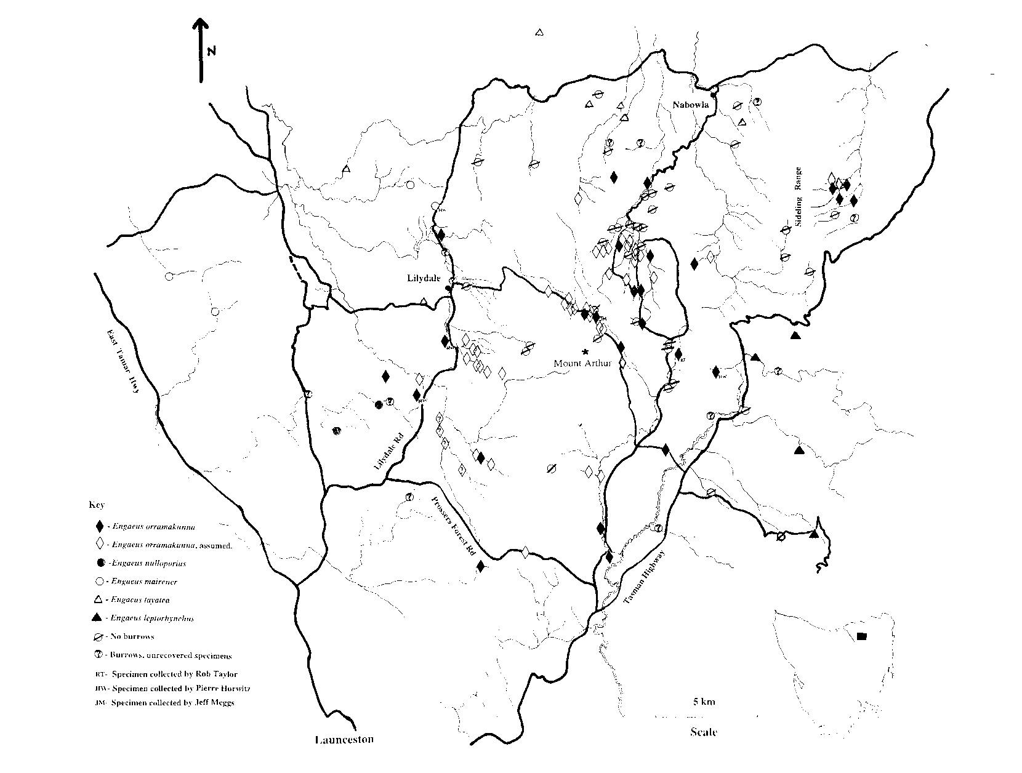

Figure 2.1: The distribution of E. orramakunna and surrounding species.
The map includes sites where the presence of E. orramakunna was confirmed by the excavation of specimens, and sites where E. orramakunna could be assumed to be the species present (see Section 2.3.1). Where more than one 'assumed' sites are close together, they may be represented by one symbol.
Five E. orramakunna and one E. mairener sites are post-scripted as appropriate to indicate known locations from previous studies and collections.
Engaeus 'sp. nov.?' was found in sympatry at the western of the two E. nulloporius sites.
Map preparation: KR
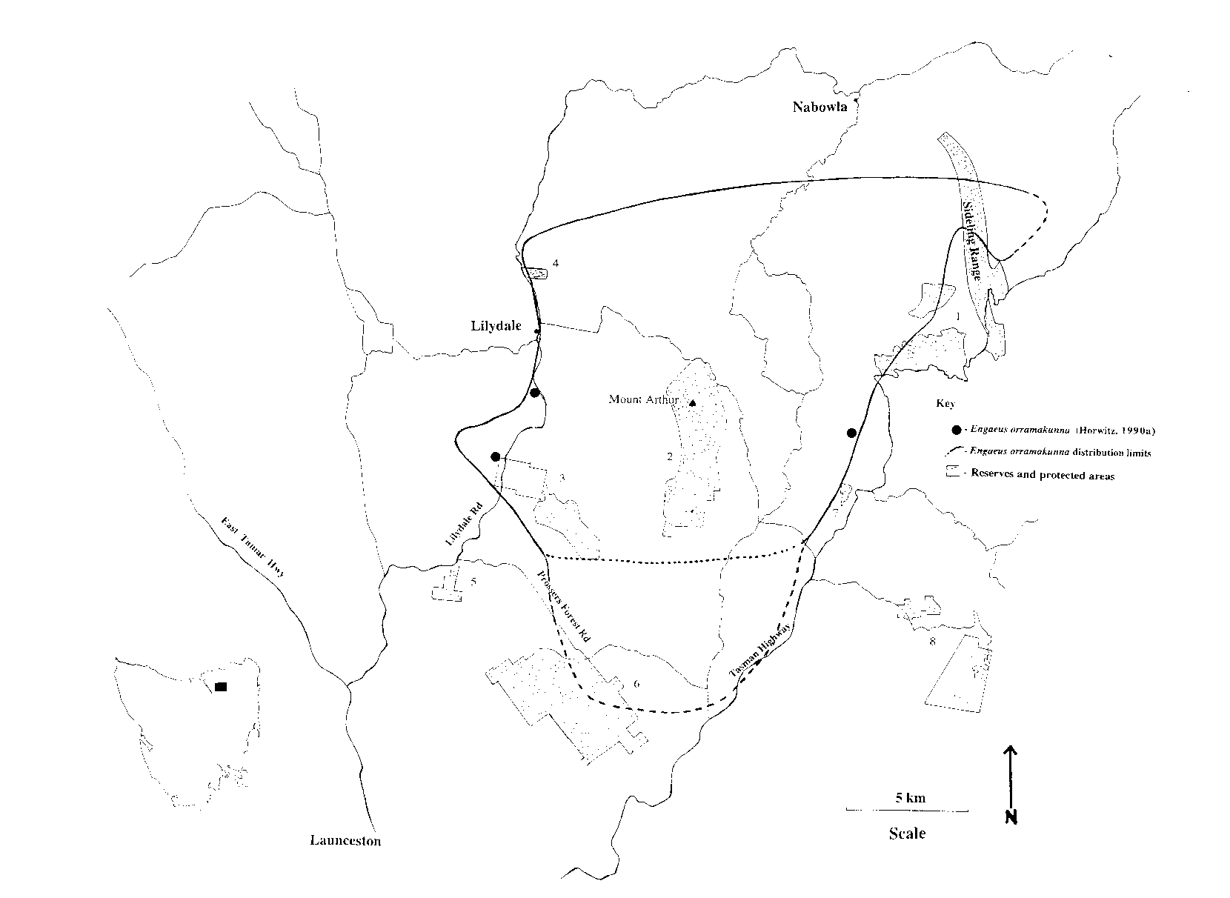

Figure 2.2: The projected distributional range of E. orramakunna .
The three originally known sites for E. orramakunna (Horwitz 1990a) are marked to demonstrate extensions in known distributional range. The solid line is deemed to show a definite or near definite distributional boundary as determined by borders with surrounding species. While minor distributional variations may be found on either side of this line, it is not expected to change greatly. The dotted lines to the north-east and south indicate non-definite boundaries, where no border with other species or complete absences of the target species have yet been determined, and the distributional range may extend for unknown distances beyond them.
The southern boundary is divided into two, with the northern line marking the change from the higher abundance northern region of the distribution to the lower abundance southern region. The drop in abundance at least superficially matches a graded change in soil and vegetation types (from richer and wetter to poorer, dryer and more open) south of Mt Arthur.
Reserved and protected areas are marked on the map to show which ones fall within the distributional range of the species. (1) Forestry Tasmania (FT) Management Decision Classification (MDC) protection zones around the Sideling Range area; (2) FT MDC Mt Arthur protection zone; (3) the Pipers River Forest Reserve (southern section) and the Hollybank Forest Reserve (northern section); (4) the Lilydale Falls Public Reserve; (5) un-named FT reserve/protection zone; (6) the Prossers Forest Reserve; (7) Targa/St Patricks River Recreation Reserve; and (8) Mount Barrow Falls State Reserve (north) and Mount Barrow State Reserve (south).
Map preparation: KR

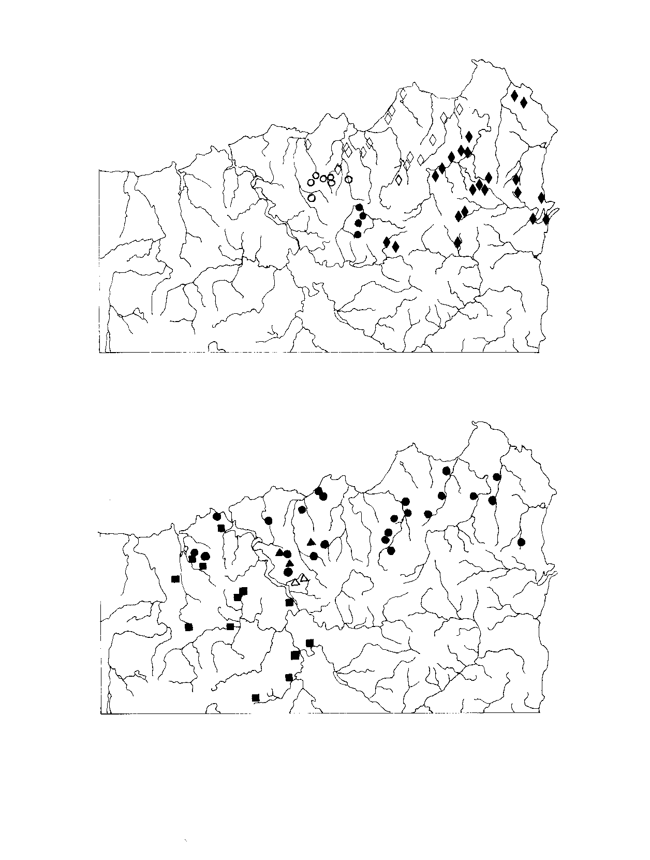
Figure 2.3: Range extensions for other Engaeus species.

The maps opposite show the locations of other Engaeus species determined in this study relative to their previously known distributions (Horwitz 1990a & in press).
Upper map:
Closed diamonds = E. leptorhynchus previously known locations
Closed circles = E. leptorhynchus range extensions
Open diamonds = E. tayatea previously known locations
Open circles = E. tayatea range extensions

Lower map:
Closed circles = E. mairener previously known locations
Closed triangles = E. mairener this study (no range extensions)
Closed squares = E. nulloporius previously known locations
Open triangles = E. nulloporius range extensions

NB the western-most of the two E. nulloporius sites determined by this study also represents the location of E. 'sp. nov.?'
Map prep: KR

Key to Tables 2.1 - 2.6:
For grid references:
• PH, JM, RT = specimens collected by Pierre Horwitz, Jeff Meggs, & Rob Taylor respectively, others from this study;
• (gps) = grid reference derived by GPS only, accurate to within 300m; others det. by GPS and 1: 25 000 scale map;
• n, s, e, or w = site to north, south, east or west of road: see below;
• n-, s-, e-, or w-stream = corresponding stream where more than one occurs at that grid-reference: see below;
• * = one of four sites close to a potential distributional boundary (Table 2.2; see Section 2.3.1).
For specimens & stream class:
• m, f, f(o), j, b, i = male, female, ovigerous female, juvenile, bisexed and intersexed individuals respectively;
• 4°, 3°, 2°, & 1° = class 4, 3, 2, & 1 respectively ("crossover?" = possibly near the transition point into the next class);
• nr. = swampy area near to stream of that class; est. = estimated; NA = not applicable.
For habitat & land status:
• MDC p.z. = Forestry Tasmania Management Decision Classification protection zone (State forest).
• SF = State forest; clrd = cleared; u/s & d/s = upstream & downstream.
• buffer = buffer zone; (size?) = older plantation where buffer may be smaller than present practices require?
For relative abundance:
• Measured on a scale of 0-4 (absent to high abundance, as per Section 2.2.3);
• NR = not recorded (estimates or minimums may be given); "reported" = information given by landowner.

Site demarcation:
Where sampling intervals were small, determination of what represented a separate site/location was at times very subjective. Different sampling areas along the same stream bed were treated as separate sites, but on the overall scale were considered to represent the one location. Sample areas 100+ m apart were regarded as separate sites, and were under 100m if they represented immediately adjacent streams (n-stream & s-stream, etc.) or habitats separated by a similar distance vertically (e.g. a roadside gutter or seep above a steep drop to a stream).
If no distinction (n, s, e, w) is made for points where streams cross roads, site descriptions hold for both sides of the road. Where distinctions are made, it is either because only the specified side was surveyed in detail, or because both sides exhibit differences in habitat or abundance. In the latter cases, different sides are noted as separate entries in the Tables, but are not counted as separate sites. The second part of each such 'coupled' sub-site is indented: in brackets where it immediately follows its partner, and not where its partner is found in a preceding Table.
The distinction of sites and the 100m threshold were derived from similar work by Horwitz (1991) on E. spinicaudatus (see Section 3.0).

Table 2.1: Confirmed E. orramakunna sites.

Sites where specimens have been collected. (Key as listed above).

Table 2.2: Assumed E. orramakunna sites.

See Section 2.3.1. (Key as listed above).

Table 2.3: Absent sites.

Sites and sub-sites where no evidence of crayfish was found. (Key as listed
above Table 2.1).

Table 2.4: Other species.

Sites where Engaeus species other than E. orramakunna were collected. (Key as listed above Table 2.1).

SPECIES | SPECIMENS | GRID REF. | 1:25000 MAP | STRM CLASS | HABITAT; LAND STATUS | ABUND.
E. tayatea | 2i | 5224-4452 | Nabowla | 3-2° | Riparian zone; open SF | 1.5 to 2
E. tayatea | 1m; 2i; 4j | 5248-4420 | Nabowla | 3-2° | Open riparian zone; SF | 2.5
E. tayatea | 2i | 5264-4416 | Nabowla | 2° | Riparian zone; pine + eucalypt SF | 2
E. tayatea | 1i; 2j/i | 5264-4410 | Nabowla | 2° | Recently re-dug channel in pine plantation; SF | 2
E. tayatea | 1i; 12j | 5320-4407 | Nabowla | NA (culvert) | Culvert in pine plantation; SF | 2.5 to 3
E. tayatea | 3i (2 burrows) | 5133-4390 | Lilydale | 1° | Stream bank; SF | 3
E. tayatea | 1i/f; 2j | 5169-4324 | Lilydale | 4° | Marshy area below farm dam; private | 4
E. mairener | 2m | 5046-4343 | Lilydale | est. 2° | Open riparian zone; eucalypt SF | 2
E. mairener | 1m (dead) | 5069-4326 | Lilydale | 1° + seep | Open riparian zone; eucalypt SF | 2 to 2.5
E. mairener | 1m | 5162-4381 | Lilydale | 3° | Enclosed riparian zone; private | 2
E. mairener | [PH] | 5174-4371 | Lilydale | 4°? | unknown | unknown
E. nulloporius | 1f(o?) | 5144-4275 | Dilston | 2° | Open marshy puddles/seeps; eucalypt SF | 1.5
E. nulloporius | 1f(o?) | 5124-4263 | Dilston | est. 4-3° | Open marshy ground and pool; eucalypt SF | 1.5
Sp. nov.? | 1j? | 5124-4263 | Dilston | est. 4-3° | Open marshy ground and pool; eucalypt SF | 1.5
E. leptorhynchus | 1m | 5351-4211 | Patersonia | 3°? | Culvert and marshy areas; road and private | 1.5 to 2
E. leptorhynchus | 1m; 1j | 5346-4251 | Patersonia | est. 2-1° | Riparian zone; private property | 2
E. leptorhynchus | 1f | 5323-4296 | Patersonia | 1° | Marshy areas/seeps in river banks; river reserve | 2 to 2.5
E. leptorhynchus | 1m; 1j | 5346-4301 | Lisle | est. 4-3° | Marshy seepages alongside stream; pine SF | 3 to 4

Table 2.5: Unknowns.

Sites where crayfish were present, but no specimens were collected. Possible species are listed based on the distributions determined by this study. (Key as listed above Table 2.1).

POSSIBLE SPECIES | GRID REF. | 1:25000 MAP | STRM CLASS | HABITAT; LAND STATUS | REL. ABUND.
E. tayatea? | 5326-4416 | Nabowla | est. 2° | Recently dug channel in plantation; SF | 1
E. tayatea? | 5256-4399 | Lisle | est. 4-3° | Pine plantation; SF | 2
E. tayatea? | 5273-4398 | Lisle | 3°? | Pine plantation; SF | 2
E. orramakunna? | 5178-4349 | Lilydale | 1° | Grassy/open bank; private | 0.5-1
E. orramakunna? | 5182-4334 | Lilydale | 1° | Open bank; Lilydale town | 0.5-1
E. orramakunna? | 5161-4232 | Dilston | 4° | Open eucalypt scrub; SF | 1.5
E. orramakunna? | 5375-4358 | Lisle | 3°? | Euc. plantation; private | NR (1.5?)
E. orram./E. leptorhynchus? | 5281-4213 | Patersonia | 1° | Open bank; private | NR (1.5?)
E. orram./E. leptorhynchus? | 5306-4267 | Patersonia | 1° | Grassy + marshy banks; public reserve | variable (1.5)
E. leptorhynchus? | 5340-4284 | Patersonia | 4° | Pine plantation; SF | NR (flooded)
unknown | 5110-4279 | Dilston | NA (gutter) | Above 1° stream; on Pipers River Road | 1.5

Table 2.6: Relative crayfish abundances in areas of varying levels of disturbance.

The Table shows the number of sites displaying different levels of abundance under the stated sets of conditions. (General key as listed above Table 2.1).

 | High abund. (3-4) | Medium (2-2.5) | Low (0.5-1.5) | Absent (0)
4° streams/seeps - unlogged | 3 | 8 | 6 | 13
4° streams/seeps - cleared and burnt | 8 | 4 | 0 | 1
4° streams harvested upstream | 2 | 2 | 0 | 0
4° streams - medium growth plantation | 1 | 3 | 0 | 0
3-1° streams - unlogged | 5 | 13 | 3 | 9
3-1° streams - logged but buffered | 2 | 2 | 0 | 0
Streams in pasture/grass | 0 | 2 | 2 | 2
Culverts, gutters, drains | 4 | 15 | 3 | NA

2.4 Discussion

2.4.1 Geographic distribution of E. orramakunna and surrounding Engaeus species

E. orramakunna is widespread and abundant within the confines of its distribution, although on a state wide scale this distribution remains relatively limited. The current work has expanded greatly on the original three sites recorded for the species, showing that it is found in areas between these sites, as well as extending some distance further north and south (Figures 2.1 and 2.2).

The original sites remain as accurate indicators of its east-west distribution, and the type locality itself (Horwitz 1990a) occurs on the western extreme. In fact, as shown by the data gathered for this project, the extent of the species onto the Lilydale 1:25 000 scale Tasmap sheet is quite limited. (A major portion of E. orramakunna's geographic range falls on the Lisle 1:25 000 Tasmap sheet, for which it is not currently listed in the Threatened Fauna Manual for Production Forests in Tasmania. However, in light of pending changes to the conservation status of the species (see Section 3.4.1) the significance of this omission is reduced.

The determined distribution is definite or near definite on most boundaries, with the exception of the far north-east corner and the south. While it is considered unlikely that the species extends much further to the north-east, an aberrant specimen possibly belonging to the species has been found north of Scottsdale (Horwitz, pers. comm.). For this reason, it is possible that the distribution may extend further north-east, and may reach the Scottsdale 1:25 000 map. If this is the case, the species will then be adding to a part of the state that is already exceptionally diverse in its crayfish fauna.

To the south, where abundance was generally lower, specimens were collected approximately 100m south of the border between the Dilston and Launceston map sheets (this specimen alone has an uncertainty of +/- 300m as its position could only be ascertained by an uncorrected GPS reading), and 400m north of the border between the Patersonia and Nunamara map sheets. Given the large regions of similar scrub, open land, and State forest in these areas, it should be considered highly possible that the species extends at least some way onto the Launceston and Nunamara maps.

The remaining boundaries demarked by this project can be considered as being quite definite based on the excavation of other species from neighbouring localities. The species is bounded to the north by Engaeus tayatea, to the north-west by E. tayatea and E. mairener, to the south-west by E. nulloporius and (potentially) Engaeus sp. nov.? (det. by Horwitz: see Section 2.4.4), and to the east/south-east by E. leptorhynchus. These localities represent significant range extensions for several of these species (Figure 2.3), and support Horwitz's (in press) prediction of quite distinct parapatric boundaries occurring within this highly diverse area. Further investigation needs to be made of the significance of these extensions with regard to 'faunal breaks' in the region (Mesibov 1994), with E. tayatea in particular now intruding on the east-west split in Engaeus species discussed by Horwitz (in press).

While some sympatry exists within the genus Engaeus, clear microhabitat separation is usually evident (Suter & Richardson 1977, Horwitz 1986, Richardson & Horwitz 1987, Horwitz, in press) and distinct parapatric boundaries appear to be a hallmark of the genus (Horwitz, pers. comm.). E. orramakunna would appear to occupy the same type of microhabitat as the above listed species, from the more burrow-abundant seeps, culverts and rich soiled streams of E. tayatea and E. leptorhynchus to the south-east, north and north-west, to the sparser distributions in more open rivers and poorer soils of E. mairener and E. nulloporius to the north-west and south-west.

Working on the distributional range as marked in Figure 2.2, the geographic (not habitat) distribution of E. orramakunna, or 'extent of occurrence' (IUCN 1994) can be estimated as approximately 215 km2 in the northern and more abundant region of its distribution (16 km2 on the Lilydale map, 21 on Dilston, 58 on Patersonia, and about 120 on Lisle). To the south, distributional boundaries are yet to be properly determined, and the extent of occurrence may be increased by anything up to 50 km2 or more (the southern region is currently marked by a further 20+ km2 on the Dilston map, 30+ km2 on Patersonia, and unknown amounts on the Launceston and Nunamara maps.

Despite some apparent absences, the 'area of occupancy' (or the area of the above distribution actually inhabited by the species: IUCN 1994) is probably high in the northern region, while much lower in the more open and drier habitat to the south. Counting 1 km2 grid squares in which the species is found, occupancy is at least 43 km2 in the northern area of distribution, and at least 6 km2 in the south. However, these figures must be viewed as major under-estimations for two reasons.

First, data collection focussed more on overall distributional range (or extent of occurrence) rather than on a fine scale kilometre-by-kilometre measure of occupancy. Therefore large areas of habitat occupied by the species in the less finely sampled areas of the north and all of the south, will not have been recorded.

Second, in those areas that were sampled intensively, occupancy was usually found to be high. These areas include 11 km2 of the Lisle Plantation, 4 km2 of the Koomeela Plantation, a 5 km stretch of the Mt Arthur Road (through approximately 8 km2 of State forest), and 3-4 km of Whites Mill Road (through approximately 4 km2 of private property and State forest). Occupancy in these areas was either total or near total, although the area in the Lisle Plantation adjoined one other intensively sampled 3-4 km2 area where no crayfish were found. Crayfish also appear to be absent from some higher altitude areas, farmland, pasture, and areas of decreased water quality within the distributional range.

Finally, it should be noted that approximately 55% (119 km2) of the larger, northern distribution of the species is in State forest, decreasing to approximately 51% (136 km2) when the southern region is included. Most of the remaining land is of private tenure.

2.4.2 Habitat requirements of E. orramakunna

Physical habitat requirements

The primary habitat requirements of the species appear to be quite simple: a high level of moisture combined with suitable soil in which to burrow. Other factors were found to be of little or no consequence apart from the ways in which they influenced these two primary factors.

Although found in both, Engaeus orramakunna appears to prefer moist seeps and flat swampy or marshy land feeding into or next to rivers and streams compared to the stream banks themselves. Although seeps and marshy areas are frequently found under the cover of vegetation, the increase in open surface seepages and runoff may explain the species' success in logged and cleared areas. With enhanced seepage characteristics, most cleared class 4 stream areas examined appeared to remain very wet (although rainfall over the period was high), while the one that did not presented no evidence of burrows.

It is important to note that high burrow densities in cleared and burnt plantations did not indicate increased activity by starving, remnant or aged populations; they were instead matched with the excavation of juvenile crayfish and, at two very separate locations and times, two large, healthy and ovigerous females. Equally, crayfish numbers and burrow extent would appear to be too great in such areas to represent recolonisation, which implies that they are able to survive harvesting and clearing activity according to current forestry practices. Given sufficient moisture and adequate soil, the indications are not only that the species is very successful in such conditions, but that it is found throughout the plantation cycle: from recently cleared, burnt and reseeded pine, to medium and full growth plantation.

The species seems quite tolerant of disturbance, and to an extent may even favour it. With burrows frequently found in high numbers in the turned and heaped soil of drains, roadsides, gutters and culverts, such 'disruptions' may alter some seepage patterns and open up patches of soil in a manner similar to the marshy seeps which represent its stronghold.

In areas where cattle are present, the crayfish generally seem tolerant of mild trampling, although heavy cattle activity may be detrimental. While continued trampling may simply obscure any sign of crayfish that are present rather than excluding the crayfish themselves, trampling has been identified as a direct threat to other Engaeus species, particularly at times of year when they are more likely to be at or near the surface (Horwitz 1991, Gaffney & Horwitz 1992). Cattle have the potential to sink deeply into the muddy seeps that the species prefers, and burrows of E. orramakunna (and E. tayatea) found in such areas tend to be limited to their fringes, or to spots that receive shelter from logs, buttongrass, blackberries, ferns, or any other vegetation.

The absence of crayfish from streams below the refuse site (GRs 5285-4286 & 5285-4283) and low absences in Lilydale itself (both in the town centre and downstream from its sewage lagoons) suggest that the species may be sensitive to changes in water quality other than those caused by physical disturbance. While there is insufficient data to draw definite conclusions from these few sites, similar factors have been identified as having adverse effects on E. yabbimunna (Section 4.4.2).

Other than moisture, open soil is certainly important to E. orramakunna, as is a high clay component in the soil. To a point this is self-evident, as it is presumably required for the structural integrity of burrows. Horwitz (1990a) found that varying soils at the type locality appeared to influence the type of burrow constructed. In this study, burrows tended not to occur in soil with low cohesive properties, be it silt, sand, grit or decomposing leaf material. Nearly all exceptions occurred where burrows could extend to more cohesive clayey soils below.

Siltation caused by clearance would appear to have little effect for this very reason, as burrows were still found in high abundance where siltation was high; the silt overlays the more cohesive soils which are then excavated to form burrows and chimneys on the surface. Similarly, burrows were frequently found in high numbers around and downstream of road crossings (as already noted), a feature also linked with increased fine sediment infiltration of stream beds (Davies & Nelson 1993). Naturally, however, no burrows were found where stream banks and beds consisted of rock.

No single plant or suite of plants appeared to correlate with the distribution or observed abundances of the species. Ferns were found in the majority of places that burrows were, but this may simply represent an association of both species with moisture rather than a direct causal link between plant and animal. While it is likely that E. orramakunna would consume fern material (roots or decomposing litter), it is probably not dependent on it. Suter and Richardson (1977) found that though plant material comprises the majority of the diet of Engaeus fossor and E. cisternarius, they are omnivorous, like other freshwater crayfish (Growns & Richardson 1988). This would appear to be supported by the indirect feeding observations made in this study.

There are patches of 'absence' within the distributional range of the species that currently defy explanation. It is possible that these represent a mosaic of independently acting factors, none of which exerts a completely dominating effect on its own. One such factor may be the degree of root-matting; crayfish were rarely found in myrtle or grassy areas where root matting was high, but could be abundant in churned culverts and roadsides next to such areas. This may explain the absence of any crayfish burrows across a large portion of the Sideling Range, where myrtle stands are dominant. This absence has been observed in both this study (Figures 2.1 & 2.2) and previous ones (Horwitz, pers. comm.).

Species' absence in other areas may be due to similar interactions between vegetative and other factors and the two primary ones of moisture and soil. Finer analysis may reveal a host of varying conditions and subsets of associations; however, it must be noted that while the presence of the species can be confirmed, absences are not definitive. Specimens may be present but not obvious, and, particularly in the current study, may have been obscured by flooding.

2.4.3 Management needs of E. orramakunna

Immediate needs

Given the tolerance shown by the species to disturbance, and the type of locations in which it has been found, management needs for Engaeus orramakunna would appear to be adequately covered by existing stream protection requirements in the Forest Practices Code (Forestry Commission 1993). However, certain considerations need to be kept in mind.

Any activities which impact on drainage patterns or water quality have the potential to cause serious impacts on the species, and should be carefully monitored in areas where high subpopulations are present. Conversely, alluvial mining techniques potentially being conducted in the Lisle valley are highly destructive of bank integrity, and the impact of their extremely high siltation rates and other effects downstream is unknown.

Excessive cattle trampling may also be deleterious to the species, and the maintenance of buffer zones or remnant habitat clumps around streams on private farmland (where they are currently not required) should be encouraged. Similarly, the recent enthusiasm displayed to the Forest Practices Board by one plantation owner to leave larger than the minimum required buffer around areas where this species is present is welcomed.

Reservation status

Although not considered to be under any immediate threat from forestry and other land use activities, it should be noted that E. orramakunna is also found in the several reserves within its geographic distribution (Figure 2.2). These include the Prossers Forest Reserve, the Pipers River Forest Reserve, the Lilydale Falls Public Reserve, the Hollybank Forest Reserve, and a large tract of protected rainforest and open scrub surrounding Mt Arthur. The species has been confirmed as present in all of these areas, with the exception of the Hollybank Forest Reserve, where it is assumed to be present (burrow excavations proved unsuccessful).

While abundances in the Prossers Forest Reserve and surrounding forest areas may be low, high abundances have been found in each of the other areas, particularly from the Mt Arthur rainforest, to the tree-fern seeps in the Lilydale Falls Reserve, and an ideal and productive tea-tree swamp in the Pipers River Forest Reserve. Approximately 7-8% (16.5 km2) of the northern distribution of the species falls within reserves or protected areas, while 6-7% (17.5 km2) does when the current (restricted) range of the southern region is included.

The species is not known to extend far enough east to reach the Mount Barrow Falls State Reserve, and may be absent from most of the protected areas of the Sideling Range.

Conservation status

This study has greatly increased the data available on the Mt Arthur burrowing crayfish since it was classified as 'Insufficiently Known' by Horwitz (1990b). The evidence presented in this study indicates that a reassessment of the 'Vulnerable' (VU) status of Engaeus orramakunna according to IUCN threatened species criteria (1994) is required.

No data is available regarding population reductions in Engaeus orramakunna, but in view of the locations in which it is found and its apparent tolerance of disturbance, such declines would appear unlikely (VU criterion A). While the extent of occurrence of the species is less than 20 000 km2, and area of occupancy is less than 2000 km2 (VU criterion B), the species is found at more than ten locations and populations do not appear to be severely fragmented (VU B.1). There would appear to be no decline (VU B.2) or extreme fluctuation (VU B.3) in its extent, occupancy, acceptable habitat, or gross number of populations, locations, or individuals. Given its geographic distribution and observed densities, the population is likely to number far more than 10 000 mature individuals (VU C & D.1), does not display acute restriction in occupancy or number of locations (less than 100 km2 or 5 respectively: VU D.2), and quantitative analysis would be unlikely to show the probability of extinction in the wild is at least 10% within a hundred years (VU E).

For these reasons, it is recommended that the taxon status be down-graded from Vulnerable to Low Risk (LR). While the species is arguably Conservation Dependent (CD) - as it may be considered part of a habitat-specific conservation program through the stream protection requirements of the Forest Practices Code - current stream protection practices do not represent a program enacted specifically for it. Equally, while a major portion of the distribution of the species falls in State forest (50-55%), and while the Forest Practices Code therefore serves to provide protection for large sections of the current habitat of the species, the crayfish can obviously tolerate disturbance over much of its range.

Periodic (e.g. five-yearly) monitoring of the species to confirm its status, using the major sites and data on abundance and distribution gathered by this project as a benchmark, would provide an adequate safe-guard to such a reclassification (see Section 2.4.4). Monitoring would also permit any new environmental threats or circumstances to be identified before their impact on the species became too great.

2.4.4 Data gaps and suggested future research

Further work on Engaeus orramakunna

Further work can always be conducted with regard to the areas from which both this and surrounding Engaeus species are absent, and border zones would of course benefit from closer examination in some areas. Most importantly, definition of the southern (in particular) and north-eastern borders needs to be completed, and could yield some interesting data with regard to the biogeographical distributions of the genus.

Within the distributional range of the species there is the opportunity to establish several low cost/low effort observational programs. Logging is a major and predictable environmental disturbance, and so is ideal for monitoring environmental effects. One particular class 4 seepage with very high crayfish abundance in fully grown pine plantation (GR 5367-4370; planted 1963, planned to be clear felled in 1997) would provide an ideal site to study the immediate effects of logging on the species, the degree of mortality and recolonisation, and any long term effects on populations and fecundity as the plantation regrows. Such monitoring would involve low investment of time, and would act as potential safe-guard to the down-grading of the conservation status of the species. Concurrent long-term but low intensity monitoring studies could also be conducted on already harvested and non-harvested plantation in adjacent areas.

The construction and ensuing colonisation of culverts and other disturbed areas provide similar opportunities. One drain site where crayfish were recorded (GR 5264-4350) was subsequently re-dug by an excavator, obliterating all trace of burrows. Again, recolonisation will probably be relatively swift and would be interesting to monitor. The data that could be gathered from such studies, again with minimal time and effort, is potentially very valuable.

The changes in abundance to the south of the distributional range alongside changes in geological and vegetative character could benefit from further research, as could long-term impacts of pesticide and poison use within plantations, and the potential effects of introduced species such as Cherax destructor and how these would effect any re-evaluation of conservation status. Given the problems encountered during the course of this study (two major floods, one involving half the monthly average rainfall in four hours), it is suggested that such studies avoid the winter months if possible. Future would would benefit from being conducted when conditions are (theoretically) drier, the ground less waterlogged, and the days longer.

Engaeus 'sp. nov.?'

The status of the indeterminate specimen collected in sympatry with E. nulloporius at GR 5124-4263 needs to be examined. Any new species in this area must be considered to be of potentially restricted distribution to have previously avoided collection, as sampling in the north-east has been intensive (e.g. Horwitz 1986, 1990a, & in press). E. spinicaudatus, E. yabbimunna and E. martigener (Sections 3-5 respectively) already demonstrate that acutely localised distributions are not uncommon for the genus.

The priority for work on Engaeus 'sp. nov.?' is to collect further individuals to determine whether the specimen represents a new species (as appears to be the case: P. Horwitz, pers. comm.), or a significant morphological variation of a recognised one. Should the species prove to be unknown, its distribution, habitat range and abundance should be investigated in detail, its conservation status assessed, and management recommendations provided.

That the potential new species occurs (at least in part) in State forest is a mixed blessing. The environment is relatively undisturbed, the species is not faced with the immediate habitat degradation problems that threaten E. yabbimunna (Sections 4.4.2 and 4.4.3), and land management decisions can be more readily made, implemented, and altered if required. Conversely, the impact of forestry on the species and the extent of its range affected by such activity are unknown and should be investigated immediately.

3.0 Engaeus spinicaudatus, the Scottsdale burrowing crayfish

3.1 Introduction

Engaeus spinicaudatus, the Scottsdale burrowing crayfish, has a limited distribution north-east of Scottsdale (Figure 3.1). The crayfish occurs in a region with a high diversity of Engaeus species (Horwitz 1991). E. tayatea and E. mairener have been found in sympatry with it, while E. leptorhynchus may be as well. Both E. orramakunna and E. cunicularius are found in nearby localities, with the proximity of the former increased by the current study (Section 2.4.1). As the distribution of crayfish fauna in the north-east has been extensively studied, both generally (Horwitz 1990a, and in press) and in regard to E. spinicaudatus in particular (Horwitz 1991), it is unlikely that its distribution will extend far beyond the limits already determined.

The species is found in four habitat types within the area: buttongrass and heathy plains (particularly with peaty and saturated soils), surface seepages, the flood plains of creeks (often with scrubby or taller tea-tree vegetation), and wet areas that have been converted to pasture, presumably from one of the three previously listed types (Horwitz 1991). The primary habitat of the species, however, would appear to be buttongrass plains.

The potential available habitat for E. spinicaudatus has been calculated as only 3.881 km2, with approximately 22.5, 12.8, and 64.7% of this being found on private land, unallocated Crown land, and State forest respectively (Horwitz 1991). On the basis of distribution, available habitat, and land use categories, it has been determined that a direct threat exists to one third of the available habitat for the species, with indirect threats to the remainder. As a result, E. spinicaudatus has been classified as 'Vulnerable' under Schedule 4 of the Tasmanian Threatened Species Protection Act (1995). The species has also been the subject of two prior management plans (Horwitz 1991, Gaffney & Horwitz 1992).

Given the attention already devoted to E. spinicaudatus, the emphasis of this study was to evaluate the current status of available habitat in accordance with the previous management plans, and, if appropriate, to ratify their suggestions.

3.2 Current status of habitat

- spinicaudatus has been recorded from only sixteen sites (Table 3.1; Figure 3.1). Visits to these areas in August 1996 confirmed the status of the habitat as previously described (Horwitz 1991, Gaffney & Horwitz 1992). Particular observations relevant to some of these sites are presented below.
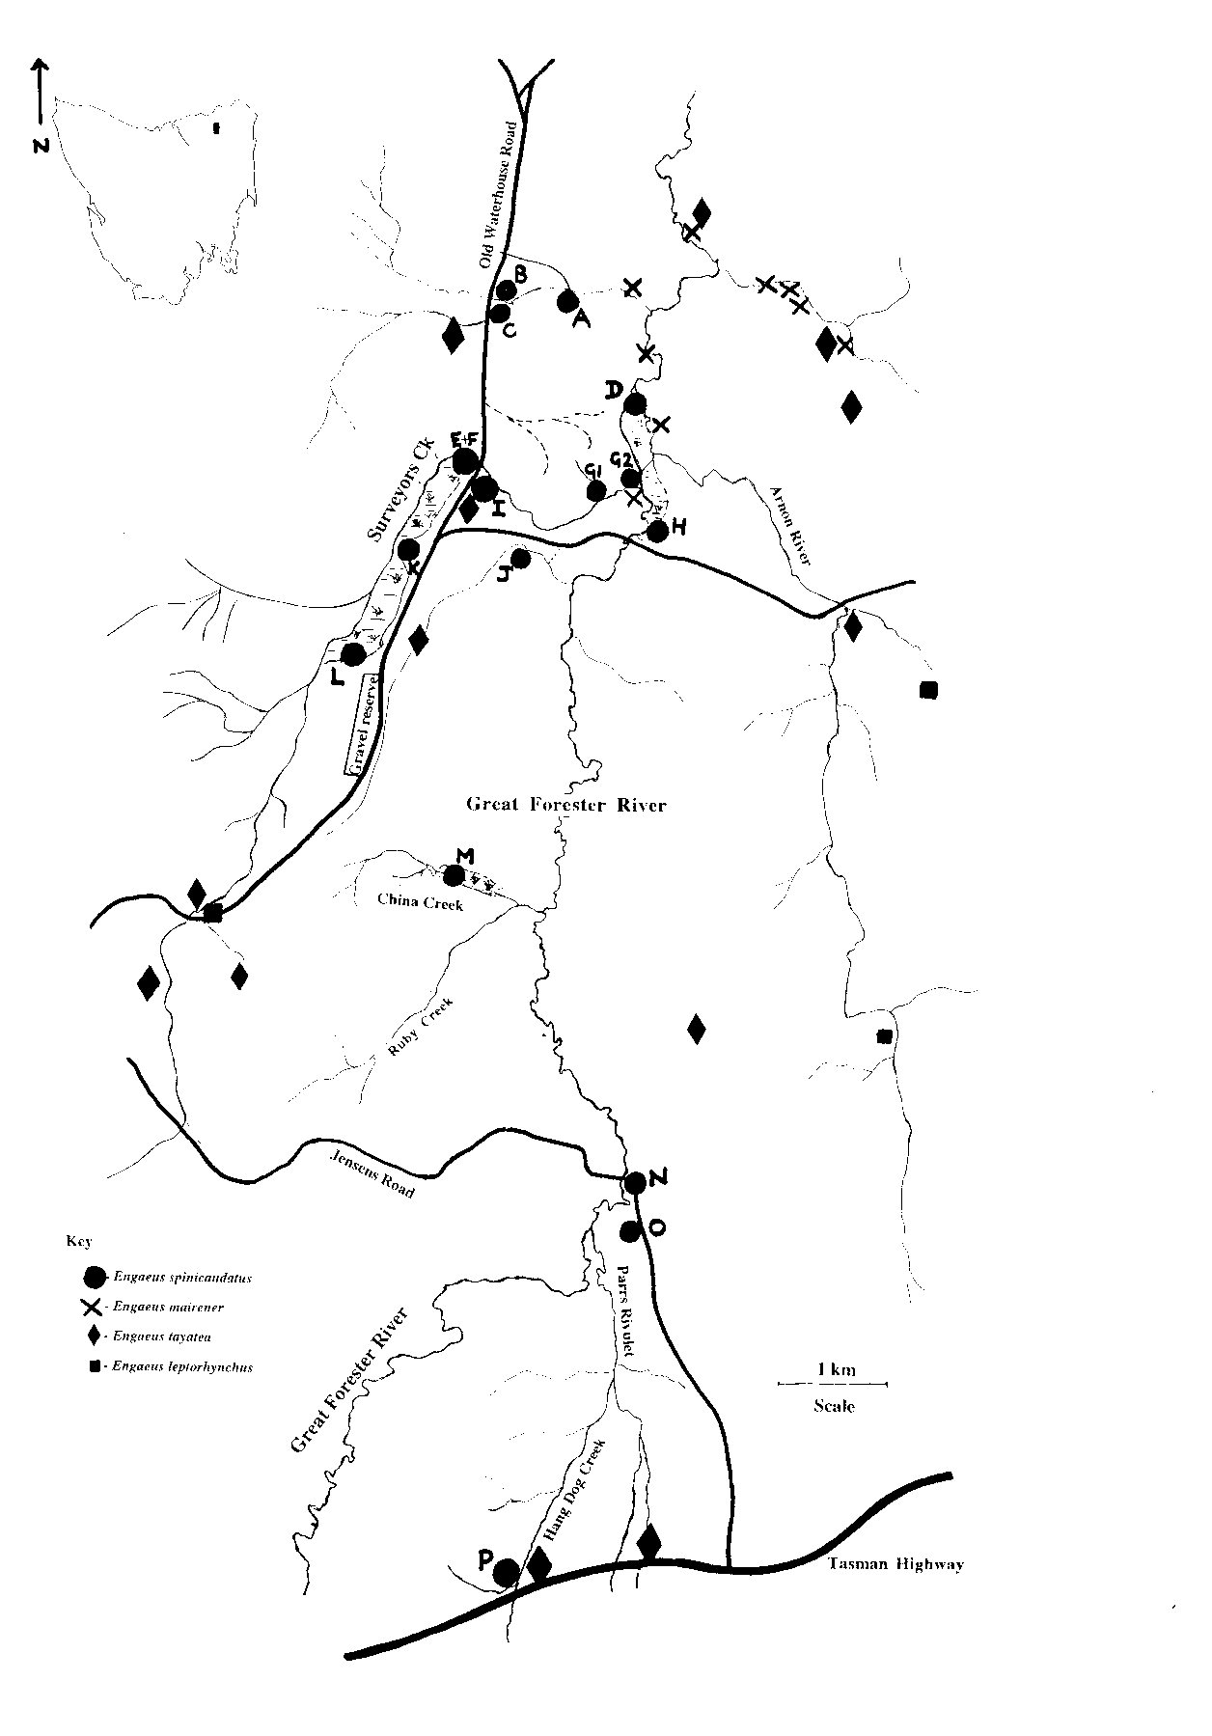

Figure 3.1: The distribution of E. spinicaudatus and surrounding species.
As per Horwitz (1991). Locations of other species are approximate.
Sites A-P are as listed in Table 3.1.
Map prep: KR/ND

Table 3.1: Known E. spinicaudatus sites.

As per Horwitz (1991).

Site | Grid Reference | Location | Habitat | Land Tenure
A | 5512-4534 | Tributary of Forester River | Buttongrass plain | Private
B | 5506-4532 | Just E of Old Waterhouse Rd | Buttongrass plain | Private
C | 5505-4530 | Just E of Old Waterhouse Rd | Buttongrass plain | Private/(Crown)
D | 5518-4523 | Above Forester River | Buttongrass slope | Crown
E | 5504-4516 | Surveyors Ck area | Marshy area | Private
F | 5503-4516 | Surveyors Ck area | Marshy area | Private
G1 | 5516-4514 | Next to tributary of Surveyors Creek | Seepage | River reserve/Crown
G2 | (5519-4517) | N of Surveyors Ck/Forester River JCN | Seepage/tea-tree slope | Crown
H | 5521-4512 | Forester River plains | Tea-tree area | Private
I | 5505-4512 | E of Old Waterhouse Rd | Water race & surrounds | Private
J | 5508-4506 | 400m S of Forester Rd | Buttongrass Plain | State forest
K | 5496-4505 | Surveyors Ck area | Buttongrass | State forest/private
L | 5493-4496 | Surveyors Ck area | Buttongrass | State forest
M | 5503-4477 | Next to China Creek | Buttongrass plain | State forest
N | 5518-4450 | Forester Flats | Seepage next to road | State forest/roadside
O | 5520-4444 | Forester Flats | Next to pool in paddock | Private/State forest
P | 5509-4413 | Next to Hang Dog Creek | Buttongrass plain | State forest

A medium sized male was collected (for field identification) and then released at GR 5519-4525, on a large area of Crown land (section of area 5 west of the river in Figure 3.2, encompassing site D from Table 3.1). The land here is a moist buttongrass seepage where the topography descends towards the Great Forester River, and a high abundance of burrows was evident. The land has previously been leased for grazing, and although a barrier of trees and scrub above the seepage present it with some protection, there was minor evidence of cattle trampling, through both track marks and semi-recent dung.

A farmer with cattle on the upper reaches of this land identified himself as the current leaseholder; curiously, according to the records of the Property Services Division of the Department of Environment and Land Management, the lease for this area expired in 1989 (ref. Property File 8527). Also according to the Property Services Division, none of the other areas of Crown land relevant to this study are currently under lease or licence. Two sections of land have previously been listed under the same temporary licence (PF 12421; GRs 5520-4455 & 5520-4448; Crown sections of area 7, Figure 3.2, but not encompassing any recorded sites), and another may have had a licence granted or applied for (PF 18026; GR 5516-4477 approx.; east of the Great Forester River in area 2, Figure 3.2, no sites) but the file has been destroyed.

A juvenile specimen was collected on a long stretch of marshy buttongrass plain/wetland at GR 5493-4497 (area 1, sites K & L). This land occurs on State forest and is considered prime habitat for the species (Horwitz 1991, Gaffney & Horwitz 1992). Again, a large number of burrows were evident, and the land was in essentially the same state as when the author visited the site with Gaffney in 1992.

At GR 5504-4476 (area 2, site M), there is another large marshy buttongrass plain where the species has previously been caught, and here again burrows were in high numbers. The buttongrass is in a wide, seepy plain at the bottom of a creekline between two hills. Some quarrying activity is underway above this site, approximately 1 km west north-west of the plain.

At GR 5504-4530 (unleased Crown land, west of area 6 and Old Waterhouse Road, no sites), the buttongrass plain subjectively appeared to be of much drier character than previously (despite heavy rain, and it being summer/autumn 1992 versus winter 1996). Horwitz (pers. comm.) has said that this area was always relatively dry, and its current condition may simply represent a part of its natural cycle. While this is not a site at which E. spinicaudatus has previously been found, the species is present immediately east of Old Waterhouse Road (a matter of metres away, sites B & C). As the drier site occurs upstream, the state of this section of land may want to be monitored over the long term, however, and any directly acting processes (drainage, excessive vegetative growth) may want to be addressed (see Section 3.4.2). No E. spinicaudatus were caught at this site, but three specimens of E. mairener (a male, and a female plus juvenile) were collected from two burrows. E. tayatea has previously been caught here (Horwitz 1991).

Several burrows were found in the disturbed soil heaped around the roadside at GR 5518-4450 (just east of the bridge; area 7, site N), and in wet gutters and seepages running down to the road. The species responsible was not collected, but was assumed to be E. spinicaudatus as determined by Horwitz (1991). On limited examination, no burrows were seen on pasture, but it is possible that wetter/more seepage prone stretches of converted land may be found in the area.

3.3 Threatening processes

Several threatening processes have been identified for E. spinicaudatus and its habitat (Horwitz 1991, Gaffney & Horwitz 1992). Drainage of swampland poses a major danger for the species, by lowering the water table, altering physico-chemical parameters of the water, and potentially altering the ability of the animals to utilise peat layers.

Horwitz (1991) noted that E. spinicaudatus occurs in a narrower habitat range than species with which it is sympatric. It is restricted to less than half the habitat available to burrowing crayfish in the area, with all areas in which it is found exhibiting evidence of permanent near-surface soil saturation (within 1m of the surface, and usually less). All other species in the area appear to be capable of burrowing to greater depths, and changes caused by lowering the water table are likely to harm E. spinicaudatus and favour its potential competitors. Drained areas have been found to have significantly lower numbers of E. spinicaudatus than non-drained ones (Horwitz 1991), and, although immediately adjacent to E. spinicaudatus habitat, the drier buttongrass plain examined at the northern extent of its distribution (GR 5504-4530) has only been found to contain E. tayatea and E. mairener (Horwitz 1991 and this study respectively).

While the species can be found on swampland that has been converted to pasture, there is evidence that such drainage and conversion has a significant impact on the species and the faunal assemblages that depend on it (Horwitz 1991). Threats encompassed by conversion to pasture include the introduction of exotic plants, ploughing, fertilisation, grazing by hooved animals, potentially higher water temperatures, and ensuing dangers of eutrophication. Ploughing disturbs the soil to a certain depth, and changes its structure by mixing and sometimes compacting layers (Horwitz 1991). Trampling by cattle is a direct threat to crayfish at times of the year when they are close to or on the surface. This occurs predominantly during the mating period of late spring and early summer (November to December: Horwitz 1991).

The effects of fertilisers (used in the conversion of buttongrass swamps to pasture) and herbicides/pesticides on E. spinicaudatus are largely unknown. However, some decapod crustaceans are known to exhibit high sensitivity to certain pesticides (Horwitz 1991, Davies et al. 1994), and while they are likely to receive a high degree of protection in their burrows, they are at the greatest risk if they are present on or in surface areas or waters (Davies, pers. comm.).

Gravel reserves, tracks and roads within the range of E. spinicaudatus are situated on gravelly and sandy soils prone to sheet, rill and gully erosion resulting in deposition of soils in low lying parts where the swamps occur (Horwitz 1991). These deposits have the potential to smother crayfish burrows, and while E. orramakunna was observed to be tolerant of similar high siltation caused by plantation clearance (Section 2.4.2, this report), the effects on the less extensive burrow systems of E. spinicaudatus (Horwitz 1990a, 1991) are unknown.

No section of the known range of E. spinicaudatus occurs within a sizable gazetted reserve. Two-thirds of the available habitat are found on State forest of mostly E4 and E3 height potential; few loggable trees exist within the relevant habitat itself except along riparian strips, but forestry activity higher in catchments may cause indirect problems through enhanced soil erosion and siltation as discussed above. The major portion of this land is currently classified as 'deferred forest' (Gaffney & Horwitz 1991). As such, those authors note, the long term preservation of these areas is not currently secured.

The remaining third of the available habitat occurs on unallocated Crown land and private property, with sections of the former leased for cattle grazing and a majority of the latter either drained, converted to pasture or regularly grazed as well (Horwitz 1991). While a small portion of unallocated crown land along Surveyors Creek is marked as a river reserve, this conveys no special status to the area beyond that of unallocated Crown land.

Inappropriate fire management also poses a potential threat to the species, and an uncontrolled fire of high intensity or inappropriate burning practices could be devastating to a species of such limited distribution. The peat habitat of E. spinicaudatus could be lost entirely under such conditions, or could smoulder for long periods (Gaffney and Horwitz 1992). Times of particular sensitivity are when the soil is at its driest (December to March/April), and once again when the species is likely to be on or near the surface (Horwitz 1991).

3.4 Management recommendations

3.4.1 Conservation status

Under IUCN Red List criteria (1994), the status of this species should remain 'Vulnerable' (VU). Although the population of E. spinicaudatus may be large (est. 1.36-2.67 by 106 adults: Horwitz 1991), it is characterised by an acute restriction in its area of occupancy (VU criterion D): 3.881 km2 at most, compared to the 100 km2 threshold of the Red List criteria (VU D.2). While recorded from sixteen sites, these are also limited to a restricted stretch of the Great Forester River and its tributaries, representing five locations or less (VU D.2). As such, the taxon is "prone to the effects of human activities (or stochastic events whose impact is increased by human activities)... and is thus capable of becoming Critically Endangered or even Extinct in a very short period" (IUCN 1994).

A direct threat (due to drainage, cattle grazing and other land use practices) has been determined to exist to one third of the available habitat for E. spinicaudatus, and an indirect threat (potential forestry activity, fire) exists to the remainder (Horwitz 1991, Gaffney & Horwitz 1992). If causal factors continue to operate, the species is likely to become Endangered (Horwitz 1991).

3.4.2 Management actions

Establishing reserves and protected areas

As stated by Horwitz (1991) and Gaffney and Horwitz (1992), protecting and/or reserving areas for the species is essential. Both prior management plans recommend two particular sections of land for protection. These areas represent both major habitat types of the species, and cover one seventh (62ha) of its total available habitat. The areas are:
• the riparian reserve along Surveyors Creek - thus securing the flood plain and tea-tree habitat - covering approximately 3.5km of creek and 15m on the northern side of the creek only (marked as '4' on Figure 3.2, running between the shaded areas marked 1 & 5, and discussed below); and
• an area of State forest around the upper portions of Surveyors Creek, consisting of buttongrass plains and a sufficient buffer of land around the potentially available habitat of the species (incorporating the majority of the shaded area '1' in Figure 3.2, and a large section of the surrounding State forest).
It has been suggested that the first area be adequately protected by the exclusion of livestock, while the second could be established as either a Fauna Reserve and/or Wildlife Sanctuary (Gaffney & Horwitz 1992).

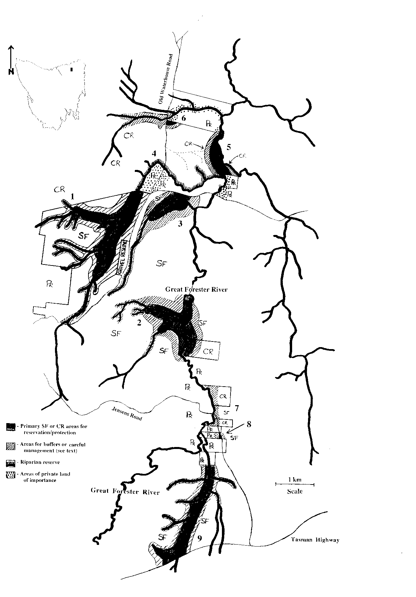

Figure 3.2: Proposed areas for reservation, protection or management.

Place names and locality information as per Figure 3.1. Hatched/buffer areas not necessarily drawn to scale (see Section 3.4.2). SF = State forest, CR = Crown land, PR = private tenure. Numbered areas relate to available habitat as discussed in the text.
Map prep: KR/ND

While not as acute as for E. yabbimunna and E. martigener (Sections 4.4.4 and 5.2.1 respectively), the restricted nature of the distribution of E. spinicaudatus requires that all undisturbed (non-pasture) land on which it is found should be regarded as essential habitat. As such, it is recommended that the above areas be considered as an absolute minimum protection/reservation requirement, and that all State forest areas in which the species is found should be afforded protection status.

This can be achieved in one of two ways. First, the areas in question should at the very least be maintained as Management Decision Classification (MDC) protection zones by Forestry Tasmania, covering the taxon, its habitat, and the catchment areas surrounding and immediately affecting them. Alternatively, the areas (or some of them) could be managed as Forestry Reserves or Nature Reserves by Forestry Tasmania or Parks and Wildlife respectively. It should be noted that MDC protection zones are non-statutory reserves, and do not give long-term, protection such that both Houses of Parliament are required to revoke the status of the area. For this reason, a mixture of MDC protection zones and reserves may be desirable, with the latter covering the most important sections of relevant habitat.

The allocation of MDC protection zones or reserves should be made in close consultation with Forestry Tasmania. As the areas concerned are classified as 'deferred forest' and tend to be buttongrass plains of largely low timber production quality (E4 to E3), this should be acceptable to the forestry industry. State forest areas recommended for protection/ reservation status are:
• The area marked '1' on Figure 3.2, west of Old Waterhouse Road, and encompassing sites K (on border) & L from Table 3.1. Important and potentially available habitat has been identified (Horwitz 1991, Gaffney and Horwitz 1992) as the buttongrass plain extending alongside the main north north-east channel of Surveyors Creek, and surrounding a tributary flowing into it from the west.
• The area marked '2' on Figure 3.2, covering areas around China and Ruby Creeks and sections of both banks of the Great Forester River. This area encompasses site M from Table 3.1, which is in the long buttongrass plain next to China Creek, and includes similar marshy and wet areas on the surrounding land (this includes an area of Crown land, which will be discussed in the following section).
• The area marked '3' on Figure 3.2, around a tributary of the Great Forester River, and encompassing site J from Table 3.1. The important land is another buttongrass plain and immediately surrounding land.
• The area marked '9' on Figure 3.2, along the banks of Hang Dog Creek/Parrs Rivulet, and encompassing site P (Table 3.1). The important land includes all buttongrass and suitable wet areas along this strip of State forest, as well as land immediately surrounding and between them.

These areas have been shaded on Figure 3.2 to indicate the important habitat and immediately adjacent areas (such as inlets) that should be protected or reserved. Suitable buffer zones also need to be incorporated to protect these areas from any potentially disruptive activity, and while these are indicated by the hatched areas on Figure 3.2, they are not necessarily drawn to scale. Required buffers need to be of adequate size and should be tailored to suit each area; given the limited amount of potential habitat available to the species, buffer sizes should err on the side of caution.

Logging is a potential activity on some sections of E3 growth on the hillside above area 1 (with access via the private block). While the effects of siltation on the shallower burrow systems of E. spinicaudatus are unknown, logging on slopes has been shown to significantly increase the infiltration of fine sediment into beds downstream (Davies & Nelson 1993). In an investigation of the effectiveness of buffer zones, the same authors have determined that the impacts of logging are dependent on buffer widths, and that small buffers (less than or equal to 10m) do not significantly protect a stream from impact (Davies & Nelson 1994).

Buffers would therefore need to be retained around not only the shaded part of area 1, but also all of the streams - including those of class 4 - that feed into it. Davies and Nelson (1994) state that buffer zones of 30 to 100m appear to provide adequate protection from short-term logging impacts, and note that this confirms earlier findings by other researchers under distinctly different stream, forest, and geomorphological conditions. While these figures were determined on data from stream dwelling macroinvertebrates, which are more likely to be directly susceptible to such impacts than burrow dwelling crayfish, Davies and Nelson (1994) note that several other factors may contribute to increased buffer width requirements under certain circumstances.

For these reasons, it is suggested that minimum buffer requirements directly around the shaded (not just the stream) section of area 1 should be set at 40-50m to match the protection criteria of class 1 streams. For the actual class 4 and larger streams feeding into this area, but not directly bordering the shaded region, buffers should be maintained at 30-40m.

Similar buffer requirements should be imposed on each of areas 2, 3 and 9 if they are to be subject to any potentially disruptive activity on the surrounding land. Again, exact buffer widths should be tailored to the exact situation, including drainage characteristics of concern, or topographic features of convenience.

Attention should be paid to the quarrying activity north-west of area 2, and larger buffers may be warranted on the relatively steeper hillsides leading down to it. Stream-side buffers of the size described above are probably not required along the entire upper length of Ruby Creek, but should extend for a distance comparable to those at area 1 before reverting to standard widths as per the Forest Practices Code.

Both the tributaries of China Creek and the stream flowing through area 3 should retain large buffers, as they originate near the gravel pits/quarry sites north-west of area 2. Both follow dirt roads which can also significantly enhance siltation (Horwitz 1991, Davies and Nelson 1993). China Creek flows into a reasonably sized pool of standing water before entering the buttongrass plain; this pool should be retained as it may aid in the settling silt and other material prior to the important area of habitat. Drainage activities to or from this pool should also be closely monitored.

Given the potential sensitivity of the areas, and the restricted amount of habitat available to E. spinicaudatus, any activity in all of these sections of State forest should be conducted with care. Compliance with buffer zone requirements is essential, and, as advised by Davies and Nelson (1994), care must be taken to preserve buffer zone integrity as well as extent and width.

Close monitoring of any effects due to logging or other activities should be conducted while they are in operation, and augmented with prior and follow-up studies. Monitoring during such activities may serve as an alert to inadequacies in the proposed protection system, such as insufficient buffer widths or means by which their effectiveness is bypassed (e.g. inappropriate enhancement of slope drainage allowing surface water to drain through the buffer unimpeded: Davies & Nelson 1994)). If problems arise that cannot be corrected, the relevant activity must stop, and beyond any remedial actions of merit, the State forest must be left undisturbed. Equally, difficulties encountered at one site may help in the planning or cancelling of activities around other sites, while a lack of difficulties may allow revision of the system proposed.

Other areas of State forest requiring attention

Two other sections of State forest require special consideration should they be subject to potentially disruptive activities in the future. These are the areas marked as '7' and '8' on Figure 3.2, representing sites N and O from Table 3.1 respectively.

Area 7 is already relatively disturbed, but Horwitz (1991) found the species in a seepage next to the road, and this study observed burrows in the gutters, seeps, and heaped soil east of the bridge. As the species would appear to be surviving in these conditions (as do other Engaeus species: see Section 2), no special action is recommended for this area. Care should be taken, however, with any drainage, construction, or roadwork activity conducted here, and similar general guidelines should be applied to the blocks of Crown land immediately north and south (see next Section).

Area 8 is another relatively disturbed site, occurring in a paddock that has presumably been converted from a more suitable habitat type. The site falls on the border between private land and State forest, most likely on the side of the former. It is suggested that any suitable seepage or wet areas on this block of State forest (west of Jensens Road) be maintained in their current state, and that any activities on the surrounding State forest be conducted with a view to minimising any further disruption (logging, drainage, excavation or otherwise) as much as possible. Similar conditions are suggested for the private land (see following Sections).

Protection on Crown land

Areas of unallocated Crown land within the distributional range of the species have the potential to be leased to graziers. According to the Department of the Environment and Land Management (Property Services Division), none of the areas where E. spinicaudatus has been recorded are currently under lease or licence. While it is possible that errors and oversights in the system may mean that some areas are under current lease, advice from the Property Services Division is that recommendations can still be made that impose conditions on these leases.

All unleased Crown land where the species occurs (as below) should either be declared reservation areas for the protection of crayfish and their habitat, or at the very least have the following guidelines attached to the terms of any leases that are granted in the future. It should be ensured that the same guidelines are imposed under the conditions and terms of any leases for relevant land that are found to be current. Guidelines should cover each of the threatening practices covered in Section 3.3, in particular excluding cattle grazing from areas of permanently saturated soils and/or peat soils, with these areas fenced off from stock (Horwitz 1991). Hazard reduction burning should not be undertaken during the sensitive times of year (as per next Section), and drainage of these areas should not be permitted.

Areas of Crown land requiring attention are as follows.
• The 3.5km long, 15m wide riparian reserve along the northern bank of Surveyors Creek, as identified by Horwitz (1991) and Gaffney & Horwitz (1992). This area is marked '4' on Figure 3.2, and runs between the shaded parts of areas 1 & 5, encompasses sites G1 and G2 (Table 3.1), and covers the flood plain and tea-tree habitat described previously. This area should be reserved with adequate provision for the exclusion of livestock, and maintained with minimised disturbance according to the guidelines listed above and in the following section.
• Two sections of Crown land marked '5' on Figure 3.2, one on the western bank of the Great Forester River, and the second on the eastern bank immediately south of its junction with the Arnon River. The former section encompasses the buttongrass slope of site D (Table 3.1), and occurs on the land one farmer claimed to have under lease (Section 3.2). The true lease status of this land needs to be determined, and the buttongrass slope and surrounding wet areas (shaded) should be protected. A similar wide buffer zone (hatched) should also be retained as proposed for the main State forest areas discussed above. The protection zone and buffer should extend to cover similar wet areas on the Crown land of the opposite bank.
• Crown land west of the private property marked '6' in Figure 3.2 (see following section). While E. spinicaudatus has not been found in the drier buttongrass west of Old Waterhouse Road, this area is immediately upstream of sites A-C on the private land, and any disruption here is likely to immediately effect those sites. For this reason, it is suggested that the section of Crown Land be treated as an elongated buffer zone centred on the water course, and covering the extent of the plain. This will also serve as protection should the species be found on that section of Crown land, thus far undetected. East of the road, protection and a suitable buffer should also be given to the section of Crown land south of the water course and immediately adjacent to sites B & C.
• The section of Crown land included in the area marked '2' in Figure 3.2. This section should be subject to the same protection and buffer requirements as per the State forest with which it is grouped (see previous Section). Similarly, the small section of tributary extending north-west onto Crown Land from area 1 should retain a suitable buffer as it is so close to a protected area within that zone. Finally, while no specific action is recommended for the Crown land north and south of area 7, care should be taken with any potentially threatening activity conducted here, as the species has been found in seeps and disturbed land in the area.

Guidelines for protection on private land

Horwitz (1991) identifies threatening processes as drainage, burning off, ploughing, fertilising, spraying of herbicides and insecticides, and cattle grazing. Private landholders need to be encouraged to undertake land use practices that limit potential impact on the species. Approaches to this issue can be made in the form of both general voluntary guidelines (Horwitz 1991) and individual management agreements established with each individual land owner and for each particular habitat (Gaffney & Horwitz 1992).

Under Part 3, Division 7 of the Threatened Species Protection Act 1995 (Tas.), the Director of National Parks and Wildlife can "...after consultation with an affected landholder, make a land management plan for the purpose of protecting a listed taxon of flora or fauna." Land management plans define the areas of concern, the objectives of management, and the actions required by the parties involved. Provision is also made for agreements regarding the carrying out of works required by the plan, and compensation for financial losses that arise from it.

Guidelines have been suggested by Horwitz (1991), and apply only to those areas within the distributional range and habitat types of E. spinicaudatus. In many places the guidelines represent responsible practices in any case, and should be of relatively little inconvenience and cost to concerned landholders. The guidelines are:

• drainage should leave relevant areas of permanent saturation (those that would be almost impossible to drain anyway) in a relatively unaltered state [drainage from other areas could potentially be directed to such areas as this];
• hazard reduction burning, ploughing, stock grazing, and the application of fertiliser, herbicides and pesticides should all be avoided on swampy and other relevant areas during November and December, when crayfish are mating or near the surface;
• hazard reduction burning should also avoid the period from December to March/April (depending on the amount of rain) when water tables are at their lowest and peats are most vulnerable to fire;
• ploughing should avoid permanently saturated areas where crayfish occur and drainage has been ineffective, and if possible should be no deeper than 25-30 cm (approximately half the typical main burrow depth of the species: Horwitz 1990a) to avoid crushing or desiccation due to dislocation; and
• the application of herbicides, pesticides and other chemicals should be avoided in areas where the species is present.

Areas of private land requiring management attention are as follows.
• Area 4 (Figure 3.2), on the southern bank of Surveyors Creek, both east and west of Old Waterhouse Road. These properties encompass sites E, F, I & K (Table 3.1), in marshy and buttongrass habitats.
• South of area 5 (Figure 3.2), on the eastern side of the Great Forester River, encompassing site H (Table 3.1) and more tea-tree habitat and floodplain areas.
• Area 6 (Figure 3.2), on the water course between Old Waterhouse Road and the Great Forester River, encompassing sites A - C (Table 3.1) all on buttongrass plains. The south-east corner of this property may also include part of the buttongrass plain of area 5 (Crown land).
• Area 8 (Figure 3.2), in a paddock bordering State forest immediately west of Jensens Road, and encompassing site O (Table 3.1).

Monitoring and further actions

Periodic monitoring should be conducted on the status of the species and its habitat, to determine whether implemented actions are adequate or whether more stringent management steps are necessary. The two management plans for E. spinicaudatus (Horwitz 1991, Gaffney & Horwitz 1992) suggest that half-yearly to yearly monitoring intervals may be appropriate. These would seem suitable for rapid field-assessment to maintain liaison with private owners and to ensure that drainage characteristics do not change, that cattle remain excluded from sensitive areas, and that disturbance from a distance has not occurred or is not likely to occur.

Monitoring should also include further observations on the drier site to the north of E. spinicaudatus' distribution. While the site has always been relatively dry in character (Horwitz, pers. comm.), it should be determined whether any appreciable change is occurring within this habitat, and, if so, whether it is due to natural or artificial causes. The significance of any change does not lie with this site itself, but with the known E. spinicaudatus sites immediately downstream and with the potential for similar changes in other patches of E. spinicaudatus habitat.

If observations reveal any implications of a change in habitat character, careful consideration should be given to controlled, low intensity burns of sections of marsh at non-sensitive or dangerous times of year. Such action may be useful in the maintenance of suitable habitat, and may provide a preferable alternative to a slow loss of any habitat through the succession of buttongrass to heath/tea-tree, and the risk of uncontrolled burns running through that drier vegetation.

4.0 Engaeus yabbimunna, the Burnie burrowing crayfish

4.1 Introduction

Engaeus yabbimunna, the Burnie burrowing crayfish, was first identified in 1992 (Horwitz 1994). Research conducted within the area at that time indicated that the species was probably restricted to three creeks in urban Burnie. Due to its apparently limited distribution and low numbers in the presence of threatening factors, it was recommended that E. yabbimunna be considered a threatened species and that steps be taken to protect it from further decline. The species is currently listed as 'Vulnerable' under Schedule 4 of the Tasmanian Threatened Species Protection Act (1995).

This study was conducted to confirm the continued presence of E. yabbimunna in Burnie, to map its current distribution, and to provide management recommendations for the species.

4.2 Methods

4.2.1 The study area

Burnie is located on the north-west coast of Tasmania, approximately 200km from Launceston. The city covers approximately 25 km2, from sea level to 140m. An area of 30 km2 surrounding Burnie was investigated, with most creeks and public waterbodies within that area being surveyed (Figure 4.1). The study area covered suburban and rural sites, with a large portion of these situated along creekbeds flowing through suburban housing estates.

A total of eight catchments were included within the study area, from which approximately 80% of the native riparian vegetation has been cleared. Few sites within urban Burnie still contain remnant native vegetation, most of which appears to be restricted to public reserves. The riparian vegetation of some creeks has been replaced with exotics including willows and blackberries, which have spread unchecked and grow along most creek and river systems throughout the north-west of the state. At other sites, no vegetation cover remains over the creeks at all. Many of these locations are at the headwaters of the catchments, where creeks flow through paddocks and stock access is permitted, causing bank erosion and siltation.

The higher altitude regions of Burnie are of Tertiary basalt origin with a landslide zone running along the north where altitudes drop to sea level. The geological origin of the Burnie foreshore is sand and gravel beneath Tertiary basalt as well as quartzite, slate, and older sand, gravel and clay on coastal platforms. The greater proportion of Romaine Creek flows across Tertiary basalt regions before its lower reaches move through landslide material and coastal platforms containing older sand, gravel and clay. Cooee Creek also flows through Tertiary basalt plains, but these are interspersed with areas of quartzite and slate. Cam River to the west of Burnie and Emu River to the east flow through quartzite and slate material for approximately 20 km of their lower catchments, and some of this region is included in the study.

4.2.2 Methods

Field work was conducted over three weeks in July 1996. The study area covered the creeks and surrounding catchments from which the species was known, to determine whether the distribution of the species extended beyond that previously identified. Investigations outside the study area were at roadside access points on the lower catchments of Ellis Creek and Penguin Creek.

Access to sites and land tenure were determined using maps and information provided by the Burnie City Council. Where access was required to private land, permission was sought from the owners.

An intensive search was conducted of each site, including the type location at Burnie Park. Data were recorded as follows:
• grid reference (GR);
• whether crayfish burrows were present or absent;
• habitat description;
• vegetation present;
• altitude (m);
• bank and stream slope (°); and
• soil type.

Burrows were excavated where found, and specimens collected for identification and release. Specimens were identified in the field if possible, or transported back to Hobart for identification in the laboratory. One specimen, later determined as E. disjuncticus, was preserved and sent to Dr Pierre Horwitz at the Edith Cowan University, W. A., for specialist advice.

4.3 Results

4.3.1 Distribution of E. yabbimunna

Forty stream-side sites were surveyed, with ten identified as containing subpopulations of the species (Table 4.1, Figures 4.1 & 4.2). These included the three sites previously reported by Horwitz (1994). All ten sites were in three creek systems (Shorewell, Romaine and Cooee creeks) within the urban regions of Burnie.

The majority of specimens were collected from areas of remnant vegetation within seepages or tributaries. However, two specimens were collected from previously cleared sites where willows (Salix spp.) and other introduced vegetation provided the only cover. At all other sites where E. yabbimunna was located the vegetation included a combination of: paperbarks (Melaleuca ericifolia), tree ferns (Dicksonia antarctica), blackwood (Acacia melanoxylon), cutting grass (Gahnia grandis), and a variety of introduced species including blackberries (Rubus fruticosa) and pasture grasses.

At four locations, riparian vegetation was dominated by tree ferns with a ground cover of ferns and shrubs, while at a further two locations remnant stands of tea-trees provided the canopy cover. E. yabbimunna was found in small numbers at other sites with no overstorey, or a mixture of willows and remnant tree ferns exist. All E. yabbimunna specimens were recorded at sites containing Tertiary basalts, with the exception of the Burnie Park site which consisted of quartzite, slate, sand and gravel mostly under Tertiary basalt.

The total population currently exists within an expanding urban setting and is extremely vulnerable to changes in its immediate environment. Stands of remnant riparian vegetation are declining in number and the creeks and seepages are still used as refuse sites or have been channelled using a mixture of cement and rocks.

4.3.2 Major locations of E. yabbimunna

Of the ten sites at which E. yabbimunna was found, six contain the largest subpopulations of the species, and two of these appear to represent a major portion of the total E. yabbimunna population: upstream of Romaine reservoir, and within Burnie Park. The sites are listed in order of decreasing importance to the species, and the three most important ones are described below:
• Romaine Creek reserve, upstream of the reserve, downstream of Mount Road (GRs 5080-4513 to 5077-4510);
• Shorewell Creek, Burnie Park, western bank (GRs 5068-4550 to 5068-4551);
• Shorewell Creek, Eastwood Reserve, upstream of the tennis courts (GR 5067-4544);
• Cooee Creek, North-western TAFE agricultural farm site (GR 5056-4523);
• Romaine Creek, downstream of Mount Road (GR 5070-4511); and
• Cooee Creek, West Mooreville Road crossing, eastern branch (GR 5054-4539).

Romaine Creek reserve

This subpopulation of E. yabbimunna is spread almost continuously along Romaine Creek from downstream Mount Road to its convergence with Alexander Creek. However, densities of the species vary greatly. The highest density of the subpopulation was recorded at GR 5080-4513 where the species is found occupying burrows throughout a moist floodplain. Tree ferns are the dominant cover, and in areas the canopy cover is dense (about 65%). Ground water is near the surface level with many pools forming throughout the uneven ground. The gradient is negligible and soils are dark brown and highly organic. Soil types vary along the creek with those further up and downstream being orangey-red clay loams. Crayfish were also observed at these sites although in lower numbers. This area is to the west of the pathway with burrows easily viewed from the path. The most important habitat is considered to be east of the creek and west of the path, between the north-south GRs: 5082-4515 and 5078-4512.

Burnie Park

E. yabbimunna appears to be mainly restricted to the western bank of Shorewell Creek where its densities are greatest within seepage zones and along tributaries entering the creek. Tree ferns dominate the seepage areas, although acacias and tea trees provide the upper canopy. Slopes were far greater at this location and range between 30° and 50°. Soil types were high in organic material at the surface, with clays below and rocks beneath. Altitudes range from 20 to 40m above sea level. The most important habitat identified is confined to the GRs 50675-45495 to 50690-45515 and encompasses the western bank below Oldaker Falls to the open grass reserve above the carpark. Although some burrows were observed on the eastern bank they were fewer in number and the habitat has already been drastically altered.

Eastwood Reserve

The crayfish habitat at Eastwood Reserve is very restricted, being confined to a small remnant stand of Melaleuca ericifolia around a seepage flowing into Shorewell Creek. This area is approximately 50 by 20m in total size. The seepage starts at the edge of the remnant vegetation, with its source unknown. Within this site the species is prevalent with many chimneys visible from the pathway crossing the seepage. Soils are highly organic brown loams. The gradient of the site is shallow, its altitude is 70m and its GR is 5067-4544.

4.3.3 Other Engaeus species

As the object of this project was to determine the distribution of E. yabbimunna, digging ceased at locations once the species was found. It is therefore possible that other Engaeus species were present but not identified at these sites.

No crayfish burrows were detected at the sites outside suburban Burnie, with the exception of three tributaries of Emu River and a tributary of Cam River. These burrows were found to represent other species of Engaeus; both E. fossor and E. disjuncticus in the Emu River tributaries, and E. fossor from the Cam River tributary. E. fossor was recorded from a total of five sites and E. disjuncticus was found at two. The distribution of all burrowing crayfish species identified in the study area is displayed in Figure 4.1, and grid references are given in Table 4.1. These distributions agree with those reported by Horwitz (1994), and Richardson et al. (1990).

A further eighteen sites showed no evidence of the presence of crayfish burrows. These sites ranged in levels of disturbance (rural to forested) and altitude (sea level to 140m), and included eight catchments (Table 4.3/Figure 4.1).

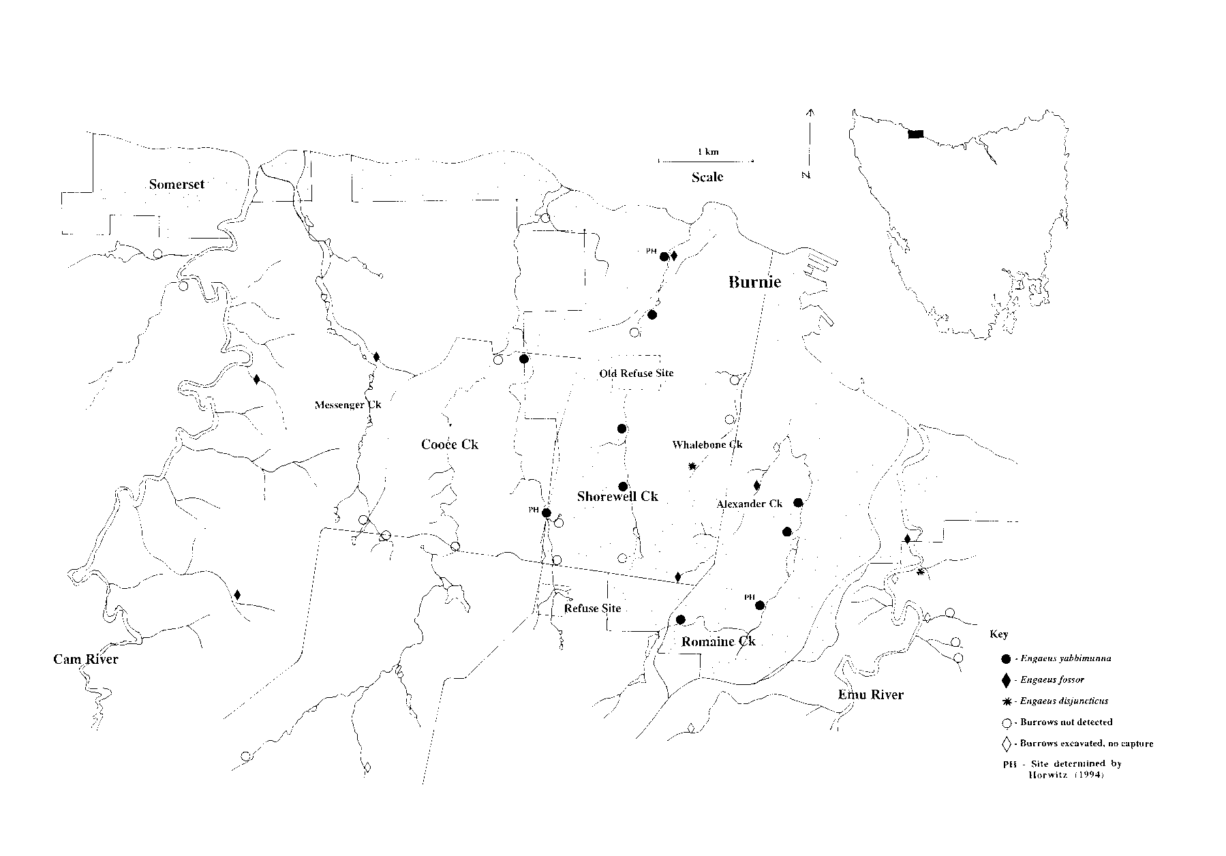

Figure 4.1: Distribution of E. yabbimunna within the study area.

Distribution of E. yabbimunna and other Engaeus species within Burnie, including land use notes. The three original sites as determined by Horwitz (1994) are marked.
Map prep: KR

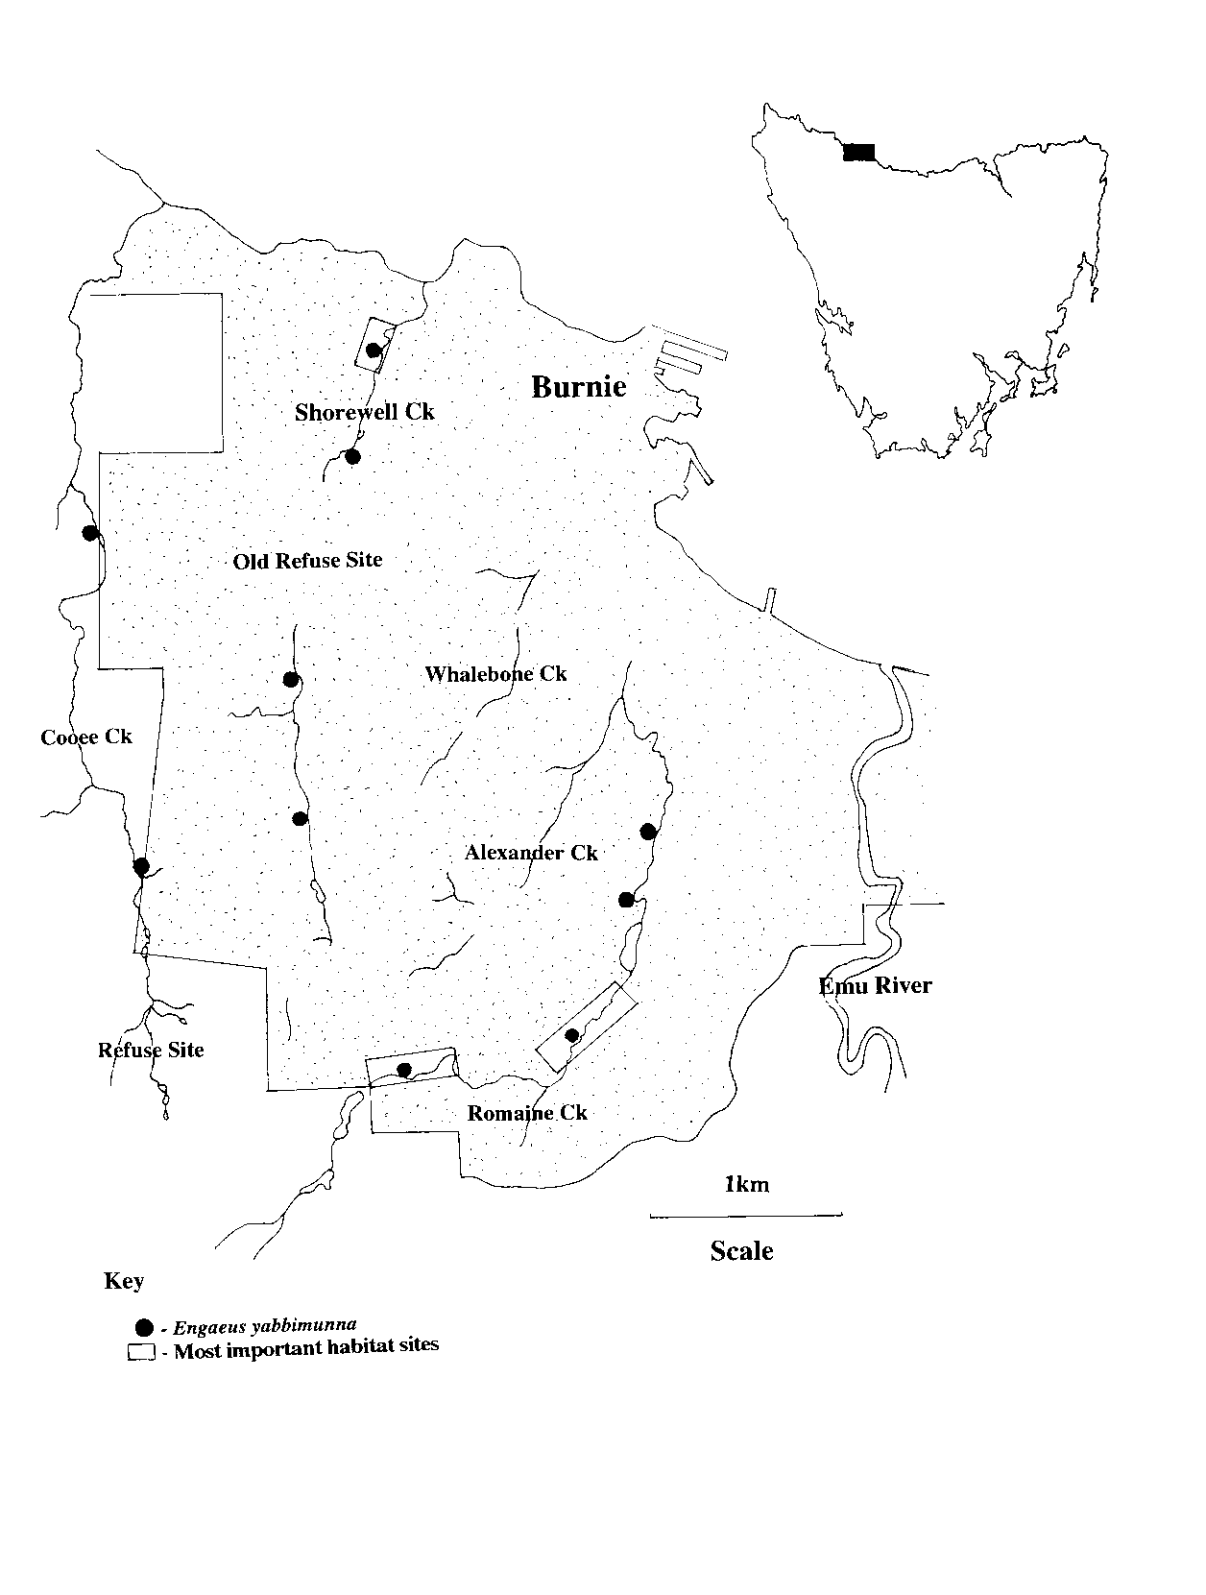
Figure 4.2: Most important habitat within the study area.
Map prep: KR

Table 4.1: Engaeus species collected (and released) within
the Burnie area.

SPECIES | No. | LOCATION | GRID. REF.
E. yabbimunna | 3 | Cooee Creek | 5056-4523
E. yabbimunna | 1 | Cooee Creek | 5054-4539
E. yabbimunna | 2 | Shorewell Creek | 5068-4551
E. yabbimunna | 1 | Shorewell Creek | 5064-4533
E. yabbimunna | 1 | Shorewell Creek | 5067-4544
E. yabbimunna | 1 | Shorewell Creek | 5065-4525
E. yabbimunna | 3 | Romaine Creek | 5070-4511
E. yabbimunna | 2 | Romaine Creek | 5080-4513
E. yabbimunna | 1 | Romaine Creek | 5083-4521
E. yabbimunna | 1 | Romaine Creek | 5084-4524
E. fossor | 3 | Emu River (trib) | 5094-4518
E. fossor | 2 | Messenger Creek | 5037-4538
E. fossor | 1 | Cam River (trib) | 5024-4536
E. fossor | 1 | Alexander Creek | 5071-4516
E. fossor | 1 | Alexander Creek | 5077-4524
E. disjuncticus | 2 | Emu River (trib) | 5096-4516
E. disjuncticus | 1 | Whalebone Creek | 5073-4527

Table 4.2: Burnie sites where crayfish were present but no
specimens were collected.

LOCALITY | GRID. REF.
Poimena Road/Mooreville Road | 5042-4490
Cascade Creek, Cascade Road | 5069-4489
Fern Glade Picnic Area | 5093-4515
Emu River (trib), Fern Glade | 5096-4511
Alexander Creek | 5082-4529

Table 4.3: Burnie sites where no evidence of crayfish was found.

LOCALITY | GRID. REF.
Distillery Creek | 5013-4549
Maldon Creek | 5016-4547
Cooee Creek, West Mooreville Road | 5050-4539
Messenger Creek, West Mooreville Road | 5036-4522
Messenger Creek, Three Mile Line Road | 5037-4520
Messenger Creek | 5032-4553
Cooee Creek, Three Mile Line Road | 5046-4518
Cooee Creek, Poimena Road | 5042-4490
Cooee Creek, Mooreville Road | 5057-4522
Cooee Creek, Three Mile Line Road | 5057-4516
Emu River (trib), Fern Glade Road | 5099-4508
Emu River (trib), Fern Glade Road | 5098-4506
Emu River (trib), Fern Glade Road | 5098-4512
Cooee Creek, Bass Highway | 5057-4557
Shorewell Creek | 5065-4543
Shorewell Creek, Three Mile Line Road | 5064-4517
Whalebone Creek | 5075-4532
Whalebone Creek | 5076-4535

4.4 Discussion

4.4.1 General distribution

Engaeus yabbimunna is most likely restricted to the catchments of Shorewell, Romaine and Cooee creeks. The occurrence of species with restricted distributions is not uncommon within this genus (Horwitz, 1994), and, although highly unlikely, this species may exist in isolated pockets elsewhere. The two other Engaeus species found in surrounding catchments are both relatively common, with populations spread over a large geographic range within north-western Tasmania.

E. yabbimunna inhabits moist remnant riparian zones of Shorewell, Cooee and Romaine creeks. It was previously thought that the species may be confined to remnant native vegetation (Horwitz 1994). While the species is found in its highest numbers at such sites, however, specimens were collected from two sites where no remnant vegetation cover existed. At these sites willows and blackberries were dominant, although a few ferns remained; one site has been recently cleared. Burrows in these areas were present in small numbers and it is probable that they are all that remains of the species in the upper reaches of Shorewell Creek.

The current distribution of E. yabbimunna may be a product of loss of habitat (as discussed below) overlayed on an initially localised pattern of distribution according to differing substrates within the study area. The geology of upper Burnie has a uniform substrate of Tertiary basalt origin, while the Burnie shoreline is of different origin. Cam and Emu rivers flow through a more coarse substrate originating as quartzite and slate material.

Burnie Park was the only site of differing geological substrate found to contain E. yabbimunna. At other locations where the species was present, the soils were organically rich and contained high clay content with Tertiary basalt underneath. This appeared to limit the distribution of the species at Burnie Park, with E. yabbimunna found only in areas of remnant vegetation where leaf litter has provided rich organic soils overlaying the rocky substrate. Dicksonia antarctica and tea-trees provided the main source of the organic material here, and are likely to be food sources for the species.

Within the Cam River and Emu River basins the substrate is far coarser with very granular and rocky soils. The soil structure is poor, possessing little organic matter or the adhesive properties that would provide stability or support for burrows. Shallow burrowing behaviour was observed in a Type 1(b) (Horwitz & Richardson, 1986) burrow of E. fossor collected in a tributary of the Cam River, where the main burrow support was provided by twigs, leaves and branch material. On Cascade Creek, a tributary of Emu River, an unidentified species produced a shallow burrow using the root systems of adjacent vegetation for burrow support.

Habitat selection is an important factor for the current and future distribution of E. yabbimunna. Suter and Richardson (1977), in a study of the habitat requirements of two species of the genus Engaeus, indicated that E. cisternarius showed no tendency to colonise the bordering habitat of E. fossor. In Burnie, it appears that neither E. yabbimunna nor E. fossor are showing any tendency to colonise areas which have previously been cleared of native vegetation along Shorewell Creek. It is unlikely that the small subpopulations of E. yabbimunna detected on upper Shorewell Creek represent expansion of the population limits, and more likely that they are either remnant subpopulations or that locals have captured the individuals elsewhere and released them at these sites. The entire length of Shorewell Creek was surveyed and only these two sites were found to contain crayfish upstream of the old refuse site.

The fact that E. yabbimunna and E. fossor live sympatrically within Burnie Park suggests that the species have different niche requirements. Distinct parapatric boundaries tend to be more common than sympatry with this genus (see discussion in Section 2.4.1 of this report), and sympatric occurrences are usually marked by clear microhabitat separation (Horwitz, in press). Horwitz (1994), however, was unable to determine any such parameters in this instance. This study did not determine the presence of E. fossor at Burnie Park. However, at sites where it was collected the species showed a tendency to occur in areas where some form of environmental disturbance had recently occurred.

At sites where E. fossor was present, the soil structure contained mainly coarse quartzites and shales and the burrows were shallower and less extensive than those of E. yabbimunna. While the habitat of E. yabbimunna was seepages or creeks under remnant vegetation cover, E. fossor was found in roadside culverts, landscaped paddocks and road-work sites. No excavations were conducted on the burrows directly connected to Shorewell Creek within Burnie, but from observations made during this study it is likely that these burrows were occupied by E. fossor rather than by E. yabbimunna.

It is highly unlikely that the distribution of E. yabbimunna will expand beyond the range determined by this study. The species has the majority of its numbers in two subpopulations, with both of these sites at present under the control of the Burnie City Council, and enjoy habitat protection within the park systems of Burnie. Of concern, however, are the sites on Cooee Creek. A real threat to the subpopulation exists at these sites through reduced water quality and further habitat removal.

4.4.2 Environmental pressures

Habitat removal, decreased water quality and disturbance have been identified as the factors posing the greatest threat to survival of the species. E. yabbimunna was deemed to be absent from the western, or main, branch of Cooee Creek, and was only found in small numbers at two sites on the eastern branch. Of concern to the Cooee Creek subpopulations is the active Burnie Municipality refuse site which is located upstream of the crayfish sites in the upper catchment of the eastern branch of Cooee Creek. The refuse site has been used for approximately nine years (Bill Walker, pers. comm.), and its effect on the species numbers downstream is unknown. Subpopulations of E. yabbimunna downstream of the refuse site may be in danger of further reduction or extinction due to small population sizes, increasing their susceptibility to changes in water quality and habitat destruction.

Absence of E. yabbimunna from directly downstream of the disused refuse site on Shorewell Creek suggests that the same may occur on Cooee Creek. The site at the TAFE farm on Cooee Creek is of particular concern as these crayfish burrow directly into the creek bank in an area where seepages do not occur. Further downstream, the second subpopulation is found within a seepage area, albeit runoff from a dam built across the creek.

Horwitz (1994) indicated that E. yabbimunna displays considerable morphological variation and suggested that this may be due to geographical location. Specimens from each of the three creek lines tend to differ from one another in varying characters, with those from Burnie Park (superficially) the most different. Breeding and dispersal between subpopulations is likely to be very limited in most cases, resulting in increased chances of inbreeding depression, and low probabilities of recolonisation if subpopulations were to become extinct.

Absence of E. yabbimunna from adjacent banks of Shorewell Creek directly downstream of the disused refuse site may be due to decreased water quality or reduced food availability. Studies on the diet of two other species of Engaeus have determined an intake of plant and animal material, with the latter supplementing the former (Suter & Richardson 1977). Gut contents were used to indicate the foraging habit of the two species: E. fossor was indicated to feed in streams under rotting logs or in the root systems of buttongrass clumps, whereas E. cisternarius, which has a more terrestrial habitat, fed beneath fallen logs or in root systems above the creeks.

It is likely that E. yabbimunna forages under structures such as fallen logs, eating the phloem and xylem of rotting vegetation, Dicksonia sporangia and other vegetable material. As its burrows always reach the water table or are directly connected to the creeks, feeding in the water seems probable; at sites where the burrows are adjacent to creeks it is probable the species supplements its diet with aquatic invertebrates. The removal of the majority of vegetation from the Burnie creeks is likely to have reduced the food sources available to the species.

Removal of habitat augmented by changes in water quality is the most probable explanation for the absence of the species immediately downstream of the Shorewell Creek disused refuse site. Water quality directly influences aquatic invertebrate distribution, with declining species abundance occurring where water quality is poor. Downstream of the disused refuse site on Shorewell Creek the water is orange, acidic and odorous and shows no evidence of aquatic macroinvertebrate activity. Similar observations can be expected to occur downstream of the Cooee Creek refuse site over time. While the effects of decline in the water quality on the food sources of E. yabbimunna is not known, they must be viewed as potentially threatening.

4.4.3 Other pressures

As described by students from the Acton Primary School (located close to Shorewell and Whalebone creeks) excavation of crayfish burrows by local children is a common practice, particularly on weekends or during school holiday periods. As E. yabbimunna is absent directly downstream of the disused refuse site on Shorewell Creek, it is considered unlikely that the species is actively increasing its range along the creekbed. As mentioned previously, it is more likely that the presence of small numbers of the species upstream indicate either a remnant population, or that specimens have been released at these sites by local children. If the latter is the case reduced food availability through habitat loss may result in the early death of these specimens at these sites. That no juvenile crayfish were collected from these burrows adds credence to both possibilities.

Release of captive crayfish by local children may also explain the unexpected presence of E. disjuncticus in Whalebone Creek. E. disjuncticus has been identified from Whalebone Creek and a tributary of Emu River, while Romaine Creek flows between these systems and contains E. yabbimunna. It would seem unlikely that E. disjuncticus would have migrated between Whalebone Creek and Emu River, whereas translocation of specimens by school children would seem more plausible. Translocations have previously been identified as a major concern with regard to freshwater decapods, and pose problems of disease, competition, hybridisation, and loss of biogeographic uniquity (Horwitz 1990b).

Numbers of burrows located at Whalebone Creek were few, indicating that only a small subpopulation exists there, and agreeing with information supplied by Acton Primary School children. E. yabbimunna was not found at the site, although soil type and the presence of seepage areas appeared to provide appropriate habitat for them. This may provide further evidence of the limited dispersal opportunities available to the species, although the removal of native vegetation may again explain the absence of the species from this site. In either case, use of this site as a potential re-introduction site must be considered.

E. yabbimunna population sizes and species distribution upstream of the disused refuse site on Shorewell Creek are few and small. Previous land use including clearing, pastoral leases and stock access may account for the absence from many sites. Removal of remnant native vegetation and replacement with introduced species may have resulted in further loss of habitat, with only small numbers of crayfish surviving in seepages. Estimation of the population numbers was not possible with the methods used during this survey. However, it became evident that E. yabbimunna is restricted to a small area, with its numbers being far less than for other threatened species of burrowing crayfish in Tasmania. From observations made during this study it is suggested that this species may only be present in its thousands, and that the total area in which its populations occur may be as little as 0.22 km2. Further work is required to accurately assess the population size of E. yabbimunna.

4.4.4 Management recommendations

Conservation status

Application of the IUCN Red List Categories (1994) to the known distribution of E. yabbimunna indicates that the status of the species should be upgraded to 'Endangered' (EN). The relevant IUCN category (EN criterion B) provides figures of 5000 and 500 km2 for extent of occurrence and area of occupancy respectively; the extent of occurrence alone of E. yabbimunna is less than 9 km2, and its area of occupancy may be as low as 0.22 km2.

In addition to the small distribution, the population is highly fragmented (EN B1) as only those on Romaine Creek are interconnected, and its ten recorded sites can be classified as only four true locations on three small water-courses: lower Shorewell Creek, Romaine Creek, Cooee Creek, and a relatively poor subpopulation in the upper reaches of Shorewell Creek (EN B1). The species has likely been and is potentially subject to declines in population in area of occupancy and extent of occurrence, and it is subject to declines in quality of habitat and the effects of pollutants, particularly in Cooee Creek (EN B2).

It is therefore recommended that E. yabbimunna be reclassified from 'Vulnerable' to 'Endangered', and that this classification be listed on the Commonwealth Threatened Species Act. The restricted habitat of E. yabbimunna coupled with its presence in an urban environment leaves the species increasingly vulnerable to decisions made at the local level. Listing by the Commonwealth will protect its status and enhance submissions for funding under the Commonwealth Endangered Species Program.

Maintenance of essential habitat

With such a limited and patchy distribution, all habitat in which the species is found must be considered essential for species survival, and should be protected from any development that may pose a threat.

Particular importance should be attributed to the sites situated within Burnie Park on Shorewell Creek and on Romaine Creek within the Romaine Creek reserve, upstream of the reservoir. Containing the two largest subpopulations of E. yabbimunna, these two sites must be viewed as the major localities of the species and their preservation is a priority. Fortunately these areas are not under immediate threat of habitat destruction as they are found within Burnie City Council reserves, and there are no plans to develop areas where the crayfish live within these parks (Bill Walker, pers. comm.).

Some work, however, may be required to restrict pedestrian traffic through sensitive E. yabbimunna habitat. Placement of pathways or fences around sites together with the erection of “environmental information” signs would provide protection and inform the public about the presence and plight of the species. This suggestion will require approval and implementation by the Burnie City Council.

It is important that all seepage zones within the Burnie Park be maintained. Crayfish communities within the park rely heavily on these as a source of water, rather than on Shorewell Creek itself. There is little information about the source(s) of the seepages although some at least come from roadside runoff. Pipes of unknown origin are found amongst the seepages within Burnie Park and supply some moisture to the site. It may be that in the future these sources can be identified and any pollution rectified. It is important that these sources continue flowing as they are the only source of water for a large number of E. yabbimunna within Burnie Park.

Beyond the park environments, particular attention also needs to be given to Cooee Creek. The presence of the species here is potentially under the greatest immediate threat of all of the sites, due to long-term changes in water quality from the refuse site upstream, and loss of shelter and food sources through the removal of vegetation. E. yabbimunna was found at two privately owned sites along Cooee Creek. The landholders at these locations should be informed about the presence of the species and its importance, and encouraged to conserve the crayfish habitat on their land.

Further management action

To date there has been no management action taken, other than minimal intervention by Burnie City Council to avoid further habitat destruction within Burnie Park, Eastwood Reserve and along Romaine Creek (Bill Walker, pers. comm.). Without further intervention, the range of E. yabbimunna will show further reductions due to the continued growth of suburban Burnie, deteriorating water quality and habitat removal.

It is essential to maintain the E. yabbimunna population within the Burnie area and, if possible, to improve habitat conditions so that its distribution can expand (whether naturally or by intervention). Habitat improvement would involve the creation of new seepage areas, improvement of existing seepages through water quality testing, introduced vegetation clearing and native vegetation replanting. Any drainage activities near known sites should be planned and monitored closely, and within the park areas containing the bulk of its population, landscaping options should be considered that use and maintain seepages rather than divert or eradicate them.

Future decisions about catchment-based refuse sites should be made with consideration for threatened species and community health. No new refuse sites should be established on the relevant streams and seepages, and these in turn should not be channelled with cement and rock to the exclusion of soil.

Revegetation of some creek sites could be undertaken with the cooperation of the Burnie City Council. The Council is continuing its program of streamside improvements throughout urban Burnie, with much emphasis placed on Shorewell Creek sites. The program involves removal of introduced vegetation and some replanting with indigenous natives. It is therefore likely that the Council would be in agreement with the idea to improve some areas for crayfish recolonisation. Potential sites for reintroduction of the species should be determined and removal of introduced plants followed by revegetation with native species carried out. Community groups such as the Burnie Field Naturalists may be willing to get involved in such projects.

Methods for clearing of introduced plants including willows and blackberries may need to be revised for the sensitive areas where the crayfish currently exist. Care should be taken not to disrupt the species to too great a degree in carrying out this work, and activity should avoid the period of October to December, when crayfish species are generally known to be at or near the surface.

Weed control around the species' habitat may require the use of herbicides which will not greatly impact the species or its food supplies. Care should be taken with the choice and application of any such compounds, as decapod crustaceans have previously been shown to exhibit high sensitivity to certain pesticides (e.g. Davies et al. 1994). Blackberries are the most prevalent of the introduced weeds in the area and require more drastic methods for removal. Introduction of the blackberry fungus would limit the spread of the weed but will not reduce it much below its current range.

Education and community involvement

It is important that the Burnie community is informed about the presence of E. yabbimunna if local support for management projects is to be sought. Community education and involvement in the conservation of the species is a necessity due to the restricted distribution of E. yabbimunna within the expanding urban environment. Survival of the species is dependent on the willingness of the Burnie community to preserve the last remaining remnant vegetation stands along the creeks, as well as to recognise the impacts of the urban environment on the habitat of the species. The community needs to be made aware of the long term effects of present actions and decisions, and the involvement of children and school groups in decisions and actions concerning the environment should be encouraged.

Discussions held with some members of the Burnie community during this study revealed a lack of information about local environmental issues reaching the public. It was evident that many people knew nothing of the species' existence within Burnie, nor of the listing of others such as the freshwater lobster (Astacopsis gouldi) under the Tasmanian Threatened Species Protection Act (1995). Both species are frequently removed from the creeks by both adults and children, and if set free are usually released at other sites. It would therefore be beneficial to conduct an education program through the schools, and to make more information available to the public.

Benefits to the community of such an approach include the interest and satisfaction that such active involvement produce. Biodiversity within the area would also be protected with habitat conservation, providing a richer environment for the Burnie residents. It would be both visually pleasing and serve as an indicator reflecting changes to the local environment, especially as habitat protection and conservation is required on a catchment-wide basis for the continued survival of this and other threatened species.

Monitoring progress

The effects of revegetation work conducted within the catchments should be monitored to determine any response in the crayfish population. Monitoring could be conducted by any interested group such as the Burnie Field Naturalists or Landcare groups under supervision and co-ordination by the Parks and Wildlife Service; periodic monitoring could then be carried out on general burrow distributions and abundance, with occasional expert support to check the populations.

E. yabbimunna spends its time almost entirely underground therefore evidence of an increase in distribution would be expected to take some time. As suggested, specimens might need to be introduced to the redeveloped sites to enhance the species progress. This should be done in consultation with the Parks and Wildlife Service, and with Burnie City Council approval and specialist advice as to the time of year, numbers involved and sex ratios required. A permit is required from Parks and Wildlife and the Inland Fisheries Commission for the collection of specimens and any such plans would have to be conducted in conjunction with departmental staff.

A further review of the listing of the species should be conducted when council improvement works have ceased and crayfish re-establishment projects have been attempted. The review could be conducted after a five year period, or when yearly monitoring implies that it may be warranted.

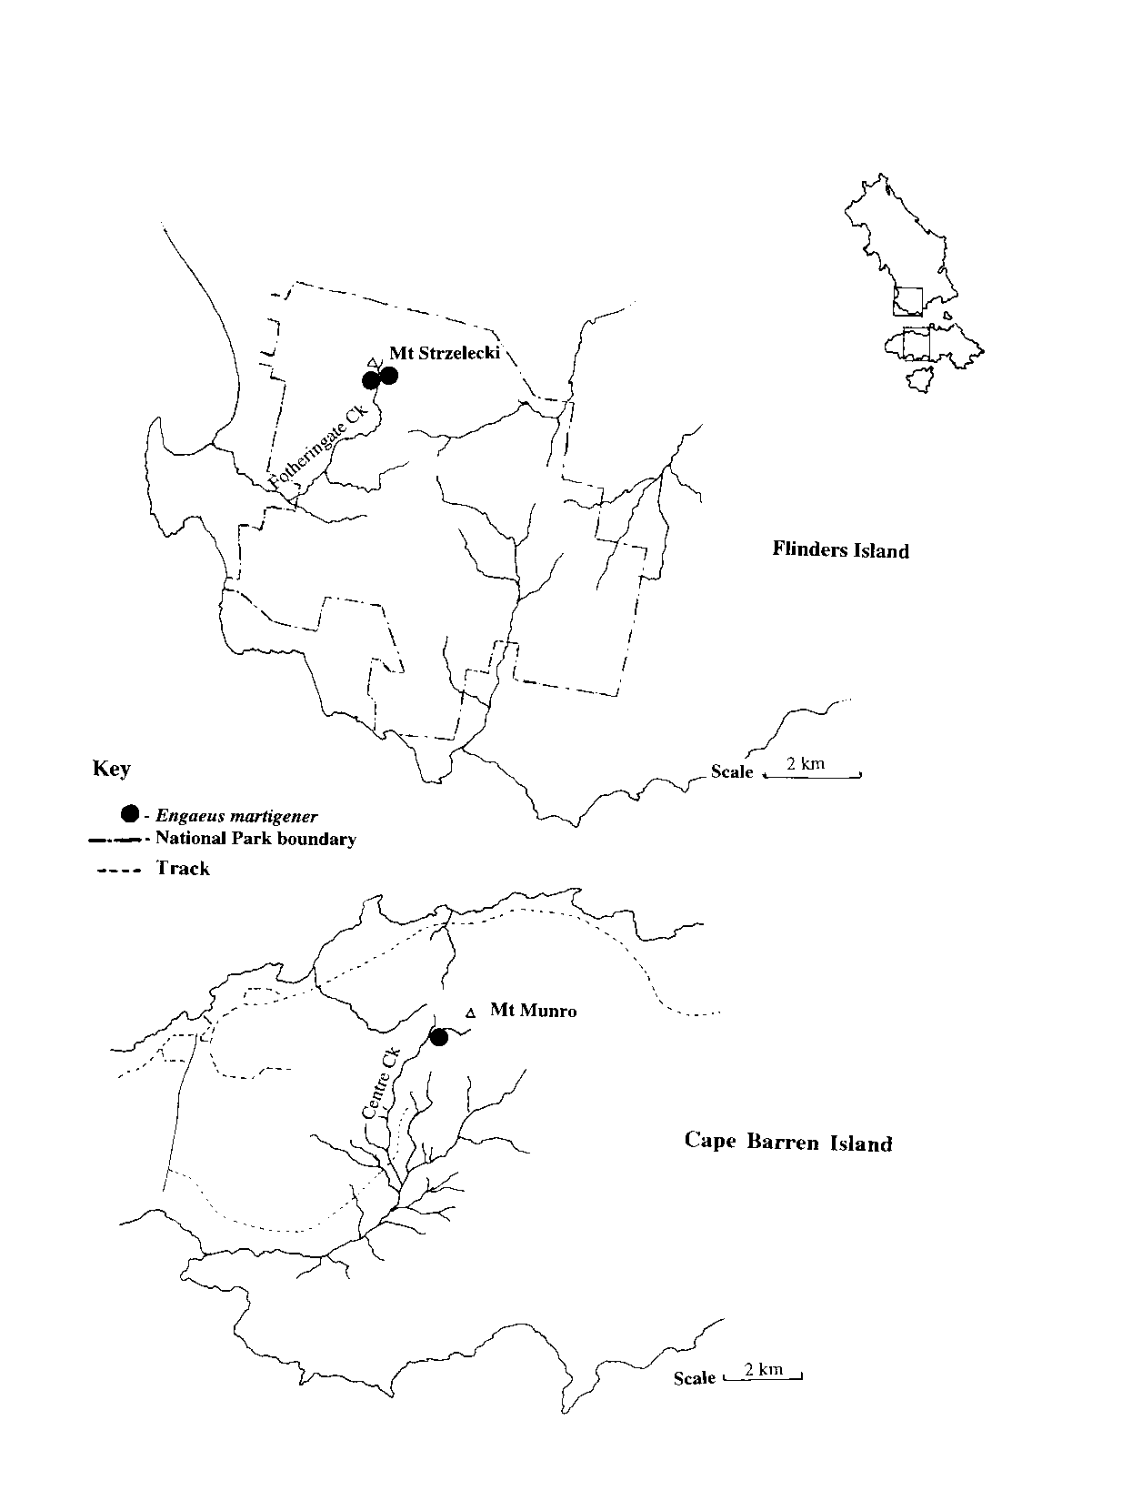
Figure 5.1: Known distribution of E. martigener.
As determined from Horwtiz 1990a & pers. comm.
Map prep: KR

5.0 Engaeus martigener, the Strzelecki burrowing crayfish

5.1 Introduction

Surveys of burrowing crayfish conducted on Flinders Island have identified the presence of two species of Engaeus ; E. martigener and E. cunicularius (Horwitz 1990a). While colour is usually not a good identifying character within the genus Engaeus , E. martigener can be distinguished by its predominantly purple hues. The carapace is often creamy coloured with light oranges, browns and purples dorsally, while the tail fan, abdomen and chelae are shades of purple (Horwitz 1990a).

E. martigener has a restricted habitat, and has only been collected from sites in moist gullies in elevated areas of Fotheringate Creek, near Mt. Strzelecki. Within its range, the species is prevalent throughout boggy areas and along small clear water creeks. No overlap between the two species of Engaeus has been observed, with the two species separated by a 150m section of creek where no crayfish are found. From the work of Horwitz (1990a), it was determined that E. martigener is restricted to high altitude moist gullies and bogs within the south-west region of Flinders Island, while E. cunicularius is found at lower altitudes and has a wider distribution.

Unpublished data has revealed that E. martigener is also present on Cape Barren Island (Pierre Horwitz, pers. comm.). Specimens of E. martigener were collected from Centre Creek on the western side of Mount Munro in 1990. The Cape Barren Island population was also found at high altitude, in granitic soils, within a moist rainforest gully. Further distribution data for the species is unavailable.

From the published and unpublished data the distribution of the species appears to be very restricted. The presence of the species within the Strzelecki National Park on Flinders Island provides habitat protection eliminating the immediate threat of extinction, while the Cape Barren Island population is not protected within a gazetted reserve.

E. martigener has been given a status of ‘Rare’ by Horwitz (1990b) and the Invertebrate Advisory Committee (1994), but has not been listed under Schedule 5 of the Tasmanian Threatened Species Protection Act, (1995). This schedule was restricted to species considered to be "Rare (Susceptible)", for which E. martigener did not qualify as the totality of its known distribution (at the time) fell in a reserve.

Research conducted on the species has been restricted to the study and observations mentioned above. Although some comparisons with other species of Engaeus can be made, it is important to determine habitat requirements, essential/critical habitat of the species, and potential threats specific to E. martigener. The aim of this chapter is to review the information that is available on the species, and to suggest potential approaches to and considerations for the investigation and management of the species.

5.2 Available information on E. martigener

5.2.1 Distribution

E. martigener is currently known from only two locations: Fotheringate Creek, Flinders Island, above 500m, GR 5913-5493, and Centre Creek, Cape Barren Island, 340m, GR 5933-5307 (Figure 5.1). The species may have a wider distribution within the Strzelecki National Park located at higher altitude, in wet/moist gullies around Big Hollow and Mt. Razorback. These areas are difficult to access and have remained unstudied. Further north on Flinders Island, Walkers Lookout (411m) and Mt Leventhorpe (501m) also pass the required altitudes, and Mount Killiecrankie (316m) may also be worth investigation.

Further suitable higher altitude areas on Cape Barren Island include Double Peak (360+m), Mount Kerford (503m), Brougham Sugarloaf (453m) and other areas of Mt Munro (687m). Although it reaches only 174m, it is possible that Prime Seal Island may hold further populations of the species, or a new one entirely (Horwitz, pers. comm.). In short, a survey of Flinders, Cape Barren, and surrounding islands should be undertaken to determine the full range of the species.

5.2.2 Conservation status

The subpopulation on Flinders Island is largely protected from habitat clearance by its existence within the National Park. On Cape Barren Island, however, it is not protected or reserved. As with E. yabbimunna (Section 4.4.4), the severely restricted distribution of this species means that all habitat in which it is found should regarded as essential for species survival.

The application of IUCN Red List criteria (1994), under which no 'Rare' category exists, suggests that the species should be reclassified as 'Vulnerable' (VU), on the basis that it is represented by a very small and acutely restricted population in its area of occupancy and number of locations (less than 100 km2 and five respectively: VU criterion D.2). While the two subpopulations may currently be stable - and this in itself needs to be confirmed - the taxon can be considered as prone to the effects of human activities or other events, and capable of becoming Critically Endangered or even Extinct within a very short period of time.

Field investigations need to be conducted to fully assess the status of the species. The condition of known populations should be determined, and other potential areas of distribution should be examined.

5.2.3 Potential management issues

One recognised threat to the habitat of E. martigener is fire. Horwitz (1990b) notes that the granitic soils of the Strzelecki Peaks are extremely prone to erosion. Any activity leading to devegetation and subsequent soil exposure are therefore considered to pose a significant threat to the species. Fire should be actively managed and avoided where possible, particularly in the case of repeated or severe fire (Horwitz 1990b). Land management practices on Cape Barren Island may need to be addressed for this reason (see below), as moist rainforest gullies may not regenerate after intense burning.

Drought is another serious natural danger for the species. The past five years have been extremely dry on Flinders Island with few water storages remaining wet. The impact of this period on the distribution of the species is unknown. Loss of canopy due to fire may enhance drying as well as erosion, particularly as much of the soil is shallow.

Feral pigs inhabit the Strzelecki National Park on Flinders Island and may be very damaging to crayfish habitat. The exact level of impact from feral pig populations should be determined, particularly during the mid to late spring/summer period, when crayfish may be close to the surface for mating (Horwitz 1990b). The effects of human usage of the Park should also be investigated.

5.2.4 Potential management actions

It must be stressed that the following suggestions are made without the benefit of field research on the above issues. Work on the distribution, habitat requirements, and environmental pressures affecting the species may determine that some of these factors are not relevant, or that more important ones are operating.

A detailed survey of all likely habitats of E. martigener should be undertaken to determine the range and distribution of the species. The survey should include all suitable high-altitude areas on the surrounding Bass Strait Islands, and habitat assessments should be made to determine areas where subpopulations are most at risk. Potential areas for investigation are listed in Section 5.2.1

Control of feral pig populations on Flinders Island may be required if they are found to have an adverse effect on E. martigener and its habitat. Depending on location specifics, it may also be necessary to control human access to significant habitats and sections of higher density or sensitivity. This could involve careful path placement and signposting to limit impacts both generally and at times of concentrated use (such as during the team ascents of the Three Peaks Race).

Habitat conservation on Cape Barren Island requires consultation with the Aboriginal community. Suitable habitat for E. martigener on the island may be under threat by burning carried out using traditional land management methods. It may be necessary to undertake discussions with the landholders to ensure that adequate management regimes are put in place if the species is to be protected on Cape Barren Island.

5.2.4 Summary

A proper review of the status of this species can only be conducted once it has been fully studied. Management actions can be undertaken once these needs have been identified, and should be supplemented with periodic monitoring of the status of the E. martigener populations thereafter.

6.0 Contacts

6.1 Contacts quoted in text

• Dr Peter Davies, Freshwater Systems, Waimea Avenue, Sandy Bay, Tasmania.
• Dr Pierre Horwitz, Department of Biology, Edith Cowan University, Perth, WA.
• Mr Mike Laffan, Forest Practices Board, Launceston, Tasmania.
• Dr Alastair Richardson, Zoology Department, University of Tasmania.
• Mr Bill Walker, Burnie City Council, Tasmania.

7.0 References

Davies, P.E. and Nelson, M. (1993). The effect of steep slope logging on fine sediment infiltration into the beds of ephemeral and perennial streams of the Dazzler Range, Tasmania, Australia. Journal of Hydrology 150: 481-504.

Davies, P.E. and Nelson, M. (1994). Relationships between riparian buffer widths and the effects of logging on stream habitat, invertebrate community composition and fish abundance. Australian Journal of Marine and Freshwater Research 45: 1289-1305.

Davies, P.E., Cook, L.S.J. and Goenarso, D. (1994). Sublethal responses to pesticides of several species of Australian freshwater fish and crustaceans and rainbow trout. Environmental Toxicology and Chemistry 13: 1341-1354.

Forestry Commission (1993). Forest Practices Code. Hobart, Tasmania. 98pp.

Gaffney, R.F. and Horwitz, P. (1992). The Scottsdale Burrowing Crayfish Recovery Plan: Management Phase. Endangered Species Program, Project Number 240, Tasmanian Parks and Wildlife Service. 16pp.

Growns, I.O. and Richardson, A.M.M. (1988). Diet and burrowing habits of the freshwater crayfish, Parastacoides tasmanicus tasmanicus Clark (Decapoda: Parastacidae). Australian Journal of Marine and Freshwater Research 39: 525-534.

Horwitz, P. (1986). The systematics and zoogeography of the freshwater crayfish genus Engaeus Erichson (Decapoda: Parastacidae). Unpublished Ph.D. thesis, Zoology Department, University of Tasmania, Hobart. 487pp.

Horwitz, P. (1988a). A key to genera of Tasmanian freshwater crayfish. The Tasmanian Naturalist, 94: 1-3.

Horwitz, P. (1988b). Sea-level fluctuations and the distributions of some freshwater crayfishes of the genus Engaeus (Decapoda; Parastacidae) in the Bass Strait Area. Australian Journal of Marine and Freshwater Research 39: 497-502.

Horwitz, P. (1990a). A taxonomic revision of species in the freshwater crayfish genus Engaeus Erichson (Decapoda: Parastacidae). Invertebrate Taxonomy 4: 427-614.

Horwitz, P. (1990b). The Conservation Status of Australian Freshwater Crustacea (with a provisional list of threatened species, habitats and potentially threatening processes). Report Series No. 14, Australian National Parks and Wildlife Service, Canberra. 121pp.

Horwitz, P. (1991). The conservation biology of Engaeus spinicaudatus, a threatened crayfish from north-eastern Tasmania. Unpublished report to the Australian National Parks and Wildlife Service, Canberra.

Horwitz, P. (1994). A new species of the freshwater crayfish genus Engaeus Erichson (Decapoda: Parastacidae) from north-western Tasmania. Memoirs of the Museum of Victoria 54: 439-445.

Horwitz, P. (in press). Biogeographical affinities of macrocrustacean groups in northeast Tasmania. Memoirs of the Queen Victoria Museum.

Horwitz, P., Adams, M. and Baverstock, P. (1990). Electrophoretic contributions to the systematics of the freshwater crayfish genus Engaeus Erichson (Decapoda: Parastacidae). Invertebrate Taxonomy 4: 615-641.

Horwitz, P. and Richardson, A. M. M. (1986). An ecological classification of the burrows of Australian freshwater crayfish. Australian Journal of Marine and Freshwater Research 37: 237-42.

Horwitz, P., Richardson, A.M.M. and Boulton, A. (1985a). The burrow habitat of two sympatric species of land crayfish, Engaeus urostrictus and E. tuberculatus (Decapoda: Parastacidae). Victorian Naturalist 102: 188-197.

Horwitz, P., Richardson, A.M.M. and Cramp, P.M. (1985b). Aspects of the life history of the burrowing freshwater crayfish Engaeus leptorhynchus at Rattrays Marsh, North East Tasmania. The Tasmanian Naturalist 82: 1-5.

Invertebrate Advisory Committee. (1994). Interim List of Native Invertebrates which are Rare or Threatened in Tasmania. Species at Risk, Tasmania - Invertebrates. Parks and Wildlife Service, Tasmania. 44pp.

IUCN Species Survival Commission. (1994). Draft IUCN Red List Categories, Version 2.2. Species 21-22: 13-24

Jackson, J. and Taylor, R. (1995). Threatened Fauna Manual for Production Forests in Tasmania. Forest Practices Unit (for the Forest Practices Board), Forestry Tasmania. 172pp.

Mesibov, R. (1994). Faunal breaks in Tasmania and their significance for invertebrate conservation. Memoirs of the Queensland Museum 36: 133-136.

Richardson, A.M.M. and Horwitz, P.H.J. (1987). Habitat partitioning by Australian burrowing crayfish. In Freshwater Crayfish Volume VII. Papers from the Seventh International Symposium of Astacology (International Association of Astacology). pp. 91-97.

Richardson, A.M.M. and Swain, R. (1980). Habitat requirements and distribution of Engaeus cisternarius and three subspecies of Parastacoides tasmanicus (Decapoda: Parastacidae), burrowing crayfish from an area of south-western Tasmania. Australian Journal of Marine and Freshwater Research 31: 475-484.

Richardson, A.M.M., Monamy, V. and Serov, P. (1990). A Faunal Survey of the Minna Creek Area [Tioxide (Aus.) Pty Ltd]. Report to Environmental and Technical Services Pty Ltd. 11pp.

Riek, E.F. (1969). The Australian freshwater crayfish (Crustacea: Decapoda: Parastacidae), with descriptions of new species. Australian Journal of Zoology 17: 855-918.

Suter, P. J. and Richardson, A. M. M. (1977). The biology of two species of Engaeus (Decapoda: Parastacidae) in Tasmania III: habitat, food, associated fauna and distribution. Australian Journal of Marine and Freshwater Research 28: 95-103.

8.0 Appendices

8.1 Project proposal as approved by the Commonwealth

Distribution, management requirements and reservation status of the Mt Arthur burrowing crayfish, Engaeus orramakunna, and production of management recommendations for the other threatened Tasmanian burrowing crayfish in forested areas.

Background

Tasmania's burrowing crayfish have been the target of several investigations and all but the Mt Arthur burrowing crayfish (Engaeus orramakunna) are relatively well understood (Horwitz 1990a). Most species are confined to forested sites (except E. spinicaudatus) where they are directly or indirectly affected by land-use practices via catchment alteration. The following species have been identified by the Invertebrate Advisory Committee (1994) as threatened:
• Engaeus spinicaudatus - Vulnerable;
• Engaeus yabbimunna - Vulnerable;
• Engaeus orramakunna - Vulnerable; and
• Engaeus martigener - Rare.
Some, such as the Scottsdale burrowing crayfish (E. spinicaudatus), have been the subject of a national Recovery Plan (Gaffney and Horwitz 1992).
The Mt Arthur burrowing crayfish (E. orramakunna) is known from only three locations on the eastern and western sides of Mt Arthur. Much of the area between known sites is State forest and, in view of the potential impact of operations in this area, additional work is urgently required to assist conservation management, particularly in relation to the effectiveness of streamside reserves in logged areas.

Objectives

To document the distribution and habitat requirements of Engaeus orramakunna. This information will be used to compare the presence and prevalence of the species in logged and unlogged areas, and to increase general knowledge on the species' ecology, management requirements, and reservation status. The study also aims to produce thematic and/or specific management recommendations for other target species.

Study design and methods

For the species E. spinicaudatus, E. yabbimunna and E. martigener, existing information will be compiled to consider all land-use management practices that directly or indirectly alter catchments.
The distribution of the Mt Arthur burrowing crayfish will be documented by undertaking surveys in streamside areas with wet sclerophyll forest in the Mt Arthur region. The surveys will include some excavation of burrows to locate individuals, estimation of burrow density in each location where individuals are found, and collection of habitat information, including stream dynamics. The methodology developed will be subject to animal ethics, Tasmanian Parks and Wildlife Service and other State Legislative requirements.

Field work on Engaeus orramakunna will use three approaches:
1. Surveying of all accessible stream areas to determine species presence or absence, including a measure of general abundance where present. General environmental characters (as below) will be recorded to characterise each site;
2. On a more specific level, quadrats will be centred on burrows chosen at random at each site. Quadrats will extend one metre upstream and downstream from the selected burrow, and this strip will extend to the water and as far away from the water as necessary to encompass all burrows on that two metre strip of bank. Over this area, selected environmental attributes and variables (as below) will be measured. This will be replicated three times at each site (where possible), and will also be done at points on sites where the species is not present; and
3. Selected areas will be returned to for repeat surveying to gain a measure of stream maximums and minimums (as far as winter conditions permit), and to determine the degree to which stream level at time of survey influences the results of surveys.
The information required for (1)-(3) will be gathered on the same proforma data sheet, with each sheet representing a separate quadrat and/ or sample time. The variables to be recorded are:
• grid reference;
• location description and altitude;
• stream width, depth, flow rate, and slope;
• vegetation cover and type (ground, scrub and canopy);
• soil type and consistency;
• soil moisture/depth of water table;
• bank slope, aspect, and micro-drainage patterns;
• surrounding land use;
• any disturbance of the area (clearing, runoff, cattle, blackberries, etc.);
• number and distribution of burrows within the transect strip, including vertical and horizontal distances from the water;
• burrow characters (e.g. chimneyed, clustered, etc.); and
• whether specimens have been dug up to confirm species identification (this will be done particularly where burrows are found some distance from other recorded localities, or in regions that may border on the distribution of other species).
The layout of the data sheet is designed to maximise the amount of information that can be recorded per site while minimising the time taken to survey each site. Results from this field work will be used to modify and refine the sampling and field techniques as required.
The initial study area encompasses more than 150 square kilometres surrounding Mt Arthur, and study sites will be chosen according to stream accessibility. From the initial sites examined, any distributional limits defined by altitude, latitude or longitude will be used to redefine the study area, while the extent of sampling will expand to encompass more remote locations and regions of streams as time permits. As field work will be intensive (four days per week until the end of September), the number of sites and the volume of data will be large.
Once the overall range of the species has been determined, the impacts of logging will be investigated by comparing streamside reserves in logged areas with those of unlogged areas. The extent of the occurrence of the species in lower order streams, where no reserves are retained on logging, will also be assessed. Experimental design details will be discussed with statistical consultants and the Australian Nature Conservation Agency.
Data analysis will involve use of the PRIMER multivariate statistics software package, in particular the CLUSTER, MDS and SIMPER sub-routines. These will be used to group sites according to similarity, and to determine which factors are contributing most to the degree of similarity between sites and dissimilarity between groups of sites. These data will then be compared with the determined distribution and abundance of the species, and correlations will be drawn with any dominant environmental conditions or attributes that may be responsible for patterns of distribution. Comparisons will also be made between the suite of logged and unlogged sites sampled, to determine if any over-riding effect or correlation exists between the logged or unlogged condition of these sites, and presence, absence, or fluctuation in the density of the species.
The management of the other threatened Tasmanian forest crayfish species will be investigated by compiling existing information from published and unpublished sources. Brief field investigations will also be conducted to confirm that this information remains current. Some ground truthing may be required to verify sightings and the integrity of habitat. Field work on these species will be undertaken by a research assistant working concurrently with the Mt Arthur crayfish investigations, and by the project officer on completion of the Mt Arthur work. No statistical analysis will be conducted on this information.

Outputs

• increased knowledge of the Mt Arthur burrowing crayfish's distribution, ecology, management and conservation status;
• a conservation assessment for all Tasmania's threatened burrowing crayfish in forest;
• production of specific management recommendations for each of the burrowing crayfish in forest associated areas;
• electronic and/or map products suitable for contributing to National Estate thematic assessments will also be produced as negotiated with the Australian Heritage Commission; and
• a report documenting the project and the outputs.

As in the RFA/Tasmanian Public Land Use Commission (PLUC) publication: Methods for Comprehensive Regional Assessment projects (Supplement to Background Report Part A: Papers for Environment and Heritage Seminar, and Social and Economic Seminar, Launceston and Hobart, August - September 1996). August 1996, pp. 48-50.

8.2 Vegetative profiles and location of raw data and specimens

Following is presence/absence data forming a vegetative profile of a subsample of 112 sites and sub-sites, as used for PRIMER analysis (Tables 8.1 & 8.2; see Sections 2.2.5 & 2.3.3). Complete sets of raw data, including detailed site descriptions and specimen locations/ information are retained by both the Forest Practices Unit and the principal author.

The majority of specimens collected in this study will be lodged with the Queen Victoria Museum, Launceston, while some may be retained for the purposes of further study (these will initially include the lone specimen of Engaeus 'sp nov.?' found west sou-west of Mt Arthur, until the status of the potential new species is determined). The location of all specimens can again be traced by contacting the principal author.

Table 8.1 (following page): Key to data in Table 8.2
Sites are identified by a code of: "status (abundance index); grid reference". For status, "absBOR", "absIN", & "absALT" = absences on the border of the range, within the range, and within the range but at high altitude respectively. "ORC" and "ora" = E. orramakunna confirmed and assumed sites respectively (see Section 2.3.1), with a corresponding abundance value in brackets.
As several of the profiles in Table 8.2 represent specific sub-site conditions, abundance values may in some cases differ from the overall abundance values given for the corresponding sites/habitats in Tables 2.1, 2.2 & 2.5. Some abundances are given as a range; unless they definitely tended to lean towards one end of the range, values were averaged for analysis and scaled down as reported in Section 2.2.5. How they were treated in analysis can be determined from the order of positions in the Table.
The type locality, at which several sub-sites were sampled = GR 5181-4307, while "?" signifies some increased degree of estimation or approximation in a value. Notation in Table 8.1 otherwise follows that for Tables 2.1-2.6 (see relevant key).

Table 8.1: Key to data in Table 8.2 (see previous page for description).

PLANTS |  |  |  | SITES |  |  |  | SITES
A | open soil |  | S01 | absALT?; 5218-4303 |  | S63 | ora(2); 5171-4286
B | algae/sludge |  | S02 | absALT?; 5216-4301 |  | S64 | ora(2); 5171-4287
C | fungus |  | S03 | absBOR; 5259-4395 |  | S65 | ora(2); 5191-4251
D | root matting |  | S04 | absBOR; 5351-4337 (n) |  | S66 | ora(2); 5265-4335
E | leaf litter |  | S05 | absBOR; 5351-4337 (s) |  | S67 | ora(2); 5264-4350
F | pine needle litter |  | S06 | absBOR; 5342-4355 |  | S68 | ora(2?); 5258-4350
G | mosses |  | S07 | absBOR; 5221-4389 |  | S69 | ora(2); 5270-4314 (e)
H | grasses |  | S08 | absBOR; 5340-4344 |  | S70 | ora(2); 5229-4329
I | Billardiera longiflora |  | S09 | absBOR; 5304-4230 |  | S71 | ora(2); 5236-4326
J | Juncus spp. |  | S10 | absBOR; 5336-4210 |  | S72 | ora(2); 5235-4325
K | bracken |  | S11 | absBOR; 5192-4390 (s) |  | S73 | ora(2); 5202-4289
L | thorny shrub 1 |  | S12 | absBOR?(dry) 5364-4363 |  | S74 | ora(2); 5196-4293
M | "apple tree" |  | S13 | absIN?; 5188-4333 |  | S75 | ora(2); 5193-4297 (sw)
N | thistles +weeds |  | S14 | absIN?; 5174-4356 |  | S76 | ora(2); 5194-4301
O | button grass |  | S15 | absIN; 5261-4359 |  | S77 | ora(2); 5188-4306 (s)
P | cutting grass |  | S16 | absIN; 5272-4350 |  | S78 | ora?(2-2.5); 5184-4245 *
Q | reeds/sedge/rushes |  | S17 | absIN; 5273-4372 |  | S79 | ORC(2.5); 5244-4319 (s)
R | ferns |  | S18 | absIN; 5277-4365 (s) |  | S80 | ORC(2.5); 5263-4354 (s)
S | manferns |  | S19 | absIN; 5277-4365 (n) |  | S81 | ORC(2.5); type locality sub-site E
T | Gleichenia sp. fern |  | S20 | absIN; 5276-4375 |  | S82 | ora(2.5?); 5266-4351 (w-strm)
U | Hawthorn (introduced) |  | S21 | absIN; 5286-4377 |  | S83 | ora(2.5?); 5258-4347
V | Cassinea aculeata |  | S22 | absIN; 5270-4314 (w) |  | S84 | ora(2.5?-3); 5269-4349
W | Culcita dubia |  | S23 | absIN; 5259-4359 |  | S85 | ora(2.5); 5305-4345
X | Ozothamus spp. |  | S24 | absIN; 5269-4360 |  | S86 | ora(2.5); 5243-4374
Y | Goodenia ovata |  | S25 | absIN; 5268-4360 |  | S87 | ora(2.5-3); 5368-4375 (w)
Z | Erica lusitanica |  | S26 | absIN; 5266-4363 |  | S88 | ora(2.5); 5368-4375 (e)
AA | holly |  | S27 | absIN; 5266-4348 |  | S89 | ora(2.5-3); 5363-4379 (e)
BB | Melaleuca ericifolia |  | S28 | absIN; 5285-4286 |  | S90 | ora(2.5); 5175-4266 *
CC | Melaleuca squarrosa |  | S29 | absIN; 5285-4283 |  | S91 | ORC(3); 5298-4342 (s-strm)
DD | Clematis aristata |  | S30 | absIN; 5246-4320 (s) |  | S92 | ORC(3); 5192-4250
EE | Calistamin viridifloris |  | S31 | absIN; 5253-4310 (s) |  | S93 | ORC(3); 5266-4329
FF | Calistamin pallidus |  | S32 | absIN; 5188-4306 (n) |  | S94 | ORC(3); 5252-4214
GG | Olearia argophylla (musk) |  | S33 | absIN; 5225-4229 |  | S95 | ORC(3-4); 5367-4370 (w)
HH | Pultenaea spp. |  | S34 | absIN; 5184-4244 (approx) |  | S96 | ORC(3); 5367-4370 (e)
II | Zieria arborescens |  | S35 | absIN; 5184-4245 (approx) |  | S97 | ORC(3-4); 5363-4376
JJ | Senecio linearifolius (fireweed) |  | S36 | absIN; type locality sub-site A |  | S98 | ora(3); 5191-4302
KK | Leucopogon sp. |  | S37 | absIN; type locality sub-site C |  | S99 | ora(3); 5270-4350 (n)
LL | Introduced maple |  | S38 | absIN; 5285-4302 |  | S100 | ora(3); 5263-4354 (n)
MM | Acaena novae-zelandiae |  | S39 | absIN; 5285-4303 |  | S101 | ora(3); 5269-4346 (s)
NN | Pittosporum bicolor |  | S40 | ora??(1); 5182-4334 |  | S102 | ora (3); 5268-4347 (n)
OO | Beyeria viscosa |  | S41 | ora??(1); 5178-4349 |  | S103 | ora(3-4); 5363-4379 (w)
PP | Pimelea drupacea |  | S42 | ora(1); type locality sub-site a |  | S104 | ora(3); 5246-4320 (n)
QQ | Coprosma quadrifida (nat. current) |  | S43 | ora(1); 5248-4318 (approx) |  | S105 | ora(3-4); 5363-4378 (e)
RR | Notelaea ligustrina (native olive) |  | S44 | ora(1); 5194-4297 (ne) |  | S106 | ora(3-4); 5363-4378 (w)
SS | Tasmannia lanceolata (nat. pepper) |  | S45 | ORC(1.5); 5166-4280 |  | S107 | ORC(4); 5375-4369
TT | blackberries |  | S46 | ORC(1.5); 5254-4204 |  | S108 | ORC(4); 5176-4356
UU | vines (Macquarie vine) |  | S47 | ORC(1.5); type local. sub-site B |  | S109 | ORC(4); 5270-4327 (n)
VV | Pomaderris apetala (dogwood) |  | S48 | ora(1.5); 5198-4246 |  | S110 | ORC(4); 5277-4379
WW | Olearia lirata |  | S49 | ora(1.5); 5298-4342 (n-strm) |  | S111 | ora(4); 5257-4338
XX | Leptospermum lanigerum |  | S50 | ora(1.5); 5244-5319 (n) |  | S112 | ora(4); 5266-4351 (e-strm)
YY | Aristotelia peduncularis |  | S51 | ora(1.5); 5247-4319
ZZ | Bedfordia salicina |  | S52 | ORC(2); 5262-4304 a
A3 | Leptospermum spp. |  | S53 | ORC(2); 5262-4304 b
B3 | Sassafrass |  | S54 | ORC(2); 5260-4384
C3 | Acacia dealbata |  | S55 | ORC(2); 5149-4288
D3 | Acacia melanoxylon |  | S56 | ORC(2); 5283-4250
E3 | Acacia verticillata |  | S57 | ORC(2); 5191-4199 (gps)
F3 | Eucalyptus spp. |  | S58 | ORC(2); 5371-4376
G3 | Wattle spp. |  | S59 | ORC(2); type locality sub-site D
H3 | Pinus radiata (pine) |  | S60 | ORC (2); type locality area one
I3 | Willow |  | S61 | ORC(2); type locality area two
J3 | Nothofagus sp. (myrtle) |  | S62 | ORC(2); 5289-4300

Table 8.2: Vegetative data as used for PRIMER analysis.
Sites/sub-sites (S01-S112) are listed vertically and plant species/groupings (A-J3) horizontally. (See Table 8.1 for key).

8.3 PRIMER ordinations and dendrograms from vegetative profiles

The crude plots are presented on the following pages (Figures 8.1-8.4).

Figure 8.1: MDS ordination from all vegetative data.
PRIMER output, from 10 random starts (default = 6). Stress = 0.33. Sites S01-S112 (Tables 8.1 & 8.2) are numbered 1-112 respectively.
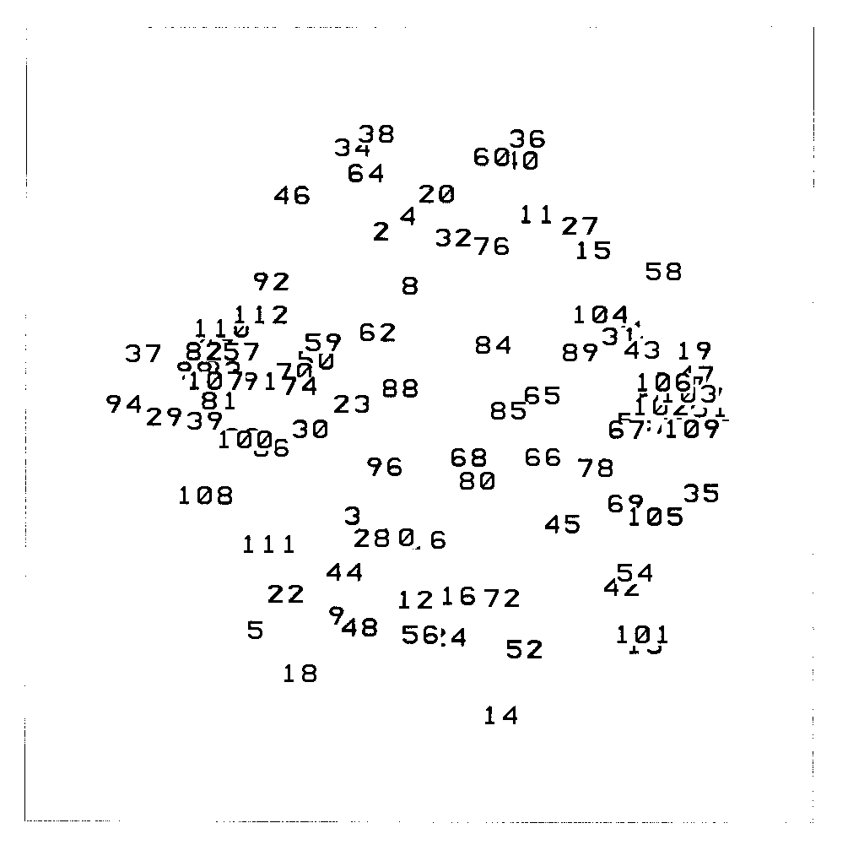

Figure 8.2: MDS ordination excluding "absBOR" and other sites.
PRIMER output, from 10 random starts (default = 6). Stress = 0.32. "absBOR", "absIN?", and "absALT" sites (S01-S14) have been excluded to avoid confusing any patterns from "absIN" sites alone. Sites S15-S112 are numbered 1-98 respectively.
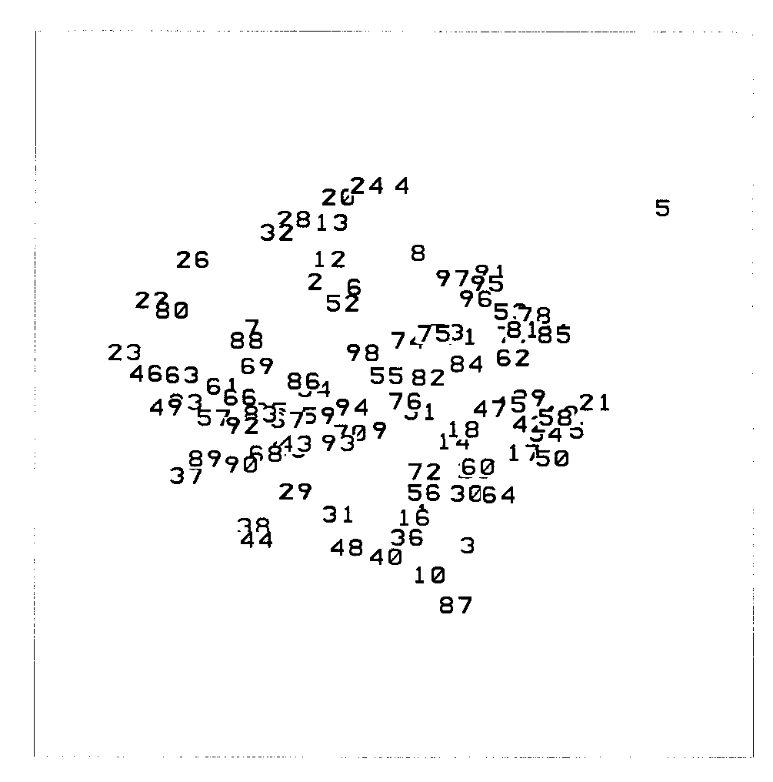

Figure 8.3: Dendrogram identifying individual sites.
Dendrogram excluding absBOR, absIN?, and absALT sites (S01-S14) as per Figure 8.2. Sites S15-S112 are numbered 1-98 respectively.
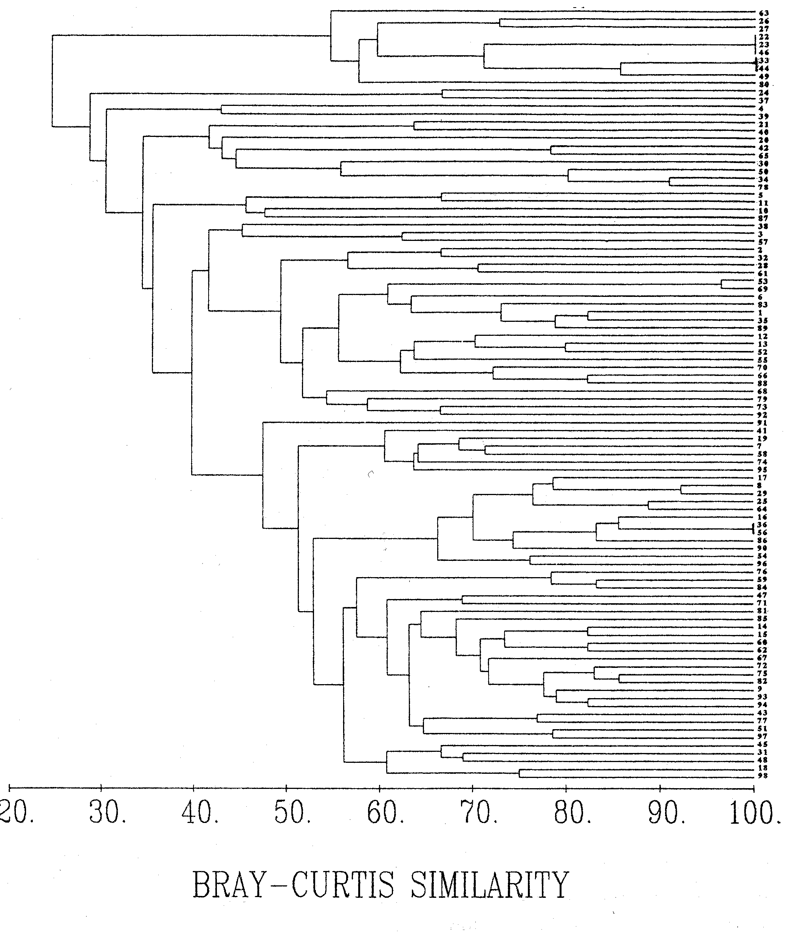

Figure 8.4: Dendrogram showing abundance groupings.
Dendrogram generated from all vegetative data, with sites listed according to their (rounded-down) abundances in order to highlight any groupings. B, N & A = absBOR, absIN & absALT sites respectively; 1-4 = corresponding abundance indices.
