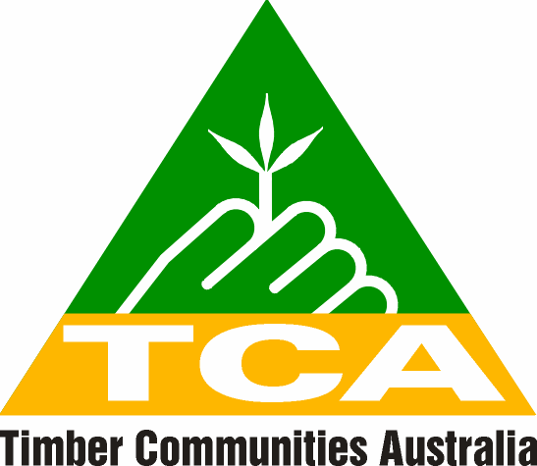

WA State Office
Unit 1 Abridge House
5 Turner Ave
BENTLEY WA 6102
Tel: 08 9472 3200
Fax: 08 9472 3155
Mobile: 0428 949 924
Email: tca@westnet.com.au

Western Australia

SUBMISSION:

‘A report on Progress with the Implementation of the Regional
Forest Agreement for the South-West Region of
Western Australia’

13 September 2013

Introduction
Timber Communities Western Australia (TCWA) is the organisation representing the regional communities throughout the South-West of Western Australia, dependent on a vibrant and sustainable timber industry.
Our members include the employees and families of the major and minor companies and businesses directly involved in the timber industry, along with many small businesses and community members working outside the industry but who depend on the timber industry as major employers, and for major economic stimulus to their communities. It is on their behalf that this submission is written.

Concerns
TCWA members agree with the purpose behind the implementation of the WA RFA, to provide ESFM, an expanded CAR system and to provide opportunities for the wood processing industry, by delivering resource security.
We believe it is of the utmost importance to maintain the WA RFA, but the undermining of the current WA RFA in 2001 by the then ‘Gallop Government’ with the implantation of Labors’ “Protecting our Old Growth Forest’ policy (POOGF), has meant that many of the reservation milestones set out in the original WA RFA have been incredibly ‘over achieved’ and not reported as such.
Due to that overachievement, the ability for the WA RFA to deliver resource security has been destabilized. The vision to provide a secure and sustainable opportunity for the wood processing industry to invest in new technology to enhance the utilization of regrowth timber has consequently been mostly unachievable and not reported as such.
Conclusion
TCWA therefore believes that in some instances, such as those mentioned above, the report is not entirely accurate in its interpretation of what has been over or under achieved.

TCWA would like to thank you for the opportunity to comment on the ‘Report on the Progress of the Implantation of the Regional Forest Agreement for the South-West Forest region of Western Australia’ July 2013. Please feel free to contact myself on 0428949924 tca@westnet.com.au should you need any further comment.

Sincerely,

Letisha Rakich
Communications Manager

