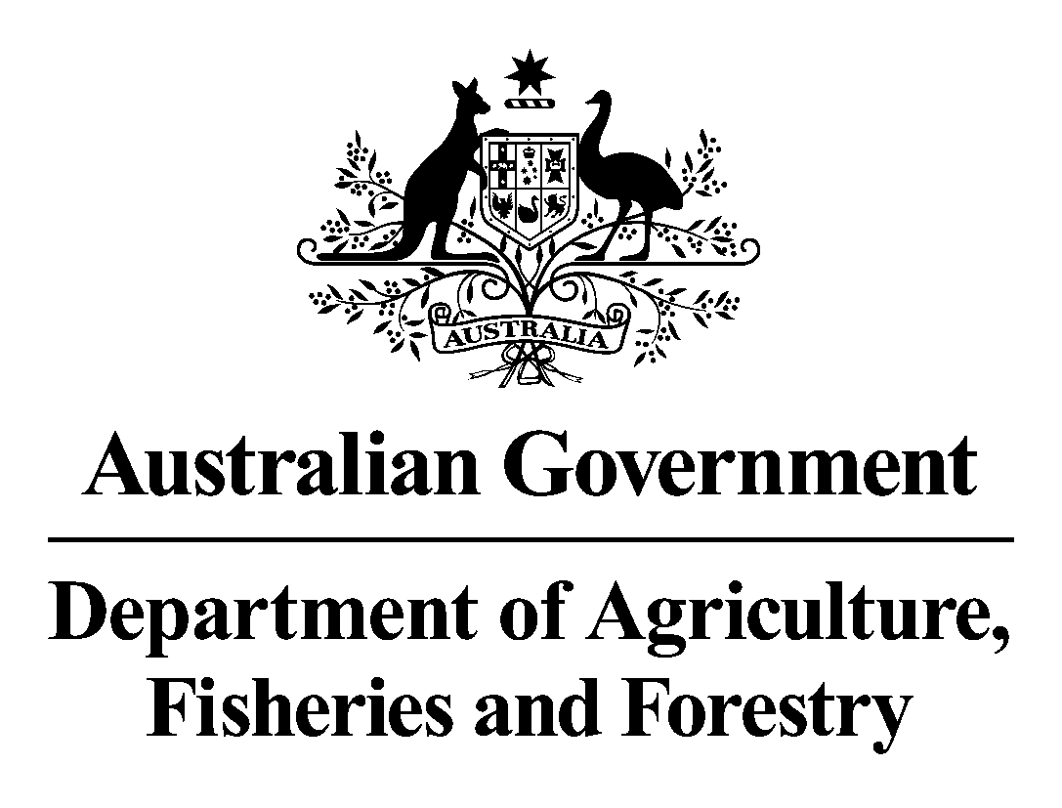
Forest Industries Development Fund
Applicant Guidelines
Round 1
January 2009
For further information:
Telephone:
(02) 6272 5079
Fax:
(02) 6272 4367
Email:
fidf@daff.gov.au
Post:
Forest Industries Development Fund
Forestry Branch
Climate Change Division
Department of Agriculture, Fisheries and Forestry
GPO Box 858, CANBERRA ACT 2601
Street address:
18 Marcus Clarke Street, CANBERRA ACT 2601
Program information, guidelines and related forms are available at
www.daff.gov.au/fidf

1. Overview
In 2005-06 the total value of turnover in Australia's sustainable forest industries was about $19 billion, representing 5.3 per cent of total Australian manufacturing industries. There were in excess of 120,000 people employed in the value chain, a significant number in the regions, and more than $3.1 billion was expended on wages.
To build on the strong economic base of this important sector the Australian Government has committed a total of $20 million to prepare the forest industries for the future. This election commitment will allow the government to work with industry to protect the long-term future of all the forestry sectors through a series of practical plans that will:
- Help address the industry's skills crisis.
- Promote world's best practice.
- Crack down on illegally logged timber imports.
- Prepare the industry for the impact of climate change.
- Encourage value adding to improve domestic market development.

2. Purpose of program
The government has committed $9 million over three financial years, 2008–09 to 2010–11, to the Forest Industries Development Fund (FIDF). Through this election commitment the Australian Government will work with the states and territories, and industry, to improve the international competitiveness and ensure the long-term economic viability of the industry through increased investment in measures designed to add value to forest resources.
The Australian Government is also providing $8 million to address knowledge gaps in preparing forest industries for climate change, $1 million to develop an industry database of skill and labour requirements for the future, $1 million to establish an industry skills council and $1 million to restrict the importation of illegally logged forest products.
The FIDF will be used as a merit-based, competitive discretionary grants program. Applicants submit expressions of interest, which are assessed against eligibility criteria. Those considered eligible and likely to meet the program objectives are invited to submit an application. This application is assessed against merit criteria. Funds are limited and therefore meeting eligibility and merit criteria does not guarantee funding. The fund will support projects that focus on the value adding objectives of the program.
The funding will be provided on the basis of co-contributions by applicants.

3. Objectives
The key objective of the FIDF is to develop value adding initiatives which improve the international competitiveness of forest products in Australia. It will also ensure the long-term economic viability of the sector and encourage the development of high value forest products.
It will achieve this by funding projects that design and/or transfer new technologies, new processing methods and new production methods, and implement them for use in the forest industries.

4. How is it to be delivered?
The program is intended to supplement investment by the applicants. As a general rule, successful projects will be offered a maximum federal grant of 30 per cent of total project costs with a maximum contribution of 20 per cent of the total project costs, by participating states and territories.
There will be two application rounds, each consisting of two stages. The first round will open on Monday 12 January 2009 and close on Friday 6 February 2009. The second round will open in 2010.
Grants will be paid on a reimbursement basis. This means that when an applicant completes each milestone specified in a Deed of Agreement, the Australian Government will reimburse a percentage of the costs incurred in achieving the milestone as specified in the Deed of Agreement.
Funding from all sources for the project will be taken into account. Funding from other Australian or state/territory government sources will not be accepted as part of an applicant's contribution to a project.
Grants from this program will generally be up to $500,000 but higher grants will be considered in special circumstances where outcomes may apply across the whole industry.
Assistance will not generally be available for goods or services that were ordered before the signing of a Deed of Agreement. Federal funding for the program will expire on 30 June 2011. Accordingly, funded projects must be completed and all claims for payment must be submitted by 30 April 2011 to allow final payments to be made by 30 June 2011.

5. Who is eligible?
Individual businesses and organisations involved in the Australian forest industry are eligible to apply for assistance. To be eligible for assistance, applicants must satisfy the following criteria:
- Your business must be a business registered for tax purposes in Australia with an Australian Business Number (ABN).
- Your business must be financially sound, with professionally prepared financial statements demonstrating the ability to fund your share of project costs.
- Your business must have secure access to a sufficient quantity and quality of forest products to undertake the proposal. Any applicant who does not currently participate in the industry will be required to demonstrate the existence of a secure agreement for resource supply as evidence that they have access to sufficient resource to undertake their proposal, and how they propose to participate in the industry; and/or have wood from a business with a wood supply contract for native forest or plantation wood; and/or be currently engaged in the growing, harvest and/or haulage and/or processing of those products under contract.
Further, applicants will have to show that:
- their project is industry focussed, innovative and commercially viable.
- their business is financially sound and is capable of providing or attracting the necessary funds to complete the entire proposed project.
- they have secure access to a sufficient quantity and quality of forest products to undertake the proposal.
- their business has capable management.
- they are contributing to the industry's competitiveness.
Applicants who are already directly participating in the Australian forest industry will have to show how they intend to sustain or improve their involvement in harvesting forest products, transporting timber, processing timber, or marketing and promotion of forest products, and they should specify the sectors of the industry in which they participate, e.g. native forest harvesting and haulage, native forest processing, plantation hardwood harvesting, haulage or processing, or marketing and promotion.
Funding will not be provided for plantation establishment, for the purchase of land or forest, to provide working capital, or for feasibility studies. Funding is not generally available to support research but is available to support its application or for research that is necessary to achieve widespread adoption of value adding technology applicable to the changed nature of the resource.
Applicants will be required to demonstrate that the technology involved in their proposals is commercially viable. Trials of a "whole-of-industry" nature that involve the application of new technology to harvest or process the resource may also be considered.

6. What activities are eligible for funding?
Projects should be principally focussed on value adding initiatives in the following areas of activity:
- new timber products - shift from low to high value products.
- improvements in cost efficiencies across the value chain.
- new uses for wood.
As this is a competitive grants program, all eligible projects will not necessarily be funded. Proposals will be eligible for funding if they:
- create wood-processing capacity that increases competitiveness and earnings of the business concerned.
- attract significant industry investment.
- attract state/territory government contributions.
- have application across a wide range of industry members and/or regional locations or come from a consortium of producers/manufacturers and have generic application.
- lead to long-term benefits.
- show evidence of significant previous development, if the program is on-going.
- develop products that attract new investment in the timber industry and associated industries.

7. How do I apply?
It will only be possible to apply to the program using the appropriate forms, available from our website (www.daff.gov.au/fidf) or from program staff. The first round of grant applications will open on Monday 12 January 2009 and close on Friday 6 February 2009. The second round will open in 2010.
Each round will consist of two stages:

1. Expression of interest
We will publish an expression of interest form for you to provide us with details about your project. Your expression of interest should be clear, concise and convincing. We are not looking for the full detail; just enough information to allow us to determine whether your project is likely to be eligible.
Expressions of interest should include:
- a summary of the proposed project.
- the estimated cost of the project.
- the amount of funding the applicant is seeking from the program.
- proposed sources of funds for the project.
- how the project meets the eligibility criteria, objectives and priorities for funding.
- the volume and character of timber necessary to make the project viable.
- evidence that the applicant has secure access to a sufficient quantity and quality of timber to complete the project.
- an estimate of the number of full-time and part-time jobs to be protected and/or created.
- the timetable for undertaking the project.
- evidence of the applicant's capacity to implement the proposal.

2. Application
If, after assessment of your expression of interest, the program manager determines that your business and project are likely to meet the program eligibility criteria and your project could be competitive, we will invite you to submit an application which will be due by Friday 27 February 2009. We will provide you with an application form. You should only submit the application on the form we provide directly. The application form will seek additional detail on your business, its financial situation and your project.
The information in your application form, the advice of an independent advisory committee and any other information relevant to your application will be used to make a final determination of eligibility and competitiveness. Further details of the project or your financial details may be sought by the Department of Agriculture, Fisheries and Forestry to assist in making a decision.
All information provided to the Department will be treated as commercial-in-confidence and handled on a strict need-to-know basis. The information collected is necessary for us to make a fair and equitable decision on funding, but we recognise the sensitivity of this data, particularly financial information. The Department is obliged to, and will, protect any personal information and private information in accordance with the Privacy Act 1988.

8. What are the conditions?
The Department will keep confidential any confidential information provided to it by applicants. The management of confidential information provided by successful applicants will be controlled by the terms of the funding agreement.
When entering into funding agreements with successful applicants, the Department will agree to keep confidential any specific information provided under, or in connection with, an application where it is appropriate to do so having regard to the matters covered by the Commonwealth's Guidance on Confidentiality in Procurement available at www.finance.gov.au/publications/fmg-series/03-guidance-on-confidentiality-in-procurement.html.
To enable the Department to consider whether it agrees to keep specific information confidential, applicants should include in their application any request that information is to be treated as confidential following the making of a funding agreement, specifying the information and giving reasons why it is necessary to keep the information confidential. The Department will inform the applicant whether or not the Department, in its sole discretion, agrees to the request and, if so, on what terms.
All applicants should be aware that the Department's obligations of confidentiality do not preclude confidential information being disclosed:
- by the Department to its advisers, officers, employees or subcontractors or to the Australian and relevant state/territory governments in order to conduct grant processes relating to the FIDF program.
- by the Department to the responsible Minister.
- by the Department in response to a request by a House or a Committee of the Parliament of the Commonwealth of Australia.
- by the Department within the Commonwealth, or with a Commonwealth agency, where this serves the Commonwealth's legitimate interests.
- if it is authorised or required by law to be disclosed, for example under the Freedom of Information Act 1982 or the Auditor-General Act 1997.
- if it is in the public domain otherwise than due to a breach of the relevant obligations of confidentiality.
- if it is disclosed with the written consent of the applicant.
The Australian and relevant state/territory governments reserve the right to release the names of successful applicants, the amount of the funding and brief descriptions of approved projects.
Successful applicants will be required to enter into a Deed of Agreement with the Commonwealth that will set out, inter alia, the details of the project and any conditions and commitments on the part of the project proponent and on the part of the Commonwealth. Grant payments will be made on a milestone basis, with the milestones being identified in a schedule to the Deed of Agreement.
The Deed of Agreement will include a clause requiring the applicant to retain ownership of all assets purchased with funding under the program, and to remain in a business substantially the same as that for which the funding was provided, for at least three years after receiving the grant.
If an applicant fails to comply with any clause in the Deed of Agreement, the applicant may be required to repay some or all of the grant monies received.

Intellectual property
Intellectual property is a valuable outcome of an innovative project and you must carefully consider its use. It is through the dissemination of intellectual property that the broadest community benefits can be realised. Therefore, while the Australian Government does not seek to own intellectual property developed through projects funded under this program, it does have an interest in how that intellectual property is used and may seek to impose conditions on its use.
Where your project is based on the adoption of technology, where there is little or no generation of intellectual property associated with the project, it will be a requirement of the project that you disseminate any lessons learned to the wider forest industries. Project funds should be committed to this purpose. In this instance, it is the demonstration of the value of the technology, thus encouraging other participants in the forest industries to take up the technology, which is the outcome sought by the Australian Government.
Additionally, if you have partners in your project and we invite you to submit an application, the application must include a letter of understanding or an agreement setting out ownership and disposition of existing and proposed intellectual property rights associated with the project.
All collaborators must sign this letter.

9. How are applications assessed?
An advisory committee consisting of three industry members with expertise in the Australian forest industry and officials of the Australian and relevant state/territory governments will oversee the implementation of the program. Members of the advisory committee will be determined before applications for the first round open. Industry committee members will be industry nominated and approved by the Minister.
Assessment of project proposals will be undertaken by the advisory committee until the funds are fully allocated. However, an initial submission date will be used to assist the advisory committee to commence assessment of applications. Intending applicants should submit a brief expression of interest outlining their proposal by Friday 6 February 2009.
The advisory committee will assess applications against the program's objectives, eligibility and merit criteria. Funding will be based on assessment of the project's innovation and value added to forest products or market development on an industry-wide or relevant state/territory-wide level.

Merit criteria
Your application will be assessed on the degree to which:
- the project will profitably lead to internationally competitive, higher valued forest products.
- the project will draw upon and involve existing knowledge and expertise within the Australian forest industries, including through collaboration with value-chain partners.
- you have the resources and capability to carry the project through to finality.
- you are able to demonstrate that your project meets your business's / organisation's strategic goals.
- your project will be unlikely to proceed in a reasonable manner and time frame without the funding.
In assessing a prospective project, the independent advisory committee will also aim to achieve a level of diversity in the projects funded, subject to the overall competitiveness of the projects.
The advisory committee will endeavour to finalise the initial assessment within three weeks of the first stage closing on Friday 6 February. Shortlisted applicants will be asked to submit a full proposal by Friday 27 February 2009, including a detailed business plan with an investment analysis of the proposal and the source and amount of financial contributions the business will make towards it. For existing businesses, the business plan should also include detailed financial records of the business over the past three years and the nature and level of investment in the business over the past five years.
The advisory committee will make recommendations to the Australian Government Minister for Agriculture, Fisheries and Forestry, and relevant state/territory Ministers on whether or not applications should be approved, whether any conditions should be attached to the offer of assistance and the timing of any assistance.
The advisory committee may ask applicants for more information. If so, the application will not be further considered until the applicant has provided the information requested.
The federal Minister and, if applicable, the relevant participating state/territory Minister will make the final decision on all applications. Applicants will be advised in writing of the decision made by the Minister(s). The advice will include the reasons for the acceptance or rejection of the proposal.

10. Additional information
Grants under the program are treated as taxable income. Applicants should discuss with their accountants or tax advisers the taxation and associated implications of receiving a grant. All grants will be announced as GST exclusive, but payments are made GST inclusive. All applicants are advised to seek independent legal advice prior to entering into an agreement with the Australian Government.

11. Appeals
For discretionary grants, such as within this program, the relevant test of the validity of a decision is that "it is not unreasonable" - so as to avoid potential challenges based on trivial grounds. Applicants should note that discretionary grants are literally made at the discretion of the Minister.
The avenues of appeal available to applicants deemed unsuccessful include:
The Commonwealth Ombudsman: for applicants who consider they have been unfairly or unreasonably treated by the Department.
The Administrative Appeals Tribunal: for applicants who wish to seek an independent review of a decision made by the Department.
The Freedom of Information Act 1982: this enables individuals the right of access to documents in the possession of the Department.

12. Roles and responsibilities
The Minister for Agriculture, Fisheries and Forestry has ultimate responsibility for the program. The Minister has responsibility for approving these guidelines and appointing the independent advisory committee. The Minister has decision-making powers and will announce all grants.
The Minister is assisted by the independent advisory committee and the program secretariat. The committee will consist of industry experts with a range of expertise in the forest industries.
The program will be administered by a secretariat from the Forestry Branch of the Climate Change Division of the Department of Agriculture, Fisheries and Forestry.
The program manager will have specific responsibility for:
- the overall supervision of the program administration, including project assessment and management.
- determining if project objectives have been met and whether repayment of funds is required.
- approving funding agreement variations.
- dispute management.
Together, the program staff will be responsible for:
- communicating program requirements to stakeholders.
- receiving expressions of interest and making recommendations to the program decision-maker on initial eligibility.
- communicating assessment outcomes to the program decision-maker and the Minister.
- receiving and assessing applications for consistency with expressions of interest.
- organising independent advisory committee meetings, ensuring adherence to conflict-of-interest requirements and providing secretariat services to the committee.
- providing the outcomes of committee meetings to the program decision-maker.
- communicating the program decision-maker's decisions to applicants.
- negotiating and finalising funding agreements.
- administering individual grants, including reconciling expenditure.
- making payments.

13. Contacting us
Further information on the Forest Industries Development Fund program is available from:
Secretariat
Forest Industries Development Fund
Forestry Branch
Climate Change Division
Australian Government Department of Agriculture, Fisheries and Forestry
GPO Box 858
CANBERRA ACT 2601
Tel: (02) 6272 5079
Fax: (02) 6272 4367
Email: fidf@daff.gov.au
Internet: www.daff.gov.au/fidf

