# Illegal Logging Compliance Plan

Our plan for managing compliance

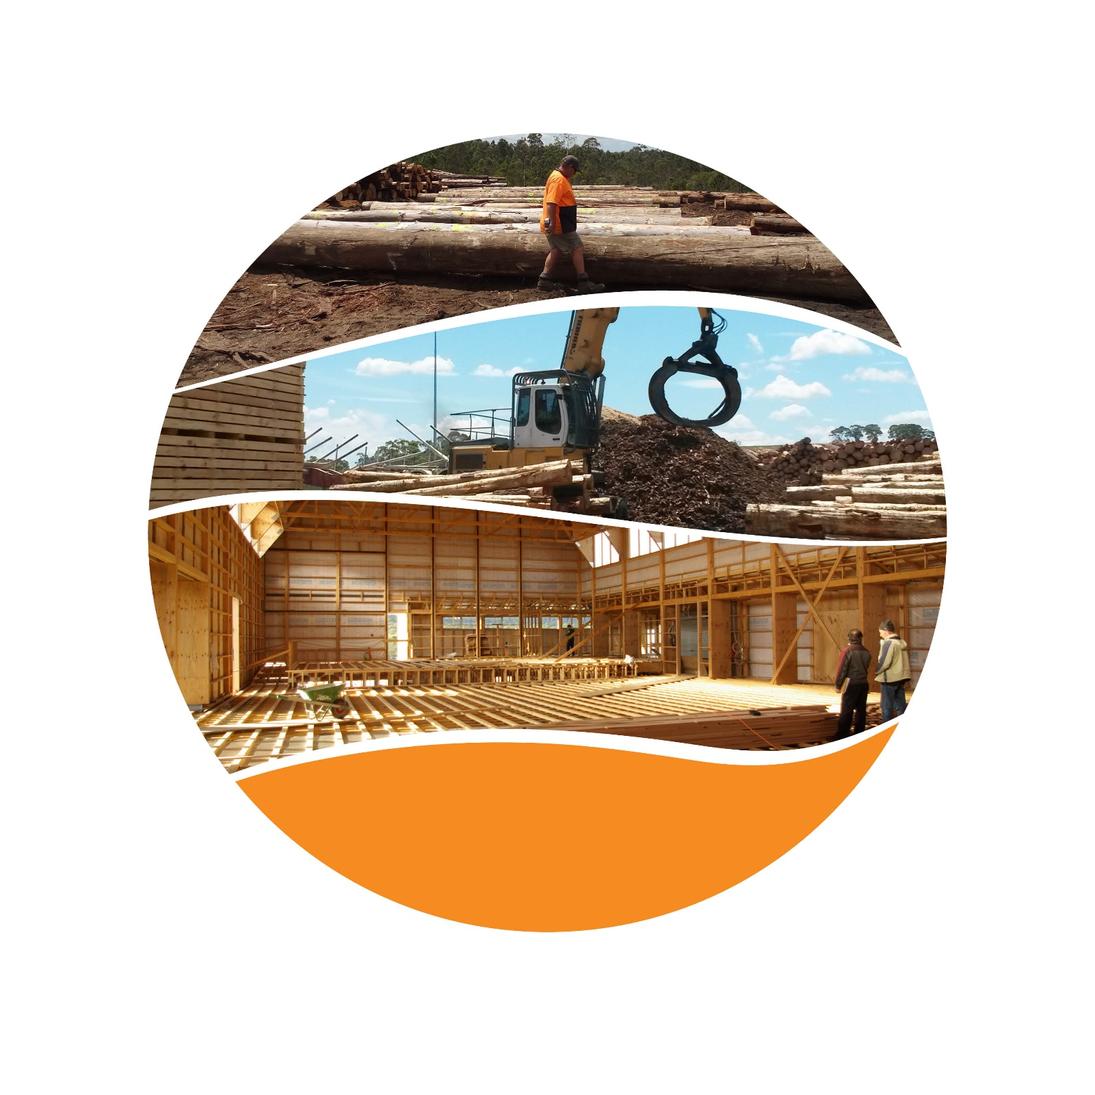© Commonwealth of Australia 2018

**Ownership of intellectual property rights**

Unless otherwise noted, copyright (and any other intellectual property rights, if any) in this publication is owned by the Commonwealth of Australia (referred to as the Commonwealth).

**Creative Commons licence**

All material in this publication is licensed under a Creative [Commons Attribution 4.0 International Licence](https://creativecommons.org/licenses/by/4.0/legalcode) except content supplied by third parties, logos and the Commonwealth Coat of Arms.

Inquiries about the licence and any use of this document should be emailed to [copyright@agriculture.gov.au](mailto:copyright@agriculture.gov.au).

C:\Documents and Settings\west merryn\Local Settings\Temporary Internet Files\Content.Word\by.png

**Cataloguing data**

This publication (and any material sourced from it) should be attributed as: Department of Agriculture and Water Resources 2018, Illegal Logging Compliance Plan: our plan for managing compliance, Canberra. CC BY 4.0.

ISBN 9781760031527 (online)

This publication is available at [agriculture.gov.au/forestry/policies/illegal-logging/compliance](http://www.agriculture.gov.au/forestry/policies/illegal-logging/compliance).

Department of Agriculture and Water Resources

GPO Box 858 Canberra ACT 2601

Telephone 1800 900 090

Web [agriculture.gov.au](http://agriculture.gov.au/)

The Australian Government acting through the Department of Agriculture and Water Resources has exercised due care and skill in preparing and compiling the information and data in this publication. Notwithstanding, the Department of Agriculture and Water Resources, its employees and advisers disclaim all liability, including liability for negligence and for any loss, damage, injury, expense or cost incurred by any person as a result of accessing, using or relying on any of the information or data in this publication to the maximum extent permitted by law.

## Foreword

Welcome to the Illegal Logging Compliance Plan.

The Department of Agriculture and Water Resources is responsible for implementing the Illegal Logging Prohibition Act 2012. The Illegal Logging Compliance Plan presents our focus for compliance activities and assessments and outlines our plan for ensuring industry’s compliance with the Act.

The department takes a differentiated approach to managing compliance by encouraging and supporting voluntary compliance and responding appropriately to those who do not comply. We view compliance as a responsibility shared with industry participants and importers.

I trust you will find this plan useful to better understand the steps we are taking to protect plants and animals and the environment, promote sustainable forest management and reduce the depletion of exhaustible natural resources that are threatened by illegal logging.

Lyn O’Connell

Deputy Secretary

Contents

Foreword iii

Introduction 6

Purpose 7

Prohibition Act and due diligence requirements 8

Compliance approach 9

Compliance posture and client behaviour 9

Education, outreach and advice 10

Compliance audits 10

Administrative measures 10

Civil and criminal penalties 11

Identifying and detecting non-compliance 12

Intelligence gathering through engagement with other law enforcement agencies 12

Working with new and evolving evidence building techniques and forensic capabilities 13

Compliance assessments to 1 January 2018 14

Our future compliance focus 15

Products from fragile and conflict-affected areas 15

CITES listed species and other species of concern 15

Complex supply chains—sourcing through multiple countries 15

Tip-offs and recommendations 16

Environmental non-government organisation reports and studies 16

Previous instances of non-compliance 16

References 17

**Tables**

Table 1 Average annual import trade statistics of regulated timber products 12

**Figures**

Figure 1 The department’s differentiated response to non-compliance 9

## Introduction

Illegal logging has environmental, economic and social costs and is a significant problem in some countries. Estimates of the global extent and overall cost of illegal logging vary, but it is suggested that illegal logging represents an annual cost to the global community of between $70 billion and $206 billion, with illegally logged timber representing between 15 and 30 per cent of the global trade (Nellemann et al. 2016). In some high risk countries illegally logged timber is estimated to account for up to 70 per cent of total timber production. This severely degrades forest environments, reduces biodiversity, undermines government regimes and revenues, and contributes to greenhouse gas emissions. On a very human level, it deprives some of the world’s poorest people of opportunities to improve the quality of their lives.

As a responsible member of the global community and as a producer of legal, sustainable timber products, it is in Australia’s interests to promote sustainable forest management and global trade in legally logged timber. By taking a strong stance against illegal logging, we not only make Australia a less attractive destination for illegal timber we also strengthen our reputation in international markets by showing that the Australian Government is committed to supporting the purchase and sale of legally logged timber products.

Australia is not alone in taking action against illegal logging. Our illegal logging laws complement legislation introduced by the European Union and the United States. Many other countries in the Asia-Pacific region are also now working to develop their own domestic laws to halt the trade in illegally logged products. These actions have already started to change market behaviour.

## Purpose

This plan aims to support industry’s understanding of the department’s approach to the management of compliance of importers and domestic processors under the [Illegal Logging Prohibition Act 2012](https://www.legislation.gov.au/Details/C2015C00427) and the [Illegal Logging Prohibition Regulation 2012](https://www.legislation.gov.au/Details/F2017C00115).

The Illegal Logging Compliance Plan should be read in conjunction with the department’s [Corporate Plan](http://www.agriculture.gov.au/about/reporting/corporate-plan). The Corporate Plan sets out our approach for continued modernisation of our import regulation and export services. The Illegal Logging Compliance Plan by contrast outlines the specific strategic approach for managing illegal logging and describes where compliance monitoring and enforcement activities will be focused.

## Prohibition Act and due diligence requirements

The Illegal Logging Prohibition Act 2012 has been in effect since November 2012. The Act makes it a criminal offence to import illegally logged timber products into Australia or to process Australian grown timber that has been illegally logged. This prohibition applies to all imported timber products (excluding those prescribed as exempt by the Regulation) and all domestically grown logs processed in Australia. ‘Illegally logged’ is defined as timber harvested in contravention of laws in force in the place where the timber was harvested.

This means that if you are importing regulated timber products into Australia or processing Australian grown logs and you receive information that it was illegally logged, or you have reason to suspect it was illegally logged, or you think that there is a significant risk that it was illegally logged, you should not import or process that timber. If you do import or process that timber and it is later found that it was illegally logged, you could face significant penalties, including heavy fines and/or imprisonment.

The Illegal Logging Prohibition Regulation 2012 came into effect on 30 November 2014. From this date, importers of certain timber or timber products (as defined in the Regulation) or processors of domestically grown raw logs are required to assess and manage the risk that the timber has been illegally logged. This is known as carrying out ‘due diligence’. Regulated timber products include most timber and wood-based products, such as sawn timber, pulp, paper, veneer, mouldings, wood panels, flooring, medium-density fibreboard, particle board, plywood and furniture. To undertake due diligence, importers need to:

* have a documented system that outlines how they will meet due diligence requirements
* gather information about the regulated timber products they are importing
* assess the risk that the timber in these products has been illegally logged either by using a Timber Legality Framework, Country Specific Guideline or by using the risk factors prescribed in the Regulation
* where necessary, undertake additional reasonable steps to reduce any risk
* keep a written record of the steps undertaken.

Importers are also required to make a declaration about their compliance with the due diligence requirements when they make a full import declaration in the Integrated Cargo System (ICS), managed by the Department of Home Affairs. Failure to make a declaration is an offence that carries a significant penalty.

From 1 January 2018, businesses and individuals who import regulated timber products into Australia, or who process domestically grown raw logs, may face penalties for failing to comply with the due diligence requirements of the illegal logging laws. The department may issue infringement notices with penalties of $2,520 for individuals and $12,500 for incorporated entities per offence. Civil and criminal prosecution may also be taken against importers and processors who are non-compliant with the requirements of the legislation.

## Compliance approach

The department uses similar principles and the same differentiated approach to managing illegal logging compliance as we do for biosecurity compliance (Figure 1). The approach focuses on encouraging and prompting voluntary compliance and responding to non-compliance in a way that is commensurate with the behaviours of those involved.

Figure 1 The department’s differentiated response to non-compliance

We manage compliance based on the degree of risk associated with four types of importer behaviour. The three high-risk behaviours involve deliberate acts (a few importers), opportunistic acts (a small number of importers) and inadvertent acts (a minority of importers). The low-risk behaviour involves importers who voluntarily comply with the law (the majority of importers).

How we manage high-risk behaviour depends on the intent of the importer. We manage deliberate and opportunistic acts through investigations, targeted and scheduled inspections, warrants, audits, show cause processes and fit and proper person tests. We respond to deliberate and opportunistic acts through criminal/civil prosecution, enforceable undertakings, injunctions, fines, limits on importer business activities, increased intervention rates, and risk-treatment costs.

We manage inadvertent acts through scheduled inspections, audits and fit and proper person tests. We respond to inadvertent acts through increased intervention rates, risk-treatment costs, guidance and advice, and corrective actions.

We manage importers who voluntarily comply with the law through scheduled inspections, audits and fit and proper person tests. We respond to voluntary compliance through reduced regulation, and guidance and advice. 


Note: Adapted from Ayres and Braithwaite, 1992.

### Compliance posture and client behaviour

The department’s illegal logging compliance model assumes that most clients will comply, or try to comply, with their obligations under the illegal logging legislation. For these entities, the department responds by providing clear guidance and advice to facilitate voluntary compliance. Despite having the intention to comply, some clients inadvertently fail to comply because they don’t understand their due diligence requirements and responsibilities. In addition to providing guidance and advice, the department may increase assessment/audit rates for these entities until clear compliance with the regulations can be established.

A small number of entities choose to deliberately contravene Australia’s illegal logging laws and take steps to avoid regulatory actions. The department will respond to deliberate non-compliance with the full force of the law. This includes formal investigation, administrative actions and where necessary prosecution.

### Education, outreach and advice

In order to allow regulated businesses time to adjust to the illegal logging laws the department held a ‘soft-start’ compliance period from 30 November 2014 to 1 January 2018. During this period no penalties were issued in regard to the due diligence requirements. Having emerged from the ‘soft start’, we will continue to focus on securing long-term voluntary compliance by means of education and guidance. The department will continue to enhance communication to the broader regulated community about the legislation and continue to adapt and improve our guidance material to assist the regulated community become aware and comply with the legislation.

In addition, we continue to publish information to support importers to undertake effective risk assessments. Due diligence requires importers to have knowledge of which countries of harvest exhibit a high risk of illegal timber harvesting. We continually adapt and improve our guidance material to assist importers differentiate high risk from low risk pathways, which is necessary for exercising responsible sourcing.

### Compliance audits

The department undertakes audits to assess compliance with the due diligence requirements of the legislation. If your business is chosen for an audit, the department will send you a Request for Information Notice. This will require you to provide information about your due diligence system and how it was applied to the importation of a specific regulated timber product, or the processing of logs. You are required to provide the requested information by the date stated on the notice.

Once your response to this request is received, the department will assess your due diligence system against the Regulation’s requirements. Depending on the nature of the information provided the department may a) provide feedback, b) issue an administrative measure, c) commence civil or criminal investigation, or d) take no action as the importer has met the requirements.

### Administrative measures

The department uses administrative measures to respond in a manner which is flexible, in proportion, and appropriate to the contravention. Administrative measures are typically less expensive to apply than court based measures, and often enable earlier resolution of the matter in question. Administrative measures lend themselves to achieving sound and timely outcomes in the public interest.

Administrative measures undertaken may include:

* issuing ‘Notices of Advice’ letters requiring future compliance
* increased compliance assessments
* infringement notices.

While administrative measures do not require court action to initiate, failure to comply with the conditions of some types of administrative measures may result in court action.

### Civil and criminal penalties

The illegal logging legislation provides a range of civil and criminal penalty provisions and associated civil remedies for certain contraventions. Civil penalties do not result in imprisonment or criminal conviction however, fines issued by the court may be sizeable.

Criminal prosecutions are the most severe compliance measure available to the department. They will generally be used where an importer or processor has deliberately taken an action they know to be in breach of the illegal logging legislation. A person found guilty of committing a criminal offence may receive a criminal record, a fine, and/or imprisonment.

If the department considers prosecution to be the most appropriate measure to address an alleged offence and sufficient evidence is gathered, a brief of evidence will be prepared and referred to the Commonwealth Director of Public Prosecutions (CDPP).

The department is likely to refer a matter to the CDPP where any of the following circumstances occur:

* we have obtained prima facie evidence to suggest that an illegally logged product has been imported or processed
* the Australian Government or community expect that the offence will be dealt with in the public interest
* the offence is of such a nature or magnitude that it is important to deter potential offenders with the possibility of prosecution

and/or

* the alleged offenders’ previous compliance history.

The final decision on whether a prosecution is to be instituted or continued rests with the CDPP. The CDPP will make this decision by considering the Prosecution Policy of the Commonwealth. This policy lists a number of criteria, including whether or not prosecution is in the public interest. The CDPP will also take the department’s views on the matter into account.

## Identifying and detecting non-compliance

We use a range of approaches to identify and detect non-compliance concerning the illegal logging laws. We use the findings of these approaches together with gathered intelligence and shared information to improve the focus and effectiveness of our interventions. By doing this we aim to reduce unnecessary intervention on importers dealing with low risk products and more effectively prevent illegally logged products ending up in Australia’s domestic market.

### Detailed analysis of available datasets

When a customs declaration is made for a regulated tariff code, the information about this consignment is transferred to the department from the Department of Home Affairs. This allows our department to monitor reported compliance with the due diligence requirements for regulated products imported into Australia.

There are approximately 19 000 importers of consignments which contain at least one regulated timber product every year (Table 1). Given the volume of regulated products entering the country, the department utilises advanced analytical software to examine trends in regulated imports and to profile and target consignments that may be a higher risk of being illegally logged.

Table 1 Average annual import trade statistics of regulated timber products

| Category | Unit | Average annual total |
| --- | --- | --- |
| Importers | no. | 19,000 |
| Suppliers | no. | 29,000 |
| Countries of origin | no. | 131 |
| Number of consignments | no. | 190,000 |
| Number of products (lines) | no. | 970,000 |
| Total value of regulated imports | $b | 7.4 |

The department monitors entities that process raw logs by gathering data through public information, other government agencies (both domestic and abroad) and through intelligence networks. There are currently around 400 individual processors of raw logs operating who process approximately 27 million cubic meters of logs per year.

The department carries out assessments and other investigations on entities it considers are of the greatest risk of importing or processing illegally logged timber. Further information regarding where our compliance activities will focus is included in Our future compliance focus.

### I**ntelligence gathering through engagement with other law enforcement agencies**

Working and collaborating with organisations internationally and domestically allows us to significantly increase our intelligence about the complex supply chains associated with forest products and assess the risk of them containing illegally logged products.

Since the introduction of the laws, we have forged strong relationships with our counterparts in international and state governments. With the move to full compliance mode in 2018 these relationships alert us to potential high risk products entering supply chains and instances where suspected trafficking in illegally logged timber is occurring. This information will also be used by the department to focus its communication and compliance activities—including criminal prosecutions.

In addition to working with our partner agencies domestically and internationally, we are also active members of major international and national level fora on forestry and wildlife crime enforcement. These include, for example, the INTERPOL Forestry Crime Working Group, Timber Regulation Enforcement Exchange (TREE) and the Australasian Environmental Law Enforcement and Regulators Network (AELERT) Forest Working Group.

We also collaborate closely with other Australian agencies involved in monitoring forest related crime. This includes, in particular, the Department of the Environment and Energy which regulates the importation of internationally endangered plants and animals under the Convention on International Trade in Endangered Species of Wild Flora and Fauna (CITES).

### Working with new and evolving evidence building techniques and forensic capabilities

New and evolving evidence building techniques and forensic capabilities are another area of importance for our compliance monitoring activities. These technologies are constantly improving and include: mass spectrometry, fibre analysis, near infrared spectroscopy, stable isotopes, DNA barcoding, population genetics and DNA profiling for individualisation.

Understanding and utilising developments in these fields is vital to the conduct of investigations and performance of our intelligence activities, particularly with respect to how evidence might be used to inform departmental actions including civil or criminal prosecutions.

The department will engage with researchers developing timber testing and forensic capabilities capable of supporting our compliance and enforcement work. In the first instance, this work is likely to include undertaking DNA tests on off-the-shelf products considered to be high risk and following up where necessary with due diligence advice, increased interventions, and appropriate enforcement action.

## Compliance assessments to 1 January 2018

During the soft-start compliance period (30 November 2014 to 1 January 2018), the department has been assessing how a selection of importing businesses and domestic timber processors are complying with the regulatory requirements. These compliance assessments were undertaken with a view to raising awareness and educating the regulated community about how to comply. Each business was issued with a Notice of Advice that sets out where their practices comply with the requirements or what they need to change to be able to comply with the requirements in the future.

These assessments have fallen into these targeted categories:

* Assessments of the 512 largest importers—this category accounts for almost 80 per cent of regulated imports by value.
* Assessments focused on imports of high risk products and pathways—these assessments have been undertaken on importers of flooring, products from fragile and conflict states, and furniture from Vietnam.
* Assessments on a selection of domestic level processors.

From these assessments we found that approximately 60 per cent of importers that were assessed were non-compliant with some, or all, of their due diligence obligations. However, this was largely inadvertent non-compliance. While business wanted to comply, most approached for these initial assessments were not aware of the laws and/or how to comply. These assessments have led to improvements in the department’s communications with the regulated community and have served to educate them directly about where improvements need to be made.

Like importers, many domestic processors were unfamiliar with the laws. However, we are still seeing a high level of compliance from this sector, largely due to their accreditation with other timber legality frameworks and successful industry regulation and enforcement at the state level for many decades.

## Our future compliance focus

The department has developed an understanding of the pathways and products that pose the greatest risk of containing illegally logged material. Our compliance efforts will focus on the areas we consider to be the highest risk.

### Products from fragile and conflict-affected areas

Fragile and conflict-affected parts of the world are characterised by weak institutional capacity, ineffective laws and governance arrangements and political instability. While it is possible to buy legal wood from these areas, responsible buyers must negotiate unclear political mandates, contested laws, weak governance and lack of enforcement relating to forest protection, as well as official documents that may be vulnerable to fraud or forgery.

Australian companies considering importing timber from these areas need to invest significant resources to ensure that their due diligence practices are strong and the resultant risk assessments and risk mitigation practices are robust. Numerous reports and tools are available on the internet to help determine which areas are considered to fall into this high-risk category.

Sawn wood is the most common product imported from these types of regions. However, other common product categories include veneers, moulding and strips, joinery products and plywood.

### CITES listed species and other species of concern

The department is strongly committed to supporting the efforts of other nations to protect their threatened timber species, through the Convention on International Trade in Endangered Species of Wild Fauna and Flora (CITES), and more broadly through the use of their own threatened species protection legislation. We work closely with the Australian Government Department of the Environment and Energy to better track and monitor the trade in CITES listed species. We also work with enforcement agencies in other countries.

We will continue targeting species from key areas of concern, looking particularly for where illicit substitution may occur and/or where products made from threatened or illegally harvested species may be imported. Our analytical software alerts us to the importation of many goods likely to contain species of concern—we continually update the data filtering and querying capabilities within this software to remain agile and responsive to any new species of concern.

### Complex supply chains—sourcing through multiple countries

The department understands that long and complex supply chains make it more difficult to complete comprehensive assessments of the origin and/or species of the timber used in regulated products. However, complex supply chains may also increase the risk of a product containing illegally harvested timber as each additional step in the supply chain represents another potential point where illegal timber could be used in the product. The more complex your supply chain, the more information you need to gather to determine the risk of the product containing illegal timber.

In this category, we will be looking particularly at imports from countries that have international reputations as ‘tax havens’—alleged through our intelligence gathering to be notable supply routes for laundering illegal timber.

### Tip-offs and recommendations

Tip-offs are an important source of information about illegal activity. When undertaking your own due diligence assessments we request that you watch and report any concerning activities to the department. These might include, for example: forged documents, goods being sold significantly below the market rate, appropriate taxes not being included in the price, being asked to pay a bribe or being offered a lower price for goods without paperwork.

The department takes allegations of non-compliance seriously. If you know something or have concerns about illegally logged products, report it to:

Redline: 1800 803 006

Illegal Logging Hotline: 1800 657 313 or [ilca@agriculture.gov.au](mailto:ilca@agriculture.gov.au)

We respect the confidentiality of those supplying information and the information will be treated in accordance with Australian Government privacy laws.

### Environmental non-government organisation reports and studies

There are a number of environmental non-government organisations who have spent time amassing considerable information and skill in monitoring and tracking illegal logging. These groups have people on the ground in high risk countries and in some cases have built up substantial evidence regarding high risk pathways and supply chains.

The department will continue to work with these groups as a source of information to support its compliance operations. We closely monitor information presented through the reports prepared by these organisations, and any others, and review allegations made.

### Previous instances of non-compliance

As identified, the department has already undertaken assessments on a number of regulated entities. If you have previously been assessed by the department and received a Notice of Advice relating to the areas requiring improvement. You may be subject to another compliance assessment, particularly if the products you are importing fall into one of the categories identified in this chapter.

## References

Ayres, I & Braithwaite, J 1992, Responsive regulation: transcending the deregulation debate, Oxford University Press, New York.

Nellemann, C, Henriksen, R, Kreilhuber, A, Stewart, D, Kotsovou, M, Raxter, P, Mrema, E & Barrat, S (eds) 2016, The rise of environmental crime: a growing threat to natural resources, peace, development and security, United Nations Environment Programme and RHIPTO Rapid Response–Norwegian Center for Global Analyses, Kenya, p. 7.