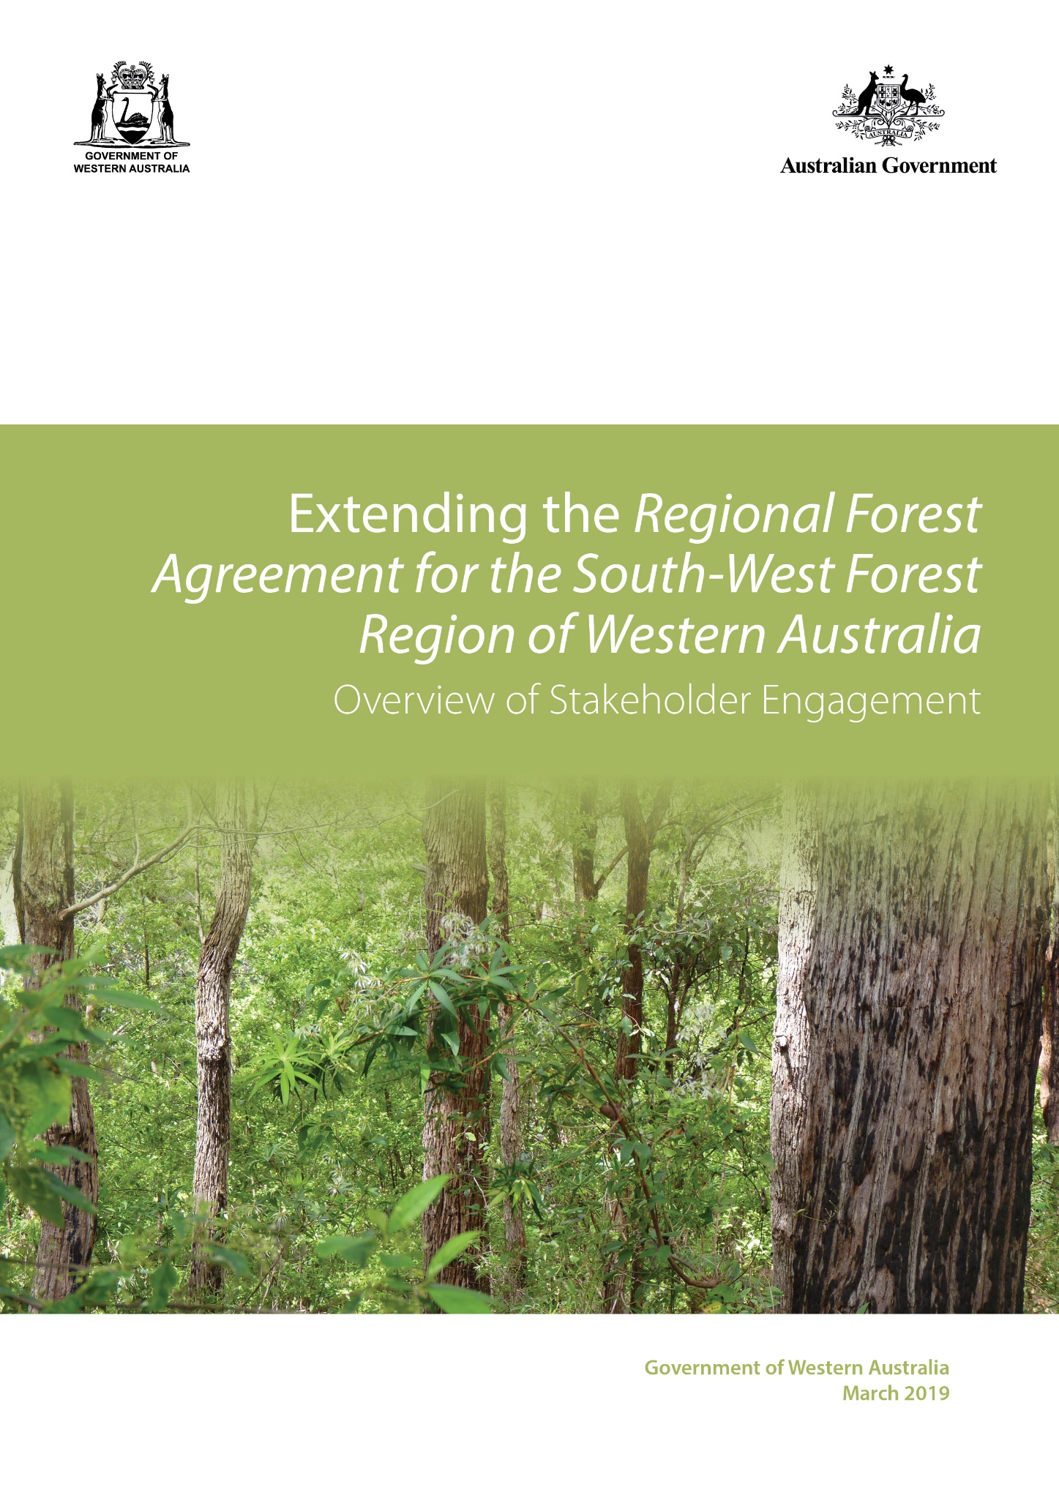

Published by:

Western Australian Department of Biodiversity, Conservation and Attractions

Title Extending the Regional Forest Agreement for the South-West Forest Region of Western Australia:

Overview of Stakeholder Engagement, November 2018

Finalised December 2018

First published March 2019

ISBN 978-1-921703-93-5

More information

Questions regarding the use of this material should be directed to:

Conservation and Ecosystem Management, Parks and Wildlife Service

Department of Biodiversity, Conservation and Attractions

Locked Bag 104

Bentley Delivery Centre WA 6983

Phone: 08 9219 9000

Email: [enquiries@dbca.wa.gov.au](mailto:enquiries@dbca.wa.gov.au)

www.wa.gov.au

Acknowledgments

Department of Agriculture and Water Resources (Australian Government)

Department of the Environment and Energy (Australian Government)

Department of Biodiversity, Conservation and Attractions (Western Australia)

Forest Products Commission (Western Australia)

**Background**

The *Regional Forest Agreement for the South-West Forest Region of Western Australia* (WA RFA), due to expire in May 2019, is a bilateral agreement between the Australian and Western Australian governments. It provides for the establishment of a comprehensive, adequate and representative (CAR) reserve system, the sustainable management of public native forests, plantations and conservation reserves in the south-west and a long-term sustainable native forest products industry.

The Australian Government’s *Strong and Sustainable Forestry Policy* (September 2013) maintains support for long-term Regional Forest Agreements (RFA) by establishing a 20-year rolling life to each RFA. The Western Australian and Australian governments are negotiating a 20-year extension to the WA RFA, with five-year rolling extensions subject to satisfactory implementation over the previous five years.

In extending the WA RFA, the governments will maintain the agreement’s key objectives:

* a CAR reserve system;
* ecologically sustainable forest management and use of WA’s productive forests;
* continued resource access and supply to WA’s forest industries; and
* certainty provided through rolling extensions to the agreement.

**Aim of stakeholder engagement**

The Western Australian and Australian governments sought feedback from key stakeholders on practical improvements to the agreement. While the governments were not renegotiating the WA RFA, or changing the fundamental objectives of the agreement, some improvements to the framework were identified. These are:

* *Modernising the WA RFA* – where practicable, incorporate contemporary information, reflect changes in policy and processes and update references to superseded legislation and policy. Stakeholders were asked what improvements could be made to the WA RFA framework.
* *Streamlined and strengthened review and reporting arrangements* – presently the five yearly reviews examine the implementation of the WA RFA clause-by-clause. Improvements were proposed to review and reporting arrangements to make them outcomes-focused and stakeholder views were sought on how governments could improve outcomes-focused monitoring and reporting as part of extending the WA RFA.
* *Improved and contemporary dispute resolution mechanisms* – these will give the governments more options for resolving issues about the implementation of the WA RFA.
* *Improved communication and consultation* – the governments will hold annual official level bilateral meetings, in the interim years between five-yearly reviews, to discuss issues relating to the ongoing implementation of the WA RFA.

**Overview of stakeholder engagement**

The precursor to extending the WA RFA was the completion of its third five-yearly review. During this process, stakeholders had an opportunity to comment (from 15 November 2016 to 13 January 2017) on extending the agreement. This feedback, the Independent Reviewer’s findings and recommendations on the *Implementation of the Regional Forest Agreement for the South-West Forest Region of Western Australia for the Period 2009-2014 (May 2017)*, and additional stakeholder feedback provided through this process, has informed the proposed extension of the WA RFA.

The Australian and Western Australian governments sought further feedback from relevant stakeholders, and invitations to attend stakeholder engagement sessions were sent to:

* Australian Forest Products Association
* Bee Industry Council of WA
* Chamber of Commerce and Industry WA
* Chamber of Minerals and Energy WA
* Conservation Council of WA
* Department of Jobs, Tourism, Science and Innovation
* Department of Mines, Industry Regulation and Safety
* Department of the Premier and Cabinet
* Forest Industries Federation of WA
* Forum Advocating Cultural & Eco Tourism Inc
* Institute of Foresters of Australian (WA Division)
* South West Aboriginal Land and Sea Council
* WA Forest Alliance
* WA Forest Communities Network
* Western Australian Local Government Association
* Wilderness Society WA.

From 17 to 19 October and on 7 November 2018, stakeholder engagement sessions were held with:

* Conservation Council of WA, WA Forest Alliance and the Environmental Defenders Office
* Bee Industry Council of WA
* Department of Jobs, Tourism, Science and Innovation
* Forest Industries Federation of WA
* Institute of Foresters of Australian (WA Division)
* Alcoa
* South32
* South West Aboriginal Land and Sea Council.

Written submissions were received from:

* Australian Forest Products Association
* Bee Industry Council of WA
* Bushwalking WA, Outdoors WA and Western Australian Rogaining Association Inc (joint submission)
* Forest Industries Federation of WA
* Hon Diane Evers MLC
* Institute of Foresters of Australian (WA Division)
* WA Timber Communities Network.

**Summary of key themes**

Generally, two very different perspectives were presented during the engagement sessions. A number of stakeholders expressed support for a long-term extension to the WA RFA, with a view that it is delivering best practice standards for the WA sustainable forest industry and providing a robust framework in which the Forest Management Plan can function. Many stakeholders also reinforced the need for continued timely access to State forest for their activities. Conversely, the conservation sector held the view that the WA Regional Forest Agreement has failed to afford protection of biodiversity, forest values and the CAR reserve system, or provide certainty of resource to provide for a world class forest industry. As such, they believe the agreement has no social licence or validity and should not be extended.

A number of themes were identified during the engagement sessions, and subsequent written submissions. In providing these themes, no subjective weighting has been given to any theme or comment that would give cause to elevate the importance of one over the another.

A summary of comments received under each theme are as follows:

*General*

* Acknowledgement of the South West Native Title Settlement and ensuring the variation agreement accounts for commitments in the Settlement.
* Support for better dispute resolution mechanisms and better communication.

*Reporting*

* Reviews must be carried out in a timely way to maintain the integrity of the process and to boost both resource security and industry’s social licence.
* Future reviews of the WA RFA should include enhanced reporting on industry outcomes and assess environmental outcomes performance across all land tenure (not just in areas for wood production).

*Operation of the agreement: industry*

* Rolling extensions of the WA RFA will provide more confidence for industry.
* A long-term WA RFA will provide security for forest-based industries including mining, timber and honey production.
* The extension of the WA RFA will encourage markets for lower-value wood products.
* Support for the intent of the WA RFA to provide industry continuity and confidence in long-term timber supply to drive development and investment in the industry.
* The original intent of the WA RFA has been undermined due to large increases in reserve area beyond what was agreed in the RFA, and this must be given serious consideration during the renewal process.
* Not supportive of changes to any processes that would result in lengthened waiting times or increased bureaucracy that would hamper industry.
* Not supportive of changes that further restrict the amount of available State forest for timber harvesting.
* Note the importance of the forest products industry to support regional areas.
* Should be more attention accorded to the economic and social outcomes of the WA RFA to balance the prevailing focus on environmental outcomes.
* Continued timely and efficient access to multi-purpose State forest for a range of activities, including wood resource, honey production, customary practice, tourism, recreation and mining.
* Any impediments to the Forest Products Commission’s timely access to remove wood resources from mining areas would impact on mining commitments in State Agreement Act areas.

*Operation of the agreement: environment*

* An agreement to exempt a select number of forest activities (primarily timber harvesting) from the requirement to be assessed under the EPBC Act is inconsistent and inappropriate.
* The science and knowledge gaps as evidenced by the lack of reporting against the Forest Management Plan key performance indicators display a failure to correctly apply the precautionary principle.
* Implementation of the agreement and the less than satisfactory supporting State laws and processes do not give the community confidence that forests are well-managed and as such the agreement lacks the necessary social licence to continue.
* If the WA RFA is extended, the legal standing of the agreement needs to be enforceable and compliant, not political.
* The current WA RFA fails to ensure that the policy and planning framework of the FMP can be effective in achieving ecologically sustainable forest management.
* The area covered by WA’s FMP lacks any large CAR reserves in high quality, high rainfall jarrah forest.
* Return to the level of scrutiny afforded under the EPBC Act that other industries such as mining are expected to meet.
* An end to logging in native forests, other than that which peer-reviewed scientific research indicates is required to maintain or improve forest health.
* Development of policy and strategy that places ecological health of the forests above the provision of resources for industry.
* Undertake a review of the influence of current sustainable forestry accreditation processes, given the ongoing decline of Western Australian forests revealed by scientific research.

*Operation of the agreement: other*

* Proactive management of forest density in mined and unmined areas will provide better opportunities for water yield, and will maintain biodiversity, timber production and recreational opportunities.
* Access to forest areas is vital for honey production.
* Mining fragments the forest, making prescribed fire and fire-suppression expensive and hazardous.
* Contraction of critical monitoring will make the task of managing and determining trends in forest health much harder.
* Failure to adequately consider and protect healthy recreational opportunities close to the Perth metropolitan area for current and future generations.
* The Forest Management Plan avoids addressing bauxite mining as the greatest threat to WA’s northern jarrah forest.
* World’s best practice minesite rehabilitation strategies cannot successfully replicate or restore the original aged jarrah forest, wandoo woodlands and landscape impacted by bauxite strip-mining in the Darling Range.
* Tourism and recreation are sustainable practices and need to be supported and encouraged.
* Community consultation on matters pertaining to State Agreement Acts and mining operations in forest areas is inadequate.

*Agreement extension process*

* The WA RFA would be strengthened by incorporating contemporary information on the impact of forest harvesting and mining on water flows in the forest ecosystems.
* Supporting documentation to the WA RFA is historical and should be revisited. Only then will it support modern environmental and biodiversity commitments.
* An assessment/investigation of the prospects for carbon farming and emerging carbon markets, along with alternatives to the native forest industry, such as transitioning to plantations, must be undertaken before extending the agreement.
* The community must be assured of continued transparency in assessing processes, science and doctrine that govern the management of forests including the WA RFA and the Forest Management Plan, and there must be opportunities for the community to be consulted and effect meaningful change to this framework on an ongoing basis.
* Provide more meaningful and ongoing opportunities for community members and stakeholders to participate in forest policy, management and evaluation of both, moving beyond current unsatisfactory modes of consultation.
* Whether or not the WA RFA is extended, an analysis of the economics of (and social licence for) native forest harvesting should be undertaken, including an independent performance audit of the FPC.

**Conclusions**

In considering the extension and changes to the Agreement, the governments have had regard to environment, Aboriginal heritage, economic and social values, along with principles of ecologically sustainable forest management. Economic values include the range of industries that derive benefit from the use of forests, including honey production, mining, tourism, timber harvesting and water production.

Consistent with principles of adaptive management and continuous improvement, the governments will consider documents, data and reports published and released since the signing of the WA RFA, to inform the agreement’s future operation should it be extended.

In considering the extension, the governments are proposing updated the dispute resolution process and introduced review provisions should either party consider it necessary to investigate the conduct or operation of the agreement.

The governments noted that some stakeholders opposed native forest timber harvesting; however, current government policy provides for a native forest products industry operating in a sustainable manner. The governments noted that some stakeholders consider that the WA RFA should be terminated rather than extended, however it remains the governments’ position that the agreement provides a suitable national framework for management of south-west forests, and that the Forest Management System in Western Australia gives effect to the agreement.

The governments noted that many stakeholders supported a long-term extension to the WA RFA to ensure ongoing and timely access for forest-based industries, including timber and honey production, mining including State Agreement Act companies, recreation and tourism.

Climate change, including declining rainfall, is recognised as one of the major management challenges to continuing to maintain healthy forests. The proposed changes to the WA RFA include provisions to integrate climate change knowledge into forest management practices. It is also noted that at present a carbon economy is not well established in Australia. Should this change in the future the agreement does not hinder exploration of this sector.