Levy Payer Portal User Guide

Contents
How to register 2
How to log in 4
How to confirm your account 5
Option 1 – Security Question 5
Option 2 – Providing identification documentation 5
How to view your levy amounts paid 6
How to update your details 6
How to reset your password 7
How to change your password 8
How to add users to account 8
How to change the primary user on the account 9
I’m not seeing the correct data in the My Levies tab 10
There is a banner on the My Account screen asking me to confirm my details 10
Contact Us 10

How to register
NB: If you received a Registration Invitation email, click the link in the email and proceed to Step 3
Step 1 – If you have not received a Registration Invitation email, navigate to the Levy Payer Portal Login Page.
Step 2 – Click ‘Levy Payer Portal Registration’. |   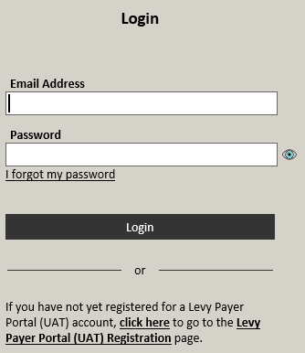
Step 3 – Enter or confirm your:  Business Name (mandatory)  ABN (if applicable)  Business Address (mandatory)  - will show options when you begin typing  - click on address to autofill fields  Mailing Address (mandatory)  - can click Copy Address if same as business address  Business Phone (mandatory)  Business Fax (optional)  Email (mandatory)  Website (optional)  Contact First Name (mandatory)  Contact Surname (mandatory)  Contact Position (mandatory)  Contact Phone and/or Mobile (must enter one) | 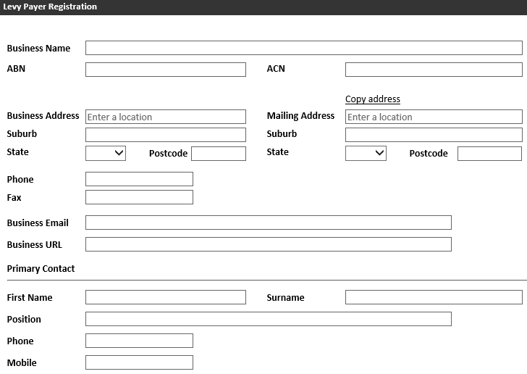
Step 4 – Click ‘Next’. | 
Step 5 – Confirm contact details are correct.
Click ‘Next’.
Step 6 – Enter the 6 digit security code sent to your email address and mobile (if listed) and click ‘Submit’. | 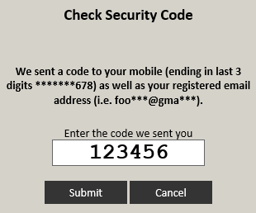
Step 7 – Enter a password in the New Password field. Re-enter the password in the Verify Password field.  - The green tick indicates a valid password  - Two green ticks indicates that the passwords match  - You can click the eye icon to see what you have entered. | 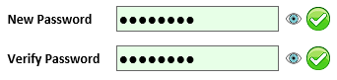
Step 8 – Click ‘Set Password’. | 
Step 9 – Click ‘Continue’. | 
You will receive an email confirming your registration.
Proceed to How to log in.

How to log in
Step 1 – Navigate to the Levy Payer Portal.
Step 2 – Enter your registered email address and password. Click ‘Login’. | 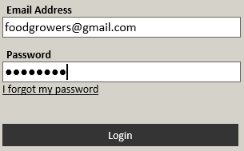
Step 3 – Enter the 6 digit security code sent to your registered email address and mobile (if listed) and click ‘Submit’.

How to confirm your account

Option 1 – Security Question
This option is only available if you have an ABN and you registered by clicking the link in your Registration Invitation email
Step 1 – Login to the Levy Payer Portal.
Step 2 – Click the link ‘Click Here’ for the security question option. (Option 1)
Step 3 – Enter the ABN of Levy Paying Agent (This is the person who collected levy on your behalf, and paid it to the department)
Enter the amount of Levy Paid
(This is the amount of levy you paid in a single return period)
Step 4 – Click ‘Next’.
If you have entered the ABN and amount correctly (you have three attempts), your account will be confirmed and you will receive an email.
If you do no enter the correct amount, you will be required to provide documentation to confirm your identity, see option 2 below.

Option 2 – Providing identification documentation
NB: This option is available for all registrations.
Step 1 – Login to the Levy Payer Portal.
Step 2 – Click the link ‘Click Here’.
Step 3 –  A draft email to Levypayers@agriculture.gov.au will open in your email program.  Attach documentation confirming your identity and/or ownership of ABN. Click ‘Send’. | 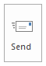
The Department will review the documentation you have sent. Please allow up to 10 working days.
If your account is approved, you will receive a confirmation email.
If the documentation you have provided is insufficent, someone from the Department will be in contact with you.

How to view your levy amounts paid
Step 1 – Click the ‘My Levies’ tab. | 
Step 2 – Enter the dates of the return period you wish to view.
Return period differ between commodities and can be found on the departments website, find the commodity which relates to you and view the ‘Return and payment dates’ section
Step 3 – Click ‘Search’.
Step 4 – If you wish to save this information, click ‘Export All’.

How to update your details
Step 1 – Login to the Levy Payer Portal.
Step 2 – Click ‘My Account’ tab. | 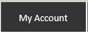
Step 3 – Click ‘Edit Account Details’. | 
Step 4 – Update your details. Click ‘Save Changes’. | 

How to reset your password
Step 1 – Navigate to the Levy Payer Portal.
Step 2 – Click ‘I forgot my password’. | 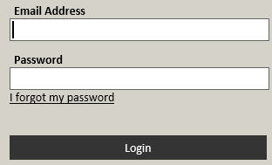
Step 3 – Enter your LRS account number, registered email address and click ‘Submit’. | 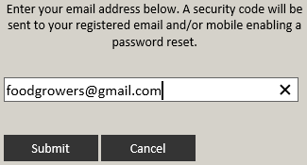
Step 4 – Enter the 6 digit code sent to your registered email or mobile phone and click ‘Submit’.
Step 5 – Enter a password in the New Password field. Re-enter the password in the Verify Password field.
- The green tick indicates a valid password
- Two green ticks indicates that the passwords match
- You can click the eye icon to see what you have entered.
Step 6 – Click ‘Set Password’.
Step 7 – Click Continue

How to change your password
Step 1 – Login to the Levy Payer Portal.
Step 2 – Click ‘My Account’ tab.
Step 3 – Click ‘Authorised Users’ tab.
Step 4 – Click the name of the user you wish to update. | 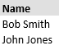
Step 5 – Click ‘Change My Password’. | 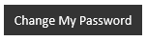
Step 6 – Enter your Current Password.  Enter a password in the New Password field. Re-enter the new password in the Verify Password field.  - The green tick indicates a valid password  - Two green ticks indicates that the passwords match  - You can click the eye icon to see what you have entered | 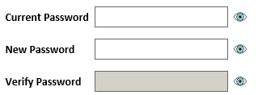
Step 7 – Click ‘Set Password’.
Step 8 – Click Continue.

How to add users to account
Step 1 – Login to the Levy Payer Portal.
Step 2 – Click ‘My Account’ tab.
Step 3 – Click ‘Authorised Users’ tab.
Step 4 – Click ‘New User’. | 
Step 5 – Enter user details.  Email (Mandatory)  First Name and Surname (Mandatory)  Position (Optional)  Phone and/or Mobile (Must have one)  Click the Tick-box if you want this user to be able to maintain user accounts. | 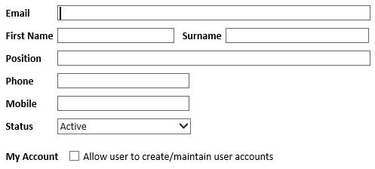
Step 6 – Click ‘Create User’. | 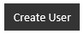
An email will be sent to the new user with their temporary password.

How to change the primary user on the account
There must always be a primary user for your account. If the person listed as a primary user is leaving your organisation, ask them to login and reassign the primary status to another user.
If the primary user has already left you can contact us to update your account for you.
Step 1 – Login as the current primary user, Click the ‘My Account’ Tab
Step 2 – Click the ‘Authorised Users’ Tab
Step 3 – Click the name of the user you want to make primary
Step 4 – Click ‘Edit’ | 
Step 5 – Click Status dropdown and select Primary  N.B. Once to save these changes the primary status will automatically be removed from the user it is currently assigned to | 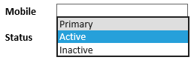
Step 6 – Click ‘Save Changes’ | 
Step 7 – Click ‘Close’ | 

I’m not seeing the correct data in the My Levies tab
Step 1 – Click ‘My Account’ tab.
Step 2 – Click ‘Agent Links’ tab.
Step 3 – Click ‘Submit Query’. | 
Step 4 – Enter details about the information you believe you should be seeing. Click ‘Submit Query’.
Step 5 – Click ‘Close’. | 
The Department will review the information you have sent. Please allow up to 10 working days.
If the department is able to match the relvant information to your account, you will see it in the portal.
If the Department is unable to locate and match the data you have requested, someone from the Department will be in contact with you.

There is a banner on the My Account screen asking me to confirm my details
The Department is commited to providing current information to the bodies that receive levy payer data.
When you see this banner you have two options:
- If your details have changed,
  - Click the Edit Account Details button
  - Update the relevant information
  - Click Save
  - The banner should disappear
- If your details have not changed,
  - Click the click here link in the banner
  - Click Ok
  - The banner should disappear

Contact Us

Free call 1800 022 384
Email levypayers@agriculture.gov.au
Mail Department of Agriculture - Levies
Locked Bag 4488
KINGSTON ACT 2604

