Discussion Paper on Ecosystem Services for the Department of Agriculture, Fisheries and Forestry

Final Report



July 5, 2012

This report was prepared by Board members, staff, fellows and scholars of Australia21, including:

Steven Cork
Geoff Gorrie
Peter Ampt
Simone Maynard
Philippa Rowland
Rachel Oliphant
Lynne Reeder
Lyn Stephens

Australia 21 Limited
ABN 25 096 242 410 ACN 096 242 410
PO Box 3244, Weston, ACT 2611
Phone: FAX: E-mail: Web:
02 6288 0823 02 6288 0823 office@australia21.org.au www.australia21.org.au

Table of Contents
Glossary of key terms and acronyms vii
Executive summary xii
Recommendations xv
1 Introduction 1
2 Terms of Reference 3
3 Approach 4
4 Issues, origins and definitions 6
4.1 Where an ecosystem services approach fits with other approaches 7
4.2 Issues that the concept addresses 8
4.2.1 Getting environmental issues heard in public decision-making 9
4.2.2 Improving the quality and efficiency of public engagement in development and implementation of environmental policy 9
4.2.3 Explaining and justifying environmental policies in the context of broader policy issues 10
4.2.4 Developing whole of government understanding of, and strategic approaches to, the interrelationships between environmental, social and economic issues 10
4.2.5 Mobilising non-government resources to complement government efforts to address public environmental issues 10
4.2.6 Considering equity in decisions that involve multiple social, economic and environmental issues 11
4.2.7 Maintaining conservation of biodiversity as a key societal goal 11
4.3 Definitions 12
4.4 Different classifications are likely to be needed for different purposes 16
4.5 Alignment with economic approaches to benefits 18
4.6 Multifunctionality 19
5 Conceptual frameworks and typologies 20
5.1 Conceptual frameworks 20
5.2 Typologies of ecosystem services 24
5.3 Inclusion of ecosystem services in international environmental-economic accounts 26

Tables
Table 1: Categories of people interviewed directly so far in this study or whose views have been captured indirectly through the MDBA study. 5
Table 2: Examples of the distinction between ecosystems services and the benefits that flow from them with human inputs⁴² (see also Section 5.1). 15
Table 3: It has been argued that different classifications of ecosystem services might be needed for different purposes but that a common definition should be sought.¹⁰² 17
Table 4: Proposed structure for a Common International Classification of Ecosystem Services (CICES) for integrated environmental and economic accounting, and its relationship with ways in which natural capital is currently considered in the international System of Environmental Economic Accounts (SEEA).¹¹⁴ 27
Table 5: Thematic, Class and Group structure proposed for the CICES.¹¹⁴ 28

Figures
Figure 1: The conceptual framework used by The Economics and Ecosystems and Biodiversity project to link ecosystems and human wellbeing.²¹⁵ xi
Figure 2: Stages in the modern history of ecosystem services.¹⁰⁹ 7
Figure 3: The concept of total economic value.^{27, 170} 18
Figure 4: Goods and services can be characterized along a continuum from rival to non-rival and from excludable to non- excludable. 19
Figure 5: A simplified version of the conceptual framework relating drivers of change, ecosystem services and human wellbeing from the Millennium Ecosystem Assessment.¹⁴⁴ 21
Figure 6: The conceptual framework used by The Economics and Ecosystems and Biodiversity project to link ecosystems and human wellbeing.²¹⁵ 22
Figure 7: The conceptual relationships between intermediate and final ecosystem services and benefits.¹⁰¹ 23
Figure 8: The conceptual framework for the UK National Ecosystem Assessment,²²⁸ which was itself adapted from Fisher et al. (2008).¹⁰¹ 25

Boxes
Box 1: Examples of ecosystem services (adapted from Maynard et al.¹⁵⁰) ix
Box 2: Examples of tools proposed by the US Environmental Protection Agency to support their sustainability framework. An ecosystem services approach should be seen as part of a set of mutually compatible approaches that support decision-making. 8

Introduction
The concept of ecosystem services has been gaining traction globally and in Australia for over a decade. The interest in the concept has generated many different interpretations and applications by government agencies and non-government organisations. Nowhere has the proliferation of opinions and ideas about ecosystem services been greater than in regard to agriculture and the management of mixed-use landscapes.
This discussion paper synthesises aspects of ecosystem services thinking and practices, in Australia and internationally, and considers how the concept could contribute more broadly to the policy imperatives of the Department of Agriculture, Fisheries and Forestry (DAFF).
Given that the concept of ecosystem services has been prominent in the scientific literature for over a decade and has been discussed both within government and among DAFF’s stakeholders, one might ask why DAFF has commissioned this study now. Indeed, this question was asked by several of the stakeholders that we interviewed. There are two answers to this question.
Firstly, DAFF has been investing in thinking about ecosystem services for much of the past decade. It was Land & Water Australia, within the DAFF portfolio, that was one of the first agencies to fund a major ecosystem services project in Australia. ⁶⁵ In addition to support for research on ecosystem services, DAFF’s investment has included discussion papers to develop the concept and make it applicable to the practical issues faced by land managers. ¹⁴⁶ Ecosystem services are in integral part of the Caring for Our Country program, jointly administered by DAFF and the Department of Sustainability, Environment, Water, Population and Communities (DSEWPaC). That programme includes a number of strategies for improving ecosystem services outcomes from farm management, and especially soil management which has been poorly understood and underestimated until recently.¹³
Secondly, insights from research on ecosystem and community resilience, together with public service reform and attempts to link carbon emissions policy with broader environmental objectives have brought a new focus on strategic thinking about multiple social and economic benefits from the environment.
There has been growing interest in policy circles and the broader community in how to make Australian society more resilient and able to adapt to change.^{18, 52, 59, 86, 149, 197, 240} Research in this area has shown that social and ecological systems cannot sensibly be considered in isolation from one another.
In the past, government departments tended to act as silos. More recently, however, the process of public service reform, in both the Australia Government and the states and territories, has emphasised the need for whole of government approaches to tackling major challenges. Examples of such challenges include changes in the state of Australia’s natural resources, the demands that Australians place on those resources, and the local, national and global drivers of environmental, social and economic change.
In September 2011, the announcement of details of the Australian Government’s policies to address carbon emissions included a Biodiversity Fund that aims to achieve multiple environmental, social and environmental benefits linked to carbon policy.
Together, these developments call for a framework that enables all Australians to engage in dialogue about the relationships between humans and the natural environments in which they live. The concept of ecosystem services is aimed at supporting this broad and open dialogue in ways that allow potential synergies and tradeoffs among social, economic and ecological objectives to be identified and addressed with due reference to the multiple perceptions that people have about benefits and beneficiaries from the environment.
Apart from these reasons for exploring the use of an ecosystem services framework and language in Australia, this approach is increasingly being used in international dialogue, in which Australia can, and should, be playing a key role. Major nongovernmental organizations (NGOs) and global intergovernmental agencies have been developing ecosystem services programs for several years now. These include The Nature Conservancy, the World Wildlife Fund, the World Resources Institute (WRI), the United Nations Development Program (UNDP) and the World Bank.²⁰⁴
DAFF’s purpose in commissioning this paper is to assess whether the intentions of ecosystem services approaches are appropriate and can be put into practice in Australia and globally and to ask what steps might need to be taken to achieve these intentions.

Terms of Reference
The Terms of Reference for this project were to:
- Review current ecosystem services definitions and discuss their appropriateness for use in Australia
- Examine available conceptual frameworks for ecosystem services - is there a framework within which the impacts of multiple benefits on multiple ecological, social and economic processes can be considered that might be best suited for use in Australia?
- Briefly review activities currently underway in Australia and overseas that seek to incorporate ecosystem services approaches into the management of natural resources, and outline the reasons as to why this approach has not yet been more widely adopted in Australia
- Provide an example framework for the ecosystem services associated with rural lands using Australian examples
- Identify the likely nature of the costs and benefits of an ecosystem services approach for Australia, and the types and scales of supporting information needed to assist in developing an Ecosystem Services framework which could support analysis and discussion of tradeoffs; for example to inform the sustainable population debate.
- Discuss how an ecosystem services approach could be implemented with reference to associated policy measures such as regulation, legislation, market based instruments, codes of conduct, environmental management systems/certification schemes, environmental impact assessment to improve government and other decision-making.
This report in intended to be a key input to a multi-stakeholder workshop/ forum, which will aim to:
- establish an agreed definition and conceptual framework suitable for further consideration of an ecosystem services approach for Australia
- share experiences with implementing services approaches within government agencies and with key interested stakeholders
- discuss barriers to the wider adoption of ecosystem services within Australian government agencies and how this might be addressed
- provide recommendations for further work

Approach
The discussion paper was developed using the following approaches:
- A targeted review of the literature to develop a summary of how the concept of ecosystem services has evolved and been applied in Australia and around the world, and to identify how an ecosystem services approach compares and contrasts with alternative approaches to addressing similar policy issues
- Interviews with key policy makers, researchers and people who have been involved in developing and implementing ecosystems services approaches and/or alternative approaches to similar policy issues
- Development of a systems map of critical issues (driving, enabling, disabling factors, key organisations and their interactions)
- Regular dialogue with DAFF staff to review progress and emerging ideas and conclusions
- Two small working meetings with DAFF staff and selected key experts and stakeholders to develop and refine an example of how an ecosystem services approach might be applied in DAFF’s policy environment
- Preparation of a detailed progress report and a final report.
The interviews were the key component of the project because much has been written in a range of literature and media but the attitudes and interpretations of key stakeholders, which ultimately affect what policies are developed and implemented, are usually not recorded explicitly and in detail. The interviews were carried out as free-ranging conversations aimed at establishing:
- What the interviewee understood about the concept of ecosystems services
- How useful they thought that concept was
- Whether it meets particular needs of decision makers at some or all levels of government and/or non-government decision-making in Australia
- Whether there are alternative and/or better ways to address those needs
- How those needs are currently being met and could be met better (considering the full range of roles government and non-government contributors but especially considering role of government agencies at all levels), including consideration of what barriers exist to meeting the needs and how those barriers might be overcome.
The interviews ranged in time and depth from a few minutes to an hour, depending on how much time an interviewee had available and how relevant their experiences were to the questions being addressed. As themes began to emerge, some interviews were focussed on obtaining views on only one or a few key issues.
As our focus was on assessing how well the concept of ecosystems services might help address the issues surrounding relationships between people and the environment, all of those chosen for interview were people who were expected to be familiar with these issues. To date over 50 people have been interviewed specifically for this project, as indicated in Table 1. Some of those interviewed have themselves conducted interviews with a range of stakeholders about their understanding of the concept of ecosystem services, so we have drawn on those processes indirectly as well. Two other important source of insights for this report were a two-day workshop on ecosystem services convened by Charles Sturt University and CSIRO in August 2011 and a one-day forum on carbon policy at the Crawford School, ANU, both of which addressed a range of issues relevant to this project. The opportunity was taken to discuss aspects of the project with numerous participants in those workshops. Finally, we have drawn on a series of interviews conducted as part of a project for the Murray Darling Basin Authority (MDBA) in 2010,⁶¹ which also asked people about aspects of the processes for management of natural resources that provide context for the current project. The numbers of these interviews are given in the ‘indirect column in Table 1.
Table 1: Categories of people interviewed directly so far in this study or whose views have been captured indirectly through the MDBA study.
Characteristics | Number of interviews
Australian government policy officers experienced in dealing with relationships between people and the environment | 14 | >20
State government policy officers experienced in dealing with relationships between people and the environment | 6 | >20
Local Government and catchment management bodies | 4 | >20
Farmers | 1 | >30
Private investors, investment brokers, business advisors | 8 | >20
Researchers who have been involved in developing ecosystem services approaches in collaboration with governments, regional bodies and other stakeholders (universities, CSIRO and other) | 21 | >30
Non-government environment and industry representative organisations | 3 | >10

Issues, origins and definitions
Key conclusions from this chapter:
- The concept of ecosystem services is now widely used by governments and non-government organisations around the world. The concept has evolved over the past four decades to facilitate dialogue about the relationships between humans and the natural environment, by describing the benefits that humans obtain from the environment in language that a wide range of stakeholders can understand
- The concept of ecosystem services is not intended to focus solely on economic assessments of worth. It is intended to provide a bridge between economic and ecological sciences and between land-use and land-protection interests
- Much of the development of the concept over the past decade has been aimed at improving its ability to be used along side theory and tools from ecology, economics and social sciences
- An ecosystem services classification should have the following elements: A definition of ecosystem services; a framework relating ecological processes to the benefits that flow to people and, broadly, who those people are; a list of services (often including a higher-level grouping of services based on broad types of services and/or the benefits they provide)
- Definitions of ecosystem services appear to be in a transition from ones that saw ecosystem services as ‘benefits to people from ecosystems’ to ones that define ecosystem services as ecological phenomena and benefits as things that flow from services as a result of human inputs
- To avoid problems of double counting in environmental-economic accounts, a distinction has been made in all recent major studies between ‘final ecosystem services’ — those that are directly used by people to provide benefits — and ‘intermediate ecosystem services’ — those that form part of a ‘cascade of services’ that support one another and underpin final services
- Although agreement on a common definition of ecosystem services is likely to be achievable in the near future, it is recommended by several experts that there should be different classifications of ecosystem services for different purposes (although those different classifications should be consistent with one another)

The concept of ecosystem services has been evolving since the 1970s (Figure 1). Its ultimate origins can be traced to the coining of the term ‘ecosystem’ in the 1930s or even to the origins of ecosystem ecology in the 1880s.¹⁵⁵
Figure 1: Stages in the modern history of ecosystem services.¹⁰⁹
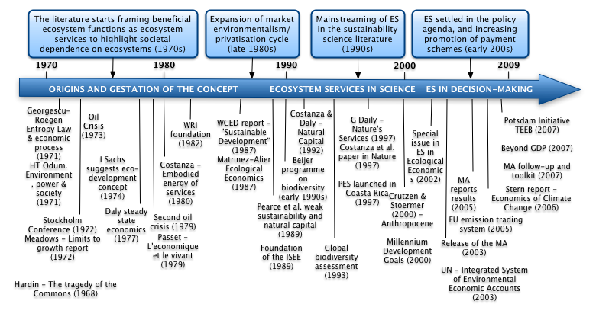

‘Ecosystem services’ is the term that has been used most frequently,^{92; 69; 144} but various alternative have been suggested, including: ‘environmental services’;²⁰¹ ‘public-service functions of the global environment’;¹¹⁸ ‘public services of the global ecosystem’;⁹¹ and ‘nature’s services’.²⁴²
Widespread acceptance of the concept can be tracked to Daily’s 1997 book ‘Nature’s Benefits’.⁷⁴ Since then the development of the concept has proceeded on four main fronts:
- Enumeration of examples of economic and other benefits to society of individual ecosystem services or some bundles of services
- Development of increasingly sophisticated quantitative and qualitative models of the interactions among social, economic and environmental systems
- Use of the concept, and often the models referred to above, as a tool to engage diverse stakeholders in dialogue about relationships between humans and the natural environment to support better planning and natural resource management
- Debate among ecologists and economists to try and harmonise typologies for ecosystem services with the ways in which these disciplines define ‘functions’, ‘processes’, ‘services’, ‘benefits’ and ‘values.
- The history of ecosystem services in economic theory and practice: From early notions to markets and payment schemes.

Where an ecosystem services approach fits with other approaches
In Chapter Error: Reference source not found, we discuss in detail what taking an ‘ecosystem services approach’ means. In summary, an ecosystem services approach is primarily an environmental benefits and beneficiaries analysis. Although such analysis can be put together using other tools, an ecosystem services approach tries to do this more holistically and with more generally-understandable language than other approaches. As such it is potentially an important component of approaches taken by governments, non-government organisations, businesses and community groups in assessing the relative merits of current decisions and thinking strategically about future investments in natural resource management. To be useful it must be compatible with other frameworks and tools that support decision-making in natural resource management (Box 1). Much of the refinement in ecosystem services definitions and approaches over the past decade has aimed at achieving this compatibility.
Box 1: Examples of tools proposed by the US Environmental Protection Agency to support their sustainability framework. An ecosystem services approach should be seen as part of a set of mutually compatible approaches that support decision-making.
Risk Assessment  Life-Cycle Assessment  Benefit-Cost Analysis  Ecosystem Services Valuation | Integrated Assessment Models  Sustainability Impact Assessment  Environmental Justice Tools  Present and Future Scenario Tools

Issues that the concept addresses
The language and concepts of ecosystem services (‘benefits to humans from ecosystems’) emerged due to concern among leading ecologists and economists that, not only was the welfare of other species being given inadequate consideration in decisions by governments, businesses and communities, but benefits critical to human wellbeing were also being overlooked with potentially major, even disastrous, implications. It was argued that these benefits were overlooked due to at least three major ‘failures’ of decision-making:
- Lack of broad understanding about benefits from ecosystems within societies
- The absence of markets for many of these benefits because they are of mostly public rather than private benefit
- The tendency of decision makers at all levels of society to deal with complex issues, such as those relating to ecological or other complex systems, by reconceiving them as simple cause and effect problems and/or to deal with only small parts of a system issues rather than trying to understand and manage the system itself
These challenges have been recognised by economists for some time. They are elements of ‘market failure’ and are frequently referred to as ‘information failure’, ‘institutional failure’ and ‘intervention failure’.
Ecologists have also recognised some of these issues, particularly the third, which is one reason that the term ‘ecosystem’ emerged in the 1930s — to emphasise that the interactions among species and between species and the non-living environment are complex and generate outcomes that are ‘greater than the sum of the parts’.
Given this prior recognition of the issues, questions are often asked by economists, ecologists and policy makers like:
- Why is the concept of ecosystem services needed?
- What is the policy issue that the concept of ecosystem services is trying to address?
Below, we identify several major policy challenges that an ecosystem services approach can add considerable value to:
- Getting environmental issues heard in public decision-making
- Improving the quality and efficiency of public engagement in development and implementation of environmental policy
- Explaining and justifying environmental policies in the context of broader policy issues
- Developing whole of government understanding of, and strategic approaches to, the interrelationships between environmental, social and economic issues
- Mobilising non-government resources to complement government efforts to address public environmental issues
- Considering equity in decisions that involve multiple social, economic and environmental issues
- Maintaining conservation of biodiversity as a key societal goal
Proponents of an ecosystem services approach do not suggest that this approach should replace, or is even capable of replacing, other scientific and/or policy approaches to dealing with these issues. It is an overarching framework that potentially integrates other approaches in some circumstances. Ways to identify when an ecosystem services approach is most appropriate are discussed in Section Error: Reference source not found.

Getting environmental issues heard in public decision-making
Although disciplines like economics have developed approaches to identifying and potentially dealing with benefits from the environment that are not captured by markets (so-called ‘externalities’), economic arguments often do not carry sufficient weight with politicians for them to compete with the arguments of vested interests. The language of ecosystem services is becoming better known and is developing strong international credibility. It is language that politicians can use and be understood by their peers and their constituents. The essence of an ecosystem services approach is discussed further in Chapter Error: Reference source not found.

Improving the quality and efficiency of public engagement in development and implementation of environmental policy
Because the benefits to humans from ecosystems are both public and private and the beneficiaries are many and varied across the whole of society, there is a need for language and concepts that potentially allow all stakeholders to both understand the benefits that they stand to gain or lose from landuse decisions and to engage in productive dialogue about those decisions. Although in theory governments represent public interests and often intervene to protect those interests in the face of market forces that favour private interests, it is difficult for governments to act if the public is unaware of the benefits that are possible and/or unable to articulate their preferences. As discussed in the subsection above, and further in Chapter Error: Reference source not found, ecosystem services approaches have been shown to be powerful ways to generate productive dialogue among stakeholders.
From the point of view of governments, it is important that inputs to decision-making are supported by sound evidence about the nature of the issues (including pubic opinion about them), the context and causes of those issues, the options for addressing the issues, the implications of different decision options, and adequate consultation with all stakeholders. In relation to environmental issues, it has been difficult to obtain informed views from the public because relationships between humans and the environment were often represented in narrow, stereotypic ways by competing interest groups and constructive consideration of tradeoffs between competing interests was difficult because there were few frameworks for considering aspects of environmental management, from conservation to production, together. Combining ecosystems services frameworks with scenario analysis, and consideration of emerging understanding of resilience, adaptability and transformability in ecosystems and societies, is an effective way to not only generate dialogue but enable critical consideration of evidence (Chapters Error: Reference source not found and Error: Reference source not found).

Explaining and justifying environmental policies in the context of broader policy issues
Flowing from the previous point is the responsibility of governments to explain their decisions, which has often been difficult in relation to environmental decisions. A particular challenge is explaining the nature and consequences of tradeoffs between economic, social and environmental values or between competing environmental values. Approaches to assessing ecosystem services are focussing increasingly on trade-off analysis, which not only allows dialogue about those trade-offs but often reveals that what were expected to be trade-offs often do not need to be if alternative management options are considered. Approaches to ecosystem services analysis are discussed in detail in Chapter Error: Reference source not found.

Developing whole of government understanding of, and strategic approaches to, the interrelationships between environmental, social and economic issues
Most government departments do not understand environmental issues and do not see the relevance of environmental policy to them. This has led to the environment struggling to be heard in budgetary debates within government and, arguably, to sometimes perverse environmental implications from decisions made in non-environment departments. Similarly, opportunities for synergies with environmental policies have likely been overlooked. In Chapter Error: Reference source not found we report strong opinions from interviewees that there is a need for better strategic consideration of environmental issues across government departments and we outline how steps towards this objective might be made by developing common language and concepts around the potential benefits from ecosystems and their implications for the business of government departments.

Mobilising non-government resources to complement government efforts to address public environmental issues
A further issue is the strong dependence of Australians on governments to solve society-wide problems, including environmental ones. It is becoming increasingly clear that the whole of society needs to contribute to solutions to Australia’s environmental challenges, including the relationships between environmental management and other ‘wicked’ policy challenges like population policy, climate change and food security, but a framework for debating this issue has been lacking. In Chapter Error: Reference source not found we make recommendations about how the Australian Government might act to encourage and empower other sectors of society to play a greater role in strategic dialogue and action to improve alignment between human wellbeing and environmental management.

Considering equity in decisions that involve multiple social, economic and environmental issues
In their review for the Natural Resource Management Standing Committee, Cork et al.⁶³ noted that:
Conventional benefit-cost analysis does not deal well with ethical issues such as fair distribution or intergenerational equity. The validity of valuation techniques for non-market services, particularly intangible services such as ‘aesthetics’, is highly contestable. Many people consider the ‘utilitarian’ nature of benefit-cost analysis inappropriate for making decisions about environmental assets with ‘intrinsic’ value. An ecosystem services approach does not resolve these issues – in fact it can bring them to the fore – but it does provide a basis for dialogue about what the values are that are being contested. Often this debate occurs without such a framework so the potential for miscommunication is large.
This observation remains relevant today. Approaches such as that being pioneered by the USEPA,^{160, 161, 194, 233} which focus on identifying not only the benefits from ecosystems but also the beneficiaries at a range of scales of space and time, provide important additional inputs to dialogue about equity issue that market signals or vote numbers in elections can convey.

Maintaining conservation of biodiversity as a key societal goal
Some conservation interests and government departments with responsibility for conserving biodiversity have expressed concern that a focus on ecosystem services might diminish the perceived importance of conserving other species for their intrinsic value and/or for moral and ethical reasons. While biodiversity is recognised as the key underpinning of ecosystem services in all widely accepted frameworks, there are differences in how conservation of biodiversity is dealt with in different frameworks. Some have argued that conservation should be considered as an ethical issue separate from the use-based considerations often emphasised in an ecosystem services approach. Others argue that biodiversity should have two key roles in an ecosystems services framework: Maintenance of biodiversity by ecosystem processes can be seen as a so-called ‘intermediate service’ (a service that helps to generate other services) and as a ‘final service’ (a service that is valued directly by people).²²² Whichever approach is taken, it can be argued that an ecosystem services approach can be a way to enhance rather than detract from the importance of human intervention to conserve biodiversity.²²² Concern remains high, however, because despite numerous demonstrations of the economic and social value of biodiversity conservation it is questionable how much people are really willing to pay when more tangible aspects of their wellbeing are perceived to be under threat.¹⁷⁶ Whether or not this is true, it makes sense to have an open and informed dialogue — in the words of the late David W. Pearce ‘begin … with an honest appraisal of just how little we do [value biodiversity]’¹⁷⁶ — so that all stakeholders are aware of the short and long-term implications of decisions about biodiversity conservation.

Definitions
The literature on definitions and classifications of ecosystem services can be very confusing, not only to the uninitiated but also those who have been involved in ecosystem services research for many years (including the authors of this report). In Appendix I we give examples of a range of different definitions. In this section we explain the reasons for these differences.
We conclude that definitions of ecosystem services appear to be in a transition from ones that saw ecosystem services as ‘benefits to people from ecosystems’ to ones that define ecosystem services as ecological phenomena and benefits as things that flow from services as a result of human inputs. While some proponents of ecosystem services approaches still prefer the older ‘benefits from ecosystems’ definitions because of their simplicity and utility as communication tools (see also Section ), four recent definitions that capture the latest thinking and are likely to be appropriate for use by the Australian Government for a range of purposes are:
… [final ecosystem services are] the components of nature, directly enjoyed, consumed, or used to yield human well-being⁴²
… the direct and indirect contributions of ecosystems to human well-being²¹⁰
… the aspects of ecosystems utilized (actively or passively) to produce human well-being¹⁰²
… the contributions that ecosystems make to human wellbeing, and arise from the interaction of biotic and abiotic processes¹¹⁴
Further conclusions from our review (explained more fully in the rest of this subsection) include:
- Ecosystem services are so-named because they arise from the actions of suites of species interacting with one another and the non-living environment — things that might be valuable to people that arise from nature but do not require these interactions (e.g., minerals, sunlight, tidal energy) are not considered to be ecosystem services
- Ecological processes that require inputs from humans (e.g., processes occurring in agricultural systems) are not in themselves considered to be ecosystem services, although they are likely to have ecosystem service components and are examples of synergy between ecosystem and human processes
- To avoid problems of double counting in environmental-economic accounts, a distinction has been made in all recent major studies between ‘final ecosystem services’ — those that are directly used by people to provide benefits — and ‘intermediate ecosystem services’ — those that form part of a ‘cascade of services’ that support one another and underpin final services
- Some services can be intermediate in some circumstances and final in others, depending on the nature of human needs
- There is more disagreement about how to define ecosystem ‘functions’ and there is a lack of clarity about how to distinguish ecosystem services from assets such as stocks, capital, infrastructure and the like — this is not likely to be a major problem for the Australia Government as it easily addressed by defining services in terms of processes rather than assets, as done by most sectors of the economy
- As discussed in Section , although agreement on a common definition of ecosystem services is likely to be achievable in the near future, it is recommended by several experts that there should be different classifications of ecosystem services for different purposes (although those different classifications should be consistent with one another).

The debate about definitions revolves largely around the concept of ‘benefits’.
Early definitions, such as those of Costanza and colleagues,⁶⁹ Daily⁷⁴ and the Millennium Ecosystem Assessment,¹⁴⁴ equated ecosystem services themselves with benefits:
… the benefits human populations derive, directly or indirectly, from ecosystem functions⁶⁹
… conditions and processes through which natural ecosystems, and the species that are part of them, help sustain and fulfil human life⁷⁴
… benefits that people receive from ecosystems¹⁴³
These definitions were deliberately broad and simple to help make the sometimes-complex issues associated with ecology and economics more easily digested by non-specialists.⁶⁷ They are still widely used. The Millennium Ecosystem Assessment definition has been used by the Australian Government,²¹ presumably for the purposes of communication and education. Most successors of the Millennium Ecosystem Assessment — The Economics of Ecosystems and Biodiversity (TEEB) program,²¹⁰ the UK National Ecosystem Assessment²²⁸ and the Global Partnership for Wealth Accounting and the Valuation of Ecosystem Services (WAVES)¹³⁷ — have also adopted the broad definition.
As explained further in Section , however, definitions have been reassessed in the past few years as the concept of ecosystem services has been applied more comprehensively to understanding and assessing the links between ecosystem processes and human wellbeing and, especially, in situations that require rigorous accounting for benefits. The debate began with concern that definitions of ecosystem processes, functions, services and benefits were not sufficiently clear or agreed and that some so-called services were being counted as both means for generating benefits and ends in their own right.^{102, 241} The Millennium Ecosystem Assessment ¹⁴³ brought a heightened focus on the benefits of ecosystem processes by more explicitly defining human wellbeing and the paths by which ecosystems might contribute to wellbeing. Binning et al.³⁴ suggested that services should be defined in terms of the transformations that they mediate (because in economics services are defined as transformations of one sort of capital into another), and Wallace argued that they should be defined in terms of the human needs that they meet.²⁴¹ While neither of these arguments has been taken up explicitly, the debate has moved to the point that recent publications have distinguished between ‘final ecosystem services’, which directly yield benefits to people, and ‘intermediate ecosystems services’, which are still beneficial to people but act to support other services that directly provide benefits.^{42, 102}
The impetus for these more recent recommendations was the need to avoid double counting so that ecosystem services typologies could be better aligned with economic theory and practice. However, their effect was to also encourage further debate about the nature of ‘processes’, ‘functions’, ‘services’ and benefits. While there appears to be general agreement about what ecosystem processes are (i.e., all interactions among components of an ecosystem), there is disagreement about the use of the word function. Although this term is used routinely by ecologists to denote functions that maintain ecosystems, some commentators are concerned that its use in an ecosystem services context infers some sense of human-centric purpose that is unacceptable to some stakeholders.¹⁰² This human-centric bias is apparent in the definition of ecosystem functions used by de Groot et al.⁸¹ — ‘the capacity of natural processes and components to provide goods and services that satisfy human needs, directly or indirectly’ — but not in the definition used by Maynard et al.,¹⁵⁰ — ‘the biological, geochemical and physical processes and components that take place or occur within an ecosystem’.
Two key areas that remain unresolved (although they are moving towards resolution) are:
- exactly which processes can quality to be ecosystem services
- whether services and benefits should be separated.
One element of the debate about what an ecosystem services is relates to what a ‘service’ is. The debate about intermediate and final services and ‘cascades of services’ has helped to sort out previous concerns about mixing ‘means’ and ‘ends’ in ecosystem services approaches. However, the sense of the word ‘service’ seems to have been lost in recent literature. In older literature, it appears that the word ‘service’ was deliberately used to denote the same sort of process that is involved in a ‘service economy’ — that is, a ‘transformation of capital’ or ‘performance of a process’ to provide a benefit that would not otherwise be available.³⁴ In a recent paper that claims to sort out a lot of the confusion about definitions of ecosystem services, Fisher et al.¹⁰² define ecosystem services as ‘aspects of ecosystems utilized (actively or passively) to produce human well-being’. They argue that this definition includes: ‘ecosystem organization or structure as well as process and/or functions if they are consumed or utilized by humanity either directly or indirectly’. Thus, they include stock, capital and infrastructure as services. This is a good definition of ‘things that are important to humans from ecosystems’, but it is not a definition that is consistent with definitions of ‘services’ on any other fields. It might seem pedantic to make this point, but a sure way to inhibit interdisciplinary dialogue is to use common terminology inconsistently. A solution might be to rephrase ecosystem services in ways that convey the transformation of process: for example, ‘maintenance and renewal of natural capital’ or ‘generation of natural capital’ in the example above.
A second element of the debate about what constitutes an ecosystem service is the distinction between services provided by ecosystems and those provided by humans. The intent of ecosystem services approaches from the beginning has been to recognise the benefits that come from systems of ‘natural’ species.⁷⁴ Several authors have argued that there is a need to distinguish between the inputs from humans and the inputs from ecosystems when considering benefits that have an ecosystem component.^{42, 101, 102, 128} It is argued that ecosystem services should be considered to be ecological phenomena and that benefits to people usually require some human input. For example, ecosystems maintain soil fertility but humans plant the crops to produce food. This might seem to be a complicating factor but it makes dealing with multifunctional landscapes easier and clearer. For example, in their assessment of the inputs to human wellbeing from ecosystems in southeast Queensland, Maynard et al.¹⁵⁰ considered the contributions to food production of both from natural ecosystems and agricultural ecosystems that required input of materials and labour by humans. When considering the roles of landowners and managers in delivering services such as water purification or natural pest control to the public¹⁰⁸ in the future, it will be useful to consider the overall social benefit and the contributions made by ecosystems and humans.
The debate about whether services and benefits should be separated has already been alluded to above. The argument for separating them is to recognise that human input is usually required to yield the benefit. For example, some ecosystem services studies identify ‘delivery of water for drinking’ as an ecosystem service. It can be argued that the ecosystem service is provision of clean water and the benefit is drinking water for domestic consumption, which requires both the demand from people to exist and some infrastructure to take the water to taps.^{42, 102} This distinction also highlights the point made by several authors that while ecosystems might produce outcomes that could be beneficial to humans, they only become benefits when people want them. To take this into account, Maynard et al.¹⁵⁰ discuss the merits of estimating both actual and potential ecosystem services.
Table 2 illustrates the distinction between benefits and services according to some authors. There is variation and a certain lack of clarity among recent studies in how this is dealt with. In The Economics of Ecosystems and Biodiversity (TEEB)²¹⁵ and the UK National Ecosystem Assessment,²²⁸ ecosystem services are defined as ‘benefits from ecosystems’ but it appears that services and benefits were identified separately. A recent consideration of soil ecosystem services in Australia³⁰ clearly delineated between services and benefit. The study by SEQ catchments in Australia¹⁵⁰ defines ecosystems services in terms of their benefits but considered the separate inputs from ecosystems and humans, as explained above.
Table 2: Examples of the distinction between ecosystems services and the benefits that flow from them with human inputs⁴² (see also Section ).
Illustrative benefits | Illustrative ecosystem services
Harvests
Managed commercial | Pollinator populations, soil quality, shade and shelter, water availability
Subsistence | Target fish, crop populations
Unmanaged marine | Target marine populations
Pharmaceutical | Biodiversity
Amenities and fulfilment
Aesthetic | Natural land cover in viewsheds
Bequest, spiritual, emotional | Wilderness, biodiversity, varied natural land cover
Existence benefits | Relevant species populations
Damage avoidance
Health | Air quality, drinking water quality, land uses or predator populations hostile to disease transmission
Property | Wetlands, forests, natural land cover
Waste assimilation
Avoided disposal cost | Surface and groundwater, open land
Drinking water provision
Avoided treatment cost | Aquifer, surface water quality
Avoided pumping, transport cost | Aquifer availability
Recreation
Birding | Relevant species population
Hiking | Natural land cover, vistas, surface waters
Angling | Surface water, target population, natural land cover
Swimming | Surface waters, beaches

Taking the above considerations into account, three definitions that are likely to be acceptable to most proponents of ecosystem services approaches (although some might prefer earlier definitions) are:
… [final ecosystem services are] the components of nature, directly enjoyed, consumed, or used to yield human well-being⁴²
… the direct and indirect contributions of ecosystems to human well-being²¹⁰
… the aspects of ecosystems utilized (actively or passively) to produce human well-being¹⁰²
We note here that, since this report was written, Nahlik et al. (2012)¹⁶⁰ have published a review of frameworks for ecosystem service analysis and have drawn essentially the same conclusions as this report. They concluded that separating services from benefits, and focussing on final ecosystem services, is not only consistent with the majority of recent discussions but is also a way to allow a range of disciplines to engage with the concept of ecosystem services. They propose a process the interdisciplinary refinement of definitions for ecosystem services and development of plans to see the concept implemented in policy. This type of approach is similar to hat we proposed in our recommendations arising from this report.

Different classifications are likely to be needed for different purposes
In response to a paper by Wallace (2008),²⁴¹ which questioned the vagueness of the definition of ecosystem services as ‘benefits to people from ecosystems’ and the inconsistency of existing classifications of ecosystem services, Robert Costanza, a pioneer of the concept, argued that such a definition is:
… a good, appropriately broad and appropriately vague definition. This definition includes both the benefits people perceive, and those they do not. The conventional economic approach to ‘benefits’ is far too narrow in this regard, and tends to limit benefits only to those that people both perceive and are ‘willing to pay’ for in some real or contingent sense. But the general population’s information about the world, especially when it comes to ecosystem services, is extremely limited.⁶⁷
Costanza further argued that different definitions and classifications of ecosystem services might be needed for different purposes. Others¹⁰² have agreed with him that different classifications may be needed (Table 3), although, as explained in the previous sub-section, many are arguing for a single definition of ecosystem services.
Table 3: It has been argued that different classifications of ecosystem services might be needed for different purposes but that a common definition should be sought.¹⁰²
Purpose | Characteristics of classifications | Implications for definition
Understanding and education | Categories need to be expressed in plain language that is understandable to the target audience(s) | Broad definitions referring to ‘benefits from nature’ are successful at meeting this purpose, while more complex ones can confuse some stakeholders^{67, 74, 150}
Environmental-economic accounting analysis | To allow the aggregated net benefits (be they measured in economic or other terms) of ecological systems to be assessed, it is important that classifications are based on discrete units so that benefits or costs are only counted once | This purpose has led to definitions that distinguish between ‘intermediate’ (which contribute to a ‘cascade of services’¹¹⁵ services and ‘final’ services (which are directly ‘consumed or enjoyed’ by humans)⁴²
Landscape management | In landscape-scale analyses, there needs to be consideration of where benefits and beneficiaries are in relation to one another and how these arrangements might change through time. Approaches to date have relied on mapping aspects of ecosystem function (see Section Error: Reference source not found). This requires classifications that explicitly link services, benefits and beneficiaries with the underpinning ecosystem processes and functions.^{77, 150, 188} | For this purpose, definitions need to very clearly distinguish between processes, functions, services and benefits. This has been an area of considerable confusion in the literature.^{30, 102}
Public policy and equity in human wellbeing | Public policy often deals with all aspects of ecosystem services considered in this table, but one particular concern of governments is ensuring that public goods and services are shared equitably. Classification for this purpose have focussed strongly on classifying beneficiaries and the links between ecosystem services and human wellbeing.^{30, 42, 150, 194, 241} | Wallace²⁴¹ attempted to define ecosystem services directly in terms of human needs. This paper generated considerable useful discussion but the definition has not been adopted widely. Most existing definitions do refer to human wellbeing in terms of ‘benefits to people from ecosystems’ but the explicit consideration of public-private distinctions and equity issues is dealt with by drawing on the disciplines of economics and social sciences.
Meeting multiple objectives | For both policy and land management the major challenges are setting and achieving multiple environmental, social and economic objectives in an integrated way. This means that classifications of ecosystem services may need to include all of the elements considered above, possibly in a nested was that allows different aspects to be emphasised with different audiences. | As mentioned above, the more technical and complex definitions can inhibit dialogue with some stakeholders but simpler definitions can hinder dialogue with others.

Alignment with economic approaches to benefits
The concept of total economic value (TEV) (Figure 2) addresses the same set of benefits to humans as ecosystem services but it not as explicit about what these benefits are and does not put an emphasis on engagement with stakeholders in identifying and understanding the benefits and beneficiaries. TEV is a framework for economic analysis while ecosystem services is primarily a communication device that focuses on identifying what the benefits are in language that engages a wide range of stakeholders in strategic dialogue that is usually not possible around economic analyses. The tools of TEV are necessary, but not sufficient, to support an ecosystem services approach.
Figure 2: The concept of total economic value.^{27, 170}
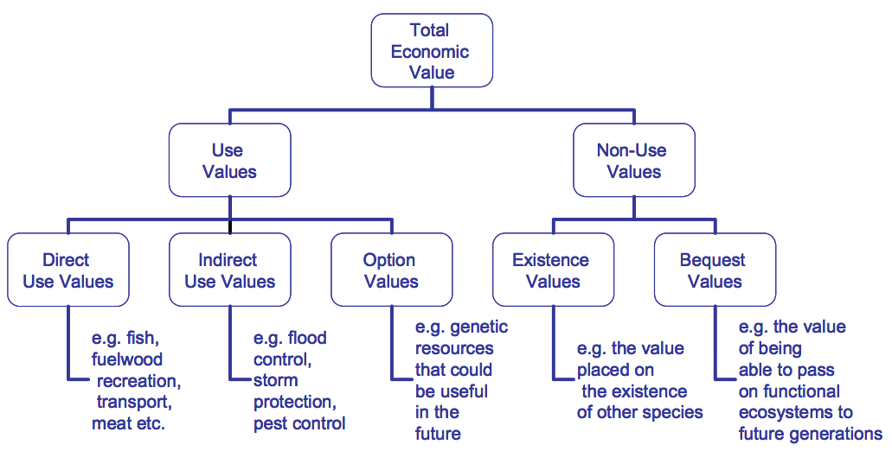

There have been some examples of misinterpretations of the relationships between ecosystem services and TEV. For example, in 2002 an OECD report ¹⁶⁹ inferred that ecosystem services were equivalent to direct and indirect use values only. This misinterpretation was copied in some other publications and used by some representatives of Australian farmers for a few years ⁶³ but appears no longer to be used in the literature or in practice.
A recent attempt to more explicitly align ecosystem services classifications with economic theory and practice is shown in Figure 3. As discussed in the previous sub-section, classifications like this are useful when the purpose is to bring ecosystem services into an economic analysis, but they can be confusing for some other purposes.
Figure 3: Goods and services can be characterized along a continuum from rival to non-rival and from excludable to non- excludable. Some goods that are non-rival at low use levels (fisheries and CO2 storage) can move towards becoming rival goods with high use.¹⁰²
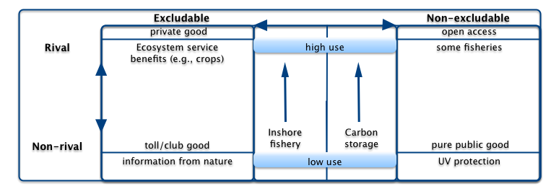

Multifunctionality
In Europe and parts of Asia it has been popular until recently to use the terms ‘multifunctionality’ or ‘multifunctional landscapes’ to refer to landscapes managed for multiple market and non-market values.^{2, 39, 49, 82, 99} This approach has been controversial as it became associated with payments to farmers to continue farming in traditional ways to maintain the cultural and tourism values of landscapes. This was interpreted as subsidisation of agriculture by some and challenged under World Trade Organisation regulations. Similar controversy has arisen in response to payments to rice farmers in Asia.³⁹

Conceptual frameworks and typologies
Key conclusions from this chapter:
- Most recent typologies of ecosystem services have made the distinction between services that have indirect benefits to humans (often, but not always, called ‘intermediate services’) and services that have direct benefits (often called ‘final services’) — this has been an important advance to avoid double counting of benefits and to align ecosystem services approaches with theory in economics and ecology
- Most recent typologies refer to three categories of ‘final’ services: Provisioning services (e.g., provision of food, water, fibre and fuel); Regulating services (e.g., climate regulation, regulation of river flows, control of diseases); and Cultural services (e.g., spiritual, aesthetic, recreational and educational opportunities) (or equivalent names)
- Several high-profile projects have continued the Millennium Assessment practice of referring to a fourth category of services —Supporting services (e.g., primary production, soil formation) — but treating these as ‘intermediate services’ when assessing benefits (this can be confusing to readers not familiar with the origins of this fourth category in earlier typologies)
- Most recent typologies continue the practice adopted by the Millennium Ecosystem Assessment of being explicit about the presumed relationships between ecosystem services and human wellbeing (see also Appendix II).

Conceptual frameworks
The original conceptual frameworks for ecosystem services^{69, 74} defined ecosystem processes, functions and services loosely. This has sometimes led to confusion, lack of uptake of the concept, and even strong opposition to its use, especially from some ecologists and economists. Research over the past 14 years has modified the original conceptual frameworks in several ways:^{42, 77, 81, 101, 128, 241}
- Broad categories of ecosystem services have been identified (provisioning, regulating, cultural and supporting)
- Relationships between ecosystem services and human well being have been made explicit
- The concept of ‘intermediate’ and ‘final’ ecosystem services has been introduced to avoid the potential double counting of benefits
- In some conceptual frameworks the maintenance of biodiversity has been included as a service (e.g., ‘habitat service’) and in others it has been considered to be an underpinning enabler of other ecosystem services (in the most recent frameworks, habitat services have been considered to be ‘intermediate’, and therefore underpinning, services)
The following three figures illustrate the evolution of thinking about ecosystem services over the past 14 years. Figure 4 is the conceptual framework used in the Millennium Ecosystem Assessment during 2000 to 2005. This framework built on the earlier definitions and typologies of ecosystem services such as those developed by Costanza et al.⁶⁹and Daily⁷⁴ (see Appendices I and II). The dialogue associated with the Millennium Ecosystem Assessment revealed that neither the relationships between ecosystem services and human wellbeing nor the nature of wellbeing itself were well understood by the general public, policy makers or social and biophysical scientists. One major contribution of the Millennium Ecosystem Assessment conceptual framework, therefore, was to address these relationships explicitly.
Figure 4: A simplified version of the conceptual framework relating drivers of change, ecosystem services and human wellbeing from the Millennium Ecosystem Assessment.¹⁴⁴ The relationship between ecosystem services and human wellbeing was specified in more detail in other parts of the framework, as was the nature of potential policy and management interventions.

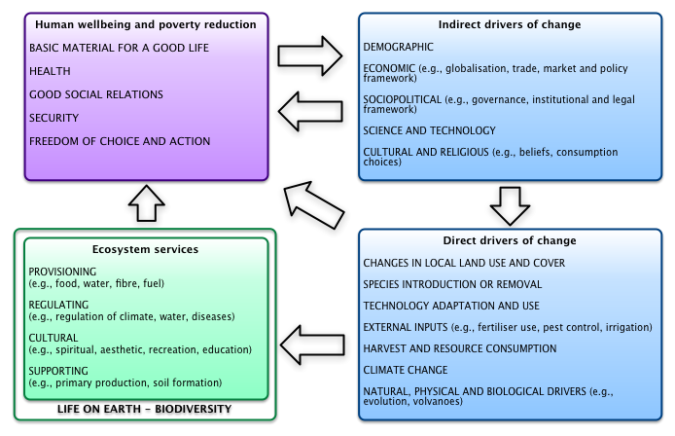

The Economics of Ecosystems and Biodiversity (TEEB) program built on the Millennium Ecosystem Assessment with a focus on developing the conceptual framework further so that it aligned better with economic valuation principles.²¹⁰ It was set up under the auspices of the United Nations Environment Program with a large number of international sponsors and partners (http://www.teebweb.org/Home/tabid/924/Default.aspx). One key advance in this framework is the explicit separation of ecosystem functions, services and benefits (Figure 5). This was a key step required to align ecosystem services thinking with economic theory and practice, which is addressed further in Figure 6.
Figure 5: The conceptual framework used by The Economics and Ecosystems and Biodiversity project to link ecosystems and human wellbeing.²¹⁵
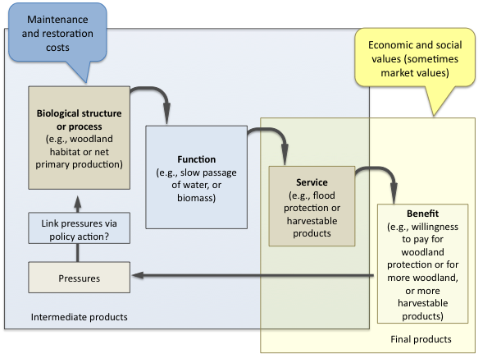

Figure 6 shows the latest thinking about how to align ecosystem services frameworks and typologies with economic theory and practice. Progress towards this interpretation began with the typology developed by deGroot and colleagues⁸¹ (see Appendix II) with major contributions to the debate from Boyd and Banzhaf⁴², Wallace²⁴¹ and Fisher and colleagues.¹⁰¹ It has been further elaborated on in the most recent TEEB foundations document ⁷⁸ but retains the same key components.
Figure 6: The conceptual relationships between intermediate and final ecosystem services and benefits.¹⁰¹
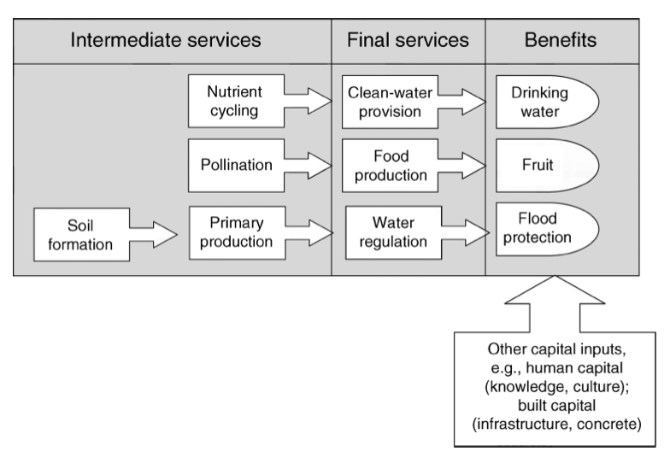
The key advance in these recent conceptual frameworks is that the possibility of multiple counting of benefits is reduced. By separating ecosystem services into intermediate and final services and benefits, the approach recognises that only the benefits generated by the final services can be aggregated. The contrast with previous approaches is illustrated in the following quote¹⁰¹:
The Millennium Ecosystem Assessment divides ecosystem services into supporting, regulating, provisioning, and cultural services. While this typology is useful as a heuristic tool, it can lead to confusion when trying to assign economic values to ecosystem services. For example, in the Millennium Ecosystem Assessment, nutrient cycling is a supporting service, water flow regulation is a regulating service, and recreation is a cultural service. However, we see the first two as providing the same service, usable water, and the third (e.g., recreation on a clean, navigable river) turning the usable water into a human benefit (i.e., the endpoint that has a direct impact on human welfare). If all three Millennium Ecosystem Assessment services were to be individually valued and added to a cost–benefit analysis, we would commit the error of double counting, as the intermediate services are by default included in the value of the final service.
Similarly, food provision is seen as a final service in this approach, whereas pollination is an intermediate service. The benefit is food for consumption. The distinction between ecosystem services and benefits is important because the same service can generate multiple benefits (e.g., flood prevention, drinking water, and recreation), and these can be added together.
The scheme shown in Figure 6 is indicative and there are still challenges associated with putting it into practice. For example, delineation between intermediate service, final services, and benefits is not always clear-cut. The services identified are often a function of a beneficiary’s perspective. Maintenance of native vegetation might be seen as a final service to someone interested in conservation but it might be an intermediate service to someone interested in the role of vegetation in resulting water flows in landscapes. On the other hand, regulation of water flows might be seen as only an intermediate service to someone interested in a steady water supply. These complications are an inevitable reality of how humans perceive and value benefits, but at least the complication of multiple counting has been reduced in the latest approaches.
It should be noted that there are still some small differences of opinion in the use of terminology in ecosystem services frameworks. For example, in the framework and typology adopted by Maynard and colleagues ¹⁵⁰ in southeast Queensland (Error: Reference source not found in Appendix II) components identified as ‘ecosystem functions’ appear to be similar to ‘intermediate services’ in Figure 6. The ‘ecosystem services’ identified by Maynard et al. would probably be classified as a mixture of ‘final services’ and ‘benefits’ by Fisher et al. Similarly, Balmford and colleagues,²⁵ use the terms ‘core ecosystem processes’ (e.g., production, decomposition, nutrient & water cycling), ‘beneficial ecosystem processes’ (e.g., biomass production, pollination, biological control, habitat and waste assimilation), and ‘benefits’ (e.g., food, fresh water, raw materials, energy and wellbeing).
Despite all of these unresolved issues, the concept of intermediate and final ecosystem services has been adopted in the most recent large scale application of ecosystem services analysis, the UK National Ecosystem Assessment.²²⁸

Typologies of ecosystem services
Since the 1990s there have been many attempts to develop and refine typologies (detailed and consistent classifications) of ecosystem services, building on the refined conceptual frameworks discussed above.69, 74, 75, 79, 94, 143, 144, 213, 241 There appears to be emerging consensus that the categorisation of ecosystem services into Provisioning, Regulatory, and Cultural services, as done by the Millennium Ecosystem Assessment (Figure 4) is useful. However, the Millennium Ecosystem Assessment’s fourth category – Supporting services – are better thought of as intermediate ecosystem services rather than final services. This development is illustrated in Figure 7.
Figure 7: The conceptual framework for the UK National Ecosystem Assessment,²²⁸ which was itself adapted from Fisher et al. (2008).¹⁰¹
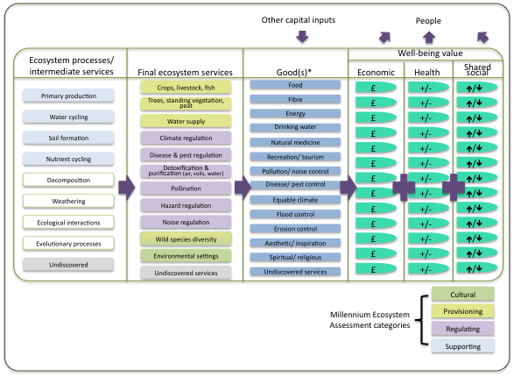

This framework illustrates how the Millennium Ecosystem Assessment’s four categories of ecosystem services — Cultural, Provisioning, Regulating and Supporting — have been recognized but only the first three are considered to be ‘final’ ecosystem services that lead directly to benefits. In the UK NEA report, this figure was accompanied by the following text: “Note that some ecosystem services can be both intermediate and final services. For simplicity, in this figure, services are shown only in the most final position that they occupy. Services such as pollination and climate regulation that also play important roles further back in the chain are not represented here. Cells with colour are ecosystem processes/services that were not in the Millennium Ecosystem Assessment classification. Note [also] that the term good(s) includes all use and non-use, material and non-material outputs from ecosystems that have value for people”.

Several examples of typologies are given in Appendix II. As explained in the previous sub-section, not all recent typologies use the terms ‘intermediate services’ and ‘final services’ but they adopt the principal of separating services that had indirect benefits to humans to ones that have direct benefits.
Several research groups that have worked closely with stakeholders emphasise that it is important to retain flexibility for those stakeholders to identify which services and benefits are most relevant to them.^{1, 34, 150, 190} As discussed previously, the challenge for future ecosystem services projects and programmes will be to encourage environmental-accounting best practice, as illustrated in Figure 5 and Figure 6, while allowing experiential learning to take place.
In response to this challenge, Johnston and Russell¹²⁸ developed a set of guiding questions to help workshop participants distinguish between benefits and intermediate and final ecosystem services. These rules are conceptually simple:
- A fully informed, rational beneficiary would be willing to pay for increases in the service rather than go without it
- The service must represent the output of an ecological system prior to any combination with human labour, capital or technology
- Willingness to pay for the service cannot depend on other ecosystem outputs and conditions
- An ecosystem outcome can simultaneously represent both a final service to some beneficiaries and an intermediate service to others — to avoid double counting, only benefits of final services (as identified by Rules 1-3) should be counted and aggregated.
Despite this apparent simplicity, application of these rules can be quite complicated, as discussed at length with examples by Johnston & Russell¹²⁸ (see also Appendix III). Rule 2, for example, considers whether an outcome is produced with or without human input. If there is human input then the outcome cannot be considered an ecosystem service by these rules. Johnston and Russell give the following example:
For example, fishing – or a harvested fish in the boat – is not an ecosystem service to a recreational angler. Rather, the benefits of fishing result from the combination of the angler's time, fishing gear, and a set of final biophysical outcomes (or ecosystem services) consumed by the angler, including the presence of fish in the water. Once human labour or capital is applied to transform a biophysical output into something else, that “something else” is no longer an ecosystem service but rather the result of human production.
Although Johnston & Russell¹²⁸ argue that the production of ecosystem goods and services requires no inputs of labour or built capital, they acknowledge, after Fisher et al.¹⁰¹, that ‘benefits are typically generated by ecosystem services in combination with other forms of capital like people, knowledge, or equipment’.
Rule 4 is especially complicated to apply, because it considers the fact that some outcomes will be final ecosystem services to some people, but not others, and that it is necessary to consider the different beneficiaries separately to avoid multiple counting. Johnston and Russell¹²⁸ illustrate this challenge using the example of water clarity. Water clarity is an ecological attribute that can be a final service to a lakeside home owner enjoying the view, but can also be an intermediate service to that same homeowner in their role as a recreational user wanting to catch fish that use submerged aquatic vegetation as habitat, given that such vegetation grows better in clear water where sunlight can penetrate. In this case, to avoid double counting of benefits from ecosystem services, it is important to consider only the final services and benefits when aggregating values or exploring tradeoffs.

Inclusion of ecosystem services in international environmental-economic accounts
At a theoretical level, Total Economic Value, a concept from the discipline of economics designed to include use and non-use value and market and non-market values, can be mapped closely to ecosystem services typologies (see a Section ). The difference is that an ecosystem services approaches seeks to be more explicit about identifying the services and benefits and to express them without the use of economic or ecological jargon as far as possible.
At a practical level, there are attempts under way internationally to develop ways to include assessments of ecosystems in the national accounts of nations. The System of Environmental-Economic Accounts (SEEA) is the statistical framework that provides internationally agreed concepts, definitions, classifications, accounting rules and standard tables for producing internationally comparable statistics on the environment and its relationship with the economy. The SEEA approach is being revised under the guidance of the United Nations Statistics Division. As part of this revision, a Common International Classification of Ecosystem Services for Integrated Environmental and Economic Accounting (CICES) is being considered.¹¹⁴ Development of the CICES has been informed by several sources.^{141, 232} First, discussions took place at two international workshops on CICES hosted by the EEA in Copenhagen, December 2008 and 2009. Second, an e‐forum organised on behalf of the EEA ran from November 2009 to January 2010, which was designed to enable a wider international audience to comment on the issues relating to the CICES concept. Over 150 people registered for the forum; participants were invited members from the international community. In 2011, three key meetings were organized that brought together the experts and practitioners from some of the leading institutions in this field. The first was a meeting in March hosted by the World Bank in Washington D.C. to kick-off the Global Partnership for Wealth Accounting and the Valuation of Ecosystem Services (WAVES). The second was the meeting of experts hosted by the EEA in May 2011 to further a consensus on the conceptual framework for ecosystem accounts and the strategy for its development within the context of the revision process of the SEEA. A convergence emerged in both of these recent meetings on the general principles and elements of the conceptual framework for ecosystem accounting, the proposed outline and road map. A third meeting was held in London in December 2011, at which the proposed typology shown in Table 4 and Table 5 was discussed and supported, with input from several Australian individuals and agencies (including the Bureau of Meteorology and the Australian Bureau of Statistics, with papers authored by Richard Mount, Simone Maynard, Steven Cork and others).¹⁴¹
Table 4: Proposed structure for a Common International Classification of Ecosystem Services (CICES) for integrated environmental and economic accounting, and its relationship with ways in which natural capital is currently considered in the international System of Environmental Economic Accounts (SEEA).¹¹⁴
The SEEA is currently under review and the CICES is being considered as a way to report on ecosystems in national accounts.
CICES Theme | CICES Class | Correspondence to SEEA 2003 ‘functions’ of natural capital
Provisioning | Nutrition  Materials  Energy | Resource function  Resource function  Resource function
Regulation and Maintenance | Regulation of wastes  Flow regulation  Regulation of physical environment  Regulation of biotic environment | Sink function  Service function (environmental quality)  Service function (environmental quality)  Service function (environmental quality)
Cultural | Symbolic  Intellectual and experiential | Service function (amenity)  Service function (amenity)
Table 5: Thematic, Class and Group structure proposed for the CICES.¹¹⁴
Theme | Class | Group
Provisioning | Nutrition | Terrestrial plant and animal foodstuffs  Freshwater plant and animal foodstuffs  Marine plant and animal foodstuffs  Potable water
 | Materials | Biotic materials  Abiotic materials
 | Energy | Renewable biofuels  Renewable abiotic energy sources
Regulation and maintenance | Regulation of wastes | Bioremediation  Dilution and sequestration
 | Flow regulation | Air flow regulation  Water flow regulation  Mass flow regulation
 | Regulation of physical environment | Atmospheric regulation  Water quality regulation  Pedogenesis and soil quality regulation
 | Regulation of biotic environment | Lifecycle maintenance & habitat protection  Pest and disease control  Gene pool protection
Cultural | Symbolic | Aesthetic, Heritage  Religious and spiritual
 | Intellectual and Experiential | Recreation and community activities  Information & knowledge

The typology proposed for the CICES is similar to those considered earlier in this chapter. The themes and classes are broad, as would be expected for national accounting. The classification has been cross-referenced to several other major UN standard classifications of environmental processes and benefits: International Standard Industrial Classification of All Economic Activities (ISIC V4); Central Products Classification (CPC); and Classification of Individual Consumption by Purpose (COICOP). It was found that some types of ecosystem outputs are accommodated in these existing classifications but that others are not and that ‘a basis probably exists to propose a new standard in this important new area’.
If Australia decides to develop a national framework for ecosystem services, it should be consistent with the CICES as this, or something similar, is likely to become an important component of international environmental economic accounting in the future.

