Discussion Paper on Ecosystem Services for the Department of Agriculture, Fisheries and Forestry

Final Report



July 5, 2012

This report was prepared by Board members, staff, fellows and scholars of Australia21, including:

Steven Cork
Geoff Gorrie
Peter Ampt
Simone Maynard
Philippa Rowland
Rachel Oliphant
Lynne Reeder
Lyn Stephens

Australia 21 Limited
ABN 25 096 242 410 ACN 096 242 410
PO Box 3244, Weston, ACT 2611
Phone: FAX: E-mail: Web:
02 6288 0823 02 6288 0823 office@australia21.org.au www.australia21.org.au

Table of Contents
8 Dealing with multiple ecological processes and multiple benefits 47
8.1 Policy challenges 47
8.2 Frameworks for integrated assessment of multiple ecosystem processes and benefits 48
8.3 Assessing and addressing information needs 49
8.4 Inferring capacity to deliver ecosystem services from indicators of ecosystem state 51
8.5 Mapping the potential spatial arrangement of ecosystem services 52
8.6 Modelling multiple ecosystem services 53
8.7 Approaches to assessing the value of multiple ecosystem services 53
9 Activities currently underway in Australia and overseas that seek to incorporate ecosystem services approaches into the management of natural resources 58

Tables
Table 10: Summary of approaches to assessing values of ecosystem services in the TEEB project.²¹⁵ 53

Figures
Figure 13: Generalized functional relationships between the levels of ecosystem services provision (Y-axis) and the degree of loss of biodiversity related to different land use intensities (X-axis).⁷⁷ 48
Figure 14: Conceptual framework for evaluating the implications of alternative future scenarios (e.g., policy choices) in relation to multiple ecosystem processes, services and benefits in the TEEB project.²¹⁵ 48
Figure 15: Conceptual Framework for the UK National Ecosystem Assessment showing the links between ecosystems, ecosystem services, good(s), valuation, human well-being, change processes and scenarios for the future of the UK.²²⁸ 49
Figure 16: An example of how the broad state of ecosystems can be assessed visually and related to likely combinations of ecosystem services produced.¹⁰³ 52
Figure 17: A depiction insights for policy from an economic framework for ecosystem service provision.¹⁰¹ 55
Figure 18: Number of papers using the term ‘ecosystem services’ or ‘ecological services’ in an ISI Web of Science search through 2007.¹⁰² 59

Boxes
Box 5: Key research questions to be resolved to support integrated assessments of multiple ecosystem services in landscape planning, management and decision-making.⁷⁷ 49

Dealing with multiple ecological processes and multiple benefits
Key conclusions for this chapter:
- Several large scale international projects have developed and tested frameworks for integrated assessments of multiple ecosystem processes and services
- The key components of these approaches are:
- Identification of information gaps and initiation of research to fill them
- Establishing relationships between indicators of ecosystem state and capacity to deliver ecosystem services
- Mapping ecosystem condition and functions as an aid to spatial planning
- Modelling of multiple interacting ecosystem processes to improve ability to anticipate outcomes of policy and/or management interventions
- Development of scenarios of future human development to anticipate requirements for ecosystem services

Policy challenges
A key dilemma for policy makers is how to adjust policy settings in relation to ecosystem services when different services are likely to change at different rates as policies and land management change.⁶³ This dilemma is illustrated in Figure 1. As landscapes move along the continuum between pristine and highly modified (X- axis), not only will the sum of ecosystem services change but also the relative amounts of different types of services. Because of the different needs of different stakeholders in different places and at different times, there will potentially be winners and losers at any point along the land conversion continuum.
Figure 1: Generalized functional relationships between the levels of ecosystem services provision (Y-axis) and the degree of loss of biodiversity related to different land use intensities (X-axis).⁷⁷
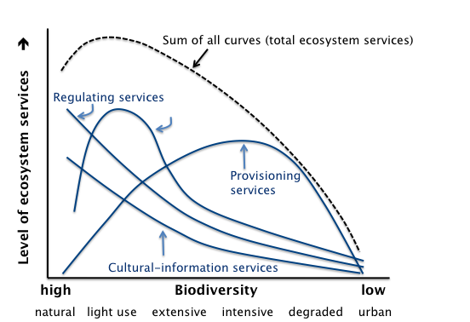
The fact that many ecosystem services are not recognised in markets has led Australian governments, like many other governments around the world, to use incentives, regulations, guidelines and resource-use caps to create and guide markets to include a wider range of ecosystem services.^{11, 33, 54, 157} Increasingly, there are calls for policy to encourage integrated management of multiple services to avoid unintended consequences of only intervening in parts of complex systems. This will require methods for engaging stakeholders in dialogue about the opportunities and tradeoffs that might be involved if governments want support for complex policies and system-level interventions.

Frameworks for integrated assessment of multiple ecosystem processes and benefits
Figure 2 and Figure 3 show two conceptual frameworks for dealing with multiple ecological processes and values at ecosystem scales up to national scales. They build on the types of conceptual frameworks of relationships between ecosystem services and human wellbeing presented in previous Chapters.
Figure 2: Conceptual framework for evaluating the implications of alternative future scenarios (e.g., policy choices) in relation to multiple ecosystem processes, services and benefits in the TEEB project.²¹⁵
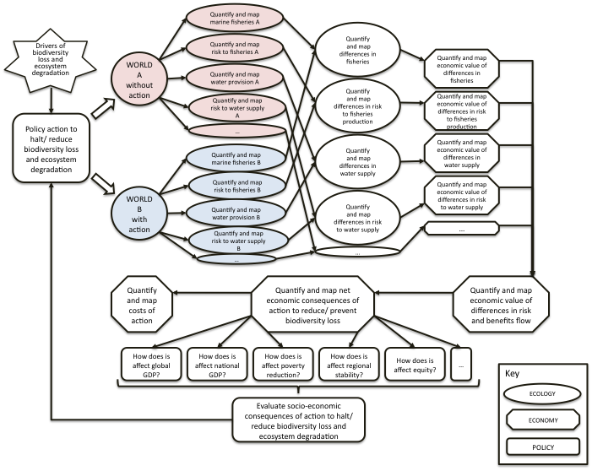

Both approaches stress the need to consider multiple scenarios (with and without actions to manage ecosystem services in the case of TEEB and scenarios for the future of the UK in the case of the UN National Ecosystem Assessment) rather than simply considering current value. This approach requires a good understanding of the service flows and the determinants of demand, and also attention to the spatial heterogeneity of service flows and economic values. This valuation framework is largely consistent with a number of other frameworks developed at around about the same time ⁵¹ and represents leading thinking in this area. A modification of this framework forms the basis for the current CSIRO project assessing the ecosystem services implications of alternative flow regimes in the Murray Darling Basin (Neville Crossman, CSIRO, personal communication 2011).
Figure 3: Conceptual Framework for the UK National Ecosystem Assessment showing the links between ecosystems, ecosystem services, good(s), valuation, human well-being, change processes and scenarios for the future of the UK.²²⁸
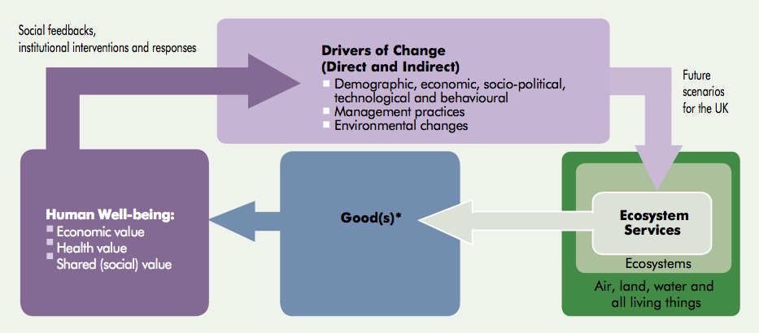
*Note that the term good(s) includes all use and non-use, material and non-material benefits from ecosystems that have value for people.

Assessing and addressing information needs
Several recent syntheses have identified the state of information and the research still needed to support integrated assessments of ecosystem service outcomes.^{47, 75, 124, 143, 144, 215} Box 1 is a summary of key research questions building on these studies.
Box 1: Key research questions to be resolved to support integrated assessments of multiple ecosystem services in landscape planning, management and decision-making.⁷⁷
a. Understanding and quantifying how ecosystems provide services
(1) What is the state-of-the art regarding the typology of ecosystem services?
(2) How can the relationship between landscape and ecosystem characteristics and their associated functions and ser- vices be quantified?
(3) What are the main indicators and benchmark-values for measuring the capacity of an ecosystem to provide services (and what are maximum sustainable use levels)?
(4) How can ecosystem/landscape functions and services be spatially defined (mapped) and visualized?
(5) How can relationships between ecosystem and landscape character and services, and their relevant dynamic interactions, be modelled?
(6) What is the effect of (changes in) dynamic conditions (temporal and spatial) of landscape functions on services, in terms of sustainability and resilience? Are there possible critical thresholds?
b. Valuing ecosystem services
(7) What are the most appropriate economic and social valuation methods for ecosystem and landscape services, including the role and perceptions of stakeholders?
(8) How to make economic and social valuation of landscape and ecosystem services consistent and comparable?
(9) What is the influence of scaling-issues on the economic value of ecosystem and landscape services to society?
(10) How can standardized indicators (benchmark-values) help to determine the value of ecosystem services and how can aggregation steps be dealt with?
(11) How can values (ecological, social and economic) be mapped to facilitate the use of ecosystem services in (spatial) landscape planning and design?
c. Use of ecosystem services in trade-off analysis and decision-making
(12) How can all the costs and benefits (ecological, socio- cultural and economic) of changes in ecosystem services and values of all stakeholders (in time and space), be taken into account properly in discounting and cost-effectiveness issues?
(13) How can analytical and participatory methods be combined to enable effective participatory policy and decision-making dialogues?
(14) How can spatial and dynamic ecosystem services model- ling be linked to participatory trade-off assessment methods to optimize multi-functional use of the ‘‘green and blue space’’?
(15) How can landscape design-alternatives be visualized and made accessible for decision-making, e.g. through expert systems and other decision and policy support tools?
d. Use of ecosystem services in Planning and Management
(16) How to incorporate resilience of landscape functions, and thresholds of service-use, into methods for landscape planning, design and management of ‘green and blue space’?
(17) What are the main bottlenecks in data availability and reliability with regard to ecosystem services management and how can they be overcome? (18) What is the relationship between ecosystem management state and the provision of ecosystem services (both on individual services and the total mix of ecosystem ser- vices)?
e. Financing sustainable use of ecosystem services
(19) What is the adequacy of current financing methods for investing in ecosystem and landscape services? How can they be improved (and linked to valuation-outcomes)?
(20) How to communicate ecosystem and landscape services, and their social and economic importance, to all stake- holders.

In an assessment of the ‘state of ecosystem services’ globally, Searle & Cox²⁰⁴ concluded that, in order to build a comprehensive knowledge base, researchers must:
- Increase replication and standardization of projects
- Increase coordination across disciplines
- Shift to more prospective, decision-guiding research
- Be more willing to publish and accept preliminary results
- Focus on local conditions
They also concluded that:
- The Ecosystem Services field lacks a comprehensive knowledge base (and needs more viable databases for capturing knowledge)
- Greater depth of knowledge exists for wetlands and forests than other ecosystems
- Greater depth of knowledge exists for water and carbon services
- Projects are globally spread, but there is a lack of replication and standardization of projects
- The field lacks standards, and sufficient measurement and monitoring tools
- The field lacks standard decision-support applications
- No application covers all geographies for even the most prevalent ecosystems and services

Inferring capacity to deliver ecosystem services from indicators of ecosystem state
One approach to assessing the capacity of ecosystems to provide services is to establish a typology of state for different types of ecosystems.^{41, 77, 103, 174} For example, a temperate forest might be classified as wild or unmanaged, sustainably managed (selective logging), degraded (clearcut + burnt), intensively managed (plantations, agroforestry, agriculture) or developed (permanent human infrastructure) and a set of ecosystem services might be expected to be associated with each of these states. Figure 4 illustrates this sort of approach. The VAST approach to classifying landscapes and ecosystems, which is widely used in Australia, is based on a similar principle.²¹⁷
Figure 4: An example of how the broad state of ecosystems can be assessed visually and related to likely combinations of ecosystem services produced.¹⁰³
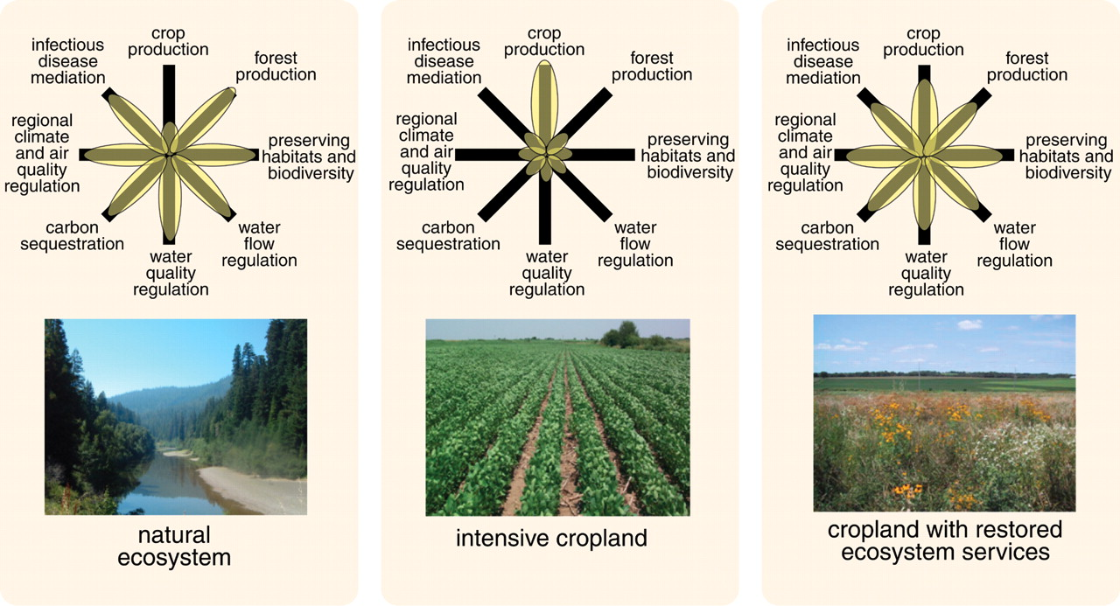
A further level of sophistication is to collect data on indicators of ecosystem services.^{76, 77, 117, 143} Increasingly, indicators of ecosystem function have been used to diagnose the state of ecosystem services provision spatially, which is the subject of the next sub-section.

Mapping the potential spatial arrangement of ecosystem services
Mapping of physical and/or social aspects of landscapes can provide insights into the potential for ecosystem services production and can be related to the places where people and live and require services. There has been a large number of projects producing maps of ‘ecosystem services’ (actually maps of indicators of ecosystem state, condition and/or function) at scales from local to regional.^{188; 48; 90, 163} These studies have consistently found that different ecosystem services are most strongly produced in different areas of landscapes and regions, meaning that spatial mapping and modelling (see next sub-section) are vital tools for considering how to align land management strategies with human needs.⁷⁷
A mapping approach has been adopted successfully in southeastern Queensland, in which relationships between ecosystem attributes and functions were developed by expert panels and the functions were mapped.¹⁵⁰ Maps of this type allow planners and stakeholders to have productive dialogue about the consequences of increases or decreases in human populations in different places, changes in demands on ecosystem services related to the activities and lifestyles of communities in different places, or land management interventions in different places. The feedback from this project (Simone Maynard, personal communication, August 2011) is that the ability to consider ecosystem processes spatially has increased awareness among stakeholders about human-ecosystem interrelationships and alerted them to opportunities for better planning and management of both rural and urban areas. While contemplation of possible economic values of ecosystem services has been useful, the stakeholders have said that the dialogue generated by the maps and associated biophysical and social assessments have been the most important influences on their thinking to date.

Modelling multiple ecosystem services
The past decade has seen the development of a range of computerized models that assess the impacts of economic and environmental factors on natural resources, including the provisioning of goods and services. These include IMAGE-GLOBIO⁴¹, GUMBO⁴⁰ and MIMES (www.uvm.edu/giee/ mimes). Most of these models, however, usually focus only on a few ecosystem goods and services and have limited ability to consider potential effects of management strategies suites of services.⁷⁷
Some regional (dynamic) models have been developed to simulate the impacts of land use change and management on ecosystem goods and services.^{113, 182} The InVEST model is widely used around the world. It provides spatially explicit modelling of multiple services and trade-offs.¹⁶⁸ A number of studies have used GIS techniques to consider the intersection of layers of information on biodiversity, ecosystem function and landuse change.^{48, 90, 106, 131, 151, 236}
Indices of some ecosystem functions have been developed, which can be mapped as part of the consideration of potential for delivery of ecosystem services. These include Mean Species Abundance ^{3, 41}, Biodiversity Integrity Index¹⁴⁷, the Biodiversity Intactness Index²⁰², and the Living Planet Index.¹⁴⁰
In Australia sophisticated landscape models have been developed and applied to considering ecosystem services ³¹ and integrating economic assessments with landuse considerations.¹⁷³

Approaches to assessing the value of multiple ecosystem services
Numerous useful papers, reports and books have been written about approaches to valuing ecosystem services 32, 38, 77, 78, 80, 175, 215, 223 and we will not attempt a comprehensive review here. Table 1 provides a summary.

Table 1: Summary of approaches to assessing values of ecosystem services in the TEEB project.²¹⁵
 | Valuation/ accounting subject |  |  | Methods/ tools/ models
Preference-based approaches | Output value | Use value | Direct use value | Market analysis  Cost methods  Production function | Disciplinary framework:  Neoclassical economics/ market theory
Preference-based approaches |  |  | Indirect use value | Market analysis  Cost methods  Hedonic pricing  Contingent valuation
Preference-based approaches |  |  | (Quasi) option value | Replacement cost method  Mitigation cost method  Avoided cost method
Preference-based approaches |  | Non-use value | Legacy/ existence/ altruism | Contingent valuation  Contingent election
Preference-based approaches |  | Social justice/ deontological values/ lexicographic preferences, non human values |  | Group valuation  Deliberative valuation  Joint analysis | Political science
Biophysical approaches | Insurance value | Resilience value | Probability of flips | Regime shift analysis  Adaptive cycles  Panarchies  Risk analysis | Resilience theory
Biophysical approaches | Physical consumption | Physical cost | Energy/ exergy/ emergy | Emodied energy  Exergy analysis  Emergy analysis | Industrial ecology/ Thermodynamics
Biophysical approaches |  |  | Materials/ surface/ landcover | Material flow analysis  Input-output analysis  Ecological footprint  Land-cover flow | Industrial ecology/ Thermodynamics

A major challenge for economists is aggregating the values of individual ecosystem services affected by such scenarios. The study by Costanza and colleagues ⁶⁹, which focussed worldwide attention on ecosystem services, generated a long and heated debate among ecologists and economists about the legitimacy of calculating total values for the world’s ecosystem services. Many critics argued that it was not legitimate to estimate the total value of ecosystem good and services by multiplying willingness to pay for marginal changes in an ecosystem service (e.g. for services provided by an individual wetland) by the total supply of the service (e.g., the total area of wetlands in a region, country or the world).⁶⁸ Others argued that the total value of the world’s ecosystem services is a meaningless concept as humanity would not accept any amount to lose its life support systems and, anyway, there is no buyer for these systems in their totality. ⁹³
At a finer scale, the problem of potential multiple counting of services and benefits has been a long-standing matter for discussion. The differentiation of intermediate and final ecosystem services, discussed earlier in the section, has gone a long way towards providing a rigorous basis for considering multiple services and benefits (Appendix III). Thus, for example, where previously economists might have been concerned that the value of pollination of plants by animals might get counted twice as the avoided cost of labour to fertilise crops and the value of the food produced by those plants, more recent approaches would see pollination of crops as an intermediate service whose value is (in theory) included in the cost of the products. There still remains the problem that the real value of pollination and other environmental processes are not in reality captured in the cost of agricultural products, and the sort of dialogue that an ecosystem services approach encourages is aimed at gaining recognition of this type of market failure.
The TEEB study has also considered three other aspects of aggregation: aggregation across different groups of people with potentially different needs and values; aggregation of values over different spatial scales; and aggregation of values over time.⁷⁸
Identifying and dealing with tradeoffs among services requires an understanding of the nature of the ecological, social and economic systems, which requires some sort of modelling (addressed below). Key tools used by economists include cost- benefit analysis and cost-effectiveness analysis.^{7, 23, 24, 78, 89, 163, 215} In the past, studies of ecosystem services often focused only on benefits but increasingly studies are considering both benefits and costs together.^{78, 163} Another tool used increasingly, although not favoured by all economists, is multi-criteria analysis^{186, 187}
A critical issue for policy makers arises from the constraint on economists to focus on marginal change (Figure 5). Economics approaches estimate prices for services and commodities by considering how willingness to pay is likely to change in response to a change in supply of, or demand for, that service or commodity, assuming that other components of the economic, social or ecological system stay constant. In practice, this means that the size of the change must usually be small and over a discrete period of time. Another complication is that people’s willingness to pay does not change linearly as supply changes. If a person is thirsty they will pay more for their first drink than subsequent drinks, for example. Value, as against price, is calculated as the sum of all marginal changes in a consumer’s willingness to pay (consumer surplus) and a producer’s willingness to accept payment (producer surplus). These surpluses are, mathematically, the areas under different parts of a supply-demand curve, which, especially when dealing with environmental outcomes, is likely to be non-linear and even discontinuous (i.e., it might involve step-changes, thresholds and irreversibilities).
Figure 5: A depiction insights for policy from an economic framework for ecosystem service provision.¹⁰¹
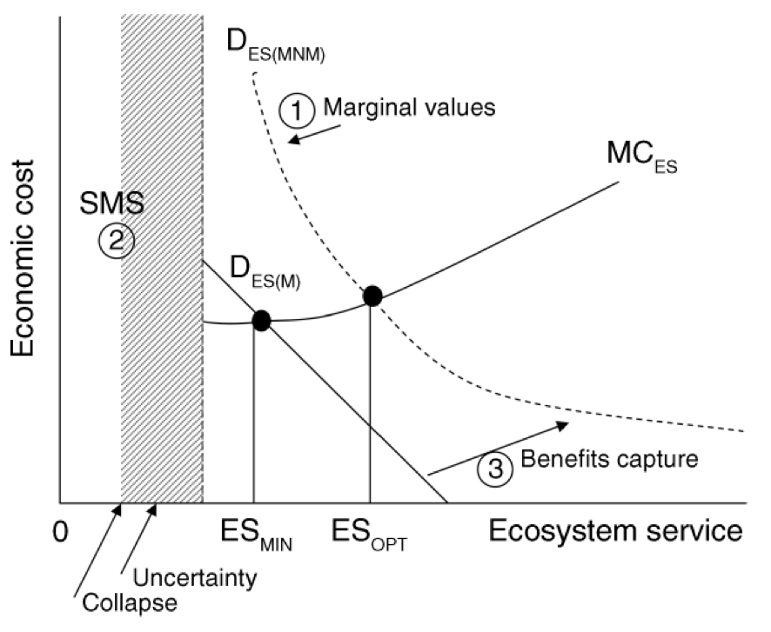
Circled numbers refer to the following insights. (1) Ecosystem services should be studied as marginal changes in landscapes or seascapes. Researchers should ask questions such as ‘Does the conversion of one more hectare of forest to agriculture represent a beneficial trade-off?’ This should lead to further questions of ‘Who benefits/loses?’ and ‘Where is the benefit realized?’ (2) At some level of degradation most systems will collapse. Knowing where this point is (safe minimum standard [SMS], i.e., some minimum level of structure or process) is crucial for point 1 (appropriate evaluation) and point 3 (policy integration). (3) Because most ecosystem services are public goods, the market will not provide an optimal level but only DES(M), the demand curve (for marketed ecosystem service benefits). For optimal ecosystem service provision we need mechanisms to provide for nonmarket services, moving to DES(MNM), the demand curve for all ecosystem service benefits, both marketed and non-marketed. The supply curve, MCES, represents the marginal cost of acquiring and managing additional units of ecosystems; ESMIN is the point where only marketed services of a landscape are provided (demanded); ESOPT is the optimal level of forest diversity and cover to supply other services.

The reason that these issues are a problem for policy makers is that many stakeholders will be asking questions about major environmental and social changes. For example, in relation to the proposed changes to water diversions in the Murray Darling Basin, many stakeholders are asking questions like: ‘What are the likely ecological, social and economic changes over the next 50-100 years as a result of different diversion options?’ The answer to this question depends not just on the likely ecological changes as a result of changed water flows, but also on how people respond in terms of land management, and social and business processes. Economic valuations can contribute to dialogue around this question, but it requires a much broader range of inputs and consideration of multiple possible futures.
Fisher and colleagues¹⁰¹ reviewed 34 studies that focused on ecosystem services with either an explicit or potential policy interaction. Few of these studies investigated how ecosystem services and/or their value changed with time or in relation to alternative policy or management scenarios (most focused on current value, for example). Fisher and colleagues suggested that there needs to be much greater focus on alternative future scenarios of policy and decision-making options in research on the economics of ecosystem services (notably, this recommendation was taken up in the recent UK National Ecosystem Assessment²²⁸). Another limitation of most studies was that it has not been possible to consider the minimum requirements for ongoing service delivery, especially the minimum numbers and types of species required and the possibility of non-linear change, such as sudden changes in ecosystem function once a critical threshold in species composition and/or resource levels is reached. These needs have been recognized in other major international studies, including the Millennium Ecosystem Assessment ⁴⁷ and The Economics of Ecosystems and Biodiversity ²¹⁰ (also see Error: Reference source not found).
Many of the studies reviewed highlighted the importance of establishing mechanisms, such as taxes, levies, payments for ecosystem services and cap and trade mechanisms as ways to allow markets to find ways to share ecosystem benefits among potential beneficiaries efficiently.¹⁰¹ A major study of the potential for payments for ecosystem services in China concluded that:
While the valuation of ecosystem services is an important ongoing part of developing ecosystem service markets, PES, and eco-compensation programs, policy makers focus less on calculating these values, and more on designing the mechanisms necessary to allow stakeholder negotiations to effectively arrive at eco-compensation subsidy rates.²⁴⁸
Payments for ecosystem services (PES) is a concept that emerged in the mid-2000s. It can be defined as: ‘a voluntary transaction whereby a well-defined ecosystem service, or a land-use likely to secure that service, is being “bought” by at least one buyer from at least one provider – if, and only if, the provider secures the provision of the service’.^{230, 247} An International Payments for Ecosystem Services Programme (IPES) was established in 2006 jointly by The World Conservation Union (IUCN) and the United Nations Environment Programme (UNEP), in close collaboration with the Secretariat of the Convention on Biological Diversity (CBD).²³⁰ Australia had involvement in that programme via CSIRO. This initiative appears to have stimulated a number of smaller projects around the world, especially in developing countries.
A related debate is that about ‘bundling’ or ‘stacking’ ecosystem service payments.^{33, 87} This debate has been active in Australia since the early 2000s, when there was growing interest in promoting farm forestry as a way to reverse salinity and it became clear that profits from growing and harvesting trees would not yield a sufficient return in many parts of Australia to be competitive with other land uses.³³ Stewardship programs in Australia, which pay land owners to manage for protection and improvement of biodiversity, allow those land owners to also receive payments for other ecosystem services, such as carbon sequestration.^{14, 15} There is currently an active debate in the USA about the merits of ‘stacked’ payments for multiple ecosystem services from the same piece of land.⁸⁷ On the one hand, it is argued that multiple payments provide greater incentives for landowners to manage for balanced ecosystem services outcomes and they might allow different types of projects to be undertaken than those possible when only single payments are allowed. On the other hand there is concern that multiple payments that only target a small proportion of services have just as much potential to distort land management as payments for single services and that the processes for defining and measuring services separately from one another might be too complicated for most potential participants in the markets to cope with.

Activities currently underway in Australia and overseas that seek to incorporate ecosystem services approaches into the management of natural resources
Key conclusions from this Chapter:
- There has been a core set of major international studies that have developed the ecosystem services concept globally, which has included the Millennium Ecosystem Assessment, The Economics of Ecosystems and Biodiversity (TEEB) programme and the Wealth Accounting and the Valuation of Ecosystem Services (WAVES) programme
- The core tool for the WAVES program is the System of Environmental-Economic Accounting (SEEA), which Australia has played a role in developing
- The SEEA framework has been adopted by the Australian Bureau of Statistics’ for the development of national environmental-economic accounts,^{6; 235} and relates to a National Plan for Environmental Information.¹⁵
- The focus of research activity in Europe and the USA over the past decade has moved from studies on the economic worth of individual ecosystem services to large scale studies of multiple services
- There has also been a lot of activity to refine typologies and frameworks for ecosystem services to align them better with economic and ecological theory
- In Australia there has been series of world-leading projects demonstrating the importance of ecosystem services to various agricultural industries and to human settlements, and ecosystem services analysis is currently being applied to assessing implications of sustainable diversion limits in the Murray Darling Basin
- Ecosystem services have become core business for some agencies in Europe and the USA
- Ecosystem services are significant components of conservation and land management policies and strategies at the national scale in Australia and in most states and territories.

Globally, and in Australia, there has been an exponential growth in publication about ecosystem services overt he past decade (Figure 6). Appendices IV and V summarise some of the major international and Australian activity on ecosystem services over the past decade. Most of the key lessons from this activity — especially with respect to conceptual frameworks, typologies and approaches to assessing multiple ecosystem services and benefits — have been captured in other sections of this report. Our summary here is very brief, therefore.
Figure 6: Number of papers using the term ‘ecosystem services’ or ‘ecological services’ in an ISI Web of Science search through 2007.¹⁰²
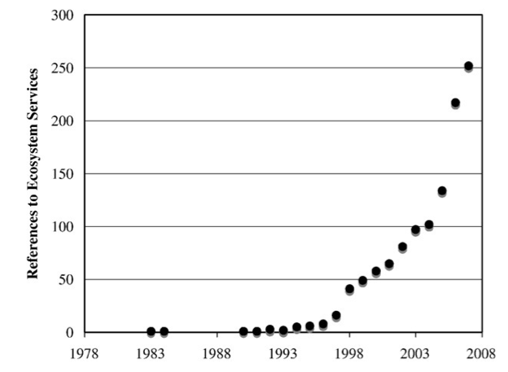
‘Environmental services’ as a search term, was left out as it returned publications related to hospital environments. Therefore, the graph is indicative but clearly an underestimate.

There has been a core set of major international studies that have developed the ecosystem services concept globally, which has included the Millennium Ecosystem Assessment (MA), The Economics of Ecosystems and Biodiversity (TEEB) programme and the Wealth Accounting and the Valuation of Ecosystem Services (WAVES) programme. These have been supported by the United Nations, the World Bank and a range of private and public partners, including the Australian Government. They have interacted and overlapped with a range of other programmes running at regional, national and global scales. The Millennium Ecosystem Assessment built on the foundational work by Robert Costanza, Gretchen Daily and their research groups in the late 1990s and developed a framework that more explicitly related ecosystem services with elements of human well being and options for intervention by decision makers. TEEB refined frameworks and approaches for economic valuation of ecosystem services. WAVES aims to develop and implement internationally accepted and standardized approaches to natural capital accounting, focusing on ecosystem services, at the national or sub-national levels. Development will occur initially in six to ten developing and developed countries to demonstrate its feasibility, and then the approaches will be promoted more widely. The core tool for this program is the System of Environmental-Economic Accounting (SEEA), which Australia has played a role in developing. The SEEA framework has been adopted by the Australian Bureau of Statistics’ for the development of national environmental-economic accounts,⁶ and relates to a National Plan for Environmental Information being developed as a whole of government initiative implemented jointly by the Department of Sustainability, Environment, Water, Population and Communities and the Bureau of Meteorology.¹⁵
Interlinked with this core pathway of development, has been a very large amount of research activity in relation to ecosystem services in the past decade, especially in Europe and the USA. There has been a movement from many studies on the economic worth of individual ecosystem services to a few large-scale studies of multiple services. Three reasons suggested for the primary focus on studies of single or a few services are: (1) the science is often clearer and analysis more straightforward when dealing with a small number of services; (2) in the case of policy development, government departments usually have a focus that includes authority to address only some ecosystem services and so they are more interested in supporting projects that are narrow rather than broad; and (3) businesses also are more likely to support and use research focussed on those services that either provide benefits to them or are affected by their operations.²⁰⁴
There has been a lot of activity to refine typologies and frameworks for ecosystem services to align them better with economic and ecological theory. Thinking about how to assess economic and other aspects of the value of ecosystem services has advanced considerably, to the point where most obstacles to collaboration between ecologists and economists have been overcome.
Although Australia took an early lead in attempting large-scale studies of ecosystem services, support for such projects has waned in the past decade. CSIRO and university researchers have conducted a number of high quality small-scale studies that have demonstrated the importance of certain ecosystems services and/or groups of organisms to particular agricultural industries and/or Australian society generally.1, 28, 29, 34-37, 46, 55, 56, 65, 71, 129, 133, 139, 189, 190, 192, 193, 207, 238, 244 This year a project has been commissioned to apply the sorts of approaches used in large scale studies in Europe and the USA to assess the potential ecosystem benefits of a sustainable diversion limit scenario for the Murray Darling Basin and compare the benefits with those expected from a business as usual scenario. CSIRO and Charles Sturt University are the lead researchers (Tony Webster, MDBA, personal communication 2011). This project is, however, being run on a very limited timeframe and so can hope to make only modest progress.
Ecosystem services have become core business for some agencies in Europe and the USA (Appendix IV) and they are significant components of conservation and land management policies and strategies at the national scale in Australia and in most states and territories (Appendix V).

