# NAQS Asian honey bee floral surveillance manual

Anthony Rice, Isarena Schneider, Samantha Barnett, Sally Cowan



© Commonwealth of Australia 2016

Referenced in 2014 by Plant Health Australia.

**Ownership of intellectual property rights**

Unless otherwise noted, copyright (and any other intellectual property rights, if any) in this publication is owned by the Commonwealth of Australia (referred to as the Commonwealth).

**Creative Commons licence**

All material in this publication is licensed under a Creative Commons Attribution 3.0 Australia Licence, save for content supplied by third parties, logos and the Commonwealth Coat of Arms.

Creative Commons Attribution 3.0 Australia Licence logo

Creative Commons Attribution 3.0 Australia Licence is a standard form licence agreement that allows you to copy, distribute, transmit and adapt this publication provided you attribute the work. A summary of the licence terms is available from [creativecommons.org/licenses/by/3.0/au/deed.en](http://creativecommons.org/licenses/by/3.0/au/deed.en). The full licence terms are available from [creativecommons.org/licenses/by/3.0/au/legalcode](http://creativecommons.org/licenses/by/3.0/au/legalcode).

Inquiries about the licence and any use of this document should be sent to [copyright@agriculture.gov.au](mailto:copyright@agriculture.gov.au).

**Cataloguing data**

This publication (and any material sourced from it) should be attributed as: Rice, A, Schneider, I, Barnett, S & Cowan, S 2016, *NAQS Asian honey bee floral surveillance manual*, Northern Australia Quarantine Service, Department of Agriculture and Water Resources, Canberra, August. CC BY 3.0.

This publication is available at [agriculture.gov.au/publications](http://agriculture.gov.au/publications).

Department of Agriculture and Water Resources

Postal address GPO Box 858 Canberra ACT 2601

Telephone 1800 900 090

Web [agriculture.gov.au](http://agriculture.gov.au/)

The Australian Government acting through the Department of Agriculture and Water Resources has exercised due care and skill in preparing and compiling the information and data in this publication. Notwithstanding, the Department of Agriculture and Water Resources, its employees and advisers disclaim all liability, including liability for negligence and for any loss, damage, injury, expense or cost incurred by any person as a result of accessing, using or relying upon any of the information or data in this publication to the maximum extent permitted by law.

Contents

Purpose 4

Introduction 5

Identifying the Asian honey bee 5

Detection methods 5

Establishing a target area for floral surveillance 6

Collection strategies 9

Specimen collection 9

Data collection 9

Reference collection 9

Appendix A: How to identify the Asian honey bee 10

Appendix B: Bee association with flowering plants in Cairns high risk port zone 14

Appendix C: How to collect foraging bees 17

Appendix D: Floral surveillance data sheet 23

References 24

## Purpose

This manual provides an overview of methods for detecting Asian honey bee (AHB), *Apis cerana*, and describes how floral surveillance can be used to detect the presence of AHB in an urban/industrial/port environment. It describes methods and resourcing required to achieve a reasonable level of confidence in the presence or absence of AHB. The manual is designed for Department of Agriculture and Water Resources officers and external stakeholders, including jurisdictions involved in monitoring AHB activities.

This document does not detail how to find nests. Use of floral surveillance as a method for monitoring for varroa mites has not been discussed because its application is not considered effective.

## Introduction

The Asian honey bee (AHB) is native to South and South-East Asia. However, its range now extends from Afghanistan to China and Japan, Indonesia, Malaysia, Papua New Guinea, the Solomon Islands and, more recently, Australia (Anderson 2010; Annand et al. 2010; Barry etal. 2010; Dunn 1992; Hepburn & Radloff 2011; Ruttner 1988).

The detection of AHB in 2007 in Cairns, Australia, prompted a cost-shared eradication campaign that continued until January 2011. At that point, the National Management Group deemed it not technically feasible to eradicate AHB from North Queensland.

In July 2011 the Queensland and Australian governments and the Australian honey industry approved funding to run a transition to management (T2M) scheme until June 2013. The shift to management led to development of optimised methods for detecting new incursions of AHB and the exotic bee parasites sometimes carried by the species.

Seaports are the primary risk pathway for further exotic bee incursions (Barry et al. 2010). However, human-assisted spread could lead to the arrival of AHB anywhere in Australia.

The Department of Agriculture and Water Resources contributed to the T2M program through its Northern Australia Quarantine Strategy (NAQS). This mainly involved developing techniques to optimise monitoring for new incursions of AHB and parasitic mites that they may carry in an environment where AHB had already become established. As the established Cairns population of AHB are free of Varroa mite, detection of mites would indicate a new incursion. Monitoring for mites required locating nests and examining comb. As part of that process, NAQS developed models for the best method for locating the nests.

### Identifying the Asian honey bee

With any insect surveillance, recognising target from non-target species is essential. Differentiating AHB from local insects is usually easy—with training and experience, most people can become adept. However, surveillance for AHB should always be supported by an experienced entomologist.

Appendix A presents a basic guide to distinguishing between AHB and other similar looking insects found at flowers. We recommend surveillance teams use the detailed illustrations in *The Asian honey bee: a guide to identification* (Zborowski et al. 2009).

### Detection methods

Several practical methods can be used to detect AHB, including examination of rainbow bee-eater pellets, erection and monitoring of feeding stations and log traps, general floral surveillance, timed floral surveillance and mobile floral surveillance (for a discussion on log hives used as traps and additional methods of detecting AHB, see Koetz 2013). These methods have their advantages and disadvantages, and this summary demonstrates why NAQS considered timed floral surveillance to be the best approach.

#### Rainbow bee-eater pellets

Koetz (2013) found that the most efficient way to detect AHB in terms of number of detections per hour invested was to examine regurgitated pellets of rainbow bee-eaters for the presence of identifiable AHB body parts, such asfore or hind wings (Bellis & Profke 2003a, b). This method should be considered as a broad area surveillance tool where bee-eater roosts occur. During the AHB incursion in Darwin in 1998, where the bee population level was low, floral surveillance was not successful. High predation levels by bee-eaters led to the idea of using the bird as a monitoring tool (Glenn Bellis [Australian Government Department of Agriculture and Water Resources] 2013, pers. comm*.* 1 April).

#### Floral surveillance

In the absence of bee-eater roosts to sample (such as in port areas or in southern latitudes), floral surveillance represents the next most efficient sampling method.

* **Targeted floral surveillance**—the natural first step in establishing a surveillance project. We recommend involvement of a botanist or local beekeeper to identify plants that are flowering and likely to attract bees. Although this is more time-consuming, the data gained can save a lot of time later because it maps both the floral sources that are flowering and those that are likely to flower later.
* **Timed or limited floral surveillance**—aims to limit time spent on floral surveillance. For example, NAQS found that once floral sources within a target zone had been identified three hours was sufficient time to cover all the flowers that AHB was likely to visit within the zone they had established.
* **Mobile floral surveillance—**involves filling a trailer with flowering plants and moving it to key locations to attract bees. It is relatively ineffective (Anna Koetz [Queensland Department of Agriculture and Fisheries] 2013, pers. comm. 1 April), expensive to maintain and, unlike free long-term flowering sources (such as bottlebrush or ti-tree), is not as likely to fit with the bee’s foraging patterns.

#### Feeding stations

Sugar solutions and essential oils can be used at feeding stations to attract bees or convert bees from feeding on nearby nectar sources to the feeding station. However, NAQS had limited success converting foraging bees to feeding stations and Koetz (2013) also rates them poorly.

#### Log traps

These are cheap, easy to maintain and take very little time to monitor. However, log traps are relatively ineffective for monitoring AHB. NAQS has log traps installed at key sites on Horn and Thursday islands (adjacent to transport hubs) as part of a larger monitoring project for AHB in the Torres Strait. The log traps as surveillance tools are supplemented biannually with targeted floral surveillance. Log traps can be enhanced with the use of pheromones, but it is not clear how effective this is.

### Establishing a target area for floral surveillance

Establishing a target area constrains the workload to manageable levels and allows targeting of the highest risk areas. Target zones are easily constructed by mapping an area of around 400 metres from likely points of entry, such as ports (for new incursions) or truck and rail terminals (for detecting spread of an existing population) (Figure 1). A shape file can then be uploaded to GPS or iPad to enable officers on the ground to stay within the zone while mapping floral resources. Most foraging by AHB occurs within 400 metres of the nest (Hyatt 2011).

Figure 1Figure 1 shows the port area for  honey bee surveillance in Cairns. 
The high risk zone has a red line around it and is 400 metres and the buffer zone has a yellow line around it and is 800 metres.
 Asian honey bee surveillance, port area, Cairns, 2009

Note: Shows port area 400 metres high risk zone and 800 metres buffer zone.  
Source: Queensland Department of Agriculture and Fisheries.

#### Targeted surveillance

The initial stage requires mapping of the location and species composition of floral resources within the zone. This should involve a botanist or beekeeper to establish a baseline for further work. European honey bee (EHB), *Apis mellifera,* has the same resource requirements as AHB. The presence or absence of EHB is a good indication of whether the flowers will be a good floral source for AHB. A natural outcome of this work would be a floral target list that would include most of the flora (including weeds, trees and cultivated garden plants) that are visited by bees within the zone. See Appendix B for flora in the Cairns port area and associated bee species.

#### Time-limited surveillance

Once the zone is established and mapped, the most efficient method for ongoing surveillance is to limit the hours allocated to the task; this makes it possible to find a balance between resource commitment and confidence in surveillance outcomes. Surveillance teams should note that:

* A single snapshot gathered in one survey is unlikely to give the necessary confidence level of the absence of AHB. The NAQS team sometimes had difficulty finding AHB in spite of the presence of a well-established population in the vicinity. A regular survey schedule should be sufficient to confirm that AHB is not present.
* Time of day for observations should be varied because:
* AHB start foraging earlier in the day and finish later in the day than EHB due to differing flight activity requirements (for a review see Koetz, 2013). Consequently AHB will often forage at times when EHB does not, such as early in the morning, late afternoon or during inclement weather.
* Honey bees have a time-memory (Zeitgedächtnis) of floral sources. Bees synchronise their foraging behaviour at different floral sources to when those sources are producing nectar or pollen throughout the day (for a mini-review see Moore, 2001)
* Use a vehicle and two staff so that one person can look for suitable flowering host plants while the other drives.

## Collection strategies

### Specimen collection

Surveillance officers should carry with them:

* a sweep net and a few 80 millilitre vials with about 20 millilitres of 70 per cent ethanol in each vial
* GPS or iPad
* appropriate equipment for working outdoors.

Appendix C details the method for collecting foraging bees.

### Data collection

Area-freedom status will require collection of negative data. This basically entails recording visits and confirmation of an absence of AHB. Appendix D shows the data collected by NAQS during port surveillance in Cairns, in 2013.

### Reference collection

A reference collection should be established that includes representatives of local species that may be confused with AHB. This collection can be used when training staff to differentiate between the species.

## Appendix A: How to identify the Asian honey bee

This basic guide will help you distinguish Asian honey bee workers from other insects commonly collected at flowers. For a more detailed illustrated guide, see *The Asian honey bee: a guide to identification* (Zborowski et al 2009).

Figure A1 European honey bee (left) Asian honey bee (right)

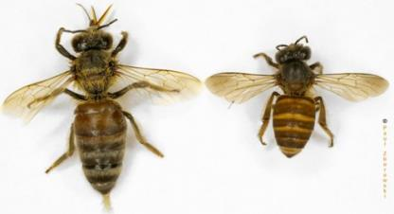

Note: Unlike the Asian honey bee (*Apis cerana)* the European honey bee (*Apis mellifera*) does not have an extra vein on its hind wing. Hymenoptera (bees and wasps) have two pairs of wings.  
Source: Paul Zborowski

Table A1 Identification key

Couplet 1 Identifying flies and Hymenoptera

| Leads | Taxon result | Pointer |
| --- | --- | --- |
| a One pair of wings; hind wings reduced to halteres (Figure A2) | flies | – |
| b Two pairs of wings | Hymenoptera (bees and wasps) | Go to Couplet 2 |

Couplet 2 Identifying wasps

| Leads | Taxon result | Pointer |
| --- | --- | --- |
| a Hind legs narrow and cylindrical, not hairy, front of abdomen constricted to form a ‘waist’ (Figure A3) | wasps | – |
| b Not as described in 2a | – | Go to Couplet 3 |

Couplet 3 Identifying apidae and other bee families

| Leads | Taxon result | Pointer |
| --- | --- | --- |
| a All these characters present:   * antennae bent forward at an ‘elbow’ (Figure A4) * three submarginal cells (Figure A5) * rear tibia with corbicula (Figure A6) * rear tibia without apical spur (Figure A7) | family Apidae | Go to Couplet 4 |
| b At least one of the characters listed in 3a is not present | other bee families | – |

Couplet 4 Identifying species of honey bee

| Leads | Taxon result | Pointer |
| --- | --- | --- |
| a Hind wing with an extra vein (Figure A5) | Asian honey bee (Figure A1, right) | – |
| b Not as described in 4a | European honey bee (Figure A1, left) | – |

Note: Couplet 4, Lead a—his character should not be used as the only means of identification because many species of native bees have this vein. First use couplets 1 to 3 to separate bees from the family Apidae from other bees.

Figure A2 Syrphid fly showing one pair of wings and halteres

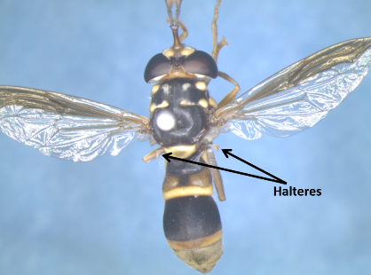  
Note: Flies have one pair of wings, with hind wings reduced to halteres.

Figure A3 Wasp with abdominal constriction forming a ‘waist’

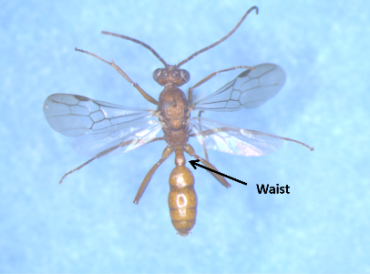

Note: Two pairs of wings. Unlike bees, the hind legs of wasps are rarely hairy and are narrow and cylindrical. The front of the abdomen is constricted to form a ‘waist’.

Figure A4 Apid bee showing antennal ‘elbows’

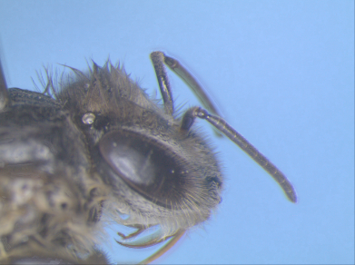

Note: Bees of the family Apidae have antennal ‘elbows’ and rear tibia without apical spur.

Figure A5 Wing venation of Asian honey bee

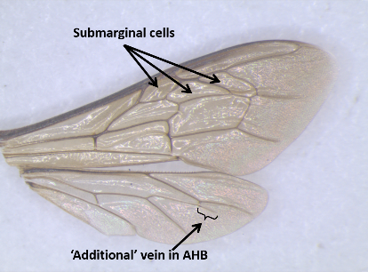

Note: Three submarginal cells on the forewing and an extra vein on the hind wing.

Figure A6 Wing venation of Asian honey bee, showing pollen-carrying corbicula

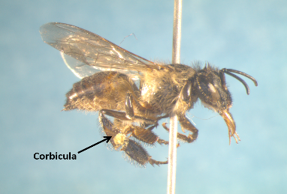

Note: Rear tibia with corbicula.

Figure A7 Bee from the family Halictidae, showing apical spur on hind tibia

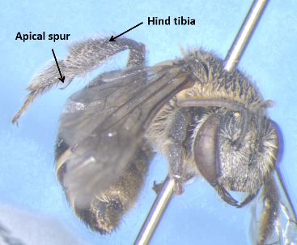

Note: Rear tibia with apical spur.

## Appendix B: Bee association with flowering plants in Cairns high risk port zone

Table B1 Bee association with flowering plants by host and flower status

| Host | Common name | Flower status | Bee species at host |
| --- | --- | --- | --- |
| *Aegiceras corniculatum* | river mangrove | flowering | *Amegilla* sp., *Tetragonula* sp.,  *Apis cerana* |
| *Aeschynomene* sp. | joint vetch | flowering | nil |
| *Agave* sp. | na | flowering | nil |
| Arecaceae spp. | palms | flowering | *Tetragonula* sp., *Xylocopa* sp., *Apis cerana* |
| *Barringtonia acutangula* | freshwater mangrove | flowering | *Apis cerana, Tetragonula* sp*.*  *Apis mellifera* |
| *Barringtonia calyptrata* | mango pine | new flowers (buds) | *Xylocopa* sp. |
| *Barringtonia calyptrata* | mango pine | flowering | *Apis cerana* |
| *Barringtonia calyptrata* | mango pine | ending flowering | *Apis cerana* |
| *Calliandra* spp. | powder puff plants | flowering | nil |
| *Calliandra* spp. | powder puff plants | ending flowering | nil |
| *Carpentaria acuminata* | Carpentaria palms | flowering | *Apis mellifera* |
| *Cathormion umbellatum* subsp. *moniliforme* | na | flowering | *Apis cerana* |
| *Cerbera* sp. | na | flowering | nil |
| *Citrus* sp. | citrus | flowering | *Apis mellifera* |
| *Cocos nucifera* | coconut | new flowers (buds) | nil |
| *Cocos nucifera* | coconut | flowering | *Apis cerana* |
| *Corymbia* sp. | bloodwood | flowering | nil |
| *Cupaniopsis anacardioides* | tuckeroo | flowering | nil |
| *Cuphea* sp. | na | flowering | *Apis cerana* |
| *Dypsis lutescens* | golden cane palm | new flowers (buds) | *Apis mellifera*, *Apis cerana, Tetragonula*  sp.,  *Xylocopa* sp. |
| *Dypsis lutescens* | golden cane palm | flowering | *Apis cerana, A. mellifera,*  *Tetragonula*  sp. |
| *Dypsis lutescens* | golden cane palm | ending flowering | *Apis mellifera, –Tetragonula*  sp., *Apis cerana* |
| Fan palms (Arecaceae spp.) | fan palms | flowering | *Apis cerana* |
| *Gossia* sp. | na | flowering | nil |
| *Lantana* sp. | lantana | flowering | nil |
| *Leptospermum brachyandrum* | weeping tea tree | flowering | *Apis cerana, A. mellifera* |
| *Licuala* sp. | fan palm | flowering | nil |
| *Livistona* sp. | cabbage palm | flowering | nil |
| *Macroptilium atropurpureum* | siratro | flowering | *Apis mellifera* |
| *Macroptilium* sp. | na | flowering | nil |
| *Mangifera indica* | mango | flowering | *Apis cerana* |
| *Mangifera indica* | mango | ending flowering | nil |
| Mangroves – various families | mangroves | flowering | nil |
| *Melaleuca* spp. | bottlebrushes | new flowers (buds) | *Apis cerana* |
| *Melaleuca* spp. | bottlebrushes | flowering | *Apis cerana, Apis mellifera, Tetragonula* sp. |
| *Melaleuca* spp. | bottlebrushes | ending flowering | *Tetragonula* sp., *Xylocopa* sp. |
| *Melaleuca* spp. | paperbarks | new flowers (buds) | nil |
| *Melaleuca* spp. | paperbarks | flowering | *Apis cerana, A. mellifera,*  *Tetragonula*  sp.,Halictidae |
| *Melaleuca* spp. | paperbarks | ending flowering | nil |
| *Mimosa* sp. | sensitive plant | flowering | *Apis mellifera, Amegilla* sp*., Tetragonula*  sp. |
| *Murraya paniculata* cv ‘Exotica’ | mock orange | flowering | nil |
| *Persea americana* | avocado | flowering | *Apis cerana* |
| *Roystonia sp.* | royal palm | flowering | *Apis cerana* |
| *Schinus terebinthifolius* | Brazilian pepper | flowering | nil |
| *Sesbania* sp. | sesbania pea | flowering | nil |
| *Sphagneticola trilobata* | Singapore daisy | flowering | nil |
| *Syzygium forte* | white apple | new flowers (buds) | *Apis mellifera, Tetragonula* sp. |
| *Syzygium forte* | white apple | flowering | nil |
| *Syzygium* sp. | lilly pilly | flowering | *Apis cerana* |
| *Syzygium tierneyanam* | river cherry | ending flowering | *Apis cerana* |
| *Tabebuia* sp. | trumpet trees | flowering | *Apis mellifera,*  *Tetragonula* sp. |
| *Tabebuia* sp. | trumpet trees | ending flowering | nil |
| *Terminalia catappa* | Indian almond | new flowers (buds) | *Tetragonula* sp.,  *Apis mellifera* |
| *Terminalia catappa* | Indian almond | flowering | *Tetragonula* sp. |
| *Tridax procumbens* | tridax daisy | flowering | *Apis cerana*  *A. mellifera* |
| *Turnera subulata* | white alder | flowering | *Xylocopa* sp. |
| *Xanthostemon* sp. | penda | flowering | nil |

**na** Not applicable.

## Appendix C: How to collect foraging bees

Step 1. Find bee at flowering plant

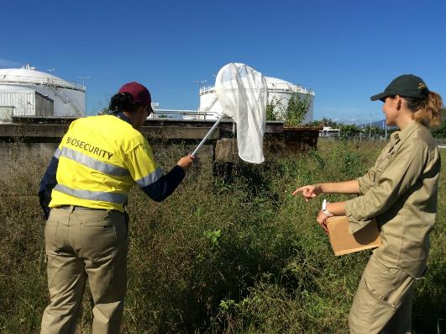

Step 2. Swing the sweep net over the bee and bring it quickly to the ground

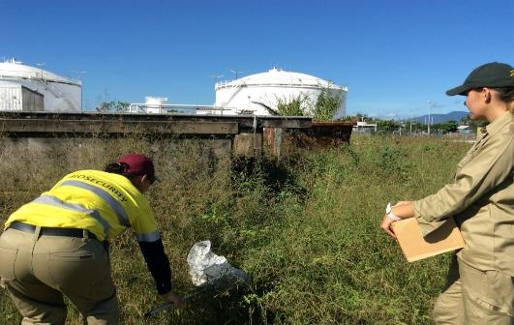

Step 3. Capture the foraging bee—as it flies upward into the net, raise the top apex of the net and keep the loop and handle on the ground.

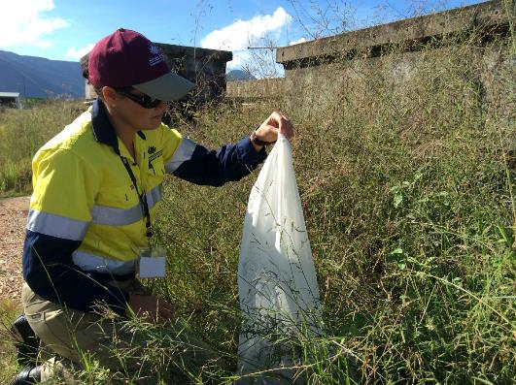

Bees will fly upward

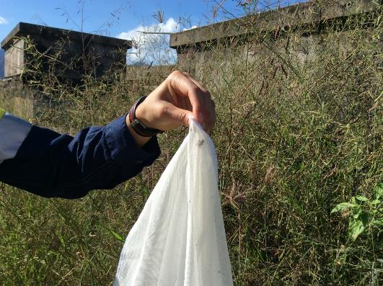

Step 4. With one hand, keep holding the top of the net. With the other hand, move the specimen vial inside the net and toward the bee. Once the bee is in the vial, hold the netting tight against the entrance of the vial.

#### The biosecurity officer is pictured holding the top of thenet with one hand while moving the specimen inside the net towards the bee.

Step 5 Tap the netting at the entrance of the vial. The bee should fall into the ethanol and die almost immediately.

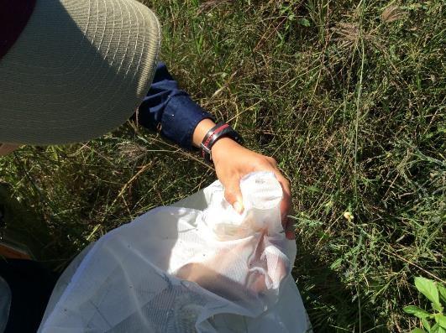

Remove the vial from the net and put the lid on. The vial can be reused until you have up to 30 bees in ethanol.

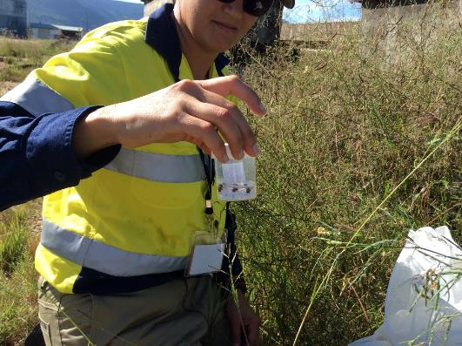

Step 6. Write a label in pencil and place it in the vial. The label should include name of site, date of collection, name of collector and host(s). For example:

Site: Kenny St, Ergon Energy (-16.93373, 145.77248)  
Date collected: 26 February 2012  
Collector: Jerry Babia  
Host: Palm tree

## Appendix D: Floral surveillance data sheet

| Northern Australia Quarantine Strategy Asian honey bee surveillance |
| --- |
| **Date:** 13 November 2012 |
| **Time:** 8.25 am to 10.30 am |
| **Weather:** Raining, windy, humid |
| **Personnel:** Isarena Schneider, Samantha Barnett and Keith Moore |

**Floral surveillance data**

| Way point | Latitude | Longitude | Location | Host | Host code | Asian honey bee | Collected | SFS code |
| --- | --- | --- | --- | --- | --- | --- | --- | --- |
| 1 | –16.93373 | 145.77248 | Kenny Street, Ergon Energy | *Barringtonia calyptrata* | AFF | Yes | 2 | 2 SS |
| 2 | –16.93635 | 145.77131 | Fernely Street, Protech | *Callistemon* sp. | AFF | No | No | na |
| 3 | –16.93685 | 145.77170 | Fernely Street, Raging Thunder | *Dypsis lutescens* | F | No | No | na |
| 3 | –16.93685 | 145.77170 | Fernely Street, Raging Thunder | *Callistemon* sp*.* | F | *Tetragonula* sp. | No | na |
| 3 | –16.93685 | 145.77170 | Fernely Street, Raging Thunder | Palm | AFF | No | No | na |
| 4 | –16.94234 | 145.76928 | Aumuller Street, McLeod Engineering | *Melaleuca* sp. (small oval leaf, white flower) | F | No | No | na |
| 4 | –16.94235 | 145.76930 | Aumuller Street McLeod Engineering | *Dypsis lutescens* | F | No | No | na |
| 5 | –16.94319 | 145.77045 | Aumuller Street, Roundabout island | *Callistemon* sp. | F | No | No | na |
| 6 | –16.94356 | 145.77074 | Aumuller Street, Portsmith Quality Meats | *Mimosa pudica* | F | No | No | na |
| 7 | –16.94766 | 145.77098 | Tingira Street, Norship Marine | *Callistemon* sp. | AFF | *Tetragonula* sp. | No | na |
| 7 | –16.94766 | 145.77098 | Tingira Street, Norship Marine | *Dypsis lutescens* | AFF | *Apis mellifera* | No | na |
| 7 | –16.94766 | 145.77098 | Tingira Street, Norship Marine | *Callistemon* sp. | F | No | No | na |
| 8 | –16.94706 | 145.77119 | Tingira Street, SeaSwift | Palm | H | No | No | na |

Note: **AFF** almost finished flowering. **F** Flowering. **H** Bees too high to collect. **SFS** Sugar feeding station (codes here only used when station was erected). **SS** Bees sprayed with sugar solution. **na** Not applicable.

## References

Anderson, D 2010, Control *of Asian honeybees in the Solomon Islands*, Australian Centre for International Agricultural Research (ACIAR), Canberra.

Annand, N 2009, ‘The Solomon Experience With Asian Honey Bees’, *The Australasian Beekeeper*, [www.theabk.com/article/solomon-experience-asian-honey-bees](http://www.theabk.com/article/solomon-experience-asian-honey-bees), (accessed 22 April 2015).

Barry, S, Cook, D, Duthie, R, Clifford, D & Anderson, D 2010, *Future surveillance needs for honeybee biosecurity*, Rural Industries Research and Development Corporation, Canberra, ACT.

Bellis, GA & Profke, AM 2003a, ‘Rainbow bee-eaters (*Merops ornatus*) as a monitoring tool for honeybees (*Apis mellifera* L.; Hymenoptera: Apidae)’, *Australian Journal of Entomology*, vol. 42, no. 3, pp. 266–70.

Bellis, GA & Profke, AM 2003b, ‘Roosting behaviour of the rainbow bee-eater’, *Merops ornatus*, in suburban Darwin, *Corella*, vol. 27, pp. 75–80.

Donovan, BJ 1980, ‘Interactions between native and introduced bees in New Zealand’, *New Zealand Journal of Ecology*, vol. 3, pp. 104–116.

Donovan, RE 1980, *Hunting wild bees: how to track bees, harvest honey and beeswax, and domesticate swarms*, Winchester Press, Tulsa, Oklahoma.

Dunn, KJ 1992, ‘Exotic Asian bee detected in Torres Strait’, *Bee Briefs*, vol. 9, pp. 18–19.

Hepburn, HR & Radloff, SE 2011, *Honeybees of Asia*, Springer, New York.

Hyatt, S 2011, *Asian honey bee (*Apis cerana javana*) in Cairns, Far North Queensland: foraging, nesting and swarming behaviour*, Report of field observations April 2007–September 2011, Queensland Department of Employment, Economic Development and Innovation, Brisbane.

Koetz, A 2013, *Detection efficacy of Asian honey bees (*Apis cerana*) in Cairns, Australia*, Asian Honey Bee Transition to Management Program, Queensland Department of Agriculture, Fisheries and Forestry, Brisbane.

Moore, D 2001, ‘Honey bee circadian clocks: behavioral control from individual workers to whole-colony rhythms’, *Journal of Insect Physiology*, vol. 47, pp. 843–857.

Ruttner, F 1988, *Biogeography and taxonomy of honeybees*, Springer-Verlag, Berlin.

Zborowski, P, Shield, J, Doherty, B, Royer, J & Bellis, G 2009, *The Asian honey bee: a guide to identification*, Queensland Department of Primary Industries and Fisheries, available at [animalhealthaustralia.com.au/wp-content/uploads/2011/04/Asian-honey-bee-ID.pdf](http://www.animalhealthaustralia.com.au/wp-content/uploads/2011/04/Asian-honey-bee-ID.pdf)