# Varroa mites on Asian honey bees in the Torres Strait

Prevalence on foraging bees and rapid screening of swarms

Anthony Rice, Isarena Schneider, Samantha Barnett, Sally Cowan

© Commonwealth of Australia 2016

Referenced in 2014 by Plant Health Australia.

**Ownership of intellectual property rights**

Unless otherwise noted, copyright (and any other intellectual property rights, if any) in this publication is owned by the Commonwealth of Australia (referred to as the Commonwealth).

**Creative Commons licence**

All material in this publication is licensed under a Creative Commons Attribution 3.0 Australia Licence, save for content supplied by third parties, logos and the Commonwealth Coat of Arms.

Creative Commons Attribution 3.0 Australia Licence logo

Creative Commons Attribution 3.0 Australia Licence is a standard form licence agreement that allows you to copy, distribute, transmit and adapt this publication provided you attribute the work. A summary of the licence terms is available from [creativecommons.org/licenses/by/3.0/au/deed.en](http://creativecommons.org/licenses/by/3.0/au/deed.en). The full licence terms are available from [creativecommons.org/licenses/by/3.0/au/legalcode](http://creativecommons.org/licenses/by/3.0/au/legalcode).

Inquiries about the licence and any use of this document should be sent to [copyright@agriculture.gov.au](mailto:copyright@agriculture.gov.au).

**Cataloguing data**

This publication (and any material sourced from it) should be attributed as: Rice, A, Schneider, I, Barnett, S & Cowan, S 2016, *Varroa mites on Asian Honey bees in the Torres Strait*, Department of Agriculture and Water Resources, Canberra, August. CC BY 3.0.

This publication is available at [agriculture.gov.au/publications](http://agriculture.gov.au/publications).

Department of Agriculture and Water Resources

Postal address GPO Box 858 Canberra ACT 2601

Telephone 1800 900 090

Web [agriculture.gov.au](http://agriculture.gov.au/)

The Australian Government acting through the Department of Agriculture and Water Resources has exercised due care and skill in preparing and compiling the information and data in this publication. Notwithstanding, the Department of Agriculture and Water Resources, its employees and advisers disclaim all liability, including liability for negligence and for any loss, damage, injury, expense or cost incurred by any person as a result of accessing, using or relying upon any of the information or data in this publication to the maximum extent permitted by law.

Contents

Varroa mites on Asian honey bees in the Torres Strait i

Prevalence on foraging bees and rapid screening of swarms i

Purpose 1

Abstract 2

Introduction 3

Methods 4

Varoa on foraging bees 4

Rapid screening of swarms 4

Results 6

Varroa on foraging bees 6

Rapid screening of swarms 6

Conclusions 7

Varroa on foraging bees 7

Rapid screening of swarms 7

References 8

**Figures**

Figure 1 Bee ‘shaker’ used to screen swarms for mites 5

Figure 2 A 500µm test sieve and aquatic invertebrate sorting tray 5

Figure 3 Percentage of total mite load recovered after 15 minutes in the ‘shaker’ (+ SE) for swarms of Asian honey bees collected in the Torres Strait 6

Figure 4 Sizes of uninfested swarms of Asian honey bees collected in the Torres Strait over 17 months in 2013 to 2014 6

## Purpose

This document describes work carried out in the Torres Strait and Cairns that aimed to aid the development of monitoring tools for varroa mites. Specifically, we aimed to:

* determine the level that Asian honey bees (AHB) foraging at flowers, are infested with *Varroa jacobsoni*
* develop a method for rapid screening of swarms for mites.

## Abstract

* Populations of *Apis cerana* Fabricius (Hymenoptera: Apidae) on Saibai, Dauan and Boigu islands have been infested with *Varroa jacobsoni* Oudemans (Acarina: Mesostigmata: Varroidae) since they arrived in 1992.
* Specimens from regular collections of AHB foraging at flowers were examined for varroa mites to determine levels of parasitism. From 27 samples consisting of 1 164 bees collected over 15 months, only two varroa mites were detected. We conclude that collecting bees from flowers and examining for mites is not a practical approach to monitoring for varroa.
* A method was developed for rapid screening of large numbers of bees for varroa mites. From 15 infested swarms carrying 582 mites, 15 minutes oscillating in an ethanol bath in the new ‘shaker’ yielded 581 mites (99.8 per cent). This new shaking method reduces the time spent screening larger swarms from several days to around 30 minutes and rapidly gives good confidence in the presence/absence of varroa mites.

## Introduction

In 1992 Asian honey bees (AHB) and *Varroa jacobsoni* arrived on Saibai, Dauan and Boigu islands in the Torres Strait from neighbouring Papua New Guinea. The Northern Australia Quarantine Strategy (NAQS) had been monitoring the southward spread of the bees through the Western Province of Papua New Guinea (PNG) towards the Torres Strait for some time prior to their arrival. Neither this population of bees, nor their parasitic mites, have spread further into the Torres Strait in the intervening two decades.

In 2007 a population of AHB, which did not harbour varroa mite, became established in Cairns. Following an unsuccessful eradication campaign, the National Management Group decided that it was not technically feasible to eradicate the pest from North Queensland. As part of a subsequent transition to management scheme, the Department of Agriculture and Water Resources through NAQS was tasked with, among other things, developing techniques to monitor for incursions of parasitic bee mites. These techniques involved creating methods for screening both foraging and swarming AHB for mites.

Floral surveillance for foraging AHB was proposed as a means of detecting varroa mites as the mites have a phoretic stage in their life cycle where they attach themselves to adult bees. The phoretic stage can last for several months if there is no brood in the nest (Huang 2012). There is no data in the literature on the prevalence of varroa mites on foraging AHB, so the presence of a population of AHB parasitised with varroa mites in the Torres Strait gave NAQS an opportunity to gather this data.

Due to the fact that the population of AHB that has become established in Cairns is mite-free, it has made monitoring for mites difficult for quarantine agencies as a new incursion that may contain mites cannot be readily distinguished from bees that are part of the established population. Mass screening of swarms at ports, or other potential points of entry is very time consuming and a large swarm can take several days to inspect manually. Previously, the development of a screening method has been hampered by a lack of varroa-infested swarms to work with (ie positive control) and the time consuming need to proof the system to gain a quantitative measure if its efficacy. Positive controls were found by using swarms of AHB with varroa mite from the Torres Strait and data collected.

## Methods

### Varoa on foraging bees

NAQS staff made regular collections of AHB from Saibai, Dauan and Boigu Islands in the north of Torres Strait. Bees were caught with sweep nets at flowers and collected directly into ethanol (see Rice et al. 2014). The bees were sent to the NAQS laboratory in Cairns where the sample and the ethanol preservative were examined for mites using a stereo dissecting microscope at 10x magnification.

### Rapid screening of swarms

#### Collecting swarms

The best way to collect the swarms and transport them back to the laboratory was to collect them into a calico bag with a draw-string sewn into the top. The bags were 500mm x 500mm and were drawn up over a swarm, and held in place and insecticide sprayed into the bag. The entire bag was then placed into a two litre ice cream container and saturated with 200ml of 70% ethanol. Excess ethanol could be drained off before sealing with tape and double bagging for consignment back to the lab. This method ensured that any mites in the swarm were collected and would be detected later. Unfortunately, this plan will not always work and bees are usually collected as best as can be managed.

#### Separating out the mites

A system was developed whereby swarms could be gently agitated in an ethanol bath and any mites on the bees could detach and sink to the bottom of the bath through a bee proof mesh screen. Firstly, the bees were placed into a ‘shaker’ made of a modified 10L stainless steel vegetable steamer (Fig. 1). The bottom of the steamer basket had been cut out and replaced with a circular piece of 3mm stainless steel mesh that allowed the mites to pass through and kept them separate from the bees. The bees were then covered in 70% ethanol to a depth of about 5-10mm and gently agitated on a RatekTM orbital mixer at 60-65 rpm (3.5 on the dial). The steamer basket was then removed and bees examined manually for mites. The mites were separated out of the ethanol bath by pouring the ethanol through a 500µm test sieve into an aquatic invertebrate sorting tray (Fig. 2).

Figure Bee ‘shaker’ used to screen swarms for mites

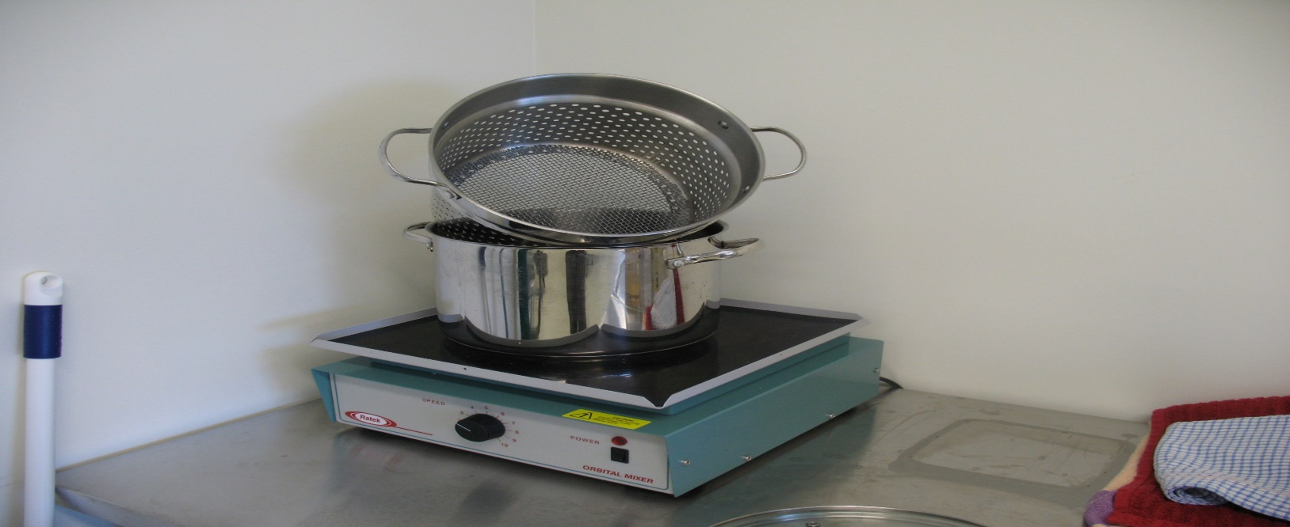

Figure A 500µm test sieve and aquatic invertebrate sorting tray

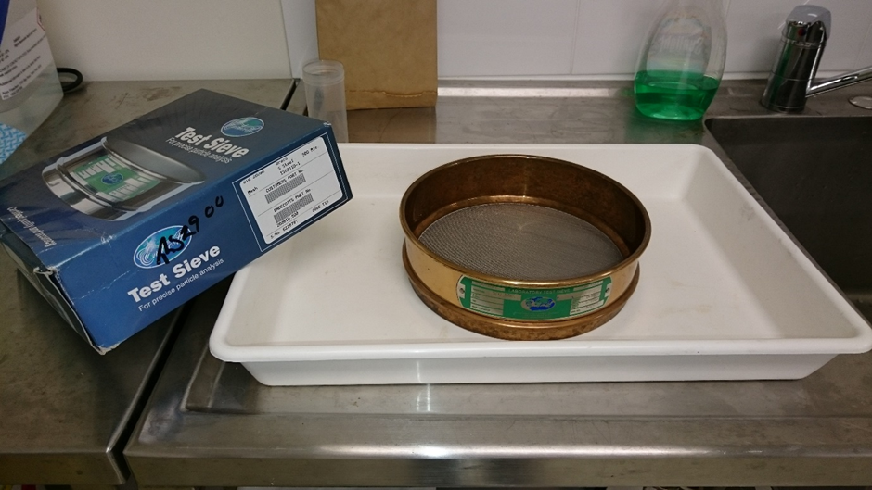

## Results

### Varroa on foraging bees

Twenty four samples comprising a total of 1 157 bees were collected and examined for mites (n = 24, $\overline{x}$ = 8.2, SE = 6.7, range = 6–121). Two *Varroa jacobsoni* were found in samples from Boigu and Dauan islands.

### Rapid screening of swarms

Following an initial inspection bees were put in the shaker three times for 5 minutes each. 99.8 per cent of mites had been recovered after 15 mintues in the shaker (Figure 3).

Figure Percentage of total mite load recovered after 15 minutes in the ‘shaker’ (+ SE) for swarms of Asian honey bees collected in the Torres Strait

We found that of the 23 swarms examined, only 17 were infested with mites. However, the uninfested swarms we examined were among the smaller of those collected (Figure 4).

Figure Sizes of uninfested swarms of Asian honey bees collected in the Torres Strait over 17 months in 2013 to 2014

## Conclusions

### Varroa on foraging bees

With a prevalence of two mites in over 1 000 foraging bees, collecting AHB as they are foraging and examining them for mites will not give an acceptable level of confidence in the absence of *V. jacobsoni*. Huang (2012) reports a preference for nurse bees over foragers in the phoretic stage of *V. destructor*, suggesting that reproducing mites use adult bees for extra nutrition and that nurse proximity to larvae (with reproducing varroa) may cause this preference. This may also be true for *V. jacobsoni*.

### Rapid screening of swarms

For quarantine agencies concerned about monitoring swarms of AHB for mites, the shaker method represents a considerable saving in time and resources. Obviously, if a captured swarm yields mites using this method, there is little need for further examination. However, if the swarm yields no mites, does it remain necessary to examine every bee?

The answer to that is probably ‘no’ because the single mite found on its host bee after treatment in the shaker in this study was securely attached to the thoracic membranes between the forecoxae via embedded mouthparts, and appeared to be killed in the action of feeding. It had to be pulled from the bee with forceps using some force. The 99.8 per cent yield of mites strongly suggests that it is unlikely that an infestation of varroa mite on AHB will be firstly, represented by a single mite, and secondly, that that mite happens to be feeding when it is collected.

We speculate that the lack of mites found on uninfested swarms that were generally smaller than infested swarms could be due to our definition of a swarm, capturing partial swarms, capturing migrating swarms that may have originated from nests that were broodless and hence were likely to have less mites on them, or simply a factor of volume whereby less bees simply carry less mites.

Care must be taken extrapolating the findings from this study onto other species of mites or bees or even to functional groupings (eg foragers, nurses, drones or swarming bees) of the same bees and mites because the relationships will almost certainly be different. Furthermore, despite the fact that varroa mite is naturally a parasite of AHB, most of its biology reported in the literature, has been determined using the European honey bee (EHB) and *V. destructor* due to this mite's economic importance as a pest on this species. Consequently, if *V. destructor* or the pathogenic strain of *V. jacobsoni* were to arrive in Australia, floral sweeping for bees may prove to be a viable monitoring method for these mites.

## References

Huang, ZY 2012, ‘Varroa mite reproductive biology’, American Bee Journal 152: 981–985.

Rice, A, Schneider, I, Barnett, S & Cowan, S 2014, NAQS Asian honey bee floral surveillance manual, Northern Australia Quarantine Strategy Technical Report 1214a.