Australian Pest Animal Strategy

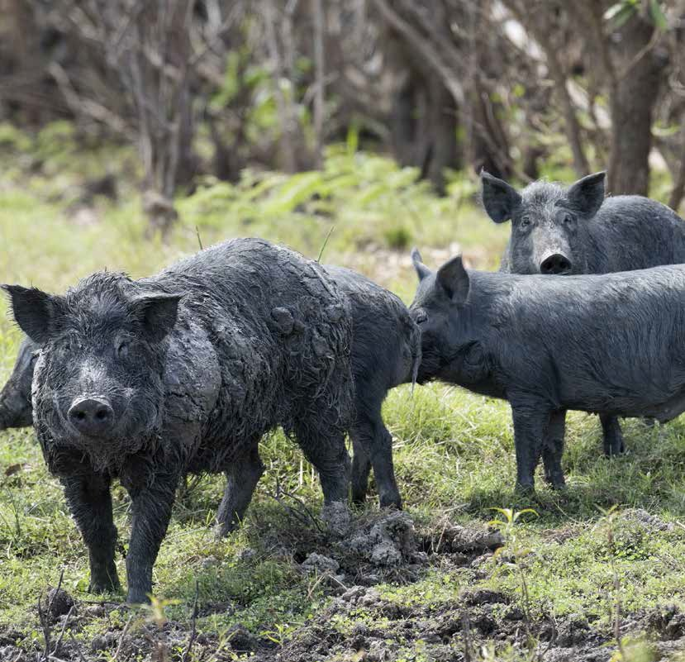

2017–2027

Invasive Plants and Animals Committee

© Commonwealth of Australia 2017

**Ownership of intellectual property rights**

Unless otherwise noted, copyright (and any other intellectual property rights, if any) in this publication is owned by the Commonwealth of Australia (referred to as the Commonwealth).

**Creative Commons licence**

All material in this publication is licensed under a Creative Commons Attribution 4.0 Australia Licence, save for content supplied by third parties, logos and the Commonwealth Coat of Arms.

Creative Commons Attribution 4.0 Australia Licence is a standard form licence agreement that allows you to copy, distribute, transmit and adapt this publication provided you attribute the work. A summary

of the licence terms is available from creativecommons.org/licenses/ by/4.0. The full licence terms are available from creativecommons.org/ licenses/by/4.0/legalcode.

Enquiries about the licence and any use of this document should be sent to [copyright@agriculture.gov.au](mailto:copyright@agriculture.gov.au).

For bibliographic purposes this publication may be cited as:

Invasive Plants and Animals Committee 2016, *Australian Pest Animal Strategy 2017 to 2027*, Australian Government Department of Agriculture and Water Resources, Canberra.

**Invasive Plants and Animals Committee** Department of Agriculture and Water Resources Postal address GPO Box 858 Canberra ACT 2601 Telephone 1800 900 090

Web [agriculture.gov.au](http://agriculture.gov.au/)

ISBN 978-1-76003-136-7 (printed)

ISBN 978-1-76003-137-4 (online)

The Australian Government, Department of Agriculture and Water Resources has collated and edited this publication for the Invasive Plants and Animals Committee. While reasonable efforts have been made to ensure that the contents of this publication are factually correct, the Australian Government and members of the Invasive Plants and Animals Committee (or the governments that the committee members represent) do not accept responsibility for the accuracy or completeness of the contents, and shall not be liable for any loss or damage that may be occasioned directly or indirectly through the use of, or reliance on, the contents of this publication.

The Australian Government acting through the Department of Agriculture and Water Resources has exercised due care and skill in preparing and compiling the information and data in this publication. Notwithstanding, the Department of Agriculture and Water Resources, its employees and advisers disclaim all liability, including liability for negligence and for any loss, damage, injury, expense or cost incurred by any person as a result of accessing, using or relying upon any of

the information or data in this publication to the maximum extent permitted by law.

**Acknowledgements**

The authors thank participants for their input.

Cover image: Feral Pigs.

Photo: John C[arnemolla/www](http://www.shutterstock.com/).shutterst[ock.com.](http://www.shutterstock.com/)

# Contents

|  |  |
| --- | --- |
| **Overview** | **1** |
| **Purpose of the strategy** | **2** |
| **Scope of the strategy** | **4** |
| **Principles of effective pest animal management** | **5** |
| **Strategy goals and priorities** | **6** |
| **Pest animals in Australia** | **7** |
| **National approach to biosecurity and pest animals** | **8** |
| **Stages of pest animal management** | **12** |
| **Pest animal management in practice** | **13** |
| **Roles and responsibilities** | **15** |
| **National vision, goals and priorities for pest animal****prevention and management** | **20** |
| **Implementation** | **38** |
| **List of acronyms** | **46** |
| **Glossary** | **47** |
| **References** | **50** |
| **Appendixes** |  |
| A Achievements of the 2007 Australian Pest Animal Strategy | 39 |
| B Detailed stages of pest animal management | 42 |
| **Figures** |  |
| 1. Vision, goals and priorities of the strategy | 6 |
| 2. Context for the Australian Pest Animal Strategy | 11 |
| 3. Four stages of pest animal management— |  |
| the generalised invasion curve | 12 |

**Case studies**

1. The risk of exotic pets—Rose-ringed Parakeets 24

2. Fighting wild dogs—a national action plan 26

3. PAPP—A new complementary tool in the fight against pest animals 28

4. European Carp and the National Carp Control Plan 30

5. Managing wild dogs—driven by the community 31

6. Increasing stakeholder awareness 33

7. Biological control of the European rabbit (*Oryctolagus cuniculus*)—

the importance of ongoing research and development 36

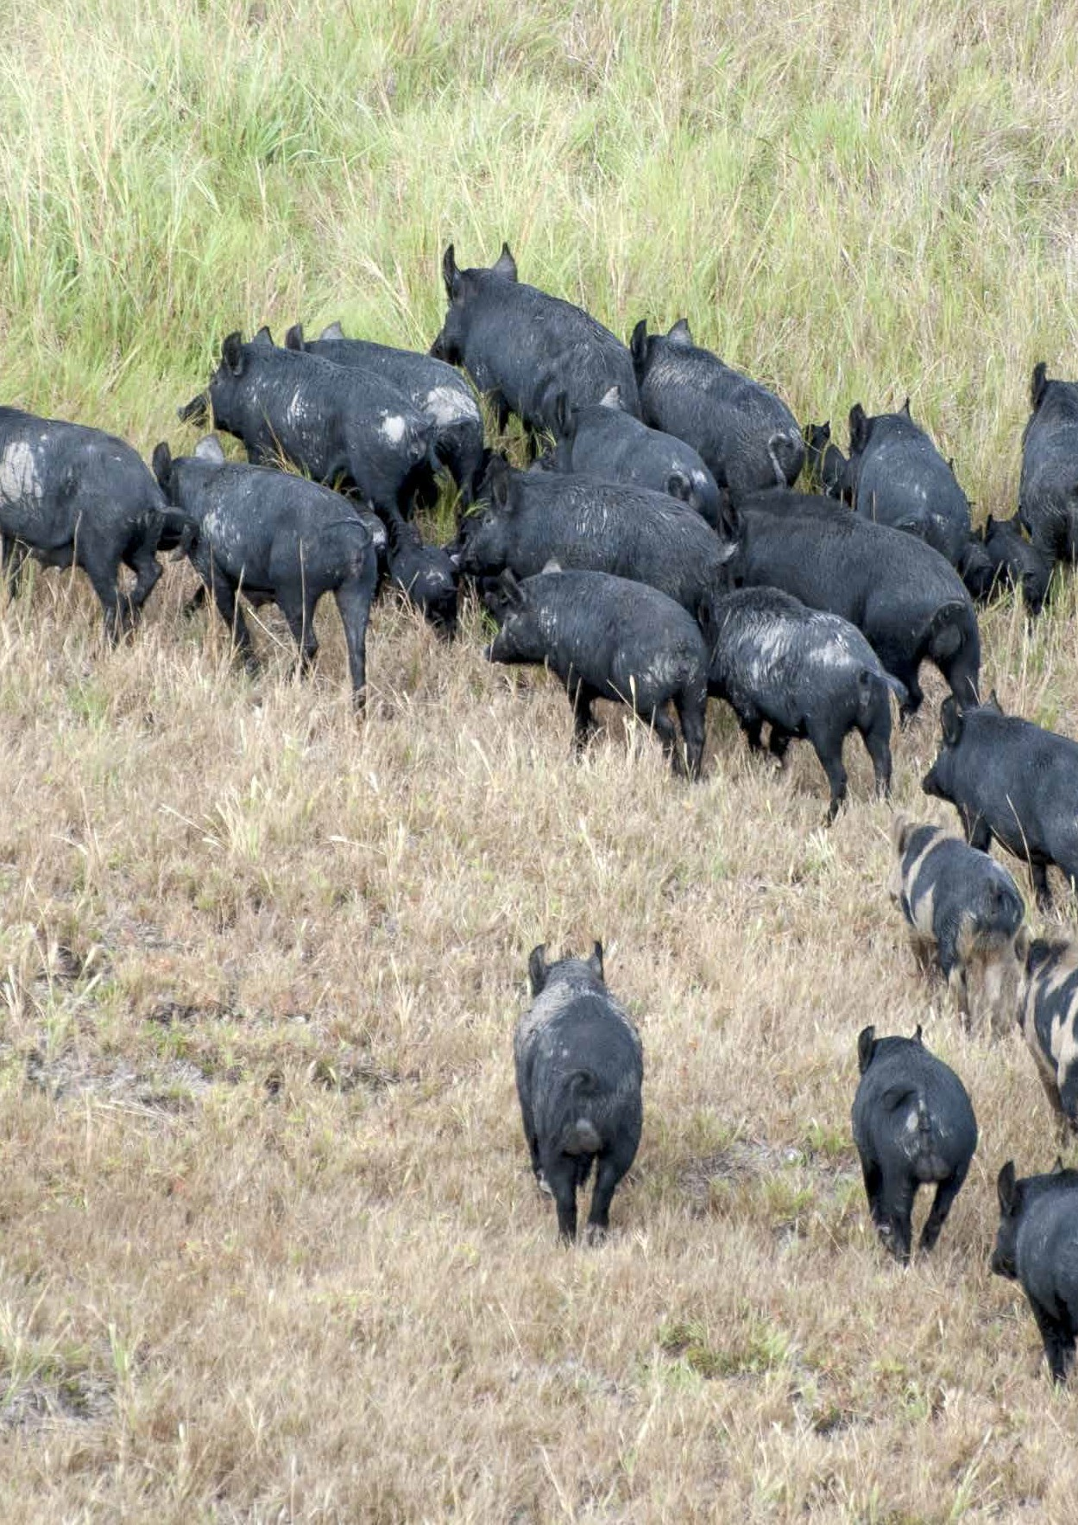

Australian Pest Animal Strategy 2017–2027

Invasive Plants and Animals Committee

# Overview

Many vertebrate animals introduced to Australia since colonisation have become pests. Pest animals are a significant social, economic and environmental burden for Australia, negatively impacting on Australia’s agriculture, biodiversity, natural and built environments, public health and productivity.

Effective pest animal management involves a combination of preventing their entry to Australia wherever possible, eradicating those that do enter (eradicating incursions) when feasible, and managing the negative impacts of those that become established.

The inaugural Australian Pest Animal Strategy (APAS) was released in 2007. This strategy has been updated following an independent evaluation in 2013, (refer Appendix A

for further details on the evaluation), and captures significant recent developments in the national biosecurity framework more broadly, including the Intergovernmental Agreement on Biosecurity (IGAB).

# Purpose of the strategy

The strategy provides national guidance on best practice vertebrate pest animal management, in striving towards the national vision of protecting Australia’s economy, environment and social wellbeing from the impact of pest animals. It reaffirms agreed national pest animal management principles, and sets national goals and priorities that will help improve Australia’s overall ability to prevent and respond to new pest animal incursions and manage the negative impacts of established pest animals.

The strategy provides the policy foundations to guide and inform the actions of stakeholders, including landholders, industry, communities and government, rather than prescribing detailed on-ground actions and activities.

It highlights areas that require national collaboration to drive the development of consistent and coordinated national approaches and provides clarity around priorities, roles and responsibilities.

The strategy aims to:

* recognise the significant challenges and negative impacts pest animals create for Australia
  + pest animals are not a challenge that can be resolved after one treatment.

Managing pest animals is an ongoing task that requires a proactive approach, continuous investment and strategic action by a wide range of stakeholders for the benefit of the economy, the environment and the community

* encourage coordination and leadership from landholders, industry and community groups, keepers of exotic animals and governments
  + to be effective, pest animal prevention and management needs to be a shared responsibility
* illustrate the national importance of a strategic approach to the management of pest animals
  + pest animal management requires a strategic approach that aligns with other biosecurity activities and national agendas

Purpose of the strategy

* + - describes and explains the eight principles of effective pest animal management
      * these principles guide all Australian stakeholders’ approaches to the prevention, eradication, containment and control of pest animals
    - identify where national effort, leadership and coordination has the potential to reduce pest animal risks or impacts
      * it sets out a national vision, goals and priorities for pest animal management.

A commitment to implementing the strategy is required from everyone who has responsibilities in relation to pest animals. This includes developing their own plans and actions to strengthen the prospect of reducing the threats pest animals pose across Australia.

The Invasive Plants and Animals Committee (IPAC) has oversight of the APAS and will use the strategy to guide the development of its annual workplan.

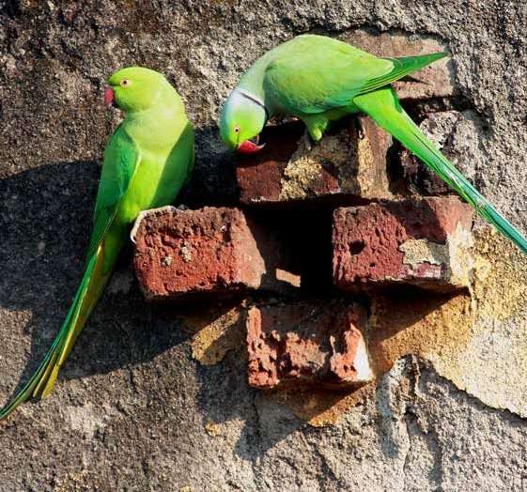

Rose-ringed parakeets (*Psittacula krameri*)

# Scope of the strategy

The strategy defines a pest animal as those animals that cause more damage than benefits to human valued resources and social wellbeing. It recognises that some species may also have positive impacts. The management of these species will need to consider both kinds of impacts.

The focus will be on preventing the establishment of, and managing existing exotic vertebrate pest animal (terrestrial and freshwater) and freshwater invertebrate problems. Marine animals are not included in the scope of the APAS.

In some instances, native animals such as kangaroos, corellas or possums can become pests. For example, an abundant population of kangaroos can compete with native animals or livestock for food. Native animals as pests should be managed in accordance with state and territory legislation.

The strategy is a national strategy encompassing principles, goals and priorities across the four stages of pest animal management: prevention; eradication; containment; and asset protection.

# Principles of effective pest animal management

The strategy embodies eight principles that underpin effective pest animal management.

1. Prevention and early intervention to avoid the establishment of new pest animal species is generally more cost-effective than ongoing management of established populations.
2. Pest animal management is a shared responsibility between landholders, community, industry and government.
3. Management of mobile pest animals requires a coordinated approach across a range of scales and land tenures.
4. Management of established pest animals should focus on the protection of priority assets (for example, a lambing paddock or a threatened ecological community) but also usually requires a ‘buffer’ management area around the asset to account for pest animal mobility.
5. Pest animal management should be based on actual rather than perceived impacts and should be supported by monitoring to measure whether impact reduction targets are being achieved.
6. Best practice pest animal management balances efficacy, target specificity, safety, humaneness, community perceptions, efficiency, logistics and emergency needs.
7. Best practice pest animal management integrates a range of control techniques (including commercial use where appropriate), considers interactions between species (such as rabbits and foxes) and accounts for seasonal conditions (for example, to take advantage of pest animal congregations during drought) and animal welfare.
8. The cost of pest animal management should be borne by those who create the risk and those who benefit from its management. Governments may co-invest where there is a net public benefit from any such intervention.

These principles should be incorporated into pest animal prevention, eradication and management strategies, plans and actions across all management levels.

# Strategy goals and priorities

The strategy has three goals, each with priorities that aim to focus national action, coordination and investment (Figure 1).

Delivery of the priorities will require cooperation and collaboration between communities.

##### FIGURE 1 Vision, goals and priorities of the strategy

|  |
| --- |
| **Vision**  Protect Australia’s economy, environment and social wellbeing from the impacts of pest animals |
| **Goal 1. Prevent the establishment of new pest animal species** |
| Priorities:   * 1. commit to and continuously strengthen risk-based approaches to pre-border and border activities   2. improve early detection and response approaches for high risk pest animals   3. ensure effective management by stakeholders who have responsibility for animals with pest potential. |
| **Goal 2. Minimise the impact of established pest animals** |
| Priorities:   * 1. develop and implement national action and coordination plans for species prioritised as nationally significant   2. continue to develop and improve best practice management methods and increase overall adoption of these practices among landholders   3. increase participation in coordinated management approaches across a range of scales and land tenures. |
| **Goal 3. Improve leadership and coordination for the management of pest animals** |
| Priorities:   * 1. develop the knowledge, capacity and commitment of stakeholders to take responsibility for pest animal management   2. improve information collection and sharing mechanisms to support effective pest animal management   3. maintain and enhance long-term research, development and extension capacity and capability   4. monitor the pest animal management approach and identify and improve areas of weakness. |

Pest animals in Australia

In the two centuries since European colonisation, many exotic animals have been introduced to Australia both legally and illegally.

In mainland Australia, it is estimated that at least 73 species of introduced vertebrates have established wild populations, including 25 mammal species, 20 birds, four reptiles, one amphibian and at least 23 freshwater fish (Bomford 2008).

Some introduced pests—such as rabbits and foxes—have become established over time in Australia with no prospect of eradication. With the extent of global and local travel and trade, the risk of additional species being introduced (known as ‘incursion events’) is increasing. Changing climatic conditions may also alter the distribution and abundance of pest animals.

While our knowledge of, and control methods for, preventing and managing the

negative impacts of pest animals have improved markedly, significant challenges remain. The negative impacts of pest animals in Australia are economic, environmental and social.

**Economy**

Information on the impact of pest animals on the Australian economy is limited. The most recent conservative estimate puts the national economic impact of pest animals, particularly in agricultural systems, at between $720 million and $1 billion annually, in production losses and public and private management costs. They can cause significant damage to

crops and seriously affect Australia’s livestock industries by preying on stock and competing for pasture. For example wild dogs can cause substantial damage to livestock producers, particularly sheep producers and goat producers, through predation and disease transfer.

## Environment

Pest animals can cause land degradation by promoting soil erosion, stream turbidity, the spread of weeds, and can threaten native plant species and animals through competition, habitat destruction and predation. They also have the potential to act as reservoirs for diseases that affect native wildlife, domestic stock or people.

## Social wellbeing

Pest animals have considerable negative social impacts. The predation of livestock has significant social and psychological effects on primary producers and their families.

In addition they are a nuisance, damaging infrastructure and culturally important sites, and displaying adverse behaviours such as disruptive noise.

# National approach to biosecurity and pest animals

Australia has a sound reputation as a safe and reliable agricultural and trading nation, and has unique biodiversity that should be maintained. The continued strength of our agricultural sector is essential to our economy and national prosperity. It is in the national interest to continuously improve approaches to reducing potential risks and impacts of pest animals in Australia.

The national biosecurity system encompasses the full range of activities undertaken by governments, industry, natural resource managers, custodians or users, and the community across the biosecurity continuum, including prevention, emergency preparedness, detection, response, recovery and on-going management of established pests and diseases.

This strategy aims to be consistent with current biosecurity policy, in particular the IGAB and is also guided by a range of other national strategies and action plans, including both the [Australian Biodiversity Conservation Strategy](http://www.environment.gov.au/biodiversity/conservation/strategy) and threat abatements plans under the *Environment Protection and Biodiversity Conservation Act 1999* (EPBC Act).

It translates biosecurity and other related policies into an approach that governments, landholders, industry and the community can use to guide their pest animal planning and management efforts. Figure 2 depicts the relationship between the policies and strategies, and work at the national, state and local level.

## Intergovernmental agreement on biosecurity

The Intergovernmental Agreement on Biosecurity, or IGAB, (Council of Australian Governments 2012) is an agreement between the Commonwealth, State and Territory governments (with the exception of Tasmania) that aims to improve shared management of risks posed by pests and diseases entering, emerging, establishing or spreading

in Australia.

The IGAB was developed to improve the national biosecurity system by identifying the roles and responsibilities of governments. It provides the direction and framework to achieve a national biosecurity system. The schedules to the agreement outline agreed priority areas for collaboration to improve the system.

National approach to biosecurity and pest animals

This agreement outlines eight principles underpinning our national biosecurity system.

1. Biosecurity is a shared responsibility between all governments, industry, natural resource managers, custodians or users, and the community.
2. In practical terms, zero biosecurity risk is unattainable.
3. The pre-border, border and post-border elements of the biosecurity continuum are managed to minimise the likelihood of biosecurity incidents and mitigate their impacts.
4. The biosecurity continuum is managed through a nationally integrated system that recognises and defines the roles and responsibilities of all sectors and sets out cooperative activities.
5. Activity is undertaken and investment is allocated according to a cost-effective, science-based and risk-management approach, prioritising the allocation of resources to the areas of greatest return.
6. Relevant parties contribute to the cost of biosecurity activities.
7. Risk creators and beneficiaries contribute to the cost of risk management measures in proportion to the risks created and/or benefits gained (subject to the efficiency

of doing so).

* 1. Governments contribute to the cost of risk management measures in proportion to the public good accruing from them.
  2. Governments, industry, and other relevant parties are involved in

decision-making, according to their roles, responsibilities and contributions.

1. Australia’s biosecurity arrangements comply with its international rights and obligations.

#### Established pests and diseases of national significance framework (IGAB schedule 5)

A key component of the national biosecurity system is a national management framework to ensure that nationally significant pests and diseases established in Australia are contained, suppressed or otherwise managed. The Established Pests and Diseases of National Significance (EPDNS) Framework provides a strategic, consistent, scientific,

risk-based approach to managing the impacts of established pests and diseases. The framework:

* + - establishes policy principles to guide government decision-making and

cooperation to better manage the consequences of established pests and diseases of national significance

* + - clarifies the role of government, industry, community, landholders and risk creators in managing established pests and diseases of national significance, including when a particular party is to take a lead responsibility in managing a particular pest

or disease

* + - establishes criteria to help determine which established pests and diseases should be deemed ‘nationally significant’.

National approach to biosecurity and pest animals

It highlights that the sustainable management of established pests and diseases is resource intensive and requires shared responsibility and effective coordination among the key stakeholders. This policy approach recognises the need to maximise the return on investment in pest animal management and consider who predominantly benefits from potential investments.

#### National surveillance and diagnostics (IGAB schedule 4)

Another important component is a comprehensive national surveillance and diagnostic system that provides for early detection and accurate and timely diagnosis of pests and diseases. Surveillance and diagnostic activities support pest animal management within the national biosecurity system by:

* enabling new incursions of exotic and emerging pest animals to be detected
* monitoring changes in the distribution of pest animals, to allow associated risks to be identified and managed.

The National Surveillance and Diagnostics Framework provides an integrated approach to the funding and management of surveillance and diagnostics across jurisdictions.

Under this framework, national plans and strategies will guide surveillance and diagnostic priorities and investment for pest animals.

#### National emergency preparedness and response arrangements (IGAB schedule 7)

A third component identified is national emergency preparedness and response arrangements that:

* comprehensively cover industries, the environment and community under pre-arranged governance and cost-sharing agreements
* maintain an effective level of preparedness and response arrangements across jurisdictions to adequately respond to biosecurity incidents and emergencies across the biosecurity continuum.

The National Environmental Biosecurity Response Agreement (NEBRA) provides a cost-sharing mechanism for emergency responses to pest animal incursions impacting the environment. This agreement ensures a planned, rapid eradication response to exotic pest and disease incursions, with most of the often difficult decision-making

and funding arrangements agreed in advance of an outbreak.

**Australian Pest Animal Strategy**

Translates higher level policies and strategies into nationally agreed principles, goals and priorities to guide pest animal management.

Implementing the strategy through the plans below will require leadership and commitment from landholders, industry, communities and governments.

**State and territory governments** Biosecurity, pest animal (strategies/plans)

Each state and territory has relevant plans or strategies that outline their pest animal policy and legislation.

**Nationally significant species action plans**

(e.g. National Wild Dog Action Plan) These plans and strategies provide more detailed assessments of risks and impacts of pest animals. They specify priorities, targets, preferred strategies and indicators. They also identify key stakeholder partners

**Threat abatement plans** These plans describe the research, management, and any other actions

necessary to reduce the impact of a listed key threatening process under the *Environment Protection and Biodiversity Conservation Act 199*9 on native species and ecological communities. Plans currently exist for rabbits, feral cats, foxes, goats, cane toads, rodents on islands <100,000 ha and feral pigs.

**Regional**

National Resource Management plans

Each NRM region and organisation has a plan or strategy that identifies local pest animal priorities and coordination and control approaches.

**Local government**

Pest animal plans

Local governments are responsible for the implementation of pest animal control on public lands they manage. They identify pest animal risks and control approaches at the local level.

**Community groups**

Local community groups and actions

Groups are present in many local communities that plan and drive collective action across landholders in their area.

**Industry**

Best practice and quality assurance programs

Industry best practices often specify pest animal species and preferred management approaches relevant to the industry.

**Property**

Property management plans

Landholders can draw on the relevant aspects of all of these plans to develop their own property level plans.

Includes all private and public landholders and keepers of exotic species.

**Farm biosecurity plans**

Landholders can utilise farm biosecurity measures to protect their properties from the entry and spread of pests and diseases.

##### FIGURE 2 Context for the Australian Pest Animal Strategy

Australian Biodiversity Conservation Strategy

Guides biodiversity conservation policies and programmes and is Australia's National Biodiversity Strategy and Action Plan under the *Convention on Biological Diversity*.

**National related strategies**

Australian Animal Welfare Strategy

Guides the welfare of all animals in Australia

**Intergovernmental Agreement on Biosecurity**

Establishes national goals and objectives for biosecurity. Aims to strengthen the working partnership between governments and improve the national biosecurity system. The schedules under the agreement identify priority areas for collaboration.

**National Environmental Biosecurity Response Arrangements** Establishes the national arrangements for responding to significant pest and disease incursions where there are predominantly public benefits.

# Stages of pest animal management

A pest animal incursion occurs in a series of sequential phases (Figure 3).

The most cost-effective management actions vary along the generalised invasion curve. When an exotic animal enters Australia and becomes established as a pest animal, it is generally as a small number of localised populations that then increase in abundance and distribution, as well as in the amount of damage caused. As a pest animal spreads, the cost of controlling each pest animal to eliminate the problem increases. The greatest return

on investment is often achieved through investing in prevention and early intervention, compared to asset based protection which takes place once pest animals are established and widespread. However, for many of Australia’s major pest animals this opportunity has passed. A pest animal management activity may not always have a positive benefit.

For example, if the costs of using a control tool to manage a pest animal exceed the benefits of managing that animal then the control activity should not be undertaken.

A detailed description of each of these stages is included in Appendix B to further illustrate the key considerations for an effective biosecurity approach to pest animals.

##### FIGURE 3 Four stages of pest animal management—the generalised invasion curve



**ASSET-BASED PROTECTION**

**CONTAINMENT**

**ERADICATION**

**PREVENTION**

**ENTRY OF INVASIVE SPECIES**

**TIME**

Species Small number

absent of localised populations

Rapid increase in distribution

& abundance.

Many populations

Invasive species widespread and abundant throughout its potential range

**AREA OCCUPIED**

Source: Victorian Government (2010) Invasive Plants and Animals Policy Framework, DPI Victoria, Melbourne.

# Pest animal management in practice

Methods used to control pest animals must be effective against species that adapt well to changing conditions, have good dispersal abilities and can quickly populate. These control methods should be sustainable; pose negligible risks to people, non-target animals or other assets; cause minimal contamination of soil, crops and waterways; and uphold animal welfare considerations.

Methods used for eradicating, preventing the spread, and minimising the impacts of pest animals include:

* killing or removal (baiting, shooting, trapping or mustering)
* exclusion (fencing or netting)
* biological or fertility control
* habitat manipulation (removal of surface refuges)
* changes in land use, including agricultural practices (timing of lambing or planting different crops).

Effective management of pest animals should integrate several of these methods and

can require coordination between many landholders and other stakeholders. One method cannot be used to the exclusion of all others.

Animal welfare is a key consideration in effective pest animal management. Humane, safe and effective pest animal control practices go hand in hand. The Australian Animal Welfare Strategy was developed to guide the development of new, nationally consistent policies for the humane treatment of animals and enhance existing animal welfare arrangements.

Consistent with the Australian Animal Welfare Strategy, national Model Codes of Practice (CoPs) and Standard Operating Procedures (SOPs) have been developed for the humane control of a range of pest animal species to provide guidance on best practice. The relative humaneness of a range of pest animal control methods has been assessed and relevant CoPs and SOPs are published on the PestSmart website.

Pest animal management in practice

The CoPs encompass all aspects of controlling a pest animal species, providing general information on best practice management, control strategies, species biology and impact, and the humaneness of current control methods.

A uniform approach to the management of pest animals is provided by SOPs. These detail the procedures involved for each control technique as applied to each of the major pest animal species and specifically address the animal welfare aspects of each technique.

The CoPS and SOPs are a great development in pest animal management. They should be continuously improved as new information becomes available, to ensure that the most effective, safe and humane control practices available are being delivered by landholders.

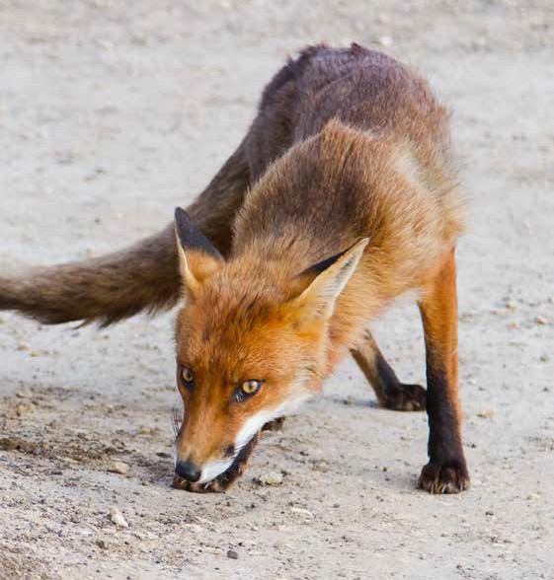

Red fox (*Vulpes vulpes*)

# Roles and responsibilities

Pest animal management is a shared responsibility, involving people and organisations from the local to the national scale.

The broad roles and responsibilities for different stakeholders vary across prevention, eradication, containment and asset protection, based on who is best placed to undertake that role. There can also be differences between jurisdictions and landscapes.

However, everyone has a responsibility to ensure that their actions do not introduce new or exacerbate existing pest animal problems.

There are challenges ensuring that all stakeholders undertake their responsibilities in pest animal management.

## Landholders (public and private) and co-existing land users

Responsibilities include:

* detect and report new pest animal occurrences
* control and manage established pest animals to mitigate, as necessary, the impacts on their own assets, or as required by regulation
* take reasonable steps to minimise the impacts of established pest animals on other landholders, particularly through participation in programs of collective industry or community-led action, and on people and the broader environment
* cooperate with and plan pest animal management activities jointly with neighbours, as well as state, territory and local governments, within a landscape scale/cross-tenure approach
* apply knowledge and skills to improve pest animal management and understand the need to use multiple approaches (e.g. chemical, physical and biological) to prevent pest animals from adapting to existing controls.

Roles and responsibilities

## Australian Government

Responsibilities include:

* honour international treaties and contribute to global and environmental trade initiatives
* oversee chemical regulation
* provide oversight and coordination for emergency responses to pest animal incursions of national significance
* provide a legislative framework, including biosecurity and environmental legislation, to minimise the risk pre-border and at the border of pest animal incursions including undertaking enforcement actions and regulatory interventions when necessary
* work with people or groups that have the potential to create pest animal incursion risks before or at the border (for example, importers) to assist adoption of risk management measures as part of normal business practices
* manage pest animals on Australian Government land in a responsible way, in co-operation with other landowners
* facilitate coordinated policy across jurisdictions for the management of established pest animals of ‘national significance’
* provide support where there is sustained collective national action to manage an established pest animal by an industry or community
* support national research and development of improved pest animal control or management when there is a strong public interest to do so, and through matching industry contributions to rural research and development
* work with state and territory governments to provide mechanisms by which pest animal issues of national significance can be identified and addressed
* coordinate, facilitate and promote national pest animal management policies and programs
* provide leadership, coordination and resources for evaluation and education to build public awareness and knowledge of pest animal issues of national significance
* encourage and support the development and integration of effective pest animal management strategies at all levels of land management
* promote the development of ongoing partnerships between governments, industry, community and scientists
* support the collection and collation of national pest animal data and information.

Roles and responsibilities

## State and territory governments

Responsibilities include:

* lead and coordinate emergency responses to priority pest animal incursions
* build coordination and collaboration in pest animal management at local, regional and state and territory levels
* encourage responsible pest animal management by providing a suitable institutional, legislative and regulatory framework; developing and implementing effective policies and programs, and where appropriate, providing positive support measures (not necessarily financial) to landholders
* provide leadership, coordination and resources for research, evaluation, advisory services and education programs about pest animals
* encourage the development of effective pest animal management strategies at local, regional, state and territory and national scales
* provide support where there is sustained collective action to manage an established pest animal by an industry or community in their state or territory
* manage pest animal problems on government land and waterways in a responsible way, in co-operation with other landowners
* when necessary for containment of an established pest animal, work with other state and territory governments to apply nationally consistent regulatory measures only to the extent necessary to manage unacceptable risks
* work with other jurisdictions and stakeholders to coordinate policy for the management of established pest animals of ‘national significance’
* work with people or groups that have the potential to create pest animal risks after the border (keepers of exotic species) to assist adoption of risk management measures as part of normal business practices
* undertake enforcement actions and regulatory interventions with respect to individual landholders when necessary to support sustained management of widely established pest animals by an industry or community
* support research, development and extension of improved pest animal control or management when there is strong public benefit or interest in the state or territory to do so
* support the collection of pest animal data and information, that can be collated nationally
* continue to work with other jurisdictions and stakeholders to update CoPs and SOPs, and consider the animal welfare impacts of pest animal control.

Roles and responsibilities

## Local governments

Responsibilities include:

* exercise statutory duties to encourage responsible pest animal management
* manage pest animal problems on local government land in a responsible way, in co-operation with other landowners
* assist with the coordination of community pest animal management programs
* support local initiatives and directions where they are representative of the APAS direction and regional and local priorities
* assist with data collection and information exchange
* develop and adopt ‘Good Neighbour’ policies, where appropriate, to help reduce the spread and impacts of high risk pest animal species
* support and build public awareness about pest animal issues.

## Industry groups

Responsibilities include:

* lead, promote and participate in collective action based on industry needs at a local, regional or national level to mitigate impacts of established pest animals on industry assets
* build pest risk mitigation and eradication measures into normal industry practices
* support and promote industry or market-driven approaches to established pest animal management where practical and applicable
* support research, development and extension of established pest animal management that provides industry benefit
* help provide their members with information on pest animal issues and best practice management approaches
* contribute to research and development programs to improve pest animal management best practice for different agricultural and natural systems, as appropriate
* help develop and encourage the adoption of codes, policies and plans that improve the effectiveness of pest animal management
* provide leadership and direction regarding pest animal risk minimisation
* represent industry interests in pest animal management
* assist with data collection and information exchange
* support and build public awareness about pest animal issues.

Roles and responsibilities

## Community groups

Responsibilities include:

* lead, promote and participate in collective action based on community needs at a local, regional or national level to mitigate impacts of established pest animals on community assets
* provide leadership and direction regarding pest animal risk minimisation
* represent community interests in pest animal management
* assist with data collection and information exchange
* support and build public awareness about pest animal issues.

## Natural resources management bodies

Responsibilities include:

* help monitor pest animal impacts and play a regional surveillance role for detecting high risk pest animal species that pose risks to their region or could spread to

other regions

* work with landholders and government to develop effective regional pest animal management programs
* play a role in coordinating and implementing regional and catchment-based pest animal management plans
* represent community interests in pest animal management
* assist with data collection and information exchange
* support and build public awareness about pest animal issues.

## Keepers of exotic species

Responsibilities include:

* must attempt to minimise the risk of escape of invasive species
* must seek approval to import new species, be proactive in reporting all escapes and have strategies in place to help respond to risks that inadvertently emerge
* must understand their legislated responsibilities, including registering exotic species where this is a statutory requirement.

# National vision, goals and priorities for pest animal prevention and management

The vision of the strategy is that Australia’s economy, environment and social amenity are protected from the impacts of pest animals.

Consistent with the principles enshrined in the IGAB, which recognise that biosecurity is a shared responsibility, the strategy sets out three clearly defined goals to focus national action, coordination and investment in pest animal prevention and management.

Successfully achieving these goals will require stakeholders to play an active and constructive role discharging their respective responsibilities across the spectrum of pest animal prevention and management activities.

The three goals of the Australian Pest Animal Strategy 2017 to 2027 are to:

* **Goal 1** prevent the establishment of new pest animal species
* **Goal 2** minimise the impact of established pest animals
* **Goal 3** improve leadership and coordination for the management of pest animals.

## Goal 1 Prevent the establishment of new pest animals

Australia’s favourable biosecurity status as a nation that remains free from many pests and diseases that affect agriculture, natural and built environments, and people in other parts of the world confers significant economic, environmental and community benefits.

To maintain this status, we act to reduce the likelihood of exotic pests and diseases that have the potential to cause significant harm from entering, becoming established or spreading in Australia.

Developing and continuously improving approaches that prevent new pest animals from entering and establishing in Australia is in the national public interest.

This encompasses two key areas of pest animal prevention and management:

* prevention through pre-border and border activities
* eradication approaches for pest animal species when technically feasible.

National vision, goals and priorities for pest animal prevention and management

As demonstrated by the generalised invasion curve (Figure 3) the highest returns on investment for a pest animal are usually obtained from preventing new pest animal incursions through early detection and intervention. There is value in identifying and continuously improving actions that support pre-border and border activities as well as eradication approaches.

Prevention and eradication are areas where Australian and state and territory governments are best placed to provide leadership and concentrate investment. However, other stakeholders still have an important role to play in helping to reduce the risk of new pest animals establishing in Australia.

This goal identifies three national priorities, explained in this section.

#### Priority 1.1 Commit to and continuously strengthen

**risk-based approaches to pre-border and border activities**

This priority identifies the need for continued support of Australia’s risk assessment and biosecurity processes. Encouraging investment in, and commitment to, early intervention is a priority as it provides greater return on investment and will reduce pest animal management costs in the longer term.

This priority aims to identify ways people and organisations can show leadership, invest and undertake feasible and cost-effective actions to reduce risks from new pest animal species.

Stakeholders surveyed during the 2007 APAS evaluation were largely supportive of Australia’s effectiveness in preventing new pest problems over five years (Appendix A). This indicates that there is integrity and confidence in pest animal biosecurity procedures in Australia. However, these biosecurity procedures must be maintained and continuously improved to remain effective in the face of changing environments, threats and challenges.

Central to these biosecurity activities are science-based assessments which determine the risk level and consequences of a new pest animal arriving and establishing in Australia.

Maintaining Australia’s capability to effectively assess risks and identify risk mitigation approaches is essential to pest animal prevention. This includes being able to assess how a species might enter the country, how it could be released and, if released, how it would establish a wild population. If the species was to establish, it is important to understand how much damage the species might cause and the options that might be available to eradicate and/or contain it.

A [National Categorisation System for Invasive Species](http://www.pestsmart.org.au/wp-content/uploads/2012/02/Natl_Categ_InvSpecies.pdf) was developed and agreed to by Australian, state and territory governments in 2012 and provides a mechanism to prioritise resources and action for invasive species management.

The system outlines ‘selection criteria’ for assigning candidate taxa to four agreed national categories for invasive species, as follows:

* national surveillance
* national eradication
* established pest animals of national significance
* national restrictions on the keeping, sale or trade of the pest animal species. This categorisation system helps guide and strengthen decision-making.

National vision, goals and priorities for pest animal prevention and management

There is a need to continually build on efforts to harmonise, or ensure consistency, between legislative and other approaches in Australia which are designed to help prevent high risk pest animal species from establishing in Australia.

Pre-border activities should also include continued work with Australia’s trading partners and near neighbours as a further way of mitigating the risk of new pest animal invasions.

As a country with pest management expertise, Australia is well-placed to play a role in assisting its near neighbours to strengthen their capacity to manage invasive species, as well as their export border processes. Such assistance would not only benefit neighbour countries but also reduce the potential for accidental pest animal incursions from imports to Australia.

Pest management assistance to neighbouring countries may occur through direct program delivery, assistance in training or the provision of technical expertise.

#### Priority 1.2 Improve early detection and response approaches for high risk pest animals

Governments play an important role in responding to pest animal risks in the prevention and eradication stages. However, for Australia to successfully minimise the risks of new pest animal invasions, others such as landholders, industry, community groups, and keepers of exotic species, need to be actively involved. They need to have the capacity

to detect and report potential problems and work with other parties to implement management actions.

Early response actions require institutional arrangements that enable investment and clarity of roles and responsibilities, including who has the leadership role and what coordination is required. The NEBRA provides a mechanism by which nationally-agreed pest animal eradication programs may be delivered. Proactive preparedness planning

is necessary if early detection and action is to be achieved. Slow detection of, or delays in responding to, an incursion may limit the ability to eradicate (or contain) a high risk species.

A National Incursion Prevention and Response Strategy has been developed to establish a planning structure that provides clear direction to government, community, industry and individual stakeholders for the management of new or potential vertebrate pest incursions across Australia. It will help ensure an ongoing decline in the rate of new pest animals establishing in Australia and form an important part of the prevention

and eradication stages of pest animal management.

These arrangements are important to ensure decisions can be made in regard to eradicating a new incursion. Eradication can be expensive and the costs of eliminating a high risk species that is likely to create significant impacts need to be considered with the potential ongoing costs that could arise from efforts to contain the species or mitigate its impacts should it be allowed to become widely established.

Surveillance is vital for early detection. The identification and monitoring of pathways for which a pest animal can enter is important.

National vision, goals and priorities for pest animal prevention and management

Effective management of potential pathways for animal introduction into Australia involves knowledge of all modes of entry, which include high risk entry points. These may include legal importation, smuggling, ‘hitchhiking’, or illegal but accidental importation caused by contamination or a lack of knowledge. It is possible to reduce both intentional and unintentional introductions by assessing the risk of one or more species entering via a particular pathway.

It requires action (surveillance and prevention), education of key stakeholders and the community (about potential pathways, risks and risk-minimisation strategies) and

information sharing so that all levels of government can access data in a timely manner on pest species incursions, interceptions and outbreaks. This will facilitate better analysis of potential pathways, prevention and early response. As part of the national surveillance network under development, education programs should encourage individuals to report new pest species.

#### Priority 1.3 Ensure effective management by stakeholders who have responsibility for animals with pest potential

In addition to biosecurity activities, the prevention of pest animals is also important within Australia’s borders. Some species that pose potentially high risks to Australia may already be here in legal or illegal captive holdings.

In these cases, stakeholders who risk exposing Australia to new pest animal incursions must take responsibility and show leadership in managing those risks, and have effective action strategies ready should issues emerge.

Keepers of exotic species, including zoos, private businesses and pet owners, must actively ensure that the species does not escape and establish outside of captivity. These stakeholders need to take a proactive approach and be able to respond should an escape occur.

Surveillance and compliance action to detect and seize illegally held pest animals is also vital to reduce the risks of new pests establishing in Australia.

At a national, state and regional level, there is value in identifying stakeholders who could pose higher risks, and then working with them to continuously improve their management of potential pest animals and their preparedness to alert others and respond to escapes.

To complement proactive stakeholder management of high risk species, there should be appropriate legislative and compliance arrangements in place that send strong signals to discourage inadequate risk management by these stakeholder groups.

It is important to ensure a robust process to effectively contain animals with pest potential in facilities (for example, zoos) to minimise the risk of escape or being stolen. IPAC has developed [Guidelines for the Import, Movement and Keeping of Non-Indigenous](http://www.pestsmart.org.au/guidelines-for-the-import-movement-and-keeping-of-exotic-vertebrates-in-australia/) [Vertebrate Animals in Australia](http://www.pestsmart.org.au/guidelines-for-the-import-movement-and-keeping-of-exotic-vertebrates-in-australia/).

These guidelines provide a nationally consistent framework for assessing the risk posed to environmental, economic and social values, including public safety, by species of non-indigenous vertebrates. As part of this, the risk of non-Indigenous vertebrate pest animal species is assessed, based (where possible) on:

* the danger posed by an individual animal
* the likelihood of establishment
* the consequences of establishment.

National vision, goals and priorities for pest animal prevention and management

**CASE STUDY 1**

The risk of exotic pets—Rose-ringed Parakeets

##### Rose-ringed parakeets (*Psittacula krameri*), also known as ring-necked parakeets, are the most widely introduced parrot species in the world. Native to the Indian subcontinent and sub-Saharan Africa, rose-ringed parakeets can now be found in 35 countries across five continents. It is popular as a pet worldwide, including in Australia, where it fortunately has not yet spread.

Rose-ringed parakeets adapt to a range of climates, ranging from the heat in India to the snow in Europe. They also have a variable diet and are able to live in disturbed habitats, such as urban parks.

It is because of these factors that there has been a significant population increase of rose-ringed parakeets in England. The species has been in England for many decades as pets, and it was people accidentally or intentionally releasing pet birds that initiated the wild population. From 1,500 in 1995, the population number is now estimated to be over 30,000 wild birds.

This parakeet is now recognised as a significant pest in England. In its native habitat on the Indian subcontinent, rose-ringed parakeets are a significant agricultural pest that reduce crop yields and damage fruit trees. Growers in England are already seeing significant damage to fruit trees and it is expected that wherever the

species establishes, severe agricultural damage will arise.

Rose-ringed parakeets are also an environmental pest. In England they occupy available nesting cavities before most native English species start breeding, and are likely to contribute to population decline of native species. Rose-ringed parakeets are also an aggressive species, and there have been cases of these birds attacking and even killing mammals that climb trees near their nest sites.

Rose-ringed parakeets have extreme pest potential in Australia especially as the species is a popular pet. If this species was to become established in Australia, it is expected that the impact would be severe, as the Australian climate is similar to that of its native habitat.

The species has been assessed by the Vertebrate Pests Committee (2007) as being in the Extreme Threat category, and Tasmania has banned the importation of the species into the state due to the significant threat. It is important that those who own rose-ringed parakeets understand that the release of this species, whether intentional or accidental, could cause significant damage to Australia’s agricultural industries, as well as the environment. Owners of this species have a responsibility to assist with pest management by ensuring that their birds are always kept captive, and do not contribute to a wild population that would damage Australia’s national environment and agriculture sector.

National vision, goals and priorities for pest animal prevention and management

## Goal 2 Minimise the impact of established pest animals

Pest animals in Australia cause negative social, environmental and economic impacts.

This goal focuses on promoting collaborative, consistent and coordinated approaches to minimise the impact of established pest animals.

The three priorities identified, and outlined in detail in this section, to achieve this goal focus on national planning, encouraging and improving best practice, as well as

encouraging greater participation in coordinated management approaches—a central part of shared responsibility.

These approaches maximise national benefit, and provide overarching guidance and consistency for more localised pest animal management actions.

Two key stages of pest animal management are incorporated into this goal:

* containment - preventing further spread of the pest animal, and, where feasible, reducing the area of establishment and extent of its impacts
* asset protection - encompassing management or control actions designed to mitigate impacts on public or private assets. These actions do not necessarily mean that direct control, reduction or destruction of the target pest animal occurs.

Where it is in the national interest to have a unified approach, the strategy provides guidance on the most advisable investment, coordination and tactics that should be employed.

#### Priority 2.1 Develop and implement national action and coordination plans for species prioritised as nationally significant

As efforts to control and manage established pest animals can be costly, risk based prioritisation is needed to determine the best use of finite resources.

At the national level this prioritisation will be based on a risk assessment that considers:

* current and potential pest animal impacts
* feasibility of control and management
* the rationale for a national approach.

The National EPDNS Management Framework is intended to guide this process. The scientific, risk-based approach and methodology contained in the National EPDNS Management Framework will be applied and continuously improved to help prioritise where national coordination, investment and action is most needed.

Where a pest animal species has been agreed to be ‘nationally significant,’ a customised plan will be developed. The principles in the strategy will guide the development of the action plans for these ‘nationally significant’ species. These plans could be new, or an existing plan could be appropriate. Plans should involve, consider and be owned by all stakeholders—coordinated action is important to achieve the best results.

National vision, goals and priorities for pest animal prevention and management

The framework recognises that governments are not always best placed to lead coordinated action in managing the adverse impacts of pest animals. For example, an industry and community led and coordinated action plan might result in greater community engagement and enable a more effective response and leveraging of resources for minimising the impacts of some established pest animals than a government led program.

The National Wild Dog Action Plan is a great example of a customised plan that fits within the framework.

**CASE STUDY 2**

Fighting wild dogs—a national action plan

The National Wild Dog Action Plan is an example of the success that can be achieved when all levels of stakeholders work together and assume responsibility for tackling a serious pest animal problem.

The plan, facilitated by WoolProducers Australia, is supported by a broad range of key government and non-government stakeholders.

The aim of the plan is to deliver best practice wild dog management that is safe, efficient and humane, and supports continuing economic activity while being socially acceptable and environmentally sustainable.

It sets out four goals to achieve this with clear actions under each for a wide spectrum of stakeholders. Importantly, the plan identifies who is responsible for actions, and the resources, priorities and timeframes; as well as identifying the monitoring, evaluation and reporting requirements associated with the plan, including standard measures of impacts, management efficacy, and cost effectiveness relevant to all parties.

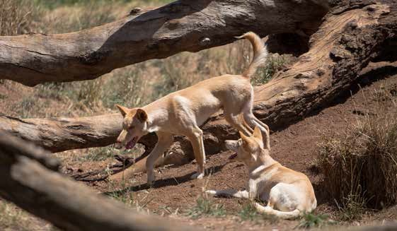

Wild dogs (*Canis familiaris*)

National vision, goals and priorities for pest animal prevention and management

#### Priority 2.2 Continue to develop and improve best practice management methods and increase overall adoption of these practices among landholders

This priority recognises the importance of best practice pest animal management, as well as the need to continually improve.

Best practice management approaches for individual and/or multi-pest management should be developed, recognised and promoted for adoption by all stakeholders. Inclusion of best practices in nationally consistent CoPs and SOPs will play an important role and substantial progress on this front has been made in recent years. National model CoPs and SOPs have been developed for a range of species to provide guidance on the management of animal welfare aspects of pest animal control.

Where self-regulatory approaches provide greater flexibility to stakeholders to adopt best practice, these are preferred over legislative, ‘top down’ enforcement. Well-implemented, self-regulatory approaches provide opportunities to demonstrate to the wider community, and to markets, that effective pest animal management processes are in place.

Recognised best management approaches for the control of all major pest animals can and should be adapted to local circumstances. All land managers need to know and utilise these wherever possible and practicable, in order to avoid wasted effort and resources. These approaches should be widely available and efforts made to ensure they are understood.

‘Best practice management’ is continually evolving, and ongoing investments in research and development are required (as outlined in priority 3.3) to ensure that the available management techniques and tools continue to meet operational needs and community expectations. While control options are available for many pest animal

species, there is a need both to continually refine the techniques available and to develop additional techniques.

The continued discovery, refinement and delivery of accessible, world-leading science, knowledge, techniques, management options and tools is crucial to support a risk-based approach to pest animal management and prevention that is humane, cost efficient and ecologically appropriate.

Cost-effectiveness is important for any control method. If the cost of using a set of control methods to a landholder is greater than the benefits received on their property (for example lower production losses) then they do not have an incentive to contribute.

Research, development and extension also helps to develop and update best practice, and to customise it for different stakeholders, industries and/or species.

National vision, goals and priorities for pest animal prevention and management

**CASE STUDY 3**

PAPP—A new complementary tool in the fight against pest animals

##### Baiting forms an effective part of a landholder’s control toolkit for best practice pest animal management. Lethal baiting is the only practical means for achieving population control in remote and inaccessible areas.

1080 is currently the common poison used for pest animal baiting in Australia. It is naturally occurring in some native plants, which means that most native species are tolerant. This makes 1080 suitable for broad scale dog control. The development of tolerance to this poison by target species is a critical concern raised by its intensive use.

One difficulty faced with 1080 is that there is no antidote, so if a pet or working dog accidently ingests the bait it will die. This discourages some landholders from using the baits—and also makes baiting more difficult in peri-urban areas, where there are more people and domestic animals are present.

This gap limits the effectiveness of cross-tenure management approaches for key species such as foxes and wild dogs. In particular, foxes are often present in peri-urban areas, preying on domestic animals such as chickens.

A new pest animal toxin, Para-aminopropiophenone (PAPP) has been developed to enable more comprehensive regional control by ‘filling the gaps’ in areas not serviceable by 1080.

Through the Invasive Animals CRC (IACRC), Australian Wool Innovation, Animal Control Technologies (Australia) Pty Ltd (ACTA) and the Australian Government, have invested in R&D to enable registration of PAPP and two bait products containing PAPP for wild dog and fox control in Australia.

This new chemical toxin, is now being manufactured and sold in baits by ACTA under the product names DOGABAIT® for wild dog control and FOXECUTE® for fox control.

PAPP has characteristics that make it suitable for use as a humane pest animal toxin. Once it is eaten and absorbed into the bloodstream, PAPP works by converting normal haemoglobin in red blood cells to methaemoglobin, which cannot carry oxygen to the heart, muscles and brain. Affected animals become lethargic and sleepy before quickly becoming unresponsive and dying. Symptoms are mild with no tissue or cell damage, which means that any animal that receives a partial dose can fully recover without

ill effect.

PAPP is known to affect some native animals if ingested. Care will therefore be needed when developing control programs using the toxin. The risk to native animals can be managed by altering the timing and presentation of baits, such as baiting at cooler times when reptiles are less active. An antidote, chemical methylene blue, to reverse the effects of PAPP poisoning to working and domestic dogs is available. However, at present this can only be administered by a vet, and would need to be administered within an hour of poisoning. PAPP does have this manageable limitation but the addition of a new wild dog and fox control tool will offer greater flexibility and strategic management of pest animals across a much broader range of landscapes. PAPP will have particular benefits on the

peri-urban fringe but 1080 will continue to be the toxin of choice for other areas.

National vision, goals and priorities for pest animal prevention and management

**Priority 2.3 Increase participation in coordinated management approaches across a range of scales and land tenures**

This priority recognises the importance of cross-tenure pest animal management, where appropriate, as well as the need for increased involvement of communities.

It is in line with the eight principles that underpin effective pest animal management, most directly with the third principle, ‘Management of mobile pest animals requires a coordinated approach at the appropriate scale, which may need to be applied across multiple land tenures’.

Coordinated management approaches, at the appropriate scale, across multiple land tenures, for individual or multi-pest management should be adopted by stakeholders. There are a number of advantages that arise from coordinated group pest management including the effective use of local expertise and resources, decreased pest management costs and encouraging ownership of the problem through group cohesiveness.

Farmers develop important knowledge about their property over time, and understand how their land adapts to changing conditions. When landholders work together across different tenures, a combination of local history and land conditions can be shared and used to develop effective pest management approaches. Coordinated management promotes awareness of the problem and potential solutions within the community while enabling management over a larger area of land.

When management practices are coordinated, the benefits rise as the number of participants increases. It is not about creating new technology to battle pests, but the community based approach means that management is more effective.

Mobile pests such as wild dogs, feral camels and horses are challenging, as individual land tenures are not able to fully benefit from their management efforts if neighbours are not also managing the same pest. This may lead to under-investment in pest management.

Landholders that are not actively involved in management may create a refuge for a pest on their property, and this effect is often seen on properties with absent landholders. Pests do not respect land boundaries and will travel between different land tenures as well

as state forests or national parks, meaning that it is vital for the entire community to be involved for successful management of the pest.

Pests such as wild dogs, feral camels and horses also have an impact on the entire community, not just individuals, and can cause psychological stress as well as economic loss. Wild dogs can have a significant impact on communities, with urban population numbers increasing, and many wild dogs living in and around houses in urban areas.

Wild dogs in urban areas attack pets, are a danger to children, and spread disease.

It is this whole community impact that makes coordinated management approaches important. Successful coordinated management creates positive social consequences for communities, as well as economic benefits for all land tenures. It can result in reduced stock losses and builds support and recognition for pest animal management throughout the community.

National vision, goals and priorities for pest animal prevention and management

**CASE STUDY 4**

European Carp and the National Carp Control Plan

European Carp (*Cyprinus carpio*) are one of Australia’s worst introduced pests. Carp decrease the water quality and the amenity value of freshwater rivers and lakes by stirring up sediment. This affects all water users, including irrigators and regional communities. Carp also have a devastating impact on biodiversity, and have decimated native fish populations in many areas since they first became

established as a major pest in the wild in the 1960s. The economic impact of carp is difficult to measure but has been estimated at up to $500 million per year.

Following years of testing by CSIRO through the IACRC, Australian scientists have determined that use of a biological control agent, the naturally occurring carp virus (*Cyprinid virus* (CyHV-3), could significantly reduce the number of carp in Australia. The virus is specific to common carp, and won’t cause disease in any other species of fish (including native Australian fish) or in other animals that are exposed to the virus, including humans.

The National Carp Control Plan will set out a considered approach to

safely manage the potential release of carp virus by the end of 2018, as part of an integrated approach to control carp in Australia’s inland waterways.

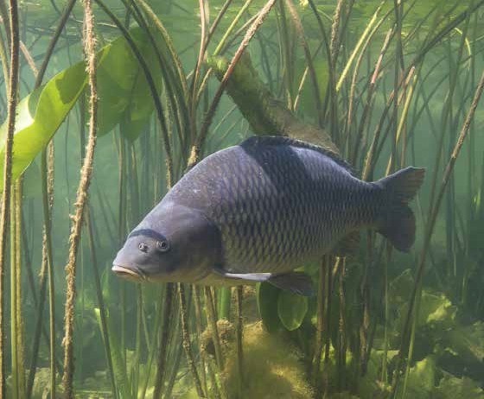

European Carp (*Cyprinus carpio*)

National vision, goals and priorities for pest animal prevention and management

**CASE STUDY 5**

### Managing wild dogs—driven by the community

##### Wild dogs (*Canis familiaris*) occur across a range of Australian landscapes, from national parks to farming areas and urban environments, and are distributed across most of the mainland. The dingo component of the wild dog population was first introduced from South East Asia more than 4000 years ago and modern dog breeds have been present since first European settlement in 1788. Modern dogs have readily interbred with dingoes creating hybrid wild dogs, which predominate in south-eastern Australia.

Wild dogs can cause many negative economic, environmental and social impacts. They are conservatively estimated to cost Australia’s agricultural sector up to

$89.33 million per year through livestock, losses, disease transmission and control costs. Wild dogs have benefited from anthropogenic changes to landscapes and their predation also limits livestock enterprise choices. They sometimes kill domestic pets in peri-urban and urban areas, and are a recognised threatening process for some native animals, including koalas (*Phascolarctos cinerus*).

Dingoes also have a value in natural systems where they can have regulating influence on kangaroo numbers and are thought by some to have beneficial effects on small mammal populations, but as yet there is no experimental data to support this.

They are iconic, have cultural value for some indigenous groups and have various levels of protection in conservation areas such as national parks and private and public nature reserves.

Though harder to quantify, the available evidence also points to wild dogs inflicting an alarmingly high emotional toll and causing significant distress to farmers, and livestock producers in particular, with negative flow-on effects for rural communities.

Wild dog management strategies are most successful when people work together. Because wild dogs do not respect tenure boundaries such as fences, borders or land uses, wild dog managers in one area are likely to be affected by the actions or inaction of people in surrounding areas. Working together ensures that all stakeholders have input into a management approach that covers the views of each interest group.

This typically requires a little bit of work from a lot of people, rather than a lot of work from a few people. A cross-tenure, landscape level approach led by the community that focuses on the ‘common problem’ is being encouraged and adopted by local wild dog management groups across the country.

The Australian Wool Innovation’s (AWI) ‘Community Wild Dog Control Initiative’ has been very successful in highlighting the importance of community and industry partnerships in tackling the problem of wild dogs. Through this initiative, AWI has supported 88 local wild dog control groups to work together to apply a nil-tenure model. On-ground work by the landholder groups has included planning and coordination, training, field days, as well as extensive trapping and baiting.

Utilising community participation, the AWI initiative has achieved significant reductions in stock losses. The initiative enabled new community groups to form and start focusing on control efforts in regions where wild dogs are an emerging problem as well as providing collaborated on-ground support for wild dog control in areas where they

have been an ongoing problem.

National vision, goals and priorities for pest animal prevention and management

## Goal 3 Improve leadership and coordination for the management of pest animals

Effective pest animal prevention and management depends on the coordinated and committed action of a large number of stakeholders.

This goal identifies three priorities for all levels to further improve the coordination of stakeholder actions, now and into the future, across all stages of pest animal invasion: prevention, eradication, containment and asset protection.

#### Priority 3.1 Develop the knowledge, capacity and commitment of stakeholders to take responsibility for pest animal management

Pest animal management is a shared responsibility. Encouraging a wide range of stakeholders to be prepared for and responsive to pest animals requires an increased awareness and understanding of pest animals, their impact, response options and available tactics.

To achieve this there needs to be:

* good science-based information on pest animals—their risks, characteristics, likely impacts and control methods
* information that is accessible to different stakeholders
* evidence of pest animal impacts that can be observed or demonstrated
* the ability to understand and adapt pest animal risk mitigation and control options for individual circumstances
* access and availability of training to develop skills in pest animal control.

This priority focuses on the need to raise stakeholders’ awareness and understanding of pest animal impacts. It recognises that different stakeholders will need different information and support to increase their capacity and motivation to respond to pest animals. As part of the 2007 APAS evaluation, it was found that one of the two most significant challenges faced was stakeholders not taking responsibility for their roles in pest animal management.

This priority also considers ways of ensuring stakeholders can access necessary skill development. Skills and access to skills building was rated in the evaluation as the third most significant barrier to pest management. A range of obstacles to accessing skills development opportunities were identified as needing monitoring and tactical action to ensure safety for both humans and animals.

Some pest animal control actions require the development and implementation of education and training for different stakeholders. This necessitates identifying people with the understanding and capacity to train others, and making training accessible to those stakeholders who need it.

This priority recognises the need to further strengthen training capability and availability. Risks to effective pest animal practices resulting from lack of training should be identified and managed. The regulations and guidelines for managing pest animals differ across state and territory governments. Efforts to develop national consistent training, for example, through the Vocational Education and Training system, will need to account for jurisdictional differences to be successful.

National vision, goals and priorities for pest animal prevention and management

**CASE STUDY 6**

Increasing stakeholder awareness

##### The PestSmart online portal has contributed to improving the quality, quantity and accessibility of key information about pest species and best practice pest animal management to stakeholders. The portal provides information about pest species, guidelines on best practice, and principles for pest management. There is access to scientific research papers, case studies and maps of pest animal distribution which assist in building stakeholder knowledge.

PestSmart provides links to relevant policies and strategies at all levels of government as well as risk assessment models and pest animal alerts. Stakeholders are able to increase their knowledge of historical and possible future pest animal issues by accessing information and links to distribution models and case studies about previous incursions and bans. Detection techniques and predictive mapping resources allow stakeholders to build capacity in recognising possible incursions in their local area.

Animal welfare plays a significant role in pest management, and it is important that all techniques are target specific and humane. PestSmart provides access to the Codes of Practice and Standard Operating Procedures, as well as different pest control methods that are available for land managers to use.

Social issues are also a large part of pest management, and there can be conflicting opinions that make choosing pest management tools difficult. PestSmart provides information on different social perspectives, so that stakeholders are able to

better understand each other, leading to increased capability of pest management decision-making.

Capacity building includes being aware of what other stakeholders are doing, and PestSmart publishes relevant news articles. Stakeholders are able to keep up to date on the latest programs and developments, increasing awareness of their own knowledge and capabilities.

Skills are developed and capabilities increased when stakeholders work together, and PestSmart provides a map that identifies local groups and landholders can connect to. Connection and networks encourage commitment to achieve an overall goal while providing support for those conducting pest management.

FeralScan is a freely available resource that is designed to encourage and improve community capacity when managing feral pests. The portal is also a smartphone app and allows stakeholders to map feral activity, print maps and receive pest activity updates. This is an important pest management tool as it facilitates communication and stakeholder participation in pest animal management.

National vision, goals and priorities for pest animal prevention and management

Unique partnerships, such as the FeralScan Citizen Science program that bring government, research, industry, business and community together, are also playing an increasingly important role in engaging and mobilising the Australian public to gather and utilise citizen data to improve pest animal management.

The participation of landholders is critical to successful, and sustainable, established pest animal management and this principle of shared responsibility between landholders, community, industry and government is central to the National

EPDNS Management Framework.

**Priority 3.2 Improve information collection and sharing mechanisms to support effective pest animal management**

This priority identifies the need to map out the data and knowledge requirements for pest animal management across the prevention, eradication, containment and asset protection stages. This will ensure that any system developed is cost effective and services the priority needs of stakeholders for data and information collection and sharing.

The IGAB identified a national biosecurity surveillance and diagnostic system as a priority reform area for collaborative effort over the near-term to improve decision-making at

the regional, state and national levels and provide access to a wide range of relevant biosecurity information sources across the biosecurity continuum.

This is relevant to pest animal prevention, eradication and management which all require effective data collection and information sharing. At a national level, coordinating data collection can inform priority setting and be used to underpin evidence-based

decision-making, but with data often held by a range of stakeholders this can be challenging.

There is a need to consider the information and knowledge requirements for effective pest animal prevention and management, and to understand what cost effective approaches could be put in place to collect data and convert it to relevant information. Consistent with the IGAB principles, careful consideration should be given to coordinating effort to enable the effective use of best available data and information collected.

Accurate knowledge and information on pest animals, their location and impacts is critical to effective pest animal management. Local level data is important to inform local management planning and actions. This data is currently collected in a range of ways such as local region surveys (undertaken by NRM groups) and community-based reporting (FeralScan). To assist with providing regional and national level best available data on pest animals there is scope for greater and more uniform data collection and

reporting. Collecting and sharing nationally consistent, best available data on the impacts, distribution and abundance of established pest animals will assist with achieving the goal of minimising the impact of established pest animals.

Where containment is thought to be achievable, it is important to have good information about the current situation and the boundaries of where a pest animal is impacting, how it might spread and the goals of the containment program.

A cost effective monitoring and surveillance approach is crucial to support effective containment approaches. Efforts in this regard are detailed in preceding sections.

National vision, goals and priorities for pest animal prevention and management

#### Priority 3.3 Maintain and enhance long-term research, development and extension capacity and capability

Science, knowledge, new techniques, management options, tools and their accessibility for pest animal prevention and management are crucial. This priority aims to keep research targeted and focused in areas that can strengthen the risk-based approaches adopted to humanely, cost effectively and feasibly respond to pest animal challenges.

Research, development and extension also help to develop and update best practice, and to customise best practice for different stakeholders, industries and/or species.

Pest animal control methods often take years to develop, and require specialist scientific skills and capabilities. To deliver the control methods of the future it is important that research, development and extension activities, and associated funding arrangements are maintained with a long-term focus. Rabbit biological control is a great example of the importance of ongoing long-term commitment to research, development and extension.

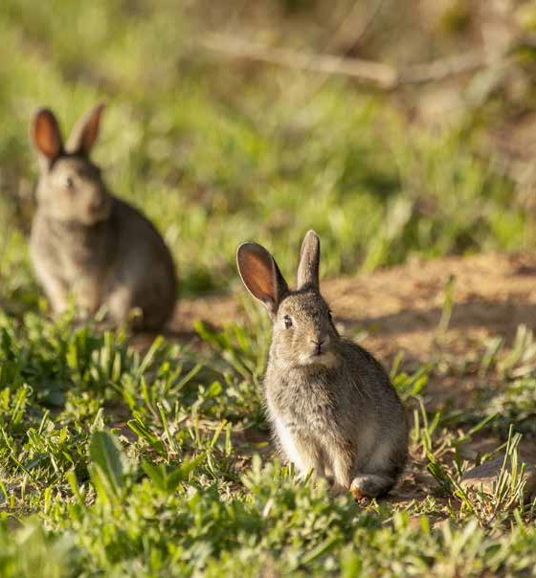

European rabbit (*Oryctolagus cuniculus*)

National vision, goals and priorities for pest animal prevention and management

**CASE STUDY 7**

### Biological control of the European rabbit (*Oryctolagus cuniculus*)—the importance of ongoing research and development

##### Biological control is the management of a pest through the use of its ‘natural enemies’. It is a critical tool for cost-effectively controlling widespread pest animals that have established in high populations.

The use of the myxoma virus—which causes the disease myxomatosis—as a biocontrol agent for wild rabbits is perhaps the most well-known biological control success story in Australia’s history.

Rabbits initially arrived in Australia with the First Fleet, and in 1859 the Victorian Acclimatisation Society released 24 rabbits on Christmas Day to hunt for sport and to help settlers feel more ‘at home’. The rate of spread of the rabbit in Australia was the fastest of any colonising mammal anywhere in the world. By 1926, Australia’s rabbit population had grown to an estimated 10 billion animals and covered over 70 per cent of the continent.

Rabbits are a significant threat to biodiversity, affecting 304 nationally threatened plant and animal species. They have direct impacts on native flora and fauna; for example, by grazing on native vegetation they prevent regeneration, and they compete with native fauna for food and shelter. Wild rabbits also support populations of introduced cats and foxes, remove vegetation which exposes fauna species (for example, burrowing petrels) to increased predation, and cause soil erosion through the digging of warrens.

As a world-first pest control technique, the myxoma virus was released into the feral rabbit population in 1950 to combat the devastating impact of rabbits. Spread predominantly by fleas and mosquitoes, the virus killed

* 1. per cent of infected rabbits, brought huge relief to farmers and a reprieve for the natural environment.

Over time the rabbit population built up genetic resistance to the myxoma virus and research into a new virus became necessary. In 1996, rabbit haemorrhagic disease virus (RHDV) was released into the feral rabbit population, killing up to 98 per cent of rabbits in arid areas. Together, these two biocontrol agents have limited wild rabbit numbers to about 15 per cent of their potential population.

Again, Australia is facing resistance to RHDV, and a new strain of the virus, known as ‘K5’ selected through a government and industry research collaboration led by NSW Department of Primary Industries through the Invasive Animals CRC, which was released nationally in March 2017. To continue to benefit from previous biocontrol agents, new and additional agents are required be released every five to 10 years to avoid the resurgence of rabbit numbers and supplement existing agents. Without new disease strains

like K5, rabbit populations would build up genetic resistance over time and population numbers would continue to increase to numbers seen prior to the use of these control methods.

Wild rabbits remain Australia’s single worst, most widespread, destructive and costly environmental and agricultural vertebrate pest animal. They cost over $200 million in lost agricultural production every year. Without these biocontrol agents, the annual cost to agriculture alone would exceed $2 billion.

The return on government investment in RHDV is said to be unmatched by any other investments in rabbit control research, or perhaps any other area of government investment, in the last 50 years.

Along with the significant economic impact, rabbit control has also had substantial social impact in Australia. Prior to the release of the myxoma virus, many farmers were forced to walk away from their properties due to the destruction caused by rabbits.

Farmers are still concerned today as rabbits damage grape vines and crops and the presence of warrens risk injury for both people and working animals. It is important to increase and maintain social awareness of wild rabbit impacts, because they are an established pest, they are a problem that needs to be continually managed.

National vision, goals and priorities for pest animal prevention and management

**Priority 3.4 Monitor the pest animal management approach and identify and improve areas of weakness**

Since the launch of the 2007 Strategy, substantial progress has been made towards a more coordinated, nationally consistent and robust approach to pest animal prevention, response and management across all stages of invasion.

The IGAB provides a useful framework to guide and target the efforts of both government and community stakeholders.

The coordinated efforts of stakeholders at all levels have seen legislative frameworks streamlined, national principles agreed, rapid response plans developed and implemented, species-specific best-practice approaches codified and practical toolkits produced and centralised in an accessible portal ([PestSmart](http://www.pestsmart.org.au/)).

Despite this considerable progress, further work is required to monitor the overall approach to pest animal management, ensure its integrity is maintained and identify areas that require strengthening.

Pest animal management is costly and there is a need to ensure that all stakeholders are investing in a risk-based way that maximises return. Demonstrating the success of investment can also encourage more stakeholders to invest and participate in coordinated approaches.

Ongoing performance monitoring of pest animal prevention and management frameworks and actions is required. Any issues that emerge if components of the system are not operating effectively must be reported.

There is also value in increasing Australia’s ability to take stock of the nation’s performance in responding to pest animals and providing an assessment of this performance to the public.

As data sharing and knowledge systems continue to be updated and improved, national indicators that can be used to publicly report on pest animal prevention and management should be identified and agreed. This would assist in demonstrating achievements and improving stakeholder and broader community commitment and support for pest animal management.

A single, comprehensive and transparent set of performance benchmarks is currently lacking with information on the status of pest animal prevention and management measures fragmented across a number of organisations and publications.

Some of the work underway such as a sector-specific national surveillance strategy and auditable action plan under the [National Surveillance and Diagnostics Framework](http://www.agriculture.gov.au/biosecurity/partnerships/nbc/intergovernmental-agreement-on-biosecurity/national-surveillance-and-diagnostics-framework) (referenced in Priority 1.2) will lay the groundwork required to implement such a performance monitoring and progress reporting framework.

# Implementation

IPAC is responsible for developing and maintaining the strategy. It comprises representatives from Australian, state and territory governments and reports to the National Biosecurity Committee.

The key to successful implementation is collaborative effort. People from different sectors with different roles and responsibilities should consider how they might best adopt the principles, goals and priorities and work with others to maximise outcomes. An action plan for each priority area should be developed by the key parties who might be best placed to play an active role in developing approaches, supporting material and/or delivering actions that respond to the priority.

The principles should be considered by all stakeholders. Where further guidelines, tools, training or resources are needed to help different stakeholders implement these principles, or to progress national goals and priorities, leadership is encouraged from stakeholders best placed to help develop this material and share it with others.

The goals and priorities are relevant to all stakeholders. There are some areas where governments need to play a leadership role and other priorities that may require leadership from other stakeholders.

This strategy guides pest animal management over the next 10 years. The strategy will be reviewed at a midpoint and after 10 years to identify progress and incorporate changes to national frameworks and approaches as well as changes in pest animal priorities. Sound data collection and monitoring at all levels will inform any reviews and will be critical to future improvements.

# Appendix A: Achievements of the 2007 Australian Pest Animal Strategy

This revision to the strategy was informed by an evaluation of the 2007 strategy (Community Solutions, 2013), undertaken in parallel with an evaluation of the Australian Weeds Strategy.

The evaluation included a national survey inviting people interested in pest animal management to provide feedback. Nearly 200 stakeholders, including landholders, local government officials, extension officers, hunters, animal welfare organisations, researchers, industry, state and territory government officials, and Australian government officials responded to the survey in relation to pest animals. In addition to

this, 29 stakeholders covering a similar cross section were interviewed in more detail to obtain their perspectives. Key findings from this evaluation are summarised in this section.

## Overall achievements

* + - The strategy formally recognised for Australian, state and territory governments the agreed challenges posed by pest animals and the need for strategic action and collaboration. This recognition was valued by stakeholders and incorporated into plans and research directions and helped them to commit to pest animal actions.
    - The strategy documented a first step towards a more integrated approach to pest animal management in Australia. It provided an aspirational framework which aligned with the biosecurity continuum approach and could be built on to support improved prevention and management of pest animals.
    - There was strong support to update the national strategy to help guide coordinated and effective pest animal management. The IGAB provides a useful framework for coordinating biosecurity effort for pest animals with other areas (such as weeds, marine pests and plant and animal disease risks).
    - The principles in the strategy were the most valued component. Stakeholders reported that these had informed their own planning and approaches to pest animal management. However, some of the principles were reported to require more information or support arrangements to help the stakeholders implement them effectively. Some of these arrangements, noted by stakeholders as required, were demonstrated to be under development at the time of the evaluation and once completed were assessed to play a useful role in enabling prioritisation and coordination of pest animal management.

Appendix A: Achievements of the 2007 Australian Pest Animal Strategy

* Examples of some of the key actions achieved under the previous strategy that will help improve pest animal management in Australia include:
  + revision of the guidelines for the Import, Movement and Keeping of Non-indigenous Vertebrates in Australia, now publicly available
  + the development of a National Categorisation System for Invasive Species to underpin a risk-based approach to prioritising pest animal species at the national level
  + the development of a range of species-specific National Model Codes of Practice for the humane control of pest animals. These codes of practice can help to guide pest animal management by all participants
  + the development of the National Feral Camel Action Plan
  + principles to maximise national consistency and effectiveness of legislation were agreed and are guiding state and territory policy and legislation amendments.

## Prevention

* Pre-border risk assessment and protocols were highly regarded. People supported Australia retaining capability and capacity for pre-border risk assessment and application of quarantine protocols. This was viewed to be a sound public investment.
* There is a need to continue to support science that underpins the risk assessment approach. The effectiveness of the risk assessment approach is underpinned by knowledge generated from national and international research endeavours.
* Stakeholders’ awareness and understanding of prevention and eradication approaches was low and requires improvement, particularly as prevention requires a wide range of stakeholders to be monitoring, detecting and reporting incidences of high risk species incursion.
* With limited public resources available for pest animal prevention and management, tensions on where to apply these resources create challenges. There is evidence

that earlier intervention provides a greater return than the considerable resources required to manage established species.

## Eradication and containment

* Leadership, coordination and funding approaches for eradication need improving. There is a lack of clarity around detection approaches and ways to invest and coordinate effective eradication activities.
* Some useful foundations were developed to identify ‘national significance’ and ‘alert lists’ which were reported as required to support effective monitoring and surveillance of high risk species.
* Attracting investment in a timely manner for eradication is challenging and has the potential to delay eradication action. This can be detrimental to its effectiveness. Also there is a need to ensure that there is clarity around who takes a leadership approach and how coordination should occur when there is an urgent eradication or containment program required which crosses state/territory borders.

Appendix A: Achievements of the 2007 Australian Pest Animal Strategy

## Established pest animal management

* Pest animal management was reported to have improved over the last five years. This included increased options available to manage pest animals.
* The strategy was criticised for not influencing on-ground action for established pests.

The evaluators noted that the actions being undertaken at the national level played a role in influencing activities at various scales and a future strategy needed to be clearer on the role of the national strategy.

* Government resource constraints and continued decline is a big factor for the level of success or otherwise for the management of widespread established pest animals.

This has triggered increased interest in ways to maximise return on investment of public funds through the development of rigorous national prioritisation approaches.

* The landholders of public and private land have a primary role in the management of established pest animals. Stakeholders reported that there were wide variations in pest animal activities by those responsible.
* The two most significant challenges inhibiting stakeholders’ capacity to manage pest animals were reported to be financial resource availability and a lack of stakeholders taking responsibility for their roles in pest animal management.
* There are tensions around reducing pest animal numbers versus managing the impacts these pest animals create. Effort should be focused on cost effective and feasible options that will reduce impacts.

# Appendix B: Detailed stages of pest animal management

## Prevention

Australia has a range of pre-border activities in place which aim to anticipate threats and manage risks before they arrive in the country.

Central to these activities are science-based risk assessments which determine risk levels for different products seeking entry to Australia. These risk assessments help the

Australian Government gauge the level of biosecurity risk that may be associated with the importation, or proposed importation, of animals, plants or other goods into Australia.

If the biosecurity risk is found to exceed the level of risk that is acceptable to Australia, then there may be measures put in place to ensure the safety of the trade. However, if the biosecurity risks cannot be overcome, then the trade will not be permitted.

Governments invest heavily, and have a critical role in pre-border and border activities to reduce the risks of new pest animals arriving. Pre-border activities include offshore

inspection, certification and overseas capacity building. At the border, Australian, state and territory governments impose biosecurity and inspection activities. These aim to prevent known risks from entering the country or state.

Scientists and industry help to determine the risk—particularly in understanding attributes of different species as well as the influences of Australia’s climate and landscape. Therefore, scientists and industry are key contributors to risk-based assessment approaches and to identifying appropriate protocols and procedures for pre and

post-border biosecurity.

A survey of stakeholders was undertaken as part of an evaluation of the first APAS.

These stakeholders were largely supportive of Australia’s effectiveness in preventing new pest problems over five years (Appendix A). This indicates that there is integrity and

confidence in pest animal biosecurity procedures in Australia. However, these biosecurity procedures must be maintained and continuously improved to remain effective in the face of changing environments, threats and challenges.

Prevention is also important within Australia. A range of animals with pest potential are held in public and private keeping, both legal and illegal. It is important to ensure a

robust process to effectively contain animals with pest potential in facilities (for example, zoos) to minimise the risk of escape or being stolen. Surveillance and compliance action to detect and seize illegally held pest animals is also vital to reduce the risks of new pests establishing in Australia.

Appendix B: Detailed stages of pest animal management

## Eradication

Pest animals with the potential to pose threats to Australia will inevitably challenge Australia’s biosecurity system through legal, illegal and accidental avenues.

Preventative approaches reduce these occurrences but it is unrealistic to expect that no pest animals will be able to breach Australia’s strict biosecurity arrangements.

Stakeholders, as part of the evaluation of the APAS, reported that there was significant opportunity to improve early detection and eradication approaches to pest animal management (Appendix A). This area was also recognised in the IGAB which identified the opportunity to improve national surveillance and diagnostics.

Significant public and private investment goes into the prevention and management of pest animals. There is evidence that there is a stronger return on investment if the focus is on early detection and intervention. As this has benefits for all stakeholders,

strengthening Australia’s approach to early eradication of new pest animals is important.

To manage and be prepared to undertake eradication actions for potential high risk pest animals requires:

* risk-based analyses that identify which species are considered high risk and the type of strategy that may be required for their eradication
* detection, monitoring and surveillance approaches to be in place. These should be supported by risk-based decision-making
* eradication and control tactics to be available and continuously improved. Stakeholders need to have the capacity and capability to act quickly should a pest animal risk be identified as a priority
* coordination and investment approaches that will enable key stakeholders to work together effectively and invest in the eradication in a timely manner
* clear decision points to help determine eradication feasibility and likely efficacy
* broader awareness, and understanding of the possible approaches used to reduce pest animal risks, and active cooperation by landholders, community, industry and government stakeholders to apply them.

Governments play an important role in responding to pest animal risks that are identified as high priorities for eradication. However, for Australia to successfully minimise these risks, others such as landholders, industry and community groups, and keepers of exotic species, need to be actively involved and have the capacity to detect and report potential problems and work with other parties to implement management actions.

## Containment

There will be instances where a particular animal species enters Australia and its population expands or its integration into the habitat makes it difficult to eradicate. In these circumstances, there may be a need to consider ways to contain or reduce the area to which that species can expand and to limit the impact.

The area of occurrence of an established pest animal may be local, regional or national. For those that are established in a specific area or region, there may be specific controls in place to mitigate further spread of that species.

Appendix B: Detailed stages of pest animal management

Pest animal containment is complex and requires:

* risk-based analysis to determine the level of risk and decision points for moving from an eradication strategy to a containment strategy or to an asset protection and monitoring strategy
* active surveillance, detection and information sharing approaches
* scientific and risk management approaches which help to understand the risks, likely pathways for spread, feasibility and mitigation options
* agreed approaches and triggers that help to determine when to move tactics from total eradication towards containment
* the ability to act, which includes legislative powers, and community support to enable investment and coordination of the required actions.

At a national level, there are instances where effective containment may need to cross state and territory borders, requiring partnerships, investment and coordination of a range of stakeholders.

A challenge for many areas of pest animal eradication, containment and management is the length of time required to sustain efforts for positive results to be achieved. The long term nature of effort required can make investing and consistent action difficult. However, this is an essential element for success.

There is increasingly an expectation that landholders who have declared pest animal species on their land will take appropriate action to avoid causing negative impacts on others.

Where containment within a boundary is the aim, institutional arrangements that support investment and coordinated action may also be needed. In particular where a small number of landholders might bear a high cost for managing the pest animal at a boundary where the benefits of this protection are received by others. Developing ways to ensure that a fair approach is taken to reduce risks and impacts for other parties is important for encouraging participation.

## Asset protection and monitoring

Once a pest animal is widespread and eradication or containment is no longer an option, the management should be based on asset protection and minimising economic,

environmental and social impacts. This approach shifts planning and management away from removal or elimination of the pest animal towards tactics and strategies focused on reducing adverse impacts created by the pest animal.

The approach used to mitigate the impacts of the pest animal should be based on risk management, feasibility, cost effectiveness, the nature of the impacts, humane treatment of the pest and the control options available.

The landholder (public or private) is generally best placed to protect their assets and has the most to benefit from minimising negative pest animal impacts. However, there is also a need for coordinated and targeted approaches that help maximise the mitigation of pest animal impacts. Biological control is one means of achieving landscape scale mitigation in a cost-effective manner.

For most widespread and well established pest animals, landholders need to work together and partner with industry and community groups, and with local and state governments, to effectively reduce the impacts created by that pest animal.

Appendix B: Detailed stages of pest animal management

There is an expectation that all landholders who have declared pest animal species on their land will take appropriate action to avoid causing negative impacts on others.

This includes governments, absentee landholders, private companies and people with lifestyle properties.

Increasingly, there are challenges around whether to put effort into the management of established pest animals or to maximise the value that can be received through earlier intervention approaches such as prevention, eradication and containment.

Important considerations for determining how to respond to established pest animals are:

* understanding the impacts created by the pest animal and the value of the assets being impacted
* feasibility and cost effectiveness of management intervention
* benefits that could be achieved through a coordinated and strategic approach to the management of the pest animal
* underpinning science to inform risk assessment, control or management options and ways to encourage landholder and other stakeholder adoption of best practice
* ongoing development of effective management options which take into consideration humane treatment of animals, human safety, efficacy, and cost effectiveness.

# List of acronyms

|  |  |
| --- | --- |
| Term | Definition |
| APAS | Australian Pest Animal Strategy |
| CoP | Code of Practice |
| CSIRO | Commonwealth Scientific and Industrial Research Organisation |
| EPDNS | Established Pests and Diseases of National Significance |
| IACRC | Invasive Animals Cooperative Research Centre |
| IGAB | Intergovernmental Agreement on Biosecurity |
| IPAC | Invasive Plants and Animals Committee |
| NBC | National Biosecurity Committee |
| NEBRA | National Environmental Biosecurity Response Agreement |
| NRM | Natural resource management |
| SOP | Standard Operating Procedure |

Glossary

|  |  |
| --- | --- |
| Term | Definition |
| Asset protection | Refers to actions that mitigate impacts or consequences of pests on assets (this includes public and private land, natural resources, biodiversity and private goods) and does not necessarily equate to direct control, reduction or destruction of the pest or disease. An example of an ‘indirect’ asset protection activity is exclusion fencing for  rabbits, wild dogs and foxes. It involves prioritising control actions for a number of threats based on the relative value of identified assets that will be protected by the action.  Prioritisation should be based on maintaining the viability of assets and optimising outcomes for asset protection and management. |
| Assets | Refers to those things on which pests may directly or indirectly impact, whether publicly or privately owned. |
| Biosecurity | The management of the risks to the economy, the environment, and the community, of pests and diseases entering, emerging, establishing or spreading. |
| Biosecurity continuum | The biosecurity continuum is an integrated approach to prevent, detect, contain, eradicate and/or lessen the impact of a pest or disease through complementary biosecurity activities undertaken onshore, at the border and offshore. |
| Containment | The application of measures in and around an infested area to prevent the spread of an invasive pest. This may include reduction of the density or area of the infestation where appropriate. A containment program may include eradication of satellite infestations. |
| Diagnostics | The process of detection and identification of a pest, disease or disease causing agent. |

Glossary

|  |  |
| --- | --- |
| Term | Definition |
| Eradication | Eradication refers to the elimination of a pest from a specified area. Eradication is indicated by the pest no longer being detectable. |
| Established pest animal | A pest animal that is perpetuated, for the foreseeable future, within any area and where it is not feasible (whether in terms of technical feasibility or a cost:benefit analysis)  to eradicate. |
| Good neighbour | ‘Good neighbour’ policies refer to the expectations placed on landholders who have declared pest animals or weeds present on their land. These expectations, including compliance and enforcement arrangements, are designed to try and manage the spread of the declared pest so  that it does not cause undue harm or increase costs on neighbour’s lands. |
| High risk pest species | Species with a high possibility of finding an incursion pathway, and that have the potential to establish as a pest animal with significant negative impacts. |
| IGAB | The IGAB is an Intergovernmental Agreement on Biosecurity concluded between the Commonwealth and all state and territory governments, with the exception of Tasmania, which came into effect in January 2012 replacing AusBIOSEC. The IGAB was developed to improve the national biosecurity system by identifying the roles and responsibilities of governments. It outlines agreed priority areas for collaboration to minimise the impact of pests and disease on Australia’s economy, environment and  the community. |
| IPAC | The Invasive Plants and Animals Committee is a cross- jurisdictional sectoral sub-committee of the NBC.  The committee is responsible for implementing the Intergovernmental Agreement on Biosecurity (IGAB) and providing policy and technical advice to the NBC on national weed, vertebrate pest and freshwater  invertebrate pest issues. IPAC comprises representatives from the Australian, state and territory primary industry or environment departments and is supported by a number of technical groups to advise it on technical matters. |
| Landholder | Individuals, companies, organisations and governments that own, lease or manage private, commercial or government land. |
| Nationally significant pest animals | A pest animal that would likely have far reaching and/ or national impacts and has been assessed, and that  assessment endorsed by AGSOC, as nationally significant in accordance with the criteria set out in the National EPDNS Management Framework. |

Glossary

|  |  |
| --- | --- |
| Term | Definition |
| NBC | The National Biosecurity Committee is an advisory committee to AGSOC that provides strategic leadership in managing national approaches to emerging and ongoing biosecurity policy issues across jurisdictions and sectors. Membership of the NBC comprises senior representatives from the Commonwealth, state and territory primary industry or environment departments. The Secretary of the Australian Government Department of Agriculture and Water Resources chairs the NBC as a member of AGSOC. |
| Pest animal | Those animals that cause more damage than benefits to human valued resources and social wellbeing. |
| Prevention | Prevention in the strategy refers to risk-based assessment and application of practices, including regulatory  and physical measures, to ensure that outbreaks are prevented or their impacts mitigated, and minimises high risk vertebrate species from entering Australia.  This includes pre-border, border and post-border activities. |
| Risk creators | Those individuals, organisations and industry groups that create risks that may result in a disease or pest entering, emerging, establishing or spreading in Australia; and  the disease or pest causing harm to the environment, or economic or community activities. It does not include governments undertaking biosecurity activities as part of their regulatory responsibilities. |
| Surveillance | Activities to investigate the presence or prevalence of a pest or disease in a given plant or animal population and its environment. This includes: general surveillance, targeted surveillance, active surveillance, passive surveillance and sentinel surveillance. |

# References

Bomford, M, 2008, *Risk assessment models for establishment of exotic vertebrates in Australia and New Zealand*, Invasive Animals Cooperative Research Centre, Canberra, [pestsmart.org.au/risk-assessment-models-for-establishment-of-exotic-vertebrates-in- australia-and-new-zealand/](http://www.pestsmart.org.au/risk-assessment-models-for-establishment-of-exotic-vertebrates-in-australia-and-new-zealand/)

Council of Australian Governments, 2012, Intergovernmental Agreement on Biosecurity: An agreement between the Commonwealth of Australia, state and territory governments to strengthen the national biosecurity system, Canberra, [coag.gov.au/node/47](https://www.coag.gov.au/node/47)

Woodburn, V, Lambert, J & Clarke, M 2013, *Australian Pest Animal Strategy Evaluation*, Community Solutions report prepared for the Vertebrate Pests Committee, Department of Agriculture, Fisheries and Forestry, Canberra,pestsmart.org.au/australian-pest-animal-strategy/

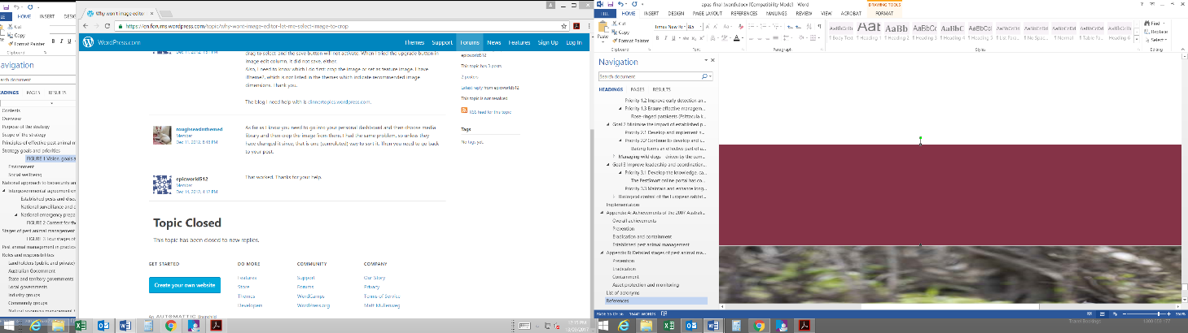

Australian Pest Animal Strategy 2017–2027

Invasive Plants and Animals Committee

DA3101_0717

Department of Agriculture and Water Resources General inquiry 1800 900 090

National office +61 2 6272 3933

agriculture.gov.au Twitter: @DeptAgNews